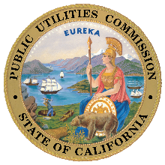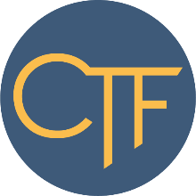 | California Teleconnect Fund  Application for K-12 Public School Districts  Distance Learning Discount
Please complete and email your application to CTFhelp@cpuc.ca.gov
School District: | Click here to enter text.
Mailing Address (Street): | Click here to enter text.
Mailing Address (City): | Click here to enter text.
Mailing Address (State): | Click here to enter text.
Mailing Address (Zip): | Click here to enter text.
Contact Person, Name: | Click here to enter text.
Contact Person, Email: | Click here to enter text.
Contact Person, Phone: | Click here to enter text.
For each provider listed below, how many mobile broadband service plans do you expect to purchase and provide to students for distance learning? Usually, each connected device requires a subscription of its own. Please also include any service plans associated with devices acquired via the Google/T-Mobile donation of devices and service through the California Department of Education.
AT&T: Click here to enter text.
Sprint: Click here to enter text.
T-Mobile: Click here to enter text.
Verizon: Click here to enter text.
Other Carrier: Click here to enter text.

