Abstract
California Water Plan Update
November 16, 2005
The Department of Water Resources (DWR) has changed the process for preparing the California Water Plan Update and the information it contains. The Water Plan has become a strategic document that describes the role of State government and the growing role of California’s regions in managing the state’s water resources.
In preparing Update 2005, DWR sought the participation of California's water communities, responded to new State laws, and, by working with an Advisory Committee, developed a new approach to planning California's water future. DWR significantly expanded the public forum for updating the California Water Plan by establishing the 65-member Advisory Committee and a 350-person Extended Review Forum and seeking input from 2,000 other interested members of the public.
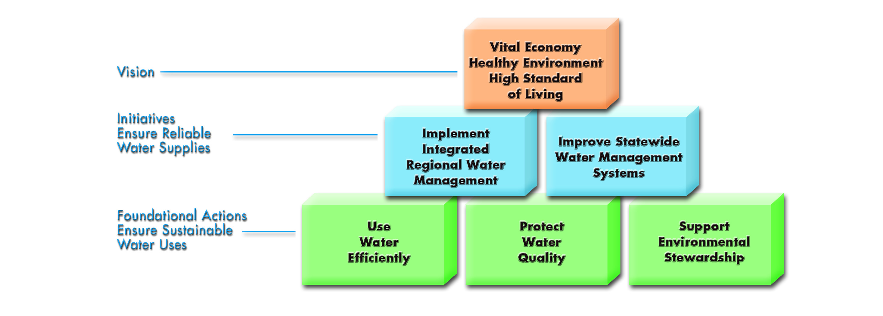
As a strategic planning document, this water plan provides California’s water communities with a vision, mission, and goals for meeting challenges of sustainable water use through 2030 in the face of uncertainty (see box, page 2). The plan provides a Framework for Action to stimulate progress now to ensure a sustainable and reliable water supply in 2030. This framework will focus and prioritize State government’s water planning, oversight, and technical and financial assistance on several foundational actions and initiatives.

The Framework for Action also identifies a number of support activities that are essential to accomplishing its foundational actions and initiatives. These support activities include providing effective State leadership, assistance and oversight; clarifying roles and responsibilities; and developing funding strategies to help local agencies and governments meet the needs of Californians. The support activities also include investing in new water technologies, adapting for global climate change impacts, improving water data management and analysis, increasing scientific understanding, and making decisions equitable across all communities.
Vision
California’s water resource management preserves and enhances public health and the standard of living for Californians; strengthens economic growth, business vitality, and the agricultural industry; and restores and protects California’s unique environmental diversity.
Mission
To develop a strategic plan that guides State, local, and regional entities in planning, developing, and managing adequate, reliable, secure, affordable, and sustainable water of suitable quality for all beneficial uses.
Goals
- State government supports good water planning and management through leadership, oversight, and public funding.
- Regional efforts play a central role in California water planning and management.
- Water planning and urban development protect, preserve, and enhance environmental and agricultural resources.
- Natural resource and land use planners make informed water management decisions.
- Water decisions and access are equitable across all communities.

We need the cooperation of State, federal, and local agencies and governments, non-governmental organizations, and water end-users to implement this strategic plan. California Water Plan Update 2005 has recommendations for decision-makers, resource managers, water suppliers, and water-users (listed on page 3). And for the first time, the water plan includes a proposal for carrying out its recommendations. For each recommendation, the implementation plan includes specific near-term and comprehensive long-term actions, resources assumptions, implementation challenges, and performance measures. Update 2005 also includes the actions in the CALFED Bay-Delta Program Record of Decision, and it is consistent with new water legislation and recommendations from recent State-sponsored water proposals.
If we make the right choices and investments, California's water resources can protect public health and improve the standard of living for all Californians; strengthen economic growth, business vitality, and the agricultural industry; and protect and restore California’s watersheds and unique ecosystems.
California Water Plan Update 2005 contains water data, information, and studies used to develop the strategic plan. Update 2005 outlines today’s water challenges and evolving water management responses; it presents benefits and costs of 25 resource management strategies (see page 4); it reports regional water conditions and activities; it considers multiple baseline scenarios for 2030 and their water demands; and it describes an approach to improve data management and analytical tools for future plan updates.
Update 2005 is presented in five volumes: (1) Strategic Plan, (2) Resource Management Strategies, (3) Regional Reports, (4) Reference Guide, and (5) Technical Guide. In April 2005, DWR distributed the Public Review Draft, and in June held public workshops to receive comments. The final California Water Plan Update 2005 is expected to be published in December 2005. More information is available online at
www.waterplan.water.ca.gov
Recommendations
California Water Plan Update 2005 provides recommendations for the next 25 years directed at decision-makers throughout the state (referred to as California), the executive and legislative branches of State Government, and DWR and other State agencies.

1. California must invest in reliable, high quality, sustainable, and affordable water conservation, efﬁcient water management, and development of water supplies to protect public health, and to improve California’s economy, environment, and standard of living.
2. State government must provide incentives and assist regional and local agencies and governments and private utilities to prepare integrated resource and drought contingency plans on a watershed basis; to diversify their regional resource management strategies; and to empower them to implement their plans.
3. State government must lead an effort with local agencies and governments to remediate the causes and effects of contaminants on surface water and groundwater quality.
4. California must maintain, rehabilitate and improve its aging water infrastructure, especially drinking water and sewage treatment facilities, operated by State, federal, and local entities.
5. State government must continue to provide leadership for the CALFED Bay-Delta Program to ensure continued and balanced progress on greater water supply reliability, water quality, ecosystem restoration, and levee system integrity.
6. State government must lead in water planning and management activities that: (a) regions cannot accomplish on their own, (b) the State can do more efﬁciently, (c) involve inter-regional, inter-state, or international issues, or (d) have broad public beneﬁts.
7. California must deﬁne and articulate the respective roles, authorities, and responsibilities of State, federal, and local agencies and governments responsible for water.

8. California must develop broad, realistic and sustainable funding strategies that deﬁne the role of public investments for water and other water-related resource needs over the next quarter century.
9. State government must invest in research and development to help local agencies and governments implement promising water technologies more cost effectively.
10. State government must help predict and prepare for the effects of global climate change on our water resources and water management systems.
11. DWR and other State agencies must improve data, analytical tools, and information management and exchange needed to prepare, evaluate, and implement regional integrated resource plans and programs in cooperation with other federal, tribal, local, and research entities.
12. DWR and other State agencies must explicitly consider public trust values in the planning and allocation of water resources and protect public trust uses whenever feasible.
13. DWR and other State agencies must invite, encourage, and assist tribal government representatives to participate in statewide, regional, and local water planning processes and to access State funding for water projects.
14. DWR and other State agencies must encourage and assist representatives from disadvantaged communities and vulnerable populations, and the local agencies and private utilities serving them, to participate in statewide, regional, and local water planning processes and to get equal access to State funding for water projects.

Resource Management Strategies
Reduce Water Demand  - Agricultural Water Use Efficiency  - Urban Water Use Efficiency | Improve Operational Efficiency & Transfers  - Conveyance  - System Reoperation  - Water Transfers
Improve Water Quality  - Drinking Water Treatment & Distribution  - Groundwater/Aquifer Remediation  - Matching Quality to Use  - Pollution Prevention  - Urban Runoff Management | Increase Water Supply  - Conjunctive Management & Groundwater Storage  - Desalination – Brackish & Seawater  - Precipitation Enhancement  - Recycled Municipal Water  - Surface Storage – CALFED  - Surface Storage - Regional/Local
Practice Resource Stewardship
- Agricultural Lands Stewardship  - Economic Incentives  (Loans, Grants, and Water Pricing)  - Ecosystem Restoration  - Floodplain Management | - Recharge Areas Protection  - Urban Land Use Management  - Water-dependent Recreation  - Watershed Management

Range of Additional Water for Eight Resource Management Choices
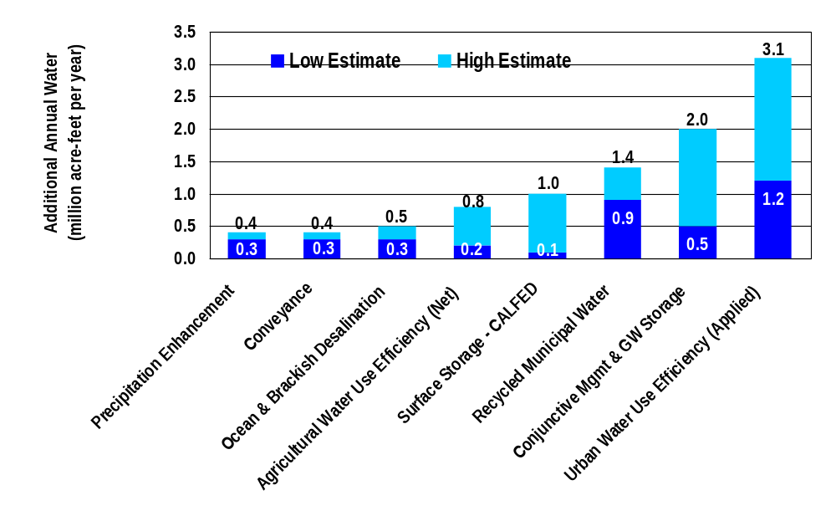
This graph shows the potential range of more water demand reduction and supply augmentation for eight resource management strategies by 2030. Low estimates are shown in the lower section of each bar. Estimates are from different studies described in Volume 2. The water benefits of these strategies are not always additive.

The Water Desalination Task Force, the State Recycling Task Force, the Stormwater Quality Task Force, the Floodplain Management Task Force, the Governor’s Advisory Drought Planning Panel, and California’s Groundwater (DWR Bulletin 118-03).

