Heritage Park
69100 McCallum Way
Cathedral City, CA 92234
latitude: 33.82364384481009
longitude: -116.45651578903198

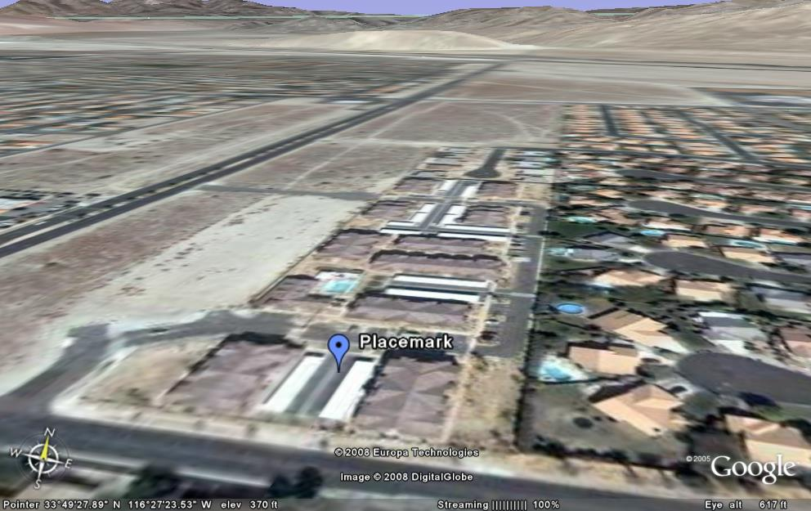

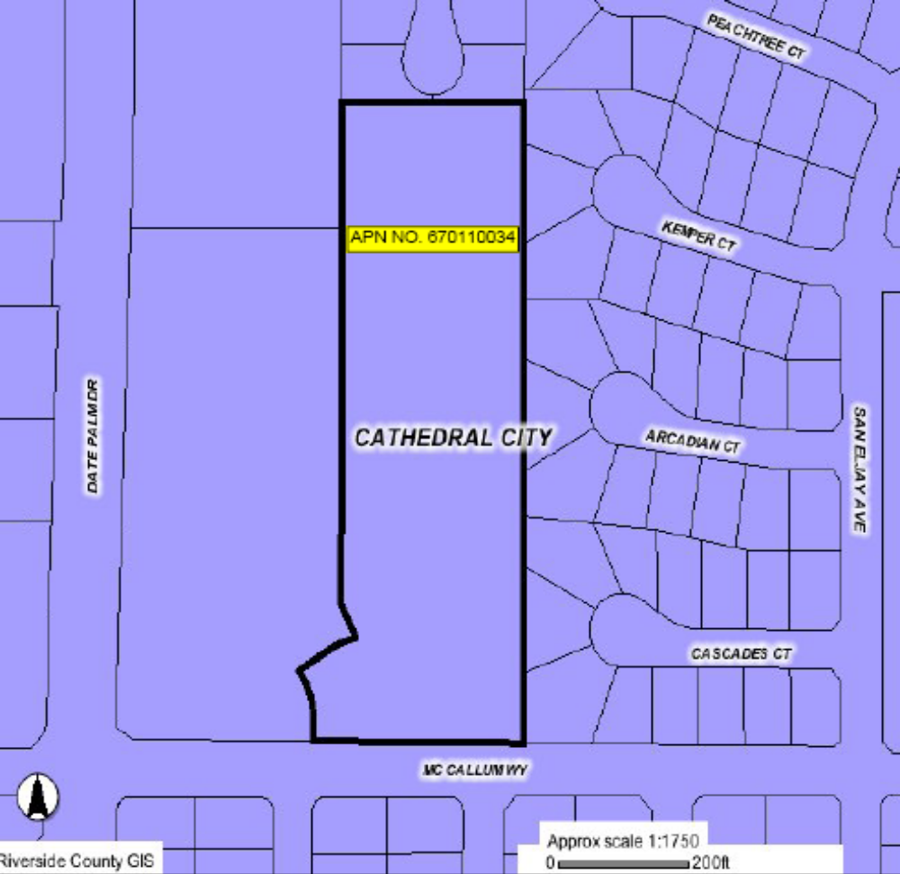
Creekside
68200 33rd Ave.
Cathedral City, CA 92234
latitude: 33.80866863935999
longitude: -116.47349953651428



