A proposal for
The Local Implementation of


The RightLights Program
in
Santa Barbara and Ventura Counties

Prepared for
California Public Utilities Commission,
San Francisco, California, September 23, 2003
Confirmation #______

by

Ecology Action of Santa Cruz


with the project team of

Center for Energy & Environment
Stan Walerczyk / Lighting Wizards
Community Environmental Council (Santa Barbara)

Implemented in Collaboration with
Ventura County Regional Energy Alliance, local Chambers of Commerce, and Hispanic Chambers of Commerce.

Contact: Mahlon Aldridge, Deputy Director / Ecology Action / 333 Front Street Suite 103
Santa Cruz, CA 95060 / 831-426-5925 x 16 / emahlon@ecoact.org

In a sister proposal, Ecology Action is proposing a complementary program to implement RightLights in 11 counties in PG&E territory in collaboration with Regional Energy Authorities, the City of San Jose, 10 Chambers of Commerce and four Hispanic Chambers of Commerce.

Table of Contents

I) PROGRAM OVERVIEW 6
A) Program Concept 6
B) Program Rationale 6
1. RightLights Program Achievements. 6
Unmet Need Persists. 7
ISO Constrained Areas. 7
Type of Program. 8
Consolidation of Target Area. 8
C) Program Objectives 8
1. Program Goals and CPUC Policy Objectives 8
Additional Goals. 9
Cost Competitiveness. 9
II) Program Process 10
A) Program Implementation 10
1. Collaborative Program Structure. 10
Coordination with Other Energy Efficiency Programs. 12
Market Barriers 13
RightLights Retrofit Process 14
FACET© Software Audit Tool. 15
Contractor Recruitment & Participation 15
Installation Process 16
Supply Chain Management 17
Quality Control 17
B) Marketing Plan 19
1. Community-Based Marketing 20
Marketing Materials 22
C) Customer Enrollment 22
D) Materials 22
1. Procurement and Installation Process 22
Installation Standards 23
Equipment Standards of Lighting Measures 23
High Efficiency Pre-Rinse Spray Nozzle Installation Standards 24
E) Payment of Incentives 24
1. Comprehensive Retrofit Incentive Package 24
Quick-Saver Package Incentive Package 25
Pre-rinse spray nozzles 25
F) Staff and Subcontractor Responsibilities 25
1. Recruitment and Training 26
G) Work plan and Timeline for Implementation 27
1. Implementation Plan. 27
III) Customer Description 28
A) Customer Description 28
1. Hard-to-Reach 28
2. Under-Served “Commercial” Multifamily 29
B) Customer Eligibility 30
C) Customer Complaint Resolution 30
D) Geographic Area 30
IV) Section IV. Measure and Activity Description 31
A) Energy Savings Assumptions 31
B) Deviations in Standard Cost-effectiveness 31
C) Rebate Amounts: 32
1. Comprehensive Retrofit “Instant Rebate” Incentive 32
Quick-Saver Package Incentive 32
D) Activities Descriptions 32
V) Program Performance Goals 33
A) Program Performance Targets 33
B) Number of Ratepayers Served 34
C) Community Capacity-Building 34
D) Upstream Supply Assurance 34
VI) Program Evaluation, Measurement and Verification 35
A) CPUC Objectives 35
B) Plan Development 36
1. Data Acquisition 36
Budget and Potential EM&V Contractors 36
VII) Qualifications 37
A) Summary of Key Personnel 37
B) Division of Roles of Each Team Member 38
C) Ecology Action Qualifications 39
D) Subcontractors 43
1. Center for Energy and Environment (Subcontractor) 43
Stan Walerczyk / Lighting Wizards (Subcontractor) 47
Community Environmental Council (Subcontractor) 47
E) Personnel Resumes – Ecology Action 50
F) Personnel Resumes — Subcontractors 57
1. Center for Energy and Environment 57
Stan Walerczyk/Lighting Wizards 65
Community Environmental Council 69
VIII) Budget Summary 71
A) Budget Line Item Comments 71
IX) Appendices 73

PROGRAM OVERVIEW

Program Concept
The team comprised of Ecology Action, Center for Energy and the Environment (2002-2003 program partner), Stan Walerczyk/Lighting Wizards, and the Community Environmental Council (Central Coast) proposes to implement the successful RightLights program in Santa Barbara and Ventura Counties. The expansion of RightLights is complementary and synergistic with the RightLights program proposed separately for PG&E customers in 11 counties of Santa Cruz, Monterey, San Benito, San Luis Obispo, Santa Barbara, Fresno, Kern, Kings, Humboldt, San Mateo, and Santa Clara. It is important to note that if both programs are funded, the combined budget can be reduced significantly since each proposal is currently budgeted to succeed on its own.
- RightLights is a multilingual program that installs comprehensive, turnkey lighting retrofits, as well as pre-rinse spray nozzles (food service only), and provides information-only resources on refrigeration, HVAC, and motors efficiency measures to nonresidential customers with less than 500 kW demand. The primary purpose of the program is to deliver persistent and sustainable energy savings at the lowest possible cost to a customer group that a) has systematically not received a proportional share of PGC program benefits, and b) for which there are virtually no other programs with the demonstrated capacity to attract their participation. Secondarily, we seek to serve the greatest possible number of businesses that met HTR criteria.
- Successful implementation will be achieved through collaboration with a network of local partners including Ventura County Regional Energy Alliance (VCREA), Chambers of Commerce, and government agencies, (please see attached letters of participation in hard copy). Ecology Action will also deliberately transfer technical program capacity and infrastructure to VCREA so that they may continue to deliver efficient lighting services and persistent savings to the hard-to-reach small commercial marketplace once the proposed contract period is complete.

Program Rationale

RightLights Program Achievements.
At the time of this submission, RightLights in the three Monterey Bay Area counties had surpassed 135% of its proposed kW goal with four months still remaining, and is on track to deliver 170% of its kW goal within budget and on time. Seventy-six percent of the 430+ businesses we have reached to date employ fewer than 10 workers and are classified as “very small.” Much of the program’s success is due to our close and effective collaboration with local entities such as Chambers of Commerce and merchant associations. This strategy will remain a key program component in the proposed expansion of RightLights (please see committed organizations listed below, with participation letters attached in hardcopy submittal).
There is nothing magic about the outstanding success of RightLights. Ecology Action designed the program to respond very specifically to the barriers faced by the small business customer. RightLights reaches California businesses that have never been adequately served by PGC-funded energy efficiency programs. We leverage our Community Marketing Partners’ existing communication channels to cost-effectively reach small businesses. As a nonprofit, our low overhead and streamlined operation allows RightLights to confer the highest possible amount of PGC dollars to the customer, in contrast to programs that have larger administrative burdens. In short, RightLights maximizes the owner’s decision-making confidence, and minimizes the time and money required to install long-term savings.
By listening closely to our target market and responding accordingly, we have begun – business by business – to deliver a more equitable share of PGC benefits to this underserved market. In the process, Ecology Action has developed a strong and productive working relationship with our current PG&E contract manager. We look forward to continuing to work closely with the IOUs in the implementation of RightLights and projects. Additionally, the proposed RightLights program is supported by elected officials from all proposed target counties (please refer to letters that accompany the hardcopy).

Unmet Need Persists.
No PGC-funded program has served a significant portion of the very small and small nonresidential customers anywhere within Santa Barbara or Ventura counties. This underscores both the enormous potential for energy savings in the small business market, as well as the need to provide convenient turnkey solutions for these customers. PGC program funds have bypassed this critically important ratepayer sector in favor of the “low hanging fruit” of larger electrical customers. In the Monterey Bay Area in 2002-2003 Ecology Action survey 275 RightLights participants and found that 88% of respondents had not taken part in other EE programs. We assume similar percentages hold true in Santa Barbara and Ventura Counties. In addition, 80% of respondents cited “Ease of Participation” as their primary motivating factor for using RightLights services (see Section II-B for additional survey results).
The 2 target counties were selected strategically to balance the following factors that we believe are essential to achieving long-term, reliable, and equitable energy savings:
- High proportion of existing businesses with less than 20 kW demand.
- No existing full service direct install lighting program is reaching very small, small and medium-sized businesses.
- Ecology Action’s ability to collaborate with Regional Energy Authorities and/or appropriate community-based organizations to partner in implementation, and to carry forward small business EE services subsequent to the contract period (see letters of collaboration in hard copy submission).
- High percentage of businesses that meet HTR criteria.
- Ability to create new, and leverage existing, relationships with local businesses associations, lighting contractors, and public agencies.
- Geographic proximity of each county to other counties proposed in Ecology Action’s complementary sister proposal for PG&E territory.

ISO Constrained Areas.
Additionally, the proposed program serves customers in areas considered by the ISO to be transmission-constrained.

Type of Program.
For CPUC evaluation purposes, we believe that RightLights is most appropriately considered a direct installation hardware/incentive program.

Consolidation of Target Area.
If the Commission considers reducing the proposed budget and scope, we suggest that the target areas be consolidated based on geography, prioritizing service to the most concentrated business areas with in each county. This will help preserve the cost-effectiveness of the proposal despite losing some economies of scale.

Program Objectives

Program Goals and CPUC Policy Objectives
The goals of the proposed program meet all of CPUC’s policy objectives as presented in the Policy Manual and shown in Table I.1 below.
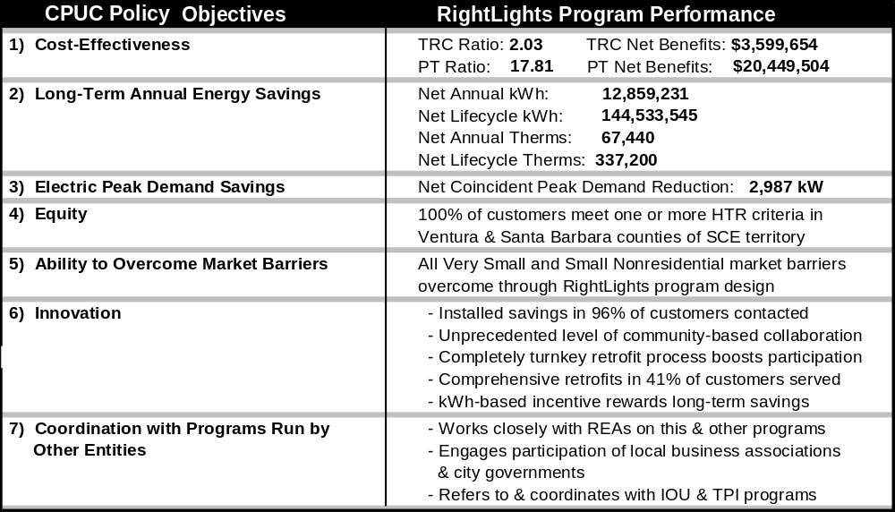

Table I.1

Additional Goals.
Related program goals include:

Community Capacity-Building.
Ecology Action’s secondary objective is to build program capacity among our partners – particularly Regional Energy Authorities and community groups – to deliver these types of programs in subsequent program cycles.

Upstream Supply Assurance.
To ensure long-term persistent energy savings, Ecology Action will work with local retailers to make certain that they stock the high efficiency lamps (mainly tubular fluorescent and multiple CFL types) that are installed by RightLights. This will facilitate customers’ replacement of lamps as they wear out, and also promote the continued transition from incandescent to high efficiency lighting technologies within the retail service area. Once the supply chain is established, RightLights will promote the new lamp availability to all participants.

Cost Competitiveness.
RightLights’ cost-effectiveness speaks for itself (as detailed in the table above in this section).
The strength of RightLights’ current achievements clearly demonstrate a program that cost-effectively fills the small business market void. Yet program cost alone is an insufficient yardstick of success when measured against hard-to-reach customer needs, and RightLights should not compared to rebate-only programs strictly on that basis. There are two reasons: 1) IOU rebate-only programs do not equitably serve small businesses, and 2) real-world marketing costs for these programs are not reflected in those IOU programs TRCs, since many customers for rebate-only programs are generated through other information-only PGC-funded efforts such as the IOU energy audit services and statewide marketing programs. As such, we believe that our full-service program both fills an unserved market and does so at less cost than the rebate-only programs currently available.

Program Process

Program Implementation
In this implementation section (II-A) we describe the program design features that are crucial to program success. They include:
- RightLights collaborative operational structure
- Strategy for coordination with other EE efforts (planned and existing) in the target areas
- Market barriers overcome by RightLights
- RightLights retrofit process
- FACET© audit software tool
6. Contractor recruitment and participation
7. Installation process
8. Supply chain management
9. RightLights quality control process

Collaborative Program Structure.
The strength of the proposed program is based on its network of community-level collaborations. Ecology Action has developed a multi-tiered implementation approach involving the Implementation Team (ourselves plus our three technical partners), Ventura County Regional Energy Alliance, and many Community Marketing Partners (i.e., Chambers of Commerce). Ecology Action’s team will deliver comprehensive lighting retrofits to a broad cross-section of very small, small and medium businesses in the two-county area using a community-based marketing strategy to achieve high enrollment at low cost. We will deliver RightLights in English and Spanish languages in all proposed areas.
In order to achieve program objectives and to maximize participation while optimizing cost effectiveness, the proposed program features the following elements:
- Outreach through trusted community organizations
- Lighting system auditing and retrofit job specification
- Use of Center for Energy and Environment’s FACET© lighting software
- Standardization of equipment specifications
- Unit pricing
- Aggregation of services
- Information on other low-cost/no-cost EE measures and links to other programs
- Active project evaluation and quality control for each job
- Broad community collaboration and support, with commitments already in place (as detailed below)

Prime Contractor and Subcontractors.
Ecology Action has assembled an implementation team that provides an unparalleled level of experience in small commercial program implementation, technical lighting, EE program design, and community-based marketing. Program partners include the Center for Energy and Environment (partner on the 2002-2003 RightLights program in the Monterey Bay Area), Stan Walerczyk/Lighting Wizards, and Santa Barbara’s Community Environmental Council.

Regional Energy Authorities.
Ecology Action has arranged to work with Ventura County Regional Energy Alliance (letter attached to hard copy) to coordinate service delivery, tap into existing local communication networks, and ultimately to transfer program capabilities to these VCREA so it may conduct business-focused EE programs in future funding cycles. Ecology Action also intends to coordinate with any other REA’s that develop during the implementation period. Confirmed REA participation in the 11-county complementary sister proposal for PG&E territory and submitted under separate cover includes the following (letters in hardcopy submittal):
- Redwood Coast Regional Energy Authority, Humboldt County (RCREA was created with PGC funding in the 2002-2003 program cycle).
- Association of Monterey Bay Area Governments (AMBAG is currently developing plans for an REA under contract with the California Energy Commission).
- California State University Fresno (proposing a county-wide REA in conjunction with the Local Government Commission).

Local Business Associations.
RightLights’ success has depended on working closely with local business associations as part of our least-cost marketing strategy. These “Community Marketing Partners” offer specific information and access to the target market that would be impossible to affordably gain otherwise. We will work with approximately 6-8 Chambers and/or Hispanic Chambers in the two-county area as “Community Marketing Partners.” To rapidly develop relationships with local chambers, we will work through VCREA and our program partner, Community Environmental Council (Santa Barbara), who both have strong working relationships with the local Chambers in their respective areas.

Letters of Support.
Please refer to the 19 letters listed below (and attached in hardcopy submittal) which support the expansion of RightLights to all 12 counties proposed by Ecology Action for SCE and PG&E territoris, including Ventura and Santa Barbara.

- Sam Farr, U.S. Congress 17th District (Monterey Bay Area)
- Mike Honda, U.S Congress 15th District (Silicon Valley)
- Cal Dooley, U. S. Congress 20th District (Fresno/Bakersfield)
- Mike Thompson, U.S. Congress 1st District (Humboldt)
- Bruce McPherson, State Senator 15th District (Santa Cruz)
- John Laird, State Assemblymember 27th District (Santa Cruz)
- Patty Berg, Assemblymember 1st District (Humboldt County)
- Nicole Parra, Assemblymember 30th District (Kern County)
- Hannah Beth-Jackson, Assemblymember 35th District (Santa Barbara/Ventura)
- Joseph Simitian, State Assemblymember 21st District (Silicon Valley)
- Manny Diaz, State Assemblymember 23rd District (Silicon Valley) *
- Rose Jacobs Gibson, Supervisor 4th District (San Mateo County)
- Donald Gage, Supervisor 1st District (Santa Clara County)
- Juan Arambula, Supervisor 3rd District (Fresno County)
- Jeff Almquist, Supervisor 5th District (Santa Cruz County)
- Naomi Schwartz, Supervisor 1st District (Santa Barbara County)
- Pete Parra, Supervisor, 5th District (Kern County)
- Andres Herrera, City of Oxnard Council Member, (Ventura County – sister proposal)

(*letter officially approved, pending delivery)

Coordination with Other Energy Efficiency Programs.
Ecology Action has coordinated closely with other energy efficiency programs and activities during 2002-2003 implementation in the Monterey Bay Area, and these efforts are expanding in conjunction with the submission of this proposal. Specifically, are we are currently collaborating with:
Regional and Statewide IOU programs
RightLights refers all our participants to other non-residential EE programs such as Express Efficiency and Standard Performance Contracting programs for which they may be eligible. These efforts include distribution of written materials, links on our www.rightlights.org website, and telephone referrals of incoming inquiries.
Regional Energy Authorities (Proposed and Exisiting)
Ecology Action has arranged to work with:

- Ventura County Regional Energy Alliance.
- Redwood Coast Regional Energy Authority in Humboldt County (recently established with PGC funds),*
- Association of Monterey Bay Area Governments (AMBAG), which is planning an REA under contract with California Energy Commission,*
- California State University Fresno, which is proposing in this funding cycle to create a Fresno County Regional Energy Authority in conjunction with the Local Government Commission.*

(*collaborators on sister proposal targeting 11 counties in PG&E territory)

In each case, Ecology Action will be collaborating closely with these REAs throughout the 2004-2005 program period. Strategies include combining of marketing efforts to target medium-sized customers and leveraging the REA’s established and nascent community relationships in order to increase participation levels. Additionally, Ecology Action will deliberately transfer program capacity to the REA with the goal of “handing over the keys” to these organizations so they may carry forward a RightLights-type program on a sustainable basis. Please refer to their letters of participation attached in our hardcopy submittal.
California Urban Water Conservation Council
We have arranged to retrofit pre-rinse spray nozzles in food service establishments in the non-urban areas not targeted by current and proposed CUWCC nozzle programs. This assures no duplication of effort. In areas that are targeted by CUWCC, we will provide CUWCC nozzle program information to RightLights participants that are food service establishments.
San Luis Obispo and Santa Barbara Counties
Through our partnership with Community Environmental Council and local energy consultants we have begun preliminary coordination on local efforts to establish an energy office in that area.
Third Party Programs
In addition to coordination with the entities listed above, we will continue to link RightLights participants to information on the third party PGC-funded programs that are available to them. For example, we coordinate with LightWash, a third-party initiative implemented by Energy Solutions which targets Laundromats for efficient lighting and washer upgrades. RightLights shares our base of prospective customers in this market segment, along with marketing information and potential leads.

Market Barriers
The proposed expansion of RightLights will serve very small, small, and medium nonresidential SCE customers within the specified territory. Despite spending a higher percentage of operating costs on energy compared to larger businesses, small enterprises present a number of obstacles to successful energy efficiency program implementation. Key market barriers include:
- Technology information search costs: Small businesses lack the time and expertise to evaluate efficiency opportunities.
- Financing information search costs: Upgrade costs are immediate while savings occur over time. Initially, cash flow can be negative and research of optimum rebate or loan programs can be time-consuming.
- Performance uncertainties: Small businesses can be unsure about appropriate energy efficiency technologies as well as the skills, honesty and motive of unfamiliar contractors.
- Transaction costs: Small firms often do not have the time or financial resources to develop and implement new projects.
- Split incentives: Tenants are reluctant to invest in a landlord’s property, and owners may not want to invest in energy efficiency when the tenant pays the utility bills.
- Lack of viable service providers: Installation and program overhead costs reduce overall program cost-effectiveness, which in turn limits the number of firms that choose to propose and implement PGC programs that could meet small business needs.
- Controllability: Business owners view energy costs as fixed rather than as expenses they can control.

A successful program needs to overcome these barriers simultaneously in order to achieve significant penetration. Each programmatic element of RightLights has been specifically designed to overcome these market barriers, and the program’s performance demonstrates its ability to do so.

RightLights Retrofit Process

A. Auditing, Designing, Specifying and Bidding.
The core of the program is comprehensive T12 to T8 fixture conversions, CFL replacement of incandescent lamps, LED upgrades of exit signs, and efficient controls. We will also promote the latest lighting technologies, such as 3100 lumen T8 lamps, high efficiency electronic ballasts, and simple daylighting controls. The program will also provide recommendations and reference materials on HVAC and refrigeration efficiency measures, as well as low-cost and no-cost strategies to reduce energy consumption.
The initial customer contact is typically made either through one of our Community Marketing Partners (please see Marketing Plan) or an in-person visit by a RightLights Lighting Auditor. While on-site the Auditor completes the lighting audit and installs a Quick-Saver Package of CFLs valued at up to $250 per business (at no cost to the customer). In the case of qualified food service businesses we will also install a pre-rinse spray nozzle(s). Within several days of the initial visit the Auditor presents a plan and pricing for a comprehensive lighting retrofit (including low/no-cost measures) for the approval of the business decision maker.
The Auditors will attempt to close deals on-site as often as possible and will follow up until contracts are signed or it becomes clear that the prospect will not yield a comprehensive lighting project. In the Monterey Bay Area RightLights program, over 40% of those who receive an initial audit go on to complete a comprehensive lighting retrofit. In cases where no comprehensive project contract is signed, installed savings are still achieved by the Quick-Saver Package, which offsets the cost of marketing to that business. Small jobs that are near one another are scheduled consecutively in a compressed timeframe in order to minimize the contractors’ travel time between jobs and setup time — savings that can be passed on to the participant.
Although the audit will focus on lighting, other energy-saving opportunities will be addressed through delivery of materials identifying no/low cost measures, as well as HVAC and refrigeration-specific measures and lamp recycling information. For non-lighting efficiency items, businesses will be referred to other IOU or TPI programs.

B. Mercury Pollution Reduction.
RightLights strives to minimize mercury pollution and maximize long-term energy savings by balancing two characteristics in the lighting equipment we specify: use of the lowest mercury bulbs from each manufacturer, combined with ballast/bulb configurations that ensure the longest operational lamp life. Both of these factors can significantly reduce mercury pollution while increasing the financial value of the retrofit to the customer. Ecology Action also developed a resource guide with proper disposal techniques and available recycling locations, which we distribute to all RightLights customers at the time of retrofit. Finally, we obligate all program contractors to properly dispose of any hazardous waste generated in the retrofit process.

FACET© Software Audit Tool.
The FACET software tool facilitates cost-effective small commercial lighting efficiency projects by streamlining the auditing, project design, finance, contracting, installation tracking, and record keeping functions for multiple small lighting projects at once. Though it has a highly sophisticated lighting analysis component, FACET is a fully-integrated retrofit management system that includes the following:
- Progress Tracking
- Construction Management
- Inter-Team Communication
- Security
- Quality Control
- Report Generation
- Invoicing/Reporting

FACET is a mature software tool with three years of field use on over 12,000 audit sites, and benefits from thousands of hours of program refinement. Program specific information is included in embedded tables that can be easily customized. Program-specific modifications will include:
- Lighting equipment and labor pricing databases will be modified to reflect equipment pricing negotiated specifically for this program
- Customer rebate calculation function will be modified to reflect program design
- All appropriate reports, instructions, and forms will be translated to appropriate non-English languages as needed
- Report logos will reflect the sponsoring organizations
- Client-specific report data generation

Contractor Recruitment & Participation

Contractor Recruitment.
Contractor input will be solicited for all aspects of the program. The contractors’ “buy in” to the program is critical to successful implementation, especially in smaller communities where customers have developed long-term trust relationships with their vendors. As such, prior to recruitment, we will solicit input on labor and equipment markups and pricing from key contractors in the region. This information will be the basis from which to derive the RightLights fixed pricing levels to be used by official program contractors that are recruited subsequently.
RightLights will develop a list of licensed electrical and lighting installation contractors within each business region. Our Community Marketing Partners will also provide valuable assistance in identifying potential installers. RightLights will invite these contractors to an informational workshop. The purpose of the workshop is to introduce the RightLights Program to area contractors and establish a pool of qualified, competent professional installers who agree to the participation terms, pricing and labor rates of the program.

Contractor Terms of Participation.
Current RightLights Program contractor guidelines ensure a professional and fairly-priced installation, delivered to participating businesses on a totally turnkey basis. These guidelines are part of a legal agreement that includes all CPUC- and IOU-required contract terms and addresses the following elements:
- Proof of Licensure and Insurance
- Warranty
- Permit and local building codes
- Protection of Work, Persons and Property
- Independent Contractor Status
- Performance Standards
- No solicitation of work outside the Bid Proposal
- Pre-set labor rates, markups, and materials pricing

In each proposed region, pricing will be established at the outset of the program and will be in force for approximately six months before being re-negotiated to reflect on-the-ground experience of the contractors and the Program team.

Installation Process

Pre-Installation Visit.
Once a business owner agrees to the retrofit, the contractor will visit the site within five days to perform a pre-installation inspection to verify the specifications. At the conclusion of the visit, the contractor either accepts or rejects the project. If accepted, the contractor arranges job scheduling with the owner and orders the specified equipment. The contractor then notifies Program staff of the scheduled installation, which is normally completed within three weeks. Changes from the original job specifications require a change order and approval from Program staff.

Permitting, Materials & Installation.
The contractor obtains any necessary permit(s) for the installation along with all necessary materials. The contractor will remove existing equipment, and all used equipment will be properly recycled or disposed of in accordance with state and local ordinances. PCB-containing ballasts and mercury-containing lamps will be recycled through certified handlers. Fixtures are cleaned as required. The contractor then completes the installation according to the auditor’s job specification and at the unit pricing levels established by the Program.

Invoicing.
For each completed job, the contractor produces a detailed invoice listing the costs for labor, permit fees, all materials essential to completing the installation (including the manufacturer’s name, model number for each product type installed, and unit price), and PCB ballast/fluorescent lamp disposal. Receipt of a copy of the invoice(s) by Program staff constitutes notification that installation is ready for post-installation inspection.

Supply Chain Management
It is critical to ensure that contractors are able to obtain the materials they need to complete the work at the lowest possible prices and on a timely basis. Almost all of the supplies are commonly used and should be available locally. Current RightLights staff have negotiated below-wholesale pricing on many of the most frequently used items in the current program area, and will seek to do likewise in each proposed area of expansion. However, some products are more specialized and suppliers may stock labor-saving items like pre-assembled wiring (whips), brackets and other components designed to streamline installation of high efficiency lighting technologies. In this case, RightLights will identify suppliers for these components and coordinate delivery as needed.
In one instance, a RightLights Auditor identified the need for a special bracket that could save considerable time and expense on installations of 8-foot to 4-foot T12-T8 conversions. Despite extensive research, no such bracket was found to exist. The Lighting Auditor teamed with one of our senior program contractors to design and manufacture this bracket, which is now in use and saves over $13 on each fixture. This development has dramatically improved the cost-effectiveness of this critical retrofit measure.

Quality Control
The team’s quality control and quality assurance (QC&QA) methods are built into the program standards and procedures and are directly confirmed by installation inspections. These specific standards and practices along with the team’s extensive experience with RightLights and other small business EE programs further assure a delivery of a quality program (see Section VII – Qualifications).

Standardized and Comprehensive Specifications.
Each comprehensive job will contain equipment specifications for all work performed. FACET© has a library of the most common retrofits that includes a description of the existing lighting system and its appropriate replacement. The Lighting Auditor merely needs to click on the relevant entry and the entire project’s description is entered into the audit. When special circumstances require an alternate design, the descriptions are easily customized. This approach also facilitates uniform and consistent CPUC and IOU reporting as well as EM&V efforts.

FACET Quality Control Features.
FACET has numerous data quality checks within the program. For instance, if 18 new fixtures are specified to replace 20 existing fixtures, FACET flags the difference. The auditor then either accepts the difference as intentional or corrects the error. Additionally:

- Progress tracking prevents jobs from “falling between the cracks”
- The Change Order feature ensures a smooth process for this often-problematic element of construction management
- Good inter-team communication is facilitated by notes made available to all parties
- Security features avoid accidental corruption of data

Additional FACET quality control features are listed in Table II.1.
Table II.1

FACET Quality Control Features

Progress Tracking
- ID Number uniquely assigned to each site.
- Audit Tracking: audit scheduled, completed, submitted, approved; approval status; change orders.
- Loan Tracking: credit application submitted; approved; approval status.
Construction Management
- Construction Tracking: contractor assigned, construction status, scheduled, completed.
- Change Orders easily entered, permanently tracked, and readily visible.
- Inspections: status, scheduled, completed.
Inter-Team Communication
- Multiple auditor access to all properties.
- Password protection to prevent data corruption.
- Notes/comments available at all level of data entry.
- Special instructions printed out on owner’s and contractor’s reports.
Security
- Multilevel authorization: auditor, program administrator, system operator.
- Log-in/log-out recorded.
- User authorization database is editable by administrator.
- Password protection for program access.
Quality Control
- Validity tests on data entry with special flagging of questionable or invalid fields.
- Auditor assignment at property level to prevent data corruption.
- Lockout on access to all administrator-only fields.
- Rebate qualifications checked at retrofit level with criteria editable by administrator.
- Analysis and report snapshot recorded and locked against change orders for future review.
- Pre-defined retrofits ensure standardization of recommendations.

Inspection.
The first five projects completed by each contractor are thoroughly inspected by a RightLights Lighting Auditor, while subsequent jobs are inspected on a random periodic basis. If the installation is deemed incomplete upon inspection by the Program representative, the Contractor is notified and must perform all services necessary to meet completion requirements at their own expense. Contractors must satisfy all requirements within five (5) business days of notification of incompleteness. Failure to meet completion requirements may result in termination from the program.

Mid-Course Adjustment and Program Evolution.
The RightLights Program design is an evolving process whereby the Team refines the systems and procedures interactively to maximize program participation and kW/kWh/Therm savings. Any adjustments will be approved by CPUC Energy Division and reflect on-the-ground experience with all program aspects. For example, different strategies may be developed for non-food retail versus grocery stores.

Customer Feedback.
Within a reasonable time after completion of the retrofit, participants are sent a survey regarding their experience with RightLights. This evaluation is used in an ongoing effort to improve the program and to identify areas where the customer is not yet fully satisfied. Results from surveys returned to date (275 participants) are summarized below:
- 80% of respondents were extremely satisfied with their RightLights experience, 8% were very satisfied, 8% were satisfied, and 4% no response
- 88% felt their knowledge of energy efficient lighting had improved as a result of their participation
- 96% would continue to use efficient lighting in the future
- 100% would recommend RightLights to other small businesses
- 100% felt that the program helped save money and energy
- 100% would like to see the program continue in the future

Marketing Plan
Our Team will develop a specific marketing implementation plan for each geographic area that will detail the content and timing of all major marketing and outreach activities. While remaining flexible and responsive to on-going program improvements, the plan will detail the geography, strategy, cost and timing for coordination of community partners, print promotions, in-person group presentations, standalone lighting workshops, and mainstream media campaigns. Materials produced to date include various brochures, flyers, posters and displays, postcards, targeted letters, and press releases (see Appendices in print copy submittal).

Community-Based Marketing
The marketing plan emphasizes effective community-based marketing approaches and employs three primary strategies:
- Community Marketing Partners: Utilizes a network of local organizations, agencies, and business associations to cost-effectively reach local businesses (see letters of participation from committed Chambers of Commerce).
- Site Visits: Conduct in-person, door-to-door visits in conjunction with Lighting Surveys and installations of Quick-Saver Packages.
- Media Coverage: Generate mainstream media coverage designed to reach the entire target business community.

The program strikes a balance between overall marketing costs and appropriate incentive levels. If incentive levels are too low, excessive marketing funds are required to get customers, whereas appropriate incentive levels ensure that money which would otherwise be used for marketing is instead offered in rebates. This approach yields greater program participation and a delivers a higher percentage of PGC funds directly to the customer.

Community Marketing Partners.
The project team utilizes a least-cost marketing approach that reaches underserved businesses through a network of at least six Community Marketing Partners including merchant associations, Chambers of Commerce, and community-based organizations. These local institutions offer heavily subscribed and highly trusted communication forums such as newsletters, bill inserts, member meetings, and program-specific seminars. Table II.2 lists potential Community Marketing Partners.
Table II.2

- Santa Barbara Hispanic Chamber of Commerce
- Buellton Chamber of Commerce
- Carpinteria Chamber of Commerce
- Goleta Chamber of Commerce
- Lompoc Chamber of Commerce
- Santa Maria Valley Chamber of Commerce
- Solvang Chamber of Commerce
- Camarillo Chamber of Commerce
- Fillmore Chamber of Commerce
- Moorpark Chamber of Commerce
- Ojai Valley Chamber of Commerce
- Oxnard Chamber of Commerce
- Port Hueneme Chamber of Commerce
- Ventura County Hispanic Network
- Santa Paula Chamber of Commerce
- Simi Valley Chamber of Commerce
- Thousand Oaks/Westlake Village Chamber of Commerce
- Ventura Chamber of Commerce

RightLights will work with these groups to leverage their knowledge and credibility to effectively reach small commercial customers in different neighborhoods and ethnic groups. Our Community Marketing Partners maintain membership lists of thousands of businesses. Many of these firms will hear about the program multiple times through a variety of trusted sources.

Existing Business Relationships.
Ecology Action and the Community Environmental Council (our Central Coast partner) maintain a database of approximately 1,100 small and medium business decision makers that have benefited from our respective organizations’ business assistance programs such as our WasteNot© Small Commercial Waste Reduction Program, our Safer Technologies in Fabricare program and our Agricultural Used Oil Programs. Through these types of initiatives our two organizations have delivered valuable technical assistance and training that helps business increase environmental and economic performance concurrently. Ecology Action and Community Environmental Council’s reputation for results-oriented professionalism and will help open the door for low-cost customer enrollment.

Door-to-Door Marketing with a Quick-Saver Package Offer.
RightLights has found our most effective marketing method to be an unscheduled, in-person visit with the business decision-maker offering the installation of our Quick-Saver Package. Because RightLights requires that our Lighting Auditors conduct a comprehensive lighting survey as a condition of receiving the no-cost Quick-Saver Package, we are assured of not only an audit, but of netting installed savings at over 96% of the businesses we approach.

Mainstream Media Coverage.
As community-based organizations with long standing relationships with the press, Ecology Action and Community Environmental Council are able to generate mainstream media coverage (feature stories in print, radio, and television) that would be very difficult for private consulting firms to match even at many times the cost. Possessing extensive experience generating feature story coverage for past programs uniquely positions Ecology Action and Community Environmental Council to capitalize on this valuable community resource. In the current RightLights program, Ecology Action has already generated two radio segments and four newspaper articles providing numerous low-cost leads.

Contractor and Participant Referrals.
Contractors are encouraged to refer their customers who could benefit from program participation. Often contractors have numerous loyal customers and want to bring the program to them. This applies to the participating RightLights contractor pool as well as “outside” contractors. In addition, satisfied participants have proved to be a good source of referrals.

Marketing Materials
Our teams combined energy efficiency technical expertise, market knowledge, local community understanding, and graphic design skills enable us to quickly provide marketing materials that affordably achieve the greatest levels of participation. To further reduce costs, RightLights will utilize much of its existing portfolio of marketing master documents for adaptation in this cycle. Please see attached samples of marketing materials developed by the RightLights team in 2002 and 2003, including materials in English and Spanish (hardcopy submittal only).

Customer Enrollment
Customer enrollment normally begins with the initial visit from the Lighting Auditor. Upon agreeing to the free Lighting Survey, the business decision maker signs an Access Agreement giving permission for the audit as required by IOU contract. If a Quick-Saver Package is to be installed at that time, a signature is also obtained for the Quick-Saver Package Agreement. When the business owner or manager agrees to the comprehensive retrofit, a Work Order is signed which authorizes work to begin on the specified project at the stated price.
RightLights then assigns the job to a participating program contractor who schedules the job with the business owner or manager, and signs a contract with the owner for the out-of-pocket portion of the retrofit.
After the job has been completed (usually within 30 days of signing work order) to the satisfaction of the owner, RightLights pays the incentive directly to the contractor, normally within 15 business days. The fast turnaround of the incentive increases participation and removes another market barrier.

Materials

Procurement and Installation Process
The core of the program is comprehensive T12 to T8 fixture conversions, CFL and HID replacement of incandescent lamps, LED upgrades of exit signs, and efficient controls. We will also promote the latest lighting technologies, such as 3100 lumen T8 lamps, high efficiency electronic ballasts, and simple daylighting controls. Our Quick-Saver Package (QSP) consists of screw-in CFLs and we offer pre-rinse spray nozzle(s) in food service establishments.
Comprehensive retrofit equipment will be purchased and installed by program contractors at fixed rates. RightLights staff will negotiate with electrical supply houses to ensure that program contractors receive a high-volume discount pricing on equipment. In turn, contractors will agree to a maximum equipment markup (in the Monterey Bay Area, RightLights has set that ceiling at 25%). Likewise, labor rates will be fixed for all lighting retrofit activities.
Quick-Saver Package CFLs and pre-rinse spray nozzles will be will be ordered, stocked and installed by RightLights staff, utilizing the negotiated high-volume pricing described above. QSP equipment will be delivered to field offices in the target counties where the Lighting Auditors will install, manage inventory and forward subsequent equipment orders to our central office for fulfillment.

Installation Standards
RightLights adheres to the highest standards for quality and workmanship when installing QSPs and comprehensive retrofits.
Comprehensive lighting retrofits will be installed by licensed contractors in accordance with industry, CPUC, and IOU standards. Labor and workmanship is warranted for twelve months by the contractor. Other specific warranties include the following:
- Ballasts – not less than five years
- Lamps – not less than one year
- Labor portion on lamps shall extend to 30 days after project completion
- New Fixtures – not less than one year
- Exit Signs – new exit signs shall be warranted for a period of not less than 10 years
- Controls (Photocells, time clocks, and occupancy sensors) – not less than three years

Equipment Standards of Lighting Measures
Lighting measures must be installed subject to the following conditions:

- All product classifications for which there is an Energy Star® rating must be Energy Star certified, or
- must be produced by a manufacturer with a least five Energy Star rated CFLs, and
- must meet the Energy Star requirements for average lamps life, CRI, and lumens per watt (unless no Energy Star LPW equivalent is readily available).
- must be produced with essentially similar components to the manufacturer’s Energy Star products, and
- no comparable Energy Star rated exact alternative is readily available.

- The lumen output of the Energy Star bulb and/or Energy Star fixture
- must be comparable with the lumen output of the existing incandescent or halogen product, or
- if the lumen output differs, it must provide an illumination level specifically preferred by the participant.

- Specialty lamps may only be replaced by a product recommended by the manufacturer to replace such a lamp. These specialty lamps include, but are not limited to: flood lights, vanity lights and lamps specifically designed for outdoor use.

- All globes, shades, and lenses must continue to fit the fixture as designed by the manufacturer. Compact fluorescent bulb elements may not protrude from the fixture significantly more than the incandescent bulb being replaced.

- Lights in low usage areas may not be retrofitted under this program. Low usage areas include, but are not limited to: closets, garage door openers, tool sheds, refrigerators and ovens.

- Compact Fluorescent Lamps (CFL) may not be installed in areas where the simple payback would be greater than five years.

- Hard-wired fixtures are fixtures that are permanently affixed to wall/ceiling electrical boxes.

- Energy efficient torchiére portable lamps must replace existing halogen torchiére portable lamps that operate at more than 150 watts. The replaced lamp must be made permanently inoperable and its materials recycled in an environmentally safe manner, consistent with state and local laws.

High Efficiency Pre-Rinse Spray Nozzle Installation Standards
Pre-rinse spray nozzles will only be installed in dishwashing areas of food service facilities to replace existing hot water pre-rinse nozzles.

Payment of Incentives
Customers will receive incentives in two ways; the receipt of the Quick-Saver Package and/or spray nozzle (including per-unit installation labor), and the receipt of financial incentives applied to comprehensive jobs.

Comprehensive Retrofit Incentive Package
The core of the Program is comprehensive lighting system upgrades. The bulk of these jobs will be the conversion of fluorescent systems with T12 lamps and magnetic ballasts to T8 lamps (3100 lumen when appropriate) and electronic ballasts. In businesses with larger incandescent loads, the lighting will be converted to fluorescent or HID. The RightLights Instant Rebate incentive is proportional to the kWh savings installed. The levels are set are based on market conditions and strike a balance between stretching rebate dollars and making the offer sufficiently attractive to sell jobs without incurring excessive marketing costs. Low rebates require proportionally higher marketing cost. We choose to confer the greatest possible benefit of the PGC dollar directly to the customer. As point of reference, the current rebate structure in the Monterey Bay Area RightLights Program depends on customer rate schedule and estimated existing demand, and varies from $.09 and $.135 per kWh saved with incentive caps that range from 80% to 100% of total job cost, also based on business size. Rebates are paid to the contractor once the retrofit has been completed to the customer’s satisfaction. The contractor then invoices the customer for the balance, if any. RightLights rebates have historically been modified by mutual agreement of CPUC and will likely be further modified in the proposed contract period.

Quick-Saver Package Incentive Package
Every participating business with incandescent lights is eligible to receive a Quick-Saver Package of screw-in CFLs installed at no cost by RightLights staff. The dollar value includes the equipment and labor costs for installation and while capped at $250 per customer the value may be less and is determined by the number of incandescent to CFL opportunities existing on site. The current value level achieves the following;
- Acts as a door-opener marketing tool that enables our Lighting Auditor to complete a full audit and present a comprehensive retrofit proposal
- Installs enough hard savings (more than one or two bulbs) in businesses that are too small to cost-effectively service otherwise
- Increases equitable distribution of PGC monies by reducing the split-incentive barrier for leased businesses

Pre-rinse spray nozzles
In addition, we are proposing that eligible food service establishments receive a super efficient pre-rinse spray nozzle(s), which will achieve a therm savings of 562 per unit.

Staff and Subcontractor Responsibilities
Table II.3 describes the relative roles and responsibilities of proposed staff and subcontractors and the amount of time dedicated to the program.
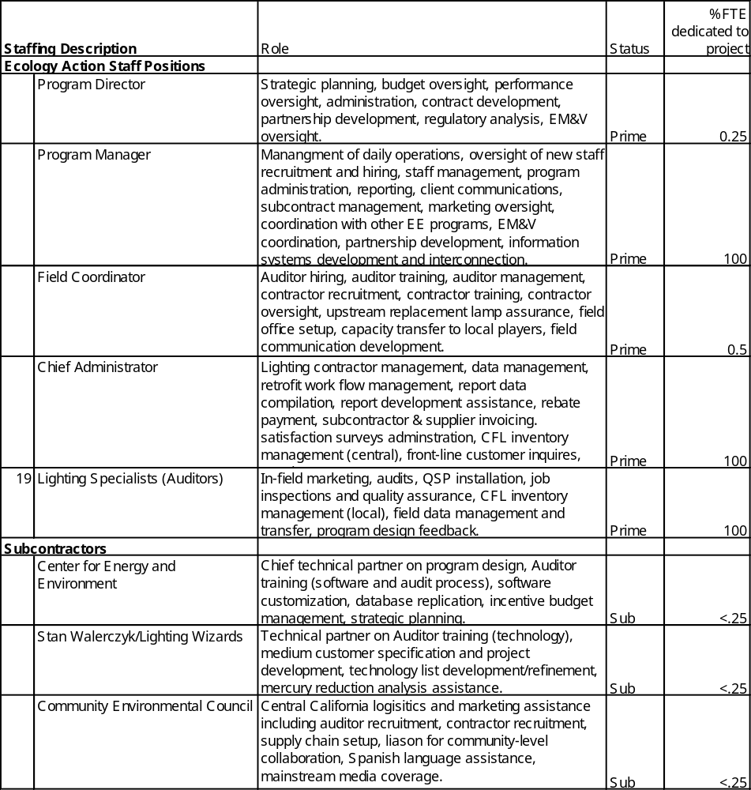
Table II.3

Recruitment and Training
Ecology Action’s management team in conjunction with CEE and the Community Environmental Council will recruit and hire all office and field staff during the first six weeks of the program. Field staff will be recruited from the geographic areas in which they will work in order to minimize daily travel costs and ensure maximum familiarity with the local business community. Training will consist of a complement of classroom and in-field sessions and will take place in Santa Cruz over a one-week period. The training team will consist of RightLights managers, Stan Walerczyk/Lighting Wizards staff (audit and technical lighting training), CEE (audit and FACET© software training), a participating RightLights contractor (lighting retrofit-related perspectives), and a local licensed commercial plumbing contractor (spray nozzle installation training). To ensure quality, new auditors will initially accompany experienced auditors in the field.
Based on Ecology Action and CEE’s mutual experience, we will seek to hire Lighting Auditors possessing backgrounds in both sales and technical lighting. As a way of maximizing auditor productively, performance incentives will be offered to augment hourly compensation and will reward the quantity and quality of installed kW/kWh savings.

Work plan and Timeline for Implementation

Implementation Plan.
In addition to the detailed plans set forth in this proposal submission, in the first 30 days of the contract our team will develop an Implementation Plan which finalizes the strategy and timing for staff recruitment and training, marketing, contractor recruitment and training, equipment and labor pricing, incentive structure, FACET software modification, EM&V subcontractor recruitment and planning, CPUC/IOU reporting, and capacity transfer to partnering local entities. Ecology Action’s management team will achieve implementation milestones as presented in Table II.4 below:
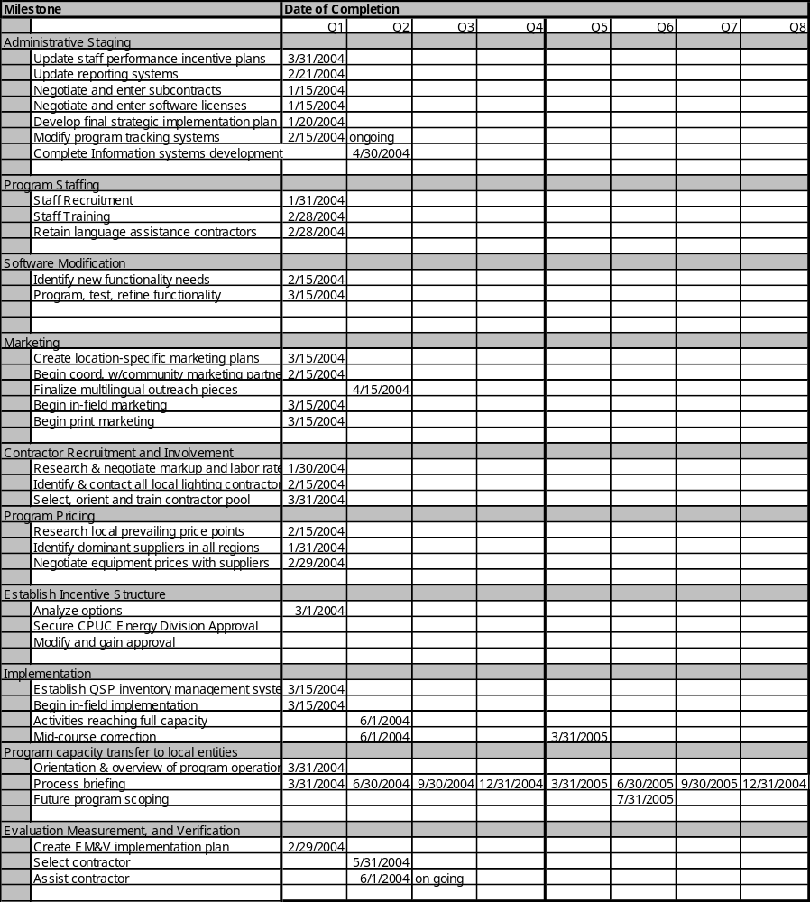

Table II.4

Customer Description

Customer Description
The proposed implementation of RightLights will serve very small, small, and medium nonresidential SCE customers in Santa Barbara and Ventura counties.
Equity achievements are projected to be as follows:

Hard-to-Reach
RightLights penetrates deeply into the hard-to-reach market segment and makes significant progress toward equitable distribution of Public Goods Charge energy efficiency funds. A majority of program participants will meet multiple definitional criteria as hard-to-reach customers including, size, ownership, language, and geography.
One hundred percent (100%) of the targeted customers will meet the CPUC criteria of hard-to-reach (Table 3), while many participants will possess multiple HTR characteristics including, size, ownership, and language. In sum, this mix will allow us to achieve persistent demand and energy savings while making significant progress toward a more equitable distribution of Public Goods Charge funds.

Size
Of the 24,994 businesses in the SCE portions of the two-county target area, 72% (or 18,215) have nine employees or less. A cornerstone of the RightLights Program is its ability to deliver significant benefits to hard-to-reach very small businesses. In the Monterey Bay Area, (76%) of the businesses we have served are classified as “very small” by the CPUC. Although demand data is not feasible to obtain for these small customers, we conservatively estimate based experience in the Monterey Bay Area that 80% (99,602) of businesses have demand less than 20 kW (See Table III.1 below).
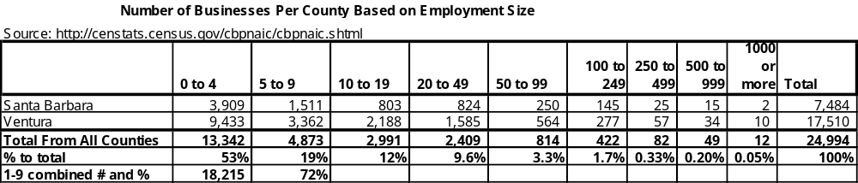

Language
Twenty-six percent residents prefer to speak Spanish as their primary language. We assume similar percentages of businesses prefer to do business in these Spanish. As such, RightLights will reach Spanish speaking populations using language-appropriate written materials and direct translation support. We will also engage ethnic-specific community groups and Chambers of Commerce when appropriate. (see Table III.2)

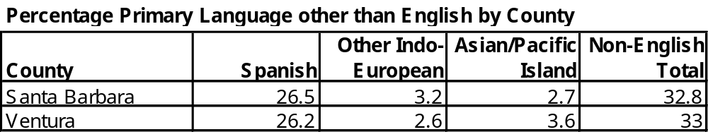
Table III.2

Split Incentive.
An estimated 49% of customers lease their spaces, which produces a split incentive barrier. The Quick-Saver Package is ideally suited to overcome this barrier by providing 100% equipment and labor cost coverage valued up to $250 (screw-in CFLs) as well as the 100% rebate on pre-rinse spray nozzles.

Geography.
One hundred (100%) of customers are outside of urban core locations, thus are considered HTR geographically.

Under-Served “Commercial” Multifamily
Currently there exist no rebate program for many Multifamily facilities that have existing 4' T12 fixtures, which are found very often in corridors and operate 24/7 (100% on-peak). Ecology Action seeks to serve this key ratepayer subsector among 4+ unit multifamily buildings and retirement communities. We propose to include these accounts for three reasons: 1) the owners often have a choice between whether to pay commercial or residential rates for their loads, 2) in many of the medium facilities the loads are closer in character to commercial then they are to small residential, and 3) the target sector is not fully served by existing programs. This specific market subsegment represents a very significant and neglected source of peak kW as well as long-term kWh reduction.

Customer Eligibility
To be eligible, the participant must be a SCE customer (see above) with less than 500 kW of existing demand, and must be located within the two target counties proposed to be served by this proposal.

Customer Complaint Resolution
Ecology Action will respond to all questions and/or complaints within three businesses days. Complaints will be recorded in writing and presented to Ecology Action’s Program Director. Complaints that require resolution will be discussed by all involved parties in order to identify a mutually agreeable solution and an acceptable timeframe for resolution. If parties cannot agree on a solution and/or an acceptable timeframe, the dispute will be handled by an independent dispute mediation firm within 30 days of the failure to agree.

Geographic Area
The target area includes all parts of Ventura County and the part of Santa Barbara County that lie within the SCE service territory. When combined with the complementary sister proposal for PG&E territory, Santa Barbara and Ventura comprise the Southwestern portion of a contiguous block of 11 counties including Santa Cruz, Monterey, San Benito, San Luis Obispo, Santa Barbara, Fresno, Kings, Kern, San Mateo, and Santa Clara. By sector, businesses in the two-county area fall into the following categories: 8% agricultural, 5% mining and construction, 19% retail trade, 4% transportation and communication, 28% services, 17% government and general, 12% manufacturing, 4% wholesale trade, and 6% other. In addition, the program serves areas that are considered constrained by California Independent System Operator 2003 Summer Assessment which includes SCE.

Section IV. Measure and Activity Description

Table IV.1 presents the data requested in both subsections:

Energy Savings Assumptions

Deviations in Standard Cost-effectiveness
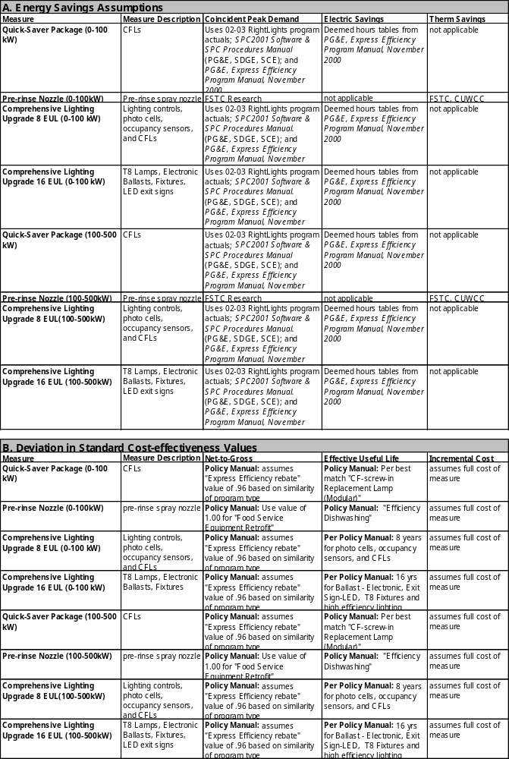
Table IV.1

Rebate Amounts:

Comprehensive Retrofit “Instant Rebate” Incentive
The RightLights Instant Rebate is driven by the kWh savings installed and rewards long-term energy savings. The levels are set based on market conditions and strike a balance between stretching available incentive dollars and making the offer sufficiently attractive to sell jobs without incurring excessive marketing costs. Low incentives require proportionally higher marketing and labor costs, so RightLights strategy has been to offer an incentive level that is generous enough to strongly motivate business owners to make an affirmative retrofit decision. Since 2002, RightLights customer incentive levels have been modified in consultation with CPUC staff, and will likely be further modified in the proposed contract period to reflect changing conditions. As point of reference, the current rebate structure in the Monterey Bay Area RightLights Program varies depending on business size, and ranges from $.09 to $.135 per kWh saved, with rebate caps that range from 80% to 100% of total job cost, also based on business size.

Quick-Saver Package Incentive
Every participating business with incandescent lights is eligible to receive a Quick-Saver Package of screw-in CFLs, valued at up to $250 and installed at no cost by RightLights staff. The dollar value includes the equipment and labor costs for installation. The level was set to achieve the following; 1) Act as a door-opener marketing tool that enables our Lighting Auditor to complete a full audit and present a comprehensive retrofit proposal, and 2) Create an incentive sufficient to justify the auditors’ time investment (which would not be offset by a small installation of only one or two CFLs), 3) install hard savings in businesses that are too small to cost-effectively service otherwise, 4) achieve installed savings immediately and increase equitable distribution of PGC monies; and 5) reduce the split-barrier for leased businesses. In addition, we are proposing that eligible food service establishments also receive a super efficient pre-rinse spray nozzle(s) which will achieve a therm savings of 562 per unit.

Activities Descriptions
No unit-based activities are proposed that will not produce energy savings.

Program Performance Goals

Program Performance Targets
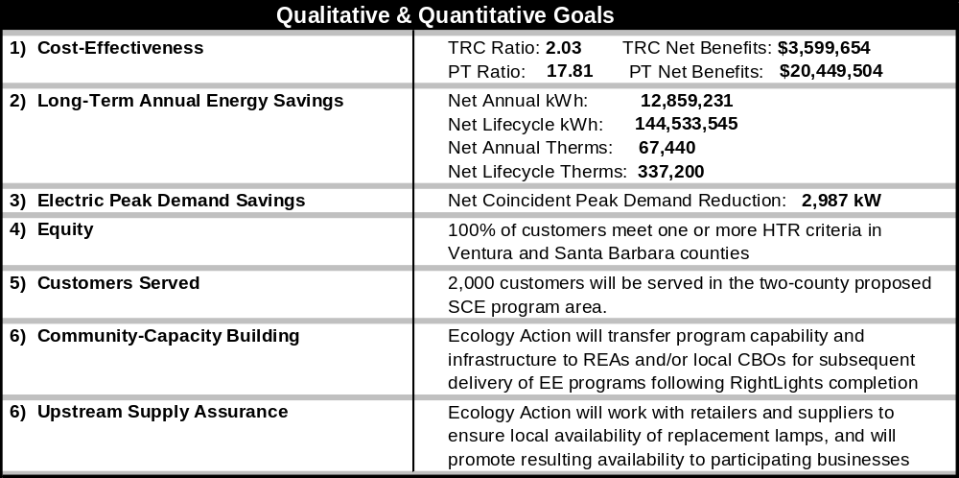
Table V.1
The primary purpose of the program is to deliver persistent and sustainable energy savings at the lowest possible dollar/kW to a customer group that a) has systematically not received a proportional share of PGC program benefits, and b) for which there are virtually no other programs with the demonstrated capacity to attract their participation. Secondarily, we seek to serve the greatest possible number of businesses that met HTR criteria. The program’s success requires that the Team meet the following overarching goals:
- Implement comprehensive projects so that the savings and the overall value of the project to the customer are maximized per site
- Minimize customer’s out-of-pocket costs by securing equipment at low cost through client aggregation and providing “instant rebate” incentive to customer
- Provide services to a broad diversity of customers through trusted community partners, market segmentation, and low-cost marketing efforts
- Provide comprehensive services, including low- and no-cost measure information and links, in order to minimize time investment from small businesses
- Reach underserved customers that meet multiple definitional criteria as hard-to-reach
- Transfer RightLights programmatic infrastructure to long-term local implementers

Number of Ratepayers Served
An important performance benchmark, in addition to demand and long-term energy savings, is the number of ratepayers served. While all ratepayers contribute to the Public Goods Charge, a disproportionate amount of PGC funds have benefited those market subsegments (e.g., larger customers) that could most easily utilize standard EE programs. RightLights specifically targets those ratepayers who have benefited less from previous conservation efforts. The Program goal is to serve 2,000 businesses.
Please see Section I.- C. for additional Program Impacts.

Community Capacity-Building
Ecology Action’s secondary objective is to build program capacity among our partners – particularly Regional Energy Authorities and community groups – to deliver these types of programs in subsequent program cycles.

Upstream Supply Assurance
To ensure long-term persistent energy savings, Ecology Action will work with local retailers to make certain that they stock the high efficiency lamps (mainly tubular fluorescent and multiple CFL types) that are installed by RightLights. This will facilitate customers’ replacement of lamps as they wear out, and also promote the continued transition from incandescent to high efficiency lighting technologies within the retail service area. Once the supply chain is established, RightLights will promote the new lamp availability to all participants.

Program Evaluation, Measurement and Verification

CPUC Objectives
The following table explicitly outlines the objectives in the CPUC Policy Manual and provides a summary of how the RightLights evaluation will address the CPUC objectives.

Table VI.1
CPUC Objectives and the RightLights Evaluation
Objectives | RightLights Evaluation Approach
Measuring level of energy and peak demand savings achieved (except information-only) | We will use the IPMVP Option A to measure the energy and peak demand savings achieved for a sample of sites.
Measuring cost-effectiveness (except information-only) | We will re-calculate the Program cost effectiveness using actual program expenditures provided by Ecology Action and the ex-post energy savings verified through this evaluation.
Providing up-front market assessments and baseline analysis, especially for new programs | A comprehensive baseline market assessment is beyond the scope of this evaluation. The baseline energy usage assessment for this EM&V plan will be determined by the monitoring data provided by Ecology Action.
Providing ongoing feedback, and corrective and constructive guidance regarding the implementation of programs | The evaluation team will be in close contact with Ecology Action and will provide ongoing feedback and recommendations.
Measuring indicators of the effectiveness of specific programs, including testing of the assumptions that underlie the program theory and approach | The evaluation will assess whether the program has reached the stated goals with the allocated resources. Interviews conducted during site visits will validate the assumptions that underlie the program theory and approach.
Assessing the overall levels of performance and success of programs | Contractor will analyze the program database and our site visit findings to assess the overall level of performance and success of the program.
Informing decisions regarding compensation and final payments (except information-only) | The effectiveness indicators developed will allow the CPUC to assess the achievement of the program and therefore make an informed decision regarding compensation and final payments.
Helping to assess whether there is a continuing need for the program. | Contractor will examine both program implementation strategies and penetration levels to estimate the remaining small commercial "hard to reach" market that can be cost-effectively reached through additional program execution.

Energy efficiency represents a substantial opportunity for California and its ratepayers to limit the financial and environmental costs associated with energy use. An evaluation, measurement and verification (EM&V) plan is an important aspect of any EE program, especially those funded by public monies. A standardized EM&V protocol provides program participants and policy makers with information about the tremendous energy savings associated with specific ECMs and programs, demonstrating program success and facilitating program replication.
The documentation of savings through the EM&V process is critical for the success of the State’s energy efficiency programs. The team has drafted an initial EM&V Plan to assure that proper data is collected during program setup and implementation so that savings determinations can be made even after program implementation is long past. Ecology Action’s currently using the Measurement and Verification approach described below for its RightLights Program, which has been approved by CPUC and is being implemented by Quantec, Inc.

Plan Development
One of the first deliverables under a contract awarded for this Program is to develop a detailed EM&V Plan. The Plan will use methodology consistent with guidance provided in the International Performance Measurement and Verification Protocol and reflect any program design changes, as well as specific EM&V requirements, identified during contract negotiations. In support of the Commission’s future analyses of ratepayer-funded programs, Ecology Action will provide an appropriate EM&V approach that can be completed on time and within budget.

Data Acquisition
Quarterly reports submitted for the Program include the amount of energy savings and peak demand reductions associated with program expenditures. These quarterly reports are formatted according to the Commission’s Reporting Requirements Manual 2 and are made available to all interested parties per CPUC guidelines. In addition to detailing energy savings and peak demand reductions, the reports will also relay information on program expenditures, funded measures and a description of progress compared with ultimate program goals. An annual report and a final report, utilizing the EM&V components described below, will also be provided.

Budget and Potential EM&V Contractors
Ecology Action has budgeted six percent of the contract amount to EM&V activities. Both Quantec and RER are qualified to evaluate the proposed program and were approved by the CPUC to evaluate RightLights in the 2002-2003 program cycle. Neither firm has a conflict of interest such as being an implementer of a small business lighting program that may compete with RightLights.

Qualifications
Ecology Action’s has assembled the implementation team of Center for Energy and Environment (program partner RightLights 2002-2003), Stan Walerczyk / Lighting Wizards, and Community Environmental Council (Santa Barbara). The team is extremely well qualified to carry out the proposed program and brings together unparalleled program design experience, an emphasis on small commercial lighting, and community based deployment and lighting. Our team members have worked on several commercial lighting efforts in the last year including both SB5X-sponsored small commercial lighting programs in San Francisco and Berkeley as well as RightLights in the Monterey Bay Area, and Xcel Energy’s “One-Stop Business Lighting Program” in Minnesota. This extensive experience includes:

- Auditing, designing, specifying and constructing energy efficiency projects including thousands of lighting jobs for very small, small, medium, and large customers.
- Subcontracting and construction management, and direct project implementation services (from initial audit through construction and inspection).
- Planning, implementing, and evaluating successful marketing campaigns.
- Effectively using a proprietary computer software tool (FACET©) that automates audits and project installations, thereby minimizing software development costs and accelerating program startup. FACET is the chosen software for the small lighting programs in San Francisco, Berkeley, and the Monterey Bay area as well as Xcel Energy’s small commercial lighting programs in Minnesota.
- Independently administering a wide range of business and residential programs. Ecology Action, CEE and the Community Environmental Council have administered energy efficiency and business assistance programs for a combined total of 85 years.

Summary of Key Personnel
The Program Team is comprised of the staff list that follows (please see attached resumes)

Ecology Action
- Mahlon Aldridge, Energy Programs Director/Deputy Director
- Gene Thomas, RightLights Program Manager
- Steve Call, Chief Lighting Auditor
- Angie Stuart, Lighting Auditor
- Aaron Brown, Lighting Auditor
- Evan Parker, Finance Director

Center for Energy and the Environment
- Richard Szydlowski, Director of Research and Engineering
- George Peterson, Manager of Engineering Services

Stan Walerczyk / Lighting Wizards
- Stan Walerczyk, Principal
- Brooks Sheifer, Director Northern California Operations

Community Environmental Council
- Sigrid Wright, Communications Director

Division of Roles of Each Team Member
Ecology Action will administer all aspects of the program including management and coordination of subcontractors. Based on experience and geographic proximity to the target customers, the distribution of team roles is as follows in Table VII.1

Table VII.1
Roles of Primary and Subcontractors by Work Category

Program Component | Ecology Action (prime) | Center for Energy and the Environment (sub) | Stan Walerczyk / Lighting Wizards | Community Environmental Council
Program Design | L | S | S | N/A
Administration & Reporting | L | S | S | S
Capacity Transfer | L | S | S | LL
Marketing | L | S | S | LL
Marketing Materials | L | S | S | S
Software Modification | S | S | L | N/A
Auditor Training (technology) | S | S | L | S
Auditor Training (auditing/software) | S | L | S | S
Auditing & Auditor Mgmt | L | S | S | N/A
Contractor Recruitment | L | S | S | LL
Contractor Management | L | S | S | N/A
Quality Assurance | L | S | S | N/A
Mid Course Fine-tuning (program design/technical) | S | L | S | S
Mid Course Fine-tuning (staff management) | L | S | S | S
EM&V | S | L | S | N/A
* L= Lead S= Support LL=Local Lead

Ecology Action Qualifications



Ecology Action of Santa Cruz is a 16-person nonprofit organization that has been working in Central and Northern California for more than 33 years. On behalf of our clients, we specialize in creating programs that help communities to concurrently improve both economic and environmental performance. Our client list includes:

- Federal Environmental Protection Agency
- EPA Region 9
- City and County of San Francisco
- California Public Utilities Commission with Pacific Gas and Electric Company
- California Integrated Waste Management Board
- State Water Resources Control Board
- City of Salinas

- Counties of Monterey, Marin, San Francisco, and Santa Cruz (and all Cities within)
- Santa Cruz County Regional Transportation Commission
- Monterey Bay Unified Air Pollution Control District
- Salinas Valley Memorial Hospital
- Waipuna International, Inc.
- West Marine, Inc.
- Various philanthropic foundations

Our work for these clients has included the design and delivery of physical infrastructure programs, marketing campaigns, and technical consulting focused on hazardous waste reduction, solid waste reduction, integrated pest management, water quality, energy efficiency, renewable energy, green business practices, and sustainable transportation. We provide busy decision makers with solutions that balance bottom-line economic imperatives with community and environmental well-being. We serve a broad cross section of industries in California including agriculture, dry cleaning, livestock owners, public agencies, pest management, retail, and manufacturing.
Ecology Action has worked with hundreds of organizations in the course of implementing 23 business-oriented programs and more than 50 residential programs. In the process, we have leveraged the relationships we have built with more than 700 firms, dozens of business associations (such as farm bureaus and chambers of commerce), as well as local government agencies, civic organizations, and the media.
Ecology Action’s Executive Director brings two decades of management and marketing experience from the private sector, while our RightLights senior managers possess 14 and 17 years experience in designing and deploying business and residential technical assistance programs. Our Finance Director brings 16 years experience in accounting and development of financial tracking systems.
Ecology Action’s past and current work includes the following programs:

- Small Business Lighting Efficiency Program (RightLights) –– Helps hard-to-reach small businesses in Santa Cruz, Monterey, and San Benito counties reduce energy costs by providing turnkey installations of energy efficient lighting technologies. The program achieved its projected energy saving goals six months ahead of schedule and is on track to deliver to participating businesses $1.7 million in direct incentives and annual avoided energy costs. As a result of the first year’s efforts alone, the program will perennially save enough electric to power more than 1,000 homes and reduce CO₂ emissions by more than six million pounds.
- Electric Bike Cost-Share Program –– Ecology Action created the Nation’s largest electric vehicle incentive program, in which residents are rebated up to half the cost of a state-of-the-art electric bicycle though a network of local private vendors. Ecology Action partnered with Lee Iacocca to help launch the initiative, which has sold 880 electric bicycles that replace 737,620 single-occupancy vehicle person miles every year.
- Business Waste Reduction Consulting –– To date this program has assisted 624 businesses in identifying, designing, and implementing waste minimization measures using Ecology Action’s proprietary WasteNot© audit and tracking software. Estimated waste diversion resulting from this work totals 2,843 tons per year, or approximately 20 tons per business yearly on average. The savings to each business averages $2,646 annually.
- Safer Technologies in Fabricare Program –– Helps individual dry cleaners throughout Northern California Counties adopt safer technologies by providing equipment demonstration, hands-on cleaning training using new spotting and finishing techniques, financing consultation, and marketing assistance that promotes nontoxic cleaning alternatives.
- Used Oil Collection Networks ––Ecology Action has developed local infrastructure and marketing campaigns to provide agricultural growers and/or recreational boaters in ten California Counties with convenient, cost-free opportunities to recycle waste oil and filters. The network of centers have diverted more than 20,000 gallons of used oil and its unintentional cargo of heavy metals and other toxic material from potential soil and water contamination. Importantly, the risk of toxic exposure has been significantly lessened for the predominantly low income and non-English speaking workers that handle these materials.
- ProMAX –– A materials exchange network (MAX) that brokers reusable discards from businesses and residences in the Monterey Bay Region. The 1,485 exchanges completed have diverted an estimated 2,145 tons from landfills over the past five years.
- Integrated Pest Management (IPM) Program –– This program reduces the use of toxic pesticides through a comprehensive campaign that builds retailer awareness (and inventory) of alternatives, while educating and marketing to consumers regarding least toxic approaches.
- Schools IPM Program–– Reduces pesticide use at school facilities in Madera County by providing technical assistance and training to administrators, teachers, grounds crews, and custodians to implement Integrated Pest Management systems.
- Schools Solar Roofs Program–– Installs grid-integrated photovoltaic (PV) arrays on local schools, and educates students and faculty on renewable energy while providing a source of clean power. The program is currently installing a PV system on its fourth school in Santa Cruz County
- Public School Resource Conservation Program–– This 24-school pilot program moves participating schools toward zero waste through reduction, reuse, recycling, on-site composting, and hands-on student and faculty education.
- City of Santa Cruz Renewable Energy Campaign –– Found solutions to maximize energy sustainability through on-site generation of renewable energy (PV arrays) at City facilities.
- Backyard Composting–– Develops and maintains compost bin cost-share programs, education, and demonstrations gardens.
- Bike-to-Work Program –– Promotes bicycle commuting opportunities with two annual campaigns, and has consistently increased bike ridership with corresponding reductions in automobile commute mileage.
- Hazardous Waste Reduction –– Educates residents to reduce the use of hazardous chemicals, and coordinates collection events to capture and recycle discarded products.
- Livestock Waste Mitigation –– Reduces runoff and watershed pollution from stables and grazing areas by educating livestock owners and equestrians about the proper handling and storing of animal waste.
- Residential Used Oil Collection Programs –– Design and development of used oil collection infrastructure, and marketing campaigns for collection of used oil and filters in central California counties.
Elements of these Ecology Action programs have been replicated in other California jurisdictions, other states, and as far away as New Zealand. Our efforts have generated immediate and long-lasting financial benefits for the individuals and businesses served, including reduced costs for energy, transportation, waste removal, hazardous waste handling, and regulatory compliance. Communities served by Ecology Action programs continue to enjoy the significant associated environmental benefits. In the process we have increased awareness of the environment and provided access to convenient opportunities to protect natural systems while, at the same time, strengthening the local economy.
Early Achievements:
- Successfully advocated for curbside recycling services for a majority of area residents.
- Founded the first recycling center in Santa Cruz County, which provided over 16 years of continuous service to area residents.
- Provided local leadership for California Recycling Act implementation in Santa Cruz County and launched the San Lorenzo Valley Redemption & Recycle Centers.
- Established the Santa Cruz County Environmental Resource Center.
- Continued coordination of the Annual Beach Cleanup in Santa Cruz County as part of the state and nationwide coastal cleanup and monitoring program.

Awards
- 2002 California State Assembly Resolution of Commendation
- 2001 City of Santa Cruz Mayor’s Proclamation “Ecology Action Day”
- 1999 Cal-EPA Integrated Waste Management board, Trash Cutters Award
- 1998 City of Santa Cruz Mayor’s Proclamation, Bike-to-Work Program
- 1998 US Congressional Recognition Certificate, Public School Resource Conservation Program
- 1997-1998 Sustainable Quality Awards, Public School Resource Conservation Program

Independent Program Administration
Unless subcontracting as part of a larger team, Ecology Action typically takes the lead role in program operations, marketing, and administration. We have autonomously administered 95% of the programs that we have implemented over the last three decades inclusive of budgeting, administration, policy development, tracking, rebate fund management, financial auditing, and reporting.
Ecology Action continues to seek innovative ways to instill environmental awareness, promote pragmatic change, and create opportunities for communities to save money, create jobs, and contribute to a sustainable local economy.

Subcontractors

Center for Energy and Environment (Subcontractor)
The Center for Energy and Environment (CEE) has been designing and implementing energy efficiency programs for more than 20 years. CEE has designed and delivered dozens of programs for cities, utilities, businesses and government agencies. Programs created by CEE are practical, technically sound and cost-effective, and have served over 50,000 homes and businesses. CEE prides itself on delivering state-of-the art technologies cost effectively to difficult to serve markets.
CEE’s Previous Experience with Small Commercial Programs
CEE has designed and delivered four previous lighting programs and is a member of the project team that implemented PowerSavers and SmartLights, two CPUC-administered small business lighting efficiency program in San Francisco and Berkeley, CA. CEE is a current implementation subcontractor for the RightLights Program in the Monterey Bay Area.
In 1997 CEE developed and implemented the Small Business Lighting Program. The program was a one-stop commercial lighting program that delivered lighting energy audits and lighting installations to over 500 small businesses in the Twin Cities metropolitan area. The program was offered to small commercial businesses in the Minneapolis and St. Paul area with peak electric demands of under 100KW. A trained energy auditor performed a comprehensive lighting audit and provided the business with a detailed lighting conservation report. The report detailed all costs associated with the recommended lighting retrofit and summarized the utility rebates, subsidies and financing that were available through the program. The program offered wholesale equipment and labor prices to the participating business, and provided construction management services as well as lamp and ballast recycling and disposal. A customized database application was used for program tracking and customer reports.
Similar in design and currently ongoing is the One-Stop Efficiency Shop. This small commercial lighting program was designed and initiated by CEE in 1999. It targets Xcel Energy’s customers in Minnesota with demands of 10 to 200kW. In the last 12 months CEE's program staff has conducted 3,000 lighting audits and have delivered lighting retrofit projects totaling 6.25 MW in demand savings. Installations are done through a team of participating local contractors using standardized pricing. The One-Stop program is specifically designed to address the concerns small business owners face when choosing more efficient lighting: limited financial resources and time, limited knowledge of lighting products, and access to quality contractors. CEE has valuable experience in the design and delivery of small commercial lighting programs and has demonstrated the ability to get retrofits installed.
Lighting Research by CEE
CEE’s research and engineering department has conducted field research in commercial, multifamily and single family buildings. The department has also designed and directed market research studies of groups ranging from low-income households to business owners, manufacturers, distributors, contractors and other groups. CEE has published over 60 technical papers on building and mechanical systems performance in archival journals, refereed conference proceedings, and is nationally recognized for its research. CEE staff currently chair the ASHRAE standard project committee developing A Method of Testing for Rating Commercial Space Heating Boiler Systems and have chaired an ASHRAE project committee to develop ASHRAE Guideline 8, Energy Cost Allocation for Multiple Occupancy Residential Buildings which was completed in 1994. Some of CEE’s lighting research is listed below:
A Practical Guide to Direct Installation Lighting Retrofit Program for Municipal Utilities, 1999. K. Larsen, M. Hewett. Municipal Utilities Association: Plymouth, MN
A Study of Compliance with the Lighting Provisions of the Minnesota State Building Code for Small Commercial Buildings, 1994. L. Gentilini, D. Bohac, T. Dunsworth, M. Hewett. Minnesota Department of Public Service: St. Paul, MN
Lighting Efficiency in New Small Commercial Construction in Minnesota, 1994. M. Sachi, M. Hewett, D. Vavricka. Legislative Commission on Minnesota Resources: St. Paul, MN.
CEE Experience with Community-Based Programs
The Center for Energy and Environment is uniquely qualified to assist with this program. Over the past 20 years, CEE has demonstrated our ability to deliver technically rigorous programs to difficult to serve markets at low cost using community participation strategies. These community-based mechanisms greatly reduce transaction costs and can make it cost-effective to serve difficult to serve customers. This proposed program builds upon our experience with community-based marketing to offer an innovative program for the small commercial market.
In the early 1980s, CEE developed the community-based Neighborhood Energy Workshop program to provide educational workshops, energy audits, free weatherization materials, and state-of-the-art hands-on training to homeowners. This project served over 28,000 households in Minnesota resulting in energy savings of over 7% per household at an average delivery cost of $80.00 per household. This program also formed the basis for CEE’s Green Workshop project in Madison, Wisconsin, that included recycling, waste reduction and water conservation components.
CEE’s Operation Insulation (OI) provided owners of 1-4 unit residential buildings with easy-to-use, one-stop shopping for house doctoring, insulation, furnace replacement and other retrofits. The project design combined energy audits, bid specifications, use of certified contractors, standardized pricing, low-cost financing, and post-installation infrared inspection to provide convenience and quality for installations serving over 10,000 residential customers totaling over $24 million. In addition, OI provided grants to residential nonprofits to make energy conservation improvements to their properties.
Current Projects
Wisconsin FOCUS on Energy – Multifamily Program
CEE is currently delivering Multifamily Facility Management Services to multifamily property owners in the state of Wisconsin as part of the Wisconsin FOCUS on Energy. This program provides a no-obligation, comprehensive facility assessment that evaluates the efficiency of existing equipment, controls, and operating procedures in multifamily buildings. CEE developed the methodology, procedures and supporting tools for this program. Services for this program include facility assessments, engineering services, training, facility check-ups and energy tracking. Recommendations are based on a thorough on-site evaluation and the subsequent analysis of building and utility data. Participants are presented with a final report that addresses the following facility management concerns: utility cost saving improvements, potential air quality hazards, tenant comfort complaints, moisture damage, equipment operation and maintenance problems, energy code compliance, documentation of installed equipment and fire safety hazards. Phase 1 of this program, which was completed in June 2000, involved 206 buildings and included 3,702 apartments.
As part of its follow-up services, CEE also trained 41 individuals on efficient and effective operations and maintenance of space heating and water heating equipment. CEE was given an extension by the Wisconsin Energy Bureau through December 2000 to assess an additional 85 buildings and to perform other services that included follow-up engineering services to address ventilation issues and energy cost savings opportunities.
CEE’s experience and ability to address the unique needs of building managers and operators has also been demonstrated through smaller scale delivery of a number of the Facility Management Services in Minnesota on a fee for service basis. One example was a ventilation study that CEE was commissioned to do as a follow-up to an earlier facility assessment that identified serious concerns about the current condition and operation of the building’s ventilation systems.
Minnegasco Commercial Industrial Energy Audit
CEE has delivered variations of Minnegasco's Multifamily Audit Program to multifamily customers from 1984 – 1998. The multifamily audit service provided energy audits with detailed analyses of energy conservation opportunities for owners of 5+ unit residential structures, quality control inspections, and training of maintenance personnel. Based upon CEE’s success in Wisconsin working with multifamily buildings, CEE was awarded funding to implement a 50 building pilot program to show the effectiveness of the Multifamily Facility Management Services program in Minnesota. This service was provided to customers in Minnegasco’s service territory for 2001.
Building Commissioning
In 20 years of field research on energy efficiency in buildings, CEE has often found inefficient operation causing complex HVAC&R systems to use more energy than is actually necessary to meet the needs of the building. To address this problem, CEE began to conduct re-commissioning case studies in 1998 through the Competitive Buildings Initiative (CBI), a DOE Rebuild America program that CEE leads. In the past two years, CEE has partnered with the leading re-commissioning experts in the U.S. to conduct eight re-commissioning projects in Minnesota, including four medical projects, three school projects, and one office project.
Sound Insulation Program
The Metropolitan Airports Commission began implementing the Sound Insulation Program in 1992 as a part of the Federal Aviation Administration's Regulation "Part 150" Airport Noise and Land Use Compatibility Planning Program. The program is designed to preserve and improve neighborhoods closely surrounding the Minneapolis/St. Paul International Airport by making the internal environment of a home more compatible with external aircraft noise.
CEE has been the lead contractor with the “Part 150” Sound Insulation Program since the program’s inception in 1992. Since that time the program has acoustically modified more than 5,000 homes in neighborhoods around the airport. As part of this program, CEE has developed a state-of-the-art computerized procedure for residential IAQ, insulation, and air-sealing evaluations. The procedure uses an automated, data logger assisted computer program that provides unequaled reliability and extensive documentation of overall house air leakage and series leakage. An automated test has also been developed to measure worst-case house depressurization, combustion vent performance, and zone air leakage characteristics. Results are stored in a central database and are used to design customized remediation measures.
Neighborhood Revitalization Program (NRP)
CEE works with the Neighborhood Revitalization Program (NRP) to assist NRP staff, neighborhood volunteers and community organizations to develop and implement innovative and cost effective financing to improve residential properties in the City of Minneapolis. In delivering these programs, CEE provides program development and marketing, loan and grant origination, post installation inspections and remodeling advice on a fee for service basis. To date, CEE has originated in excess of $3.25 million in NRP funded home improvement loans/grants.
Indoor Air Quality (IAQ)
CEE is currently conducting a research project to quantify contaminant dispersal and air movement among units in a sample of multifamily buildings in Minnesota, using passive perfluorocarbon tracer gas techniques, multiple fan depressurization and air flow modeling. CEE will diagnose air transfer between units in multifamily buildings, treat the building structure and the ventilation system(s) to reduce it, and measure the reductions achieved.

Stan Walerczyk / Lighting Wizards (Subcontractor)
Stan Walerczyk/Lighting Wizards is a recently-formed firm that brings together the combined capacity and talent of the principal, Stan Walerczyk, and Brook Shiefer, Director, Northern California Operations. Together they bring 25 years experience in delivering technical and analytical resources necessary to retrofit commercial, institutional, and residential lighting. Mr. Walerczyk has become widely recognized as a leading technical resource in lighting efficiency, having published 15 articles, given hundreds of training presentations, and completed hundreds of lighting retrofits over the last 15 years.
Clients include
- 1st Source Lighting
- After Image & Space
- Advanced Micro Devices
- Alameda Power & Telecom
- Beckman Coulter
- Brown, Vence & Associates
- Clorox
- Contra Costa Newspapers (owned by Knight Ridder)
- Energy Solutions
- Engineering Resources Associates
- Modesto Irrigation District
- NEC
- Pleasanton (City of)
- PowerLight (the photovoltaic company)
- Southern California Edison’s AgTAC
- Sun Energy Solutions (Director of Lighting)
- Watt Stopper

Community Environmental Council (Subcontractor)
The Community Environmental Council (CEC) is a 33-year-old nonprofit community service, research, education, and technical assistance organization headquartered in Santa Barbara, California. CEC successfully operates:
- Two recycling centers
- A hazardous waste collection center
- A watershed resource center
- A reuse and environmental education center, Art From Scrap
- A model green building and renewable energy center, which serves as CEC’s headquarters.

Our direct experience with providing both environmental services and education gives CEC a unique and insightful perspective on environmental problem solving. Over more than three decades, CEC has an established reputation in reaching Southern and Central California residents with environmental messages, on issues such as:
- Pollution prevention
- Oil recycling
- Pesticide reduction
- Watershed restoration
- Recycling
- Energy

As the leading environmental education organization in Santa Barbara County, CEC is highly respected and has vast experience in reaching all audiences. Our methods include coordinating advertising campaigns, working with media, providing in-school education, organizing and attending community events, teaching adult education courses, and coordinating community workshops and seminars. Some of our recent accomplishments include:
- Teaching pesticides reduction strategies to more than 250 English and Spanish speaking gardeners and landscapers through an adult education “Green Gardener” certification program;
- Organizing a one-day conference on energy conservation for institutions and small businesses, in conjunction with Southern California Edison;
- Collecting hazardous materials from 327 small businesses in FY 2002-2003;
- Educating more than 14,000 children in the 2002-2003 school year on waste reduction and recycling through our Green Schools program;
- Organizing Santa Barbara’s Earth Day festival, attended by approximately 6,000 people in 2003; and
- Coordinating newspaper, radio and television campaigns encouraging do-it-yourself mechanics to recycle their used motor oil.

CEC also has a long history of serving as a resource center for public education about energy conservation and renewable energy. In the mid 1980s we installed one of the first grid-tied solar photovoltaic systems in California and negotiated a net metering arrangement with the local utility company, more than a decade before net metering became a law. Two of our centers – the Gildea Resource Center headquarters and Watershed Resource Center at Arroyo Burro beach – are model green buildings equipped with solar power systems and utilizing energy conservation techniques, and are often the site of public meetings held by other groups or agencies.
Until August, 2003, we acted as the umbrella organization for a community-based “energy alliance,” which included business leaders, government representatives, citizen groups and local residents working on a Community Energy Plan that emphasizes local, renewable resources. Through this Alliance, CEC held numerous forums on energy-related issues, including a town meeting on the future of hydrogen, with keynote speaker S. David Freeman, Chairman of the California Power Authority.

Sigrid Wright has more than a decade of experience in managing communications and outreach for non-profit environmental organizations, including the Alliance To Save Energy in Washington, D.C. As CEC’s Director of Communications for the last 8 years, she has also directed numerous events and workshops, including the Santa Barbara Earth Day festival (1997-2000), a seminar on waste-to-energy technologies (1999), and a one-day seminar on energy conservation and renewable energy at La Casa de Maria (2001). In June 2001 she coordinated a City and County designation of Energy Conservation Day, which included organizing more than a dozen elected officials and community leaders to speak on the topic for a successful media event.

Personnel Resumes – Ecology Action
Mahlon Aldridge
Ecology Action
Deputy Director/Energy Programs Director

Experience

’96 to present Ecology Action of Santa Cruz: Energy Programs Director/Deputy Director. Mahlon has most recently directed all aspects of the creation of RightLights, a $1.9m program that helps small and medium businesses cut costs and save operating dollars by upgrading to super efficient lighting technologies.

    - Currently working with clients on design, marketing, and infrastructure development for environmental benefit programs that serve businesses, government agencies and residence. Designed and secured program financing for a PV rooftop project for the City of Santa Cruz’s City Hall. Coordinated the Monterey Bay Area Chapter of the Bay Area Million Solar Roofs Consortium.

    - Designed and secured start-up capital for Ecology Action’s Commercial Waste Reduction Program. Designed, implemented and marketed the California Integrated Waste Management Board’s (CIWMB) Agricultural Used Oil Recycling Programs for seven California counties. Designed and put into practice EPA’s Northern California Wet Cleaning Technical Assistance program that helped dry cleaners transition to less toxic cleaning processes by providing training and marketing and financing technical assistance. Educated the San Francisco City Environmental Enforcement staff in alternative technologies in the garment care industry. Served as the primary consultant with Waipuna Inc., a New Zealand company, to market its non-toxic weed eradication technology in the Western U.S.

    - Recruited and trained high school students as outreach staff for four California counties under CIWMB contract to promote proper used oil and hazardous waste disposal. Designed an Integrated Pest Management Program for Madera Unified Schools District. Helped managed County of Santa Cruz’s solid waste programs including technical assistance for businesses, schools, public agencies and residences. Oversee the Public Schools Waste Reduction Campaign to educate students and staff about minimizing waste at both school and at home while simultaneously achieving significant cost savings through waste diversion. Designed and assist in the management of the Regional Water Resources Board’s Nitrate Management Program for livestock stable owners in the San Lorenzo River watershed.

    - Authored or co-authored grant proposals successfully generating equaling well over five million dollars in successful program within a five-year period.

1996 – 2000 Independent Program Development Consultant: Clients and projects included:

- The Salt Lake Olympic Organizing Committee: Created a Zero Waste strategy for 2002 Olympic Games.
- The Warehouse, Inc: Advised in the development of the corporation’s Green Retailing Strategy. The Warehouse is the largest retailer in New Zealand.
- The Tindall Foundation: Served as advisor to Foundation Director on grant making processes and provided funding recommendations. Conducted a twelve-city seminar tour in New Zealand on nonprofit job creation through waste minimization.
- The University of California Santa Cruz: Designed and wrote program proposals for a video documentary and education project on Chile’s political history.
- The Pelagic Shark Research Foundation: Advised on the development of enterprise activities that combined mission fulfillment with revenue generation.

1994 - 1996 Save Our Shores, Sanctuary Steward Certification Program: Founding Program Director. Designed and implemented all aspects of the SOS program that trained and engaged local citizenry in the protection of the Monterey Bay National Marine Sanctuary. This involved course development in natural history and policy, development of public outreach displays, and the strategic coordination of issue-specific outreach campaigns. This program is currently in its fifth year and is the 1995 winner of The Award for Outstanding Community Involvement awarded by Association of Monterey Bay Area Governments (AMBAG).

1991 - 1993 Alameda County Home Composting Education Program: Founding Director. Designed a program and managed its twelve staff members in the creation of educational garden classrooms, marketing campaigns, and the establishment of California’s first Master Composter Training Program. This composting program, the largest in the State, is currently in its tenth year, is the 1993 winner of the California Resource Recover Association’s Source Reduction Program of the Year Award.

1989 - 1990 City of Santa Cruz: Commercial Recycling Specialist. Assisted in the design and deployment of the Santa Cruz’s recycling program for the City’s commercial sector. Designed and conducted waste generation survey of local businesses. Analyzed container and collection technology and developed a marketing plan and all promotional materials.

Education: University of California at Santa Cruz, Bachelor of Arts, Environmental Policy and Planning, 1989.
GENE THOMAS
Ecology Action

RightLights Program Manager

SALES - MARKETING - BUSINESS DEVELOPMENT - MANAGEMENT

Accomplished professional with years of experience in personnel and operations management, training,
recruitment, employee supervision, and sales administration. Experienced in business development, project
management, and product development and positioning. Top sales producer with a strong record of building
territories, client base, and profits. Skilled in marketing to sophisticated clientele and in resolving difficult
customer service issues. Proficient in Microsoft Office, desktop publishing, and Internet software applications.

AREAS OF PROFICIENCY:

●  KEY ACCOUNT SALES   ●  SALES MANAGEMENT & TRAINING
●  BUSINESS DEVELOPMENT ●  RECRUITING & HUMAN RESOURCES
●  PROGRAM MANAGEMENT  ●  PRODUCT DEVELOPMENT

CAREER HIGHLIGHTS / EMPLOYMENT HISTORY:

PROJECT MANAGER 2002 - Present
Ecology Action, Inc.

DESCRIPTION: Manage deployment of energy efficiency projects for nonprofit environmental services corporation. Provide leadership and oversight for publicly-funded $1.9 million commercial lighting retrofit program. Analyze program performance and created regular status reports for CPUC and utility managers. Conceptualize and research potential new energy conservation initiatives and funding sources; assist in development of program and grant proposals.

ACCOMPLISHMENTS:

●  Ensured attainment of program deliverables; achieved projected energy savings six months ahead of schedule.

●  Developed incentive-based compensation plan for technical sales staff.

●  Hired, trained, and supervised project employees and volunteers.

● Obtained support from political leaders and community groups for expansion of public goods conservation programs.

●  Coordinated public relations and created content for program marketing initiatives and website.

●  Purchased and integrated Windows-based computers into existing Macintosh IT infrastructure.

NATIONAL DIRECTOR 1999 - 2002
EnergyCheckup, a division of LandAmerica OneStop / Primis, Inc. / Inspectech Corporation (successive mergers)

DESCRIPTION: Responsible for the development and sales of revenue-generating proposals to utilities, federal agencies, and industry on a national basis. Identify opportunities for energy efficiency retrofit projects. Manage ongoing projects including marketing, sales, contract administration, billing, contractor training, and personnel. Identify potential strategic partners and help develop synergistic business relationships. Work with government entities (elected officials, Public Utility Commission, Energy Commission, etc.) and trade groups to represent and promote corporate interests. Coordinate with engineering partners to ensure accuracy and marketability of software tools, training deployment, and entry into new markets.

ACCOMPLISHMENTS:

●  Researched and wrote the first third-party proposals for the company, resulting in $5 million in utility contracts.

●  Co-developed a unique Home Energy Rating System (HERS) which achieved certification in California and Texas and gained 10% market share in first two years.

●  Developed overall division marketing strategy; created content for EnergyCheckup website and produced end-use marketing materials, advertisements, newsletters, and press releases.

●  Successfully lobbied California Public Utility Commission to ensure investor-owned utility funding for third-party energy efficiency programs.

●  Personally recruited and trained more than 200 building industry professionals as Certified HERS Raters.

BUSINESS DEVELOPMENT DIRECTOR / RECRUITMENT MANAGER 1996-1999
Inspectech Corporation (pre-merger):

DESCRIPTION: Responsible for business development and recruitment of building industry professionals for nation’s third-largest inspection firm.

ACCOMPLISHMENTS:

●  Directed Special Projects and led efforts to diversify product base; developed and implemented the company’s first environmental testing and energy audit programs.

●  Functioned as interim Marketing Director; created training and marketing support materials and website content.

●  Interviewed more than 500 candidates and helped double the firm’s inspector force.

●  Co-developed employee compensation plans; established written training procedures for field support personnel.

●  Top franchise sales producer; implemented corporate transition from franchising to leased employee model.

TERRITORY MANAGER 1993 - 1996
Recomm International Display, Ltd.

DESCRIPTION: Responsible for sales of electronic displays to key medical and institutional accounts in California.

ACCOMPLISHMENTS:

●  Number one in new account production among 14 Territory Managers.

●  Developed two sales territories and product lines.

DISTRICT MANAGER / UNIT MANAGER 1991 - 1993
Expressly Portraits, Inc.

DESCRIPTION: Multi-unit retail management (ten units and 150 employees) for national 150-store chain of photography studios. Responsible for employee recruiting, supervision, training, color lab production, and creative control.

ACCOMPLISHMENTS:

●  As District Manager, took my district from #6 (of 7) to #2 in first 120 days.

●  As Unit Manager, took my location from #20 to #1 in first 90 days while advancing sales 151% of plan.

●  Developed new pricing structure that increased segment sales average by 28%.

●  Originated incentive plan that increased customer base 20%.

REGIONAL SALES TRAINER 1986 - 1990
PCA International, Inc.

DESCRIPTION: Key account sales position in photography industry. Trained new Account Directors in the field; ensured proper sales methods and procedures in various territories. Provided post-sales training for account groups; managed resources to maximize profitability.

ACCOMPLISHMENTS:

●  Tripled territory market share within first 18 months.

●  Top performer nationally, awarded for consistently high sales performance while generating over $3 million in revenue.

AWARDS / EDUCATION:

●  Certified Home Energy Rating System (HERS) Rater, 2001
●  Member, HERS Software Development Team, 1999 - 2001
●  Member, Compensation Committee, 2000, 1997
●  Member, Web Development Committee, 1999, 1998
●  Recipient, Peak Performer Award, 1995
●  Recipient, Master Manager Award, 1992
●  Member, Corporate Compensation Commission, 1992
●  Recipient, "Rookie of the Year" Award, 1987
●  Orange Coast College, CA - Marine Biology, 1972 - 1974
Stephen Call

Chief Lighting Auditor, RightLights Program
174 Oxford Way
Santa Cruz, CA 95060
831-295-8485
scall@ecoact.org

Lighting Experience:

6/1996-12/1999
Owner, Energy Reduction Systems
Responsible for all aspects of running a small lighting retrofit business, primarily marketed multi-tenant buildings with the help of the PG&E Express Efficiency lighting program.
Highlights: Sold and installed savings of over 3 million annual KWH. Manufactured all optical reflectors.

9/2002-current
Chief Lighting Auditor, RightLights Program, Ecology Action
Responsible for selling energy-saving lighting retrofits and marketing the RightLights rebate to small and medium size businesses. Retrofits include electronic T8 and HID conversion, optical reflectors, compact fluorescent lamps, and photocell installation.
Highlights: Sold and installed savings of over 2 million annual KWH. Designed optical reflector for industrial strip lighting. Negotiated rates for lighting materials and contractor labor costs.

Education:
B.S. Economics, 1988 Santa Clara University

Evan Parker
Ecology Action
Finance Director

Experience

2000 - Present Ecology Action of Santa Cruz: Business Manager. Developed and managed RightLights ’02-’03 internal budget tracking system to match CPUC requirements including expenditure tracking, rebate processing, billing, and reporting.
Routinely oversees and expedites all daily financial operations including accounts receivable, accounts payables, payroll, payroll taxes, check disbursements and checkbook reconciliation. Also responsible for deciphering and resolving all billing discrepancies, monitoring project expenditures and budgeting and allocating funds for future projects. Responsible for IT/MIS management including the evaluating and purchasing of all company computer hardware and software and for providing individual technical support.

6/98 - 1/00 John Teuteberg, CPA: Auditor. Worked as field auditor for a variety of non-profit organizations providing exposure to a wide variety of non-profit corporations. Also, worked as the bookkeeper for a number of non-profit arts organizations in Santa Cruz.

10/88 - 6/98 Tandy Beal & Company/ New Pickle Circus: Business Manager. Helped to manage annual budgets of 1.5 Million during from 94-98.

1/88 - 9/88 George Coates Performance Works, San Francisco: Managing Director.
Implemented and maintained a computerized bookkeeping system

9/84 - 8/87 Tandy Beal & Company: Managing Director. Continued to provide lighting design for various opera companies in across the United States

1979 - 1984 Baltimore Opera: Props Designer /Lighting Designer.

1975 -1979 Cabrillo College: Instructor. Taught Scenic and Lighting Design and Stagecrft.

1973 -1979 Cabrillo College: Technical Director / Scenic and Lighting Designer.

1972 -1973 Back Alley Theatre, Washington, DC: Technical Director.

Education: University of Maryland 1967-1972; Cabrillo College 1992.

Personnel Resumes — Subcontractors

Center for Energy and Environment
Richard F. Szydlowski
Center for Energy and Environment
Director of Research and Engineering

Work Experience
1995 to Present Director of the Research and Engineering Department, Center for Energy and Environment in Minneapolis, Minnesota. Supervise and provide strategic guidance for 12 staff engaged in energy efficiency and renewable energy research, and field activities that test or demonstrate energy efficiency concepts. Directly manage several projects and specialize in energy efficiency programs that target multifamily buildings and re-commissioning of commercial buildings.

Developed and manage a multifamily energy efficiency program for the state of Wisconsin to support their transition from traditional utility DSM programs to state managed programs under the new de-regulated utility environment. The pilot program served 3,700 apartments and resulted in identification of 10% utilities cost savings from simple controls updates and operational changes. The pilot program will expand to a state wide program in 2001.

The initial commercial building re-commissioning activities were promoted under a U.S. DOE Rebuild America grant based on a successful proposal I developed. I manage the program and am using it to help build capability, experience and a national reputation in the building re-commissioning area of energy efficiency. My department has completed several high exposure projects, is partnering with other national experts, and is working with the utilities in Minnesota to promote re-commissioning as standard utility DSM programs.

I have also managed and participated in research projects that conducted field monitoring and evaluation of gas-fired absorption chillers; heat-recovery ventilation in commercial buildings using building computer modeling programs; design and installation of a dozen renewable (solar) powered projects in MN state parks; design and implementation of a shared savings energy efficiency project for MN non-profit organizations.

1988 - 1995 Senior Research Engineer, Pacific Northwest National Laboratory (PNNL), Richland, Washington. Managed or participated in a wide variety of building energy systems and new technology field evaluations. Emphasis was on real-world field evaluations, as compared to ideal laboratory conditions. The result was development of an extensive suite of monitoring equipment and automatic data collection and analysis software. Depending on the project, my involvement included all aspects of a project, from custom sensor development, to installation of equipment in the field, to data collection and analysis, to overall project management and supervision of support staff. Trained support staff on proper installation, operation, and interpretation of the metering equipment.

Most of the projects were for U.S. Department of Defense (DoD) or U.S. Department of Energy (DoE) installations throughout the continental US. Energy system evaluations stressed commercial buildings, but include all building types, and included electrical and thermal generation (e.g., central power plants) and distribution. Because most federal facilities have almost no installed energy metering or end-use history, PNNL's field metering capability was a necessary capability for conducting the energy system evaluations.

PNNL's role in the establishment of energy efficiency centers in Eastern Europe gave me the opportunity to manage an energy conservation demonstration project in Kraków, Poland, during 1992-94. I was successful in overcoming language, cultural, and technical challenges. And the encouraging results from these central thermal distribution system heated multi-family housing buildings is now being applied to follow-on demonstration projects in Russia.

Other projects included measurement of energy demand profiles for electronic office equipment, design of an automatic meter reading and load control system, and basic research and development of a new operations and maintenance information system.

1983 - 1987 Staff Scientist, Lawrence Berkeley National Laboratory (LBNL) Applied Science Division, Berkeley, California. Directed development and construction of a new data acquisition system, including the electronic design, hardware, and software development. Developed a software program for data management and analysis for this new data acquisition system. Twenty-three of the data acquisition systems were built for internal project support and the new hardware and software technology was transferred to private industry.

Managed three major field monitoring research projects involving a total of 90 occupied single- and multi-family residences in Oregon, Illinois, Minneapolis, and central California. I selected commercial hardware where appropriate, designed custom components where needed, and wrote data acquisition and analysis software related to the field monitoring. I worked with the funding agencies and the homeowners, and provided training and supervision of the support personnel. I conducted most of the data analysis and final reporting. I assisted in the long-term indoor air quality monitoring of a large commercial office building. I provided field data collection and analysis of 12 laboratory/ office buildings for evaluation of co-generation and ice-storage potential.

1979 - 1983 Mechanical Engineer, U.S. Department of Energy's Ames National Laboratory, Solar Division, in Ames, Iowa. I served as lead mechanical engineer responsible for technical review of DOE funded active and passive solar demonstration projects in commercial buildings. The technical review included both pre-construction design evaluation and subsequent operational monitoring. I developed a portable, short-term, in-situ solar system performance evaluation package, including both hardware and software. The package was subsequently duplicated by private industry. I designed and constructed both active and a 3-cell passive solar test facilities.

1977 - 1979 Research Assistant, Engineering Research Institute, Iowa State University, Ames, IA.

1975 - 1977 Mechanical Engineer, U.S. Army Armament Command, Rock Island, IL.

Education M.S. Mechanical Engineering Major and Energy Systems Engineering Minor, Iowa State University, 1980
M.E. Industrial Engineering, Texas A&M University, 1975
Product/Production Engineering Program, United States Army Materiel Command Intern Training Center, Red River Army Depot, 1974
B.S. Aerospace Engineering, Iowa State University, 1973

Publications

Szydlowski, R. F. and T. H. Kuehn, "Analysis of Transient Heat Loss in Earth Sheltered Structures," Underground Space, V. 5, No. 4, pp. 237-242, March 1981.

Grimsrud, D. T., R. F. Szydlowski, and B. H. Turk, "A Study of Indoor Air Quality Control Using Several Residential Ventilation Strategies," Proceedings, Indoor Air Quality in Cold Climates: Hazards and Abatement Measures, Air Pollution Control Association International Specialty Conference, Ottawa, Ontario, Canada, April 29-May 1, 1985.

Vine, E., R. Diamond, and R. F. Szydlowski, "Domestic Hot Water Consumption in Four Low-Income Apartment Buildings," Report LBL-21771, Lawrence Berkeley Laboratory, Berkeley, California, June 1986.

Vine, E., R. Diamond, and R. F. Szydlowski, "Domestic Hot Water Consumption in Four Low-Income Apartment Buildings," Proceedings, American Council of an Energy-Efficient Economy (ACEEE), Santa Cruz, California, August 17-23, 1986.

Grimsrud, D. T., R. F. Szydlowski, and B. H. Turk, "Field Study of Exhaust Fans for Mitigating Indoor Air Quality Problems," Report LBL-22281, Lawrence Berkeley Laboratory, Berkeley, California, September 1986.

Szydlowski, R.F., and R. C. Diamond, "Data Specification Protocol for Multifamily Buildings," Report LBL-27206, Lawrence Berkeley Laboratory, Berkeley, California, May 1989.

Secrest, T. J., R. F. Szydlowski, and D. Wade, "Polish-American Children's Hospital in Kraków, Poland," PNL-8544, Pacific Northwest Laboratory, Richland, Washington, January, 1993.

Markel, L. C., A. Gula, M. Ciechanowski, J. Markiewicz, R. F. Szydlowski, and R. Reeves, "Energy Savings Potential in Multifamily Residences in Kraków," Proceedings, Conference on Alternatives for Pollution Control from Coal-Fired Low Emission Sources, Pl_en, Czech Republic, April 26-28, 1994.

Szydlowski, R. F., J. S. Schliesing, and D. W. Winiarski, "No Maintenance -- No Energy Efficiency," Proceedings, 17th World Energy Engineering Congress, The Association of Energy Engineers, Atlanta, Georgia, December 7-9, 1994.
George Peterson, P.E.
Center for Energy and Environment
Manager of Engineering Services

Work Experience

Summary George Peterson has twenty years of experience in energy conservation engineering including residential and commercial auditing, research and testing of conservation strategies, mechanical system design and troubleshooting and project management. He has acted as project manager or offered engineering support on numerous projects including a citywide weatherization program in Minneapolis, research and testing of multifamily building retrofit strategies in the Midwest, development of a multifamily program under a grant from the California Energy Commission, development of a heat pump retrofit program for Pacific Gas and Electric Company, and evaluating the persistence of energy saving for the statewide California DSM Advisory Committee.
Mr. Peterson is a registered professional engineer in the State of California.
Previous to becoming an engineer, ten years of commercial construction experience including four years in a supervisory position. Extensive experience in carpentry and familiarity with the work of other trades.

2001 – : Center for Energy and Environment: Pittsburg, CA. As the manager of engineering services for CEE’s California office, Mr. Peterson has lead CEE’s effort to begin transferring the core elements of programs that CEE operates successfully in the Midwest for use in California.

1990 – 2001 Aurora Engineering: Bolinas, CA As an engineering consultant in private practice Mr. Peterson assisted clients in a wide variety of energy engineering projects.
Major accomplishments included:
Proctor Engineering Group - San Rafael, CA: Helped develop persistence of savings estimates for the California Demand-side Management Advisory Committee (CADMAC). Developed a model of peak load reduction from conservation programs delivering a variety of services for residential air conditioners. Helped develop a program for the optimum tuning of residential air conditioners. Estimated the impact of focused peak load reduction programs on utility local area peak.
City of Minneapolis - Minneapolis, MN: Measured the savings from a project to reduce energy usage at city-owned parking facilities.

1988 – 1990 Building Resources Management Corp.; Oakland, CA. Project engineer for BRMC. In charge of product development and engineering support. Major projects include development of a multifamily program under a grant from the California Energy Commission and development of a heat pump retrofit program for Pacific Gas and Electric.

1981 – 1987 Minneapolis Energy Office; Minneapolis, MN. While employed at the Minneapolis Energy Office, Mr. Peterson had broad responsibilities for technical development throughout the office. In addition, he acted as project manager on numerous technical projects which included:
Multifamily Testing Program Developed the Multifamily Testing Program to determine the most cost effective energy retrofits for multifamily buildings through research and field testing. The testing program has gained a national reputation for innovation and practical technical development. Some accomplishments of the testing program include development of a new technique for balancing single pipe steam heating systems and measurement of the savings from outdoor resets on multizone hot water heated apartment buildings.

Multifamily Pilot Project: The Multifamily Pilot Project was conducted to further refine multifamily retrofit techniques and to test a large-scale delivery service. Fifty multifamily buildings were retrofitted. This service has been commercialized and incorporated into the office's ongoing programs.

Commercial Energy Conservation Projects: Conducted audits and research on the energy conservation potential in supermarkets. Performed a feasibility study of waste water heat recovery in laundry facilities.

City Energy Use: Developed a computerized system for tracking the energy use of the City of Minneapolis. Conducted audits and special projects for numerous city buildings and operations including City Hall, Minneapolis Convention Center, Water Works, street lights and various other city facilities. Supervised the energy retrofit of the Gateway Municipal Parking Ramp.

Aircraft Noise: Completed a research project on interior noise abatement for residents affected by aircraft noise near the Minneapolis / St. Paul International Airport.

Education Ph.D. Psychology, May 2001, California Institute of Integral Studies
M.S. Mechanical Engineering, June 1984, University of Minnesota.
B.S. Chemistry, January 1971, University of Illinois

Professional P.E. Mechanical Engineering in California
Licenses:

Patent: Usage Responsive Hot Water Recirculation System U.S. Patent # 4,936,289

Publications: “Persistence #3A: An Assessment of Technical Degradation Factors: Commercial Air Conditioners and Energy Management Systems.” (#α with deKieffer, R., Proctor, J, Downey, T.) Submitted to CADMAC Persistence Subcommittee, Report # 2028P, Feb. 1999.

“Negative Technical Degradation Factors: Supplement to Persistence Studies, Final Report.” (# with Proctor, J.) Submitted to CADMAC Persistence Subcommittee, Report #2031P, Oct., 1998.
“Statewide Measure Performance Study #2: An Assessment of Relative Technical Degradation Factors, Final Report.” (# with Proctor, J.) Submitted to CADMAC Persistence Subcommittee, May, 1998.
“Effects of Occupant Control, System Parameters, and Program Measures on Residential Air Conditioner Peak Loads.” (# with Proctor, J.) Proceedings of The ACEEE 1998 Summer Study. American Council for an Energy Efficient Economy; August, 1998.
"Residential New Construction Pilot in NPC Service Territory" (with Proctor, J., Blasnik, M., Downey, T.). Prepared for Nevada Power Company, Electric Power Research Institute and Nevada State Energy Office, November, 1996.
"Assessment of HVAC Installations in New Homes in APS Service Territory" (with Blasnik, M., Downey, T., and Proctor, J.). Prepared for Arizona Public Service Company, April, 1996.
"Assessment of HVAC Installations in New Homes in the Nevada Power Company's Service Territory" (with Proctor, J., Blasnik, M., Downey, T., and Sundal, J.). Prepared for Nevada Power Company, Electric Power Research Institute and Nevada Department of Business and Industry, State Energy Office, February, 1995.
"Investigation of Peak Electric Load Impacts of High SEER Residential HVAC Units" (with Proctor, J., Agboatwala, A., Katsnelson, Z., and Edminster, A.). Prepared for Pacific Gas and Electric Company, Department of Research and Development, May, 1994.
“Targeted Demand Side Management to Delay Transmission and Distribution Expenditures at the Paradise Sub-Station.” (# with Proctor, J.) Prepared for Pacific Gas and Electric by Proctor Engineering Group. 1993
“Measured Energy and Demand Impacts of Efficiency Tune-ups for Small Commercial Cooling Systems” (with Hewett, M. et al). Proceedings of the 1992 Summer Study on Energy Efficiency in Buildings, American Council for an Energy Efficient Economy; 1992.
“Commercial Gas Cooling Equipment: Current Status and Future Directions”, (# with Hewett, M.) Prepared under contract to Minnegasco by Center for Energy and Urban Environment. 1991.
“Pacific Gas and Electric Heat Pump Efficiency and Super Weatherization Pilot Project,” (with Proctor, J.; Davids, B.; Jablonski, F.). Building Resource Management Corp.; 1990.
Optimizing the Conversion of Heating Systems from Two Pipe Steam to Hot Water. (with Lobenstein, M. S.). Report MEO/TR88-4-MF, Minneapolis Energy Office; 1988.
“The Multifamily Pilot Project: Single Pipe Steam Balancing; Hot Water Outdoor Reset”. (#) Proceedings of the 1986 Summer Study on Energy Efficiency in Buildings, American Council for an Energy Efficient Economy; 1986.
"Superinsulation – Questions of Cost Effectiveness" (# with Monson, C.). Third National Superinsulation in Housing Conference and Exposition, Rochester Area Vocational-Technical Institute, Center for Energy Education Development; 1985.
Achieving Even Space Heating in Single Pipe Steam Buildings. (#) Minneapolis Energy Office; Minneapolis, MN; 1985.
"Measured Energy Savings from Outdoor Resets in Modern, Hydronically Heated Apartment Buildings". (with Hewett, M.J.) Proceedings of the 1984 Summer Study on Energy Efficiency in Buildings, American Council for an Energy Efficient Economy; 1984.
"Correcting Uneven Heating in Single Pipe Steam Buildings: The Minneapolis Steam Control System". (#) Proceedings of the 1984 Summer Study on Energy Efficiency in Buildings, American Council for an Energy Efficient Economy; 1984.
Personnel Resumes

Stan Walerczyk/Lighting Wizards

STAN WALERCZYK
Principal, Stan Walerczyk & Associates

Experience
Fifteen years of experience in lighting design consultation, turnkey retrofit assistance, third party review of lighting project design, technical writing and speaking. Projects include businesses, schools, hospitals, office buildings, historic commercial buildings, retail stores, factories, warehouses, parking facilities, multifamily dwellings, and single family houses.

Clients List
- 1st Source Lighting
- After Image & Space
- Advanced Micro Devices
- Alameda Power & Telecom
- Beckman Coulter
- Brown, Vence & Associates
- Clorox
- Contra Costa Newspapers (owned by Knight Ridder)
- Energy Solutions
- Engineering Resources Associates
- Modesto Irrigation District
- NEC
- Pleasanton (City of)
- PowerLight (the photovoltaic company)
- Southern California Edison’s AgTAC
- Sun Energy Solutions (Director of Lighting)
- Watt Stopper

Certifications
NCQLP - LC (National Council on Qualifications for the Lighting Professions - Lighting Certified)
AEE - CLEP (Association of Energy Engineers - Certified Lighting Efficiency Professional)
IES - CTK (Illuminating Engineering Society - Certificate of Technical Knowledge)
EPA Green Lights - Surveyor Ally (U.S. Environmental Protection Agency)

Associations
IES (Illuminating Engineering Society)
CALEP (California Association of Lighting Efficiency Professionals), Cofounder
AEE (Association of Energy Engineers)

Committees
IES Energy Management Lighting Committee Board Member, 5/99 - present
IES Retrofit/Upgrade Subcommittee Chairman, 5/99 – 4/03
IES Retrofit/Upgrade Subcommittee Board Member, 4/03 - present
IES Golden Gate Section Board Member, 7/99 - 6/00
The Lighting Forum Golden Gate Section Board Member, 6/00 – 6/02

Awards
Lighting Efficiency Advocate of the Year – S.F. Chapter of AEE, 11/01
One International Illumination Design Award - EPRI, 2/00
Two International Illumination Design Awards - EPRI, 2/99

Presentations (since 1999)
- Cutting Edge Retrofitting and Relighting, World Energy Engineering Conference, Atlanta, 11/03
- Lighting Session of Building Operator Certification, Northern & Southern California, 10/03 – 2/04
- Cutting Edge Retrofitting and Relighting, SDG&E, 6/03
- Scotopically Enhanced Lighting and Other Hot Topics, LADWP, 6/03
- Commercial Retrofits and ROIs, Pacific Energy Center and San Jose, 5/03
- The Lowdown on Hibay Lighting, SCE’s AgTAC, 4/03
- Lowdown on Hibays, SCE’s CTAC, 4/03
- ED150 – Ballast Section, Golden Gate Chapter of IES, 3/03
- Hibays and Cutting Edge Retrofitting, Roseville Electric, 3/03
- Big Box Retail, Pacific Energy Center, 3/03
- Rebuild America – Lamps Section, Stockton, Fresno & Salinas, 3/03
- Cutting Edge Retrofitting and Relighting, SCE’s AgTAC, 2/03
- Hibays and Cutting Edge Retrofitting, PG&E’s Stockton Training Center, 2/03
- New retrofit/Relighting Design Approach Using Scotopically Enhanced Lighting, PEC & San Jose, 12/02
- Cutting Edge Retrofitting & Relighting, GE’s Lighting Institute, 12/02
- The Latest & Greatest Hibay Lighting Techniques, SMUD’s Energy & Technology Center, 11/02
- ED 100 - Energy Management & Economics, Golden Gate Chapter of IES, 11/02
- Cutting Edge Retrofitting & Relighting For Fluorescent Applications, SMUD’s E & T Center, 10/02
- Hibay Lighting Applications, Pacific Energy Center, 10/02
- Cutting Edge Retrofitting & Relighting, SMUD’s Energy & Technology Center, 10/02
- Thinking out of the Box, IESNA Section Luncheon, Portland, OR, 10/02
- Lowdown on Hibays, Earth Advantage National Center, Portland, OR, 10/02
- Are You Sure Your Lighting System is Efficient and Cost-Effective?, Pacific Energy Center, 9/02
- The Lowdown on Hibay Lighting, SDG&E, three in 9/02 & 10/02
- Hibay Workshop, SCE’s CTAC, 4/02 & 9/02
- Thinking out of the Box – Innovative Retrofits and Relighting, IES Annual Conference, 8/02
- Cutting Edge Retrofitting and Relighting, Lightfair, 6/02
- GE Power Buyers West Coast Seminars – Lighting Section, 4-6/02
- The Best Retrofitting/Relighting Strategies, Pacific Energy Center, 5/02
- ED150 - Economics Section, Golden Gate Chapter of IES, 5/02
- Lighting for Offices and Schools: Retrofits/Upgrades/Remodels/New Construction, SCE’s CTAC, 5/02
- Hibay Seminar, Lawrence Berkeley National Laboratory, 3/02
- Lighting for Offices and Schools: Retrofits/Upgrades/Remodels/New Construction, PEC, 11/01
- Warehouse and Gymnasium Lighting Retrofits and Upgrades, Pacific Energy Center, 11/01
- The Hot Topic – Lighting and the new Energy Crisis, IES Annual Conference, 8/01
- Advanced Lighting Retrofit Class, Pacific Energy Center, 5/01
- Bay Area AEE Meeting, 4/01
- Lighting Certification Prep Course, Golden Gate Chapter of IES, Fall/00 and Fall/01
- Fluorescent vs HID - 10 Rounds in the High Bay Arena, Lightfair, 5/99
- Lighting Retrofit Class, Pacific Energy Center, 4/99

Publications (individual and co-author)
“Cutting Edge Retrofitting, Relighting & Redesigning” WEEC, 11/03
“Retrofit/Upgrade Quarterly”, LD+A, 9/02, 12/02, 3/03, 6/03, 9/03
“So Watt If Already T8s”, published as “Watt’s the Word on T8 Retrofits?” Energy User News, 4/03
“Follow The Money”, LD+A, 8/02
“Essay by Invitation” (a.k.a. Penny Wise and Dollar Foolish”, LD+A, 7/02
“Essay by Invitation” (a.k.a. Hibays, Hibays, Hibays), LD+A, 2/02
“IESNA Guidelines for Retrofitting Lighting Systems in Commercial & Institutional Spaces”, in progress
“Sight and cent-savers tips for seniors”, Alameda Journal, 9/26/01
“Why Should the Customer Have to Pay Twice”, LD+A, 9/01
“Essay by Invitation” (a.k.a. The Case for T5HO Hibays), LD+A, 6/01
“Essay by Invitation”, LD+A, 9/00
“Essay by Invitation” (a.k.a. HIDon’t), LD+A, 4/99
“Comparing Fluorescent and HID”, Energy User News, 9/98
“Essay by Invitation”, LD+A, 11/97
“The T8 Advantage”, LD+A, 7/97

Contact info
925-944-9481(office) / 925-786-3825 (mobile) / lightingwizard@sbcglobal.net

Brooks Sheifer
General Manager, Northern California Division
Stan Walerczyk & Associates

Education

Bucknell University – Business Administration, Bachelor of Science
Affiliations: EPA-GreenLights (Surveyor Ally)

With over 20 years experience in commercial real estate marketing, management and publishing, Mr. Sheifer moved into the energy-efficient lighting industry in 1992. Over the years Mr. Sheifer has developed strong retrofit lighting skills, and has developed systems for detailing and managing retrofit projects. Contractors, projects managers, end-users and utility officials have all recognized his data management systems to do an unparalleled job of coordinating instructions and material requirements to installers, and financial and operational information to customers, managers and contractor executives. He has co-authored articles about energy efficient lighting that have appeared in leading energy and lighting design publications, and has trained lighting contractors, facility operators and utility representatives through local and national seminars. Contractual strengths from previous experience have been used to organize, simplify and streamline the agreement process – particularly in performance subcontracts with ESCO customers.

Personnel Resumes

Community Environmental Council

SIGRID A. WRIGHT
Communications Director
1643 Oramas Road • Santa Barbara, CA 93103
h: (805) 962-8681 • w: (805) 963-0583, ext. 109 • swright@cecmail.org

professional experience

Director of Communications
Community Environmental Council, Santa Barbara, CA

Communications Associate
Community Environmental Council, Santa Barbara, CA
Alliance to Save Energy, Washington, D.C.

Communications Assistant
National Wildlife Federation, Washington, D.C.
University of Baltimore Public Relations Department, Baltimore, MD

Summary of Qualifications
Over a decade of experience in non-profit environmental organizations in:

- Organizational development. Work closely with Board of Directors to set direction for the organization by supporting thorough organizational analysis, including intensive review of programs, mission and vision, financial structure, overhead, and capital assets.
- Marketing and publicity. Serve as spokesperson for the organization, produce press releases, publish articles, define and carry out organization’s message and marketing themes. Produce all external communications from conceptualization to fulfillment, including web, print, and radio and television media.
- Fundraising and development. Oversee development staff and consultant, meet with major donors and foundations, guide Board in donor contacts, write and produce donor communications, participate in grant writing, oversee budget for Annual Fund.
- Event planning. Oversee production of fall fundraising dinner and annual Santa Barbara Earth Day festival at Courthouse Sunken Gardens. Includes managing budgets, fundraising and publicity.
- Project management. Execute major projects. Includes managing departmental and project budgets.
- Administrative management. Recruit, train, and manage administrative personnel. Provide direction on outsourced Human Resource functions, including development of job definitions, compensation analysis, and personnel policies. Participate in other staff hiring as needed.

Education
M.A., School of Communications Design, University of Baltimore
B.S., School of Journalism, University of Oregon

Volunteer and Freelance Experience
Center for Resource Solutions, freelance public relations
Wilderness Youth Project Board member
Get Oil Out! Board member
Gaviota Coast Study Group, freelance writer and editor
Economic Community Project, freelance editor
The Otter Project, freelance public relations

Sample Projects and Publications
- Organized a one-day conference on energy conservation at La Casa de Maria, geared toward institutions and small businesses. (2001)
- Organized a seminar on new forms of waste-to-energy technologies. Co-authored a technical report on the outcomes of that seminar, Conversion Technologies and Materials Management in the 21st Century. (1999)
- Participated in a three-month organizational assessment facilitated by the Fielding Institute. Assisted in developing the resulting Board/Staff visioning retreat and subsequent reviews of programs, mission, message, and financial structure. (2002 - 2003)
- Part of an American team that trained two dozen community leaders in Romania to improve public awareness of environmental issues. (2000)
- Participated in developing a strategic planning assessment of the organization, including an extensive internal and external survey, a Board/Staff retreat, and annual Management Action Plans. (2000)
- Edited and produced an environmental education guide, Garden Detectives (2000)
- Edited and produced recommendations resulting from a consensus-based land use blueprint of the Santa Ynez Valley, The Valley Blueprint. (2000)
- Edited and produced annual Community Indicators reports. (1998 and 1999)
- Edited and produced CEC policy paper Discarding Solid Waste As We Know It: Managing Materials in the 21st Century. (1998)

Budget Summary

For a detailed breakdown of RightLights budget categories and expenditures, see the accompanying CPUC Budget Workbook. See Table VIII.1 below for highlights.

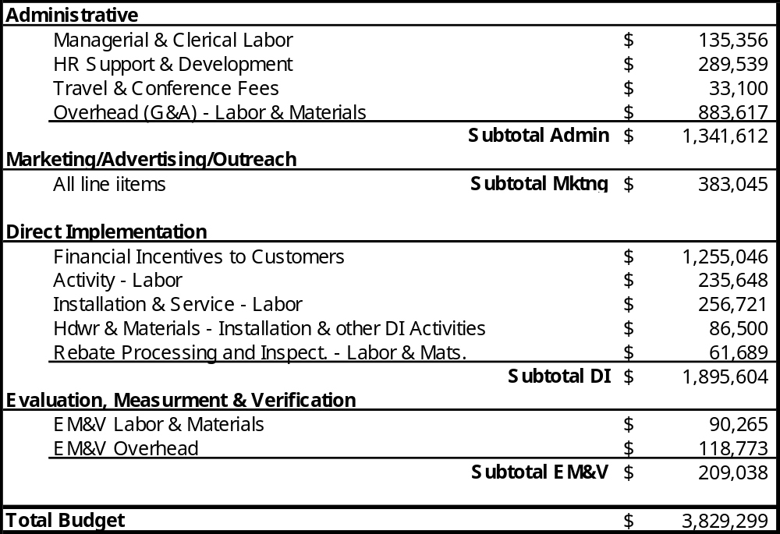
Table VIII.1

Budget Line Item Comments

47-52 Travel.
These figures include the projected travel costs for the field work of five Auditors in all target areas, as well as travel and accommodations for these Auditors to attend central training in Santa Cruz. These line items also include projected costs for RightLights managers who will be making multiple trips to each target region during the contract period, as well as local travel for marketing and administration.

53 Equipment – Communications.
This item applies to communication infrastructure and services at the six field-offices that will be established as minimal workspaces for Lighting Auditors and will include telephone, DSL, fax, printers, and copiers. Whenever possible, we will house Auditors in rented space at existing Regional Energy Authority facilities or at the offices of CBOs. This will allow us to pay incremental costs only for communications. When it is not feasible to establish an office in an existing agency where communications equipment can be rented as part of an office rental package, we equip an outside office with leased equipment, rather than purchasing the equipment.

54 Equipment – Computing.
The proposed RightLights expansion will require the purchase of six additional computers and associated software including laptops for five Auditors, plus a desktop PC to equip the new office-based staff that is required.

58 Facilities – Lease/Rent Payment.
This item applies to rental costs of the two field-offices that will be established for Lighting Auditors. Because Auditors will meet customers in the field rather than the opposite, we envision the need for only minimal cubicle space with no public access needed (i.e., no “store front”). This will also include space sufficient to organize and store Quick-Saver Package equipment (CFL and spray nozzle inventory). Whenever possible, we will house Auditors in rented space at existing Regional Energy Authority facilities or at the offices of CBOs, which will allow us to pay only proportional or incremental costs for space.

99-120 Marketing.
The marketing costs presented are based on RightLights marketing strategy, which has proven to be very successful in 2002-2003. The majority of our resources (line items 103 – 106, 115, and 118) are dedicated to in-person marketing that will be done largely by our Auditors through their visits to prospective businesses. The remainder of expenses are dedicated to production of marketing pieces that will be disseminated through our network of Community Marketing Partners.

132 Labor – Measure Installation.
This line item represents the direct labor cost for installation of Quick-Saver Packages and Pre-Rinse Spray Nozzles.

135 – Audit – Applications and Forms.
Facet software license and replication fees.

155 Subcontractor Labor – EM&V.
We have allocated 5% of the total budget to hire an EM&V contractor. This line item is the projected director labor portion (i.e. no overhead or profit) for that EM&V contractor.

Appendices

For example, based on PG&E’s experience with their direct install program, overall program costs for full service small business lighting programs reach a minimum for incentive levels equal to 50 to 60% of installed costs, because the marketing dollars spent per participant decrease markedly.
US Census Bureau. Census Business Patterns 2000-2001, http://censtats.census.gov/cbpnaic/cbpnaic.shtml
California Public Utilities Commission. Energy Efficiency Policy Manual, Draft: November 29, 2001, page 12.
1999 State-Level Small/Medium Nonresidential MA&E Study, Page 5-10.
Field experience in California of Center for Energy and Environment 2001-2003
The International Performance Measurement & Verification Protocol can be found at http://www.ipmvp.org/info/downloads.html.
 (#) indicates principal author

