Proposal
for
The Energy Savers Program
Northern California

2004 – 2005 Energy Efficiency Program Selection
Proceeding Number R.01-08-028

CPUC Confirmation Number  TBD | Submitted to:  The California Public Utilities Commission  Submitted on:  September 23, 2003
Submitted by:  RLW Analytics, Inc.  administration for the  Small Business Energy Alliance  Sonoma, California  Phone: (800) 472-6716  Fax: (707) 939-9218  email: info@rlw.com  RLW web: www.rlw.com  SBEA web: www. sbeaonline.com |  | 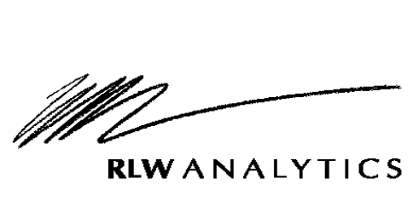  

Table of Contents
Program Overview 2
Program Concept 2
Program Rationale 2
Program Objectives 11
Program Process 14
Program Implementation 14
Marketing Plan 21
Customer Enrollment 23
Materials 24
Payment of Incentives 27
Staff and Subcontractor Responsibilities 27
Workplan and Timeline for Program Implementation 28
Customer Description 30
Customer Description 30
Customer Eligibility 30
Customer Complaint Resolution 31
Geographic Area 31
Measure and Activity Descriptions 33
Energy Savings Assumptions 33
Deviations in Standard Cost-effectiveness Values 34
Goals 38
Program EM&V Plan 39
Qualifications 42
About RLW Analytics, Inc. and the Small Business Energy Alliance 42
Team Overview 42
Overview of Primary Implementer, RLW Analytics, Inc. 42
Subcontractor: Geltz Communications 44
Association of Bay Area Governments 46
California Air-conditioning Contractors of America 46
Biographies of Key Staff 46
Budget 50

Program Overview

Program Concept
The RLW team, in conjunction with the Small Business Energy Alliance (SBEA), presents a unique project concept, providing energy efficiency programs for the small business sector. The focus of our proposed program is to reduce peak demand and energy usage through short-payback efficiency improvements in the small non-residential hard-to-reach sector.
Specifically, the proposed program:
- Targets “very small” “small” and “medium” hard-to-reach and underserved businesses in several counties, including Sonoma, Napa, Solano, Marin and Lake.
- Focuses on five cost effective energy efficiency measures.
- Offers small businesses financial incentives in the form of matching funds.
- Will coordinate program activities with the existing Green Business Program.
- Educates and trains both customers and contractors on energy efficient practices.
- Is built on a blueprint for success: the proven 2002 Energy Savers Program.

Program Rationale
The proposed 2004-05 Energy Savers Program is a “Local Program”. Our program now has a successful track record in both Southern California and Northern California. The 2002 Northern California program was designed to serve the needs of underserved regions of several North Bay counties, including Sonoma, Napa, and Lake.

Focus and Strategy
Primarily, the proposed program is a Demand Side Management (DSM) program, designed to reduce energy use and reduce peak demand through the installation and implementation of the following energy efficient products, services, and practices:
- Installation of energy efficient lamps, ballasts and occupancy sensors
- Installation of programmable thermostats
- Replacement of inefficient unitary HVAC systems
- Tune-ups of air-cooled package unit air conditioners
- Tune-ups of self-contained and split-system refrigeration systems
- Recommendations for energy efficient practices specific to lighting, air conditioning, and refrigeration systems
The strategies employed by the proposed program include customer incentives and information programs.

A Focus on Appealing Measures

Energy Measure | Advantage
- Installation of efficient lighting systems (mostly lamp and ballast retrofit), compact fluorescent measures, and lighting controls (mainly controls for T-5’s in high bay retrofits. | - Reduces lighting costs by 20% to 60%  - Improves lighting quality  - Reduces heat gains to building  - Has average payback periods of less than two years (varies with the type of business and operating hours)
- Installation of programmable thermostats to control air-cooled package unit HVAC systems | - Easily authorized by a small business owner  - Reduces heating and cooling costs
- Tune-ups for air-cooled package unit air conditioners using the Honeywell Service Assistant™ | - Easily authorized by a small business owner  - Can provide from 5% to 30% savings  - Need can be easily identified through visual inspection
- Tune-ups for self-contained and split-system refrigeration systems | - Easily authorized by a small business owner  - Can provide from 5% to 30% savings
- New packaged HVAC units with air-side economizers | - Produces energy and demand savings, ranging from 5% to 30% (and more!)  - Need is easily identified by contractor conducting tune-up activities

A Targeted Approach to Identify Customers and Contractors
A systematic, targeted approach to identifying eligible customers and contractors is key to program success. Techniques that were effective in the 2002 program and would be used in the 2004-2005 program are:
Contractor enrollment
- Continue to use contractors that are currently serving the program cost effectively. In 2002 the SBEA put forth a great amount of effort to enroll contractors that provided competitive pricing for small business customers.
- Work specifically with CALACCA to locate HVAC contractors willing to use tools recommended by the SBEA program.
- Invite new contractors to participate in the program in order to keep pricing competitive for the small business owner.
- Joint market with local contractors, and coordinate marketing efforts with cities and local agencies.
- Form pools of contractors who agree to participate in the program and develop justifiable costs for the program measures.
Customer enrollment
- “Feet in the Street”, there is no better way to market to the “very small” and “small” sectors.
- Market to property managers with whom we have existing relationships, and continue to build relationships with new property managers
- Leverage the Green Business Program by harvesting leads brought in by Green Business Program staff members.
- Work to implement local energy efficiency programs with cities and counties in the SBEA service territory.
- Continue to market the program through print media, local government, community based organizations, and professional associations.

Overcoming Market Barriers
The target population for the proposed 2004-05 Energy Savers Program exhibits multiple “market barriers” that have inhibited the adoption of energy efficient products and practices that would provide the customer with significant cost benefits. Below is a summary of key characteristics of our target population and how the program is designed with these characteristics in mind.

Market Intelligence: Characteristics of and Barriers to Reaching Small Business Customers
Statewide research and our own Energy Saver Program pilot have taught us the following about small business owners:
- Small business owners are very well aware of the state’s ongoing energy crisis (even though in some specific locations, small business owners are somewhat insulated from its effects).
- Many are willing to do no-cost and low-cost measures, but they often are unwilling to pay for more expensive measures if they are renters, especially if the payback period is more than two years.
- They are approached with many kinds of marketing offers for energy measures from energy service companies, whom the small business owners do not perceive as equally credible as the utility.
- They are not automatically motivated by money-saving offers from utilities (whom they perceive as the expert on energy matters).
- Just because the utility wants to give them something that will help them save money doesn’t mean that all small business owners will be motivated to take advantage of an energy efficiency program.
- The endorsement of a trusted third party such as a trade association or city government makes a significant impact in breaking down their attitudinal barriers.
- For renters, the participation of their property manager in administering and/or financing their retrofit makes the most significant impact.
- Small business owners typically are engaged more than full time in running their business and are uninterested in anything that interferes with business operations. This also means they are unlikely to turn out for even the most beneficial seminars or workshops.
In addition, we have discovered the following about small businesses in outlying areas of the San Francisco Bay Area:
- They are harder to reach with mainstream outreach efforts delivered regionally, but more likely to heed messages delivered on a local level than their suburban counterparts (due to more “noise” and distractions in the big city).
- Their local city small business agencies are more likely to endorse and help deliver a program such as this, since these agencies must pour more resources into attracting and retaining small businesses than their urban or suburban counterparts.
- They are likely to live in the same community as their business, and are more likely to turn out for community events than their urban or suburban counterparts.

Program Design Elements that Address These Characteristics
The “hands-on” approach inherent in the proposed program design, coupled with specific program strategies and tactics, overcomes these barriers and maximizes enrollment in this program.

Summary of Key Barriers and How We Overcome Them
The chart below and on the following pages summarizes the market barriers that are pivotal to the proposed Energy Savers Program and describes some of the strategies and tactics that will overcome these barriers.
Overcoming Market Barriers
Barrier |  |  | Strategy or Tactic
Lack of consumer information about energy efficiency benefits | Customers who don’t know the benefits and savings potentials of specific energy efficiency measures are highly unlikely to implement them.  We anticipate overcoming this barrier through:  - A comprehensive and aggressive outreach program that “takes the program to the customer.”  - A no cost energy survey that spells out potential cost savings and clearly identifies the generous SBEA incentives for participating in the program.  - “Where you want it, when you need it” education for small business owners and operators as well as building managers.  The education component of the program includes clear, concise informational materials that may be used in both formal seminars and informal discussions between survey technicians and small business owners.  We also address the lack of information barrier by bringing the program to the customer’s place of business. Our well trained “feet in the street” staff not only provide free energy audits, but also inform, educate, and train business owners on the fundamentals of energy conservation. Myths are dispelled, factual information is provided, and trust is built from day one. The approach works because we are in the customers place of business, and are able to capture their interest and signature once they realize their potential monetary savings and improvements in overall business operations.
Lack of financing for energy efficiency improvements | When up-front investments are high, or payback periods are long, customers in the target market segments typically are reluctant to participate.  - The financial incentives the proposed Energy Savers Program offers makes the recommended measures more affordable.  - We selected the measures identified for the Energy Savers Program specifically because they will provide the customer with the maximum energy savings and the shortest payback periods when incentives are included.  - We put customers in touch with financing options such as Safe-Bidco, offering low interest 4% financing on energy efficient loans.
Experiences from the 2002 SBEA Program: Possible the biggest barrier, certainly in these times of economic uncertainty, is lack of capital for energy efficiency improvements. The SBEA provides up to 75% funding for lighting measures, and 50% funding for all other measures in the program. These substantial incentives take a large portion of the financing barrier away. Through customer education and presentation of financial returns, the SBEA has been successful at showing customers the value and return on energy efficient investments. Of course we were able to completely remove the financial barrier for participating customers who resided in the Sonoma redevelopment zone, since they were able to leverage city funding (discussed in detail later). However, removing the financial barrier does not make any of this work a slam dunk, customers still require energy use education and assurance that they are making a sound fiscal decision, even at no cost.
Split incentives |  | Business owners who lease a facility typically are reluctant to invest in energy efficiency measures when they perceive that they will reap the benefit only for a relatively short period (the length of the lease).  However, our survey technicians remind property owners that they and their facilities will benefit for the lifetime of the measure with improved property values. We encourage property owners to approach their tenants with an offer to split the incentive with the tenant. This technique has proven very successful—tenants are more likely to participate in the program knowing they will share in the savings.  SBEA outreach to building management firms allows us to reach property owners with a clear message about the benefits of saving energy.
Experiences from the 2002 SBEA Program: The split incentives barrier is perhaps one of the most difficult barriers to overcome, namely because the majority of customers in the market we serve lease their buildings. As a result, making improvements to the building is not always viewed by the customer as a prudent investment. By educating the customers and asking pointed questions about their lease, and more importantly, who pays the utility bill, the SBEA has overcome this barrier. As of September, 81% of our participating customers are leasing their buildings, clear evidence that the SBEA has nearly eliminated the split incentives barrier.
Lack of a viable and competitive set of providers of energy efficiency services in the market |  | Even if they are convinced of the potential cost-benefit of an efficiency measure, many customers falter with the implementation because they find it difficult and time-consuming to find a reliable, cost-competitive service provider.  - We make implementation fast, easy, and attractive because we identify the product and service providers.  - As unbiased consultants, we offer customers the assurance that they are receiving the products and services they want at competitive prices. We keep the service providers honest and hold them accountable.  - Through the program’s contractor-direct rebate, we ensure contractors offer “the big business price” to the small business owner.
Insufficient resources or lack of time to pursue implementing energy efficiency measures |  | Many customers in our target population are fully occupied with the day-to-day requirements of running the business. They don’t have time to pursue information about energy efficiency, nor do they have the time or resources to coordinate and monitor the actual installation and implementation of energy efficiency measures. They may agree that the measures and technology they’ve heard about are good, but they are just too busy to investigate and take action.  - Because SBEA will “do the research for them,” customers do not need to take time away from the business at hand.  - Because SBEA screens and selects contractors, customers do not need to spend time going through that process. Customers can feel assured the contractors will do the job promised at a reasonable price.
Experiences from the 2002 SBEA Program: Small business owners, on average, do not implement energy efficient measures on their own for many reasons, mainly the lack of financial resources and time required to hire an energy expert. The SBEA overcomes these barriers by providing each business owner with an SBEA project manager. The SBEA PM makes recommendations to the customer, brings the most cost effective, yet reputable, contractor to the customer, manages the contractor and all activities required to complete the job, inspects and verifies the installation, and takes care of 90% of the paperwork for the business owner. Through this process we educate the customer and remove the time burden associated with the work, thereby allowing the customer to go about business as usual.

Successes of the 2002-03 Northern California Energy Savers Program
Unlike the 2002-03 ASW program, the SBEA’s Energy Savers Program did not have the name recognition in Northern California already enjoyed by the Southern California program. In Southern California the program had already been operating for more than a year as part of an SCE TPI contract. In late 2002 RLW’s Northern California Energy Savers Program began laying the groundwork for creating a branded name for energy efficiency services for the small business customers in the North Bay. Using targeted outreach approaches through existing agencies, such as city governments, chambers of commerce, county governments, and community based organizations, the SBEA has been able to create awareness at the local government level. Other targeted outreach approaches and mechanisms, most notably “feet in the street”, in addition to the property manager outreach, articles and endorsements, print media, participant success stories, and the Internet, have been our other approaches to marketing the Program.
The SBEA has created the same momentum recognition garnered by ASW after their first program year offering under the SCE TPI contract. According to our EM&V contractor, the second most common reason (second to “feet in the street”) customers participate in the program is due to referrals. This momentum has taken many months and hard work to create; it is exciting to finally see the benefits and results of our outreach efforts.
In the following paragraphs we discuss some of our most effective program activities conducted in the first year of the Energy Savers Program. We also present a preliminary assessment of our 2002 program’s energy savings objectives and planned accomplishments.

Leveraging Existing Funds and Creating Lasting Local EE Programs
One of the most exciting success stories of the 2002-03 Program is how the SBEA was able to leverage other funding resources and create lasting energy efficiency programs in two cities.
In the city of Sonoma, the SBEA drafted a proposal for the City Manager that proposed using funds from the Economic Redevelopment budget to fund energy efficiency improvements for businesses in the city’s redevelopment zone. The SBEA presented the idea at several city council meetings, spoke with the Mayor and other civic leaders, and received unanimous approval by the council. In essence, the City of Sonoma adopted the general aspects of the Energy Savers Program, providing matching funds to customers installing any of the four measures offered by the SBEA. Customers in the city’s redevelopment zone could get up to $1,000, or half the project cost covered by the city, with the other half covered by the SBEA. Nearly all Sonoma customers that participated in the program received their measures at no cost, or very low cost, due to the efforts of the SBEA. Moreover, all the customers that participated in the Sonoma/SBEA program fit the “very small” non-residential definition.
To date, the SBEA has utilized approximately $30,000 of Sonoma redevelopment monies. The city has agreed to provide more if necessary, and has also agreed to keep the program in place for customers that want to take advantage of this program in the future, with or without the SBEA.
The SBEA worked to create a similar program in the city of Sebastopol. While the city of Sebastopol did not agree to GIVE redevelopment funds to their constituents, the city did agree to provide 0% interest loans of up to $1,500 for installation of any SBEA measure. The loan could be financed for a period of up to five years.

Making an Impact in the “Small” and “Very Small” segment
The SBEA has had remarkable success in the “small” and “very small” market segment. We continue to exceed all of our own goals in this segment, proving that our “feet in the street” strategy works. As it sounds, we walk the street and look for opportunities by conducting cold calls. Early in the program “feet in the street” is what generated nearly all of our business. Now however, we are getting referrals, contractors are coming to us, we are being contacted via word of mouth, and existing customers are asking us to look at other buildings they own. These types of activities are excellent metrics for measuring the momentum and success of a program.
The next key to our success in this market has been replacement of incandescent lighting with compact fluorescent lighting. The SBEA selected a CFL manufacturer that makes a CFL replacement lamp for virtually every incandescent application. Our “feet in the street” staff members carry sample kits provided by the CFL manufacturer, full of just about every type of CFL they might need to specify in the field. Customers are amazed at the color temperature selections, light output, shape, and how well they compare to their existing incandescent lights. Moreover, the heat reduction from replacing incandescent with the CFL’s is at times more important to the customer than the energy savings. What we hear the most from these customers is that they had no idea such lighting products were available. Many comment on unsatisfactory previous experiences with early CFL products, lack of variety at stores in which they shop, and color temperature problems.
Early in the program, representatives from our compact fluorescent manufacturer conducted a training session at Sonoma State University with SBEA staff. A second training day was conducted during the summer at the SBEA headquarters in Sonoma. These sessions focused on choosing the right color temperature, lamp shape, and wattage for the application. What we have learned is that the process of choosing the right lamp can be daunting for the small business owner. Our staff provides these customers with the technical expertise typically not available to the small business owner. We also discovered that many had unsatisfactory experiences with the early CFL products, resulting in technology snapback to standard incandescent lamps. This was due to the poor performance of the lamps and incorrect application of the product. As a result, the SBEA trained staff are able to overcome these market barriers.
As part of our services we educate the customer on how to select CFL’s, and we also leave them with product sheets of the CFL’s they purchased and where they can find replacements when needed. Using our “CFL kits” we install and present the customer with several options, allowing them to select the wattage, color and style that suits their business the best. Using this approach the SBEA and the CPUC can be assured that the new lights will remain in place because the customer gets the lighting system they expected to get.
Here are just a few of our success stories where customers replaced existing incandescent lamps with CFLs, and the results of these actions.

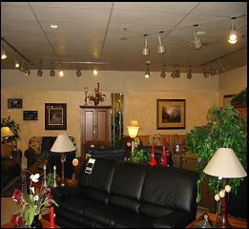 | 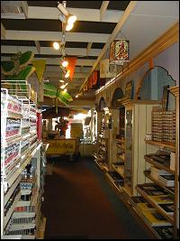 | 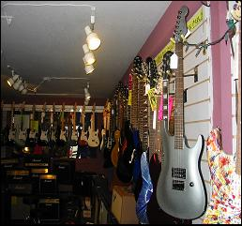
Top Left: The La-Z-Boy Showroom & Gallery  - SBEA retrofitted 390 fixtures with CFL’s  - Pre watts/sf = 1.90 Post watts/sf = 0.75  - 61% Reduction in lighting load  - $7,700 savings in annual electric costs  - 3 month simple payback | Middle: Montmartre Art Supply  - SBEA installed 73 CFL’s  - Pre watts/sf = 1.71 Post watts/sf = 0.45  - 74% reduction in lighting load  - $2,100 savings in annual electric costs  - 1.3 month simply payback | Top Right: Zone Music  - Pre watts/sf = 2.2 Post watts/sf = 0.59  - SBEA retrofitted 283 fixtures with CFL’s  - 73% reduction in lighting load  - $9,000 savings in annual electric costs  - 1.5 month simple payback
*Permission was granted by all customers to use name and results

Coordination with other programs
Early in the Program the SBEA coordinated efforts with PG&E’s Statewide Energy Auditor Training Program to educate our auditors on energy conservation measures for small business. PG&E and SBEA organized a two-day training session that was held at the Environmental Technology Center at Sonoma State University. The training efforts were successful, a total of approximately 20 students and staff members of the SBEA were certified by PG&E as energy auditors.
The SBEA also coordinated with the Statewide Express Efficiency Program. Early in the program the SBEA invited Express Efficiency Program managers to our offices. We discussed our two programs and identified ways in which we could assist each other’s implementation efforts. Throughout implementation the SBEA has provided Express Efficiency literature to many customers, some of these customers would not have participated in the Express program without SBEA assistance.
It is important to note however, that the great majority of our participants had not heard of the Express Efficiency Program, and would have been very unlikely that they would have participated in the Express program. Therefore, we do not feel that our program is in conflict with the Express Program, if anything we are helping to market the program by providing materials and information to interested customers.

Projections and Energy Reductions for the 2002 Energy Savers Program
In this section we present the 2002 Energy Savers Program energy and demand targets, prepared during the planning stages of the 2002 program. We show where the 2002 program is with regard to budget and preliminary energy savings estimates, and also predict future trends in energy savings and program spending.

2002 Energy Savings Goals
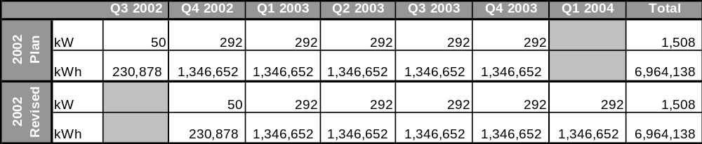
Table 1 illustrates the energy and demand reductions as planned by the SBEA. Two items are important to note. First, the table shows goals as planned, and as revised which takes into account the late start. The 2002 planned estimates assumed an earlier start than actually took place, while the 2002 revised rows (bottom two rows) show a more realistic picture of the goals by quarter. Secondly, the SBEA did make a program planning miscalculation; we assumed that energy and demand reductions would be equal, quarter-by-quarter. Our experience after operating the program is that the savings goals should have been scaled upward by quarter, primarily because the larger sites, which account for most of the savings, take longer to find, longer to develop relationships with, and generally take longer to make implementation decisions. Therefore, a better approach, and one we will take next time, is to scale the energy savings goals so that more of the savings come toward the end of the program, rather than equally across the program’s implementation period.
Table 1: 2002 Energy Savers Goals

2002 Energy Savings Forecast
Next we present where the current program stands with respect to goals, we also trend our current data to predict how long it will take to meet our total program goals, and how many kilowatt hours the SBEA should expect to commit by the end of the first quarter of 2004. Using a polynomial function, we computed quarterly energy savings for the 4th and 1st quarter of 2003 and 2004, respectively. For the third quarter of 2003 we are using energy savings committed through mid September, therefore the third quarter data used for the trending is conservative since there are two more weeks remaining in the quarter, and we fully expect more customers to sign up during this period.
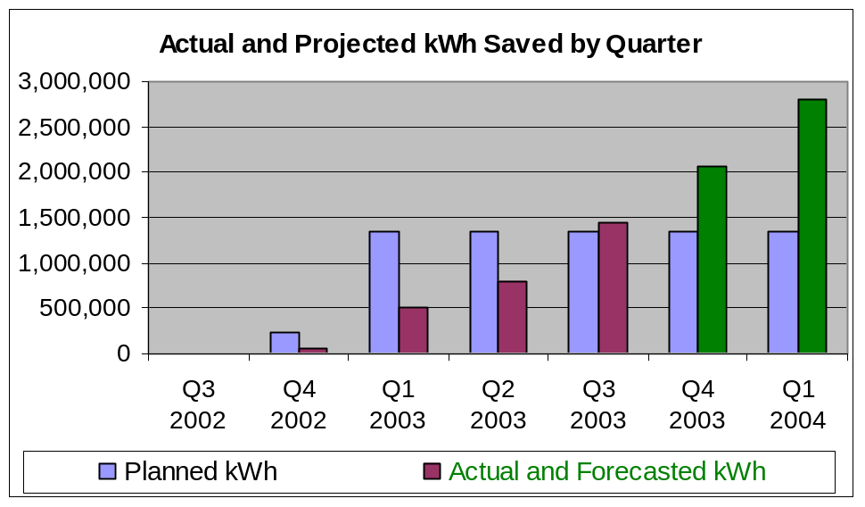
Figure 1 shows the results of this analysis. The planned data is presented in blue, which agrees with the table above which shows equally distributed kWh savings across all quarters. In the purple and green we present the actual kWh saved by quarter, and the forecasted kWh savings by quarter respectively. The table clearly shows an upward trend in energy savings. The model predicts a total program savings of 7.6 MWh; more energy savings than the 2002 program proposed it would save (6.96 MWh). This suggests that if the program were to be refunded we would already have customers “in-line” for incentives.
Figure 1: Actual and Forecasted kWh Savings for the 2002 Energy Savers Program
We certainly believe that these forecasts are evident of what the Energy Savers Program will do in the remaining months of implementation. The start-up period was slow, which we did not account for, as we should have. However, we have currently audited 6,840,000 kWh and 1975 kW. A great many of the customers that represent these audited savings are currently in the sales and decision-making process. As time passes many of these customers will be making decisions with regard to program participation, and we expect a large proportion of these customers to participate. In the mean time the SBEA will continue to harvest new leads and bring added projects into the program in order to accomplish program goals.

Program Objectives
In this section we discuss the planned objectives with regard to direct implementation activities, measure installations and energy and demand reduction targets.

Direct Implementation Activities and Measure Installations
Table 2 illustrates the number of direct implementation (DI) activities, namely cold calls and energy audits, which the SBEA will undertake in order to meet our energy reduction goals. The gray rows show these estimates by activity, customer size, and in total. The table shows that 73% of our direct implementation (DI) activities will be in the very small sector, while 201% will be in the small sector, and 7% will be in the medium sector. A total of 1,240 cold calls and 1,000 free energy audits will be conducted if our estimates are accurate.
Table 2 also shows the number of measures that the SBEA is estimating for the program, shown by measure type and by customer size. Once again, the very small customers will receive the majority of the program benefits, receiving 59% of the total program measures, or 352 installed measures. Note that the definition of a “measure” for lighting includes all lighting at a participant site. For example a lighting measure refers to all the lighting fixtures retrofitted at a particular building. Similarly, the definition of a HVAC measure is tune-ups for all units at a customer site.
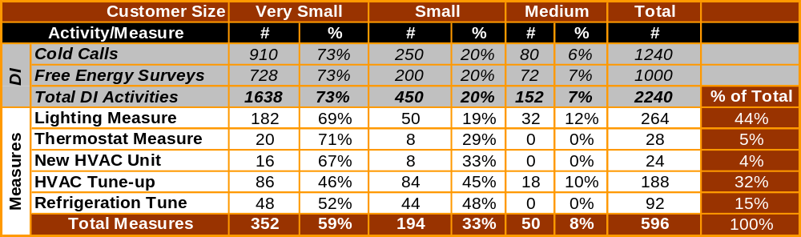
The SBEA has designed the program such that the very small and small customers receive the majority of the program benefits in terms of direct implementation activities. We have kept the medium customers in the program to help keep the Programs total resource test competitive with other programs like the SBEA’s. Medium customers will receive 8% of the total program measures; moreover the SBEA has planned that the medium customers will only be eligible for two of our program measures, HVAC tune-ups and lighting measures.

Table 2: Direct Implementation Activities and Measure Installation Goals
- Lighting Measures: A lighting measure refers to all lighting retrofitted at a customer location.
- Thermostat Measures: This has been a difficult measure to sell (Energy Savers 2002) in Northern California for two reasons, 1.) Many customers do not have AC, 2.) Many customers already have programmable type thermostats. We will continue to recommend them where possible, however we have reduced the total number installed to 28 for this program year. If demand goes up we believe there will likely be resources to increase supply. We also limit this measure to the very small and small customers. Medium customers will be referred to the Express program.
- New HVAC Units: New HVAC units are new to the program this year. We have dramatically increased the number of tune-ups, as a result we decided to add this measure for those customers that have failing units, as identified by the HVAC tune-up contractor. Again, we limit this measure to very small and small customers, and units less than 12 tons in size. Medium size customers will be referred to the Express program for new HVAC unit rebates.
- HVAC Tune-ups: The SBEA is dramatically increasing the number of tune-ups that we will complete as part of 2004 program. Contractors will be trained to use a new and improved process (discussed earlier) for conducting tune-ups. They will be able to offer the tune-up to existing customers since the scope of work included in the process is so much more robust than standard tune-up practice. Contractors will then refer their customers to the SBEA for a free energy audit and recommendations. Essentially creating a synergistic relationship between the SBEA and the SBEA’s qualified HVAC service contractors. We have approximate equal numbers of all customer segments being served primarily because we are interested in learning how each segment adopts this new practice, and we believe it is important that customers of all sizes have access to this technology. The program will tune about 620 units at about 188 locations in 2004-05.
- Refrigeration Tune-ups: The SBEA will complete approximately 60 refrigeration tune-ups, split evenly between “very small” and “small” customer segments. Since we think most of our medium customers will be office type buildings we do not anticipate the need to have refrigeration tune-ups as a measure for this customer segment.

Energy and Demand Reduction Goals
Table 3 presents the energy and demand goals for the 2004-05 Energy Savers Program. Using $897,550 for customer incentives we estimate a total demand reduction of 2,416 kW. We have assumed that 90% of our demand savings will be coincident demand savings because the Energy Savers measures are commercial (i.e. operated during standard business hours) and are also weather sensitive. (The 10% accounts for the small amount of exterior lighting that will be retrofitted and other lighting usage that may not be on during the peak period.) For every kilowatt reduced, the program is paying $371.
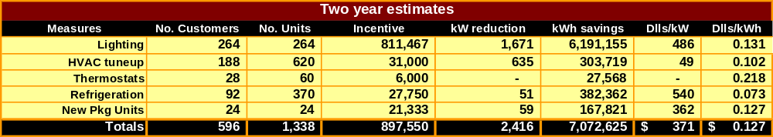
In terms of energy savings, the program is paying just less than 13 cents per kilowatt-hour reduced. Through implementation of the five program measure types the program estimates a reduction of more than 7 MWh. Again the program will focus on lighting measures to deliver the majority of the energy savings, but will look to the other measures to deliver substantial savings as well.

Table 3: 2004-05 Energy Savers Program Goals

Program Process

Program Implementation
The mechanisms and momentum for conducting this program are in place and are ready to be continued in selected local areas of Northern California served by Pacific Gas & Electric Company. We believe an extension of the existing program will be an ideal local element of the Commission’s 2003-2004 Energy Efficiency Program and will fully meet the Commission’s program requirements.
Our experience with this program and its proven approach demonstrates our understanding of the requirements of small business energy programs that have served customers with diverse economic and cultural backgrounds in a variety of locations.
Program Startup and Plan Refinement  1 | The first step is to coordinate with all program team members and assess “lessons learned” from 2002 – 2003 implementation of the Energy Savers Program to identify ways to increase the efficiency and effectiveness of program operations. Specific areas addressed during the startup step include:  - Refine the work plan and revise the Survey Technician’s Guidebook  - Refine and expand the database structure  - Modify survey instruments and customer authorization forms  - Review and revise customer eligibility if necessary and begin outreach  - Enlist contractors, negotiate pricing, and select equipment  - Conduct survey technician training and orientation
Outreach and Participant Enrollment  2 | Once we’ve refined the details of the program plan, we will reach the target population and enroll them in the program. We use a variety of marketing techniques and educational efforts to reach our target population, and businesses have multiple options for enrolling:  - Mail in a filled-out application form  - Go on-line and enroll at the SBEA website  - Call our toll-free phone number and enroll with our representative’s assistance
Survey Scheduling  3 | After customers are enrolled, we schedule the survey at a time that is convenient for them.  - The SBEA scheduler will contact each interested customer and set an appointment for a survey technician to visit the business in order to conduct an on-site survey  - As appropriate, the SBEA scheduler will conduct follow-up calls to confirm appointments before the survey technicians arrive
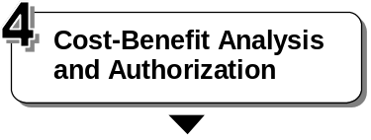 | At the customer’s site, the SBEA survey technicians identify and recommend EE measures, describe cost-benefit considerations, and gain the customer’s agreement to proceed.  - SBEA survey technicians perform an inventory of what is installed at the business site (lighting, HVAC, and refrigeration equipment)  - SBEA calculates costs of proposed energy efficiency measures and present a simple cost-benefit analysis to the customer  - Customers sign authorization forms agreeing to pay their portion of the energy efficiency measures they decide to implement. Survey technicians leave behind a list of energy efficiency tips and other information on how customers can save on energy costs
Incentive Allocation and Implementation  5 | After customers formally enroll, incentive money is allocated and SBEA coordinates and monitors the implementation.  - The survey technician notifies the contractors and schedules the installation with the business owner.  - The survey technician and contractors resolve any possible issues, and answer any questions the business owner may have.  - The customer signs a contract with the contractor agreeing to pay for the work.  - After the work is performed, customers pay the contractor for their share (the remainder due after the incentive). Because the customer is given credit for SBEA portion of the payment at the time of installation, there is “zero turnaround time” for the incentive to the customer.  - SBEA pays the remainder to the contractor, and bills the state for the incentive compensation.
Follow-up and Verification  6 | SBEA survey technicians verify the work for 100% of the installations and make sure the customer is satisfied with the work.
Data Entry  7 | SBEA keeps current and complete records on all relevant program activities.  - Survey technicians enter all pertinent information about the business and the measures that were implemented into a central SBEA tracking database.  - This data is maintained so that SBEA and the CPUC can monitor and evaluate the program.
Reporting  8 | Over the span of the program, SBEA will submit regular reports to the utility and CPUC program management.  - Monthly reports will present a concise summary of audit and incentive results to date.  - An annual report and a program summary report will summarize program results.

Implementation Changes for the 2004-05 Program
In this proposal, RLW offers to continue this successful program that was adapted to meet the local needs of targeted counties in Northern California. For the 2004-2005 implementation, we will continue to offer small business owners energy audits (at no cost) and incentives for implementing energy efficiency measures.
Based on our experiences operating the 2002 program we are proposing to introduce several new features to the program implementation plan. The following is a summary of changes to the existing 2002-03 Energy Savers program being proposed by RLW. A more complete description of these changes can be found in the section immediately following.
- In the 2004-05 program the SBEA will focus more attention to the “very small” and “small” hard to reach customers, with less of an emphasis on the medium customers. This will result in less conflict of interest between the Energy Savers Program and the statewide Express Efficiency Program, since the medium size customers are the primary market for the Express Efficiency program.
- For the 2004-05 Program RLW will subcontract some outreach activities to the Association of Bay Area Governments (ABAG) and will design and coordinate our program activities with Marin, Sonoma and Napa countys Green Business Program, which are all overseen by ABAG’s Green Business program administrator. RLW, ABAG, and the county agencies running the Green Business Program believe there are excellent synergies and possibilities for coordination of our two respective programs.
- Although Sonoma State University will not be a subcontractor to RLW for this year’s Program offering, the SBEA will continue to utilize graduating students of the Energy Management and Design curriculum as project managers for the Energy Savers program.
- More robust tune-up activities. The SBEA will subcontract with the California Air-conditioning Contractor Association (CAL ACCA) to train two HVAC contractors in the service territory to use the Honeywell Service Assistant for tune-up activities. Tune-ups completed with the Service Assistant result in a more robust and complete diagnosis and maintenance of the HVAC system, which also result in better energy savings and improved documentation of field results.
- Addition of HVAC measure. Through HVAC tune-up and inspection activities, the SBEA has determined that some customers would benefit from replacement of their HVAC systems. Therefore, RLW is proposing the introduction of an HVAC retrofit measure for only the very small and small customer segments.
- Expansion of area served. We are proposing to add Marin and Solano counties to the program portfolio. Marin is a key county because of the existing Green Business Program operated by the county of Marin and ABAG. Marin County contacted the SBEA in July to solicit assistance with energy audits and energy efficiency rebates; therefore this territory expansion will allow the SBEA and Green Business programs the ability to work together. We would like to expand to Solano County due to the proximity of our existing service area.

2004-05 Energy Savers Program Enhancements

Association of Bay Area Governments and the Green Business Program
SBEA Northern California will subcontract to the Association of Bay Area Governments for two primary purposes, 1.) Outreach to local governments to promote localized energy efficiency programs, and 2.) Programmatic and economic support for Green Business Program administrators in Marin, Napa and Sonoma counties.

About the Association of Bay Area Governments (ABAG)
ABAG is the official comprehensive planning agency for the San Francisco Bay region. ABAG's mission is to strengthen cooperation and coordination among local governments. In doing so, ABAG addresses social, environmental, and economic issues that transcend local borders. In 1961, elected officials from the region's cities and counties came together to form ABAG - California's first council of governments. The ABAG General Assembly includes an elected official from each member city and county in the nine-county Bay Area. Since its inception, ABAG has examined and facilitated constructive engagement among its members on regional issues like housing, transportation, economic development, education, and environmental quality.

Local Government Outreach
As discussed earlier, the SBEA was successful at convincing two city governments to create energy efficiency programs and provide added economic support above and beyond the SBEA to their constituents. We believe these efforts were some of the most effective activities of the 2002-03 program. Not only was the SBEA able to leverage other funds, we were also able to create lasting energy efficiency programs at the city level. For the 2004-05 program we plan to take this approach to the next level.
Our first strategic step as part of this effort will be to create a case study of our efforts, and the results of these efforts, in the City of Sonoma and City of Sebastopol. In glossy form, the publication we produce will illustrate the connection between energy conservation and local economic development. The case study will provide information on the following aspects:
- The Flow of Energy Dollars: This piece will discuss the annual energy bill for a community, and more importantly what happens to money spent on energy. With the basic concept being that the great majority of dollars spent on energy leaves the community.
- The Economic Multiplier: Known as the multiplier effect, it is a measure of the how much economic activity can be generated in a community by different combinations of purchasing and investment. The economic multiplier helps by generating more economic activity, which in turn strengthens the local economy. For energy efficiency measures, the economic multiplier is thought to be around 2.23 per dollar saved. From the perspective of local government, this policy approach leads to growth in the local tax base and a healthier fiscal picture.
- How Local Economic Growth Occurs: For most communities, the majority of energy monies leaves the local economy as payments for energy bills, and escapes the local influence. Investments made in energy efficiency can be an economically healthy choice because the economic multiplier results in several economic benefits, including Direct Effects such as job creation, Indirect Effects such as downstream effects from the direct effects, Induced Effects, such as money paid to those involved in the direct and indirect effects.
Effects other than the multiplier effect include increased discretionary dollars, created from the investment in energy efficiency. This is thought to be even more powerful than the multiplier effect.
- Business and Job Growth: There are several published studies that have analyzed actual and projected economic development effects of energy efficiency. The studies show that through investments in energy efficiency, jobs are created and local spending is also increased.
The case study will likely include other information that will be developed through secondary research. Putting this information in the hands of the local government decision makers will be the primary goal of this effort, which we plan will result in positive local initiatives upon which the SBEA can build and leverage. Since ABAG has existing relationships with local governments in the SBEA service area, they are the best candidates for presenting local governments with the concept of local energy efficiency programs. SBEA representatives will also take part in some or all of these presentations to civic leaders.
The SBEA, Geltz Communications, and ABAG will work closely to develop a package of information that will be presented to each county and city agency in the Program’s service area by ABAG representatives. Additionally, ABAG will also present the same material to other local governments not in the SBEA area, since ABAG represents several other counties in the Bay Area that are not part of the SBEA territory. These efforts will be coordinated with other statewide and local program implementers in order to further extend the benefits of these activities and publications that will be developed as part of our marketing and outreach plan.

Coordination with the Green Business Program
To improve our outreach and recruitment capacity, the SBEA is excited to collaborate with the Association of Bay Area Governments Green Business Program. The Green Business Program, which has certified over 275 businesses in 6 Bay Area counties, including Marin, Sonoma and Napa counties, has a proven track record in successfully recruiting businesses that are motivated to improve their environmental performance. Developed by ABAG in partnership with local, regional, state and federal agencies and industry representatives, the Program assists and recognizes small and medium-sized businesses that voluntarily go beyond compliance with environmental regulations. To be certified "green", businesses must demonstrate to qualified green business auditors that they have implemented a specified number of measures to prevent pollution, conserve energy and water, and minimize solid and hazardous waste.
This partnership will serve two purposes. First, it will provide an essential service to the Green Business Program coordinators in the North Bay counties who have had difficulty accessing on-site energy audits and technical assistance for businesses seeking certification. The lack of energy related services and expertise has constrained the Program’s efforts to help all interested businesses. By collaborating with SBEA, those services would now be readily available. Secondly, for many potential green businesses, the financial investment needed to reduce energy use can be a barrier. Often, green business candidates are small and medium-sized businesses that have very slim profit margins. Through this collaboration, ABAG will facilitate the participation of the Green Business coordinators in Marin and Sonoma counties who will refer motivated businesses to us. The SBEA will then assist those businesses with energy audits and financial assistance. This will give businesses two incentives to participate: 1) they will receive financial and technical assistance to reduce their energy use; 2) they will be recognized as "green businesses" if they meet all of ABAG's Green Business Program certification criteria.

More Robust Tune-up Activities using the Honeywell Service Assistant
In the 2004 program the SBEA will work with the California Air-conditioning Contractors of America (CAL-ACCA) to train and certify two HVAC maintenance contractors in the SBEA service territory on the use of Honeywell’s Service Assistant. These activities will lead to many more tune-up activities than were completed as part of the SBEA 2002 northern California program activities. We expect to complete approximately 250 tune-ups using this improved approach.
There are two primary barriers that are keeping this product from becoming standard business practice. The first barrier is the added cost of using the tool. HVAC service contractors live in a competitive environment and are very reluctant to increase prices at the risk of loosing service contracts. And because the Service Assistant procedures are more time consuming the contractors will have to increase pricing for these more robust services. In addition to the added cost to the customer, the contractor must also make an investment, not only in training employees on the value of the service, but also on the use and cost of the equipment. Each of these cost barriers are very real and will need to be overcome if we are to expect contractors to participate and adopt this new technology. To do this, the SBEA will pay for the contractor training, purchase four HVAC service assistants, and pay $50 for each tune-up, the approximate incremental cost of this added service.
In return the HVAC contractors will offer to their existing customers, and new customers, the opportunity to participate in the SBEA program. For participating the contractor will cover the cost of this enhanced tune-up service, the results of which will be presented to the customer. The customer will then evaluate the value of the new service and determine whether they would like to continue receiving the service without the SBEA incentive. The contractor will then attempt to sell the customer on the enhanced service under a revised pricing schedule/contract.
These more robust services will allow the contractor to differentiate themselves in the market place. Additionally, the HVAC contractors will be able to leverage the SBEA incentive for new package unit air-conditioners, programmable thermostats, and refrigeration tune-ups, which can also use the service assistant. The SBEA will also train the service contractors to identify customer’s that would benefit from an energy audit. HVAC service technicians will be trained to identify inefficient lighting systems, and will provide customers with information on free energy audits and other funding available from the SBEA. We anticipate this will be a highly effective model for identifying program participants.

About the Honeywell Service Assistant
Winner of the 2003 AHR Expo Innovation Award, the Honeywell Service Assistant is the next generation of tools that will be used by HVAC service professionals. The service assistant has many features and capabilities that greatly improve standard methods employed for conducting tune-ups that put this project far ahead of the curve. Because it is a new technology, adoption by the HVAC service professional community has been slow. As part of this effort we plan to train HVAC contractors not only how to use the equipment, but also on how to continue selling this level of service to their existing customer base. First, we present information on this revolutionary tool that will change standard practice in the future.
The tool show below is the “brains” behind the Service Assistant. It is able to electronically store and serve to the internet the following data:
- Efficiency Index (EI) is an estimate of an air conditioner's efficiency as a percentage of what its efficiency could be (while running under the same driving conditions) if it was serviced to the Benchmark Performance Standard.
- Capacity Index (CI) is an estimate of an air conditioner's total capacity as a percentage of what its capacity could be (while running under the same driving conditions) if it was serviced to the Benchmark Performance Standard.
- If a unit is running at the Benchmark Performance Standard, its EI and CI are 100%. If its performance is degraded because of a fault (e.g. dirty condenser coil) such that EI is 80%, then it is running 20% less efficient than is could be if it were serviced and the fault(s) were fixed.
- Efficiency Index (EI) and Capacity Index (CI) are fundamentally innovative tools and exclusive patent pending technology. There has never existed, and currently does not exist anywhere else, a tool for making practical field estimates of an air conditioner's efficiency and capacity. These tools, for the first time, relate the impact of service decisions to the equipment owner's utility bill.
- 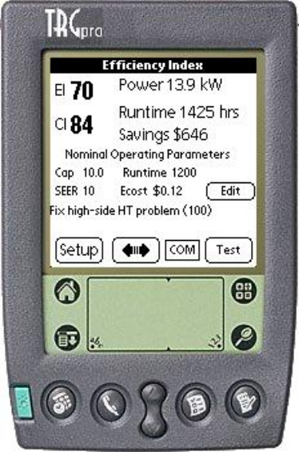Estimated current power, annual runtime, and annual energy cost savings potential are presented on the top right.
- Nominal operating parameters, displayed in the middle, characterize the unit with no faults. Parameters include design capacity and COP, annual runtime hours, and $/kWh. Set these parameters by pressing the "Edit" button.
- The diagnostic message is displayed on the bottom. “Fix high-side HT problem (100)
EI can be used to directly estimate the impact of poorly performing air conditioners on utility bills. This can be done using more and less sophisticated techniques.
The Service Assistant has a relatively simple, but useful and strait forward technique, integrated into it. This involves simply multiplying the utility rate (e.g. 0.10 $/kWh) times the average number of runtime hours per year (e.g. 1200 hours) times the energy consumption per ton (e.g. 1kW/ton for an average efficiency unit) times the nominal capacity of the unit (e.g. 20 tons) times EI estimated by the service assistant (e.g. 20%).
In this example, a 20 ton unit consumes 24,000 kWh/year at a cost of $2,400/year. A 20% efficiency improvement on this unit is worth $480/year in energy savings.
The unit then completes a building tune-up report with energy savings calculated based on data collected before and after servicing each unit. The SBEA will leverage this data for program reporting purposes.

About the California Air-conditioning Contractors of America (CALACCA)
ACCA is the leading national trade association for heating, ventilation, air conditioning and refrigeration contracting businesses. The ACCA help quality contractors increase their profits, control their costs, and grow their businesses. The SBEA will contract to the California division, CAL-ACCA, to conduct several days of training for two selected contractors in the SBEA service area. Specifically the SBEA will work with Mr. Dale Gustafson, Executive Director and Dale Rossi, co-founder of the Service Assistant. Contractors selected by the SBEA and CAL-ACCA will have no prior experience with the Honeywell Service Assistant, and will agree to use the tool for all projects coordinated through the SBEA’s program. CAL-ACCA has a wealth of members and will bring to the program two to three CAL-ACCA members that agree to participate.
A three-day training session will be held for the contractors recruited by CAL-ACCA representatives. Dale Rossi will give the training. The training session will have two fundamental purposes. The first day of training will teach business owners how to sell this enhanced level of service to their clients, while the second and third day of training will show the service technicians how to perform the enhanced tune-up and diagnostics using the Honeywell Service Assistant.

HVAC System Retrofits
This year’s program will benefit from the addition of one measure, incentives for unitary package roof-top units less than 12 tons in capacity. It is anticipated that the increase in tune-up activities will naturally lead the program into recommending new HVAC units to a limited number of customers. HVAC retrofits will be reserved only for customers in the “very small” and “small” hard to reach categories. All units will be required to have air-side economizers and will have a 12 EER or greater efficiency factor. More discussion on this added measure is located in later sections of this proposal.

Support of and Coordination with Other Relevant Programs
Both to benefit the customer and to support other energy efficiency programs sponsored by state and local agencies, we encourage participating customers to seek other opportunities for implementing cost-effective energy efficiency measures outside the scope of the Energy Savers Program.
Some examples of measures supported by other programs include those offered by the CPUC’s state-wide “Express Efficiency” program which offers rebates and incentives for new air conditioners, energy efficient motors, refrigeration system upgrades, and others, plus other programs that offer programs for reflective window film, insulation, and more. Small businesses in the rural areas we will be addressing may be interested in the rebates for drip irrigation and low-pressure sprinklers.
In addition, SBEA is an Energy Star® for Small Business Partner. We can let customers know of the many benefits this EPA program offers.
Specifically, Energy Savers Program personnel will:
- Inform customers of other local and state programs they might participate in and describe the general features and benefits of those programs
- As appropriate, provide customers with promotional and informational material (brochures, flyers, response cards, summary sheets, etc.) for other relevant programs
- Help avoid potential “double-dipping” by doing the following:
- Have the business owners sign an agreement stating they will not participate in other programs that offer incentives or rebates for the measures they implemented through the Energy Savers Program
- Report to PG&E at least monthly which businesses have participated in the Energy Savers Program and what measures they implemented through the program

Marketing Plan
Geltz will provide consulting services to RLW to launch and deliver the following elements of its comprehensive public relations and marketing campaign simultaneously to help the program meet its customer installation goals.
Provide support to the in-person (“feet-in-the-street”) small business owner recruitment campaign to be delivered by the SBEA field force. This activity will include:
- Revised program brochures in English and Spanish containing basic program features and benefits along with enrollment information that can be easily customized for use among particular business types and geographical regions. These can be used to recruit new customers as well as promote word-of-mouth-referrals to other customers.
- One-page case studies in English and Spanish of successful installations in various kinds of businesses.
- Window or door decals including the SBEA, Green Business and/or Energy Star logos.
- Other collateral tools and resources as needed and requested by RLW..
Deliver a property manager/leasing manager campaign. The following is the strategy to be used:
- Geltz will update and mail SBEA brochures targeted at property managers along with a cover letter to property management firms with small business tenants in these five counties. The marketing approach for property managers promotes the positive aspects of energy retrofits on net operating income, property values and return on investment.
- An SBEA representative will follow up this mailing by phone to offer to speak to weekly PM meetings and introduce the program, outlining its asset management and property value benefits to property managers.
- Geltz will provide an SBEA portfolio or “kit” for use in these presentations, as well as at city government and other meetings.
- The SBEA representative will offer to do a mailing of the SBEA small business brochure (in English and or Spanish) with a cover letter from the property management firm to their tenant list, to be followed up by phone contact with the tenants.
Design and launch a comprehensive public relations and print ad campaign targeted at general, business and trade media on a local and regional level to build general awareness among small business customers and the entities that represent them.
Geltz will submit press releases about the new 2004-05 program to business, chamber, city and environmental newsletters, local newspapers, local radio and cable stations, and trade association newsletters. Geltz will follow up these press release submissions with story leads featuring satisfied SBEA customers. To reinforce SBEA brand recognition and further promote local government energy efficiency programs, Geltz will submit print ads to local media thanking local governments and small business participants for keeping dollars in the community by saving energy.
Work co-operatively with ABAG to support its information and relationship-building campaign as part of the Green Business Program. This effort will capitalize on existing communication channels including trade associations, city redevelopment and business retention agencies, various Chambers of Commerce, and small business assistance entities in the five targeted counties. Our support would include:
- A glossy case study on the design and success of the City of Sonoma’s Energy Efficiency Program.
- Other communication tools such as newsletter articles and media insertions as directed by ABAG.
Update the SBEA Web site supporting all aspects of the program. This site will be an extension of the existing SBEA Web site and will provide the following features promoting the Northern California SBEA program:
- New program information
- SBEA success stories (case studies) in English and Spanish, including Green Business certifications and Energy Star for Small Business partnerships
- Easy on-line registration for small businesses and property managers
- Customization to include specific pages devoted to SBEA’s partnership with ABAG in the Green Business program.
Cooperate and co-brand with EPA’s Energy Star for Small Business Program (ESSB). ESSB officials and their ad agency have been very impressed with the formula, outreach, and success of the SBEA program. In fact, ESSB is planning to highlight SBEA as an exemplary program in the national Energy Star newsletter.

During several conference calls, they and we have discussed numerous ways in which SBEA could rely on ESSB resources to put more clout into our marketing, and at the same time, ESSB could extend its brand recognition in the California marketplace. These ideas have included the following:
- Airing an existing 30-second TV commercial produced by ESSB featuring Edward James Olmos that promotes energy efficiency in small businesses and refers viewers to SBEA's hotline number at the end for more information. This ad would air in English and Spanish.
- Make print ads from photography stills from the shooting of this TV ad.
- We intend to continue the following activities:
- At community outreach events we make ESSB enrollment cards available to small business owners.
- SBEA is an official ESSB technology provider and have a page on the ESSB Web site. As a result, SBEA uses the Energy Star logo on its print material and Web site.
- We have used several energy-saving tips from ESSB's Energy Guide for Small Businesses for informational purposes on the SBEA Web site.
Monitor and track outreach results. Geltz will work with the SBEA field staff to continually monitor the effectiveness of the marketing strategy so that it can be adjusted to maximize its effectiveness. The information collected will be used to provide a final report at the conclusion of the program and should offer broader implications for the marketing of small business energy efficiency programs in the future.

Customer Enrollment

Initial Enrollment
Initial enrollment in the Energy Savers Program occurs when customers contact us to request a Energy Savers site survey and provide us with the basic information about their business (type of business, location, contact information, etc.).There are three ways in which customer may submit an initial enrollment application for the Energy Savers Program:
- Give us a filled-in hard copy of the application form — either by mailing it in or by giving it to an appropriate representative at a trade show, educational outreach session, etc.
- Submit an application online, at the SBEA website
- Call our toll-free phone number and sign up with our representative’s assistance
Once customers have completed the initial enrollment, we will contact them and schedule an on-site survey of the business by a survey technician.

Eligibility Confirmation during Site Survey
During the site visit, the survey technician performs an inventory of relevant equipment, presents the customer with a simple cost-benefit analysis for the Energy Savers measures recommended for the site, and asks if the customer wants to sign up to implement the recommended measures through the program.
Before asking customers to sign up for program measures, the survey technician checks the site meter and reviews the business’s electric bills to confirm that the customer is eligible for the Energy Savers Program.

Program Authorization
Customers who want to implement the recommended program measures fill in an authorization form and give it to the survey technician. (If a customer wants to further consider the recommendations, or discuss them with associates, the survey technician may leave the authorization form with the customer, and the customer may submit the form at a later date.)
When customers sign the authorization form, they also agree that they will not take advantage of any other program offering rebates or incentives for the same energy efficiency measure.

Materials
When customers sign up for specific measures under the Energy Savers Program, they may authorize any or all of the four measures that the program encompasses.
- Three of these measures include equipment purchase and installation (HVAC, lighting and thermostats).
- The other two measures include tune-up services for existing equipment (package unit air conditioners and refrigeration systems).
All of the equipment that is to be installed has been pre-selected. This assures everyone of the quality of the products and establishes the costs. This means that, at the time of the survey, the survey technicians are able to determine exactly what equipment is required for the upgrade and its cost. The survey technicians send this information to the contractor who verifies the pricing. The customer signs a contract with the contractor agreeing to pay their share of the matching funds. If they wish, customers can pay using a credit card in two no-interest payments. SBEA then pays the contractor the remaining portion of the project cost, after the survey technician visits the site and confirms the installation.

Procurement and Delivery Procedures
The equipment purchase and installation process for the program’s lighting, HVAC and programmable thermostat measures begins when a customer authorizes implementation of these measures.  - When customers authorize a recommended lighting measure, they agree to purchase and install specific equipment in specific locations.  - When customers authorize installation of a programmable thermostat, they select the thermostat they want from an approved product list.  - The cost of the equipment and installation is specified at the time the agreement to proceed is made.  The tune-up measures included in the Energy Savers Program do not involve equipment purchase or installation. Rather, they involve the purchase of specific services from a contractor. The process involved is essentially the same as that described for equipment installation. All HVAC and refrigeration, if possible, tune-ups will be completed using the Honeywell Service Assistant. | Customer agrees to install recommended equipment  SBEA notifies approved contractor with customer information and equipment requirements  Contractor installs agreed equipment; customer pays contractor for installation, less incentive amount  Customer and contractor schedule installation  SBEA visits customer site to verify installation  SBEA pays contractor for remaining installation costs

Equipment Specifications and Installation Standards

Energy Efficient Lighting Systems

Specifications:
- Four foot T8 lamps shall be third generation lamps with the following characteristics:
- Color Rendering Index (CRI) equal to or greater than 86
- Initial Catalog Lumens equal to or greater than 3100 lumens
- Approximate Mean Lumens 2900, Average Rated Lamp Life = to 30,000 hours
- Reduced Light Output (RLO) ballast factor shall be (<0.85)
- Normal Light Output (NLO) ballast factor shall be (0.85 to 0.95)
- High Light Output (HLO) ballast factor shall be (>0.95)
- The Osram-Sylvania Quicktronic lighting system is our preferred lighting system, equal is acceptable with approval from the project manager.
- All first generation 4-foot lamps are excluded from this program.
- Second and third generation lighting products are eligible for SBEA program incentives.
- HID, T5, LED, compact fluorescent, 2', 3', 8' and U-bent fluorescent T8 systems are eligible for SBEA program incentives.
- Ballast shall be instant start if possible in order to maximize savings.
- Reflector kits shall be as specified in the work order agreement. Changes can be made with project manager approval only.
- Compact fluorescent lighting products shall be Energy Star certified.
- Occupancy sensor installations shall have a minimum connected load of 220 watts.

Installation Standards:
- Contact the customer and set up an appointment within 10 days from receiving authorization to proceed form for installation during normal business hours. (Installation outside normal hours may be worked out between the contractor and the customer).
- Notify SBEA's project manager of any discrepancies of fixture counts.
- Retrofit existing fixtures with approved fluorescent lamps & ballasts. Clean the fixture's reflective surface & lens.
- Provide the customer with an invoice identifying the full cost of the work, indicate the incentive, and the amount payable to the contractor.
- Provide the customer with equipment and service warranties.
- Provide SBEA with a detailed report of equipment removed and installed.
- Notify SBEA when the work is completed and invoice RLW for the amount of the incentive.
- Prices submitted on the final bid document. Contractor has option of job walk prior to final acceptance of the job (highly recommended). Contractor must notify RLW Project Manager of planned job walk within 3 days of receiving notification of bid acceptance.
- Additional items such as new lenses, tombstones, etc., are not included in this program. Any additional costs, other than lamps, ballasts, conversion kits, and new fixtures may be worked out between the customer and the contractor. In addition any work not specified in the bid document will be performed under a separate agreement between the contractor and the customer.
- All labor, material and workmanship will be performed in full accordance with the latest rules and regulations of all codes and ordinances having jurisdiction in this project. The contractor, not RLW or the SBEA, is responsible for the installation and workmanship.

New Package Unit HVAC

Specifications:
- Must have air-side economizer
- Must be less than 12 tons in capacity
- EER of 12 or greater
- Must be replacing existing unit that has reached its effective useful live.
Installation Standards:
- Contractor shall analyze load and specify correct capacity;
- Be installed so that the static air pressure drop across the handler is within manufacturer and design specifications;
- Have sealed supply ductwork that will provide proper air flow;
- Be installed with a return system sized to provide correct return air flow;
- Have sealed return ductwork that will provide proper air flow to the fan, and avoid air entering the HVAC system from polluted zones (e.g., fumes from autos and stored chemicals, and attic particulates);
- Have balanced air flows between supply and return systems to maintain neutral pressure in the home;
- Be properly charged with refrigerant;
- Have proper burner operation and proper draft.

Programmable Thermostats

Specifications:
- Energy Star Compliant.
- Seven day or two day type thermostat programming.
- Customer must have air-conditioning to qualify.

Installation Standards:
- Must be installed by qualified contractor.
- Must be operational upon installation.
- Contractor shall program the thermostat with customer.

Aggressive Program Cost Control
RLW is a small business that continually strives to keep our overhead low and our operating costs down. As a result, we deliver superior services at very competitive prices. In keeping with our standard operating procedures, the Energy Savers Program will be carefully managed, and administrative costs will be carefully monitored and contained.
We carefully select contractors for the Energy Savers Program on the basis of both quality and cost. We know what the retrofit equipment costs should be and make sure our contractors comply. We insist on state-of-the-art equipment at low wholesale prices. This assures customers of affordable, top-quality equipment and helps reduce overall program costs.
In addition, the program design helps ensure that our survey technicians spend their time most effectively and efficiently. Our targeted marketing approach solicits participation from the small businesses that are eligible for the Energy Savers Program and who will most benefit from the measures it encompasses. The application form customers submit to request a site survey essentially pre-screens customers before we schedule our survey technicians for a site visit. In addition, we conduct an initial interview with potential customers to verify they are likely to participate in the program measures before we offer the no-cost survey.

Payment of Incentives
After customers formally agree to participate, incentive money is allocated and SBEA coordinates and monitors the implementation.
- The survey technician notifies the contractors and schedules the installation with the business owner.
- The survey technician and contractors resolve any possible issues, and answer any questions the business owner may have.
- The customer signs a contract with the contractor agreeing to pay for the work.
- The SBEA project manager monitors the entire project; at the end of the project the SBEA project manager verifies the installations and has the customer sign the verification form.
- After the work is performed, customers pay the contractor for their share.
- SBEA pays the remainder to the contractor, and bills the state for the incentive compensation.

Staff and Subcontractor Responsibilities
Figure 2 shows the organization of the Energy Savers Program contractors and staff. The Program Advisor is Dr. Roger Wright. Dr. Wright has significant experience providing consulting services to the electric power industry. Dr. Wright’s experience providing program design, assessment and evaluation services to utilities across the country and around the world is unparalleled.
Matt Brost, Western Regional Manager of RLW Analytics and current Program Manager of the 2002 Energy Savers Program, will continue to act as program manager for the 2004-05 Energy Savers Program. Mr. Brost will devote approximately 25% of his time to program management activities. David Wylie, Program Manager for the SBEA in Southern California will be available to the program, along with other staff, for information and knowledge transfer. RLW will play a similar role in the ASW program, costs incurred through information sharing will be billed to our own respective programs, and therefore there is no need to have a formal subcontract with ASW Engineering.
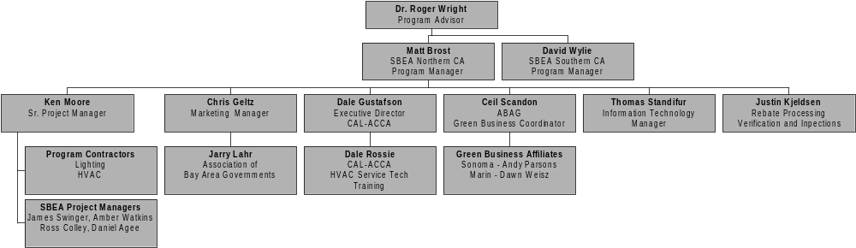
Figure 2: Energy Savers Program Organizational Chart
Ken Moore, Sr. Project Manager for the SBEA will also continue his role as lead Project Manager and also contractor negotiator and manager. Mr. Moore comes highly qualified, as he has been directly engaged in small business energy efficiency programs for the past 5 years. In this time he has managed more than 2,000 retrofits in which he has worked with the contractors, customers, utilities, and other agents involved in the program. Mr. Moore has also been a sales manager for a large lighting manufacturer, worked as an energy consultant, and is a graduate of the Energy Management and Design program at SSU.
Ms. Geltz will again lead the marketing efforts as described in this proposal. Geltz has provided excellent services to the SBEA since it’s inception in 1999 as part of the TPI efforts. Geltz is also the marketing consultant for the Southern California program, which allows for significant cost sharing activities. For the 2004-05 program Chris will work closely with Jerry Lahr of the Association of Bay Area Governments to develop strategic marketing material targeting local government.
The SBEA management team will work closely with Dale Gustavson, Executive Director of the California Air-conditioning Contractors of America (CAL-ACCA). Mr. Gustafson will identify HVAC service contractors in the SBEA service territory that are willing and able to enhance their services by using the HVAC service assistant. Once identified, Dale Rossi, co-founder of the service assistant, will conduct a three-day training session for both management employees, as well as service technicians.
Ceil Scandon, Coordinator of the Green Business Program, will assist the SBEA in coordination activities between the Green Business Program Representatives and the SBEA. Ms. Scandon will work to create an effective partnership between the goals of the SBEA and the Green Business program, which are already very similar, by working closely with the SBEA program manager and the Green Business representatives.
Thomas Standifur will be responsible for development and on-going maintenance of the SBEA program tracking database. If awarded funding, the database will be ported from MS Access to Sequel Server. This will allow Project Managers the ability to input field data into the Energy Savers Database via the Internet. RLW and ASW will share the cost of porting the database to a more robust platform. Mr. Standifur is also responsible for the functionality of the project managers IT tools, namely portable laptop computers and portable printers used for in-field customer presentation.
Lastly, Mr. Kjeldsen will be responsible for rebate processing, site verification scheduling and review of final transactions. Mr. Kjeldsen is currently overseeing these activities for the 2002 Energy Savers program.

Workplan and Timeline for Program Implementation
The implementation timeline for the Energy Savers Program is two calendar years. We propose to begin our program as soon as a contract is signed, and continue through March of 2006. SBEA will begin work on this project immediately after we have a signed contract. We expect the start date will be around January 1, 2004. The schedule of start dates and major milestones below and on the following pages assumes this date of start, but can be adjusted if the project actually starts earlier or later.
Over the course of the program, we will continually make adjustments to improve the operation of the program. For the second year, we will “regroup” in January 2005 to reassess the program’s progress and success. We will closely examine what aspects are working and what aspects need to be expanded, improved, or fine-tuned for the second year. Table 4 shows planned completion dates of important tasks, using January 1, 2004 as the assumed start date.

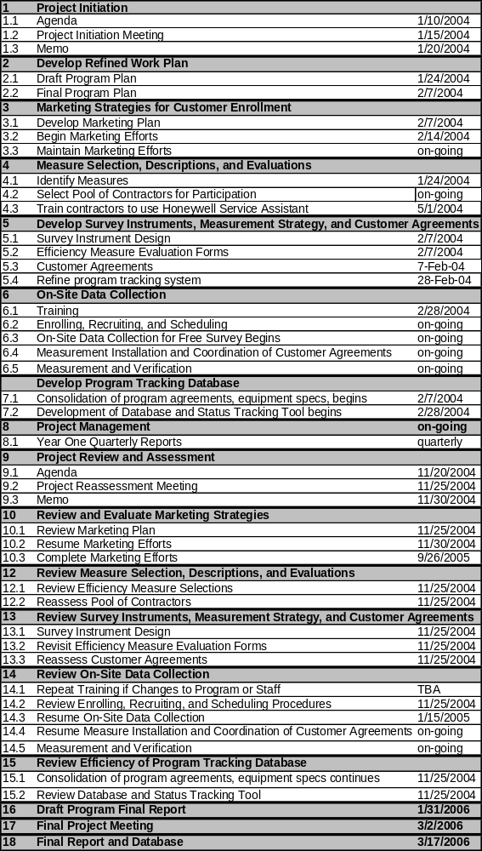
Table 4: Energy Savers 2004-05 Timeline

Customer Description

Customer Description
For the 2002 implementation of the Energy Savers Program, we are proposing a “Local Program” that will provide free energy audits and incentives to underserved customers in some underserved regions of Northern California, specifically, the counties of Marin, Sonoma, Lake, Solano and Napa.
Our target market segment is “Small Nonresidential Comprehensive Retrofit” and will fall under the category of “Nonresidential Hard-to-Reach.” That is, those customers who typically do not have easy access to program information or generally do not participate in energy efficiency programs.
Our program will target businesses that fall in the “Very Small Nonresidential,” “Small Nonresidential,” and “Medium Nonresidential” customer categories. Of the entire population of very small to medium businesses, we believe that about 80% of all fall under the category “Nonresidential Hard-to-Reach.” Using Dun and Bradstreet business demographics from some of the counties in our area we have determined that 80% of businesses have 9 employees or less. We are assuming that businesses this size are most likely to fall into the small non-residential sector. Showing a great amount of potential in the counties the SBEA would like to serve.
Other hard-to-reach market characteristics served by the program will include property managers, tenants leasing space, and language barriers (primarily Spanish). The 2002 program has been very successful in each of these areas.

Customer Eligibility
This section provides information on who is eligible to participate in the Energy Savers Program.
This proposed program is designed to address the market segment defined as “Small Nonresidential Comprehensive Retrofit.” The businesses eligible to participate in the program will need to meet certain criteria, and will fall under the category of “Nonresidential Hard-to-Reach.”
Within the nonresidential category, we are targeting customers who are defined as “Very Small Nonresidential,” “Small Nonresidential,” and “Medium Nonresidential” businesses.
Many of the targeted customers are considered “hard-to-reach” because of business size (very small businesses) and due to their geographic location (they reside in outlying regions and small or rural communities that are less well served).
Only businesses that are utility customers whose annual electric demand is less than 500 kW will qualify.
- Survey technicians prior to the site survey will verify that the business is a qualified customer on the correct electricity schedule.
- Most likely this will include small business customers with less than 75,000 kWh/month.
- However, while larger business will be included in the program, we realize the truly under served customers are the smallest of this group, therefore we have designed this proposal with the smallest customers in mind. The bulk of our services will target the very small and small customers, those who need education and assistance the greatest.

Customer Complaint Resolution
RLW has been successfully implementing the Energy Savers Program during 2002 and 2003. We have nearly 200 participants and have not had a serious complaint. All minor complaints have been addressed and handled appropriately. We will continue to learn from these experiences and apply them as necessary. As such, our procedures for responding to consumer questions and complaints have already been established. They are as follows:
- RLW will set-up a toll-free hotline for all customer inquiries. This phone will go directly to RLW’s Energy Savers Program Administrator. Currently our 800 number is 1-800-472-SBEA (6716).
- Our program administrator will have a working database at all times. If the customer is on file, we can immediately bring up the status of their services through our Small Business Energy Alliance (SBEA) database. If it is a new inquiry we will record the name, phone number, city, best time to call, and specific question.
- Often the call is in reference to services being provided. In those cases we will answer any questions we can and then pass on the information to the SBEA account representative for that business. At that point, our account representative will attempt to answer questions or reconcile complaints.
- Resolutions or sustained complaints will be recorded in our SBEA central database and under the accounts paper file.
- In the event that the customer complaint is not resolved, RLW program managers will get involved to help reconcile complaints.
RLW will respond to customer complaints immediately. In no such case will a complaint go longer than two days without a response. If the surveyor, RLW, and the contractor are unable to resolve a complaint within a week of the first recorded complaint, RLW will involve the PG&E contract administrator for further advice and conflict resolution. It will then be up to PG&E’s discretion as to when they should involve the CPUC, if required.

Geographic Area

Service Territory for the Northern California Energy Savers Program
The Energy Savers Nnorthern California Program is planning to serve a five county area. These counties include: Sonoma, Marin, Lake, Solano, and Napa.

Serving Transmission Constrained Zones
The CPUC has asked implementers to indicate whether programs will be implemented in transmission constrained zones. We point out that adding Solano county to the program service area will result in an energy efficiency program serving a transmission constrained zone. The “Vaca-Dixon Area” congestion zone is concentrated in Solano County, and more specifically the city of Vacaville. If awarded this expanded area the SBEA will concentrate Solano County activities in Vacaville in order to help reduce the grid congestion in this area.
It is also important to note that the “North Bay Area” congestion zone shown on the map is also part of the SBEA service area. The “North Bay Area” congestion zone includes nearly all of Lake County, and most of Sonoma County. If the 2004 SBEA program is selected, the Program would operate in two of California’s 10 congestions zones as identified by the California Independent System Operator Grid Planning.
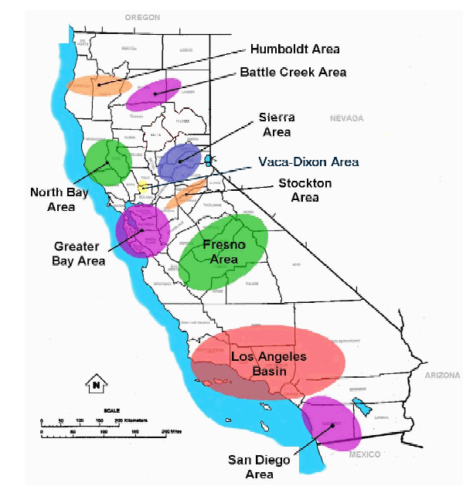

Measure and Activity Descriptions

Energy Savings Assumptions

Data | Source
Equipment costs | Lighting and HVAC contractor data
Energy and demand savings (kWh, kW) | Estimates have been derived using the following sources:  - Software developed by ASW  - DEER  - Standard Performance Contracting lighting values  - Secondary sources  - Energy Policy Manual  - 2002 Energy Savers Data  Lighting: The ASW software uses manufacturer data and our own experience in implementing the Energy Savers program (reported wattage) to calculate energy and demand savings. The Energy Savers database tracking system uses Standard Performance Contracting (SPC) codes and values for tracking lighting savings.  Coincident peak demand is calculated based on the hours of operation reported by participant customers in 2002. Hours outside of the peak period (i.e., 12-6 PM, Monday – Friday) are not considered peak demand measures, only energy saving measures.  The values for measuring HVAC tune-up savings come from the ASW workbook, which calculates annual operating hours and kilowatt-hour consumption for HVAC equipment. HVAC load factors were calculated using data from local weather stations, including Santa Rosa and Calistoga. We then apply a 12% savings multiplier to energy savings and an 8% savings on demand, which is conservatively based on the following Technology report: “The Honeywell HVAC Service Assistance. A Tool for Reducing HVAC Electrical Energy and Demand Consumption” Field Diagnostics Services Inc. 2002. Page 5. We have included the report and our post analysis in the appendix. We have used conservative estimates because we understand the report weights findings by unit tonnage, and we do anticipate doing many large units.  The values used for kW and kWh refrigeration tune-ups came from the report study titled Small Commercial A/C and Refrigeration Maintenance Program, Draft Report, sponsored by the Sacramento Municipal Utility District (SMUD) Measurement and Evaluation Group, January 2001.  The energy savings estimates for programmable thermostats are established from the deemed savings based on reduced operating hours, as documented in the Southern California Edison Book of Standards and MARS program.  All HVAC and refrigeration measures are considered coincident peak demand measures because they are weather sensitive measures.
Discount rate | 8.15% (from the August 2003 Energy Efficiency Policy Manual)
Net-to-Gross Ratios | From the August 2003 Energy Efficiency Policy Manual Table 4.2
Measure lifetime data | From the Energy Efficiency Policy Manual Table 4.1 Effective Useful Lives of Energy Efficiency Measures for the lighting and programmable thermostats and from the SMUD study for the AC and refrigeration tune-up estimates.
Avoided costs | From the Energy Efficiency Policy Manual, Tables 4.3, 4.4, and 4.5

Deviations in Standard Cost-effectiveness Values

Net to Gross and Effective Useful Life of Energy Efficiency Measures (EULs)
The table below shows the applicable measures and the corresponding Net to Gross and EUL values extracted from table 4.1 of the Energy Efficiency Policy manual. For AC and refrigeration tune-ups, we have used an EUL of three years, as we did in the 2002 program. We have been unable to identify a source of EUL data for this measure.
Measure | NTG | Lifetime
Lighting: T-8/T-5 Lamp and electronic Ballast | .96 | 16 years
Lighting: CFL — Screw-in Replaceable Lamp (Modular) | .96 | 8 years
HVAC Tune-up | .8 | 3 years
Refrigeration Tune-up | .8 | 3 years
HVAC: Set-Back Thermostat | .96 | 11 years
New Unitary HVAC units | .96 | 15 years
One deviation, of sorts, can be found in the program workbook. For comprehensive lighting measures in the “very small” and “small” customer segments we used a EUL of 12 years. The 12-year estimate is based on the mix of compact fluorescent and linear fluorescent technologies we installed in the 2002 program. CFL’s have an 8-year EUL and linear fluorescents have a 16-year EUL, using the 2002 Energy Savers data, and a weighted average calculation, we arrived at an average EUL of 14 years for lighting measures in the very small and small participant projects. Showing that the majority of the savings still remain in linear fluorescent lighting.

Incremental Measure Costs
For each of the four measures offered by the SBEA program, we have determined the incremental measure costs based on our matching funds design of the program, which is 75% incentive and 25% customer participation for lighting measures, and 50% incentive and 50% customer participation for thermostat and tune-up measures. Therefore, we have defined the gross IMC as the incentive plus the customer’s cost to be equal to the gross incremental cost per unit by measure. In the 2002 program we implemented the same design, and based on the success of this program, propose the same approach for this version. For new package units, we have estimated that the incentive pays for about one fifth of the cost; therefore we have defined gross IMC to be five times the incentive paid by SBEA.

Per Unit Energy Savings Estimates
- Lighting — Per unit lighting savings are calculated in our attached spreadsheets. The assumed annual kWh savings is a function of operating hours, size of facility (square feet), and delta kW of the retrofit. Baseline lighting levels of 1.8 Watts per square foot are used. Future lighting levels are estimated to be 1.0 Watts per square foot. Then based on the distribution (the kW demands, areas, and hours of operations) of the actual businesses enrolled in the program, the kW and kWh savings are determined. However, the operating hours and facility size do vary based on our projected participant population. Demand (kW) reduction values are a function of facility size and delta kW of the retrofit. Through our experience with the 2002 Energy Savers Program we have learned that this is a quite accurate predictor.
- Programmable Thermostats — We are assuming savings of 8% of annual kWh available. There are no demand savings resulting from this measure.
- AC and Refrigeration Tune-ups — The Database for Energy Efficient Resources (DEER) does not list AC or refrigeration tune-up as measures. Therefore, we have developed conservative estimates of energy savings.
For AC tune-ups, estimates are based on cooling capacity, load factor, operating hours, and a 12% increase in system efficiency. The average 12% energy savings are derived from Technology Report: The Honeywell HVAC Service Assistance. A Tool for Reducing HVAC Electrical Energy and Demand Consumption. Field Diagnostics Services Inc. 2002. Page 5. We have been more conservative than the report because the findings were weighted by tonnage. Since we do not anticipate servicing very large units we decided to reduce our savings claims.
- Net-to-Gross Ratio — We applied the appropriate Net-to-Gross Ratio (NTGR) that is used to estimate “free-ridership” for the Program. NTGRs are used to estimate the free-ridership that occurs in energy efficiency programs. Free riders are “program participants who would have undertaken an activity, regardless of whether there was an energy efficiency program promoting that activity or not.”
The NTGRs do exist in the DEER for the measures we are proposing. However, in all cases we have decided to use the NTGR the utilities used when filing their Express Efficiency programs.
- For lighting and programmable thermostat measures, we have used a NTGR of .96, which is consistent with PG&E’s 2002 Express Efficiency Program filing.
- For both AC and refrigeration tune-up measures, we have used a NTGR of .80.

Rebate Rationale and Amounts
This section briefly describes the rationale and rebate structure for the Energy Savers Program measures.
The program rationale is to pay up to 75% of the cost of the lighting retrofits, the SBEA measure that required the largest investment on average on the part of the customer. The rationale behind the incentive is to overcome the lack of financing barrier. In the 2002 program we started with 50% incentives for lighting, however we found that the investment was still too much for customers to agree to, especially since many lease buildings and require very short payback periods. We petitioned to have the incentive amount lifted to 75%, which was accepted by the CPUC. Participation increased as a result of the change. More importantly, the change did not affect the amount of energy savings the program could deliver; it simply made the program more attractive to participating customers.
For the remaining measures we pay about half of the cost, and since these measures require less investment on the part of the customer, because they are less expensive measures, a 50% rebate is enough to entice customers to participate.
- Lighting Measures: The SBEA will pay $0.13 per kilowatt-hour saved, not to exceed 75% of the total project cost.
- HVAC Tune-ups: The SBEA will pay up to $50.00 per tune-up. The incentive will be broken into two equal halves of $25.00. Using the Honeywell service assistant, service technicians will take a preliminary diagnosis of the HVAC unit. A $25.00 incentive will be paid for all units that receive a preliminary diagnosis. If the unit is diagnosed as requiring service, the service tech will service the unit and take a follow-up diagnosis. The service tech will continue to re-diagnose the system until it is operating at peak efficiency. The SBEA will pay the second $25.00 for all systems requiring service and follow-up diagnosis. Therefore, a total of $50.00 per unit is the max incentive, while $25.00 is the minimum incentive. This is the same methodology NYSERDA is employing as part of their Unitary HVAC Program.
- Refrigeration Tune-ups: The SBEA will pay $75.00 per tune-up, or about half the cost.
- Programmable Thermostats: The SBEA will pay $100.00 per thermostat, or about half the cost of the equipment and professional installation.
- HVAC Replacements: The SBEA will pay $160.00 per ton. Units will be less than 12 tons, and customer participation will be limited to the “very small” and “small” sectors.

Activities Descriptions
In this section we discuss activities the program will undertake that will not directly produce energy savings. These are the indirect direct implementation Program activity requirements conducted by the SBEA project managers (a.k.a energy specialists).

Customer Cold Calls
In order to engage customers the SBEA conduct cold calls via the “feet in the street” approach. During the cold call visit customers are asked if they would like to receive an SBEA energy audit at no cost. The SBEA representative gathers information such as address, business name, and other easily identifiable business characteristics, in addition to the customers desire to have an energy survey or not.

Free Energy Surveys
Customers agreeing to the energy survey receive, at their convenience, an SBEA energy survey. Included in the survey are the applicable measures covered by the SBEA program. Additionally, SBEA surveyors look for other opportunities that customers might implement on their own, or through the assistance of another program. However the primary concentration are on the five SBEA measures. The energy surveyors also gather information on the business, such as utility account number, PG&E rate schedule, customer size, building size, primary language, number of employees, and other “firmographics”. Once all the data is gathered it is entered into the SBEA database. The SBEA database produces an energy savings and project cost report, which is presented to the customer. The presentation recommends various measures based upon the findings of the SBEA staff member. For small sites these activities may be completed on-site using portable computers and printers. Larger more complex sites require more input and analysis before a presentation can be made.

Participant Processing
The SBEA representative will continue to follow-up with the customers until a decision is made regarding measure implementation. The SBEA project manager then processes customers that decide to implement any of the SBEA measures. As part of these direct implementation activities the SBEA project manager works with the customer to complete all necessary paperwork, identifies the contractor (or contractors) that will complete the work, and works with the customer and contractors to successfully implement the measures. The SBEA project manager becomes the customer’s agent for completing the work, thereby allowing the customer to go abut business as usual.

Site Verifications
The final aspect of direct implementation activities undertaken by the SBEA project manager is the site verification. The SBEA energy surveyor inspects the installations and notes any discrepancies from the original measure installation plan. Once the customer and SBEA project manager agree that the installations are complete and satisfactory the customer is asked to sign the project approval form. Lastly, the SBEA project manager records changes, if any, in the Program tracking system, and signed documents are added to the project file.

Rebate Processing
Once the project is complete the project manager will evaluate and approve the final work order and invoice provided by the installation contractor or contractors. The SBEA project manager will calculate the final rebate amount and request payment be made to the contractor(s). The project manager will notify the customer of their amount due to the contractor, which the implementation contractor will bill them for.

Goals
The SBEA Energy Savers Program has specific performance goals for:
- Energy and peak demand savings
- The number of small businesses enrolled and audited
- The number of small businesses electing to participate in the incentive programs or the equipment tune-up
Two of the primary purposes of the Energy Savers Program is to provide:
- Permanent and verifiable long-term annual energy savings over the life of the measures
- Long-term and permanent electric peak demand savings over the life of the measures
The total program goals for the program will be a usage reduction of approximately 7,072,828 kWh and 2,418 kW demand reduction over the course of the two years of the program. We anticipate providing 1,240 cold calls, and audits for approximately 1,000 small business customers. The kWh savings and demand reduction are based on an estimated one-third of small business customers participating in the program after receiving an audit.

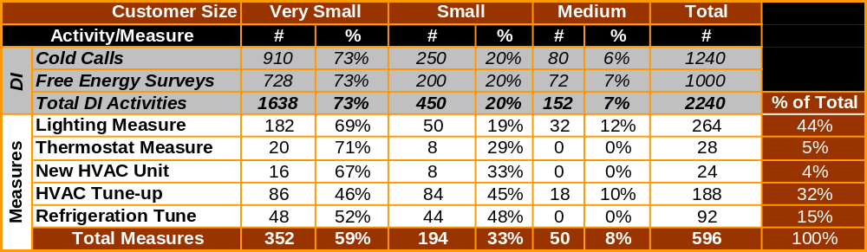
Figure 3: Direct Implementation Activities and Measure Installations
Total program savings is calculated as the approximate number of customers times the number of kWh saved and the kW reduced that result from implementing the energy efficiency measures. We anticipate that the total program cost will reflect approximately $0.127 cents per kWh saved. We plan to implement lighting measures at 264 customer sites, conduct 620 tune-ups at 188 customer locations, install 60 thermostats, complete 370 refrigeration tune-ups, and install 24 new package unit air-conditioners.
Figure 4: Program Goals

Program EM&V Plan

Evaluation, Measurement and Verification Overview
For each of the energy efficiency measures offered by the program, the evaluation, measurement, and verification (EM&V) method shall adhere to current International Performance Measurement and Verification Protocols (IPMVP) standards for impact assessment.
The EM&V plan shall be designed in such a way that it answers the critical questions that any EM&V plan should address. Some of these questions are:

Technical Questions | General Program Questions
- What are the gross and net kW and kWh savings for the program as a whole and for each of the measures individually?  - Surveyors use specific tools and devices to gather data for assessing the kW and kWh savings of the energy efficiency measures. Are these tools accurate? If not, why?  - Is the program cost effective?  If not, why? | - How can the program be refined to better meet the needs of the participants and the contractors?  - Is the program reaching the target market?  - Have the targeted communities and the participating contractors embraced the program?
In order to answer these questions a comprehensive strategy must be established to accurately and effectively evaluate, measure, and verify the program process and savings claims. RLW and ASW will work with the EM&V contractor and the contract administrator to determine the most effective plan for program measurement.

The SBEA Program Tracking System
One critical task of the SBEA program is to track its progress. To facilitate this task, the SBEA will build and maintain the Tracking System database.
The Tracking System will be used to keep a record of the details of the program, and will serve the many functions of program implementation, including the evaluation, measurement, and verification of program savings.
The Tracking System database will contain each customer’s baseline information and energy efficiency measure information. These data will be used to calculate individual participant savings as well as savings for the entire population of program participants.
SBEA also will specify the procedures for entering data into the Tracking System database, including who will enter the data and when. The tracking system will then be used to establish all pre data (baseline) and post data.

Measurement & Verification Plan Overview
We believe that an integrated approach to field data collection will meet the standards required by the PUC for this evaluation. The recruiter, the survey technicians, and the analysts will work together to ensure that all of the necessary data is collected as efficiently as possible.
The EM&V budget should be allocated effectively; we recommend that the allocation is representative of the measures producing the energy savings. As planned, the majority of the Program’s savings are resulting from lighting measures. Therefore we suggest a greater proportion of the EM&V budget be reserved for evaluating lighting measures, and so forth. Including the larger energy savings projects in the EM&V is another way to stretch the EM&V budget, by evaluating projects with greater amounts of energy savings the EM&V contractor is able to increase their estimates of precision and is able to keep sample sizes low.
For lighting measures, the bulk of the program savings, on-site engineering analysis and existing engineering data will likely be the primary method used to assess the savings associated with installed measures at the participants sites. The focus of the on-site engineering assessments will be the development of an independent estimate of the energy savings associated with the installed measures.
- For the other four program measures, use of engineering analysis, secondary research, and review of program tracking data will be the primary method of EM&V. For lighting measures we recommend lighting logger measurement and analysis. The SBEA has hundreds of lighting loggers to lend for EM&V activities if needed.

Programmable Thermostats
Because it is difficult to measure savings for programmable thermostats, the M&V plan will utilize deemed savings estimates, in addition to an on-site verification survey. The verification survey will validate that the measure has been installed and is in proper working condition. No monitoring will be undertaken to support the deemed savings estimates.

AC and Refrigeration tune-up
Measurement and verification of this program will be completed in order to evaluate the effectiveness of the program offerings. For several reasons, this program does not lend itself to the traditional M&V protocol. The program is service-based, not equipment based, and actual energy savings are difficult to verify. Also, the program is implemented by the contractor with little cost to, and very little effort required by the customer, therefore we can assume that customer free-ridership is negligible.
The Energy Savers Program will utilize the Honeywell Service Assistant for tune-up activities. The functionality of the service assistance allows for all data captured using the hand-held device to be uploaded to an internet site. These data include both pre and post operating conditions for the unit and weather conditions. These data, along with standard engineering analysis, will be more than adequate in determining energy and demand savings. The program tracking system will also utilize these data for measure tracking. There are also current and past studies of this product that have evaluated energy savings using this technology. We strongly recommend these studies, along with the data captured by the tool, be used to perform EM&V.

New Package Unit HVAC
Replacement of existing package unit air-conditioners will be a small part of the SBEA program, representing a small fraction of the program savings. Therefore we recommend less EM&V resources be used to evaluate this measure. Evaluation of this measure will likely be completed using pre and post data captured by the program tracking system, along with participant project files, and possibly survey data. The EM&V contractor may use simulation modeling, engineering analysis, or secondary research to complete EM&V activities for this measure.

Recommended EM&V Contractors
Sisson and Associates is the current EM&V contractor for the Energy Savers Program. If on-site surveys are required to evaluate the 2004-05 program we would recommend that Sisson and Associates team with a company with engineering skills, such as Aloha Systems.

Sisson and Associates
Phil Sisson
42 Moody ct.
San Rafael, CA 94901
(415) 845-8820
philsisson1@attbi.com

Aloha Systems
Dr. Mark Shirilau P.E.
2691 Richter Ave. #20
Irvine, CA 92606
(949) 851-2221
www.alohasys.com

EM&V Budget
We have allowed for nearly 3% of the total program budget to go to EM&V. In 2002 EM&V efforts for the Northern and Southern California Programs were coordinated with one contractor, Sisson and Associates. We recommend once again combining EM&V efforts. Between our two budgets we believe there is enough funding to conduct a robust EM&V of the program, including on-site data collection if deemed necessary.

Qualifications

About RLW Analytics, Inc. and the Small Business Energy Alliance
This proposal is submitted by RLW Analytics, Inc. in partnership with the Small Business Energy Alliance (SBEA). Our contact information is:

RLW Analytics, Inc.
1055 Broadway, Suite G
Sonoma, CA 95476
800.472.6716
www.rlw.com

Contact persons:
- Roger L. Wright, Ph.D., President, RLW Analytics, Inc.
- Matt Brost, Western Regional Manager, RLW Analytics, Inc.

Organizational Mission: The purpose of the Small Business Energy Alliance is to educate and facilitate. Our purpose is to serve as an advocate to small businesses; to educate about energy efficiency measures; to provide access to incentive and rebate programs that offer financial support; and to make it simple for businesses to participate in these programs. We handle all of the paperwork and schedule the installation work through one point of contact.

Team Overview
The SBEA team offers the technical skill and experience necessary to complete all aspects of this project. We have very strong skills in:
- Project planning and program design
- Marketing and communications
- Development of teaming with contractors
- Data collection—we employ experienced survey technicians, have established customer protocols, and have expertise in identifying energy efficiency opportunities
- Contractor relationships—we have years of experience with multiple contractors, know how to determine quality work and are able to implement program measures
Considering the success of the 2002 Energy Savers Program, the SBEA team is in place and very qualified to oversee a next generation program for the CPUC.
The Northern California Team proposing to implement the SBEA Program consists of four unique entities:
- RLW Analytics, Inc., the primary implementer will operate the program from its corporate headquarters in Sonoma, CA. RLW Analytics, Inc. is a consulting firm specializing in electric and gas energy efficiency, program design and implementation, program evaluation and energy information.
- Association of Bay Area Governments
- CAL-ACCA
- Geltz Communications

Overview of Primary Implementer, RLW Analytics, Inc.
Dr. Roger L. Wright, President of RLW Analytics, Inc., first founded Roger L. Wright and Associates in 1970. In 1989, Dr. Wright left the position of Statistics and Management Science Department Chair at the University of Michigan Graduate School of Business Administration, and joined Curt Puckett of Consumers Power Company to form RLW Analytics. Since then, RLW has grown to more than 30 full-time employees at four offices in California, Michigan, Connecticut and New York.
RLW is a recognized industry leader in providing innovative analytical, engineering and market research consulting for energy companies, end-users and organizations. Our consultants are experts in energy auditing, engineering modeling, load research and load monitoring, statistical sampling, econometrics, energy analysis, market research, software development, and project management. We have collected detailed information at thousands of residential, commercial and industrial sites, built thousands of DOE-2 models, implemented numerous telephone surveys, and statistically summarized the resulting information into meaningful terms for each project.
RLW Analytics has a simple corporate purpose, encompassed in its mission statement:

“Our mission is to develop and transfer practical solutions to our clients’ challenges, following sound engineering principles, innovative statistical analysis and creative market research.”

Early on, as a new company, RLW established its core business around conducting load research studies and measurement and evaluation studies for several large utility clients. RLW Analytics' innovative approaches to the evaluation of DSM and energy service programs have made the firm a recognized leader in both the residential and commercial/industrial markets. Instead of reapplying the same old techniques used by so many other consultants, our cross-functional team of program design experts and research design professionals are constantly coming up with new solutions to each client's unique set of challenges. Notably, the company developed the Engineering Calibration Approach as a more effective and unbiased impact evaluation approach that simultaneously provides actionable market intelligence on the most important customers.
Increasingly, regulators are shifting focus from the classical DSM impact study to explore the behavior of energy consumers, the functioning of energy-related product markets, and ultimately market transformation. As a recognized leader in this area of energy research, RLW Analytics has conducted market effects and baseline assessment studies and presented papers on its research methodologies. RLW consultants work with clients to develop sound market transformation research programs and to produce defensible market effect measurement plans that are customized to meet the clients information needs.
As the company grew, and the energy markets matured, RLW began to see the need to offer program implementation services. Having measured and evaluated programs of all types and sizes, for clients across the nation, RLW felt program implementation would be a natural fit for our company’s skill sets and experience. On the East Coast, implementation opportunities began to flourish for RLW. Our first program implementation began in 2000, with the NYSERD Energy Smart School Program. We then moved into implementing several commercial, industrial and residential load management programs for the New York Power Authority and Connecticut Light and Power.
Later, in California, program implementation opportunities surfaced in the form of Third Party Initiatives (TPI), which sought competitive bids for program implementation within the jurisdiction of California’s Investor Owned Utilities. RLW teamed with Architectural Energy Corporation and Constructive Technologies Group, under the auspices of the California Building Energy Alliance (CBEA) to implement retrocommissioning program for large commercial customers in the SCE service territory. We consider all of the aforementioned programs to be a success; the following paragraphs describe in more detail each of the programs RLW has implemented.

Other Implementation Experience
NYSERDA Small Commercial Energy Audit Program
RLW is currently partnered with Landsberg Engineering to provide full marketing, outreach, solicitation, and delivery of comprehensive energy audits under this program. This program is designed to have the program fully managed and delivered by the contractor, and provides a full energy audit to any small building owner with $100,000 or less in annual electricity bills. The audit consists of a full breakdown of measures by estimated installation cost, annual savings, and simple payback; a cash flow assessment based on project savings; and specification sheets on each recommended measure. Prospective customers are provided individual phone consultation on their individual needs, and a follow up is provided by the team to ensure that audit recipients are familiarized and comfortable with the results.
NYSERDA New York Energy $mart Schools Program
RLW Analytics designed and implemented the Energy and Environmentally Sensitive Schools Project in New York State. The tasks were:
- Market Coordination.
- Schools Surveys.
- Market Assessment.
- Program Materials.
- Intensive Outreach (100 Schools).

Project Manager: Ed Morrison, 518-862-1090, x. 3362
New York Power Authority (NYPA)
In the Spring and Summer of 2000, RLW provided support services to the New York Power Authority which enabled them to implement and verify the only Peak Load Management Program (PLM) that was run during the year 2000 in the New York Independent System Operators (NY-ISO) service area. RLW performed three main functions, technical on-site assessments, development of the demand reduction verification protocol, and verification of the site by site load reductions for each of the curtailment events, using the curtailment tool module in RLW’s Visualize-IT software. The technical assessments were performed by RLW’s crack staff of on-site engineers to identify and quantify load curtailment strategies that could be implemented without the installation of additional equipment.
California Building Energy Alliance (CBEA)
For SCE, RLW Analytics, Inc. has teamed with Architectural Energy Corporation and Constructive Technologies Group to design and implement a commissioning program for large commercial buildings. The goal of the program is to decrease the energy consumption of commercial buildings in the Southern California Edison service territory by applying commissioning techniques to tune-up the air-conditioning equipment in participating buildings. The program offers a no-cost engineering study of the energy consuming equipment and provides recommendations to improve the equipment through tune-up activities, such as repairs or improved control strategies. The program involves all aspects of a typical commissioning plan, limited to systems of a central plant. As part of the program RLW is developing commissioning plans for each participant in the program.

Subcontractor: Geltz Communications
Geltz Communications is a full-service communications consulting firm specializing in the electric utility industry. Located in Pasadena, California, their services include branding, marketing, employee and technical communications strategies and the components needed to fulfill them: planning, pricing, design, writing, editing, photography and print production supervision. Their deliverables have included marketing literature, training programs and materials, research reports and articles, corporate annual reports, internal and external newsletters, technical fact sheets and case studies. Integrated Internet and CD-ROM applications of these deliverables are a recent addition to the company portfolio.
Geltz is dedicated to the following principles:
- Provide cost-effective, strategic marketing programs that help our clients achieve their energy efficiency goals.
- Turn somewhat complex technical information into engaging copy packaged with attractive design that speaks to targeted audiences.
- Stay flexible to fine-tune program elements so that we can leverage budgets for maximum goal fulfillment.
Marketing Qualifications
Geltz Communications has delivered many successful communication programs for investor-owned and municipal utilities as well as Third Party Implementers in California. These programs have exceeded program goals and led to extended contracts for expanded programs encompassing new technologies and new ways of reaching customers. In addition, the programs’ marketing and communication tools have won awards from such distinguished entities as the Association of Energy Services Professionals International, the International Association of Business Communicators, the Society for Technical Communication, the League of American Communication Professionals, and the Business Marketing Association. The company’s principal, Christine Geltz, has recently been a featured speaker at professional development seminars around the country, helping energy services professionals to incorporate the most effective communication tools and strategies into their efficiency programs.

Significant Accomplishments in Marketing Energy Efficiency and Demand Response Programs
Among Geltz’s achievements are communication strategies and tools that led to the success of these programs:
- Statewide Energy Design Resources Program – Non-residential new construction design information resources (SCE, PG&E, SDG&E, SoCalGas)
- Statewide Savings By Design Program – Non-residential new construction design incentives and awards (SCE, PG&E, SDG&E, SoCalGas)
- Statewide Comfort Home/ComfortWise Program – Residential new construction consumer and builder marketing with vendor tie-in (SCE, PG&E, SDG&E)
- SoCalGas’s Clean Profits Program – Laundromat and dry cleaner owner training and information
- State of California Third Party Initiative branded the Small Business Energy Alliance (SBEA) – Hard-to-reach small business information and retrofit incentives
- State of California’s Third Party Initiative branded the South Bay Energy Rewards Program (SBER) – Community- and retailer-oriented residential Energy Star appliance coupons and energy efficiency education
- SCE Energy$mart ThermostatSM Program – Demand-responsive smart thermostat incentives for small businesses
- SCE Super Peak Pricing Program – Peak pricing rate pilot program for small businesses

Association of Bay Area Governments
ABAG is the official comprehensive planning agency for the San Francisco Bay region. ABAG's mission is to strengthen cooperation and coordination among local governments. In doing so, ABAG addresses social, environmental, and economic issues that transcend local borders. In 1961, elected officials from the region's cities and counties came together to form ABAG - California's first council of governments. The ABAG General Assembly includes an elected official from each member city and county in the nine-county Bay Area. Since its inception, ABAG has examined and facilitated constructive engagement among its members on regional issues like housing, transportation, economic development, education, and environmental quality.
In 1970, ABAG broke ground with the Regional Plan, 1970-1990, the Bay Area's first comprehensive regional plan, outlining the first regional open space plan, regional information systems and technology support, criminal justice and training, water policy and waste collection, and earthquake hazards and planning.

ABAG has been involved with energy issues since the mid 1980’s when it first authored informational guides on alternative energy projects. In the late 1990’s ABAG formed ABAG Publicly OWned Energy Resources (ABAG POWER) that operates as a separate JPA to take advantage of pooled purchasing opportunities of electricity and natural gas for local governments, as well as, provide information and outreach for a variety of energy management issues.
Building coalitions, task forces, and partnerships within the Bay region and beyond have typified ABAG's problem-solving approach to issues affecting the Bay Area. Today, ABAG's approach includes research and analysis, education and outreach, and cost-effective member service programs.

California Air-conditioning Contractors of America
ACCA is the leading national trade association for heating, ventilation, air conditioning and refrigeration contracting businesses. The ACCA helps quality contractors increase their profits, control their costs, and grow their businesses.

Biographies of Key Staff

RLW Analytics
Dr. Wright is one of the premiere statistical consultants serving electric and gas utilities. He founded Roger L. Wright and Associates in 1970 and formed RLW Analytics, Inc. in 1989, leaving the position of Statistics and Management Science Department Chair at the University of Michigan Graduate School of Business Administration. Dr. Wright's work has included the development and practical application of innovative statistical sampling and analysis methodologies including Model Based Statistical Sampling, Model Based Domains Analysis, and the Engineering Calibration Approach. Dr. Wright continues his commitment to advancing the state of the art in energy marketing, load research, and DSM evaluation through his work at Northeast Utilities, Wisconsin Electric, Pacific Gas and Electric, and other innovative utilities. He is the faculty leader for the AEIC Seminar on Advanced Applications in Load Research and has published several reports for EPRI.

Mr. Brost is currently the Western Regional Manager of RLW Analytics. Mr. Brost holds a bachelors degree in Energy Management and Design and is also a Certified Energy Manager. Mr. Brost’s eight years with RLW Analytics have allowed him the opportunity to experience and participate in a diverse set of studies and projects for a multitude of clients. Mr. Brost’s earliest responsibilities as a junior analyst with RLW Analytics included residential and commercial on-site audits, building simulation using DOE-2, and market research activities. As Mr. Brost’s project experience expanded he began accepting larger roles in all aspects of the projects he was involved in. Expanded responsibilities included field staff management, detailed simulation modeling, survey instrument design, data analysis, and report writing. In 2000 Mr. Brost was promoted to Western Regional Manager of RLW Analytics. In this position Mr. Brost’s primary responsibilities are project management, client relations, business development, project reporting, and software sales. Mr. Brost has concentrated expertise in non-residential new construction program evaluation, earned through several years of managing evaluations of California’s Statewide Savings By Design Program. In addition to the statewide NRNC evaluation, Mr. Brost is currently project manager of California’s Statewide Energy Star New Homes Program evaluation, SCE’s Energy Smart Thermostat Pilot Program Evaluation, and the SCE/PG&E NRNC 9th Year Persistence Study, which are among several others. Mr. Brost is also Program Manager for the Small Business Energy Alliance, a division of RLW Analytics that is implementing a tri-county energy efficiency incentive program named The Energy Savers Program.

Mr. Moore is the senior project manager for the Small Business Energy Alliance. His areas of expertise include energy efficient lighting design, construction management, auditing, auditor training, contract negotiation, and sales and marketing. Prior to joining the SBEA team Mr. Moore worked on the Power Savers project in San Francisco and Smart Lights program in Oakland. Mr. Moore was responsible for Northern California, Oregon, and Washington as Regional Sales Manager for Ruud Lighting, a lighting fixture manufacturing company. Mr. Moore worked extensively with electrical contractors, wholesalers, architects, engineers, and end users to implement new construction and tenant improvement projects. Projects ranged in size from small office spaces to large warehouses over 1,000,000 square feet in size. He has been involved on the conservation side since 1992 when he joined Newcomb Anderson Associates as an Energy Engineer where he audited and wrote specifications for millions of square feet of buildings in California. Prior to that he served with the United States Navy in their nuclear power program. Mr. Moore has a Bachelor of Arts Degree in Environmental Studies, with a concentration in Energy Management and Design from Sonoma State University.

Ms. Geltz has more than 20 years of experience in planning, delivering and evaluating marketing communications programs. She founded Geltz Communications in 1990 to help utility companies achieve their communications and energy efficiency program goals. In addition to leading an award-winning team of graphic designers, energy experts, instructional designers, media professionals and Web technicians, she is a featured speaker at energy conferences and professional development seminars. Ms. Geltz has also held leadership positions in energy services associations. She has a B.A. in education and will complete her M.A. in communications this year.

Dale Gustavson was once the vice president of a design/build electrical contracting company where he personally sold over 400 private sector energy management projects, Dale turned his attention to the HVACR industry when he realized the immense benefits HVACR delivers to society, i.e. productivity, competitiveness, good health, better educated students, etc. Over the years, he has concluded that armed with the right information and skills, HVACR contractors are potentially the best delivery channel for energy efficiency in the light commercial and residential sectors. Energy efficiency, bundled with comfort, equipment reliability, and indoor air quality create quite a value proposition.
Since leaving contracting, Dale has provided consulting and training to thousands of contractors, engineers, consultants, wholesalers, manufacturers, utilities and agencies throughout the country. He has been able to help each of these stakeholder groups more effectively design, market, sell, apply and support energy management projects. A market transformation advocate since before the term became commonplace, Dale has focused his attention on building an unsubsidized and sustainable private sector energy efficiency industry, particularly in the hard-to-reach light commercial sector.
He has also published more than 40 papers and articles, co-authored the EMCS chapter of the "Energy Management Handbook" and co-wrote the best selling book, "The Business of Energy Management - Doing it Right and Making Money At It."

Dale Rossi has worked in the commercial air conditioning service industry for twenty-five years, first as a technician and eventually as a contractor. In 1988, he co-founded Four Seasons Mechanical and grew that company to $5 million in annual revenue. By the time it was sold in 2001, Four Seasons’ nearly 100 technicians were maintaining multi-location retail clients in 20 states. Unlike many companies in the same niche, Four Seasons utilized state of the art portable diagnostics to deliver superb service at competitive prices and good margins.
Dale is also a founding partner and board member of Field Diagnostic Services. Field Diagnostic Services developed and manufactures the diagnostics tool now being marketed by Honeywell as the HVAC Service Assistant. Prior to Honeywell’s assuming worldwide distribution of the Service Assistant, under Dale’s personal direction, Four Seasons field-tested and perfected the technology over a three-year period.
Contractors and distributors who are considering adoption of advanced portable diagnostics want to talk to Dale Rossi. Contractual obligations have made that impossible until recently.

Mr. Rossi brings these unique qualifications to the team:
- Co-developed with Dr. Todd Rossi and has provided advanced training in refrigeration science to over 250 technicians and their managers.
- Has personally trained over 100 technicians and managers in the use of the HVAC Service Assistant.
- Has personally collected, sorted and analyzed over 20,000 HVAC Service Assistant diagnostics records.
- Has integrated those records with transactional data in order to provide quality control of 250 technicians in multiple states.
- Has created sorting routines for Service Assistant on line reports that identify the best targets for energy savings.
- Assisted clients to make wise, high ROI tune up and maintenance investments using the theme: “Pay for consistent comfort, good IAQ, safety and long equipment life with energy savings.”
- Has made presentations on benefits of advanced portable diagnostics at the highest executive levels of a dozen major corporations.
- The county’s most compelling evangelist for advanced diagnostics.
Dale is the most experienced provider of advanced diagnostics services for unitary HVAC systems in the country.

Gerald Lahr has thirteen years of experience in the energy industry in addition to his eight years as an officer in the U.S. Navy and merchant marine. Currently he manages the ABAG POWER Joint Powers Agency. The principle goal of this agency is to conduct pooled purchasing of electricity and natural gas on behalf of local governments and special districts. ABAG and ABAG POWER also seek to support energy efficiency and demand management goals that benefit local governments. ABAG POWER currently has 67 local governments and special districts in Northern California as members. Gerald has also worked as both an Operations Manager and Project Engineer for energy efficiency programs in Northern California including audit and analysis work and performance contracting. In addition he has worked as a financial and operations analyst for an energy supplier. Gerald is a graduate of the U.S. Naval Academy, and holds a MBA from Creighton University.

Ceil Scandone has 13 years experience in managing multi-jurisdictional planning and environmental programs that address land use, air and water quality, resource conservation and related issues for the Association of Bay Area Governments. For the past 4 years, Ms. Scandone has served as the Regional Coordinator for the Bay Area Green Business Program, which certifies small and medium-sized businesses that are in compliance with all environmental regulations and then voluntarily meet additional standards to conserve energy and water, minimize waste and prevent pollution. The Green Business Program currently operates in 6 Bay Area counties – Alameda, Contra Costa, Marin, Napa, Santa Clara and Sonoma. The Program has certified over 275 businesses in 17 industries, including auto repair shops, printers, restaurants, hotels and wineries. As the regional coordinator, Ms. Scandone’s duties include ensuring the Program is offered consistently in all jurisdictions, and building effective partnerships with organizations that are similarly interested in helping businesses improve their practices to benefit the environment. Ms. Scandone holds a degree in Environmental Studies and Planning from Sonoma State University.

Budget

Table 5 presents the budget as proposed by RLW Analytics to implement the 2004-05 Energy Savers Program. The total program budget is $2.4 million, approximately the same as the 2002 Energy Savers Program. Program administration accounts for 33.5% of the total budget. Marketing will results in 6.7% of the total program budget. Customer incentives are 38% of the total. This amount is less than the previous program because we have placed more of an emphasis on HVAC tune-up measures than we did in the 2002 program. Savings for this measure are some of the most cost-effective, therefore we plan to implement more of these measures. We have also reduced the lighting rebate to 13 cents per kWh, down from 15 cents in the 2002 program. Total direct implementation budget is 57% of the total budget.
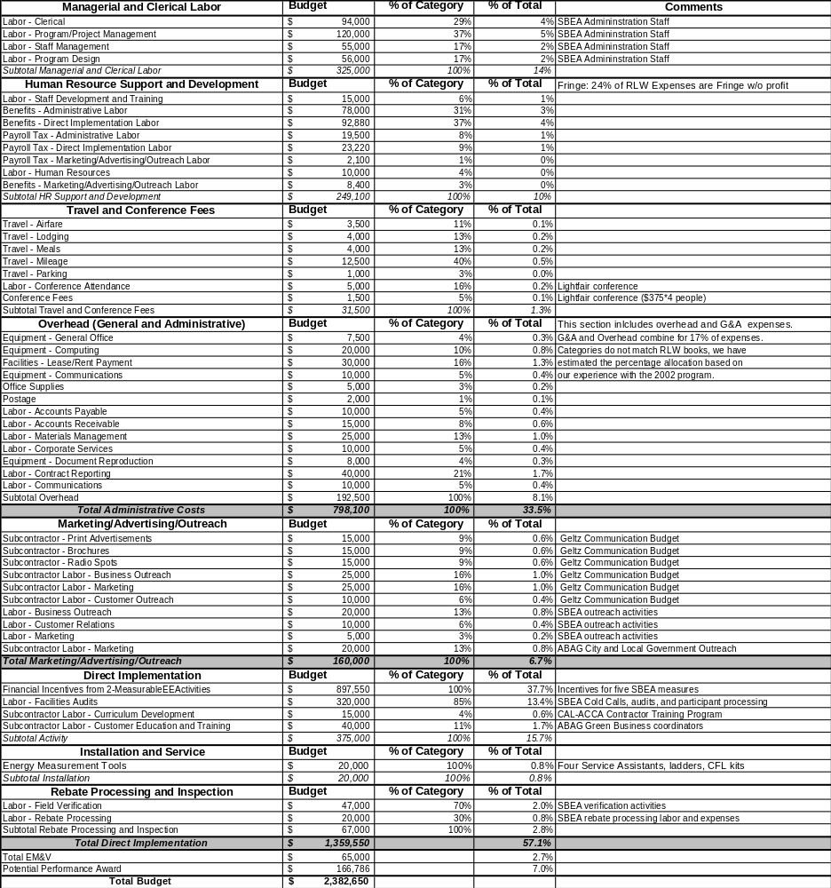

Table 5: Energy Savers Program 2004-05 Budget

2004 Reliability Must-Run Technical Study of the ISO-Controlled Grid. May 2003 Prepared by: Grid Planning Department

