BEFORE THE PUBLIC UTILITIES COMMISSION
OF THE STATE OF CALIFORNIA

Order Instituting Rulemaking to Examine Rulemaking 01-08-028
Commission’s Future Energy Efficiency Policies, (Filed August 23, 2001)
Administration and Programs

PROPOSAL – 2004-2005 ENERGY EFFICIENCY PROGRAM

AGRICULTURAL PUMPING EFFICIENCY PROGRAM – II – PG&E

CALIFORNIA STATE UNIVERSITY, FRESNO FOUNDATION

Peter Canessa
Center for Irrigation Technology
California State University, Fresno
5370 North Chestnut Avenue M/S OF18
Fresno, CA 93740
Tel. (559) 278-2066
Fax. (559) 278-6033
E-mail pcanessa@csufresno.edu

September 23, 2003

BEFORE THE PUBLIC UTILITIES COMMISSION
OF THE STATE OF CALIFORNIA

Order Instituting Rulemaking to Examine Rulemaking 01-08-028
Commission’s Future Energy Efficiency Policies, (Filed August 23, 2001)
Administration and Programs

PROPOSAL – 2004-2005 ENERGY EFFICIENCY PROGRAM

AGRICULTURAL PUMPING EFFICIENCY PROGRAM – II – PG&E

CALIFORNIA STATE UNIVERSITY, FRESNO FOUNDATION

Pursuant to Decision 03-08-067 of August 21, 2003, this proposal for an Energy Efficiency program for 2004-2005 is submitted by California State University, Fresno Foundation. The title of this proposal is Agricultural Pumping Efficiency Program-II-PG&E (“Program” or “APEP-II”). This program contains both information and measurable savings components. It is one of four proposals being submitted that will share a common administration and implementation plan.

Table of Contents

- Program Overview . . . . . . . 1
  - Program Concept . . . . . . . 1
  - Program Rationale . . . . . . 2
  - Program Objectives . . . . . . 4

- Program Process . . . . . . . . 5
  - Program Implementation . . . . . . 5
  - Marketing Plan . . . . . . . 9
  - Customer Enrollment . . . . . . 12
  - Materials . . . . . . . . 17
  - Payment of incentives . . . . . . 17
  - Staff and Subcontractor Responsibilities . . . . 18
  - Work Plan and Timeline for Program Implementation . . 20

- Customer Description . . . . . . . 20
  - Customer Description . . . . . . 20
  - Customer Eligibility . . . . . . 20
  - Customer Complaint Resolution . . . . . 22

  - Geographic Area . . . . . . . 23

- Measure and Activity Descriptions . . . . . 23
  - Energy Savings Assumption . . . . . 23
  - Deviations in Standard Cost-Effectiveness Values . . 25
  - Rebate Amounts . . . . . . . 25
  - Activities Descriptions . . . . . . 25

- Goals . . . . . . . . . 29

- Program Evaluation, Measurement, and Verification . . . 29

VII. Qualifications . . . . . . . . 33
  - Primary Implementer . . . . . . 33
  - Subcontractor . . . . . . . 35
  - Resumes . . . . . . . . 35

- Budget . . . . . . . . . 42

List of Figures

Figure 1a – View of the MEC ready for transport . . . . 6

Figure 1b – View of MEC in use for an educational seminar . . 6

Figure 2 – Excerpt from a pump efficiency test report using the standardized
software developed with APEP-I . . . . . . 8

Figure 3 – Example use of APEP-II program title, tag line, and logo . 10

Figure 4 – Record of Test form submitted for each Pump Efficiency Test . 14

Figure 5 – Instructions page for APEP-I Pump Retrofit/Repair Incentive
Rebate application . . . . . . . . 15

Figure 6 – Contract page for APEP-I Pump Retrofit/Repair Incentive
Rebate application . . . . . . . . 16

Figure 7 - Table of Organization for Agricultural Pumping Efficiency
Program – II – PG&E . . . . . . . . 19

List of Tables

Table 1 – Program goals and current and projected status for the current
APEP-I (Proposal 203-02A) . . . . . . . 2

Table 2 – Number of Pump Retrofit/Repair Projects and Pump Efficiency Tests
submitted to the Ag Peak Load Reduction Program (APLRP) and the
Agricultural Pumping Efficiency Program (APEP-I) since May 2002
(as of August 31, 2003) . . . . . . . 4

Table 3 – Numeric goals for the proposed APEP-II . . . . 5

Table 4 – Summary of marketing and educational materials produced by
APEP-I and to be used by APEP-II . . . . . . 11

Table 5 – Project statistics for Pump Retrofit/Repair Projects for the
Agricultural Peak Load Reduction Program (as of August 31, 2003) . 24

Table 6 – Project statistics for Pump Retrofit/Repair Projects for the current
Agricultural Pumping Efficiency Program (as of August 31, 2003) . . 24

Table 7 – Quantitative and qualitative goals for APEP-II . . . 29

Table 8 - EM&V Objectives and how APEP-II will address them . . 30

Table 9 – Budget Summary . . . . . . . 42

Agricultural Pumping Efficiency Program – II – PG&E

I. Program Overview

I.A Program Concept

APEP-II for 2004-2005 will build on the current Agricultural Pumping Efficiency Program (“APEP-I”), which is Proposal 230-02A funded by the CPUC through 2002-2003. APEP-II will operate in the service area of Pacific Gas and Electric Company. As with APEP-I, the goal of APEP-II is energy conservation in water pumping systems in both agricultural and commercial turf installations. The twin objectives of APEP-II are:

- Get highly efficient pumping systems in place.

- Manage those systems properly.

APEP-II program components are similar to APEP-I:

- Education to improve pumping system selection, maintenance, and operation as well as overall water management. The basic educational message has four parts:
  - Know how to specify an efficient pump.
  - Know how to maintain an efficient pump.
  - Know how much water needs to be pumped.
  - Know how much water has been pumped.

- Technical assistance to improve pumping system selection and overall energy efficiency, as well as to provide aid in arranging for a pump test or completing incentive rebate applications.

- Subsidized pumping plant efficiency testing (an audit of the pumping plant) to develop objective information necessary to enable a benefit/cost analysis for a pump retrofit/repair.

- Direct incentives for retrofit or repair of pumping plants to improve efficiency.

The intention is that the educational and informational aspects of the Program, especially the pump efficiency tests, coupled with the incentive rebate will persuade clients of the economic benefits of a pump retrofit/repair in order to improve pumping efficiency.

I.B Program Rationale

This proposal for APEP-II is basically for a continuation of the APEP-I (funded by CPUC for 2002-2003 as Proposal 230-02A). Both APEP-I and the proposed APEP-II contain information and measurable savings components. Table 1 lists major goals and current status of the current APEP-I as of August 31, 2003.

Table 1 – Program goals and current and projected status for the current APEP-I (Proposal 203-02A)

Efficiency  Measure | Total Program Goal | Achieved as of  August 31, 2003 |  | Projected to  December 31, 2003
Efficiency  Measure | Total Program Goal | Number | Net kwh/therm savings | Number | Net kwh/therm savings*
Electric Pump Retrofit/Repair | 325 | 33 | 940,195 | 75 | 2,136,806 kwh
Natural Gas Pump Retrofit/repair | 45 | 0 | 0 | 10 | 22,500 therm
Pump Efficiency Tests | 4,200 | 2,894 | NA | 4,200 | NA
Educational Seminars | 25 | 13 | NA | 25 | NA
* Net kwh/therm savings based on a .75 Net-to-Gross ratio; total kwh savings based on current rate of kwh savings per project

As indicated by Table 1 the current APEP-I will fulfill targets in education and pump efficiency tests. However, there seems to be a significant shortfall in the number of pump retrofit/repair projects. The word “seems” is used in light of two significant impediments to APEP-I in achieving its original goals:

- Delay in contract execution.

- Unexpected extension of another energy efficiency program by the California Energy Commission.

Delay in Contract Execution - Although the Commission approved the original APEP-I for implementation in May 2002 and the Program Implementation Plan was approved in July 2002, the contract with the Administrator was not signed until September 13, 2002. Thus, the bulk of the spring and summer 2002 pumping season was lost. This meant that many opportunities for pump efficiency testing were lost.

Not only did this impact the ability to achieve immediate goals for tests, it impacted goals for pump retrofit/repair incentives. This is because the APEP-I Policies and Procedures require that the retrofit/repair project be finished within one year of a pump efficiency test. To the extent that the APEP-I was unable to develop the objective information that flows from a pump test, agriculturalists would not be aware of the economics of a retrofit/repair nor would they have the prerequisite pump test to qualify for the Program.

Unexpected Extension of the Agricultural Peak Load Reduction Program – The most important issue though is that an existing grant program, the Agricultural Peak Load Reduction Program (“APLRP“) was unexpectedly extended through December 31, 2003 by the California Energy Commission. (The APLRP is funded by general tax revenues and authorized by SB 5x -2001). The APLRP also offers pump efficiency tests and grants for pump retrofit/repair projects. Thus, there has been some competition for available projects.

Table 2 lists the number of pump efficiency tests and pump retrofit/repair projects funded by APLRP and APEP-I since the approval of the APEP-I Program Implementation Plan. Not all of the tests/projects submitted under the APLRP would have been eligible for APEP-I (because of location within a municipal utility district). However, Table 2 does indicate that the APLRP impacted APEP-I’s operations substantially, especially as regards pump retrofit/repair projects. Note also that as the APEP-I marketing efforts have taken hold (“Jan 2003 – Aug 2003”), the number of pump repair projects submitted to APEP-I has risen.

Table 2 also indicates the demand for this type of program. The total number of pump efficiency tests submitted to both APLRP and APEP-I since May 2002 (column titled “Total May 2002 – Aug 2003”) indicates that the APEP-I easily fulfills pump efficiency test goals given a full sixteen months. And, although probably not fulfilling the original goal for pump retrofit/repairs, APEP-I would have had in the range of 400 projects given the full term (operating until December 2003) and without the APLRP in place.

As an additional indication for the potential for this program the Agricultural Peak Load Reduction Program has funded over 7,800 pump efficiency tests and 439 pump retrofit/repair projects since its start in June 2001.

The Rest of This Page Intentionally Left Blank
Table 2 – Number of Pump Retrofit/Repair Projects and Pump Efficiency Tests submitted to the Ag Peak Load Reduction Program (APLRP) and the Agricultural Pumping Efficiency Program (APEP-I) since May 2002 (as of August 31, 2003).

 | May 2002  –  Jun 2002 | Jul 2002  –  Aug 2002 | Sep 2002 –  Dec 2002 | Jan 2003 –  Aug 2003 | Total  May 2002 –  Aug 2003 | Total Net annual kwh savings  May 2002 –  Aug 2003*
Pump Retrofit/  Repair Projects – APLRP | 34 | 34 | 68 | 136 | 272 | 6,426,000
Pump Retrofit/  Repair Projects – APEP | 0 | 0 | 1 | 59 | 60 | 1,246,800
Total Retrofit/Repair Projects for Both Programs | 34 | 34 | 69 | 195 | 332 | 7,672,800
Pump Efficiency Tests – APLRP | 260 | 1424 | 482 | 798 | 2964 | NA
Pump Efficiency Tests – APEP | 0 | 0 | 76 | 2,876 | 2,952 | NA
Total Pump Efficiency Tests for Both Programs | 260 | 1,424 | 558 | 3,674 | 5,916 | NA
* Net kwh savings based on a .75 Net-to-Gross ratio; total kwh savings if all projects submitted are installed

I.C Program Objectives

The proposed APEP-II has objectives for pump retrofit/repair projects that will produce measurable savings as well as information-only activities. Table 3 lists the numeric and non-numeric goals for the proposed Program.

The Rest of This Page Intentionally Left Blank

Table 3 – Objectives for the proposed APEP-II

Efficiency Measure/Activity | Proposed Number | Net kwh/therm Savings*
Pump Retrofit/Repair Projects – electric | 500 | 15,937,5000
Pump Retrofit/Repair Projects – natural gas | 26 | 58,500
Pump Efficiency Tests | 5,400 | NA
Energy audits of irrigation systems by the Mobile Irrigation Laboratories | 170 | NA
Educational Seminars | 60 | NA
Further enhancement of educational facilities and curriculum for energy efficiency seminars at California State University, Chico (CSUC |  | NA
Development of a certification process for pump efficiency testers in California |  | NA
Enhancement of educational facilities at the CSU Fresno campus |  | NA
* Net kwh/therm Savings based on a .75 Net-to-Gross ratio

Note that the objectives for pump retrofit/repair projects during APEP-II are at a lower rate than for APEP-I (255/year for APEP-II versus about 280/year for APEP-I). In part this is recognition of the current, very poor agricultural economy. However, Program policies and procedures designed to reduce “free riders” seem to have had a larger than anticipated impact also on the number of submitted projects (e.g. no incentives for a repair of a broken pump).

II. Program Process

II.A Program Implementation

The proposed APEP-II builds on the current APEP-I and will be implemented in an identical manner. There are four major components:

- Education

- Technical Assistance

- Subsidized Pump Efficiency Tests

- Incentive Rebates for Pump Retrofit/Repair

APEP-II is one of four Local Program proposals for 2004-2005 by CSUF. All proposals are similarly titled, “Agricultural Pumping Efficiency Program-II-__”. They all propose the same type of program (information and measurable savings) except that each is for a different IOU service area and each has a different budget and numeric goals. The four programs will share a common administration and implementation process.

II.A.1 Education
The educational component will consist of:

- Presentation of 60 educational seminars utilizing the Mobile Education Centers (MEC) constructed during APEP-I and the CSUC and CSUF facilities. Figures 1a and 1b are views of the MEC ready for transport and during an educational seminar. The MECs are basically self-contained, mobile pumping plants. Equipment on board includes a generator, two types of pumps, a variable frequency drive, valving, and flowmeters. The system is instrumented and operating data is fed to a laptop computer and then projected on a screen for seminar attendees. The MEC is used to demonstrate pump performance curves, pump efficiency at different operating conditions, proper placement of flow meters, operations and economics of variable frequency drives, electric motor efficiency, and various other aspects of pump operation.

- Continued enhancement of programs at the five Mobile Irrigation Laboratories in the PG&E service area to a) ensure that energy efficiency is part of their message when an irrigation evaluation is performed, b) ensure that growers know how much water should be pumped, c) know how to measure water in the field, and d) act as trade allies in ensuring that farmers know of the Pump Efficiency Program.

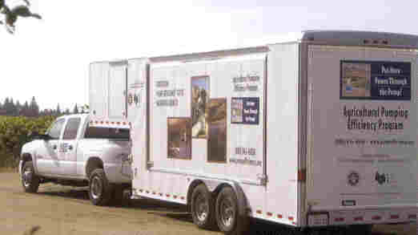  Figure 1a – MEC ready for transport | 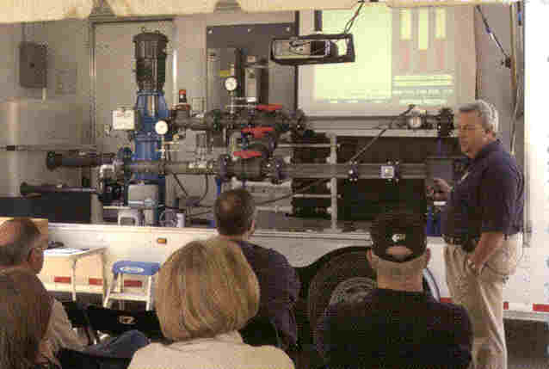  Figure 1b – MEC in use during an educational seminar

- Enhancement of the Pump and Meter Station of the water efficiency and pumping demonstration facility at California State University at Chico. This facility is being developed with funding from the Federal Bureau of Reclamation, the California Department of Water Resources, and private donations. APEP-I contributed funds so that energy efficiency was an integral part of the education message. APEP-II would fund the installation of a sprinkler-test site and variable frequency drives as well as curriculum development there.

- Enhancement of educational facilities at CSU Fresno.

The main messages of the educational component are:

- Ensure proper design of the pumping system.

- Ensure proper maintenance of the pumping system.

- Know how much water needs to be pumped.

- Know how much water has been pumped.

The last two points have generally not been parts of pump efficiency programs in the past. However, as has been pointed out by many, a pump repair may or may not reduce energy use. This is because a pump repair generally results in more water flow and thus, an increased pump load (e.g. higher horsepower input). If the farmer does not reduce the overall time of pumping then energy use is likely to increase. (This may be unavoidable, especially in situations where the poor pump performance has resulted in a water shortage on the farm.) Thus, an important aspect of the program will be to ensure that the full potential of the pump repair is achieved by a) helping clients to know how much water should be pumped; and b) helping clients to know how much water has been pumped.

II.A.2 Technical Assistance
Education provides sufficient information for some pumpers to make changes. However, others may require more specific assistance. APEP-II personnel will be available, both at seminars presented with the MECs and at other venues as available (local Farm Bureaus for example) to identify potential energy saving opportunities on an individual basis. The will also assist with program applications and follow up and verification of energy savings.

The education and technical assistance portions of the Program provide limited energy savings by themselves. However, technical assistance can be crucial to overcoming program barriers for some potential clients.

II.A.3 Subsidized Pump Efficiency Testing
Identifying and repairing existing, inefficient pumps is a very cost-effective way to reduce electricity use and increase flexibility to reduce pumping during peak hours. The program will provide an incentive to private pump suppliers and testers to conduct efficiency tests.

This component will not only provide an objective measure of current pump efficiency but also will develop projected economics resulting from improved efficiency. The pump efficiency test identifies power input to the pumping plant, water flow, total pressure in the system, static and pumping water levels in wells, overall pumping plant efficiency, and kilowatt (or therm) required per acre-foot of water pumped.

Subsidies are only available to Participating Pump Test companies. These are entities that have proven track records in this field. They use standardized computer software developed during APEP-I. An excerpt from the report showing the pumping cost analysis is seen in Figure 2.

CONFIDENTIAL/PROPRIETARY INFORMATION
Any Ranch Saturday, September 20, 2003
SUBJECT: PUMPING COST ANALYSIS
HP: 30 Plant: NORTH WELL
PUMP TEST REFERENCE NUMBER: 9999999
The following Pumping Cost Analysis is presented as an aid to your cost accounting. This analysis is an estimate prepared from data acquired from the pump test performed 10/22/2002 and information provided by you.
Please pay careful attention to the assumptions. The estimated savings are only valid
for the assumptions made and conditions measured during the pump test.
It is assumed that:
1. Overall plant efficiency is improved to: 62.0 %
2. Motor loaded at: 47.1 %
3. Flow rate will be: 1,512.0 gpm
4. Total Head will be: 23.0 feet = 23 ft PWL
5. Water requirements will be: 159.1 acre-feet/year
ESTIMATED
EXISTING EFFICIENCY IMPROVED EFFICIENCY SAVINGS
6. kWh/AF: 89 38 51.4
7. Estimated Total kWh: 14,201 6,028 8173
8. Average Cost per kWh: $0.17
9. Average Cost per hour: $3.02 $1.79 $1.22
10. Average Cost Per Acre Ft.: $15.18 $6.44 $8.73
11. Estimated Acre Ft. Per Year : 159.1 159.1
12. Overall Plant Efficiency: 26.3% 62.0
13. Estimated Total Annual Cost: $2,414.12 $1,024.77 $1,389.35

Figure 2 – Excerpt from a pump efficiency test report using the standardized software developed with APEP-I
APEP-II will be working directly through a new organization, the California Association of Pump Test Professionals (“CAPP”, non-profit corporation) to further ensure quality control. CAPP has published initial standards for pump testing in the field that all members must adhere to and is currently refining these standards.

APEP-II will continue on-going discussions with Southern California Edison Company so as to standardize pump testing throughout California. (SCE offers the Pump Testing and Hydraulic Services program in its service area.)

II.A.4 Subsidized energy audits of irrigation systems
APEP-II will work with the five Mobile Irrigation Laboratories in the PG&E service area to develop an audit tool that will provide for an energy efficiency analysis while the Mobile Lab evaluates the irrigation system.

II.A.4 Incentive Rebates for Pump Retrofit/Repair
The program will also provide incentives for repair/retrofit of existing electric and natural gas-powered pumping systems with new, more efficient equipment. This incentive will not apply to an inoperable pumping plant, a change in operating conditions required by a new irrigation (or other type of process) system, or for construction of a new well. The incentive for a pump repair will be paid directly to the pump owner.

It will be implemented with a process of application (see Figures 5 and 6), application review, notice of project completion, and payment just like the current APEP-I.

II.B Marketing Plan

The primary objective of the marketing plan is to reach small, medium and large agricultural and large turf operations and educate them on the benefits of retrofitting and/or replacing existing pumping equipment and how to effectively use the equipment in their operation. This will be done by:

- Program Branding: APEP-I created a program title and tag line that “name brands” the Program. Figure 3 is an example of how the program title, logo, and tag line are used on two of the Program’s brochures. APEP-II will continue to use this unified, consistent look in all printed materials, advertising, and education components.

The Rest of This Page Intentionally Left Blank
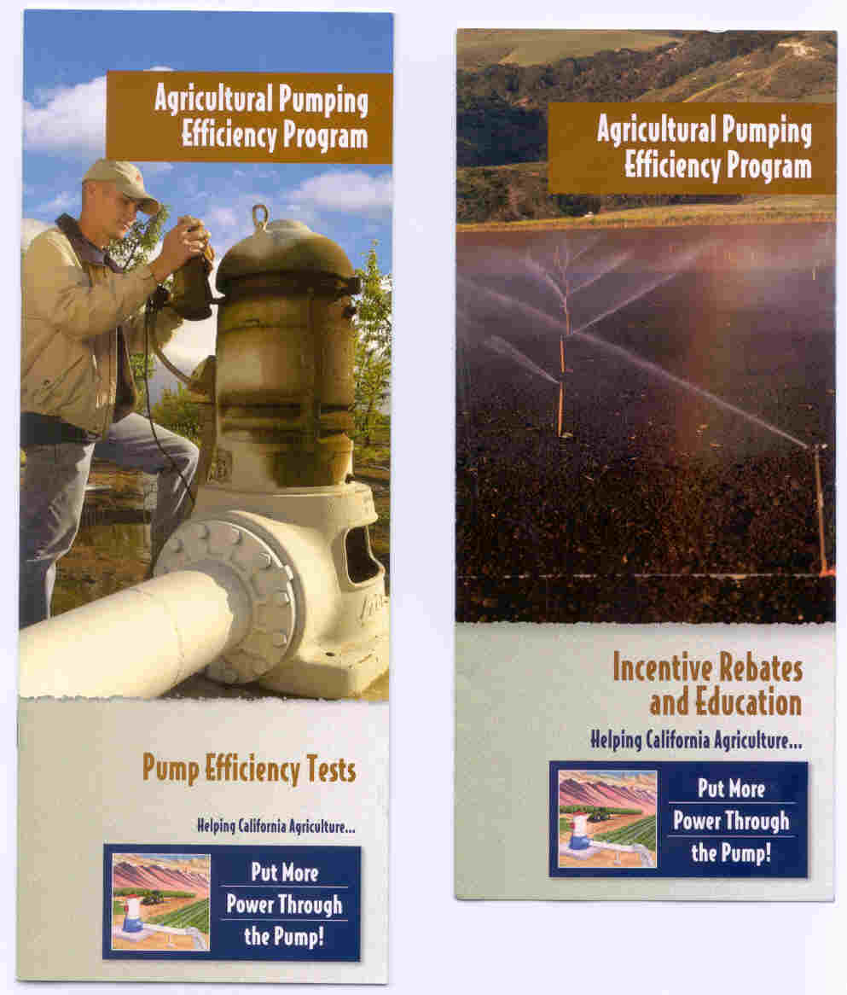

Figure 3 – Example use of APEP-II program title, tag line, and logo.

- Direct Mail – APEP-II will work with agricultural groups and organizations as much as possible. Use of their mailing lists is an effective and efficient method of marketing the APEP-II program.

- Collateral Material – collateral material will include:
Web Site – the web site is fully operational and incorporates complete program information and application forms. With the experience of APEP-I, success stories will also be posted.
Literature – Both educational and marketing information has been prepared under APEP-I. A full list is contained in Table 4. This information is distributed at:
- Program Education Events
- County Farm Bureaus and Ag-related Organizations
- Tradeshows
- Ag Energy & Irrigation Organizations
- Other Ag Organizations

Information/Press Kit – This consists of ready-to-use language for newsletters, web sites and other communications pieces for use by county Farm Bureaus, commodity groups, grower association and any other ag-oriented organizations to get the word out to their constituents. It includes:

- 1-2 paragraph program brief
- 1 page complete story with optional visuals
-picture of DPR trailer
-picture of working-over rig pulling a pump
-picture of a pump test in progress
- 2-3 page story with case study
- Copies of program literature
- Copies of related articles

Table 4 – Summary of marketing and educational materials produced by APEP-I and to be used by APEP-II

Materials | Material  Type | Print  Format | Approximate Number to be Printed for APEP-II
Program Web Page | Web site | .htm files | 1
Pump Repair/Retrofit  Incentive Rebate Application -Electric | 3 page -3 fold flyer | 2 – color | 5,000
Pump Repair/Retrofit  Incentive Rebate Application -Gas | 3 page -3 fold flyer | 2 – color | 2,000
Program Brochure | 1 page -3 fold | 4 – color | 30,000
Pump Efficiency Test | 12 page brochure | 4 – color | 2,500
Flow Meter Brochure | 12 page brochure | 4 - color | 2,500
Program Brochure – Spanish | 1 page -3 fold flyer | 4 – color | 10,000
Pump Test Brochure – Spanish | 12 page brochure | 4 - color | 1,000
Promotional Labels | 1 4X4 adhesive | 4 - color | 2,000
Educational Brochure | 8 page brochure | 4 – color | 2,500
Consolidated Education pamphlet | 24 page pamphlet (w/ the slide rule) | 4 - color | 10,000
Planning an Irrigation | 24 page brochure | 4 – color | 5,000
The Pumping Energy Calculator | 8 page brochure | 4 - color | 15,000
The Pumping Energy Calculator | Slide-Rule | 2 - color | 15,000
APEP Posters | Single Page 18 x 24 | 4 - color | 2,000
APEP Post-cards | Single page – 4 x 6 | 4 - color | 20,000
Pump Test Labels | Peel-off 4 x 4 | 1 - color | 10,000

- Trade Ally Materials – APEP-II will provide participating pump repair companies, pump test companies, farm equipment dealers, and irrigation supply dealers with program materials and a point-of-purchase display.

- Media Advertising – media advertising includes:
Print – placement of program specific ads in Ag Alert (ag weekly reaching 40,000 Farm Bureau members statewide) and California-targeted monthly agriculture publications such as California Farmer.

Radio – placement of program specific ads in early-morning agriculture-oriented programs on stations such as KMJ 580 (Central Valley) that have an extremely high agricultural audience. Promote program in general and upcoming educational events.

Local Newspapers – these will be used as needed to promote the APEP-II in regional media markets and also to promote success stories through media releases as they become available.

Event Outreach – APEP-II plans to participate in many agriculture-oriented tradeshows and events including but not limited to:

- Citrograph & Tree Fruit Expo - Visalia
- Grape Grower Magazine Farm Show - Caruthers
- Nut Grower Harvest Show - Modesto
- Grape Grower Magazine Farm Show- Lodi
- Ag Fresno - Fresno
- Stockton Ag Show - Stockton
- Unified Wine & Grape Symposium - Sacramento
- Colusa Farm Show - Colusa
- World Ag Expo - Tulare
- Vegetables West Show - Salinas

II.C Customer Enrollment

Customer enrollment procedures for APEP-II will be identical to APEP-I.

II.C.1 Education
There will be no cost to the client for educational programs. Education will be made available in several forms, including:

- Seminars presented at traditional, centralized locations such as the Center for Irrigation Technology at CSU Fresno or CSU Chico.

- Seminars presented at major trade shows such as the International Agricultural Exposition at Tulare.

- Use of the Mobile Education Centers to provide seminars at remote locations throughout the service area.

- A dedicated web site.

- Brochures and pamphlets available through the mail and distributed at the seminars and by trade allies (pump testers, pump repair companies, and the Mobile Irrigation Laboratories).

There will be local and statewide efforts at advertising time and location of educational seminars. Customers will learn of training opportunities through mailings, publicity in trade publications, participation in Mobile Irrigation Laboratory programs, articles in trade and local publications, and information on the APEP-II website. A formal reservation will be encouraged, especially for those programs and courses where space may be limited or where refreshments will be offered. However, the basic premise of this part of the Program is that all that the client has to do is “show up”.

II.C.2 Technical Assistance
There is no cost to the client for technical assistance. However, the client does have to request the assistance. This may be by personal contact at an education session, by phone, by fax, or by E-mail.

II.C.3 Pump Efficiency Testing
CIT will sign agreements with qualified private companies for performance of pump efficiency tests. These agreements will specify the level of accuracy required and how the developed information is conveyed to both the client and CIT. (It is noted that there is some embedded profit for the participating pump test companies.) The list of “participating pump test companies” will be made available through the web site, by mail, fax, or E-mail, through the Mobile Irrigation Laboratories, and marketing efforts of the pump test companies themselves.

Pump owners/operators will contact the individual pump test company directly and the pump test will be a business transaction between the client and the pump tester. The incentive for pump efficiency testing will be paid directly to the pump test company. They will invoice CIT on a monthly basis. The invoice package will include the signature of each participant on both an Access Agreement and a Record of Test (see Figure 4) to ensure that services have been rendered.

Tester – Please fill in this section and return to the Program

Pump Test Company_____________________
I certify that I performed a SERIES / SINGLE pump efficiency test (dated)__________
at the pump serviced by: Utility __________________ Meter: __________________
Tester Name (print):_____________________ Tester Signature: _________________________

Pump Operator/Owner – Please fill in this section
I certify that this pump efficiency test was not for the purposes of a real estate transaction or to fulfill requirements of any government or quasi-government agency. I further certify that I have legal authority over the operation of this pump.

I was given a record of the pump test containing all measured data and the calculated Overall Pumping Plant Efficiency and kilowatt-hours (or therms) required to pump an acre-foot of water. I am aware that the test information and a picture of the test section will be sent to the Program. I am also aware that the Program is providing a rebate to the pump tester.

Name (print) ____________________________
Business (print):________________________ Signature: _______________________________
Phone Number: _________________________ Position: ________________________________

Figure 4 – Record of Test form submitted with each pump efficiency test

II.C.4 Pump Repairs
Pump repairs will be performed by the private company of choice for each participant. CIT will utilize a system of incentive application, application review, and incentive payment similar to that used for the state-wide Express Efficiency programs offered by the IOUs. The instructions page and contract page of the current CPEP-I application is seen as Figures 5 and 6. The pump repair incentive will be available to any agricultural, industrial, or commercial gas or electric account where water pumping is the primary function.

The incentive will be available for any repair/retrofit of the existing well and pump that will improve efficiency or reduce total energy use. This will include:

- Repair or replacement of the bowl, impeller, or bearing (motor replacement is an Express Efficiency measure).

- Activities to improve the specific yield of a well so as to reduce drawdown.

- Installation of an approved flow meter as part of a pump repair/retrofit project.

- Tune-up or repair of a natural gas engine.

Specific ineligible activities include:

- Repairing an inoperable pump.
- Constructing a new well.

- Replacing the pump for purely cultural system-related reasons (e.g. switching to a pump with “pressure bowls” to be able to run a sprinkler system)

- Replacing damaged well casing except where it is shown that the damage is impacting pump efficiency.

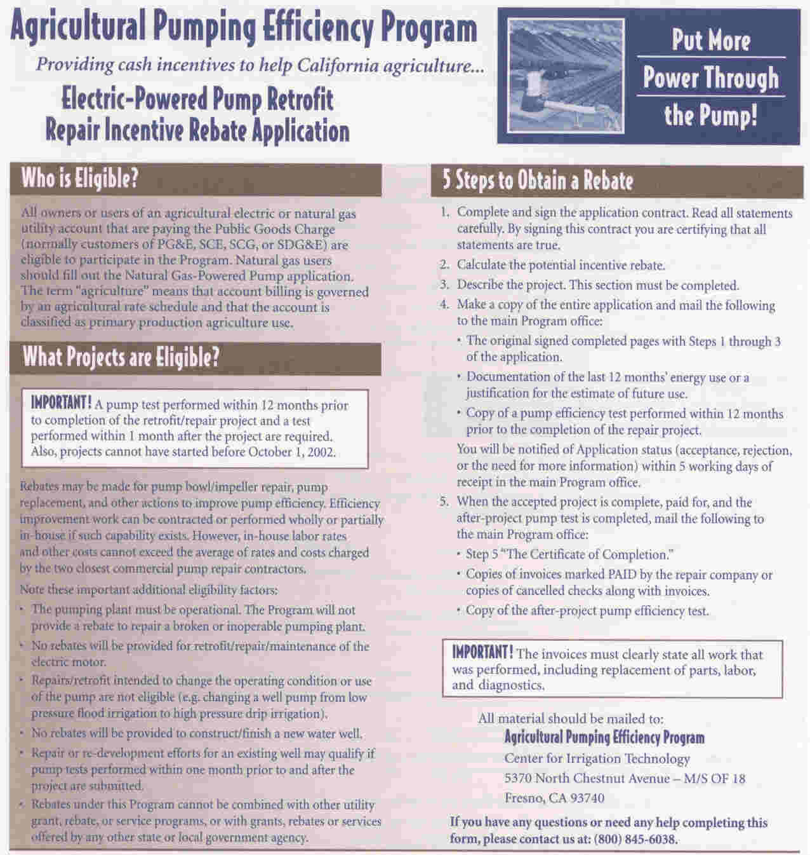

Figure 5 – Instructions page for APEP-I Pump Retrofit/Repair Incentive Rebate application form

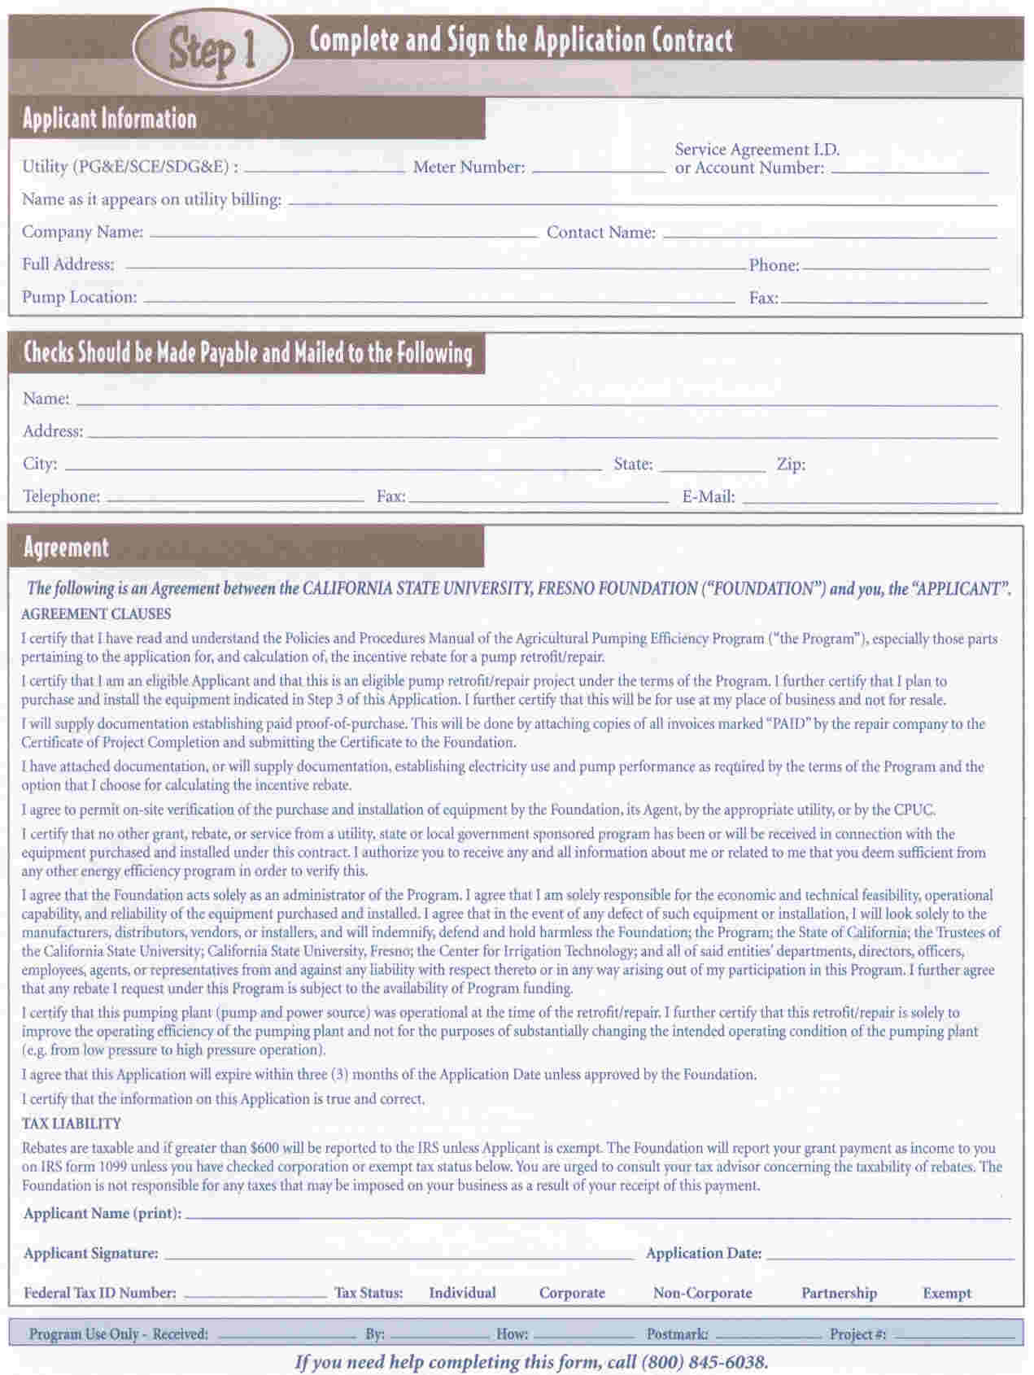

Figure 6 – Contract page for APEP-I Pump Retrofit/Repair Incentive Rebate application form
II.D Materials

This section is not applicable to either APEP-I or APEP-II. Pump retrofit/repair projects are a business transaction between the client and the pump repair company he/she chooses. Since the Program only pays the incentive rebate on submittal of a paid invoice, the assumption is that the work was done to the satisfaction of the client.

II.E Payment of Incentives

II.E.1 Subsidized Pump Efficiency Tests
Purchase Orders are issued to the Participating Pump Test Companies with an expiration date and an “invoice by” date. The submitted invoice package contains an Access Agreement, Record of Test, picture of the pumping station, and electronic record of all data and calculations. Payment is authorized directly to the Test Company as the invoice package is deemed complete.

II.E.2 Incentive Rebate for pump retrofit/repair
There will be two methods for computing potential incentive rebates for a pump retrofit/repair. One will utilize the actual performance improvement shown by the required pre- and post-repair pump efficiency tests. The equation for calculating the grant is:

Grant = .10 * (kwh annual – (kwh annual * pre-repair OPE / post-repair OPE))
Where:

kwh annual = 12 months of energy use prior to the repair.
OPE = Operating Plant Efficiency as tested.

This option must be used if the pre-project pump efficiency test shows an overall pumping efficiency of 50% or greater (35% for submersible pumps).

The other method will be used if the pre-test shows an OPE under 50%. It will then be assumed that the project will result in 33% improvement in pumping plant efficiency. This is provided that the repair includes repair or replacement of either or both of the pump impeller and bowl/volute. The equation for calculating the grant with this option is:

Grant = .10 * .25 * kwh annual

Where:

kwh annual = 12 months of energy use prior to the repair.

The incentive is capped at 50% of the project cost for both options.

When the client submits an invoice marked paid for the project the payment is authorized and a check is mailed directly to the client.

II.F Staff and Subcontractor Responsibilities

Figure 7 shows the projected Table of Organization for APEP-II

The Rest of This Page Intentionally Left Blank

Director of Center for Irrigation – Campus level planning and coordination
David Zoldoske
CSU, Fresno Foundation Liaisons
APEP-II Program Manager – Overall program planning and management Legal – John Melikian
Peter Canessa Accounting – Randy Larson
Contracts – Tom Campbell
Communications/Staff Supervision
Kate Norum

Secretary
Delia Zemora

Accounting
Bookkeeping Foundation Accounting Reporting
Nancy Munday Nathon Zanoni / Linda Christian Open

Education
Education Manager Specialist Specialist MEC Maintenance/Construction Support Consultant
William Green Lisa Basinal Tim Jacobson Hercules Gonsalves / Steve Martin Ed Norum

Area Coordinators – Local marketing, outreach, education
No. California No. San Joaquin So. San Joaquin Central Coast
Jim Tischer John Weddington Jerry McDonald Open

Rebate Processing – Pump efficiency tests, incentive rebates
Rebate Review Secretarial
Bob Hall Patti Senter

Marketing
Marketing Manager Consultant
Theresa Sebasto Hudson-Orth Communications

Evaluation, Measurement & Verification
Equipose Consulting

Figure 7 - Table of Organization for Agricultural Pumping Efficiency Program – II – PG&E

II.G Work Plan and Timeline for Program Implementation

This proposal is to basically continue APEP-I for 2004-2005. APEP-I is currently operational with personnel, policies and procedures, operations database, marketing, printed materials, an approved EM&V plan, rebate review, and reporting and accounting systems in place. The educational program is complete with printed material, presentations, visual aids, and the Mobile Education Centers in operation. Thus, APEP-II Program implementation is immediate. However there are several significant milestones for APEP-II. These would be:

- Issuance of new Professional Services Agreements for the Participating Pump Test Companies – to be completed by January 31, 2004. This will allow pump efficiency testing to commence.

- EM&V plan approved – as required by the current (September 2003) Draft 2004-5 Agreement for Non-Utility Energy Efficiency Implementers (“Draft Agreement”), within 30 days after selection of an approved contractor but not more than 120 days after proposal approval.

- New incentive rebate application forms printed and distributed – to be completed by January 31, 2004. Critical dates need to be changed and it is planned to not offer the option to use future energy use as the basis for a rebate calculation.

All other reporting activities would occur as per the current Draft Agreement.

III. Customer Description

III.A Customer Description

APEP-II is aimed at electric and natural gas utility accounts that pump water. These accounts will include:

- Production agriculture (farms, dairies, livestock operations, and nurseries)

- Large turf installations (golf courses, cemeteries, schools, commercial buildings)

III.B Customer Eligibility

Although the target audience is agricultural and large turf water pumpers, anyone is welcome to participate in the educational program. However, there are policies that govern eligibility for subsidized pump efficiency tests and the incentive rebate for a pump retrofit/repair.

Eligibility policies for subsidized pump efficiency tests include:

- Test is not required by a government or quasi-government agency.

- Test is not in association with a real estate transaction.

- No more than one test per year for a well and no more than one test every two years for a booster pump.

- If testing a water well, the pumping water level must be measurable.

Eligibility requirements for the incentive rebate include:

- The project must be completed within a year of an acceptable pump efficiency test (generally one performed by a participating pump test company).

- A pump test must be completed within one month after the project is completed.

- Fuel-switching projects are not eligible projects (for example, switching from natural gas power to an electric motor or vice-versa).

- The pumping plant must be operational. The Program will not provide a rebate to repair a broken or inoperable pumping plant.

- Repairs/retrofit intended to change the operating condition or use of the pumping plant are not eligible (e.g. changing a pump from low pressure flood irrigation to high pressure drip irrigation pump).

- No repairs or maintenance activities for electric motors are eligible. (Note that the investor-owned utilities may have energy efficiency programs that provide funds for these projects).

- No rebates will be provided to construct or finish a new well.

- Repair or re-development efforts for an existing well may qualify if pump tests taken within one month prior to and after the project are submitted.

- The incentive rebate cannot be combined with any other grant, rebate, or service offered for the project by one of the investor owned utilities or any state or local agency.

III.C Customer Complaint Resolution

The pump efficiency test and the pump repair will be business transactions between the individual pump testing or repair company, and the participant. To the extent there is a dispute regarding the performance of the test or pump repair it should be resolved through normal channels (Department of Consumer Affairs, Better Business Bureaus, etc.) and CSUF will not be involved.

To the extent that there is a dispute regarding payment to a participating pump test company or a pump repair participant by CSUF, the following general statement will apply (“Participant” refers to either a participating pump test company or an individual applying for a pump repair incentive; “Foundation” refers to the California State University, Fresno Foundation; “Parties” refers jointly to the Foundation and the Participant, “Agreement” refers to either the contractual relationship between participating pump test companies and the Foundation, or the Application by which the Foundation has approved a pump repair project for incentive payment):

The Parties shall attempt in good faith to resolve any dispute arising out of or relating to the Agreement. Either Party must give the other Party written notice of any dispute within twenty (20) Business Days of learning of the dispute.

If the Foundation’s designated representative and the Participant’s officer fail to reach an agreement within thirty (30) calendar days after commencing negotiations, either Party may initiate a mediation of the controversy within a reasonable period of time. Pending resolution, the Foundation shall continue to make payments for undisputed items.

All negotiations and any mediation conducted are confidential and shall be treated as compromise and settlement negotiations, to which Section 1152.5 of the California Evidence Code shall apply, and Section 1152.5 is incorporated herein by reference.

Notwithstanding the foregoing provisions, a Party may seek a preliminary injunction or other provisional judicial remedy if in its judgment such action is necessary to avoid irreparable damage or to preserve the status quo.

Pending resolution, the Foundation shall continue to make payments for undisputed items.

Note also the following language included in the current APEP-I’s Policies and Procedures manual (available on www.pumpefficiency.org):

“Participants in the Agricultural Pumping Efficiency Program who have complaints of any form can submit these complaints in the following manner:

- The first step is to file the complaint with the Program. Call toll free 1.800.845.6038 and tell the Operator that you wish to complain. The Operator will take all information. Program personnel will respond to the complaint in five working days. There is also a feedback form on the web site at WWW.PUMPEFFICIENCY.ORG where an e-mail message can be sent to the Program that is specifically marked as a complaint.

- If you do not hear from the Program within five working days, or are not satisfied with the Program’s response, you may submit your complaint to the Investor Owned Utility that is administrating this Program on behalf of the California Public Utilities Commission. Contact the Pacific Gas & Electric Company Business Customer Center at 1.800.468.4743.

- If you are not satisfied with the response from either or both of the Program or Pacific Gas and Electric Company you can submit your complaint directly to the Public Utilities Commission by contacting Mr. Tim Drew at 1.415.703.5618.”

III.D Geographic Area

The Program will operate in the entire service area of Pacific Gas and Electric Company.

IV. Measure and Activity Descriptions

IV.A Energy Savings Assumptions

There are no peak demand (kw) savings claimed for the pump retrofit/repair.

The annual energy savings assumed are derived from experience with both the Agricultural Peak Load Program (APLRP) and APEP-I. Table 5 lists statistics regarding the 439 approved pump retrofit/repair projects in APLRP and Table 6 lists the same for 54 approved projects in APEP-I.

It is important to note that the numbers for before-project pumping plant efficiency and after-project efficiency are similar for each data set, about 38% before the retrofit/repair and 61% afterwards. This indicates a 61% improvement in pumping plant efficiency. Both APLRP and APEP-I use 33% as a default assumption. Thus, the kwh savings from pump retrofit/repair appear to be much greater than expected.

Further, the budget for APEP-I was predicated on an average, gross 31,500 kwh savings/year per project. Tables 5 and 6 indicate that the savings are probably more in the range of 60,000 kwh savings/year (gross) for all projects and 45,000 kwh savings/year (gross) when the larger pumps are excluded. This proposal is using a conservative estimate of 42,500 kwh savings/year. Absent significant data, the same 2,250 therm savings/year used in APEP-I is used for APEP-II

Table 5 – Project statistics for Pump Retrofit/Repair Projects for the Agricultural Peak Load Reduction Program (as of August 31, 2003)

 | All Projects (statewide) | Excluding Pumps with > 500,000 kwh Use per Year
Average OPE Before Project* | 38% | 38%
Average OPE After Project | 61% | 61%
Average Annual kwh Use | 157,491 | 130,419
Average Annual kwh Savings | 59,382 | 49,174
Average Project Cost | $12,099 | $11,637
Average Rebate | $3,964 | $3,572
* OPE – Overall Pumping Plant Efficiency

Table 6 – Project statistics for Pump Retrofit/Repair Projects for the current Agricultural Pumping Efficiency Program (as of August 31, 2003)

 | All Projects (all IOU areas) | Excluding Pumps with > 500,000 kwh Use per Year
Average OPE Before Project* | 38% | 38%
Average OPE After Project | 62% | 61%
Average Annual kwh Use | 161,052 | 109,642
Average Annual kwh Savings | 62,342 | 41,340
Average Project Cost | $12,799 | $11,673
Average Rebate | $3,336 | $2,656
* OPE – Overall Pumping Plant Efficiency

In Tables 5 and 6 the estimated annual kwh savings are calculated using the following equation:

KWHsave = Current – ((OPE1 / OPE2) * Current)

Where:
KWHsave = estimated gross annual kwh savings
Current = current annual kwh use (established by submittal of billing records)
OPE1 = overall pumping plant efficiency prior to retrofit/repair
OPE2 = overall pumping plant efficiency after the retrofit/repair

Note that a key assumption is that the same amount of water is pumped in the twelve months after the retrofit/repair as before.

IV.B Deviations in Standard Cost-effectiveness Values

Net-to-Gross ratio - A Net-to-Gross ratio of .75, listed for Agricultural and Dairy Measures in Table 4.2 of the Energy Efficiency manual (version 2 August 2003) is used.

Estimated Useful Life - Pump retrofit/repair projects are not listed in Table 4.1 of the manual. However, Process Overhaul is listed with a 20 year life. This proposal uses a conservative 15 years as the Estimated Useful Life for a pump retrofit/repair. (Note that 15 years was also used in the approved proposal for APEP-I.)

Incremental Measure Cost - There is no practical “efficient” option for the pump retrofit/repair. Thus the IMC is the cost of the repair itself. (It is intended that the information and the incentive rebate provided by the Program results in a pump retrofit/repair much sooner than would normally be expected.) Currently, the average actual project cost for the 439 approved pump retrofit/repairs in the Agricultural Peak Load Reduction Program is $12,099. The average project cost for 54 approved projects in APEP-I is $12,799. An IMC of $12,500 is used for this proposal.

IV.C Rebate Amounts

The rebate is based on a conservative estimate of the first year expected kwh savings at the rate of $.10/kwh. Rebate amounts will vary depending on the annual energy use of the pumping plant and in some cases, the actual improvement in pump efficiency. Please refer to section II.E.2 for a description of how the rebate is calculated. The current average rebate for APEP-I is $3,336. This represents about 26% of the average project cost. An average rebate of $3,350 is used for this proposal.

IV.D Activities Descriptions

Pump Efficiency Tester Qualification – Currently there is no qualification process for pump efficiency testers outside the apprentice-type program used by Southern California Edison Company (and formally by Pacific Gas & Electric Company). Although a short two-day tutorial in pump efficiency testing theory and techniques is offered by the Irrigation Training and Research Center at California Polytechnic University at San Luis Obispo (ITRC), there is no objective field testing or peer-review process for proving tester qualification. APEP-II will be working with a new organization, the California Association of Pump Test Professionals (“CAPP”), a non-profit corporation. A majority of CAPP membership are ex-utility pump testers or pump repair companies. CAPP has published initial standards for pump testing in the field that all members must agree to follow. In addition they are working with the Hydraulics Institute to further refine these standards. APEP-II will be providing administrative services for the two years of the Program while this much-needed organization develops independent funding sources. In addition, APEP-II will work with CAPP, SCE, and ITRC in order to develop an objective qualification process. This will include in-field demonstration by the tester that he/she can test accurately as well as safely, in a variety of environments.

Mobile Irrigation Laboratories (“Mobile Labs”) – Mobile Labs evaluate (audit) irrigation systems and system management as a means of improving irrigation efficiency in California. There are eight of these groups scattered throughout California. APEP-I worked with the Mobile Labs to integrate the energy efficiency message into their evaluation procedures and reporting. APEP-II will continue this effort. It will include providing written material to the Labs for inclusion in their reports, development of an energy audit tool for irrigation systems management, training in the use of the energy evaluation software developed under APEP-I, and specialized educational seminars. It is planned that 170 irrigation system evaluations will be accompanied by an energy audit using the developed tool. In addition, APEP-II personnel will accompany the Mobile Labs on field evaluations in order to provide “real world” training in recognizing and communicating energy efficiency opportunities.

IV.D.1 Education – The APEP-II education program includes a knowledge base on the Program web site, written materials, and educational seminars. The educational message has four parts:

- Know how to specify an efficient pump – introduction to the pump performance curve and the components of overall pumping plant efficiency; importance of identifying the required operating condition (combination of pump flow and total system head); what to do with fluctuating operating conditions; trade-offs with different types of power sources; variable frequency drives.

- Know how to maintain an efficient pump – this goes beyond the “janitorial” aspects of pumping plant maintenance. The key issue is to recognize a) if the required operating condition has changed or if the pump operating condition has changed.

- Know how much water needs to be pumped – the focus is on the individual irrigation. Each irrigation should have a purpose- put a specific amount of water in a specific volume of soil, as uniformly across the field as possible. The most efficient pump in the world wastes energy if run twice as long as needed.

- Know how much water has been pumped – it is essential to measure water flow and volume to manage water. It does no good to know how much water needs to be pumped if one cannot measure the amount that actually has been pumped.

Some 60 educational seminars are planned for 2004-2005, 6 or more will utilize the facilities at CSU Chico, at a direct cost of $2,500 each.

Brochures, many in Spanish, are available that discuss all of the above. In addition, the Mobile Education Centers are available throughout the service area for seminars. Table 4 lists the type of educational materials available and the projected number to be printed and distributed.

Part of the education program will be further enhancement of the facilities at California State University, Chico (CSUC). CSUC serves as the northern California “anchor” for the Program. Its educational facilities include several instrumented water wells and a pumping demonstration site along side working agricultural fields. This allows for educational seminars addressing both pump efficiency and irrigation efficiency. APEP-II will continue the partnership started by APEP-I by funding the construction of a sprinkler-test site and extending other capabilities of the educational facility. $60,000 will be utilized for this purpose.

The enhancements at CSUC will allow demonstration of the following:

- Effects of using a variable frequency drive on various types of pumps in common use in agriculture.

- Effects of system maintenance on delivery efficiency (e.g. effects of sprinkler nozzle wear).

- Effects of wind on distribution uniformity and energy use of sprinkler systems.

- Practical applications of low-pressure sprinkler nozzles (currently a measure on the Express Efficiency program).

Another part of the Education program will be enhancement of the facilities at California State University, Fresno. $1.8 million dollars has been appropriated by the federal Environmental Protection Agency and $25,000 by the federal Bureau of Reclamation for the purpose of constructing a specialized pump demonstration, flow measurement calibration, and educational facility. CSUF is allocating an approximate 1.5 acre site for this purpose valued approximately $250,000. This proposal allocates $425,000 in matching funds.

IV.D.2 Pump Efficiency Tests – pump efficiency tests provide objective information concerning current pumping plant performance, including the all-important overall pumping plant efficiency (OPE). Because experience provides guidance as to the potential OPE, APEP-II can provide a pumping cost analysis that can help the client make an informed judgment as to when to retrofit/repair an inefficient pumping plant. APEP-II subsidizes pump tests at the rate of $200/test.

IV.D.3 Mobile Irrigation Laboratories – APEP-II views energy use in the agricultural sector with the following equation:

KWHyear = KWHaf * AFyear

Where
KWHyear = annual energy use
KWHaf = kilowatt-hours required to pump an acre-foot of water
AFyear = acre-feet of water pumped per year

If reducing energy consumption one can reduce the KWHaf, most commonly by improving the overall pumping plant efficiency, but also by reducing required system pressure; or by reducing the acre-feet needed to pump. The Mobile Labs mission is to reduce the number of acre-feet pumped by improving distribution uniformity and irrigation efficiency. APEP-I and the proposed APEP-II work with the Mobile Labs to ensure that the energy-savings aspects of improved water management are communicated to the client. (Note that another real benefit of working with the Mobile Labs is that they become another marketing team for the Program and the energy efficiency message.)

APEP-II will provide the Mobile Labs with the written educational material for each irrigation system evaluation they perform. There will also be two special educational seminars offered and APEP-II personnel will go into the field with the Mobile Labs to provide guidance in recognizing energy-savings opportunities.

APEP-II will also develop an audit tool that the Mobile Labs can use to perform an energy audit of the irrigation system in conjunction with their normal water efficiency audit. The APEP-II objective is 170 of these audits at a cost of $200/each.

The cost of the planned effort is approximately $50,000 for this proposal.

IV.D.4 Administrative duties for CAPP – the California Association of Pump test Professionals is a new group consisting of pump efficiency testers throughout the state. The majority of their membership are either ex-utility testers or pump repair companies. There is no current certification process in place for pump testers. This group has written initial test standards that all members must adhere to and is in the process of refining these standards in consultation with the Hydraulics Institute. APEP-II will develop and maintain the group’s web site. The site, among other things, will allow potential pump test clients to easily find a tester in their area.

Currently there is no certification process for pump efficiency testers outside the apprentice-type program used by Southern California Edison Company (and formally by Pacific Gas & Electric Company). APEP-II will also be working with CAPP to develop a certification process that will include field work and peer review. APEP-II will provide other administrative services and guidance as needed. $30,000 will be allocated for these efforts.

V. Goals

Table 7 lists the goals for the 2004-2005 APEP-II.

Table 7 – Quantitative and Qualitative Goals for APEP-II

Program Component | Goal | Net Annual kWh/Therm Savings
Education
Educational seminars | 60 | NA
CSU Chico Facilities | Installation of VFD, sprinkler demonstration test site | NA
Mobile Irrigation Labs | Development of energy audit tool for irrigation system evaluations – 170 evaluations | NA
Written materials | As per Table 4 | NA
CSU Fresno Facilities | Matching funds to help construct a multi-purpose water technology/pump demonstration, flow meter calibration, and educational  facility | NA
Pump Efficiency Tests | 5,400 | NA
Pump Retrofit/Repair Incentive Rebates | 526 | 15,937,500 kwh  33,750 therm

VI. Program EM&V

VI.A Approach

All evaluations must address a set of eight overall objectives stated in the CPUC Energy Efficiency Policy Manual (EEPM – version 2 of August 25, 2003). The eight objectives are listed in Table 8 below along with a description of how each might be addressed by the chosen evaluation team.

Table 8 - EM&V Objectives and how APEP-II will address them

CPUC Objective | How evaluation is expected to meet the objective
1. Measuring level of energy and peak demand savings achieved. | The chosen evaluation team is expected to use IPMVP Option A to measure the energy impact of the program. It is expected that the approach will be the same as was used for the 2002/03 Program It is noted that this approach relies on the information from both pre-repair and post-repair pump tests. If pre- and post-repair pump tests are not performed, then this approach must be updated. No peak demand impacts are expected and peak demand savings will not be assessed.
2. Measuring cost-effectiveness (except information-only) | The evaluation team will use data pulls from the program database to track and verify the pump tests and pump repairs. This information will be provided to APEP for use in the CPUC worksheets to calculate a TRC.
3. Providing up-front market assessments and baseline analysis, especially for new programs | Since market assessments have been completed within the last five years for this sector, a market assessment or baseline analysis will not be done as a part of this evaluation.
4. Providing ongoing feedback and corrective and constructive guidance regarding the implementation of programs. | The evaluation team will be expected to provide communication both orally and via email to the program manager as needed. Additionally, written feedback and recommendations is expected to occur in the report.
5. Measuring indicators of the effectiveness of specific programs, including testing of the assumptions that underlie the program theory and approach. | A thorough evaluability assessment was done on the 2002/03 program. The evaluation team is expected to update, as needed, the implementation theory and program theory from that assessment. The evaluation of the 2004/05 program will use the updated program theory to identify possible indicators of immediate, intermediate, and long-range outcomes, and assess the desirability and feasibility of obtaining these indicator data in light of the stated Program objectives and the evaluation performed previously on the 2002/03 program.
6. Assessing the overall levels of performance and success of programs. | The evaluation team is expected to assess the extent to which the Program achieved its stated objectives through the various areas of the program evaluation.
7. Informing decisions regarding compensation and final payments. (except information-only) | The chosen evaluation team will track the total kWh impact in comparison to the planned kWh objectives for the program and provide this data as needed to the Program Implementer and/or CPUC to inform decisions regarding compensation and final payments.
8. Helping to assess whether there is a continuing need for the program. | The evaluation team will use all the information gathered during the evaluation of the 2004/05 program to help assess the need for this program in the future.

EM&V Components for the Pump Repairs
In addition to meeting the objectives above, the evaluation needs to address issues around baseline, energy efficiency measures, and EM&V approach. We have suggested how the evaluation may choose to meet these issues below. It is expected that the final evaluation plan by the evaluation team will fully explain all required components.

Baseline Information
For the energy component of the Program, the baseline is defined as the state of the customer before program participation. The pre-repair pump tests provide all necessary data on the state of the customer before participation. The baseline information on awareness and knowledge of growers and water agencies is covered in previous evaluation reports.

Energy Efficiency Measure Information
The Program plans to provide incentives for that the following types of pumping plant energy efficiency changes:
- Replace either the bowls and/or impeller in the pump assembly
- Clean well to reduce draw down.
- Remove or replace valves and fittings that have high-pressure losses, if they are within 10 feet of the pump head discharge.
- Encourage actions that reduce air entrainment.
It is expected that the final EM&V report will include a full listing of energy efficiency measures implemented through the incentives and the frequency of each, derived from program tracking information.

Measurement and Verification Approach
The M&V approach for the 2004/05 program is expected to be identical to what occurred for the 2002/03 program. Details are provided below.
The Program provides subsidies for pump testing or incentives to undertake a capital investment to make a change to their pumping equipment. The pump repair component is designed to generate energy savings, and thus, must undergo a measurement and verification. The CPUC has stipulated that the measurement and verification of the local programs must adhere to guidelines in the International Performance Measurement and Verification Protocol (IPMVP). For this Program, Option A of the IPMVP is the most appropriate approach to use. This is called the Partially Measured Retrofit Isolation approach in which savings are determined by partial field measurement of the energy use of the system to which an energy conservation measure (ECM) is applied. It is an engineering calculation using post-retrofit measurements and stipulations. In this case, the pre- and post-retrofit pump tests supply the majority of the parameters of the energy savings, but billing data is required to obtain estimated annual energy savings. It is the billing data that is the stipulated parameter within this option. The algorithm planned to be used to calculate energy savings from the pump repairs is shown below.
Program Energy Impact Algorithm
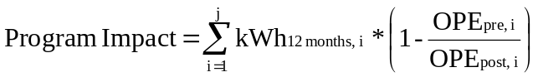
Where:
j = number of pump repair participants
kWh = 12 months of actual billing data from the pump, assumed to be pre-repair in most cases, this data obtained from the grower
OPE = operating pump efficiency, pre and post, from pump tests on that pump

Any deviation from this algorithm on a per-site level is expected to be thoroughly documented in the draft and final reports.
While the evaluation team will rely on the data from the Program to calculate energy impacts attributable to the program, a complete verification of the data is expected to occur. An analysis of the database in which the data reside will be performed along with verification of the electronic data through paper copy backups. This will be done on a quarterly basis.
The net-to-gross ratio as specified in this proposal will be kept and used in the final evaluation of net energy impact. No net-to-gross analysis is expected to occur in this evaluation.

Evaluation Approach
The evaluation team will assess what has been evaluated from the 2002/03 program and use that information to build upon the 2004/05 evaluation approach. It is possible that a process evaluation may be done to analyze the program implementation linkages from the evaluability assessment. It is expected that an impact evaluation, which involves testing the hypothesized causal linkages illustrated in the program theory will occur. The chosen evaluation team will document in the final evaluation plan which of these linkages will be assessed.

VI.B Potential EM&V Contractors
Equipoise Consulting Inc. Team - The Program has chosen the team currently evaluating the 2002/03 program as one of the two potential EM&V contractors. For the reasons mentioned below, we feel that the Equipoise Team is the best choice to evaluate the 2004/05 program.

This team, headed by Equipoise Consulting Inc. and including Ridge & Associates, Vanward Consulting, and California AgQuest Consulting, Inc., has provided exemplary evaluation services to date. None of the firms on this team have any known conflict of interest with this program. This was determined during the first selection process and remains true to date. An objective evaluation of this program requires knowledge about the agricultural sector to assure that factual knowledge is used and that the evaluation is not biased in some way due to uninformed choices. Additionally, California AgQuest Consulting provides a wide range of technical services for production agriculture and related industries, which provides this team with invaluable first-hand knowledge of the market targeted by the Program.

Nexant Consulting - An alternate EM&V contractor is Nexant Consulting. Nexant evaluates key performance indicators to help program managers monitor progress, measure results, and diagnose market response to program features. They conduct quantitative program evaluations to determine how much impact (e.g., on energy, peak demand, emissions, etc.) client programs are achieving in the market and at what cost. Their expertise ranges from statistical techniques to sample and analyze large populations of program participants to technology-based techniques to measure and analyze end use and process performance. They have been designated an approved EM&V contractor for the 2002-2003 Local Programs.

VI.C Proposed EM&V Budget

The proposed APEP-II program will budget 4% of the total program cost for the evaluation effort. While EM&V budgets can vary between 4%-10%, the 2002/03 APEP-I budget was 4% of the program costs and was indicated to be adequate by the 2002/03 evaluation team. The effort required for the evaluation of the 2004/05 program is expected to be of similar magnitude.

VII. Qualifications

VII.A Primary Implementer

Center for Irrigation Technology at California State University, Fresno acting as Program Manager on behalf of the California State University, Fresno Foundation
The Center for Irrigation Technology (CIT) is a research center operating under the auspices of the Department of Agricultural Sciences on the campus of California State University, Fresno. CIT holds a unique position as an independent research and testing facility, serving a vital role in assisting designers, manufacturers and users of irrigation equipment to make technological advances. CIT is experienced with working with multiple projects, with funding from both government agencies and private companies. Current CIT projects include:

- Development of a rapid seepage assessment protocol utilizing geo-referenced electromagnetic inductance measurements (funded by U.S. Bureau of Reclamation)

- Development and implementation of a comprehensive educational program in water and energy resources management (funded by California Department of Water Resources)

- Training in the use of scientific irrigation scheduling (funded by U.S. Bureau of Reclamation)

- Development and maintenance of the WATERIGHT site, an internet web site dedicated to improved water and energy management (funded by the U.S. Bureau of Reclamation).

- Development of standards and testing for backflow preventers for agricultural pumping station installations (funded by the California Department of Pesticide Regulation).

- Grant Administrator for the Agricultural Peak Load Reduction Program, a grant program for reducing peak period demand managed by the California Energy Commission (funded through Senate Bill 5x-1, 2001)

Past publications and projects relating to energy use in agriculture include:

- Irrigation Equipment Performance Report: Drip Emitters and Micro-Sprinklers - A Complete Guide to Understanding and Interpreting Drip Emitter and Micro sprinkler Test Results

- Impact of Water Storage on Irrigation Costs: Merritt Farms, A Case Study - Final Report

- Field Determination of Agricultural Pumping Plant Electric Motor Efficiencies

- The Economics of Energy Conservation in Turf Irrigation

- Sensors and Techniques for Irrigation Management

The Center for Irrigation Technology is directed by Dave Zoldoske, EdD. The proposed Program will be managed by Peter Canessa, P.E.

VII.B Subcontractor

Equipose Consulting
Equipoise Consulting (Equipoise) focuses on sustainable energy resource analysis, project management and training services for the utility industry. Our staff have over 28 year of experience providing services to the commercial, industrial, and governmental business sectors. The combined energy feasibility studies, assessments and evaluations conducted by Equipoise staff represent over 240 megawatts of electrical demand, 1,200 gigawatt-hours of conserved electrical energy, and 3,000 kilotherms of thermal energy. The projects assessed include wind power generation, geothermal power generation, cogeneration, conservation technology feasibility, electric vehicle infrastructure development, industrial energy conservation, commercial energy conservation, agricultural energy conservation, energy efficiency design review, advanced commercial conservation design, and Demand Side Management (DSM) program planning and evaluation.
Equipoise Consulting Incorporated, in association with California AgQuest Consulting, has assembled a team (the Equipoise/AgQuest Team) that has the expertise and experience needed to evaluate these programs. The Equipoise/AgQuest Team will use the experience gained during PG&E’s 1994, 1995, 1996 and 1997, 1998 carryover agricultural evaluations, and subsequent retention studies, to specify an approach that maximizes use of accumulated data.

VII.C Resumes of Program Management

VII.C.1 DAVID F. ZOLDOSKE – Director, Center for Irrigation Technology

ADDRESS
5370 North Chestnut Avenue – M/S OF 18
California State University, Fresno
Fresno, CA 93740
(559) 278-2066
david_zoldoske@csufresno.edu

AREAS OF EXPERTISE
- Program Leadership
- Educational Opportunities
- Analytic Studies
- Grants and Contracts Management

EDUCATION
EdD, Education University of La Verne La Verne, CA
(Leadership)

MS, Agriculture California State
(Economics) University, Fresno Fresno, CA

BS, Agricultural Business California State
University, Fresno Fresno, CA

EXPERIENCE
1994- Present Director (70%), Center for Irrigation Technology (CIT), California State University, Fresno. Requires administrating all aspects of the management of the Center including: planning and budgeting (currently at 12 million dollars); promotion and public relations with community and industry; liaison with advisory board; provide educational opportunities to the public, development of contract projects for applied research, supervision of staff and research; training and publications efforts.

2000- Present Associate Director (20%), California Water Institute, California State University, Fresno. Given the charge from Proposition 13 to develop the Water Institute. Activities include developing partnerships with three sister CSU campuses, working with campus president to secure funding from CSU Chancellor’s office, obtain building space, hire and supervise staff, allocate and fund campus research projects, and create advisory board.

2002 - Present Interim Director (10%), International Center for Water Technology, California State University, Fresno. Working directly with approximately 40 flow technology companies in the San Joaquin Valley to secure funding for a proposed 35 million dollar technology building on campus. Responsibilities include establishing an interim industry board, project leadership, and providing liaison between the community and the University.

1990 - 1993 Assistant Director, Center for Irrigation Technology (CIT), California State University, Fresno. Specific duties include developing educational programs for the irrigation industry, promotion of Center activities, developing grant and contract proposals, supervision of staff and students positions supporting the Director's duties as required, and performing special projects as assigned.

1986 - 1990 Hydraulic Lab Manager, Center for Irrigation Technology (CIT), California State University, Fresno. Responsible for the operations of the internationally recognized research laboratory, including program development, liaison with private sector clientele, educational efforts, and supervision of staff and students positions.

1983 - 1985 Research Technician, Center for Irrigation Technology (CIT), California State University, Fresno. Worked primarily in laboratory and field research and providing technical support to farming enterprise. Assisted faculty and graduate students in conducting field trials and research.

HONORS AND RECOGNITION
Recognized nationally as one of 18 Environmental Stewards and Innovators in the Golf Industry by the Golfweek’s Superintendent NEWS, October 26th, 2001.

Honorary Life Membership in the American Society of Irrigation Consultants, May 2001.

National Water and Energy Conservation Award presented to CIT by the Irrigation Association, 1998.

Roy Williams Memorial Award presented to CIT for service to the industry by the American Society of Irrigation Consultants, 1996.

Edwin J. Hunter Industry Achievement Award presented to CIT for service to the industry by Hunter Industries, 1994.

PROFESSIONAL ACTIVITIES
Elected Vice-President (2002) by the membership of the Irrigation Association. responsible for approval and expenditures of the annual 2.3 million dollar association budget. This includes oversight for performance of executive director and staff.

Elected President (2002) by the membership of the American Society of Agronomy, California Chapter.

Advisory Board Member for the American Vineyard magazine, Lawn & Landscape magazine and Irrigation Journal magazine. Also serve as a frequent columnist for the California Grower magazine.

Member, Irrigation Association Long Range Planning Council, July 1994, to November 1995. Council is responsible for identifying and recommending long-term goals and objectives to the Board of Directors of Irrigation Association.

USA delegate to ISO / TC23 / SC18 Committee, Tel Aviv, Israel, October 1993. In association with the American National Standards Institute (ANSI), represented the USA position in developing international irrigation standards.

USA delegate to ISO / TC23 / SC18 Committee, aix en Provence, France, September 1991. In association with the American National Standards Institute (ANSI), represented the USA position in developing international irrigation standards.

INTERNATIONAL INVITATIONS
Project Director for the Zimbabwe Irrigation Technology Center, Harare, Zimbabwe. Completed contract for design, training, and development of testing and research facility, Nov./Dec., 1996.

Visiting Scholar to the Dzhambul Institute for Irrigation, Land Reclamation and Civil Engineering (DICI), located in Dzhambul, Kazakhstan, USSR. Agreement made to develop joint irrigation demonstration and educational plots in Dzhambul region, May 1991.

Keynote Address to the Fourth International Micro-Irrigation Congress, Albury-Wadonga, Australia. Presentation on The Role of an Independent Test Laboratory in Micro-Irrigation". October 23 - 28, 1988

PUBLICATIONS
Over 80 publications with references available upon request.

VII.C.2 Peter Canessa, P.E. – APEP-II Program Manager

ADDRESS
665 Asilo
Arroyo Grande, CA 93420
(866) 473-0847
pcanessa@charter.net

EDUCATION
- Bachelor of Science - Industrial Engineering, California Polytechnic State University, San Luis Obispo, 1972 (with Honors)
- Master of Science - Irrigation and Drainage Engineering, Utah State University, Logan, 1977
- Additional post-graduate studies, Utah State University, 1983-1984

EXPERTISE
- Agricultural Water, Water Quality, and Energy Management
- Microcomputer Applications for Business and Engineering
- Education (extension or classroom)

PARTIAL LIST OF CLIENTS/PROJECTS
Center for Irrigation Technology, Fresno State University (1999 to present)
- content development and improvements to irrigation scheduling system for the WATERIGHT web site
- development of seepage assessment vehicle utilizing geo-referenced electro-magnetic inductance instrumentation
- teaching of Agricultural Water Resources Management in California
- program design and management - Agricultural Peak Load Reduction Program, an incentive rebate program funded by Senate Bill 5x (2001) through the California Energy Commission (funded to $19,000,000)
- program design and management – Agricultural Pumping Efficiency Program, an information and incentive rebate program funded through the Public Goods Charge under the auspices of the California Public Utilities Commission (funded to $6,400,000)

Narromine Irrigation Board, Narromine, NSW, Australia (1999 to 2001)
- development of an Action Plan to guide improvements in the irrigation district's operations to address seepage control, water measurement accuracy, energy use, and on-farm efficiency

Macquarie River Food & Fibre, Macquarie Valley Landcare Group, and New South Wales Agriculture, Dubbo, NSW, Australia (1998 to 2001)
- implementation of an irrigation management evaluation/improvement program

San Diego County Water Authority, San Diego, CA (1996 to 2002)
- investigations to identify water conservation opportunities and implementation costs in Imperial Irrigation District in support of on-going negotiations between SDCWA and IID for a potential long-term water transfer agreement

Pacific Gas & Electric Company, San Francisco, CA (1991 to 2002)
- presentation of educational seminars for Agricultural Account Representatives concerning recognition and analysis of energy efficiency projects in irrigation systems
- development of revised Financial Incentives Application process
- development of new Incentive products
- preparation and review of Incentive Applications for validity
- co-author of analysis of Kerman, CA, Photovoltaic Site for agricultural production systems
- analyses of selected measures of the energy efficiency program for agricultural power-users, including gated and transfer pipelines, low-pressure sprinkler nozzles, surge-valves, time-clocks, variable frequency drives, micro-irrigation, and automatic pump re-starters for irrigation systems, plate-coolers and heat-exchangers for dairies, and thermal curtains for greenhouses
- technical advisor for measurement and evaluation studies of the Agricultural Incentive Program’s gross and net energy savings for 1994 through 1997

Monterey County Water Resources Agency, Salinas, CA (1991 - 1998)
- preparation of draft Nitrate Management Program document (addressing groundwater contamination)
- evaluation of different methods for groundwater extraction reporting
- feasibility study of using Agricultural Commissioner's Office pesticide-use data for preparation of summary land/water-use statistics in Salinas Valley
- review of the Agency's Water Conservation Plan
- Consultant to CH2M-Hill, Inc. (a consultant to the US Bureau of Reclamation) during the 1991 MCWRA-Bureau of Reclamation Joint Land-Use Survey, responsible for the development of a Salinas Valley crop calendar, identification of common crop rotations, and preliminary estimates of crop water use; development of crop water demand simulation programming for estimating average annual net and gross water demands as well as serving as database for the crop calendars, rotations, climatic information, and crop water use estimates

Washington State University, Pullman, WA (1993 - 1997)
- Project Coordinator writing/publicizing a Best Management Practices manual addressing non-point source pollution for irrigated agriculture in Eastern Washington under a joint Washington State Department of Ecology/ WSU Cooperative Extension project

California Energy Commission, Sacramento, CA (1992)
- co-author with Kurt Schulbach, University of California Cooperative Extension, of position paper discussing possible responses to higher electrical energy costs by Central Coast agriculture

Irrigation Training and Research Center, California Polytechnic State University, San Luis Obispo (1991 - 1993)
- co-author of Irrigation and Drainage in the Grassland Area of the Westside of the San Joaquin Valley by Dr. Charles Burt, R. Walker, P. Canessa, K. Robison, a study funded by the Central Valley Regional Water Quality Control Board (contract 1-078-150-1)
- co-author of Irrigation Efficiencies in Parts of the Selenium Drainage Area on the West Side of the San Joaquin Valley by Dr. Charles Burt, P. Canessa, J. Parrish, a study funded by the CVRWQCB (agreement #45902062)

California Polytechnic State University at San Luis Obispo, Agricultural Engineering Department (1991-1993 and 1980-1982)
- Lecturer in agricultural water management, irrigation science and irrigation system design

Central California Irrigation District, Los Banos, CA (1990-1991)
- Water Conservation Coordinator for the eight Grasslands area water districts (a project funded by the California Department of Water Resources) - development and implementation of the area’s first formal water conservation program including preparation, dissemination, and presentation of educational materials, a weekly newspaper column, and the monthly New Irrigator newsletter

Westlands Water District, Fresno, CA (1987-1991)
- Project Advisor performing irrigation system efficiency evaluations under the California Department of Water Resources/Westlands Water District/Westside Resource Conservation District-sponsored Water Management and Drainage Reduction programs
- development of ICE, the Irrigation Cost Evaluator- programming for rapid analysis of alternative irrigation system’s benefits and costs
- rewrite and further development of the District's Water Conservation Handbook

Also...
Irrigation Engineer, Superior Farming Company, Bakersfield, CA (1977-1980)
- irrigation system design, installation, and maintenance (fully automated drip, automated surface, tailwater return systems, level basins, high and low-pressure pumping plants)
- irrigation scheduling (computer program development, neutron probe operation, field consultations)
(Superior Farming was a 38,000 acre, fully diversified, extremely modern farm with operations in the central and southern San Joaquin Valley, the Coachella Valley, and Tucson, Arizona. Superior Farming was a leader in the development and adaptation of modern water management including micro-irrigation, computerized water-budget irrigation scheduling, and linear sprinklers. By 1980, Superior had well over 15,000 acres in drip and was using neutron probes, on-site weather stations and an on-site IBM 32 computer for irrigation scheduling and irrigation system design)

MEMBER
- American Society of Agricultural Engineers
- United States Committee on Irrigation and Drainage
- California Irrigation Institute
- Soil and Water Conservation Society

VIII. Budget

This proposal is for a continuation of the current APEP-I. APEP-I was funded for 2002-2003 in the PG&E service area for $4,820,684 for an eighteen month program. This equates to $6,427,579 over two years. In comparison, the proposed APEP-II is budgeted at $6,131,702. This reflects two things, 1) some startup costs are avoided with APEP-II, but 2) the bulk of activity is expected in the PG&E service area.

Table 9 – Summary Budget

Budget Category | Amount | Sub Total | % of Budget
Administrative |  | $1,361,970.47 | 22.2%
Managerial/Clerical Labor | $222,190.00
Human Resources Support | $425,190.72
Travel and Conference Fees | $151,250.00
Overhead/G&A/Materials | $563,339.75
Marketing/Advertising/Outreach | $343,345.00 | $343,345.00 | 5.6%
Direct Implementation |  | $4,179,060.25 | 68.2%
Financial Incentives to Clients | $1,762,100.00
Activity – Labor | $1,618,550.00
Hardware and Materials | $654,556.25
Rebate Processing | $143,854.00
Evaluation, Measurement, & Verification |  | $247,326.63 | 4.0%
EM&V Labor | $7,012.50
EM&V Overhead | $240,314.13
Budget Total |  | $6,131,702.35 | 100%

Financial incentives are composed of 526 pump retrofit/rebate projects with an average incentive rebate of $3,350 each.

There is a significant information component to the Direct Implementation budget of this program. Objectives include 5,400 pump efficiency tests at a cost of $200 each, 170 irrigation system audits at a cost of $200 each, 60 educational seminars at a cost of $1,500 each (not counting travel), enhancement of facilities at CSU Chico, and enhancement of facilities at CSU Fresno. Itemized these would be:

Pump efficiency tests – 5,400 @ $200 = $1,080,000.
Irrigation system energy audits – 170 @ $200 = $34,000
Educational seminars - $90,000
Enhancement of facilities at CSU Chico - $55,000
Enhancement of facilities at CSU Fresno - $425,000

Respectively Submitted,

Peter Canessa
Program Manager
665 Asilo
Arroyo Grande, CA 93420
(866) 473-0847
pcanessa@charter.net

