Confirmation Number: ___________

Program Name:
Local Crosscutting
Diverse Market Outreach Program
by
Southern California Gas Company

Contact Person: Frank Spasaro
Address: 555 West Fifth Street, GT 28F2
Los Angeles, California 90013-1046
Telephone: 213-244-3648
E-mail: fspasaro@semprautilities.com

All Public Goods Charge (PGC) programs proposed by SoCalGas:

STATEWIDE | LOCAL
Single Family Rebates Program | Diverse Market Outreach Program
Multi-Family Rebates Program | Nonresidential Financial Incentive Program
Home Energy Efficiency Survey Program
California Energy Star® New Homes Program | PARTNERSHIPS
Express Efficiency Program | Bakersfield/Kern Energy Watch Partnership
Nonresidential Energy Audit Program | Energy Coalition
Building Operator Certification Program | LA County
Savings By Design Program | South Bay Cities Council of Governments
Educational Training Program | Ventura REA
Codes & Standards Program | UC/CSU
Emerging Technologies Program

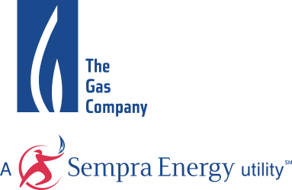 September 23, 2003

Table of Contents
Diverse Market OUtreach Program Proposal

Section I. Program Overview 1
A. Program Concept 1
B. Program Rationale 1
C. Program Objectives 5
Section II. Program Process 7
A. Program Implementation 7
B. Marketing Plan 10
C. Customer Enrollment 10
D. Materials 10
E. Payment of Incentives 10
F. Staff and Subcontractor Responsibilities 11
G. Work Plan and Timeline for Program Implementation 12
Section III. Customer Description 13
A. Customer Eligibility 14
B. Customer Complaint Resolution – 14
C. Geographic Area 15
Section IV. Measure and Activity Description 16
Section V. Goals 16
Section VI Program Evaluation, Measurement and Verification 16
Section VII. Qualifications 18
Section VIII. Budget 22

Diverse Markets Outreach Program (DMOP)

Section I. Program Overview

Program Concept
The Diverse Markets Outreach program (DMOP) is an energy efficiency information program, currently being offered in the service territory of Southern California Gas Company (SoCalGas). The program targets hard-to-reach residential and commercial customers with comprehensive information and facilitates easy access to the array of available resources they need to improve the energy efficiency of their homes and businesses, thereby helping them to save them time and money.

The primary program focus is to provide high quality energy efficiency information to hard-to-reach customers. It does so by promoting the full range of energy efficiency programs, offered by the Investor Owned Utilities (IOU), the municipal utilities and third party energy efficiency programs as well as energy efficiency financing and funding resources. The proposed scope of program activity is possible because the program can leverage a number of existing utility resources, at no additional cost to the program, thereby stretching the reach and impact of its program funding.

Program Rationale
In many cases the biggest obstacle customers face in implementing energy efficiency measures is simply knowing which opportunities apply in which areas and how to go about availing oneself of the benefits. Add to that full slate of options, the fact that the information is provided in a language in which the customer is less than fluent, and you have a need for a Diverse Markets Outreach program. DMOP serves to filter the vast assortment of statewide and regional energy efficiency program information, cutting across energy service providers, allowing customers in the SoCalGas service territory the ability to quickly identify the set of energy efficiency programs that best serve their unique needs.

SoCalGas’ customers overlap all three electric utilities’ service areas and several and municipal utilities as well. This can present a challenge to customers looking for program information, but confused about their eligibility or the applicability of similar energy efficiency programs offered by the IOUs, third parties, municipal utilities and other agencies. DMOP acts as a clearinghouse of all energy efficiency program information and can tailor an unbiased information package for customers based on their location and service type (residential or commercial).

DMOP was first awarded funding in the second half of 2002 and extended into 2003. It has successfully generated awareness and interest about energy efficiency programs, especially in hard-to-reach communities through targeted in-language and English program materials. The program addresses the need for coordination among different programs with parallel goals, by serving as a single source clearinghouse of information to connect hard-to-reach customers with a wide array of programs in the region. By the end of 2003, DMOP will have reached over 400,000 residential customers through direct outreach , 12,000,000 customers through media communications and more than 80,000 commercial customers through its direct and mass media outreach of information about utility and non-utility energy efficiency programs.
For many hard-to-reach communities, word of mouth is one of the most effective methods of information dissemination. Through the endeavors of SoCalGas’ Public Advisors, DMOP has elevated community leaders’ awareness of energy efficiency, which has resulted in the willingness of 92 community groups and chambers of commerce to add a DMOP presentation to their meeting agendas. Armed with a customized and region specific package of energy efficiency program information, they then can pass the information to their constituents.

Direct Outreach efforts to both the residential and commercial markets have included:
- Distribution of energy efficiency brochures, in English, Spanish Chinese, Korean and Vietnamese;
- Presentation of workshops/seminars to community groups in English, Spanish, Chinese and Korean;
- Sponsorship and participation in community events and trade shows;
- Distribution of Energy Efficiency Information Kits customized to the customer’s specific regional and/or market segment needs;
- On-site visits to commercial business centers by the Energy Efficiency InfoVan (formerly known as the Mobile Energy Workshop).
- Energy Efficiency InfoCenter with a toll-free number as a one-stop resource to help connect small business customers with resources they need to improve energy efficiency at their facilities.
Mass media efforts to both the residential and commercial markets have included:
- TV and radio interviews on Chinese language stations
- Print advertising - in English, Spanish, Chinese, Korean and Vietnamese
- Multi-lingual Press releases to special interest and community publications;
- Multi-lingual bill inserts
- Mass mailings

DMOP raises the bar for best practices among information programs. Its innovative approach recognizes that multiple communication channels are required to reach and inform the diverse residential and commercial market segments classified as hard-to-reach. The DMOP takes that philosophy to heart, making it happen through its multi-pronged, proactive, “go-to-the-customer” approach to customer outreach.

DMOP is designed to overcome the many barriers that separate the hard-to-reach customer from the information they need to assess their individual or business energy efficiency needs and then match those needs with the appropriate program resources. The grassroots outreach approach used by this program results in a relaxed environment where customers readily learn about energy efficiency. Once informed and on the energy efficiency bandwagon these customers have a higher likelihood of becoming emissaries themselves, helping to spread the information to others in the hard-to-reach community.
Working with those in the hard-to-reach community we have identified several key factors that prevent these customers from getting the information they need to help them take advantage of the myriad of energy efficiency opportunities. The DMOP is specifically designed to focus on those market barriers, including : 1) lack of information; 2) confusing and overlapping program information; 3) isolation from mainstream communication channels; 4) language barriers; 5) lack of time; 6) trust in the information resource.
These DMOP strategy for overcoming each of those barriers is set forth below.
- Lack of information: Research has demonstrated that a relatively small portion of residential and commercial customers are aware of existing energy efficiency programs.
Strategy: Get the information to the customer in a manner and form that facilitates receipt and retention. If you give the customers the information but they throw it in the recycling bin with the junk mail or never read it, it is the same as not giving it to them at all. DMOP brings the information to events or places where interested customers can ask questions and pick up printed material regarding available energy efficiency programs.
- Confusing and overlapping program information: Changing market and regulatory conditions have resulted in the inclusion of many independent third party sources of local energy efficiency programs. These programs are sometimes restricted to a specific and narrow customer type or geographic area while some programs may appear to offer the same or similar measures. SoCalGas customers who are also municipal utility customers are eligible for an entirely different mix of energy efficiency programs.
Strategy: Provide information tailored to the specific customer’s service type and area. Interested customers can fill out a DMOP Business Reply Card (BRC) or make a request by phone to the SoCalGas Call Center or Energy Efficiency InfoCenter. DMOP program staff will customize an information packet that will demystify the process and put the customer in touch with the right parties providing services suited to their unique needs.

- Isolation from mainstream communication channels: Customers who live outside the LA Basin or who do not speak English as their predominate language can find themselves outside of the mainstream communication channel.
Strategy: Provide a multi-lingual mass media campaign employing multi-lingual print communications, multi-lingual e-mail communications, and multi-lingual audio press releases. Last year the DMOP program placed ads/information pieces in XX local newspapers specifically targeted to the Y community. X of those are primarily serve the Chinese, X the Korean, X the Vietnamese and x the Spanish speaking communities within the SoCalGas region. The commercial mass mailings are targeted to very small and small business customers whose businesses lie outside of the Los Angeles Basin.
- Language barriers: A large percentage of the hard-to-reach community speak a language other than English as their primary language. Of those that do speak English as a second language many do not feel entirely comfortable in their fluency.
Strategy: Get the word out in the customers’ language(s). DMOP outreach material is available in five languages and Call Center staff is multi lingual. Program brochures, fact sheets and presentations are available in English, Spanish, Chinese, Vietnamese and Korean. The same program information is also available @www.socalgas.com in Spanish, Chinese and English.
- Lack of time: Most owners/operators of small commercial businesses are busy with day-to-day operations and cannot afford the time to attend seminars or to read and digest materials mailed to them.
Strategy: Bring the material to the customer on their time schedule. The DMOP program provides personalized information through one-on-one phone calls and on-site visits with its innovative Energy Efficiency InfoVan bringing relevant energy efficiency information to hard-to-reach business customers’ facilities.

- Trust in information resource: The 2002 Multi Cultural Market Study revealed that 66% of Korean, 62% Chinese, 41% Vietnamese, 47% Spanish and 49% of English speaking customers seek advice from SoCalGas when they have questions about energy. A small commercial and industrial customer market research project conducted during the same time frame also finds that the bulk of respondents see SoCalGas as their main source of reliable energy-related information..

Strategy: Make SoCalGas the central source for information about energy savings programs offered by all utilities. That is the heart and soul of the DMOP program. It is what makes it unique and what ultimately makes it so effective.

The DMOP is a very unique program. Because SoCalGas is a unifying factor for customers served by the three major electric utilities as well as a variety of municipal and independent providers this program has been able to reach a broad base of users with a full range of energy efficiency and conservation options. Building upon the success and customer response to the DMOP , we propose to step up our targeted and proactive outreach efforts in 2004.

Program Objectives
The DMOP Program is designed to achieve:
- Awareness building regarding the benefits of energy efficiency, especially amongst hard-to-reach community members;
- Education directed to the hard-to-reach customer that is targeted to identify their unique set of energy efficiency resources;
3) Optimized dissemination of energy efficiency information through the most effective distribution formats and channels
To achieve the first objective the DMOP will use a mix of multi-lingual mass-marketing and more directed communication strategies. Awareness-building efforts will include the following outreach strategies:
- Community alliances
- Media relations
- Bill inserts
- Print ads
- Websites/Electronic mail

In order to build awareness we must not only know which communities need the information but equally important is knowing how best to deliver that information. Last year the DMOP successfully drew upon market segmentation methods to target specific hard-to-reach customer groups and identify their needs with respect to energy efficiency information. In 2004, we will continue that effort in addition to using information from the Residential Appliance Saturation Study to perform a detailed market study to understand better which customer groups are currently installing energy efficiency upgrades in their homes and following energy conservation practices and identify groups that may benefit from further targeted communication and outreach efforts.

Satisfying the objective of educating hard-to-reach customers on energy and water efficiency programs that can best serve their unique needs will require the extensive use of the following multi-lingual outreach strategies and tools:
- Workshop presentations through the Energy Efficiency InfoVan and community organizations.
- Distribution of brochures and technical publications
- Display booths for residents and businesses at community and trade events
- Residential customer call center contacts
- Commercial/Industrial customer call center contacts
- Commercial/Industrial service technician visits
- Energy Efficiency InfoCenter (Help Desk)
- SoCalGas Web site
- Direct-mail Home Energy Efficiency Survey
- Referrals to outside resources and programs

Achieving the third objective of optimizing the dissemination of energy and water efficiency information through the most effective channels has been and will continue to be achieved by leveraging the extensive in-house resources, experience, and infrastructure available at SoCalGas with the materials and resources available from the individual program providers. Calling on SoCalGas’ in-house capabilities and overarching customer network will extend the program’s effectiveness without expanding it’s budget. SoCalGas is in the unique position of being able to act as a clearinghouse for the energy efficiency and water conservation programs offered by the various investor owned electric utilities municipal utilities or other water and electricity providers. The SoCalGas Energy Resource Center can direct customers to the appropriate energy efficiency workshops regardless of who the electricity provider may be. The SoCalGas call center will serve as a primary point of contact with residential customers. Public Affairs Managers within SoCalGas will call upon their extensive contacts within cities and business and community organizations. A dedicated team of residential-sector customer service representatives (CSRS) and commercial service technicians (CSTs) are already in contact with customers on a daily basis. The program will piggy-back on all of these contacts to disseminate energy efficiency information to customers. Having those representatives and technicians be able to provide information and materials on the programs being offered by other providers, adds little if any additional cost. On the other hand, having each of the utilities and third party providers create and support a distribution network of the same depth and breadth would strain the budget of each and diminish the objective of all – to inform the greatest number of users and achieve the maximum energy efficiency and water conservation possible.

Section II. Program Process

A. Program Implementation
SoCalGas has been successfully conducting outreach through the DMOP for the past 16 months. If the Commission chooses to continue to fund this highly successful and popular program the current outreach activities will continue and expand. The DMOP will build on its on-going program to advance community awareness of energy efficiency and promote the full range of utility and non-utility programs and resources. The program will encourage and advocate for participation in all energy efficiency programs, including utility programs offered by SCE, LADWP, other municipal utilities, and water conservation programs offered by MWD (Metropolitan Water District) and its member water agencies. The Diverse Markets Outreach program is an important lead generator for other energy efficiency initiatives. Since the information will be fuel-neutral, both gas and electric programs benefit from the synergistic relationship with this program.
The program will also connect customers with the array of additional resources available, including financing and funding resources and non-utility Internet-based resources. Four key Internet sources that will be featured include the Energy Star® Web site (www.energystar.gov), the California Energy Commission’s Consumer Energy Center (www.consumerenergycenter.org), the Department of Energy’s “Energy and Efficiency” web site (http://www.energy.gov/efficiency/index.html) and energy efficiency and conservation information available in Spanish, Chinese and English on socalgas.com.

The name of the Diverse Market Outreach Program itself tells the story of its implementation scheme – it is without question multi-tracked and varied. Included among the implementation methods are the production of multi-lingual brochures, seminars, workshops, a traveling show that takes the answers to the questioners, as well as computer and telephone based networks where the questioners can come for the answers at their convenience.

Workshops and Seminars
Keeping as a primary focus the goal of reaching out to hard-to-reach customers, the DMOP seminars and workshops are conducted as part of the agenda at a variety of familiar settings such as chamber of commerce meetings, special interest clubs, faith based meetings, etc. The DMOP is not a program confined to the hallowed halls of any institution. It is instead, a program that puts itself out there in the form of trained company representatives who can answer questions and distribute program information where the people are. It is a program that intends to be a visible and viable presence at community events, fairs and local celebrations. In addition SoCalGas’ customer service representatives offer DMOP program information to customers who call to inquire about energy efficiency rebates. Commercial Service technicians also have DMOP program brochures available to provide to small business customers during service calls.

Energy Efficiency InfoVan

The Energy Efficiency InfoVan is a key and truly unique feature of the DMOP program. The Energy Efficiency InfoVans disseminate energy efficiency information to owners and/or operators of small commercial businesses through workshops that are held in “strip-mall” shopping centers where the concentration of small hard-to-reach commercial customers is high. The energy efficiency information that is provided to the customers includes brochures on how to save energy and reduce costs for lighting, HVAC, hot water and process loads as well as application forms for various energy efficiency programs. The customers are provided information on how to obtain rebates and other financial assistance. Rebate and financial assistance forms are reviewed with the customers. As needed, they are assisted in completing these forms and the mail-in energy survey offered by SoCalGas.

The workshops are conducted in strip malls where a portable booth is set up. It is a very visible presence. The booth is stocked with information regarding SoCalGas’ and SCE’s statewide, local and third-party energy efficiency programs as well as municipal utility programs suitable for these hard-to-reach, business customers.

Each workshop is conducted informally. Workshops are scheduled to start throughout the business day, with the starting and ending times arranged to maximize participation. Recruitment is done by going door-to-door each morning and inviting the business owners to participate in a workshop. A compact fluorescent light bulb for each business owner/manager is offered as an incentive for participating. They are informed that by installing this light bulb (which qualifies for rebate through the Statewide Express Efficiency program), they can save about 12 dollars per year.

During each workshop, the presentation begins with a discussion of the value of energy cost reduction. An explanation is given of how energy cost reduction translates directly to profit for the business owner. Participants are asked if they have participated in any energy efficiency programs or if they have implemented any energy conservation actions on their own. They are informed that they are charged, as a part of their utility bills, a fee that supports energy efficiency programming.
Next, technologies applicable to their business are introduced and they are informed of the energy savings and available rebates. Attendees are also provided information on possible resources for equipment financing. Interested participants are assisted in filling out the energy audit mail-in questionnaire.
The Energy Efficiency InfoVan provides workshop participants with the following information:

- Program information and application forms for the Statewide Express Efficiency program. This program offers rebates for replacing existing energy-using equipment with more energy efficient models. Information for both SoCalGas and Southern California Edison’s programs are available.
- Program information and application forms for SoCalGas’ Commercial Food Service Equipment Rebate Program - for food service customers only.
- “ Saving Energy & Money – A California Energy Guide” brochure in both English and Spanish.
- A bilingual flyer in English and Spanish promoting SoCalGas’ Energy Savings Finder (an energy analysis tool) on SoCalGas web site.
- Commercial & Industrial Energy Savings Tips sheet. This sheet informs business customers of eight simple tips which may help to reduce their energy usage.
- A list of business energy efficiency programs available in the customer’s area, including programs offered by the IOUs, municipalities and independent businesses.
- A mail-in energy analysis survey.
- Phone numbers and addresses for programs where financing for energy efficiency upgrades may be available for small to medium-sized companies

City/Municipality/Other Teaming
As part of the 2004 program, if approved, SoCalGas intends to work with municipalities to offer jointly sponsored seminars to educate customers on energy and water efficiency programs being offered through the utility or city. Individual seminars will be tailored to address the needs of the respective customer groups, including residents, small businesses, multifamily building owners/managers and new home buyers. The DMOP will work with the municipality to secure the most appropriate meeting facilities, provide publicity promoting the seminars through city and community communication networks and to provide speakers to elaborate on the city operated efficiency programs.
The seminars will focus on how customers can save money on their energy bills by taking advantage of the full range of efficiency programs whether they are offered through the utility, municipality or a third party. These seminars will invite representatives from all of the energy and water efficiency programs for which customers in a selected area would be eligible. Seminars will be scheduled in advance in conjunction with participating municipalities.
In addition to the jointly produced seminars, SoCalGas intends to work with municipal representatives, to take advantage of large residential gatherings at local events. Such events offer a built in opportunity for SoCalGas and municipal representatives to bring DMOP and city program information to the people. The Energy Efficiency InfoVan will visit strip malls jointly with municipality representatives during pre-arranged time periods. SoCalGas plans to pilot this collaborative effort with municipalities in 2004.
Name the munis and have an action plan
Also new in 2004, the EE InfoCenter staff will work with trade associations and chambers of commerce to identify interested customers and offer customized recommendations, and help with rebate applications. Outreach through business conferences and events will continue as will the Energy Efficiency Analysis and provision of advice on how to obtain energy efficiency upgrade financing. Additionally, two updated and improved on-line energy efficiency workshops will be launched: one for coin laundry operators and the other one for dry cleaners. SoCalGas is excited about the launch of these two specialty programs focusing two categories that are extremely hard to reach. The owners and operators typically are extremely busy and unable to attend workshops or conferences. Providing them the option to go on line at their convenience fills a gap that has to this date not been addressed.

Marketing Plan
As described above, DMOP is designed to provide energy efficiency information to hard-to-reach customers. As such it has no formal marketing plan since it is a marketing and promotion vehicle in and of itself.

C. Customer Enrollment

Not Applicable

D. Materials

Marketing Materials | Quantity | Method of Distribution | Estimated Cost
DMOP Brochure-English | 100,000 | Community Events, presentations, seminars, SoCalGas branch payment offices, SoCalGas Field Service Calls | $15,000
DMOP Brochure-Spanish | 50,000 | Community Events, presentations, seminars, SoCalGas branch payment offices, SoCalGas Field Service Calls | $10,000
DMOP Brochure-Chinese | 17,000 | Community Events, presentations, insertion in Chinese language newspapers | $10,000
DMOP Brochure-Korean | 17,000 | Community Events, presentations, insertion in Korean language newspapers | $10,00
DMOP Brochure-Vietnamese | 17,000 | Community Events, presentations, insertion in Vietnamese language newspapers | $10,000
Res Fact Sheet-English | 10,000 | Energy Efficiency Information Kits are mailed in response to requests made by customers through the Call Center or by returning the business reply card attached to the residential program brochure. The fact sheets are also available at wwwsocalgas.com. | $4,000
Res Fact Sheet-Spanish | 10,000 | See above. | $5,250
Res Fact Sheet-Chinese | 6,000 | See above. | $5,250
Res Fact Sheet-Korean | 6,000 | See above, with the exception that the fact sheets are not available on socalgas.com. | $5,250
Res Fact Sheet-Vietnamese | 6,000 | See above, with the exception that the fact sheets are not available on socalgas.com. | $5,250

E. Payment of Incentives
Not applicable

F. Staff and Subcontractor Responsibilities

Program Manager: Has overall responsibility for program operations and achievement of program goals, particularly energy and peak demand savings. These activities include program design and budget preparation; and overseeing of the program operations. The program operations include the development of program procedures; program promotion; program data processing; customer communications; contracting and procurement for program services as needed; as well as working with market suppliers, vendors, trade organizations and other industry-related organizations. The Program Manager retains the lead role in working with community-based organizations, monitoring the budget and preparing regular reports of the program activities. The supervision of program implementation staff lies with the Program Manager as well.

SoCalGas relies strongly on the outstanding efforts of its third party contractors. DMOP’s subcontractor ADM Associates will be responsible for conducting 160 Energy Efficiency InfoVan workshops to small hard-to-reach business customers. ADM Associates conducted these workshops last year as part of the 2003 DMOP Program. The workshops were extremely well received and popular among the nearly 2000 customers.

G. Work Plan and Timeline for Program Implementation
Residential Implementation
Residential Implementation
Category | Task | Due
Fulfillment | Revise English and Spanish cover letters | Feb. 2003
Fulfillment | Train/update residential marketing and mult-lingual CSRs on DMOP 2004 | Feb. 2003
Fulfillment | train/update Energy Information Center reps on DMOP 2004 | Feb. 2003
Fact Sheets | Send fact sheets to other utilities and non-utility program managers for updating | Feb. 2003
Fact Sheets | Update fact sheets, all languages | Feb. 2003
Fact Sheets | Post revised fact sheets (E/S/C/K/V) on web. | Feb. 2003
Brochure | Update copy | Feb. 2003
Brochure | Reprint 100K English, 50K Spanish, 17K each C/K/V | Feb. 2003
Brochure | Arrange for field distribution of brochures | Feb. 2003
Brochure | Arrange for Branch Payment Office distribution of res program brochures | Feb. 2003
Presentations/ Seminars | Schedule meetings with Public Affairs Managers to discuss DMOP 2004 | Feb. 2003
Presentations/ Seminars | Identify and train SoCalGas employees who can deliver presentations in Spanish, Chinese, Korean, Vietnamese and English | March-03
Presentations/ Seminars | Get quotes on translating updated presentation into Chinese, Korean, Vietnamese, Spanish | March-03
Advertising | Plan print communications for all markets | Feb. 2003
Advertising | Launch Print Communications in all Markets | April-03
Events | Identify and schedule participation in Community Events | Feb-03

Section III. Customer Description

Customer Description

Residential Customers: SCG’s residential customer base is becoming increasingly diverse. The following chart shows the demographic shifts that have occurred since 1990 and illustrates the need for a comprehensive energy efficiency information program that reaches out to customers in their own language and in their own communities. Particularly notable is the decline in the percentage of people who speak only English and an increase in the percentage who speak other languages.

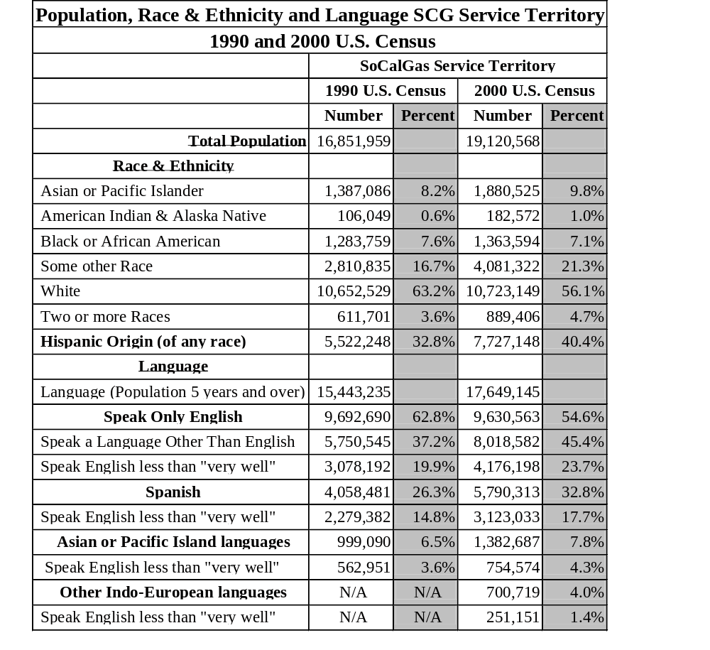
Commercial Customers: SoCalGas serves over 176,000 small commercial and industrial customer meters at year-end 2002.
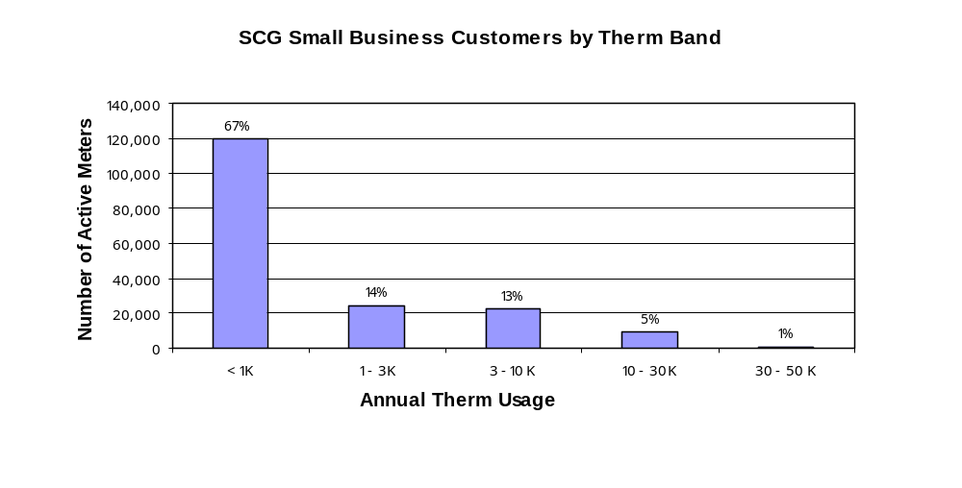
Fifteen business segments represented almost 66 percent of the meter count total. Food Service customers account for about 14 percent of the customer total and more than 34 percent of total consumption; with an average per meter consumption of about 5,600 therms a year. Laundromats constitute another important customer segment, accounting for about 10 percent of the total gas consumption. Approximately 166,7000 businesses fell below the 10,000-therm usage level. More than 90 percent of small commercial and industrial customers qualify as hard-to-reach as defined by CPUC’s Policy Manual.

About 31% of small businesses in Southern California are minority-owned according to the 1997 Economic Census. As the general population in Southern California becomes more ethnically diverse, SoCalGas expects this percentage to increase bringing with it the need for evermore innovative and cross cultural marketing and information outreach.

Customer Eligibility
The DMOP material and services are available to all of SoCalGas’ residential and business customers. The program will, however, continue to target its focus on those hard-to-reach customers who might otherwise be overlooked.

Customer Complaint Resolution –

The Diverse Market Outreach Program strives to prevent problems by keeping the program information straightforward and clearly communicated on program materials. SoCalGas believes that providing the information in the customer’s native language goes a long way toward preventing problems that might arise through miscommunication. However, in the rare instance that customers may have issues with the program they may contact SoCalGas’ Call Center at the following numbers:
Residential Customers/1-800- 427-2200;
Commercial & Industrial Customers/1-800-427-2000;
Information in Spanish/1-800-342-4545;
Information in Cantonese/1-800-427-1420;
Information in Korean /1-800-427-0471;
Information in Mandarin/1-800-427-1429;
Information in Vietnamese/1-800-427-0478

The SoCalGas Call Center uses the “Customer Comment Tracking System” (CCTS) to log and track customer complaints. All calls are recorded and saved for 3 months then filed on disk. CCTS records the complaint directly on the customers account and automatically notifies the appropriate program manager for resolution. The resolution information is also maintained in the CCTS. All CCTS records are maintained for seven years per CPUC regulations.

C. Geographic Area
The DMOP program targets all residential and nonresidential customers located in the service territory of SoCalGas. It is that broad service area that makes SoCalGas’ management of this program so effective and such a unifying force. By covering the entire SoCalGas service area, we are able to provide comprehensive energy efficiency information to customers regardless of their electricity provider. SoCalGas service area encompasses 23,000 square miles of diverse terrain throughout most of Central and Southern California, from Visalia to the Mexican border. As the nation’s largest natural gas distribution utility, it serves 18 million through 5 million gas meters in more than 530 communities.
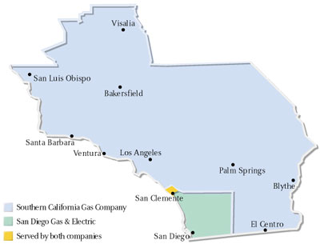

Section IV. Measure and Activity Description

Energy Savings Assumptions

Not Applicable

Deviations in Standard Cost-effectiveness Values

Not Applicable

Rebate Amounts

Not Applicable

Activity Descriptions

Train SoCalGas Customer Service Representatives and Public Affairs Managers on other utility, municipal and non-utility energy efficiency programs.

Section V. Goals
- Outreach efforts to residential customers will reach at least 200,000 households each year, representing approximately 10 percent of the hard-to-reach residential sector and is the same annual goal as 2003. This includes 40 seminars or presentations and participation in 25 community events.
- Outreach efforts to commercial customers will reach at least 40,000 businesses each year, representing approximately 20 percent of the hard-to-reach commercial sector and is the same annual goal as 2003.

Section VI Program Evaluation, Measurement and Verification

General Approach to Evaluating Program Success
This Program Evaluation, Measurement and Verification (EM&V) plan is based on the Commission’s objectives as outlined in the Energy Efficiency Policy Manual Version 2 (EE Policy Manual).

This EM&V plan will continue to use the existing EE Policy Manual and established EM&V methods to evaluate the DMOP program’s success while the EM&V protocols and framework are being revised. At such time as the revised protocols and framework are adopted, a detailed EM&V plan will defer to the EM&V protocols and framework as appropriate to evaluate the program’s success.

Under the proposed evaluation method the DMOP program’s success will primarily be gauged by program evaluation studies, such as process evaluation, and market assessment and customer behavior analysis studies. Program process evaluation studies provide ongoing feedback and corrective guidance to SoCalGas regarding program implementation and customer delivery. Market assessment and customer behavior analysis provide measured indicators of the program effectiveness based on participation levels and customer’s satisfaction.

Approach to Measure and Verify Energy and Peak Demand Savings
Not Applicable.

Approach to Evaluation Program Success
To comply with the objectives of the Commission for ongoing assessment and improvement of programs, the EM&V plan will address process issues as appropriate. The plan may include 1) analysis of program accomplishments; 2) benchmarking comparisons between a variety of initiatives to identify best-practices for program design, delivery and implementation; 3) an assessment of program targeting and customer satisfaction; 4) an analysis of incentive levels and options, and 5) additional market assessment and evaluation as needed. More specifically, these activities may be done as follows:
- Market Assessment and Customer Behavior Analyses: These activities assist with assessing customer awareness, behaviors and practices given their participation in the DMOP. The market assessment study will analyze the market penetration of the DMOP measures as part of the energy efficiency-related gains achieved by the program.
- Process Evaluations: These activities will include evaluations of program delivery in terms of adherence to procedures, timeliness and customer satisfaction. The objectives of these activities will be to provide feedback to the program implementers on elements of the DMOP that can be improved to enhance the program’s performance. Assessing performance of various delivery aspects of the program will help to identify specific, actionable servicing actions to make the program more effective.

Potential EM&V Contractors
The potential EM&V Contractors are listed below in alphabetical order, not necessarily in order of preference. These contractors have worked with the Sempra Utilities in the past and have successfully completed evaluations for a variety of utilities. These contractors are highly regarded in the Evaluation Community and have presented papers at various Evaluators Conferences. Many of their reports have been filed with the CPUC and can be found on the CALMAC website. Currently, the Sempra Utilities have no information that indicates these consultants could not be objective in their evaluation of the DMOP. While this list of potential EM&V contractors is not exhaustive, it includes:
Equipoise Consulting
Itron-RER
Kema-Xenergy
Quantec
Quantum Consulting
RLW Analytics

Section VII. Qualifications

- Primary Implementer
SoCalGas is the primary implementer of this program in SoCalGas service territory. SoCalGas has provided residential and nonresidential customers with energy efficiency programs at the direction of the Commission since 1976. Early programs provided information to residential customers on energy efficient appliances, home insulation, heating and air conditioning while providing commercial customers detailed, on-site energy analysis (audits). Programs and services for both markets evolved into information programs coupled with equipment rebate programs, loan programs and incentives for new building construction by the early 1980s. These programs have grown, contracted or been redirected based on the changing goals of the Commission, the needs of the marketplace and the input from the many community stakeholders in the energy efficiency industry.
Surveys of customers indicate that SoCalGas has remained the most trusted source for unbiased energy efficiency information, services and programs. Customers continue to look to SoCalGas for assistance in managing their energy use and costs.
Teams of SoCalGas engineers, marketing professionals and customer service specialists have demonstrated significant competencies in a variety of essential areas of program design and deployment, reporting/ accountability program measurement, assessment and evaluation.
The Program’s managing Supervisor is Rick Hobbs who has overall responsibility for program operations and achievement of program goals, particularly energy and peak demand savings for several programs and supervises program staff.
He is supported by the Program Manager, Tanya Peacock, who has overall responsibility for program operations and achievement of program goals, particularly energy and peak demand savings. These activities include program design and budget preparation; overseeing of program operations including the development of program procedures; program promotion; program data processing; customer communications; contracting and procurement for program services as needed; working with market suppliers, vendors, trade organizations and other industry-related organizations; working with community-based organizations; budget tracking and reporting of program activities; and supervision of program implementation staff.

Subcontractors

ADM Associates

ADM Associates, Inc. is a professional services corporation providing research and consulting services in applied engineering and economics to clients in business, industry and government. Since 1979, ADM has conducted hundreds of energy-related studies and projects for utility companies, government agencies, and other clients throughout North America. We produce highly competent work on schedule and within budget.

ADM has both analytical and practical capabilities for analysis of energy use by households and by commercial and industrial firms. We have strong capabilities in analyzing commercial and residential end-use loads, in assessing commercial and residential appliance technologies, in developing and evaluating energy-efficiency programs, and in developing forecasts of energy use by end-use.

Moreover, our analytical capabilities are complemented by our strong, hands-on capability in designing and implementing large-scale projects in the area of energy efficiency and conservation in households, commercial buildings and industrial firms. We have conducted market research, and large scale on-site, mail, and telephone energy related surveys for a variety of clients.

Typical projects that ADM has conducted include the following areas:

- Program Development and Implementation
- Program Measurement and Evaluation
- End-Use Metering and Monitoring
- Evaluation of Commercial/Industrial End-Uses
- Evaluation of Residential End-Uses
- Energy Auditing and Analysis
- Appliance Technology Assessments
- End-Use Load Profiles
- End-Use Forecasting Models

- Resumes
(see following pages)
Qualifications of Richard D. Hobbs

Segment Manager

Professional Experience as it relates to Current Position:
1998—Present, Segment Supervisor/Manager (SoCalGas): Oversee all aspects of program administration for energy efficiency programs targeting small commercial and industrial customers. Responsible for budgeting, budget management, program planning, policy development, research, and program administration.

Area of Responsibility In These Programs:
Overall responsibility for program operations, achievement of program goals, and supervising program staffs.

Educational Background:
B.A. -- Business Management, University of Redlands (1987)

Professional Affiliations:
Member, Board of Directors, Gas Food Equipment Network

Tanya Peacock – Senior Program Manager

Area of Responsibility In This Program:
Overall responsibility for program operations and achievement of program goals, especially hard-to-reach goals. These activities includes program design and budget preparation; overseeing of program operations include the development of program procedures; program promotion; program data processing; customer communications; contracting and procurement for program services as needed; working with market suppliers, vendors, trade organizations and other industry-related organizations; working with community-based organizations; budget tracking and reporting of program activities; and supervision of program implementation staff.
Professional Experience as it relates to current position:
2000—Present, Senior Program Manager (SCG): Responsible for the design and implementation of various energy efficiency and customer information programs. Work with communications department to develop outreach material for customers, including the development of newspaper ads and TV spots and radio spots.

1998—2000, Manager of Public Policy (Sempra Energy International): Responsible for developing regulatory applications and implementation plans for natural gas distribution companies in Canada and Eastern United States.

Educational Background:
MRP—Masters in Regional Planning, Cornell University, Ithaca, NY (1993)
B.A.—English, Mills College, Oakland, CA (1987)

Professional Affiliations: Member, American Planning Association

Section VIII. Budget

Program Budget
Cost Description |  | Amount ($Nominal)
Administrative Costs
 | Managerial/Clerical | $ 50,000
 | Human Resources | $ 52,914
 | Travel / Conferences | $ 15,394
 | Overhead | $ 162,218
 | Sub-Total Administrative | $ 280,526
Marketing Costs |  | $ -
Implementation Costs
 | Incentives | $ -
 | Activity | $ 191,428
 | Installation | $ -
 | Hardware / Materials | $ 1,336,686
 | Rebate Processing | $ -
 | Sub-Total Implementation | $ 1,528,114
EM&V Costs
 | Activity | $ 70,838
 | Overhead | $ 4,522
 | Sub-Total EM&V | $ 75,360
Total Program Budget |  | $ 1,884,000

Residential market research conducted in Korean, Chinese, Vietnamese, Spanish and English found that overall, only one in five residential customers is aware of rebate programs for energy efficient appliances. Awareness is highest among English speaking customers, with 33% being aware of rebate programs, and lowest among Chinese and Vietnamese customers with only 13% and 16% respectively aware of the programs. Market research conducted in Nov/Dec 2002 finds that only 26% of our small C&I customers are aware of various energy efficiency rebates and incentives offered by SoCalGas and only 19% have actually participated in these programs.
Small Commercial and Industrial Customer Program Awareness and Outreach Survey conducted by Strategic Decisions, Inc. for Southern California Gas Company, published in January 2003.

