# 

Modeling Assumptions for the 2021-2022 Transmission Planning Process

February 2021



Contents

1. Document Purpose 3

2. Scope 7

3. Report Summary 8

4. Inputs 9

4.1 46 MMT with 2019 IEPR 11

4.2 38 MMT with 2019 IEPR 14

4.3 Offshore Wind Portfolio 16

5. Busbar Mapping Methodology Improvements 20

6. Analysis 22

6.1 46 MMT with 2019 IEPR Portfolio 22

6.2 38 MMT with 2019 IEPR Sensitivity Portfolio 32

6.3 Offshore Wind Sensitivity Portfolio 40

7. Results 44

7.1 46 MMT with 2019 IEPR Portfolio 44

7.2 38 MMT with 2019 IEPR Portfolio 51

7.3 Offshore Wind Portfolio 57

8. Other Assumptions for TPP 63

8.1 Thermal Generator Retirement 63

8.2 Demand Response 64

9. Conclusion and Next Steps 66

9.1 Guidance on the 46 MMT with 2019 IEPR Base Case Resource Portfolio 67

9.2 Guidance on the 38 MMT Policy-Driven Sensitivity Resource Portfolio 68

9.3 Guidance on the Offshore Wind Policy-Driven Sensitivity Resource Portfolio 69

9.4 Busbar Mapping for 2022-23 TPP and Future Cycles 70

10. Appendices 71

## Document Purpose

Resource-to-busbar mapping (“busbar mapping”) is the process of refining the geographically coarse electricity resource portfolios produced in the California Public Utilities Commission’s (CPUC) Integrated Resource Plan (IRP) proceeding, into plausible network modeling locations for transmission analysis in the California Independent System Operator’s (CAISO) annual Transmission Planning Process (TPP).

The purpose of this Report is to memorialize and communicate the methodology and results of the busbar mapping process performed by the CPUC, CAISO and California Energy Commission (CEC), for input into the 2021-2022 TPP, providing transparency and opportunity for IRP and TPP stakeholder engagement.

Similar to preparation for the 2020-2021 TPP, this Report includes the key guidance for TPP studies that in past years was conveyed in the “Long-Term Procurement Plan Assumptions and Scenarios” and later the “Unified Inputs and Assumptions”, thus superseding earlier guidance and documents.

The purpose of this Report is to provide detailed documentation to accompany several Excel workbooks that identify the locations for future generation and storage resources that are expected to be necessary to support the California electric grid. Please see Section 10: Appendices for links to these workbooks:

* Methodology for Resource-to-Busbar Mapping & Assumption for the 2021-2022 TPP
* CEC Busbar Mapping Results for Generation Resources – 46 MMT with 2019 IEPR base case portfolio, 38 MMT with 2019 IEPR policy-driven sensitivity portfolio, Offshore wind policy-driven sensitivity portfolio
* Busbar Mapping Results for Battery Storage – 46 MMT with 2019 IEPR base case portfolio, 38 MMT with 2019 IEPR policy-driven sensitivity portfolio, Offshore wind policy-driven sensitivity portfolio
* Busbar Mapping Dashboard workbook – 46 MMT with 2019 IEPR Base Case Portfolio
* Busbar Mapping Dashboard workbook – 38 MMT with 2019 IEPR Portfolio
* Busbar Mapping Dashboard Workbook – Offshore Wind Sensitivity Portfolio
* 2020 IRP Baseline (for non-battery resources)
* IRP Procurement Decision Baseline (for battery storage resources)
* Retirement List for the Offshore Wind Policy-Driven Sensitivity Portfolio
* Solar Cost Sensitivity Modeling slides

The figures below are a visual map-based representation that convey the mapped resources, one of the primary inputs being transmitted by the CPUC to the CAISO for the 2021-2022 TPP, in an easily digestible manner. These maps provide an overview of the results of the implementation of the busbar mapping process. These results, as well as the inputs, methodology, and analysis are described in detail in the following sections of this Report.

Figure 1. Map of final busbar mapping results for 46 MMT base case portfolio[1]

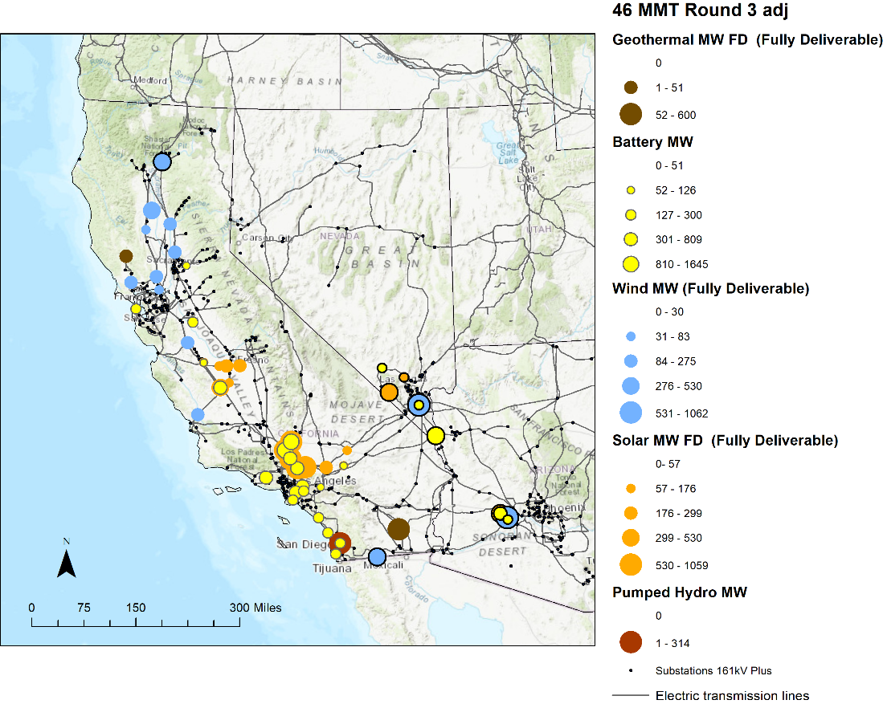

Figure 2. Map of final busbar mapping results for 38 MMT policy-driven sensitivity portfolio[2]

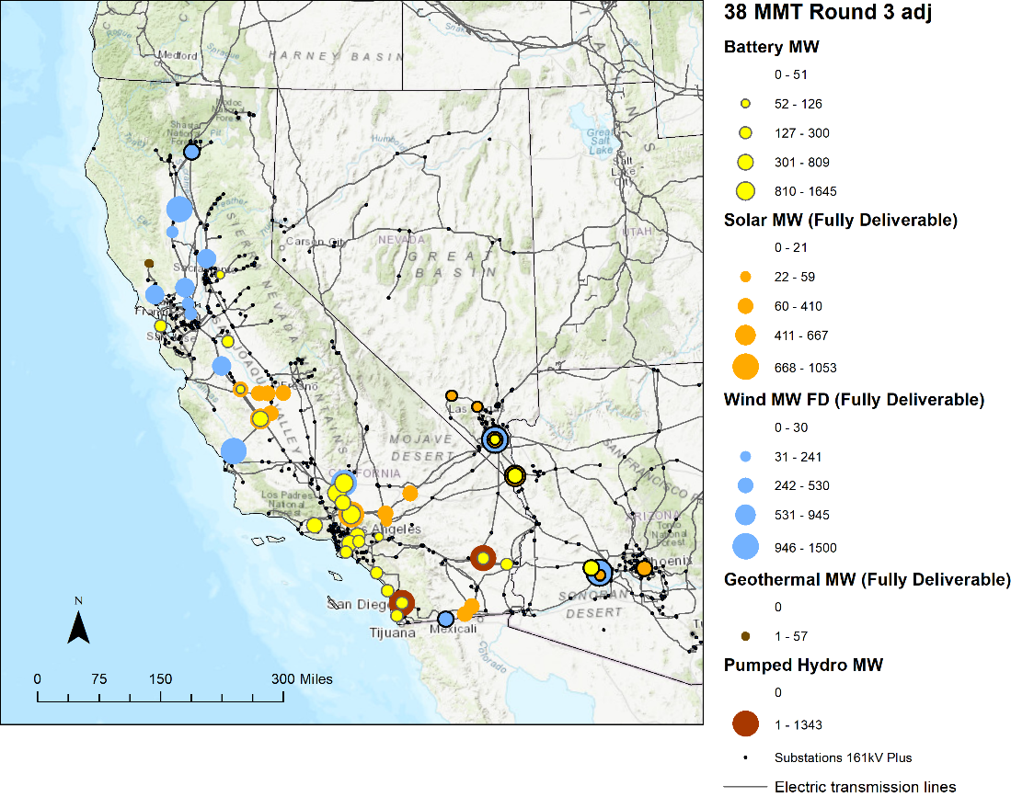

Figure 3. Map of final busbar mapping results for Offshore wind sensitivity portfolio[3]

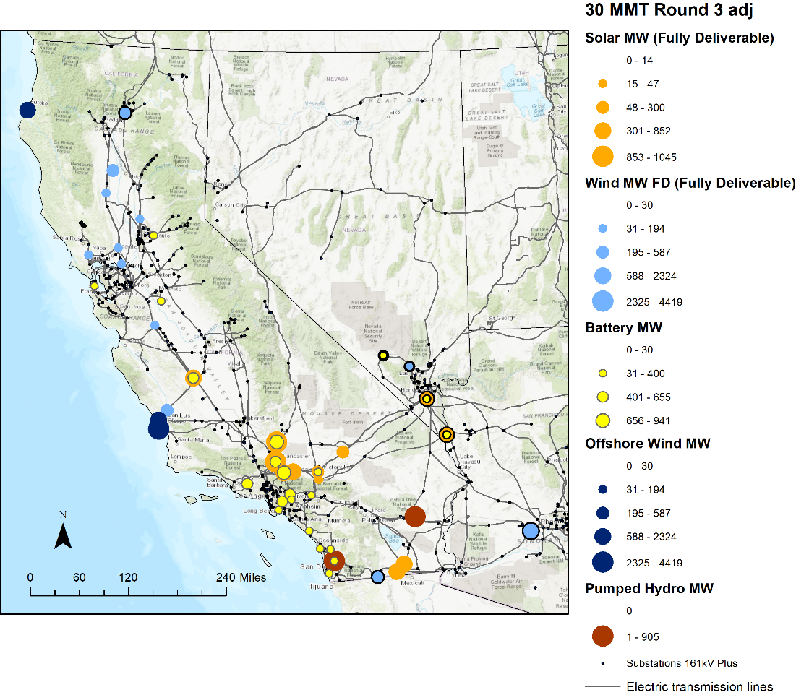

## Scope

This Report addresses the busbar mapping and other modeling assumptions for all portfolios being transmitted by the CPUC to the CAISO for the 2021-2022 TPP, as outlined in Table 1 below.

Table 1 Modeling assumptions reported in this document

|  |  |  |
| --- | --- | --- |
| **IRP Portfolio** | **2021-2022 TPP Portfolio Use Case(s)** | **Modeling Assumptions** |
| 46 MMT with 2019 IEPR[4] base case portfolio (46 MMT portfolio) | * Reliability base case * Policy-driven base case assessment * Economic assessments | * Busbar allocations of non-battery resources and battery resources * Demand response assumptions |
| 38 MMT with 2019 IEPR policy-driven sensitivity portfolio (38 MMT portfolio) | * Policy-driven sensitivity assessments | * Busbar allocations of non-battery resources and battery resources * Demand response assumptions |
| Offshore Wind policy-driven sensitivity portfolio (Offshore wind portfolio) | * Policy-driven sensitivity assessment | * Busbar allocations of non-battery resources and battery resources * Demand response assumptions * Thermal retirement assumptions |

## Report Summary

The October 20, 2020 Ruling Seeking Comments on Portfolios to be Used in the 2021-2022 TPP recommended transmitting three resource portfolios. The busbar mapping work was then conducted by staff, taking into consideration parties’ comments on the ruling. A Proposed Decision (PD) was issued on January 7, 2021, with a January 2021 version of this Report attached. The final portfolios and busbar mapping of the resources was reached in response to comments received on the PD. This Report describes the final three portfolios, their mapping to specific busbars, as well as additional inputs and assumptions for the CAISO’s TPP. This Report is structured as follows:

Section 4 states the objectives of studying each portfolio and details the inputs CPUC staff provided to the mapping process.

Section 5 summarizes the updates made to the proposed methodology[5] used by CPUC, CAISO and CEC staff to conduct busbar mapping and produce other inputs and assumptions for the 2021-2022 TPP.

Section 6 details the analysis and steps taken by staff to improve the allocations in order to meet the criteria.

Section 7 summarizes the results of the mapping process.

Section 8 presents other information about the portfolios that is required for TPP.

Section 9 draws conclusions regarding mapping the three portfolios for the 2021-2022 TPP and provides guidance to the CAISO.

## Inputs

In order to the complete the steps in the methodology described below, the following input is needed: Portfolio of selected resources for 2031, by transmission zone, with Fully Deliverable (FD) and Energy-Only (EO) megawatt (MW) amounts specified.

The portfolios described below were developed using the same modeling assumptions as were used to develop the 2019 Reference System Plan (RSP) 46 MMT by 2030 portfolio adopted by D.20-03-028,[6] with a few exceptions, including the following updates:

* An updated load forecast using the 2019 IEPR (annual GWh, peak MW, and load and load modifier shapes);
  + IEPR behind-the-meter (BTM) storage assumptions were used with adjustments to the BTM battery peak contribution consistent with the method used in the 2019 RSP
* Updated building electrification shapes developed using a combination of E3’s RESHAPE model and CEC shapes, applied to new building electrification load (i.e., the incremental building electrification load assumptions post-2031 from the CEC High Biofuels PATHWAYS scenario)[7];
* Transportation electrification shapes use the 2019 IEPR for (light-duty vehicle) LDV and medium-duty (MDV)/heavy-duty vehicle (HDV) types and E3’s load shape for electric buses
* An updated gas price forecast based on CEC June 2020 workbook;[8]
* For the sensitivity cases, the expanded EO transmission limits were used, as specified in the RESOLVE Scenario Tool, “Sys – Tx” worksheet (whereas for the base case, FD and EO transmission limits continued to be those identified in the May 2019 CAISO whitepaper,[9]); and
* Additional minor RESOLVE updates and corrections.[10]

New baseline resources added since the RESOLVE baseline was set in January 2019 were identified from load-serving entity (LSE) plans filed on September 1, 2020 and removed from the RESOLVE-selected resources of each portfolio to prevent them from being double-counted in TPP modeling (for details see tab “NewBaselineSumByRESOLVEResource” within the Dashboard Workbook for each portfolio, available in the Appendices). The steps are described below with reference to the 46 MMT base case portfolio and apply to all three portfolios:

* LSE Plans were aggregated and filtered to show contracted projects only. Staff reconciled this new contract list with the RESOLVE baseline (GenList tab in the Resource Cost and Build workbook, a part of the RESOLVE model package), to remove those that were already included in the RESOLVE baseline. Table 2 below summarizes these newly contracted resources not accounted for in the RESOLVE baseline.
* The contracts that were presented by LSEs using the RESOLVE resource names enable comparison to the RESOLVE selected resources. However, in some instances, LSEs entered some resources as generic RESOLVE resources instead of location-specific RESOLVE resources. In those instances, staff used interconnection data and other known project information to the extent possible to map those resources to RESOLVE resources. But if no other project information was available, and no point of interconnection was provided, staff left the resource as generic and did not map it to a specific RESOLVE resource. Approximately 1,087 MW of new solar contracts fit into this category whereas staff were able to associate all new wind contracts with specific RESOLVE resources.
* Staff then subtracted new contracted amounts from RESOLVE generic resources where there were RESOLVE resources, up to the original amount that RESOLVE selected. The subtraction was only done where the new contracts matched the RESOLVE selected resources. If a new contract exists but the resource was not selected, no subtraction was done. This left 300 MW of new baseline wind contracts (Arizona) and 1,000 MW of new baseline solar contracts (Central Valley, Kramer Inyokern, Riverside, and Southern Nevada) for which newly contracted amounts exceeded RESOLVE selected amounts, and thus these new contracts were not deducted from the 46 MMT portfolio.

As a result of these reconciliation steps, a total of 694 MW of solar (Inyokern, Carrizo, Tehachapi, Westlands) and 324 MW of wind (Kern/Carrizo, Norcal, Solano, Westlands, Baja) was subtracted from RESOLVE-selected resource amounts in the 46 MMT portfolio. Whereas 300 MW of new wind contracts and 1,000 MW of new solar contracts, plus a further 1,087 MW of solar contracts, could not be accurately subtracted from the portfolio for the reasons described above.

Table 2. New Baseline Resources

|  |  |  |
| --- | --- | --- |
| **New Baseline Resources** |  |  |
| RESOLVE Resource | **Transmission Zone** | New contracts (MW) |
| Arizona_Wind | N/A | 300 |
| Baja_California_Wind | SCADSNV_Z3_GreaterImperial | 105 |
| Central_Valley_North_Los_Banos_Solar | SPGE_Z4_CentralValleyAndLosBanos | 180 |
| Humboldt_Solar | N/A | 2 |
| Inyokern_North_Kramer_Solar | GK_Z2_InyokernAndNorthOfKramer | 100 |
| Kern_Greater_Carrizo_Solar | SPGE_Z2_KernAndGreaterCarrizo | 336 |
| Kern_Greater_Carrizo_Wind | SPGE_Z2_KernAndGreaterCarrizo | 40 |
| Kramer_Inyokern_Ex_Solar | KramerInyoOutsideTxConstraintZones | 162 |
| Northern_California_Ex_Wind | Norcal_Z3_SacramentoRiver | 99 |
| Riverside_Palm_Springs_Solar | SCADSNV_Z4_RiversideAndPalmSprings | 546 |
| Solano_Wind | Norcal_Z4_Solano | 80 |
| Southern_Nevada_Solar | SCADSNV_Z2_GLW_VEA | 76 |
| Tehachapi_Solar | Tehachapi | 145 |
| Westlands_Solar | SPGE_Z4_CentralValleyAndLosBanos | 150 |
| Generic Solar Resources | N/A | 1,087 |
| Grand Total |  | 3,407 |

Additionally, after accounting for battery baseline reconciliation, 1,216 MW of new LSE battery storage contracts were subtracted from the amount of battery storage contained in each of the portfolios described below. Details of the baseline reconciliation for both non-battery and battery resources are available in Appendix G.

### 46 MMT with 2019 IEPR

#### Objective and Rationale

The objective of transmitting this portfolio to the CAISO for the TPP base case studies is to ensure that transmission planning and development aligns with resource planning and development. The design of this portfolio achieves this objective by reflecting a possible lowest-cost achievement of the state’s greenhouse gas reduction goals as informed by IRP capacity expansion modeling, which in turn is used by LSEs to inform their individual planning efforts. In Decision 20-03-028 the Commission adopted a greenhouse gas (GHG) emissions target for the electric sector of 46 MMT in 2030. This 46 MMT with 2019 IEPR portfolio is designed around that 2030 GHG target, and is named based on the convention of referring to that target. However, because the resource planning horizon needed specifically for the 2021-2022 TPP extends to 2031, the emissions of the portfolio in 2031 are lower than 46 MMT. This is described in more detail under the “Description” section below.

The RESOLVE portfolio indicates the need for transmission upgrades to accommodate approximately 665 MW of resources selected in 2031 that could not be accommodated by the existing transmission system. However, RESOLVE is a system level capacity expansion model with simplified transmission capability and cost assumptions. As an input to the busbar mapping process the RESOLVE selected resources and their locations get evaluated based on interconnection feasibility, potential required transmission upgrades, and other criteria.

However, CPUC staff cannot know for certain the transmission implications until they are studied by the CAISO in the TPP at actual busbar locations. For this reason, the CPUC will transmit this portfolio to the CAISO to conduct detailed transmission planning to assess the exact transmission needs. CAISO TPP results will indicate whether any reliability or policy-driven transmission upgrades are found necessary, and if so, those transmission upgrades may be recommended to the CAISO Board of Governors for approval.

If any of the approved transmission upgrades are investments made specifically to accommodate the resource development future reflected by the CPUC in this portfolio, this portfolio will have helped ensure that transmission and generation resources are developed concurrently. This should minimize risk of stranded generation assets later being discovered to be undeliverable to load due to a lack of available transmission capability.

To ensure this is a bidirectional minimization of ratepayer costs, the CPUC expects to receive information from the CAISO regarding which approved transmission projects are developed to accommodate policy-driven resource planning. (Typically, the CAISO Transmission Plan clearly identifies the policy-driven projects). The CPUC can then act accordingly to encourage the development of those resources that can utilize the transmission capacity in order to avoid stranded transmission assets. Further, the CPUC’s transmittal here cannot be assumed to prejudge the outcome of a future siting Application for a specific transmission line (e.g. a Certificate of Public Convenience and Necessity Proceeding). However, the CPUC’s transmittal here of resource planning assumptions can be considered in the need determination phase of the CPUC’s consideration of any specifically proposed transmission project.

#### Description

For the planning year 2031, the portfolio comprises 10,635 MW of new battery storage, 15,097 MW of new in-state renewable resources, and 1,062 MW of new out-of-state (OOS) renewable resources on new OOS transmission, among other resources.

Table 3 summarizes the resource build out in 2031, the resource planning year needed specifically for the 2021-2022 TPP. The GHG target modeled in 2031 was 44.1 MMT.[11]

Table 3. Capacity Additions in 2031 in the 46 MMT with 2019 IEPR Portfolio

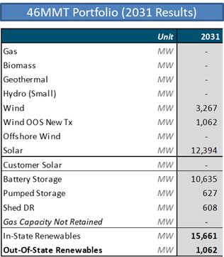

This portfolio meets the RESOLVE 15% Planning Reserve Margin (PRM) constraint and additionally contains the 2 GW calibration adjustment added in 2026 and later years. The loss of load expectation (LOLE) study results include a 0.10 LOLE in 2026 and a 0.064 LOLE in 2031, indicating that this is a reliable portfolio.

The inputs to the mapping process for this portfolio are summarized in Table 4 below. The inputs started with the RESOLVE selected resources, then applied the baseline reconciliation described in the Inputs above, to account for the new baseline contracted resources. The resulting adjusted selected resources for the first round of busbar mapping for this portfolio amounted to 11,700 MW of solar resources, 2,943 MW of in-state wind, 1,062 MW of out-of-state wind, 9,419 MW of battery storage, and 627 MW of pumped hydro storage resources. Further details of these are available in Appendix D.

Table 4. All resources selected in the 46 MMT portfolio (2031 cumulative)

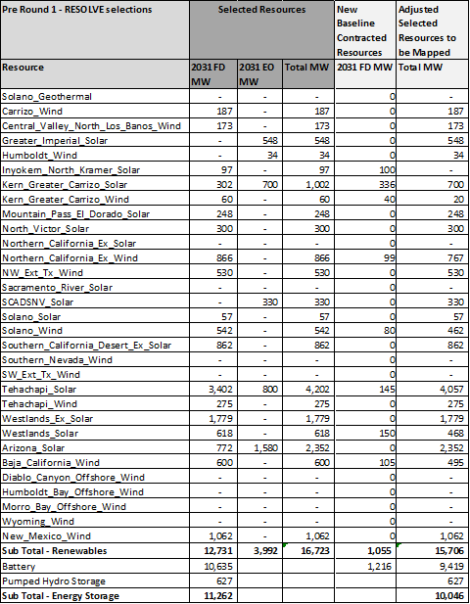

### 38 MMT with 2019 IEPR

#### Objective and Rationale

The objective for the transmittal of this portfolio to the CAISO for the 2021-2022 TPP as a policy-driven sensitivity is to understand the transmission implications under a 38 MMT resource planning future, one not previously studied in the TPP, and to inform future CPUC decision-making to drive resource planning and development. The design of this portfolio best achieves this by closely reflecting the most recent 38 MMT portfolio included as planning guidance for LSEs in D.20-03-028 but updated to the most recently adopted IEPR load forecast. The TPP assessment results produced could be used to inform future IRP modeling inputs, assumptions, or scenarios. Because the resource planning year needed specifically for the 2021-2022 TPP is 2031, the emissions of the portfolio in 2031 are lower than the 38 MMT as described in more detail under the “Description” section below. The portfolio naming convention reflects the 2030 GHG target as that is the primary policy driven planning year.

Furthermore, the CAISO could use this policy-driven sensitivity portfolio to determine which identified base case upgrades or alternatives are “least regrets” under a lower GHG target resource planning future.

#### Description

For the planning year 2031, the 38 MMT portfolio comprises 19,928 MW of new in-state renewable resources, 3,000 MW of OOS renewable resources, and 10,663 MW of battery storage, among other resources. Table 5 summarizes the resource build out in 2031, the resource planning year needed specifically for the 2021-2022 TPP. The GHG target modeled in 2031 was 36.4 MMT.[12]

The inputs to the mapping process for this portfolio are summarized in Table 6. The inputs started with the RESOLVE selected resources, then applied the baseline reconciliation described in the Inputs section 4 above, to account for the new baseline contracted resources. The resulting adjusted selected resources for the first round of busbar mapping for this portfolio amounted to 13,816 MW of solar resources, 4,955 MW of in-state wind, 3,000 MW of out-of-state wind, 105 MW of geothermal, 9,447 MW of battery storage, and 1,843 MW of pumped hydro storage resources. Further details of these are available in Appendix E.

Table 5. Capacity Additions in 2031 in the 38 MMT with 2019 IEPR Portfolio

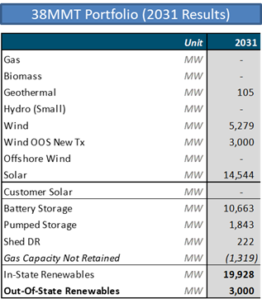

Table 6. All resources selected in the 38 MMT portfolio (2031 cumulative)

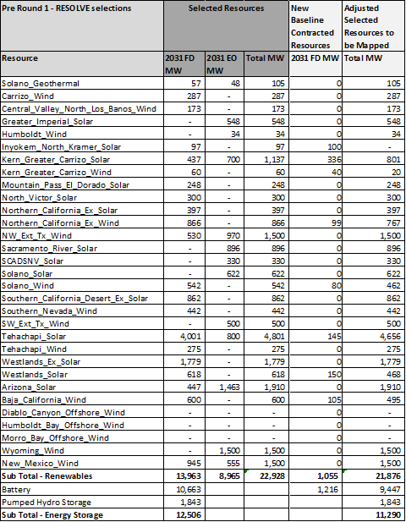

### Offshore Wind Portfolio

#### Objective

The objective of transmitting the “Offshore Wind Policy-Driven Sensitivity Portfolio” to the CAISO for the TPP is to improve transmission assumptions relevant to offshore wind for the benefit of future IRP modeling

CPUC staff plan to improve the quality of the data used in modeling offshore wind resources in the CPUC IRP RESOLVE model. For future IRP modeling, CPUC staff plan to use the ongoing 2020 NREL California offshore wind study,[13] when completed, to update resource costs and generation profile data in RESOLVE. This updated information will pertain to five specific areas: Diablo Canyon, Morro Bay, Humboldt, Cape Mendocino, and Del Norte. CPUC staff will also need to update inputs and assumptions on the cost of the bulk transmission system required to deliver resources from these areas to load. In the current CPUC IRP inputs and assumptions, transmission deliverability data is based on a CAISO whitepaper.[14] However, for three of the five resource areas – Humboldt, Cape Mendocino, and Del Norte – the CAISO whitepaper does not contain any transmission deliverability information. In order for CPUC staff to use the RESOLVE model to consider offshore wind in all five areas in the future, the CPUC needs additional information about transmission upgrade costs. This TPP policy-driven sensitivity resource portfolio is designed with the objective of CAISO producing the required information that will be used to update RESOLVE inputs.

The aim is that the outputs produced will be long-lasting and can be used to study a wide range of futures, including cases that reflect the SB 100 2045 policy goal and high electrification futures. CPUC staff strive to eliminate the need to include limits on the quantity of a resource type that can be selected in the optimization due to a lack of inputs.

#### Portfolio Development

The offshore wind sensitivity portfolio was developed using the following assumptions in RESOLVE:

* Force in the following quantities of FD offshore wind in 2030 in each area based on resource potential limits: [15]
  + Humboldt: 1.6 GW
  + Diablo Canyon: 4.3 GW
  + Morro Bay: 2.4 GW
* Assume Diablo Canyon Nuclear Plant retirement, but without its transmission deliverability being made available to any candidate resources, including offshore wind. This is consistent with the treatment of transmission deliverability associated with all units retiring in RESOLVE.[16]
* Optimize the remainder of the portfolio using a 30 MMT target
* Maintain PRM and other RESOLVE constraints

#### Portfolio Description:

For the planning year 2031, the offshore wind sensitivity portfolio comprises 23,555 MW of new in-state renewables of which 8,351 MW are offshore wind resources, per the objective of the portfolio. Additionally, the portfolio comprises 3,000 MW of OOS renewable resources and 8,820 MW of battery storage among other resources.

In addition to the 8.3 GW of offshore wind resources, which CAISO will use to conduct the policy-driven sensitivity assessments including a power flow study, deliverability assessment, and production cost modeling, the CAISO will also conduct an “outlook” assessment focusing on a longer timeframe to accommodate remaining offshore wind resource potential including 6.2 GW at Cape Mendocino and 6.6 GW at Del Norte, totaling 21.1 GW of offshore wind resources. This outlook assessment will aim to ensure that the inputs obtained pertinent to transmission development for early offshore wind resources reflect a “least regrets” approach. The objective is to identify how transmission development can be planned within the 2031 timeframe to accommodate further potential offshore wind development in the 2045 timeframe.

Table 7 summarizes the resource build out in 2031. The inputs to the mapping process for this portfolio are summarized in Table 8. The inputs started with the RESOLVE selected resources, then applied the baseline reconciliation described in the Inputs subsection above, to account for the new baseline contracted resources. The resulting adjusted selected resources for the first round of busbar mapping for this portfolio amounted to 9,807 MW of solar resources, 4,689 MW of in-state wind, 3,000 MW of out-of-state wind, 8,351 MW of offshore wind, 7,604 MW of battery storage, and 1,613 MW of pumped hydro storage resources. Further details of these are available in Appendix F.

Table 7. Capacity Additions in 2031 in the Offshore Wind Portfolio (Sensitivity #2)

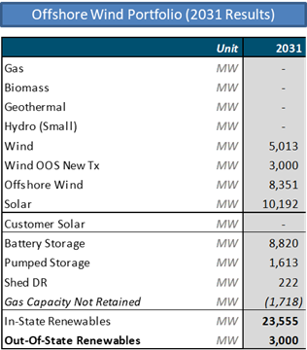

Table 8. All resources selected in the Offshore wind portfolio (2031 cumulative)

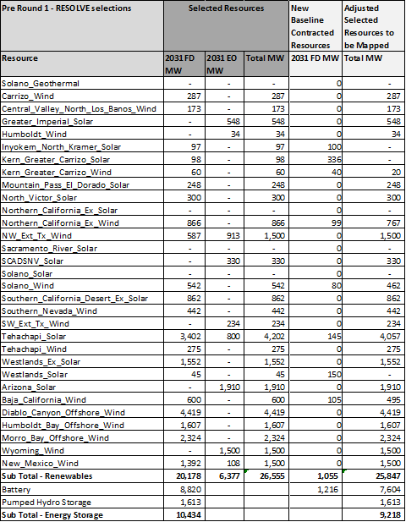

## Busbar Mapping Methodology Improvements

Staff from the two agencies and the CAISO completed the steps described in the “CPUC Staff Proposal: Methodology for Resource-to-Busbar Mapping and Assumptions for the 2021-2022 TPP, October 23, 2020” (Staff Proposal), except where improvements were identified, as summarized here. The full, updated Methodology is available as a separate document (see Appendix A).

Figure 4. Flowchart of the 2021-2022 TPP busbar mapping process

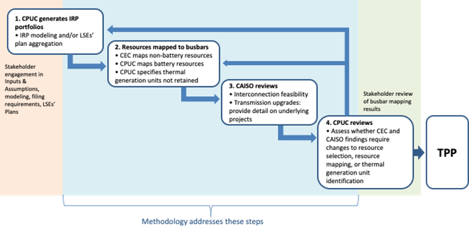

Improvements to the Staff Proposal were informed by stakeholder feedback, recommendations from the CEC and CAISO, and staff’s experience during implementation of the busbar mapping process, as summarized below.

#### Non-Battery Busbar Mapping Steps

* CPUC – Step #2 line 5 now includes language that makes exceptions for substations associated with remote resources where the only available buses are of lower voltage

#### Busbar Mapping Criteria

* “Distance to transmission” language reflects the allowance for exceptions of lower voltages.
* “Commercial interest” language now reflects consideration of projects in advanced stages of development identified through stakeholder comments
* “Consistency with prior year” now focuses on reductions in selected resources assigned to a zone from the previous to the current year’s mapping.

#### Implementation of the Busbar Mapping Criteria

* For out-of-state resources, review of distance to transmission was removed
* For available low-value land area, one additional criterion was added “Irreplacability”

#### Battery Mapping Policy Objective #1: Minimizing Ratepayer Costs

“Increasing the amount of co-located battery resources” language has been updated to reference the definition of a “co-located resource”. It also clarifies the benefits of co-location and the treatment of the FD status of the solar resource when it is co-located with battery resources. Finally, it explains the rationale for this treatment of FD status.

#### Battery Mapping Steps

Based on feedback from stakeholders and recommendations from the CAISO the battery mapping steps have been updated.

1. The order of the mapping now reflects the identification of the FD resources allocated to substation using results of the non-battery busbar mapping and the new CAISO transmission deliverability methodology for solar.
2. Updated substation voltage limit from 230 kV to 161 kV or unless otherwise stated in the non-battery mapping.
3. Removes the 60% limit on battery capacity when co-located with solar resources
4. The language for Local Capacity Requirement (LCR) Area identification provides more clarity on the 4-hour battery storage duration limits at LCR areas and explains how resources can be mapped beyond this limit.
5. Includes the consideration of curtailment as an additional substation characteristic.
6. Reorders the mapping priority to begin with stand-alone resources to maximize the utilization of siting in LCR areas, Disadvantaged Communities (DACs) and non-attainment status areas.
7. Co-location mapping now occurs after the stand-alone storage resources have been mapped. In addition, the FD status of the solar resources at the substations is transferred to the battery resources. This provides the benefit of remaining under the FD limit at the substation, preventing any exceedances. It also maximizes the utilization of the FD status of the substation and the capacity value that can be provided. Essentially, a co-located solar + storage resource is able to provide more capacity value than a stand-alone solar or stand-alone battery resource.
8. Finally, it allows for the manual allocation of batteries based on further interaction with the non-battery busbar mapping and previous TPP busbar mapping analysis study results.

Thermal Generator Retirement Assumptions  
The language has been updated to reflect that biomass is not considered for retirement.9

## Analysis

This section details the analysis and iterative mapping process performed to reach the final results in Section 7. Each of the subsections below first discuss analysis of the non-battery resources and follow with the analysis of the battery resources. For the non-battery resources staff use a “dashboard” to identify whether busbar allocations of a particular round of mapping of a portfolio comply with the five key criteria described in the Methodology (see Appendix A). This informs whether changes to the allocation may be required. A. For the battery resources CPUC staff apply the methodology and analyze it through the lens of achievement of policy objectives, interaction with the non-battery resources, and transmission implications. Unlike the non-battery mapping which builds on the locational information reported in the resource selection results from the RESOLVE optimization, battery resources do not have any locational assignments. Accordingly, the battery mapping analysis for each portfolio begins from a neutral position without needing to make adjustments due to the application of the considerations in the methodology.

The analysis discussion for each portfolio is divided into a discussion of each round of mapping. For each round, the analysis below first notes the compliance with the criteria established in the Methodology for the mapped resources via a summary dashboard. Staff then discuss what changes to the reallocation need to be made in the next round of mapping to better comply with the criteria and to better achieve policy objectives. The results of the last round of mapping after which CPUC staff determine no further mapping is necessary are discussed in the Results, Section 7.

### 46 MMT with 2019 IEPR Portfolio

**Round 1 Mapping Analysis**

Starting with the RESOLVE-selected non-battery resources identified in Section 4.1, above, CEC staff mapped these resources in accordance with the Methodology, and demonstrated reasonable compliance with criteria 1 (distance to transmission of appropriate voltage), 3a (available land area), 3b (high environmental impacts), 4 (commercial interest), and 5 (consistency with prior year’s mapping) as shown in Table 9 below. Note compliance with criterion 5 was assessed with reference to the February 2020 busbar allocations of the 2019 RSP Policy-driven Sensitivity Portfolio 1 described in the 2020-2021 TPP Report Release 2. Storage resources, both batteries and pumped hydro storage, were not mapped during Round 1 so are not included in Table 9 or accounted for in the transmission capability limits (criterion 2). They are mapped during Round 2.

Table 9. Dashboard showing compliance of busbar allocations for the 46 MMT portfolio, after Round 1 mapping, with the criteria

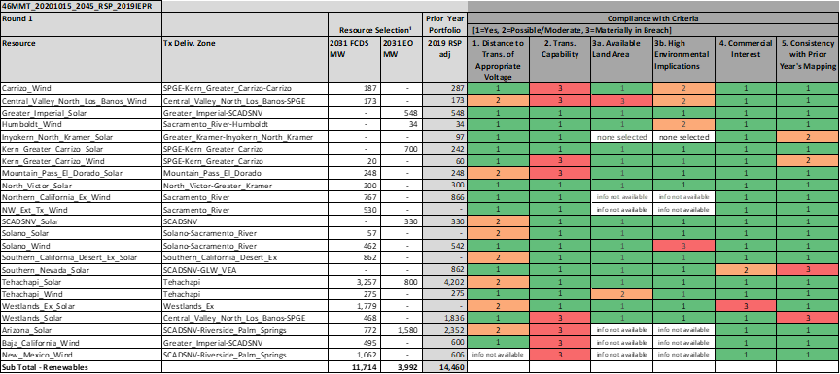

**Proposed Adjustments for Round 2 of mapping**

Following Round 1 mapping, CPUC staff observed material non-compliances with criterion 2 (transmission capability) and determined that further changes were necessary to resolve these non-compliances. These changes, as well as some unrelated improvements, were recommended by CPUC staff as adjustments for Round 2:

* Solar resources in “Ex” zones: “Ex” transmission zones have available transmission capacity, indicated by active capacity in CAISO’s interconnection queue, but are outside of CAISO’s defined transmission zones. Many resources in the supply curve in RESOLVE are outside of CAISO’s assigned zones and so were assigned during 2019 IRP Inputs and Assumptions development to “Ex” zones due to their location. In the mapping process for the 2020-2021 TPP Report, staff generally sought to reallocate RESOLVE-selected solar resources from “Ex” zones to CAISO’s defined zones due to less certainty in the transmission assumptions for “Ex” zones. To avoid this uncertainty and to address the non-compliances with criteria 4 and 5 within these zones, staff is taking the same approach toward solar resources in “Ex” zones as in the 2020-2021 TPP Report. Staff determined it was necessary to reallocate these “Ex” zone resources as follows:
  + Westlands Ex Solar: reallocate 955 MW, 623 MW, and 201 MW FD to Westlands Solar, Tehachapi Solar, and Pisgah Solar respectively. The Westlands inner renewable transmission zone and the Southern PG&E outer renewable transmission zone do not have enough transmission capability to accommodate all the resource, so it is also reallocated to the Tehachapi and Pisgah resources based on the availability of commercial interest and transmission capability available for each resource.
  + Southern California Desert Ex Solar: reallocate 624 MW, and 238 MW FD to Southern Nevada Solar, and Southern California Desert and Southern Nevada Solar, respectively. Priority is placed on allocating FD MW to Southern Nevada Solar at substations in the GLW-VEA renewable transmission zone due to their proximity to the selected resources. Once the GLW-VEA transmission limit is reached, resources are then reallocated to Southern California Desert and Southern Nevada Solar and specifically mapped to the Mohave 500 kV substation to avoid utilizing capability of the inner subzones within the Southern California Desert and Southern Nevada outermost renewable transmission zone.

Such manual reallocations of solar resources can improve compliance with busbar mapping criteria without materially impacting the expected cost, reliability or emissions of a portfolio. This is supported by the solar cost sensitivity modeling staff performed for the 2020-2021 TPP Report (see Appendix I).

* Southern PG&E renewable transmission zone: the RESOLVE model run calls for new transmission build in the Southern PG&E transmission zone. CAISO staff’s guidance is that this corresponds to a transmission project that provides a 1,000 MW expansion for both the Westlands inner renewable transmission zone and Southern PG&E outer renewable transmission zone. However, the initial allocations and subsequent reallocations described above are still found to result in breaches of the outer zone limit. Accordingly, staff recommended the following change:
  + Westlands Solar: remap 409 MW FD of this resource to the Gates-Diablo 500 kV system based on CAISO staff’s guidance that this system appears geographically in the Southern PG&E outer renewable transmission zone, but it is electrically not in any zone.
* Tehachapi Solar: remap 947 MW from the Pear Blossom substation to the Vincent 230kV substation in the same zone based on CAISO’s staff guidance that the Pear Blossom substation has no further transmission capability. Remap resources from the Whirlwind and Antelope 500 kV substations to the Whirlwind and Antelope 230 kV substation respectively to more closely align with commercial interests and to avoid higher interconnection costs at 500 kV substations.
* Arizona Solar: remap 1,223 MW from the Hoodoo Wash substation to the Delaney and Hassayampa substations based on CAISO’s staff guidance that this would prevent increased curtailments at the Hoodoo Wash substation. 820 MW and 403 MW are mapped to the Delaney and Hassayampa substations based proportionally on the commercial interest at each substation.
* New Mexico Wind: reallocate 1,062 MW FD to 1,062 MW FD Wyoming Wind and map to El Dorado 500 kV substation. CPUC staff chose to reallocate to the Wyoming Wind RESOLVE model resource for consistency with the 38-MMT and Offshore wind portfolios both for which RESOLVE selected Wyoming Wind.[17] The dashboard shows resources within the Southern California Desert and Southern Nevada outer renewable transmission zone exceeding the outer zone limit. Based on CAISO staff guidance and preliminary results from the CAISO’s 2020-2021 TPP, the actual transmission limit of the outermost zone is likely higher than the limit used in the mapping process. Per guidance from CAISO staff, approximately 6,281 MW of new FD resources can be mapped to the Southern California Desert and Southern Nevada outermost transmission zone. However, CAISO staff noted the preliminary 2020-2021 TPP 30 MMT EO sensitivity portfolio results had a significant amount of resources mapped to El Dorado 500 kV and Mohave 500 kV substations (2,498 MW). Mapping a similar number of resources but to different regions risks triggering transmission constraints within the outer zone and increases the likelihood of needing a $2.1 billion transmission upgrade. To minimize cost to ratepayers, CPUC staff recommended reallocating New Mexico Wind to Wyoming Wind mapped to the El Dorado 500 kV substation. This reallocation more closely aligns the portfolio to the 2020-2021 TPP results for the 30 MMT EO sensitivity portfolio.
* Pumped Storage Hydro: 627 MW FD pumped storage hydro resource is mapped to the Lee Lake substation, where there is commercial interest. Pumped storage hydro was not initially mapped in Round 1. The Lee Lake substation is not in any of the CAISO’s outer transmission zones.

The CEC completed these adjustments in Round 2 of mapping.

**Round 2 Battery Mapping**

With these adjustments in place, staff then mapped the batteries to busbars. After accounting for baseline reconciliation as noted in Section 4, 9,419 MW of battery storage needed to be mapped. The implementation of the Methodology builds on the allocation results from the non-battery busbar mapping.

As described above, in Round 1 the following non-battery resources were mapped: 7,644 MW of FD solar resources, 4,071 MW of FD wind resources, and 627 MW of FD pumped storage hydro resources.

After the implementation of battery mapping steps 1 through 8, CPUC staff observed the following:

* No substations with available transmission headroom in the outer renewable transmission zones.
* 20 substations within LCR areas within the renewable transmission zones, 17 substations within LCR areas within the “Ex” zones.
* 17 substations within DACs within the renewable transmission zones, 28 substations within DACs within the “Ex” zones.
* 52 substations within non-attainment areas within the renewable transmission zones, 74 substations within non-attainment areas within the “Ex” zones.
* 38,377 MW of battery commercial interest within the renewable transmission zones, 3,178 MW of battery commercial interest within the “Ex” zones.

CPUC staff mapped the battery resources in the following manner while implementing steps 9a through e:

* 2,008 MW of stand-alone battery resources providing LCR and system RA located entirely in “Ex” zones.
* 1,170 MW of stand-alone battery resources providing system-only RA located entirely in “Ex” zones.
* 5,320 MW of co-located solar + battery resources located in the renewable transmission zones

With the total of 8,498 MW of battery resources initially mapped, the implementation of step 9f involved further interaction with the non-battery mapping Dashboard to identify suitable substations for siting the remaining 921 MW of battery resources. As stated in the Round 1 non-battery analysis based on CAISO’s staff guidance, CPUC staff identified the Gates 500 kV substation and the 1,000 MW transmission upgrade for Tehachapi to accommodate mapping of the battery resources as a least-regrets approach. This upgrade would improve the curtailment problem at Whirlwind substation. According the CAISO 2020-2021 TPP preliminary policy and economic assessments results[18], Whirlwind Substation has one of the highest curtailment costs. The exceedance of the Tehachapi transmission constraint is consistent with the 38 MMT portfolio which demonstrates that Tehachapi is also an area selected by RESOLVE for solar development. Furthermore, the CAISO interconnection queue includes 7,845 MW of commercial interest in batteries and 4,117 MW in solar resources in the Tehachapi area. CPUC staff manually allocated the battery resources across the following substations based on substation characteristics and battery storage commercial interest:

* 692 MW to Whirlwind substation
* 61 MW to Vincent substation
* 147 MW to Windhub substation
* 21 MW to Gates 500 kV substation

**Round 2 Mapping Analysis**

After Round 2 of mapping to implement the changes noted above and to map the battery resources, CPUC staff reassessed the mapped resources compliance with the five criteria. These results are summarized below in Table 10. CPUC staff note improved compliance for criteria 1 (distance to transmission of appropriate voltage), 4 (commercial interest), and 5 (consistency with prior year’s mapping). The reallocations implemented during Round 2 and the mapping of battery resources resulted in further criterion 2 (transmission capability) non-compliance as the result of reallocating resources from “Ex” zones into CAISO’s renewable transmission zones and the addition of stand-alone battery resources. These non-compliances and the remaining non-compliances for criteria 3a (available land area) and 3b (high environmental impacts) are discussed later in detail in the Results section 7.1.

Table 10. Dashboard showing compliance of busbar allocations for the 46 MMT portfolio, after Round 2 of mapping, with the criteria



**Proposed Adjustments for Round 3 of mapping**

The January 2021 PD included the results of Round 2 of mapping shown in Table 10, and parties were able to review and provide comments on the mapping. Following party comments and replies to the PD, CPUC staff implemented the following adjustments:

* Pumped Storage Hydro: remap a portion of the pumped storage hydro resources to an additional busbar so that 314 MWs are mapped to Sycamore Canyon substation and 313 MWs are mapped to Lee Lake substation. This change makes the mapping of pumped storage hydro resources more consistent with the mapping of the 2020-2021 TPP 2019 RSP sensitivity portfolio, which had pumped storage hydro resources mapped to multiple substations. This remapping incorporates data on pumped storage hydro projects that have active or pending preliminary permits or licenses with the Federal Energy Regulatory Commission and data on projects formerly included in the CAISO interconnection queue. This information captures additional commercial interest that is not fully represented by the current CAISO interconnection queue.
* Greater Imperial Geothermal: Add 600 MW of FD geothermal resources to the portfolio and map to the Bannister substation in the Greater Imperial transmission zone, without substituting out resources currently in the portfolio. The addition of geothermal improves the portfolio mapping’s consistency with the resource portfolio mapped in the 2020-2021 TPP base case, which had 604 MW of FD geothermal (and 652 MW of EO) mapped to Greater Imperial. Additional geothermal further increases the diversity of resources in the portfolio and puts the portfolio on a path to lower GHG emissions. Mapping the resource to the Greater Imperial area aligns with the presence of geothermal resources included in LSEs’ plans and 550 MW of geothermal commercial interest listed in the Imperial Irrigation District’s interconnection queue.
* Solano Geothermal: Add 51 MW of FD Solano Geothermal and substitute out 57 MW of FD Solano Solar and 51 MW of co-located battery storage. This substitution addresses similar issues as noted for the addition of Greater Imperial Geothermal above. Additionally, Solano geothermal was chosen by RESOLVE in the 38 MMT portfolio. The substitution of the solar and battery resources is necessary in order to include the 51 MW of geothermal while minimizing ratepayer costs. Exceeding the transmission limit would lead to investment that is not required to accommodate the addition of the geothermal resource.
* Southern Nevada Solar: Add 1,400 MW of EO Southern Nevada Solar and map to substations within GLW-VEA inner renewable transmission zone. In proposing this adjustment, CPUC staff focused analysis in the following areas:
  + Consistency with prior year mappings: The 2020-2021 TPP base case portfolio had approximately 3,000 MW of Southern Nevada Solar selected but as shown in Table 11, most of those resources were mapped to El Dorado or Mohave substations. In contrast, the 2020-2021 TPP 2019 RSP policy driven portfolio had a significant amount of Arizona Solar selected and this was mapped to CAISO substations in Arizona.

Table 11. Total amount of solar resources mapped to certain locations relevant to Southern Nevada and Arizona Solar for the 46 MMT base case portfolio compared to 2020-2021 TPP portfolios

|  |  |  |  |
| --- | --- | --- | --- |
| Location | 46 MMT portfolio: Round 2 mapping (FD+EO) | 2020-21 TPP Base case portfolio: final mapping (FD+EO) | 2020-21 TPP 2019 RSP portfolio: final mapping (FD+EO) |
| GLW-VEA transmission zone substations | 624 MW | 700 MW | 700 MW |
| El Dorado substation (230 kV and 500 kV) | 248 MW | 1,070 MW | 410 MW |
| Mohave 500 kV substation | 568 MW | 1,236 MW | 330 MW |
| Arizona substations | 2,352 MW | 428 MW | 2,352 MW |

* + Interconnection cost estimates: CPUC staff conducted an interconnection cost analysis for solar resources at GLW-VEA substations and Arizona substations. In past TPPs, parties expressed concerns that RESOLVE underestimated interconnection costs to 500 kV substations. For this TPP, staff compared the estimated interconnection costs of 500 kV substations for Arizona solar and 230 kV substations for solar in the GLW-VEA area.
    1. For gen-tie costs, CPUC staff utilized available data from the 2020 final per unit cost guides shared by CAISO, specifically GLW data for the 230 kV substations in the GLW-VEA area and DCRT data for the Arizona solar 500 kV substations. While DRCT costs data only apply to some of the Arizona substations, data on interconnection costs for the other Arizona transmission owners is not readily available. To account for this particular uncertainty for Arizona substations and for interconnection cost uncertainty in general, staff applied simplified sensitivity analysis for possible higher or lower gen-tie costs. Based on these calculations, on a per project basis, interconnection to 230 kV substations in the GLW-VEA area costs significantly less than interconnection to 500 kV substations.
    2. CPUC staff then incorporated possible transmission upgrade costs to compare the total costs of remapping the approximately 1,500 MW of EO solar mapped to Arizona solar substations during Round 2 to GLW-VEA area substations. The placement of the resources to Arizona substations requires no apparent transmission upgrades. Reallocating the resource to GLW-VEA area would require two transmission upgrades. The first upgrade is noted in CAISO’s 2020-2021 preliminary TPP report[19] to cost an estimated $90 million. CAISO staff’s guidance noted an additional upgrade from the CAISO’s Cluster 13, Phase 1, generation interconnection study that would likely be needed as well, costing between $48 and $55 million.
    3. CPUC staff combined these cost estimates and factored in additional variables including the average size of projects currently in the interconnection queue and the distances of projects from substations. The resulting total cost estimates showed approximately equivalent total costs for mapping 1,500 MW of EO solar to either Arizona substations or GLW-VEA area substations.
  + Commercial Interest: Based on solar projects currently listed in the CAISO interconnection queue, Arizona solar has approximately 10,000 MW of commercial interest, the GLW-VEA area has 2,800 MW, and the Mohave substation has 1,890 MW, while the El Dorado substation has only 300 MW. Nearly all the commercial interest in the CAISO interconnection queue in these areas is requesting full deliverability status rather than energy only. However, parties have expressed significant interest in EO solar in the GLW-VEA transmission zone in comments to both this TPP process and the 2020-2021 TPP.

From this analysis staff recommend the addition of 1,400 MW of EO solar rather than any reallocation of EO solar resources. The addition of EO to the GLW-VEA area avoids the lack of significant commercial interest at El Dorado substation while addressing the commercial interest in the GLW-VEA area, particularly party comments regarding interest in EO solar. Adding the resources, instead of reallocating from Arizona solar, acknowledges the continued high commercial interest in Arizona. Additionally, this adjustment results in the 46 MMT aligning more closely with the total amount of EO solar resources mapped in the 38 MMT portfolio. The portfolio achieves this without increasing expected costs to ratepayers unnecessarily, based on the interconnection cost comparison showing roughly equal total costs between adding resource to the GLW-VEA area or Arizona.

The CEC made these adjustments in Round 3 of mapping.

**Round 3 battery mapping**

CPUC staff also implemented the following battery storage adjustments in Round 3:

* Removed 51 MW of co-located battery storage for the Solano Geothermal resource addition.
* Moved 608 MW of stand-alone battery storage from the Rio Hondo substation in the LA Basin LCR Area to other substations, based on CAISO staff guidance to prevent worsening the Mesa – Laguna-Bell transmission constraint. The 608 MW of battery storage was distributed to the following substations in the San Diego-Imperial Valley LCR Area: Talega 138 kV (200 MW), Trabuco 138 kV (250 MW), and Encina 138 KV (160 MW).
* Slight changes in the distribution of battery resources by function and location due to the adjustments to the non-battery mappings described above.

All the implemented adjustments in the battery storage mapping led to the following change to the manual allocations:

* 21 MW to Gates 500 kV substation

The results of Round 3 of mapping are discussed in the Results section 7.1 below.

### 38 MMT with 2019 IEPR Sensitivity Portfolio

**Round 1 Mapping Analysis**

For Round 1, CEC staff mapped the RESOLVE-selected non-battery resources identified in Section 4.2, in accordance with the Methodology, and demonstrated reasonable compliance with criteria 1 (distance to transmission), 3a (available land area), 3b (high environmental impacts), and 4 (commercial interest), and 5 (consistency with prior year’s mapping) as shown in Table 12 below. Compliance with criterion 5 was assessed with reference to the February 2020 busbar allocations of the 2019 RSP Policy-driven Sensitivity Portfolio 1 described in the 2020-2021 TPP Report Release 2. Storage Resources, both batteries and pumped hydro storage, were not mapped during Round 1 so are not included in Table 12 or accounted for in the transmission capability limits (criterion 2). They are mapped during Round 2.

Table 12. Dashboard showing compliance of busbar allocations for the 38 MMT portfolio, after Round 1 mapping, with the criteria

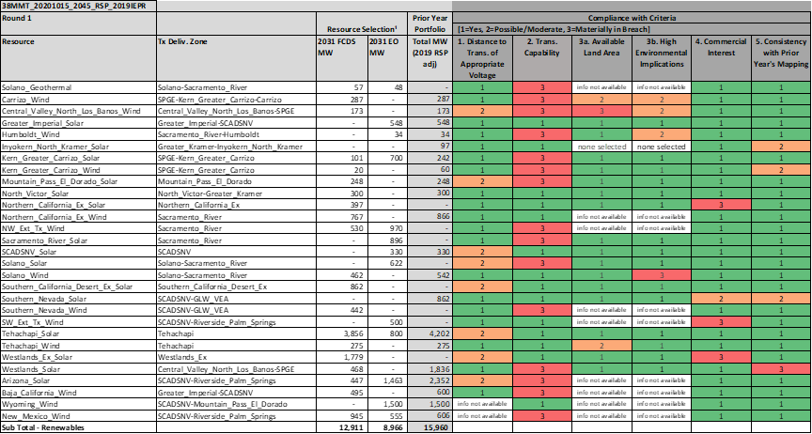

**Proposed Adjustments for Round 2 of Mapping**

Following Round 1 mapping, CPUC staff observed the material non-compliances with criterion 2 (transmission capability) and determined that further changes were necessary to resolve these non-compliances. These changes, as well as some unrelated improvements, were recommended by CPUC staff as adjustments for Round 2:

* Solar resources in “Ex” Zones: Staff determined it was necessary to reallocate these solar resources from “Ex” zones. The rationale for these reallocations is consistent with that described for the 46 MMT Portfolio in Section 6.1 above.
  + Westlands Ex Solar: reallocate 955 MW, 623 MW, and 201 MW FD to Westlands Solar, Tehachapi Solar, and Pisgah Solar respectively. The Westlands inner renewable transmission zone and the Southern PG&E outer renewable transmission zone do not have enough transmission capability to accommodate all the resource, so it is also reallocated to the Tehachapi and Pisgah resources based on the availability of commercial interest and transmission capability available for each resource.
  + Southern California Desert Ex Solar: reallocate 182 MW FD to Southern Nevada Solar, 600 MW FD to Greater Imperial Solar, and 80 MW FD to Southern California Desert and Southern Nevada Solar. Priority is placed on allocating FD MW to Southern Nevada Solar at substations in the GLW-VEA renewable transmission zone due to their proximity to the selected resources. To avoid exceeding the GLW-VEA transmission limit, resources are then reallocated to Greater Imperial Solar. Then resources are reallocated to Southern California Desert and Southern Nevada Solar and specifically mapped to the Mohave 500 kV substation to avoid exceeding the Greater Imperial zone’s transmission limit.
  + Northern California Ex Solar: reallocate 397 MW FD to Tehachapi Solar. The RESOLVE model run calls for new transmission build in the Tehachapi renewable transmission zone that, according to CAISO staff’s guidance, corresponds to a transmission project that provides a 1,000 MW expansion for the Tehachapi renewable transmission zone. This expansion enables more resources to be reallocated in Tehachapi Solar.
* Southern PG&E renewable transmission zone: the RESOLVE model run calls for new transmission build in the Southern PG&E transmission. CAISO staff’s guidance is that this corresponds to a transmission project that provides a 1,000 MW expansion for both the Westlands inner renewable transmission zone and Southern PG&E outer renewable transmission zone. However, the initial allocations and subsequent reallocations described above are still found to result in breaches of the outer zone limit. Accordingly, staff recommended the following change:
  + Westlands Solar: map 610 MW FD of this resource to the Gates-Diablo 500 kV system based on CAISO staff’s guidance that this system appears geographically in the Southern PG&E outer renewable transmission zone, but it is electrically not in any zone.
* Tehachapi Solar: remap resources from the Pear Blossom substation to the Vincent 230kV substation and remap resources from the Whirlwind and Antelope 500 kV substations to the Whirlwind and Antelope 230 kV substation respectively for the same reasons noted in Sections 6.1 for the 46 MMT portfolio.
* Arizona Solar: remap 993 MW from the Hoodoo Wash substation to the Delaney and Hassayampa substations based on CAISO’s staff guidance that this would prevent increased curtailments at the Hoodoo Wash substation. 666 MW and 327 MW are mapped to the Delaney and Hassayampa substations based proportionally on the commercial interest at each substation.
* Pumped Storage Hydro: map 500 MW FD pumped storage hydro to the Lee Lake substation and 1,343 MW FD to the Red Bluff substation in accordance with commercial interest. Pumped storage hydro was not initially mapped in Round 1. The Lee Lake substation is not in any of the CAISO’s outer transmission zones, while the Red Bluff substation is in the Riverside Palm Springs inner renewable transmission zone.
* Arizona Solar: reallocate 330 MW FD to Southern California Desert and Southern Nevada Solar and specifically map to the Mohave 500 kV substation. This reallocation is needed to prevent exceeding transmission limits in the Riverside Palm Springs inner renewable transmission zone triggered by mapping pumped storage hydro to the Red Bluff substation.
* Northern California renewable transmission zone: initial allocations comply with the transmission limits for all the inner zones but are found to exceed the Northern California outer zone’s EO limit. The following reallocation was recommended to address the exceedance:
  + Sacramento River Solar: reallocate 665 MW EO to Westlands Solar. The Sacramento River zone has little solar commercial interest while Westlands Solar has commercial interest for EO solar but none was assigned by RESOLVE.
* Wyoming Wind: reallocate 1,500 MW of EO to FD, keeping the resource mapped to El Dorado 500 kV substation. Reallocating the Wyoming wind as FD enables its contribution to resource adequacy, which may be beneficial based on the wind output in evening periods. The FD resource status ensures its ability to be delivered during peak times.

The CEC completed these adjustments in Round 2 of mapping.

**Round 2 Battery Mapping**

With these adjustments noted above in place, staff then mapped the batteries to busbars. After accounting for baseline reconciliation as noted in Section 4, 9,447 MW of battery storage was mapped for this sensitivity. As described above, in Round 1 the following non-battery resources were mapped: 7,845 MW of FD solar resources, 2,727 MW of FD wind resources, 57 MW of FD geothermal resources, and 1,843 MW of FD pumped storage hydro resources.

After the implementation of battery mapping steps 1 through 8, CPUC staff identified the following initial results:

* No substation with available transmission headroom in the outer renewable transmission zones.
* 20 substations within LCR areas within the renewable transmission zones, 17 substations within LCR areas within the “Ex” zones.
* 17 substations within DACs within the renewable transmission zones, 28 substations within DACs within the “Ex” zones.
* 52 substations within non-attainment areas within the renewable transmission zones, 74 substations within non-attainment areas within the “Ex” zones.
* 38,377 MW of battery commercial interest within the renewable transmission zones, 3,178 MW of battery commercial interest within the “Ex” zones.

CPUC staff mapped the battery resources in the following manner while implementing steps 9a through e:

* 2,008 MW of stand-alone battery resources providing LCR and system RA located entirely in “Ex” zones.
* 1,170 MW of stand-alone battery resources providing system-only RA located entirely in “Ex” zones.
* 4,836 MW of co-located solar + battery resources located in the renewable transmission zones.

With the total of 8,014 MW of battery resources initially mapped, CPUC staff implemented step 9f. This involved further interaction with the non-battery mapping Dashboard and checking consistency with the previous year’s mapping to identify suitable substations for siting the remaining 1,433 MW of battery resources. In the non-battery analysis CPUC staff identified exceedances of transmission constraints at multiple zones including the Southern California Desert and Southern Nevada zone. CPUC staff used a part of the 2,800 MW transmission upgrade to map the remaining battery resources. CPUC staff selected the Riverside East Palm Springs sub-zone due to the 1,400 MW of available transmission capacity as part of the transmission upgrade for the outer renewable transmission zone. CPUC staff also identified 734 MW of available headroom at the Gates substation based on CAISO’s staff guidance. CPUC staff mapped the battery resources across substations that had battery storage commercial interest in the following manner:

* 420 MW to Delaney-Colorado substation
* 420 MW to Red Bluff substation
* 420 MW to Colorado River substation
* 173 MW to Gates 500 kV substation

**Round 2 Mapping Analysis**

After a second round of mapping to implement the changes noted above and to map the battery resources, CPUC staff reassessed the mapped resources compliance with the five criteria. These results are summarized below in Table 13. CPUC staff note increases in compliance for criteria 1 distance to transmission of appropriate voltage), 4 (commercial interest), and 5 (consistency with prior year’s mapping). The adjustments made during Round 2 of mapping resulted in improved compliance in criterion 2 (transmission capability) for resources in the Northern California transmission zone but increased non-compliance for resources in other transmission zones mostly as the result of reallocating resources from “Ex” zones into CAISO’s renewable transmission zones and moving EO resources to FD. These non-compliances and the remaining non-compliances for criteria 3a (available land area) and 3b (high environmental impacts) are discussed in detail in the Results section 7.2.

Table 13. Dashboard showing compliance of busbar allocations for the 38 MMT portfolio, after Round 2 of mapping, with the criteria

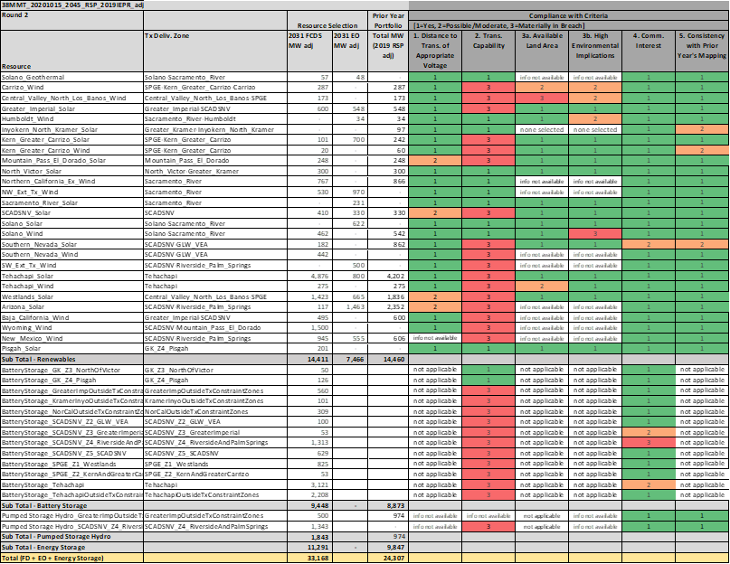

**Proposed Adjustments for Round 3 of Mapping**

The January 2021 PD included the results of Round 2 of mapping shown in Table 13, and parties were able to review and provide comments on the mapping. Following party comments and replies to the PD, CPUC staff implemented the following adjustments:

* Pumped Storage Hydro: remap 500 MW of pumped storage hydro mapped to the Red Bluff substation to the Sycamore Canyon substation. This remapping results in the following distribution of pumped storage hydro: 500 MW at Lee Lake substation, 500 MW at Sycamore Canyon substation, and 843 MW at Red Bluff substation. Similar to the changes described in Section 6.1 for the 46 MMT base case, this adjustment better aligns the pumped storage mapping with the 2020-2021 TPP portfolios and accounts for additional areas of commercial interest.
* New Mexico Wind: reallocate 555 MW of EO to FD, keeping the resource mapped to Palo Verde 500 kV substation. Reallocating the New Mexico wind so that the total of 1,500 MW is FD enables its contribution to resource adequacy, which may be beneficial based on the wind output in evening periods. The FD resource status ensures its ability to be delivered during peak times.

The CEC made these adjustments in Round 3 of mapping.

**Round 3 Battery Mapping**

CPUC staff also implemented the following battery storage adjustments:

* Moved 608 MW of stand-alone battery storage from the Rio Hondo substation in the LA Basin LCR Area to other substations, based on CAISO staff guidance to prevent worsening of the Mesa – Laguna-Bell transmission constraint. The 608 MW of battery storage was distributed to the following substations in the San Diego-Imperial Valley LCR Area: Talega 138 kV (200 MW), Trabuco 138 kV (250 MW), and Encina 138 KV (160 MW).
* Revised the non-battery busbar mapping allocations to four substations: Windhub 230 kV, Whirlwind 230 kV, Antelope 230 kV, and Vincent 230 kV. CPUC staff found that the previous battery busbar mapping to these substations did not reflect the reallocation of 1,020 MW of Westlands Ex Solar and Nothern California Ex Solar to Tehachapi Solar noted above in the post Round 1 mapping adjustments.

All the implemented adjustments to the battery storage mapping led to the following changes to the manual allocations:

* 278 MW to Delaney-Colorado substation
* 278 MW to Red Bluff substation
* 278 MW to Colorado River substation

The results of this final mapping are discussed in the Results section 7.2 below.

### Offshore Wind Sensitivity Portfolio

**Round 1 Mapping Analysis**

For Round 1, CEC staff mapped the RESOLVE-selected non-battery resources identified in Section 4.3, in accordance with the Methodology, and demonstrated strong compliance with criteria 1 (distance to transmission), 3a (available land area), and 3b (high environmental impacts), as shown in Table 14 below. Compliance with criterion 5 was assessed with reference to the February 2020 busbar allocations of the 30 MMT EO Policy-driven Sensitivity Portfolio 2 described in the 2020-2021 TPP Report Release 2. Storage Resources, both batteries and pumped hydro storage, were not mapped during Round 1 so are not included in Table 14 or accounted for in the transmission capability limits (criterion 2). They are mapped during Round 2.

Table 14. Dashboard showing compliance of busbar allocations for the Offshore Wind portfolio, after Round 1 mapping, with the criteria

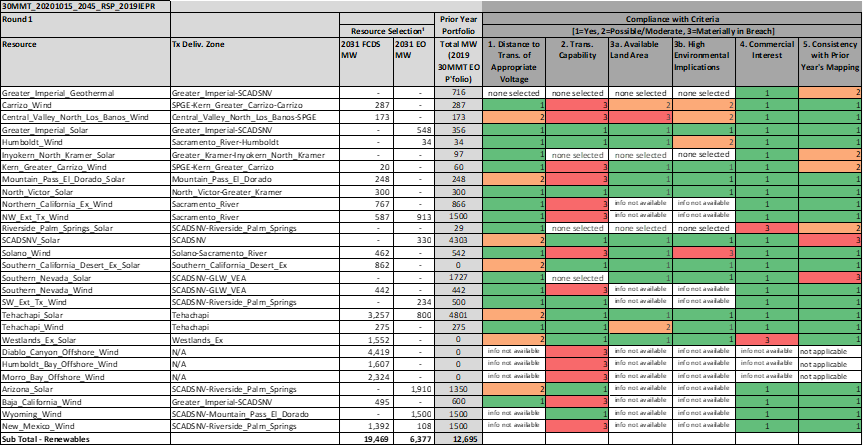

**Proposed Adjustments for Round 2 Mapping**

Following Round 1 mapping, CPUC staff observed the material non-compliances with criterion 2 (transmission capability) and determined that further changes were necessary to resolve these non-compliances. These changes, as well as some unrelated improvements, were recommended by CPUC staff as adjustments for Round 2:

* Solar resources in “Ex” Zones: Staff determined it was necessary to relocate these solar resources from “Ex” zone. The rationale for these reallocations is consistent with that described for the 46 MMT with 2019 IEPR Portfolio in Section 6.1 above.
  + Westlands Ex Solar: reallocate 827MW, 623 MW, and 201 MW FD to Westlands Solar, Tehachapi Solar, and Pisgah Solar respectively. The Westlands inner renewable transmission zone and the Southern PG&E outer renewable transmission zone do not have enough transmission capability to accommodate all the resource, so it is also reallocated to the Tehachapi and Pisgah resources based on the availability of commercial interest and transmission capability available for each resource.
  + Southern California Desert Ex Solar: reallocate 182 MW FD to Southern Nevada Solar, 600 MW FD to Greater Imperial Solar, and 80 MW FD to Southern California Desert and Southern Nevada Solar. Priority is placed on allocating FD MW to Southern Nevada solar at substations in the GLW-VEA renewable transmission zone due to their proximity to the selected resources. To prevent exceeding the GLW-VEA transmission limit, resources are then reallocated to Greater Imperial Solar. Then resources are reallocated to Southern California Desert and Southern Nevada Solar and specifically mapped to the Mohave 500 kV substation to prevent exceeding the Greater Imperial zone’s transmission limit.
* Southern PG&E renewable transmission zone: initial allocations and subsequent reallocations breach the transmission limit for the Southern PG&E outer renewable transmission zone. Accordingly, staff recommended the following change:
  + Westlands Solar: map 728 MW FD of this resource to the Gates-Diablo 500 kV system based on CAISO staff’s guidance that this system appears geographically in the Southern PG&E outermost renewable transmission zone, but it is electrically not in any zone.
* Tehachapi Solar: remap resources from the Pear Blossom substation to the Vincent 230kV substation and remap resources from the Whirlwind and Antelope 500 kV substations to the Whirlwind and Antelope 230 kV substation respectively for the same reasons noted in Section 6.1 for the 46 MMT portfolio.
* Arizona Solar: remap 1,049 MW from the Hoodoo Wash substation to the Delaney and Hassayampa substations based on CAISO’s staff guidance that this would prevent increased curtailments at the Hoodoo Wash substation. 704 MW and 345 MW are mapped to the Delaney and Hassayampa substations based proportionally on the commercial interest at each substation.
* Pumped Storage Hydro: map 590 MW FD pumped storage hydro to the Lee Lake substation and 905 MW FD to the Red Bluff substation. Pumped hydro was not initially mapped in Round 1. The Lee Lake substation is not in any of the CAISO’s outermost renewable transmission zones, while the Red Bluff substation is in the Riverside and Palm Springs inner renewable transmission zone. Both substations have commercial interest, while the amount mapped to the Red Bluff substation is selected to not exceed the estimated transmission limit in the Riverside Palm Spring inner zone.

**Round 2 Battery Mapping**

With these adjustments listed above in place, staff then mapped the batteries to busbars.

After accounting for baseline reconciliation as noted in Section 4, 7,604 MW of battery storage was mapped for this sensitivity. As described above, in Round 1 the following non-battery resources were mapped: 5,230 MW of FD solar resources, 9,538 MW of FD wind resources, and 1,495 MW of FD pumped storage hydro resources.

After the implementation of battery mapping steps 1 through 8, CPUC staff identified the following initial results:

* No substations with available transmission headroom in the outer renewable transmission zones.
* 20 substations within LCR areas within the renewable transmission zones, 17 substations within LCR areas within the “Ex” zones.
* 17 substations within DACs within the renewable transmission zones, 28 substations within DACs within the “Ex” zones.
* 52 substations within non-attainment areas within the renewable transmission zones, 74 substations within non-attainment areas within the “Ex” zones.
* 38,377 MW of battery commercial interest within the renewable transmission zones, 3,178 MW of battery commercial interest within the “Ex” zones.

CPUC staff mapped the battery resources in the following manner while implementing steps 9a through e:

* 2,008 MW of stand-alone battery resources providing LCR and system RA located entirely in “Ex” zones.
* 1,170 MW of stand-alone battery resources providing system-only RA located entirely in “Ex” zones.
* 4,337 MW of co-located solar + battery resources located in the renewable transmission zones.

With the total of 7,514 MW of battery resources initially mapped, CPUC staff implemented step 9f. This involved further interaction with the non-battery mapping Dashboard and checking consistency with the previous year’s mapping to identify suitable substations for siting the remaining 90 MW of battery resources. CPUC staff manually allocated the remaining battery resources in the following manner to be consistent with the non-battery reallocations:

* 90 MW to Mohave 500 kV substation

**Proposed Adjustments for Round 3 of Mapping**

The January 2021 PD included the results of Round 2 of mapping with the adjustments noted above. Parties were able to review and provide comments on the mapping. Following party comment and replies to the PD, staff implemented the following mapping adjustments to non-battery and battery resources:

* Pumped Storage Hydro: remap 500 MW of pumped storage hydro mapped to the Red Bluff substation to the Sycamore Canyon substation. This remapping results in the following distribution of pumped storage hydro: 500 MW at Lee Lake substation, 500 MW at Sycamore Canyon substation, and 495 MW at Red Bluff substation. The reasons noted in Analysis Sections 6.1 and 6.2 for similar remappings of pumped storage hydro resources in the 46 MMT and 38 MMT portfolios apply to this adjustment.
* Battery Storage Adjustment: Moved 608 MW of stand-alone battery storage from the Rio Hondo substation in the LA Basin LCR Area to other substations, based on CAISO staff guidance to prevent worsening the Mesa – Laguna-Bell transmission constraint. The 608 MW of battery storage was distributed to the following substations in the San Diego-Imperial Valley LCR Area: Talega 138 kV (200 MW), Trabuco 138 kV (250 MW), and Encina 138 KV (160 MW).

All the implemented adjustments to the battery storage mapping led to the following changes to the manual allocations:

* 26 MW to Mohave 500 kV substation

With only two minor changes noted for Round 3 of mapping, the dashboard for the offshore wind portfolio for Round 2 is not displayed here. The dashboard and the final results following Round 2 and Round 3 are instead discussed in the Results Section 7.3 below.

## Results

This section summarizes the results of mapping each portfolio. There is one section for each portfolio, beginning with a dashboard showing criteria compliance after Round 2 mapping (see Methodology for criteria definitions), followed by a discussion of criteria exceedance flags, discussion of the battery mapping, and a figure presenting the Round 2 results on a geographic map. Batteries and pumped storage hydro have been added to the dashboards to present a more complete summary of each portfolio, though, it is important to note that the five compliance criteria from the Methodology are not applied in the same manner to storage resources.

### 46 MMT with 2019 IEPR Portfolio

Two rounds of mapping were required to arrive at the allocations for the 46 MMT portfolio (see Appendix B for final CEC Busbar Mapping Results). A summary of the final results is provided in the dashboard in Table 15 below.

Table 15. Dashboard showing compliance of busbar allocations for the 46 MMT Portfolio, following Round 3 of mapping, with the criteria

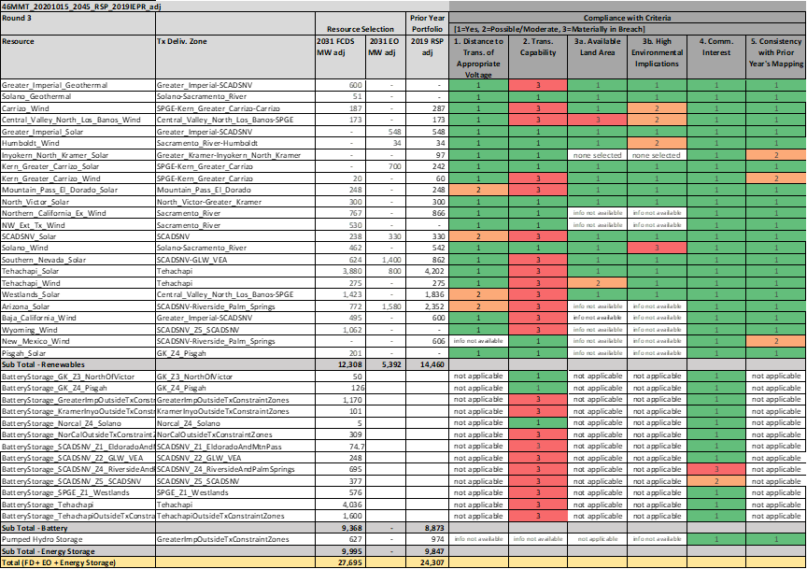

#### Non-battery Resources

As required by the Methodology, staff explain the material non-compliances (level-3) that remain for the non-battery resources with these final allocations as follows:

* Central Valley North Los Banos Wind: The dashboard shows exceedance in criterion 3a (available land area), with the mapped resources requiring 102% of available land. However, this value is calculated from a RESOLVE-derived wind power density of 232 acres/MW. Implementing the calculation with the wind power density of 91.5 acres/MW cited in the Methodology averts this non-compliance.
* Solano Wind: the material non-compliance for criterion 3b (high environmental implications) is triggered at only one potential wind resource tract at the Lakeville substation. The remaining potential tracts at the Lakeville substation, which do not trigger non-compliance with the high environmental impact criterion, are able to accommodate the wind resources mapped to the substation.
* Southern PG&E renewable transmission zone: Resources mapped to zones in the Southern PG&E outer renewable transmission remain flagged for criterion 2 (transmission capability) non-compliance for exceeding the outer zone limit. Resources mapped to the inner Westlands renewable transmission zone also exceed the inner zone limit. The exceedance of transmission limits is partially alleviated by taking into account the 645 MW transmission upgrade called for by RESOLVE in the Southern PG&E. CAISO staff’s guidance is that this corresponds to a transmission project that provides a 1,000 MW expansion for both the Westlands inner renewable transmission zone and Southern PG&E outer renewable transmission zone. CPUC staff then assumed the entire 1,000 MW is available for mapping resources. This transmission limit increase does not fully address all the transmission exceedance. The remaining capacity exceedance is eliminated by allocating solar resources in Westlands Solar to the Gates-Diablo 500 kV system. CAISO staff’s guidance is that this system appears geographically in the Southern PG&E outermost renewable transmission zone, but is electrically outside the boundary of the constraint that limits the transmission capability estimate for this zone. This addresses the criterion 2 (transmission capability) non-compliances for the following resources:
  + Carrizo Wind
  + Central Valley North Los Banos Wind
  + Kern Greater Carrizo Solar and Wind
  + Westlands Solar
* Southern California Desert and Southern Nevada outer renewable transmission zone: Resource allocations comply with subzone transmission limits; however, the dashboard shows resources within the Southern California Desert and Southern Nevada outer renewable transmission zone exceeding the outer zone limit. Based on CAISO staff guidance and preliminary results from the CAISO’s 2020-2021 TPP, the actual transmission limit of the outermost zone is likely higher than the limit used in the mapping process. CAISO staff noted that 6,280 MW of FD resources were mapped within the Southern California Desert and Southern Nevada outer renewable transmission zone in the 2020-2021 TPP’s 30 MMT EO sensitivity portfolio and the preliminary results did not find any transmission constraints related to those FD resources. Guidance from CAISO staff further noted, however, the TPP’s preliminary finding of no transmission constraints for that amount of FD resources could only readily be applied to a portfolio with resources mapped in a similar manner to the 2020-2021 TPP 30 MMT EO portfolio. Mapping a similar number of resources but to different regions risks triggering transmission constraints within the outer renewable transmission zone. Following Round 1 of mapping, the number of resources mapped to the Riverside East and Palm Springs inner renewable transmission zone exceeded the transmission headroom amount utilized in the 2020-2021 TPP 30 MMT EO portfolio by approximately 400 MW. CPUC staff made reallocations noted in Section 6.1 that more closely align the mapping results to the 2020-2021 TPP results. Staff avoided reallocating solar resources from the Mohave and El Dorado 500 kV substations to lower voltage substations in the Riverside East and Palm Springs area, which have cheaper interconnection costs, and reallocated wind resources from the Palo Verde substation to the El Dorado 500 kV substation. These adjustments reduce the risk of transmission constraints within the Southern California Desert and Southern Nevada outer renewable transmission zone and minimize cost to ratepayers by not needing the $2.1 billion transmission upgrade of the outer transmission zone. This addresses the criterion 2 (transmission capability) non-compliances for the following resources:
  + Greater Imperial Solar
  + Greater Imperial Geothermal
  + Mountain Pass El Dorado Solar
  + SCADSNV Solar
  + Southern Nevada Solar
  + Arizona Solar
  + Baja California Wind
  + Wyoming Wind
* GLW-VEA inner renewable transmission zone: The addition of 1,400 MW of EO Southern Nevada solar, which was mapped to substations within the GLW-VEA inner renewable transmission zone results in exceedance of the GLW-VEA zones transmission limit. This exceedance is an additional issue triggering the criterion 2 (transmission capability) non-compliance for Southern Nevada Solar. This exceedance can be alleviated with a transmission upgrades costing between $138-145 million as noted in the Southern Nevada solar discussion in the proposed adjustments following Round 2 mapping subsection in Analysis Section 6.1 (sum of $90 million and $48 to $55 million). This addition of solar resources further aligns the resource selection to that needed in a 38 MMT emissions scenario. The interconnection cost analysis conducted in Section 6.1 for this resource addition concludes that its costs are comparable to adding the resources to an Arizona solar area that does not require transmission upgrades. Thus, it does not unnecessarily increase costs to ratepayers in moving towards the 38 MMT scenario.
* Tehachapi renewable transmission zone: Both Tehachapi Solar and Tehachapi Wind are in material non-compliance for criterion 2 (transmission capability). The mapping of batteries to the Tehachapi renewable transmission zone resulted in exceedance of the transmission limit. This exceedance can be alleviated with the 1,000 MW proposed transmission upgrade based on CAISO staff guidance. This upgrade is a least regrets approach. Mapping these battery resources to other renewable transmission zones would likely trigger upgrades for those transmission zones that are significantly more expensive than the estimated $100 million cost for the Tehachapi zone upgrade. Further, this upgrade would ameliorate the curtailment problem at the Whirlwind substation. According to the CAISO 2020-2021 TPP preliminary policy and economic assessment results, the Whirlwind substation has one of the highest curtailment costs.

Level-2 non compliances for criteria 3a (available land area) and 3b (high environmental impact) for mapped wind resources: Following Round 1 of mapping, the dashboard showed level-2 non-compliance with criteria 3a (available land area) and 3b (high environmental impact) for multiple wind resources for exceeding 75% of available land and exceeding 20% available environmentally low-value acreage. As noted in the description of the level-3 non-compliance with criterion 3a for Central Valley North Los Banos Wind above, this value is calculated from a RESOLVE-derived wind power density for each specific wind resource. As noted above, this density is higher than the density cited in the Methodology. The consistency of the level-2 non-compliance for the 3b criterion across all the wind resources mapped for which data was available suggests either a constraint on the availability of environmentally low-value land to site wind resources or a need for CPUC staff to better tailor the environmental inputs of this criterion to provide a more nuanced assessment of environmental implications.

Level-2 non-compliance with criterion 1 (Distance to transmission of appropriate voltage) for multiple solar resources: Following Round 1 of mapping, the dashboard showed level-2 non-compliance with criterion 1 for multiple solar resources for having resources mapped to 500 kV substations. As required by the Methodology, CPUC staff performed interconnection cost calculations showing generally higher interconnection costs for 500 kV substations compared to lower voltage substations. As a result, CPUC staff sought to reallocate and remap these resources to avoid high interconnection costs at 500 kV substations if such adjustments would not violate other criteria. For 500 kV substations that also had 230 kV buses located in the same location, CPUC remapped the resources assigned to the 500 kV to its 230 kV counter parts. Wind and solar resources at the following substations were remapped to the lower voltage alternative: the Vaca-Dixon & GC Yard substation in the Solano renewable transmission zone and the Whirlwind and Antelope substations in the Tehachapi renewable transmission zone. For 500 kV substations without a co-located lower voltage substation in the same transmission zone, CPUC staff were unable to make significant adjustments to solar resources mapped these 500 kV substations due to predominately triggering non-compliance with criterion 2 (transmission capability constraints). Possible adjustments that were considered but not implemented include:

* Limiting solar resources mapped to the Gates 500 kV substation: the Gates 500 kV substation has a significant amount of solar resources mapped to it despite estimated high interconnection costs. However, exceedance of the transmission limits for the Southern PG&E outer renewable transmission zone and the Westlands inner renewable transmission zone, even with the triggered transmission upgrades, required remapping of resources in Westlands Solar to the Gates 500 kV substation. The substation is geographically near the Westlands renewable transmission zone but electrically separate from the Southern PG&E transmission zone according to guidance from CAISO.
* Remapping solar resources at Mohave and El Dorado 500 kV substations to lower voltage substations in the Greater Imperial and Riverside Palm Springs inner renewable transmission zones. This adjustment was considered given the commercial interest in Greater Imperial Solar and Riverside Palm Springs Solar, and the number of DACs in these areas. However, CAISO staff provided guidance on possible transmission constraints within the Southern California Desert and Southern Nevada outer renewable transmission zone based on the distribution of resources amongst the inner transmission zones as noted above. Keeping the solar resources to the Mohave and El Dorado 500 kV substation reduces this potential to trigger the costly transmission upgrade in the Southern California Desert and Southern Nevada outer renewable transmission zone.
* Remapping Arizona Solar EO resources from the 500 kV substations mapped during Round 1 to lower voltage substations in the GLW-VEA inner renewable transmission zone. CPUC staff’s estimated interconnection cost calculations found interconnecting to the Arizona Solar 500 kV substations significantly higher than the lower voltage substation in the GLW-VEA inner transmission zone. However, as discussed in Analysis Section 6.1, staff concluded not to relocate Arizona Solar resources from their mapped locations to maintain consistency with the mapping of the 2020-2021 TPP’s 2019 RSP portfolio and to align with the significant amount of commercial interest in the resource.

Based on the above, staff concludes that the instances of non-compliance for this portfolio are acceptable.

#### Battery Storage

The busbar mapping of battery resources was completed with only one round of mapping, following the first round of non-battery (generation) resources proposed adjustments. Details of the battery mapping results are shown in Appendix C and summarized below.

Function Summary:

Stand-Alone Resources

The first battery resources mapped are to LCR areas and represent the amount of battery resources that can provide both local and system capacity. 2,133 MW are mapped to substations within the “Ex” zones. In addition to these, stand-alone resources that provide system-only capacity are also mapped to substations inside LCR areas and outside of LCR areas. For the substations in the LCR areas, these batteries are beyond the 4-hour 1-for-1 replacement for local resources but can still provide system benefits. CPUC staff mapped 914 MW to substations in the renewable transmission zones, all located outside of LCR areas. CPUC staff also mapped 1,052 MW to substations in the “Ex” zones, all within LCR areas.

Co-Located Resources

In keeping with the minimization of ratepayer costs policy directive contained in the Methodology, CPUC staff maximized the amount of co-located solar + storage. CPUC staff mapped 5,269 MW of co-located battery resources to substations in the renewable transmission zones. CPUC staff transferred the FD status of the solar resources already mapped to the substations to the battery resources.

Table 16. Battery storage busbar mapping results for 46 MMT portfolio by function summary



Location Summary:

CPUC staff also executed the mapping in keeping with the minimization of criteria pollutants policy directives contained in the Methodology.

LCR Areas

For substations located in LCR areas, CPUC staff mapped 3,185 MW of stand-alone battery resources within the “Ex” zones and 674 MW of co-located battery resources within the renewable transmission zones.

Disadvantaged Communities (DACs)

For substations located in DACs, CPUC staff mapped 1,401 MW of stand-alone battery resources within the “Ex” zones and 674 MW of co-located battery resources within the renewable transmission zones.

Air-Quality Non-Attainment Areas

For substations located in air-quality non-attainment areas, CPUC staff mapped 4,075 MW of stand-alone battery resources within the “Ex” zones and 4,583 MW of co-located battery resources within the renewable transmission zones.

Table 17. Battery storage busbar mapping results for 46 MMT portfolio by location summary



The figure below shows Round 2 results for the 46 MMT portfolio. Note bubbles indicating out-of-state resources are displayed at the assumed CAISO delivery point, and highlighted with a black outline.

Figure 5. Map of Final Round busbar mapping results for 46 MMT portfolio[20]



### 38 MMT with 2019 IEPR Portfolio

Two rounds of mapping were required to arrive at the allocations for the 38 MMT portfolio (see Appendix B for final CEC Busbar Mapping Results). A summary of the final results is provided in the dashboard in Table 18 below.

Table 18. Dashboard showing compliance of busbar allocations for the 38 MMT Portfolio, following Round 3 of mapping, with the criteria

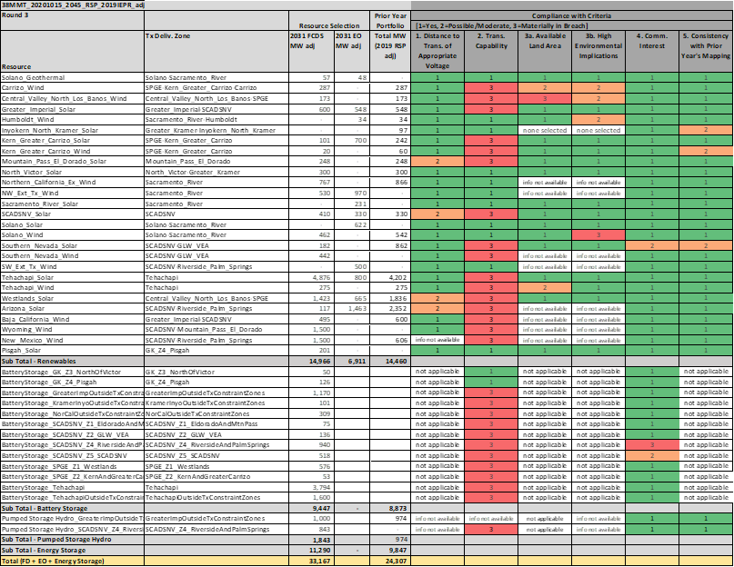

#### Non-battery Resources

As required by the Methodology, staff explain the material non-compliances (level 3) that remain for the non-battery resources with these final allocations as follows:

* Central Valley North Los Banos Wind: the exceedance in criterion 3a (available land area), is acceptable for the same reasons as for the 46 MMT portfolio described in Section 7.1 above.
* Solano Wind: the material non-compliance for criterion 3b (high environmental implications) is acceptable for the same reasons as for the 46 MMT portfolio described in Section 7.1 above.
* Southern PG&E renewable transmission zone: Resources mapped to zones in the Southern PG&E outer renewable transmission remain flagged for criterion 2 (transmission capability) non-compliance for exceeding the outer zone limit. Resources mapped to the inner Westlands renewable transmission zone also exceed the inner zone limit. The exceedance of transmission limits is partially alleviated by taking into account the transmission upgrade called for by RESOLVE in the Southern PG&E. CAISO staff’s guidance is that this corresponds to a transmission project that provides a 1,000 MW expansion for both the Westlands inner renewable transmission zone and Southern PG&E outer renewable transmission zone. CPUC staff then assumed the entire 1,000 MW is available for mapping resources. This transmission limit increase does not fully account for all the transmission exceedance in the Southern PG&E outer zone. RESOLVE all calls for a transmission upgrade in the Carrizo inner renewable transmission zone, which per CAISO staff’s guidance, corresponds to a transmission project that provides a 7,000 MW expansion for the Carrizo inner renewable transmission zone. The upgrade does not increase the transmission limit for the Southern PG&E outer renewable transmission zone. Thus, the remaining transmission capacity exceedance is eliminated by allocating solar resources in Westlands Solar to the Gates-Diablo 500 kV system. CAISO staff’s guidance is that this system appears geographically in the Southern PG&E outermost renewable transmission zone, but is electrically outside the boundary of the constraint that limits the transmission capability estimate for this zone. This addresses the criterion 2 (transmission capability) non-compliances for the following resources:
  + Carrizo Wind
  + Central Valley North Los Banos Wind
  + Kern Greater Carrizo Solar and Wind
  + Westlands Solar
* Southern California Desert and Southern Nevada outer renewable transmission zone: Resource allocations comply with subzone transmission limits; however, the dashboard shows resources within the Southern California Desert and Southern Nevada outer renewable transmission zone exceeding the outer zone limit. Based on CAISO staff guidance and preliminary results from the CAISO’s 2020-2021 TPP, the actual transmission limit of the outermost zone is likely higher than the limit used in the mapping process. Based on the preliminary 30 MMT EO sensitivity portfolio from the 2020-2021 TPP results, approximately 6,281 MW of new FD resources can be mapped to the Southern California Desert and Southern Nevada outermost transmission zone. This expanded transmission capability is able to partially accommodate the number of resources mapped within this zone. To alleviate the remaining transmission exceedance, CPUC staff recommend the 2,800 MW transmission upgrade to the Southern California Desert and Southern Nevada outer renewable transmission zone, noted in the CAISO’s May 2019 White Paper on Transmission Capability Estimates[21] as costing $2.1 billion. This upgrade also expands the Riverside Palm Springs inner renewable transmission zone by 1,400 MW. This addresses the criterion 2 (transmission capability) non-compliances for the following resources:
  + Greater Imperial Solar
  + Mountain Pass El Dorado Solar
  + SCADSNV Solar
  + Southern Nevada Solar and Wind
  + Westlands Solar
  + Arizona Solar
  + Baja California Wind
  + New Mexico Wind
  + Wyoming Wind
  + SW_Ext_Tx_Wind
* Tehachapi renewable transmission zone: Both Tehachapi Solar and Tehachapi Wind are in material non-compliance for criterion 2 (transmission capability). The exceedance of transmission limit is alleviated by taking into account the transmission upgrade called for by RESOLVE in the Tehachapi renewable transmission zone. CAISO staff’s guidance is that this corresponds to a transmission project that provides a 1,000 MW expansion. CPUC staff then assumed the entire 1,000 MW is available for mapping resources, and reallocated addition solar resources to Tehachapi solar during the mapping process as noted in Section 6.2

#### Multiple mapped wind resources received level-2 non compliances for criteria 3a (available land area) and 3b (high environmental impact) in the dashboard. The description of these non-compliances in Section 7.1 apply here to this portfolio as well.

Multiple mapped solar resources received level-2 non-compliance with criterion 1 (Distance to transmission of appropriate voltage) in the dashboard for having solar resources mapped to 500 kV substations. These non-compliances flagged are acceptable for the same reasons as described in section 7.11 above.

Based on the above, staff concludes that the instances of non-compliance for this portfolio are acceptable.

#### Battery Storage

The busbar mapping of battery resources was completed with only one round of mapping, following the first round of non-battery (generation) resources proposed adjustments. Details of the battery mapping results are shown in Appendix C and summarized below.

Function Summary:

Stand Alone Resources

The first battery resources mapped are to LCR areas and represent the amount of battery resources that can provide both local and system capacity. 2,128 MW are mapped to substations within the “Ex” zones. In addition to these, stand-alone resources that provide system-only capacity are also mapped to substations inside LCR areas and outside of LCR areas. For the substations in the LCR areas, these batteries are beyond the 4-hour 1-for-1 replacement for local resources but can still provide system benefits. CPUCS staff mapped 834 MW to substations in the renewable transmission zones, all located outside of LCR areas. CPUC staff also mapped 1,052 MW to substations in the “Ex” zones, all within LCR areas.

Co-Located Resources

In keeping with the minimization of ratepayer costs policy directive contained in the Methodology, CPUC staff maximized the amount of co-located solar + storage. CPUC staff mapped 5,433 MW of co-located battery resources to substations in the renewable transmission zones. CPUC staff transferred the FD status of the solar resources already mapped to the substations to the battery resources.

Table 19. Battery storage busbar mapping results for 38 MMT portfolio by function summary



Location Summary:

CPUC staff also executed the mapping in keeping with the minimization of criteria pollutants policy directives contained in the Methodology

LCR Areas

For substations located in LCR areas, CPUC staff mapped 3,180 MW of stand-alone battery resources within the “Ex” zones and 674 MW of co-located battery resources within the renewable transmission zones.

Disadvantaged Communities (DACs)

For substations located in DACs, CPUC staff mapped 1,401 MW of stand-alone battery resources within the “Ex” zones and 709 MW of co-located battery resources within the renewable transmission zones.

Air-Quality Non-Attainment Areas

For substations located in air-quality non-attainment areas, CPUC staff mapped 3,448 MW of stand-alone battery resources within the “Ex” zones and 4,705 MW of co-located battery resources within the renewable transmission zones.

Table 20. Battery storage busbar mapping results for 38 MMT portfolio by location summary



The figure below shows Round 2 results for the 38 MMT portfolio. Note bubbles indicating out-of-state resources are shown at the assumed CAISO delivery point, and highlighted with a black outline.

Figure 6. Map of Final Round of busbar mapping results for 38 MMT portfolio[22]

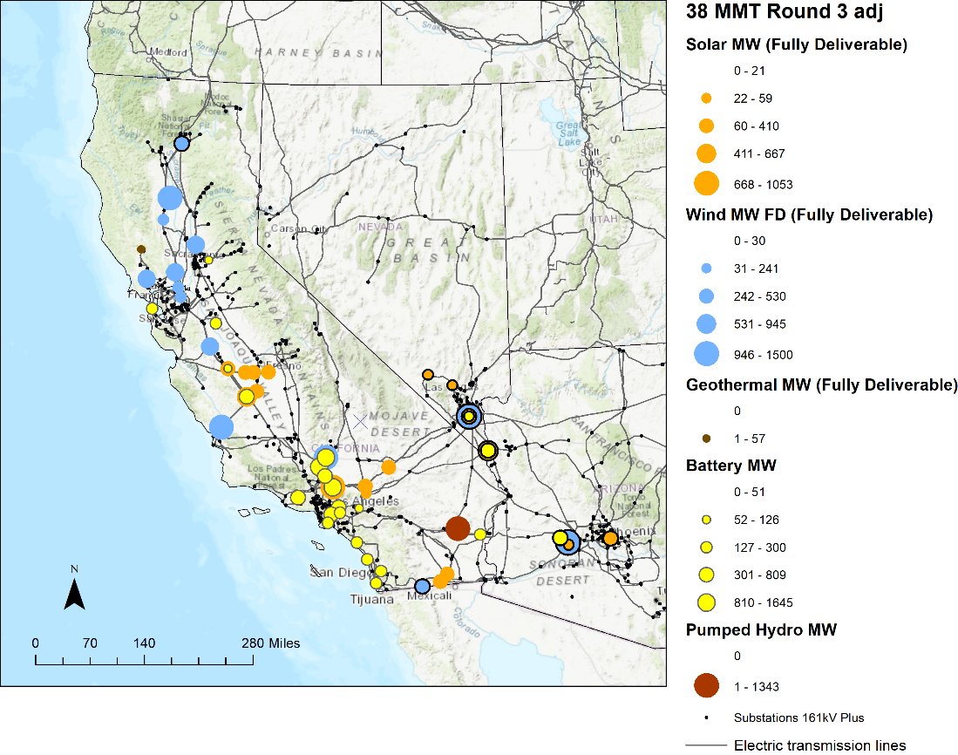

### Offshore Wind Portfolio

Two rounds of mapping were required to arrive at the allocations for the Offshore Wind portfolio (see Appendix B for final CEC Busbar Mapping Results). A summary of the final results is provided in the dashboard in Table 21 below.

Table 21. Dashboard showing compliance of busbar allocations for the Offshore Wind Portfolio, following Round 3 of mapping, with the criteria

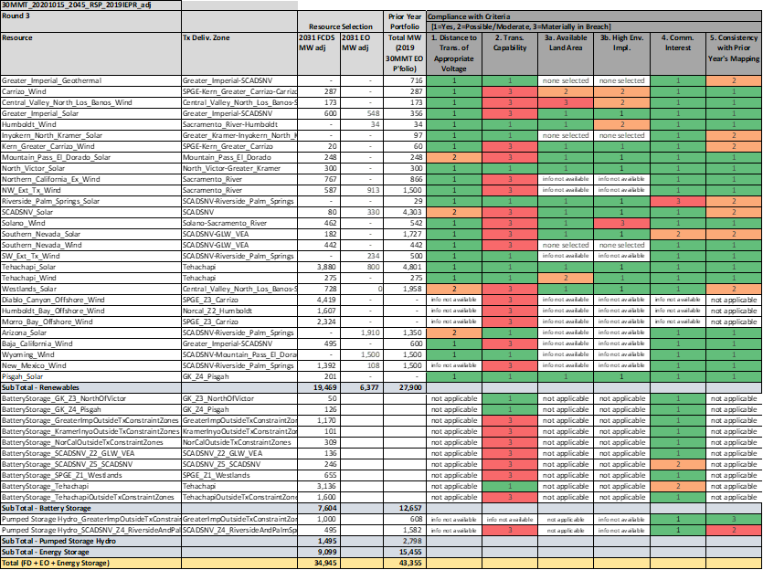

#### Non-battery Resources

As required by the Methodology, staff explain the material non-compliances (level 3) that remain for the non-battery resources with these final allocations as follows:

* Central Valley North Los Banos Wind: the exceedance in criterion 3a (available land area) is acceptable for the same reasons as for the 46 MMT portfolio described in Section 7.1 above.
* Solano Wind: the material non-compliance for criterion 3b (high environmental implications) is acceptable for the same reasons as for the 46 MMT portfolio described in Section 7.1 above.
* Northern California outer renewable transmission zone: Resources mapped to zones in the Northern California outer renewable transmission zone remain flagged for criterion 2 (transmission capability) non-compliance for exceeding the outer zone limit. Resources mapped to the Humboldt inner renewable transmission zone also exceed the inner zone limit. The mapping of offshore wind resources to the Humboldt inner renewable transmission zone trigger theses exceedances. The purpose of this Offshore wind portfolio is to study the transmission implications of offshore wind. The mapped offshore wind accounts for the material non-compliance in criterion 2 (transmission capability) for the following resources:
  + Northern California Ex Wind
  + NW Ext. Tx. Wind
  + Solano Wind
  + Humboldt Bay Offshore Wind
* Southern PG&E outer renewable transmission zone: Resources mapped to zones in the Southern PG&E outer renewable transmission zone remain flagged for criterion 2 (transmission capability) non-compliance for exceeding the outer zone limit. Resources mapped to the Wetlands and Carrizo inner renewable transmission zones also exceed the inner zone limit. The mapping of the Diablo Canyon and Morro Bay offshore wind resources to the Carrizo inner renewable transmission zone trigger the exceedances in the Carrizo inner zone and the Southern PG&E outer zone. The purpose of this Offshore wind portfolio is to study the transmission implications of offshore wind. The reallocating of “Ex” zone solar to Westlands Solar also causes transmission exceedance. This exceedance is eliminated by allocating solar resources in Westlands Solar to the Gates-Diablo 500 kV system. CAISO staff’s guidance is that this system appears geographically in the Southern PG&E outermost renewable transmission zone, but is electrically outside the boundary of the constraint that limits the transmission capability estimate for this zone. These points address the material non-compliances for criterion 2 (transmission capability) for the following resources:
  + Central Valley North Los Banos Wind
  + Kern Greater Carrizo Wind
  + Westlands Solar
  + Diablo Canyon and Morro Bay Offshore Wind
* Southern California Desert and Southern Nevada outer renewable transmission zone: Resource allocations comply with subzone transmission limits; however, the dashboard shows resources within the Southern California Desert and Southern Nevada outer renewable transmission zone exceeding the outer zone limit. Preliminary results from the CAISO’s 2020-2021 TPP of the 30 MMT EO sensitivity portfolio show that approximately 6,281 MW of new FD resources can be mapped to the Southern California Desert and Southern Nevada outermost transmission zone. Guidance from CAISO staff noted that the 2020-2021 TPP 30 MMT EO sensitivity portfolio results had a significant number of resources mapped to El Dorado 500 kV and Mohave 500 kV substations (2,498 MW). Using the 6,281 MW FD transmission capability for the outer zone and not mapping a comparable number of resources to those substations may lead to possible transmission constraints. This updated transmission limit addresses the criterion 2 (transmission capability) non-compliances for the following resources:
  + Greater Imperial Solar
  + Mountain Pass El Dorado Solar
  + SCADSNV Solar
  + Southern Nevada Solar and Wind
  + SW Ext. Tx. Wind
  + Baja California Wind
  + New Mexico Wind
* Riverside Palm Spring Solar: Despite the high commercial interests, RESOLVE did not select any of this solar resource, and CPUC staff found no opportunity to reallocate other solar resources to improve alignment for criterion 4 (commercial interests). The offshore wind focus of this portfolio resulted in RESOLVE allocated significantly less solar resources than either the 46 MMT portfolio or the 38 MMT portfolio.
* SCADSNV Solar: For the 2020-2021 TPP Sensitivity #2 30 MMT EO portfolio, the busbar mapping process reallocated more the 2,000 MW of solar resources to this resource, which results in the material no compliance flag for criterion 5 (consistency with prior year). For this portfolio, staff found little need to reallocate solar resources to SCADSNV Solar. The offshore wind focus of this portfolio resulted in RESOLVE allocating significantly less solar resources than either the 46 MMT portfolio or the 38 MMT portfolio.
* Southern Nevada Solar: despite a comparable amount of FD solar resources, the comparison to the 2020-2021 TPP Sensitivity #2 30 MMT EO portfolio results in material non-compliance for criterion 5 because the 2020-2021 TPP portfolio had over 1,400 MW of EO solar allocated to this resource. The offshore wind focus of this portfolio resulted in RESOLVE allocated significantly less solar resources than either the 46 MMT portfolio or the 38 MMT portfolio.

#### Multiple mapped wind resources received level-2 non compliances for criteria 3a (available land area) and 3b (high environmental impact) in the dashboard. The description of these non-compliances in Section 7.1 applies here, to this portfolio as well.

Multiple mapped solar resources received level-2 non-compliance with criterion 1 (Distance to transmission of appropriate voltage) in the dashboard for having solar resources mapped to 500 kV substations. These non-compliances flagged are acceptable for the same reasons as described in section 7.1 above.

Based on the above, staff concludes that the instances of non-compliance for this portfolio are acceptable.

#### Battery Storage

The busbar mapping of battery resources was completed with only one round of mapping, following the first round of non-battery (generation) resources proposed adjustments. Details of the battery mapping results are shown in Appendix C and summarized below.

Function Summary:

Stand Alone Resources

The first battery resources mapped are to LCR areas and represent the amount of battery resources that can provide both local and system capacity. 2,128 MW are mapped to substations within the “Ex” zones. In addition to these, stand-alone resources that provide system-only capacity are also mapped to substations inside LCR areas and outside of LCR areas. For the substations in the LCR areas, these batteries are beyond the 4-hour 1-for-1 replacement for local resources but can still provide system benefits. CPUC staff mapped 26 MW to substations in the renewable transmission zones, located outside of LCR areas. CPUC staff also mapped 1,052 MW to substations in the “Ex” zones, all within LCR areas.

Co-Located Resources

In keeping with the minimization of ratepayer costs policy directive contained in the Methodology, CPUC staff maximized the amount of co-located solar + storage. CPUC staff mapped 4,337 MW of co-located battery resources to substations in the renewable transmission zones. CPUC staff transferred the FD status of the solar resources already mapped to the substations to the battery resources.

Table 22. Battery storage busbar mapping results for Offshore wind portfolio by function summary



Location Summary:

CPUC staff also executed the mapping in keeping with the minimization of criteria pollutants policy directives contained in the Methodology

LCR Areas

For substations located in LCR areas, CPUC staff mapped 3,180 MW of stand-alone battery resources within the “Ex” zones and 575 MW of co-located battery resources within the renewable transmission zones.

Disadvantaged Communities (DACs)

For substations located in DACs, CPUC staff mapped 1,401 MW of stand-alone battery resources within the “Ex” zones and 575 MW of co-located battery resources within the renewable transmission zones.

Air-Quality Non-Attainment Areas

For substations located in air-quality non-attainment areas, CPUC staff mapped 3,170 MW of stand-alone battery resources within the “Ex” zones and 3,978 MW of co-located battery resources within the renewable transmission zones.

Table 23. Battery storage busbar mapping results for Offshore wind portfolio by location summary



The figure below shows Round 2 results for the Offshore Wind portfolio. Note bubbles indicating out-of-state resources are shown at the assumed CAISO delivery point, and highlighted with a black outline.

Figure 7. Map of Final Round busbar mapping results for Offshore Wind portfolio[23]

## Other Assumptions for TPP

Guidance previously provided to CAISO as part of the annual CPUC portfolio transmittal was included in a document called the “Unified Inputs & Assumptions”. CPUC and CAISO staff agree that any necessary content be included in this Report. This section describes the additional modeling assumptions the CPUC provides to the CAISO’s TPP, besides the portfolio and busbar mapping assumptions described in the rest of this report.

### Thermal Generator Retirement

RESOLVE reports the aggregate amount of thermal generation not retained by resource category. Unit-specific information is not modeled. Because the TPP studies require modeling of specific units and locations, CPUC staff is providing information to the CAISO regarding which units should be assumed as retired for transmission planning purposes. The detailed workbook is contained in Appendix H. CPUC staff applied the steps described in the methodology (see Appendix A) to develop this list.

The above steps aim to minimize any post-processing work by the CAISO. Once the IRP portfolios are transmitted to the CAISO, if within the TPP it is identified that known local area requirements are not met, then CAISO staff may reallocate mapped battery storage from a general CAISO System area to a particular local area to meet the local area requirement up to known battery storage charging limits. Refer to the methodology (Appendix A) for related guidance. If known local area requirements are still not met, then local thermal generation will be restored in reverse order of the list developed in steps 1 and 2.

### Demand Response

This subsection provides guidance on modeling treatment of demand response (DR) programs in network reliability studies including allocating capacity from those programs to transmission substations.

The CPUC’s Resource Adequacy (RA) proceeding (R. 17-09-020 or its successor) determines what resources can provide system and local resource adequacy capacity. Current RA accounting rules indicate that all existing DR programs count to the extent those program impacts are located within the relevant geographic areas being studied for system and local reliability. For its TPP studies the CAISO utilizes data from Supply-Side Resource Demand Response, which is registered in the CAISO market as either dispatchable, fast-response Reliability Demand Response Resources (RDRR) or slow-response Proxy Demand Response (PDR).

By nature, impacts from DR programs are distributed across large geographies. In order for these impacts to be applied in network reliability studies, DR program capacity must be allocated to transmission substations. To this end, CPUC staff requests the Investor-Owned Utilities (IOUs), in their capacity as Participating Transmission Owners (PTOs), to submit this information through the CAISO’s annual TPP Study Plan stakeholder process. To the extent possible, this data should also allocate impacts of DR programs administered by CCAs or procured from third parties.

Separately, and coupled with the CPUC’s annual Load Impact Protocols (LIP) filings,[24] IOUs are to submit a second, updated filing. Thus, the data for the TPP is first filed in mid-February, followed by the LIP final Report filing in April, which is then followed by the updated filing in August of the same year.

While we recognize that the annual TPP Study Plan that concludes in March already incorporates busbar-level details, this additional reporting will validate the results from the earlier filings.

Because the data requirements specified in both filings contain confidential information, the CPUC expects the CAISO and the IOUs to exchange data using their own non-disclosure agreements.

Contact and recipient details for these filings will be provided by the CAISO as part of the 2021-2022 TPP. Both the TPP and updated filings are to contain the following:

1. Portfolio aggregate ex-ante load impacts (in MW), by program, for 1-in-2 under CAISO’s August system peak, for each of the full ten-year forecast period, disaggregated by Western Electricity Coordinating Council (WECC) transmission level busbar, in plain Excel format. The WECC busbar shall be identified by two columns (fields):
   1. WECC busbar number as used in CAISO power flow models;
   2. Substation identifier/name (for example, [22256, ESCNDIDO] for SDG&E; [24214, SANBRDNO] for SCE; and [33207, BAYSHOR2] for PG&E). This applies to all dispatchable IOU DR programs and does not include non-dispatchable programs such as Time-of-Use (TOU) rates;
   3. The final year of the forecast (furthest into the future), for all program operating hours (not just the Resource Adequacy [RA] operating window). Disaggregate the data into four geographic zones: PG&E Bay, PG&E Valley, SCE, and SDG&E. PG&E Bay is defined as the Greater Bay Area Local Capacity Area (LCA) and PG&E Valley is defined as everything else in PG&E. This requirement applies to all dispatchable and non-dispatchable programs.
2. The methods and assumptions for disaggregating DR impacts by WECC transmission level busbar shall be standard and uniform across each IOU and documented in a supplemental report. To the extent this data does not sufficiently mask individual customer load information, the IOUs shall provide both a public version of the data with individual customer load information masked, and a confidential version of the data with complete information. The IOUs shall make the confidential dataset known and available to the CAISO (with applicable NDAs) by the annual deadline for its request for stakeholder input on “unified planning assumptions” for the TPP.

## Conclusion and Next Steps

The three CPUC resource portfolios have been mapped to busbars in reasonable accordance with the criteria and with consideration of state policy objectives, as described in the Methodology (see Appendix A). The results (available at Appendix B and C are transmitted to the CAISO for use in the reliability and policy-driven base case as well as the policy driven-sensitivity cases in the 2021-2022 TPP. The implementation of the busbar mapping process resulted in adjustments to the resource composition of each portfolio as described in Section 6 and Section 7. The chart below depicts the final resource composition of each portfolio that will be transmitted to the CAISO for the 2021-2022 TPP.

Figure 8. Final Resource Composition of Portfolios for the 2021-2022 TPP

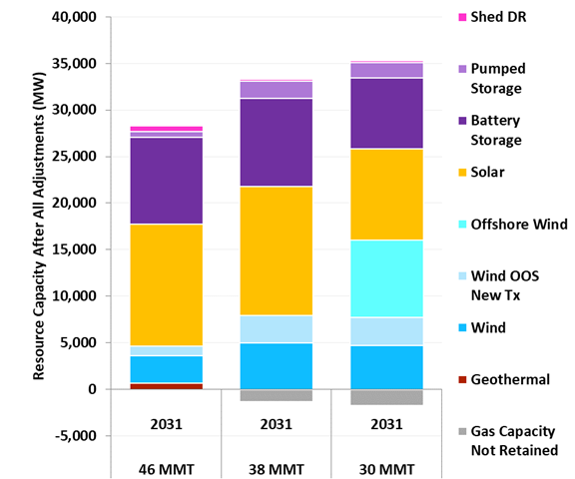

Table 24. Final Resource Composition of Portfolios for the 2021-2022 TPP

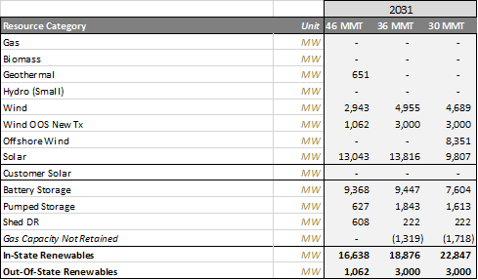

The final busbar mapping of resources in each portfolio resulted in some transmission exceedances, which are described in more detail in the subsections below. Notably, the transmission exceedances in the 46 MMT portfolio align with those in the 38 MMT portfolio, with the exception of one exceedance in the Southern California Desert and Southern Nevada area. This indicates that if CAISO finds that transmission upgrades are required in alignment with the exceedances identified, and the transmission upgrades required under the 46 MMT portfolio are made, all else being equal, the grid should be able to accommodate all resources included in the 38 MMT portfolio with the exception of a portion of the out-of-state resources. CAISO results from assessing the 38 MMT policy-driven sensitivity portfolio will provide more detailed information. The grid is of course ever evolving and for this reason the CPUC transmits portfolios to the CAISO annually for transmission planning. Nevertheless, this alignment in portfolio exceedances is encouraging because it indicates that if California were to move to a 38 MMT target, significant transmission planning in that direction would already be in progress.

### Guidance on the 46 MMT with 2019 IEPR Base Case Resource Portfolio

As described in greater detail in Section 7, the mapped resources exceed existing transmission limits in the 46 MMT with updated IEPR base case portfolio in the following zones:

* Southern PG&E: The transmission limit exceedance in this area could be resolved by a transmission upgrade with a CAISO estimated cost of $55 million, which would increase the estimated transmission capability by 1,000 MW.
* Tehachapi: The transmission limit exceedance in this area could be resolved by a transmission upgrade with a CAISO estimated cost of $100 million, which would increase the estimated transmission capability by 1,000 MW.
* GLW-VEA transmission zone (Southern Nevada): The energy only transmission limit exceedance in this area is resolved by a combination of two transmission upgrades with a CAISO-estimated cost of $138-145 million, which would increase estimated EO transmission capability by at least 1,500 MW.

If the TPP policy-driven assessment of the base portfolio identifies the need for upgrades, the CAISO would typically recommend to the CAISO Board of Governors for approval of the upgrades as policy-driven transmission upgrades. The CAISO retains more flexibility with approval of projects if they are identified only in the reliability assessments, and if the estimated build time does not necessitate immediate commencement to meet the identified resource need. The CPUC will continue to coordinate with the CAISO and will be engaged in the CAISO's Transmission Planning Process by providing comments or additional guidance through the TPP stakeholder process based on results of the analysis for the base portfolio related to transmission upgrade needs that are identified.

CPUC Staff recognize the need for a unique approach with the 1,062 MW of OOS resources in the base case resource portfolio. Due to the uncertainty of the implications on the CAISO transmission grid the injection of these OOS resources may have, CPUC staff is not able to determine at which busbar location injection would best meet policy goals while minimizing costs to ratepayers. For this reason, CPUC staff appreciates CAISO reply comments, which indicated the possibility of studying the full amount at both injection points to accommodate this rare situation.[25] Although the dashboards include only one location to prevent double counting, CPUC staff note that a single injection point has not been selected for the purposes of the TPP base case assessments.

CPUC staff recognize that the amount of battery mapping in a base case portfolio is unprecedented. The Working Group agrees that in some cases, better information is needed to understand the full impacts of the battery mappings before new transmission projects are identified by the CAISO as needed. Accordingly, the CAISO should consult the CPUC before moving forward with any new policy-driven transmission needs associated specifically with storage mapping in this planning cycle. Additionally, to the extent that storage resources are required for mitigation of transmission issues identified in the CAISO’s 2020-2021 Transmission Plan, CPUC staff would expect to coordinate with CAISO to enable small adjustments in the CPUC’s mapping of storage resources to allow for the inclusion of this storage in the CAISO’s analysis of these 2021-2022 TPP portfolios.

### Guidance on the 38 MMT Policy-Driven Sensitivity Resource Portfolio

As described in greater detail in Section 7, the mapped resources exceed existing transmission limits in the 38 MMT policy-driven sensitivity portfolio in the following areas:

* Southern PG&E: The transmission limit exceedance in this area could be resolved by a transmission upgrade with a CAISO estimated cost of $55 million, which would increase the estimated transmission capability by 1,000 MW.
* Tehachapi: The transmission limit exceedance in this area could be resolved by a transmission upgrade with a CAISO estimated cost of $100 million, which would increase the estimated transmission capability by 1,000 MW.
* Southern California Desert and Southern Nevada: the transmission limit exceedance in this area could be resolved by a transmission upgrade with a CAISO estimated cost of $2,156 million, which would increase the estimated transmission capability by 2,800 MW. Preliminary results from the 2020-2021 TPP assessment of the 30 MMT EO sensitivity portfolio indicate that the transmission limits in this area may potentially be higher than those originally used as an input to this busbar mapping process. This area in particular needs to be further assessed by CAISO in order for the transmission implications to be better understood.

The transmission implications of the 38 MMT portfolio reflect those of the 46 MMT portfolio. In accordance with the methodology guiding principles of “consistency with prior year mapping results” it is best to test a sensitivity portfolio that builds on a base case portfolio. Furthermore, the batteries in the 46 MMT portfolio have been mapped with consideration of the transmission implications of the 38 MMT portfolio to ensure a “least regrets” approach.

### Guidance on the Offshore Wind Policy-Driven Sensitivity Resource Portfolio

As described in greater detail in Section 7, the mapped resources exceed existing transmission limits in the offshore wind policy-driven sensitivity portfolio in the following areas:

* Northern California: Offshore wind resources trigger this transmission limit exceedance. The purpose of this portfolio is for CAISO to study the transmission implications of this offshore wind mapping.
* Southern PG&E: Offshore wind resources trigger this transmission limit exceedance. The RESOLVE model called for a transmission upgrade in the Carrizo area which corresponds to a 700 MW upgrade with a CAISO estimated cost of $53 million. This upgrade would partially address the exceedance; however, the purpose of this portfolio is for CAISO to study the transmission implications of this offshore wind mapping.

These exceedances will allow CAISO to identify transmission limit and upgrade cost information, currently a deficient input in RESOLVE for these specific areas, which CPUC staff is seeking to improve. By transmitting this portfolio for study in TPP, the CPUC is not making offshore wind-specific policy. For example, the CPUC is not requesting that CAISO conduct the studies with an assumption that offshore wind has preferred access to the transmission deliverability that will eventually become available after the retirement of Diablo Canyon Power Plant. This matter, and other policy considerations associated with the development of offshore wind, are outside the objectives and scope of this specific study.

The CAISO will use the transmitted offshore wind policy-driven sensitivity portfolio to conduct the policy-driven sensitivity assessments including a power flow study, deliverability assessment, and production cost modeling of the sensitivity portfolio including 8.3 GW of offshore wind resources (Humboldt, Diablo Canyon and Morro Bay).

The expected product is an updated transmission capability limits and upgrade cost estimate table, including:

* Updated transmission capability available in existing transmission zones.
* New transmission zones where appropriate and transmission capability estimates for the new transmission zones.
* The cost of upgrading transmission to accommodate the 8.3 GW in the Offshore wind portfolio with the potential to increase to up to 21.1 GW offshore wind capacity as a part of the outlook assessment.

In addition to the sensitivity assessment, the CAISO will conduct an “outlook” assessment focusing on a longer timeframe to accommodate the remaining offshore wind resource potential including 6.2 GW at Cape Mendocino and 6.6 GW at Del Norte, totaling 21.1 GW. This outlook assessment will aim to ensure that transmission development for early offshore wind resources is “least regrets”. The objective is to identify how transmission development can be planned within the 2031 timeframe to accommodate further potential offshore wind development in the 2045 timeframe.

Load forecasts and generation beyond 2031, the tenth study year, are more uncertain and outside of the scope of the 2021-2022 TPP. For this reason, the outlook assessment will not include deliverability assessment or production cost modeling. In order to identify a “least regrets” transmission plan for offshore wind, it will be important to ensure that transmission development to accommodate early offshore wind resources is not undersized for future offshore wind development. Although the Central Coast will be included in the outlook assessment, the North Coast is expected to be the focus due to the inability of the existing transmission system to deliver the significant offshore wind resources there to CAISO’s main load centers.

### Busbar Mapping for 2022-23 TPP and Future Cycles

Staff appreciates the suggestions from stakeholders in response to the questions posed in the October 2020 ruling as well as the comments submitted in response to the January 2021 Proposed Decision. Anything not already addressed in the transmittal for the 2021-2022 TPP will be a priority for consideration in the draft workplan for 2022-23 TPP busbar mapping. Furthermore, CPUC staff will strive to resolve the process alignment and timing issues that make it challenging to inform resource busbar mapping for an upcoming TPP with the results of the ongoing TPP.

## Appendices

##### Methodology for Resource-to-Busbar Mapping & Assumption for the 2021-2022 TPP

Available at the CPUC’s “Portfolios & Modeling Assumptions for the 2021-2022 Transmission Planning Process”

webpage: <https://www.cpuc.ca.gov/General.aspx?id=6442466555>

##### CEC Busbar Mapping Results for Non-Battery Resources – 46 MMT with 2019 IEPR base case portfolio, 38 MMT with 2019 IEPR policy-driven sensitivity portfolio, Offshore wind policy-driven sensitivity portfolio

Data Basin link to Excel files: <https://caenergy.databasin.org/galleries/eab0ce3a5be447ce928a310e80c65c8d#expand=208848>

##### Busbar Mapping Results for Battery Storage – 46 MMT with 2019 IEPR base case portfolio, 38 MMT with 2019 IEPR policy-driven sensitivity portfolio, Offshore wind policy-driven sensitivity portfolio

Workbook available at the CPUC’s “Portfolios & Modeling Assumptions for the 2021-2022 Transmission Planning Process”

webpage: <https://www.cpuc.ca.gov/General.aspx?id=6442466555>

##### Busbar Mapping Dashboard workbook – 46 MMT with 2019 IEPR base case portfolio

Workbook available at the CPUC’s “Portfolios & Modeling Assumptions for the 2021-2022 Transmission Planning Process”

webpage: <https://www.cpuc.ca.gov/General.aspx?id=6442466555>

##### Busbar Mapping Dashboard workbook – 38 MMT with 2019 IEPR Portfolio

Workbook available at the CPUC’s “Portfolios & Modeling Assumptions for the 2021-2022 Transmission Planning Process”

webpage: <https://www.cpuc.ca.gov/General.aspx?id=6442466555>

##### Busbar Mapping Dashboard Workbook – Offshore Wind Sensitivity Portfolio

Workbook available at the CPUC’s “Portfolios & Modeling Assumptions for the 2021-2022 Transmission Planning Process”

webpage: <https://www.cpuc.ca.gov/General.aspx?id=6442466555>

##### 2020 IRP Baseline Reconciliation (for non-battery and battery mapped resources)

Workbook available at the CPUC’s “Portfolios & Modeling Assumptions for the 2021-2022 Transmission Planning Process” webpage: <https://www.cpuc.ca.gov/General.aspx?id=6442466555>

##### Retirement List for the Offshore Wind Policy-Driven Sensitivity Portfolio

Excel file available at the CPUC’s “Portfolios & Modeling Assumptions for the 2021-2022 Transmission Planning Process”

webpage: <https://www.cpuc.ca.gov/General.aspx?id=6442466555>

##### Solar Cost Sensitivity Modeling slides

Available at:

<https://www.cpuc.ca.gov/uploadedFiles/CPUCWebsite/Content/UtilitiesIndustries/Energy/EnergyPrograms/ElectPowerProcurementGeneration/irp/2019/2020-02-Solar_Cost_Sensitivity_Modeling-slides-V1.0.pdf>

##### SERVM Analysis of IRP 46 MMT Portfolio for Use in the 2021-2022 TPP Slide deck available at the CPUC’s “Portfolios & Modeling Assumptions for the 2021-2022 Transmission Planning Process” webpage: <https://www.cpuc.ca.gov/General.aspx?id=6442466555>

---- DOCUMENT ENDS ----

1. Note: Out-of-state (OOS) wind resources are shown at their point of interconnection with the CAISO. Pumped storage hydro resources mapped to the Lake Elsinore area are not shown due to unavailability of proposed interconnection substation coordinates.
2. Note: OOS wind resources are shown at their point of interconnection with the CAISO. Pumped storage hydro resources mapped to the Lake Elsinore area are not shown due to unavailability of proposed interconnection substation coordinates.
3. Note: OOS wind resources are shown at their point of interconnection with the CAISO. Pumped storage hydro resources mapped to the Lake Elsinore area are not shown due to unavailability of proposed interconnection substation coordinates.
4. Referring to the Integrated Energy Policy Report (IEPR) prepared by the California Energy Commission.
5. Referring to the version attached to the 10/20/20 Ruling. Available at: <https://docs.cpuc.ca.gov/PublishedDocs/Efile/G000/M348/K816/348816247.PDF>
6. Decision 20-03-028, <https://docs.cpuc.ca.gov/PublishedDocs/Published/G000/M331/K772/331772681.PDF>
7. E3 updated its RESHAPE model to produce updated space heating and water heating building electrification load shapes and used the CEC California IOU Electricity Load Shapes Report (<https://ww2.energy.ca.gov/2019publications/CEC-500-2019-046/CEC-500-2019-046.pdf>) for cooking and clothes drying loads. These shapes only apply to the PATHWAYS-based loads modeled in 2045, since the 2019 IEPR contains no explicit building electrification loads. Per the 2019-20 IRP Inputs and Assumptions, the previous assumptions used an older version of RESHAPE for space heating loads and relied on E3 PATHWAYS’ load shapes for water heating, cooking, and clothes drying.
8. <https://www.energy.ca.gov/programs-and-topics/topics/energy-assessment/natural-gas-burner-tip-prices-california-and-western>
9. http://www.caiso.com/Documents/WhitePaper-TransmissionCapabilityEstimates-InputtoCPUCIntegratedResourcePlanPortfolioDevelopment.pdf
10. These include re-adding 22 MW of Riverside East and Palm Springs wind left out of the RPS supply curve, properly assigning the transmission zone for Mountain Pass / El Dorado solar PV, and other minor updates.
11. Extrapolated from a 46 MMT by 2030 target using the same assumptions that were used for incorporating post-2030 years into select modeling runs to reflect achievement of the Senate Bill (SB) 100 (DeLeón, 2018) 2045 goals in the development of the 2019 RSP.
12. Extrapolated from a 38 MMT by 2030 target using the same assumptions that were used for incorporating post-2030 years into select modeling runs to reflect achievement of the Senate Bill (SB) 100 (DeLeón, 2018) 2045 goals in the development of the 2019 RSP.
13. Relevant MAG webinar slides found here: <ftp://ftp.cpuc.ca.gov/energy/modeling/2020-08-Offshore_Wind-MAG-Slides-Energy_Division.pdf>; and here <ftp://ftp.cpuc.ca.gov/energy/modeling/200827_MAG%20webinar_NREL.pdf>
14. <http://www.caiso.com/Documents/WhitePaper-TransmissionCapabilityEstimates-InputtoCPUCIntegratedResourcePlanPortfolioDevelopment.pdf>
15. Inputs & Assumptions, 2019-2020 Integrated Resource Planning, November 2019 <ftp://ftp.cpuc.ca.gov/energy/modeling/Inputs%20%20Assumptions%202019-2020%20CPUC%20IRP%202020-02-27.pdf>
16. This is not a change in the approach to develop this portfolio, but rather a correction to Attachment B of the October 20, 2020 Ruling Seeking Comments on Portfolios to be Used in the 2021-22 TPP
17. Although CPUC staff refers to Wyoming wind here, CPUC staff acknowledges that various resource types from various states may inject at this substation. This mapping is not intended to indicate a preference for Wyoming Wind.
18. Preliminary results available at:<http://www.caiso.com/Documents/Presentation-2020-2021TransmissionPlanningProcess-Nov172020.pdf>
19. Draft 2020-2021 Transmission Plan, CAISO, p212, Feb. 1, 2021, <http://www.caiso.com/Documents/Draft2020-2021TransmissionPlan.pdf>
20. Note: OOS wind resources are shown at their point of interconnection with the CAISO. Pumped storage hydro resources mapped to the Lake Elsinore area are not shown due to unavailability of proposed interconnection substation coordinates.
21. CAISO’s May 2019 White Paper “Transmission Capability Estimates as an input to the CPUC Integrated Resource Plan Portfolio
22. Note: OOS wind resources are shown at their point of interconnection with the CAISO. Pumped storage hydro resources mapped to the Lake Elsinore area are not shown due to unavailability of proposed interconnection substation coordinates.
23. Note: OOS wind resources are shown at their point of interconnection with the CAISO. Pumped storage hydro resources mapped to the Lake Elsinore area are not shown due to unavailability of proposed interconnection substation coordinates.
24. D. 08-04-060 in R. 07-01-041, “Decision Adopting Protocols for Estimating Demand Response Load Impacts. LIP Final Reports are filed annual on April 1.
25. This flexibility in busbar mapping of a resource for a TPP base case is an exception and CPUC staff does not perceive it as precedent setting.