“Renewing Our Commitment to Diversity”
Public Hearing
Background Information

INTRODUCTION
The California Public Utilities Commission (CPUC or Commission) is conducting this full panel hearing to assess the status and to identify areas of improvement for two key areas - the utilities’ purchase of goods and services from minority-, women-, and disabled veteran-owned business enterprises and diversity within the utilities’ workforce. These are matters that contribute to the California economy, to the growth of California businesses and to the California workforce.
In several pending Commission proceedings, commissioners and parties have raised specific questions and concerns about these issues. In February 2003, the Commission initiated Rulemaking (R.) 03-02-035 to examine a proposal submitted by the Greenlining Institute and the Latino Issues Forum (Greenlining/LIF) to eliminate utility procurement exclusions and to conduct audits of the utilities’ procurement transactions and reported results. In addition, the rulemaking is addressing the issue of standardized reporting methodologies. This hearing allows the Commission to assess these programs from a cross-industry perspective and is not intended to supplant the Commission’s consideration of specific issues in the existing proceedings. The hearing also provides an opportunity for business leaders, union representatives, community leaders, academicians, and utility executives and managers to share ideas and concerns
In preparation for this hearing, the CPUC Deputy Executive Director issued a data request on May 19, 2003 to 62 CPUC-regulated utilities, of which 41 responded and 21 have not. (See Attachment 1.) This document is based on Commission staff’s review of the utilities’ responses to the data request and the utilities’ annual reports regarding their procurement activities. Note, the Commission currently does not require the utilities to report on employment, including ethnicity and gender information. Information provided in this document regarding utility employment was solely obtained from the utilities’ responses to the May 19 data request.

UTILITY EMPLOYMENT DIVERSITY
Background
The Commission has authority to review utility employment diversity, but has until recently not undertaken an in-depth review of this subject. In the late 1970s, the Commission expressed the view that it had jurisdiction to consider discrimination in both utility contracting practices and employment. (Case (C.) 10308) The California Supreme Court denied an appeal of this decision. (See, Decision (D.) 87739 (1977) 82 CPUC 422.) In Gay Law Students v. Pacific Tel. & Tel. (1979) 24 Cal.3d 458, the California Supreme Court found that Public Utilities (PU) Code § 453, which prohibits utility discrimination, was broad enough to prohibit arbitrary employment discrimination by public utilities.
In 1980, the Commission decided to address contracting issues first, reserving employment issues for a later time. (D.82-12-101 (1982) 10 CPUC2d 414.) In subsequent decisions regarding allegations of discrimination against individual employees, the Commission has generally deferred to the expertise of other agencies such as the state Department of Fair Employment and Housing, and the federal Equal Employment Opportunity Commission (EEOC) and noted that PU Code § 2106 mandates that complaints for damages under § 453 be brought in civil court. (See, e.g., D.96-07-022 (1996) 66 CPUC2d 764; D.94-08-017 (1994) 55 CPUC2d 520; and D.99-11-003 (1999 Cal. PUC LEXIS 640, *2.)
The Commission has recently begun focusing attention on utility employment diversity issues in a number of proceedings such as the PG&E and Edison General Rate Cases. In addition, Greenlining/LIF has petitioned to modify General Order 77-K to, among other things, require utilities to report on employment diversity. (P.02-12-039.) The questions posed in the May 19 data request represent the Commission’s most extensive effort to gain a deeper understanding of utility practices in the field of employment diversity.
PU Code § 451 states among other things that “Every public utility shall furnish and maintain such adequate, efficient, just, and reasonable service, instrumentalities, equipment, and facilities … as are necessary to promote the safety, health, comfort, and convenience of its patrons, employees, and the public.” And PU Code § 453 provides in part that: “(a) No public utility shall, as to rates, charges, service, facilities, or in any other respect, make or grant any preference or advantage to any corporation or person or subject any corporation or person to any prejudice or disadvantage.” The Commission’s current review of employment diversity serves its interest in ensuring utility compliance with both of these Public Utilities Code provisions.

Overview of Utility Employment Diversity
Most utilities provided detailed information regarding employee diversity programs, including statistics regarding diversity of employees in various employment classifications. In general, utilities appear to be conscientiously striving to implement employment practices that encourage employee diversity without compromising equal employment opportunities. As might be expected, non-white and non-male employees generally hold a greater percentage of jobs in the “Officials and Managers” category in 2002 than they did in 1997 and 1992, although for some utilities the percentage figures have remained relatively constant.

Utility Diversity Programs and Goals
Most utilities emphasize the nondiscriminatory nature of their employment practices, and communicate EEO and diversity policies during employee hiring and orientation sessions, through workplace postings required by law, through information on company intranet and/or internet sites, and/or through periodic training sessions. Some provide periodic memoranda to supervisors and staff. One utility has a diversity awareness month during which additional information is conveyed, with opportunities for employee family members to enter essay contests with various prizes.
Utilities most often report that a vice president of human resources is responsible for EEO compliance and employment diversity, and that this individual reports to a senior or executive vice president, or to a president or CEO. Some utilities report that their president is the highest officer responsible for diversity issues, and that the president reports to the board of directors. Some report that the highest person is the director of a special diversity department or division.
Most large utilities establish employment diversity goals through the affirmative action programs mandated for companies with federal contracts by the United States Department of Labor, Office of Federal Contract Compliance. Utilities with federal contracts and certain other businesses are required to file annual EEO 100 reports detailing their employee diversity. Most utilities that do not have federal contracts report that they do not establish employment goals, citing their nondiscriminatory employment policies.
Utilities with goals generally report that the goals are established by corporate diversity or human resources offices, and are based on federal guidelines that require a complex comparison of actual employment figures to the number of individuals of various ethnicities and genders that might be expected to be available for particular jobs in particular locations. (E.g., 41 C.F.R. § 60-2.10 et seq.) Goals were communicated to human resources managers and other staff with employment responsibilities, but usually were not much more widely communicated within the company. A few utilities noted that goal information was provided on their internet sites.
Many utilities provided the requested EEO Form 100 reports. A preliminary review suggests that many utilities employ women and minorities in greater percentages, and at higher employment levels than was the case five or ten years ago. However, in some cases there has been little change at the upper employment levels during this period. More review will be necessary before truly meaningful conclusions may be drawn.

Outreach
Many utilities reported that they had diversity outreach programs, with some providing extensive detail. Many others answered essentially that while they had no outreach program specifically identified as a diversity outreach program, they engaged in outreach activities such as participation in job fairs or posting employment opportunities on diversity oriented employment internet sites. Some reported communicating employment opportunities to community service agencies in diverse communities. One emphasized its coordination with a Sacramento County job-links program and other local governmental employment efforts.
The vast majority of utilities have no external employment advisory boards. A few utilities did report having outside advisory boards, or having representatives on such boards. Several reported having internal advisory boards, created by the utility and a number of organizations representing employees. San Diego Gas & Electric Company reported receiving input from 25 member Community Advisory Councils composed of community, consumer and business leaders who reflect a cross-section of ethnic, geographic and customer interests, and who provide input on a variety of topics that may include diversity management.

Management Performance
While a number of utilities reported that performance evaluations included a review of employee participation and achievement in furthering diversity policies, an almost equal number stating that evaluations did not include such a review. Most utilities either have no monetary bonus programs or do not directly take diversity achievement into account when awarding bonuses. Many utilities, however, stated that since bonuses were based on performance evaluations, and such evaluations included assessment of an individual’s efforts to implement EEO/diversity programs, the bonuses were at least indirectly based in part on an individual’s efforts to implement EEO/diversity programs.

Employment Demographics
As noted earlier, the Commission has not previously reviewed utility employment diversity data. This is its first effort to look at the utility industry as a whole. The data shows that, overall, the percentage of minority utility employees increased from 1997 to 2002. The greatest increase (18.3% to 23%) is in the number of Hispanic employees. The other minorities either varied slightly or remained constant. A review of upper level positions, i.e., officers, managers, and professionals, reveals a similar trend. In 1997 minorities comprised 32% of these upper level positions, and in 2002 represented 36.6% of the total. In 1997, women comprised 44% of the utility workforce and 39% in 2002. In 1997 women made up 41% of the utility officers, managers, and professionals, and 37 % in 2002. This analysis reflects an initial consolidation of utility employment diversity data provided by energy, telecommunications, and water utilities, and does not represent a comprehensive detailed analysis. The decline in numbers and percentages of women utility employees requires further review. For an in-depth breakdown of the figures used in the charts below, please refer to Attachments 2 and 3.

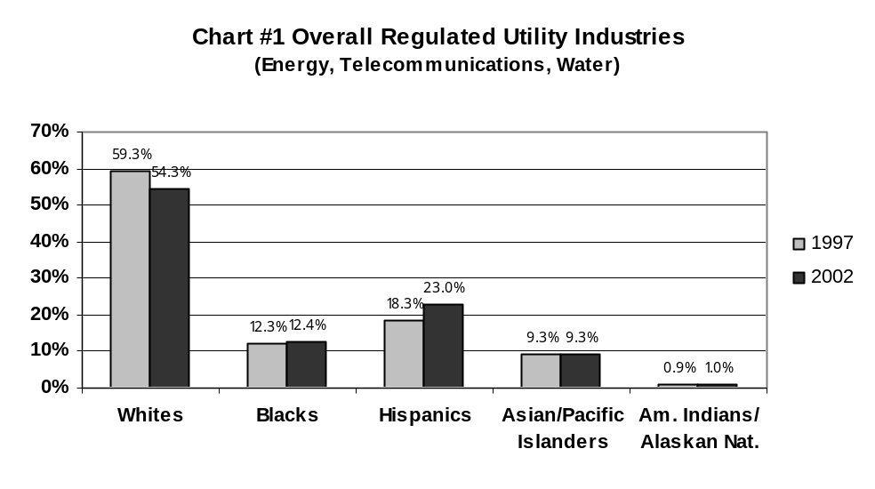

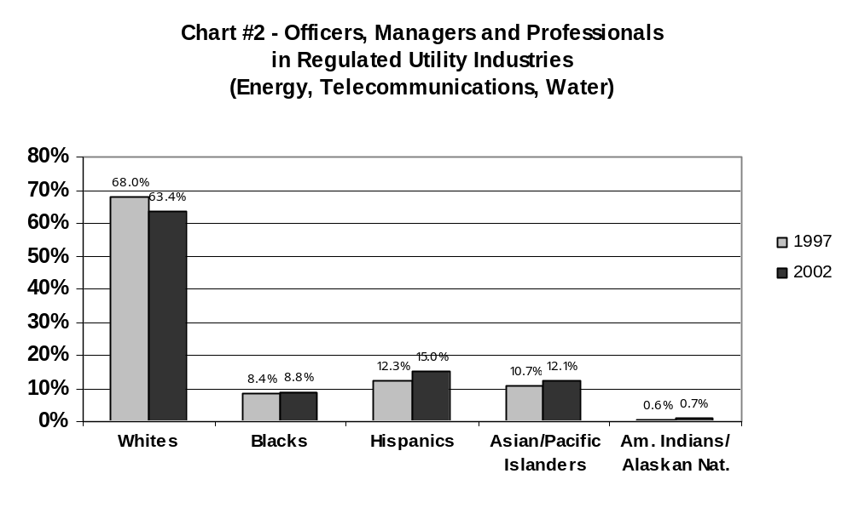

Salaries and Diversity
Many utilities provided information regarding the average weighted salary by ethnicity and gender for permanent full-time employees, although a number reported that they did not maintain such information or felt it was confidential. A number of utilities noted how such information depended on a great number of factors such as the number of individuals from any ethnicity, the type of employment, and so on. In some circumstances, a few highly paid individuals may skew the average weighted salary of an employment classification with only a few total members. As might be expected, the format and detail of utility responses varied widely.

Table 1: Average Weighted Monthly Salaries
All Utility Employees | Average Weighted Salaries
White Men | $3,870 to $5,533
White Women | $3,234 to $4,504
Hispanic Men | $3,287 to $5,078
Hispanic Women | $3,116 to $4,539
Asian/Pacific Is. Men | $2,425 to $5,806
Asian/Pacific Is. Women | $2,999 to $6,356
Native Amer. Men | $4,514 to $5,583
Native Amer. Women | $2,919 to $4,529
African-Amer. Men | $3,484 to $5,074
African-Amer. Women | $3,425 to $3,847

Because of the wide variety of reporting formats, the absence of information correlating the reported average weighted salaries to the number of employees, the absence – in most cases – of a breakdown of information by specific classes of utility employees, the absence of information from many utilities that declined to report such information, and the assertions of confidentiality by a number of utilities, these statistics do not comprehensively reflect overall relative salaries of employees of various ethnicities and genders. The statistics do, however, indicate a rough broad range for most groups.

Leadership and Mentoring
Most utilities have leadership development programs, some of which are quite extensive and detailed. One utility provides tuition assistance of up to $50,000 for those seeking master’s degrees. Many utilities expressed pride in their progress in the area of employment, diversity, outreach, and training, and describe their accomplishments in great detail. Many simply said that they were working in good faith toward the achievement of their goal of increasing diversity through nondiscriminatory employment programs.

Employment Policy Issues
- Are there any recognizable patterns of utility employment practices that act as a systematic barrier to employment diversity at all employment levels?
- What could the Commission productively do to encourage the development of further leadership training and mentoring programs designed to prepare a diverse workforce for higher level employment positions?
- Is there anything else the Commission could do to encourage further employment diversity without duplicating Federal employment diversity programs?

THE WOMEN-, MINORITY-, and DISABLED VETERAN-OWNED BUSINESS ENTERPRISE PROGRAM (WMDVBE)

Assembly Bill 3678 (Moore): Enabling Legislation
In 1986, the Legislature declared that it is in the State’s interest to (a) encourage greater economic opportunity for women and minority business enterprises (WMBE); (b) promote competition among regulated public utility suppliers to enhance economic efficiency in the procurement of electrical, gas, and telephone corporations’ (and their affiliates’) contracts; and (c) clarify and expand the program for the utilities’ procurement of products and services from WMBE. Specifically, Assembly Bill 3678 (Moore), which added Sections (§§) 8281 - 8285 to the Public Utilities Code, requires that regulated gas, electric and telecommunications utilities with gross annual revenues exceeding $25 million annually submit to the Commission detailed and verifiable plans for increasing procurement with women-and minority-owned business enterprises. The utilities must also include short- and long-term goals and timetables for implementing their plans. CPUC-regulated water utilities are not explicitly referenced in the legislation. The Commission is to report annually to the Legislature on the progress of activities undertaken by each utility to implement the WMDVBE program and recommend legislation it deems necessary.

Definitions of “Women Business Enterprise” and “Minority Business Enterprise”
PU Code § 8282 (a) defines WBEs as “a business enterprise that is at least 51 percent owned by a woman or women; or, in the case of any publicly owned business, at least 51 percent of the stock of which is owned by one or more women; and whose management and daily business operations are controlled by one or more of those individuals.” PU Code § 8282 (b) similarly defines MBEs. Disabled veteran enterprises are defined pursuant to Military and Veterans Code Section (§) 999 (g).

General Order 156: The Commission’s Rules and Regulations
In 1988, the Commission issued General Order (GO) 156, which sets forth the specific rules and regulations for the utilities’ WMBE programs pursuant to PU Code §§ 8281 - 8286. GO 156 requires the utilities to establish a program to inform, recruit and establish goals to obtain at least 15% of their products and services from minority-owned business enterprises and 5% of their products and services from women-owned enterprises within a five year period.
Section 8.5 of GO 156 provides that a utility can create an “excluded category” of products or services where it is clearly evident that WMBEs do not provide such services or that sole source procurement is the only available procurement method. The utility has the burden of demonstrating the unavailability of WMBEs capable of supplying such products and services and must justify in its annual report the continued existence of any excluded category.
Subsequently, the Commission issued D.95-12-045, which requires utilities to purchase at least 1.5% of their goods and services from disabled veteran-owned business enterprises.

Ten Year Trend
Over a ten-year period from 1993 to 2002, the utilities experienced not only a general increase in procurement, but also an increase in the percentage of procurement from WMDVBE firms. (See Charts 3 and 4.) This trend started to reverse itself in 2001, and continued in 2002. The years 1998 through 2001 had the highest percentages of WMDVBE procurement of the ten-year span. The peak year was in 2000, with 31.12 percent of procurement going to WMDVBE firms. (See Attachments 4, 5a and 5b.)
The utilities attribute the rise and subsequent decline in procurement spending to several factors:
- Sempra and PG&E reported that WMDVBE procurement has not declined since year 2000 and there have actually been increases.
- SCE states that the main factors contributing to the decline in its WMDVBE procurement are significant cost cutting and cash conservation measures instituted during the energy crisis in 2001. It was unable to make investments in infrastructure, load growth and system automation.
- Since 2000, SBC’s WMDVBE procurement has declined. In 2000, SBC reported 33.60% WMDVBE procurement, 33.3% in 2001, and 24.3% in 2002. SBC attributes this decline to “the overall national economic downturn and the unprecedented telecommunications industry depression.” It also noted that several of its largest diversity suppliers filed for bankruptcy protection in 2000 and 2001 and ceased doing business. Other WMDVBEs simply terminated their business when they realized they could no longer continue to operate.
- Verizon attributes its decline in WMDVBE procurement to “decreased deployment of its telecommunications network and declines in the purchase of cable, wire and outside plant construction.”
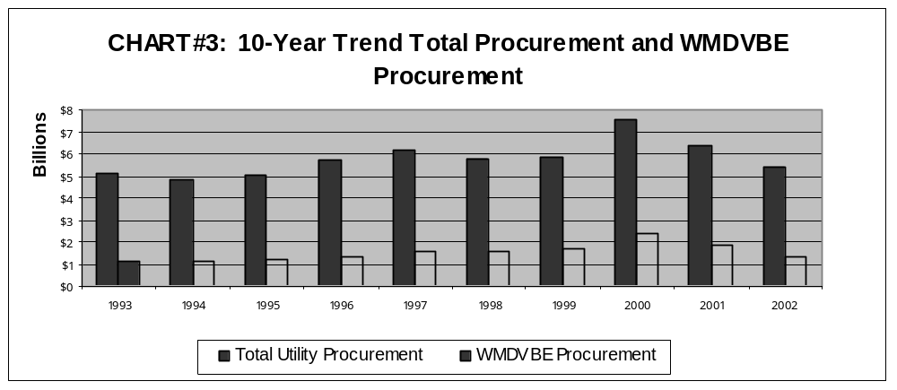

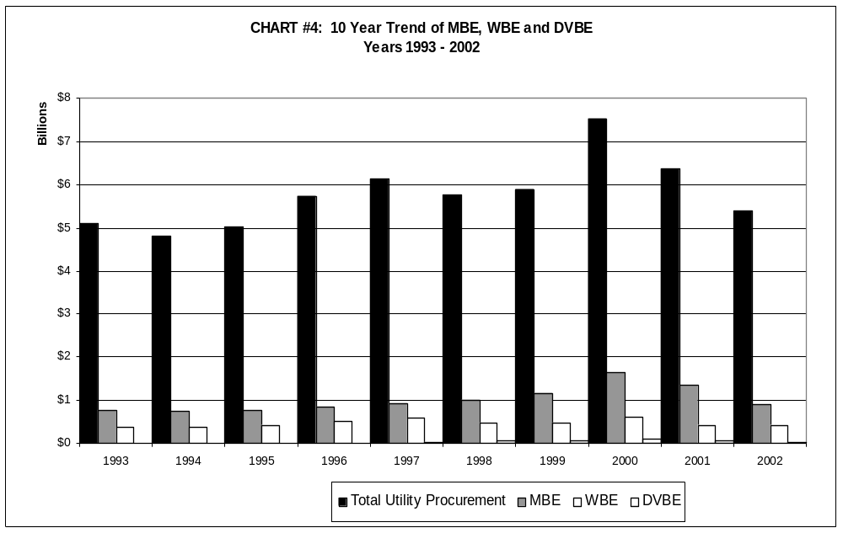

Certified WMDVBE Vendors
PU Code § 8284 (a) states that the Commission shall adopt criteria for verifying and determining the eligibility of women-, minority-, and disabled veteran-owned business enterprises for procurement contracts. In order to comply with this requirement, the Commission, in General Order 156, required the establishment of a WMBE clearinghouse. The WMBE clearinghouse verifies that firms seeking to compete for procurement opportunities with various utilities meet the eligibility criteria for women and minority owned and operated business enterprises. The Department of General Services verifies the status of disabled veteran-owned businesses. The clearinghouse operator maintains a database of all verified vendors, including DVBEs, and performs re-verifications on all vendors whose three-year status has expired.
Section 324.5 of the PU Code requires that the clearinghouse database be available online and in hardcopy to the public. The database is accessible through the CPUC’s website. Verification and database operations costs are borne by the utilities subject to the requirements of GO 156.
As of May 2003, there are a total of 4,433 certified vendors in the CPUC’s database. (See Chart 5.) There are 2,058 certified WBEs, which represents 46.65 percent of the certified vendors. Men own the majority of minority-owned businesses. For example, of the 741 Hispanic-owned businesses, men own 546, and of the 654 Asian-owned businesses, men own 444. (See Attachment 6.)
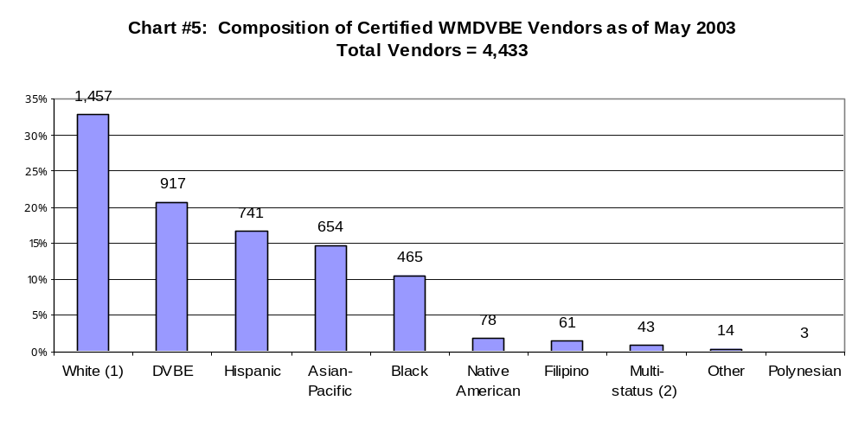

(1) All certified white-owned businesses are owned by women.

(2) “Multi-status” represents a business owned by a white female and a minority male. There may be three or more owners where no single individual can be considered the principal owner.

Utilities’ Business Strategies and WMDVBE Goals
The May 19 data request asked the utilities to summarize the number of WMDVBE vendors used since 1998. GO 156 does not require the utilities to report this information in its annual WMDVBE report to the Commission. The 17 utilities that have implemented WMDVBE programs provided the most comprehensive information, of which only 8 provided data that allowed a complete comparison for a five-year period. The data shows that the utilities have continued to meet the program goals for WMBEs, but they have contracted with fewer WMDVBE firms. (See Table 2.)
Verizon reports that it used 88 WMDVBE vendors in 2002 and that the number of suppliers has declined from prior years. Sempra provided data for two years: In 1999 it had contracted with 215 vendors and in 2002, 311 vendors. ATT Wireless responded that WMDVBE activity is tracked by dollars and not necessarily on the number of contracts awarded. ATT Wireless also stated that this request was burdensome and to compile the data in the allotted time would be resource intensive and not feasible. The water utilities stated that they were not subject to GO 156 and none provided data as requested.
The utilities contracted with the greatest number of WMDVBE firms in 1998 and 1999. Subsequently, significant declines occurred in years 2000 (decrease of 24 percent from the previous year) and 2001 (decrease of 16 percent from the previous year). This trend appears to parallel the decline in overall utility procurement and lower WMDVBE achievement.

Table 2:
No. of WMDVBEs Utilized by Utilities from Years 1998 through 2002
Utilities | 1998 | 1999 | 2000 | 2001 | 2002
ATT/Cal | 157 | 105 | 149 | 158 | 91
Pacific Gas and Electric | 728 | 647 | 623 | 468 | 563
PacifiCorp | 3 | 14 | 12 | 13 | 12
Roseville | 52 | 55 | 60 | 64 | 59
SBC | 524 | 633 | 191 | 186 | 201
SCE | 586 | 573 | 508 | 409 | 425
Sierra Pacific | 57 | 55 | 27 | 24 | 22
Southwest Gas | 27 | 27 | 32 | 31 | 30
Total | 2,134 | 2,324 | 1,602 | 1,353 | 1,769
Source: Utilities responses to the May 19 data request.

Changing Procurement Approaches - Strategic Sourcing
Many utilities, like other businesses, implement “strategic sourcing” as a business approach to reduce procurement costs and leverage spending practices. Loosely defined, strategic sourcing is the practice of consolidating diverse vendors into single source relationships. An example of strategic sourcing is when a utility issues one contract with ten tasks to a single vendor, rather than ten individual contracts to more than one firm for the same services. Such “strategic sourcing” may reduce the utilities’ overall procurement costs, since larger contractors can provide economies of scale that smaller businesses cannot provide. Also, the transaction costs of contract administration might be reduced if there are fewer contractors. Thus, there could be a practical conflict between the implicit goal of the WMDVBE statute and economic efficiency. Utilities such as Sempra, SCE, PG&E, Verizon, and SBC employ some form of strategic sourcing.
It is not clear whether and how the practice of strategic sourcing results in limited opportunities for WMDVBEs to contract with utilities, or serves to complement the WMDVBE program.

Utility WMDVBE Program Expenditures
The May 19 data request asked the utilities to summarize the resources they allocated to the WMDVBE program for the last five years. The 17 utilities that have implemented WMDVBE programs provided more data than those utilities that do not. Several utilities reported that the information is not available, has not been tracked, or that they were not required to maintain such information.
Cumulatively, the utilities allocated more dollars to the WMDVE program in the year 2000, which coincides with when the utilities reported the highest overall company procurement and the highest WMDVBE procurement. (See Table 3.) Only PG&E and Sprint report that the year 2002 represents their highest yearly expenditure on the WMDVBE program. The other utilities report declines in WMDVBE expenditures.

Table 3:
Summary of WMDVBE Program Expenditures for Year 1998 through 2002
Utilities | 1998 | 1999 | 2000 | 2001 | 2002
ATT/Cal | 447,007 | 385,423 | 397,793 | 344,355 | 344,146
PacifiCorp | 3,950 | 4,750 | 4,750 | 3,250 | 3,250
PG&E | 1,068,685 | 1,176,307 | 1,204,335 | 1,089,326 | 1,217,622
Roseville | 43,327 | 34,223 | 40,008 | 27,269 | 23,412
SBC | 1,662,000 | 1,693,000 | 1,694,000 | 1,461,000 | 731,000
SBC ASI | N/A | N/A | N/A | N/A | 73,000
SCE | 1,490,911 | 1,631,064 | 1,845,897 | 1,269,382 | 1,326,092
Sempra | 1,134,152 | 1,323,693 | 1,238,121 | 1,420,759 | 1,382,820
Sierra Pacific | 56,110 | 61,093 | 57,698 | 58,434 | 55,673
Sprint | 684,869 | 1,100,134 | 1,570,164 | 1,548,376 | 1,519,315
Verizon | 527,132 | 398,013 | 364,160 | 221,635 | 235,000
Worldcom | 200,586 | 49,148 | 74,649 | 111,493 | 105,114
Total | $7,318,729 | $7,856,848 | $8,491,575 | $7,555,279 | $7,016,444

Source: Utilities’ response to the May 19 data request.

Failure to Achieve the 1.5% DVBE Procurement Goal
GO 156 establishes a 1.5 % DVBE procurement goal. Overall, DVBE procurement declined from over $90 million in 2000 to $30 million in 2002. Of the 17 utilities implementing GO 156 provisions, none reported achieving the 1.5 % goal. Most of the utilities attribute this failure to their inability to find DVBEs that are of the size and scope needed for contracting opportunities and to the unavailability of qualified, competitive and certified DVBEs. SBC, from 1999 to 2001, was the only utility that had met its DVBE procurement goal. PG&E reports steady increases in DVBE procurement since 2000. It states that its year-to-date as of May 2003 DVBE procurement is at 1.8 percent.
In a white paper submitted as testimony in the SCE GRC (A.02-05-004/I.02-06-002), the California DVBE Alliance encourages the Commission to adopt SBC’s DVBE program for all utilities. SBC’s DVBE program includes assigning a specific program manager to facilitate internal DVBE procurement activities; providing easy access to online DVBE resources; establishing a DVBE advisory council comprised of SBC managers and DVBE suppliers; and, instituting an employee recognition program for those employees who contribute to achieving the DVBE procurement goal.
The DVBE community and utilities might benefit from a Commission examination of those specific utility activities, which contribute to a successful DVBE program, and how these program elements might be implemented by utilities.

Opportunities for Small Businesses
A policy issue to consider is whether GO 156 should be modified to include small businesses in addition to the existing women, minority and disabled veteran designations. The U.S. Small Business Administration, in its report, Minorities in Business, 2001, states that approximately 99 percent of the businesses owned by various minority groups are defined as small businesses. As noted by the Governor’s Office of the Advocate for Small Business, California’s small businesses comprise nearly 98 percent (2.5 million) of all businesses in the State, and employ more than 50 percent (7.5 million) of California’s workforce. In May 2001, Governor Gray Davis issued Executive Order D-37-01, which encourages state agencies “to pursue aggressively an annual 25 percent small business participation level in state contracting.”
The addition of a small business component in GO 156 could be considered to be consistent with, and further the goals of the statutory language on which GO 156 is based. This modification could be viewed as promoting the interests of small and disadvantaged businesses and expanding the number of potential suppliers. Since most women, minority, and disabled veteran businesses are also small businesses and/or small and disadvantaged businesses, program elements that benefit small businesses and small and disadvantaged businesses would benefit the original core constituencies of GO 156.

Elimination of Excluded Categories
GO 156 allows the utilities to exclude certain products and services from the base of WMDVBE procurement dollars where the utilities can demonstrate the unavailability of WMDVBE suppliers. In order to use an exclusion, utilities must justify such use and provide “a description of any efforts made to find and or recruit WMDVBE suppliers of products and services in the excluded category.”
Some utilities, such as SBC, have voluntarily eliminated all excluded categories, while others have retained such categories since the adoption of GO 156, despite the Commission’s directive that utilities review these categories annually and eliminate those that are no longer appropriate. Many utilities do not present sufficient justification on an annual basis for continuing the exclusions. The annual WMDVBE reports filed by SCE, PG&E, and Verizon for 1999, 2000, and 2001 show that the justification and description of the excluded categories is insufficient. In these three reports, SCE offers substantially the same paragraph to justify its exclusions. PG&E reported the highest percentage of excluded categories for its 2002 WMDVBE program results, with 33 percent of its procurement expenditures excluded from its gross procurement. This means that approximately one third of its procurement is excluded from its contract value base number against which it measures its WMDVBE program results. SCE had the second highest percentage of exclusions at 26 percent.
The Greenlining Institute and Latino Issues Forum have proposed eliminating the “excluded categories” element of General Order 156. Greenlining/LIF believes that the markets have changed dramatically since the WMDVBE program was initiated. They believe that more WMDVBEs can offer products and services to the utilities to a more significant extent than before. They believe that the utilities unnecessarily rely on exclusions rather than aggressively fostering WMDVBE participation.
Several of the utilities argue that although the market for some categories of utility products and services provided by WMDVBEs has developed, the market for other categories has not, and therefore the utilities should be permitted to continue excluding these categories from their WMDVBE goals.
In R.03-02-035, the Commission is considering revising GO 156 to eliminate a utility’s ability to create an “excluded category” of products and services. The current proposal under consideration is to allow a utility the opportunity to explain in detail how its ability to meet its WMDVBE goals are affected because WMDVBE suppliers do not offer a particular product or service, or because sole source procurement is the only available procurement method. The utility may also include a description of the utility’s efforts to find and recruit such suppliers.

Utility Outreach and Education to WMDVBEs
GO 156 requires the utilities to include in their annual WMDVBE reports the status of their outreach activities to the WMDVBE communities. The utilities, among other things, are required to seek opportunities to identify WMDVBE contractors, to actively support efforts of organizations that promote the interests of WMDVBE contractors, to work with WMDVBE contractors, and to facilitate contracting relationships, etc. Each utility is directed to offer this same assistance to non-WMDVBEs, upon request.
The utilities state that as part of their outreach efforts to the WMDVBE community, they advertise prominently in various newspapers; actively participate in trade fairs and conferences; attend community and association events, i.e., chambers of commerce events and trade fairs; and, support education programs and seminars, i.e., the Price Center for Entrepreneurial Studies at the Anderson School at UCLA’s Management Development Program for Entrepreneurs.
The utilities appear to be fulfilling their obligation to perform outreach to the WMDVBE communities. However, it is not clear how much of the utilities’ achievement of the WMDVBE goals are attributable to outreach activities and expenditures.

Procurement Policy Issues
- Is the practice of strategic sourcing consistent with the goals and purpose of the WMDVBE program? Does strategic sourcing result in the utilities doing business with fewer WMDVBEs?
- Would increased allocations of utility resources result in greater WMDVBE program achievement?
- Would adding a small business component to GO 156 further the goals of the WMDVBE program?

The Commission is also examining utility employment diversity and utility procurement activities in three major energy proceedings: The Southern California Edison Company General Rate Case, Application (A.) 02-05-004, the Pacific Gas and Electric Company General Rate Case A.02-11-017, and the Southern California Gas Company and San Diego Gas & Electric Company Cost of Service proceedings (A.02-12-027/A.02-12-028/ I.03-03-016).
The May 19 data request was sent to (1) the 15 utilities currently participating in the Women, Minority and Disabled Veteran-owned Business Enterprise program, pursuant to PU Code § 8283, (2) those utilities that meet the threshold criteria set forth in § 8283, but do not currently participate in the WMDVBE program, and (3) respondents in R.03-02-035.
See Decision 88-04-057, 28 CPUC2d 36.
All data represented in Charts 2 and 3 is derived from the data responses and annual reports of the 15 utilities participating in the WMDVBE program. These utilities include AT&T, Verizon of California, SBC, SBC/ASI, Pacific Gas and Electric Company, Sempra (SDG&E and Southern California Gas Company), Southern California Edison Company, Citizens Telecommunications Company of California, MCI, PacifiCorp, ATT Wireless, Roseville Telephone Company, Sprint, Southwest Gas Corporation and Sierra Pacific Power Company.
The 17 utilities that have implemented WMDVBE programs are: AT&T California, AT&T Wireless, Citizens Utilities Company, ComCast, MCI WorldCom, Pacific Corp., Pacific Gas and Electric Company, Roseville Telephone Company, SBC, SBC Advanced Solutions, Inc., San Diego Gas & Electric Company, Sierra Pacific Power Company, Southern California Edison Company, Southern California Gas Company, Southwest Gas Corporation, Sprint Communications.
Southwest Gas Company did not itemize the information by year as requested but gave a five cumulative total of $176,499. In 2001, ATT Wireless started reporting its annual WMDVBE information separate from ATT California. Citizens stated that it could not provide the data as requested because it did not have access to the expenditure information over that period of time. SBC/ASI provide the data for 2002. Prior to 2002 SBC/ASI was part of SBC and thus did not have data for the years 1998,1999, 2000, and 2001.
Trade and Commercice Agency, Office of Economic Research, September 2000.

