Summer 2000 Energy Efficiency Initiative

Request for Proposal Response

July 21, 2000

Table of Contents

1 INTRODUCTION 3

1.1 Andersen Consulting’s Understanding of The California State Government’s and
The Commission’s Business Situation 3

2 ANDERSEN CONSULTING’S LOAD MANAGEMENT VISION 4

2.1 Residential Curtailment 4
2.2 Load Curtailment Internet Hub 6
2.3 California State-wide Load Management 9
2.4 Considerations for the Success of the Proposed Three Program Components 11

3 PRE IMPLEMENTATION ACTIVITIES 12

3.1 Objectives 12
3.2 Scope 13
3.3 Andersen Consulting Approach 13
3.4 Work Plans 15
3.5 Staffing 16
3.6 Cost Estimates 16
3.7 Implementation Activities 17

4 ANDERSEN CONSULTING CREDENTIALS 18

4.1 ISOs/PXs 18
4.2 Electricity and Other Commodities 21
4.3 Project Management 25

5 CONFIDENTIALITY STATEMENT 26

Introduction

Andersen Consulting’s Understanding of California State Government’s and The Commission’s Business Situation
According to its order on July 6, 2000 (section XIII), the California Public Utilities Commission (CPUC) is interested in immediate delivery of demand and energy usage reductions to alleviate problems associated with energy supply and demand being out of balance in the state. The CPUC directed parties to provide program components that will bring about the largest reductions in electric demand and/or electric usage reductions in the shortest period of time.

It is Andersen Consulting’s vision that the three (3) program components listed below will act as an excellent complement to the current energy efficiency programs and load curtailment programs implemented by utilities, ESPs, the ISO, and large commercial and industrial customers throughout the State of California. The recent advances in internet technology, wireless communications, and smart thermostats make these three (3) program options viable today, enabling the utilities, ESPs, the ISO and large commercial and industrial customers to provide the large reductions in electric demand and/or electric usage in a short period of time and at an effective cost.

- Residential Curtailment - A state-wide Load Control Program for Residential HVAC systems that takes full advantage of the advances in internet technology, wireless communications, and smart thermostats.

- Load Curtailment Internet Hub - A central hub for energy users and suppliers to create, implement and monitor load management activities in California.

- California State-wide Load Management – A state-wide Load Control Program for Commercial and Industrial Customers that takes full advantage of the advances in internet technology, wireless communications, and smart thermostats.

The Residential Curtailment and Load Curtailment Internet Hub program components are an integral part of the California State-wide Load Management program component. Therefore, for completeness, a summary of each of the three (3) program components is provided in the next section of this proposal. However, the primary focus of this proposal is to address the plans for the evaluation of the California State-wide Load Management program component.
Standalone proposals for the first two (2) components are submitted separately from this proposal.

2 ANDERSEN cONSULTING’S LOAD management VISION
This section will summarize the purpose, benefits, high level technology and technical architecture of each of the program components within Andersen Consulting’s vision. Andersen Consulting will take the lead roll in the pre-implementation activities proposed for the California State-wide Load Management initiative. In addition, Andersen Consulting is interested in working with the CPUC, as appropriate, to foster the successful implementation of all three (3) program components. It is assumed that Silicon Energy will provide the technology platform, expertise and vendor alliances to enable implementation of three (3) program components:

Residential Curtailment - A state-wide Load Control Program for Residential HVAC systems that takes full advantage of the advances in internet technology, wireless communications, and smart thermostats.

Load Curtailment Internet Hub - A central hub for energy users and suppliers to create, implement and monitor load management activities in California.

California State-wide Load Management – A state-wide Load Control Program for Commercial and Industrial Customers that takes full advantage of the advances in internet technology, wireless communications, and smart thermostats.

2.1 Residential Curtailment

2.1.1 Purpose/Benefits

Carrier Electronics and Silicon Energy are proposing a state-wide Load Control Program for Residential HVAC systems that takes full advantage of the advances in internet technology, wireless communications, and smart thermostats. The technologies and methodologies designed by carrier Electronics and Silicon Energy will allow the CPUC to:

- Offer a load-control program that also preserves ultimate end-use customer control
- Adjust residential HVAC loads by various amounts during peak periods
- Identify the devices contributing to load relief and the customers choosing to override the system
- Gather information about device use and performance, enabling verification of savings, and finer targeting of price signals in the future

These benefits will be realized by enabling two-way communications to each home, with Internet interoperability between a Carrier EMi Thermostat and the Silicon Energy software. The Silicon Energy software will collect and store event information for later retrieval by the CPUC for program settlement, planning and tuning.

The proposed load control system will be configured to allow the CPUC to customize their data gathering as well as display the customers’ event participation patterns. In addition, the CPUC will have the ability to control the customer’s thermostat, with the customer having the ability to override CPUC decisions at any time. The information is logged on Silicon Energy’s central server and can be presented in a variety of customizable forms to both the CPUC and the customer.

2.1.2 High-Level Technology Summary

- Carrier Electronics’ EMi Thermostat technology will be used for the HVAC load control hardware to be installed at each residential site
- Silicon Energy will provide data services, project management, and load control software for the large commercial/industrial load control programs
- The most appropriate communications services provider(s) will be used for control event messaging and data collection between the Carrier EMi and the Silicon Energy system
- Silicon Energy will provide administrator web data and reporting interfaces, as well as consumer web interfaces

2.1.3 Technical Architecture

At the heart of all Silicon Energy systems is the real-time database server, which comes complete with all the productivity tools necessary to configure and administer the software. The Silicon Energy server supports all Silicon Energy and 3rd party application modules, provides a high sustained transaction rate (hundreds/second), uses local queuing layers for bursts in traffic, and is highly scalable. The Silicon Energy server can be distributed across multiple CPUs and employs a unique ‘push’ technology to deliver targeted information immediately while maintaining high security.

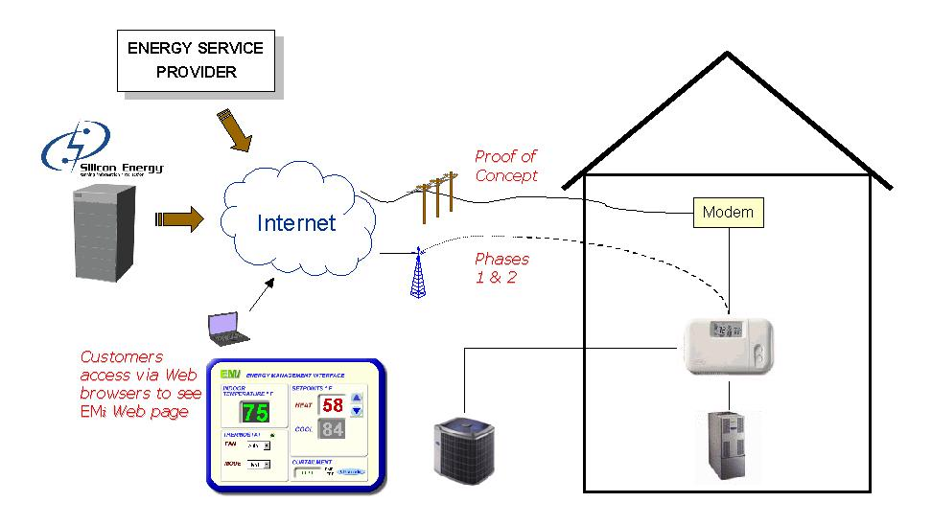

2.2 Load Curtailment Internet Hub

2.2.1 Purpose/Benefits

A central load curtailment internet hub for energy users and suppliers will be developed and implemented to monitor load management activities in California. The capabilities and benefits of the load curtailment internet hub is as follows:

- Provides energy users a single entry point to the full range of load management participation opportunities
- Weather, energy price, and load management options are customized to individual users
- Supports multiple program implementations by utilities, ESP’s, the ISO, and the PX
- Supports centralized load management for multi site commercial and industrial end users

A centralized portal will significantly increase the quantity and cost effectiveness of load management resources in California. Benefits include:

- A single point of contact, which reduces customer confusion, leverages marketing dollars, and simplifies participation in multiple programs
- A flexible, yet comprehensive infrastructure that speeds program implementation
- A technology which enables all customers to participate, regardless of their energy provider
- A centralized infrastructure that allows all service providers to leverage, or link to their own system, at their option

2.2.2 High Level Technology Summary

How it Works – Setup

- Silicon Energy hosts a website that provides the customer portal weather, energy price data, and curtailment links.
- Silicon Energy provides a series of Enterprise servers configured to allow the range of curtailment and load management options.
- Customers access the Enterprise systems through selections made in the curtailment portal.
- Customers configure their sites, locations, and preferred load management participation.
- Each curtailment and load management option selected can be configured based on the preferences of the provider and the customer.

How it Works – Operations

- Silicon Energy gathers load data for customers by installing gateways to each utilities’ and/or ESP’s existing Meter Data Management and Acquisition’s (MDMA) collection system.
- The data resolution available will depend on the data collection rate of the utility or MDMA for that customer.
- Energy providers and utilities have secure access to view their customer’s load data and to send notices or publish price signals.
- Security provisions assure that service providers can see only their customers load data.
- The load management systems can be hosted by Silicon Energy, linked to a Silicon Energy system maintained by a service provider, or linked to a system not provided by Silicon Energy.

2.2.3 Technical Architecture
The technical architecture proposed provides the following:
- Basic curtailment notification and event tracking for customers without interval data
- Curtailment notification, baseline calculation, and settlement for customers with interval data, but without real time metering
- Full real time notification, monitoring and settlement for customers with real time meter data collection
- Automatic direct load reduction implementation based on user defined price triggers for any customer (requires some additional hardware and communications)
- Links to other curtailment or load management systems tailored to each customer

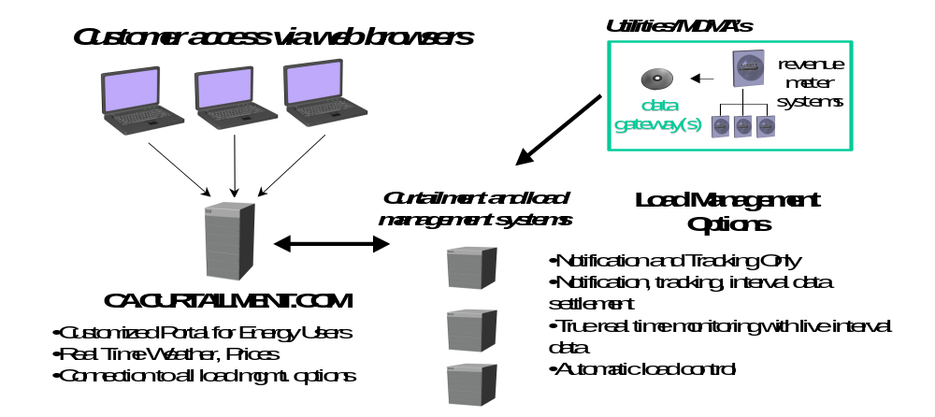
Figure 1

2.3 California State-wide Load Management

2.3.1 Purpose/Benefits

Andersen Consulting and Silicon Energy are proposing a California State-wide Automated Load Management Program that takes advantage of the advances in internet technology and wireless communications. The technologies and methodologies designed by Andersen Consulting and Silicon Energy will allow the CPUC to:

- Synchronize the Residential Curtailment and Load Curtailment Internet Hub Program Components as well as maximize the potential benefits of each of these two components

- Provide the utilities, ESPs, and/or the ISO a single entry point to implement automated load management throughout the State of California

- Provide the utilities, ESPs, and/or the ISO an excellent mechanism to manage load curtailment events during critical high peak load periods within the State of California

- Provide California State-Wide direct load control at an extremely low cost (estimated $13/Kw installation cost and a $10/MWh to operate - Program costs and economics are more fully described in the Proposal for “Load Management Infrastructure Solutions” submitted in a separate filing by Silicon Energy Corporation

These benefits will be realized by enabling two-way communication pathways between utilities, ESPs, and/or the ISO and participating Commercial and Industrial Customers throughout the State of California.

2.3.2 High-Level Technology Summary

How it Works –

There are two options to consider in the final design of the California State-wide Load Management Program Component (e.g. participation/sign-up):

- Andersen Consulting in conjunction with the ISO approach large Commercial and Industrial Customers within the State of California to sign up for the California State-wide Load Management Program Component.

- Andersen Consulting, in conjunction with the ISO, coordinate with utilites and ESPs in California to approach large Commercial and Industrial Customers within the State of California to sign up for the California State-wide Management Program Component.

How it Works - Setup

- Set up is described under the Load Curtailment Internet Hub Section 2.2.2 and is also provided in detail in Silicon Energy’s proposal submission.

How it Works – Operations

- California State utilities and ESP’s have the ability to manage load utilization of their commercial and industrial customers
- California State utilities and ESP’s have the ability to manage load utilization of their residential customers
- The ISO has the ability to manage the load utilization of utilities and ESP’s (e.g. the ISO will have a direct connection to a selection of commercial and industrial customers throughout the State of California)

2.3.3 Technical Architecture

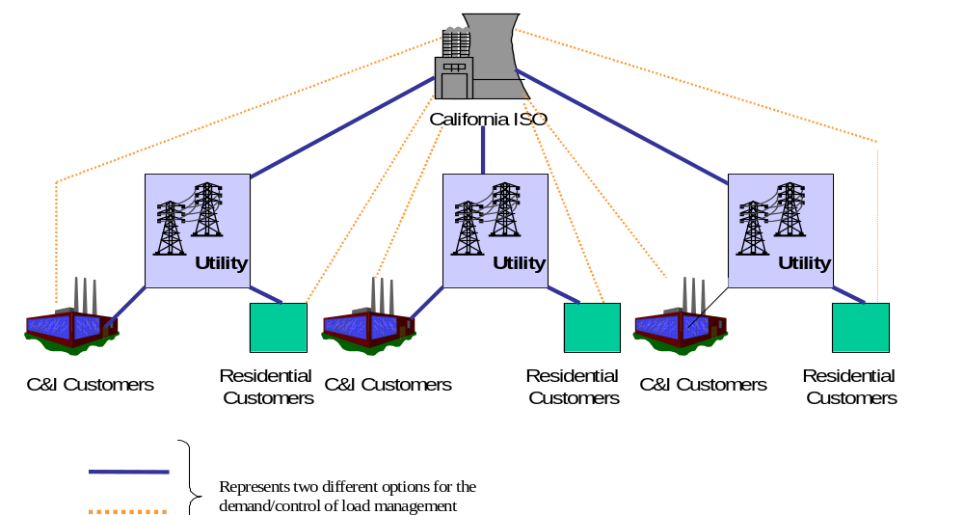
It is anticipated that the technical architecture utilized to accomplish the California State-wide Management Program Component will be provided by the Load Curtailment Internet Hub component described in the previous section. However, it is understood that additional functionality will have to be added to the Load Curtailment Internet Hub to provide the utilities, ESPs and/or the ISO with automated load management control of commercial and industrial energy devices.
Figure 2

2.4 Considerations for the Success of the Proposed Three Program Components
A sophisticated technological diagnostic is not needed to commence work activities for the Residential Curtailment or the Load Curtailment Internet Hub Program Components, however, it is highly recommended that pre-implementation activities be completed as a key starting point for the State-wide Load Management Component. These pre-implementation activities provide the basis for the proper sponsorship from the California State utilities, ESP’s, and the ISO. The activities are outlined in the next section.

3 PRE IMPLEMENTATION Activities
This segment of work will commence by defining the California State-wide Load Management Value Proposition. In essence, the proposed pre-implementation activities will demonstrate the energy efficiency savings gained by the CPUC through State-wide Load Curtailment optimization. It is envisioned, that by assessing the State-wide Load Management Component, the CPUC may be able to supplement and/or enhance the current Load Curtailment and efficiency programs currently administered by the California ISO, Pacific Gas & Electric, San Diego Gas & Electric and Southern California Edison. The results from the pre-implementation activities will include, but may not be limited to, the identification of the:

- specific load management performance improvement opportunities discovered
- capabilities necessary to implement the recommended improvement opportunities
- technology necessary to implement the recommended improvement opportunities
- estimated costs to implement the recommended performance improvement opportunities
- benefits realized through the implementation of the recommended improvement opportunities.

In addition to an implementation plan to execute the recommended performance improvement opportunities.

3.1 Objectives
- Andersen Consulting will coordinate with the CPUC and Silicon Energy to form a team which will assess the as-is situation. i.e. the Load Curtailment business processes, organization and technologies currently employed by California ISO, Pacific Gas & Electric, San Diego Gas & Electric and Southern California Edison
- The team will employ thought leadership, innovation, experience of industry best practice and judgement to arrive at the to-be situation. i.e. improved Load Curtailment business processes, organization and technology.
- The team will identify the gaps between the as-is and to-be models in order that it can recommend and develop cost/benefit estimates for the implementation of business process, organization and/or technology improvements.

3.2 Scope
Business process analysis will address what is being done, why it is being done, who does it and how they do it. The scope of this analysis will identify performance improvement opportunities in any or all of those areas.
Analysis will pertain to the following areas:
- Residential Curtailment programs
- Commercial and Industrial Curtailment Programs
- Execution and Tracking of Curtailment Events
- Execution and Tracking of Billing Management for Curtailment Events
- Customer Communication Processes (e.g., marketing programs, early limit warnings, etc.)

3.3 Andersen Consulting Approach
Andersen Consulting has shaped and reinvented the consulting industry by constantly exploring new ways to maximize the value delivered to our clients. We have pioneered the concept of the Business Integration Model and have encapsulated its principles in the Business Integration Methodology. It is through this state of the art approach that Andersen Consulting brings high levels of consistency and rigor to the way we help clients plan, deliver, manage, and sustain broad-based change.
Andersen Consulting Business Integration Model

Technology

Process

Organization

Strategy
Integration
Assessment

Accomplishing business change requires an array of skills and abilities and thus requires the combined and coordinated efforts of many people. The Business Integration Methodology considers activities, deliverables, controls and tools needed to facilitate the people, process, strategy and technology aspects of any business change program. It provides a strong guiding framework allowing people to work as a team and to harness their collective skills to reach a common goal.
Our project team proposes to utilize the Business Integration Methodology to ensure consideration of specific Load Curtailment processes in the context of the business strategy, process, human resource and technology situations of California ISO, Pacific Gas & Electric, San Diego Gas & Electric and Southern California Edison. This approach will enable the project team to consider existing constraints, identify areas of strength and arrive at improvement opportunities which will be achievable by these organizations.
As defined by the Business Integration Methodology, this segment of work will deliver the following:
Value Proposition – (validated value proposition) a statement that communicates the value of the Load Curtailment initiatives to the sponsoring organization. This proposition is arrived at through understanding the strategic context and intent, the performance improvement opportunities and the selected value creating opportunities (those which can be realized quickly, easily and which realize the largest benefits).
Business Case – a document which provides economic justification for the Load Curtailment (example) initiatives. The Business Case explains why the initiatives should be undertaken, what value the sponsors receive by changing, and what steps are necessary for a successful change.
Business Capability Blueprints – summary definitions of the as-is and to-be business capabilities associated with the Load Curtailment processes. These definitions will address process, organization and technology and will include consideration of leading edge Load Curtailment market offerings utilizing the abilities afforded by the Internet.
Implementation Plan – plan of work, schedule, resource and cost to implement the desired Load Curtailment initiatives. As required by the business process analysis, the plan will include custom system development, package solution procurement/configuration, organization design, training, communications, production turnover, operations and benefits realization.

3.4 Work Plans
This type of work is not suited to a bottom up approach for estimation as the diversity of scope and the issues based approach makes it difficult to identify discrete work units up front. Therefore estimates for this work will focus on resources required for a specific period of time to investigate high value opportunities within subject areas or associated with business issues. Also, given the subjective definitions of completeness for the deliverables from this work (e.g. at what point are all high value opportunities identified) it is prudent to timebox activities (i.e. complete opportunity assessment) after 15 days of work.
 | W1 | W2 | W3 | W4 | W5 | W6 | W7 | W8 | W9 | W10 | W11 | W12
Pre-Implementation
Confirm Sponsor goals and expectations
Understand strategic context and intent (CAISO, PG&E, SCE, SDG&E)
Identify performance improvement and value creating opportunities
Define Value Proposition
Business Architecture
Analyze and document as-is Load Curtailment business processes (CAISO, PG&E, SCE, SDG&E)
Analyze and document as-is Load Curtailment organization (CAISO, PG&E, SCE, SDG&E)
Analyze and document as-is Load Curtailment technology (CAISO, PG&E, SCE, SDG&E)
Define and document to-be Load Curtailment business processes (CAISO, PG&E, SCE, SDG&E)
Define and document to-be Load Curtailment organization (CAISO, PG&E, SCE, SDG&E)
Define and document to-be Load Curtailment technology (CAISO, PG&E, SCE, SDG&E)
Define Integrated Business Architecture
Develop Implementation Plan (effort, resource, schedule, cost, risk)
Develop/Refine Business Case
Present Recommendations
Package deliverables from pre implementation activities
Present recommendations to Sponsors

3.5 Staffing
We estimate the total project time for the Pre Implementation Activities to equate to 250-300 person days. Depending on the scope and required deliverables of the project, the proposed staffing can be scaled up or down to better fit the needs of the CPUC.

3.6 Cost Estimates
Andersen Consulting anticipates the total cost of the project to be $575,000. This estimate is based on the Pre Implementation Activities being completed in the twelve weeks outlined in the project schedule. If the CPUC desires to complete the pre-implementation activities in a modified timeframe, (e.g. shorter than 12 weeks) or the project runs slightly over estimates with respect to time/people, together we will determine a mutually agreeable payment solution.
In addition, Andersen Consulting will bill for out-of-pocket expenses, such as airfare, hotel, database access, and other expenses necessarily incurred to complete this work. These expenses will be billed at out-of-pocket cost, without additional markup. Typically these expenses approximately range between fifteen to twenty percent of consulting fees.

  - Implementation Activities
After the successful completion of the Pre-Implementation Activities, the next logical step will be the completion of a proof concept through a pilot phase. The entities envisioned to participate in this pilot phase include the California ISO, a selection of utilities, ESPs, commercial customers, and industrial customers throughout the State of California.

Andersen Consulting credentials

4.1 ISOs/PXs
Andersen Consulting is a market leader in providing solutions for ISOs, power exchanges and other trading organizations around the world. We provide global experience and depth of knowledge to our clients. The practice focuses on end-to-end wholesale and retail markets in electricity, gas, and water. Andersen Consulting’s mission is to transform or build an organization and its technical infrastructure and business processes to meet the requirements of the newly deregulated markets.
The table below provides a summary of representative engagements for previously completed work or work in progress. The engagements demonstrate Andersen Consulting’s global experience, depth of business knowledge and capability in delivering solutions.

Client/Service Provided | Program/Project Management | Conceptual Design | Systems Design, Build & Test | Systems Implementation | Training | Market Information Reporting | Portal Development & Implementation | Business Procedure/Process Definition
PX Brazil (ASMAE) |  |  |  |  |  |  |  | 
ISO New England |  |  |  |  |  |  |  | 
PJM ISO |  |  |  |  |  |  |  | 
Power Pool of Alberta |  |  |  |  |  |  | 
ERCOT |  |  |  |  |  |  | 

ISO New England – Massachusetts, USA
Andersen Consulting teamed with ISO New England in their transition to a competitive bid-based ISO and Power Exchange. To achieve this, Andersen Consulting worked in partnership with ISO-NE to design new business processes to support all of the settlement functions needed for the transition from a tight pool to an ISO/PX. To support the implementation of the business processes, Andersen Consulting implemented the Energy eXchange™ to provide the following power exchange functions for the wholesale and competitive markets: settlements, billing, bid submission, contracts submission, market information publishing, customer information maintenance, and power system maintenance. The implementation of the Energy eXchange™ software and processes was accompanied by the appropriate organizational and training design and development for both ISO-NE employees and market participants.

PJM Interconnection – Pennsylvania, USA
PJM Interconnection is the world’s oldest and fourth largest centrally dispatched pool, and became the first fully operational ISO in the United States on January 1, 1998. Andersen Consulting has delivered value in project management, organizational studies, strategy, assistance in developing innovative technology solutions, and helping PJM develop an environment that supports human change. For each of these initiatives, Andersen Consulting has combined its industry and technical skills along with its methodology to assist PJM as it evolves its business. Listed below are some of these projects:

- Market User Interface
- Customer Choice – eSchedules Application Development Project
- Customer Choice – PJM eCapacity Application Development Project
- Market Pricing Project
- Information Services Strategy
- Pricing Strategy

Power Pool of Alberta – Calgary, Alberta, Canada
The Power Pool of Alberta is a public organization responsible for operation of the bulk power system (generation and transmission) and the competitive marketplace for electricity in the province of Alberta, Canada. Recent legislation extended the scope and accelerated the market's deregulation, significantly increasing demands on the pool’s system in terms of performance, transaction volumes, and overall processing complexities.

Andersen Consulting is working with Power Pool of Alberta to create, deliver, and implement new infrastructure to provide market trading and settlement business functions and interfaces between the Power Pool's participants and the Market Operator. Andersen Consulting’s Energy eXchange™ is the basis for the new infrastructure and will be seamlessly integrated into an Information Provider Portal, enabling the participants to bid more effectively into the system. The internet-based energy trading system includes functionality to support bidding, meter data submission, settlements, billing, and market information publishing.

As a result of the new systems and business capabilities, the Pool expects to provide improved participant service levels, increase operational efficiency, and promote a more robust competitive electricity marketplace for end use customers.

ERCOT – Texas, USA
The Electric Reliability Council of Texas (ERCOT) represents a bulk electric system located totally within the state of Texas and serves about 85% of Texas’s electrical load. With the directive in Senate Bill 7 calling for retail competition in electric service to begin by January 1, 2002 and a “competition pilot” beginning June 1, 2001, ERCOT will become the state’s Independent System Operator.

ERCOT selected Andersen Consulting to develop and implement the overall integrated market solution program. Andersen Consulting will deliver business systems and procedures so that ERCOT can control power flows, oversee market operations, track commercial transactions, and archive and retrieve data. The development and implementation of a stable infrastructure is required for a reliable and robust competitive electricity market in Texas.

The program consists of three package solutions focusing on core business capabilities and a prime integration component focusing on integration across the three packages as well as rollout of the solution to the marketplace. Andersen Consulting is supported by subcontractors including Alstom ESCA, LODESTAR, and Regional Economic Research (RER) to deliver the package solutions: System Operations, Commercial Operations, and Data Warehousing and Data Archiving. Andersen Consulting’s primary integration component includes: Program Management, Solution Architecture, Solution Integration, Technical Architecture, Information Portal, Organization and Market Participant Readiness, and Communications.

ASMAE – Brazilian Power Exchange – Sao Paulo, Brazil
ASMAE is a new company created in February, 1999 to manage the wholesale energy market (MAE) for the country of Brazil. MAE was established under a federal law that set out steps to deregulate Brazil’s electricity sector. Issues addressed by the law are: disintegration of power utilities, introduction of competitive trading, guarantee of open access to the grid, and the reduction of the State’s role as an entrepreneur in the sector.

ASMAE hired Andersen Consulting and CEPEL (Brazilian Electric Research Center) to develop and implement the technology, market systems, procedures, and capabilities necessary to allow electronic trading. ASMAE expects the e-Commerce-enabled system to enhance the accessibility of the market and provide a market-based price for electricity.

Andersen Consulting is helping ASMAE in the following areas: program management, market agent communication and training, implementation of the Energy eXchangeTM solution to support Brazilian market rules, establishing a call center capability, designing and developing internal processes and procedures, implementation of interfaces between ASMAE and the system operator and financial clearinghouse, and design and development of an internet portal to provide market participants and ASMAE users with access to the Energy eXchangeTM, market information and ASMAE/MAE institutional data.

Electricity and Other Energy Commodities
Andersen Consulting has a solid history of working with business leaders in the energy and power markets. Andersen Consulting brings the cumulative experience of hundreds of professionals dedicated to serving clients in these markets who have developed solutions with their clients and brought the recommendations to full implementation. Andersen Consulting has a lengthy list of successful implementations in these industries including the following:
San Diego Gas and Electric
San Diego Gas & Electric chose Andersen Consulting’s CUSTOMER/1 product as the basis for Project CISCO - Customer Information System for Corporate Objectives. The CISCO solution represents an advanced evolution of the CUSTOMER/1 system developed at Illinois Power.
Project CISCO was fully installed at the start of the project and was kept operational for the duration of project CISCO. Andersen Consulting is assisting SDG&E in the analysis, design and installation phases of Project CISCO.
SDG&E’s goal for the system is to use CISCO as the basis for providing SDG&E as a competitive advantage in California’s rapidly changing regulatory environment. The system will support the billing of over 1 million accounts, allow for unbundling of rates, billing for new services, and real time pricing. The system will support 1,500 CIS Users.

Pacific Gas and Electric

Andersen Consulting partnered with PG&E to assist them in the areas of Change Management and Systems Integration. Andersen’s change management role included development and implementation of plan to guide PG&E through the massive organizational, process and technology changes associated with the new systems implementation. The plan includes a proactive knowledge transfer process to position the client for independent, continuous improvement, impacting 5,600 “heavy” users and 1,400 “casual” users.

Andersen’s systems integration role is to provide PG&E with program management and implementation support in the financial and management information functional areas. Functional scope includes the implementation of SAP's FI, CO, PS, AM modules. Andersen Consulting is responsible for management and leadership of the financial program and the teams in these functional areas. The teams consist of functional and technical analysts from Andersen Consulting, PG&E, SAP, and other SAP consulting organizations.

Southern California Edison

IT Transformation - Andersen Consulting worked with the IT department to develop a business case which supported consolidation of the Business Unit application development and maintenance organizations into a consolidated IT organization. The team helped develop the new organization model as well as the service model. The team assisted SCE personnel in transitioning to the new organization on 1/1/2000.

Wires Project - Assisting the T&D department in developing the SCE integrated work management
system. Began to assist this project with the OCM effort in March, 1999. Developed an overall
change plan and are executing that plan. Helped establish successful change program in the field that has already generated over $15 million dollars of annual savings in the scheduling area.
Transferred knowledge to SCE to continue with the change program. Were additionally brought in October 1999 to start addressing program management and other development problems that had
developed. Assisting the T&D department in developing the SCE integrated work management
system.

EIX eCommerce Strategy - This project involved working with the EIX Strategy department in developing an eCommerce strategy for Edison International. The work included development of the overall EIX strategy, development of a framework to analyze new opportunities, and the development of high level business cases for a number of the opportunities.
Entergy
Andersen Consulting has teamed with Entergy on a number of projects, including a comprehensive corporate-wide effort aimed at delivering a sustainable cost savings of $200 million per year by January 2000. Andersen Consulting’s two month business diagnostic began in August 1998 with the formation of teams to review each of Entergy’s major business units including Customer Service, Finance, Fossil & Nuclear Power Plants, Information Technology, Retail and Supply Chain Management.
Western Resources
Western Resources and Andersen Consulting are working together to improve trading controls and reporting. This includes developing a trading scorecard of best practices and gap analysis templates, as well as a review of daily trading reports, policies, and controls. As a result of Andersen Consulting’s recommendations, a corporate risk management function was established.
RWE
Andersen Consulting worked with Germany’s largest utility, RWE, to determine scenarios for future competitive market operations including trading capability implementations. Andersen Consulting is assisting RWE in software selection and implementation of systems which support physical and financial energy trading across Europe to take advantage of deregulation.
Connectiv
A partnership between Andersen Consulting and Connectiv (Delmarva P&L) resulted in a gap analysis between current practices and best practices that called for organizational changes and the use of trading scorecards to track progress. In addition, Andersen Consulting assisted in implementing the front to back office architecture.
MidAmerican Energy
Working with MidAmerican Energy, Andersen Consulting is enhancing existing energy trading and risk management functionality through the creation of additional risk management and exposure reporting capabilities and through the development of risk-centric operating models for trading.
BC Hydro
Working with BC Hydro, Andersen Consulting helped develop a business architecture (people, processes, and technology) for the company’s trading organization to address regulatory changes that affected the level of competition and pricing. BC Hydro chose to work with Andersen Consulting because of the firm’s global scope, experience with “best-in-class” thinking and solutions for the international marketplace, and understanding of business integration concepts.
ENEL SpA
ENEL SpA, Italy’s largest vertically integrated state-owned electric company teamed with Andersen Consulting to transform the company’s structure and operations in response to changes in the power markets in Italy and Europe. Andersen Consulting worked with ENEL’s Finance Department to revise the Finance Corporate Operations Model and to develop implementation plans for change projects identified through a business diagnosis.
Conoco
Andersen Consulting teamed with client personnel on the implementation of the Zai*Net risk management system at Conoco. This software package was installed across ten user groups at three trading locations. The effort included derivatives deal capture, measuring and reporting forward exposure, and the generation of accounting entries. Project deliverables include numerous reports and user documentation as well as process methodologies.
Unocal
Working with Unocal, Andersen Consulting assisted in refining the existing value at risk process, creating confirmations and invoices for all derivatives activity, developing strategic mark-to-market reports for the trading group, and testing and implementing new releases of the Zai*Net risk management system.

4.3 Project Management
Andersen Consulting offers the breadth and depth of project management experience that spans from engagements as small as one person assigned for two weeks to projects comprised of over 2,000 people working in multiple phases for several years. Our use of Business Integration Methodology provides a consistent approach that allows us to begin training consultants on the basics of project management early in their careers and build those skills over multiple projects of varying scale and scope.

5 Confidentiality Statement
Although the content within this document does not contain proprietary and/or confidential information, the Bidder should be made aware that future information provided by Andersen Consulting relevant to this proposal will contain proprietary and confidential information.

