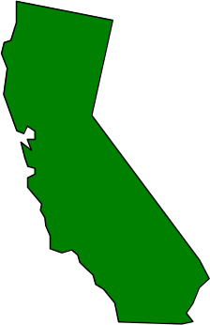
Utilities Safety Branch
1999 Electric Safety Report

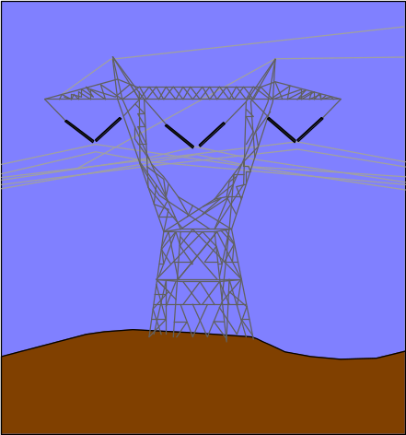
Promoting system reliability and safety for the general public.

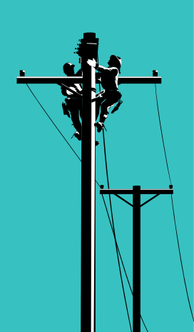

June 2000

CPUC Headquarters Los Angeles Office
505 Van Ness Avenue 320 West 4th Street, Suite 500
San Francisco, CA 94102 Los Angeles, CA 90013



Table of Contents
Page No.

Memorandum…………………………………………………………………………….. 1
I. Introduction ………………………………………………………………………... 2
- Purpose of Report………………………………………………………………... 2
- CPUC’s Responsibilities ……………………………………………...………… 2
- General Order 95………………………………………………………… 2
2. General Order 128……………………………………………………….. 3
- General Order 165……………………………………………………….. 3
- Incident Investigation & Customer Complaints.……………………….... 4

C. Caveat……………………………………………………………………………. 4

II. Utility Companies Under the Jurisdiction of the CPUC…..…..………… 5
- Power Companies………………………………………………………………... 5
- SCE ……………………………………………………………………… 5
- PG&E …………………………………………………………….……… 5
- SDG&E …………………………………………………………….……. 5
- Other Investor Owned Companies………………………………………. 6
- Electric Cooperatives…………………………………………………...... 6
- Municipalities ………………………………………………………….... 6
B. Communication Companies.…………………………………………...…….…. 7
1. Pacific Bell.……………………………………………...………….….… 7
2. General Telephone Electronics ………………………………………..…. 7
3. Others ………………………………………………………………….… 7
C. Cable Television ………………………………………...………………….…... 8

III. Annual Electric Report ……………………………………………………….... 9
- General Order 95 Inspections………………………………………………….… 9
- Utility Data ……………………………………………………………... 11
- USB Inspection Statistics ….…………………………………………… 13
- General Order 128 ……………………………………………………………… 14
1. Utility Data ……………………………………………………………… 14
2. USB Inspection Statistics………………………………….…………….. 16
- General Order 165 ……………………………………………………………… 17
Page No.

- Electric Incidents & Customer Complaints ………………………………………… 18
1. Overhead Equipment …………………………………………………… 20
- Underground Equipment ……………………………………………….. 24

IV. Additional Information …………………………………...…………………… 26
A. Publications ……………………………………………………………...…….. 26
- How to Order ………………………………………………………….... 26
- G.O. 95, 128, and 165 …………………………...……………………... 26
Page No.

LIST OF TABLES AND FIGURES

Table 1. Summary of the Utility Company’s Overhead Equipment…………………… 11
Figure 1A. Percentage of Overhead Transmission & Distribution Lines Each
Utility Co. Has in California…………………………………………....…….. 11
Figure 1B. Percentage of Poles Each Utility Co. Has in California…………...……...…... 11
Figure 1C. Number of Miles of Overhead Transmission and Distribution Lines……….... 12
Table 2. Number of California Customers Each Utility Company Serves..……...…….. 12
Table 3. Summary of the G.O. 95 Inspections Conducted in 1999 ...…………..……… 13
Table 4. Tabulation of G.O. 95 Inspection Data for 1999……………………………… 13
Table 5. Summary of G.O. 95 Infractions Incurred by the Utility Companies
in 1999 ………………………………………………………………………... 13
Table 6. Summary of the Utility Company’s Underground Equipment ………...…….. 14
Figure 6A. Percentage of Underground Transmission & Distribution Lines Each
Utility Co. Has in California ...…………………...……………………….….. 14
Figure 6B. Percentage of Surface Mounted Structures Each Utility Co. Has
in California …………………………………...……………........................... 15

Figure 6C. Percentage of Underground Structures Each Utility Co. Has in California...... 15

Figure 6D. Number of Miles of Underground Transmission and Distribution Lines .…… 15
Table 7. Summary of the G.O. 128 Inspections Conducted in 1999 …………..………. 16
Table 8. Tabulation of G.O. 128 Inspection Data for 1999…………………………..… 16
Table 9. Summary of G.O. 128 Infractions Incurred by the Utility Companies
in 1999 ………………………………………………………………………... 16

Page No.

Table 10. Summary of Incident Investigations & Customer Complaints for USB
in 1999 ………………………………………………………………..………. 19
Table 11. Tabulation of Incident Investigation Data for 1999 ………….………………. 19
Table 12. Summary of Leading Causes of 1999 Incidents Relating to G.O. 95 ….…….. 20
Figure 12A. Graph of Leading Causes of Incidents Involving Overhead Equipment
in 1999 ………………………………………………………………………... 21
Figure 12B. Percentage of Overhead Incidents Resulting in Fatalities …..…………...…… 22
Figure 12C. Percentage of Overhead Incidents Resulting in Injuries ….………………….. 22
Figure 12D. Percentage of Overhead Incidents Resulting in Media Attention …...……….. 23
Table 13. Summary of Leading Causes of 1999 Incidents Relating to G.O. 128 .…….... 24
Figure 13A. Graph of Leading Causes of Incidents Involving Underground Equipment
in 1999 ………………………………………………………………………... 24
Figure 13B. Percentage of Underground Incidents that Resulted in Injuries ………..….…. 25
Figure 13C. Percentage of Underground Incidents that Resulted in Media Attention …….. 25

MEMORANDUM
This annual report of Electric Safety presents an account of various activities carried out under the California Public Utilities Commission’s (CPUC) electric safety program for the 1999 calendar year.

The CPUC has been entrusted with the safety jurisdiction over all electric and communication overhead and underground facilities in the state of California by Legislative mandate. It is responsible for enforcing safety regulations, inspecting and investigating all work affected by the statutes, and making necessary additions and changes to regulations for promoting the safety of utility employees and the general public. In addition, these standards promote improved reliability of services. The electric safety program consists of administration of General Orders (G.O.) 95, 128, 165, and Public Utilities Code, Sections 315, 768, 8026 through 8038, and 8051 through 8057.

The state of California has the nation’s largest electric and communication system. Therefore, it is important to maintain an adequate level of inspections and oversight to ensure that these systems are designed, constructed, operated, and maintained properly in accordance with the regulations for systems reliability and safety of the utility employees and the general public. The CPUC’s Utilities Safety Branch (USB) implements the safety program by carrying out accident investigations, follow up investigations, compliance inspections, review of utilities’ reports and records, construction inspections, and special studies. This is especially important with an aging system.

Acknowledgment

Fadi Daye, Associate Utilities Engineer, under the general direction of Mahendra Jhala, Chief of the Consumer Services Division’s Utilities Safety Branch, prepared this report. We acknowledge the assistance provided by USB staff, the utilities, and other agencies in furnishing the data necessary for this report.

I. INTRODUCTION

PURPOSE OF REPORT

The purpose of this report is to document administration of General Order (G.O.) No. 95,
“Rules of Overhead Electric Line Construction”; G.O. No. 128, “Rules for Construction of Underground Electric Supply and Communication Systems”; and G.O. No. 165, “Inspection Cycles for Electric Distribution Facilities” for the calendar 1999 year as reported by utility companies and as accomplished by the USB staff. It also provides general information on utility companies and statistical data on incidents and investigations related to electric facilities and other safety activities during 1999.

CPUC’s RESPONSIBILITIES

The CPUC is granted the authority to inspect, make further additions or changes as deemed necessary for the purpose of system reliability, safety to employees and the general public under the Public Utilities (PU) Code Section 8037. Inspections and investigations are performed by USB staff to enforce G.O. 95, 128, and 165 regulations. An overview of each general order is listed below.

- General Order 95

G.O. 95, “Rules for Overhead Electric Line Construction”, became effective July 1, 1942. Changes are noted in the order which reflect development of new materials and standards for line construction and changing operational practices. The latest edition is dated 1998.

The purpose of these rules is to formulate, for the state of California, uniform requirements for overhead electrical line construction. The application of these requirements will provide adequate service and secure safety to persons engaged in the construction, maintenance, operation or use of overhead electrical lines and to the general public.
Since November 13, 1968, the Commission has the jurisdiction to regulate safety of cable antenna television corporations (PU Code Section 215.5 and 768.5). G.O. 95 is also applicable to regulate cable television (CATV) facilities. Inspection of CATV facilities has been integrated with the field inspection program conducted on electric and telephone pole facilities.

- General Order 128

G.O. 128, “Rules for Construction of Underground Electric Supply and Communications Systems”, became effective December 12, 1967. The latest edition was issued in 1998.

The purpose of these rules is to formulate, for the State of California, uniform requirements for underground electrical supply and communication systems. The application of these requirements will provide adequate service and secure safety to all persons engaged in the construction, maintenance, operation or use of underground systems, and to the general public.

- General Order 165

G.O. 165, “Inspection Cycles for Electric Distribution Facilities”, became effective March 31, 1997 and it is the latest edition.

The purpose of this general order is to establish minimum inspection cycles requirements for electric distribution facilities addressing the utilities’ inspection (including maximum allowable inspection cycle lengths), condition rating, scheduling and performance of corrective action, record keeping, and reporting, in order to ensure safe and high quality electrical service.
G.O. 165 also implements the provisions of PU Code Section 364, which the California Legislature adopted when it enacted Assembly Bill 1890, Chapter 854, Statutes of 1996.

- Incident Investigation & Customer Complaints

In addition to enforcing the above general orders, USB staff conducts investigations of reportable incidents from the utility companies. Section 315 of the Public Utilities Code provides that the Commission shall investigate the cause of accidents occurring upon the property of any utility.
Reportable incidents, as updated in CPUC Decision (D.)98-07-097, Appendix B, are those which: “(a) result in fatality or personal injury rising to the level of in-patient hospitalization and attributable or allegedly attributable to utility owned facilities; (b) are the subject of significant public attention or media coverage and are attributable or allegedly attributable to utility facilities; (c) involve or allegedly involve trees or other vegetation in the vicinity of power lines and result in fire and/or personal injury whether or not in-patient hospitalization is required.”

The USB staff also handles all safety related customer complaints pertaining to G.O. 95, 128, and 165. This may range from answering a telephone inquiry or correspondence to conducting a formal investigation.

C. CAVEAT

The various utility companies operating in California provided the information contained in this annual report. All reasonable efforts have been made to ensure that the statistics contained herein are accurate.

II. UTILITY COMPANIES UNDER THE

JURISDICTION OF THE CPUC
The CPUC has been granted the authority by the Legislature to adopt and enforce G.O. 95, 128, and 165 requirements on investor owned utilities and municipalities. There is a number of investor owned power and communication utility companies providing service in California as well as utilities operated by municipalities and cooperatives.

POWER COMPANIES

1. Southern California Edison Company

Edison International’s largest subsidiary is Southern California Edison Company (SCE). SCE provides service to more than 4.3 million customers in a 50,000 square mile area. SCE serves portions or all of California’s central and southern counties.

2. Pacific Gas and Electric

Pacific Gas and Electric (PG&E) is one of the largest investor-owned company in the U.S. They provide electric service to about 4.9 million customers in California. Their service area spans 70,000 square miles, including portions or all of 49 counties out of California’s 58 counties.

3. San Diego Gas and Electric

San Diego Gas and Electric (SDG&E) became a Sempra Energy company in 1998. They provide electric service for 1.2 million customers in San Diego and portions of southern Orange County. Their service area covers a total of 4,100 square miles in over 25 cities.

4. Other Investor Owned Companies
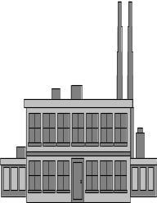
These companies also provide electric service to the people of California:
• Bear Valley Electric • SierraPacific
• Kirkwood Gas & Electric • PacifiCorp

5. Electric Cooperatives
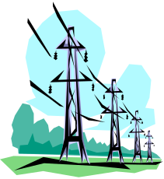
These electric co-operatives provide service to certain California customers:
• Surprise Valley Electrication Corp. • Anza Electric Cooperative
• Plumas-Sierra Rural Elect. Coop • Valley Electric Association, Inc.

6. Municipalities
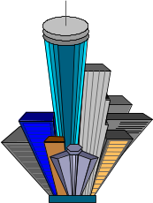
These California municipalities provide electric service to their customers.
• Alameda • Anaheim
• Azusa • Banning
• Biggs • Burbank
• Colton • Glendale
• Gridley • Healdsburg
• Imperial Irrigation District • Lassen Municipal Utility District
- Lodi • Lompoc
• Los Angeles • Modesto Irrigation District
• Needles • Northern Cal. Power Agency
• Oroville-Wyandotte Irrigation District • Palo Alto
• Pasadena • Redding
• Riverside • Roseville
• Sacramento Municipal Utility District • San Francisco
• Santa Clara • Shasta Lake
• Southern Cal. Public Power Authority • Tri-Dam Project
• Trinity County • Truckee Donner Public
Utility District
• Turlock Irrigation District • Ukiah
• Vernon

COMMUNICATION COMPANIES

- Pacific Bell

PacBell has a total of 17.9 million access lines including residential, commercial, and others. The telephone service area covers approximately 51,000 square miles in California.

- General Telephone Electronics

In 1998, GTE had a total of 3.96 million residence and business access lines. This total does not include CentraNet/Wats, Circuits and Foreign Exchange Lines.

3. Others

There are 21 smaller telephone companies in California under the jurisdiction of the CPUC. These companies have overhead equipment that is inspected by the USB for compliance with G.O. 95.

C. CABLE TELEVISION

There are many cable television companies serving California cities. They range from local companies serving one city to larger companies that may serve several cities. A majority of the cable television companies are members of the California Cable Television Association (CCTA). CCTA represents over 250 cable television systems which provide cable television service to over 6 million California homes.

III. aNNUAL ELECTRIC REPORT

The USB is entrusted to enforce the provisions of General Orders 95, 128, and 165. To do so, the USB conducts periodic inspection of both overhead and underground electric, communication and cable lines throughout the state. This involves both field inspection and document audit. Furthermore, the USB investigates accidents involving overhead and underground electric and communication lines as mandated by Public Utilities Code Section 315, to determine utilities’ compliance with the General Orders. This section contains information and statistical data on the various electric related activities conducted by the USB during 1999.

A. GENERAL ORDER 95 INSPECTIONS

In 1999, USB staff engineers conducted G.O. 95 field inspections of overhead lines with utilities representatives’ participation. The field inspections provide evidence on the quality of a utility's workmanship and maintenance programs. Staff engineers inspect 2 miles of pole lines per day and record all G.O. 95 infractions found during the inspection.

The field inspections are conducted over a three-day period. The visual survey is conducted on the first day and the actual inspections are conducted on the remaining two days. Typically, two staff engineers will use the first day of inspection to identify a specific area for the detailed inspections. They will do this by conducting a visual survey of two communities/cities that appears to have numerous G.O. 95 infractions. The staff engineers may also contact the utility company to request information such as circuit maps prior to conducting the visual survey.

During the detailed field inspection, the staff engineers record the infractions found on the overhead electric system, which includes poles, conductors, and all overhead equipment. We request the power, communication and cable utilities to participate in these inspections as it expedites correction as their personnel are also recording these infractions.
A file on each area inspected is maintained for a period of three years or more. Records are maintained in both San Francisco and Los Angeles, showing the areas where inspections have occurred for the last several years. These records are used as a basis to determine future inspections. For example, in some years the USB has concentrated on urban areas, rural areas, or municipal utilities, depending on complaints, failures, or time lapse since the last inspection.

In 1999, USB personnel were divided into basically three units where each unit was assigned specific counties to conduct G.O. 95 inspections in California. The following lists the counties each unit covered.

Northern Unit: Alpine, Alameda, Amador, Butte, Calaveras, Colusa, Contra Costa, Del Norte, El Dorado, Glenn, Humboldt, Lake, Lassen, Modoc, Napa, Nevada, Placer, Plumas, Sacramento, San Francisco, San Mateo, Shasta, Sierra, Siskiyou, Solano, Sonoma, Sutter, Tehama, Trinity, Yolo, Yuba, plus portions of Mono that are served by Pacific Gas and Electric.

Central Unit: Marin, Mendocino, Mariposa, Merced, Monterey, San Benito, San Joaquin, San Luis Obispo, Santa Clara, Santa Cruz, Stanislaus, plus portions of Fresno, Inyo, Kern, Kings, Madera, Santa Barbara, Tulare and Tuolumne that are served by Pacific Gas and Electric.

Southern Unit: Imperial, Los Angeles, Orange, Riverside, San Diego, San Bernardino, Ventura, plus portions of Fresno, Inyo, Kern, Kings, Madera, Mono, Santa Barbara, Tulare and Tuolumne that are served by Southern California Edison and/or Los Angeles Department of Water and Power.
1. Utility Data

Utilities | Total Miles of Overhead Lines |  | Transmission  Lines (miles) |  | Distribution Lines (miles) |  | Number  of Poles
PG&E |  | 110,481 |  | 18,624 |  | 91,857 |  | 2,275,635
SCE | 72,620 |  | 11,750 |  | 60,870 |  | 1,449,245*
SDG&E | 8,751 |  | 1,865 |  | 6,886 |  | 234,434
Sierra Pacific | 1,121 |  | 383 |  | 738 |  | 22,778
PacifiCorp | 3,142 |  | 725 |  | 2,417 |  | 67,393
Grand Total | 196,115 |  | 33,347 |  | 162,768 |  | 4,049,485
Table 1. Summary of the Utility Company’s Overhead Equipment (*reflects wood poles only)

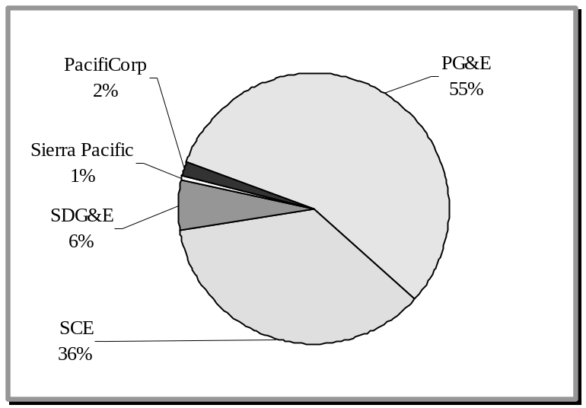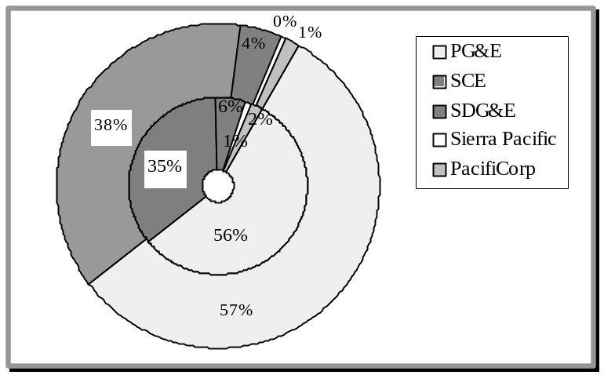
Transmission
Distribution
Figure 1A.
Percentage of Overhead Transmission & Distribution Lines Each Utility Co. Has in California
Figure 1B.
Percentage of Poles Each Utility Co. Has in California
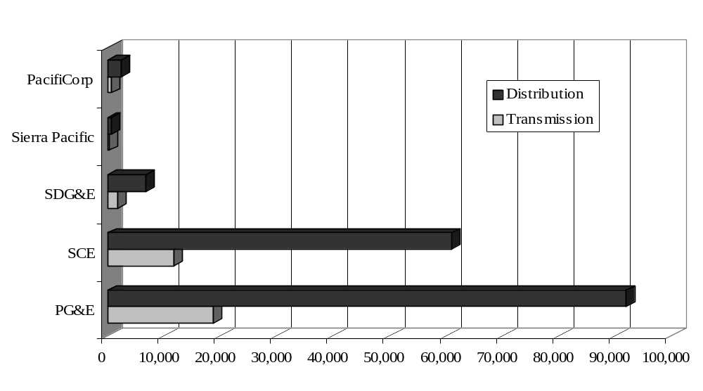
Figure 1C. Number of Miles of Overhead Transmission and Distribution Lines

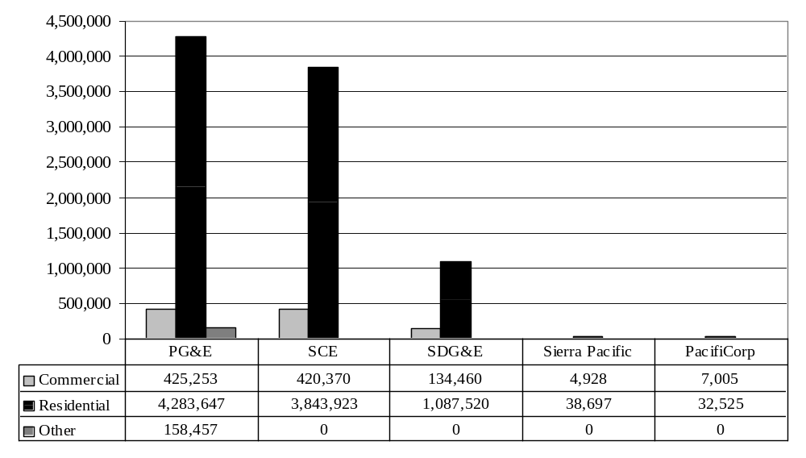
Table 2. Number of California Customers Each Utility Company Serves
- USB Inspection Statistics

For the 1999 Year | Total
Number of Inspections | 35
Number of Inspection Weeks | 23
Number of Inspection Days | 82
Number of Personnel Days Used | 154
Number of Pole Line Miles Cited | 81
Number of Poles Inspected | 3311
Number of Infractions Cited (See Table 5 for a summary.) | 7753
Table 3. Summary of the G.O. 95 Inspections Conducted in 1999

For the 1999 Year | Figures
Average Number of Inspection Days Per Week | 3.56
Average Number of Personnel Days Per Inspection Week | 6.7
Average Number of Pole Line Miles Cited Per Inspection | 2.31
Average Number of Infractions Cited Per Day | 94.55
Average Number of Poles Inspected Per Day | 40.37
Average Number of Infractions Per Pole | 2.34
Table 4. Tabulation of G.O. 95 Inspection Data for 1999

Utility Company | Number of G.O. 95 Inspections | Total G.O. 95 Infractions | Average Number of Infractions Per Inspection
PG&E | 6 | 423 | 70.5
SCE | 18 | 1499 | 83.28
SDG&E | 2 | 65 | 32.5
Municipalities/Others | 12 | 779 | 64.91
Pacific Bell | 19 | 1519 | 79.95
GTE | 15 | 1093 | 72.87
Cable TV | 39 | 2279 | 58.44
Table 5. Summary of G.O. 95 Infractions Incurred by the Utility Companies in 1999
B. GENERAL ORDER 128 INSPECTIONS

One staff engineer or inspector usually conducts General Order 128 underground facility inspections. The inspection areas are selected similar to G.O. 95 inspections. The staff engineer will also spend time reviewing the records required by G.O. 128 for an auditable and consistent program of inspection. The inspection lasts three days and usually occurs in one utility operating district. G.O. 128 inspections are conducted only with the electric utilities because communication utilities have fewer hazards associated with their facilities. However, if the staff engineer finds any problems with the communication facilities, he will notify the communication company to correct the problems.

The G.O. 128 inspector joins a qualified utility lineman who opens the equipment enclosures containing live or energized equipment. The live equipment may be contained inside an underground vault, a walk-in vault, or a subsurface enclosure such as a padmount. The inspector record notes about the infractions and afterwards prepares a formal report. The report details the infractions and directs the utilities to correct them and reply by three months. The records are maintained similar to G.O. 95 inspections.

1. Utility Data

Utilities | Total Miles of Underground Lines | TransmissionLines (miles) | Distribution Lines (miles) | Surface Mounted  Structures | Underground Structures
PG&E | 21,775 | 108 | 21,667 | 88,440 | 260,986
SCE | 32,378 | 238 | 32,140 | 110,586 | 194,846
SDG&E | 7,760 | 48 | 7,712 | 89,584 | 160,239
Sierra Pacific | 155 | 0 | 155 | Not Available | Not Available
PacifiCorp | 474 | 0 | 474 | 3,473 | 1,478
Grand Total | 62,542 | 394 | 62,148 | 292,083 | 617,549
Table 6. Summary of the Utility Company’s Underground Equipment
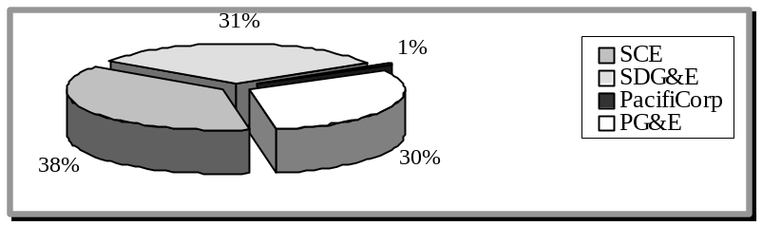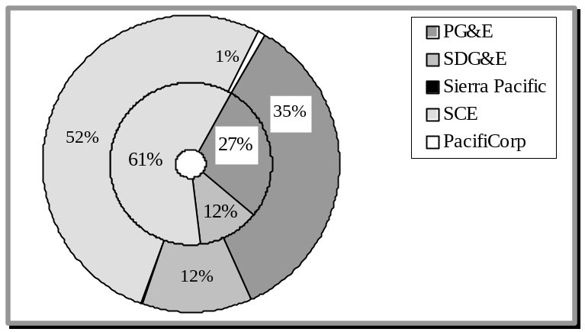
Transmission
Distribution

Figure 6B.
Percentage of Surface Mounted Each Utility Co. Has in California.

Figure 6C.
Percentage of Underground Structures Each Utility Co. Has in California.

Figure 6A.
Percentage of Underground Transmission & Distribution Lines Each Utility Co. Has in California
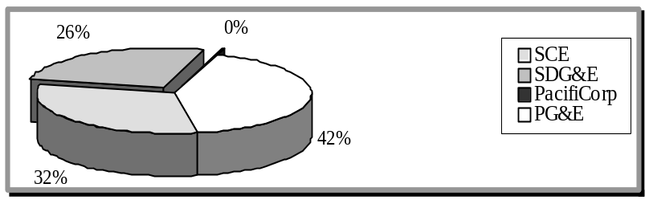
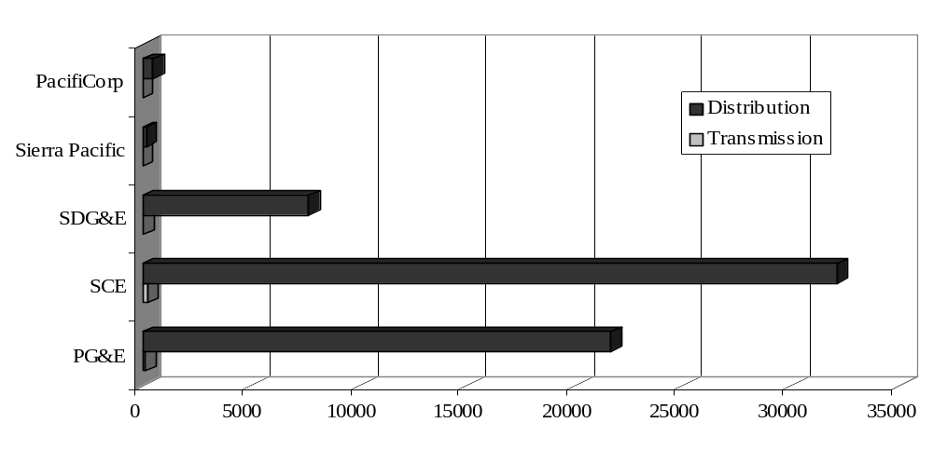Figure 6D. Number of Miles of Underground Transmission and Distribution Lines
2. USB Inspection Statistics

For the 1999 Year | Total
Number of Inspection Weeks | 18
Number of Inspection Days | 51
Number of Personnel Days Used | 53
Number of Structures Inspected | 671
Number of Structures Cited | 376
Number of Infractions Cited (See Table 9 for a summary) | 630
Table 7. Summary of the G.O. 128 Inspections Conducted in 1999

For the 1999 Year | Figures
Average Number of Inspection Days Per Week | 2.83
Average Number of Personnel Days Per Inspection Week | 2.94
Average Number of Structures Inspected Per Day | 13.16
Average Number of Structures Cited Per Day | 7.37
Average Number of Violations Cited Per Day | 13.35
Average Number of Violations Per Structure Cited | 1.68
Table 8. Tabulation of G.O. 128 Inspection Data for 1999

Utility Company | Number of G.O. 128 Inspections | Total G.O. 128 Infractions | Average Number of Infractions Per Inspection
PG&E | 5 | 48 | 9.6
SCE | 5 | 191 | 38.2
SDG&E | 2 | 74 | 37
Municipalities/Others | 6 | 317 | 52.84
Table 9. Summary of G.O. 128 Infractions Incurred by the Utility Companies in 1999
C. GENERAL ORDER 165 INSPECTIONS

General Order 165 became effective on March 31, 1997 for Pacific Gas & Electric, PacifiCorp, SDG&E, Sierra Pacific Power Company, and Southern California Edison. This General Order establishes minimum requirements for electric distribution facilities, regarding inspection (including maximum allowable inspection cycle lengths) scheduling and performance of corrective action, condition rating, record keeping, and reporting. The requirements of this order are in addition to the requirements of G.O. 95 and G.O.128 to maintain a safe and reliable electric system.

The G.O. 165 inspection procedures were being formalized between the USB and the utility companies in 1998. The utility companies had to create additional detailed inspection procedures in their plan for overhead and underground structures in accordance with the requirements of G.O. 165. In 1999, through a series of meetings, the USB reviewed and advised the utility companies on the adequacy of their plans.

There were no records available for auditing in 1999 since the utility companies did not complete their plan and begin implementing their G.O. 165 procedures until year 2000. Therefore, the USB did not perform any G.O. 165 inspections during the 1999 calendar year. The USB will begin scheduling follow-up inspections in 2000 to ensure that utilities are following the inspection intervals, the corrective action criteria, and the record keeping requirements specified in G.O. 165. These inspections will be part of our regularly scheduled G.O. 95 and G.O. 128 inspections.
D. ELECTRIC INCIDENTS & CUSTOMER COMPLAINTS

The USB staff receives and investigates reportable electric incidents from regulated utility companies. Per Appendix B of D98-07-097, reportable incidents are those which (a) result in fatality or personal injury rising to the level of in-patient hospitalization and attributable or allegedly attributable to utility owned facilities; (b) are the subject of significant public attention or media coverage and are attributable or allegedly attributable to utility facilities, (c) involve or allegedly involve trees or other vegetation in the vicinity of power lines and result in fire and/or personal injury whether or not in-patient hospitalization is required.

The electric utility companies are required to provide notice to designated USB staff within two hours of a reportable incident. The notice shall identify the time and date of the incident, the time and date of notice to the Commission, the location of the incident, casualties which resulted from the incident, identification of casualties and property damage, and the name and telephone number of a utility contact person.

The designated USB staff is called the On-Call Engineer (OCE). The OCE is responsible for receiving reportable incidents from the utility companies and he or she is available to do so 24 hours per day. Each staff engineer assumes the OCE duties for an entire week (including weekends) several times per year. The OCE or a staff engineer may investigate incidents at any hour, including weekends. If it is determined that a G.O. violation was involved, staff prepares a report and recommends action against the utility.

In addition, the USB maintains a database of outages and accidents to note trends. If there is significant trending, the staff will investigate and work with utilities to correct the problem. The database has been very useful in noting trends about a manufacturer defect, lack of tree trimming, or lack of preventive maintenance. The Commission has initiated Order Instituting Investigations (OIIs) based on the results of USB’s investigations. USB staff also handles customer complaints relating to G.O. 95 and 128 safety issues. In addition to investigating incidents reported by the utility companies, USB investigates customer complaints involving alleged violations of the General Orders.

For the 1999 Year | Total
Number of Incidents Reported | 188
Incidents Involving Overhead Equipment | 168
Incidents Involving Underground Equipment | 20
Number of Incidents Investigated | 188
Number of Weeks for On Call Engineer Duties | 52
Number of USB Engineers** (not including management) | 13
Table 10. Summary of Incident Investigations & Customer Complaints for USB in 1999
** Average taken since the number of engineers varied throughout the 1999 year.

For the 1999 Year | Figures
Average Number of Incidents Reported Per Month | 15.67
Percentage of Incidents Reported Involving Overhead Equipment | 89.36%
Percentage of Incidents Reported Involving Underground Equipment | 10.64%
Average Number of Incidents Investigated Per Month | 15.67
Percentage of Incidents Investigated Per Incidents Reported | 100%
Average Number of Incidents Investigated Per USB Engineer | 14.46
Average Number of Incidents Reported Per OCE Week | 3.62
Average Number of OCE Weeks Per USB Engineer | 4
Table 11. Tabulation of Incident Investigation Data for 1999

- Overhead Equipment

The following table is a summary of leading causes of incidents in 1999 relating to overhead equipment:

Electric Incident Causes | Fatalities | Injuries | Media Attention
Contact by: Aircraft | 6 | 5 | 8
Animal | 0 | 0 | 3
Booms | 0 | 3 | 3
Crane | 1 | 3 | 4
Irrigation Pipe | 0 | 3 | 0
Ladder | 0 | 1 | 1
Metal Object | 2 | 4 | 4
Tree/Line Contact | 1 | 3 | 29
Tree Trimmer | 1 | 4 | 6
Falling Tree | 0 | 0 | 40
Fire | 0 | 0 | 8
Insulator Failure | 0 | 1 | 3
Line Failure | 0 | 0 | 3
Natural Cause | 0 | 0 | 7
Other/Miscellaneous Causes | 0 | 6 | 14
Unknown | 0 | 2 | 6
Utility Employee Working Overhead | 0 | 8 | 4
Vehicle | 2 | 2 | 9
Grand Total | 13 | 45 | 152
Table 12. Summary of Leading Causes of 1999 Incidents Relating to G.O. 95

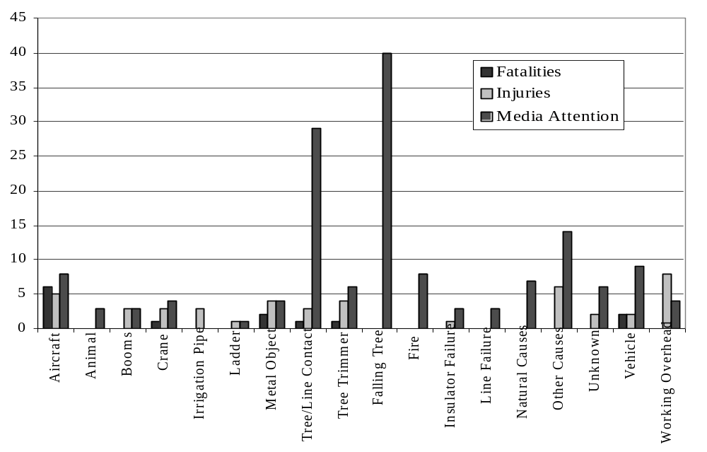
Figure 12A. Graph of Leading Causes of Incidents Involving Overhead Equipment in 1999
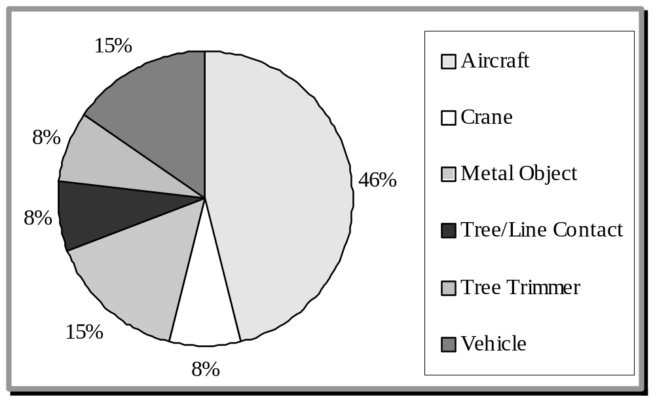

Figure 12B. Percentage of Overhead Incidents Resulting in Fatalities.

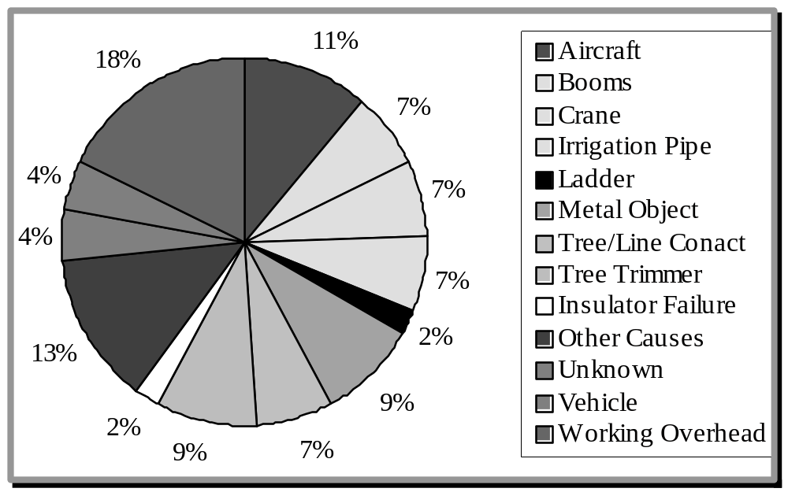Figure 12C. Percentage of Overhead Incidents Resulting in Injuries.

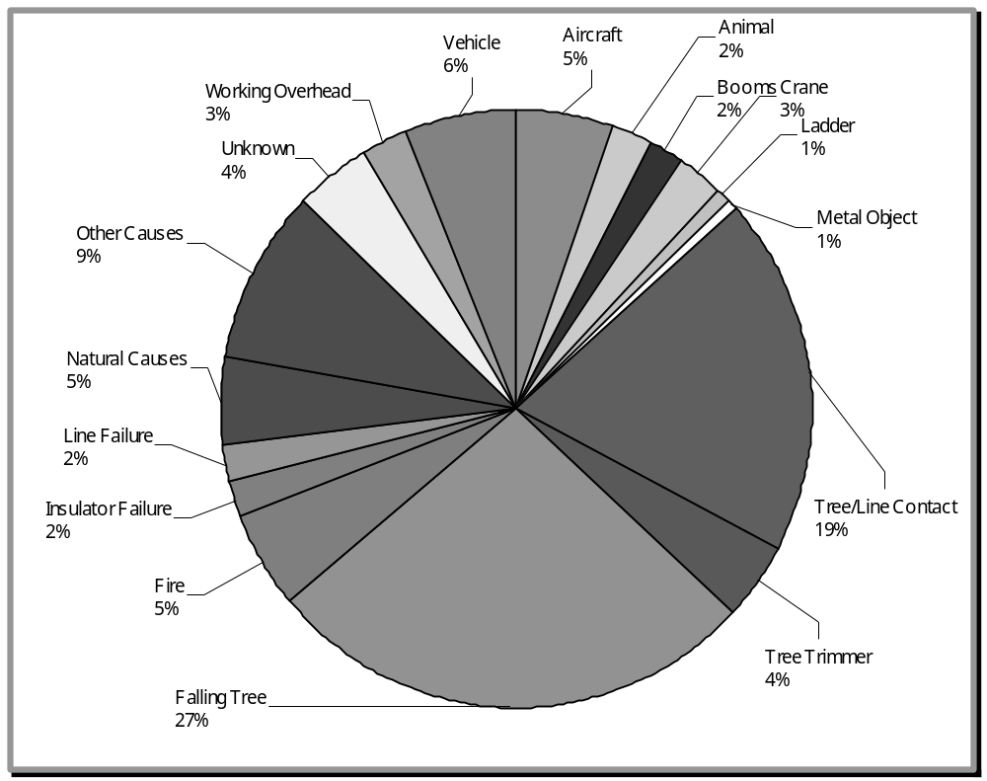
Figure 12D. Percentage of Overhead Incidents Resulting in Media Attention.
2. Underground Equipment
The following table is a summary of leading causes of incidents in 1999 relating to underground equipment.

Electric Incident Causes | Fatalities | Injuries | Media Attention
Dig In | 0 | 4 | 4
Switch Malfunction | 0 | 0 | 4
Transformer Malfunction | 0 | 0 | 3
Other/Miscellaneous Causes | 0 | 4 | 1
Underground Cable Failure | 0 | 0 | 4
Utility Employee Working Underground | 0 | 0 | 2
Grand Total | 0 | 8 | 18
Table 13. Summary of Leading Causes of 1999 Incidents Relating to G.O. 128

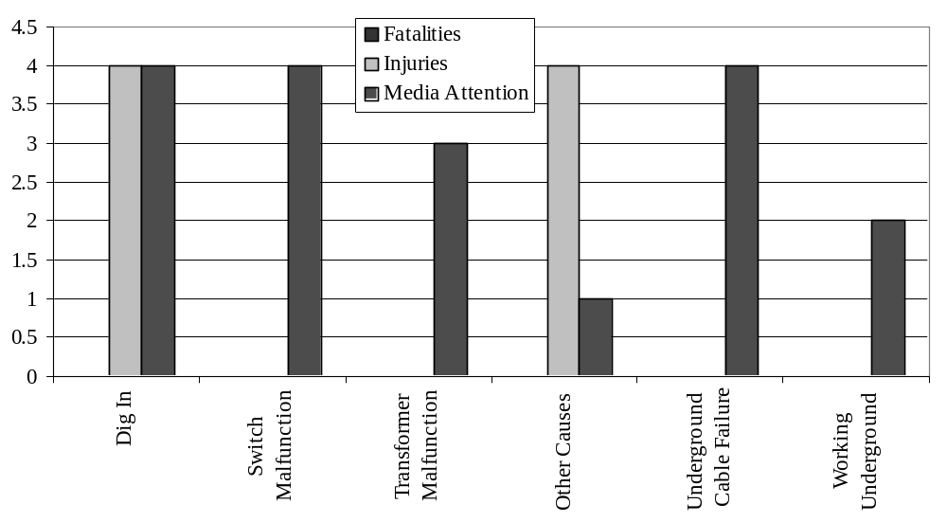
Figure 13A. Graph of Leading Causes of Incidents Involving Underground Equipment in 1999
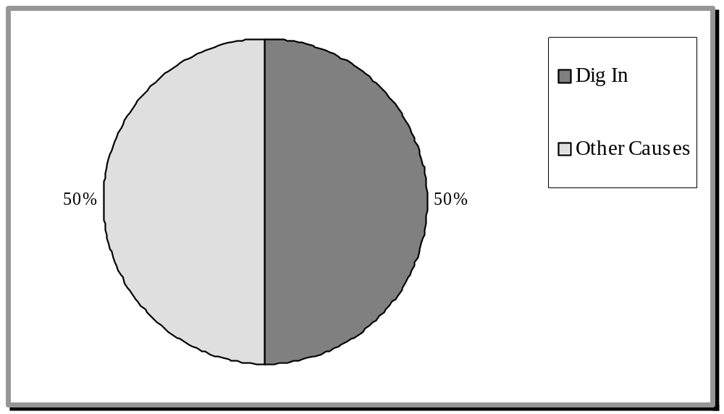
Figure 13B. Percentage of Underground Incidents Resulting in Injuries.

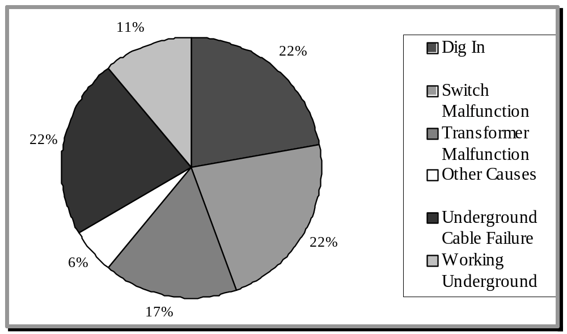
Figure 13C. Percentage of Underground Incidents Resulting in Media Attention

IV. ADDITIONAL INFORMATION

A. PUBLICATIONS
Copies of G.O. 95, 128, and 165 are available to the general public for purchase from the CPUC.

1. How to Order
Documents, California Public Utilities Commission
505 Van Ness Avenue
San Francisco, CA 94102
(415) 703-1713
Call or Write
the CPUC at…

California Public Utilities Commission (most documents available)
320 West 4th Street, Suite 500
Los Angeles, CA 90013
(213) 576-7003

2. G.O. 95, 128, and 165
G.O. 95: “Rules for Overhead Line Construction” book is available for purchase at
$20.00 each.

G.O. 128: “Rules for Construction of Underground Electric Supply and Communication Systems” book is available for purchase at $5.00 each.

G.O. 165: “Inspection Cycles for Electric Distribution Facilities”, the first copy of the G.O. leaflet is free with additional copies at $0.50 each.


General Order 95 and 128 may be viewed at the CPUC web site. The URL is:
http://www.cpuc.ca.gov/divisions/CSD/USB/usb.htm

