Utilities Safety Branch
Natural Gas & Propane Safety Report For 1998

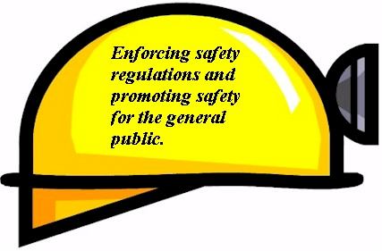

July 1999

CPUC Headquarters Los Angeles Office
505 Van Ness Avenue 320 West 4th Street, Suite 500
San Francisco, CA 94102 Los Angeles, CA 90013


Table of Contents

Page No.
Memorandum…………………………………………………………………………….. 1

I. Introduction…………………………………………………………………………... 2
- Purpose of Report………………………………………………………………... 2
- CPUC’s Responsibilities …………………………………………..……………. 2
- General Order 112-E..…………………………………………….……… 2
- Mobilehome Park Program (MHP)……………………………………… 3
- Propane Safety Program (PSP)………………………………..………… 4
- Description of Typical Inspection………………………………………... 7
- Gas Incident Reports…………………………………………………….. 8
- Safety Related Condition Reports………………………………………. 10
- Drug and Alcohol Program …… …………………………………... 10
- Underground Service Alert (USA)……………………………………… 11
- Pipeline Replacement Program………………..……………………...… 11
- Meter Protection Program………………………………………………. 13
- Pipe Lining Rather Than Replacement ……......……………………….. 13
- Granting of Waivers………………………………………………….…. 13
- Above Ground Pipe Inspections………………………………………… 14
- Seismic Safety Program………………………………………....……… 14
- Other Programs….…………………………………………………..….. 16
- Other Duties Required by the Pipeline Safety Act……………………… 17

C. Size of the California Gas System……..…………………………………….…. 18

- Utility Companies Under the Jurisdiction of the CPUC ……………...… 27

- Natural Gas Companies…….…………………………………………………… 27
- Southern California Gas Company (SCG)…………………………….... 27
- Pacific Gas & Electric Company (PG&E)……………………….…...… 27
- San Diego Gas & Electric Company (SDG&E)………………….…….. 27
- Southwest Gas Corporation (SWG)…………………………………….. 28
- Washington Water Power Company (WPP)………………………...….. 28
- Southern California Edison (SCE)……………………………...………. 28
- Municipalities ………………………………………………………..… 28
Page No.

- Coalinga.……………………………………………….……….. 28
- Long Beach…………………………………………….……….. 28
- Palo Alto………………………………………………………… 28

- Mobilehome Park (MHP) Program………………………………….………….. 28
- Jurisdictional Propane Systems…………………………………………………. 28

- USB’s Gas Statistics for 1998…………………………………………………... 29

- 112-E Inspection Areas…………………………………………………………. 29
- USB Inspection Data ……………………………………..…………………….. 30
1. Inspections………………………………………………………………. 30
2. Incidents………………………………………………………………… 31
3. Summary of Incident Causes…………………………………….……… 31
- Gas Incidents and Customer Complaints.………………………………….….... 32

- Additional Information …………………………………………………………. 34

Publications
- How to Order GO 112-E…… …………………….……………………. 34
- How to Order GO 112-E and Federal Regulations on Internet…………. 34

List of Tables and Figures

Page No.

Table 1. Miles of Pipeline in California by Utility………………..…………………..... 20
Figure 1. Chart Illustrating Amount of Pipe in California by Type…………….….….... 20
Table 2. Number of Services in California by Utility ………..…………………...….... 21
Figure 2. Number of Services in California by Utility………………………………..… 21
Table 3. Number of Leaks Detected on Mains and Services in California in 1998 ….... 22
Figure 3. PG&E - Leaks found on Mains ………………………………………………. 23
Figure 4. PG&E - Leaks found on Services ………………………………………..…… 23
Figure 5. SCG - Leaks found on Mains ………...…………………………………...….. 24
Figure 6. SCG - Leaks found on Services ………..…………………………………..… 24
Figure 7. SDG&E - Leaks found on Mains ..….……………….……………………..… 25
Figure 8. SDG&E - Leaks found on Mains …………………...……………………..… 25
Figure 9. Causes of Gas Incidents in 1998……………………………………………… 26
Table 4. G.O. 112-E Inspection Person-days Conducted in 1998……..………………. 30

Table 5. Investigations of Conducted in 1998…..……………………………………… 30
Table 6. Incident Investigations and Customer Complaints…………………….……… 31

Table 7 Summary of Incident Causes.. ……………………………………………...… 31

MemoranduMm

This annual report of Natural Gas and Propane Safety presents an account of various activities carried out under the California Public Utilities Commission’s (CPUC) natural gas and propane safety programs for the calendar year of 1998. The CPUC has been entrusted with the safety jurisdiction over certain natural gas and propane facilities in the state by legislative mandate. It is responsible for enforcing safety regulations, inspecting all work affected by the statues and making necessary additions and changes to regulations for promoting the safety of the general public and the utility employees that work on the system.

Regulations for the natural gas and propane safety programs are stated in General Order (G.O.) 112-E . G.O. 112-E adopts Title 49 of the Code of Federal Regulations (49 CFR), Parts 190-199 and Part 40 that pertain to natural gas and/or propane safety. G.O. 112-E also includes a few regulations which are more stringent than the federal regulations. Other pertinent legislation is stated in the Public Utilities Code. The CPUC’s Utilities Safety Branch (USB) oversees the safety programs and maintains an adequate level of inspections and surveillance to ensure that these systems are designed, constructed, operated, and maintained in accordance with the regulations for safety of the general public. It also conducts accident investigations, follow up investigations, compliance inspections, review of utilities’ reports and records, construction inspections, and on occasion conducts special studies regarding pipeline safety.

Acknowledgment
This report was prepared by Grayson Grove, Senior Utilities Engineer, designed by Winnie Ho, Utilities engineer, under the general direction of Mahendra Jhala, Chief, and Julian Ajello, Program and Project Supervisor, of the USB, of the Consumer Services Division. The staff also acknowledges the assistance provided by utilities and agencies in furnishing data necessary for this report and expresses its appreciation for their cooperation.

I. INTRODUCTION

A. PURPOSE OF REPORT

This Annual Report provides general information about the Utilities Safety Branch’s (USB) activities and summarizes the progress of its safety programs during the 1998 calendar year. The California Public Utilities Commission (CPUC) monitors the pipeline safety of investor owned gas utilities, mobile home parks and certain propane systems under General Order (GO) 112-E. The Utilities Safety Branch (USB) is charged with enforcing this order which adopts the federal code (basically, 49 CFR Sections 190, 191, 192, 193, and 199). The mission of the USB is to regulate pipeline safety of utilities under Commission jurisdiction and assure an acceptable level of operational safety for the protection of the public and the utilities’ employees.

B. CPUC’s RESPONSIBILITIES

1. G.O. 112-E

GO 112-E requires the USB to conduct audits of the regulated utilities’ natural gas facilities and jurisdictional propane systems. The large utilities are made up of a number of operational units, such as divisions, each of which is normally audited every two years; half the divisions in one year and the other half in the next. When a significant problem is found, the inspection interval is reduced to either one year or six months depending on the severity of the problem. Once the problem is remedied the unit returns to the two-year inspection cycle.

During these audits, the USB inspectors review the utilities' Emergency Plans and Operation and Maintenance (O&M) practices looking for deficiencies or oversights. The USB staff inspects leak survey records to see if the utility is meeting the standards for repairing leaks in a timely manner. They review the utility’s cathodic protection records to assure that corrosion control is being maintained in accordance with the regulations. They insure that the utility is properly certifying its welders and pipe joiners. Finally, they check records from the anti-drug and alcohol program performed by the company.

The field inspection focuses on verifying the records kept by the utility by physically operating valves, checking regulator set points, requesting random testing of cathodic protection areas and verifying that repairs have actually been completed. Inspectors also observe the overall condition of the system and how the utility follows its published procedures. The USB inspectors will cite the utility for noncompliance and specify the time within which corrective action must be taken. The USB also implements programs it deems necessary to improve the utilities' performance. This report describes most of the programs administered by the USB and provides some general statistical data that has been gathered as a result.

2. Mobile Home Park Program (MHP)

The majority of natural gas customers in California receive gas directly from and are billed by the local gas utility. A portion of the gas rate covers the utility’s cost of operating and maintaining the natural gas distribution system. Although this network of pipes and valves is under ground and therefore cannot be seen, there are prescribed maintenance activities and operating procedures that the utilities are required to follow to ensure that the system remains safe and in good operating condition.

Some customers in California do not receive gas direct from the local utility. In the case of many of the State’s mobile home parks, a resident receives gas from and is billed by the park operator. In this case, the park is operating a master meter system. The park receives this gas at a slight discount since the local utility is not responsible for maintaining and operating the park’s natural gas distribution system. The park, in turn, bills its residents at the rates paid by other directly served residential customers.

The difference between what the master meter operator pays for gas from the utility and what the operator charges its residents is not profit. Instead, these funds are to be used by the master meter operator to maintain and operate a safe natural gas system within the park. In fact, the master meter operator must conform to the same rules concerning maintenance and operation as followed by the natural gas utilities.

The MHP program provides for periodic inspections of mobile home park operators who have master metered systems. These operators are expected to meet the requirements outlined in the federal "Guidance Manual for Operators of Small Gas Systems". USB inspectors are charged with carrying out this program and have the authority to cite operators who are in noncompliance with the law. In addition to inspections, the USB offers training seminars to master meter operators to reacquaint seasoned operators and introduce new operators to the requirements for operating a gas system.

USB’s MHP Program was implemented in 1991 and is funded partially by the federal government with the remainder funded by a user fee of approximately 20¢ per month per space which is collected by the utility. USB is responsible for inspecting just under 3,000 master meter mobile home parks in California ranging in size from 2 to over 1,000 customers at least once every five-years. Many of the parks require special attention to meet state requirements. This requires USB to conduct follow-up inspections of certain operators more than once during the five-year period.

The program has been successful. Many potentially dangerous situations have been found by USB inspectors and corrected before an incident occurred. USB logs the results of the inspections, in a database which is used to identify problem areas where inspections should be focused.

3. Propane Safety Program (PSP)

The Propane Safety Program (PSP) is modeled after the MHP program. The same "Guidance Manual for Operators of Small Gas Systems" is used although; DOT is preparing a revised version specifically for propane. Operators are required to have a map of their system, an emergency plan, and an operation and maintenance plan to assure safe operation of their system. USB inspectors verify that the propane system operator is knowledgeable about the system, the code, the operation and maintenance of the system. USB engineers also perform a visual inspection of the system to determine if any apparent problems exist.

The PSP was precipitated by a number of propane related incidents involving death and injury that occurred in the Sierras in 1992 and 1993. Investigation of these incidents revealed that operators of the propane systems had very little safety regulation. As a result, Assembly Bill (AB) 766 (Hauser) became law on September 1, 1994 and was later amended by AB 2430 on September 19, 1996. The Public Utilities Code incorporates the law in sections 4451 through 4465. This program directs operators of jurisdictional propane distribution systems in California to comply with the federal pipeline safety standards, and permits the CPUC to adopt rules, at least as stringent as the federal law, to protect the health and safety of the operators, their employees and the customers they serve. The CPUC's responsibility covers all propane distribution systems serving 10 or more customers in a residential or commercial districts, and 2 or more customers located in a mobilehome park.

Since PSP was patterned after the MHP program it requires the CPUC to inspect the natural gas systems of mobile home parks that serve two or more customers. In addition to implementing the program, AB 2430 requires the CPUC to collect a user fee from the propane operators under its jurisdiction. At present, the fee is set at twenty-five cents per unit per month or $3.00 per unit per year. In accordance with the legislation enacted to implement this program, every operator of a propane system serving 10 or more units in a commercial or residential area or 2 or more mobilehomes must prepare and submit to the CPUC a completed Annual Report form and pay the annual user fee.

Under existing law, the operator is subject to an inspection of the facility every two years (for those systems that serve over 200 customers), three years (for those systems that serve at least 100 but less than 200 customers) or five years (for those systems that serve less than 100 customers). USB is proposing to sponsor legislation to change the inspection cycle to be based on need rather than size of the park, because many large systems are well maintained. According to the law, operators may be cited and fined if corrective action is not taken in a reasonable period of time for any noncompliance found during the audit.

The jurisdictional systems were identified by accessing existing databases, phone surveys and field visits conducted in 1996 and 1997. Approximately 725 jurisdictional systems have been identified. Of these, approximately 150 were fully audited by USB inspectors since 1997. As with any new program, USB's inspectors are finding that many operators, who are not suppliers, have little knowledge of their system. In these cases, the inspector becomes an instructor; working with the operator to list necessary actions to increase safety and bring the distribution system into compliance with federal regulations. The operator is then given a date by which to comply. Penalties for non-compliance are outlined in the PU Code. Our inspectors are finding that many operators are hiring consultants to inspect and leak survey their systems prior to our inspections. These operators are striving to comply with the law and as a result the propane systems in California are becoming safer.

USB works with the propane industry, mainly through the Western Propane Gas Association (WPGA) to improve the program. Many of the operators of these propane systems also supply the propane. They are more knowledgeable about the system, safety and the federal regulations. USB listens to the concerns of these operators, and will seek necessary legislation to improve the program, if warranted.

Based on its early experience with this program, USB has noted several problems it will seek to solve. The first problem is capturing all jurisdictional systems in the database and keeping the database current (i.e. removing entities that become non-jurisdictional and adding new entities as they become jurisdictional). There is no existing reliable and comprehensive database of propane master tank operators that contains the information necessary to determine whether they are subject to Commission jurisdiction. The USB database was assembled by using the Department of Housing and Community Development database to get a list of mobilehome parks and then just noting the presence of other possibly jurisdictional installations during inspection trips. One obvious source of information to identify propane distribution systems is the propane suppliers who deliver gas to these systems. They are not obligated to provide USB this information and generally decline to do so voluntarily.

Collecting the user fee is another problem due to the changes in park ownership, park operators, propane suppliers and maintenance staff. Program costs are estimated to be $300,000 to $360,000 to inspect approximately 750 jurisdictional operators serving 30,000 customers. Assuming all operators pay the user fee, this program could generate up to $90,000 annually. Unfortunately many operators are not paying the user fee, which results in less revenues and higher expenses (to collect from those who have not paid). Consequently, the revenue collected does not offset the cost of billing and collection. This is the only program for which USB is obligated to bill and collect a user fee.

4. Description of a Typical 112-E Inspection

The auditor normally audits records and pertinent documents in the operator’s office and then conducts a field audit to determine if the facilities are operating properly. In the office, the auditor determines if the operator possesses accurate maps of the system, a functional and complete Emergency plan and an adequate Operation and Maintenance (O&M) plan (with documentation that the plan is being followed). The auditor reviews the utility’s records and verifies that the proper maintenance and appropriate surveys (cathodic protection, leak detection, odorant checks, etc.) were performed in accordance with state and federal regulations. The auditor may use this review of the records as a guide as to what utility facilities to audit in the field.

During the field audit the inspector focuses on the condition and operation of the facilities. This usually includes checking the amount of cathodic protection on metal pipes, verifying the set points on over pressure protection devises, visually inspecting above ground facilities and exercising critical emergency valves to assure they can easily be found and operated. This inspection also may be used to verify the records that were reviewed in the operator’s office.

The staff aids small MHP and PSP systems. If an operator needs to prepare an O&M or emergency plan, the USB auditor helps him by answering questions and gives him a copy of our brief O&M and Emergency plan guide. The auditor may be more of a teacher during the initial audits. For both systems, the auditor should conduct spot checks to assure that system is in compliance with the existing standards (i.e. this includes cathodic protection levels, general condition of the facilities, atmospheric corrosion and possible gas leaks). If a PSP operator has existing (permanent) bar holes, the auditor may randomly test them with a combustible gas indicator, commonly called a CGI (instrument that measures the amount of a combustible gas in an air sample usually drawn from a bar hole with a long narrow probe). Otherwise, he/she will do a random above ground survey, concentrating on meter and tank connections as well as low lying areas where propane may collect.

As was necessary at the start of the MHP program, the PSP program will be directed toward educating many operators and assisting them in developing Emergency plans, O&M plans, a schedule for doing the required tasks, as well as listing options if the system is in need of a lot of work to achieve compliance (e.g. pipe replacement, single tanks, alternate fuel, etc.). Without naming specific firms, the safety inspector can suggest the operator obtain the services of a consultant for performing leak surveys, cathodic protection and, if necessary, repair. A consultant could also prepare an O&M/Emergency Plan. The inspector should inform the operator of possible options he may consider as well as possible pitfalls in pursuing any course of action. The inspector is directed to just state facts and try to be helpful without recommending any specific type of action, brand names or specific consultants. Our goal is to establish a reasonable inspection that will ensure the propane system is safe and the operator is following good maintenance procedures to minimize the occurrence of accidents.

5. Gas Incident Reports

The USB monitors and investigates gas incidents, which occur in the service territory of utilities under Commission jurisdiction. The purpose is two-fold. First, to determine the cause and whether the utility was negligent or violated GO 112-E; and second, to determine if measures can be taken to prevent similar incidents. By keeping a log of the incidents, the staff can track any trends that are occurring in gas incidents and initiate action to prevent them. Tracking leak histories and incident occurrences have led to the "Pipeline Replacement Program", "Meter Protection Program" and the ''Above Ground Pipeline Inspection Program".

Each utility is required to report any incident to the CPUC and United States Department of Transportation (DOT) which involves death, injury, $50,000 or more of damage to property, including loss of gas, or in the operators judgment is significant. These incidents are to be reported to both the CPUC and the DOT within 2 hours (during working hours) and 4 hours (during non-working hours) of the crew arriving on the scene. The USB has more stringent incident reporting requirements than the DOT. In addition to the requirements above, USB requires the utility to report any incident that involves significant media coverage. USB also requires the utility to file a quarterly report listing all reportable and non-reportable incidents that involve the escape of natural gas. This report includes all incidents from minor dig-ins to large incidents that involve fire or explosion, regardless of the amount of property damage. This data is tabulated, analyzed and used to evaluate the need to develop other programs or modify existing ones.

The USB staff investigates those incidents it believes are significant. This may be done by conducting a full scale investigation, visiting the site, making written data requests, conducting phone interviews with the operator and witnesses of the incident or a combination of these activities. The major cause of gas incidents is dig-ins which account for more than half (57%) of the reportable gas incidents. Damage causing fire/explosion accounts for approximately 10% of the total and caused by vehicles damaging facilities equates to 8%. The remaining 25% are made up of incidents caused by corrosion, construction, material defects, suicide and miscellaneous origin (see Figure 9). Many incidents are caused by home owners and small contractors doing work on the customer's property which are not reportable because they do not meet the criteria established by the CPUC or DOT.

Some people equate the number of leak repairs to the number of incidents. This is not an accurate comparison. USB engineers audit the utilities leak repair records which include repairs of all leaks, including those caused by incidents. Many of these leaks are detected by leak surveys rather than incident reporting. The statistics illustrate the following causes of leaks: corrosion (37% for mains and 28% for services), third party (17% for mains and 31% for services), outside forces (3% for mains and 4% for services), construction defects (10% for mains and 8% for services), material defects (8% for mains and 7% for services) and other (27% for mains and 22% for services) (totals derived from Figure 3). Over 68% of all the leaks found in 1998 were repaired in that year. Most of those that were not repaired (32%) were considered to be minor (mainly grade three and possibly some grade two leaks) and do not require immediate attention.

On average, about 400 to 500 natural gas incidents are reported to the USB every year. Of these, only 1 to 5 percent are reported to DOT and half of those are questionable because many incidents involve considerable damage and sometimes death or injury while the cause is unknown (e.g. a house fire started by faulty wiring, causes a wall to fall on the gas meter. It is not immediately obvious that the broken gas meter was not the initial cause of the fire). In order to comply with the federal rules, the utility tends to assume an incident to be DOT reportable if gas could have been the cause and rescinds its notification if gas was found not to be the cause.

During the last three years most of the DOT reportable incidents involved damage over $50,000. There were very few fatalities or injuries related to natural gas incidents. Most of the reportable incidents that resulted in injury or fatality were caused by attempted suicides, leaks from faulty gas appliances within the home, or attempted relighting of gas appliances. Surprisingly, very few utility employees and those who dug into gas lines were injured, as a result of a gas incident. California has many more deaths and injuries caused by electrical contact than by natural gas.

6. Safety Related Condition Reports

Safety-Re1ated Condition Reports are required by the DOT to monitor situations that could affect public safety if not repaired in a timely manner. These reports are generally required in the event of a natural disaster, physical damage (e.g. dig-in), corrosion, material defect or operating error causing over pressurization of the pipe that results in the utility having to reduce pressure or shut down the line and not being able to repair it within five days. The complete definition is found in CFR 49 parts 191.23 and 191.25. The utilities appear to dislike monitoring this type of condition and prefer to repair the occurrence as if it were an incident in less than five days. As a result, California utilities file a minimum number of "safety-related condition reports" during the year.

7. Drug and Alcohol Testing Program

Utility Drug Testing Programs were required by DOT in 1990. Alcohol testing was incorporated in 1995. Each utility is now required to have a drug and alcohol-testing program that conforms to the guidelines set forth by DOT in CFR 49 Parts 40 and 199. In essence, the utility is required to randomly test utility employees that perform "emergency response functions" in accordance with DOT's procedures. USB monitors the utility’s performance by performing thorough audits at the utility’s headquarters where inspector reviews Drug and Alcohol Plan. USB also audits the medical review officer (MRO), the collection process, drug testing laboratory and the chain of custody of the sample. The headquarters audit is supplemented by information gathered in periodic G.O. 112-E audits of its field offices where questions are asked concerning the utility’s Drug and Alcohol Program.

8. Underground Service Alert (USA)

USA was established in an effort to minimize the damage caused by dig-ins. USA is funded by its member utilities (gas, electric, water, telephone, cable, etc.) that are at risk of a dig-in and each utility is charged based on either miles of facilities in the ground or population with some weight given to the importance of the buried facilities (e.g. a fiber optic cable or large high pressure gas line has more importance than a 2 inch water line). The function of USA is to provide a single 800 number for excavators to call (One call system) 48 hours before they dig. USA notifies utilities that have facilities in the area to locate and mark them so the excavator will be aware of their location prior to digging.

Calls made to the 800 number are directed to one of two USA organizations in California; one serving northern California and the other serving southern California. Approximately 600,000 calls are made annually to the two locations. Of these calls, less than one-half of one percent result in a contractor damaging a pipeline. Major contractors tend to call before they dig. Some small contractors and homeowners appear to be unaware of the need to call before they dig and learn by an unfortunate experience. Even though violators are subject to fines, they are rarely levied. The USB has endeavored to promote legislation to increase penalties for not calling USA, especially for repeat offenders. USB also sends warning letters in particularly egregious cases. Presently, the State Contractor’s Licensing Board will revoke contractor licenses if it is determined that the contractor is violating the rules.

9. Pipeline Replacement Program (PRP)

The PRP is of paramount importance to a gas utility. Its purpose is to replace old gas pipe, which are technologically obsolete and prone to leakage or failure, with new pipe. Pacific Gas and Electric Company (PG&E) and Southern California Gas Company (SoCal Gas) have implemented excellent programs which evaluate the numerous factors that must be considered in determining the priority of replacement. In general, the type of pipe, age, condition, location, proximity of known faults, population density and leak history are the major considerations in setting the priority. As a result of the Loma Prieta earthquake in 1989, seismic effects were added as a major consideration in the formula. At this time, each pipeline segment has a seismic factor which is computed using four factors: (1) the probability of strong ground shaking, (2) the probability of surface faulting, (3) the susceptibility to soil liquefaction and (4) the susceptibility to slope failure or landslide.

PG&E and SoCal Gas presently use all these factors to develop a priority list for pipeline replacement. Both programs are well designed and appear to be an accurate method for planning and budgeting future replacements systematically. Each utility tracks the progress of its program detailing what has been accomplished and what remains to be completed. The priorities are subject to modification with substantial cause. For example, when a utility learns of a planned repaving project, it may rearrange priorities so that scheduled pipe replacement can be accomplished at the same time as the paving project. Working closely with local public works departments is appreciated because it reduces disruption of traffic. As a result some pipeline replacement projects may be accelerated and others de1ayed.

Cast iron pipe replacement has always been at or near the top of SoCal Gas and PG&E's priority lists. Southwest Gas Corporation (SWG) and San Diego Gas and Electric Company (SDG&E) do not have cast iron pipe in their systems. SoCal Gas recently finished replacing the entire cast iron pipe in its system. PG&E has approximately 400 miles of cast iron pipe (mainly in the San Francisco Bay area) left to replace. As shown by Figure 3, PG&E is systematically replacing this pipe as well as other high priority pipe. PG&E projects that it will complete its cast iron replacement in approximately six years.

Pre-1931 steel distribution mains and steel transmission lines with joint configurations and girth welds not meeting current standards are a high priority on all utility pipe1ine replacement programs. These pipelines may be higher priority for replacement than cast iron if they operate at higher pressures, are located in highly corrosive areas, are subject to earth movement, are situated in a heavily populated area or have a leak history that logically places them at a greater risk of failure.

Leak surveys and evaluations regarding the cause of recently replaced pipe are used to judge the original pipeline replacement priorities. This coupled with unforeseen events, such as natural disasters, changes in operating conditions, city or county repaving programs, load shifts and funding all have an impact on the original set of priorities. With proper cause, replacement priorities can and should be modified. USB monitors these modifications and determines if they are in the best interest of public safety.

10. Meter Protection Program

The meter protection program was initiated as a result of statistics indicating a high number of gas incidents were caused by vehicles hitting and rupturing gas pipelines. Upon further investigation of the statistics, it was determined that many of these incidents could have been avoided, if gas meters were either relocated on protected by steel posts. In the late 1980s, gas companies considered meter protection programs in order to minimize the vehicle-caused incidents that occurred in their service territory. In 1990, the Commission ordered gas companies to develop a meter protection program and provide the Commission with annual status reports in order to monitor the utilities progress. Initially, meter readers were to identify those meters that they felt were vulnerable to being struck by a vehicle. These meters were evaluated a utility expert and many were slated to be protected. As a result of this program, the number of incidents involving a vehicle has decrease substantially.

11. Pipe Lining Rather Than Replacement

PG&E requested a waiver from the federal regulations to use a liner in an existing pipeline rather than replacing the pipe. The new technology was less expensive and less disruptive to traffic than excavating a street and replacing the pipeline. In 1995, PG&E installed this liner in a large main in the San Francisco area. The pipe liner appears to be a cost-effective solution to replacement for pipelines that are prone to leakage. USB is still monitoring the status of this new technology and how it performs over time. It is through the waiver process that new technologies are tested and if proven to be effective are incorporated into the regulations.

12. Granting Of Waivers

The process of granting waivers normally involves a regulated utility requesting to do something not covered by the existing regulations. In order to use a new product or technology the utility requests USB to evaluate the merit of the utility’s proposal. If USB is convinced this request has merit, it will prepare a resolution for commission approval to grant a waiver contingent upon DOT/OPS approval. If the waiver is granted, the utility may proceed with the project for which the waiver was granted. It cannot use this technology elsewhere until DOT incorporates the new technology into the regulations or the utility requests and is granted a new waiver to use the technology in another project. A good example of how a request for a waiver eventually is incorporated into the regulations is SoCal Gas Company’s persistent requests for waivers to install larger diameter polyethylene pipe than allowed by the regulations on various jobs. SoCal Gas was convinced that the pipe was safe and economical to use in their system. Eventually the regulations were changed to allow this pipe to be installed.

13. Above Ground Pipe Inspections

Above ground pipeline inspections were initiated in 1990 after significant corrosion was observed on a major transmission line. Inspections revealed big differences in the surface condition of exposed piping in different districts within the same utility. In some districts above ground pipe was in excellent condition while in an adjacent district, there were frequent instances of surface rust and pitting.

As a result of these inspections, USB is directing some of the utilities to identify all above ground spans, state the general condition of each span, confirm when it was last inspected, identify who conducted the inspection, and indicate when the work will be completed on the span, if needed. When this procedure is refined, USB will implement the program statewide All utilities will be required to keep records of above ground facilities and these records will be reviewed during the course of normal GO 112-E inspections.

14. Seismic Safety Program

As a result of the Loma Prieta earthquake the Seismic Safety Commission (SSC), which is charged with implementing an earthquake hazards reduction program for the state, set milestones for identifying and mitigating earthquake hazards. The CPUC was designated as the lead agency for utility systems providing critical services. In the process, the SSC set forth the following milestones:

A. Establish, by August 1, 1989, the channels of communications to all parties which have an interest in this sector.

B. Establish, by January 1, 1990, appropriate seismic safety criteria and procedures for design, construction and operation of new facilities, hazard mitigation, and reliability improvement for existing facilities.

C. Establish, by July 1, 1990, suitable emergency response criteria and procedures to assure rapid restoration of services and to facilities repair or replacement of damaged or destroyed systems.

D. Determine, by January 1, 1991 if existing state authority is adequate to assure that seismic safety criteria and procedures will be met.

E. Provide, by July 1, 1991, for any additional state authority required to establish all seismic safety criteria and procedures.

USB staff met with the SSC after the Loma Prieta earthquake to inform it of the progress being made to restore service and to assess earthquake preparedness. In light of the significant amount of information gathered from the earthquake, the USB requested, and was granted, an extension of time from the SSC to respond to the milestones previously established by the SSC. The SSC agreed to accept a report from the Commission which would address the following five elements:

1. Policy Statement: A statement of policy that states goals, expectations, and deadlines, and explains the ranking of seismic safety in the agency's responsibilities.

2. Seismic Safety Program: A seismic safety program with a plan and process to identify earthquake hazards to people and to the organization's functions, to abate the unacceptable hazards, and to prudently manage the risks that cannot be eliminated.

3. Responsible Staff: A management 1evel agency official having clear responsibility for meeting the goals in the policy statement, and an appropriately sized staff that has the administrative and technical knowledge and experience needed to carry out the program.

4. Adequate Funds: Funds adequate to carry out the program or a plan to raise the funds needed.

5. Accountability: A way to measure and report progress to the person or organization legally responsible for the agency, and to the Governor and the Legislature, and a way to ensure technical performance in carrying out the program.

Since 1990, the USB has worked with the utilities to insure that the above-mentioned five elements provided the foundation for the utilities' responses, and to determine various seismic considerations, parameters and lessons learned from the Loma Prieta (1989), Northridge (1994) and other earthquakes. It should be noted that many of the preventative measures suggested in this report are currently being considered or have been implemented by the utilities. Further, all utilities were found to be well aware of seismic issues. Damage caused by both the Loma Prieta and the Northridge earthquakes indicates that gas systems survive with relatively minor damage compared with other types of structures in the area of seismic activity. The USB is of the opinion that the major utilities have each deve1oped a comprehensive and effective seismic safety program.

15. Other Programs

USB is currently looking at new technology and pragmatic solutions to handle the current concerns in this state to improve gas safety. Paramount on this list is to improve on the existing method to control gas during and immediately after a seismic occurrence. If the interior house/building gas lines are damaged and leaking, it might be useful to have a device that would automatically shut off the gas at the meter. Criteria for seismic shut-off valves has been approved. The city of Los Angeles adopted rules to mandate installation of these valves under certain conditions and SoCal Gas conducted a pilot program to install these devices. Numerous valves have been installed in southern California at customer expense. False closures of these valves may be a problem. Other firms are working on a product that would sense the presence of gas in the air. The sensor would detect the amount of methane (CH4) in the environment and possibly carbon monoxide (CO), and at preset 1eve1s would shut off the gas supply to the building. The device would also sound an alarm much like a smoke detector notifying the occupants with two alarms; first, that there is a problem and the gas is about to be shut off and second, when it is automatically shut off. It is expected that the most of the existing seismic shut-off valves will have some problems. USB believes the real test will come when there is a seismic event that triggers many of these valves and what transpires after the valves are tripped.

The USB is also looking at better ways to measure the condition of pipelines. Manufacturers are currently developing devices that can be inserted into a gas line, travel through it and locate any areas of corrosion or damage. These devices are called "smart pigs". In time, they will be able to provide video of the interior of the pipe, measure wall thickness, determine where the pipe wrap may have been damaged, positively locate the area of concern and in some cases even repair certain conditions. These smart pigs combined with the improvement of other gas detection devices will improve the safety of the gas systems.

Other devices such as pipe liners capable of being inserted into existing pipes may greatly reduce the cost of pipeline replacement especially in highly populated areas. System Control And Data Acquisition (SCADA) systems are being used to remotely monitor critical pipeline facilities and in some cases, work as an early warning system to alert the utility to a potential problem such as overpressurization. Programs continue to be enacted as a result of information gathered following a natural disaster (e.g. the water heater-strapping program resulted from investigations of the causes of natural gas fires following an earthquake).

16. Other Duties Required by the Pipeline Safety Act

The USB is required to log each of the regulated utilities’ construction projects, uprates and hydro tests. During the process of recording the construction projects, USB staff also checks the utility's calculations to verify the pipe has adequate wall thickness to carry the pressure. In addition, USB reviews the type of project (new or replacement), the location of the project, and the pipe material being used. It also performs random inspections of these activities. These inspections are usually conducted when time permits or a significant job warrants an inspection.

The USB is annually audited by the DOT to verify its ability to perform as an agent for the federal government. Federal funding is based on the results of this audit. The audit consists of reviewing USB's records of the previous year. Records regarding incident reports, inspections, citations for noncompliance and knowledge of the federal law are reviewed. Person-days spent on auditing utilities and investigating gas incidents are weighted heavily. DOT also accompanies staff inspectors when they perform an audit of the utility. The DOT also requires the USB to account for its actions, to have its inspectors fully trained by attending all the required courses at DOT's Transportation Safety Institute, to implement new rule changes in the federal regulations and to participate in certain annual meetings

It is expected that a number of new provisions will be looked at during the next few years. Many of these concerns will deal with pipeline safety and effect on the environment. The Pipeline Safety Act of 1992 places the environment on an equal basis with safety in making regulatory decisions. It appears DOT’s Office of Pipeline Safety (OPS) is moving ahead with its risk-based planning approach. In its "work redesign" program, it identified the need for better analytical tools to assess the safety and environmental risks of pipe1ine transportation for long-range planning of activities. OPS is in the process of prioritizing the pipeline risks according to their probability of occurrence and consequences. In proposing solutions, it will consider the finite resources available and the relative costs and benefits to develop programs to address the risks. OPS intends to work with the industry, states and general public during this process.

C. SIZE OF THE CALIFORNIA GAS SYSTEM

The California gas system (gas and propane) serves approximately 8 million gas customers with approximately 88,000 miles of gas mains. Six gas companies serve California's customers. Table 1 and Figure 1 illustrate the amount and type of transmission main and Table 2 and Figure 2 illustrate the number and type of services each company had in 1998. Table 3 lists the cause of leaks determined by each utility on their system in 1998. Figures 3A, 3C, and 3E show the type of gas leaks found on mains and Figure 3B, 3D and 3F show the types of gas leaks found on service lines. Figure 4 illustrates the type of incidents that occurred in California in 1998. The text shows the reader the difference between reportable and non-reportable incidents.

PG&E and SoCal Gas are two of the largest gas companies in the United and serve most of northern (PG&E) and southern California (SoCalGas). SDG&E, while a large company in its own right, is significantly smaller and serves the greater San Diego area. Southwest Gas Corporation (SWG) is smaller and serves approximately 110,000 customers in north Lake Tahoe and the high desert area near Victorville. Avista (formerly Washington Water Power Company) is very small and serves south Lake Tahoe. Southern California Edison (SCE), one of the largest electric companies in the United States operates a very small gas operation that serves the town of Avalon on Catalina Island.

Most of the gas that is consumed in California originates from Texas, New Mexico the Rocky Mountain Overthrust (Wyoming) and Canada. The gas pipelines serving California are capable of delivering up to 7 or 8 billion cubic feet per day if each were running full and the demand existed. California underground storage fields are capable of holding over 200 Bcf of natural gas. Of the eight storage fields in California, two are large (over 50 Bcf), three medium sized (10-50 Bcf) and the remainder could be considered small (under 10 Bcf) All are strategically located to aid gas flows in event of a curtailment on a major transmission line or during severe demand during the winter.

Company |  | Steel Pipe |  |  |  |  |  |  |  | Plastic |  | Cast Iron |  | Ductile Iron |  | Copper |  | Other |  | Total
 | Unprotected |  |  |  | Protected
 | Bare |  | Coated | Bare | Coated
PG&E | 219 |  | - | - | 21,184 | 15,194 |  | 425 |  | - |  | - |  | - |  | 37,022
SCG | 5,324 |  | 5,621 | 76 | 15,416 | 16,589 |  |  |  | - |  | - |  | - |  | 43,026
SDG&E | - |  | - | - | 3,699 | 3,164 |  | - |  | - |  | - |  | - |  | 6,863
SWG | - |  | - | - | 464 | 1,751 |  | - |  | - |  | - |  | - |  | 2,215
AVISTA | - |  | - | - | 124 | 107 |  | - |  | - |  | - |  | - |  | 231
SCE | - |  | - | - | - | - |  | - |  | - |  | - |  | - |  | -
Total | 5,543 |  | 5,621 | 76 | 40,887 | 36,805 |  | 425 |  | - |  | - |  | - |  | 89,357

Table 1. Miles of Pipeline in California by Utility

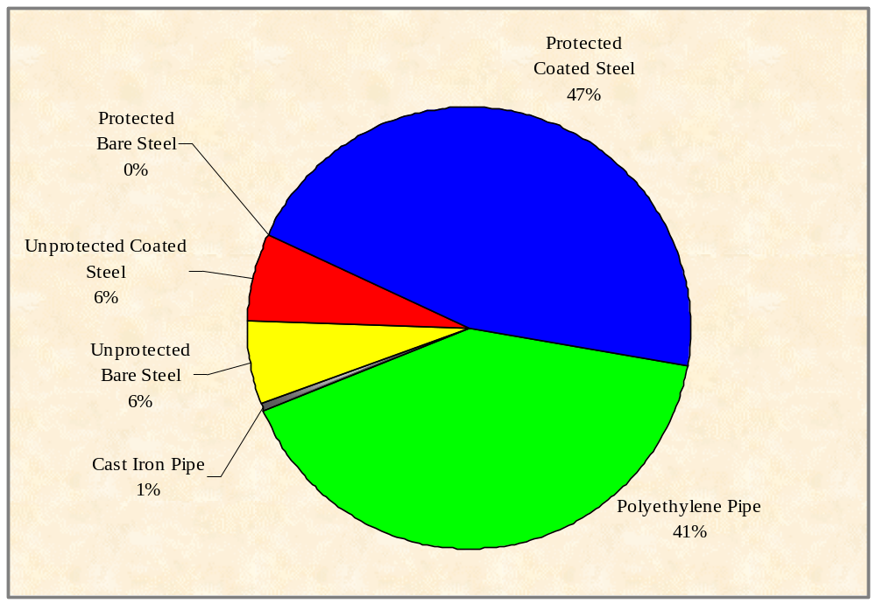

Figure 1. Chart Illustrating Amount of Pipe In California by Type

Company | Steel Pipe |  |  |  |  |  |  | Plastic | Cast Iron | Ductile Iron | Copper | Other | Total
 | Unprotected |  |  | Protected
 | Bare | Coated | Bare | Coated
PG&E | 30,254 | - | - | 1,255,877 | 1,545,355 | - | - | 85,806 | - | 2,917,292
SCG | 101,490 | 98,523 | 6,950 | 1,555,302 | 2,019,618 | - | - | 6,054 | - | 3,787,937
SDG&E | - | - | - | 270,300 | 259,212 | - | - | - | - | 529,512
SWG | - | - | - | 6,889 | 105,796 | - | - | - | - | 112,685
AVISTA | - | - | - | 7,873 | 7,424 | - | - | - | - | 15,297
SCE | - | - | - | - | - | - | - | - | - | -
Total | 131,744 | 98,523 | 6,950 | 3,096,241 | 3,937,405 | - | - | 91,860 | - | 7,362,723

Table 2. Number of Services in California by Utility

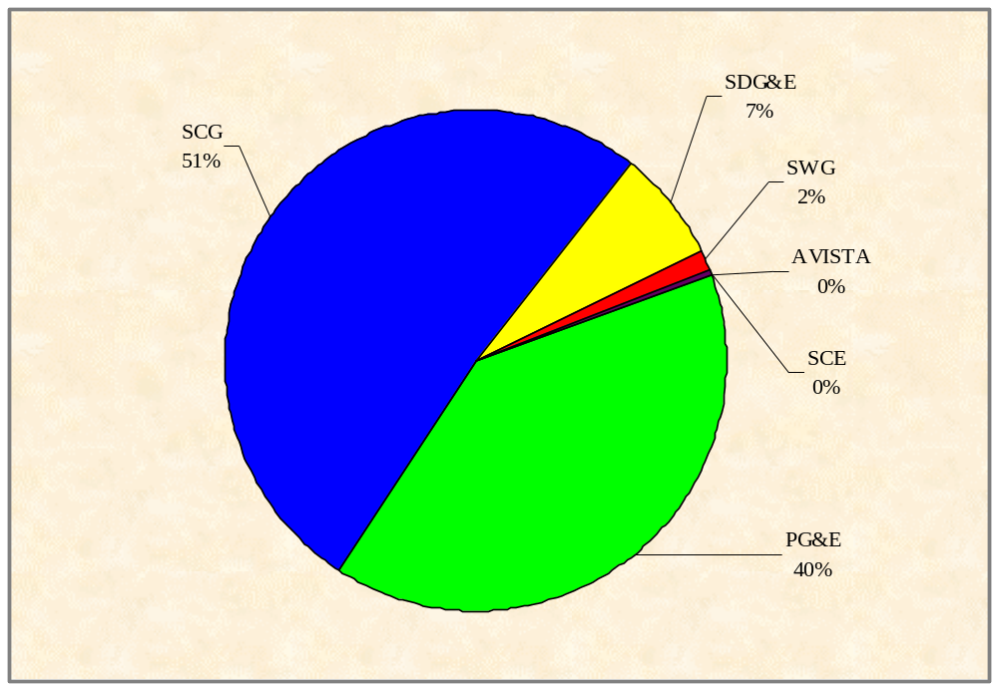

Figure 2. Number of Services in California by Utility

PG&E | Corrosion | Third Party | Outside Force | Construction Defect | Material Defect | Other | Total
Mains | 871 | 474 | 101 | 309 | 202 | 695 | 2652
Services | 1890 | 1429 | 350 | 867 | 822 | 1177 | 6535
SubTotal |  |  |  |  |  |  | 9187
Not Repaired |  |  |  |  |  |  | 5160
SCG | Corrosion | Third Party | Outside Force | Construction Defect | Material Defect | Other | Total
Mains | 1917 | 666 | 66 | 234 | 144 | 1034 | 4061
Services | 2513 | 3705 | 155 | 290 | 159 | 1991 | 8813
SubTotal |  |  |  |  |  |  | 12874
Not Repaired |  |  |  |  |  |  | 3629
SDG&E | Corrosion | Third Party | Outside Force | Construction Defect | Material Defect | Other | Total
Mains | 36 | 168 | 0 | 70 | 16 | 268 | 558
Services | 437 | 579 | 0 | 118 | 75 | 197 | 1406
SubTotal |  |  |  |  |  |  | 1964
Not Repaired |  |  |  |  |  |  | 93
SWG | Corrosion | Third Party | Outside Force | Construction Defect | Material Defect | Other | Total
Mains | 10 | 23 | 5 | 62 | 0 | 4 | 104
Services | 12 | 149 | 49 | 148 | 3 | 12 | 373
SubTotal |  |  |  |  |  |  | 477
Not Repaired |  |  |  |  |  |  | 5
WPNG | Corrosion | Third Party | Outside Force | Construction Defect | Material Defect | Other | Total
Mains | 16 | 124 | 1 | 15 | 5 | 21 | 182
Services | 8 | 252 | 1 | 24 | 6 | 11 | 302
SubTotal |  |  |  |  |  |  | 484
Not Repaired |  |  |  |  |  |  | 0

Table 3. Number of Leaks Detected on Mains and Services For Major Gas Utilities in California
Figure 3. PG&E – Leaks Found on Mains
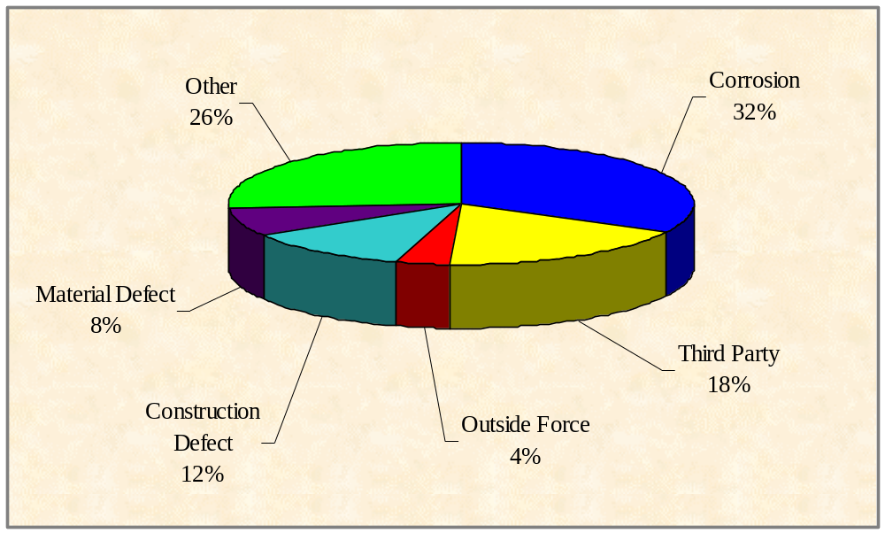

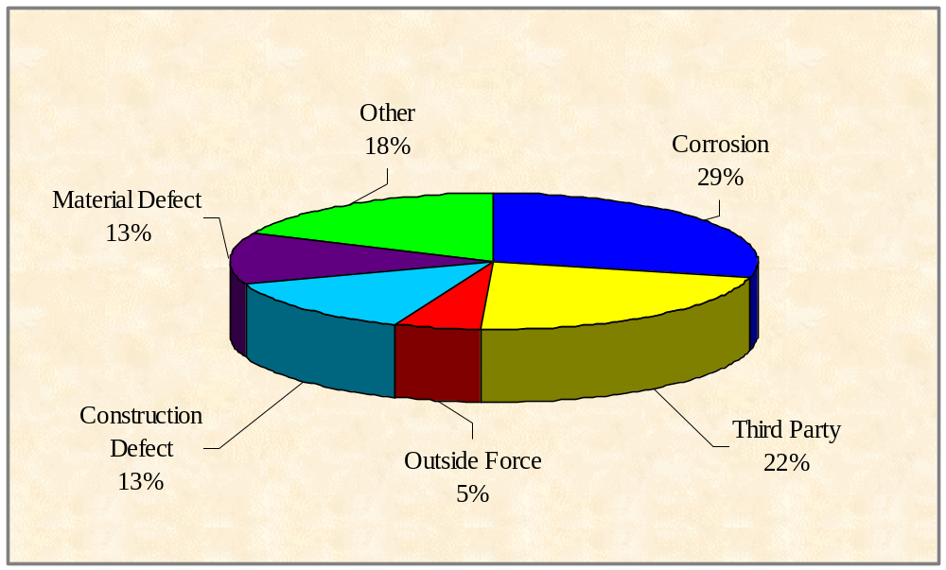Figure 4. PG&E – Leaks Found on Services

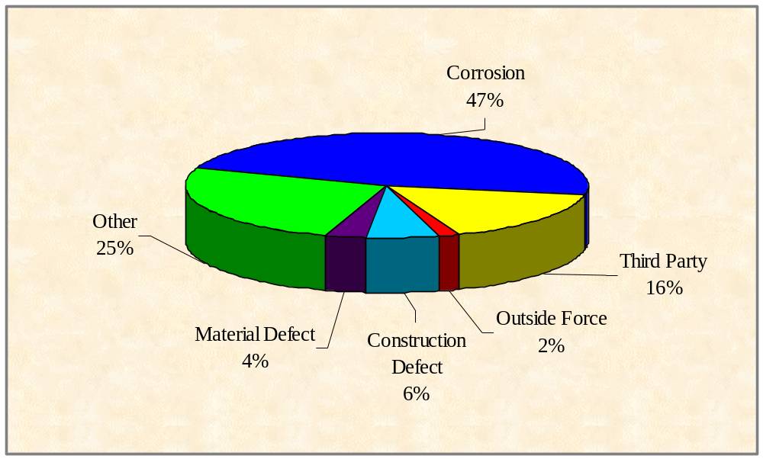Figure 5. SCG – Leaks Found on Mains

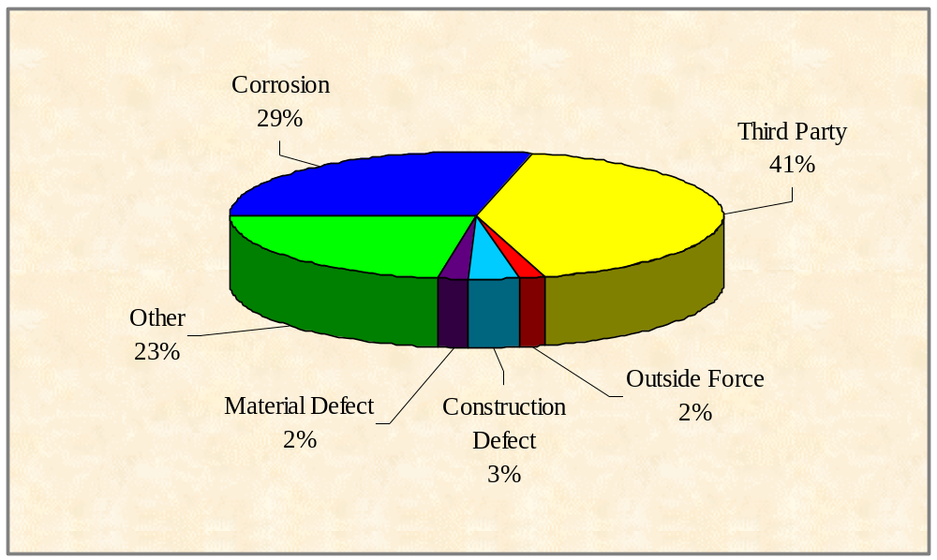
Figure 6. SCG - Leaks Found on Services
Figure 7. SDG&E – Leaks Found on Mains
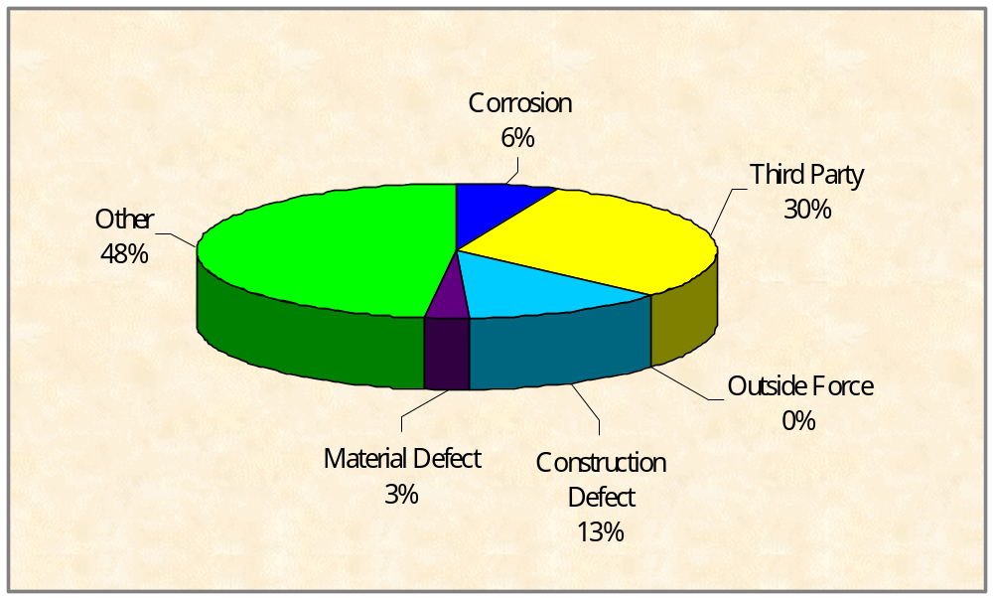
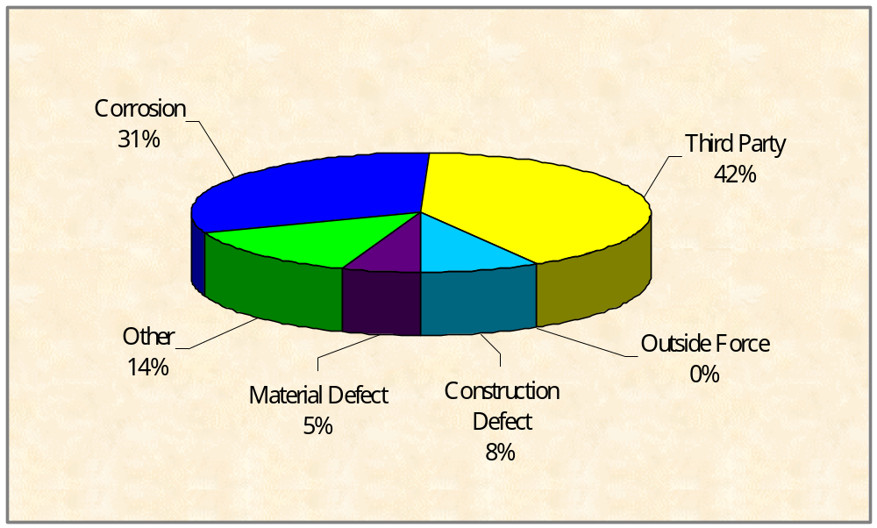
Figure 8. SDG&E – Leaks Found on Services
Below is a pie chart illustrating that “dig-ins” are the predominant cause of gas incidents comprising 57% of all gas incidents reported in 1998. For this reason the federal government and the CPUC have worked together to enhance the one-call system, which requires contractors to call before they dig, so any underground utilities can be located prior to excavating. The second highest category involves fire and/or explosion at 10% with vehicles damaging facilities at 8%. Other incidents (25%) include natural causes storm damage, corrosion leaks, construction defects, material defects and incidents that are unknown in origin such as faulty home appliances, poor gas connections, vandalism and attempted suicides. In essence this graph shows the need for the “One-Call” (USA) system and the meter protection program.

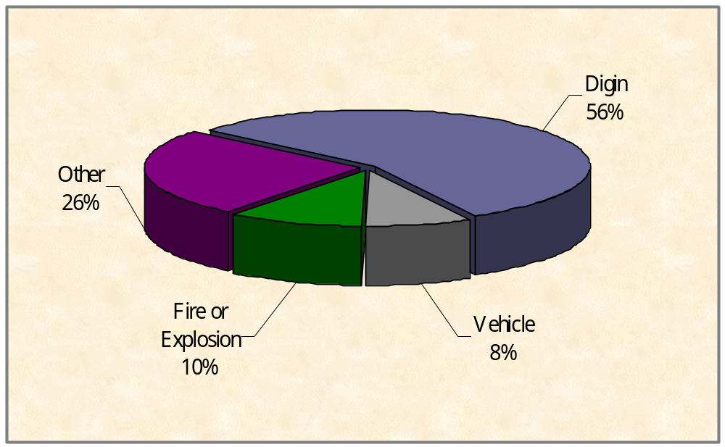
Figure 9. Causes of Incidents in 1998

There are many incidents that occur on utility systems which are not reportable because they are minor and do not meet the requirements set forth by the federal government nor the state of California to be reported. However, the CPUC requires the gas companies to submit quarterly reports detailing all incidents where gas is released. Approximately 90% of these incidents are caused by excavating (boring, trenching, farm equipment plowing, landscaping, gardening, etc.). Approximately half of the dig-ins are caused by people who did not notify USA (Underground Service Alert). Most of these people are homeowners (or helpers)who hit service lines while working in their yard and are unaware of USA or the utility lines buried in their yard.

II. UTILITY COMPANIES UNDER THE

JURISDICTION OF THE CPUC
The CPUC has been granted the authority by the Legislature to adopt and enforce requirements of G.O. 112-E on publicly owned utilities. There are six publicly owned natural gas utility companies within the state and three owned by municipalities with districts formed under the provisions of various laws of the State of California.

- NATURAL GAS COMPANIES
- Southern California Gas Company
Southern California Gas Company serves almost 4 million customers in southern California. Prior to the unbundling of its facilities it was capable of storing over 110 Bcf of natural gas in its 5 underground storage fields which could deliver over a BCF per day to the system upon demand.



- Pacific Gas and Electric
Pacific Gas and Electric (PG&E) provides gas service to almost 3 million customers. Its service area spans 70,000 square miles, including all or portions of 48 of California’s 58 counties. Prior to unbundling PG&E had approximately 100 Bcf of underground storage capacity.


3. San Diego Gas and Electric
San Diego Gas and Electric (SDG&E) provides natural gas service to approximately 520,000 customers in San Diego and Orange county.



4. Southwest Gas Corporation
Southwest Gas provides natural gas service to approximately 110,000 customers in Victorville, Big Bear and North Lake Tahoe within California. The company also serves much of Nevada and Arizona.
5. Washington Water Power Company
.This company serves approximately 15,000 customers at south end of Lake Tahoe.

6. Southern California Edison Company
Edison operates a gas system (propane /butane air) system on Catalina Island that serves approximately 1000 customers. It also transports gas to one of its power plants. SCE is one of the nations’ largest electric utilities, serving more than 11 million customers in a 50,000-square-mile area within Central and Southern California.


7. Municipalities
These California municipalities provide natural gas service to their customers.
a. Coalinga b. Long Beach c. Palo Alto

B. MOBILEHOME PARKS
The Utilities Safety Branch inspects approximately 2800 mobilehome over a five year period.

C. JURISDICTIONAL PROPANE SYSTEMS
There are approximately 750 jurisdictional propane systems under CPUC regulation at the present time that are inspected over five years.

III. USB’S GAS STATISTICS FOR 1998

A. 112-E INSPECTION AREAS

In 1998, USB personnel were divided into four units where each unit was assigned specific counties to conduct G.O. 112-E inspections in California. The following lists the counties each unit covered.

Unit 1 (North): Alameda, Butte, Colusa, Contra Costa, Del Norte, Glenn, Humboldt, Lake, Marin, Mendocino, Modoc, Napa, San Francisco, San Mateo, Shasta, Siskiyou, Solano, Sonoma, Sutter, Tehama, Trinity, Yolo and Yuba.

Unit 2 (Central/ West Special Projects): Alpine, Amador, Calaveras, El Dorado, Lassen, Mono, Nevada, Placer, Plumas and Sierra.

Unit 3 (Central): Fresno, Inyo, Kern, Kings, Madera, Mariposa, Merced, Monterey, Sacramento, San Benito, San Luis Obispo, San Joaquin, Santa Barbara, Santa Clara, Santa Cruz, Stanislaus, Tuolumne and Tulare.

Unit 4 (South): Imperial, Los Angeles, Orange, Riverside, San Bernardino, San Diego and Ventura

A file is kept on each area inspected for a period of at least 3 years. Every unit of a major gas company and municipal utility is inspected every two years or more often if the condition of the unit is unsatisfactory and not in compliance with federal law. MHP and propane systems are inspected once every 5 years unless the audit warrants more frequent inspection. Records are kept in both Los Angeles and San Francisco. The federal government audits USB’s records annually. Federal funding to the state is based on the results of the federal audit.
B. USB INSPECTION DATA

1. Inspections

For the 1998 Calendar Year | Total
Number of Person-Days of Utility Inspections | 181
Number of Person-Days of MHP Inspections | 243
Number of Person-Days of Propane Inspections | 124
Number of Person-Days Inspecting Incidents | 134
Number of Person Days Performing Other Field Work | 110
Table 4. Summary of the G.O.112-E Inspection Person-days Conducted in 1998

For the 1998 Calendar Year | Total
Number of Inspection Units Inspected (Major utilities) | 97
Number of Inspection Units Inspected (Municipal utilities) | 1
Number of Inspection Units Inspected (Master Meter - Gas) | 327
Number of Inspection Units Inspected (Master Meter - LPG) | 41
Number of Inspection Units Inspected (Major util. - Transmission | 69
Number of Inspection Violations Found | 1555
Number of Inspection Violations Corrected | 1637
Number of Compliance Actions Taken | 405
Table 5. Tabulation of Inspections Conducted and Probable Violations Found in 1998
2. Incidents

For the 1998 Calendar Year | Total
Number of Incidents Reported | 134
Number of Incidents Investigated | 134
Number of Gas Complaints Received | 220
Number of Weeks for On Call Engineer Duties | 52
Number of USB Engineers* (person-years excluding managers) | 8
Table 6. Summary of Incident Investigations & Customer Complaints for USB in 1998

3. Summary of Incident Causes
The following is a summary of leading causes of incidents in 1998 relating to gas pipelines.

For the 1998 Calendar Year | Total
Dig in | 7,569
Corrosion | 7,710
Material Defect | 1,432
Construction Defect | 2,137
Outside force | 728
Miscellaneous other causes | 5,410
Grand Total | 24,986
Table 7. Summary of Leading Causes of 1998 Leaks Relating to G.O. 112-E
(includes reportable and non-reportable)
C. GAS INCIDENTS & CUSTOMER COMPLAINTS

The USB staff receives and investigates reportable gas and propane incidents from regulated utility companies or regulated systems (propane and MHP). GO 112-E states the reportable incidents are those which involve the release of gas and (a) result in fatality or personal injury rising to the level of in-patient hospitalization and attributable or allegedly attributable to utility owned facilities; (b) cause over $50,000 in damage including the loss of gas; and (c) are the subject of significant public attention or media coverage and are attributable or allegedly attributable to utility facilities

The gas utility companies are required to provide notice to designated USB staff within 2 hours of a reportable incident. The notice shall identify the time and date of the incident, the time and date of notice to the Commission, the location of the incident, casualties which resulted from the incident, identification of casualties and property damage, and the name and telephone number of a utility contact person.

The designated USB staff is called the On-Call Engineer (OCE). The OCE is responsible for receiving reportable incidents from the utility companies and he or she is available to do so 24 hours per day. The OCE duties are shared amongst the USB staff. Each staff engineer assumes the OCE duties for an entire week (including weekends) several times per year. The OCE or a staff engineer may go out to investigate incidents at any hour, including weekends. If it is determined that a G.O. violation was involved, staff writes up a report and recommends action against the utility.

In addition, the staff maintains a database of outages and accidents to note trends. If there is significant trending, the staff will investigate and work with utilities to correct the problem. The database has been very useful in noting trends about dig-ins by excavators, manufacturer defects, corrosion areas, and need for meter protection. The Commission has initiated Order Instituting Investigations (OIIs) based on the supporting data and investigations of USB.

USB staff also handles customer complaints relating to safety issues per G.O. 112-E. Besides investigating incidents reported by the utility companies, USB may investigate customer complaints involving alleged violations of the General Orders, sometimes on behalf of Consumers Affairs Branch or through direct referral.

IV. ADDITIONAL INFORMATION
PUBLICATIONS
Copies of G.O. 112-E are available for the general public from the CPUC. Copies of federal regulations regarding pipeline safety must be obtained from the federal government. A form to obtain this information is on the last page of GO-112-E.

1. How to Order G.O. 112-E
Documents, California Public Utilities Commission
505 Van Ness Avenue
San Francisco, CA 94102
(415) 703-1713
Call or Write
the CPUC at…

California Public Utilities Commission (most documents available)
320 West 4th Street, Suite 500
Los Angeles, CA 90013
(213) 576-7003

2. How to Access G.O. 112-E and Federal Regulations on the Internet
G.O. 112-E and The USB Gas & Propane Safety Report
can be viewed at the CPUC web site. The URL is:
http://www.cpuc.ca.gov/divisions/CSD/USB/usb.htm

The Federal Regulations can be viewed at the following URL:
http://www.access.gpo.gov/_docs/aces/aces140.html



