Beat the Heat:
A Proposal to Replace Halogen Torchieres in California's Commercial and Institutional Buildings

Submitted by:
Ecos Consulting Inc.

To:
The California Public Utilities Commission

For:
The Summer 2000 Energy Efficiency Initiative

July 21, 2000

I. Executive Summary

The state of California finds itself at a crucial juncture in the utility restructuring process. To ensure adequate supplies of electricity in the summer of 2001, the California Public Utilities Commission has issued an urgent call for energy efficiency programs that can make a tangible and immediate difference in the state’s peak and total electricity demand. Ecos Consulting, a California-based provider of innovative energy efficiency solutions, proposes a program that builds on one of the state’s most dramatic residential success stories – the Energy Star® torchiere. Our objective is to extend that success story to a massive and completely untapped market: commercial and institutional customers. Why? Their energy consumption is often highest at precisely the time of day and season of the year when California most needs energy savings.

Our proposal to “beat the heat” is truly unique in the number of ways it promises to benefit Californians:

- By cutting light fixture power consumption from 300 watts to 60 watts, the program will slash electric bills and demand charges for current users of halogen torchieres, continuing to save electricity for years in the future for less than a penny per kilowatt-hour.
- By lowering lamp operating temperatures from 750 to 150 degrees F, the program will improve comfort and generate palpable additional savings on air conditioning bills, especially during the vital summer months.
- Even more importantly, those lower operating temperatures will bring a dramatic improvement in fire safety to light fixture users, eliminating the risk that halogen torchieres will cause additional fires that destroy property and injure or kill innocent victims.
- Energy Star® torchieres will also reduce utility greenhouse gas and criteria air pollutant emissions by 80% compared to conventional halogen models, making a useful contribution to local, state, and national efforts to prevent urban smog, urban heat islands, and global warming.

II. Introduction

California utilities have been working to improve the energy efficiency of residential lighting for more than 15 years. Through internal programs conducted by company staff, and external programs conducted by Ecos Consulting and other contractors, they have begun the process of shifting homeowners and apartment-dwellers from incandescent lighting to more energy efficient alternatives. These programs began with small pilot projects to give away compact fluorescent lamps (CFLs) to low income customers. They have progressed through a series of informational and incentive-oriented program designs to encourage the purchase of both CFLs and dedicated fluorescent light fixtures. Virtually all of these programs have worked through mass market retailers like Home Depot, HomeBase, Wal-Mart, Target, Orchard Supply Hardware and other consumer sales channels to introduce residential customers to Energy Star® lighting products at attractive prices.

By targeting traditional residential customers, however, these programs have not effectively reached out to a vast number of customers that reside in institutional facilities. These buildings include public housing, dormitories, military barracks, hotels and motels, managed care facilities, and a host of other building types that are often considered commercial accounts for purposes of utility billing, but which exist primarily to house residents. In most cases, their lighting is not purchased through standard consumer retail channels, yet it represents a significant electric load with enormous opportunities for energy efficiency improvements.

At the same time, the California utilities have also aggressively pursued a fairly standard series of measures to improve the energy efficiency of overhead lighting in large commercial buildings. These measures primarily include the replacement of magnetic ballasts with more efficient electronic ballasts, the replacement of T-12 fluorescent lamps with T-8 alternatives, and various other improvements to the reflectors, lenses, and controls for such overhead lighting. These programs and similar ones run by other utilities have had a major impact, though magnetic ballasts and T12 lamps remain in use in a remarkably high 70 to 80% of the nation’s commercial and industrial fluorescent fixtures.

A few commercial lighting programs have gone even further, targeting other types of permanently installed lighting for retrofit, including downlighting, exit signs, sconces, and exterior lighting. Missing, however, in all of these commercial lighting programs, has been any sort of focus on portable lighting.

Portable lighting can take a variety of forms in commercial buildings, but normally includes floor lamps, table lamps, and desk lamps (task lighting) that all provide a cord and integral switch for installation and operation by the user. In many cases (see Energy User News article in Appendix 1), this lighting is not even provided or tabulated by the companies occupying the buildings, but is brought from home by workers or ordered from office supply catalogs as part of the requisition process. Workers often utilize portable lighting to give a more home-like feel to cubicles and offices. Many, in fact, perceive their overhead fluorescent lighting to be too bright, unattractive, or even bad for their health, so utilize their portable light fixtures instead of the energy efficient lighting installed overhead by cost-conscious building managers. This leads to long hours of operation during periods of peak demand, confounding California’s efforts to meet its electricity needs.

This proposal seeks to target the most energy-wasteful types of portable lighting – halogen torchieres. Moreover, it hones its search for those products to three very precise segments of the California building population:

- Large commercial buildings in which portable light fixtures have been overlooked by past efficiency programs
- Small commercial buildings in which few energy efficient lighting measures have ever been undertaken
- Institutional residential buildings not presently served by the state’s residential lighting program

We propose to identify buildings where large numbers of halogen torchieres remain in use, offer a convenient and free means of recycling those products to eliminate their electric load from the California grid, and replace them with highly cost effective and safe Energy Star® alternatives.

III. The Energy Efficiency Opportunity

Halogen floor lamps, or torchieres, represent one of the premier energy savings opportunities in the lighting sector. In a traditional residential lighting program, great effort is expended to encourage customers to switch from 75 watt incandescent bulbs to 20 watt compact fluorescent equivalents. While each of these measures saves 55 watts and represents a useful endeavor in its own right, it pales by comparison to the savings achieved through the replacement of each halogen torchiere with an Energy Star® alternative. In that case, power consumption drops from 300 or even 500 watts to only 50 to 80 watts, saving an average of about 240 watts.

In addition, the torchiere fixture offers a far more long-lived measure than a typical screw-in compact fluorescent lamp. By housing its high quality ballast inside the fixture, the Energy Star® torchiere allows its user to simply replace a burned out compact fluorescent lamp with another for a few dollars, continuing to generate energy savings for years into the future. As shown in Appendix 1 (figure 2), the lifetime savings of electricity and replacement bulbs for an Energy Star® torchiere average more than $300 at typical national electric rates. With California’s electric rates and the hours of usage typically found in commercial and institutional buildings, lifetime savings could approach $500 per fixture.

Halogen torchieres also afford more compelling retrofit messages to building owners, managers, and occupants than the normal energy savings message associated with light bulbs. Both safety and comfort are powerful selling points for this program, as evidenced by its name: Beat the Heat.

Figure 1
Comparing Lamp Operating Temperatures to the
Ignition Temperatures of Common Household Materials

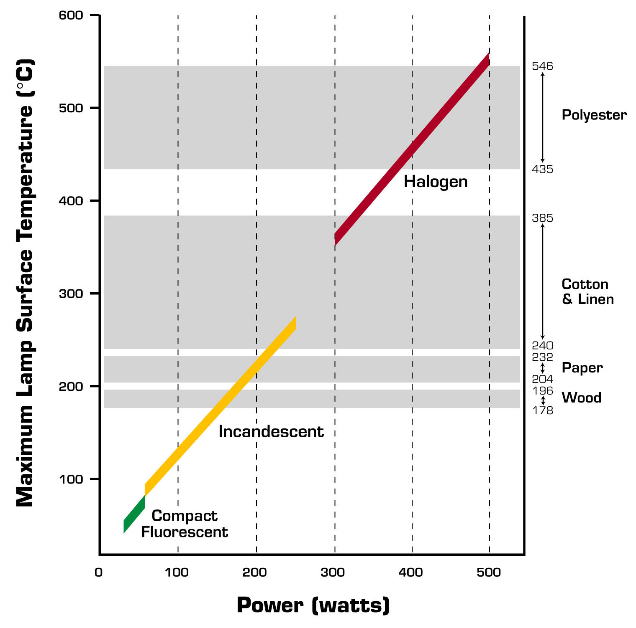

As shown in Figure 1, halogen torchieres run at temperatures four to five times hotter than their compact fluorescent alternatives – hot enough to ignite paper, cloth, plastic, and wood. They convert 90 to 95% of their electricity into heat. As a result, the products have caused more than 435 documented fires nationwide, killing at least 32 people, injuring at least 114 people, and causing tens of millions of dollars of property damage and liability costs. At least four Californians have already died from halogen torchiere fires. The horrifying burns a torchiere caused to a four year old girl near San Diego have already led to a legal settlement of $11 million and the withdrawal of the products from Wal-Mart’s shelves throughout the country (see Appendix 1).

Commercial and institutional building managers are uniquely interested in responding to such safety problems when made aware of them. The consequences of a fire in such buildings go well beyond property loss or personal injury. Commercial building fires can also lead to millions of dollars in lost economic output and wages, in addition to enormous legal costs.

At the same time, the functional result of operating 300 to 500 watt halogen lamps in conditioned building space is identical to operating an equivalent number of space heaters of the same wattage. This makes building occupants uncomfortable and results in substantial additional air conditioning demand, on peak, during much of the year. So the net outcome of replacing a 300 watt halogen torchiere with a 60 watt Energy Star® model in a conditioned building is not only 240 watts of lighting savings, but as much as an additional 60 to 80 watts of air conditioning savings.

This “HVAC bonus” for efficient lighting has been documented extensively by researchers at Lawrence Berkeley National Laboratories for a variety of commercial buildings in California, and typically ranges from 13 to 27% in cold climates and 29 to 37% in hot climates. Peak cooling demand savings average 33 to 35% in cold and hot climates. We conservatively estimate a 25% energy savings bonus and peak cooling demand savings bonus for commercial building torchieres in this program, and assign a 15% energy savings and peak cooling demand savings bonus to the institutional residential torchieres.

Market potential, of course, is the product of the savings that can be achieved per unit and the number of units in use. Though ongoing research by Ecos Consulting since 1995 has documented total halogen torchiere sales and number in use, we are unaware of any studies that have attempted to allocate total torchiere population by state or by building type within a state. However, it is possible to estimate those totals with national data. As shown in Appendix 2, the total number of units in use nationwide has roughly stabilized at approximately 50 million, and appears now to be in slow decline.

California has been more aggressive than most states in targeting these products for replacement in its residential lighting programs. Ecos Consulting has been working under contract to implement those programs on behalf of the California utilities, but all of the current $1.65 million of torchiere incentives are directed explicitly at traditional residential customers through consumer retail stores. These stores are segmented into three key channels: do-it-yourself (DIY) stores like Home Depot and HomeBase, mass merchandisers such as Target and Wal-Mart, and lighting specialty and hardware stores like Lamps Plus and Ace TrueValue. None of these incentives are available for use by office supply stores like Office Depot and Staples or by other procurement companies that often cater to the office supply needs of large and small commercial and institutional customers.

Ecos Consulting has also conducted a variety of halogen torchiere turn-in events around the state since 1998, including events in Sacramento, San Jose, San Francisco, Contra Costa County, Fresno, and Anaheim. Additional events are likely in San Diego and northern California during 2000. Again, the survey card data from these turn-ins has indicated that an overwhelming percentage of participants are single family homeowners, and do not overlap with the target market for this proposal. While the current statewide residential lighting program is leading to rapid increases in retail availability of Energy Star® torchieres and steady reductions in price, this program does not target institutional residents or commercial customers. Indeed, the statewide program is barred from such a focus by its residential charter. At the same time, traditional commercial and industrial efficiency programs may be missing opportunities to replace halogen torchieres for the reasons noted in the introduction above.

Though California would normally be expected to have higher than its population-weighted share of halogen torchieres because of population demographics and its role as an import destination for the products arriving from Asia, the utility programs have done more to reduce their usage in single family homes and apartments here than in most states. We therefore assume that torchieres are roughly as prevalent here as in the nation as a whole, with approximately one torchiere for every five residents. With a state population of 32.5 million, California has approximately 6.5 million torchieres in use.

RLW Analytics, in a recent survey of California residences, found an average of 0.36 torchieres per home. This would suggest a total of about 4 million torchieres in use in the state’s single family homes and private apartments. Our program proposes to target the remaining 2.5 million units, aiming specifically for the kinds of buildings with the longest hours of on-peak operation and the greatest remaining energy savings potential.

A significant fraction of Americans reside in places not traditionally considered residential accounts by a utility. In most cases, these people reside in buildings where the management provides permanent lighting fixtures and often pays the electric bills as well. However, the residents or their families often provide portable light fixtures at their own discretion. Or, building owners may add portable lighting to hotels and motels, for example, after energy efficiency retrofits are completed, negating some of the energy savings achieved. In either case, those fixtures contribute to the building’s electric load, but are not always addressed by energy efficiency programs that target building managers and maintenance staff.

Those building types, along with their approximate national and California resident populations, include:

Building Type | National Population | CA Population (est.)
Nursing homes | 1.6 million | 0.19 million
Psychiatric hospitals | 0.2 million | 0.02 million
Managed care facilities | 0.4 million | 0.05 million
Public housing | 15.0 million | 1.80 million
Mobile homes/trailer parks | 13.0 million | 1.56 million
College & university residence halls | 2.0 million | 0.24 million
Hotels, motels & boarding houses | 4.8 million | 0.58 million
Juvenile detention facilities, half-way houses & prisons | 0.6 million | 0.07 million
Military barracks | 0.2 million | 0.02 million
TOTAL | 37.8 million | 4.53 million

There is ample evidence to suggest that halogen torchieres are found in greater concentrations in institutional residential settings than in traditional single family homes (see Appendix 1). Surveys conducted of university residence halls have shown concentrations of one torchiere for every one to three rooms, and hours of usage that are often 50 to 100% greater than that found in typical single-family homes. Public housing authorities in major metropolitan areas have found at least one torchiere in every three to four units. A managed care facility in Grand Junction, Colorado reported one of the first documented halogen torchiere fires back in 1995, which caused $60,000 worth of damage to an elderly patient’s room and those surrounding it. Many of the fatalities and the most severe halogen torchiere fires have occurred in mobile homes, where construction practices often lead to rapid, total devastation in the event of a fire.

In short, institutional residential buildings are likely to have large numbers of halogen torchieres because the residents have a lower-than-average income, often endure substandard overhead lighting, do not pay their own electric bills, and are seeking the brightest and most convenient light they can find for the lowest up-front purchase price.

Estimates of how the 2.5 million torchieres are divided between California’s institutional buildings, large commercial buildings, and small commercial buildings are extremely difficult to make without a full baseline study. Moreover, we recognize that perhaps a third of the 2.5 million torchieres may be in use in the service territories of municipal electric utilities like SMUD and LADWP, and therefore not accessible to this project. However, of the remaining 1.7 million torchieres, we estimate that about 1 million are found in institutional buildings (0.22 per resident) and about 0.7 million are found in commercial buildings. Our goal is to recycle roughly 1.5% of those units, targeting the models with highest energy and peak demand usage, especially those used in conditioned buildings.

IV. Detailed Project Description

Ecos Consulting proposes a Beat the Heat torchiere program running from September 2000 through October 2001 in the Pacific Gas & Electric, Southern California Edison, and San Diego Gas & Electric service territories.

Capabilities

Based out of our central office in the metropolitan Los Angeles area, the program would have at its helm the most seasoned and successful torchiere team in the nation. Ecos Consulting’s energy efficiency implementers boast a greater depth of experience with halogen and Energy Star® torchieres than any energy service provider in the country. Our staff’s torchiere-related activities before and during their Ecos tenure include:

- Co-developing the original compact fluorescent torchiere prototype in 1994.
- Drafting the initial Energy Star® labeling proposal for torchieres on behalf of EPA in 1996.
- Authoring more than a dozen articles regarding torchieres for E SOURCE, EPA, Home Energy, the International Association for Energy Efficient Lighting, Greening of the Campus II, and Energy User News.
- Working from 1996 to 2000 to convince many of the current manufacturers to produce compliant products.
- Launching the first Internet site to offer comprehensive education about the halogen torchiere problem and online ordering capabilities for Energy Star® alternatives.
- Implementing incentive and education programs for torchieres in California, Oregon, Washington, Idaho, Montana, Wisconsin, and Illinois.
- Conducting the majority of utility-funded halogen torchiere turn-in events throughout the country, in all of the above states plus New York.

Project Goals

The goal of this project will be to recycle up to 25,000 halogen torchieres and encourage the purchase of 20,000 Energy Star® torchieres by commercial and institutional customers. As noted in Appendix 3, there are two different pathways for lighting energy savings here:

- the savings that result from eliminating the use of 20,000 halogen torchieres at 300 watts apiece and replacing them with 20,000 Energy Star® models at 60 watts apiece
- the savings that result from recycling an additional 5,000 halogen torchieres that are not replaced, simply because building owners or managers prevent their use out of safety or liability concerns

The program will assign the highest priority to identifying torchieres that are used during peak demand hours, especially in air conditioned buildings, in order to achieve maximum kwh and kw savings.

Target Markets

There are two overarching target markets. The primary one includes building managers, risk managers, residential life directors, and energy managers. These individuals will often have responsibility and decision-making power regarding the usage of torchieres in their facilities, even if they were not the original product purchasers. They may, for example, possess the authority to bar the use of halogen torchieres on their premises because of safety concerns. In some cases, they may be the original purchasers of the products, as has been documented at many universities, giving them a strong incentive to want to reduce the labor costs associated with changing the expensive, short-lived bulbs in halogen torchieres. As the payer of both utility bills and insurance bills for the premises, they will have a very strong additional economic incentive to take action. At a more basic level, they are also well-positioned to actively encourage their residents to take advantage of an energy- and money-saving opportunity to replace halogen torchieres with Energy Star® models.

The second target market is the lighting users themselves, particularly in institutional residential settings like managed care facilities or dormitories. While it will be difficult to market to these people individually, we may well be able reach them by furnishing building managers with information they can post in common areas or distribute to residents in print and electronic form. We can also market to family members, care-givers, and others who have direct influence over the lighting choices made by building residents.

Market Barriers

The principal market barriers among these customer types are familiar ones. Decision-makers may face split incentives to act, since those who choose the portable lighting often do not pay the resulting energy bills and vice versa. Likewise, there remains a lack of available information to some key decision-makers because of their captive or at least limited-mobility situation. Since much of the current torchiere education in California is occurring through retail stores, those who are unable or unwilling to visit such retailers frequently may not be aware of the energy and safety opportunity Energy Star® models provide. Another key market barrier will certainly be first cost, since the Energy Star® torchieres are more expensive initially than halogen models. Likewise, because many of the targeted customers have below-average incomes, the first cost barriers for them may be especially acute.

Intervention Strategies

We plan to have a decisive impact through detailed market segmentation, leveraging of existing manufacturer relationships and research contacts, networking through trade associations and building management firms, targeted and customized mailings, and attentive customer service for respondents. We will eliminate the inconvenience of removing and recycling halogen torchieres by bringing the truck directly to the customers’ premises and recycling the torchieres for free. We will schedule trucks to retrieve the units from customers in close geographic proximity on the same day to minimize transportation costs. We will also arrange with a local metal recycler to reclaim as much steel from the units as possible, and use the scrap metal value to help offset the cost of retrieving and recycling the units.

We will eliminate the difficulty of finding an aesthetically pleasing and affordable Energy Star® model by competitively selecting a wide range of the highest quality models and styles and bringing them directly to the customers’ location. We will employ manufacturer incentives of $15 per unit to greatly reduce the first cost barrier customers would otherwise face. This will allow them to purchase Energy Star® models for the same price or slightly more than typical halogen products. This combination of strategies should help overcome the reluctance that some customers may have shown to remove, disassemble, and transport their halogen torchieres to a centralized turn-in location in the past.

Likewise, we intend to actively employ safety messages in a program with an energy efficiency goal, which may help motivate larger institutions that would otherwise fail to act on the energy message alone. High-density residential situations are particularly prone to fire damage and tend to be somewhat more risk-conscious than a typical single family homeowner. In addition, we may be able to employ linkages to regional insurance companies and fire departments to gain additional referrals to targeted customers. Their messages will reinforce our own to stimulate action by the customers.

Finally, we intend to document success stories publicly and leverage relationships among business peers. Ecos staff would create brief case studies about customers who achieved the most dramatic results from replacing their halogen torchieres. These would be given out to subsequent program participants, posted on the Internet, and submitted to local news media/trade magazines for publication. The intent of creating these case studies would be to urge other customers to pursue torchiere replacement in the future. If widely distributed, the case study results should be expected to encourage a greater level of activity by institutional residential customers, commercial office buildings, and even traditional residential customers.

V. Energy Savings and Cost Effectiveness Estimation

As noted above, the program goal is to recycle 25,000 halogen torchieres and encourage the sale of 20,000 Energy Star® models. This goal presents an exceptional opportunity to reduce electric demand in a short period of time. Based on data from the most recent California torchiere turn-in (November 1999), it appears that average hours of usage for halogen torchieres in residential applications are about 5 hours per day. Because large commercial buildings typically have a substantial number of offices and spaces that cannot be lit by daylight, we assume average torchiere usage of 6 hours per day in those locations, and conservatively estimate 4 hours per day for institutional buildings (see Appendix 3 for summary table of assumptions). Likewise, commercial buildings are more likely to experience torchiere loads during periods of peak demand (summer afternoons), because of the 9 to 5 work day and greatly diminished occupancy at night. Conversely, though, commercial buildings would normally be utilized only about 260 days per year, compared to 365 days per year of use in institutional buildings. Additional assumptions about wattages, product lifetimes, HVAC bonus, and allocations of products between commercial and institutional buildings are summarized in Appendix 3.

The bottom line is simple: this program can generate electricity savings of 11.5 million kwh per year and lifetime savings of approximately 101 million kwh throughout the state of California. In addition, this program can shave peak demand by about 7.6 MW. We estimate the program cost is about 0.73 cents per lifetime kwh saved – substantially cheaper than the fuel cost of existing power plants. Even on a first year basis, we believe this program can save energy for 6.4 cents per first year kwh – a bargain in a state where the spot market for power is rising in the summertime to substantially higher levels.

The program would cost an average of $14.80 for each torchiere recycled and $18.50 for each new torchiere purchased, but would yield annual energy savings at $0.10/kwh of more than $43 per torchiere swapped, paying for itself about nine months after the new torchieres are installed. Any economic value attached to the demand savings simply shortens this payback time even further. Likewise, the safety, comfort, convenience, and environmental benefits are difficult to quantify, but add substantially to the attractiveness of the program.

We pledge to work with regulators and evaluators to develop other quantitative estimates of cost effectiveness, as needed, to mesh with existing techniques of evaluating participant costs, non-participant costs, societal costs and benefits, and other meaningful metrics of program success.

VI. Verification of Demand and Energy Reductions

Ecos Consulting has completed a number of interim reports, final program reports, and top-level evaluations (available upon request) of its past and ongoing torchiere program results in Illinois, Wisconsin, the Pacific Northwest, and California. Because most of these programs are operating primarily with a market transformation impetus, their reporting and evaluation challenges are actually greater and more complex than with the Beat the Heat program proposed here.

This commercial and institutional program would be focusing primarily on sites with dozens, hundreds, or even thousands of halogen torchieres in use per location. As a result, transactions would occur at the wholesale level, in volume, rather than in increments of one or two through thousands of individual purchases at retail stores. Sales would occur directly between manufacturers or master distributors and final purchasers, with no retail middleman. This eliminates the possibility for double-counting or duplicity with the state’s existing retail program for torchieres. Yet it still allows for useful synergies to occur when people try an efficient product at home and then encourage their company to follow suit, or try one at work and decide to purchase an additional unit at a retail store for home use.

We propose, to the maximum extent possible, to maintain records on every product sold and every torchiere recycled through this program. We will conduct follow-up visits with large customers to verify the installation and use of products, answer questions, and encourage word-of-mouth marketing to other companies in the field. We will make our records available to independent program evaluators, making it possible for them to return to the locations of customers of their choosing to audit fixture counts, interview users, and assess utility bill impacts. This same information will be made available to the utility account representatives for large customers, allowing them to track anticipated lighting and HVAC bonus savings.

In most cases, the purchasing entity would also be the bill-payer for a particular commercial or institutional utility account, simplifying the tracking process. No customer coupons or rebate checks will be involved, since incentive payments will flow directly to manufacturers upon proof of delivery of qualifying products to qualifying locations. In addition, we will work during the early months of the program to further refine the halogen torchiere baseline estimated in this proposal, so California’s regulators and utilities can better assess progress against that baseline.

VII. Budget and Timeline

Work Area | Estimated Cost | Timeline
I. Program Launch  ▪ Detailed work plan  ▪ Kick-off meetings  ▪ Expand field staff | $ 35,000 | 09/00 to 10/00
II. Competitive Product Selection  ▪ RFP to manufacturers  ▪ Evaluate, score responses  ▪ Print summary of available products | $ 20,000 | 09/00 to 10/00
III. Opportunity Assessment  ▪ Market research/segmentation  ▪ Establish baseline  ▪ Initial site visits | $ 55,000 | 9/00 to 11/00
IV. Develop Promotional Materials  ▪ Creative design and review  ▪ Printing / web publishing | $ 25,000 | 10/00 to 11/00
V. Program Marketing  ▪ Contact trade associations,  building management firms  ▪ Sales calls, trade shows, newsletter  articles, networking, mailing  ▪ Create, circulate, and promote case  studies of early successes | $ 85,000 | 10/00 to 10/01
VI. Recycle Halogen Torchieres  ▪ Select and schedule recycling  companies for halogen pick-up | $ 90,000 | 11/00 to 10/01
VIII. Energy Star Torchiere Incentive Payment, Processing  ▪ Establish $15/unit manufacturer  incentive process  ▪ Pay manufacturer invoices | $340,000 | 11/00 to 11/01
IX. Program Management  ▪ Administration and record-keeping  ▪ Team oversight  ▪ Final program report | $ 55,000 | 9/00 to 11/01
X. Program Administrative Costs  ▪ Telephone charges  ▪ Copying  ▪ Postage  ▪ Travel and mileage  ▪ Other miscellaneous expenses | $ 35,000 | 9/00 to 11/01
Total Program Budget Not to Exceed | $740,000

Appendix 1

Energy User News, February 2000, pp. 10-11

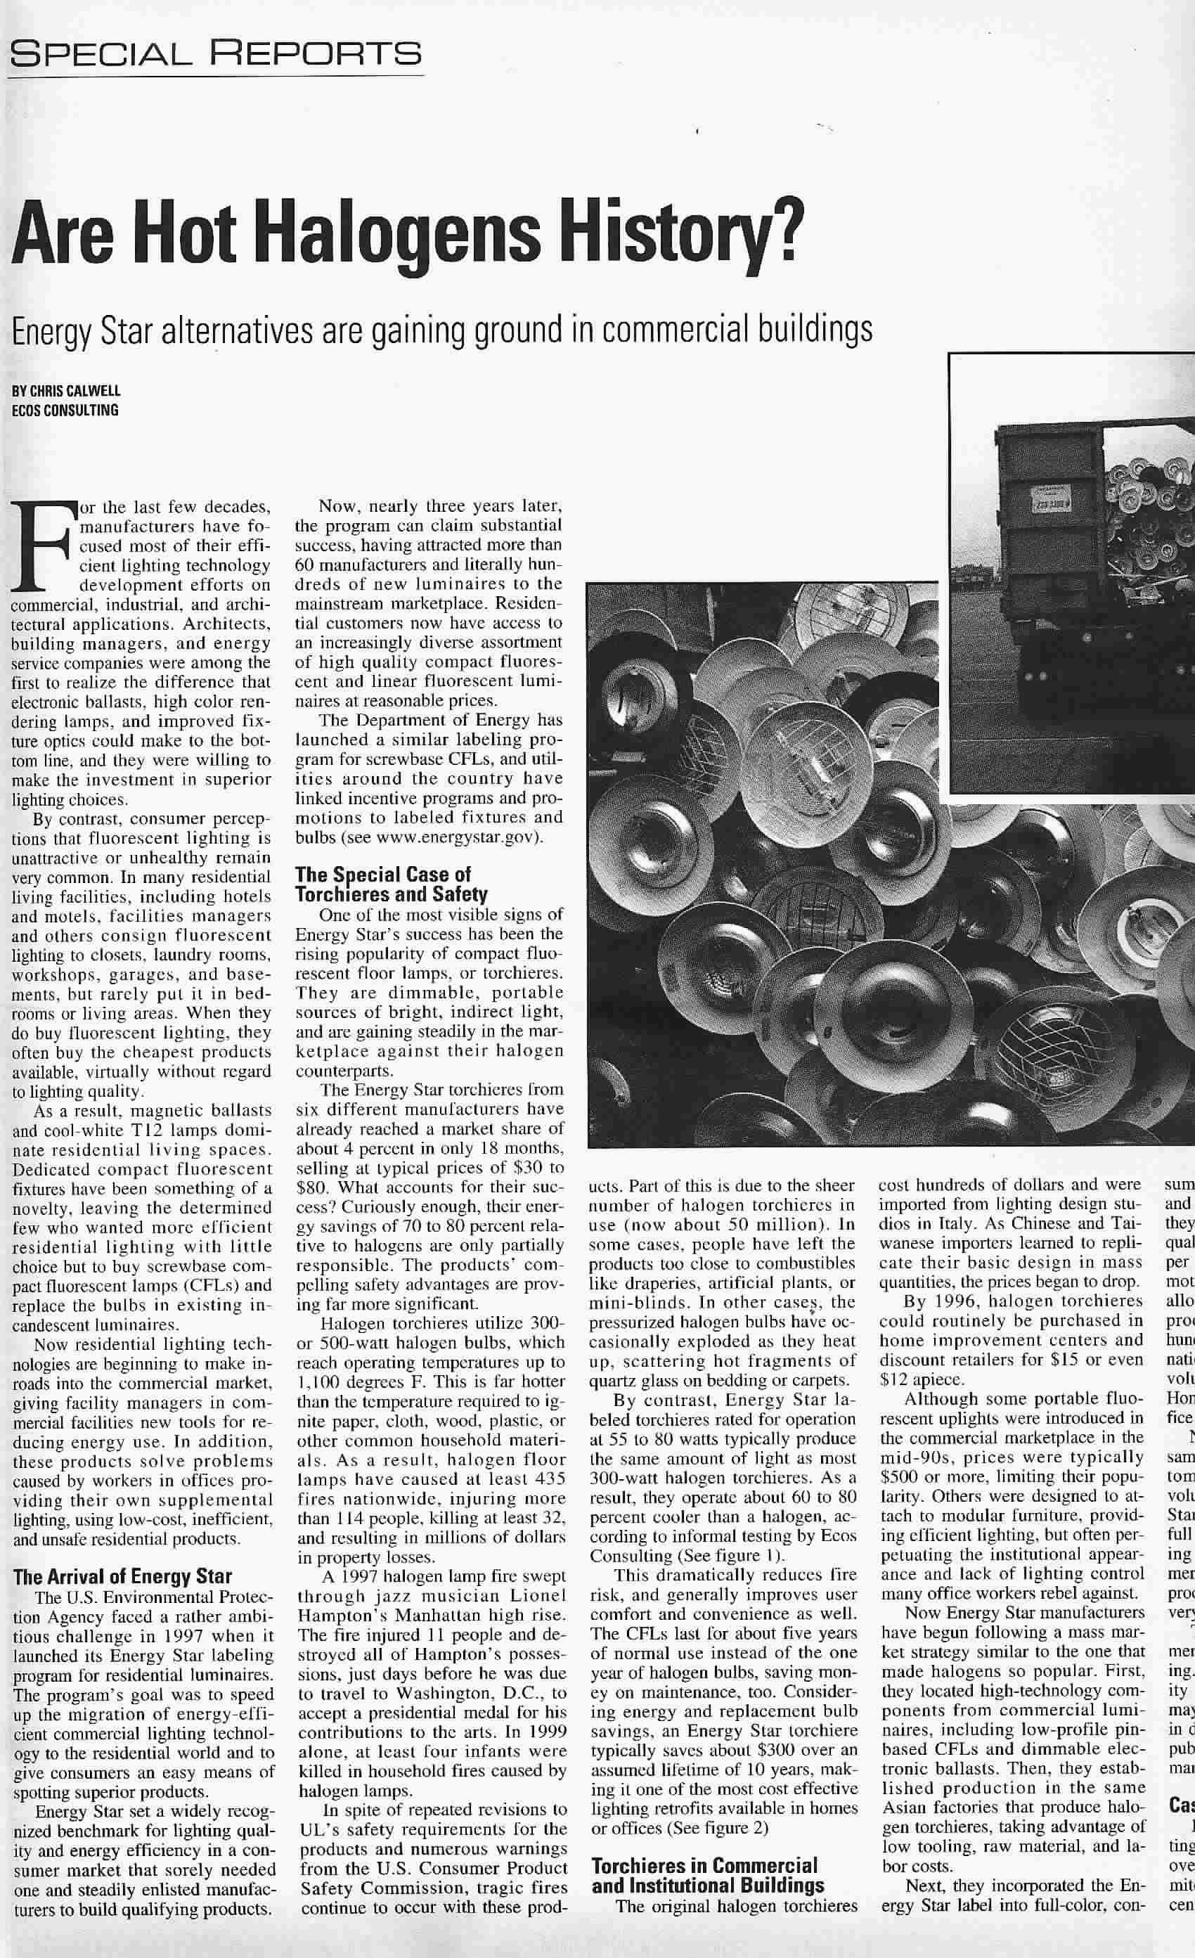
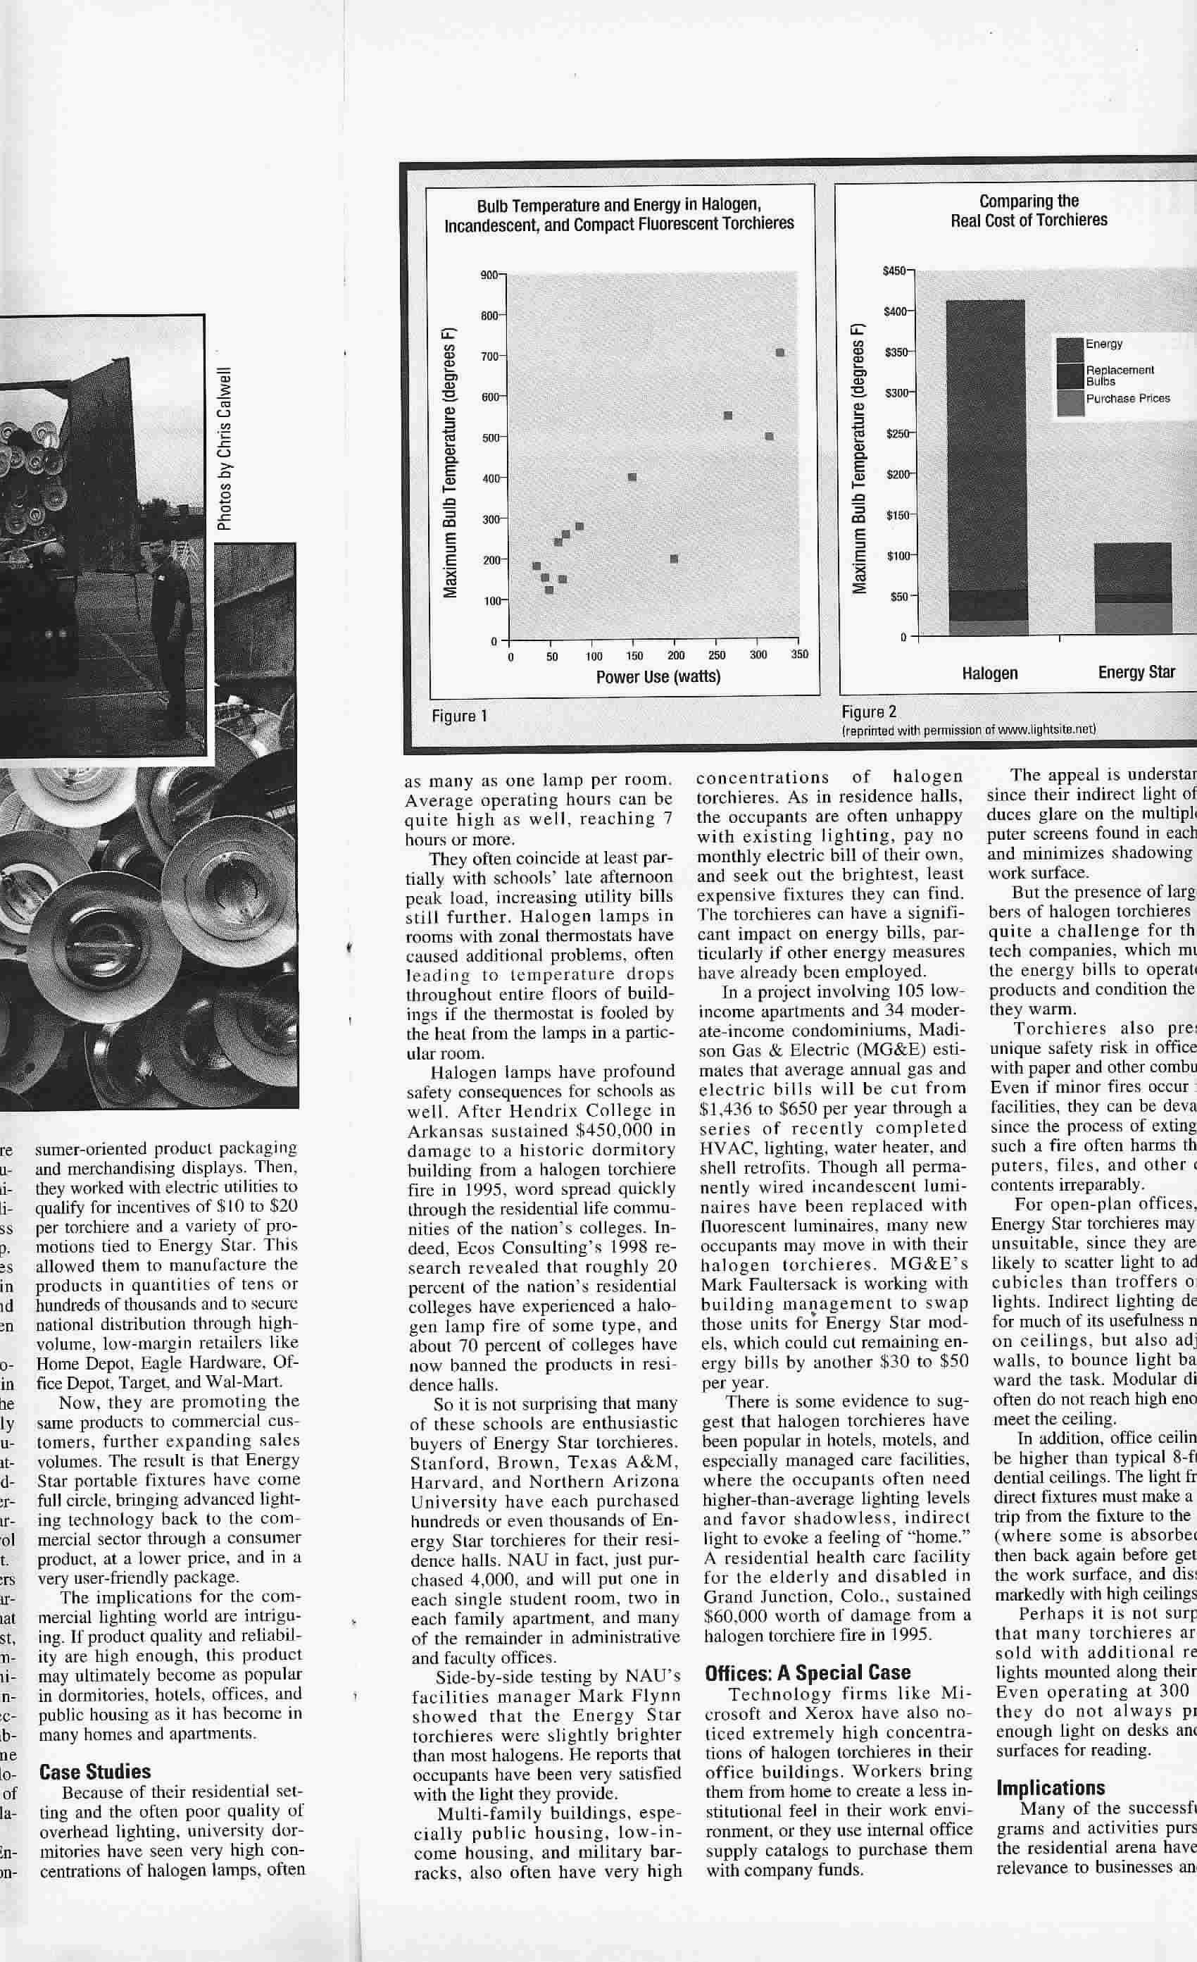
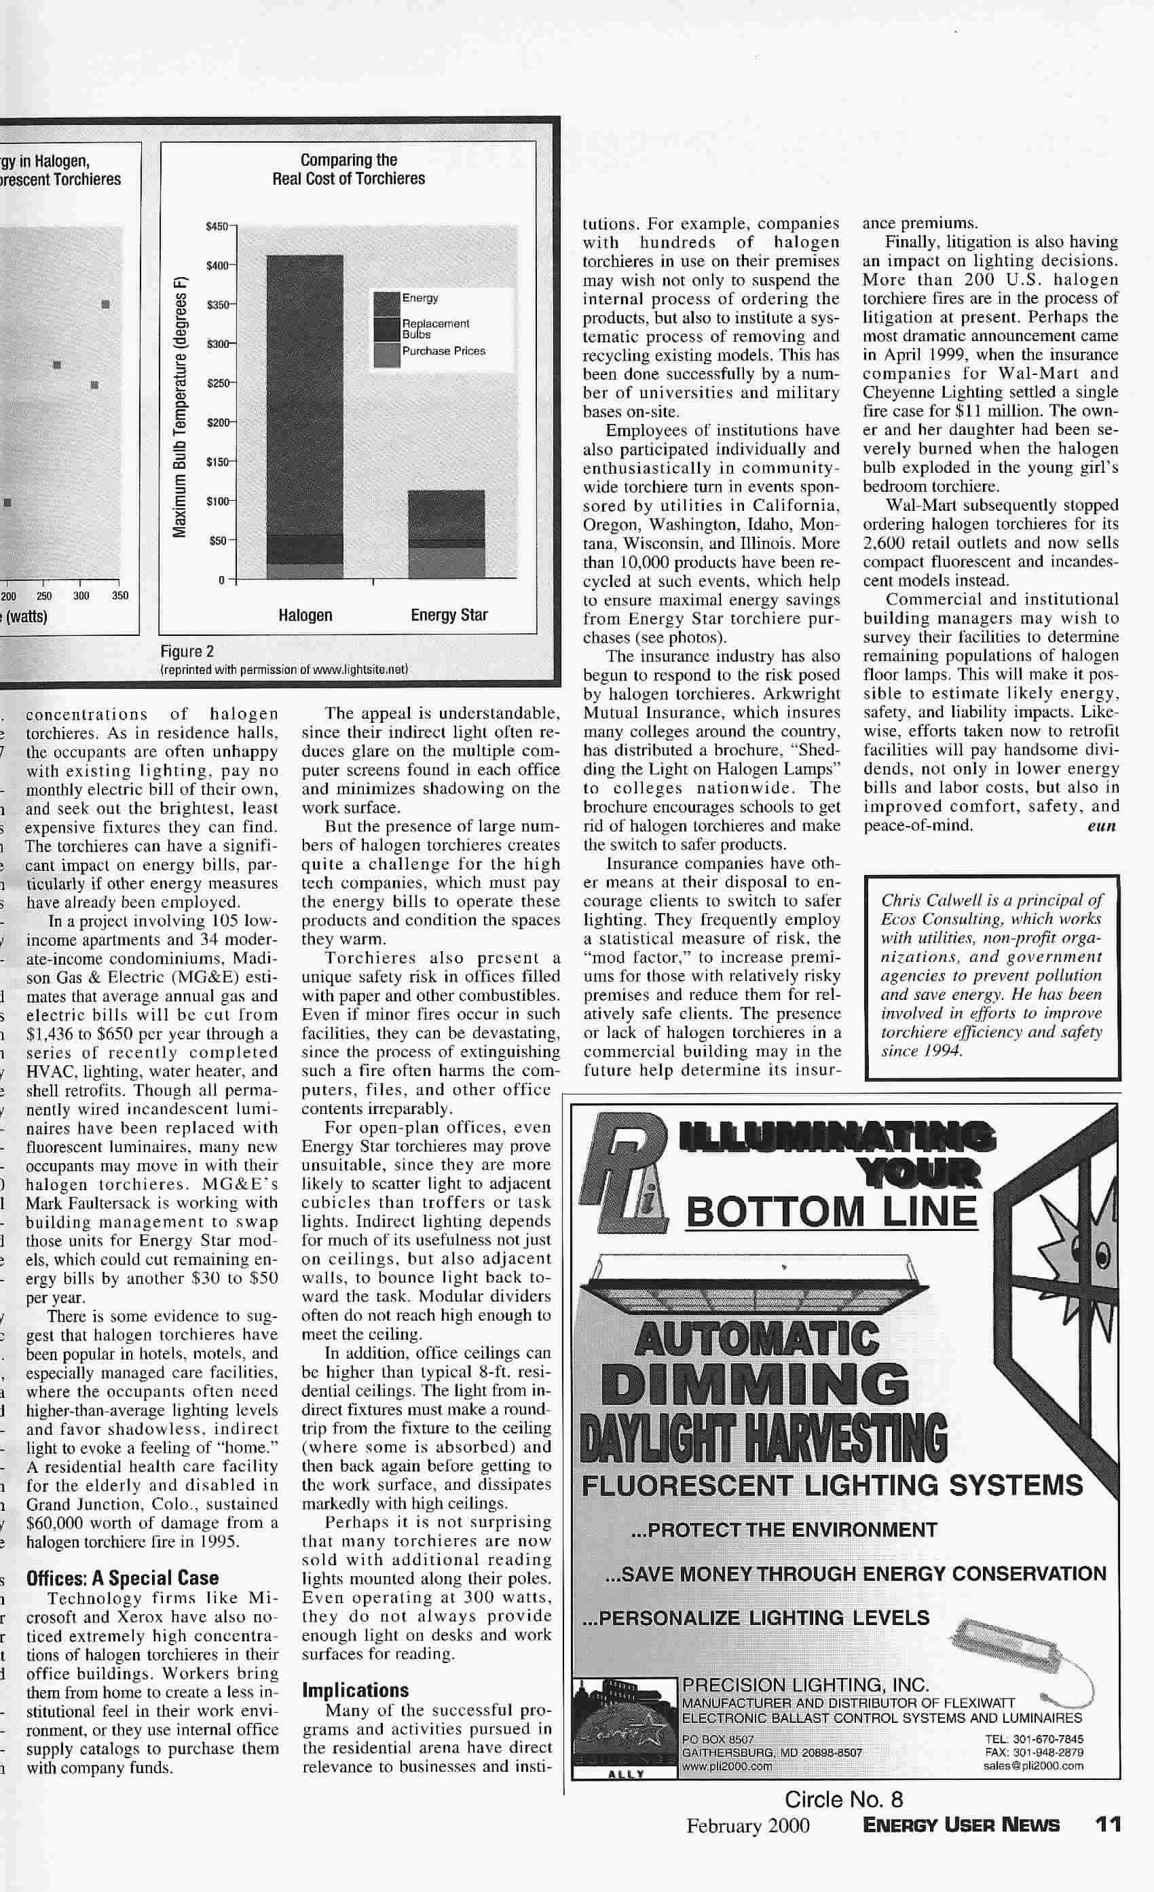

Appendix 2

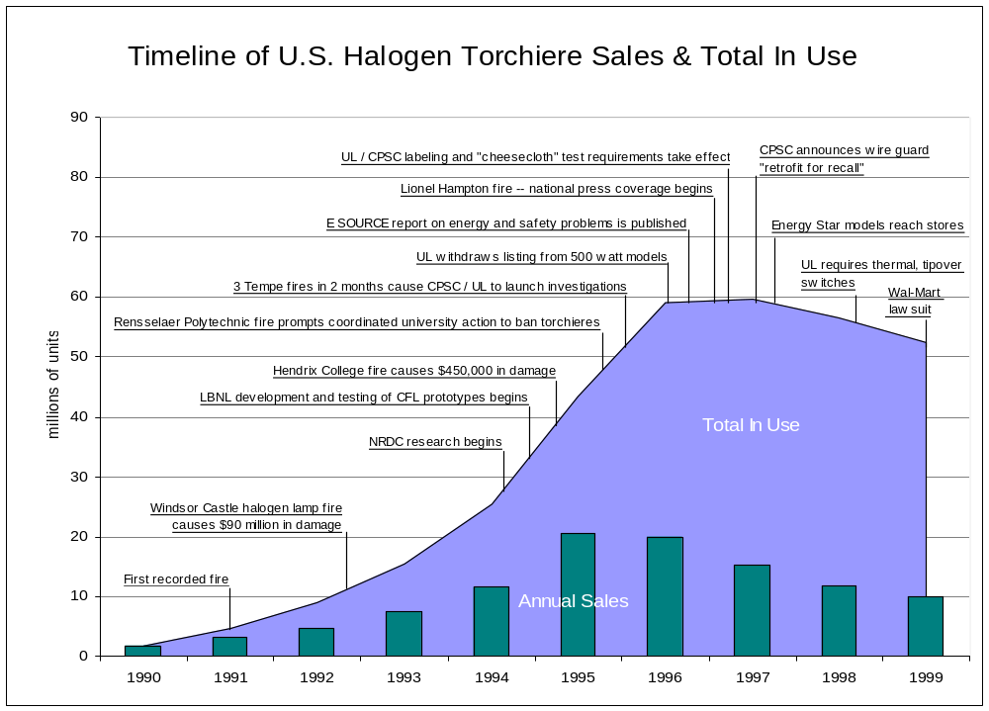

Appendix 3
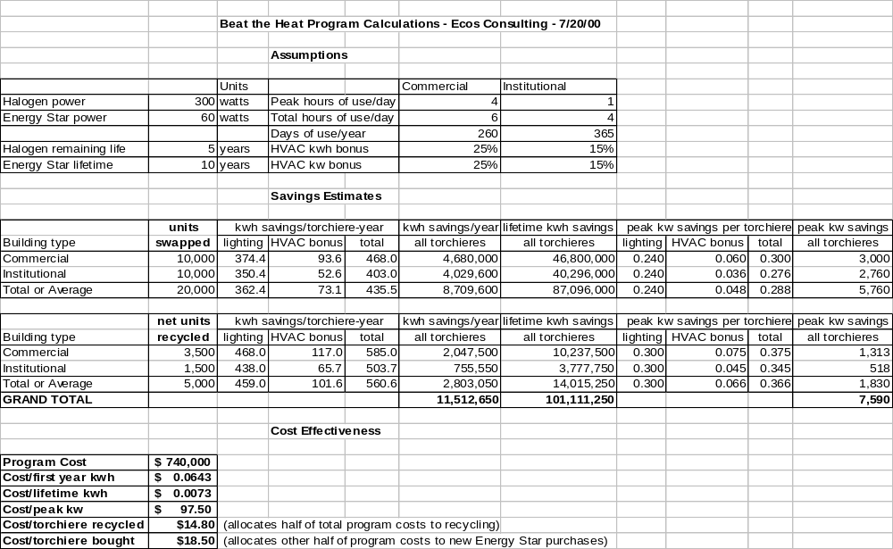

For more background on residential lighting programs to date, see Chris Calwell, Chris Granda, Lois Gordon, and My Ton, Lighting the Way to Energy Savings: How Can We Transform Residential Lighting Markets?, prepared by Ecos Consulting for the Natural Resources Defense Council, project manager: Noah Horowitz, December 1999.
Chris Calwell, Danielle Dowers, and Doug Johnson, How Far Have We Come? Remaining Opportunities for Upgrading Fluorescent Ballasts and Lamps, prepared by Ecos Consulting for E SOURCE, Strategic Memo SM-98-4, May 1998.
Note that Energy User News inadvertently repeated Figure 1’s caption in Figure 2. Figure 2’s caption should read, “Lifetime cost (15,000 hours of operation)”.
Chris Calwell, Compact Fluorescent Torchieres: A Case Study in Market Transformation, prepared by Ecos Consulting for Energy Efficiency in Household Appliances and Lighting conference, September 2000.
E SOURCE, “Effects on Other Building Systems,” in Lighting Technology Atlas, 1997, pp. 47-52.
RLW Analytics, California State Wide Lighting and Appliances Study, Draft, April 27, 2000.
In our experience with residential turn-ins, some halogen torchiere owners simply wish to get rid of their old products because of safety or cost concerns, and do not always replace them with an equivalent number of efficient models.

