Program Description
The Permanent Load Shifting (PLS) program provides a one-time incentive payment ($875/kW shifted) to customers who install qualifying PLS Thermal Energy Storage (TES) technology in place of typical central air conditioning units or process cooling equipment. Incentives are determined based on the designed load shift capability of the system and the project must undergo a feasibility study prepared by a licensed engineer. The load shift is typically accomplished through shifting of daytime chiller load to overnight hours. All electric customers on time-of-use electricity rates are eligible for the program, including: residential, commercial, industrial, agricultural, direct access, and Community Choice Aggregation customers.
Customers are required to shift load by running the TES system during peak-period hours on summer weekdays, which are defined as 12 to 6 PM from June 1 through September 30.

Key Assumptions
There are no current PLS program installations to produce ex post impact estimates for 2014 or to use for estimating ex ante impacts. Consequently, the ex ante impact estimates rely on information contained in the existing applications and feasibility studies, and assumptions from the PLS program management and EM&V staff.
Ex ante impacts were forecast for two different types of projects—identified (those for which customers have completed an application) and unidentified (applications that are expected to be submitted by the end of 2016). Load impacts for both types were developed using building simulation models. Impacts for identified projects were allocated to the applicant’s specific Local Capacity Area (LCA), and based on the expected installation date. The allocation of impacts for unidentified projects was estimated based on key assumptions, including:
- The number of unidentified installations under the base case scenario assumes that 65% of the 2015−2016 incentive budget will be spent; unidentified projects are assumed to come online through 2018;
- Expected size of unidentified projects is: 675 kW;
- It is assumed that 10% of projects reaching the application stage will drop out of the program prior to project installation;
- PLS load impacts are projected to degrade by 2.5% per annum after five years in service due to expected losses in system efficiency; and
- Unidentified projects are distributed by LCA in proportion to the distribution of the large C&I population across LCAs.

Enrollment
Table 1 provides the annual PLS program enrollment forecast by LCA for the base scenario. SCE expects two identified projects and no unidentified projects to come online in 2016. The remaining three identified projects and two additional unidentified projects are forecast to become operational in 2017. Enrollment is expected to remain constant at 11.5 projects from 2018 through the end of the forecast horizon in 2025. Funding for additional projects after 2016 is expected; utility program staff will update the enrollment forecast after the new budgets are formally approved.

Table 1: PLS Program Enrollment Forecast by LCA –
Base Scenario
LCA | 2015 | 2016 | 2017 | 2018-2025
LA Basin | 0 | 2 | 6.5 | 10
Outside LA Basin | 0 | 0 | 0.1 | 0.5
Ventura | 0 | 0 | 0.3 | 1
Total | 0 | 2 | 6.9 | 11.5

Projected Load Reduction Capability
(Ex Ante Load Impacts)
Figure 1 illustrates how the August 1-in-10 load impact estimates vary by forecast year and scenario. Figure 2 shows the same results for August 1-in-2 weather conditions. Across the forecast years and scenarios, the impacts are slightly higher under August 1-in-10 weather conditions but the difference is less than 0.6 MW. The three scenarios correspond to different forecasts of the percent of the total PLS program incentive budget that will be committed by the end of 2016, with 40% assumed under the low scenario, 65% under the base scenario, and 90% under the high scenario. The different percentages of the total PLS program incentive budget being committed translate into different enrollment forecasts across the three scenarios.
When the aggregate impact peaks in 2018 (before the 2.5% annual degradation begins), the PLS program is forecasted to deliver 6.1 MW in the low scenario and nearly 9.4 MW in the high scenario. At 7.8 MW, the aggregate impact for the base scenario is in the middle.
Figure 1: August 1-in-10 Monthly System Peak Day Load Impacts (1 to 6 PM)
by Forecast Year and Scenario
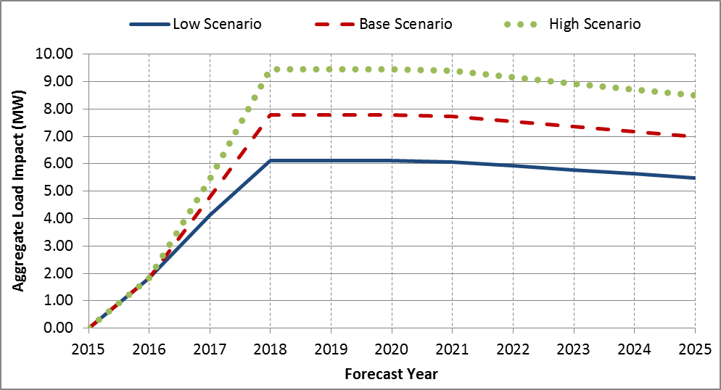
Figure 2: August 1-in-2 Monthly System Peak Day Load Impacts (1 to 6 PM)
by Forecast Year and Scenario
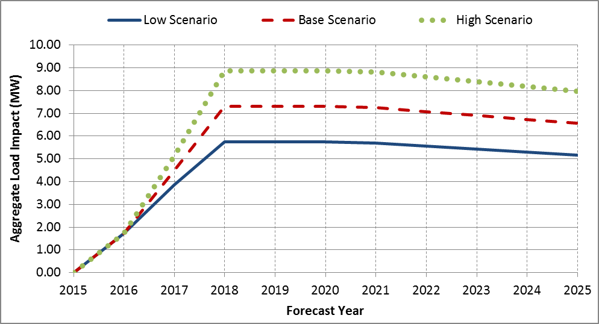
Tables 2 and 3 show the forecasted load impacts under August 1-in-10 and 1-in-2 year weather conditions from 2015 through 2025 for the SCE-specific and CAISO-specific weather conditions. The SCE-specific impacts tend to be slightly larger than the CAISO-specific impacts. This trend appears through the entire time horizon of the forecast. An August 1-in-10 impact of 7.8 MW for the utility specific, and 7.7 MW for the CAISO specific peak was observed. The difference of approximately 1.5% is what should be expected for future unidentified projects.
Table 2: August 1-in-10 Monthly System Peak Day Load Impacts (1 to 6 PM) by Forecast Year (MW) –
Base Scenario
Year | SCE-Specific  Peak | CAISO-Specific  Peak
2015 | 0.00 | 0.00
2016 | *** | ***
2017 | 4.79 | 4.72
2018 | 7.78 | 7.67
2019 | 7.78 | 7.67
2020 | 7.78 | 7.67
2021 | 7.73 | 7.63
2022 | 7.54 | 7.44
2023 | 7.35 | 7.25
2024 | 7.17 | 7.07
2025 | 6.99 | 6.89
Table 3: August 1-in-2 Monthly System Peak Day Load Impacts (1–6 PM) by Forecast Year (MW) – Base Scenario
Year | SCE-Specific  Peak | CAISO-Specific  Peak
2015 | 0.00 | 0.00
2016 | *** | ***
2017 | 4.51 | 4.41
2018 | 7.30 | 7.16
2019 | 7.30 | 7.16
2020 | 7.30 | 7.16
2021 | 7.26 | 7.12
2022 | 7.08 | 6.94
2023 | 6.90 | 6.77
2024 | 6.73 | 6.60
2025 | 6.56 | 6.43

*** Redacted to protect confidential customer information

Fractions of installations are not possible in reality. However, the projected enrollment numbers properly reflect the uncertainty of the forecast. In this case, the realistic expectation is that every LCA has a chance of ultimately having a PLS program installation. However, because several of the LCAs are so small in terms of the number of IOU customers that are located there, the expected number of installations is less than one in those LCAs.

