Program and Rate Description
Critical Peak Pricing (CPP) is the default rate for all large SDG&E non-residential customers with at least 12 months of hourly interval data. The first wave of small and medium business customers was defaulted in early 2016, but small and medium customers were also able to enroll on an opt-in basis at any time. Customers who become eligible for the tariff must opt out within 45 days or they must remain on the rate for at least 12 months. In addition, customers can elect to insure all, part, or none of their electricity use against higher peak period prices on PDP event days with Capacity Reservation.
CPP customers experience a higher peak price from 11 AM to 6 PM on up to 18 event days per year. In exchange, they are provided energy rate reductions during non-event days and reduced demand charges. The higher charges reflect the cost of building additional peaking power plants to meet high demand levels. By limiting demand during CPP event periods, participants can reduce their electric bill and help reduce the need to build additional peaking power plants.
2014 Peak Electricity Use Reductions from CPP
On average, 1,142 service accounts enrolled on a default basis remained on CPP in 2014. These customers experienced 6 official CPP events in 2014. The load impacts and weather conditions for each individual event day are summarized in Table 1. CPP participants typically accounted for 291 MW of load during event day afternoons in 2014. When PDP events were called, on average, they reduced demand by 8.8% across the 11 AM to 6 PM event window, delivering 25.4 MW of demand reduction. The load impacts were estimated using a combination of difference-in-differences, a method that uses data from a control group and hot non-event days and individual customer regressions. Demand reduction estimates varied from 7.1% (14.6 MW) to 11.7% (33.7 MW) for individual event days. Despite the differences, the average event day load impact is typically within the coverage of the 90% confidence interval of the individual event load impacts. Figure 1 shows the percent demand reduction and 90% confidence bands for each event and the average event. The wide confidence bands reflect the challenge of detecting relatively small percentage changes in demand and distinguishing them from typical load variation.
Figure 1: 2014 Estimated Percent Demand Reductions with Confidence Intervals
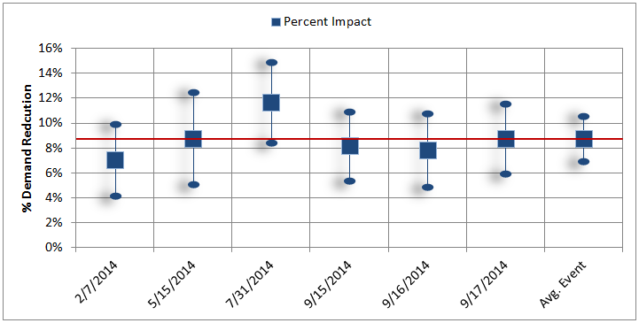

Table 1: Default Peak Day Pricing Average Impacts for Event Period by Event Day
Event Date | Day of Week | Accounts | Avg. Customer Reference Load | Avg. Customer Load w/ DR | Impact | Aggregate Impact | % Reduction | Avg. Temp.
 |  |  | (kW) | (kW) | (kW) | (MW) | % | °F
2/7/2014 | Fri | 1,141 | 181.8 | 169 | 12.8 | 14.6 | 7.10% | 60.4
5/15/2014 | Thu | 1,142 | 242.8 | 221.5 | 21.3 | 24.3 | 8.80% | 93.8
7/31/2014 | Thu | 1,143 | 252.6 | 223.1 | 29.5 | 33.7 | 11.70% | 79.9
9/15/2014 | Mon | 1,143 | 282.1 | 259 | 23 | 26.3 | 8.20% | 87.2
9/16/2014 | Tue | 1,142 | 285.8 | 263.5 | 22.4 | 25.5 | 7.80% | 91.3
9/17/2014 | Wed | 1,141 | 281.4 | 256.8 | 24.6 | 28.1 | 8.70% | 83.7
Avg. Event |  | 1,142 | 254.4 | 232.2 | 22.3 | 25.4 | 8.80% | 82.7

Other Key Findings in 2014
- SDG&E called more events in 2014 than in 2013. Six events were called in 2014 versus four in 2013. One of the events in 2014 was called in February.
- The differences between individual event day results and average event day results are not statistically significant. As with other utility results, day-to-day performance can vary, but most of the variation is explained by statistical uncertainty.
- Demand reductions are concentrated in specific industry segments – Wholesale, Transport & Other Utilities and Institutional/Government. For SDG&E, these customers make up 25% of program enrollment and 19.8% of program reference load, but account for 55.7% of the estimated demand reductions. On a percentage basis, the highest-performing industry was agriculture, mining and construction, with average load reductions of 34.6%; however, there is still a large amount of uncertainty in the estimate as the sector is comprised of only 15 customers. These customers accounted for just 1% of both program enrollment and reference load.
Figure 2: Distribution of Program Accounts, Load and Demand Reductions Across Industries
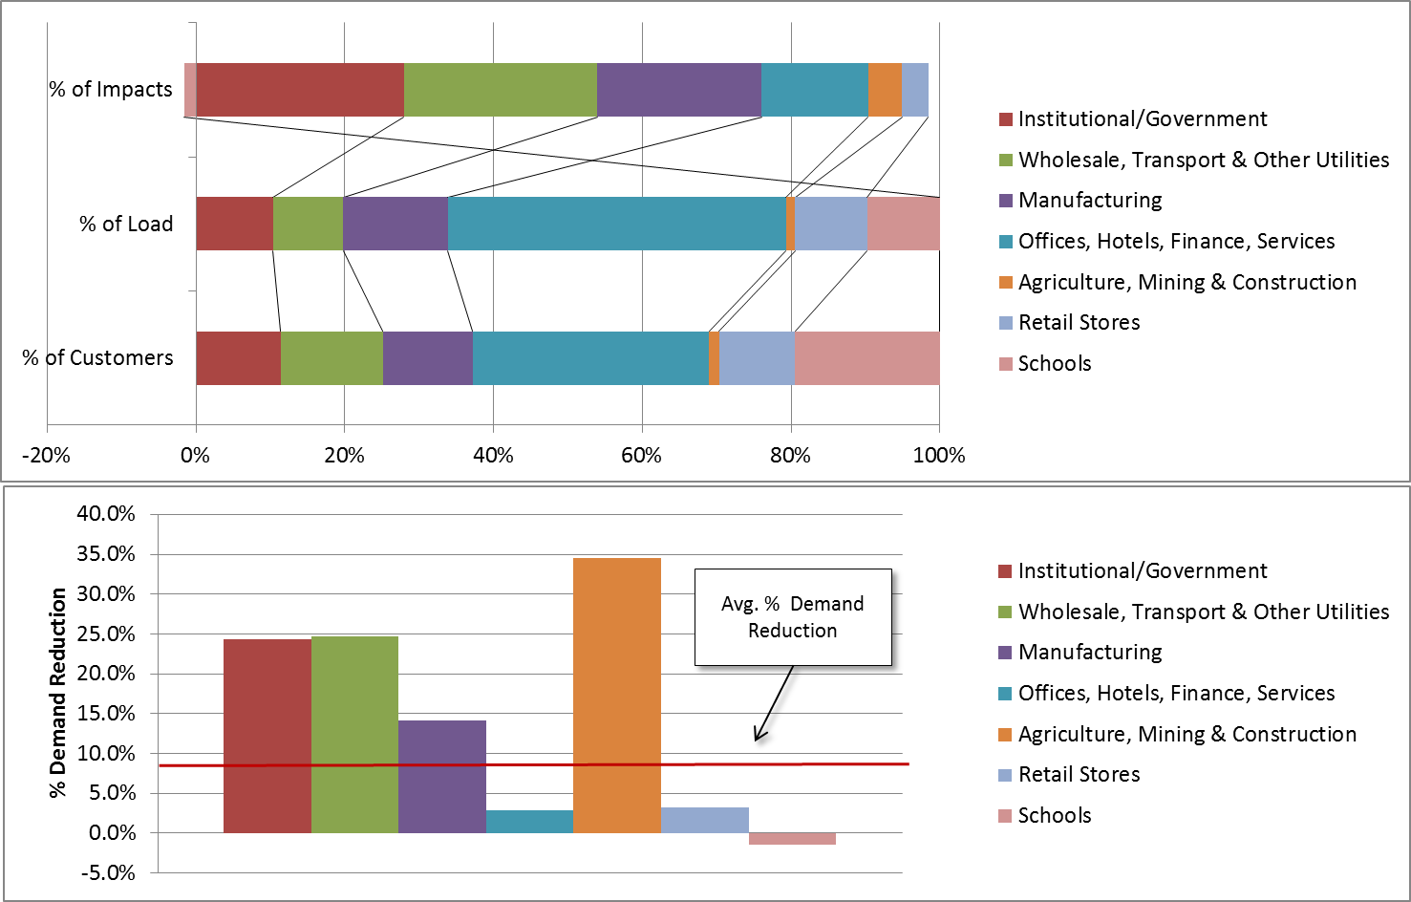
Projected Load Reduction Capability
(Ex Ante Load Impacts)
Ex ante load impacts describe the demand reduction capability of a demand response resource under a standard set of 1-in-2 and 1-in-10 weather year conditions, assuming all resources are dispatched. Ex ante load impacts for large customers are expected to grow from 25.2 MW in 2015 to 27.9 MW in 2025 under 1-in-2 year SDG&E weather due to growth in the number of large customers. Ex ante load impacts for large customers are based on percent load reductions from historical 2013 and 2014 CPP events and assume that future percent load reductions will be similar to those experienced historically.
Medium non-residential customers will be defaulted onto CPP in March 2016. Table 2 summarizes the forecasted enrollment and demand reductions for 1-in-2 and 1-in-10 peaking conditions for large as well as medium accounts for both CAISO and SDG&E specific weather scenarios. Ex ante load impacts for medium customers are expected to grow from 8.4 MW in 2016 to 10.4 MW in 2025 under 1-in-2 year SDG&E weather. Default CPP ex ante load impacts for medium non-residential customers are highly uncertain. There is very limited empirical data about how many medium customers will remain on CPP or about the magnitude of demand reductions they will deliver. For medium customers, modest percent reductions are assumed, as no empirical evidence is available on defaulted SMB impacts.
Table 2: Ex Ante Impacts and Enrollments for 1-in-2 and 1-in-10 Year
August Monthly Peak
Weather Scenario | Weather Year | Year | Enrolled Accts. | Agg. Load Impact | Enrolled Accts. | Agg. Load Impact
 |  |  |  | (MW 11 AM-6 PM) |  | (MW 11 AM-6 PM)
 |  |  | Large |  | Medium
SDG&E | 1-in-10 | 2015 | 1,253 | 27.4 | 0 | -
 |  | 2016 | 1,267 | 27.6 | 8,914 | 9.0
 |  | 2017 | 1,283 | 28.0 | 8,050 | 9.2
 |  | 2018 | 1,297 | 28.2 | 7,704 | 10.0
 |  | 2025 | 1,405 | 30.4 | 8,577 | 11.1
 | 1-in-2 | 2015 | 1,253 | 25.2 | 0 | -
 |  | 2016 | 1,267 | 25.4 | 8,914 | 8.4
 |  | 2017 | 1,283 | 25.7 | 8,050 | 8.7
 |  | 2018 | 1,297 | 26.0 | 7,704 | 9.4
 |  | 2025 | 1,405 | 27.9 | 8,577 | 10.4
CAISO | 1-in-10 | 2015 | 1,253 | 26.1 | 0 | -
 |  | 2016 | 1,267 | 26.4 | 8,914 | 8.7
 |  | 2017 | 1,283 | 26.7 | 8,050 | 9.0
 |  | 2018 | 1,297 | 26.9 | 7,704 | 9.7
 |  | 2025 | 1,405 | 29.0 | 8,577 | 10.8
 | 1-in-2 | 2015 | 1,253 | 25.8 | 0 | -
 |  | 2016 | 1,267 | 26.0 | 8,914 | 8.6
 |  | 2017 | 1,283 | 26.3 | 8,050 | 8.9
 |  | 2018 | 1,297 | 26.6 | 7,704 | 9.6
 |  | 2025 | 1,405 | 28.6 | 8,577 | 10.7

