2012 – 2014 Statewide Permanent Load Shifting Program Proposal

Comments by Klaus Schiess PE, CEM
KSEngineers
La Jolla and Mill Valley
www.ksengineers.com

Cell # (858) 472-3331

Learn from the Past

Programs in the late 80ties and early nineties

When TES was first introduced as a permanent load shifting opportunity the utilities under the guidance of the CPUC developed incentive programs that definitely had success in getting TES systems implemented. From my personal perspective I predicted at the time that by about the year 2000 there would be hardly any chilled water system built without TES included as a permanent policy. I could not have been more wrong TES has become the most neglected demand shifting technology while in my opinion it is still the best battery money can buy.

During the heydays of TES the following actions and incentives were taken by the utilities to promote TES:

- The rate structures mainly TOU types offered considerable savings potential by reducing the on-peak demand charge that approached $25/KW. In addition the cost per KWH differential between on-peak and off-peak hours reached 8 to 10 cents.
- The incentives ranged in the region of $300/KW shifted. Remember that’s about $600 in today’s Dollars.
- Feasibility studies were funded initially to the tune of up to $10,000 by the utilities, that later changed to sharing 75% then down to 50% with the client. Note that the PLS proposal implies that a feasibility study could cost $40,000.
- Utilities presented workshops to owners, consultants and contractors to educate the intricacies of TES design.
- The utilities had TES program managers that did the actual footwork of finding potential customers and offering the financial assistance for feasibility studies.
- EPRI produced a special computer program to assist utilities and whoever was interested that specifically allowed utilities to develop incentive programs. It was sold to the public at the time for $800. The program manager for PG&E for instance made it a condition that COOLAID was used for feasibility studies. COOLAID is a DOS program and over the last few years KSEngineers have repeatedly tried to get the Energy Commission and EPRI interested in upgrading it to windows. So far there were no takers as TES was not prominent enough and the market too small. I have a special old computer because today’s computers are too fast and black out.

Those were the good things that had TES projects implemented all over California.

Certain developments however worked against the success of the whole industry.
As TES was basically an old yet new technology many designers did not spend enough time to ensure that the design was technically sound. Certain aspects were underestimated which lead me to publish a paper in 1993 with the title “TES the Natural Way”and also made presentations at conferences. (Refer to www.ksengineers.com/ and click on publications and then TES Natural Way, or directly:
http://ksengineers.files.wordpress.com/2012/09/tesnaturalway4.pdf

The basic reasons for design errors are subtly described because some laws of nature were simply neglected.

- Manufacturers defects resulted that many projects did not perform as expected with some serious lawsuits developing. The utilities were drawn into these lawsuits as they represented deep pockets potential. There was one particular encapsulated ice manufacturer which managed to market initially very successfully a system that had basic design flaw that contributed to the largest law suits that shook the TES industry.
- The utilities started to change the rate structures in such a way that reduced the savings potential for both the demand shift and the energy differential that contributed to the savings.
- A new demand charge NTR (non time related) started to shift the emphasis onto the peak of the month value irrespective of when it happens. Over the years, the NTR rates increased while the on-peak demand charges decreased. For the few TES owners who kept up with checking their utility bills, it became a disappointment that their investment was basically sabotaged with the rate changes.
- Lately, this trend has increased by the introduction of another demand charge under the title of capacity reservation charge, which is then even linked to a ratchet clause. Or critical peak period programs were developed to encourage demand response to shift power only when the grid was in trouble.
- Existing systems suffered from mission creep such as the described rate creep, then operator creep and control creep.

Therefore, to make this PLS TES program a success it must pick the good items from the past programs and try to prevent to repeat the mistakes or barriers that stifled the progress TES should have had over the last two decades.

- The cost for feasibility studies should not be paid out of the incentive. This puts the cart before the horse. It introduces the fact that the feasibility study is dependant on the successful implementation of the project to get paid. Refer to the full explanation in Appendix A: Feasibility study issues.

- Rate changes: If the program expects five years of guaranteed operation then the investors must have a similar guarantee that the savings potential will not be reduced during the five year period. In the past TES investors were disappointed when rate changes reduced their savings potential.

In order to explain the intricacies of the rate changes on TES systems please refer to Appendix B where charts are developed for this particular TES application as given in the proposal. It shows the charts only but KSE would like to make a presentation at the

workshop to explain how the non-time related charge affects the control sequences of TES systems. To get the most savings (not shift) some load leveling methodology must be applied. The example of 60 tons for the constant delivery of the chillers is one of the most difficult control sequence to achieve. To shift load only during the on peak period was relatively easy, but today’s rate schedules require complex control sequences to optimize savings.

- Why exclude abandoned TES system that could be rejuvenated. These actually represent the lowest hanging fruit to get the ball rolling in shifting power. If these systems have been out of commission for three years, why not accept them as projects. The fact that the program only allows for a maximum of 50% of the expenses, these projects are fair game.

- The program planners should be aware of the influence the various demand charges have on the operational sequences as well as on the payback.

The table below summarizes the results of various calculations to high light the effect of the chiller only electrical load profile and then combined with the building electrical load profile. A typical recent rate was chosen for the proposal example for each utility for the four different cases applicable shown as “May” representing the optimized control sequence with the realistic morning cool down, for “June” representing the total electrical load profile with realistic morning cooling loads that can create the peak for the day outside the on-peak period, “July” the same as June but the chiller electrical load alone without the building load and “August” the chiller electrical load profile just for the on-peak period representing the example of the proposal.

Note the variance of savings and the payback periods for the same example for the different cases and different rate schedules for the three utilities. The most significant is the differences and shows thus the decay of savings potential for the SDG&E rate of 1999 as compared with 2011.

Again, this needs to be explained and presented at the workshop on the 18th in order for the program creators to be made aware that the example is too simplified and that there are other factors that influence TES savings and thus feasibility.

- Why the large variance in incentives for the three IOUs? Compared to the past these amounts are too small. Inflation is reducing the incentive amount drastically when we compare them with what was offered 25 years ago.

- The building load simulation calculations required are tedious, cost a large amount of time and are even unnecessary. Why calculate a year’s worth of cooling load profiles if we only need the peak on the design day?

- The industry needs a program like COOLAID specifically geared for TES application, relatively simple but effective enough for feasibility studies and developing control sequences. KSEngineers has repeatedly tried to get the Energy Commission and EPRI interested in upgrading COOLAID to Windows but KSE was always told there is not enough interest in TES to warrant spending funds for this. The time has come if this program is to produce results.

- The program must provide for the education of customers, consultants and designers. In the past too many inexperienced designs have spoilt the image of TES systems.

- As in the past, the utilities have utilized a special dedicated TES program manager to actually approach customers in their territory to locate potential TES projects. They would sign up customers for a feasibility study. If the study showed a potential project this program manager would assist the customer in trying to get the project to implementation stage.

- This is how KSEngineers assisted with feasibility studies that eventually became design projects either with KSE’s assistance or other consultants of which many systems are still in operation today.

- The M&V requirements should be excluded from the incentive program. All the program needs is to verify that the chillers are not in operation during the on-peak period or do not exceed the agreed on load for partial storage systems. If the utilities and the CPUC want to analyze the effect and results of the program then the customer should be compensated separately for any of those costs.

Refer to APPENDIX C for direct comments to actual text from the proposal high lighted in yellow. The comments by KSEngineers are high lighted in green immediately after the original text.

RATE: SCETOU8P SUMMER

DEMAND: ON-PEAK $17.95 PART. PEAK $2.70 NON-COINCIDENT $6.60
ENERGY: ON-PEAK $0.09422, PART PEAK $0.05847 OFF PEAK $0.03874

MONTH | CON KW | TES KW | SHIFT KW | SUMMER  SAVINGS | PAYBACK  W/O INCT | PAYBACK  WITH INC | PAYBACK  MIN $20K
“MAY” | 268 | 162 | 106 | $12,056 | 9.95 | 4.02 | 4.98
“JUNE” | 268 | 149 | 119 | $10,880 | 11.03 | 3.65 | 5.51
“JULY” | 168 | 49 | 119 | $10,492 | 11.44 | 3.78 | 5.72
“AUG” | 168 | 49 | 119 | $10,438 | 11.60 | 3.83 | 5.80

RATE: PG&E19P11 SUMMER

DEMAND: ON-PEAK $10.93 PART. PEAK $2.53 NON-COINCIDENT $7.78
ENERGY: ON-PEAK $0.14350, PART PEAK $0.09810 OFF PEAK $0.08108

MONTH | CON KW | TES KW | SHIFT KW | SUMMER  SAVINGS | PAYBACK  W/O INCT | PAYBACK  WITH INC | PAYBACK  MIN $20K
“MAY” | 268 | 162 | 106 | $13,356 | 8.98 | 6.13 | 7.63
“JUNE” | 268 | 149 | 119 | $11,394 | 10.53 | 6.77 | 8.53
“JULY” | 168 | 49 | 119 | $10,710 | 11.20 | 7.20 | 9.07
“AUG” | 168 | 49 | 119 | $10,776 | 11.14 | 7.16 | 9.02

RATE: SDG&E AL-TOU (1999) SUMMER

DEMAND: ON-PEAK $21.05 PART. PEAK N/A NON-COINCIDENT $4.48
ENERGY: ON-PEAK $0.10900, PART PEAK $0.07250 OFF PEAK $0.0581

MONTH | CON KW | TES KW | SHIFT KW | SUMMER  SAVINGS | PAYBACK  W/O INCT | PAYBACK  WITH INC | PAYBACK  MIN $20K
“MAY” | 268 | 162 | 106 | $14,935 | 8.03 | 4.39 | 5.73
“JUNE” | 268 | 149 | 119 | $15,405 | 7.79 | 3.83 | 5.13
“JULY” | 168 | 49 | 119 | $15.080 | 7.96 | 3.91 | 5.24
“AUG” | 168 | 49 | 119 | $14,840 | 8.09 | 3.97 | 5.32

RATE: SDG&E AL-TOU (2011) SUMMER

DEMAND: ON-PEAK $5.53 PART. PEAK N/A NON-COIN. + CRC. $11.11
ENERGY: ON-PEAK $0.11362, PART PEAK $0.09228 OFF PEAK $0.07022

MONTH | CON KW | TES KW | SHIFT KW | SUMMER  SAVINGS | PAYBACK  W/O INCT | PAYBACK  WITH INC | PAYBACK  MIN $20K
“MAY” | 268 | 162 | 106 | $12,280 | 9.77 | 5.34 | 6.97
“JUNE” | 269 | 149 | 119 | $6,825 | 17.58 | 8.64 | 11.57
“JULY” | 168 | 49 | 119 | $5,560 | 21.58 | 10.60 | 14.20
“AUG” | 168 | 49 | 119 | $5,390 | 22.26 | 10.94 | 14.65

APPENDIX A

FEASIBILITY STUDY ISSUES

Feasibility study to be paid by the incentive.

For TES to be considered for either a new project or for an existing system, an engineer with TES experience has to convince a potential client that it may be technically and economically feasible to invest in a TES project he/she has to be able to have enough information to convince the investor that it is a worth while proposition. This basically means that a 50% to 70% feasibility study has to be performed before enough information is available to decide to take the feasibility study to the final stage which includes basically the full economic analysis and a design concept that proves that it is technically feasible as well.

The initial information that has to be made available to determine if there is a feasibility to take it to a full feasibility study is as follows:

A. Technical feasibility:

Text in italics is text from the program proposal.

A site visit is necessary to inspect existing plant, equipment to determine which type of TES application is technically feasible to be added to the system. Is there space available and can the TES system easily be incorporated in the existing system, especially as it concerns pumping capacities.

This site visit will also yield some Evaluation of customer’s ability to maintain system.

This visit should also yield information on Customer Site Information
- Business description
- Utility electrical rate structure
- Listing of existing affected buildings

The peak cooling load profile has to be determined.
The total electrical load profile (preferable 15 minute interval readings) needs to be made available in order to determine the central plant.

Each central plant system has its own peculiarities in operation such as hotels or hospitals that are operated on a 24/7 basis, or office type applications or schools that may have only day time 5 days a week operation or industrial applications or universities campuses that could be a mix between the two.

Determination of the adaptability of the existing control system to the addition of TES controls.

B. Economic feasibility:

TOU rate benefit analysis which requires to Determine if the customer’s current electric rate schedule is most beneficial post installation.

The information listed above in A. and B. constitute the initial requirements for a feasibility study to actually determine if a fully fledged feasibility study is feasible and acceptable to the investor or owner.

This initial study can cost anything between $3,000 up to $8,000. After this the fully fledged study can cost another $6,000 to $12,000.

Is there anyone willing to spend this kind of time and money to determine if they have a potential project or not? If the funding for the initial and final feasibility studies is depending on the project actually going ahead introduces unacceptable barriers. The study can then easily be contaminated by the fact that it has to have a certain payback to get the incentive in order to get paid for the feasibility studies. The engineer should not have to be put into this controversial situation. Refer to Submitting a feasibility study does not guarantee a customer incentives under the PLS program.

Therefore, the program has to deal with the funding for feasibility studies independently of the program incentives. There is always the temptation for the engineer who does the feasibility study to see savings potential in a very rosy light in order to assure the design contract as well.

APPENDIX B

“AUGUST”

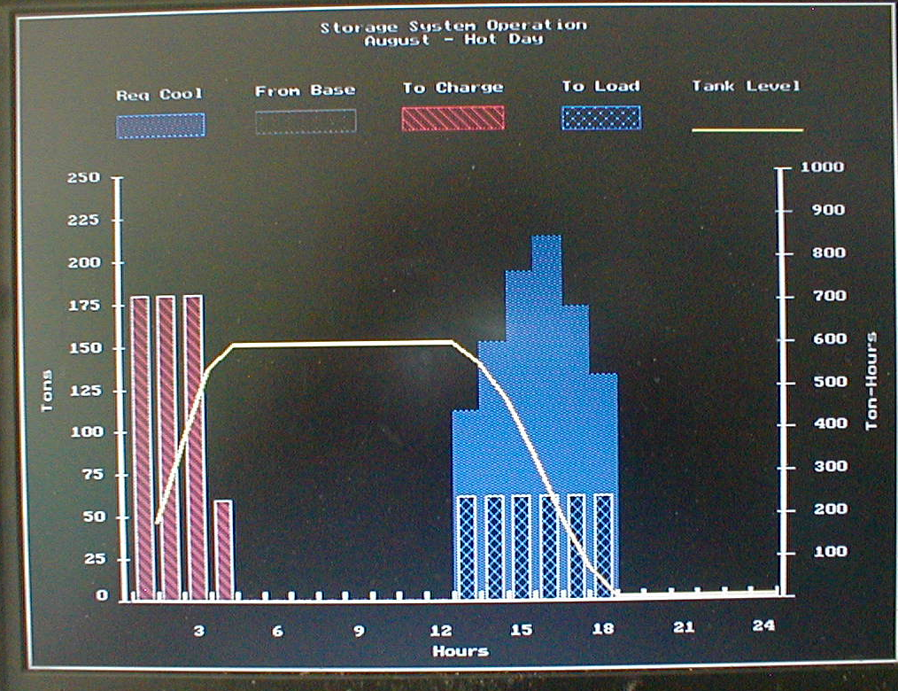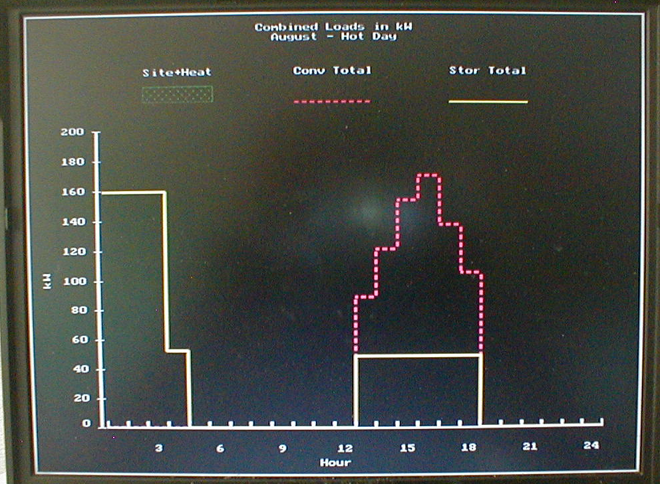

COOLING LOAD PROFILE ELECTRICAL LOAD PROFILE OF
OF EXAMPLE EXAMPLE WITHOUT ANY OTHER
ELECTRICAL LOAD

“JULY”

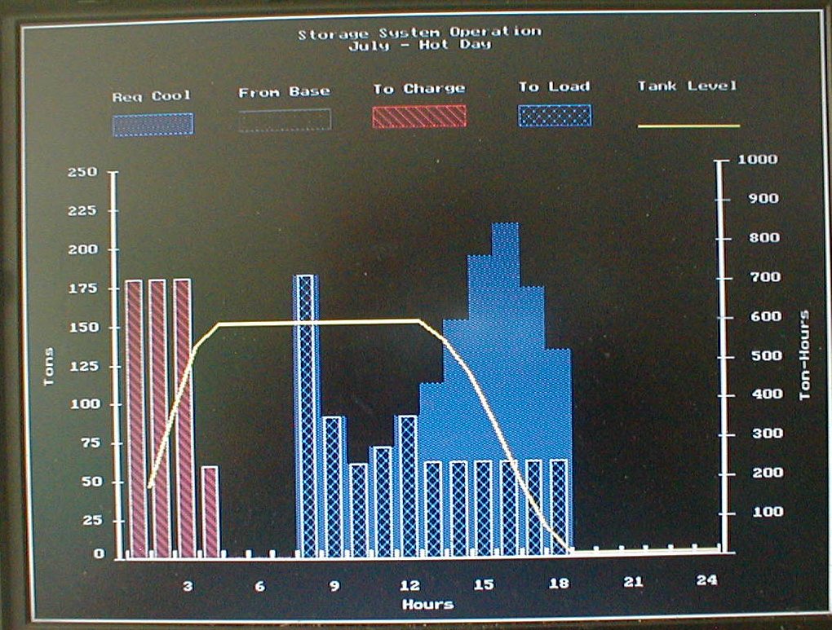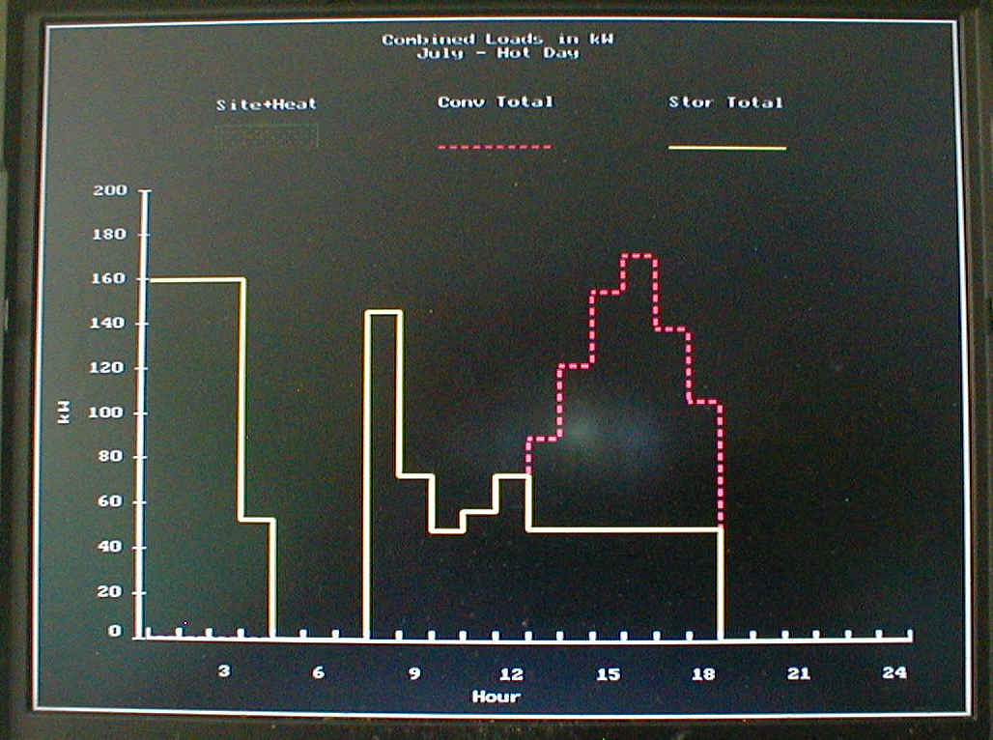

COOLING LOAD PROFILE WITH ELECTRICAL LOAD PROFILE WITH
REALISTIC MORNING LOAD REALISTIC MORNING LOAD ADDED
ADDED BUT WITHOUT ELECTRICAL BASE
LOAD

“JUNE”

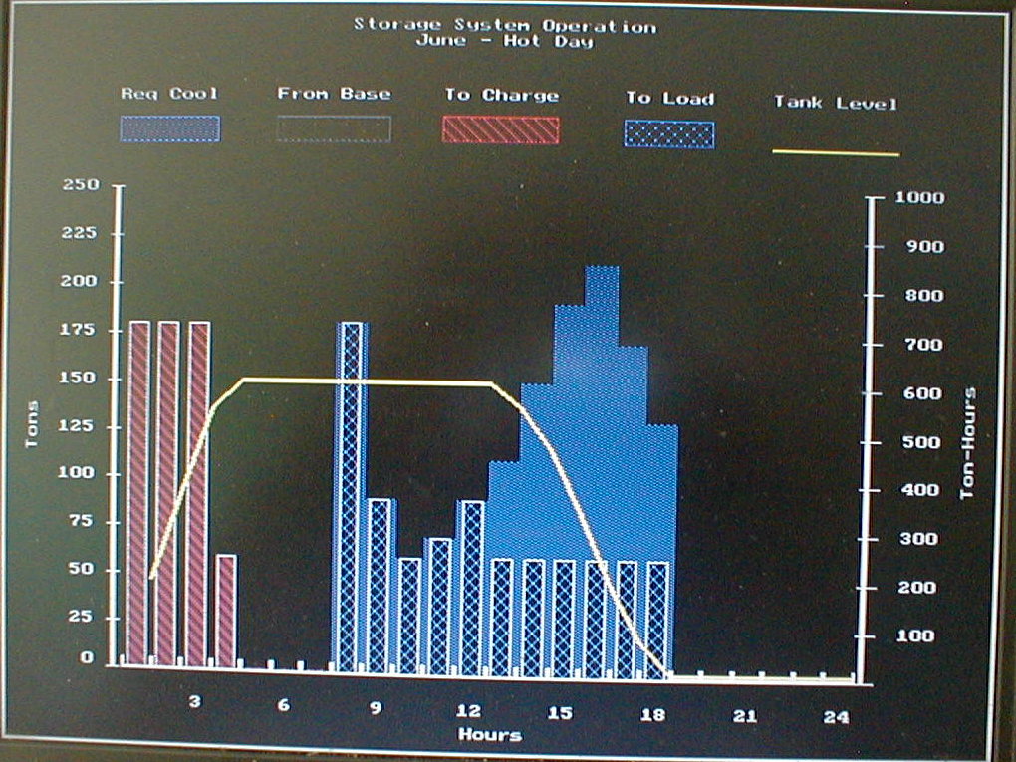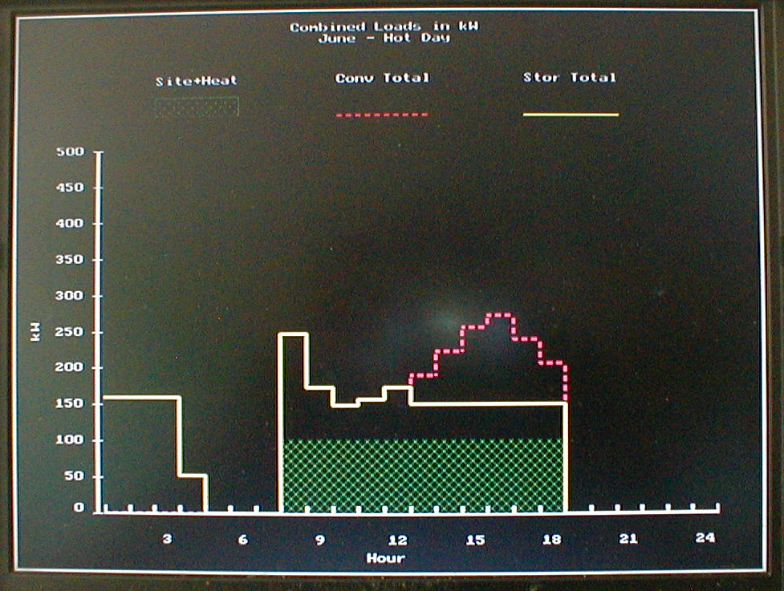

COOLING LOAD PROFILE WITH ELECTRICAL LOAD PROFILE WITH
REALISTIC MORNING LOAD REALISTIC MORNING LOAD ADDED
ADDED WITH ELECTRICAL BASE LOAD
LOAD

“MAY” OPTIMIZED

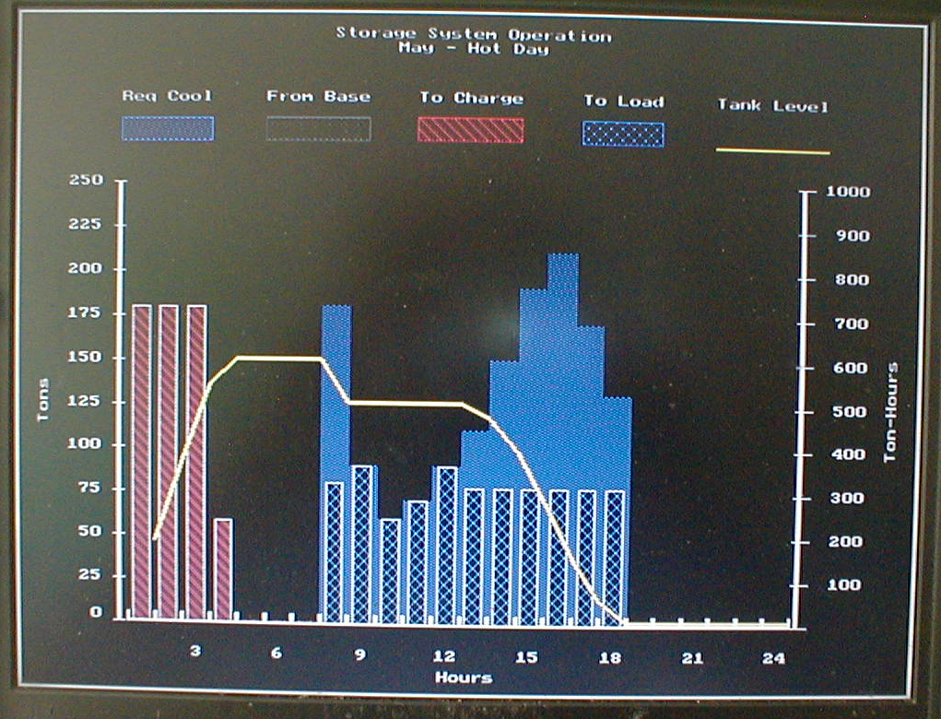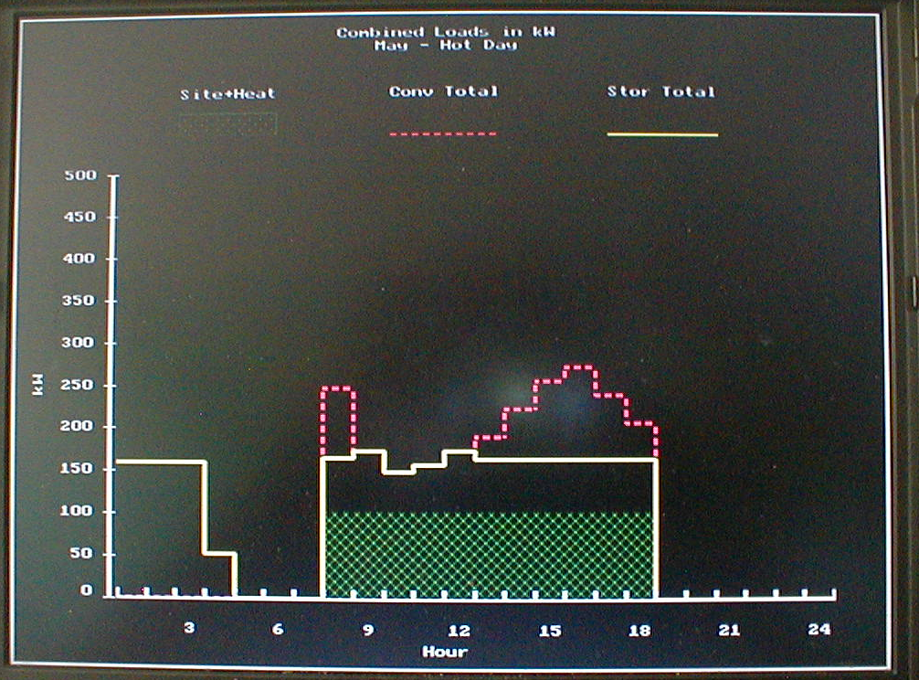

COOLING LOAD PROFILE ELECTRICAL LOAD PROFILE

WITH 100 KW BASE LOAD
APPENDIX C

The following pages show actual text from the proposal high lighted in yellow with directly following comments by KSEngineers high lighted in green.

4.1 • TOU rates provide incentive to reduce on-peak electrical demand and peak usage through the utilization of a TES system during peak hours. Customers who receive incentives under this program will be required to be on a TOU rate for a minimum of 5 years (starting once the customer receives the incentive). Will the utility guarantee in the same spirit not to change the rate structure in such a way that savings will be diminished for the same 5 year period? Many of the complaints by owners in the past were that the utility changed the rates in such a way that savings were at times drastically reduced.

• This program requires that the customer operate the TES system during the summer
on-peak hours on a weekday basis. Important statement and forms the basis of the whole program. It is expected for some customers to see benefits of running the system outside the summer months and will be encouraged to do so if customer savings can be realized.
• All equipment eligible for incentives must be new and not refurbished or previously used; and Needs to be clarified. Why exclude abandoned systems that could be rejuvenated easily and made to work utilizing the existing tanks and heat exchangers by changing the faulty or damaged encapsulated ice containers. These systems probably represent the most economical projects to get the biggest bang for the available bucks.
5.0
• For existing facilities, we require that customers use no more than 105% of the energy they currently use (pre-TES installation) to meet the same cooling load in the course of a full charge-discharge cycle. Customers will be required to address energy efficiency savings during the TES design phase.
• For new construction, customers will be required that their chilled water system use no more than 105% of the annual energy of a minimally compliant chilled water system without a TES.
This is an important issue and from past experience would have stopped some of the open to atmosphere tank systems. KSE can name a few systems where the extra pumping energy was not addressed and more energy is used than was disclosed in the feasibility study. However,KSE would recommend that the limit be set at 110%.

Table 3 – Incentive Amounts by Utility

 | PG&E ($/kW) | SCE ($/kW) | SDG&E ($/kW)
Thermal Energy Storage | $360 | $675 | $513

Why this discrepancy for a state wide program?
6.2
5. Miscellaneous (i.e. tractor rental, earthquake cement) What is this, cut and paste from some other project?

6.3 Customers will have the option to receive a portion of their incentives for approved projects ahead of installation. Customers can receive 25% of the cost of a feasibility study, to a maximum of $10,000, implies that the feasibility study could cost $40,000
7.2
Submitting a feasibility study does not guarantee a customer incentives under the PLS
program. What if the feasibility study shows that TES is not feasible, may be technically or economically, or the owner decides not to proceed. Who pays for this?

o Evaluation of customer’s ability to maintain system
How is the engineer going to state that the customer is not able to maintain the TES system? If the conclusion is negative that’s most likely the end of the story.
o Engineers recommendation of the best course of action and feasibility of the customer investing in a TES system. What if the engineer finds TES not feasible? Who is going to pay for that?

3. Energy Models
• Energy models of a customer’s cooling load for an entire year will be required, which will include the hourly thermal cooling load profile for a 24 hour period for January through December based on expected operating schedule.
Why do we need to model a whole year if we only deal with the peak cooling load? This is an unnecessary but expensive exercise.
Actual sub- metered cooling load data can be submitted if available, subject to approval by the Utility.
• Energy models must come from a program that is:
We are determining the peak cooling load (design load profile). Often the operators have very good information which is reliable enough or perhaps even more so than the theoretical simulation programs. KSEngineers has seen too many calculated cooling loads that were over estimated by up to 30%.
o Compliant with ASHRAE Standard 140
o Non-proprietary
o Acceptable to the Utility-commissioned engineer approving the feasibility study
This engineer needs to be an expert in TES analysis and preferably in design as well to avert some of the mistakes made in the past.
o Examples of acceptable energy model programs include eQuest and
EnergyPro
• The models must include:
o Peak or Design Day Cooling load in tons without the TES system

• Maintenance strategy plan Owner need not change on existing maintenance plan of equipment.
• Commissioning plan of the TES system
• Energy Efficiency analysis (refer to section 3)

5. Monitoring Plan
• Instrument list to complete functional tests and M&V with point names and specs
• One line schematic diagram with sensor placement
• Strategy for developing the baseline chilled water plant energy use regression model What’s this?
• Baseline data must include at least two months of swing season data (April – May or Oct – Nov) What’s the purpose of this?
• Instrumentation list for pre-installation data capture for baseline development purposes. This could require purchase of instrumentation prior to completion of Feasibility Study.
We are dealing with the demand shift during the summer on-peak period. The program does not need to monitor anything during the swing season. Who will purchase instrumentation prior to completion of the feasibility study, if payment of the feasibility study comes out of the incentive? Refer to feasibility study payment argument.

• TOU rate benefit analysis
o Determine if the customer’s current electric rate schedule is most beneficial post-installation
This is one of the challenges of the feasibility study. The utilities have added many other rate schedules to their basic TOU rates such as critical peak etc. Adds considerable calculations to the feasibility study.

7.3 Maximum Incentive Reservation

Customers will not be allowed to reserve incentives beyond their before-installation summer maximum on-peak cooling demand as determined by computer by the simulation/energy modeling-software programs such as eQuest or EnergyPro delete. By The summer max on-peak cooling load profile determined. demand will be determined by the maximum on-peak cooling need simulated by an approved energy model program. Delete. This will prevent providing incentives to over-sized TES system designs. The use of an approved energy model program does not guarantee that the results are not subject to over estimation. Usually, simulations turn out to be over estimations in any case due to safety factors introduced by the input.

7.4 Calculating the Incentive Reservation

Both retrofit and new construction customers will be subjected to the energy modeling process. Energy simulation models, provided by software programs such as eQuest and/or EnergyPro, will be required to model a customer’s cooling load for an entire year without a load-shifting system. Expensive and unnecessary process to determine the peak cooling load. Adds considerable work for the feasibility study for retrofit applications. If there are multiple buildings involved is it necessary to get all the old drawings and do a complete simulation input. There are simpler and easier ways of determining the peak cooling load of a chiller plant. For new designs this info is probably available under the normal design requirements.

The load reduction calculation will be based on approved simulated software energy models rather than actual performance of the TES system. What does this really mean? If the M&V process shows something else either up or down, does then the calculations count?

Energy models will be used to determine a customer's cooling load profile over a year
(8,760 hours). From the profile, the day with the greatest total cooling load in the
summer on-peak hours will be identified. Again, expensive and unnecessary. The capacity of the TES system will be applied to the on-peak period for that maximum cooling load day. The incentive will be based on the cooling tonnage (ton) shifted from the peak hour on that day. There you have it. A conversion factor will be used to convert the cooling load shift tons to electricity load shift (kW). This methodology will be adopted for both full and partial storage systems.

The conversion factor is based on Title 24 average efficiency of both water and air cooling chillers (including reciprocating, rotary screw and centrifugal type chillers). Refer to Table 112-D of the 2008 California Building Energy Efficiency Standards for
the Coefficient of Performance (COP) efficiency levels by equipment type.1 Note that 0.8 kW/ton is an average calculated factor of the chiller types converted to an average kw/ton using the following recognized conversion equation:

kW/ton = 12/(Coefficient of Performance x 3.412)

Why use a conversion factor? Use the actual KW/ton of the chillers. It is closer to the actual shift achieved. Older chillers have higher KW/ton than the newer ones with better efficiencies.

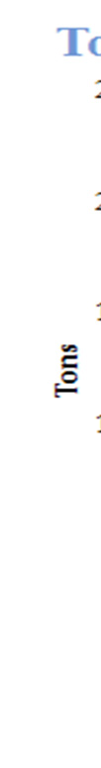
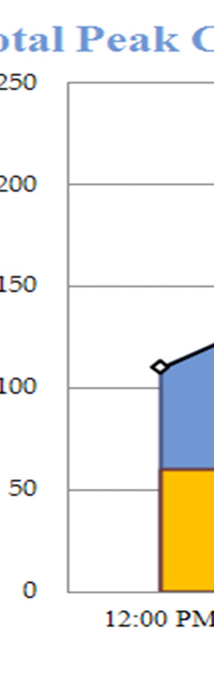
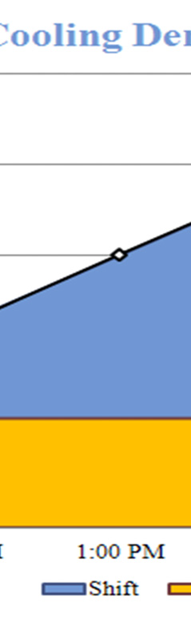
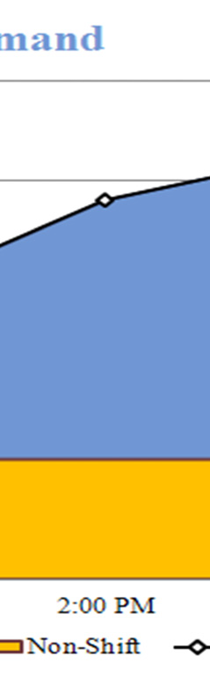
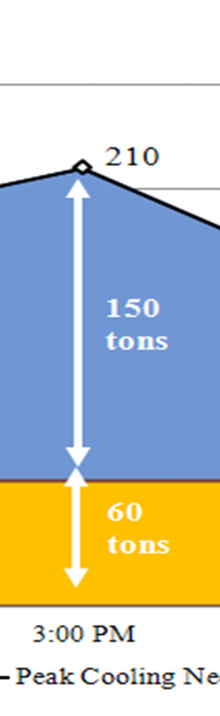
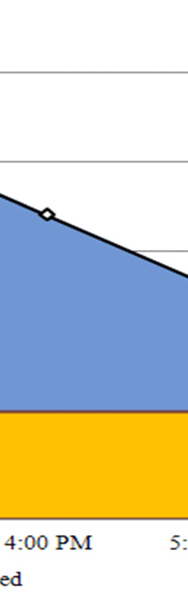
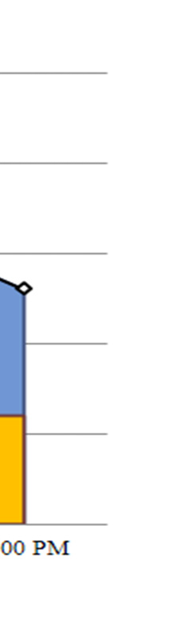
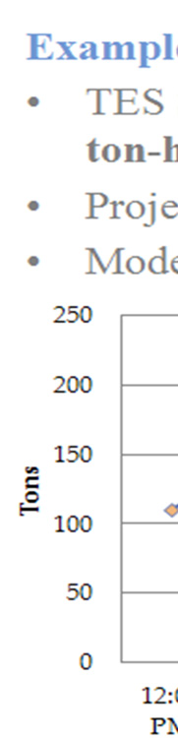
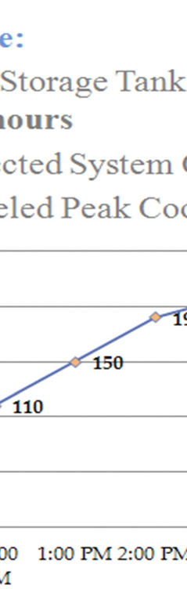
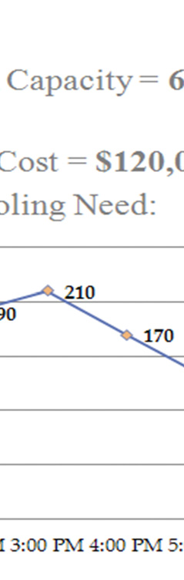
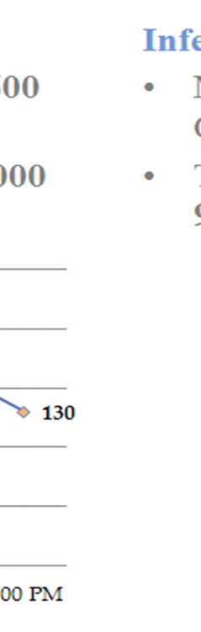
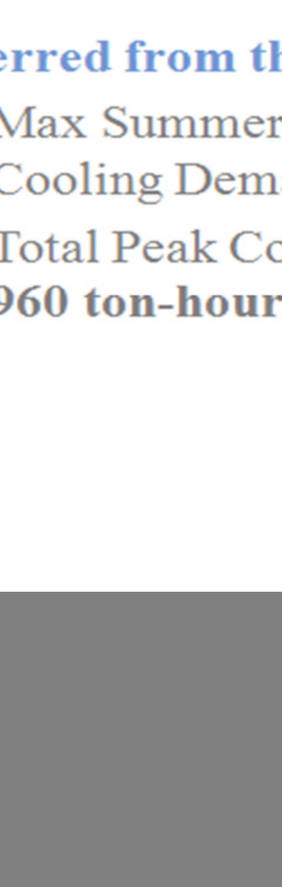
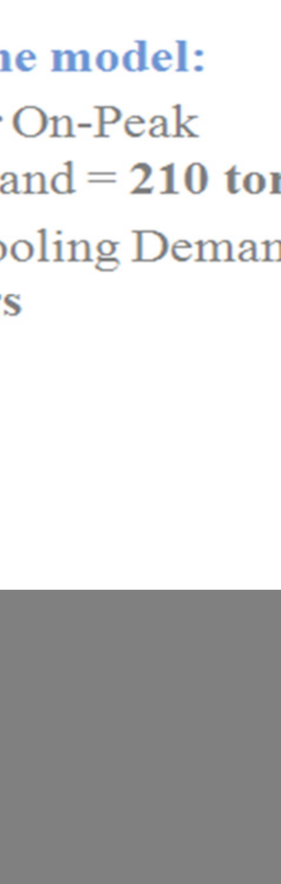

Incentive Reservation Calculation Example:
From above page:

Inferred from the model:

Max.Summer on-peak cooling demand = 210 tons

Total peak cooling demand = 960 ton-hours

Cooling demand is tons and then also ton-hours, demand should not be used for different units.

The title for the chart Total Peak Cooling Demand should read: Total peak cooling load profile.

The colored in areas of the chart represent only five hours. The area under the curve represents ton-hours. A bar chart for each of the six hours would a correct and a better representation.

By the way, the choice of constant limited chiller capacity is theoretically easy to understand but in practice it is very difficult to control. Do we decide on one constant chiller delivery value for the whole summer and the tank does the rest for the peak day? Or do we try to utilize the tank every day to its full depletion to achieve the maximum shift every day the tank can deliver?

A customer in the PG&E territory will get only an incentive of:

150 tons x 0.8 KW/ton x $360 = $43,200. Why, just for being an PG&E customer?

5. Documentation of adequate thermal capacity What’s this?
6. Complete and submit CEC T24 Thermal Energy Storage functional test results
(Functional Test Requirements to be provided during implementation of program).
7. TES entering temperature at which it reaches full charge. TES leaving fluid temperature set point
8. Documentation that M&V instrumentation (temperature sensors, flow meters and
watt-hour meters) are installed and working properly and data is being gathered at the proper intervals.
Why do we need all this expensive equipment? All the program wants to make sure of is that the chillers are not operating during the summer on-peak period as stipulated for full on-peak storage systems. For partial storage systems the chillers should not draw more power than the stipulated value. Therefore, all that is needed is a separate meter monitoring the demand of the chiller/s.

A customer installing different equipment than what was originally proposed in the feasibility study will be required to provide an addendum to the feasibility study with the corrected installed equipment. Final incentive calculations will be based on the cooling capacity of installed equipment. What’s this? The incentive is based on the shift achieved during the on-peak summer months.
8.2 Penalty Structure

A customer that receives a PLS incentive will be contractually obligated to operate the TES load shifting equipment for 5 years from the date of installation signoff by the utility.

The customer agrees that the IOU can request a refund of the incentive if for any reason the customer removes the equipment during the first 5 years of operation, terminates service prematurely or does not operate the system as contracted.

It does happen that the TES system blows the demand on occasions. The customer will be penalized automatically because the on-peak demand will increase for that month and the bill will increase. However, if it is found that the customer is negligent and blowing the demand occurs too frequently, then perhaps there should be some repayment of the incentive.

9. Monitoring for Measurement and Verification
Customers will be required to install measurement and verification (M&V) instrumentation. This requirement will allow the utilities to conduct data analysis on cooling-load-shift performance and provide data for load impact evaluation. This requirement probably will cost more than the incentive is worth. If the utility wants to conduct data analysis then the expense for this must come from the utilities but not from the customer. These monitoring devices also enable customers to optimize operation of their TES system.

Approved monitoring equipment devices can be included in the overall project cost. Customers will be required to submit quarterly data to the utility providing the above requirements in this section. What else does the utility want from the incentive? There is clearly a conflict with the scope of work for this program. Is this program instigated to promote PLS for the state or is it there to provide data analysis for the utilities? If so but then this needs to be addressed and funded separately.
Looking at this example KSE gets the feeling that the incentive is not worth getting as it forces the customer to have to jump through so many hoops that probable cost more than if the project is done without program.

This should be the end of the proposal that goes to the customers. What follows is utility stuff with whatever the PLS program requires.

The customer or the program should not be burdened with any of this that is described below under:
10. Evaluation Measurement and Verification
11. PLS Cost Effectiveness Evaluation

