Energy Efficiency Potential and Goals Study for 2018 and Beyond

Final Public Report

Prepared for:

California Public Utilities Commission

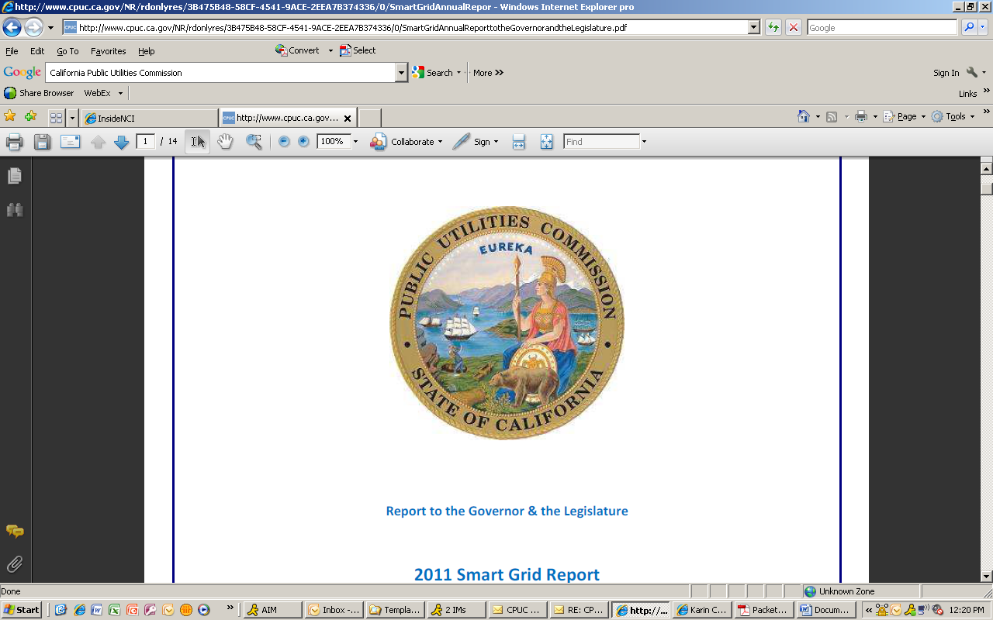

*Submitted by:*

Navigant Consulting, Inc.

1 Market Street

Spear Tower, Suite 1200

San Francisco, CA 94105

415-356-7100

navigant.com

Reference No.: 174655

August 23, 2017

This study was conducted by Navigant Consulting, Inc. under contract to the California Public Utilities Commission. Principal authors include:

* Greg Wikler
* Amul Sathe
* Surya Swamy
* Carishma Menon
* Debyani Ghosh
* Matt O'Hare
* Kristin Landry
* Rosanna Ren
* Julie Penning
* Nicole Reed Fry
* David Bluestein

Navigant was supported by:



Special thanks are due to the staff of California Public Utilities Commission and the many stakeholders for providing direction, guidance, insight, and data throughout the conduct of this study.

Table of Contents

Table of Contents ii

List of Figures and Tables v

Disclaimer xi

Executive Summary xii

Background xii

Scenarios xiv

Results xv

Total Market Potential xv

Market Potential as a Percent of Sales xix

Market Potential by Sector xxii

Expenditures xxv

1. Introduction 1

1.1 Context of the Goals and Potential Study 1

1.2 Types of Potential 3

1.3 Scope of this Study 4

1.4 Stakeholder Engagement 5

1.5 Content of this Report 6

2. Study Methodology 7

2.1 Modeling Methods 8

2.1.1 Rebated Technologies 9

2.1.2 Whole Building Packages 20

2.1.3 Industrial and Agriculture Custom Measures and Emerging Technologies 20

2.1.4 Behavior, Retrocommissioning, Operational Efficiency (BROs) 21

2.1.5 Residential Low Income 23

2.1.6 Codes and Standards (C&S) 23

2.1.7 Financing 25

2.2 Calibrating Rebated Technologies and Whole Building Approaches 28

2.3 Scenarios 29

2.3.1 Stakeholder Input 30

2.3.2 Final Scenarios 32

3. Data Sources 34

3.1 Global Inputs 34

3.1.1 Retail Rates and Sales Forecasts 34

3.1.2 Building Stocks 35

3.1.3 Historic Rebate Program Activity 36

3.1.4 Non-Incentive Program Costs 37

3.1.5 Avoided Costs 38

3.2 Residential and Commercial Technology Characterization 41

3.2.1 Technology Selection Process 41

3.2.2 Comparison with Measure Characterization in the 2015 Study 45

3.3 Technology Characterization 46

3.3.1 Energy Use 47

3.3.2 Technology Costs 49

3.3.3 Market Information: Density and Saturation Values 51

3.4 Agriculture, Industrial, Mining, and Street-lighting (AIMS) Technology Characterization 53

3.4.1 Agriculture and Industrial Sectors 54

3.4.2 Mining Sector 59

3.4.3 Street Lighting Sector 59

3.5 Industrial and Agriculture Custom Technologies Data Sources 60

3.5.1 Generic Custom Measures 60

3.5.2 Emerging AIMS Technologies 61

3.6 Whole Building Initiatives 62

3.6.1 New Construction 63

3.6.2 Retrofit 65

3.7 Codes and Standards 67

3.8 Behavior, Retrocommissioning, and Operational (BROs) Energy Efficiency 71

3.8.1 Stakeholder Input 75

3.8.2 Data Rigor 76

3.9 Low Income Programs 77

3.9.1 Households Treated 77

3.9.2 Unit Energy Savings 78

3.10 Energy Efficiency Financing 78

3.10.1 Residential Inputs 78

3.10.2 Commercial Inputs 80

4. 2018 Study Results 82

4.1 Incentive Program Savings 82

4.1.1 Total Savings and Spending by Scenario 82

4.1.2 Total Savings and Spending by Sector 88

4.1.3 Equipment Rebate Program Results 96

4.1.4 BROS Scenario Results 123

4.2 C&S Savings 126

4.3 Detailed Study Results 127

5. Comparision to 2015 Study 133

Appendix A. Calibration A-1

A.1 Overview A-1

A.2 Necessity of Calibration A-1

A.3 Interpreting Calibration A-3

A.4 Implementing Calibration A-4

Appendix B. Technical, Economic and Cumulative Market Potential for Equipment Rebate Programs B-6

Appendix C. BROS C-1

C.1 Residential - Home Energy Reports C-1

C.2 Residential - Real-Time Feedback: In Home Displays and Online Portals C-3

C.3 Residential - Competitions: Large and Small C-5

C.4 Commercial - Strategic Energy Management C-8

C.5 Commercial - Building Operator Certification C-10

C.6 Commercial - Building Energy and Information Management Systems C-12

C.7 Commercial - Business Energy Reports C-14

C.8 Commercial - Benchmarking C-16

C.9 Commercial - Competitions C-17

C.10 Commercial - Retrocommissioning C-19

C.11 Industrial/Agriculture - Strategic Energy Management C-21

C.12 Other Data Sources and References C-26

Appendix D. AIMS Sectors D-1

D.1 Industrial D-1

D.2 Agriculture D-3

Appendix E. Codes & Standards E-1

Appendix F. Ind/Ag Generic Custom & Emerging Technologies F-1

F.1 Ind/Ag Generic Custom Measure Forecast Methodology F-1

F.2 Ind/Ag Emerging Technology Measures F-3

Appendix G. Low Income Programs G-1

G.1 PG&E G-1

G.2 SCE G-2

G.3 SCG G-3

G.4 SDG&E G-4

G.5 Effective Useful Life G-5

Appendix H. Detailed Scenario Results H-1

H.1 PG&E H-1

H.2 SCE H-7

H.3 SCG H-11

H.4 SDG&E H-13

Appendix I. Summary of Stakeholder Inputs I-19

List of Figures and Tables

**Executive Summary Figures**

Figure ES-1. Statewide Incremental Electric Savings by Scenario xvii

Figure ES-2. Statewide Incremental Gas Savings by Scenario xviii

Figure ES-3. Incremental Electric Market Potential as a Percent of Sales xx

Figure ES-4. Incremental Gas Market Potential as a Percent of Sales xxi

Figure ES- 5. Statewide Incremental Electric Market Potential for Incentive Programs by Sector for the TRC Reference Scenario xxiii

Figure ES- 6. Statewide Incremental Gas Market Potential for Incentive Programs by Sector for the TRC Reference Scenario xxiv

Figure ES- 7. Statewide Program Expenditures by Scenario for Incentive Programs xxv

**Executive Summary Tables**

Table ES- 1. Scenarios for Energy Efficiency Market Potential xiv

Table ES- 2. Statewide Incremental Electric Savings by Scenario xvii

Table ES- 3. Statewide Incremental Gas Savings by Scenario xviii

Table ES- 4. Incremental Electric Market Potential as a Percent of Sales xx

Table ES- 5. Incremental Gas Market Potential as a Percent of Sales xxi

Table ES- 6. Statewide Incremental Electric Market Potential for Incentive Programs by Sector for the TRC Reference Scenario xxiii

Table ES- 7. Statewide Incremental Gas Market Potential for Incentive Programs by Sector for the TRC Reference Scenario xxiv

Table ES- 8. Statewide Spending by Scenario for IOU Rebate Programs (Million $) xxvi

**Figures**

Figure 2‑1. Stock Flow within a Technology Group 11

Figure 2‑2. Three-Step Approach to Calculating Market Potential for Rebated Measures 12

Figure 2‑3. The Bass Diffusion Framework: A Dynamic Approach to Calculating Measure Adoption 13

Figure 2‑4. Illustration of Logit Willingness Curve 15

Figure 2‑5. Payback Acceptance Curve for AIMS sectors 16

Figure 2‑6. Cumulative Savings Illustration 17

Figure 2‑7. Below Code NTG Illustration 18

Figure 2‑8. C&S Savings Calculation Methodology 24

Figure 3‑1. Res/Com Technology Selection Process 41

Figure 3‑2. Res/Com Technology List Development Process 42

Figure 3‑3. Projected LED Technology Improvements, 2013-2030 50

Figure 3‑4. Projected LED Cost Reduction Profiles, 2013-2030 51

Figure 3‑5. Industrial and Agriculture Technology List Development Process 54

Figure 3‑6. Whole Building Retrofit Savings Calculation and Viability Check 66

Figure 3‑7. Selection Process for Residential and Commercial BROs Energy Efficiency Programs 71

Figure 3‑8. Residential BROs 73

Figure 3‑9. Commercial BROs 73

Figure 4‑1. Incremental Electric Market Potential as a Percent of Sales 86

Figure 4‑2. Incremental Gas Market Potential as a Percent of Sales 87

Figure 4‑3. Statewide Spending by Scenario for IOU Incentive Programs 87

Figure 4‑4. Statewide Incremental Net Electric Market Potential by Sector for Incentive Programs in Scenario 1 (TRC Reference) 88

Figure 4‑5. Statewide Incremental Net Electric Market Potential by Sector for Incentive Programs in Scenario 2 (mTRC w/ GHG adder 1) 89

Figure 4‑6. Statewide Incremental Electric Market Potential by Sector for Incentive Programs in Scenario 3 (mTRC w/ GHG adder 2) 89

Figure 4‑7. Statewide Incremental Electric Market Potential by Sector for Incentive Programs in Scenario 4 (PAC Reference) 90

Figure 4‑8. Statewide Incremental Electric Market Potential by Sector for Incentive Programs in Scenario 5 (PAC Aggressive) 90

Figure 4‑9. Statewide Incremental Gas Market Potential by Sector for Incentive Programs in Scenario 1 (TRC Reference) 91

Figure 4‑10. Statewide Incremental Gas Market Potential by Sector for Incentive Programs in Scenario 2 (mTRC w/ GHG adder 1) 91

Figure 4‑11. Statewide Incremental Gas Market Potential by Sector for Incentive Programs in Scenario 3 (mTRC w/ GHG adder 2) 92

Figure 4‑12. Statewide Incremental Gas Market Potential by Sector for Incentive Programs in Scenario 4 (PAC Reference) 92

Figure 4‑13. Statewide Incremental Gas Market Potential by Sector for Incentive Programs in Scenario 5 (PAC Aggressive) 93

Figure 4‑14. Statewide Spending by Sector for Incentive Programs in Scenario 1 (TRC Reference) 94

Figure 4‑15. Statewide Spending by Sector for Incentive Programs in Scenario 2 (mTRC w/ GHG Adder 1) 94

Figure 4‑16. Statewide Spending by Sector for Incentive Programs in Scenario 3 (mTRC w/ GHG Adder 2) 95

Figure 4‑17. Statewide Spending by Sector for Incentive Programs in Scenario 4 (PAC Reference) 95

Figure 4‑18. Statewide Spending by Sector for Incentive Programs in Scenario 5 (PAC Aggressive) 96

Figure 4‑19.Statewide Incremental Electric Market Potential by Scenario 97

Figure 4‑20. Statewide Incremental Gas Market Potential by Scenario 98

Figure 4‑21. Statewide Residential Incremental Electric Market Potential by End Use for Equipment Rebate Programs in Scenario 1 (TRC Reference) 99

Figure 4‑22. Statewide Residential Incremental Electric Market Potential by End Use for Equipment Rebate Programs in Scenario 2 (mTRC w/ GHG Adder 1) 100

Figure 4‑23. Statewide Residential Incremental Electric Market Potential by End Use for Equipment Rebate Programs in Scenario 3 (mTRC w/ GHG Adder 2) 100

Figure 4‑24. Statewide Residential Incremental Electric Market Potential by End Use for Equipment Rebate Programs in Scenario 4 (PAC Reference) 101

Figure 4‑25. Statewide Residential Incremental Electric Market Potential by End Use for Equipment Rebate Programs in Scenario 5 (PAC Aggressive) 101

Figure 4‑26. Statewide Residential Incremental Gas Market Potential by End Use for Equipment Rebate Programs in Scenario 1 (TRC Reference) 102

Figure 4‑27. Statewide Residential Incremental Gas Market Potential by End Use for Equipment Rebate Programs in Scenario 2 (mTRC w/ GHG Adder 1) 103

Figure 4‑28. Statewide Residential Incremental Gas Market Potential by End Use for Equipment Rebate Programs in Scenario 3 (mTRC w/ GHG Adder 2) 103

Figure 4‑29. Statewide Residential Incremental Gas Market Potential by End Use for Equipment Rebate Programs in Scenario 4 (PAC Reference) 104

Figure 4‑30. Statewide Residential Incremental Gas Market Potential by End Use for Equipment Rebate Programs in Scenario 5 (PAC Aggressive) 104

Figure 4‑31. Statewide Commercial Incremental Electric Market Potential by End Use for Equipment Rebate Programs in Scenario 1 (TRC Reference) 105

Figure 4‑32. Statewide Commercial Incremental Electric Market Potential by End Use for Equipment Rebate Programs in Scenario 2 (mTRC w/ GHG Adder 1) 106

Figure 4‑33. Statewide Commercial Incremental Electric Market Potential by End Use for Equipment Rebate Programs in Scenario 3 (mTRC w/ GHG Adder 2) 106

Figure 4‑34. Statewide Commercial Incremental Electric Market Potential by End Use for Equipment Rebate Programs in Scenario 4 (PAC Reference) 107

Figure 4‑35. Statewide Commercial Incremental Electric Market Potential by End Use for Equipment Rebate Programs in Scenario 5 (PAC Aggressive) 107

Figure 4‑36. Statewide Commercial Incremental Gas Market Potential by End Use for Equipment Rebate Programs in Scenario 1 (TRC Reference) 108

Figure 4‑37. Statewide Commercial Incremental Gas Market Potential by End Use for Equipment Rebate Programs in Scenario 2 (mTRC w/ GHG Adder 1) 109

Figure 4‑38. Statewide Commercial Incremental Gas Market Potential by End Use for Equipment Rebate Programs in Scenario 3 (mTRC w/ GHG Adder 2) 109

Figure 4‑39. Statewide Commercial Incremental Gas Market Potential by End Use for Equipment Rebate Programs in Scenario 4 (PAC Reference) 110

Figure 4‑40. Statewide Commercial Incremental Gas Market Potential by End Use for Equipment Rebate Programs in Scenario 5 (PAC Aggressive) 110

Figure 4‑41. Statewide AIMS Incremental Electric Market Potential by End Use for Equipment Rebate Programs in Scenario 1 (TRC Reference) 111

Figure 4‑42. Statewide AIMS Incremental Electric Market Potential by End Use for Equipment Rebate Programs in Scenario 2 (mTRC w/ GHG Adder 1) 112

Figure 4‑43. Statewide AIMS Incremental Electric Market Potential by End Use for Equipment Rebate Programs in Scenario 3 (mTRC w/ GHG Adder 2) 112

Figure 4‑44. Statewide AIMS Incremental Electric Market Potential by End Use for Equipment Rebate Programs in Scenario 4 (PAC Reference) 113

Figure 4‑45. Statewide AIMS Incremental Electric Market Potential by End Use for Equipment Rebate Programs in Scenario 5 (PAC Aggressive) 113

Figure 4‑46. Statewide AIMS Incremental Gas Market Potential by End Use for Equipment Rebate Programs in Scenario 1 (TRC Reference) 114

Figure 4‑47. Statewide AIMS Incremental Gas Market Potential by End Use for Equipment Rebate Programs in Scenario 2 (mTRC w/ GHG Adder 1) 115

Figure 4‑48. Statewide AIMS Incremental Gas Market Potential by End Use for Equipment Rebate Programs in Scenario 3 (mTRC w/ GHG Adder 2) 115

Figure 4‑49. Statewide AIMS Incremental Gas Market Potential by End Use for Equipment Rebate Programs in Scenario 4 (PAC Reference) 116

Figure 4‑50. Statewide AIMS Incremental Gas Market Potential by End Use for Equipment Rebate Programs in Scenario 5 (PAC Aggressive) 116

Figure 4‑51. Statewide Stranded Electric Potential by End Use for all sectors in Scenario 1 (TRC Reference) 117

Figure 4‑52. Statewide Stranded Electric Potential by End Use for all sectors in Scenario 2 (mTRC w/ GHG Adder 1) 118

Figure 4‑53. Statewide Stranded Electric Potential by End Use for all sectors in Scenario 3 (mTRC w/ GHG Adder 2) 118

Figure 4‑54. Statewide Stranded Electric Potential by End Use for all sectors in Scenario 4 (PAC Reference) 119

Figure 4‑55. Statewide Stranded Electric Potential by End Use for all sectors in Scenario 5 (PAC Aggressive) 119

Figure 4‑56. Statewide Stranded Gas Potential by End Use for all sectors in Scenario 1 (TRC Reference) 120

Figure 4‑57. Statewide Stranded Gas Potential by End Use for all sectors in Scenario 2 (mTRC w/ GHG Adder 1) 121

Figure 4‑58. Statewide Stranded Gas Potential by End Use for all sectors in Scenario 3 (mTRC w/ GHG Adder 2) 121

Figure 4‑59. Statewide Stranded Gas Potential by End Use for all sectors in Scenario 4 (PAC Reference) 122

Figure 4‑60. Statewide Stranded Gas Potential by End Use for all sectors in Scenario 5 (PAC Aggressive) 122

Figure 4‑61. BROs Electric Savings – Reference Scenario 123

Figure 4‑62. BROs Gas Savings – Reference Scenario 124

Figure 4‑63. BROs Program Spending – Reference Scenario 124

Figure 4‑64. BROs Electric Savings – Aggressive Scenario 125

Figure 4‑65. BROs Gas Savings – Aggressive Scenario 125

Figure 4‑66. BROs Program Spending – Aggressive Scenario 126

Figure 4‑67. C&S Electric Savings (Including Interactive Effects) 127

Figure 4‑68. C&S Gas Savings (Including Interactive Effects) 127

Figure 4‑69. Results Viewer Overview Tab 130

Figure 4‑70. Results Viewer Scenario Comparison (Illustrative) 131

Figure 4‑71. Results Viewer End Uses (Illustrative) 132

**Appendix Figures**

Figure A‑1. The Concept of Calibrating A-2

Figure A‑2. Illustrative 2013-2015 Calibration Targets A-4

Figure B‑1. Statewide Technical, Economic and Cumulative Electric Market Potential for Equipment Rebate Programs in Scenario 1 (TRC Reference) B-7

Figure B‑2. Statewide Technical, Economic and Cumulative Electric Market Potential for Equipment Rebate Programs in Scenario 2 (mTRC w/ GHG Adder 1) B-7

Figure B‑3. Statewide Technical, Economic and Cumulative Electric Market Potential for Equipment Rebate Programs in Scenario 3 (mTRC w/ GHG Adder 2) B-8

Figure B‑4. Statewide Technical, Economic and Cumulative Electric Market Potential for Equipment Rebate Programs in Scenario 4 (PAC Reference) B-8

Figure B‑5. Statewide Technical, Economic and Cumulative Electric Market Potential for Equipment Rebate Programs in Scenario 5 (PAC aggressive) B-9

Figure B‑6. Statewide Technical, Economic and Cumulative Gas Market Potential for Equipment Rebate Programs in Scenario 1 (TRC Reference) B-9

Figure B‑7. Statewide Technical, Economic and Cumulative Gas Market Potential for Equipment Rebate Programs in Scenario 2 (mTRC w/ GHG Adder 1) B-10

Figure B‑8. Statewide Technical, Economic and Cumulative Gas Market Potential for Equipment Rebate Programs in Scenario 3 (mTRC w/ GHG Adder 2) B-10

Figure B‑9. Statewide Technical, Economic and Cumulative Gas Market Potential for Equipment Rebate Programs in Scenario 4 (PAC Reference) B-11

Figure B‑10. Statewide Technical, Economic and Cumulative Gas Market Potential for Equipment Rebate Programs in Scenario 4 (PAC Aggressive) B-11

Figure F‑1. Examples of Industrial Market Segments at Risk of Relocating Offshore F-7

Figure F‑2. Example Trends in PG&E Electric Energy Usage (Indexed to 1990 Usage = 1) F-8

**Tables**

Table 1‑1: Stakeholder Meeting Schedule 6

Table 2‑1. Overview of Modeling and Calibration Approach 8

Table 2‑2. Example of Technologies within a Technology Group 10

Table 2‑3. NTG Adjustment Factors 20

Table 2‑4. Example Present Value Comparisons for Base and Efficient Technologies and Financing 28

Table 2‑5. Variables Affecting Energy Efficiency Potential 29

Table 2‑6. Stakeholder Feedback 30

Table 2‑7. Final Scenarios for Energy Efficiency Potential – Summary 32

Table 2‑8. Reference vs. Aggressive Programs 33

Table 3‑1. Overview of Global Inputs Updates and Sources 34

Table 3‑2. 2016 IEPR Electric Service Territory to Planning Area Adjustment Ratios 35

Table 3‑3. 2016 IEPR Gas Service Territory to Planning Area Adjustment Ratios 35

Table 3‑4. Mapping CEC Planning Areas to IOU Service Territories 36

Table 3‑5. 2013-2015 IOU-reported Portfolio Gross Program Savings 37

Table 3‑6. Non-Incentive Program Costs Summary 37

Table 3‑7. California RPS Targets, 2016-2030 39

Table 3‑8. Costs of Carbon, 2016-2046 40

Table 3‑9. Final List of Technology Groups (with Examples) and Individual Technologies 44

Table 3‑10. Comparison of Efficient Residential and Commercial Technologies in 2015 and 2018 PG Study 45

Table 3‑11. Residential and Commercial Accelerated Replacement Technology Groups 46

Table 3‑12. Key Fields for Measure Characterization with Brief Descriptions 47

Table 3‑13. Hierarchy of Data Sources for Energy Use Information 48

Table 3‑14. Hierarchy of Data Sources for Technology Cost Information 49

Table 3‑15. Example of Density and Saturation Calculation 52

Table 3‑16. Sources for Density and Saturation Characterization 53

Table 3‑17. Final List of Technology Groups and Individual Technologies 56

Table 3‑18. Generic Custom Measures - Key Assumptions 60

Table 3‑19. Emerging Technologies - Key Assumptions 61

Table 3‑20. Whole Building Technology Levels 63

Table 3‑21. Commercial New Construction Whole Building Data Sources 64

Table 3‑22. Residential New Construction Whole Building Data Sources 65

Table 3‑23. Commercial Retrofit Whole Building Data Sources 67

Table 3‑24. Residential Retrofit Whole Building Data Updates 67

Table 3‑25 C&S Data Source Summary 68

Table 3‑26 2016 and 2019 Savings Percentages 70

Table 3‑27. Behavioral Intervention Summary Table 74

Table 3‑28. Stakeholder Feedback 75

Table 3‑29. Qualitative Assessment of Data Quality 77

Table 3‑30. 2013-2015 Achievements by Regional Financing Program 79

Table 3‑31. Key Inputs to Residential Financing Cash Flow Model 80

Table 3‑32. Key Inputs to Commercial and Industrial (C&I) Financing Cash Flow Model 81

Table 4‑1. Statewide Net Incremental Electric Savings by Scenario 83

Table 4‑2. Statewide Net Incremental Demand Savings by Scenario 84

Table 4‑3. Statewide Net Incremental Gas Savings by Scenario 85

Table 4‑4. Results Viewer Tabs 128

Table 5‑1. Total Incentive Program Market Potential Comparison - Gross Electric Savings 134

Table 5‑2. Total Incentive Program Market Potential Comparison - Gross Gas Savings 134

Table 5‑3. BROs Potential Comparison - Gross Electric Savings 135

Table 5‑4. BROs Potential Comparison - Gross Gas Savings 135

Table 5‑5. C&S Net Program Results Comparison - Electric 136

Table 5‑6. C&S Net Program Results Comparison - Gas 136

**Appendix Tables**

Table A‑1. Calibration Levers A-5

Table B‑1. Home Energy Reports - Key Assumptions C-1

Table B‑2. Real-Time Feedback - Key Assumptions C-4

Table B‑3. Residential Competitions - Key Assumptions C-6

Table B‑4. Commercial Strategic Energy Management - Key Assumptions C-9

Table B‑5. Commercial Building Operator Training - Key Assumptions C-11

Table B‑6. Building Energy and Information Management Systems - Key Assumptions C-13

Table B‑7. Business Energy Reports - Key Assumptions C-14

Table B‑8. Benchmarking - Key Assumptions C-16

Table B‑9. Commercial Competitions - Key Assumptions C-18

Table B‑10. Commercial Retrocommissioning - Key Assumptions C-20

Table B‑11. Industrial/Agriculture SEM - Key Assumptions C-22

Table B‑12. Industrial Sector Strategic Energy Management Unit Energy Savings Multiplier C-24

Table B‑13. Agricultural Sector Strategic Energy Management Unit Energy Savings Multiplier C-25

Table D‑1. C&S Modeled E-1

Table D‑2. C&S Superseded Codes and Standards E-7

Table E‑1. Industrial/Agriculture GC - Key Assumptions F-1

Table E‑2. Generic Custom Unit Energy Savings Multiplier F-2

Table E‑3. Industrial/Agriculture ET - Key Assumptions F-3

Table E‑4. Emerging Technology Evaluation Criteria F-5

Table E‑5. Emerging Technologies UES Multipliers by Segment and Fuel F-9

Table F‑1. PG&E Households Treated G-1

Table F‑2. PG&E UES G-1

Table F‑3. SCE Households Treated G-2

Table F‑4. SCE UES G-2

Table F‑5. SCG Households Treated G-3

Table F‑6. SCG UES G-3

Table F‑7. SDG&E Households Treated G-4

Table F‑8. SDG&E UES G-4

Table H‑1. PG&E Electric Savings H-1

Table G‑2. PG&E Demand Savings H-3

Table G‑3. PG&E Gas Savings H-5

Table G‑4. SCE Electric Savings H-7

Table G‑5. SCE Demand Savings H-9

Table G‑6. SCG Gas Savings H-11

Table G‑7. SDG&E Electric Savings H-13

Table G‑8. SDG&E Demand Savings H-15

Table G‑9. SDG&E Gas Savings H-17

Disclaimer

This report was prepared by Navigant Consulting, Inc. (Navigant) for the California Public Utilities Commission. The work presented in this report represents Navigant’s professional judgment based on the information available at the time this report was prepared. Navigant is not responsible for the reader’s use of, or reliance upon, the report, nor any decisions based on the report. NAVIGANT MAKES NO REPRESENTATIONS OR WARRANTIES, EXPRESSED OR IMPLIED. Readers of the report are advised that they assume all liabilities incurred by them, or third parties, as a result of their reliance on the report, or the data, information, findings and opinions contained in the report.

Executive Summary

Background

Navigant Consulting, Inc. along with its partners Tierra Resource Consultants LLC (collectively known as “the Navigant team”) prepared this study (“2018 and Beyond Potential and Goals Study”) for the California Public Utilities Commission (CPUC). The purpose of this study is to develop estimates of energy and demand savings potential in the service territories of California’s major investor-owned utilities (IOUs) during the post-2017 energy efficiency (EE) rolling portfolio planning cycle. This report includes results for Pacific Gas and Electric (PG&E), Southern California Edison (SCE), San Diego Gas and Electric (SDG&E), and Southern California Gas (SCG) collectively referred to as investor owned utilities or IOUs. A key component of the 2018 Potential and Goals Study (2018 Study) is the Potential and Goals Model (PG Model), which provides a single platform in which to conduct quantitative scenario analysis that reflects the complex interactions among various inputs and policy drivers.

A significant number of recent policy changes in California are driving updates to the approach and methodology of the 2018 Study. These policy drivers include:

* **California Assembly Bill 802 (AB802)** - AB802 allows and incentivizes all energy savings (including those that are “below-code”).[1] Furthermore, AB802 instructs energy efficiency be achieved not only though equipment installations but also through behavior and operational efficiency interventions.
* **California Senate Bill 350 (SB350)** - SB350 mandates a doubling of statewide energy efficiency savings in electricity and natural gas end uses by 2030 and that the goals not be constrained based on past EE program performance.
* **CPUC Cost Effectiveness Tests and Inputs Updates** - Multiple changes have been or are being considered though the Integrated Distributed Energy Resources (IDER) proceeding (R. 14-10-003). The CPUC has been considering the application of the California Standard Practice Manual tests for distributed energy resource needs including the use of a greenhouse gas (GHG) adder to be incorporated into the current avoided costs.[2]
* **CPUC Net Goals Direction** – The CPUC directed 2018 and beyond goals to be set net of free-ridership due to changes in baseline policy.[3]

The 2018 Study supports a number of objectives:

1. Informs the CPUC as it proceeds to adopt EE savings goals and targets, providing guidance for the next IOU EE program portfolios;
2. Guides the IOUs in EE program portfolio planning and the state’s principal energy agencies in forecasting for procurement, including the planning efforts of the CPUC, California Energy Commission (CEC), and California Independent System Operator (CAISO);
3. Informs strategic contributions to SB350 targets. The CEC has historically used the PG study to develop its forecast of Additional Achievable Energy Efficiency Potential (AAEE; SB350 requires doubling AAEE by 2030. The CEC will continue to rely upon the PG study as an input to AAEE; the PG study will also serve as an input to SB350 target setting; and
4. Identifies new EE savings opportunities under the guise of AB802.

The 2018 Study period spans from 2018-2030 based on the direction provided by CPUC and focuses on current and potential drivers of energy savings in IOU service areas. Analysis of energy efficiency savings in publicly owned utility service territories is not part of the scope of this effort.

Consistent with previous CPUC potential studies and consistent with common industry practice, the 2018 Study forecasts EE potential at three levels for rebate programs:

1. **Technical Potential:** Technical potential is defined as the amount of energy savings that would be possible if the highest level of efficiency for all technically applicable opportunities to improve EE were taken, regardless of cost.
2. **Economic Potential:** Drawing from technical potential analysis, economic potential represents total EE potential available when limited to only cost effective measures.[4] All components of economic potential are a subset of technical potential.
3. **Market Potential:** The final output of the potential study is a market potential analysis, which calculates the potential EE savings based on specific incentive levels and assumptions about existing CPUC policies, market influences, and barriers. All components of market potential are a subset of economic potential. Market potential has historically been used by the CPUC to inform the goal-setting process.
   1. **Stranded Potential** is a subset of the Market Potential that was added to the 2018 Study to accommodate AB802. These savings are defined as the opportunities for EE that have not historically been captured by either EE program administrator (PA) rebate programs or codes and standards. Stranded Potential is below-code savings to AB802 that is not materializing in the market because there are no incentives for customers to upgrade their existing equipment given current program rebate policies.

This 2018 Study forecasts the potential energy savings from various EE programs as well as codes and standards advocacy efforts for the following customer sectors: Residential, Commercial, Agricultural, Industrial, Mining, and Street Lighting. The 2018 Study does not set IOU goals nor does it make a recommendation as to how to set goals. Rather it informs the CPUC’s goal-setting process. The Navigant team engaged with stakeholders through the Demand Analysis Working Group[5] (DAWG) over the course of the 2018 Study to obtain data and incorporate feedback on scope, methodology, key assumptions, and interim results.

Scenarios

In previous CPUC potential studies, a single forecast of EE potential was developed and used by policymakers to establish IOU goals. In these past studies, alternate scenarios were developed and passed along to the CEC to inform its load forecasting efforts. These scenarios were developed after the CPUC had established goals and were primarily driven by the needs of the CEC. The 2018 PG study considers multiple scenarios to explore how EE potential might change based on a number of alternative assumptions about policies, measures and market response.

SB350 directs the CPUC to adopt goals based on EE potential studies that are not restricted by previously accomplished EE program savings. Commission staff proposed to meet this direction by exploring scenarios reflecting alternative future outcomes based on variables that can be controlled by policy decisions or program influence. This study considers scenarios primarily built around policies and program decisions that are within the sphere of influence of the CPUC and IOUs collectively.

Commission staff and Navigant, with input from stakeholders, developed scenarios to determine alternative estimates of market potential based on the following considerations:

* Cost-effectiveness test: The Total Resource Cost (TRC) test, which considers costs incurred by both participants and program administrators and the Program Administrator Cost (PAC) test, which considers only those costs incurred by program administrators to deliver the various EE programs and measures relative to the monetary benefits of those programs and measures derived from traditional avoided costs, is the threshold test for determining market potential.
* Avoided costs: Two sets of greenhouse gas (GHG) abatement prices proposed under the IDER proceeding that account for the cost of achieving 2030 GHG targets are used as a modifier to the Total Resource Cost (TRC) test.
* Program engagement: Aggressive approaches to EE program engagement that include increases to the incentives paid to customers, enhanced marketing and outreach efforts, and innovative financing approaches are used to modify the rates of customer adoption.

Commission staff’s intent was to keep the number of scenarios manageable but still provide a range of alternatives to bound the estimates of market potential. Therefore, one “business as usual” scenario and four alternative scenarios were developed and are listed in the table below.

Table ES- . Scenarios for Energy Efficiency Market Potential



The Scenario 1 (TRC Reference) represents “business as usual” and the continuation of current policies. Three of the alternate scenarios continue to assume the same program engagement strategies as the reference scenario but apply different cost effectiveness tests and avoided costs. The final Scenario 5 (PAC Aggressive) is meant to show an upper bound of the combination of program engagement and cost-effectiveness screens and can be used to compare against SB350 targets.

More information about the scenarios can be found in Section 4.1.

Results

Total Market Potential

Figure ES-1 and Figure ES-2 show the total market potential over time for electric and gas measures, respectively. Table ES-2 and Table ES-3 summarize the magnitude of the market potential for two points in time – 2018 and 2030. The figures illustrate the magnitude of market potential for each type of EE program delivery approach for each of the five scenarios.[6] A few important notes about these results:

* Equipment Rebate program savings[7] are different for each scenario based on parameters shown earlier in Table ES-1.
* Behavior, Retrocommissioning and Operational (BROs) savings, a subset of rebate programs, vary only in terms of Reference vs. Aggressive. Thus, four of the five scenarios have identical BROs savings. BROs savings do not vary by cost effectiveness screen in our model. The reference scenario is dominated by savings from residential home energy reports (HERs). Additional high impact interventions after HERS include web-based real time feedback, strategic energy management, retrocommissioning, and Building Energy Information Management Systems (BEIMs). HERS dominates savings as it is one of the largest, most well-studied existing interventions with reliable data upon which to base a forecast. Savings from all interventions increase over time as we expect enrollment in programs to gradually increase. The Aggressive BROs variation includes interventions less studied or not yet implemented in California but with conceivable savings potential.
* Codes and standards (C&S) and Low Income savings do not vary by scenario.

Total savings are dominated by C&S. Because C&S savings do not vary by scenario, the overall variability in total savings may appear minimal. True variability in savings originates from Equipment Rebate and BROs programs. Results in tabular form for each year are available in Section 4.

Some notable takeaways from this study include:

For Equipment Rebate programs, the savings appear to increase for each alternative scenario relative to the business as usual. This reflects the fact that more measures pass the economic screen as quantification of additional benefits (e.g. an interim GHG adder) are applied, cost-effectiveness tests are changed, and aggressive programmatic interventions are introduced.

For BROs programs, the growth in savings for each of the scenarios increases over time reflecting greater market adoption as incentives increase and consumers become more aware of such programs leading to higher levels of customer uptake. In 2030, savings in the BROs aggressive scenario is just short of a doubling of the BROs reference scenario.

For Incentive programs (Equipment Rebates, BROs and Low Income), all three variations of the TRC test as represented in scenarios 1, 2 and 3 provide more savings per $ spent for both gas and electric savings than the PAC test in scenarios 4 and 5. This is because as the cost effectiveness threshold becomes less strict, more expensive measures are included in the portfolio. Thus, we generally observe diminishing returns on program investment when comparing PAC based scenarios to TRC based scenarios. Specifically:

For Scenario 4 (PAC Reference), while the 2030 expenditures increase by 36% compared with Scenario 1 (TRC Reference), the 2030 incremental incentive program savings only increase by 9% and 14% for electric and gas respectively.

For Scenario 2 (mTRC w/ GHG adder 1) and Scenario 3 (mTRC w/ GHG adder 2), 2030 expenditures increase by 7% and 25% respectively relative to Scenario 1 (TRC Reference), while incremental incentive program savings increase by 1% and 3% for electric, and 4% and 16% for gas.

In comparison to the 2015 study (see section 5 for details), even though Equipment Rebate programs alone represent a drop from 2015, after adding BROs and Low Income program savings in, the results are at par or higher than the 2015 study results (depending on the scenario used). C&S savings are higher than in the 2015 study due to more standards being considered.

By 2030, under Scenario 1 (TRC Reference), AB802 Stranded Potential and BROs interventions are expected to contribute about 42% of electric incentive program savings and 43% of gas incentive program savings, with most that coming from BROs measures.

For C&S programs, savings remain constant during the early years of the potential study time horizon but eventually drop off as greater numbers of consumers naturally adopt codes and standards and fewer codes and standards are modeled because they are not yet “on the books.”

Figure ES-. Net Statewide Incremental Electric Savings by Scenario

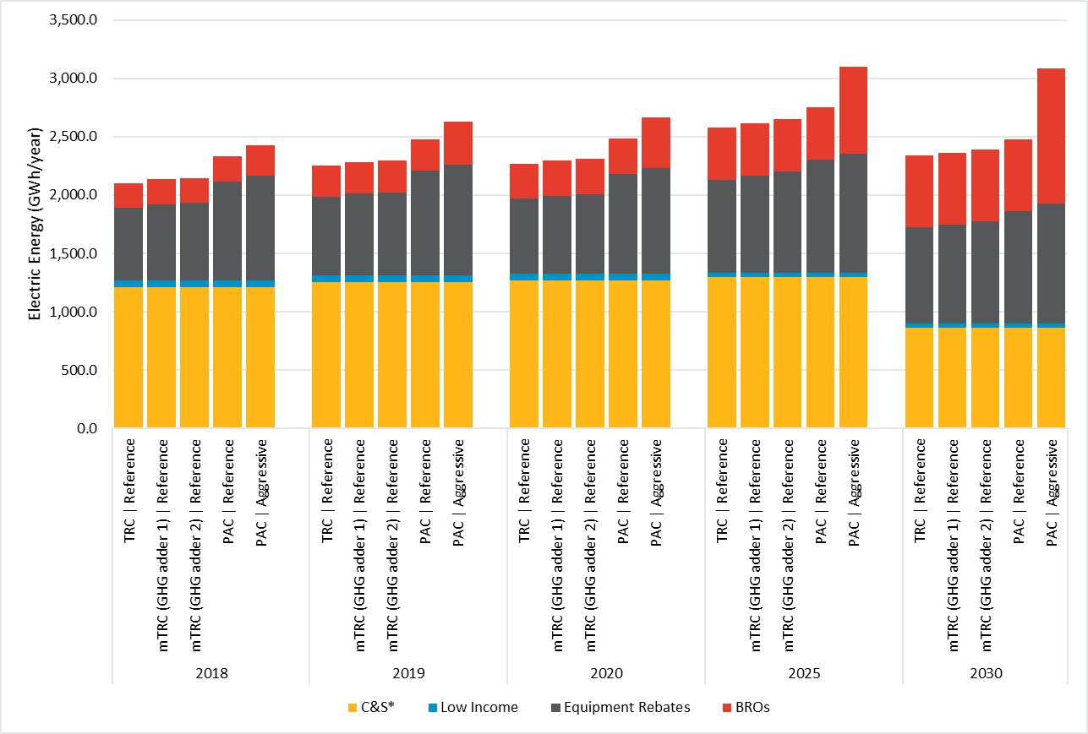

Table ES- . Statewide Net Incremental Electric Savings by Scenario

|  |  |  |  |  |  |  |  |  |  |  |
| --- | --- | --- | --- | --- | --- | --- | --- | --- | --- | --- |
|  | **Electric Energy (GWh/year)** | | | | | | | | | |
| **Year:** | **2018** | **2030** | **2018** | **2030** | **2018** | **2030** | **2018** | **2030** | **2018** | **2030** |
| **Program Type** | **Scenario 1:  TRC Reference** | | **Scenario 2: mTRC w/ GHG adder 1** | | **Scenario 3: mTRC w/ GHG adder 2** | | **Scenario 4:  PAC Reference** | | **Scenario 5:  PAC Aggressive** | |
| **Equipment Rebates** | 622 | 830 | 654 | 851 | 664 | 879 | 848 | 966 | 896 | 1,027 |
| **BROs** | 213 | 613 | 213 | 613 | 213 | 613 | 213 | 613 | 264 | 1,164 |
| **Low Income** | 57 | 33 | 57 | 33 | 57 | 33 | 57 | 33 | 57 | 33 |
| ***Incentive Programs (Subtotal)*** | ***892*** | ***1,476*** | ***924*** | ***1,497*** | ***935*** | ***1,524*** | ***1,118*** | ***1,611*** | ***1,217*** | ***2,223*** |
| **C&S\*** | 1,212 | 864 | 1,212 | 864 | 1,212 | 864 | 1,212 | 864 | 1,212 | 864 |
| **Grand Total** | **2,104** | **2,340** | **2,136** | **2,361** | **2,146** | **2,389** | **2,330** | **2,476** | **2,429** | **3,088** |

*includes interactive effects

Figure ES-. Statewide Net Incremental Gas Savings by Scenario

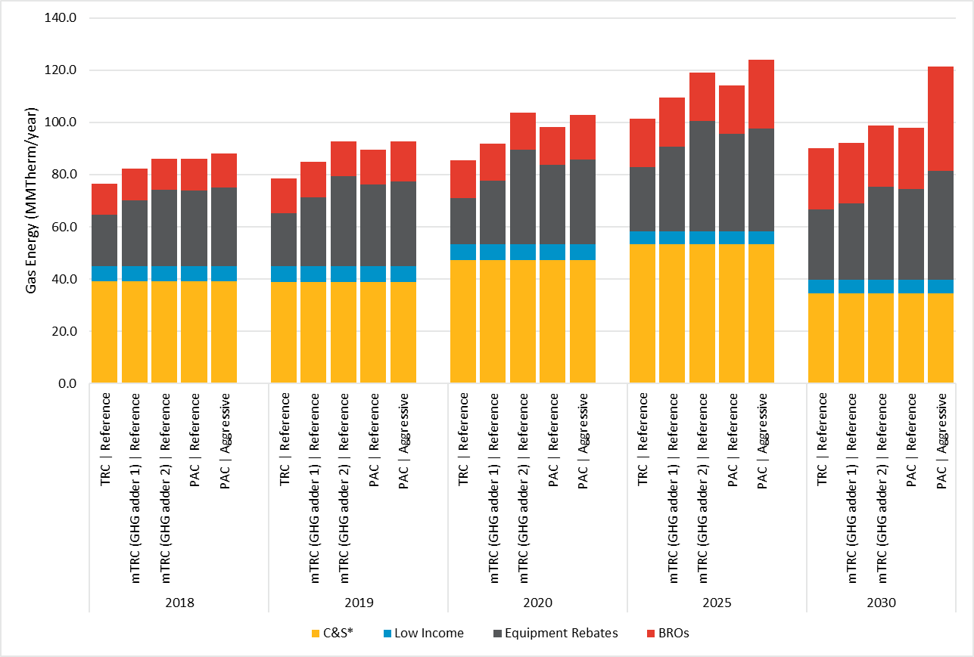

Table ES- . Statewide Net Incremental Gas Savings by Scenario

|  |  |  |  |  |  |  |  |  |  |  |  |
| --- | --- | --- | --- | --- | --- | --- | --- | --- | --- | --- | --- |
| **Gas Energy (MMTherm/year)** | | | | | | | | | | | |
| **Year:** | **2018** | **2030** | **2018** | **2030** | **2018** | **2030** | **2018** | **2030** | **2018** | **2030** |
| **Program Type** | **Scenario 1: TRC Reference** | | **Scenario 2: mTRC w/ GHG adder 1** | | **Scenario 3: mTRC w/ GHG adder 2** | | **Scenario 4: PAC Reference** | | **Scenario 5: PAC Aggressive** | | |
| **Equipment Rebates** | 20 | 27 | 25 | 29 | 29 | 36 | 29 | 35 | 30 | 42 |
| **BROs** | 12 | 23 | 12 | 23 | 12 | 23 | 12 | 23 | 13 | 40 |
| **Low Income** | 6 | 5 | 6 | 5 | 6 | 5 | 6 | 5 | 6 | 5 |
| ***Incentive Programs (Subtotal)*** | ***37*** | ***55*** | ***43*** | ***58*** | ***47*** | ***64*** | ***47*** | ***63*** | ***49*** | ***87*** |
| **C&S\*** | 39 | 35 | 39 | 35 | 39 | 35 | 39 | 35 | 39 | 35 |
| **Grand Total** | **77** | **90** | **82** | **92** | **86** | **99** | **86** | **98** | **88** | **121** |

*includes interactive effects

Market Potential as a Percent of Sales

Figure ES-3 and Figure ES-4 illustrate the market potential savings for incentive programs (Equipment Rebates, BROs and LI) as a percent of IOU sales for electric and gas, respectively. Table ES-4 and Table ES-5 report the year-by-year percentage reductions for each of the five scenarios for electric and gas, respectively. Savings as a percent of sales is a common metric provided in many potential studies. The percent savings serves as a useful benchmark when comparing market potentials to other jurisdictions and previous potential studies. It should be noted that savings from C&S were excluded from these calculations as per industry standard practice. The calculation uses net savings.

The following observations are noted for the electric results:

* Net market potential savings as a percentage of forecasted electric energy usage grows from 0.48% to 0.75% between 2018 and 2030 under Scenario 1 (TRC Reference). Under the most optimistic case, market potential grows from 0.66% in 2018 to 1.13% by 2030 under Scenario 5 (PAC Aggressive).
* Electric potential increases as the cost test used to screen measures accounts for additional benefits (addition of GHG abatement costs) or does not account for customer costs (PAC), with the TRC test yielding the least potential and the PAC test yielding the most potential. By 2030, Scenario 4 (PAC Reference) produces about 9% more electric savings than Scenario 1 (TRC Reference).
* Further, the electric results show that aggressive program engagement in the form of financing as well as increased marketing and incentives can yield additional savings beyond current program engagement as illustrated under Scenario 5 (PAC Aggressive), which produces about 38% more electric savings than Scenario 5 (PAC Reference).
* Finally, Scenario 5 (PAC Aggressive) produces about 51% more electric savings than Scenario 1 (TRC Reference).

The following observations are noted for the gas results:

* Market potential as a percentage of forecasted gas energy usage generally increases as the cost test used to screen measures becomes less stringent.
* For gas incentive program savings, Scenario 5 (PAC Aggressive) and Scenario 3 (mTRC w/ GHG adder 2) are roughly on par until 2023. This is because the GHG adder, which is high in Scenario 3, is applied uniformly to all gas measures. On the other hand, the impact of the adder on electric measures is loadshape-dependent, which means the benefits of the GHG adder vary by time of day and season. Beyond 2023, Scenario 5 starts to yield the highest gas potential as BROs participation starts to ramp up in the Aggressive scenario.
* By 2030, Scenario 3 (mTRC w/ GHG adder 2) produces about 16% more gas savings than Scenario 1 (TRC Reference).
* Another noteworthy trend for the gas results is that Scenario 5 (PAC Aggressive) surpasses Scenario 4 (PAC Reference) by about 36% at the end of the forecast period. This is attributable to aggressive program engagement. Overall, Scenario 5 (PAC Aggressive) produces about 56% more gas savings relative to Scenario 1 (TRC Reference) by 2030.

Figure ES-. Incremental Net Electric Market Potential as a Percent of Sales

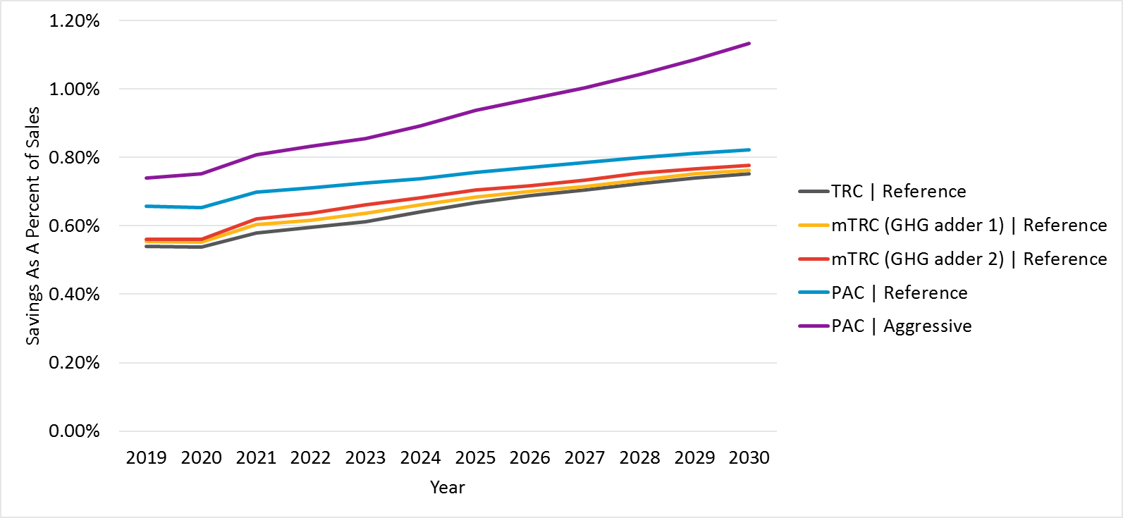

Note: Excludes C&S

Table ES- . Incremental Net Electric Market Potential as a Percent of Sales

|  |  |  |  |  |  |
| --- | --- | --- | --- | --- | --- |
| Year | Scenario 1: TRC Reference | Scenario 2: mTRC w/ GHG adder 1 | Scenario 3: mTRC w/ GHG adder 2 | Scenario 4: PAC Reference | Scenario 5: PAC Aggressive |
| 2018 | 0.48% | 0.50% | 0.51% | 0.61% | 0.66% |
| 2019 | 0.54% | 0.55% | 0.56% | 0.66% | 0.74% |
| 2020 | 0.54% | 0.55% | 0.56% | 0.65% | 0.75% |
| 2021 | 0.58% | 0.60% | 0.62% | 0.70% | 0.81% |
| 2022 | 0.59% | 0.62% | 0.64% | 0.71% | 0.83% |
| 2023 | 0.61% | 0.64% | 0.66% | 0.73% | 0.86% |
| 2024 | 0.64% | 0.66% | 0.68% | 0.74% | 0.89% |
| 2025 | 0.67% | 0.68% | 0.70% | 0.76% | 0.94% |
| 2026 | 0.69% | 0.70% | 0.72% | 0.77% | 0.97% |
| 2027 | 0.71% | 0.72% | 0.73% | 0.79% | 1.00% |
| 2028 | 0.72% | 0.73% | 0.75% | 0.80% | 1.04% |
| 2029 | 0.74% | 0.75% | 0.77% | 0.81% | 1.09% |
| 2030 | 0.75% | 0.76% | 0.78% | 0.82% | 1.13% |

Figure ES-. Incremental Net Gas Market Potential as a Percent of Sales

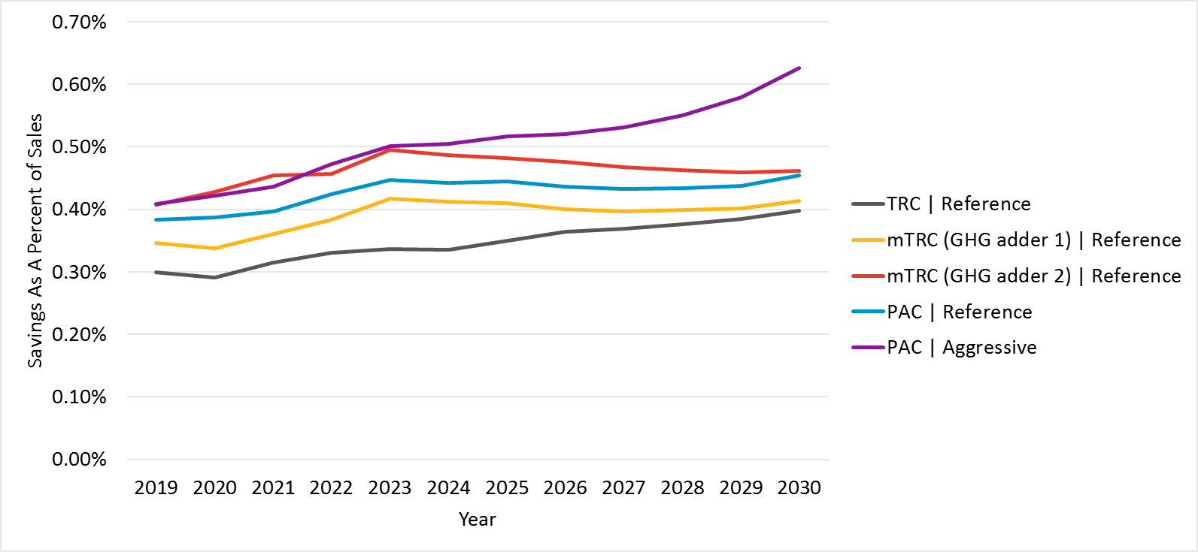

Note: Excludes C&S

Table ES- . Incremental Net Gas Market Potential as a Percent of Sales

|  |  |  |  |  |  |
| --- | --- | --- | --- | --- | --- |
| Year | Scenario 1: TRC Reference | Scenario 2: mTRC w/ GHG adder 1 | Scenario 3: mTRC w/ GHG adder 2 | Scenario 4: PAC Reference | Scenario 5: PAC Aggressive |
| 2018 | 0.28% | 0.33% | 0.36% | 0.35% | 0.37% |
| 2019 | 0.30% | 0.35% | 0.41% | 0.38% | 0.41% |
| 2020 | 0.29% | 0.34% | 0.43% | 0.39% | 0.42% |
| 2021 | 0.32% | 0.36% | 0.46% | 0.40% | 0.44% |
| 2022 | 0.33% | 0.39% | 0.46% | 0.43% | 0.48% |
| 2023 | 0.34% | 0.42% | 0.50% | 0.46% | 0.51% |
| 2024 | 0.34% | 0.42% | 0.50% | 0.45% | 0.52% |
| 2025 | 0.36% | 0.42% | 0.49% | 0.46% | 0.53% |
| 2026 | 0.37% | 0.41% | 0.48% | 0.45% | 0.53% |
| 2027 | 0.38% | 0.41% | 0.47% | 0.44% | 0.54% |
| 2028 | 0.39% | 0.41% | 0.47% | 0.44% | 0.56% |
| 2029 | 0.39% | 0.41% | 0.47% | 0.45% | 0.59% |
| 2030 | 0.41% | 0.42% | 0.47% | 0.46% | 0.63% |

Market Potential by Sector

Figure ES-5 and Table ES-6 illustrates the electric market potential savings for incentive programs (Equipment Rebates, BROs and LI) separated for each of the six sectors assessed in this study (Residential, Commercial, Industrial, Agricultural, Mining, and Streetlighting). Figure ES-6 and Table ES-7 provides the comparable information for the gas market potential savings. Savings represented by sector helps to inform the magnitude of potential for each of the sectors. It should be noted that savings from C&S were excluded from these calculations. The rationale for the exclusion was that the CPUC adopts separate goals for C&S. Note further that the sector-specific results are only shown for Scenario 1 (TRC Reference). The rationale for reporting on only one scenario is that while the magnitude of savings for the other four scenarios differ, the relative share of savings across the various sectors does not vary significantly. Sector-level results for all scenarios are provided in section 4.

The following observations are noted about the electric results:

* As can be seen in the chart and table, the commercial and residential sector dominate the savings with the commercial sector showing slightly higher potential over the study horizon.
* The incremental savings potential grows over time for the residential, commercial and agricultural sectors. This growth is largely attributable to sectoral growth but also reflects greater levels of market uptake for BROs in the later years.
* Conversely, the incremental savings potential declines for the industrial, mining and streetlighting sectors. For industrial and mining, this savings decline is highly correlated with flat or negative customer growth rates during the time horizon. For streetlighting, the market potential for high efficiency measures becomes more saturated over time.

The following observations are noted about the gas results:

* The largest savings potential comes from the residential sector, with smaller savings for industrial and commercial, and minimal savings for the agricultural and mining sectors.
* Yearly savings potential for all sectors grows modestly over time with much of the growth coming from higher levels of market uptake for BROs in the outer years.

Figure ES- . Statewide Net Incremental Electric Market Potential for Incentive Programs by Sector for the TRC Reference Scenario

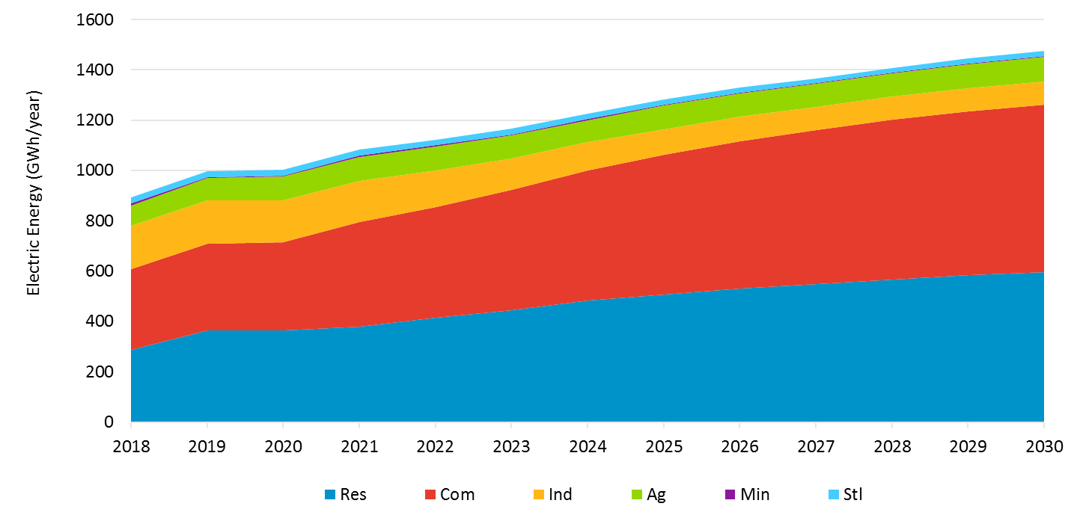

Table ES- . Statewide Net Incremental Electric Market Potential for Incentive Programs by Sector for the TRC Reference Scenario

|  |  |  |  |  |  |  |  |  |  |  |  |  |  |
| --- | --- | --- | --- | --- | --- | --- | --- | --- | --- | --- | --- | --- | --- |
| Sector | 2018 | 2019 | 2020 | 2021 | 2022 | 2023 | 2024 | 2025 | 2026 | 2027 | 2028 | 2029 | 2030 |
| Res | 288.42 | 363.72 | 364.89 | 379.77 | 414.97 | 445.20 | 481.69 | 506.66 | 530.09 | 548.55 | 566.71 | 583.29 | 595.86 |
| Com | 319.09 | 345.57 | 349.69 | 416.82 | 440.93 | 477.00 | 518.60 | 554.76 | 585.26 | 612.90 | 636.26 | 652.92 | 664.59 |
| Ind | 173.73 | 171.12 | 165.78 | 162.16 | 145.37 | 125.17 | 111.37 | 103.28 | 98.70 | 91.88 | 90.70 | 91.28 | 93.09 |
| Ag | 80.72 | 89.43 | 94.64 | 96.22 | 95.37 | 92.44 | 88.67 | 93.16 | 91.42 | 90.72 | 92.20 | 94.96 | 99.17 |
| Min | 6.24 | 5.02 | 4.76 | 4.67 | 4.53 | 4.37 | 4.20 | 4.03 | 3.87 | 3.61 | 3.43 | 3.29 | 3.15 |
| Stl | 24.29 | 23.70 | 23.02 | 22.37 | 21.74 | 21.14 | 20.57 | 20.04 | 19.54 | 19.08 | 18.65 | 19.05 | 19.90 |

Figure ES- . Statewide Net Incremental Gas Market Potential for Incentive Programs by Sector for the TRC Reference Scenario

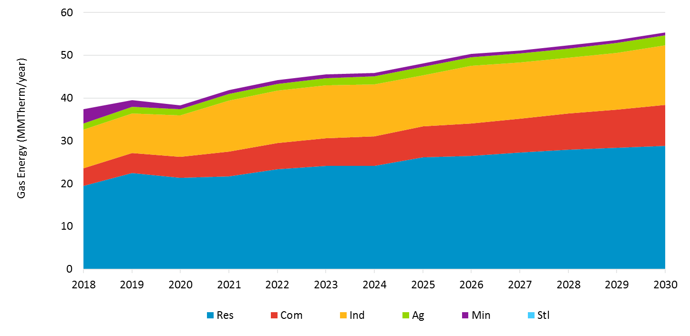

Table ES- . Statewide Net Incremental Gas Market Potential for Incentive Programs by Sector for the TRC Reference Scenario

|  |  |  |  |  |  |  |  |  |  |  |  |  |  |
| --- | --- | --- | --- | --- | --- | --- | --- | --- | --- | --- | --- | --- | --- |
| Sector | 2018 | 2019 | 2020 | 2021 | 2022 | 2023 | 2024 | 2025 | 2026 | 2027 | 2028 | 2029 | 2030 |
| Res | 19.42 | 22.45 | 21.37 | 21.73 | 23.39 | 24.09 | 24.15 | 26.17 | 26.51 | 27.21 | 27.94 | 28.41 | 28.87 |
| Com | 4.10 | 4.68 | 4.89 | 5.76 | 6.07 | 6.53 | 6.95 | 7.24 | 7.56 | 8.01 | 8.43 | 8.90 | 9.51 |
| Ind | 9.06 | 9.31 | 9.67 | 11.88 | 12.23 | 12.32 | 12.14 | 11.93 | 13.46 | 13.11 | 13.03 | 13.25 | 13.94 |
| Ag | 1.49 | 1.50 | 1.51 | 1.57 | 1.64 | 1.72 | 1.79 | 1.93 | 2.01 | 2.10 | 2.19 | 2.28 | 2.39 |
| Min | 3.29 | 1.61 | 0.85 | 0.86 | 0.85 | 0.83 | 0.81 | 0.78 | 0.75 | 0.72 | 0.70 | 0.67 | 0.64 |
| Stl | 0.00 | 0.00 | 0.00 | 0.00 | 0.00 | 0.00 | 0.00 | 0.00 | 0.00 | 0.00 | 0.00 | 0.00 | 0.00 |

Expenditures

Figure ES-7 and Table ES-6 show projected statewide spending by scenario. Expenditures represent the costs for both rebates and program administration costs. Expenditures are only shown for Equipment Rebates and BROs costs[8]. No cost data is reported for LI and C&S programs. Cost increases over time for all scenarios are explained by forecasted increase in annual adoption (a function of rebates and increased awareness and willingness to adopt) as well as cost inflation. In addition, higher program acquisition costs are experienced due to greater shares of higher cost measures being rebated over time.

Since overall potential is driven by electric savings, the trend generally follows that of electric potential whereby Scenario 5 (PAC Aggressive) produces the most expensive portfolio for equipment savings, and Scenario 1 (TRC Reference), the least. By 2030, Scenario 4 (PAC Reference) is expected to cost about 36% more than Scenario 1 (TRC Reference). Aggressive program engagement further increases spending as illustrated by Scenario 5 (PAC Aggressive), which costs about 38% more than Scenario 4 (PAC Aggressive).

Figure ES- . Statewide Program Expenditures by Scenario for Incentive Programs

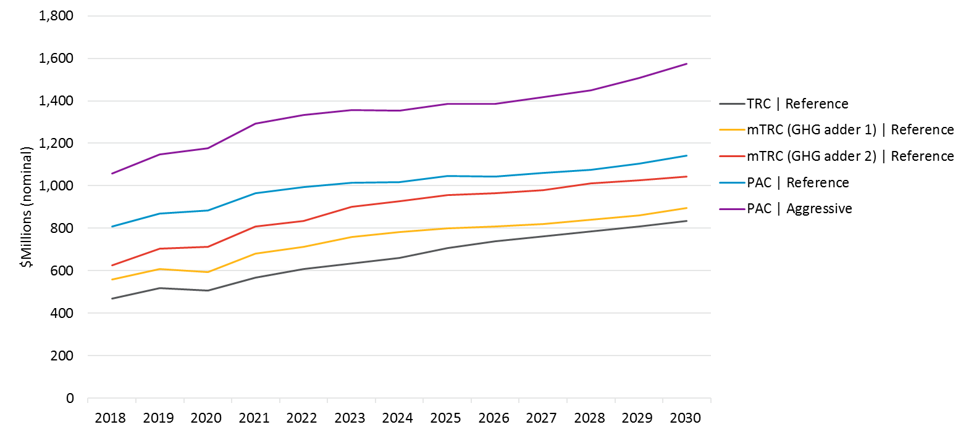

Note: Excludes C&S and Low Income

Table ES- . Statewide Spending by Scenario for IOU Rebate Programs (Million $)

|  |  |  |  |  |  |
| --- | --- | --- | --- | --- | --- |
| Year | Scenario 1: TRC Reference | Scenario 2: mTRC w/ GHG adder 1 | Scenario 3: mTRC w/ GHG adder 2 | Scenario 4: PAC Reference | Scenario 5: PAC Aggressive |
| 2018 | 469.8 | 558.7 | 624.6 | 807.6 | 1058.7 |
| 2019 | 519.0 | 609.1 | 703.9 | 870.0 | 1146.8 |
| 2020 | 506.6 | 593.0 | 713.2 | 884.2 | 1177.5 |
| 2021 | 568.9 | 682.1 | 808.1 | 965.7 | 1293.4 |
| 2022 | 607.9 | 713.0 | 833.3 | 994.3 | 1334.1 |
| 2023 | 633.6 | 758.8 | 902.6 | 1014.7 | 1355.8 |
| 2024 | 659.1 | 782.2 | 928.0 | 1016.6 | 1353.9 |
| 2025 | 706.5 | 800.6 | 957.2 | 1047.7 | 1385.1 |
| 2026 | 738.7 | 807.0 | 965.7 | 1044.8 | 1386.2 |
| 2027 | 762.6 | 819.2 | 979.4 | 1060.6 | 1418.4 |
| 2028 | 786.0 | 839.2 | 1011.9 | 1076.0 | 1450.8 |
| 2029 | 808.9 | 860.9 | 1024.8 | 1104.1 | 1507.5 |
| 2030 | 835.6 | 896.2 | 1042.7 | 1140.7 | 1574.6 |

# Introduction

## Context of the Goals and Potential Study

Navigant Consulting, Inc. along with its partners Tierra Resource Consultants LLC (collectively known as “the Navigant team”) prepared this study (“2018 and Beyond Potential and Goals Study”) for the California Public Utilities Commission (CPUC). The purpose of this study is to develop estimates of energy and demand savings potential in the service territories of California’s major investor-owned utilities (IOUs) during the post-2017 energy efficiency (EE) rolling portfolio planning cycle. This report includes results for Pacific Gas and Electric (PG&E), Southern California Edison (SCE), San Diego Gas and Electric (SDG&E), and Southern California Gas (SCG). A key component of the 2018 Potential and Goals Study (2018 Study) is the Potential and Goals Model (PG Model), which provides a single platform in which to conduct robust quantitative scenario analysis that reflects the complex interactions among various inputs and Policy Drivers.

The 2018 Study is the fourth consecutive potential study conducted by the Navigant team on behalf of the California Public Utilities Commission (CPUC). Navigant conducted the 2011[9] study, which informed the 2013-14 IOU program goals, and the 2013 Study,[10] which was used to inform the 2015 goals for California IOUs, and the 2015[11] study which informed the 2016 and beyond goals. A significant number of recent policy changes in California are driving updates to the approach and methodology of the 2018 study. These policy drivers include:

* **California Assembly Bill 802 (AB802)** has the potential to significantly shift the way California energy efficiency Program Administrators (PAs) rebate and claim energy savings from energy efficiency programs. Historically Investor Owned Utilities (IOU) programs have been mostly limited to seeking, rebating, and claiming energy efficiency savings for equipment that exceeds current code or standard. Furthermore, and with a few exceptions, the only energy savings that could be claimed was the difference between code or standard and the high efficiency installation; this is referred to as “above-code savings”.[12] However, AB802 could shift away from this paradigm to allow and incentivize all energy savings (including those that are “below-code”).[13] Furthermore, AB802 instructs energy efficiency be achieved not only though equipment installations but also through behavior and operational efficiency interventions. Navigant produced a Technical Analysis of AB802 (AB802 TA) in 2016. The AB802 TA did not inform goals but its methodological advances over prior studies serves as a basis for the 2018 PG study.
* **California Senate Bill 350 (SB350)** established California’s 2030 greenhouse gas reduction target of 40 percent below 1990 levels. To achieve this goal, SB 350 sets 2030 targets for energy efficiency and renewable electricity, among other actions aimed at reducing greenhouse gas emissions. Of concern to the PG study, SB350 requires the state to double statewide energy efficiency savings in electricity and natural gas end uses by 2030 and that the goals not be constrained based on past program performance.
* **CPUC Cost Effectiveness Tests and Inputs Updates** are currently underway though the Integrated Distributed Energy Resources (IDER) proceeding (R. 14-10-003). Multiple changes have been or are being considered. First, in mid-2016 the CPUC released updated energy avoided costs for use in all distributed energy resources, including energy efficiency program planning and budget approval. These avoided costs were generally observed to be lower than previous avoided cost thus potentially resulting in lower overall portfolio cost effectives through the Total Resource Cost (TRC) Test.[14] The CPUC has been considering the application of the California Standard Practice Manual tests for DER needs including the use of a GHG adder to be incorporated into the current avoided costs.[15]
* **CPUC Net Goals Direction** – The CPUC directed 2018 and beyond goals to be set net of free-ridership due to changes in baseline policy.[16] As such, all results, tables, and graphs shown in this document are reported as net of free-ridership unless otherwise noted.

The 2018 Potential and Goals Study supports multiple related efforts:

1. Inform the CPUC as it proceeds to adopt goals and targets, providing guidance for the next IOU energy efficiency portfolios. The potential model is a framework that facilitates the stakeholder process. The model helps build consensus for goals by soliciting agreement on inputs, methods, and model results.
2. Guide the IOUs in portfolio planning and the state’ principal energy agencies in forecasting for procurement, including the planning efforts of the CPUC, California Energy Commission (CEC), and California Independent System Operator (CAISO). Although the model cannot be the sole source of data for IOU program planning activities, it can provide critical guidance for the IOUs as they develop their plans for the 2018 and beyond portfolio planning period. The study is also providing California’s principal energy agencies with the tools and resources necessary to develop outputs in a manner that is most appropriate for their planning and procurement needs.
3. Inform strategic contributions to SB350 targets. The CEC has historically used the PG study to develop its forecast of Additional Achievable Energy Efficiency Potential (AAEE). SB350 targets a doubling of the AAEE by 2030. The CEC will continue to rely upon the PG study as an input to AAEE; the PG study will also serve as an input to SB350 target setting.

The study period spans from 2018-2030 based on the direction provided by CPUC and focuses on current and potential drivers of energy savings in IOU service areas. Analysis of energy efficiency savings in publicly owned utility service territories is not part of the scope of this effort.

## Types of Potential

Consistent with the 2015 Study and consistent with common industry practice, the 2018 Study forecasts energy efficiency potential at four levels for rebate programs:

1. **Technical Potential:** Technical potential is defined as the amount of energy savings that would be possible if the highest level of efficiency for all technically applicable opportunities to improve energy efficiency were taken, including retrofit measures, replace-on-burnout measures, and new construction measures. Technical potential represents the immediate replacement of applicable equipment-based technologies regardless of the remaining useful life of the existing measure. Technical potential is undefined for codes and standards, low income programs, whole building programs, and behavior/retrocommissioning/operational efficiency programs.
2. **Economic Potential:** Using the results of the technical potential analysis, the economic potential is calculated as the total energy efficiency potential available when limited to only cost effective measures.[17] All components of economic potential are a subset of technical potential. Like technical potential, economic potential can be represented as instantaneous or annualized. Economic potential screens considered in this study include:
   1. ***Total Resource Cost (TRC) Test*** - The CA Standard Practice Manual defines the TRC test as the measurement of the net benefits and costs that accrue to society (program administrator all its customers). It compares the benefits, which are the avoided cost of generating electricity and supplying natural gas, with the total costs, which include program administration and customer costs. The TRC does not include the costs of incentives.
   2. ***Modified TRC*** (**mTRC**)- The mTRC test builds upon the TRC test by including a GHG adder to the avoided cost of electricity and natural gas. The GHG adder is intended to estimate the value of the reduced carbon emissions that energy efficiency provide, and that the value of the GHG adder should be based on the marginal cost of abatement (i.e., the cost of achieving California’s GHG reduction goals). The GHG cost included in the 2016 avoided cost reflects the values of the permits utilities are required to buy as part of California’s Assembly Bill (AB) 32 cap and trade program for 2020 GHG targets. The GHG adder is intended to cover the anticipated additional costs to meet 2030 GHG targets.
   3. ***Program Administrator Cost (PAC) Test*** - The CA Standard Practice Manual defines the PAC test as the measurement of the net benefits and costs that accrue to the program administrator (i.e. the utilities). It compares the benefits, which are the avoided cost of generating electricity and supplying natural gas, with the total costs, which include program administration and incentive costs. The PAC does not include the additional out-of-pocket costs for equipment paid for by the customer.
3. **Market Potential:** The final output of the potential study is a market potential analysis, which calculates the energy efficiency savings that could be expected in response to specific levels of incentives and assumptions about existing CPUC policies, market influences, and barriers. All components of market potential are a subset of economic potential. Some studies also refer to this as “achievable potential.” Market potential is used to inform the utilities’ energy efficiency goals, as determined by the CPUC. Market potential has historically been used by the CPUC to inform the goal-setting process.
4. **Stranded Potential** is a subset of the Market Potential. These savings are defined as the opportunities for EE that have not historically been captured by either EE program administrator (PA) rebate programs or codes and standards. Stranded Potential is below-code savings that is not materializing in the market because there is no incentive for the customer to upgrade their existing equipment given current program rebate policy. Under AB802, PAs could start offering rebates for bringing existing equipment up to code thus potentially motivating a whole new subset of customers to install EE measures and thus capture the Stranded Potential.

Market potential is represented in the 2018 PG study two different ways; each is based on the same data and assumptions though each serve separate needs and provide necessary perspectives.

1. **Incremental Savings** represent the annual energy and demand savings achieved by the set of programs and measures in the first year that the measure is implemented. It does not consider the additional savings that the measure will produce over the life of the equipment. A view of incremental savings is necessary to understand what additional savings an individual year of energy efficiency programs will produce. This has historically been the basis for IOU program goals.
2. **Cumulative Savings** represent the total savings from energy efficiency program efforts from measures installed since 2015 including the current program year, and are still active in the current year. It includes the decay of savings as measures reach the end of their useful lives and the continuation of savings as customer re-install high efficiency equipment that has reached the end of its EUL. Cumulative savings also account for the timing effects of codes and standards that become effective after measure installation.

Many variables drive the calculation of market potential. These include assumptions about the way efficient products and services are marketed and delivered, the level of customer awareness of energy efficiency, and customer willingness to install efficient equipment or operate equipment in ways that are more efficient. The Navigant team used the best available current market knowledge to calibrate market potential for voluntary rebate programs

## Scope of this Study

This study forecasts the potential energy savings from the energy efficiency programs and codes and standards across all customer sectors: Residential, Commercial, Agricultural, Industrial, Mining, and Street Lighting. This study does not set IOU goals nor does it make a recommendation as to how to set goals. Rather it informs the CPUC’s goal setting process.

The study builds upon the 2015 PG Study as well as the AB802 TA. Notable updates to the 2018 PG study relative to the 2015 PG study include:

* **Fully accommodate calculation of Stranded Potential** – Modeling algorithms pioneered in the AB802 TA were adapted and improved upon in the 2018 PG study to capture the impacts of AB802 and quantify Stranded Potential
* **Present Scenarios to inform Goal Setting** – The 2018 PG study integrated scenario analysis at a much earlier stage in the project allowing the CPUC to consider scenarios in the goal setting process.
* **Refresh Residential and Commercial measure list** – The study conducted a holistic refresh of the rebated technologies to be included in the model. The previous measure list was not referenced when creating the new measure list to avoid any bias. Rather existing rebate programs, stakeholder feedback, IOU emerging technology programs, and potential studies elsewhere around the nation were primarily considered in developing a new list. The new list was designed to better accommodate modeling of Stranded Potential
* **Technology based model for Industrial/Agriculture sectors** – The 2015 PG model forecasted savings in the Industrial and Agriculture sectors primarily using end-use energy efficiency supply curves derived from regional data available from the U.S. Department of Energy. The 2018 PG model dives deeper and forecasts savings at a representative technology level (rather than just at the end use level).
* **Expand Consideration of Behavior, Operational, Retrocommissioning (BROs) Savings** – The model significantly expanded the consideration of BROs interventions in the residential and commercial sectors. Industrial Strategic Energy Management was also considered.
* **Report Potential on a Net Basis** – Past PG studies have reported potential on a gross basis for goal setting purposes. The CPUC is moving towards setting goals on a net basis[18]. Thus, all results are reported on a net basis. Because results are reported as net, and previous studies reported gross, direct comparison of results from this study to past studies may not be appropriate.

## Stakeholder Engagement

The Navigant team engaged with stakeholders through the Demand Analysis Working Group[19] throughout the process of this study to request data, collect feedback on scope, methodology, and key assumptions. Table 1‑1 below provides the schedule of meetings that were held. After each meeting, stakeholders were provided a period in which they could submit informal comments to the Navigant team and CPUC. The team reviewed all comments received and incorporated appropriate edits/changes in the study thus.

Table ‑: Stakeholder Meeting Schedule

|  |  |
| --- | --- |
| Date | Topics of Discussion |
| July 19, 2016 | Overview of the scope of the 2018 Potential and Goals Study |
| August 29, 2016 | Residential, Commercial and AIMS Measure Selection |
| November 4, 2016 | BROs intervention selection, Whole Building characterization methodology, and avoiding double counting |
| December 9, 2016 | (Webinar) AIMS Methodology |
| December 12, 2016 | (Webinar) Calibration, Scenarios, and Cumulative Savings |
| April 20, 2017 | (Webinar) BROs Draft Results |
| April 28, 2017 | (Webinar) Low Income Methodology/Data |

## Content of this Report

This report documents the data relied upon by and the results of the 2018 Study.

* **Section 2** provides an overview of the study’s methodology for each key area of the study.
* **Section 3** provides details on the input data used for each key area of the study. It describes the data sources and process taken to incorporate the data into the PG Model.
* **Section 4** provides the 2018 PG Model results.
* **Section 5** compares the 2018 PG Model results to the 2015 PG Study.
* **Appendices** provide additional details for key topic areas.

Aside from this report, the following are available to the public:

* 2018 PG Model File – an Analytica based file that contains the PG model used to create the results of this study;
* 2018 PG BROs Model File – a spreadsheet based file that contains the model used to create the BROs results for this study;
* 2018 PG Results Viewer – a spreadsheet viewer that contains detailed results at the end use level; and
* 2018 PG MICS – a spreadsheet version of the Measure Input Characterization System documenting all final values for all technologies forecasted in the model.

These additional documents and files can be found on the CPUC’s website.[20]

# Study Methodology

The primary purpose of the 2018 Study is to provide the CPUC with information and analytical tools to engage in goal setting for the IOU energy efficiency portfolios. In addition, this study informs forecasts used for procurement planning. The model itself does not establish any regulatory requirements.

The 2018 model forecasts potential energy savings from a variety of sources within six distinct sectors: Residential, Commercial, Agricultural, Industrial, Mining, and Street Lighting. These sectors are also used in the CEC’s IEPR forecast. Within some or all the sectors, sources of savings include:

* **Rebated Technologies:** Discrete mass market technologies that are incentivized and provided to IOU customers in the Residential, Commercial, Industrial, Agricultural, Mining, and Street-lighting sectors. These sectors are modeled using individual measures for specific applications.
* **Whole Building Approaches:** In the case of whole-building initiatives, the “measure” is characterized for the building retrofit or house retrofit rather than for specific technology or end uses. Whole building initiatives are modeled for the Residential and Commercial sectors.
* **Custom Measures and Emerging Technologies:** This study defines Custom Measures as improvements to processes specific to the industrial and agricultural sectors, the measures themselves are not individually defined and rather represent a wide array of, niche technologies. Similarly, Emerging Technologies are represented as a wide array of technologies and not individually defined.
* **Behavior, Retrocommissioning, Operational Efficiency (BROs):** For the purposes of this study, the Navigant team defines behavior-based initiatives as those providing information about energy use and conservation actions, rather than financial incentives, equipment, or services. Savings from BROs are modeled as incremental impacts of behavior and operational changes beyond equipment changes.
* **Residential Low Income:** The methodology for the low-income sector remains unchanged from the 2013 Study. Data was updated to reflect the most recent information available from the CPUC regarding savings per participant and forecasted participants.
* **Codes and Standards (C&S):** Codes regulate building design, requiring builders to incorporate high-efficiency measures. Standards set minimum efficiency levels for newly manufactured appliances. Savings are forecasting from C&S that went into effect starting in 2006.
* **Financing:** Financing has the potential to break through several market barriers that have limited the widespread market adoption of cost-effective energy efficiency measures. The PG Model estimates the effects of introducing energy efficiency financing on market potential and how shifting assumptions about financing affect the potential energy savings.

AB802, SB350 and possible changes to the CPUC Cost Effectiveness policies have driven the PG study to update its methodology in several key areas. The modeling methodology leverages much of what was used in the 2015 Study but further builds upon the analysis presented in the AB802 Technical Analysis. The rest of this section discusses the 2018 Study methodology.

## Modeling Methods

Table 2‑1 below summarizes the modeling approach for each source of savings. The modeling approaches are discussed in more detail in the subsequent subsections.

Table 2‑1. Overview of Modeling and Calibration Approach

|  |  |  |
| --- | --- | --- |
| Savings Source | Summary of Modeling Approach | Summary of Calibration Approach |
| **Rebated Technologies** | Bass diffusion forecast competes below code, at code and above code technologies against each other. | Calibrated to historic program spending |
| **Whole Building Packages** | Bass diffusion forecast competes below code, at code and above code technologies against each other. | Calibrated to historic program spending |
| **Industrial Custom Measures and Emerging Technologies** | Trend forecast based on recent IOU custom project savings in the industrial sector. Emerging technologies can “ramp up” the trend in the future. | Forecast is anchored in IOU program history and thus inherently calibrated to current market conditions. |
| **Behavior, Retrocommissioning, Operational Efficiency (BROs)** | Interventions are limited to the applicable customers and markets. For the applicable markets, Navigant assumptions are made regarding reasonable penetration rates. | Starting penetration rates are based on current penetration rates. |
| **Residential Low Income** | Forecast of participation based on IOU program filings, data gaps filled by Navigant through extrapolation. | Forecast is anchored in IOU program history and plans and thus inherently calibrated to current market conditions. |
| **Codes and Standards (C&S):** | Model replicates the algorithms of the CPUC’s Integrated Standards Savings Model (ISSM) | Calibration not needed as evaluated results are used. |
| **Financing** | Financing is applied to rebated technologies and whole building approaches. It reduces upfront barriers increasing consumer adoption and supplements bass diffusion modeling framework | No program data to calibrate to |

### Rebated Technologies

Rebated technologies make up the majority of historic program spending and savings claims. Thus, they are a core part of the 2018 PG model’s forecast. Historically, rebate programs could mostly claim above-code savings for rebated technologies. However, with the introduction of AB802, rebate programs can now claim to-code savings for select technologies more broadly. Our approach to modeling rebated technologies has thus updated since the 2015 PG study to accommodate the modeling of to-code savings.

#### Types of Technologies

The PG study forecasts the adoption of more than 150 energy efficiency technologies. Each measure can be classified into one of several broad measure types. Each measure type is treated differently in terms of calculating cost effectiveness, calculating energy savings relative to baseline, and modeling consumer decisions and market adoption. These differences are further discussed throughout this section report. The types of measure installations are:

* **New Construction –** Equipment that is installed in a newly constructed building. In this situation, energy savings calculations are always relative to code.
* **Installation in Existing Buildings**
  + **Equipment**
    - **Replace on Burnout (ROB) –** New equipment needs to be installed to replace equipment that has reached the end of its useful life, has failed, and is no longer functional. Upon failure ROB equipment is generally not repaired by the customer and instead replaced with a new piece of equipment. Appliance standards are applicable to some types of ROB equipment and apply to all new purchases. An example of an ROB measure is the light bulb.
    - **Accelerated Replacement –** Equipment that is beyond its EUL and is continuing to function in the market (likely because of repairs that a customer has conducted on the equipment to extend its life). The customer is not planning to replace the equipment on a “regular cycle” and thus programs are targeted at the customer to accelerate the equipment’s replacement. Appliance standards are applicable to some types of Accelerated Repair equipment but only apply to new purchases (not the repair). Examples include measures such as boilers and chillers.
  + **Retrofit**
    - **Retrofit Add-on –** New equipment being installed onto an existing system, either as an additional, integrated component or to replace a component of the existing system. In either case, the primary purpose of the add-on measure is to improve overall efficiency of the system. These measures are not able to operate on their own as stand-alone equipment and are not required for the operation of the existing equipment or building. Codes or standards may be applicable to some types of Retrofit Add-on measures by setting minimum efficiency levels of newly installed equipment; but the codes or standards do not require the measure to be installed. Examples include measures such as boiler controls, VFDs, and window film.
    - **Retrofit Replacement –** Measures that will be replaced not due to equipment failure but rather triggered by building renovation. These measures are those that are installed to replace previously existing equipment that has either not failed or is past the end of its EUL but is not compromising use of the building (such as insulation and water fixtures). Many of these installations are subject to building code but upgrades are not always required by code until a major building renovation (and even then some may not be required).

#### Technology Groups, Efficiency Levels and Competition

Within each technology type, multiple groups of technologies are formed and characterized. A technology group consists of multiple levels of efficiency of the same technology. An example or which is illustrated below in Table 2‑2. Technologies within a technology group compete for installations. The advantage of characterizing technology-based inputs is that a technology group can have multiple baseline and efficient technologies, in contrast to specifically defined ones in measure-based inputs (as used in the 2015 PG study).The individual technologies characterized within each group are designed to capture varied efficiency levels including below code units, at code units, and multiple levels of high efficiency units (up to and including “emerging technologies” where appropriate.) In determining which technologies to include in a group, the team considers possible future code levels as well as popular efficiency levels historically rebated by IOU programs.

Table ‑2. Example of Technologies within a Technology Group

|  |  |  |
| --- | --- | --- |
| Technology Group | Technology | Description |
| Residential Central AC | Residential SEER 10 AC | Average Below-Code Efficiency Level |
| Residential SEER 13 AC | Code Efficiency Level pre 2015 |
| Residential SEER 14 AC | Code Efficiency Level 2015 and Beyond |
| Residential SEER 15 AC | High Efficiency Level 1 |
| Residential SEER 18 AC | High Efficiency Level 2 |
| Residential SEER 20 AC | High Efficiency Level 3 |

The model simulates the flow of equipment stock across the different technologies within a technology group. Flow of stock occurs when the customer owning the equipment reaches a decision point to either maintain the existing equipment or replace it with a new unit. The decisions available to the customer in the model depend on the type of technology (discussed previously in section 2.1.1.1) the equipment in question falls in. Figure 2‑1 below illustrates the replacement options a customer is faced with. The model allows customers to maintain their existing equipment, upgrade to higher efficiency equipment or downgrade from high efficiency equipment to code level equipment. With each replacement is associated a unique unit energy savings, cost, and cost effectiveness of the decision.

Figure ‑. Stock Flow within a Technology Group

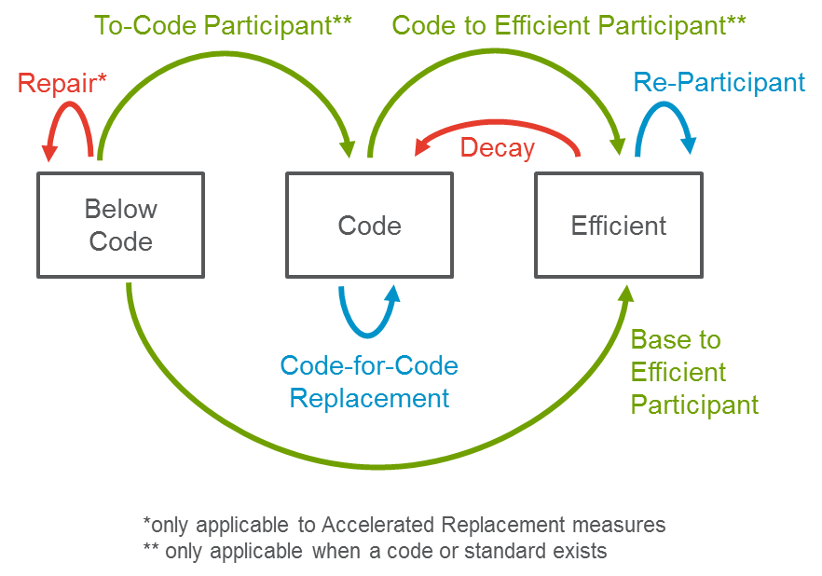

#### Technical and Economic Potential

Technical potential is defined as the amount of energy savings that would be possible if the highest level of efficiency for all technically applicable opportunities to improve energy efficiency were taken, including retrofit measures, replace-on-burnout measures, and new construction measures. As previously discussed, technical potential can be reported in two forms: Instantaneous and Annualized. The following considerations are factored into our calculation of technical potential:

* Technical potential assumes all eligible customers within a technology group adopt the highest level of efficiency available within the technology group
* Technical potential represents the savings from converting all equipment that is at or below code to the highest level of efficiency within a technology group.
* Total technical potential is a sum of all individual technical potential within each technology group excluding whole building packages, low income programs, and BROs. Whole building packages are excluded from the technical potential as doing so would be duplicative. Technical potential for low income programs and BROs are undefined in our study.

Using the results of the technical potential analysis, the economic potential is calculated as the total energy efficiency potential available when limited to only cost effective measures. All components of economic potential are a subset of technical potential. In addition to the above considerations in modeling technical potential, the following additional considerations are factored into our calculation of economic potential:

* Economic potential assumes all eligible customers within a technology group adopt the highest **cost-effective** level of efficiency available within the technology group. The most efficient technology within the group may not be cost effective.
* Various cost effectiveness screens can be applied (previously discussed in Section 1.2); thus, economic potential can vary by scenario. Meanwhile, technical potential does not vary by scenario.

#### Market Potential

To estimate the market potential for rebated technologies, the model employs a three-step process as shown in Figure 2‑2. In the first step, the model calculates the number of installation decisions expected to occur for each measure in each year. The types of installations decisions vary by type of technology. For ROB technologies (e.g. residential lighting), the customer decision to adopt occurs at the end of the base measure’s life. For accelerated replacement where equipment is past the EUL (e.g. commercial chillers), we model the customer decision to adopt past the EUL (based on the extended life due to repair). Finally, for RET technologies the customer adoption decision is not governed by equipment failure and thus can occur before or after the EUL. The model simulates technology stocks for base and efficient technologies separately to account for EUL differences. The number of adoption decisions that occur in each year is considered the “eligible population”, which is a function of the building stocks, technology saturation, type of technology, and technology burnout rates (i.e., based on EUL).

In the second step, the model simulates the adoption of each measure that passes a cost-effectiveness screen in each year. The model considers the number of installation decisions that may occur in each year, the estimated level of awareness of each measure in the eligible population, and the willingness to adopt each measure that passes the cost-effectiveness screen. It is in this step that the PG model employs the Bass Diffusion approach to simulate adoption that is described in more detail below. In the final step, the model calculates energy savings and corresponding costs and benefits resulting from measure adoption decisions in the second step. Savings are calculated relative to the appropriate baseline efficiency level depending on the type of replacement.

Figure ‑. Three-Step Approach to Calculating Market Potential for Rebated Measures

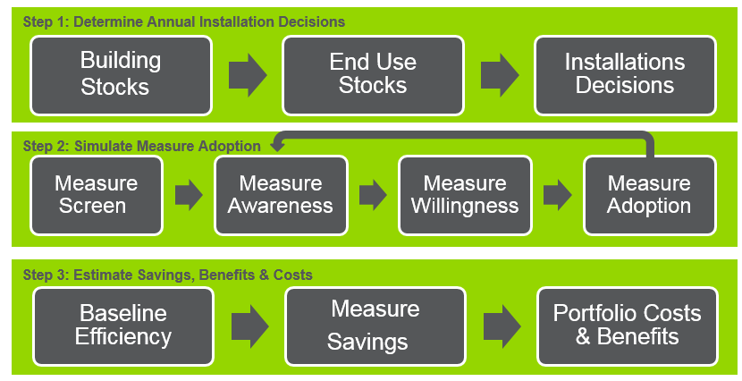

As noted above, the model employs a bottom-up dynamic Bass Diffusion approach to simulate market adoption of efficient measures. The Bass Diffusion model is illustrated in Figure 2‑3 and contains three parameters:

* **Marketing, education, and outreach** (ME&O) moves customers from the unaware group to the aware group at a consistent rate annually. Unaware customers, as the name implies, have no knowledge of the energy efficient technology option. Aware customers are those that have knowledge of the product and understand its attributes. ME&O is often referred to as the “Advertising Effect” in Bass Diffusion modeling.
* **Word of mouth** represents the influence of adopters (or other aware consumers) on the unaware population by informing them of efficient technologies and their attributes. This influence increases the rate at which customers move from the unaware to the aware group; the word-of-mouth influence occurs in addition to the ongoing ME&O. When a product is new to the market with few installations, often ME&O is the main source driving unaware customers to the aware group. As more customers become aware and adopt, however, word of mouth can have a greater influence on awareness than ME&O, and leads to exponential growth. The exponential growth is ultimately damped by the saturation of the market, leading to an S-shaped adoption curve, which has frequently been observed for efficient technologies.
* **Willingness** is the key factor affecting the move from an aware customer to an adopter. Once customers are aware of the measure, they consider adopting the technology based on the financial attractiveness of the measure. The PG Model applies two distinct approaches to calculate willingness depending on the sector and need. Additional discussion of willingness follows the figure below.

Figure ‑. The Bass Diffusion Framework: A Dynamic Approach to Calculating Measure Adoption[21]

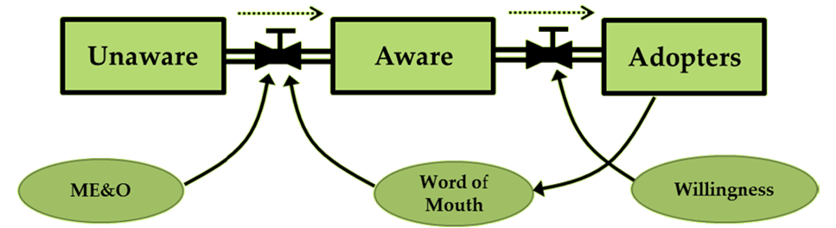

**Approach to Calculating Willingness**

Customer willingness to adopt is a key determinant of long-run market share i.e. what percentage of individuals choose to purchase a technology provided those individuals are aware of the technology and its relative merits (e.g. the energy- and cost-saving features of the technology). The PG Model applies two approaches to calculating willingness depending on the sector:

* **Levelized Measure Cost/Logit Approach:**  For the residential and commercial sectors where information on baseline and efficient costs are available, and to more appropriately capture the impacts of EE financing on market adoption, a levelized measure cost (LMC)/logit approach is applied. The levelized measure cost is based on the present value of the cost of purchasing and operating the equipment throughout its EUL, discounted using a consumer implied discount rate (iDR)[22]. The equation used to calculate the LMC is shown below.

Equation . Levelized Measure Cost Calculation

$$LMC=Upfront Cost+PV\left(Annual Operating Cost, iDR, EUL\right)$$

To calculate long-run market share or willingness as a function of the levelized measure cost for both base and efficient technologies, Navigant employed a logit decision-maker approach.[23] [24] This approach applies best practices in predicting consumer behavior and allows competition of multiple measures with different EULs for each end use.

Equation . Logit Decision Model[25]

The figure below illustrates how consumer willingness changes as a function of the ratio of the efficient to base LMC. In this illustration, a LMC ratio of 1 implies both the efficient and base technologies are at parity and thus the market is split with 50% choosing to adopt the efficient technology. For a LMC ratio of 0.5, which implies the efficient technology is cheaper than the base technology, the curve indicates that 73% would adopt the efficient technology.

Figure ‑. Illustration of Logit Willingness Curve

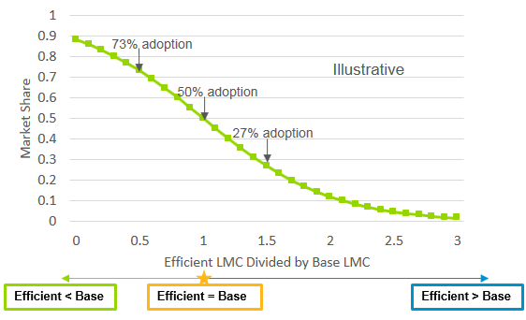

* **Payback-based Approach:** For the AIMS sectors, where information on baseline technology costs are not available, and where there isn’t a need to explore the impacts of EE financing, Navigant used a payback-based approach to calculate willingness. Payback time reflects the length of time (years) required for an energy efficiency investment to recover the initial upfront cost in terms of energy savings. After calculating payback time, to estimate market share for the AIMS measures, Navigant relied on “payback acceptance” curves based on Navigant-led primary research in the US Midwest in 2012.[26] Though California-specific data were not available to estimate these curves, Navigant considers that the nature of customer decision-making process is such that the data developed using North American customers represents the best industry-wide data available at the time of this study.

Figure ‑. Payback Acceptance Curve for AIMS sectors

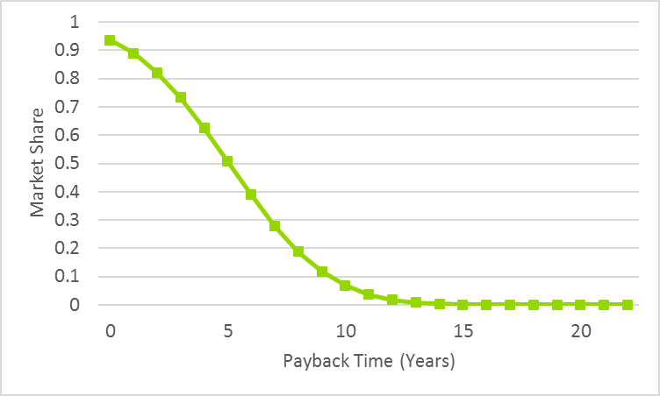

#### Calculating Cumulative Market Potential

The PG study reports both incremental and cumulative savings. In the recent past, IOU goals have been based on incremental savings only while the CEC used cumulative savings to inform the demand forecast. Cumulative savings represent the total energy efficiency program savings from measures installed since a “start year” and are still “active” in the current year. “Active” savings are calculated by accounting for:

* Decay of savings as measures reach the end of their useful lives
* Codes & standards that come into effect over time

Unlike annual savings, cumulative savings include savings from reparticipants. Incremental savings only considers that from first-time adopters. Sustained savings from re-adoptions needs to be counted in cumulative savings for the purposes of demand forecast. The PG model assumes reparticipants re-adopt measures at the same rate as new participants. The calculation of cumulative savings is illustrated in Figure 2‑6.

Figure ‑. Cumulative Savings Illustration

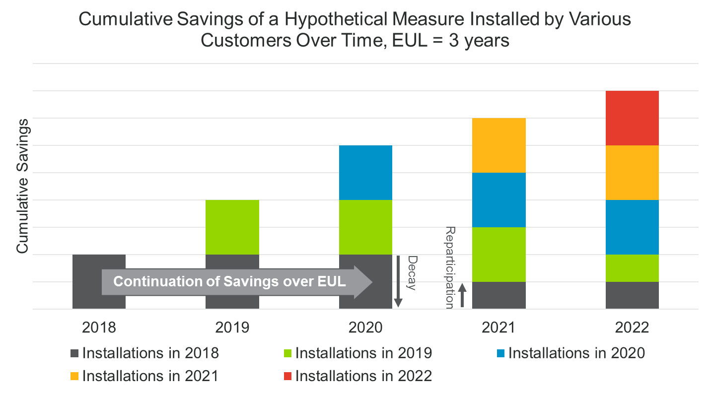

Navigant presented this information to stakeholders at a DAWG workshop in December 2016 and posed the following questions:

1. When should the PG model start cumulating savings?
2. There is no new research to inform treatment of decay/reparticipation in the PG model. What should we assume about decay?
   1. Starting with the 2013 PG model, reparticipation estimated based on market penetration rates (varies by measure)
   2. 2011 PG model assumed a blanket reparticipation rate of 50% based on CPUC D. 09-09-047
3. D. 09-09-047 required that the utilities make up 50% of the savings decay as measures expire.
   1. 2015 PG study annual market potential included only new participants
   2. Thoughts on how to how to reconcile this?

Comments were provided by NRDC and PG&E. NRDC supported re-examining the 50% policy for re-participation and requested further discussion be had regarding Navigant’s alternate method and to better understand implications of the re-participation rate implications on goals. PG&E commented that decay “occurs much less frequently” than the 50% assumption indicates.

Given the comments, Navigant maintained its approach to calculating cumulative potential and set the “cumulation start year” to 2015 to be consistent with AAEE and SB350 needs.

#### Avoiding Double Counted Savings

The PG study is required to avoid double counted savings between codes and standards and below-code rebate programs. These are the below-code savings generated from rebated equipment that would be realized even in the absence of PA rebate programs. This savings would occur as equipment would naturally turn over and be replaced with code compliant equipment. These savings are already embedded and accounted for in the California Energy Commission Demand Forecast, thus further decrementing the forecast with this savings would be double counting. The AB802 TA took a top-down approach to highlight the end uses and sectors at risk for double counted savings. However, the 2018 PG study takes the approach of attempting to remove double counted savings from the market potential (which informs IOU goals).

The first step the PG study takes in avoiding double counting is to target old equipment when considering Stranded Potential (for non-lighting equipment this is done by isolating the population that is older than its EUL). This equipment is that which is not turning over on a regular basis. The remainder of equipment that is turning over on a regular basis has its below code savings already captured through C&S.

The next step in avoiding double counted savings is to identify free ridership of below code savings. This is illustrated below in Figure 2‑7. Below-code free ridership implies that customers were not necessarily influenced by the IOU rebate to come up to code but were influenced by other outside factors. This requires the PG study to apply a net-to-gross ratio to below code savings.

Figure ‑. Below Code NTG Illustration

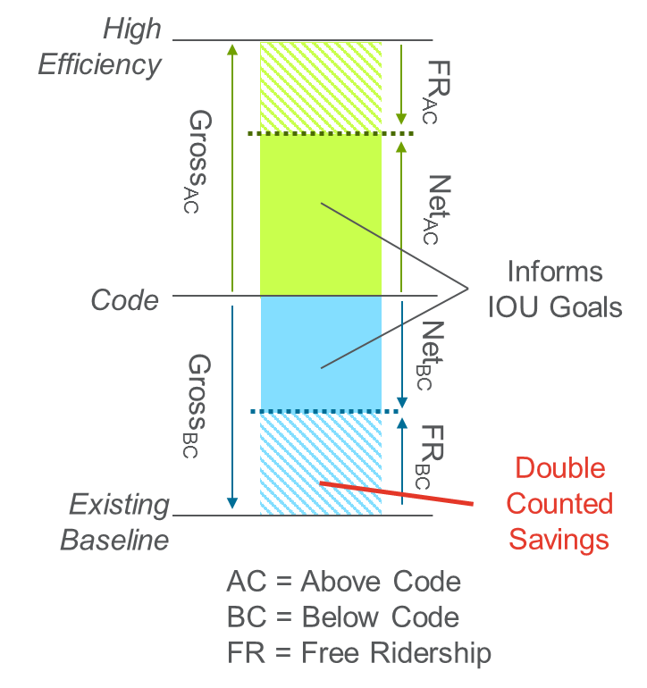

Determination of the below code NTG (*NTGBC*) is not a simple task as no data exists to inform this process. The Navigant team presented the concept of below code NTG to the Demand Analysis Working Group on November 4th, 2016. A framework of basing the below code NTG on the above code NTG (*NTGAC*) was presented. The following question was posed:

*What is the appropriate below code NTG to assume (assumption may vary by measure type)?*

* + 1. *NTGBC = 1*
    2. *NTGAC < NTGBC < 1*
    3. *NTGBC = NTGAC*
    4. *NTGBC < NTGAC*

No specific feedback was provided by stakeholders.

Navigant can see arguments for a wide range of NTGBC.

***NTGBC < NTGAC***

Navigant and Commission staff discussed this concept with the CPUC’s Ex-Ante consultants who provided feedback that below code NTG is likely less than above code NTG. The Ex-Ante consultants further advised that NTGBC is likely low for equipment with high capital cost where utility rebates are likely a small percentage of the full cost of the new equipment (such as HVAC equipment). In such situations, the argument is made, the utility rebate is a very small influence on the decision to come up to code such that the amount of savings attributed to the utility program (i.e. the NTG ratio) will be small. However, NTGBC may be closer to NTGAC for equipment that has low capital cost (such as lighting). In these situations, the argument is made, the utility rebate has a larger influence on customer decisions.

***NTGBC ≥ NTGAC***

We define Stranded Potential as “the opportunities for energy efficiency that are ***not currently captured*** by either PA rebate programs or codes and standards. Stranded Potential is below-code savings that ***is not materializing in the market because there is no incentive for the customer***to upgrade their existing equipment given current program rebate policy. Under AB802, PAs could start offering rebates for bringing existing equipment up to code thus ***motivating a whole new subset of customers to install energy efficiency*** and capturing the Stranded Potential.” Our definition of stranded potential implies below code savings programs target customers who wouldn’t have upgraded equipment in the first place. Thus, any influence the IOU has on the upgrade has limited free ridership. Under this argument it’s also important to note that NTG is an average of the entire market and has been calculated as such in past evaluations. However, Stranded Potential is targeting a different population of customers who were not motivated to act on their own, thus imply a lower level of free ridership relative to the general population.

Based on the lack of data and high uncertainty in this area, Commission staff advised Navigant to follow a conservative approach and assume NTGBC is less than NTGAC. This would imply a lower market potential and a more conservative basis for setting IOU goals. We expect better data to become available after further research and evaluation of such programs.

We estimate NTGBC to be some fraction of NTGAC where:

*NTGBC = NTGAC x NTG Adjustment Factor*

Table 2‑3 below indicates our assumptions for the NTG Adjustment factor. These are purely assumptions based on direction from the CPUC and commentary from the CPUC’s Ex Ante Consultants. Lighting has a larger factor than all other end uses due to its low capital cost. Data centers have a smaller factor than all other end uses because of the multiple influences driving data center upgrade decisions. All others are assumed to be 0.5 for lack of better data.

Table ‑3. NTG Adjustment Factors

|  |  |  |
| --- | --- | --- |
| End Use Category | Res | Com |
| Data Center |  | 0.25 |
| HVAC | 0.5 | 0.5 |
| Lighting |  | 0.75 |
| WaterHeat | 0.5 | 0.5 |

### Whole Building Packages

Whole building packages are modeled the same way as rebated technologies with one exception. Technical and economic potential results are not presented as they are duplicative with the technical and economic potential of rebated technologies.

### Industrial and Agriculture Custom Measures and Emerging Technologies

Custom measures and emerging technologies for the Industrial and Agricultural sectors used Equation 2‑3 to calculate incremental market potential.

Equation ‑. General Equation for Calculating Incremental Market Potential for Generic Custom and Emerging Technologies

$$Incremental Market Potential=Population × Applicability Factor × Unit Energy Savings × Penetration Rate$$

Where,

* **Population** is a global input that is represented as the total energy consumption by subsector within the Industrial and Agriculture sectors.
* **Applicability Factor** represents eligibility and other program-specific variables.
* **Unit Energy Savings** represented the percent savings expected from customers adopting technologies.
* **Penetration Rate** represents annual new participation and varies over time and can vary by scenario for Emerging Technologies.

Emerging technologies were screened for consideration based on an 8-level screening process considering the following factors:

1. Relevance to the industrial and agricultural sectors
2. Relevance by NAICS segment
3. End use application
4. Type of fuel savings
5. Potential energy savings percentage
6. Impact potential (including technical and market potential, risks, and non-energy benefits)
7. Segment energy consumption trends
8. Segment market trajectory

The Emerging Technologies that passed the screening criteria were used to derive ET UES values grouped by market segment (e.g. Petroleum, Food Processing, etc.) using the methodology defined in Appendix F. ET UES is represented as a percent savings relative to the total building energy consumption. It is meant to reflect the combination of available emerging technologies that pass the screening process for each sector and segment (rather than represent individual technologies). UES is estimated based on multiple factors listed below Equation 2‑4.

Equation ‑. UES Equation for Emerging Technologies

$$UES=T_{e} × E_{i,j} × {MT}_{j }× {TW}_{j}$$

Where:

*e* = subscript indicating the specific emerging technology

*i* = subscript indicating the specific end-use and fuel type

*j* = subscript indicating the market sub-sector and NAICS segment

$T_{e}$ = technology energy savings percentage for emerging technology, *e,* by end-use application

$E_{i,j}$ = percentage of total energy consumption by sub-sector *j* energy attributable to end-use, *i*

${MT}_{j }$ = market trajectory for sector *j*

${TW}_{j}$ = segment energy consumption trend weight for sector *j*

The technology energy savings percentage, *Te,* was determined for each emerging technology. The sector end-use percentage, *Ei,j,* is derived from California market data. The market trajectory for each sector, *MTj*, is a value between 0 and 1, indicating if the sector is likely to move offshore (0.33), close to tipping point of moving offshore (0.67), or likely to remain in the US (1).[27] The segment energy consumption trend weight, *TWj*, is a value between 0 and 1, indicating the trend of energy consumption of each sector over time based on an analysis provided by the California Energy Commission (CEC) shows electricity consumption trend for various industries from 1990 through 2015.

Section 3.5 discussed the data inputs for this equation.

### Behavior, Retrocommissioning, Operational Efficiency (BROs)

For the purposes of this study, the Navigant team defines behavior-based initiatives as those providing information about energy use and conservation actions, rather than financial incentives, equipment, or services. The market potential modeled for these initiatives is incremental to savings from equipment change-outs.

#### Energy and Demand Savings

Equation 2‑5 is the general equation for the BROs potential model. Each of the components are described below.

Equation ‑. General Equation for Calculating Incremental Market Potential for BROs

$$Incremental Market Potential=Population × Applicability Factor × Unit Energy Savings × Penetration Rate$$

Where,

* **Population** is a global input that can be represented in two ways - number of homes and square feet of floor space or in sector energy consumption.
* **Applicability Factor** represents eligibility and other program-specific variables, including existing saturation that precludes customers from participating in future IOU interventions.
* **Unit Energy Savings** represent the savings expected from participants and can also be represented in two ways – kWh and therms or in percent of consumption.
* **Penetration Rate** represents participation and varies over time and by scenario (reference or aggressive). This reflects both the utility-driven rollout and the customer uptake of the program, depending on the nature of the program.

The initial penetration rates are based on existing levels of participation (either for the California IOUs for existing programs or the program from which data was drawn applied to the California IOUs’ territories). The forecasts are the result of professional judgement based upon program operations and whether participation is utility driven (opt-out) or customer driven (opt-in).

The potential for double counting among BROs programs was addressed in the characterization of programs in the same sector. Adjustments to penetration and applicability were made to avoid the double counting of savings.

This effort does not examine demand-focused programs, but does include demand savings that are associated with programs focused on energy efficiency using the energy savings from Equation 2‑5 in Equation 2‑6.

Equation ‑. General Equation for Calculating BROs Demand Savings

$$Incremental Market Potential \left(kW\right)=Incremental Market Potential \left(kWh\right) × Peak to Energy Ratio$$

#### Costs

Similarly to demand savings, utility program costs are calculated from the energy savings in Equation 2‑5. The Cost Factor in Equation 2‑7 is a unit energy cost expressed in either dollars per kWh or dollars per therm. For programs that save both electricity and gas, it was sometimes possible to divide the costs by fuel type, but in instances where this was not possible all costs were assigned to one fuel type to avoid double-counting costs.

Equation ‑. General Equation for Calculating BROs Program Costs

$$Program Cost=Incremental Market Potential × Cost Factor$$

### Residential Low Income

The potential for energy efficiency in the low-income sector is forecast based on the Energy Savings Assistance program (ESAP). ESAP is offered by all four IOUs as a no cost direct installation of weatherization measures that also includes a wide range of energy efficiency equipment combined with energy efficiency education and referrals to other income qualified programs. The 2018 PG model forecast is an update to previous forecasts based on changes in the low-income market and regulatory environment that impact the ESAP offering. One of the major changes to the 2018 PG model is to include ESAP program savings for ‘retreatment’ installations as allowed by Decision 16-11-022 (the Decision).[28] The Decision allows the ESAP program to go-back and retreat households by installing new and updated measures in homes that have been served by past ESAP program activity. All past PG model low income forecast have only included estimates of potential for ‘first time’ installations on households that have never participated in ESAP.

Residential Low Income (LI) programs are modeled based on two key inputs: number of households (HH) forecasted to be treated and unit energy savings (UES) per treated household. The savings are calculated using Equation 2‑8

Equation ‑. General Equation for Calculating LI Savings

$$Low Income Program Savings=Households Treated x Unit Energy Savings$$

The forecast for Households treated is obtained from IOU plans. The team does not develop its own forecast. The savings potential reported for Low Income are not a true “Market Potential” but more of a “forecast of IOU planned activity”. The model allows for disaggregation of savings by building type (Single Family, Multifamily, Mobile Home) based on IOU data provided.

The PG model reports LI savings separately from all other rebate programs. Though this may not be the case in the goal setting process.

### Codes and Standards (C&S)

Codes and Standards (C&S) impacts on energy efficiency potential are modeled two ways:

* C&S impacts the code baseline for IOU rebated measures; as C&S becomes more stringent in the future, above-code savings claimable by IOU programs decreases. This is discussed further in section 2.1.1.2.
* IOUs can claim a portion of savings from C&S that come into effect through the IOU C&S advocacy programs. This section describes the calculation of IOU claimable savings from C&S.

This study calculates the estimated savings of codes and standards in multiple formats, each for a different use:

* **Net C&S Savings** are the total energy savings estimated to be achieved from the updates to codes and standards since 2006. Net savings calculations account for naturally occurring market adoption (NOMAD) of code-compliant equipment and are used to inform demand forecasting, procurement planning, and tracking against greenhouse gas targets. This informs the CEC forecast.
* **Net IOU C&S Program Savings** identifies the portion of the Net C&S Savings that can be attributed to the advocacy work of the IOU’s C&S program. This result is used to inform the IOU program goals.

The modeling methodology of C&S savings was based on the Integrated Standards Savings Model (ISSM)[29] developed by CADMUS and DNV GL used by the CPUC in C&S program evaluation. The Navigant team replicated the methodology of ISSM in the PG Model for use in this study. The process of calculating Net C&S Savings and Net IOU C&S Program Savings is illustrated in Figure 2‑8. Key components of the calculation listed in Figure 2‑8 include:

* **Unit Sales** – Unit sales are the assumed baseline units sold each year for each measure. They represent the expected population of code-compliant or standard-compliant equipment adopted.
* **Unit Energy Savings** – Unit energy savings are the energy savings (in kWh, kW, or therms) relative to the previous code or standard for the new compliant equipment.
* **Compliance Adjustment Factor (CAF)** – (CAF) is the baseline assumption for the rate at which the population complies with codes or standards.
* **NOMAD** – The naturally occurring market adoption is the fraction of the population that would naturally adopt the code-compliant or standard-compliant measure in the absence of any code or standard.
* **Attribution** – IOU Attribution is the portion of gross C&S savings in California that can be claimed by IOU Code Support programs.
* **Allocation Factors** – Allocation factors are the fraction of the statewide C&S savings that occur in each IOU territory. Additional allocation factors assumed by Navigant break down the savings into sectors and end uses.

Figure ‑. C&S Savings Calculation Methodology

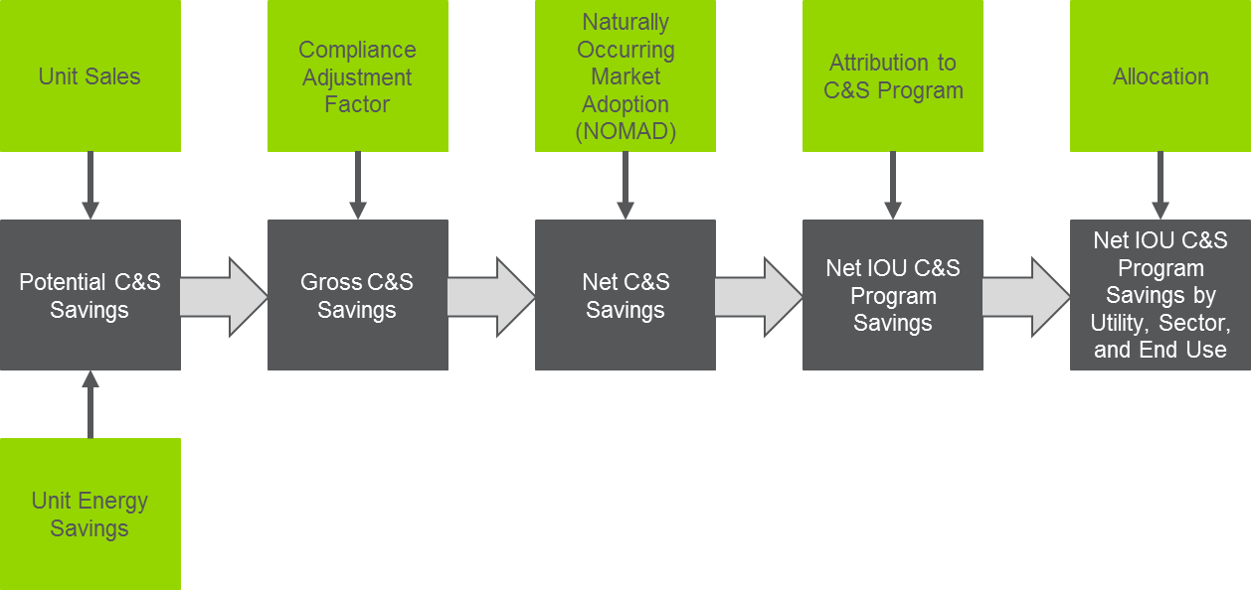

The 2018 study continued to use no layering when analyzing net IOU attributable C&S savings. In addition to the removal of layering as provided by ISSM data, the 2018 study analyzed all codes and standards included in the analysis and removed savings from standards that were superseded by other standards once the new standard took effect. This holistic approach to layering removal is a change in methodology relative to the 2015 study. A detailed table of C&S impacted by layering can be found in Appendix E.

### Financing

Financing has the potential to break through a number of market barriers that have limited the widespread market adoption of cost-effective energy efficiency measures. The PG Model estimates the incremental effects of introducing energy efficiency financing on energy efficiency market potential and how shifting assumptions about financing affect the potential energy savings.

Examples of market barriers that can slow energy efficiency adoption[30] include:

* **Information Search Cost** - Even when information of new technologies is publicly available, it is costly for consumers to learn about the innovation
* **Lack of Capital Access and Liquidity Constraint -** Lack of up-front capital or credit for energy efficiency investments.
* **Un-internalized Externalities** - Energy is heavily subsidized; consumers are not aware of the true cost of energy.
* **Split Incentives** - Party making the efficiency investment decision is not the party benefitting from the decision.
* **Hassle Factor -** This includes efforts invested in completing transactions such as the application process.
* **Behavioral Failures** - Consumers are not perfectly rational, resulting in consumer behavior inconsistent with utility maximization or energy cost minimization.

#### Financing Programs Background

California financing programs address some of these market barriers, such as lack of capital access and liquidity. Per the CPUC’s PY2014 Finance Residential Market Baseline Study Report[31], more than half of homeowners (54%) believe that the higher upfront costs present a barrier to energy efficiency projects and one third of respondents stated that financing could help reduce that barrier.

Furthermore, there is research to suggest that financing programs encourage deeper energy savings per project since consumers can take on larger projects with higher associated savings, beyond what they could have otherwise afforded in the absence of financing.[32] Amongst homeowners who made an energy upgrade and used financing, nearly three-quarters using financing indicated that the financing allowed them to do a larger project or purchase higher quality equipment than what they would have done on their own[33]. For the non-residential sector, 83% of on bill financing (OBF) loans were for projects exceeding 10% energy savings.[34]

Financing may also reduce the “hassle factor” barrier that may affect a consumer’s willingness to take on an energy efficiency project. In a California study of homeowners who chose to use financing, a clear majority (88%) felt that financing was the most convenient option for them[35].

For non-residential customers, qualified customers can access zero-percent OBF through a statewide program administered by the investor-owned utilities (IOUs). The OBF programs use alternative underwriting criteria that considers utility bill repayment history as a measure of creditworthiness[36]. Participating in OBF and repaying the financed cost through a utility bill may be easier to understand and more convenient than applying for and repaying a conventional financing option.

Because a significant proportion of customers (46%) indicated a preference for zero percent financing over rebates (34%)[37], PG&E is testing an OBF alternative pathway that will be paired with metered energy data instead of an incentive[38]. Because the incentive applications are where most problems occur in the application process, the alternate pathway program may further reduce the complexity and hassle barrier that some customers may associate with participating in utility energy efficiency programs.[39]

#### Impact of Financing on Consumer Economics

Financing allows consumers to use private capital to fund energy efficiency projects; borrowers avoid the up-front cost and repay the project cost over time. We can evaluate the attractiveness of a financing option by looking at the annual cash flows for an efficient measure, compared to an efficient measure that is financed, and comparing the net present value of the options.

The net present value (NPV) is calculated by assigning costs and benefits, discounting future costs and benefits (future value, or FV) by an appropriate discount rate (i), and subtracting the present value total costs from the present value total benefits.[40]

To discount future payments, we apply the annual consumer discount rate (*i*) per Equation 2‑9, where *n* is the number of years:

Equation ‑. Present Value Equation

$$Present Value =Future Value ×{(1+i)}^{-n}$$

We can evaluate the present value of an energy efficiency measure over the useful life of the equipment by comparing the net present value of the hypothetical costs of the equipment and energy. For example, Table 2‑4 shows the present value cost of a base efficiency technology ($1000) purchased in year 0, followed by energy costs for that unit of $200 annually for ten years. The total cash outflows are discounted by the assumed consumer discount rate, which for this example is 7%. The net present cost of the base technology is $2,405.

The next calculation shows the net present cost of the efficient technology, which in this case costs $1250 to the consumer up-front after a 50% rebate on the incremental cost of the efficient technology whose original cost was $1500 (i.e., $1500 – [($1500-$1000) x 50%] = $1250). The annual energy cost of the efficient technology is $125 per year. The total cash outflows are discounted by the same consumer discount rate (7%), yielding a net present cost for the efficient technology is $2,128. This total cost is less than the base technology.

Finally, the third calculation shows the net present cost of the efficient technology after financing. The efficient technology costs $1250 with the utility incentive. Assuming a consumer uses an energy efficiency loan at 4% for ten years, the equipment and financing costs are spread over ten years at $148 per year. The annual energy cost of the efficient technology financed is still $125 per year. The total cash outflows are discounted by the same consumer discount rate (7%), yielding a net present cost for the efficient technology with financing of $1,992. This total cost is less than the base model and less than the efficient technology without financing.

Table ‑4. Example Present Value Comparisons for Base and Efficient Technologies and Financing

|  |  |  |  |  |  |  |  |  |  |  |  |
| --- | --- | --- | --- | --- | --- | --- | --- | --- | --- | --- | --- |
| Base Technology |  | | | | | | | |  | | |
| **Year** | **0** | **1** | **2** | **3** | **4** | **5** | **6** | **7** | **8** | **9** | **10** |
| Base Equipment Cost | $1,000 | $0 | $0 | $0 | $0 | $0 | $0 | $0 | $0 | $0 | $0 |
| Energy Cost | $0 | $200 | $200 | $200 | $200 | $200 | $200 | $200 | $200 | $200 | $200 |
| Total Cash Out | $1,000 | $200 | $200 | $200 | $200 | $200 | $200 | $200 | $200 | $200 | $200 |
| Present Value | $1,000 | $187 | $175 | $163 | $153 | $143 | $133 | $125 | $116 | $109 | $102 |
| **Net Present Value Cost** | **$2,405** |  |  |  |  |  |  |  |  |  |  |

|  |  |  |  |  |  |  |  |  |  |  |  |
| --- | --- | --- | --- | --- | --- | --- | --- | --- | --- | --- | --- |
| Efficient Technology |  | | | | | | | | | |  |
| **Year** | **0** | **1** | **2** | **3** | **4** | **5** | **6** | **7** | **8** | **9** | **10** |
| Efficient Equipment Cost | $1,250 | $0 | $0 | $0 | $0 | $0 | $0 | $0 | $0 | $0 | $0 |
| Energy Cost | $0 | $125 | $125 | $125 | $125 | $125 | $125 | $125 | $125 | $125 | $125 |
| Total Cash Out | $1,250 | $125 | $125 | $125 | $125 | $125 | $125 | $125 | $125 | $125 | $125 |
| Present Value | $1,250 | $117 | $109 | $102 | $95 | $89 | $83 | $78 | $73 | $68 | $64 |
| **Net Present Value Cost** | **$2,128** |  |  |  |  |  |  |  |  |  |  |

|  |  |  |  |  |  |  |  |  |  |  |  |
| --- | --- | --- | --- | --- | --- | --- | --- | --- | --- | --- | --- |
| Efficient Technology with Financing | | | | | | | | | | | |
| Year | 0 | 1 | 2 | 3 | 4 | 5 | 6 | 7 | 8 | 9 | 10 |
| Equipment Cost Financed | $148 | $148 | $148 | $148 | $148 | $148 | $148 | $148 | $148 | $148 | $0 |
| Energy Cost | $0 | $125 | $125 | $125 | $125 | $125 | $125 | $125 | $125 | $125 | $125 |
| Total Cash Out | $148 | $273 | $273 | $273 | $273 | $273 | $273 | $273 | $273 | $273 | $125 |
| Present Value | $148 | $255 | $239 | $223 | $208 | $195 | $182 | $170 | $159 | $149 | $64 |
| **Net Present Value** | **$1,992** |  |  |  |  |  |  |  |  |  |  |

The modified cash flows feed into the calculation of consumer willingness (described earlier in 2.1.1.4) by representing the effective present value of financing to the customer as a fraction of the upfront cost. Increasing willingness results in higher adoption of EE measures and thus more savings. The model does not estimate technical or economic potential of financing, only market potential.

## Calibrating Rebated Technologies and Whole Building Approaches

SB 350 directed the CPUC to adopt goals based on energy efficiency potential studies that are not restricted by previous levels of utility energy efficiency savings. However, this does not mean that a potential study model shouldn’t be calibrated.

Like any model that forecasts the future, the PG model faces challenges with validating results, as there is no future basis against which one can compare simulated versus actual results. Calibration, however, provides both the developer and recipient of model results with a level of comfort that simulated results are reasonable. Calibration is intended to achieve three main purposes:

* Anchors the model in actual market conditions and ensures that the bottom-up approach to calculating potential can replicate previous market conditions;
* Ensures a realistic starting point from which future projections are made; and
* Accounts for varying levels of market barriers and influences across different types of technologies. The model applies general market and consumer parameters to forecast technology adoption. There are often reasons why markets for certain end uses or technologies behave differently than the norm- both higher and lower. Calibration offers a mechanism for using historic observations to account for these differences.

The PG model is calibrated by reviewing portfolio data from 2013 through 2015 to assess how the market has reacted to program offerings in the past. For more details on the necessity of calibration, the data basis of calibration, effects of calibration, and interpreting calibration please see Appendix A.

## Scenarios

In the recent past (2013 and 2015), the PG studies produced a single forecast of energy efficiency potential for the purposes of informing IOU goals. The forecast was calibrated to historic program activity. In these past studies, alternate scenarios were only considered in the Additional Achievable Energy Efficiency (AAEE) forecast used by the California Energy Commission. The AAEE scenarios were developed after the CPUC had established goals and were primarily driven by the needs of the CEC. The 2018 PG study considers multiple scenarios to inform the goal setting process.

SB 350 directed the CPUC to adopt goals based on energy efficiency potential studies that are not restricted by previous levels of utility energy efficiency savings. Commission staff proposed to meet this direction by exploring scenarios reflecting alternative future outcomes based on variables that can be controlled by policy decisions or program influence. This study considers scenarios primarily built around policies and program decisions that are under control of the CPUC and IOUs collectively, these are referred to as “internally influenced” variables. On the other hand, “externally influenced” variables were not considered in scenarios that inform the goals. External variables are those that CPUC and IOUs collectively have no control over. A list of example internally and externally influenced variables can be found in Table 2‑5 below.

Table ‑5. Variables Affecting Energy Efficiency Potential

|  |  |
| --- | --- |
| Internally Influenced | Externally Influenced |
| * Cost-effectiveness (C-E) test * C-E measure screening threshold * Incentive levels * Marketing & Outreach * Behavior, Retro commissioning & Operational (BROs) customer enrollment over time * IOU financing programs | * Building stock forecast * Retail energy price forecast * Measure-level input uncertainties (unit energy savings, unit costs, densities) * Non-IOU financing programs |

Additional details on each of the internally influenced variables can be found in the study team’s presentation to the Demand Analysis Working Group (DAWG) on December 12, 2016.[41]

### Stakeholder Input

Stakeholders and members of the DAWG were given the opportunity to provide informal feedback to the team on the development of scenarios including which variables to consider and the range of variables. Table 2‑6 contains a summary of relevant stakeholder feedback received from the December DAWG meeting.

Table ‑6. Stakeholder Feedback

| Stakeholder Comments | Additional Context from Navigant |
| --- | --- |
| **Cost Effectiveness Test** | |
| * **PG&E:** Screening measures based on different cost-effectiveness tests is acceptable “so long as the goals assigned to the IOUs are aligned with the policy that the IOUs will have to follow when operating their portfolios.” * **NRDC:** Supports assessing the potential using the PAC as well as the SCT * **SDG&E:** Supports creating scenarios around prospective changes in the C-E tests given that the CPUC is actively exploring such tests. * **TURN:** Suggests portfolio cost-effectiveness should be subject to a 10-year lifecycle average measure mix. * **SCE:** Encourages investigating alternative C-E tests, and assessing the impacts of changes on EE programs ability to capture savings. | * TURN’s comment is a broader policy issue that Navigant does not plan to address in these scenarios. * Factors impacting the SCT test (discount rate, cost of carbon) may be informed by the other CPUC proceedings as appropriate. Methods to determine some factors, like health and air quality impacts are yet to be defined. |
| **C-E Screening Threshold** | |
| * **PGE:** Current thresholds of TRC in the model (0.85 for conventional technologies, 0.5 for emerging technologies) are appropriate. * **SoCalGas:** Prefers using a “1.0 TRC scenario as a benchmark” * **SCE:** Prefers using a TRC threshold of 0.85 with no exception for new technologies or approaches (i.e. including emerging technologies). SCE does encourage exploring “what if” scenarios around thresholds to guide possible policy changes. | * The assumption of 0.85 has been used for several iterations of the study and is also reflective of the history of measures with TRC < 1 being included in programs |
| **Incentive Levels** | |
| * **PG&E:** Suggests it’s reasonable to use tiered incentives with a cap at 50% as was previously used in the AB802 Technical Analysis.[42] Suggests it would be reasonable for a high scenario to use up to a 75% cap and a low scenario to use as low as a 25% cap. | * Scenarios will explore higher levels of rebates but not lower. |
| **Marketing & Outreach** | |
| * **Jeanne Clinton:** Suggests having scenarios on different levels of penetration, to reflect different levels of “market effectiveness and/or payment facilities” to better inform program design and market strategy. * **NRDC:** Suggests an additional scenario that assesses the energy savings potential based on various delivery channels (e.g., upstream, midstream, downstream) * **SCE:** Advocating for explicitly identifying barriers to EE program adoption when developing Scenarios. | * The model does not forecast the explicit impact of specific program design or delivery mechanisms or barriers to specific technologies but rather the overall effect of removal of barriers that drive more participants to programs. |
| **Behavior, Retro-commissioning & Operational (BROs) Enrollment** | |
| * **PG&E:** Suggests assuming current levels of participation for the reference forecast is acceptable, as well as reasonable upper and lower ranges around current levels. * **SCE:** Suggests including scenarios around increased savings from behavior and operational efficiency programs. * **SDG&E:** “It would be useful to see scenarios built around holistic approaches/program designs that develop potential long-term energy road maps for customers, in addition to looking at just individual technologies or end uses. An example would be Strategic Energy Management programs.” | * Scenarios will explore reasonable upper bounds but no lower than current levels. * Navigant held a follow-up workshop on BROs that included discussion of scenarios. Additional discussion can be found in section 0 |
| **IOU Financing Programs**[43] | |
| * **PG&E:** IOU activities (to date) are not driving the energy efficiency financing industry though there is a role for IOUs to play in the future. PG&E further commented that most energy efficiency projects “will be financed – however PG&E doesn’t think it is appropriate to assume this financing will use [IOU] EE financing tools. Traditional financing tools are more likely to be the financing source (e.g., bonds … mortgages…). PG&E would expect to see greater participation in EE financing tools as goals increase. However, the financing schemes that are put in place are unlikely to change much under different goal scenarios. So PG&E believes that incentive level is the primary driver of EE financing investments.” * **SoCalGas:** Suggests any assumptions about financing programs “should be realistic because of the slow start and likely niche operations” of IOU financing programs. * **SDG&E:** Supports different scenarios considering different financing levels/schemes though also comments that IOU financing pilots are not deployed and cannot provide complete information. | * Since the last PG study there have been no new completed impact evaluations of financing programs to better inform our analysis. * Note: the 2015 PG study excluded financing from the results being used to inform goals |
| **Additional Comments** | |
| * **PG&E:** Suggests overall scenarios should focus on three variables: cost-effectiveness, awareness, and incentive level. * **SDG&E:** Suggests various scenarios and sensitivity analysis around avoided costs. | * Avoided costs are an externally influenced variable and is out of scope of scenario analysis. |

### ***Final*** Scenarios

The team worked with Commission staff to develop scenarios for consideration in the goal setting process. Each of the internally influenced variables in Table 2‑7 is expected to have an impact on the forecast of energy efficiency potential. The combined impact of these variables represents a scenario.

Commission staff took the following into consideration when directing Navigant on the final scenarios

* Commission staff followed closely the developments in the IDER proceeding. This informed the alternative cost-effective tests to consider.
* On February 2017, Commission staff released a Societal Cost Test (SCT) white paper with recommendations for parameters to support a SCT as well as modifications to currently used TRC and PAC.
* On April 2017, Commission staff proposed a GHG adder curve as an interim value that could inform goal setting. The interim GHG adder proposal followed the methods proposed in the SCT staff white paper. The GHG adder curve was developed based on draft runs of the RESOLVE model in the Integrated Resources Proceeding (IRP).
* In the comments to the staff proposed interim GHG adder, the joint IOUs proposed an alternative GHG adder curve based on the Allowance Price Containment Reserve (APCR)[44]. This curve is an extrapolation of preliminary values released by the ARB during the development of the California Air Resources Board AB 32 Scoping Plan Update. Although the proposed allowance prices are not final and are subject to change, Commission staff believes they are a reasonable alternative to the staff proposal and will give stakeholders the chance to see how market potential changes when using alternative GHG adder values.

Commission staff’s intent was to keep the number of scenarios manageable but still provide a range of alternatives to bound market potential. Therefore, five scenarios in total were proposed and are listed in Table 2‑7.

Table ‑7. Final Scenarios for Energy Efficiency Potential – Summary



The TRC | Reference scenario represents “business as usual” and the continuation of current policies. Three of the alternate scenarios continue to assume similar program design but apply different cost effectiveness tests and avoided costs. The final scenario (PAC | Aggressive) is meant to show an upper bound of the combination of program engagement and cost-effectiveness screens. Table 2‑8 below lists more detail for regarding Program Engagement.

Table ‑8. Reference vs. Aggressive Programs

|  |  |  |
| --- | --- | --- |
| Variable | Reference | Aggressive |
| **Incentive levels** | $/kWh  $/Therm  Capped at 50% of incremental Cost | $/kWh  $/Therm  Capped at 75% of incremental Cost |
| **Marketing & Outreach** | (default calibrated value) | Increased marketing strength |
| **BROs** | Continued offering of existing BROs interventions and planned new interventions based on policy directions | Additional BROs interventions that had limited verified data though show promise for possible savings |
| **IOU financing programs** | No savings claimed from financing programs[45] | IOU financing programs broadly available to Residential and Commercial customers |

# Data Sources

The data sources relied upon in the 2018 PG study are vast and varied. Throughout the study, the Navigant team sought to rely upon CPUC-vetted products as much as possible. However, in several cases, the team needed to seek alternate data sources where CPUC resources did not provide the necessary information. This chapter describes the data update process and sources for key topic areas.

## Global Inputs

Global inputs are macro-level model inputs that are not specific to any measure, but rather apply to market segments or sectors. Navigant reviewed the data source for each of these inputs to ensure that the most recent data is utilized for the 2018 PG Model update. Table provides an overview of all the global inputs within the 2018 model and their data source. This section discusses each item in Table 3‑1 in further detail in the sub-sections that follow.

Table 3‑1. Overview of Global Inputs Updates and Sources

|  |  |
| --- | --- |
| Global Input  *(description)* | Data Source for Update |
| **Retail Rates**  *($/kWh, $/therm)* | CEC - *2016 Integrated Energy Policy Report (IEPR) Update and Demand Forecast Forms.* Adopted Feb. 2017.  Excel Demand Forecast Forms available at: *http://www.energy.ca.gov/2016_energypolicy/documents/*  CPUC *– California Energy Consumption Database (ECDMS).* Accessed: Apr. 2017 |
| **Sales Forecasts**  *(GWh, MW, and MM Therms)* |
| **Building Stocks**  *(households, floor space, consumption)* |
| **Avoided Costs**  *(Avoided energy and capacity costs)* | CPUC – *Cost Effectiveness Tool.* Accessed: Mar. 2017 |
| **Historic Program Accomplishments** *(Used for calibration)* | CPUC – Energy Efficiency Full Program Cycle (2013-2015) Data. Download at: *http://eestats.cpuc.ca.gov/Views/EEDataShelf.aspx* |
| **Non-Incentive Program Costs** |

### Retail Rates and Sales Forecasts

The CEC’s Integrated Energy Policy Report (IEPR), which includes a forecast that is updated annually, is the source for retail rates and sales forecasts in the 2018 Study. The team used the 2016 IEPR for electric rates and forecasts and the 2015 IEPR for gas rates and forecasts. This was because only electric rates and forecasts were updated in the 2016 IEPR.

Navigant revised the retail rates and sales forecast based on information from the recently released IEPR 2016, published by the CEC in February 2017.

Sales forecasts in IEPR are shown by CEC’s eight planning areas, which differs slightly from the IOU service territory area. Some of the CEC planning areas include the territories of small POUs in California. Therefore, an adjustment is needed. Using data on service territory and planning area sales for 2015, Navigant calculated ratios to adjust the planning area consumption (found within IEPR) down to each IOU’s actual service territory consumption for both PG&E and SCE. These ratios, with the service territory consumption based on the 2015 QFER, are referred to as Service Territory to Planning Area adjustment ratios and are detailed in Table 3‑2. The CEC planning area for San Diego directly maps to SDG&E service territory so this is no need to calculate an adjustment ratio for SDG&E.

Table ‑2. 2016 IEPR Electric Service Territory to Planning Area Adjustment Ratios

|  |  |  |  |  |  |  |
| --- | --- | --- | --- | --- | --- | --- |
|  | Residential | Commercial | Industrial | Mining | Agriculture | Streetlights |
| PG&E | 97.0% | 89.4% | 88.4% | 96.2% | 97.0% | 87.7% |
| SCE | 92.6% | 90.2% | 89.2% | 94.1% | 58.8% | 90.3% |

Source: California Energy Commission, 2017.

Most POUs in California do not offer any gas service (currently only the City of Palo Alto and Island Energy offer natural gas service). It is estimated that California IOUs sell approximately 99% of the state’s natural gas. However, there are some exceptions, notably SMUD in PG&E territory. To obtain service territory consumption values, Navigant staff used 2013-2014 data from the CEC’s Energy Consumption Database (ECDMS), shown in Table 3‑3.[46]

Table ‑3. 2016 IEPR Gas Service Territory to Planning Area Adjustment Ratios

|  |  |  |  |  |  |  |
| --- | --- | --- | --- | --- | --- | --- |
|  | Residential | Commercial | Industrial | Mining | Agriculture | Streetlights |
| PG&E | 100.0% | 98.1% | 99.3% | 99.3% | 99.5% | NA |
| SCG | 100.0% | 97.0% | 100.0% | 10.3% | 97.9% | NA |

Source: California Energy Commission, 2017.

While most of the adjustment ratios are close to or at 100%, SCG mining is 10.3% based on service territory sales found in ECDMS. Many of the largest oil and gas extraction companies in SCG’s planning area purchase gas directly from the pipeline companies. The service territory to planning area adjustment calculation additionally must remove the gas sales that are attributed to those large oil and gas companies.

These ratios were applied to both the sales forecast and the building stocks for electric and gas impacts.

### Building Stocks

Building stocks are the total “population” metrics of a given sector, though represented by different metrics for most sectors. Residential building stocks are based on number of households in an IOU’s service territory. Commercial building stocks are represented by total floor space for each commercial building type. Industrial and agricultural building stocks are represented by energy consumption. Mining and streetlighting stocks are the number of pumps and streetlights respectively. The residential, commercial, industrial and agriculture building stock metrics are derived from the CEC’s IEPR.

The model requires building stocks by sector, scenario, and utility for the time frame 2013-2030.

IEPR 2016 organizes building stock data into the 8 electric planning areas determined by the CEC. To translate these IEPR results to the PG model and split them by utility, Navigant worked with CEC to map CEC planning areas to the IOU service territories in Table 3‑4.

Table ‑4. Mapping CEC Planning Areas to IOU Service Territories

|  |  |  |  |
| --- | --- | --- | --- |
| **CEC Electric and Gas Planning Areas to Utilities** | | | |
| **CEC Forecasting Climate Zones** | **Electric Planning Area Number** | **Electric Planning Area Utilities** | **Natural Gas Planning Area Utilities** |
| Climate Zone 1 | 1 - PG&E | PG&E | PG&E |
| Climate Zone 2 |
| Climate Zone 3 |
| Climate Zone 4 |
| Climate Zone 5 |
| Climate Zone 6 |
| Climate Zone 7 | 2- SCE | SCE | SCG |
| Climate Zone 8 |
| Climate Zone 9 |
| Climate Zone 10 |
| Climate Zone 11 |
| Climate Zone 12 | 3 - SDG&E | SDGE | SDGE |
| Climate Zone 13 | 4 - NCNC | SMUD | PG&E |
| Climate Zone 14 | TID |
| Climate Zone 15 | Other (Modesto, Redding, Roseville, Trinity, and Shasta Lake) |
| Climate Zone 16 | 5 - LADWP | LADWP | SCG |
| Climate Zone 17 |
| Climate Zone 18 | 6 - Burbank/Glendale | Burbank/Glendale |
| Climate Zone 19 | 7 - IID | IID |
| Climate Zone 20 | 8 - Valley Electric | Valley Electric |

Source: California Energy Commission, 2017.

### Historic Rebate Program Activity

The historic rebate program achievements for each of the IOUs are important inputs for calibrating our forecast of rebate programs.

The CPUC maintains the Energy Efficiency Statistics (EEStats) portal, an online resource that collects program achievement data, for public use. A spreadsheet of 2013-2015 program achievement data is available for download on this website. This data set includes ex ante and evaluated program savings, expenditures, cost-effectiveness, and emissions for energy efficiency programs statewide. For the 2017 PG study, Navigant used this data set to compute portfolio net and gross savings for each sector and utility.

Table 3‑5 provides the 2013-2015 gross ex-post savings. Some program savings were not modeled as a rebate program and those savings are excluded from this analysis. For example, residential home energy reports and retro-commissioning fall under the definition of the BROs subtask and were removed to prevent double-counting savings. Savings labeled “Other” were also removed.

Table ‑5. 2013-2015 IOU-reported Portfolio Gross Program Savings

|  |  |  |  |  |  |  |
| --- | --- | --- | --- | --- | --- | --- |
| IOU | Spending ($MM) | | Energy Savings (GWh) | | Gas Savings (MM Therms) | |
| RES | COM | RES | COM | RES | COM |
| PG&E | 282.50 | 520.96 | 758.46 | 1,120.47 | 8.8 | 27.6 |
| SCE | 299.59 | 503.66 | 892.17 | 1,291.51 | NA | NA |
| SCG | 77.08 | 36.16 | NA | NA | 12.7 | 17.5 |
| SDG&E | 70.69 | 110.08 | 175.57 | 295.18 | -1.0 | 3.5 |

Source: CPUC – Energy Efficiency Full Program Cycle (2013-2015) Data

Additional discussion of the calibration process can be found in Appendix A.

### Non-Incentive Program Costs

Non-incentive program costs also come from the 2013-2015 Full Program Cycle Data on the CPUC’s EEStats portal. For the PG Model, Navigant determined program costs per unit of kWh or therm, by sector. This is facilitated by the EEStats data, where program costs for each program and measure line are already listed. In EEStats, program costs combine administrative costs, marketing costs, implementation (customer service) costs, overhead, and EM&V costs. Note that interactive effects are excluded prior to calculating these costs.

Table 3‑6 provides an overview of the Non-Incentive Program Costs, based on gross reported savings. The displayed AIMS program cost is an average of the individual agriculture, industrial, mining, and streetlighting costs calculated.

Table ‑6. Non-Incentive Program Costs Summary

|  |  |  |  |  |  |  |
| --- | --- | --- | --- | --- | --- | --- |
| IOU | Electric Savings ($/Gross kWh) | | | Gas Savings ($/Gross therm) | | |
| RES | COM | AIMS | RES | COM | AIMS |
| PG&E | $0.12 | $0.15 | $0.08 | $3.55 | $4.53 | $2.38 |
| SCE | $0.16 | $0.18 | $0.18 | NA | NA | NA |
| SCG | NA | NA | NA | $2.14 | $1.15 | $0.72 |
| SDG&E | $0.12 | $0.07 | $0.06 | $3.40 | $1.92 | $1.88 |

Source: CPUC – Energy Efficiency Full Program Cycle (2013-2015) Data

### Avoided Costs

Avoided costs place an economic value on the amount of energy and greenhouse gas that is saved by implementing an energy saving measure. Avoided costs are a key input to the calculation of cost effectiveness.

To determine avoided costs, Navigant used the Cost-effectiveness Tool (CET), a calculator commissioned by the CPUC. Post-processing of the CET calculator data resulted in a dataset that displays total avoided costs for 2016-2046 by IOU, sector, end use category, and sub-end use category.

Electric avoided costs for the PG model are the sum of the avoided costs of generation, transmission and distribution (T&D), and carbon from the CET. Carbon in the CET is expressed in Tons/kWh so Navigant needed to multiply this data by the cost of carbon. Gas avoided costs are the sum of the avoided costs of generation and T&D as reported by the CET. The CET embeds the cost of carbon in its valuation of gas “generation” avoided cost.

Using the original data obtained in the CET calculator, Navigant created a baseline projection of avoided costs that is to be used for the calculation of the Total Resource Cost test. However, in considering the modified TRC test the team needed to update the cost per ton of carbon. Two different GHG adders were used in this analysis.

In April 2017, the CPUC issued a draft statement on an interim greenhouse gas adder for consideration in alternate cost effectiveness tests. This adder is an incremental cost of carbon forecast that projects the cost from $0 per ton beginning in 2017 to $250 per ton in 2030.[47] Navigant refers to this data set as GHG Adder #2 in its scenario analysis as is the larger of the two adders. In the comments to the staff proposed interim GHG adder, the joint IOUs proposed an alternative GHG adder curve based on the draft Allowance Price Containment Reserve (APCR)[48]. This curve is an extrapolation of preliminary values released by the ARB during the development of the California Air Resources Board AB 32 Scoping Plan Update. Navigant refers to this data set as GHG Adder #1 as is the lower of the two adders. Both adders are detailed in Table 3‑8.

Both GHG adders must be multiplied by (1 - RPS%) to subtract any effect of the Renewables Portfolio Standard (RPS) on avoided cost of emissions. Navigant uses the RPS percentages listed in Table 3‑7, up to the RPS target of 50% by 2030.

Table ‑7. California RPS Targets, 2016-2030

|  |  |  |
| --- | --- | --- |
| Year | RPS% | 1 – RPS% |
| 2016 | 25% | 75% |
| 2017 | 27% | 73% |
| 2018 | 29% | 71% |
| 2019 | 31% | 69% |
| 2020 | 33% | 67% |
| 2021 | 35% | 65% |
| 2022 | 37% | 64% |
| 2023 | 38% | 62% |
| 2024 | 40% | 60% |
| 2025 | 42% | 58% |
| 2026 | 43% | 57% |
| 2027 | 45% | 55% |
| 2028 | 47% | 53% |
| 2029 | 48% | 52% |
| 2030 | 50% | 50% |

Table ‑8. Costs of Carbon, 2016-2046[49]

|  |  |  |  |  |  |
| --- | --- | --- | --- | --- | --- |
| Year | Baseline Carbon Cost (nominal $/ton) | GHG Adder #1 (real 2016 $/ton) | Carbon Cost #1 (Baseline + Adder #1 * (1 – RPS%)) (nominal $/ton) | GHG Adder #2 (real 2016 $/ton) | Carbon Cost #2 (Baseline + Adder #2 * (1 – RPS%)) (nominal $/ton) |
| 2016 | $12 | $47 | $48 | $0 | $12 |
| 2017 | $13 | $50 | $50 | $0 | $13 |
| 2018 | $14 | $55 | $53 | $19 | $28 |
| 2019 | $15 | $59 | $56 | $38 | $43 |
| 2020 | $25 | $55 | $61 | $58 | $67 |
| 2021 | $27 | $59 | $65 | $77 | $82 |
| 2022 | $29 | $60 | $67 | $96 | $98 |
| 2023 | $31 | $61 | $68 | $115 | $113 |
| 2024 | $33 | $61 | $70 | $135 | $128 |
| 2025 | $36 | $62 | $71 | $154 | $142 |
| 2026 | $38 | $62 | $74 | $173 | $159 |
| 2027 | $41 | $62 | $76 | $192 | $173 |
| 2028 | $45 | $63 | $78 | $212 | $187 |
| 2029 | $48 | $63 | $81 | $231 | $203 |
| 2030 | $52 | $63 | $83 | $250 | $217 |
| 2031 | $55 | $64 | $87 | $250 | $223 |
| 2032 | $58 | $63 | $90 | $250 | $230 |
| 2033 | $62 | $62 | $93 | $250 | $237 |
| 2034 | $65 | $61 | $96 | $250 | $244 |
| 2035 | $68 | $60 | $98 | $250 | $251 |
| 2036 | $72 | $59 | $101 | $250 | $258 |
| 2037 | $75 | $58 | $104 | $250 | $265 |
| 2038 | $79 | $58 | $107 | $250 | $272 |
| 2039 | $82 | $57 | $110 | $250 | $279 |
| 2040 | $85 | $56 | $114 | $250 | $286 |
| 2041 | $89 | $56 | $117 | $250 | $294 |
| 2042 | $92 | $55 | $120 | $250 | $301 |
| 2043 | $96 | $55 | $123 | $250 | $309 |
| 2044 | $99 | $55 | $126 | $250 | $317 |
| 2045 | $102 | $54 | $129 | $250 | $324 |
| 2046 | $106 | $54 | $133 | $250 | $332 |

## Residential and Commercial Technology Characterization

The technology characterization step in the potential study develops the essential inputs that are used in the PG model to calculate potential. This section provides an overview of the technology selection process for residential and commercial sectors, describes the fields along which technologies are characterized, lists the data sources and describes how these sources are used for characterization, and directs the reader to the complete database of characterized technologies.

The 2018 study departs from the 2015 Study in terms of measure characterization. The 2015 study classified measures defined by a base technology upgrading to an efficient level technology (e.g. SEER 13 to SEER 15 and SEER 13 to SEER 18 are **two** different measures). The 2018 study uses a technology-based characterization, which characterizes the individual technologies (e.g. SEER 13, 15 and 18 are **three** different technologies). This new method allows the model to better track stock flow between technology levels (as discussed earlier in 2.1.1.2.

### Technology Selection Process

The first step under technology characterization is to select and develop a list of representative technologies. The selection process is necessary to identify high impact technologies with significant savings opportunities across multiple end uses, referred to as “representative” technologies. As part of this, the Navigant team reviewed multiple databases and information sources and followed a systematic process for selection of the “representative” technologies, briefly described below, and represented in Figure 3‑1 below.

Figure ‑. Res/Com Technology Selection Process

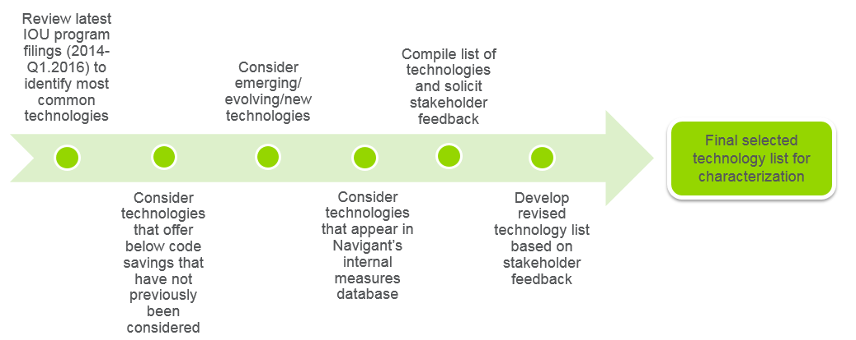

As depicted in Figure 3‑1, the technology selection process involved multiple steps to arrive at the list of selected technologies. It involved review and inclusion of technologies from the California IOUs recent program databases (2014 to Q1.2016) and approved utility workpapers, consideration of technologies that provide below-code savings opportunities not considered previously, review and consideration of emerging technologies, and inclusion of technologies from Navigant’s internal technology databases used for other utility studies. Navigant presented an initial list of compiled technologies for stakeholder review and feedback (in August 2016), addressed stakeholder comments and developed a final list of selected technologies for characterization.

Figure 3‑2 below presents additional details associated with these steps.

Figure ‑. Res/Com Technology List Development Process

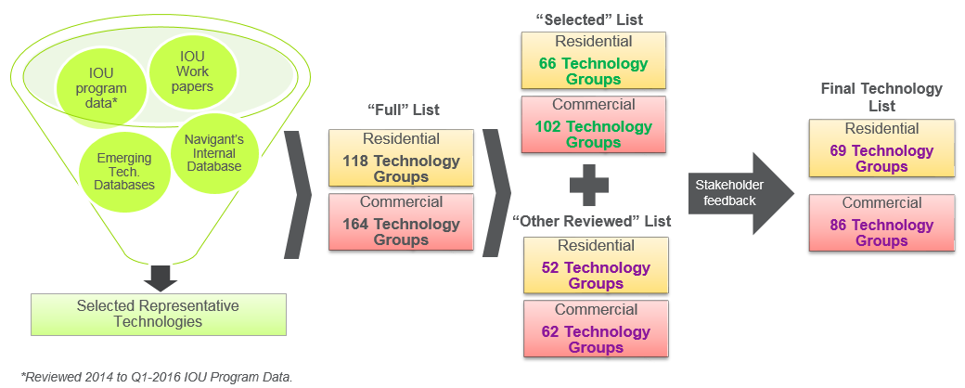

The first step in the technology selection process included a review of multiple information/data sources, described earlier, to develop a comprehensive and universal list of technology groups for consideration in the study (referred to as the “Full” list in Figure 3‑2). Note that a *“technology group”,* defined and referred to earlier in Section 2.1 of the report, includes multiple technologies with different efficiency levels that compete for stock replacement under an end use. “Technology group” is also commonly referred to as “competition group”. For e.g., residential ACs with different efficiency levels (ranging from SEER 10 to SEER 21) are considered a single technology group termed “Residential Air Conditioners” under residential HVAC. The “full” list was developed based on a review of different sources, which primarily include available databases in EEstats[50], program savings data from California IOUs[51], utility work papers, emerging technology databases, and Navigant’s internal technology database of energy efficient technologies outside of this study.

The next step after developing the “full” list of technology groups was to parse it into two sets, a “selected” list and an “other reviewed” list, as depicted in Figure 3‑2. The “selected” list at this stage included representative technology groups from the California IOUs’ program portfolios that provide bulk of the savings[52], new below-code technologies not considered previously, refreshed list of emerging technologies, and relevant technologies included through Navigant’s benchmarking with other similar potential studies. Technology groups not included in the “selected” list were in the “other Reviewed” list.

Navigant presented this list of “selected” and “other reviewed” technology groups for stakeholder review and feedback.[53] From stakeholder comments, the team developed a **“**final**”** list of technology groups that addressed stakeholder comments. This final list served as the starting point for developing the full list of individual technologies under each technology group. As discussed earlier in section 2.1.1.2, the individual technologies in each technology group represent “average below code”, “code” and “efficient” technologies that compete for stock replacement. Table 3‑9 below shows the number of technology groups and individual technologies characterized in the study, by end use for residential and commercial sectors. This includes technologies included under both fuel types, electric and gas.[54]

Table ‑. Final List of Technology Groups (with Examples) and Individual Technologies

|  |  |  |  |  |
| --- | --- | --- | --- | --- |
| Sector | End Use | Technology Group Examples[55] | Number of Technology Groups | Number of Individual Technologies[56] |
| **Residential** | Appliances/Plug Loads | Refrigerators, Pool Pumps, Clothes Dryers. | 13 | 42 |
| Building Envelope | Weatherization, Attic Duct Insulation, Windows. | 13 | 39 |
| HVAC | Air Conditioners, Heat Pumps, Ceiling Fans. | 16 | 47 |
| Lighting | Indoor Screw-in Lamps, Specialty Lamps, Linear Fixtures. | 13 | 50 |
| Water Heating | Electric Water Heaters, Faucet Aerators, Showerhead. | 9 | 23 |
| **Total** |  | **64** | **201** |
| **Commercial** | Appliances/Plug Loads | Power Strips, Servers, Vending Controls. | 14 | 43 |
| Building Envelope | Ceiling/Roof Insulation, Wall Insulation, Windows. | 6 | 19 |
| Com. Refrigeration | Display Case Motors, Strip Curtains, Anti Sweat Heat Controls. | 8 | 19 |
| Data Center | Server Virtualization, High efficiency UPS, CRAC upgrades. | 5 | 10 |
| Food Service | Electric Convention Ovens, DCV Exhaust Hood, Steamers. | 7 | 14 |
| HVAC | Chillers, Split AC, Mini Split Heat Pumps. | 23 | 80 |
| Lighting | High Bay Fixtures, Lighting Fixtures (Indoor and Outdoor), Indoor Reflector Lamps. | 12 | 47 |
| Water Heating | Electric Storage Water Heaters, Faucet Aerators, Showerhead. | 3 | 12 |
| **Total** |  | **78** | **244** |

### Comparison with Measure Characterization in the 2015 Study

The technology-based characterization allows greater flexibility in characterization, this combined with our holistic refresh of the technology list, expands the number of efficient technologies included in the 2018 study relative to the 2015 study. This comparison is shown in Table 3‑10. Several notable changes can be observed form the table:

* Increase in the number of HVAC technologies
* Increase in the number of building envelop technologies
* Increase in the number of Commercial Refrigeration technologies
* Addition of a “Data Center” end use and technologies
* Consolidation of “Service” and “Process Heat” end uses into HVAC

Table ‑. Comparison of Efficient Residential and Commercial Technologies in 2015 and 2018 PG Study

|  |  |  |  |
| --- | --- | --- | --- |
| Sector | End Use | Number of Efficient Technologies in 2015 Study | Number of Efficient Technologies in 2018 Study |
| **Residential** | Appliances/Plug Loads | 18 | 22 |
| Building Envelope | 3 | 14 |
| HVAC | 12 | 26 |
| Lighting | 29 | 25 |
| Water Heating | 6 | 12 |
| **Total** | **68** | **99** |
| **Commercial** | Appliances/Plug Loads | 4 | 22 |
| Building Envelope | 3 | 7 |
| Com. Refrigeration | 5 | 10 |
| Data Center | N/A | 5 |
| Food Service | 7 | 7 |
| HVAC | 25 | 44 |
| Lighting | 27 | 26 |
| ProcHeat | 1 | N/A |
| Service | 4 | N/A |
| Water Heating | 9 | 7 |
| **Total** | **85** | **136** |

The technology-based characterization allows for the inclusion of below-code technologies (and thus to-code savings). In the new technology list, Navigant defined the average below code efficiency level for technology groups where appropriate. Such technologies are flagged as “Accelerated Replacement” and are summarized in Table 3‑11 below.

Table ‑. Residential and Commercial Accelerated Replacement Technology Groups

|  |  |  |
| --- | --- | --- |
| Sector | End Use | Number of Technology Groups Characterized as Accelerated Replacement |
| **Residential** | Building Envelope | 2 |
| HVAC | 6 |
| Lighting | 2 |
| **Total** | **10** |
| Data Center | 1 |
| HVAC | 9 |
| Water Heating | 3 |
| **Total** | **13** |

## **Technology**Characterization

Characterization of the selected technologies involves developing various inputs for each technology that are necessary for calculation of potential. Table 3‑12 below summarizes the key items for characterization of technologies with brief descriptions.

Table ‑. Key Fields for Measure Characterization with Brief Descriptions

| Items | Brief Description |
| --- | --- |
| **Technology Description** | Specifies the following for each technology:   * Sector * End Use * Fuel Type * Climate Zone * Segment/Building Type * Replacement type |
| **Energy Use** | Specifies the following for each technology:   * Energy use (electric and gas) * Coincident Peak Demand * Interactive Effects |
| **Technology Costs** | Specifies the following for each technology:   * Equipment Cost * Repair Cost (for accelerated replacement technologies). * Installation Cost |
| **Market Information** | Specifies the following for each technology:   * Applicability by Segment/Building Type * Density associated with the Technology Group * Saturation for Individual Technologies |
| **Other Items** | Includes the following:   * Technology lifetime (EUL and RUL), * Net-to-Gross (NTG) ratio |

The following sub-sections describe in detail how the energy use, costs, market information and other relevant fields were developed and the associated hierarchical list of data sources for this information.

### Energy Use

Energy use is a key input for technology characterization. The technology-based approach followed in this study implies that we need to specify the absolute energy use associated with “average below code”, “code” and “efficient” technologies.

This study utilizes the findings from the CPUC AB802 Technical Analysis study to define below-code baseline (referred to as “average below code”) vs. defining code technology as the baseline, which is common practice for many potential studies (including prior CPUC potential studies). The below-code baseline of a given measure is the average efficiency level of older units that are not up to code and have not been replaced. These units have the option of being upgraded to the code/standard or to the efficient or above-code efficiency level.

Unit energy use is specified in kWh for electric technologies, and in therms for gas-fueled technologies. Electric technologies also require the characterization of coincident peak demand. For dual-fuel technologies that can achieve both electric and gas savings, such as insulation, both metrics are calculated. Additionally, some technologies will have interactive effects. An example is energy efficient lighting, which produce less waste heat than incandescent bulbs and thus have additional HVAC consumption associated with it. The technology characterization template requires these interactive effects to be included.

Table 3‑13 below lists the data sources for energy use (in hierarchical order) with brief descriptions of the sources.

Table ‑. Hierarchy of Data Sources for Energy Use Information

| Priority | Energy Consumption Source Name | Description | Author | Year |
| --- | --- | --- | --- | --- |
| 1 | DEER (Database of Energy Efficient Resources) | Navigant used information from 2017/2018 DEER updates for obtaining energy use and coincident peal demand for technologies, wherever available.  Lighting energy use was calculated using the lighting calculator tool available at DEER. | CPUC | 2016 |
| 2 | Non-DEER Ex Ante Database | Navigant referred to the Non-DEER ex ante database, available from Commission staff, for characterizing technologies that were not included in DEER. | CPUC | 2016 |
| 3 | IOU Workpapers [with CPUC Disposition] | Navigant referred to the inventory of workpapers published by the California IOUs and referred to **approved workpapers** for technology characterization, wherever applicable. | California IOUs | Various |
| 4 | CMUA TRM | Navigant referred to the CMUA TRM for energy use information for applicable technologies. | Cal TF | 2015 |
| 5 | CA IOU Emerging Technology Reports | Navigant reviewed and researched project/technology reports from the ETCC—a collaborative forum with IOUs and leading member organizations for characterization of emerging technologies. | Emerging Technology Coordinating Council (ETCC); IOUs | Various |
| 6 | IOU Program Data | Navigant referred to the 2016 EEStats database[57] and 2014-Q12016 program savings[58] database from CA IOUs, in case energy use information was not available from the above-listed sources. | CPUC, IOUs | 2014-2016 |
| 7 | Non-California source examples:   * Regional Technical Forum (RTF) Database | In cases where CA-specific sources were not available for energy use information, Navigant referred to the following sources:   * Measure-level savings data from evaluated programs in the Pacific Northwest region, available through the RTF. | Northwest Power and Conservation Council (NPCC) | 2015 |
| * Navigant Potential Study Database | * Navigant’s archive of characterized measure savings from potential studies and projects with other utilities. | Navigant | 2015-2016 |

### Technology Costs

The measure characterization database requires specification of equipment costs, labor costs for installation and repair costs for “accelerated replacement” technologies. Information on technology costs were primarily sourced from the California Measure Cost Study, published by Itron in 2012. Some of the other cost data sources are the same as those listed earlier under energy use. Table 3‑14 below summarizes the data sources used for technology costs.

Table ‑. Hierarchy of Data Sources for Technology Cost Information

| Priority | Cost Source Name | Description | Author | Year |
| --- | --- | --- | --- | --- |
| 1 | CA Measure Cost Study | This served as the primary surce of information for equipment and installation costs. | Itron | 2012 |
| 2 | DEER | Navigant used information from 2017/2018 DEER updates for obtaining equipment and labor costs for technologies, wherever available. | CPUC | 2016 |
| 3 | IOU Workpaper [with CPUC Disposition] | Navigant obtained equipment and labor costs from **approved CA IOU workpapers**, in cases where the Navigant team referred to these workpapers for obtaining energy use information. | Calfornia IOUs | Various |
| 4 | CMUA TRM | Navigant obtained equipment and labor costs from the CMUA TRM, in cases where the Navigant team referred to the CMUA TRM for obtaining energy use information. | Cal TF | 2015 |
| 5 | CA IOU Emerging Technology Reports | Navigant obtained cost information on emerging technologies from ETCC technology reports, wherever available. | Emerging Technology Coordinating Council (ETCC); IOUs | Various |
| 6 | Non-California source examples:   * Energy Savings Forecast of Solid-State Lighting in General Illumination Applications[59] * Navigant Potential Study Database | For lighting technologies, Navigant referred to a DOE report authored by Navigant for LED cost data (see discussion following table)  In cases where no California-specific source was available for costs, Navigant referred to the company’s internal database of energy efficient technologies for available cost information. | DOE  Navigant | 2016  2015-2016 |

Navigant referred to forecast from the DOE to obtain LED costs.[60] This was done to incorporate cost projections into the model while maintaining consistency across years. Navigant used efficacy (lm/W) and price per kilo-lumen ($/klm) projections to determine current and future costs for LEDs. Figure 3‑3 and Figure 3‑4 below graphs the projected efficacy and costs of different lamp types of LEDs, respectively, through 2030.

Figure ‑. Projected LED Technology Improvements, 2013-2030

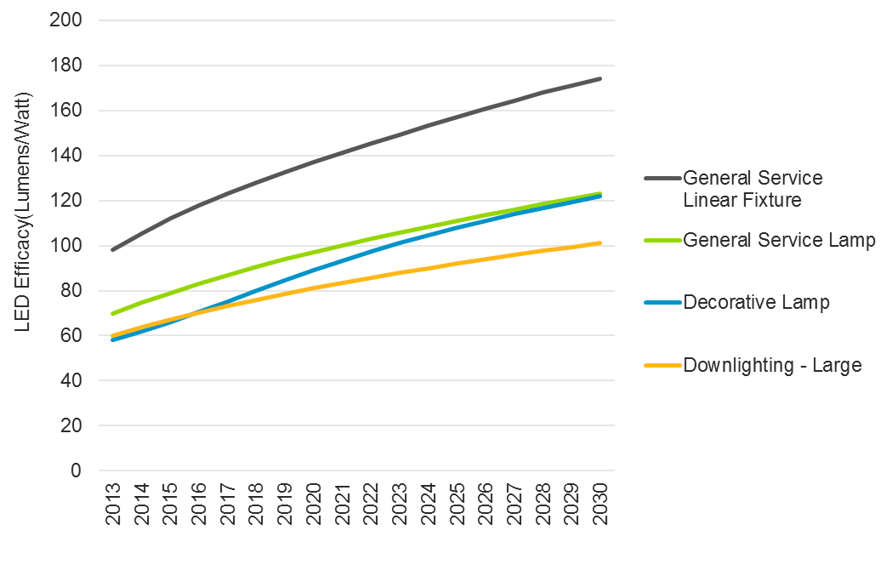

Figure ‑. Projected LED Cost Reduction Profiles, 2013-2030

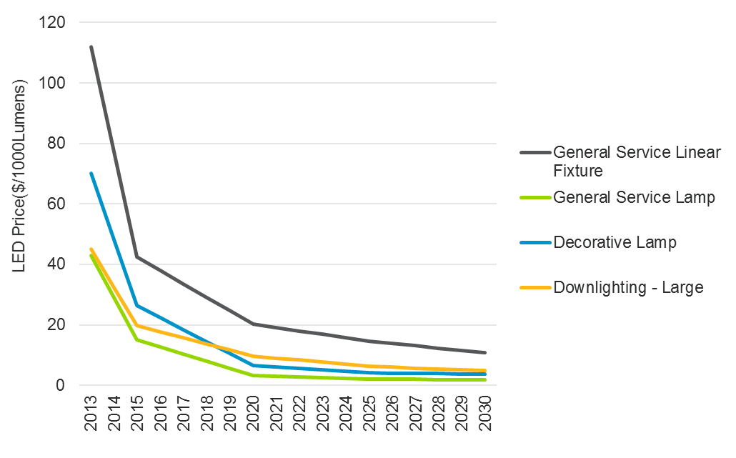

### Market Information: Density and Saturation Values

Density and saturation are two essential calculations of technology characterization.

* Density is a measure of the number of units per building. The potential model uses the density information to determine the number of applicable technology units on the appropriate scaling basis (per household for residential and per sq. ft. for commercial), to scale up the technology stock by segment/building type. Density is specified by technology group and by individual technologies. Density can be expressed as the following (for example): units/home, bulbs/home, fixtures/1000 square feet, tons of cooling/1000 square feet, etc.
* Saturation is the share of a specific technology within a technology group, so that the sum of the saturations across a technology group always sums to 100%. Saturation can also be calculated by dividing the individual technology density by the total technology group maximum density.

As an example, Table 3‑15 below shows the densities and saturations for residential refrigerators in single-family homes in PG&E’s service territory.

Table ‑. Example of Density and Saturation Calculation

|  |  |  |  |  |
| --- | --- | --- | --- | --- |
| Technology Name | Base Year Efficiency Level | Unit basis | Technology Density (units per household) | Technology Saturation |
| Average Below Code Refrigerator | Average Below Code | No. of Refrigerators | 0.155 | 13% |
| Code Compliant Refrigerator | Code | No. of Refrigerators | 0.590 | 51% |
| ENERGY STAR Refrigerator | Efficient | No. of Refrigerators | 0.405 | 35% |
| **Total** |  |  | 1.15 | 100% |

The table shows that an average single-family home in PG&E’s territory has 1.15 refrigerators per home, which is the density for refrigerators in single-family homes. The saturations for average below code, code compliant and ENERGY STAR refrigerators for single family homes is 13%, 51% and 35% respectively. The saturation change overs time with population growth and stock turnover as more “below-code” stock gets replaced with “at-code” and “higher efficiency” stock.

Table 3‑16 lists the resources used to calculate density and saturation for the residential and commercial sector in 2017, in order of priority. Navigant primarily used California-specific sources for density and saturation data, and referred to non-California sources only in cases California-specific sources did not have the required data.

Table ‑. Sources for Density and Saturation Characterization

| Priority | Sources | Description | Author | Year |
| --- | --- | --- | --- | --- |
| 1 | California Lighting & Appl. Saturation Survey (CLASS) | Residential baseline study of 1,987 homes across California. | DNV GL | 2012 |
| 2 | Commercial Saturation Survey (CSS) | Baseline study of 1,439 commercial buildings across California. | Itron | 2013 |
| 3 | Residential Appliance Saturation Study (RASS)[61] | Residential end-use saturations for 24,000 households in California. | DNV GL (formerly KEMA) | 2009 |
| 4 | Non-California source examples:   * Residential Building Stock Assessment (RBSA) * Comm. Building Stock Assessment (CBSA) | RBSA and CBSA survey residential and commercial building stock across the Northwest states (Idaho, Montana, Oregon, Washington) | Northwest Energy Efficiency Alliance (NEEA) | 2014 |
| * Res. Energy Consumption Survey (RECS) * Comm. Bldg. Energy Cons. Survey (CBECS) | RECS and CBECS are surveys of residential and commercial building stock in the United States by region. Used West regional data only. | U.S. Dept. of Energy | 2009 |
| * Energy Star Shipment Database | Unit shipment data of Energy Star-certified products collected to evaluate market penetration and performance | EPA | 2003-2016 |

In addition to the density and saturation values, measure characterization requires specification of the technical suitability or applicability factor (which has a value less than or equal to 1), that defines the share of customers with the physical or infrastructural pre-requisites to install a technology. The applicability factor assumptions are based on data sources, wherever available, and the Navigant team’s industry expertise and subject matter expertise in the area.

* + 1. ***MICS Database***

The MICS database consolidates the information from the measure characterization effort and in an Excel spreadsheet that serves as an input to the potential model. It presents the various dimensions along which measures are characterized as separate fields in the database. The database is publicly available and can be downloaded through the CPUC website.[62]

## Agriculture, Industrial, Mining, and Street-lighting (AIMS) Technology Characterization

The 2018 PG study updated the Agriculture, Industrial, Mining, and Street Lighting (AIMS) sectors, with a heavy focus on the Agriculture and Industrial sector and limited focus on the Mining and Street lighting sectors. The Navigant team’s approach to each sector’s data sources varied. The primary effort for Agriculture and Industrial focused on historical program data to directly relate measures developed for the potential model to IOU program activities. The data approaches to Mining and Street Lighting remain largely consistent with the 2015 PG study, but Navigant reviewed and updated the existing data with new and current sources. The following sections provide additional details about the development of data for the four AIMS sectors. Additional detail on the industrial and agriculture subsectors and measures can be found in Appendix D.

### Agriculture and Industrial Sectors

Navigant identified over 900 records[63] in the 2013 to 2015 Energy Efficiency Statistics (EEStats) data associated with the Agriculture and Industrial sectors. The team refined this list of records, focusing on the high impact measures (i.e., those contributing significant amounts of energy savings), and excluded records with negligible savings contributions or those representing niche activities. Navigant then combined similar ProgramIDs into representative technology groupings based on the team’s familiarity with the industrial market.

The Navigant team presented the list of initial representative technologies to stakeholders during the DAWG meeting in August 2016, seeking feedback on whether the list appropriately represented the two sectors, and whether to add or delete any of the identified technologies. Stakeholders generally agreed with the overall approach to leveraging EEStats data and recommended a few areas of improvement, including expanding the lighting end-use to cover specific technologies (e.g., LEDs and lighting controls). Figure 3‑5 illustrates this technology list development process.

Figure ‑. Industrial and Agriculture Technology List Development Process

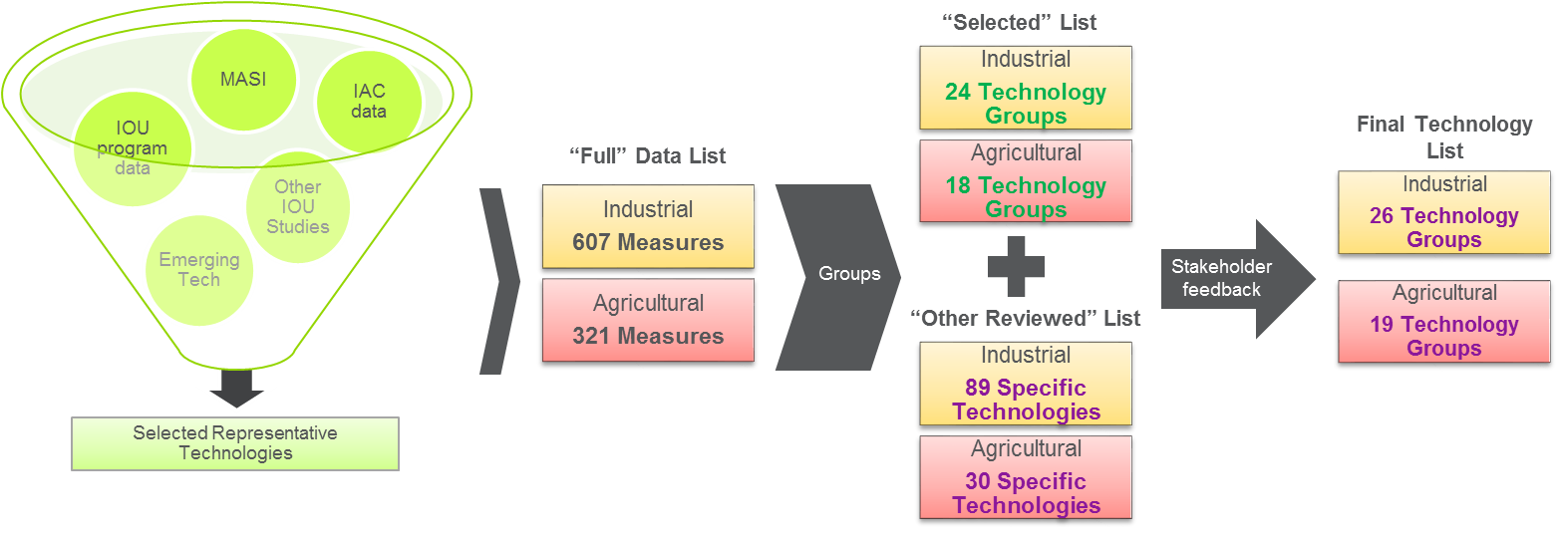

The Navigant team then segmented the final technology list into three categories:

* Discrete **identified deemed** measures, readily defined and forecasted using the diffusion model using deemed savings estimates
* Discrete **identified custom** measures, readily defined and forecasted using the diffusion model using custom savings estimates
* **Generic custom** measures included in projects unique to various subsectors that cannot be readily defined at the measure level or forecasted using a diffusion model. Navigant describes the methodology used to characterize these generic custom measures in section 3.5.
  + - 1. ***Agricultural and Industrial Identified Technologies***

For the 2018 study, Navigant characterized 19 technology groups for the Agriculture sector, and 26 for the Industrial sector, representing the identified deemed and identified custom measures for the diffusion model (summarized in Table 3‑17). Most of these are sourced from the EEStats technologies with other sources informing the development of four technologies, two each for Industrial and Agriculture. This approach provided consistency with the methods used in the Residential and Commercial sectors, and allowed the modeling team to calibrate the PG model using prior program achievements detailed in EEStats and establish greater confidence in the results.

Table ‑. Final List of Technology Groups and Individual Technologies

|  |  |  |  |  |
| --- | --- | --- | --- | --- |
| Sector | End Use | Technology Group Examples[64] | Number of Technology Groups | Number of Individual Technologies[65] |
| **Agriculture** | Machine Drives | Motors, Pumps, Air Compressor Equipment | 3 | 33 |
| Irrigation Drives | Crop Irrigation, Water Pumping | 3 | 10 |
| Lighting | Indoor LED Fixtures, Specialty Lamps, Linear Fixtures. | 5 | 92 |
| HVAC | Air Conditioners, Heat Pumps, Ventilation | 1 | 16 |
| Process Heating | Greenhouses, Post-Harvest Processing, Drying | 3 | 48 |
| Process Refrigeration | Milk Cooling, Wine Cooling | 3 | 61 |
| Other | System Controls and Optimizations | 1 | 9 |
| **Total** |  | **19** | **269** |
| **Industrial** | Machine Drives | Motors, Pumps, Air Compressor Equipment | 11 | 145 |
| Lighting | Indoor LED Fixtures, Specialty Lamps, Linear Fixtures. | 3 | 206 |
| HVAC | Air Conditioners, Heat Pumps, Ventilation, VAV Systems | 5 | 82 |
| Process Heating | Boilers, Steam Traps, Insulation, Furnace/Ovens | 4 | 56 |
| Process Refrigeration | Refrigerators, Refrigeration Controls | 1 | 20 |
| Other | System Controls and Optimizations | 2 | 6 |
| **Total** |  | **26** | **515** |

The Industrial and Agriculture sectors of this 2018 study are informed by 515 individual technologies sourced from EEStats (as listed in Table 3‑17). For comparison, the 2015 study was informed by 167 supply curves defining a specific combination of subsector, end-use, measure type, and fuel. As a result, the 2018 study has more granular disaggregation of savings opportunities.

* + - 1. ***Technology Characterization***

The PG diffusion model required the characterization of a number of technology-level inputs including, unit energy savings, unit costs, and the saturation or density of efficient versions of each technology currently existing in the marketplace. The team mined a number of data sources to complete a comprehensive characterization of the agriculture and industrial technologies.

* **Agricultural** data sources for measure characterization included EEStats, CPUC workpapers, and data provided by the investor-owned utilities. The team also relied on the Database for Energy Efficiency Resources (DEER) for information on energy savings estimates by technology.
* **Industrial** data sources were similar to those mined for the agriculture sector, including EEStats and data provided by IOUs, the CPUC, and the CEC. For energy savings estimates, the team used the Industrial Assessment Center (IAC).[66]

Navigant closely reviewed the data sources for agricultural technologies and aggregated common technology details for each input to the diffusion model, including energy savings, costs, effective useful life (EUL), and densities. The team then weighted the results of each source and rolled them up to estimate the technology-level inputs. For most of the measures, Navigant leveraged California-specific resources, but when not applicable or available to certain measure types, Navigant utilized other peer group jurisdictions and substituted in California specific variables where possible (e.g., for post-harvest process grain dryers, Navigant reviewed the Wisconsin TRM but substituted California specific data for operating hours, moisture content, and other general drying conditions).[67]

For the industrial technologies, the team used a mix of data sources to characterize the inputs to the diffusion model.

***Energy Savings.*** The team used data from the national IAC database to supplement EEStats data, and inform the energy savings estimates for the industrial diffusion technologies. The IAC network is comprised of 24 universities which have completed over 16,000 industrial assessments at industrial facilities across the nation. Each assessment completed by the IAC includes detailed recommendations for improving energy consumption at a given site,[68] the specific energy savings the site can expect by implementing such improvements, and the total energy each site currently uses. Navigant notes that the PG Model study efforts have relied on IAC data since 2011.

Navigant mapped all the unique IAC recommendations to the list of identified deemed or identified custom industrial technologies created from the EEStats database. The team then used NAICS coding to sum the energy savings estimates for each technology to the entire industrial sector level by building type, and divided it by the total energy consumption for all buildings of that type. This provided the percentage each technology saves by building type across the entire industrial sector.[69] The team followed this process for both electric (kWh) and gas (therm) consuming industrial measures.

The IAC database included robust, informative data for all but a few industrial technologies. The technologies not included in IAC, but identified in EEStats, were LED Lighting, Injection Molding, and Wastewater Aerators.

*Lighting End Use:* Navigant leveraged commercial sector data for all industrial and agriculture lighting measures. To account for differences in lighting characteristics between commercial, industrial, and agriculture sectors, the team applied a 50 percent technical suitability factor to the industrial and agriculture savings results for lighting controls.[70]

*Injection Molding and Wastewater Aerators:* Southern California Edison (SCE) provided work paper data regarding actual savings estimates from the installation of these two technologies, which the team used to estimate sector level savings percentages.

***Costs.*** Navigant primarily used the EEStats database to calculate the incremental cost per unit energy savings for technologies included in the industrial and agriculture analysis.[71] The team multiplied the incremental cost per unit by the technology energy savings to estimate technology costs.

***EUL and NTG.*** Navigant used the EEStats database to calculate the EUL and net-to-gross (NTG) ratios for all technologies included in the industrial technology list.

***Saturations and Densities.*** Technology characterization requires data on the saturation of efficient technologies currently existing in the industrial marketplace. This provides a clearer picture of how much potential energy savings still exists by upgrading remaining baseline technologies within that marketplace. For industrial technologies analyzed using the IAC database, the team assumed that every recommendation made at an industrial facility meant that this facility still had the inefficient baseline technology installed. For example, if a facility received a recommendation to upgrade their lighting system, the team assumed that this facility still used inefficient or baseline lighting technologies. This assumption allowed the team to identify the percentage of sites with baseline equipment (i.e., those receiving a recommendation for a technology).[72] The team then used this baseline percentage as one of the variables for calculating the total sector savings available for each measure defined in the Energy Savings section above.

For measures not covered in the IAC database, the team used professional judgment, based on data sources such as commercial sector saturation data and feedback from stakeholders, to estimate a density of efficient versus inefficient technology.

### Mining Sector

The PG Model and the updates for the 2018 effort rely on the mining sector inputs established in previous studies.[73] Navigant defined the mining sector inputs using a bottom-up approach consistent with the other AIMS sectors. The team sourced data from several sources including region-specific information on oil and gas extraction activities from the California Department of Conservation.[74] This data provided the number of active and idle wells; the amount of oil and water produced from wells; the amount of steam and hot water generated for mining operations; and the number new wells created.[75]

The Navigant team also used consumption data from the CPUC and other secondary sources, including IOU program data, and industry-specific reports and studies. These sources inform estimates for energy savings, costs, EUL, and NTG. Navigant also updated select model inputs such as equipment stocks, sector consumption, and saturations of efficient equipment.

### Street Lighting Sector

Like the mining sector, the PG Model and the updates for the 2018 Street Lighting effort rely on the inputs established in previous studies.[76] The team also used a bottom-up approach to define sector inputs. Information provided directly by the IOUs served as the primary basis for street lighting inputs, specifically the inventories of customer-owned and IOU-owned street lights included in the LS-1 and LS-2 rate classes.[77] The PG Model outputs reflect potential energy savings associated only with customer-owned lamps (LS-2 rate schedule). However, Navigant gathered data on IOU-own lamps (LS-1 rate schedule) to aid with data vetting and quality control.

The IOU street lighting inventories inform several model inputs including equipment stocks, densities, and saturations of efficient equipment. Finally, Navigant also relied on secondary sources to update equipment costs. The team revised cost forecasts for LEDs with information from the DOE’s Solid State Lighting program.[78]

## Industrial and Agriculture Custom Technologies Data Sources

This section describes the data sources used to characterize the custom and emerging technologies for the Industrial and Agriculture sectors.

### Generic Custom Measures

Generic custom measures in the industrial and agriculture market sectors are projects that tend to be specific to an industry segment or production method. Generic custom measures are often listed by non-descript names such as ‘Process-Other’ in publicly report IOU tracking data and they present several challenges within a potential forecast, including:

* Having unique attributes that make them difficult to forecast within the diffusion based PG model
* Being unlikely to saturate over time due to continual process changes in the industrial and agricultural sectors
* Often consisting of emerging technologies with little to no engineering details, market parameters, or work papers

Generic custom measures make-up a significant portion of the energy efficiency program portfolio. Based on an analysis portfolio level EEStats data for the 2013 and 2014 portfolio, generic custom accounted for 36% of industrial savings and 58% of agricultural sector savings.

The 2018 potential model treats generic custom measures as a specific measure class. Table 3‑18 provides the inputs for electricity and natural gas for these measures. Navigant estimated savings based on building type consumption (kWh or Therms/year), however since these technologies are forecast as a single class of measure, savings do not vary by market segment or IOU. Navigant does provide separate UES estimates for the industrial and agricultural market sectors. The team calculated the EUL for these measures at 15 years since they tend to be larger capital investments with long operating lives. Costs for electricity and natural gas savings are $0.33 /kWh and $2.25/therm. Navigant applied cost and EUL values consistently across market segments within the industrial and agricultural sectors and across utilities.

Table ‑. Generic Custom Measures - Key Assumptions

|  |  |  |  |  |  |  |  |
| --- | --- | --- | --- | --- | --- | --- | --- |
| Sector | Type | EUL years | Savings Range | | Cost | | kW/kWh Savings Ratio |
| **kWh** | **Therm** | **kWh** | **Therm** |
| AIMS | Generic Custom | 15 | 0.16% (Ind)  0.28% (Ag) | 0.17% (Ind)  1.19% (Ag) | $0.33 | $2.25 | 0.000195 |

Source: Navigant team analysis

Applicability of generic customer measures in the industrial and agricultural sectors is 100% because these measures are considered ubiquitous to all activities in all market segments. Because the forecasting approach assumes generic custom measures will produce a static level of savings each year, penetration rates are meant to ultimately reflect current savings levels and do not vary over the forecast period. Penetration rates were held constant over the forecast horizon because industrial facilities continually upgrade equipment and processes and it is likely that generic custom measures will be installed at the same rate as past program activity.

Savings from generic custom measures are based on an analysis of portfolio level savings from data available through the California EEStats portal[79] for programs operating from 2006 through 2015. Over this period, generic custom measures contributed 42% of industrial and 62% of agricultural sector net electricity savings, with similar percentage contributions for natural gas. Navigant based the savings values in the 2018 PG model on an analysis of generic custom measures savings in EEStats for the 2013 and 2014 program years. Data for these program years provided the level of detail necessary to separate generic custom measures from savings attributable to deemed measures, or other custom measures that could be defined and modelled using a diffusion approach.

Using historic savings values defined by the analysis of EEStats data and sector level consumption forecasts provided by CEC, the team determined that generic custom measures would save roughly 0.16% and 0.17% of annual Industrial sector electricity and natural gas usage, respectively. Using a similar methodology, Navigant forecasted savings from generic custom measures in the Agricultural sector at 0.28% of annual electricity consumption, and 1.19% of annual gas usage. These percentages are used in both the reference or aggressive cases and remain constant throughout the forecast horizon. 5.Appendix F provides addition details on the generic custom analysis and forecast methodology.

Navigant based costs for electricity and natural gas savings on an analysis of industrial and agricultural programs operating in California and across the nation throughout 2016. They are estimated at $0.33/kWh and $2.25/therm, and they are applied consistently across sectors and utilities through the 2018 study forecast horizon.

### Emerging AIMS Technologies

New emerging technologies (ET) to reduce energy use and energy demand are continually being introduced in the California marketplace. For the 2018 study, Navigant initially identified approximately 1,500 potential ETs. These ETs were run through a screening process to rate energy technical potential, energy market potential, market risk, technical risk, and utility ability to impact market adoption. This process ultimately yielded 169 emerging technology processes[80] for final consideration within the model. For a summary of the ET literature reviewed, and details on screening process and how this was used to define sub-sector potential, see Appendix F.

Table 3‑19 summarizes the resulting savings and cost factors. Navigant applied segment-specific electric and gas savings, as well as costs, EUL, and the kW/kWh savings ratio consistently across all utilities.

Table ‑. Emerging Technologies - Key Assumptions

|  |  |  |  |  |  |  |  |
| --- | --- | --- | --- | --- | --- | --- | --- |
| Sector | Type | EUL years | Savings Range (Percent of Building Energy Consumption) | | Cost | | kW/kWh Savings Ratio |
| **kWh** | **Therm** | **kWh** | **Therm** |
| AIMS | Emerging Technologies | 15 | 0.18% - 4.8% | 0.44% - 9.5% | $0.42 | $2.83 | 0.000195 |

Emerging technologies apply to different industrial and agricultural sectors in varying degrees. However, because Navigant conducted sector-specific technology applicability calculations during the screening process, the team assigned each sector a 100% eligibility factor for modeling purposes. This was possible because the forecasted savings for that sector are derived only from those technologies that are relevant to the end uses within that respective industrial or agricultural sector.

Electric savings range from 0.18% to 4.8%, with an average of 1.74%. Natural gas savings range from 0.44% to 9.5%, with an average of 3.99%.

The model uses a universal EUL of 15 years to accommodate the broad range of emerging technology adoption curves. Similarly, a universal 0.000195 ratio of kW to kWh was applied to all three electric utilities. This is same value used for SEM, and it based on an analysis of several third-party SEM programs operating in California during the 2014-2015 portfolio cycle. Actual ET-specific EULs and kW/kWh are presently unknown and can be refined during future ET market studies as additional information becomes available.

Adoption of future ETs will vary by technology. Some ETs will gain widespread customer acceptance and capture broad market share based on price, energy savings, and other customer-driven factors, while other ETs will see a more limited adoption. Although Navigant assigned unique risk factors to each new technology during the screening process, it is impossible to definitively predetermine which technology will be successful. Therefore, the model considers all emerging technologies in aggregate and applies a consistent participation rate to all ETs. As such, penetration forecasts for both the industrial and agricultural sectors begin with a saturation level of 1% for the reference case and follow a compound annual growth rate of 2.95%, yielding a target saturation of 21.17% by 2030. The 2030 target saturation of the portfolio of AIMS relevant ETs of approximately 20% is an estimate that acknowledges the timeline over which new technologies move through the adoption cycle to reach 80% saturation (typically ranging from 10 to 30 years), and the relatively slow turnover of the diverse set of production equipment associated with many industrial processes.

Navigant estimated costs for electricity and natural gas ET savings based on an analysis of industrial and agricultural programs operating throughout 2016. Costs for electricity and natural gas savings are estimated at $0.42/kWh and $2.83/therm, and are applied consistently for all utilities and across all industrial and agricultural sectors. Additional information on the methodology used to derives UES values and costs for ET measure can be found in Appendix F.

## Whole Building Initiatives

Whole building initiatives aim to deliver savings to residential and commercial customers as a package of multiple efficiency measures that are all installed at the same time. The 2018 Study models whole building initiatives via the technology levels indicated in Table 3‑20. As described in section 2.1.1.2, the technology levels within the technology group include existing baseline, code baseline, and the efficient result of a whole building initiative.

Table 3‑. Whole Building Technology Levels

|  |  |  |
| --- | --- | --- |
| Technology Group | Residential Technology Level | Commercial Technology Level |
| New Construction | Title 24 2008 Code | Title 24 2008 Code |
| Title 24 2013 Code | Title 24 2013 Code |
| Title 24 2016 Code | Title 24 2016 Code |
| Title 24 2019 Code | Title 24 2019 Code |
| ZNE | ZNE |
| Retrofit | Existing Building – No Retrofit | Existing Building – No Retrofit |
| Energy Upgrade CA - Basic | Retrofit – 15% Savings |
| Energy Upgrade CA - Advanced |  |

Source: Navigant team analysis, 2017.

The Navigant team presented measures and methodology overviews at the Demand Analysis Working Group (DAWG) Meeting on November 4, 2016 and requested additional data sources of stakeholders. No additional data sources were provided to support this analysis. The following sections discuss the technology levels used in the 2018 Study. The final values for savings, cost, measure life, and other key model inputs can be found in the MICS spreadsheet.

### New Construction

The 2018 Study refines results to represent each Title 24 code level as it becomes the baseline for ZNE construction as the efficient measure, with energy consumption in absolute terms and costs represented as incremental to 2008 Title 24 levels. Though analysis is ongoing, communications with the CEC indicate that 10 percent energy savings are expected for 2019 Title 24 over 2016 Title 24.

#### Commercial

Table 3‑21 provides the sources for the characterization of commercial new construction whole building initiatives. These represent the best and usable data sets available to the team at the time of characterization. Of particular value was the data from the 2016 CBECC-Com software, which provided variability by climate zone.

Table 3‑. Commercial New Construction Whole Building Data Sources

| Data Category | Data Items | Data Sources |
| --- | --- | --- |
| **Cost** | Incremental Cost of  2013 Title 24 over 2008 Title 24 | California Energy Commission, 2013 Standard Cost Impact Analysis: <http://www.energy.ca.gov/title24/2013standards/rulemaking/documents/final_rulemaking_documents/05_Impact_Analysis.pdf> |
| Incremental Cost of  2016 Title 24 over 2013 Title 24 | California Energy Commission, 2016 Notice of Proposed Action: <http://www.energy.ca.gov/title24/2016standards/rulemaking/documents/NOPA_title24_parts_01_06.pdf> |
|  | Incremental Cost of  2019 Title 24 over 2016 Title 24 | Navigant extrapolation based on 2016 T24 |
|  | Incremental Cost of ZNE over 2013 Title 24 | Calculated using the following:  New Building Institute, Getting to Zero 2012 Status Update: A First Look at the Costs and Features of Zero Energy Commercial Buildings: <http://newbuildings.org/getting-zero-2012-status-update-first-look-costs-and-features-zero-energy-commercial-buildings> Comm. RE Specialists, Cost Per Square Foot For New Commercial Construction, 2013. Reed Construction Data Inc., RS Means Square Foot Estimator, 2013: <http://www.rsmeansonline.com> |
| **Energy Consumption and Savings** | 2016 Title 24 Energy Consumption | California Energy Commission, CBECC-Com 2016 Std. Design Results, January, 2017. |
| Incremental Energy Savings of  2013 Title 24 over 2008 Title 24 | California Energy Commission, 2013 Impact Analysis: <http://www.energy.ca.gov/2013publications/CEC-400-2013-008/CEC-400-2013-008.pdf> |
| Incremental Energy Savings of  2016 Title 24 over 2013 Title 24 | California Energy Commission, 2016 Impact Analysis: <http://www.energy.ca.gov/title24/2016standards/rulemaking/documents/15-day_language/impact_analysis/2016_Impact_Analysis_2015-06-03.pdf> |
| Incremental Energy Savings of  2019 Title 24 over 2016 Title 24 | Communications with the California Energy Commission, January, 2017. |
| Incremental Energy Savings of  ZNE over  2013 Title 24 | ARUP, The Technical Feasibility of Zero Net Energy Buildings in California, December, 2012. |

#### Residential

Table 3‑22 provides the sources for energy consumption and cost data. By using the percent savings values rather than absolute energy consumption reported by different sources, the 2018 Study accounts for inconsistencies in simulation assumptions across data sources. This results in lower electricity consumption and higher natural gas consumption in comparison to the 2015 Study.

Table 3‑. Residential New Construction Whole Building Data Sources

| Data Category | Data Items | Data Sources |
| --- | --- | --- |
| **Cost** | Incremental Cost of  2013 Title 24 over 2008 Title 24 | California Energy Commission, 2013 Standard Cost Impact Analysis: <http://www.energy.ca.gov/title24/2013standards/rulemaking/documents/final_rulemaking_documents/05_Impact_Analysis.pdf> |
| Incremental Cost of  2016 Title 24 over 2013 Title 24 | California Energy Commission, 2016 Notice of Proposed Action: <http://www.energy.ca.gov/title24/2016standards/rulemaking/documents/NOPA_title24_parts_01_06.pdf> |
| Incremental Cost of  2019 Title 24 over 2016 Title 24 | Navigant extrapolation based on 2016 T24 |
| Incremental Cost of  ZNE over  2013 Title 24 | CEC Draft Title 24 Code Update Analysis provided to Navigant |
| **Energy Consumption and Savings** | Incremental Energy Savings of  2013 Title 24 over 2008 Title 24 | California Energy Commission, 2013 Standard Cost Impact Analysis: <http://www.energy.ca.gov/title24/2013standards/rulemaking/documents/final_rulemaking_documents/05_Impact_Analysis.pdf> |
| 2013 Title 24 Energy Consumption | California Energy Commission, CBECC-Res 2013 Std. Design Results, 2015. |
| 2016 Title 24 Energy Consumption | California Energy Commission, CBECC-Res 2016 Std. Design Results, January, 2017. |
| Incremental Energy Savings of  2019 Title 24 over 2016 Title 24 | Communications with the California Energy Commission, January, 2017. |
| Incremental Energy Savings of  ZNE over  2013 Title 24 | ARUP, The Technical Feasibility of Zero Net Energy Buildings in California, December, 2012. |

### Retrofit

Characterization of both commercial and residential whole building retrofits reflects the encouragement of to-code savings in existing buildings expressed in AB802.

#### Commercial

In the 2015 Study, bundles of electric and gas measures were assembled from the MICS to represent the weighted average installation of measures by a typical participant. This 2018 Study moves away from this bottom-up approach, and instead uses a top-down approach with a goal of saving 15 percent of consumption at the whole building level. This target was selected in response to feedback collected at the November DAWG Meeting that indicated that whole building retrofits needed to achieve 15% savings to be able to differentiate savings from noise when using normalized metered energy consumption (NMEC) methods and reflect deeper energy savings from multi-measure approaches.[81]

Navigant verified that this level of savings could be achieved by addressing cooling, ventilation, lighting, and refrigeration electric end-uses and heating, water heating, and food service gas end-uses.[82] Figure 3‑6 uses the example of colleges in PG&E’s territory to demonstrate the calculations conducted for each building type to ensure feasibility of the 15% savings target. After defining the total savings target, these savings are distributed among the end uses listed above. The distribution was derived by starting with the percent savings exhibited by each end use in the 2013-2015 California energy efficiency portfolio. These had to be modified in an iterative process using the following parameters to ensure that reasonable savings were expected from each end use: Navigant kept savings at or below 50% for lighting and at or below 20% on all other end-uses with minimal exceptions.

Figure ‑. Whole Building Retrofit Savings Calculation and Viability Check

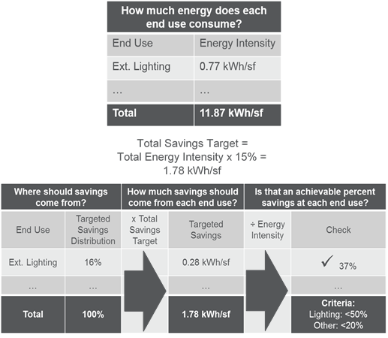

Costs were applied to these energy savings using an average unit energy savings ($/kWh or $/therm) associated with each end use across the 2013-2015 California energy efficiency portfolio. The data sources listed in Table 3‑23 were used for this analysis. This approach yields increased demand savings and comparable energy savings to the 2015 Study analysis.

Table 3‑. Commercial Retrofit Whole Building Data Sources

| Data Items | Data Sources |
| --- | --- |
| Energy Intensity by End-Use and  Building Type | California Energy Commission, California Commercial End-Use Survey, March, 2006. |
| Floorspace | California Energy Commission, 2016 Integrated Energy Policy Report. |
| Costs | California Public Utilities Commission, California Energy Efficiency Statistics, 2013-2015 Program Cycle. |

#### Residential

Table 3‑24 provides the sources of data used in characterizing the Energy Upgrade California program. Costs were applied to the energy savings using an average unit energy savings ($/kWh or $/therm) as derived from the program metrics reported by all Energy Upgrade California IOU programs. The 2018 Study results indicate higher multifamily costs than the 2015 Study as well as higher energy savings.

Table 3‑. Residential Retrofit Whole Building Data Updates

| Data Items | Data Sources |
| --- | --- |
| Single Family Savings | DNV GL, Focused Impact Evaluation of the 2013-2014 Home Upgrade Program, CALMAC ID: CPU0118.01.  <http://www.calmac.org/publications/CPUC_HUP_Focused_Evaluation-FINAL_05-03-16atr.pdf> |
| Multifamily Savings | Apex Analytics, Draft Results of 2015 Impact Evaluation. |
| Costs | California Public Utilities Commission, California Energy Efficiency Statistics, 2013-2015 Program Cycle. |

## Codes and Standards

C&S modeled in the PG study use data from multiple sources. For evaluated C&S the 2018 PG Model uses ISSM[83] as its data source. For certain unevaluated C&S, the 2018 PG model uses data provided by PG&E[84]. For all other C&S, the 2018 PG Model uses data from the 2015 Potential and Goals Study[85] or additional assumptions made by Navigant.

Table 3‑25 lists the number and type of codes and standards and their data source. A full list of the modeled C&S, their compliance rates, effective dates, and policy status (on the books, possible, or expected) are listed in Appendix E.

Table ‑ C&S Data Source Summary

|  |  |  |
| --- | --- | --- |
| IOU C&S Group | Number and Type of Codes and Standards | Data Source |
| 2005 Title 20 | 22 appliance standards | ISSM |
| 2006-2009 Title 20 | 13 appliance standards | ISSM |
| 2011 Title 20 | 4 appliance standards | ISSM |
| 2015-2016 Title 20 | 14 appliance standards | PG&E |
| Future Title 20 | 15 appliance standards | PG&E, 2015 Model, Navigant Estimates |
| Federal | 50 appliance standards | ISSM, PG&E, 2015 Model |
| 2005 Title 24 | 19 building codes | ISSM |
| 2008 Title 24 | 22 building codes | ISSM |
| 2013 Title 24 | 46 building codes | ISSM |
| 2016 Title 24 | 12 building codes | PG&E |
| Future Title 24 | 5 building codes | Navigant Estimates |

Sources: Cadmus and DNV GL. Integrated Standards Savings Model (ISSM). 2017.; Julie Liberzon. PG&E. January 3, 2017. Personal email communication in response to CPUC data request.

The 2018 study made several adjustments to the data obtained:

* An uncertainty factor of 80% was applied to all unevaluated C&S.
* IOUs provided claims for “T20 LED Quality” standards. This is a voluntary standard and thus was removed from the forecast to err on the side of conservatism.
* Per guidance from Cadmus, several 2013 Title 24 codes were removed from the analysis because their savings were already included in Whole Building codes[86].

For 2013 Title 24, ISSM provides the option to use either "bounded" or "unbounded" energy savings adjustment factors (ESAF), which are analogous to compliance factors for appliance standards[87]. "Unbounded" refers to the case where a building, project, or measure can consume less energy than the level established by the current Title 24 code, resulting in an ESAF greater than 100%. "Bounded" refers to limiting the ESAF values to a maximum of 100%. The 2018 PG study uses bounded values from ISSM.

The 2018 study re-evaluated the percentage of C&S savings that occurs in new construction vs. building retrofits. The 2015 study assumed new construction percentages of 0-2% for appliance standards and 100% for building codes. The 2018 study, on the other hand, used new construction percentages for 2005 and 2008 Title 24 evaluated measures from the 2010-2012 impact evaluation report[88]. For 2013 Title 24, each evaluated code name specified whether it was for new construction. For Title 20 and federal standards, the 2018 study calculated new construction percentages based on the average new construction rate for each standard’s sector and the retrofit lifetimes for each standard, as shown in Equation 3‑1.

Equation ‑. C&S New Construction Percentage

$$New Construction Percentage= \frac{Sector Population Annual Growth Rate}{1/{Measure EUL}}$$

The 2018 study determined new energy savings estimates for future Title 24 codes in 2019. The 2018 study has unit energy savings (UES) inputs for 2013 and 2016 Title 24 from ISSM and PG&E data sources. The 2018 study also had whole building energy use values for 2013, 2016, and 2019 Title 24 (discussed in further detail in section 3.6.1). The team therefore used UES values and ratios of consumption values to estimate 2019 Title 24 UES for C&S analysis using Equation 3‑2.

Equation 3‑2. 2019 Unit Energy Savings

$$2019 UES=\frac{(1-2016\%savings)×(2019\%savings)}{(2016\%savings)}x 2016 UES$$

Where

*2019%savings* = expected percent savings of a 2019 T24-compliant relative to a 2016 T24-compliant building

*2016%savings* = expected percent savings of a 2016 T24-compliant relative to a 2013 T24-compliant building

Table 3‑26 shows the savings percentages used in Equation 3‑2.

Table ‑26 2016 and 2019 Savings Percentages

|  |  |  |  |
| --- | --- | --- | --- |
| Building Type | Impact Type | Year | Savings Percentage |
| Residential Multi Family | Electric Energy (kWh/year) | 2016 | 34.5% |
| Residential Multi Family | Electric Energy (kWh/year) | 2019 | 10% |
| Residential Multi Family | Electric Demand (kW) | 2016 | 27.3% |
| Residential Multi Family | Electric Demand (kW) | 2019 | 10% |
| Residential Multi Family | Gas Energy (Therms/year) | 2016 | 31.2% |
| Residential Multi Family | Gas Energy (Therms/year) | 2019 | 10% |
| Residential Single Family | Electric Energy (kWh/year) | 2016 | 14.1% |
| Residential Single Family | Electric Energy (kWh/year) | 2019 | 31.8% |
| Residential Single Family | Electric Demand (kW) | 2016 | 11.7% |
| Residential Single Family | Electric Demand (kW) | 2019 | 32.9% |
| Residential Single Family | Gas Energy (Therms/year) | 2016 | 12.4% |
| Residential Single Family | Gas Energy (Therms/year) | 2019 | 32.5% |
| Commercial | Electric Energy (kWh/year) | 2016 | 4.6% |
| Commercial | Electric Energy (kWh/year) | 2019 | 10% |
| Commercial | Electric Demand (kW) | 2016 | 4.4% |
| Commercial | Electric Demand (kW) | 2019 | 10% |
| Commercial | Gas Energy (Therms/year) | 2016 | 4.6% |
| Commercial | Gas Energy (Therms/year) | 2019 | 10% |

Source: Navigant analysis.

Title 24 codes beyond 2019 (for example, the 2022, 2025, and 2028 cycles) were not considered in the 2018 study forecast due to the highly uncertain nature of their savings. While California has a goal of all new commercial construction to be ZNE by 2030, the regulatory path towards requiring this by 2030 is uncertain. The 2015 study included a preliminary estimate of the savings from 2022 T24 using a similar process to Equation 3‑2 above. However, that estimate was ultimately excluded from the goal setting process. The updated assumptions used for 2019 T24 made in this study would necessarily change what remaining savings can be obtained from 2022 T24. However, CEC staff were unable to provide guidance on what savings may remain for 2022 T24.

The 2015 study applied a reduction factor to the number of units for 2013 and later Title 24 to account for the recession. The 2018 study removed the reduction factors after confirming with Cadmus that the 2013 Title 24 ISSM analysis[89] already accounted for the recession.

## Behavior, Retrocommissioning, and Operational (BROs) Energy Efficiency

To forecast customer behavioral energy savings, the Navigant team considered a wide range of behavioral intervention types for both residential and commercial customers. Because this is an uncertain area that has been getting a lot of interest from the industry and was called out in AB802 and SB350 as an emerging area for increased opportunities given NMEC, we cast the net wide in consideration of interventions and coordinate with stakeholder through the Demand Analysis Working Group. Figure 3‑7 illustrates the five-step selection process used to determine intervention types to include in the reference case scenario.

Figure ‑. Selection Process for Residential and Commercial BROs Energy Efficiency Programs

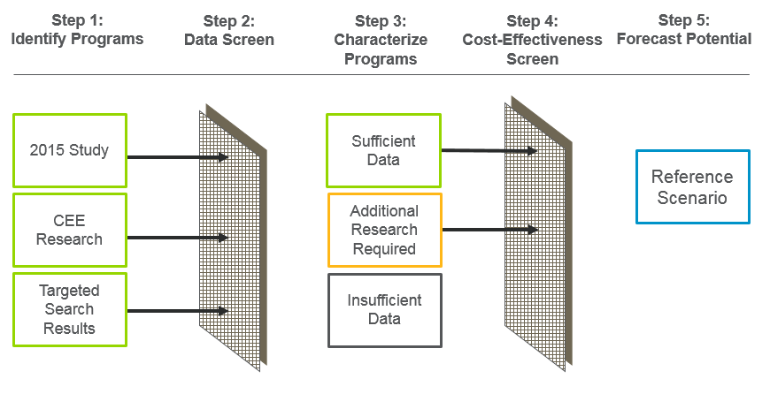

**Step 1: Identify Programs.** The first step was to identify general program categories and then to conduct a literature review to identify specific programs. The team augmented our existing knowledge base drawn from the 2015 study and the AB802 TA with additional findings from numerous Navigant evaluations and research studies, as well as findings from the Consortium for Energy Efficiency Database, American Council for an Energy Efficient Economy, and various other secondary research sources. Once appropriate utility programs had been identified, we sought out formal evaluation findings wherever possible—particularly evaluations of programs run by the four California investor owned utilities—as well as other commissioned original research studies.

**Step 2: Screen Data.** Potential programs were then organized by intervention type and screened to ensure sufficient data. This initial literature review captured all available data, including utility, program name, state, number of years, number of participants per year, participant type, participation rates, eligibility considerations, energy savings, persistence, and cost. Because findings were obtained from many sources, data were inconsistently reported and thus “apples-to-apples” comparisons were not always possible.

**Step 3: Characterize Interventions.** Behavioral interventions were ultimately included in the model when a sufficiency of data was available for five primary modeling inputs:

* kWh savings
* therm savings
* participation rates
* persistence
* cost

While savings and participation rates were generally readily available from formal EM&V evaluations, cost data were more often scarce. So, in some cases we extrapolated or estimated based on a limited number of data points.

Penetration rates were calculated based on relevant EM&V reported program participation rates for current California IOU program offerings and reported participation in programs in other states.

We modeled an EUL of one year for residential programs. Commercial programs used a two or three year EUL, per CPUC Decision 16-08-019, unless evidence supported a longer duration.

Specific modelling inputs for each intervention type are discuss in detail in Appendix C.

**Step 4. Cost Effectiveness Screen.** The cost-effectiveness screen used the total resource cost (TRC) test – the most conservative of the cost-effectiveness tests used in the 2018 Study – and the latest CPUC-approved avoided costs for each utility. This screen was used to eliminate measures from the reference case. Even programs that were not cost-effective are included in the aggressive scenario as an indication of the data available on the potential of these programs.

**Step 5. Forecast Potential.** The forecasts are the result of professional judgement based upon program operations and whether participation is utility driven (opt-out) or customer driven (opt-in). The forecasted penetration rates were adjusted to represent a reference and an aggressive scenario.

The results of Step 1 were presented at the DAWG meeting held in San Francisco on November 4, 2016. Feedback from stakeholders on these interventions was requested during the meeting, but none was subsequently submitted. Several of the originally-considered behavior intervention types were eliminated after completing the five-step selection process due to insufficient data. Thus, the 2018 Study ultimately includes the programs shown in Figure 3‑8 and Figure 3‑9. A more detailed description of each of the final intervention types follows in Table 3‑.

Figure ‑. Residential BROs

*Note: Removed from the reference case scenario due to low cost effectiveness.

Figure ‑. Commercial BROs

*Note: Removed from the reference case scenario due to high uncertainty.

Table ‑27. Behavioral Intervention Summary Table

| Sector | Type of  Behavioral Intervention | Brief Description | EUL (years) |
| --- | --- | --- | --- |
|
| RES | Home Energy Reports (HERs) | Residential customers are periodically mailed HERs that provide feedback about their home’s energy use, including normative comparisons to similar neighbors, tips for improving energy efficiency, and occasionally messaging about rewards or incentives. | 1 |
| RES | Web-Based Real Time Feedback (Web RTF) | Real time information and feedback about household energy use provided via websites or mobile apps | 1 |
| RES | In-Home Display Real Time Feedback (IHD RTF) | Real time information and feedback about household energy use provided via energy monitoring and feedback devices installed in customer homes | 1 |
| RES | Small Residential Competitions | Small residential competitions are organized competitions with fewer than 10,000 participants per year in which participants compete in events, contests, or challenges to achieve a specific objective or the highest rank compared with other individuals or groups as they try to reach goals by reducing energy consumption. | 1 |
| RES | Large Residential Competitions | Large residential competitions are organized competitions with more than 10,000 participants per year in which participants compete in events, contests, or challenges to achieve a specific objective or the highest rank compared with other individuals or groups as they try to reach goals by reducing energy consumption. | 1 |
| COM | Commercial Competitions | Commercial competitions are organized competitions between cities, businesses, or tenants in multi-unit buildings in which participants compete in events, contests, or challenges to achieve a specific objective or the highest rank compared with other groups as they try to reach goals by reducing energy consumption. | 2 |
| COM | Business Energy Reports (BERs) | BERS are periodically mailed to small and medium size business to provide feedback about their business’s energy use, including normative comparisons to similar businesses, tips for improving energy efficiency, and occasionally messaging about rewards or incentives. | 2 |
| COM | Building Benchmarking | Building benchmarking scores a business customer’s facility or plant and compares it to other peer facilities based upon energy consumption. It also often includes goal setting and rewards in the form of recognition. | 2 |
| COM/IND/AG | Strategic Energy Management (SEM) | Strategic Energy Management is a long-term continuous improvement process that educates and trains business energy users to develop and execute long-term energy goal setting and strategic planning; and to integrate energy management into business practices throughout the organization, from the corporate board office to the boiler room and the work floor. It can include consulting services, customized training, benchmarking and measurement, feedback, data analysis, and performance review. | 5 |
| COM | Building Energy Information Management Systems (BEIMS) | Building Energy Information Management Systems enable building operations staff to achieve significant energy savings by monitoring, analyzing, and controlling building system performance and energy use. BEIMS can include benchmarking and utility bill tracking software, energy information systems (EIS), building automation systems, fault detection and diagnostic tools, and automated system optimization software, as well as value added services and contracts. | 3 |
| COM | Building Operator Certification | Building Operator Certification trains and educates commercial building operators about how to save energy by encouraging them to adopt energy efficient behaviors and make building changes that reduce energy use. | 3 |
| COM | Retrocommissioning | Commissioning is a whole-building systems approach to improving an existing building’s performance by identifying and implementing operational improvements to save energy and increase comfort. Retrocommissioning refers to commissioning a building that has not previously been commissioned. This program also includes recommissioning, or commissioning a building that has been commissioned at least 5 years prior. | 3 |

### Stakeholder Input

Stakeholders and members of the DAWG were given the opportunity to provide informal feedback to the team following a webinar presentation of draft results on April 20, 2017. Navigant also made revisions based on feedback received following the June 2017 draft release. Table 3‑28 contains a high-level summary of relevant stakeholder feedback received and Navigant responses.

Table ‑28. Stakeholder Feedback

| Stakeholder Comments | Additional Context from Navigant |
| --- | --- |
| **General** | |
| * Reduce near-term potential to reflect uncertainty. * Provide a high-level assessment of data quality and recommendations for further research to improve estimates of potential. * Explicitly address potential double-counting of savings among interventions in the same sector. * Reflect the non-linear scaling of costs. | * Table 3‑29 provides a high-level assessment of data quality, and the general recommendation is to focus future research on initiatives with high potential savings, but a low level of data rigor. * The methodology employed in this study does not account for non-linear cost scaling as sufficient data was not available. |
| **Residential Programs** | |
| * IOUs contributed additional data that helped tailor the analysis of each residential program. * Concern was raised that savings forecasted in this study may already have been claimed as part of the rollout of Smart Meters. * Concerns were expressed that the penetration of web-based real-time feedback was not representative of an opt-in program. | * Double counting in the residential sector was determined not to affect the achievable savings because the programs target different behavior changes. * As the utilities have not decreased their claimed savings as a result of Smart Meters to-date, no such reduction was included in this modeling effort. * The penetration of web-based real-time feedback was adjusted to reflect more conservative estimates. |
| **Commercial Programs** | |
| * IOUs contributed additional data that helped tailor the analysis of several commercial programs. * Commercial Competitions drew heavy criticism for its high forecasted potential and low data rigor. * It was suggested that unit energy savings for BEIMS increase over time to reflect improvements to data analytics and software algorithms (e.g., machine learning). * The potential for claimed savings from Building Benchmarking was questioned in light of related government requirements. * A CPUC decision allows for recommissioning after 5 years. | * Double counting concerns were addressed by adjusting the penetration of recommissioning after all other revisions were made. All other penetration is considered independent. * Business Energy Reports were removed from the reference scenario. * Penetration of BOC, BEIMS, and Retrocommissioning was delayed until 2018 for SoCalGas. * The savings associated with Commercial Competitions was lowered to reflect IOU analysis presented. * Energy savings of BEIMS was not increased over time due to a lack of data and to maintain a conservative forecast. * Building Benchmarking was removed from the reference scenario. * Recommissioning was added to the characterization of the Retrocommissioning program. |

### Data Rigor

Navigant conducted an extensive industry scan for data on BROs initiatives and found that many of these programs are relatively new and much learning about their effectiveness is ongoing. The published data spans a wide range in the rigor of analysis conducted on the data around energy savings resulting from these interventions. Table 3‑29 provides a snapshot of the quality of data collected for this study. Across the board, demand savings data is often very limited and cost data is hard to obtain. Penetration forecasts are the most uncertain because of limited historic penetration rates upon which to base a forecast.

We recommend the industry consider pilot studies along with measurement and verification to provide better data to future potential studies. Interventions that literature claims to show large promise though limited verified data exists include: strategic energy management, building benchmarking, competitions, web based feedback, and in-home real time feedback.

Table ‑29. Qualitative Assessment of Data Quality



## Low Income Programs

Data for Low Income Programs was primarily obtained from the IOUs via a formal data request. The first round of data provided by the IOUs was summarized by Navigant in a public workshop through the Demand Analysis Working Group on April 28, 2017. The workshop noted several minor gaps in data received. Discussion during and after the workshop releveled that additional information was available from the IOUs to fill these gaps. The final data provided by the IOUs is reflected in this report and can be found in Appendix G.

### Households Treated

The IOUs provided planned household participation for first time treatment and retreatment in their Low Income Programs. The primary eligibility criteria for ESAP first time participants are that they must live in a house, mobile home or apartment that is at least five years old and must meet income guidelines which are the same as those for the California Alternative Rates for Energy (CARE) program. Decision 16-11-022 also defines various criteria for retreatment eligibility. Based on these criteria, California’s four IOUs forecasted ESAP eligibility and participation at the household (HH) level including:

* Installation forecasts by HH type for single family, multifamily, and manufactured homes
* First time HH installation forecasts for program years 2017 through 2020
* Retreatment HH installation forecasts for program years 2017 through 2030

All IOUs provided HH type forecast for first and retreatment households, though only SCG and SDG&E provided guidance on HH retreatment forecasts from 2017 to 2030, as allowed by the Decision. PG&E and SCE only provided retreatment HH forecasts for 2017 through 2020, and the 2018 PG model therefor forecasts retreatment HH for PG&E and SCE using the assumption that participation rate holds constant from 2020 through 2030 (similar to was SCG and SDG&E assume).

### Unit Energy Savings

Consistent with Navigant’s past forecasts of low income sector potential, the forecast is based on a unit energy savings (UES) that is defined at the household level. Throughout April and May of 2017 the CPUC Energy Division and Navigant Consulting Inc. engaged California’s four IOUs in several data requests to provide the UES estimates for KWh, KW, and Therms used in the 2018 PG model, including:

* UES values for first time installations by HH type for single family, multifamily, and manufactured homes
* UES value for retreatment installations by HH type for single family, multifamily, and manufactured homes

All IOUs provided UES estimates by HH type for first time and treatment installations. PG&E, SDG&E, and SCG also provided estimated useful life (EUL) values by HH type which ranged between 8 and 14 years. SCE declined to provide an EUL estimated and the 2018 PG model uses an average of EUL estimated provided by the other IOUs, ranging between 10.8 and 11.9 years, depending on the household type and treatment. All IOUs concurred with the CPUC-ED and Navigant guidance that a net-to-gross of 1.0 is appropriate for the low-income sector forecast.

## Energy Efficiency Financing

The CPUC has recognized financing as an energy efficiency resource program.[90] However, as of March 2017 (when research for this study was finalized), no impact evaluations have been published to provide verified savings estimates. In the absence of impact studies, the input data to model financing was developed by Navigant leverage available market studies***.***

### Residential Inputs

To develop the residential financing cash flow model inputs, Navigant considered the achievements to date of the existing Regional Finance Programs, and the key financing terms for the Residential Energy Efficiency Loan (REEL) Program lenders[91].

Table ‑. 2013-2015 Achievements by Regional Financing Program

|  |  |  |  |  |  |  |  |
| --- | --- | --- | --- | --- | --- | --- | --- |
| Program | Start Date | Utility | Min. FICO | Avg. Rate | Avg. Term (yrs) | Avg. Amount ($) | Loans to Date |
| Golden State Financing Authority (GSFA) Energy Retrofit Program | Sep-12 | PG&E | 640 | 6.50% | 15 | 25,612 | 201 |
| emPower Central Coast | Nov-11 | SCE, SCG, PG&E | 590 | 5.85% | 14.5 | 20,809 | 52 |
| SoCalREN Home Energy Loans | Dec-13 | SCE, SCG | 660 | 5.87% | 9.5 | 18,087 | 100 |

Source: Regional Finance Program Attribution and Cost Effectiveness Study Evaluation Plan.

Interest rate

The interest rate is the percentage of the principal that a lender charges to a borrower for taking out a loan. Navigant considered the average discount rates of the Regional Financing Programs, and the range of interest rates available to borrowers of the Residential Energy Efficiency Loan (REEL) Program. Based on this information, Navigant assumed an interest rate of 6% for residential energy efficiency loans in the cash flow model.

Loan term

The loan term is the length of time of the loan agreement. REEL Program loans offer terms up to 15 years[92]. The average term of the Regional Finance Program loans ranges from 9.5 to 15 years. Based on this information, Navigant assumed a loan term of 12 years in the cash flow model.

Consumer discount rate

The discount rate is the rate by which future cash flows are discounted to determine the present value of the payment stream. Using a consumer discount rate allows multiple payment streams to be compared in the same timeframe. A low discount rate indicates that the value of future cash flows is low compared to the value now. We use the real discount rate, instead of the nominal discount rate, to eliminate the effect of inflation.

Estimating the discount rate for residential customers is not straightforward, and may vary by demographic factors such as credit score, income, race, and household size. The Office of Management and Budget (OMB) has prescribed a discount rate of seven percent for benefit-cost analysis, and the U.S. Department of Energy (DOE) uses 3 percent and 7 percent in the analyses for residential appliance standards.[93] Other government organizes use discount rates in this range. For example, the Northwest Power and Conservation Council which used 3% in the Seventh Power and Conservation Plan, and a lighting study by the DOE calculated a consumer discount rate of 5.6%.

However, the estimated discount rate for residential customers may be much higher than the range of 3-7% used in regulatory analysis. For example, one study looked at the observed discount rates for individuals and their preferences for energy efficiency and found that “a simple fact emerges that in making decisions which involve discounting over time, individuals behave in a manner which implies a much higher discount rate than can be explained in terms of the opportunity costs of funds available in credit markets”.[94] Based on these considerations, Navigant used a consumer discount rate of seven percent for the financing model.

Eligible population

Navigant updated the residential population eligibility in the 2015 Potential and Goals Study using Experian Consumer Credit data, accessed in November 2014. The 2015 Study identified the residential population eligibility at 98%. Like the 2015 Potential Study, Navigant assumes that residential customers with FICO credit scores above 580 are eligible for financing, and that 98% of single family customers are eligible for financing. The credit requirement aligns with the REEL program, which requires a minimum FICO score of 580 with income verification, and a FICO score of 640 without income verification.

Following the approach to eligibility assumptions for the multi-family sector in the 2013 and 2015 Potential Studies, Navigant estimated multi-family sector eligibility to be 5% based on the proportion of the segment that is affordable housing.[95]

In summary, the Navigant team used the following inputs for the residential cash flow model:

Table ‑. Key Inputs to Residential Financing Cash Flow Model

|  |  |  |
| --- | --- | --- |
| Model Input | Assumption | Source |
| Interest Rate | 6% | Navigant analysis of California IOU financing programs data1 |
| Loan Term | 12 years | Navigant analysis of California IOU financing programs data1 |
| Discount Rate | 7% | OMB Circular No. A-94 |
| Eligible Population | 98% of single family customers 5% of multifamily customers | 2015 California Potential and Goals Study |

Navigant analysis of the Regional Finance Program Attribution and Cost-effectiveness Study: Evaluation Plan

### Commercial Inputs

Interest rate

Non-residential customers can access zero-percent financing through the statewide OBF program. The projects are designed to be bill neutral, such that the monthly payment is less than the projected energy savings.[96] Based on these guidelines, Navigant assumed an interest rate of 0% in the cash flow model for OBF loans for the commercial and industrial sector.

Loan term

The OBF program offers zero-percent financing for loans up to five years for the small and large commercial sector, and up to ten years for the government sector. Given that our model doesn’t distinguish between the commercial and government sector, we apply a single assumption for the commercial sector.

Consumer discount rate

For non-residential customers, the discount rate is the weighted average cost of capital for companies (WACC) who use both debt and equity to fund their investments.

In summary, the Navigant team used the following inputs for the commercial and industrial cash flow model:

Table ‑. Key Inputs to Commercial and Industrial (C&I) Financing Cash Flow Model

|  |  |  |
| --- | --- | --- |
| Model Input | Assumption | Source |
| Interest Rate | 0% | California on-bill financing (OBF) program terms |
| Loan Term | 5 years | California on-bill financing (OBF) program terms |
| Discount Rate | 5.8% | 2016 LBNL Commercial Discount Rate Estimation for Efficiency Standards |

# 2018 Study Results

## Incentive Program Savings

The following subsections summarize statewide market potential results. These results are for all IOUs combined. The IOU breakdown for these savings can be found in the results viewer that accompanies this report (see section 4.3 for details). All results are presented as net savings; all statewide results are inclusive of interactive effects. Note that the purpose of this report is to present the findings of our potential study, and not to establish goals as that is under the purview of the CPUC. As such, the scenario comparisons presented in the following subsection are meant to illustrate a range of potential that can be achieved based on our study.

Graphs in this section focus on electric and gas savings. Peak demand savings are not illustrated though are quantified by the model. Full results for all scenarios and all utilities are available in the results viewer (discussed further in section 4.3).

### Total Savings and Spending by Scenario

Table 4‑1 through Table 4‑3 show the total incremental market potential from all savings sources by scenario. A few important notes about these results:

* Equipment Rebate program savings, which include savings from discrete equipment, whole building and shell measures, are different for each scenario based on parameter discussed earlier in section 2.3.2. Additional discussion of the variation in rebate program savings by scenario can be found in 4.1.3
* BROs savings vary only in terms of Reference vs. Aggressive. Thus, four of the five scenarios have the same forecast of BROs savings. Additional discussion of the variation in BROs savings by scenario can be found in 4.1.4.
* Codes and Standards and Low Income Savings do not vary by scenario.

Total savings are dominated by C&S. Because C&S savings do not vary by scenario, the overall variability in total savings may appear minimal. True variability in savings originates from Equipment Rebate Programs and BROs.

Versions of the following tables for each IOU can be found in Appendix H.

Table ‑. Statewide Net Incremental Electric Savings by Scenario

|  |  |  |  |  |  |  |  |  |  |  |  |  |  |
| --- | --- | --- | --- | --- | --- | --- | --- | --- | --- | --- | --- | --- | --- |
| **Electric Energy (GWh/year)** | | | | | | | | | | | | | |
| **Year** | **2018** | **2019** | **2020** | **2021** | **2022** | **2023** | **2024** | **2025** | **2026** | **2027** | **2028** | **2029** | **2030** |
| **TRC | Reference** | | | | | | | | | | | | | |
| **Equipment Rebates** | 622 | 672 | 644 | 712 | 727 | 744 | 778 | 798 | 814 | 820 | 828 | 830 | 830 |
| **BROs** | 213 | 270 | 302 | 338 | 363 | 388 | 414 | 451 | 482 | 514 | 547 | 582 | 613 |
| **Low Income** | 57 | 57 | 57 | 33 | 33 | 33 | 33 | 33 | 33 | 33 | 33 | 33 | 33 |
| **Incentive Programs (Subtotal)** | 892 | 999 | 1,003 | 1,082 | 1,123 | 1,165 | 1,225 | 1,282 | 1,329 | 1,367 | 1,408 | 1,445 | 1,476 |
| **C&S\*** | 1,212 | 1,257 | 1,266 | 1,304 | 1,269 | 1,406 | 1,347 | 1,299 | 1,218 | 1,173 | 1,067 | 966 | 864 |
| **Total** | **2,104** | **2,256** | **2,269** | **2,386** | **2,392** | **2,572** | **2,572** | **2,581** | **2,547** | **2,540** | **2,475** | **2,411** | **2,340** |
| **mTRC (GHG adder 1) | Reference** | | | | | | | | | | | | | |
| **Equipment Rebates** | 654 | 700 | 669 | 758 | 768 | 789 | 818 | 832 | 836 | 839 | 846 | 854 | 851 |
| **BROs** | 213 | 270 | 302 | 338 | 363 | 388 | 414 | 451 | 482 | 514 | 547 | 582 | 613 |
| **Low Income** | 57 | 57 | 57 | 33 | 33 | 33 | 33 | 33 | 33 | 33 | 33 | 33 | 33 |
| **Incentive Programs (Subtotal)** | 924 | 1,027 | 1,028 | 1,128 | 1,165 | 1,210 | 1,265 | 1,315 | 1,351 | 1,386 | 1,426 | 1,468 | 1,497 |
| **C&S\*** | 1,212 | 1,257 | 1,266 | 1,304 | 1,269 | 1,406 | 1,347 | 1,299 | 1,218 | 1,173 | 1,067 | 966 | 864 |
| **Total** | **2,136** | **2,284** | **2,295** | **2,432** | **2,433** | **2,616** | **2,612** | **2,614** | **2,569** | **2,560** | **2,493** | **2,434** | **2,361** |
| **mTRC (GHG adder 2) | Reference** | | | | | | | | | | | | | |
| **Equipment Rebates** | 664 | 710 | 685 | 792 | 804 | 839 | 857 | 871 | 870 | 873 | 885 | 883 | 879 |
| **BROs** | 213 | 270 | 302 | 338 | 363 | 388 | 414 | 451 | 482 | 514 | 547 | 582 | 613 |
| **Low Income** | 57 | 57 | 57 | 33 | 33 | 33 | 33 | 33 | 33 | 33 | 33 | 33 | 33 |
| **Incentive Programs (Subtotal)** | 935 | 1,037 | 1,044 | 1,163 | 1,200 | 1,259 | 1,304 | 1,355 | 1,385 | 1,420 | 1,466 | 1,497 | 1,524 |
| **C&S\*** | 1,212 | 1,257 | 1,266 | 1,304 | 1,269 | 1,406 | 1,347 | 1,299 | 1,218 | 1,173 | 1,067 | 966 | 864 |
| **Total** | **2,146** | **2,294** | **2,311** | **2,467** | **2,469** | **2,666** | **2,651** | **2,654** | **2,603** | **2,593** | **2,532** | **2,463** | **2,389** |
| **PAC | Reference** | | | | | | | | | | | | | |
| **Equipment Rebates** | 848 | 891 | 856 | 936 | 948 | 960 | 963 | 971 | 971 | 974 | 975 | 972 | 966 |
| **BROs** | 213 | 270 | 302 | 338 | 363 | 388 | 414 | 451 | 482 | 514 | 547 | 582 | 613 |
| **Low Income** | 57 | 57 | 57 | 33 | 33 | 33 | 33 | 33 | 33 | 33 | 33 | 33 | 33 |
| **Incentive Programs (Subtotal)** | 1,118 | 1,218 | 1,214 | 1,306 | 1,344 | 1,381 | 1,410 | 1,455 | 1,486 | 1,521 | 1,556 | 1,587 | 1,611 |
| **C&S\*** | 1,212 | 1,257 | 1,266 | 1,304 | 1,269 | 1,406 | 1,347 | 1,299 | 1,218 | 1,173 | 1,067 | 966 | 864 |
| **Total** | **2,330** | **2,476** | **2,481** | **2,611** | **2,613** | **2,787** | **2,758** | **2,753** | **2,703** | **2,695** | **2,622** | **2,553** | **2,476** |
| **PAC | Aggressive** | | | | | | | | | | | | | |
| **Equipment Rebates** | 896 | 944 | 910 | 998 | 1,008 | 1,020 | 1,021 | 1,023 | 1,027 | 1,029 | 1,030 | 1,028 | 1,027 |
| **BROs** | 264 | 369 | 433 | 479 | 529 | 576 | 654 | 748 | 812 | 884 | 967 | 1,059 | 1,164 |
| **Low Income** | 57 | 57 | 57 | 33 | 33 | 33 | 33 | 33 | 33 | 33 | 33 | 33 | 33 |
| **Incentive Programs (Subtotal)** | 1,217 | 1,370 | 1,400 | 1,510 | 1,570 | 1,628 | 1,707 | 1,803 | 1,872 | 1,946 | 2,030 | 2,120 | 2,223 |
| **C&S\*** | 1,212 | 1,257 | 1,266 | 1,304 | 1,269 | 1,406 | 1,347 | 1,299 | 1,218 | 1,173 | 1,067 | 966 | 864 |
| **Total** | **2,429** | **2,627** | **2,666** | **2,814** | **2,839** | **3,034** | **3,055** | **3,102** | **3,090** | **3,119** | **3,097** | **3,086** | **3,088** |

*includes interactive effects

Table ‑. Statewide Net Incremental Demand Savings by Scenario

|  |  |  |  |  |  |  |  |  |  |  |  |  |  |  |
| --- | --- | --- | --- | --- | --- | --- | --- | --- | --- | --- | --- | --- | --- | --- |
| **Electric Demand (MW)** | | | | | | | | | | | | | | |
| **Year** | **2018** | **2019** | **2020** | **2021** | **2022** | **2023** | **2024** | **2025** | **2026** | **2027** | **2028** | **2029** | **2030** |
| **TRC | Reference** | | | | | | | | | | | | | | |
| **Equipment Rebates** | 119 | 133 | 126 | 142 | 148 | 154 | 163 | 170 | 175 | 177 | 181 | 182 | 183 |
| **BROs** | 39 | 49 | 55 | 61 | 65 | 70 | 74 | 81 | 87 | 92 | 98 | 104 | 109 |
| **Low Income** | 10 | 10 | 10 | 6 | 6 | 6 | 6 | 6 | 6 | 6 | 6 | 6 | 6 |
| **Incentive Programs (Subtotal)** | 168 | 193 | 191 | 209 | 219 | 229 | 243 | 257 | 267 | 275 | 284 | 292 | 298 |
| **C&S\*** | 272 | 275 | 311 | 368 | 359 | 440 | 422 | 408 | 392 | 382 | 361 | 344 | 327 |
| **Total** | **440** | **468** | **502** | **577** | **578** | **669** | **665** | **665** | **659** | **658** | **646** | **636** | **625** |
| **mTRC (GHG adder 1) | Reference** | | | | | | | | | | | | | | |
| **Equipment Rebates** | 131 | 143 | 134 | 155 | 159 | 165 | 174 | 179 | 180 | 182 | 185 | 188 | 188 |
| **BROs** | 39 | 49 | 55 | 61 | 65 | 70 | 74 | 81 | 87 | 92 | 98 | 104 | 109 |
| **Low Income** | 10 | 10 | 10 | 6 | 6 | 6 | 6 | 6 | 6 | 6 | 6 | 6 | 6 |
| **Incentive Programs (Subtotal)** | 179 | 202 | 199 | 222 | 230 | 241 | 254 | 265 | 272 | 280 | 289 | 297 | 303 |
| **C&S\*** | 272 | 275 | 311 | 368 | 359 | 440 | 422 | 408 | 392 | 382 | 361 | 344 | 327 |
| **Total** | **451** | **478** | **511** | **590** | **589** | **681** | **676** | **674** | **664** | **663** | **651** | **641** | **630** |
| **mTRC (GHG adder 2) | Reference** | | | | | | | | | | | | | | |
| **Equipment Rebates** | 134 | 147 | 140 | 165 | 170 | 180 | 196 | 204 | 204 | 206 | 214 | 214 | 213 |
| **BROs** | 39 | 49 | 55 | 61 | 65 | 70 | 74 | 81 | 87 | 92 | 98 | 104 | 109 |
| **Low Income** | 10 | 10 | 10 | 6 | 6 | 6 | 6 | 6 | 6 | 6 | 6 | 6 | 6 |
| **Incentive Programs (Subtotal)** | 183 | 206 | 205 | 232 | 241 | 256 | 276 | 290 | 296 | 304 | 317 | 323 | 328 |
| **C&S\*** | 272 | 275 | 311 | 368 | 359 | 440 | 422 | 408 | 392 | 382 | 361 | 344 | 327 |
| **Total** | **455** | **482** | **517** | **600** | **600** | **695** | **698** | **699** | **688** | **686** | **679** | **667** | **655** |
| **PAC | Reference** | | | | | | | | | | | | | | |
| **Equipment Rebates** | 220 | 239 | 232 | 258 | 260 | 271 | 269 | 270 | 266 | 266 | 267 | 268 | 267 |
| **BROs** | 39 | 49 | 55 | 61 | 65 | 70 | 74 | 81 | 87 | 92 | 98 | 104 | 109 |
| **Low Income** | 10 | 10 | 10 | 6 | 6 | 6 | 6 | 6 | 6 | 6 | 6 | 6 | 6 |
| **Incentive Programs (Subtotal)** | 269 | 299 | 297 | 324 | 331 | 347 | 349 | 357 | 359 | 364 | 371 | 378 | 382 |
| **C&S\*** | 272 | 275 | 311 | 368 | 359 | 440 | 422 | 408 | 392 | 382 | 361 | 344 | 327 |
| **Total** | **541** | **574** | **608** | **693** | **690** | **786** | **771** | **765** | **751** | **746** | **732** | **722** | **709** |
| **PAC | Aggressive** | | | | | | | | | | | | | | |
| **Equipment Rebates** | 233 | 255 | 249 | 278 | 279 | 290 | 287 | 285 | 282 | 282 | 283 | 284 | 284 |
| **BROs** | 47 | 64 | 74 | 82 | 91 | 99 | 110 | 126 | 136 | 148 | 161 | 176 | 193 |
| **Low Income** | 10 | 10 | 10 | 6 | 6 | 6 | 6 | 6 | 6 | 6 | 6 | 6 | 6 |
| **Incentive Programs (Subtotal)** | 290 | 329 | 333 | 365 | 376 | 395 | 403 | 416 | 424 | 436 | 450 | 466 | 482 |
| **C&S\*** | 272 | 275 | 311 | 368 | 359 | 440 | 422 | 408 | 392 | 382 | 361 | 344 | 327 |
| **Total** | **562** | **604** | **644** | **734** | **735** | **834** | **825** | **824** | **816** | **818** | **812** | **810** | **810** |

*includes interactive effects

Table ‑. Statewide Net Incremental Gas Savings by Scenario

|  |  |  |  |  |  |  |  |  |  |  |  |  |  |  |
| --- | --- | --- | --- | --- | --- | --- | --- | --- | --- | --- | --- | --- | --- | --- |
| **Gas Energy (MMTherm/year)** | | | | | | | | | | | | | | |
| **Year** | **2018** | **2019** | **2020** | **2021** | **2022** | **2023** | **2024** | **2025** | **2026** | **2027** | **2028** | **2029** | **2030** |
| **TRC | Reference** | | | | | | | | | | | | | | |
| **Equipment Rebates** | 20 | 20 | 18 | 21 | 23 | 24 | 23 | 24 | 26 | 26 | 26 | 26 | 27 |
| **BROs** | 12 | 13 | 14 | 15 | 16 | 17 | 18 | 19 | 19 | 20 | 21 | 22 | 23 |
| **Low Income** | 6 | 6 | 6 | 5 | 5 | 5 | 5 | 5 | 5 | 5 | 5 | 5 | 5 |
| **Incentive Programs (Subtotal)** | 37 | 40 | 38 | 42 | 44 | 45 | 46 | 48 | 50 | 51 | 52 | 54 | 55 |
| **C&S\*** | 39 | 39 | 47 | 54 | 54 | 54 | 54 | 53 | 40 | 36 | 35 | 34 | 35 |
| **Total** | **77** | **78** | **85** | **95** | **98** | **99** | **100** | **101** | **90** | **88** | **87** | **88** | **90** |
| **mTRC (GHG adder 1) | Reference** | | | | | | | | | | | | | | |
| **Equipment Rebates** | 25 | 27 | 24 | 28 | 30 | 34 | 33 | 32 | 31 | 30 | 29 | 29 | 29 |
| **BROs** | 12 | 13 | 14 | 15 | 16 | 17 | 18 | 19 | 19 | 20 | 21 | 22 | 23 |
| **Low Income** | 6 | 6 | 6 | 5 | 5 | 5 | 5 | 5 | 5 | 5 | 5 | 5 | 5 |
| **Incentive Programs (Subtotal)** | 43 | 46 | 45 | 48 | 51 | 56 | 56 | 56 | 55 | 55 | 55 | 56 | 58 |
| **C&S\*** | 39 | 39 | 47 | 54 | 54 | 54 | 54 | 53 | 40 | 36 | 35 | 34 | 35 |
| **Total** | **82** | **85** | **92** | **102** | **105** | **110** | **110** | **109** | **95** | **91** | **91** | **90** | **92** |
| **mTRC (GHG adder 2) | Reference** | | | | | | | | | | | | | | |
| **Equipment Rebates** | 29 | 35 | 36 | 40 | 40 | 45 | 43 | 42 | 40 | 39 | 38 | 36 | 36 |
| **BROs** | 12 | 13 | 14 | 15 | 16 | 17 | 18 | 19 | 19 | 20 | 21 | 22 | 23 |
| **Low Income** | 6 | 6 | 6 | 5 | 5 | 5 | 5 | 5 | 5 | 5 | 5 | 5 | 5 |
| **Incentive Programs (Subtotal)** | 47 | 54 | 57 | 60 | 61 | 67 | 66 | 66 | 65 | 64 | 64 | 64 | 64 |
| **C&S\*** | 39 | 39 | 47 | 54 | 54 | 54 | 54 | 53 | 40 | 36 | 35 | 34 | 35 |
| **Total** | **86** | **93** | **104** | **114** | **115** | **121** | **120** | **119** | **105** | **100** | **99** | **98** | **99** |
| **PAC | Reference** | | | | | | | | | | | | | | |
| **Equipment Rebates** | 29 | 31 | 30 | 33 | 36 | 39 | 38 | 37 | 35 | 34 | 34 | 33 | 35 |
| **BROs** | 12 | 13 | 14 | 15 | 16 | 17 | 18 | 19 | 19 | 20 | 21 | 22 | 23 |
| **Low Income** | 6 | 6 | 6 | 5 | 5 | 5 | 5 | 5 | 5 | 5 | 5 | 5 | 5 |
| **Incentive Programs (Subtotal)** | 47 | 51 | 51 | 53 | 57 | 61 | 60 | 61 | 60 | 60 | 60 | 61 | 63 |
| **C&S\*** | 39 | 39 | 47 | 54 | 54 | 54 | 54 | 53 | 40 | 36 | 35 | 34 | 35 |
| **Total** | **86** | **90** | **98** | **107** | **111** | **115** | **114** | **114** | **100** | **96** | **95** | **95** | **98** |
| **PAC | Aggressive** | | | | | | | | | | | | | | |
| **Equipment Rebates** | 30 | 33 | 32 | 35 | 38 | 41 | 40 | 39 | 38 | 37 | 37 | 38 | 42 |
| **BROs** | 13 | 15 | 17 | 19 | 20 | 22 | 24 | 27 | 29 | 31 | 34 | 37 | 40 |
| **Low Income** | 6 | 6 | 6 | 5 | 5 | 5 | 5 | 5 | 5 | 5 | 5 | 5 | 5 |
| **Incentive Programs (Subtotal)** | 49 | 54 | 56 | 58 | 64 | 68 | 69 | 71 | 71 | 73 | 76 | 80 | 87 |
| **C&S\*** | 39 | 39 | 47 | 54 | 54 | 54 | 54 | 53 | 40 | 36 | 35 | 34 | 35 |
| **Total** | **88** | **93** | **103** | **112** | **117** | **122** | **122** | **124** | **111** | **110** | **111** | **114** | **121** |

*includes interactive effects

Figure 4‑1 and Figure 4‑2 compares the savings from all incentives programs, which include savings from Equipment Rebate programs, BROs interventions and Low Income programs, as a percent of IOU sales. Savings as a percent of sales is a common metric provided in other potentials studies and industry standard practice is to exclude savings from C&S from such calculations. Energy sales are sourced from the CEC’s IEPR Mid-Case.

For electric, market potential savings as a percentage of forecasted electric energy usage grows from 0.48% to 0.75% between 2018 and 2030 under Scenario 1 (TRC Reference). Under the most optimistic case, market potential grows from 0.66% in 2018 to 1.13% by 2030 under Scenario 5 (PAC Aggressive).

For gas incentive program savings, Scenario 5 (PAC Aggressive) and Scenario 3 (mTRC w/ GHG adder 2) are roughly on par until 2023. This is because the GHG adder, which is high in Scenario 3, is applied uniformly to all gas measures. On the other hand, the impact of the adder on electric measures is loadshape-dependent, which means the benefits of the GHG adder vary by time of day and season. Beyond 2023, Scenario 5 starts to yield the highest gas potential as BROs participation starts to ramp up in the Aggressive scenario.

**Figure 4‑1. Incremental Electric Market Potential as a Percent of Sales**



Note: Excludes C&S

Figure ‑. Incremental Gas Market Potential as a Percent of Sales

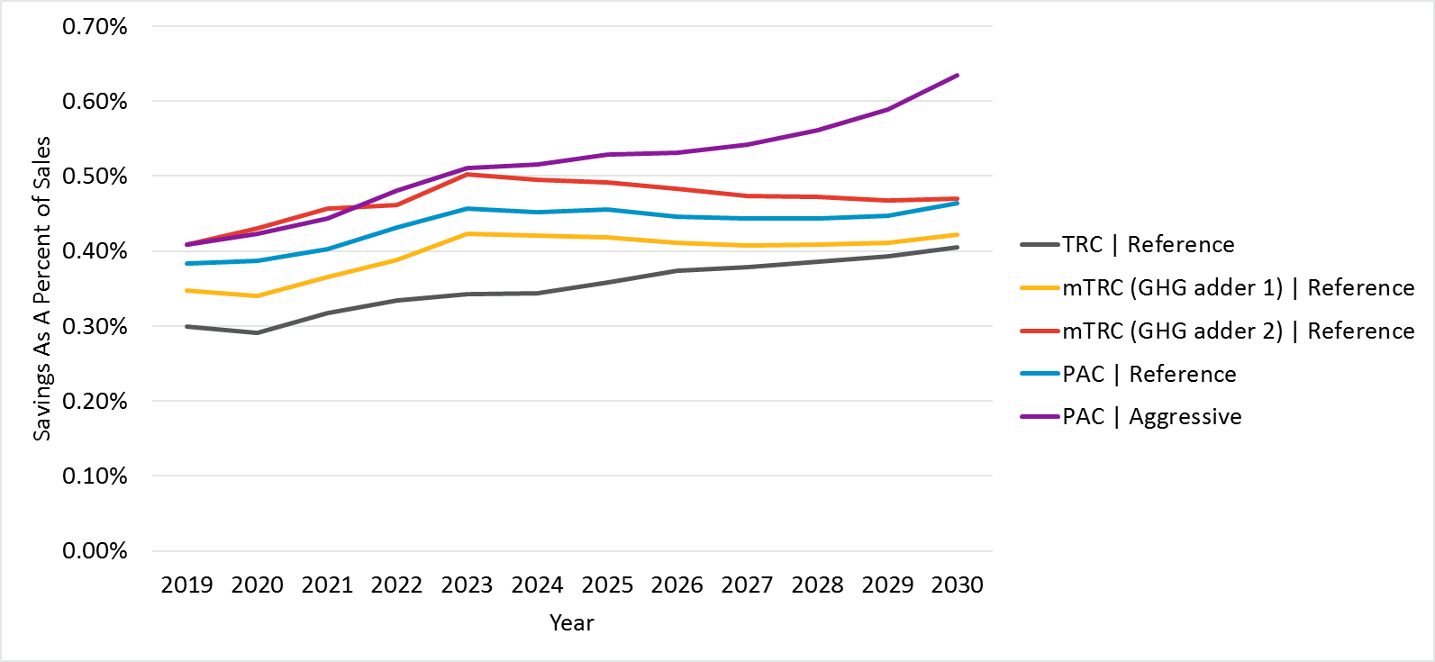

Note: Excludes C&S

Figure 4‑3 shows projected statewide spending for rebate programs and BROs by scenario. Spending includes both incentive and non-incentive program costs, which were approximated from historic program activity spending data from the IOUs. Since overall potential is driven by electric savings, the trend generally follows that of electric potential whereby Scenario 5 (PAC Aggressive) produces the most expensive portfolio for equipment savings, and Scenario 1 (TRC Reference), the least. By 2030, Scenario 4 (PAC Reference) is expected to cost about 36% more than Scenario 1 (TRC Reference). Aggressive program engagement further increases spending as illustrated by Scenario 5 (PAC Aggressive), which costs about 38% more than Scenario 4 (PAC Reference). Low income program costs were not estimated by this study.

Figure ‑. Statewide Spending by Scenario for IOU Incentive Programs



Note: Excludes Low Income

### Total Savings and Spending by Sector

Figure 4‑4 through Figure 4‑12 show the breakdown of electric (GWh) and gas (MMTherms) savings respectively by sector for incentive programs, which include savings from Equipment Rebate programs, BROs interventions and Low Income programs. All graphs exclude savings from re-participants and only Scenario 5 (PAC Aggressive) includes the effects of aggressive program engagement.

For electric savings, the commercial and residential sector dominate the savings across all scenarios, with the commercial sector showing slightly higher potential over the study horizon. The incremental savings potential grows over time for the residential, commercial and agricultural sectors. This growth is largely attributable to sectoral growth but also reflects greater levels of market uptake for BROs in the later years. Conversely, the incremental savings potential declines for the industrial, mining and streetlighting sectors. For industrial and mining, this savings decline is highly correlated with flat or negative customer growth rates during the time horizon. For streetlighting, the market potential for high efficiency measures becomes more saturated over time.

For gas savings, the largest savings potential comes from the residential sector, with smaller savings for industrial and commercial, and minimal savings for the agricultural and mining sectors.

Figure ‑. Statewide Incremental Net Electric Market Potential by Sector for Incentive Programs in Scenario 1 (TRC Reference)



Figure ‑. Statewide Incremental Net Electric Market Potential by Sector for Incentive Programs in Scenario 2 (mTRC w/ GHG adder 1)

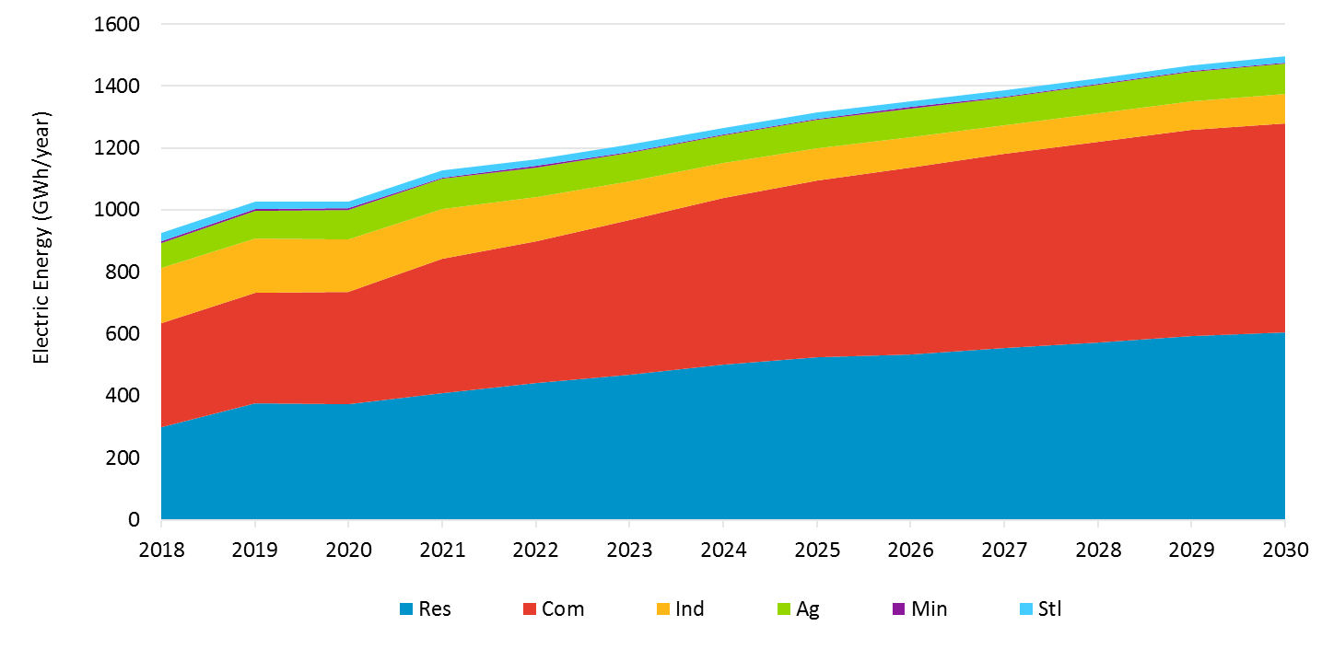

Figure ‑. Statewide Incremental Electric Market Potential by Sector for Incentive Programs in Scenario 3 (mTRC w/ GHG adder 2)

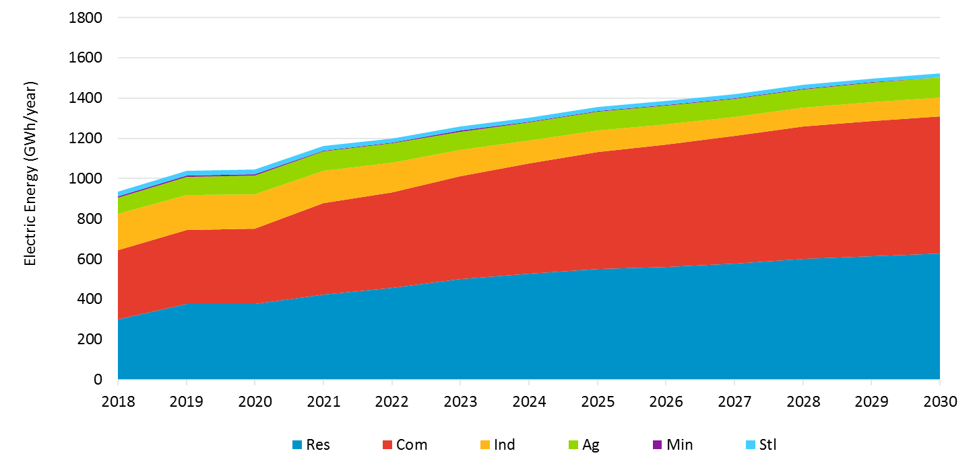

Figure ‑. Statewide Incremental Electric Market Potential by Sector for Incentive Programs in Scenario 4 (PAC Reference)

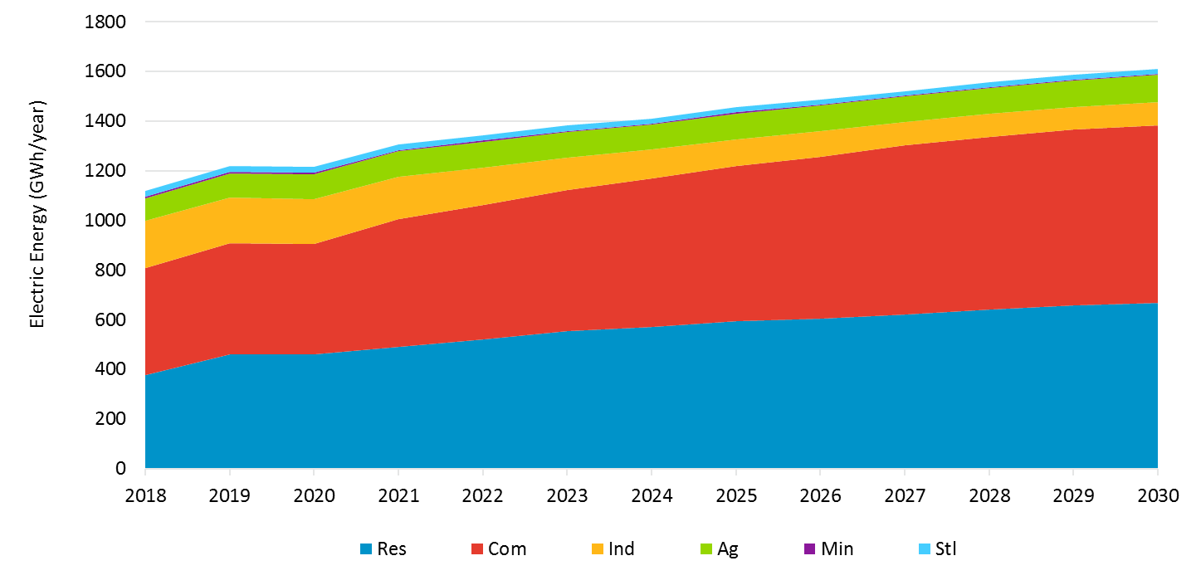

Figure ‑. Statewide Incremental Electric Market Potential by Sector for Incentive Programs in Scenario 5 (PAC Aggressive)

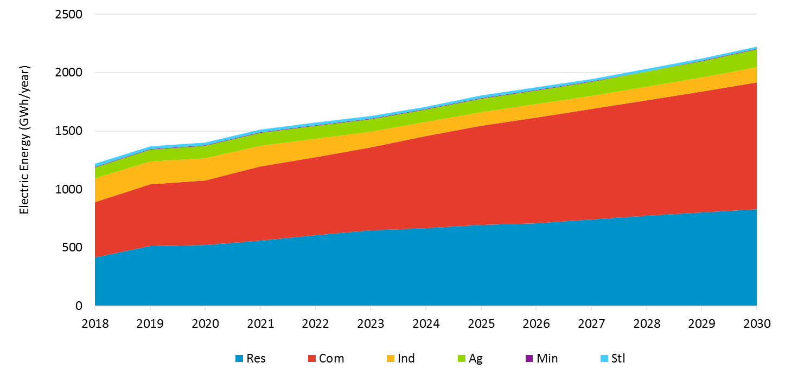

Figure ‑. Statewide Incremental Gas Market Potential by Sector for Incentive Programs in Scenario 1 (TRC Reference)



Figure ‑. Statewide Incremental Gas Market Potential by Sector for Incentive Programs in Scenario 2 (mTRC w/ GHG adder 1)

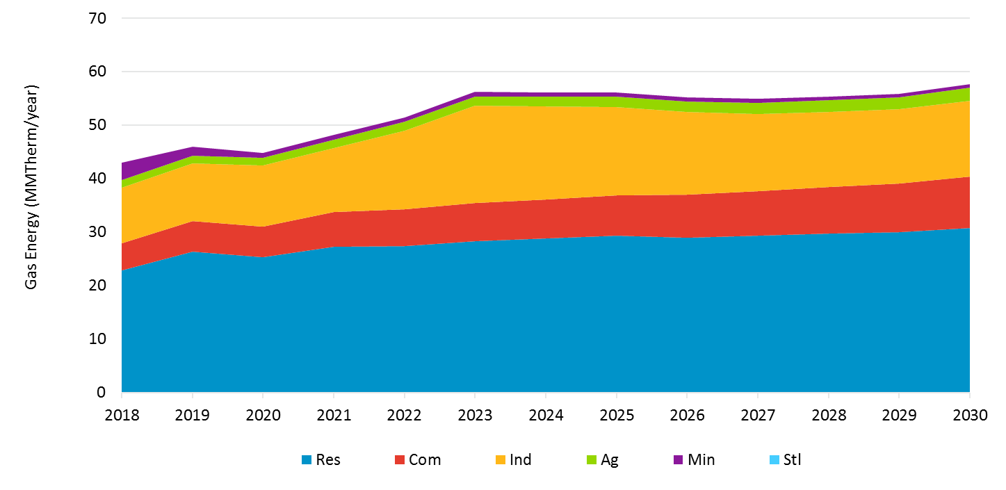

Figure ‑. Statewide Incremental Gas Market Potential by Sector for Incentive Programs in Scenario 3 (mTRC w/ GHG adder 2)

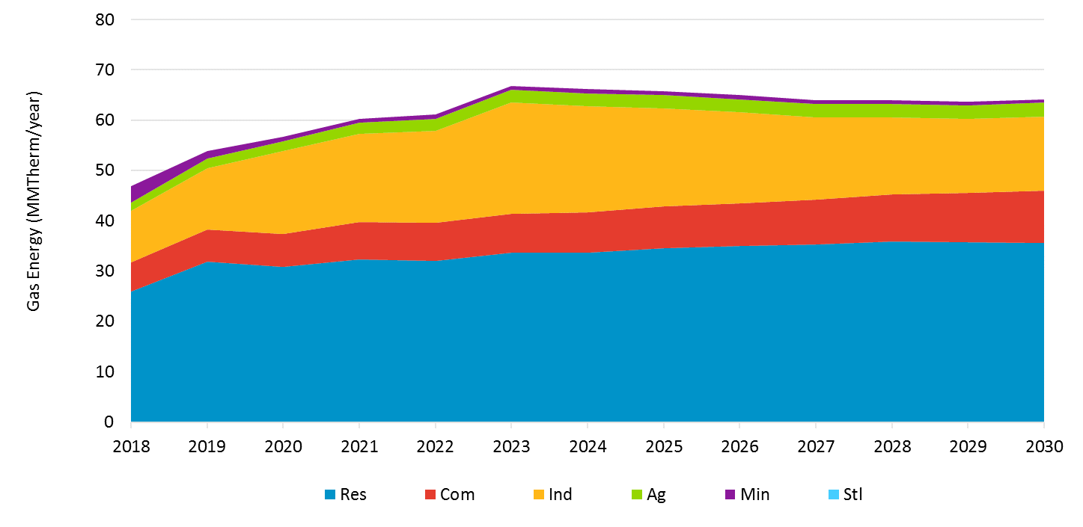

Figure ‑. Statewide Incremental Gas Market Potential by Sector for Incentive Programs in Scenario 4 (PAC Reference)

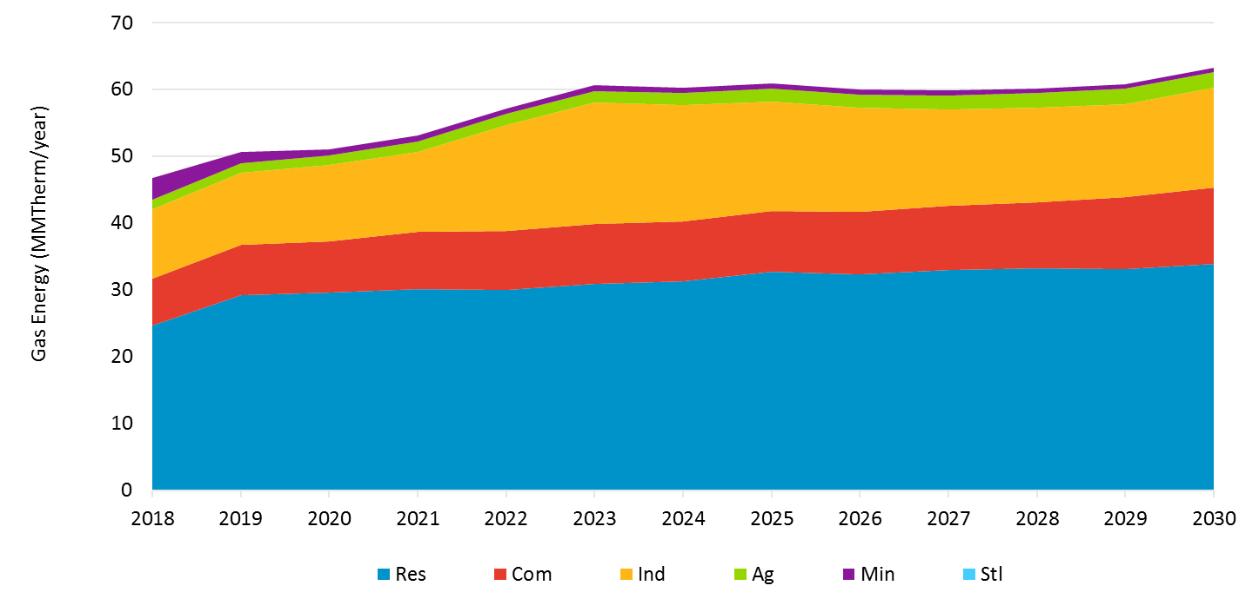

Figure ‑. Statewide Incremental Gas Market Potential by Sector for Incentive Programs in Scenario 5 (PAC Aggressive)

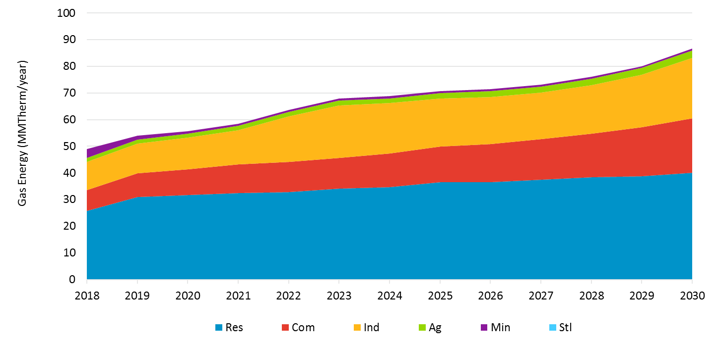

A peak demand savings version of the above figures can be found in the results viewer under the “Total Incr Potential by Sector” tab.

Figure 4‑14 through Figure 4‑18 show the breakdown of statewide spending by sector for incentive programs, which include savings from Equipment Rebate programs and BROs interventions. We do not report spending for low income programs. One again, a key takeaway from these graphs is that the share of each sector’s savings generally remains the same across scenarios, with the residential and commercial sectors generally dominating spending.

Figure ‑. Statewide Spending by Sector for Incentive Programs in Scenario 1 (TRC Reference)

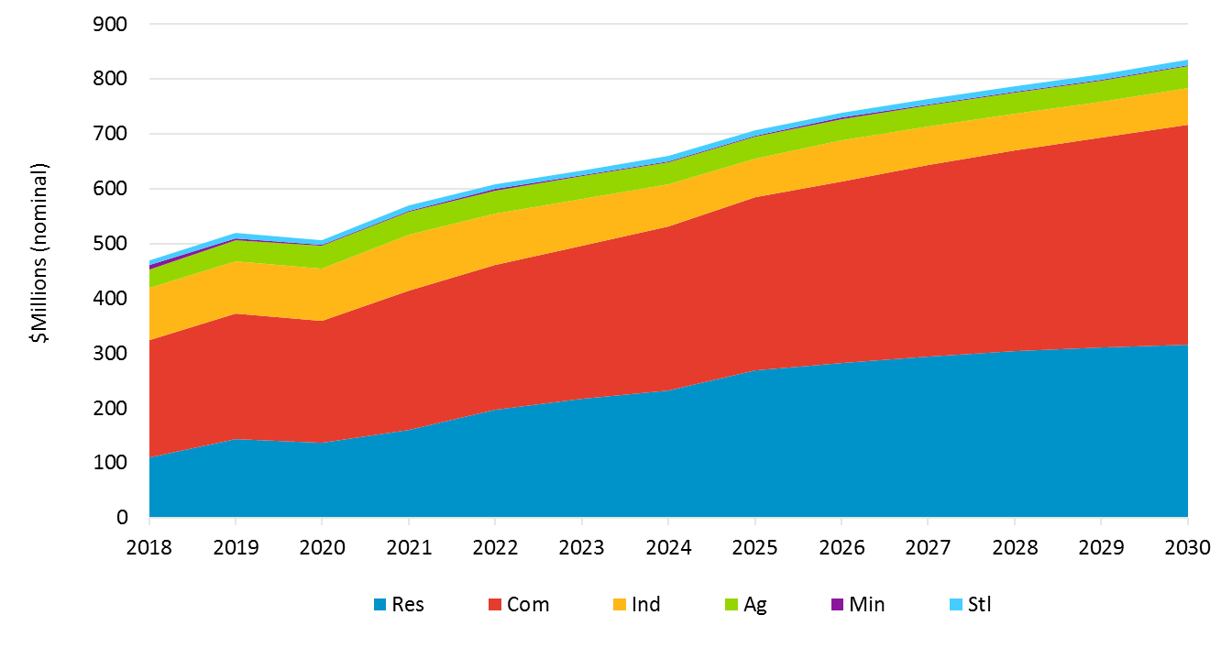

Note: Excludes Low Income

Figure ‑. Statewide Spending by Sector for Incentive Programs in Scenario 2 (mTRC w/ GHG Adder 1)

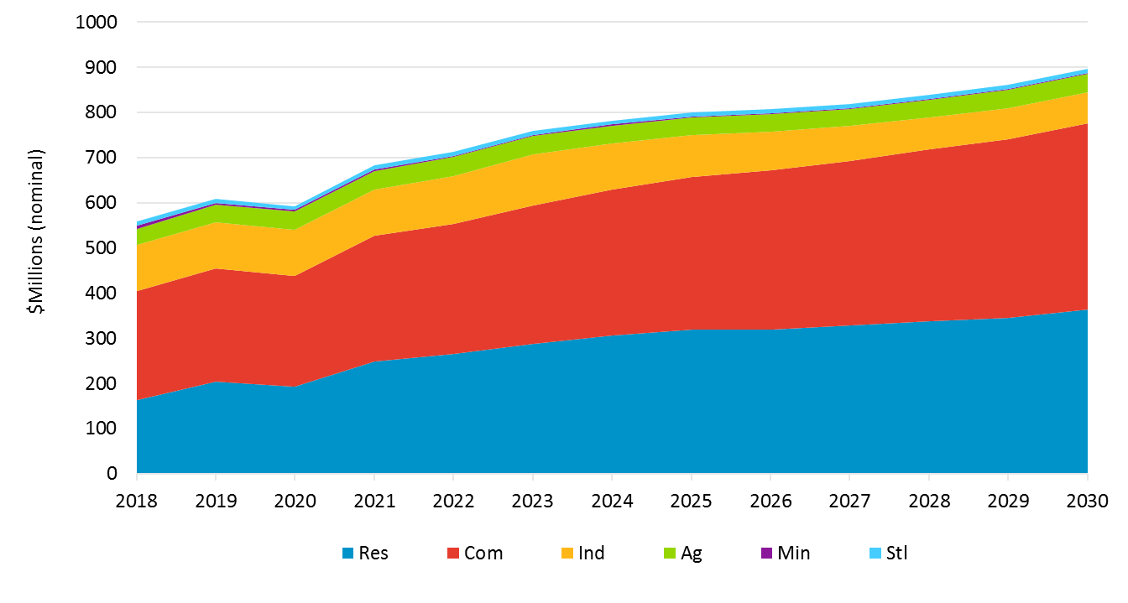

Note: Excludes Low Income

Figure ‑. Statewide Spending by Sector for Incentive Programs in Scenario 3 (mTRC w/ GHG Adder 2)

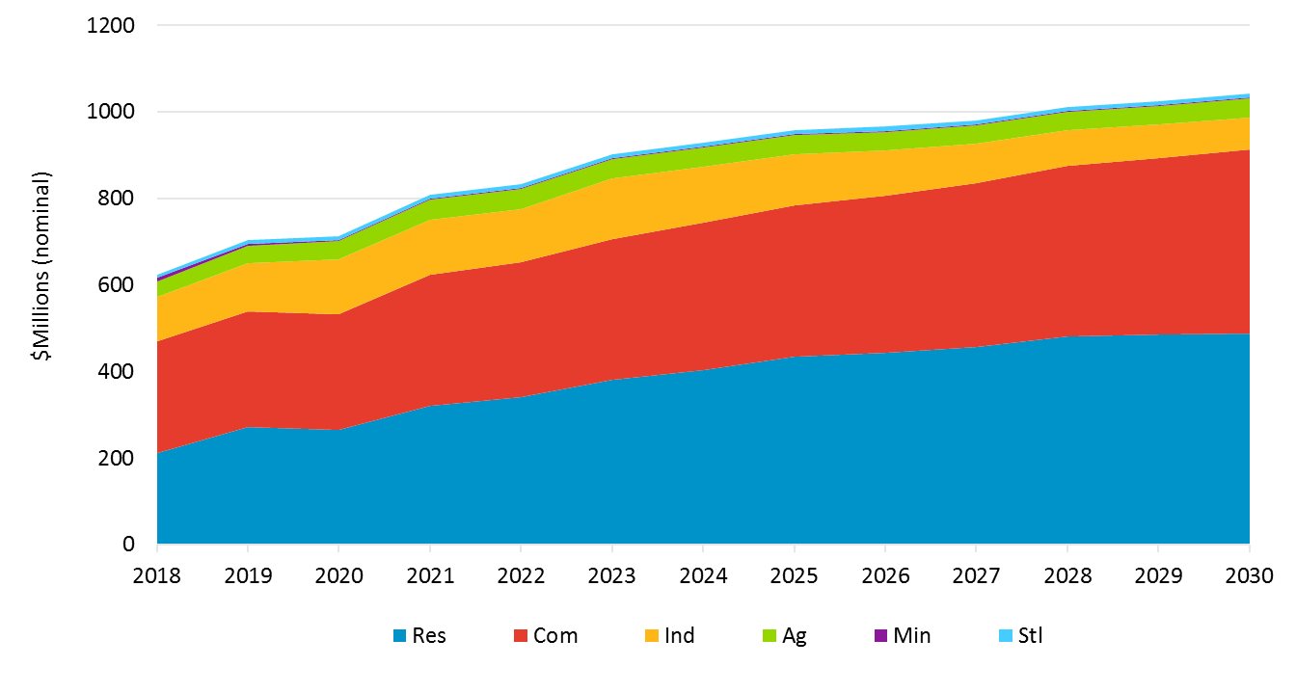

Note: Excludes Low Income

Figure ‑. Statewide Spending by Sector for Incentive Programs in Scenario 4 (PAC Reference)

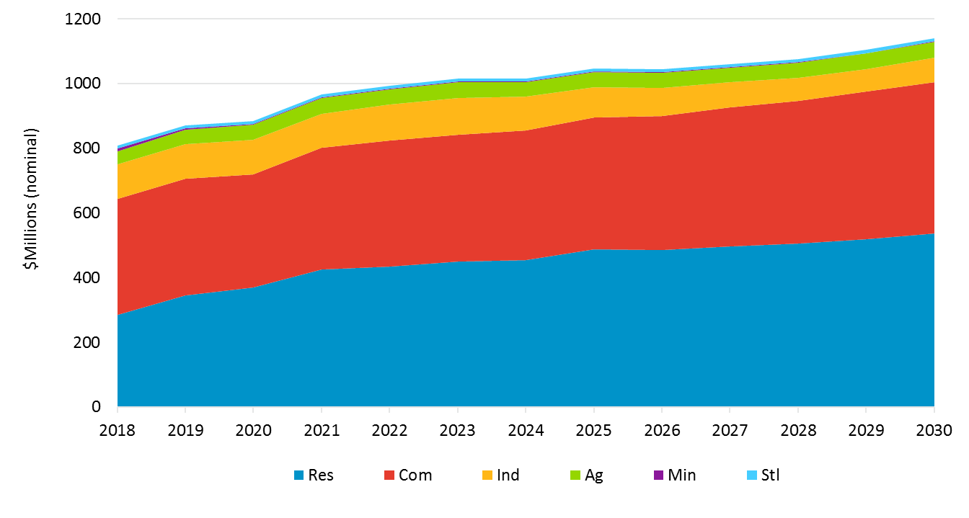

Note: Excludes Low Income

Figure ‑. Statewide Spending by Sector for Incentive Programs in Scenario 5 (PAC Aggressive)

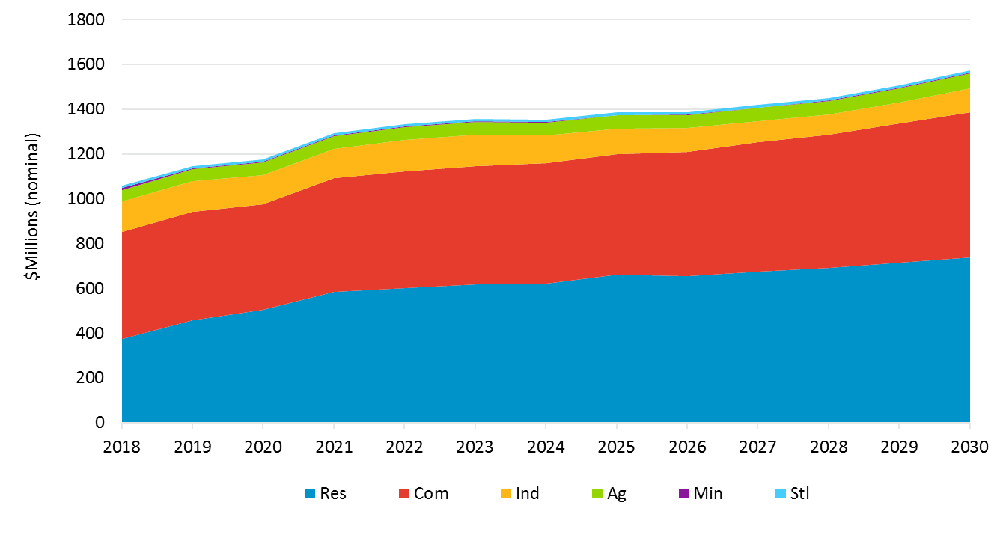

Note: Excludes Low Income

### Equipment Rebate Program Results

Figure 4‑19 and Figure 4‑20 illustrate the statewide incremental market potential from Equipment Rebate program savings, which include savings from discrete equipment, whole building and shell measures, by scenario for electric (GWh) and gas (MMTherms) respectively. These graphs exclude IOU claimable savings from C&S advocacy programs, BROs interventions and Low Income programs. They also exclude savings from re-participants, as we were tasked to assess incremental potential from first-time adopters in the market. Cumulative savings are discussed in Appendix B. Per the scenarios framework discussed earlier in section 2.3, only Scenario 5 (PAC Aggressive) includes the effects of aggressive program engagement.

Figure 4‑19 shows that electric potential increases as the cost test used to screen measures becomes less stringent, with the TRC test yielding the least potential and the PAC test yielding the most potential. By 2030, Scenario 4 (PAC Reference) produces about 16% more electric savings than Scenario 1 (TRC Reference). The figure also shows that aggressive program engagement in the form of financing as well as increased marketing and incentives can yield additional savings beyond business-as-usual program engagement as illustrated by Scenario 5 (PAC Aggressive), which produces about 6% more electric savings than the Scenario 4 (PAC Reference). Overall, the Scenario 5 (PAC Aggressive) produces about 24% more electric savings than the Scenario 1 (TRC Reference).

Figure ‑.Statewide Incremental Electric Market Potential by Scenario

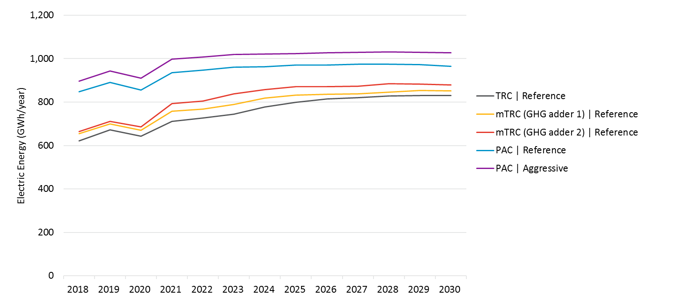

Like Figure 4‑19, Figure 4‑20 shows that gas potential generally increases as the cost test used to screen measures becomes less stringent. The only exception to this trend is Scenario 3 (mTRC GHG adder 2). While one might expect to see the PAC scenarios yield the highest potential, Scenario 3 (mTRC GHG adder 2) yields the most gas savings for Equipment Rebate programs during most of the forecast period. The reason for this is twofold. First, the GHG adder in the mTRC scenarios is applied differently to electric versus gas measures. The Cost-effectiveness Tool (CET), commissioned by the CPUC, produces avoided electric costs that vary by loadshape. The GHG adder is incremental to the base GHG cost that is already embedded in these avoided electric costs, resulting in modified avoided costs that also vary by loadshape. This means that the GHG adder yields more benefits for some electric measures versus others. On the other hand, the CET produces a single time-series of avoided costs that do not vary by loadshape for gas measures. This allows the GHG adder to yield the same benefits across the board for gas measures. Second, the GHG adder in Scenario 3, based on Commission staff’s proposal, ramps up to $250 by 2030. Since the benefits from this high GHG adder is applied uniformly to gas measures, Scenario 3 produces the highest gas potential for Equipment Rebate program savings.

Note that the gap between Scenario 2 (mTRC GHG adder 1) and Scenario 1 (TRC Reference) for gas savings is larger than that for electric savings. This is due to the way the GHG adder is applied as explained above. However, Scenario 2 (mTRC GHG adder 1) produces less potential than the PAC scenarios as the adder, which is based on the draft ARB APCR, only ramps up to $63 by 2030 (see section 3.1.5 for more details).

By 2030, Scenario 3 (mTRC GHG adder 2) produces about 33% more gas savings than Scenario 1 (TRC Reference). Another noteworthy trend is that Scenario 5 (PAC Aggressive) surpasses Scenario 5 (PAC Reference) by about 19% at the end of the forecast period. This is attributable to aggressive program engagement. Overall, Scenario 5 (PAC Aggressive) produces about 55% more gas savings than the Scenario 1 (TRC Reference) by 2030.

Figure ‑. Statewide Incremental Gas Market Potential by Scenario

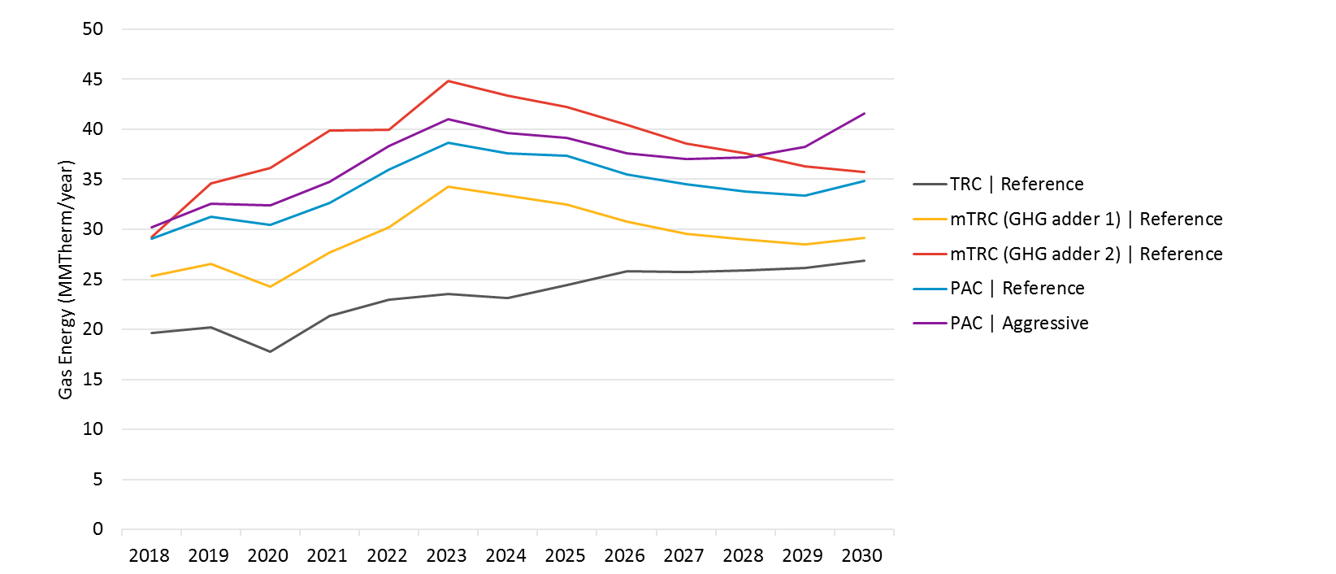

Note that we also produced cumulative market potential as part of the 2018 study for equipment rebate program measures, and compared it against technical and economic potential for all 5 scenarios. Details on these results can be found in Appendix B.

The following subsections discuss the statewide program and end use-level potential results for electric (GWh) and gas (MMTherms) savings for equipment rebate programs, BROs interventions and low income programs in different sectors. Additional versions of this graph for each IOU and for peak demand savings can be found in the results viewer under the “Use Category - Inc Rebate Net” tab. Note that measure-level results are available in a database that accompanies this report.

#### Residential Rebate Programs

Figure 4‑21 through Figure 4‑25 shows the breakdown of electric savings by end use in the residential sector for each scenario. Key observations from these graphs are:

* Amongst end use categories that capture potential from discrete measures, lighting dominates electric potential in the residential sector, followed by Appliance and HVAC measures across all scenarios. Lighting potential is driven by LEDs. EISA standards that are expected to take effect in 2018 remove savings from CFLs and drive programs and customers toward LEDs as high efficiency opportunities.
* There is a high degree of variation between scenarios for HVAC savings. As the cost effectiveness screening test gets less stringent, more expensive HVAC measures are included in the potential.
* Residential whole building potential contributes somewhat significantly to potential in the first few years of the forecast across all scenarios. The drop in savings between 2019 and 2020 is due to a new Title 24 code that is expected to take effect starting in 2020.
* Overall potential ramps up significantly towards 2024 and then gradually begins to taper off towards the end of the forecast period across all scenarios. This is due to the model simulating an increasingly saturated market over time as more customers begin adopting efficient equipment with limited remaining low efficiency equipment to convert. This behavior is primarily driven by lighting measures, which turn over at a fast rate than other equipment.

Figure ‑. Statewide Residential Incremental Electric Market Potential by End Use for Equipment Rebate Programs in Scenario 1 (TRC Reference)

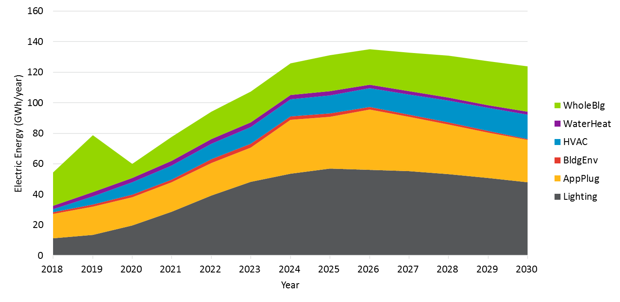

Figure ‑. Statewide Residential Incremental Electric Market Potential by End Use for Equipment Rebate Programs in Scenario 2 (mTRC w/ GHG Adder 1)

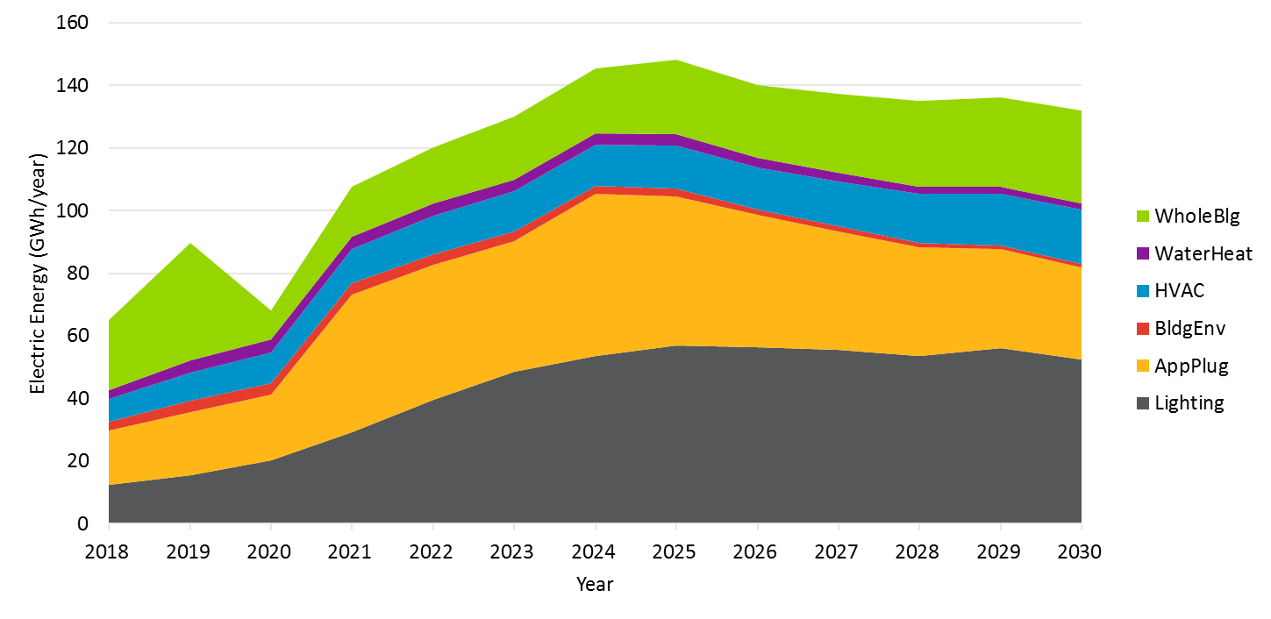

Figure ‑. Statewide Residential Incremental Electric Market Potential by End Use for Equipment Rebate Programs in Scenario 3 (mTRC w/ GHG Adder 2)

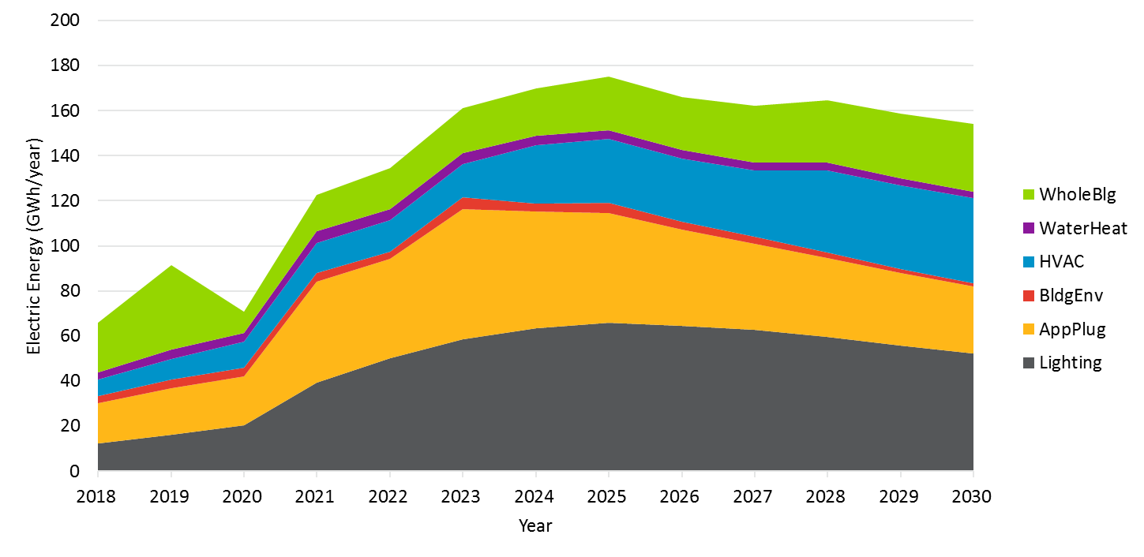

Figure ‑. Statewide Residential Incremental Electric Market Potential by End Use for Equipment Rebate Programs in Scenario 4 (PAC Reference)

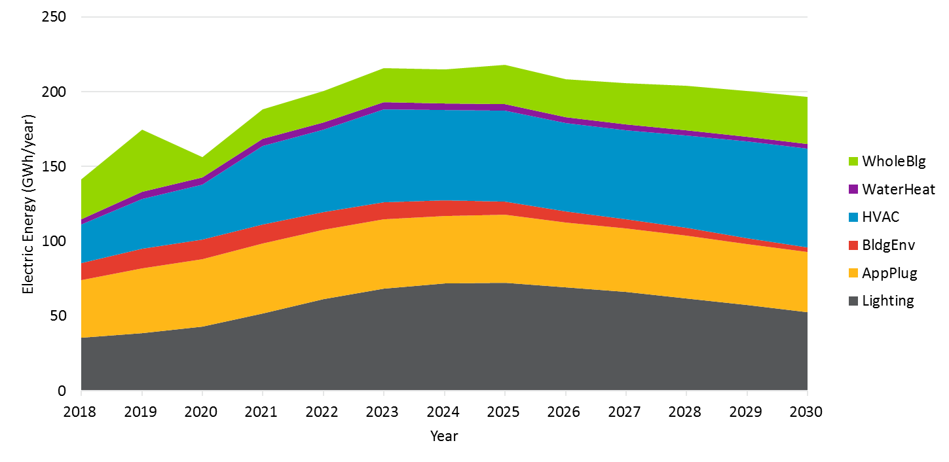

Figure ‑. Statewide Residential Incremental Electric Market Potential by End Use for Equipment Rebate Programs in Scenario 5 (PAC Aggressive)

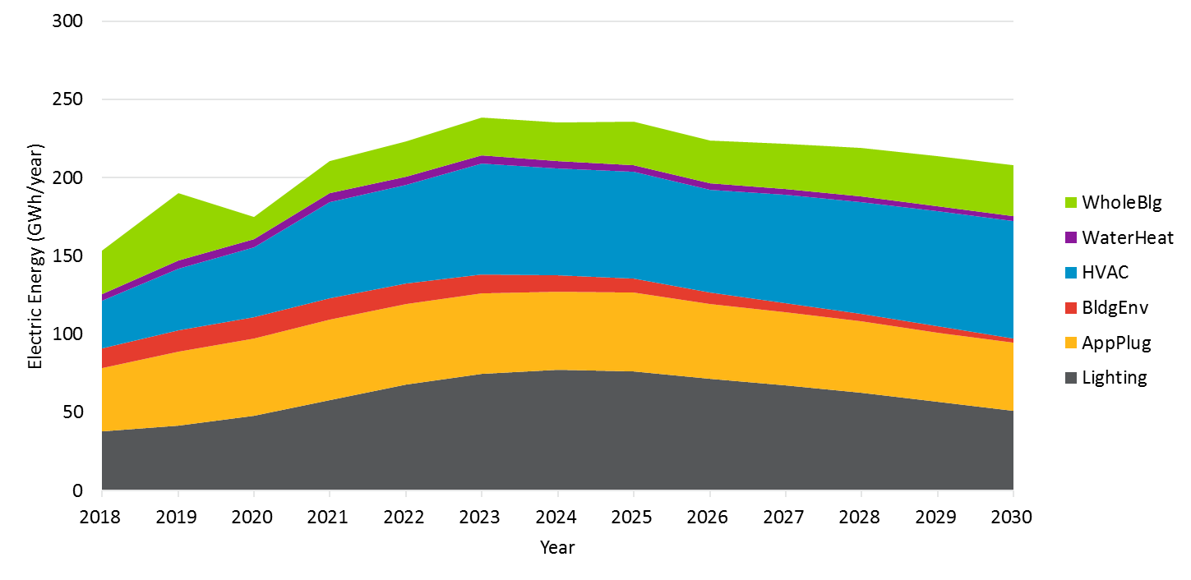

Figure 4‑26 through Figure 4‑30 show the breakdown of gas savings by end use in the residential sector. Key observations from these graphs are:

* Negative gas savings due to interactive effects from lighting measures reduces the overall net gas potential in the residential sector across all scenarios.
* Amongst end use categories that capture potential from discrete measures, water heating dominates potential in the residential sector, followed by HVAC and Building Envelope measures across all scenarios.
* HVAC potential does not show up until 2021 in Scenario 1 (TRC Reference) as no measures screen the TRC test prior to that. It does however show up throughout the forecast period for all other scenarios that use a less stringent screening cost test.
* Residential whole building potential contributes significantly to overall potential. Again, the drop in savings between 2019 and 2020 is due to a new Title 24 code that is expected to take effect starting in 2020.
* Unlike electric potential, overall potential does not taper off towards the end of the forecast period across all scenarios as most gas measures have long lifetimes and do not turn over as fast. As such, there continues to be opportunity for first-time adopters in the gas market, which does not saturate as fast.

Figure ‑. Statewide Residential Incremental Gas Market Potential by End Use for Equipment Rebate Programs in Scenario 1 (TRC Reference)

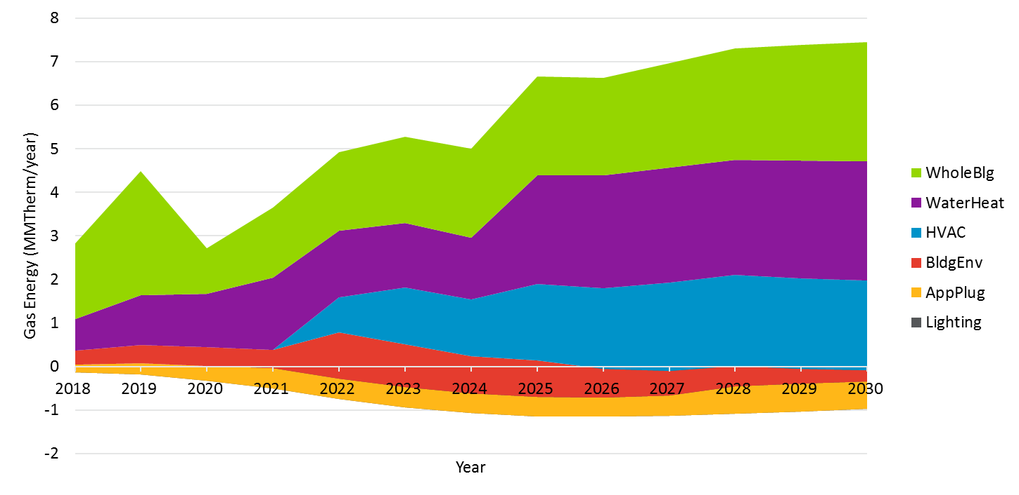

Figure ‑. Statewide Residential Incremental Gas Market Potential by End Use for Equipment Rebate Programs in Scenario 2 (mTRC w/ GHG Adder 1)

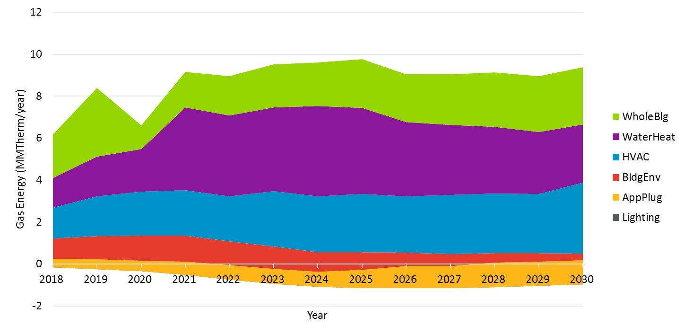

Figure ‑. Statewide Residential Incremental Gas Market Potential by End Use for Equipment Rebate Programs in Scenario 3 (mTRC w/ GHG Adder 2)

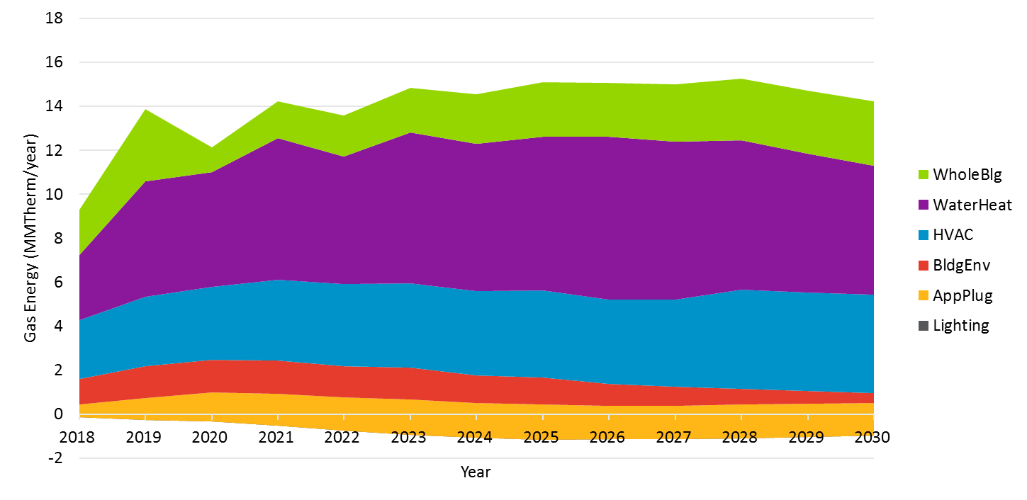

Figure ‑. Statewide Residential Incremental Gas Market Potential by End Use for Equipment Rebate Programs in Scenario 4 (PAC Reference)

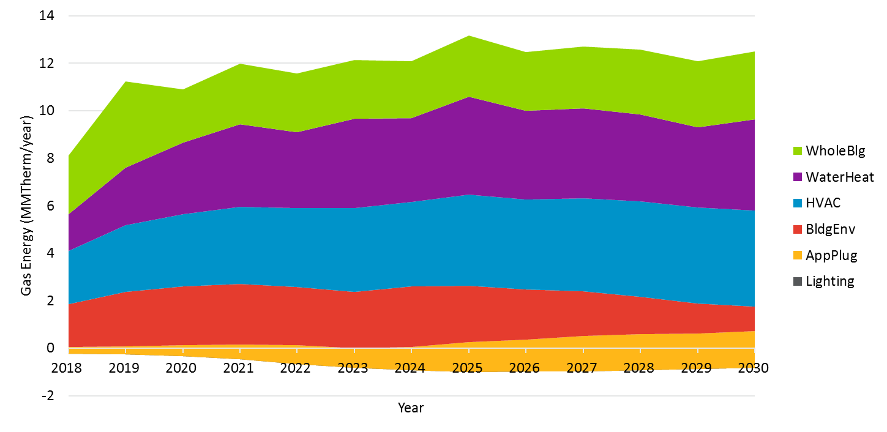

Figure ‑. Statewide Residential Incremental Gas Market Potential by End Use for Equipment Rebate Programs in Scenario 5 (PAC Aggressive)

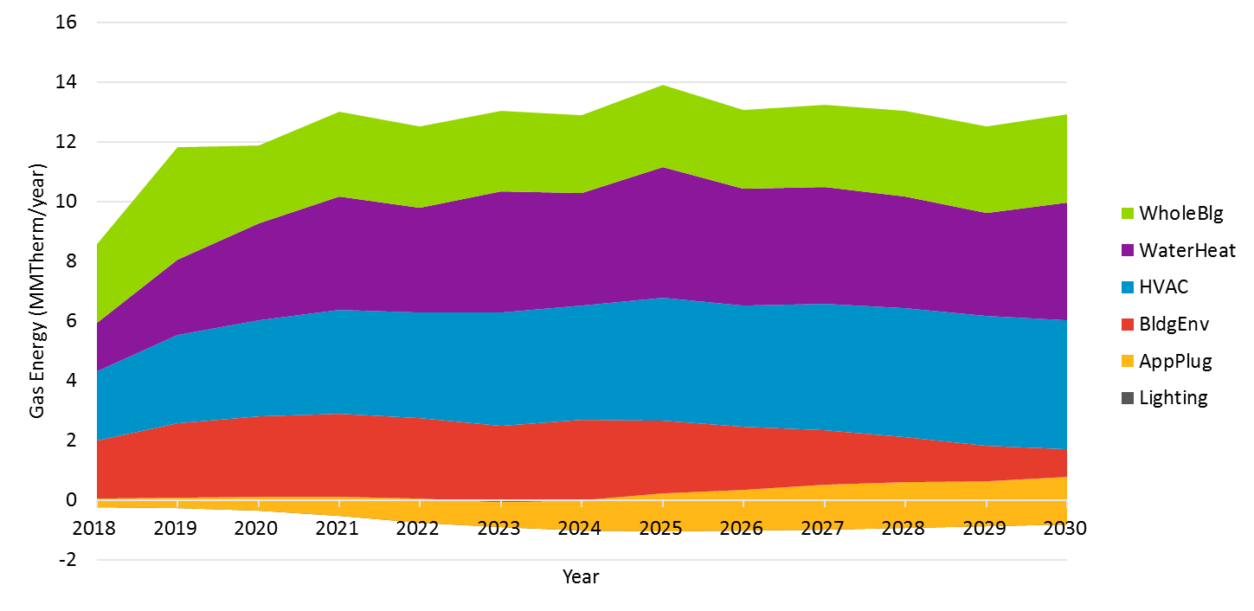

#### Commercial Rebate Programs

Figure 4‑31 through Figure 4‑35 show the breakdown of electric savings by end use in the commercial sector for each scenario. Key observations from these graphs are:

* Amongst end use categories that capture potential from discrete measures, lighting dominates electric potential in the commercial sector, followed by HVAC and commercial refrigeration measures across all scenarios. Like the residential sector, lighting potential is driven by LEDs.
* Like the residential sector, there is a high degree of variation between scenarios for HVAC savings. As the cost effectiveness screening test gets less stringent, more expensive HVAC measures are included in the potential.
* Commercial whole building potential contributes significantly to overall potential across all scenarios. The drop-in savings between 2019 and 2020 is due to a new Title 24 code. Whole building shows a larger potential in the future as commercial retrofit whole building programs are expected to capture savings.
* Overall potential increases over the forecast period with a ramp rate that decreases over time across all scenarios. This is due to the model simulating an increasingly saturated market over time as more customers begin adopting efficient equipment for the first time. This behavior is less pronounced in the commercial sector versus the residential sector as lighting measures, which dominate potential, have longer lifetimes in commercial buildings.

Figure ‑. Statewide Commercial Incremental Electric Market Potential by End Use for Equipment Rebate Programs in Scenario 1 (TRC Reference)

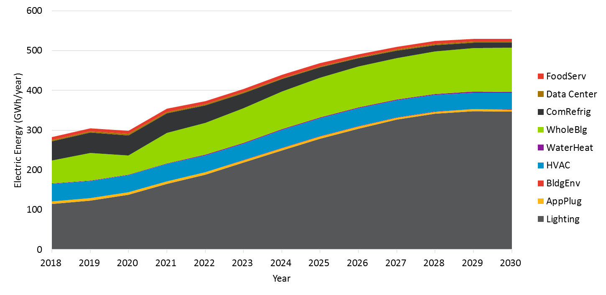

Figure ‑. Statewide Commercial Incremental Electric Market Potential by End Use for Equipment Rebate Programs in Scenario 2 (mTRC w/ GHG Adder 1)

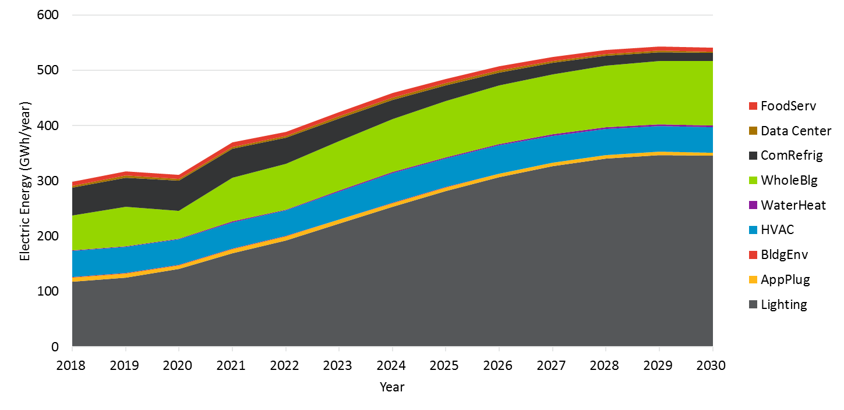

Figure ‑. Statewide Commercial Incremental Electric Market Potential by End Use for Equipment Rebate Programs in Scenario 3 (mTRC w/ GHG Adder 2)

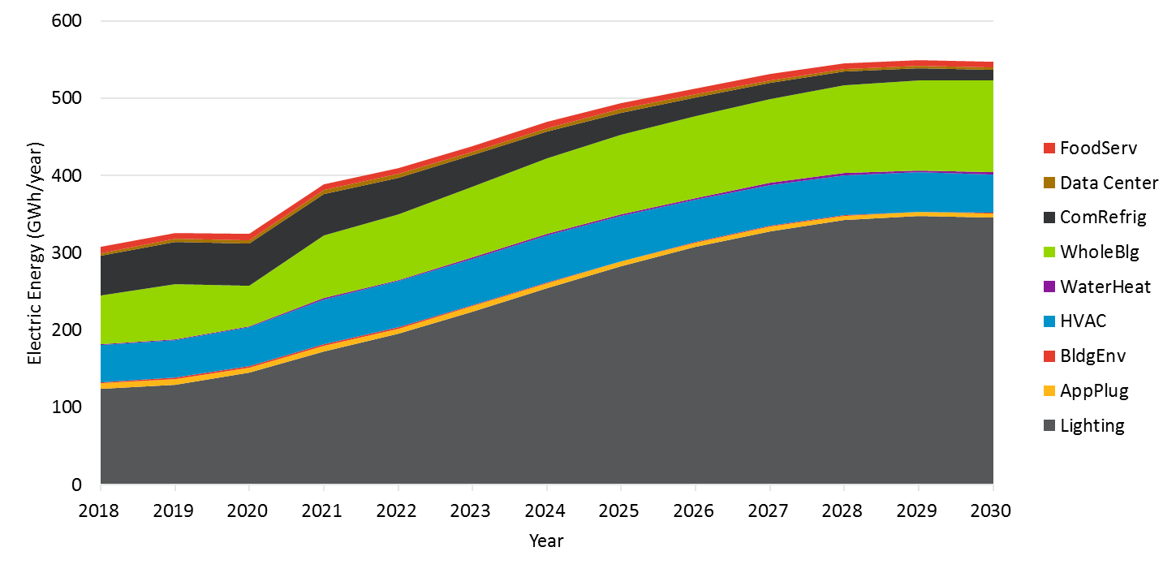

Figure ‑. Statewide Commercial Incremental Electric Market Potential by End Use for Equipment Rebate Programs in Scenario 4 (PAC Reference)

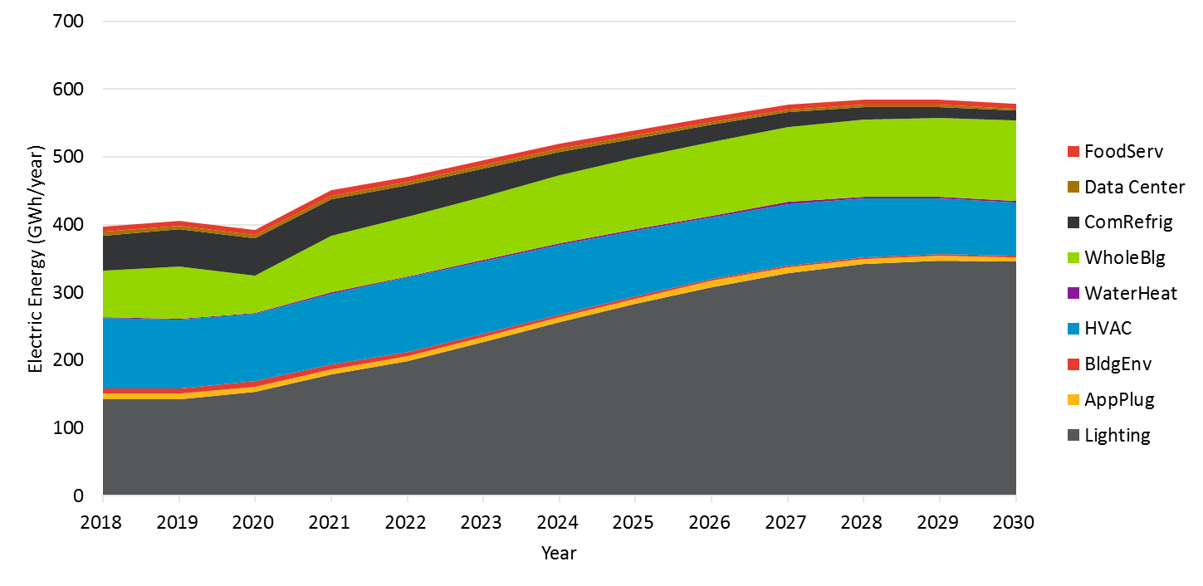

Figure ‑. Statewide Commercial Incremental Electric Market Potential by End Use for Equipment Rebate Programs in Scenario 5 (PAC Aggressive)

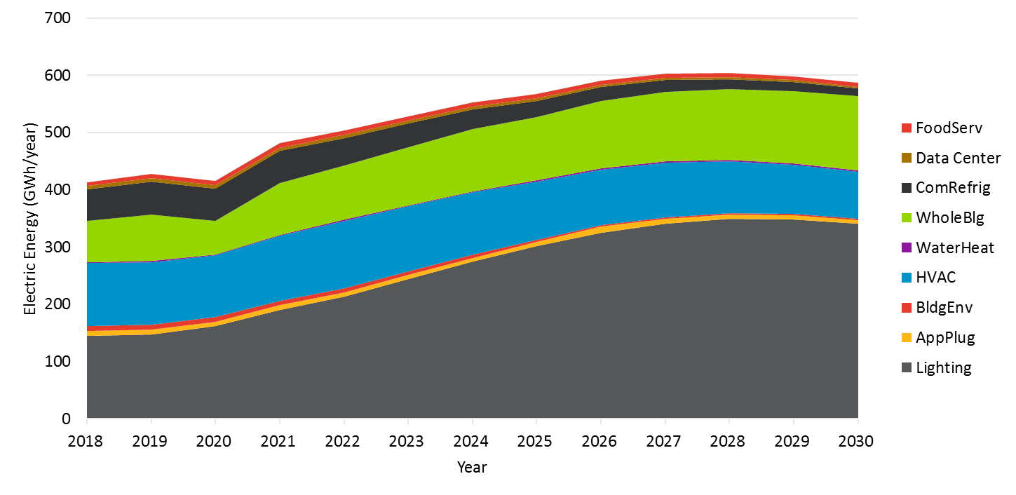

Figure 4‑36 through Figure 4‑40 show the breakdown of gas savings by end use in the commercial sector for each scenario. Key observations from these graphs are:

* Like the residential sector, negative gas savings due to interactive effects from lighting measures reduces the overall net gas potential in the commercial sector across all scenarios.
* Amongst end use categories that capture potential from discrete measures, HVAC dominates potential in the commercial sector, followed by food service and water heating measures across all scenarios. Unlike the residential sector, one or more HVAC measures is cost-effective under Scenario 1 (TRC Reference) throughout the forecast period.
* Commercial whole building potential contributes significantly to overall potential across all scenarios. Again, the drop in savings between 2019 and 2020 is due to a new Title 24 code.
* Unlike electric potential, overall potential increases over the forecast period at a relatively steady ramp rate across all scenarios as most gas measures have long lifetimes and do not turn over as fast. As such, there continues to be opportunity for first-time adopters in the market, which does not saturate as fast.

Figure ‑. Statewide Commercial Incremental Gas Market Potential by End Use for Equipment Rebate Programs in Scenario 1 (TRC Reference)

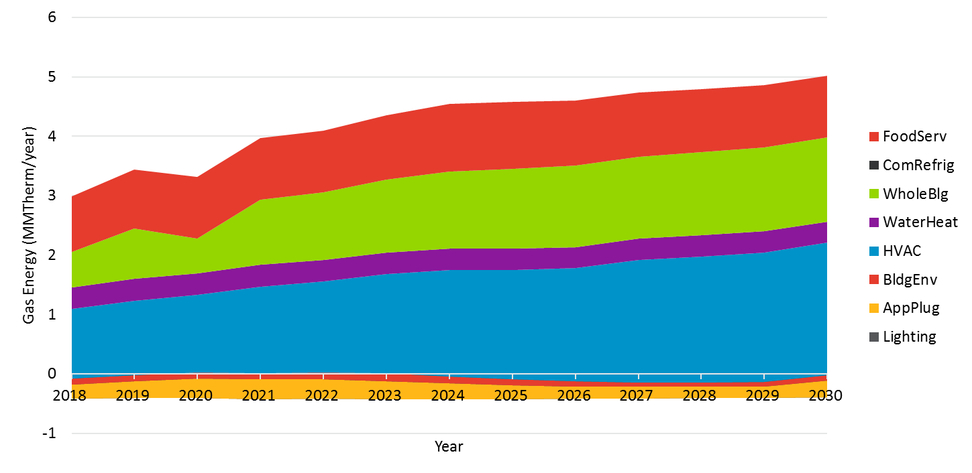

Figure ‑. Statewide Commercial Incremental Gas Market Potential by End Use for Equipment Rebate Programs in Scenario 2 (mTRC w/ GHG Adder 1)

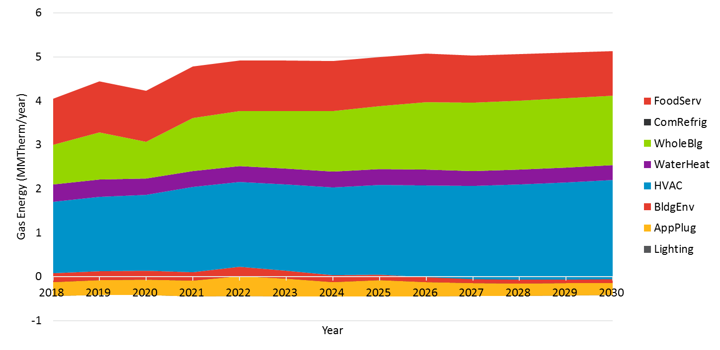

Figure ‑. Statewide Commercial Incremental Gas Market Potential by End Use for Equipment Rebate Programs in Scenario 3 (mTRC w/ GHG Adder 2)

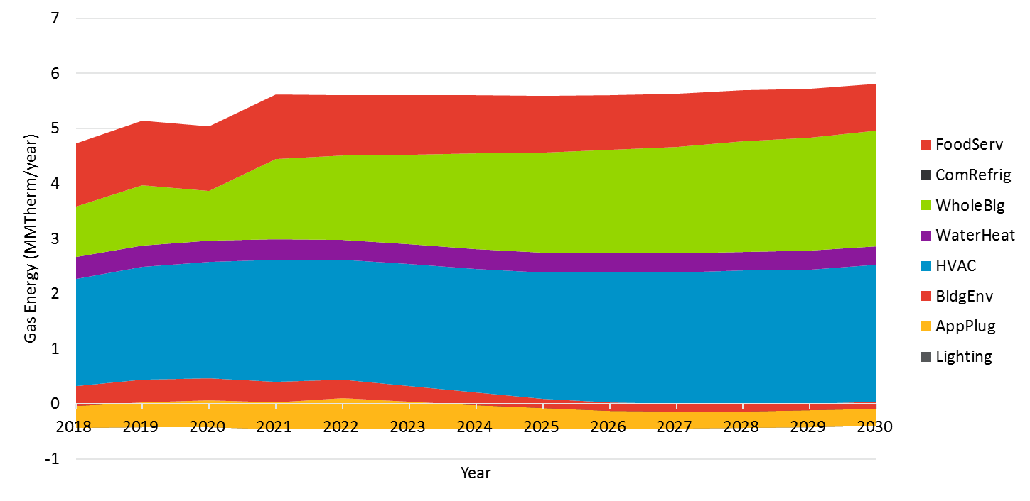

Figure ‑. Statewide Commercial Incremental Gas Market Potential by End Use for Equipment Rebate Programs in Scenario 4 (PAC Reference)

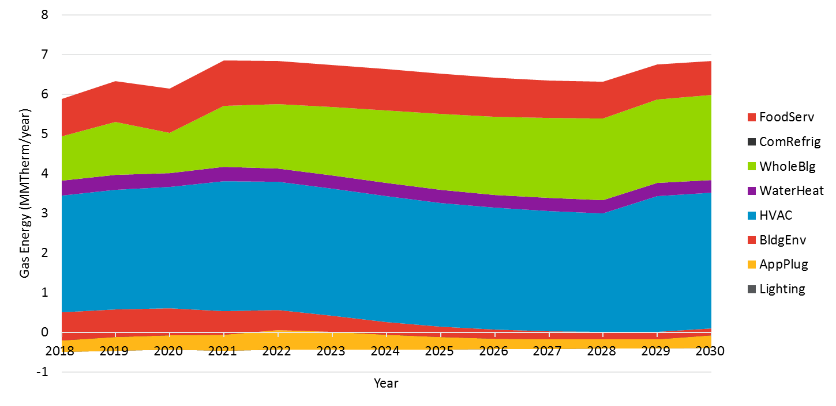

Figure ‑. Statewide Commercial Incremental Gas Market Potential by End Use for Equipment Rebate Programs in Scenario 5 (PAC Aggressive)

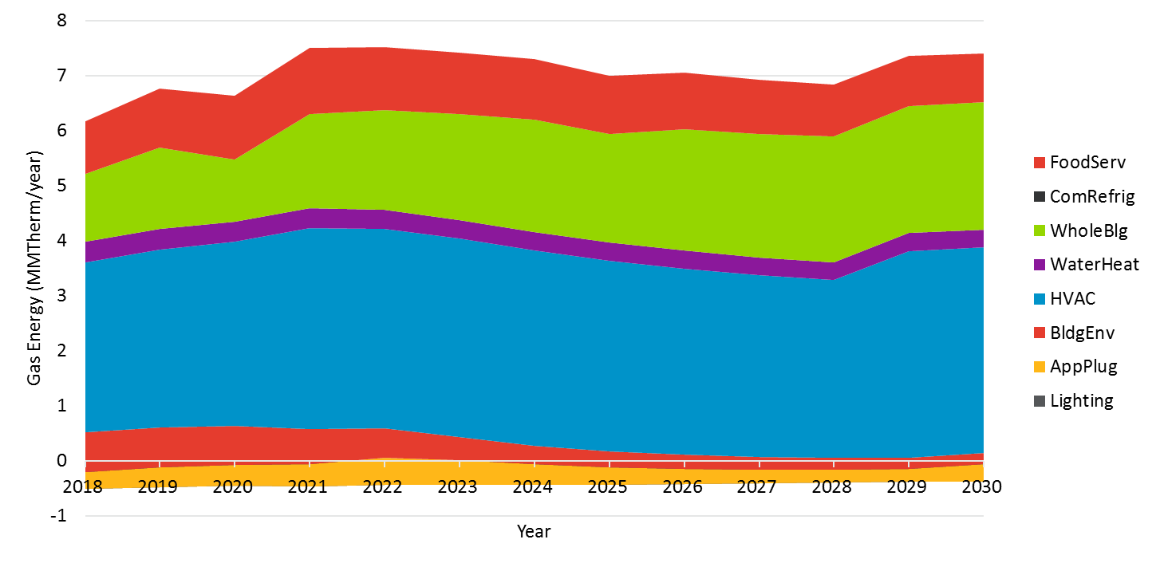

#### AIMS Rebate Programs

Figure 4‑41 through Figure 4‑45 show the breakdown of electric savings by end use in the AIMS sectors for each scenario. Key observations from these graphs are:

* Amongst end use categories that capture potential from discrete measures that produce deemed savings, lighting dominates electric potential in the agriculture and industrial sectors, followed by machine drive and process refrigeration measures across all scenarios.
* The whole building end use category represents potential from generic custom measures and emerging technologies in the agriculture and industrial sectors. Potential from these measures contributes significantly to the agriculture and industrial sectors across all scenarios, and is expected to increase over time. These measures are tagged into the “whole building” end use because it represents a broad array of opportunities across all end uses.
* The mining sector, which is made up of oil and gas extraction equipment, contributes minimally to overall potential across all scenarios.
* Streetlighting measures contribute a steady amount of potential across the forecast period across all scenarios.
* Potential from individual technologies in the agriculture and industrial sectors ramps down over the forecast period across all scenarios. To align with the model with historic program activity and the characteristics of the market, we see a significant majority of the potential being realized between 2013 and 2016. Thus, the out years reflect less opportunity and an increasingly saturated market over time. This decrease in potential from deemed savings is somewhat made up for towards the end of the forecast period by increased potential from emerging technologies.

Figure ‑. Statewide AIMS Incremental Electric Market Potential by End Use for Equipment Rebate Programs in Scenario 1 (TRC Reference)

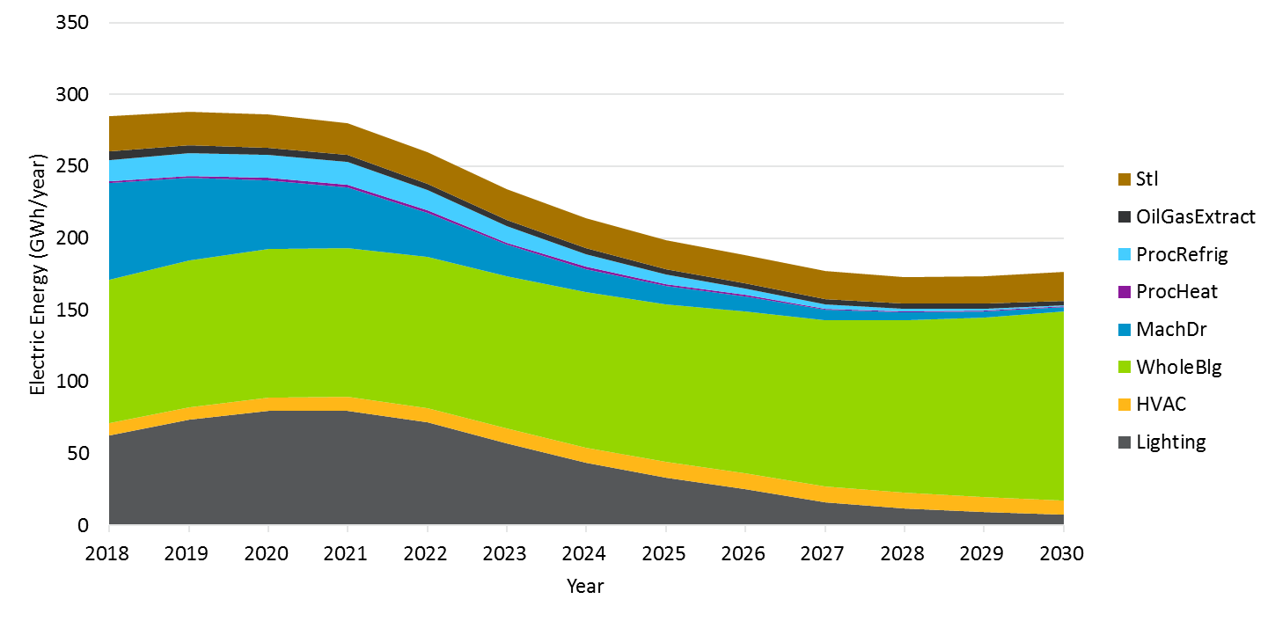

Figure ‑. Statewide AIMS Incremental Electric Market Potential by End Use for Equipment Rebate Programs in Scenario 2 (mTRC w/ GHG Adder 1)

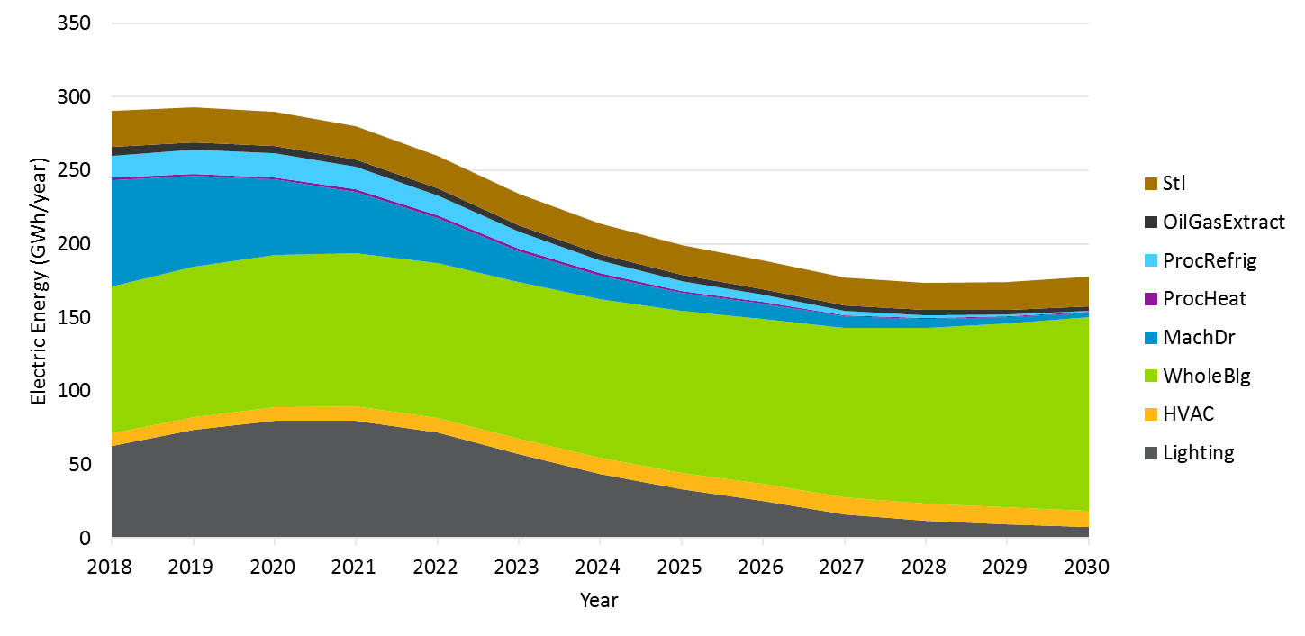

Figure ‑. Statewide AIMS Incremental Electric Market Potential by End Use for Equipment Rebate Programs in Scenario 3 (mTRC w/ GHG Adder 2)

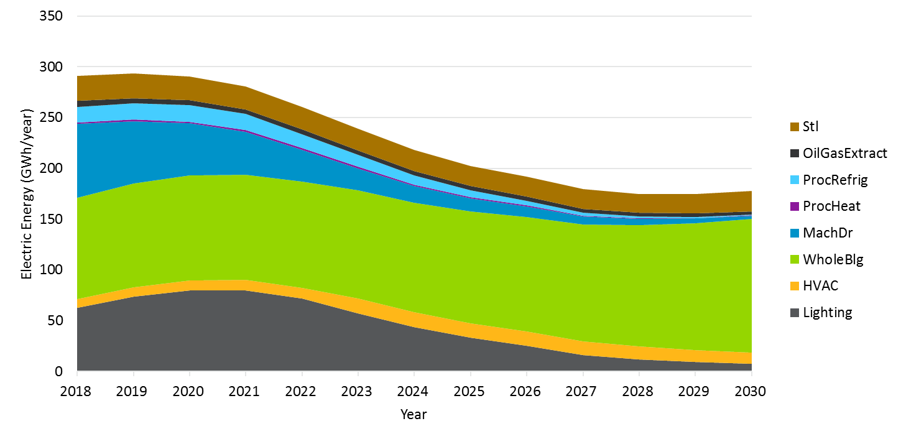

Figure ‑. Statewide AIMS Incremental Electric Market Potential by End Use for Equipment Rebate Programs in Scenario 4 (PAC Reference)

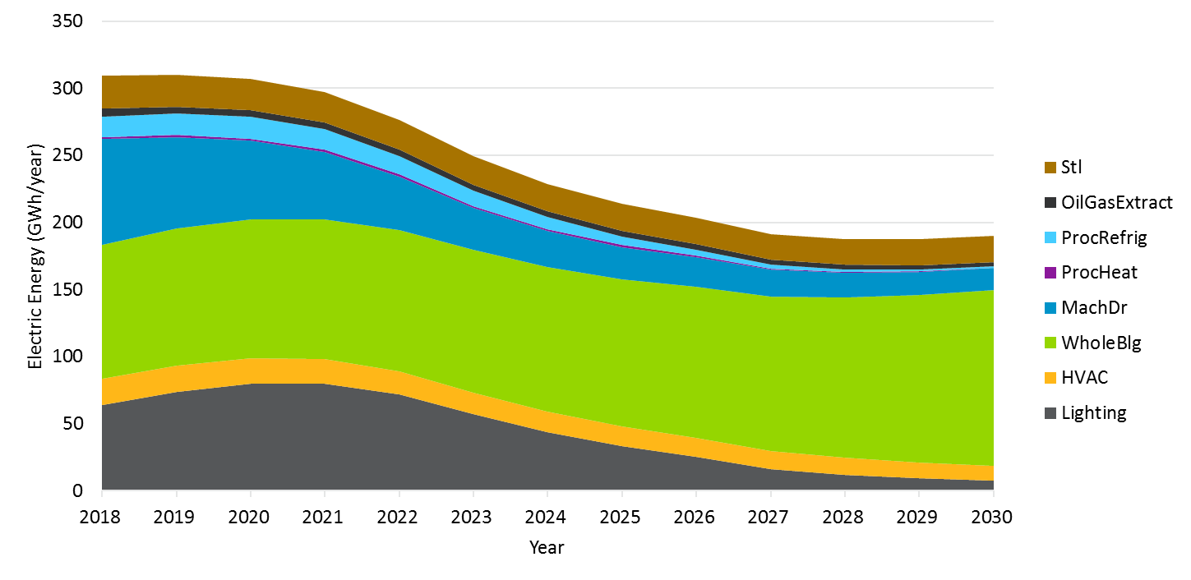

Figure ‑. Statewide AIMS Incremental Electric Market Potential by End Use for Equipment Rebate Programs in Scenario 5 (PAC Aggressive)

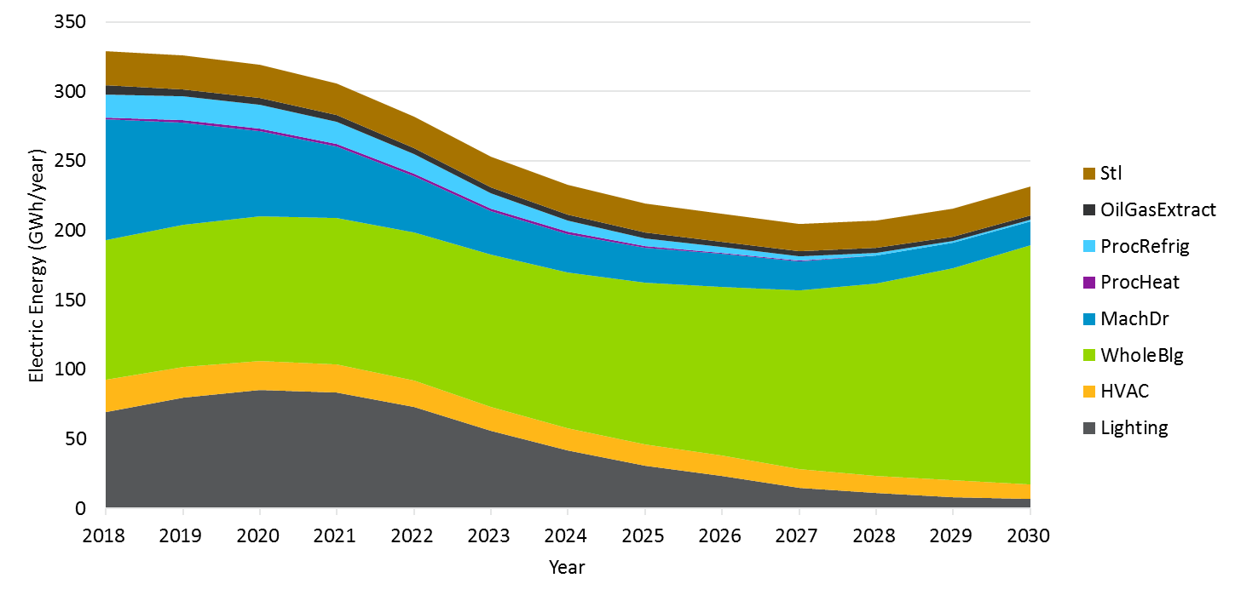Figure 4‑46 through Figure 4‑50 show the breakdown of gas savings by end use in the AIMS sectors for each scenario. Key observations from these graphs are:

* Negative gas savings due to interactive effects from lighting measures slightly reduces the overall net gas potential in the agriculture and industrial sectors across all scenarios.
* Amongst end use categories that capture potential from discrete measures that produce deemed savings, process heat dominates gas potential in the agriculture and industrial sectors, followed by HVAC and oil and gas extraction measures across all scenarios.
* Once again, the whole building end use category represents potential from generic custom measures and emerging technologies in the agriculture and industrial sectors. Potential from these measures contributes significantly to the agriculture and industrial sectors, and is expected to increase over time across all scenarios.

Figure ‑. Statewide AIMS Incremental Gas Market Potential by End Use for Equipment Rebate Programs in Scenario 1 (TRC Reference)

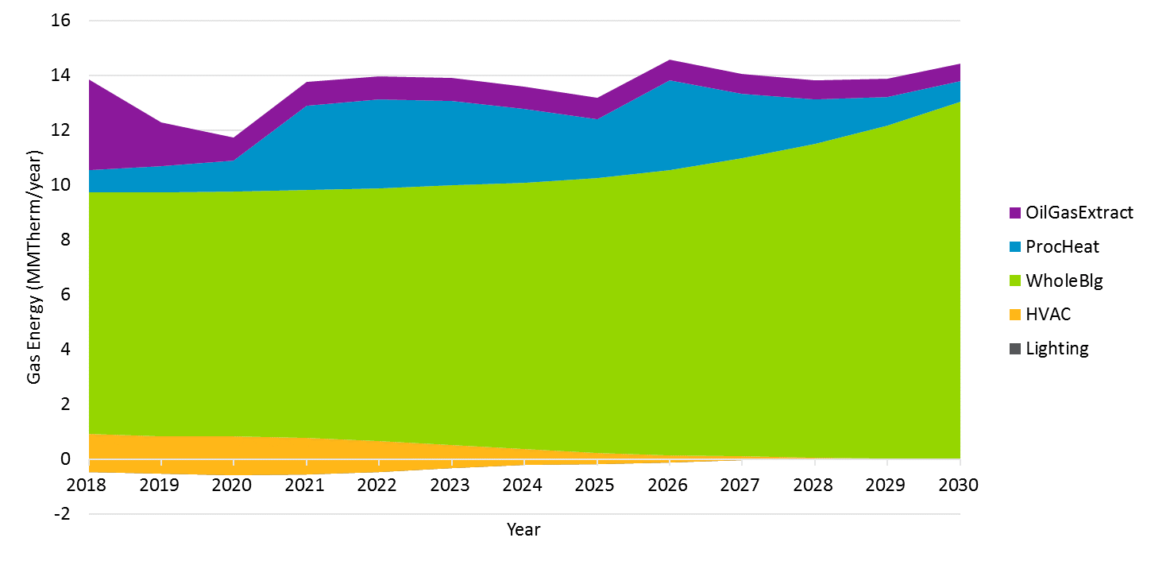

Figure ‑. Statewide AIMS Incremental Gas Market Potential by End Use for Equipment Rebate Programs in Scenario 2 (mTRC w/ GHG Adder 1)

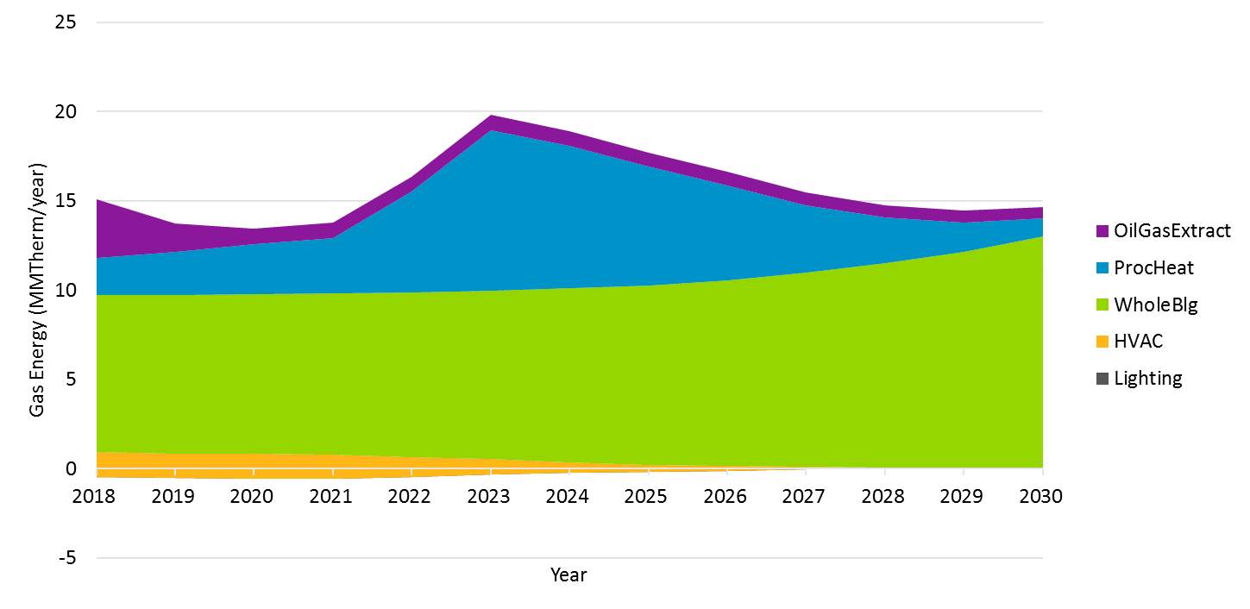

Figure ‑. Statewide AIMS Incremental Gas Market Potential by End Use for Equipment Rebate Programs in Scenario 3 (mTRC w/ GHG Adder 2)

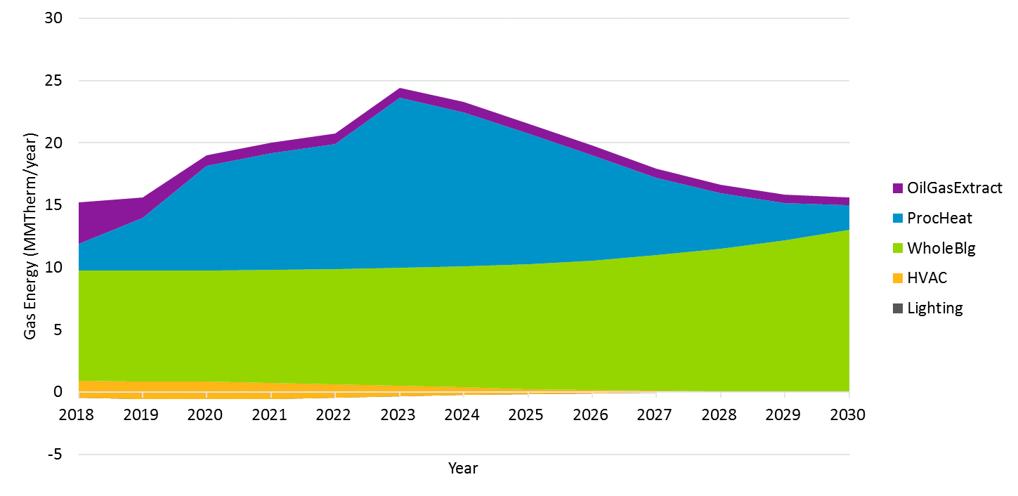

Figure ‑. Statewide AIMS Incremental Gas Market Potential by End Use for Equipment Rebate Programs in Scenario 4 (PAC Reference)

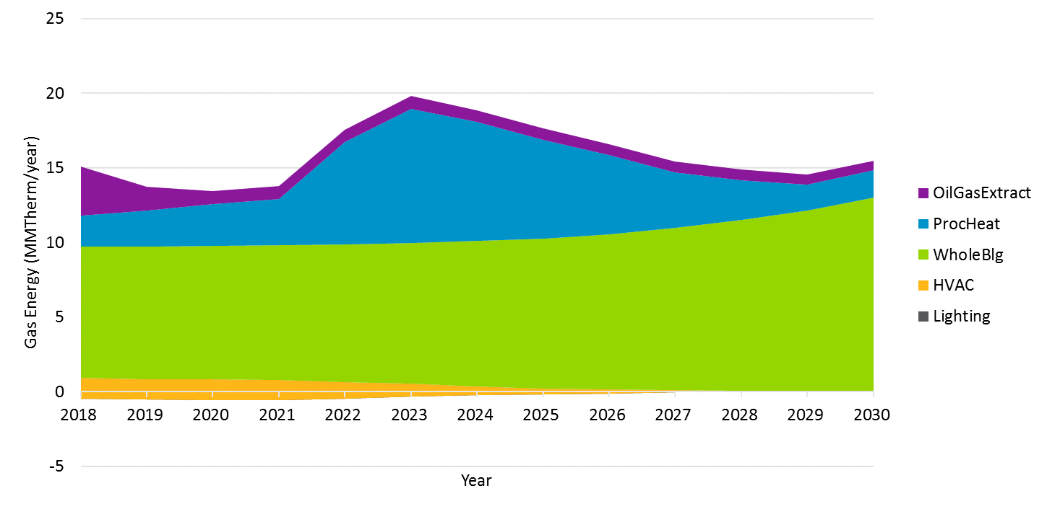

Figure ‑. Statewide AIMS Incremental Gas Market Potential by End Use for Equipment Rebate Programs in Scenario 5 (PAC Aggressive)

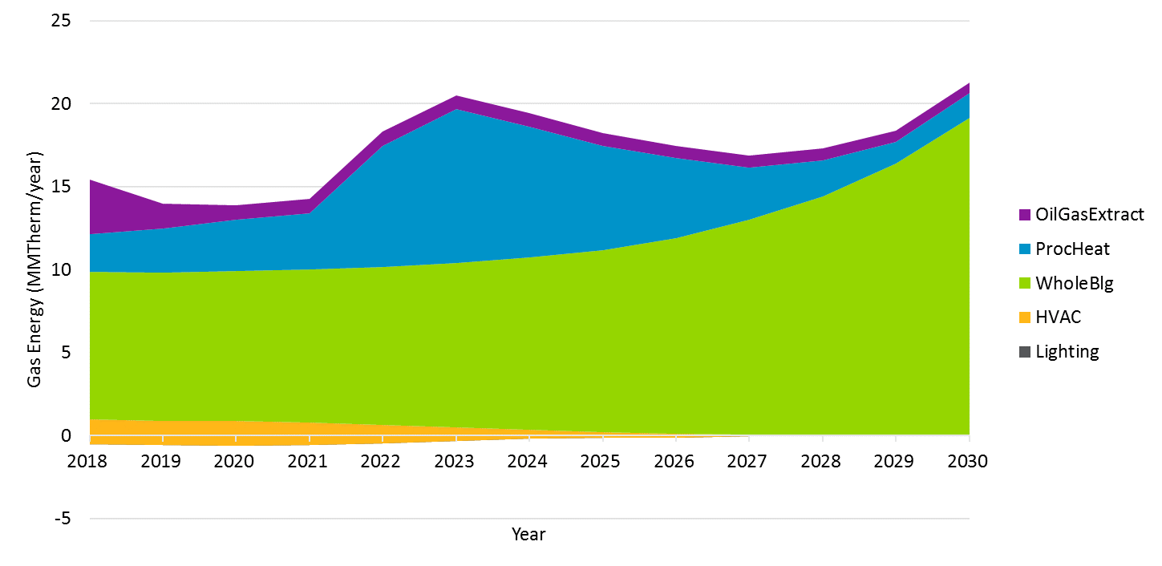

#### Stranded Potential

Figure 4‑51 through Figure 4‑55 shows the breakdown of electric stranded potential by end use across all sectors for each scenario. These savings are captured through accelerated replacement decisions in the model prompted by the availability of rebates for upgrading existing below code equipment. We assume that these rebates will be available starting in 2018 in the model. Key observations from these graphs are:

* Lighting measures contribute significantly to stranded electric potential across all scenarios. Potential from lighting measures is captured through customer decisions to upgrade existing equipment (e.g. T12 linear fluorescent fixtures) to more efficient technologies (e.g. T8 or T5 linear fluorescent fixtures). The results reflect a portion of the market that start out in 2018 with inefficient, below-code measures which ramps down over time as customers upgrade their equipment thus shrinking the below-code population.
* HVAC measures also contribute significantly to stranded electric potential across all scenarios. Potential from HVAC measures is captured through customer decisions to upgrade existing equipment (e.g. SEER 10 air conditioners) to more efficient technologies (e.g. ≥ SEER 14 air conditioners) instead of keeping their old equipment. As the cost effectiveness screening test gets less stringent, more expensive HVAC measures are included in the stranded potential thus increasing savings.
* Water heating and data center measures contribute negligibly to stranded potential across all scenarios.
* Stranded potential makes up approximately 7% of total equipment savings in 2018 and 1% of total equipment savings in 2030 in Scenario 1 (TRC Reference), and 12% of total equipment savings in 2018 and 3% of total equipment savings in Scenario 5 (PAC Aggressive).

Figure ‑. Statewide Stranded Electric Potential by End Use for all sectors in Scenario 1 (TRC Reference)

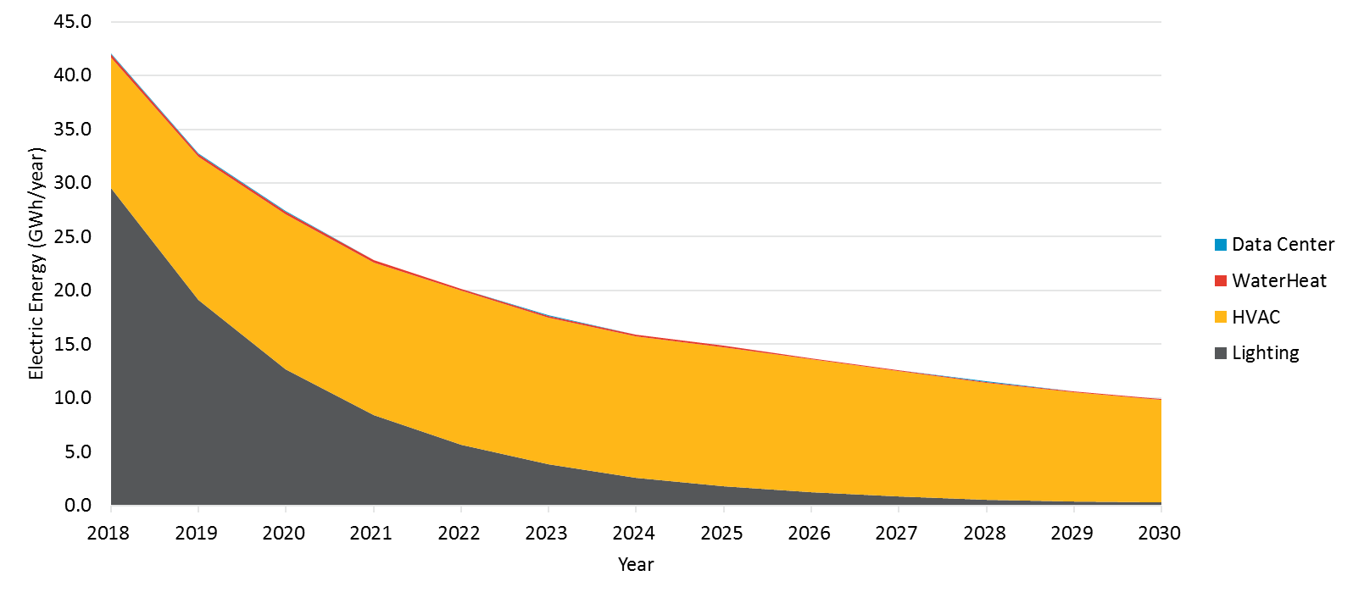

Figure ‑. Statewide Stranded Electric Potential by End Use for all sectors in Scenario 2 (mTRC w/ GHG Adder 1)

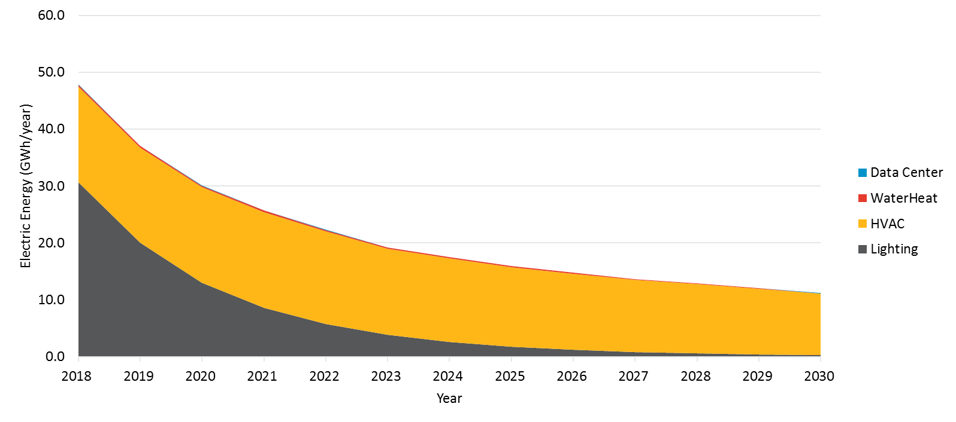

Figure ‑. Statewide Stranded Electric Potential by End Use for all sectors in Scenario 3 (mTRC w/ GHG Adder 2)

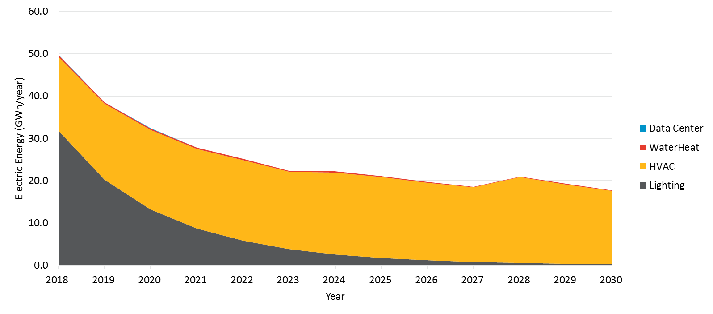

Figure ‑. Statewide Stranded Electric Potential by End Use for all sectors in Scenario 4 (PAC Reference)

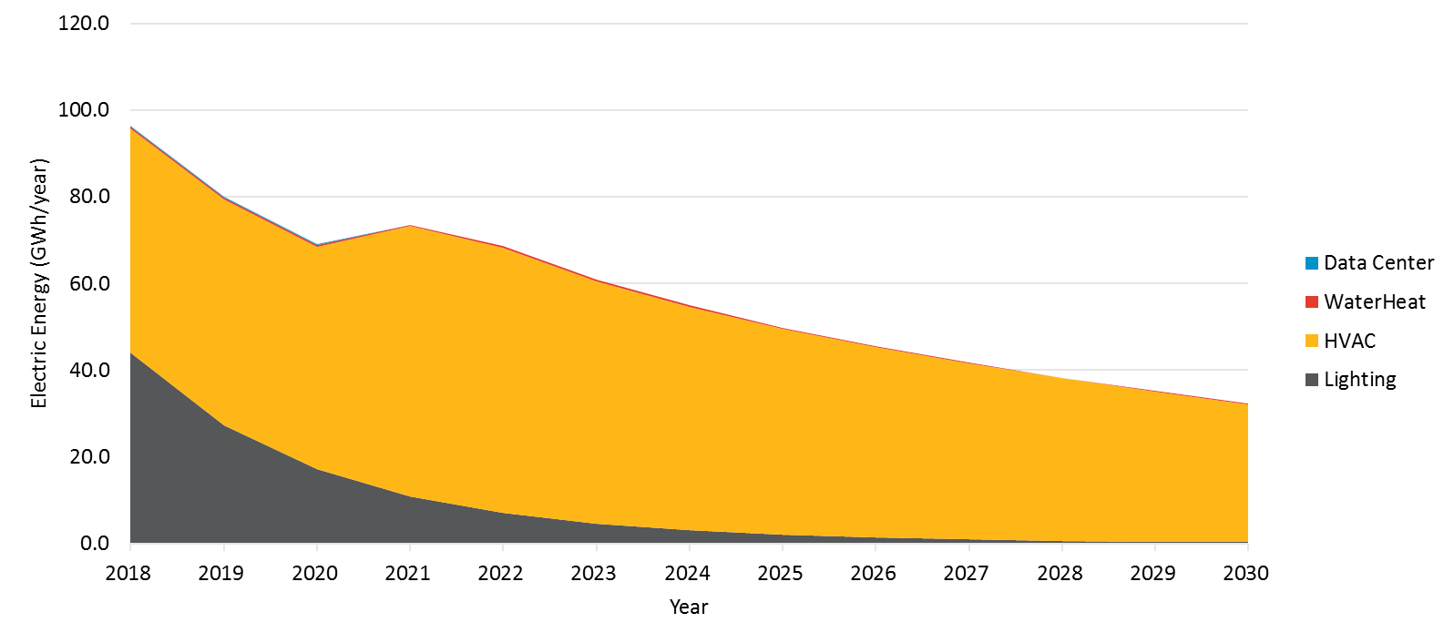

Figure ‑. Statewide Stranded Electric Potential by End Use for all sectors in Scenario 5 (PAC Aggressive)

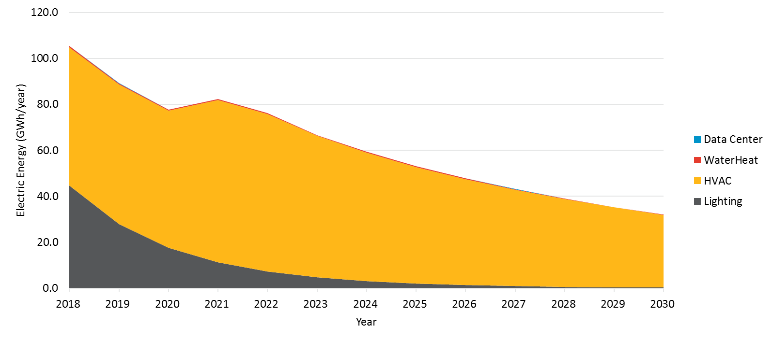

Figure 4‑56 and Figure 4‑60 show the breakdown of gas stranded potential by end use across all sectors. Key observations from these graphs are:

* HVAC measures contribute significantly to stranded gas potential across all scenarios. Again, potential from HVAC measures is captured through customer decisions to upgrade existing equipment (eg. 77 AFUE furnaces) to more efficient technologies (eg. 80 AFUE or higher furnaces) instead of keeping their old equipment.
* Water heating measures also contribute significantly to stranded gas potential across all scenarios. The primary source of savings are gas storage water heaters.
* Lighting measures, which produce negative gas savings due to interactive effects, contribute negligibly to stranded potential but do appear in the graphs for all scenarios.
* Stranded potential makes up approximately 2% of total equipment savings through 2030 in Scenario 1 (TRC Reference). It makes up 3% of total equipment savings in 2018 and slightly reduces to about 2% of total equipment savings by 2030 Scenario 5 (PAC Aggressive).

Figure ‑. Statewide Stranded Gas Potential by End Use for all sectors in Scenario 1 (TRC Reference)

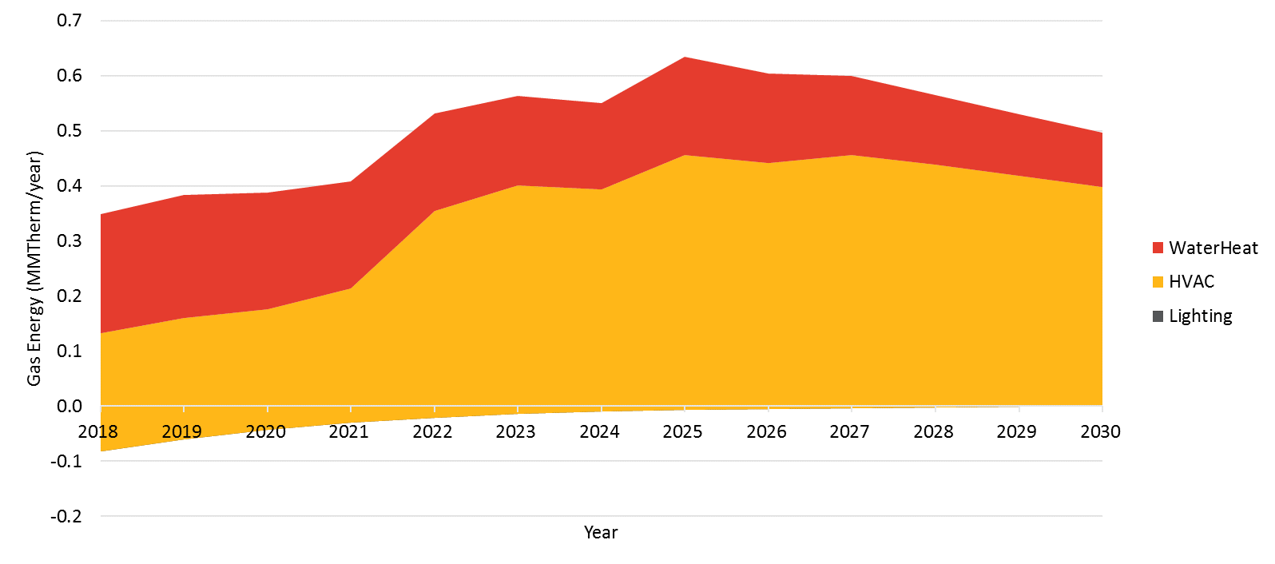

Figure ‑. Statewide Stranded Gas Potential by End Use for all sectors in Scenario 2 (mTRC w/ GHG Adder 1)

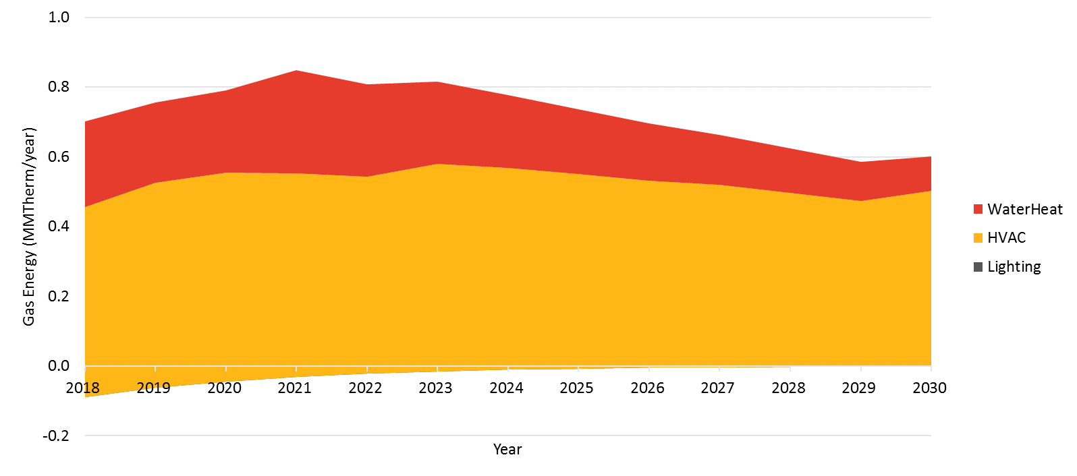

Figure ‑. Statewide Stranded Gas Potential by End Use for all sectors in Scenario 3 (mTRC w/ GHG Adder 2)

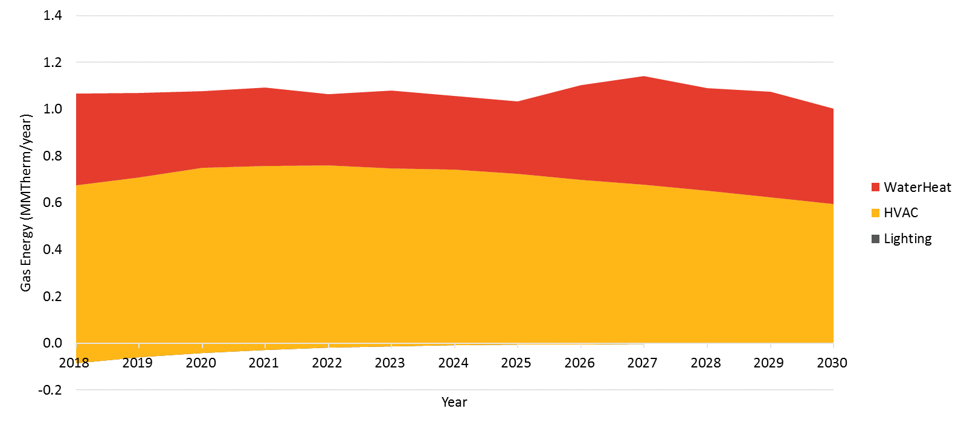

Figure ‑. Statewide Stranded Gas Potential by End Use for all sectors in Scenario 4 (PAC Reference)

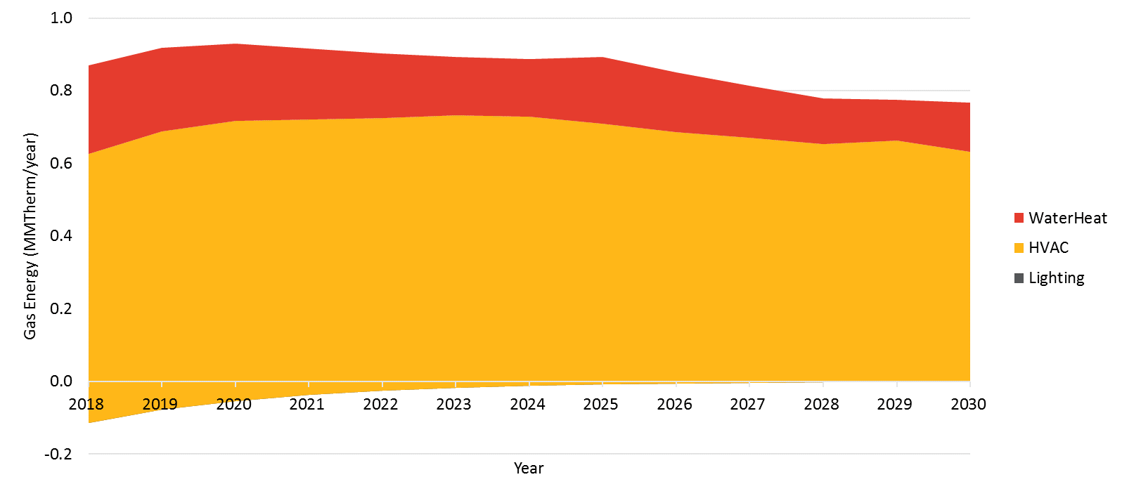

Figure ‑. Statewide Stranded Gas Potential by End Use for all sectors in Scenario 5 (PAC Aggressive)

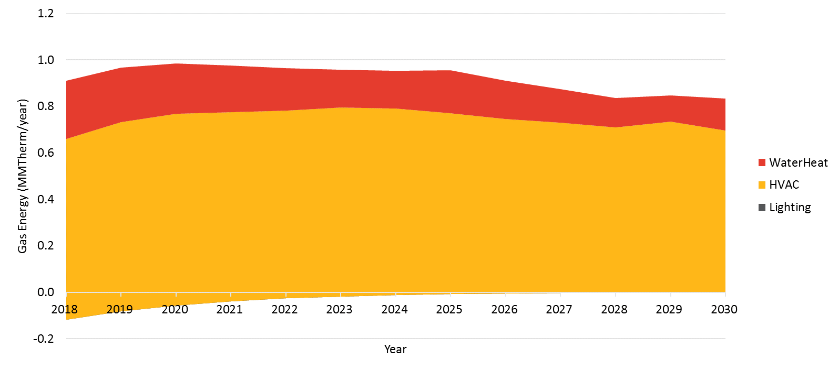

#### Portfolio Cost Effectiveness

Navigant calculated portfolio cost-effectiveness for measures under the equipment rebate programs for IOU and a few screening tests of interest to stakeholders under each scenario over time. These results can be found in the “Cost-effectiveness” tab of the results viewer that accompanies this report.

Several caveats are noted on these results:

* These results account for benefits and costs from rebated measures that contribute to equipment savings but exclude Low Income, Codes and Standards Savings, and BROs.
* Results exclude several cost categories that would typically be accounted for in a portfolio-level cost-effectiveness assessment (i.e. non-resource program costs)
* Program non-incentive costs are estimated based on past program years, these could vary in the future.

Based on these caveats, it is recommended that stakeholders pay attention to general trends rather than actual values in the results. As such, these costs are for reference purposes only and not to be used to determine budgets.

### BROS Scenario Results

This section presents incremental savings and program spending on BROs interventions under the Reference and Aggressive scenarios. BROs savings do not vary by cost effectiveness screen in our model. Additional versions of graphs appearing in this section for each IOU and including peak demand savings can be found in the results viewer under the tabs “Incremental Behavior” and “Behavior Spending”.

The reference scenario is dominated by savings from residential home energy reports (HERs) as illustrated in Figure 4‑61 and Figure 4‑62. As such, program spending is also estimated to be dominated by HERs (Figure 4‑63). Additional high impact interventions after HERS include web-based real time feedback, strategic energy management, retrocommissioning, and BEIMs. HERS dominates savings as it is one of the largest, and most well-studied, existing interventions with reliable data upon which to base a forecast. Savings from all interventions increase over time as we expect enrollment to in programs to gradually increase. Additional details about penetration rates can be found in Appendix C.

Figure ‑. BROs Electric Savings – Reference Scenario

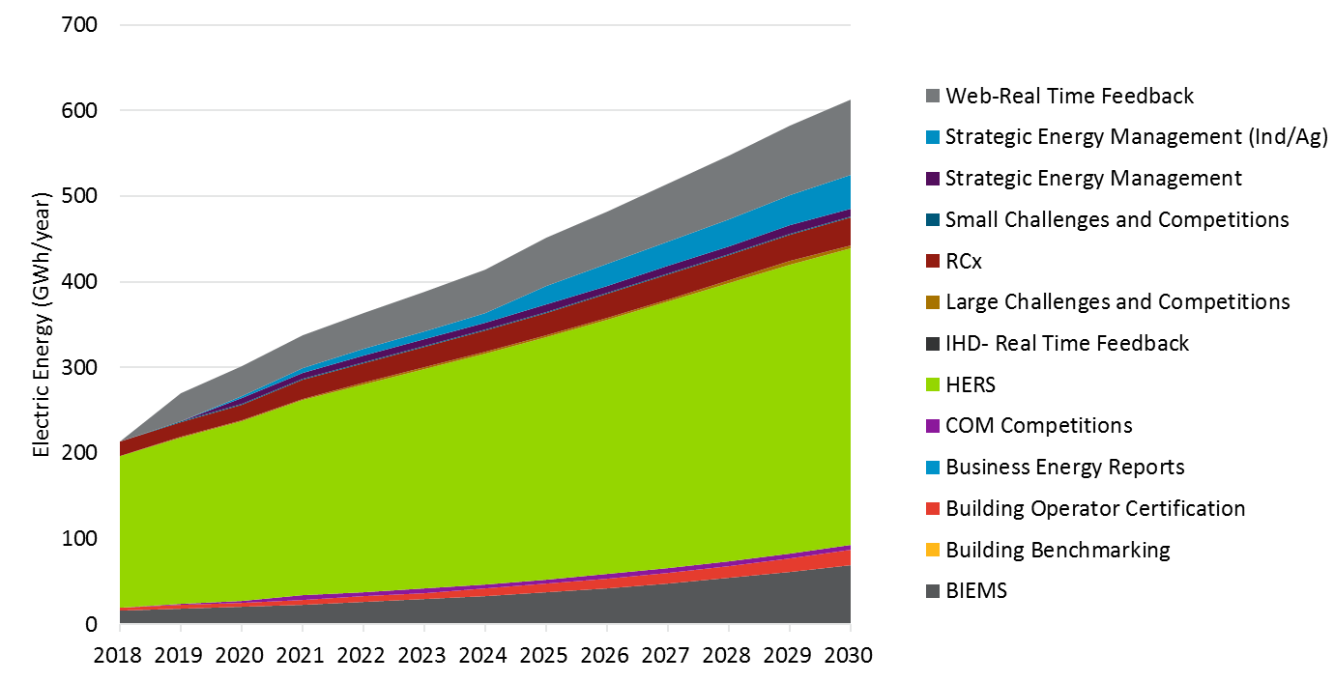

Figure ‑. BROs Gas Savings – Reference Scenario

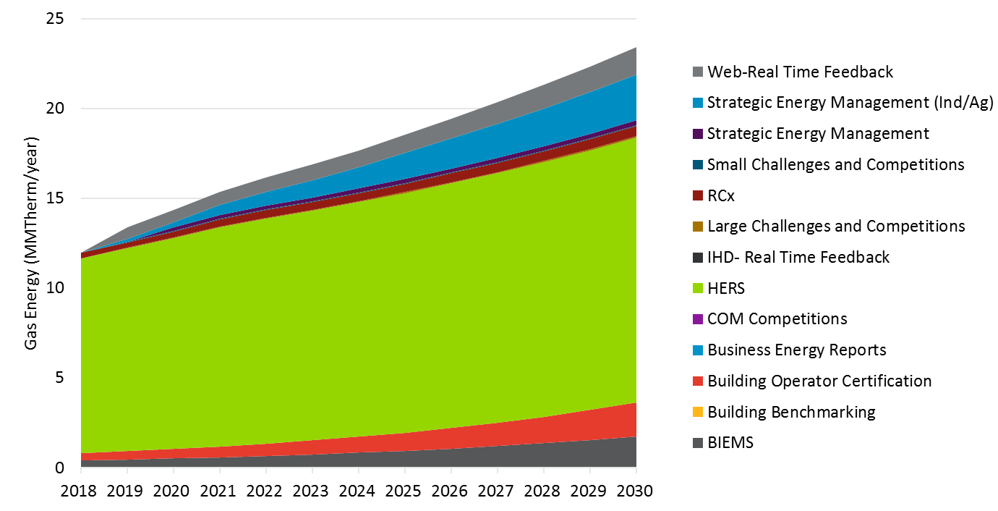

Figure ‑. BROs Program Spending – Reference Scenario

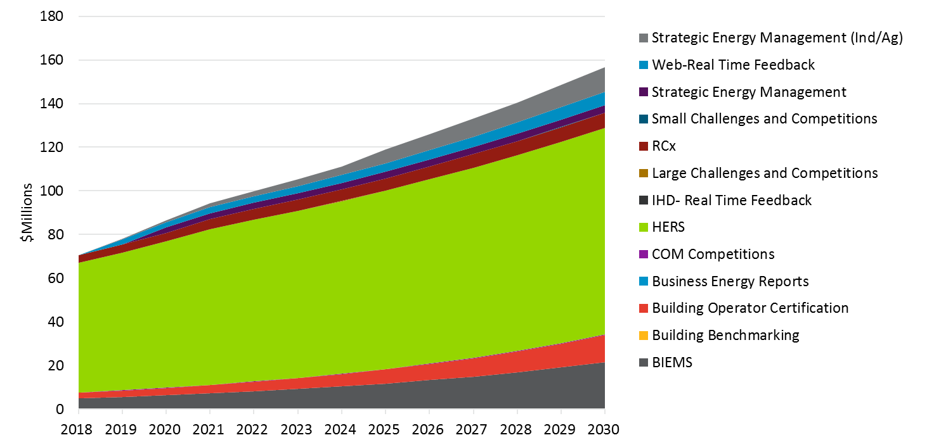

The aggressive scenario still shows a large portion of savings originating from HERs (Figure 4‑64 and Figure 4‑65). However, web-based real time feedback, strategic energy management, retrocommissioning, building benchmarking, and BEIMs combined offer more electric savings than HERs in this scenario. The aggressive scenario contains savings from in home displays and building benchmarking while the Reference scenario left these out. Savings and spending (Figure 4‑66) in the aggressive scenario is just short of a doubling of the reference scenario.

Figure ‑. BROs Electric Savings – Aggressive Scenario

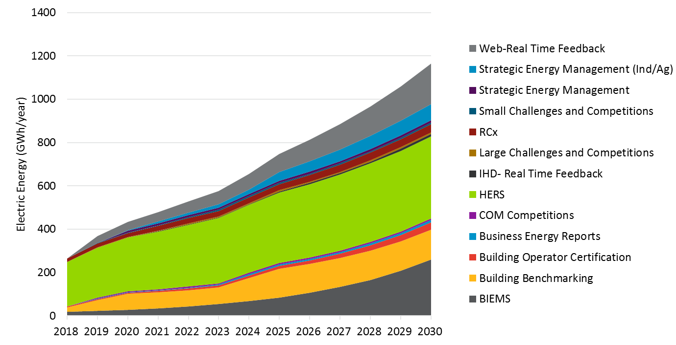

Figure ‑. BROs Gas Savings – Aggressive Scenario

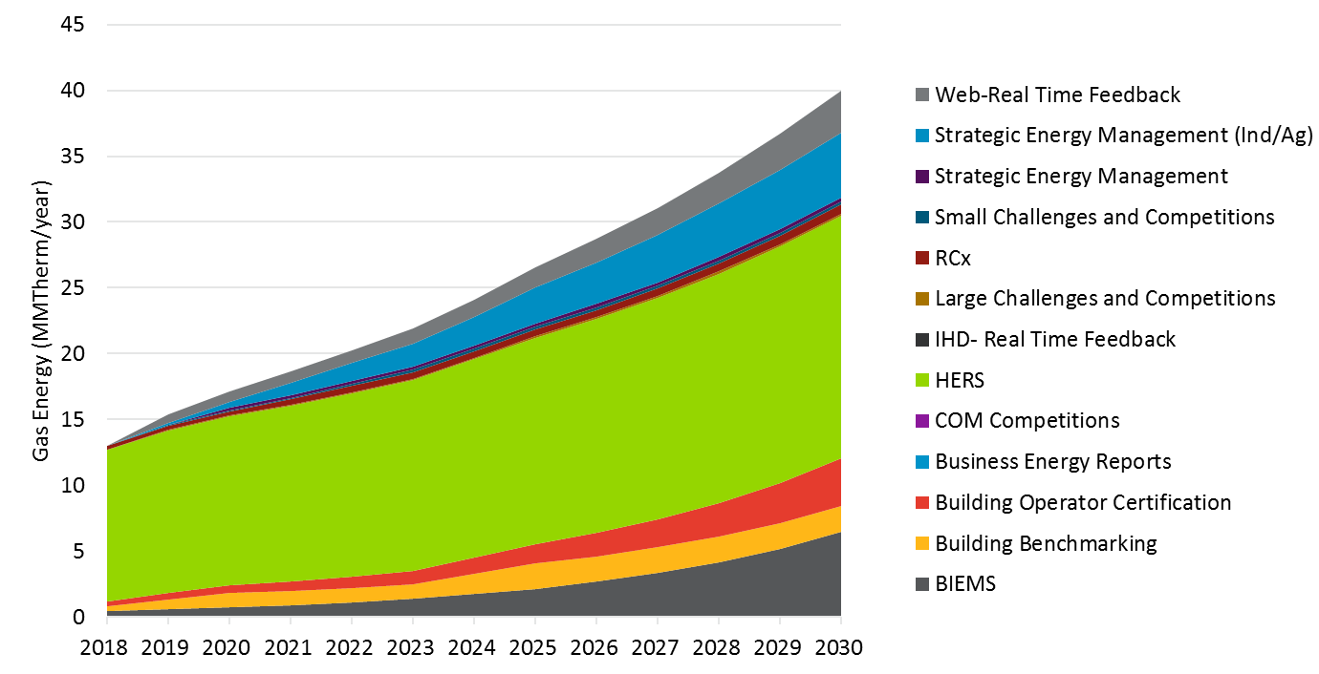

Figure ‑. BROs Program Spending – Aggressive Scenario

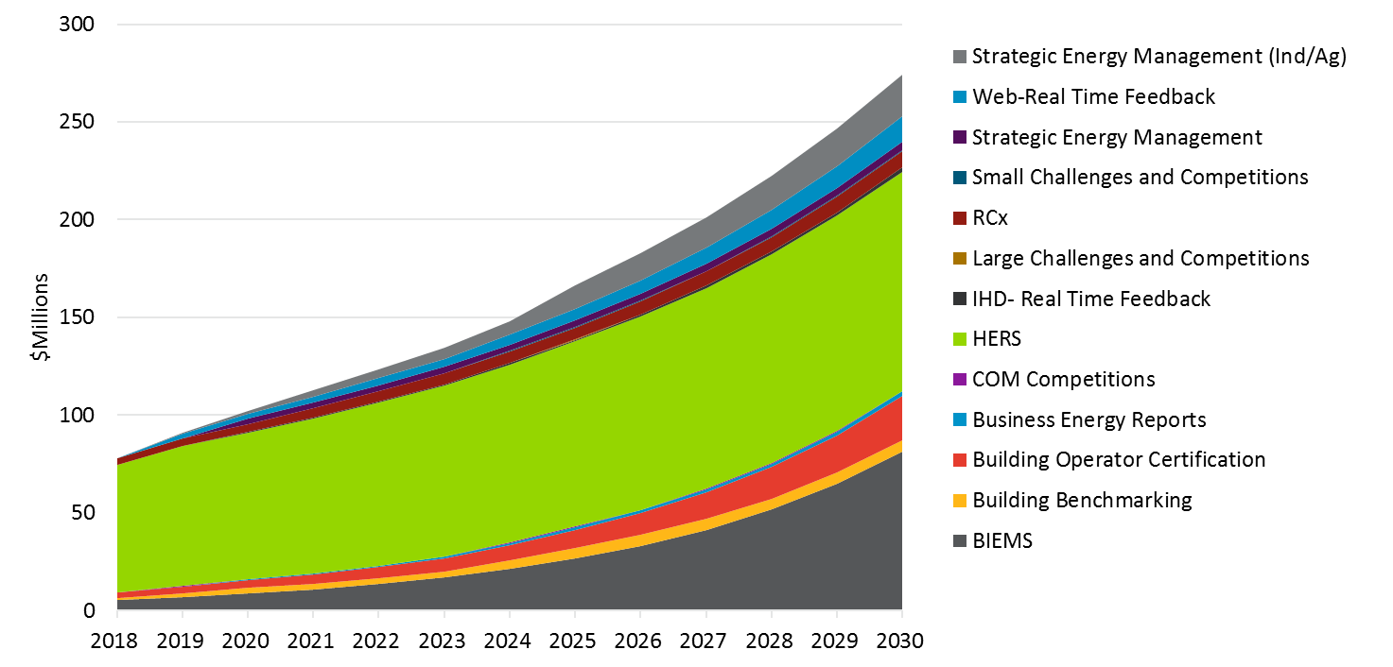

## C&S Savings

Incremental annual savings from C&S are illustrated in Figure 4‑67 and Figure 4‑68. Savings from C&S are significantly higher than those estimated in the 2015 PG study. The primary reason for increased savings are due to:

Evaluated 2013 T24 savings are higher than those unevaluated savings estimated in the 2015 study

IOU claims for 2016 Title 24 are higher than those savings estimated in the 2015 study

Inclusion of estimates for 2019 T24 in the 2018 study; these were not previously included in the mid case of the 2015 PG study

Additional/updated federal standards claimed by the IOUs not included in the 2015 study

The team performed a high-level review of the estimates the IOU provided in their claims. Navigant removed savings claims related to LED voluntary quality standards from the CEC for two reasons: 1) it’s uncertain how much savings a voluntary standard would generate, and 2) savings from 2018 T20 general service lamp standards were included in the model by Navigant. Furthermore, we note that some C&S are not ‘on the books’ are inherently uncertain. C&S savings estimates represent the best estimate based on available data.

Several notable trends can be observed in the results. Increases in whole building savings in 2020 and 2021 are attributed to the estimated impacts of 2019 T24 building codes we estimate to come into effect mid-2020. The increase in HVAC savings in 2023 is from the Federal Air-Cooled Commercial Package ACs and HPs standards (data provided by IOU claims). Incremental savings seems to decrease in the outer years as the market impacted by a code or standard has completely turned over and savings from the retrofit market are no longer counted.

Figure ‑. C&S Electric Savings (Including Interactive Effects)

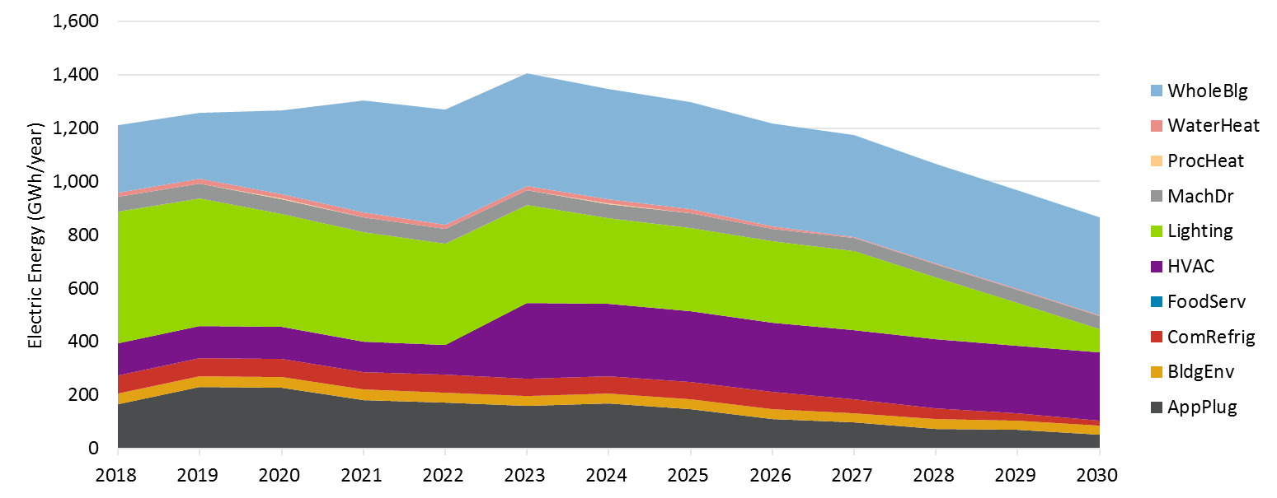

Figure ‑. C&S Gas Savings (Including Interactive Effects)

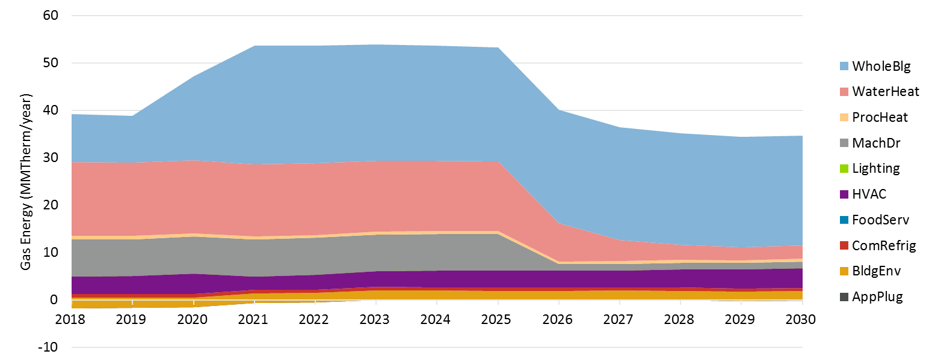

Additional versions of Figure 4‑67 and Figure 4‑68 for each IOU and including peak demand savings can be found in the results viewer under the tab “Codes & Standards”

## Detailed Study Results

Along with the model file and the summary results shown above, the team developed a downloadable excel tool, the 2018 PG Results Viewer. The Results Viewer provides stakeholders the ability to manipulate and visualize model outputs. The viewer contains multiple tabs (listed and described in Table 4‑4) some provide high level results, others provide end use level results, and other provided detailed raw output. The results viewer provides “measure level” results from C&S, Low Income, and BROs. A separate database of measure level results for rebate programs is also made available with this release.

Table ‑4. Results Viewer Tabs

| Tab | Description |
| --- | --- |
| Data Key and Definitions | A brief description of key data fields and definitions of terms used in this tool |
| Total Incr Potential | Stacks up the Incremental Market Potential data by sector for all programs |
| Total Incr Gross Potential | Stacks up the Incremental Gross Market Potential data by sector for all programs |
| Total Cumul Potential | Stacks up the Cumulative Market Potential data by sector for all programs |
| Total Spending | Stacks up the Incremental Spending data by sector for all programs |
| Scenario Pivot - Incremental | Provides Incremental Market Potential data for all programs by Scenario. It also allows the user to manipulate the data based on their needs through filters such as Service Territory, Building Type, Sector etc. |
| Scenario Pivot - Increm % | Provides Incremental Market Potential as a percent of sales for all programs by Scenario. It also allows the user to manipulate the data based on their needs through filters such as Service Territory, Building Type, Sector etc. |
| Scenario Pivot - Cumulative | Provides Cumulative Market Potential data for all programs by Scenario. It also allows the user to manipulate the data based on their needs through filters such as Service Territory, Building Type, Sector etc. |
| Scenario Pivot - Spending | Provides Incremental Spending data by for all programs by Scenario. It also allows the user to manipulate the data based on their needs through filters such as Service Territory, Building Type, Sector etc. |
| Tech, Econ and Market Potential | Statewide technical, economic and market potential for 2018 and beyond in GWh, MW and MMTherms by scenario for equipment rebate programs. |
| Use Category - Inc Rebate Net | Visualize the Incremental Net Market Potential data by End Use Categories for equipment rebate programs. It also allows the user to manipulate the data based on their needs through filters such as Service Territory, Building Type, Sector etc. |
| Use Category - Inc Stranded Net | Visualize the Stranded Potential data by End Use Categories for equipment rebate programs. It also allows the user to manipulate the data based on their needs through filters such as Service Territory, Building Type, Sector etc. |
| Use Category - Inc Rebate Gross | Visualize the Incremental Gross Market Potential data by End Use Categories for equipment rebate programs. It also allows the user to manipulate the data based on their needs through filters such as Service Territory, Building Type, Sector etc. |
| Cost-effectiveness | Shows the portfolio cost effectiveness results for equipment rebate programs (excludes C&S, BROs, Low Income). |
| Incremental Behavior | Incremental effects of Behavioral programs by intervention. It also allows the user to manipulate the data based on their needs through filters such as Service Territory, Savings Type, Sector, and Scenario. |
| Cumulative Behavior | Cumulative effects of Behavioral programs by intervention. It also allows the user to manipulate the data based on their needs through filters such as Service Territory, Savings Type, Sector, and Scenario. |
| Behavior Spending | Spending on Behavioral programs by intervention. It also allows the user to manipulate the data based on their needs through filters such as Service Territory, Savings Type, Sector, and Scenario. |
| Codes & Standards | Codes and Standards potential by End Use. It also allows the user to manipulate the data based on their needs through filters such as Service Territory, Savings Type and Sector. |
| Total Incr Mkt Potential | Raw data of the Incremental Market Potential for all incentive programs in all service territories from 2018 through 2030 |
| Total Incr Gross Mkt Potential | Raw data of the Incremental Gross Market Potential for all incentive programs in all service territories from 2018 through 2030 |
| Increm Mkt Potential Spending | Raw data of the Market Potential Spending for Rebated Equipment and BROs programs in all service territories from 2018 through 2030 |
| Total Cumul Mkt Potential | Raw data of the Cumulative Market Potential for all programs in all service territories from 2018 through 2030 |
| CEC Sales Data | Raw data from the CEC of energy sales from 2018 through 2030 |
| Equipment Incr Tech Potential | Raw data of the Technical Potential for equipment rebate programs in all service territories from 2018 through 2030 |
| Equipment Incr Econ Potential | Raw data of the Economic Potential for equipment rebate programs in all service territories from 2018 through 2030 |
| Equipment Incr Mkt Potential | Raw data of the Incremental Market Potential for equipment rebate programs in all service territories from 2018 through 2030 |
| Equipment Incr Gross Mkt Pot | Raw data of the Incremental Gross Market Potential for equipment rebate programs in all service territories from 2018 through 2030 |
| Equipment Cumul Mkt Potential | Raw data of the Cumulative Market Potential for equipment rebate programs in all service territories from 2018 through 2030 |
| Equiment Incr Stranded Pot | Raw data of the Stranded Potential for equipment rebate programs in all service territories from 2018 through 2030 |
| Equip Portfolio CE | Raw data of portfolio cost-effectiveness for equipment rebate programs in all service territories from 2018 through 2030 |
| Incremental BROs Savings | Raw data of the Incremental Behavior Program potential for all service territories from 2018 through 2030 |
| Cumulative BROs Savings | Raw data of the Cumulative Behavior Program potential for all service territories from 2018 through 2030 |
| BROs Spending | Raw data of the Behavior Program spending for all service territories from 2018 through 2030 |
| Low Income Incremental | Raw data of the Incremental Low Income Program potential for all service territories from 2018 through 2030 |
| Low Income Cumulative | Raw data of the Cumulative Low Income Program potential for all service territories from 2018 through 2030 |
| Incremental C&S - w Interactive | Raw data of the Codes and Standards potential with interactive effects for all service territories from 2018 through 2030 |
| Incremental C&S wo Interactiv | Raw data of the Codes and Standards potential without interactive effects for all service territories from 2018 through 2030 |
| Cumulative C&S - w Interactive | Raw data of the Codes and Standards potential with interactive effects for all service territories from 2018 through 2030 |
| Cumulative C&S - wo Interactive | Raw data of the Codes and Standards potential without interactive effects for all service territories from 2018 through 2030 |

The viewer is illustrated in Figure 4‑69 through Figure 4‑71.

Figure ‑. Results Viewer Overview Tab



Figure ‑. Results Viewer Scenario Comparison (Illustrative)

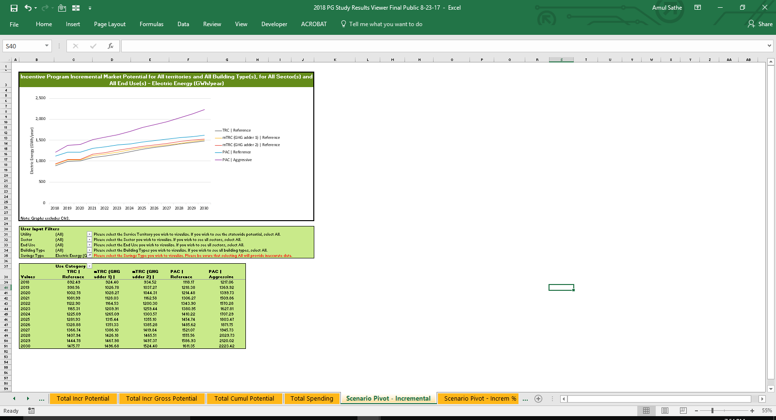

Figure ‑. Results Viewer End Uses (Illustrative)

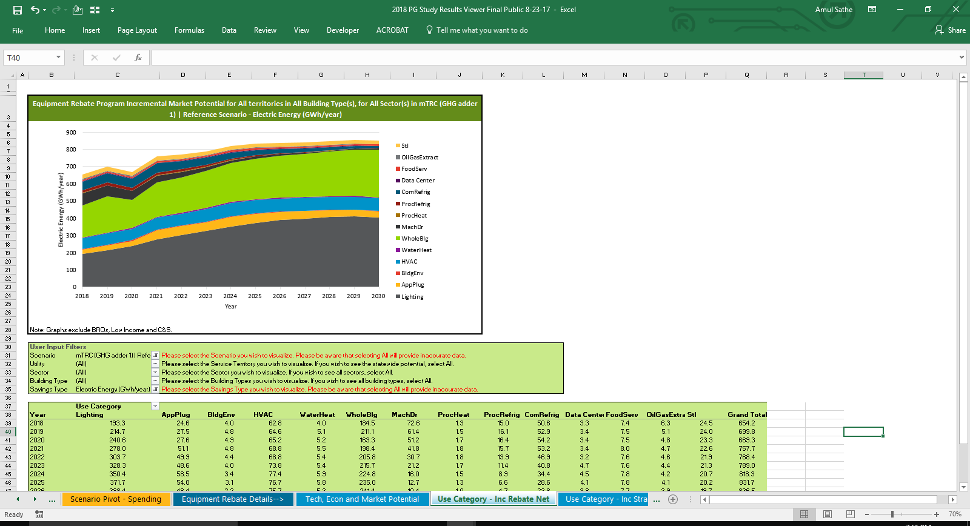

# Comparision to 2015 Study

Several recent changes in policy lead to significant changes in the way potential is expressed in the 2018 Study as compared to the 2015 Study.

* Market potential in the 2018 study is expressed in terms of net savings
* Multiple scenarios are presented in the 2018 Study based on various cost effectiveness test parameters
* The scope of savings from BROs and Low income are expanded in the 2018 study.

This section compares savings from the 2018 study to the 2015 study. To make an even comparison, results for incentive programs from the 2018 study in this section are expressed as gross savings instead of net. Comparisons are made for the calendar year 2018 (the first year of the forecast for the 2018 study) and 2024 (the last year of the forecast for the 2015 study)

Table 5‑1 and Table 5‑2 show the comparison between electric and gas savings for all incentive programs, which include savings from Equipment Rebate programs, BROs interventions and Low Income programs. All scenarios generally yield higher results in the 2018 study compared to the 2015 for both gas and electric. The noted exception is Scenario 1 (TRC Reference) electric savings in the year 2018, which is just slightly lower than the 2015 study forecast. It is important to note that the different incentive programs included in the total market potential contribute differently to this trend:

* Savings from Equipment Rebate programs alone in the 2018 study are lower than the 2015 study results in some scenarios:
  + Electric savings in Scenario 1 (TRC Reference), Scenario 2 (mTRC w/ GHG Adder 1) and Scenario 3 (mTRC w/GHG adder 2) are lower than the 2015 study results. This implies that the drop in avoided costs used to calculate the benefits for Equipment Rebate program measures decreases program savings and the proposed GHG adders are not enough to bring avoided costs back up to the level of the 2015 study. Values for the PAC scenarios in the 2018 Study are substantially higher than in the 2015 Study.
  + Gas savings in Scenario 1 (TRC Reference) are lower than the 2015 study results, but on par or higher than the 2015 study results for all other scenarios.
* The scope of BROs interventions was significantly expanded in the 2018 study, which led to a substantially higher BROs savings in the 2018 study compared to the 2015 study. Table 5‑3 and Table 5‑4 summarize this trend. Thus, BROs programs make up for the lost potential due to lower avoided costs in the equipment rebate programs, causing the overall market potential for incentive programs in the 2018 to be generally higher than the 2015 study results across all scenarios.

Table ‑1. Total Incentive Program Market Potential Comparison - Gross Electric Savings

|  |  |  |  |  |  |
| --- | --- | --- | --- | --- | --- |
|  | **2018** | | **2024** | | |
|  | **Market Potential (GWh)** | **Percent Difference Relative to 2015 study** | | **Market Potential (GWh)** | **Percent Difference Relative to 2015 study** |
| 2015 Study | 1,177 | - | | 1,332 | - |
| 2018 Study – Scenario 1 (TRC Reference | 1,160 | -1% | | 1,577 | 18.4% |
| 2018 Study – Scenario 2 (mTRC w/ GHG Adder 1) | 1,208 | 3% | | 1,631 | 22% |
| 2018 Study – Scenario 3 (mTRC w/ GHG Adder 2) | 1,225 | 4% | | 1,690 | 27% |
| 2018 Study – Scenario 4 (PAC Reference) | 1,528 | 30% | | 1,888 | 42% |
| 2018 Study – Scenario 4 (PAC Aggressive) | 1,654 | 41% | | 2,210 | 66% |

Table ‑2. Total Incentive Program Market Potential Comparison - Gross Gas Savings

|  |  |  |  |  |  |
| --- | --- | --- | --- | --- | --- |
|  | **2018** | | **2024** | | |
|  | **Market Potential (MMTherms)** | **Percent Difference Relative to 2015 study** | | **Market Potential (MMTherms)** | **Percent Difference Relative to 2015 study** |
| 2015 Study | 34.6 | - | | 40.8 | - |
| 2018 Study – Scenario 1 (TRC Reference | 42.4 | 22% | | 53.5 | 31% |
| 2018 Study – Scenario 2 (mTRC w/ GHG Adder 1) | 51.3 | 48% | | 72.2 | 77% |
| 2018 Study – Scenario 3 (mTRC w/ GHG Adder 2) | 59.5 | 72% | | 91.2 | 124% |
| 2018 Study – Scenario 4 (PAC Reference) | 55.3 | 60% | | 74.8 | 83% |
| 2018 Study – Scenario 4 (PAC Aggressive) | 57.8 | 67% | | 83.6 | 105% |

Table 5‑3 and Table 5‑4 show BROs results for electric and gas compared to the previous study. As previously mentioned, BROs savings are significantly higher compared to the previous study primarily owing to the expanded scope of BROs interventions and data updates.

Table ‑3. BROs Potential Comparison - Gross Electric Savings

|  |  |  |  |  |  |
| --- | --- | --- | --- | --- | --- |
|  | **2018** | | **2024** | | |
|  | **Market Potential (GWh)** | **Percent Difference Relative to 2015 study** | | **Market Potential (GWh)** | **Percent Difference Relative to 2015 study** |
| 2015 Study | 153 | - | | 176 | - |
| 2018 Study - Reference | 213 | 39% | | 414 | 135% |
| 2018 Study - Aggressive | 264 | 73% | | 654 | 271% |

Table ‑4. BROs Potential Comparison - Gross Gas Savings

|  |  |  |  |  |  |
| --- | --- | --- | --- | --- | --- |
|  | **2018** | | **2024** | | |
|  | **Market Potential (MMTherms)** | **Percent Difference Relative to 2015 study** | | **Market Potential (MMTherms)** | **Percent Difference Relative to 2015 study** |
| 2015 Study | 5.3 | - | | 6.1 | - |
| 2018 Study - Reference | 12.0 | 126% | | 17.7 | 191% |
| 2018 Study - Aggressive | 13.0 | 146% | | 24.1 | 297% |

Table 5‑3 and Table 5‑4 show net C&S results for electric and gas compared to the previous study. As mentioned earlier in section 4.2 savings from C&S are significantly higher than those estimated in the 2015 PG study. The primary reason for increased savings are due to:

Evaluated 2013 T24 savings are higher than those unevaluated savings estimated in the 2015 study

IOU claims for 2016 Title 24 are higher than those savings estimated in the 2015 study

Inclusion of estimates for 2019 T24 in the 2018 study; these were not previously included in the mid case of the 2015 PG study

Additional/updated federal standards claimed by the IOUs not included in the 2015 study

Table ‑5. C&S Net Program Results Comparison - Electric

|  |  |  |  |  |  |
| --- | --- | --- | --- | --- | --- |
|  | **2018** | | **2024** | | |
|  | **Market Potential (GWh)** | **Percent Difference Relative to 2015 study** | | **Market Potential (GWh)** | **Percent Difference Relative to 2015 study** |
| 2015 Study | 925 | - | | 543 | - |
| 2018 Study | 1,212 | 31% | | 1,347 | 148% |

Table ‑6. C&S Net Program Results Comparison - Gas

|  |  |  |  |  |  |
| --- | --- | --- | --- | --- | --- |
|  | **2018** | | **2024** | | |
|  | **Market Potential (MMTherms)** | **Percent Difference Relative to 2015 study** | | **Market Potential (MMTherms)** | **Percent Difference Relative to 2015 study** |
| 2015 Study | 16.7 | - | | 14.5 | - |
| 2018 Study | 39.2 | 135% | | 53.7 | 270% |

##### Calibration

###### Overview

Forecasting is the inherently uncertain process of estimating future outcomes by applying a model to historic and current observations. As with all forecasts, the PG model results cannot be empirically validated a priori, as there is no future basis against which one can compare simulated versus actual results. Despite that all future estimates are untestable at the time they are made, forecasts can still warrant confidence when historic observations can be shown to reliably correspond with generally accepted theory and models.

Calibration provides both the forecaster and stakeholders with a degree of confidence that simulated results are reasonable and reliable. Calibration is intended to achieve three main purposes:

* Ground the model in actual market conditions and ensure the model reproduces historic program achievements;
* Ensure a realistic starting point from which future projects are made; and
* Account for varying levels of market barriers across different types of technologies and end uses.

The PG model is calibrated by reviewing historic program data from 2013 to 2015 to assess how the market has reacted to program offerings in the past. The Navigant team used 2013-2015 IOU-reported spending and savings data as the calibration data.

The calibration data are used to inform the appropriate values for the customer willingness and awareness parameters that drive measure adoption during the model time horizon. These parameters are then considered to account for the range of factors—technological, economic, market, and program factors— that contribute to historic program achievements. This includes consumers’ awareness of programs and their willingness to participate in them.

This calibration method (a) tracks what measures have been installed or planned for installation over an historic three-year period and (b) forecasts how remaining stocks of equipment will be upgraded, including the influence of various factors such as new codes and standards, or new delivery mechanisms.

###### Necessity of Calibration

Calibration refers to the standard process of adjusting model parameters such that model results align with observed data. In evaluative statistical models, calibration is called regression, and goodness of fit is typically the main focus since the models are usually simple. In situations of complex dynamics and non-linearity (as in this study), model sophistication and adequacy can become the main focus. But grounding the model in observation remains equally necessary. The ability of a forecast to reasonably simulate observed data affords credibility and confidence to forecast estimates.

Although there are data supporting all underlying parameters in the PG model, much of the data are at an aggregate level that can be inadequate to forecast differences across the various classes of technologies and end uses. The customer willingness-to-adopt factor is a good example of this effect. Customers may exhibit certain average purchase tendencies in adopting measures based on their financial characteristics. Nevertheless, there may be features of certain end use technologies that cause customer behavior to vary from the average. Residential building envelope is an end use where adoption of measures like insulation is consistently lower than would be predicted compared with other end uses. Residential lighting adoption, on the other hand, performs better than the average predicted customer purchase tendencies, even after adjusting for differences in financial attractiveness. We often think of these differences as the influence of non-financial product attributes or of market barriers.

Figure A-1 below illustrates the concept of calibration. The chart on the left shows how certain end uses may over predict (blue) or under predict (green) adoption compared to observations of program participation. By adjusting the calibration levers, as illustrated in the right chart below, the modeled results in past years become aligned with reported historical program achievements.

Figure ‑. The Concept of Calibrating

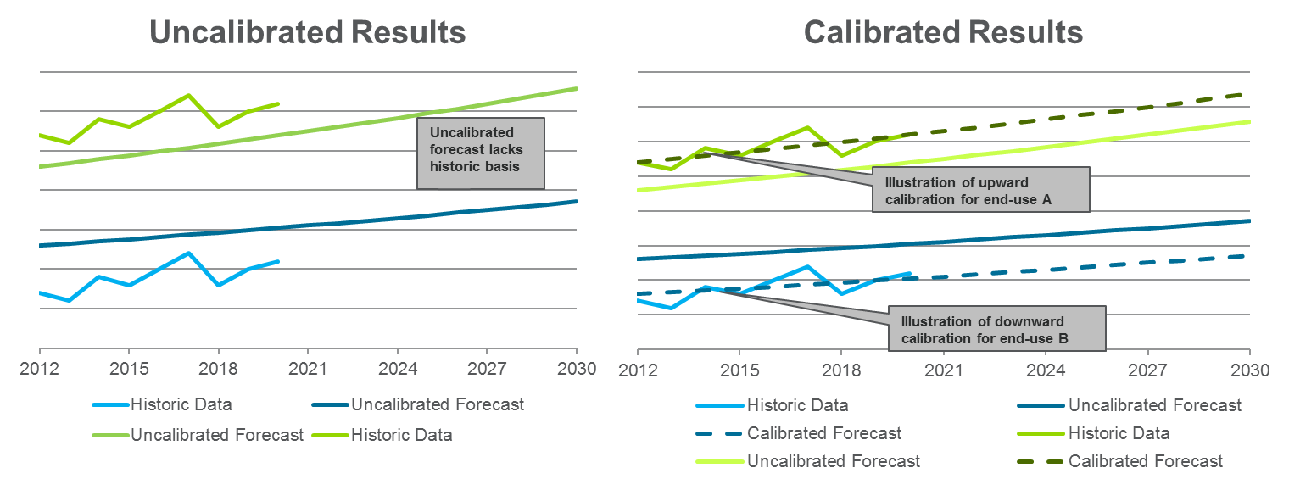

Note that model parameters and results may be increased or decreased depending on the end use. We do not “calibrate down” on aggregate, but rather just “calibrate” the end uses both up and down as appropriate based on the data, as shown in the chart on the right above.

Calibration is not an optional exercise in modeling. One might suggest that the average customer data should be sufficient to make a reliable aggregated forecast. Nevertheless, there are two important non-linearities that compel us toward a more granular parameterization:

* Program portfolios are not evenly composed across end-uses. This leads to an uneven weighting issue whereby average customer willingness and awareness may not lead to the correct calculation of total savings and costs.
* The dynamics in the model regarding the timing of adoption can become incompatible with the remaining potential indicated by program achievements. For example, if the forecast results were not calibrated for CFL lighting in the residential sector, the saturation may remain inaccurately low in early years and indicate a larger remaining potential in future years. Thus calibrating upward may increase potential in the early years but decrease potential in later years. This implies that in the absence of IOU program intervention, residential CFLs would have historically had much lower adoption. Calibration therefore allows us to capture these program influences to more accurately reflect remaining potential.

This discussion is intended to highlight the necessity of calibration and the effective irrelevance of uncalibrated parameters. It may be tempting to “relax” the calibrated parameters back toward the average to measure the effect of what could be possible. But the uncalibrated results can be difficult to interpret and almost certainly would not produce feasible results for certain end uses. Thus they provide no basis for a reasonable forecast. Instead, we treat the calibrated results as the most basic set of interpretable results from which alternate scenarios are developed. Changes to calibrated parameters are not returned to the uncalibrated averages, but are rather explicitly developed based on the feasibility of values that parameters might take over time and how quickly the change might occur. This is discussed more in the last section of this brief.

###### Interpreting Calibration

Calibration can constrain market potential for certain end uses when aligning model results with past IOU energy efficiency portfolio accomplishments. Although calibration provides a reasonable historic basis for estimating future market potential, past program achievements may not capture the potential due to structural changes in future programs or changes in consumer values. Calibration can be viewed as holding constant certain factors that might otherwise change future program potential, such as:

* Consumer values and attitudes toward energy efficient measures;
* Market barriers associated with different end uses;
* Program efficacy in delivering measures; and
* Program spending constraints and priorities.

Changing values and shifting program characteristics would likely cause deviations from market potential estimates calibrated to past program achievements.

Does calibrating to historic data constrain the future forecast? In a strictly numeric sense, yes. If a certain end use is calibrated downward or upward, then future adoption and its timing are affected. Nevertheless, this should not be interpreted as “calibration constrains the level of adoption that we think is possible.” Rather calibration provides a more accurate estimate of the current state of customer willingness, market barriers, program characteristics and remaining adoption potential. One forecast scenario might assume that the underlying conditions remain the same—a sort of business as usual scenario. We might develop another scenario such that it represents a transforming market based on agreed-upon end state parameter values appropriate for the end use market. For insulation that may mean a slight improvement, for water heating a greater improvement, and for lighting perhaps little change is warranted if fewer market barriers exist today.

One interpretation is that the calibration process creates a floor for the remaining potential. Market barriers, customer attitudes, and program efficacy generally move in the direction of improvement. The extent to which a market or program can improve should not be compared to the uncalibrated results, but rather to the vision for what is reasonably possible for the parameters describing each end use. This may require little change, some change, or greater change in parameter values for different end-uses. But improvements to parameter values are based on their own merits and feasibility, and are independent of the uncalibrated parameter values and results.

###### Implementing Calibration

The PG model is calibrated primarily using historic program budgets. Calibration inputs include 2013-2015 IOU-reported incentive and admin expenditures in Compliance Filings[97]. An illustration of the calibration targets used is shown below:

Figure ‑. Illustrative 2013-2015 Calibration Targets

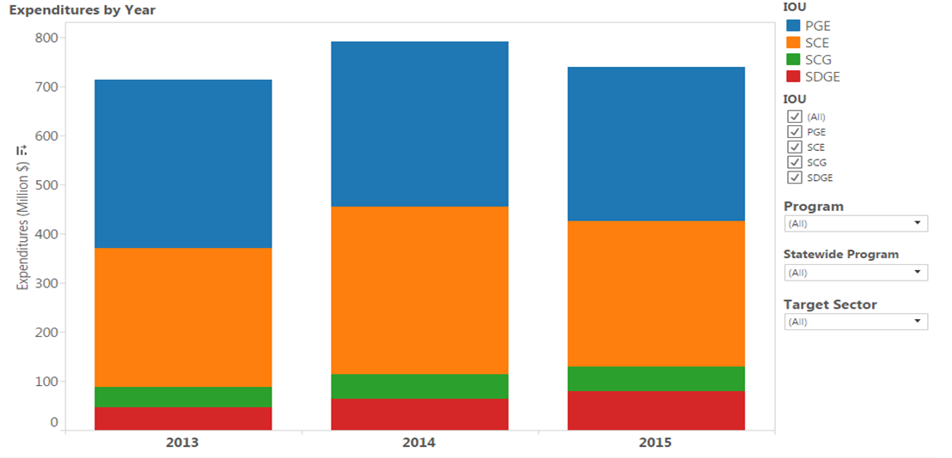

During the calibration period, budgets are anchored to historical spending. During the forecast period, budgets can change over time based on inputs and assumptions that go into the model. Broadly, calibration examines two categories of levers to best align results with past program achievements. A comprehensive list of the calibration levers that are used and their impact on model results is provided below.

Table ‑. Calibration Levers

|  |  |  |
| --- | --- | --- |
| Category | Lever | Impact on Model results |
| Awareness | Initial Awareness | Increasing initial awareness shortens the time required for a measure to reach 100% consumer awareness. Also sets upper bound on adoption in the first year. |
| Marketing Strength | Increasing marketing strength increases adoption rate of measures in the nascent stage (i.e. having low initial consumer awareness). Less useful for measures having moderate to high initial consumer awareness. |
| Word-of-Mouth (WOM) Strength | Increasing WOM increases adoption ramp rate, particularly in a measure’s growth stage*.* |
| Willingness | Implied Discount Rate (iDR) | the iDR is adjusted when perceived market barriers are higher or lower than normal, or when factors other than cost effectiveness may play a larger role in purchase decisions. |
| Sensitivity | the consumer sensitivity is adjusted when markets are considered mature and customer primary focus is measure cost effectiveness |
| Incentive levels | Spending and savings are sensitive to incentive levels, so changes in incentive levels by small increments are explored. |

Parameters are adjusted to fit historic observations during the calibration period. Then the parameters are applied to the forecast period, which begins in the year of most recent density data vintage. Calibrating parameters up and down can have different effects in a dynamic model depending on the initial saturation (i.e., density) data. For example, calibrating up can increase both historic and future adoption if the initial saturation is low. If initial saturation is high, then calibrating up can increase past adoption in the model, leaving less for future years.

Once the consumer preference parameters are calibrated, the model forecast begins in 2016 by applying known market saturation data of that same vintage. Forecasts indicate the saturation of measures over time under the expected IOU future program influences.

##### Technical, Economic and Cumulative Market Potential for Equipment Rebate Programs

Figure B-1 through Figure B-10 below illustrate the statewide technical, economic and cumulative market potential from IOU equipment rebates for electric (GWh) and gas (MMTherms) respectively for each scenario. These graphs do not show IOU claimable savings from behavior, low income or C&S advocacy programs as the technical and economic potential for these sources are undefined. Only Scenario 5 (PAC Aggressive) includes the effects of energy efficiency financing. The cumulative market potential line is based on an accumulation start year of 2015 to match the needs of tracking towards SB350.

The technical potential is based on instantaneous potential, which is defined as the amount of energy savings that would be possible if the highest level of efficiency for all technically applicable opportunities to improve energy efficiency were taken. It does not account for equipment stock turnover. The economic potential shown in the graph is a subset of technical potential that is cost-effective under the relevant screening test in each scenario. Both the technical and economic potential lines grow steadily over time to reflect stock growth across all scenarios.

The large gap between the economic and technical potential on the graphs for Scenario 1 (TRC Reference) reflects that a significant number of measures are not cost-effective. A key driver for this is the 2016 avoided cost update, which produced avoided costs that are lower than in previous studies. This gap becomes smaller as the cost test used to screen measures becomes less stringent for electric savings. This gap is smallest in Scenario 2 (mTRC w/ GHG Adder 2) for gas savings as the adder is applied uniformly to all gas measures. On the other hand, the impact of the adder on electric measures is loadshape-dependent, which means the benefits of the GHG adder vary by time of day and season.

The electric cumulative market potential generally grows at a steady pace between 2018 and 2021, after which it ramps up out to 2030 across all scenarios. Savings from LEDs are expected to grow significantly during this time. Since overall potential is generally dominated by lighting measures, the growth in the LED market drives the cumulative market potential.

Additional versions of these figures including demand savings and savings as a percent of consumption are available for each utility and all scenarios in the results viewer under the tab “Tech, Econ and Market Potential”

Figure ‑. Statewide Technical, Economic and Cumulative Electric Market Potential for Equipment Rebate Programs in Scenario 1 (TRC Reference)

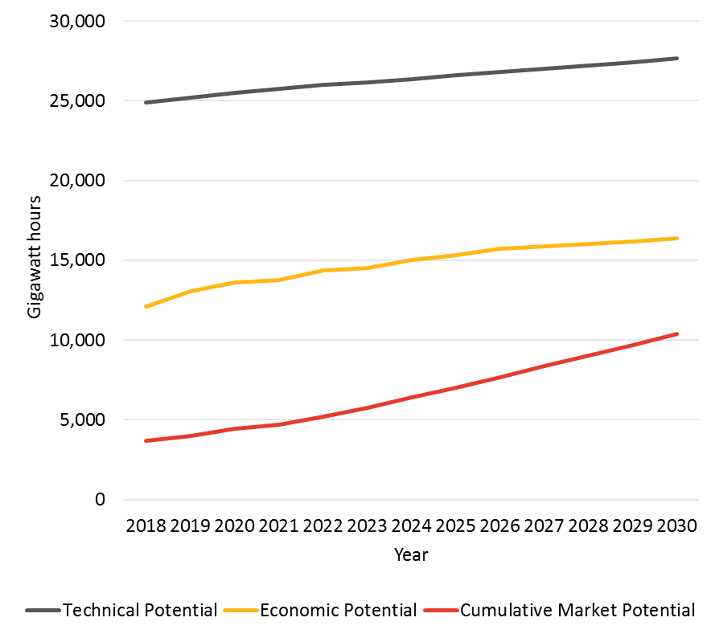

Figure ‑. Statewide Technical, Economic and Cumulative Electric Market Potential for Equipment Rebate Programs in Scenario 2 (mTRC w/ GHG Adder 1)

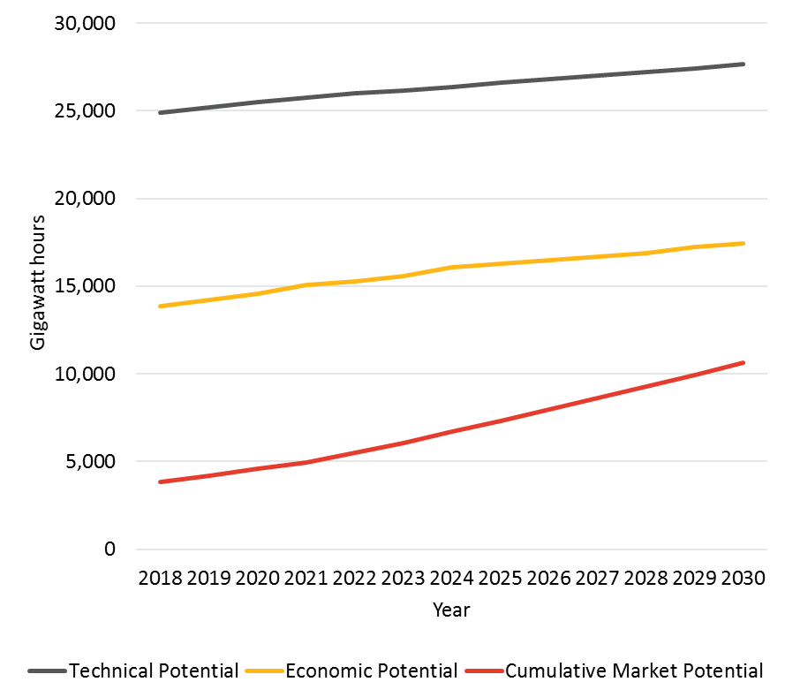

Figure ‑. Statewide Technical, Economic and Cumulative Electric Market Potential for Equipment Rebate Programs in Scenario 3 (mTRC w/ GHG Adder 2)

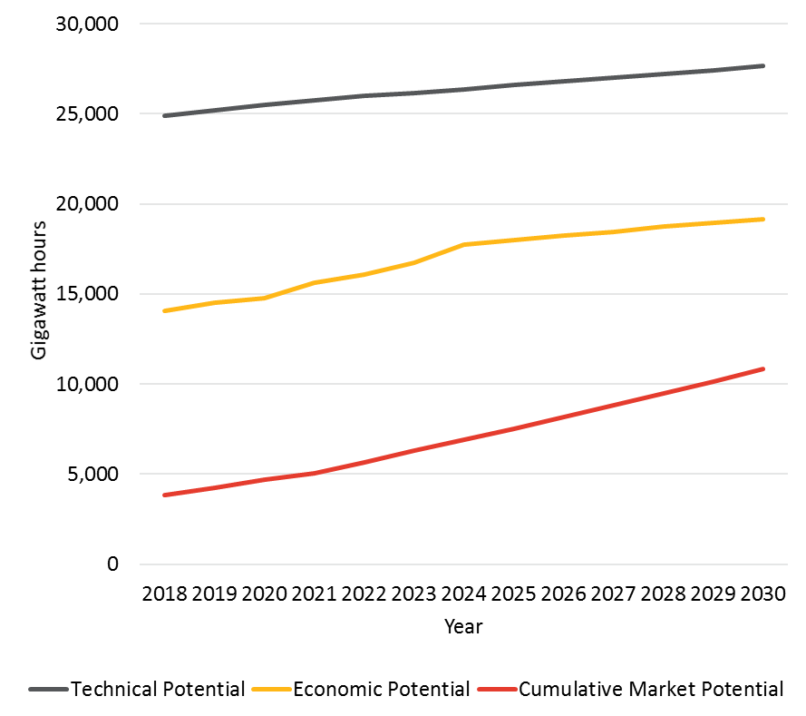

Figure ‑. Statewide Technical, Economic and Cumulative Electric Market Potential for Equipment Rebate Programs in Scenario 4 (PAC Reference)

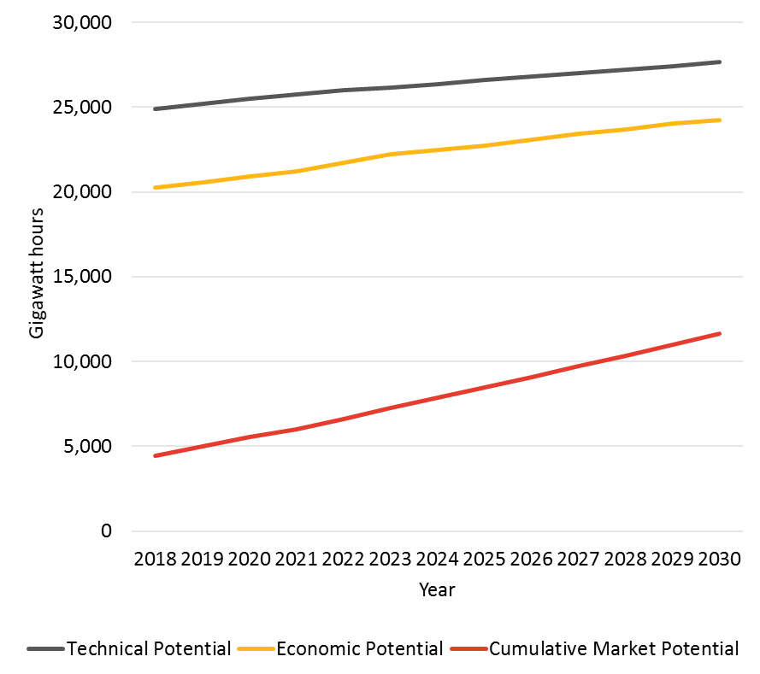

Figure ‑. Statewide Technical, Economic and Cumulative Electric Market Potential for Equipment Rebate Programs in Scenario 5 (PAC aggressive)

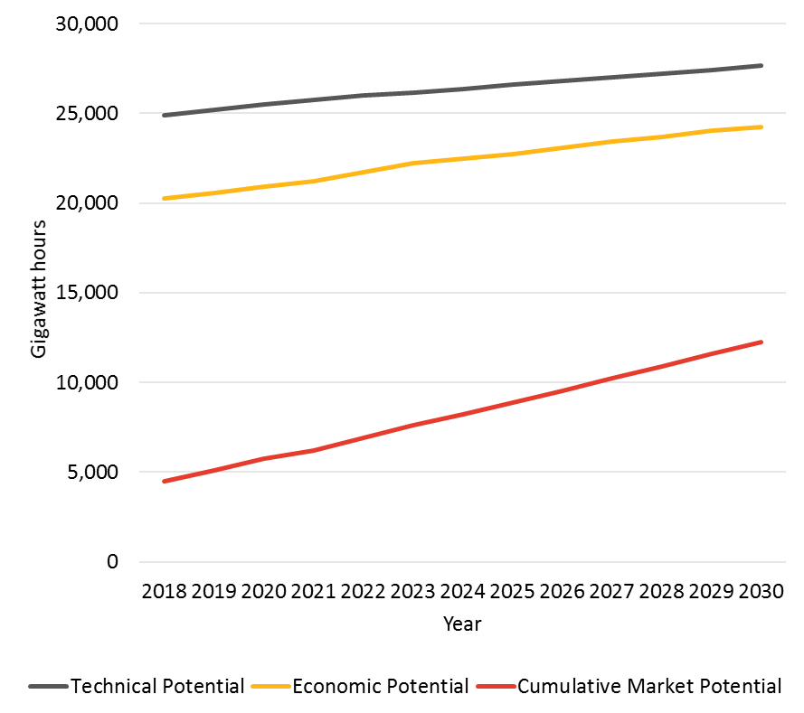

Figure ‑. Statewide Technical, Economic and Cumulative Gas Market Potential for Equipment Rebate Programs in Scenario 1 (TRC Reference)

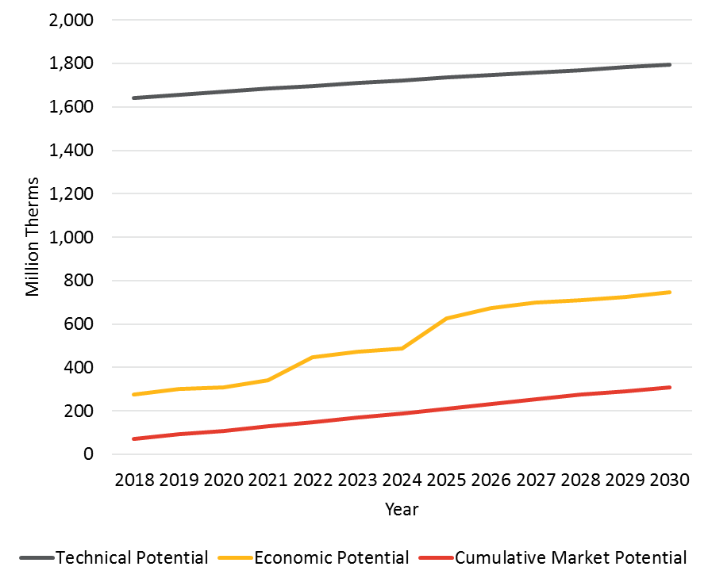

Figure ‑. Statewide Technical, Economic and Cumulative Gas Market Potential for Equipment Rebate Programs in Scenario 2 (mTRC w/ GHG Adder 1)

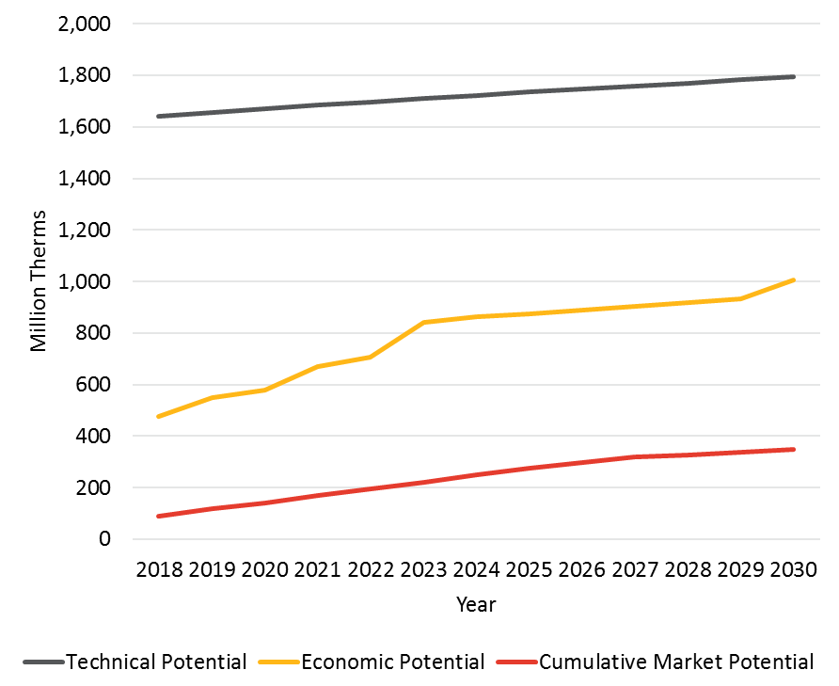

Figure ‑. Statewide Technical, Economic and Cumulative Gas Market Potential for Equipment Rebate Programs in Scenario 3 (mTRC w/ GHG Adder 2)

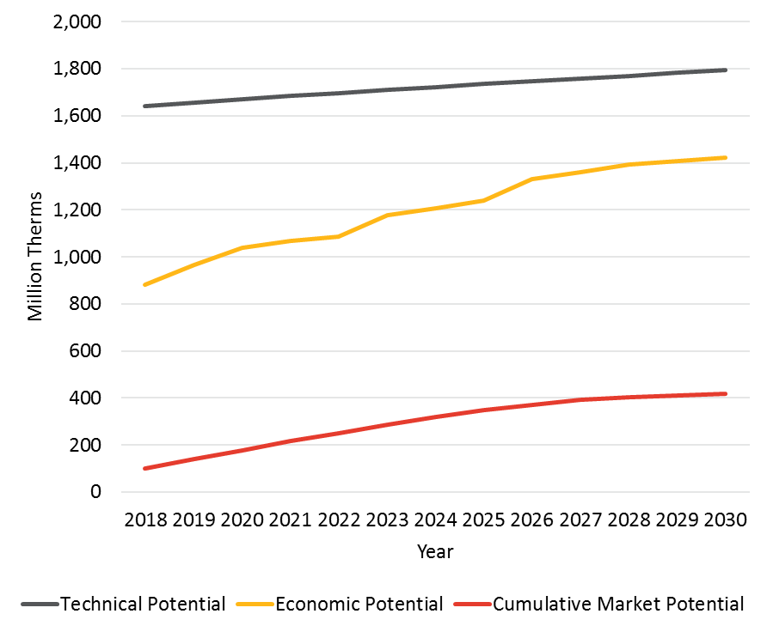

Figure ‑. Statewide Technical, Economic and Cumulative Gas Market Potential for Equipment Rebate Programs in Scenario 4 (PAC Reference)

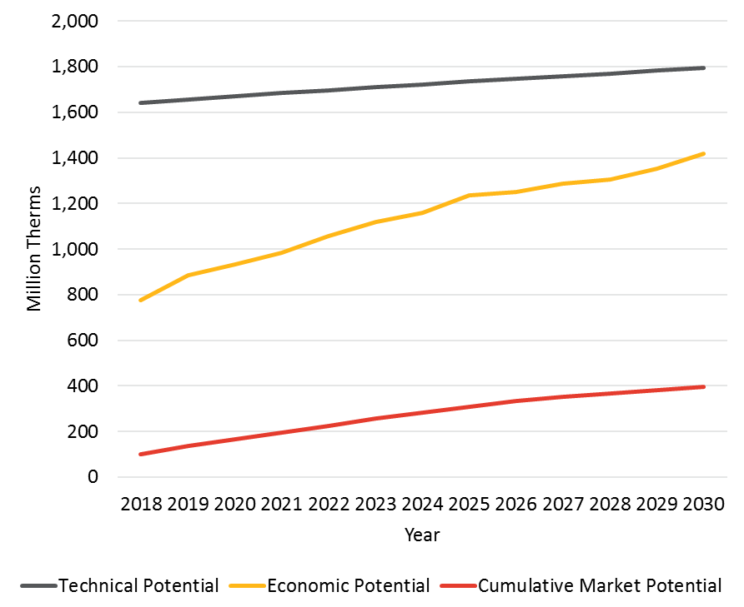

Figure ‑. Statewide Technical, Economic and Cumulative Gas Market Potential for Equipment Rebate Programs in Scenario 4 (PAC Aggressive)

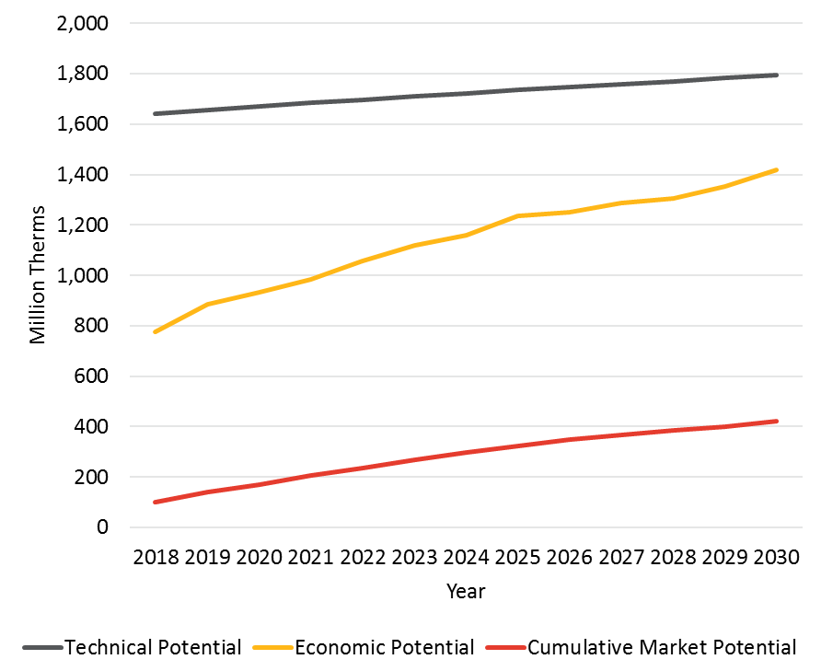

##### BROS

This appendix discusses the BROs interventions that are include in the PG model. It describes each intervention and discusses data sources and assumptions. A separate spreadsheet is also made available for stakeholders to review the final detailed inputs for intervention specific each utility and building type.

###### Residential - Home Energy Reports

**Summary**

Home Energy Reports (HERs) are among the most prevalent and widely studied of behavioral interventions. Residential customers are periodically mailed HERs that provide feedback about their home’s energy use, including normative comparisons to similar neighbors, tips for improving energy efficiency, and occasionally messaging about rewards or incentives. HERs programs are generally provided to customers on an opt-out basis, although utilities in other states have conducted opt-in programs.

Estimated electric savings range from 1.0-2.3%, while gas savings are 0.6%-1.9%. Costs are set at $0.09-$0.29 per kWh and $3.06-$4.11 per therm.

Table ‑. Home Energy Reports - Key Assumptions

|  |  |  |  |  |  |  |  |
| --- | --- | --- | --- | --- | --- | --- | --- |
| **Sector** | **Type** | **EUL years** | **Savings** | | **Cost** | | **kW/kWh Savings Ratio** |
| **kWh** | **Therm** | **kWh** | **Therm** |
| RES | Home Energy Reports (HERs) | 1 | 1.0 – 2.3% | 0.6% – 1.9% | $0.09 - $.29 | $3.06 - $4.11 | 0.00019058 |

**Assumptions and Methodology**

***Eligibility and Participation***

Although all targeted residential households may receive HERs as participants in an opt-out program, in practice, PG&E found that 0.5% of customers elect to opt out. For this reason, we reduced applicability to 99.5% for single family homes. Applicability for multi-family homes is further reduced to 89.5%, dropping another 10% in order to account for multifamily homes that do not have individual meters.[98] SCE provided data indicating that only 0.17% of their multifamily customers are master-metered, so the applicability in their territory remains higher, at 99.33%.

While participation rates in HER programs fluctuate over time due to program opt-outs, customer moves, and changes in program implementation such as adding new waves, specific forecasts require details beyond those publicly available via 2017 IOU-filed Rolling Business Plans.[99] For this reason, the team reviewed all formal California IOU evaluations of HERS programs to ascertain historic HER program participation rates and wave sizes and then applied a weighted average of IOU wave sizes to forecast the future cohort waves according to the number of households within a given service territory.[100],[101],[102],[103],[104],[105],[106],[107],[108] Additionally, SCG indicated that they would not deploy a HER program until 2018.[109] Finally, a cap was placed on the penetration of HERs based on feedback from PG&E that the bottom quartile of energy consumers will not be targeted and an equal number of customers need to be reserved as a comparison group for evaluation purposes. The behavioral model then applies these projected penetration rates to the number of forecasted IOU households, which increases over time from 2016-2030, resulting in an increase in the absolute number of actual HER participants over time.

***Savings***

The team reviewed the above-mentioned evaluations of all IOU HER programs to compile per-household adjusted savings rates for each wave of each year of each HER program, spanning from 2011-2014, depending upon each utility’s first year of operation.[110],[111] We then calculated weighted averages using each individual wave treatment participation numbers and per household savings percentages to derive singular values for kWh and therm savings that can be applied across the full treatment populations for each utility.

The model uses an EUL of one year for HER program participants. That is, while customers may participate in a utility HER program for more than one year, their average adjusted savings is assumed to be the same as for all other participants in that year. While some recent evaluations of HERs programs have found savings persistence of more than one year, reported savings percentages vary, with some sources citing higher later year savings and others showing a degradation of savings over time. For this model, an EUL of one year is assumed, as is standard with traditional persistence calculations for HER programs.

The ratio of kW to kWh savings was developed using a weighted average of adjusted kW and kWh savings as reported in DNV-GL’s 2013 and 2014 evaluation findings for PG&E and SCE. SDG&E’s kW demand data was not reported in its formal evaluations and thus we have applied the same value as used for PG&E and SCE.

***Cost***

Costs per unit of kWh and therm savings were calculated based on utility-reported HER program costs for 2013 and 2014 as found at eestats.cpuc.ca.gov. These costs were divided by the adjusted kWh and therm savings as reported in the above-mentioned 2013 and 2014 DNV-GL evaluation findings for SCE and SDG&E. PG&E provided their own cost values.[112] Therm savings for multiple years of SCG HER programs were obtained from Nexant’s Evaluation of Southern California Gas Company’s 2015‐2016 Conservation Campaign, August 31, 2016.

###### Residential - Real-Time Feedback: In Home Displays and Online Portals

**Summary**

Unlike HERs that arrive in the mail on a periodic basis, real-time feedback programs change customer behaviors by delivering advanced metering data on household consumption to utility customers via an   
in-home display (IHD) or remotely via an online portal, such as a website or a smart phone application. While some feedback programs only provide information, others provide energy saving tips, rewards, social comparisons, and/or alerts.

Although utility behavior programs utilizing IHDs and online portals both afford feedback opportunities, we have separated our modeling inputs for the two categories to better capture differences in adoption, energy savings, and costs between the two types of programs. Of note is the higher cost typically associated with offering in-home displays, due to the need for the installation of specialized hardware, whereas online portals typically provide cloud-based information directly to the customer’s smartphone, tablet, or computer.

Real-time feedback programs may also be associated with different customer rates, including time of use plans and more traditional usage based billing. Although real-time feedback is a popular behavioral intervention for demand response programs, our analysis focused on programs designed to drive energy efficiency. In all, we reviewed a total of 38 programs, including 20 providing IHDs and 18 offering online portals. Several programs offered both types of feedback. In those cases, we categorized them in the IHD category since they had associated costs for the hardware.

Table ‑. Real-Time Feedback - Key Assumptions

| **Sector** | **Type** | **EUL years** | **Savings** | | **Cost** | | **kW/kWh Savings Ratio** |
| --- | --- | --- | --- | --- | --- | --- | --- |
| **kWh** | **Therm** | **kWh** | **Therm** |
| RES | Real-Time Feedback – In Home Display | 1 | 2.3% | -- | $0.19 | -- | 0.00019058 |
| RES | Real-Time Feedback – Online Portal | 1 | 2.2% | 1.3% | $0.07 | -- | 0.00019058 |

**Assumptions and Methodology**

***Eligibility and Participation***

Both web-based and IHD real-time feedback programs are offered on an opt-in basis to customers with smart-meter equipped homes. Although most residential feedback programs are focused on providing information about electricity consumption, some natural gas savings result from these programs which are likely the result of tips and recommendations concerning thermostat settings. For modeling purposes, we assume 100% applicability for electric savings among individually metered homes and 59% applicability for gas. This latter figure is conservative given that 59% of California households use natural gas as their main source of space heating and 84.4% of CA homes use natural gas for water heating.[113]

In-home displays did not pass the cost-effectiveness screen, and so are not included in the reference case. SCE indicated they would not deploy these programs until 2019, and they would still only be pilots at that time.[114] This assumption was used for all utilities. We assume penetration rates for programs that use online portals to display customer information will be higher than those that rely on in-home displays. For online portals, our reference case assumes an 8% increase in penetration per year, while the aggressive case assumes a 15% annual increase, based on professional judgement. PG&E provided penetration rate data for IHDs.[115]

***Savings***

Savings forecasts differ for online portals and IHDs. For online portals, we estimate 1.3% savings for both kWh and therms. For IHDs, we estimate 2.3% savings for kWh and no gas savings. These estimates were developed based on numerous data points for kWh savings.[116],[117],[118],[119],[120],[121]

The model uses an EUL of one year, the same as we apply for HER program participants. Because insufficient demand savings data was available for real time feedback for non-demand response programs, for ratio of kW to kWh to savings, we applied 0.00019058, which is the figure used for HERs for all three electric utilities.

***Cost***

Hardware acquisition and installation constitute the primary cost associated with IHD programs, and they are accrued during the first year of customer participation. Sometimes these costs are paid by the utility, and other times by the customer. For modeling purposes, we assumed that the utilities will provide the hardware and that IHDs cost $100, annualized over 5 years – similar to the life of other consumer electronics.[122]

To calculate the cost, we began with a 2014 report by the Alberta Energy Efficiency Alliance for the City of Calgary that notes the cost for a real-time direct feedback program are estimated to be about $0.07 per kWh saved not including the hardware.[123] For IHDs, we add in the annualized $100 hardware acquisition and installation costs, resulting in $0.19 per kwh of savings (assuming 7,000 kwh per household).

###### Residential - Competitions: Large and Small

**Summary**

Residential competitions are a behavioral intervention approach in which participants compete in energy- related challenges, events, or contests. The goal of such challenges is generally to reduce energy consumption either directly or by raising awareness, increasing knowledge, or encouraging one or more types of action. Competitions can run for different lengths of time, ranging from a single month to multiple years. They can also include a mix of behavioral strategies, including goal-setting, commitments, games, social norms, and feedback. Our analysis does not include competitions and challenges that focus on the use of equipment upgrades as a means of generating energy savings.

It is also important to note that the way in which competitions are designed can vary depending upon the size of the targeted participant group. Small-scale competitions are typically designed to engage participants more deeply, with a higher number of touches and a broad spectrum of targeted behaviors that generate higher savings and serve as a model to get the larger population engaged. Large-scale competitions engage greater numbers of people in a more superficial way and encourage a limited number of behaviors. For this reason, we separate our modeling calculations to estimate the savings for the two types of competitions separately.

We define small competitions as having less than 10,000 participants per year and large competitions as having more than 10,000 participants per year. In total, we reviewed 18 small competitions and 5 large competitions. Data availability varied across programs.

Table ‑. Residential Competitions - Key Assumptions

| **Sector** | **Type** | **EUL years** | **Savings** | | **Cost** | | **kW/kWh Savings Ratio** |
| --- | --- | --- | --- | --- | --- | --- | --- |
| **kWh** | **Therm** | **kWh** | **Therm** |
| RES | Small Competitions (<10,000 ppl) | 1 | 8.1% | 5.2% | $0.050 | $1.344 | 0.00019058 |
| RES | Large Competitions (>10,000 ppl) | 1 | 14% | 5.2% | $0.002 | $0.101 | 0.00019058 |

**Assumptions and Methodology**

***Eligibility and Participation***

All residential customers are considered eligible to participate in competitions. The estimated participation rate of 6.5% for small competitions was determined by averaging available reported participation rates. Participation data for small-scale competitions was derived from SDG&E’s “Biggest Energy Saver” program, SMECO’s “Energy Savings Challenge”, and Minnesota Valley Electric Cooperative’s “Beat The Peak” program.[124] CoolChallenge California[125] provided a participation rate of 0.1% for large competitions. This information was supplemented with findings from program reviews conducted by the Consortium for Energy Efficiency,[126] American Council for an Energy-Efficient Economy,[127] and Illume Advising.[128]

Penetration rates for the reference case assume that small competitions are conducted by each utility with a consistent target population of 10,000 households per year each year between 2019 and 2030. Starting saturation level is determined by dividing 10,000 by the number of residential households per utility and multiplying by the 6.5% participation rate. The aggressive case also starts in 2019. It assumes that years 2019-2021 are limited to two target groups of 10,000, but then increased to 5 target groups of 10,000 each in subsequent year. These groups may be small towns, neighborhoods within larger cities, or similar.

Penetration rates for large competitions are based upon the participation rate and a targeted percentage of utility households. The reference case for large competitions assumes that each utility targets 10% of its residential customers between 2019 and 2021; then rises to 15% of customers from 2022 to 2024 before increasing to 20% in 2025 and rising to 25% of customers in 2028. The aggressive case uses the same time intervals, but it starts at 20% of customers and rises in increments of 10% rather than the 5% of the reference scenario.

***Savings***

We averaged the percentage of kWh savings reported to arrive at 8.1% for small competitions and CoolCalifornia Challenge reported 14% for large competitions.[129] Gas savings of 5.3% are used for both small and large competitions and are based on an average of an ACEEE review of three programs that report gas savings between 0.4% and 10%.[130]

Because competitions can be run for different lengths of time, lasting from a few months to multiple years, we have standardized the model on an EUL of one year. (This is the same EUL that we apply for other residential interventions.) Because insufficient demand savings data was available for residential competitions, we applied a ratio of 0.00019058 kW to kWh to savings, which is the figure used for HERs for all three electric utilities.

***Cost***

Costs associated with competitions are largely associated with program administration and game-related prizes. We used data gathered from the 2015 ACEEE’s report on energy efficiency and gamification and information from the CEE database of behavioral programs to create cost estimates for both small and large behavior-based competitions. We approached the calculations for both small and large competitions in the same way. We began by estimating total program costs and total program savings and then divided total program costs by total program savings to get average cost per kWh. We estimated total program savings by multiplying the average number of participants per competition by the cost per participant. We estimated total program savings by multiplying average household electricity consumption by the average number of participants and the average savings rate per participant.

We assume that prizes account for 50% of program costs. We estimated the cost per kWh at $0.007 for large competitions, based on the prizes and participation reported for SDG&E’s “San Diego Energy Challenge” and Puget Sound Energy’s “Rock the Bulb” program. We estimated the cost per kWh at $0.050 for small competitions based on the prizes and participation reported for SMECO’s “Energy Savings Challenge” and Minnesota Valley Electric Cooperative’s “Beat The Peak” program.[131]

###### Commercial - Strategic Energy Management

**Summary**

Strategic Energy Management (SEM) is a process for evaluating and implementing opportunities to optimize energy use in the commercial and industrial sectors. SEM is a continuous improvement approach that focuses on changing business practices to enable companies to save money by reducing energy consumption and waste. In California, pilot SEM programs are currently being administered in the industrial sectors. Customers that benefit the most from SEM, typically fall under one of the following categories:

* Campuses with multiple buildings and building types
* Customers with a large portfolio of buildings and a range of building types
* Buildings with complex energy systems

SEM allows for continuous energy performance improvement by providing the processes and systems needed to incorporate energy considerations and energy management into daily operations. While SEM applications vary depending on customer specific needs, program participants generally implement the following policies and activities:

* Measure and track energy use to help inform strategic business decisions
* Drive managerial and corporate behavioral changes around energy
* Develop the mechanisms to track and evaluate energy optimization efforts
* Implement ongoing operations and maintenance practices
* Reduce total annual energy costs between 5% and 10%
* Identify and prioritize capital improvements or process changes that lead to more savings
* Justify additional resources to energy management as a result of demonstrated success
* Overcome barriers to efficiency
* Boost employee engagement to contribute to sustainability goals
* Embed SEM principles into a company’s operations.

The model inputs for electric and natural gas shown in Table C‑4 represent savings associated with operational and behavioral changes. Savings are estimated at 3% of customer segment consumption (kWh or therms per year) and are applied consistently by building and fuel type across utilities. Costs for electricity and natural gas are $0.27 per kWh and $3.65 per therm, and are also applied consistently by building type across utilities.

Table ‑. Commercial Strategic Energy Management - Key Assumptions

| **Sector** | **Type** | **EUL years** | **Savings** | | **Cost** | | **kW/kWh Savings Ratio** |
| --- | --- | --- | --- | --- | --- | --- | --- |
| **kWh** | **Therm** | **kWh** | **Therm** |
| COM | Strategic Energy Management | 5 | 3.0% | 3.0% | $0.27 | $3.65 | 0.000126 |

**Assumptions and Methodology**

***Eligibility and Participation***

Segments of the commercial market are considered suitable for SEM type program approaches. Customers that benefit the most from SEM typically operate portfolios or campuses with multiple buildings, building types, and a variety of complex energy systems, each with its own unique set of energy management requirements. The market defined for the PG BROS Model therefore includes the following segments:

* Schools
* Colleges
* Healthcare
* Large Office Buildings

Depending on the segment, the model assumes that between 10% and 55% of buildings have already implemented SEM,[132] resulting in reduced applicability of any commercial SEM program. After accounting for the estimate of customers that have already implemented SEM outside of any program intervention, the PG BROS model applies an applicability factor of between 45% and 90%. A compound annual growth rate (CAGR) was used to forecast growth in participation over time, starting in 2020.[133] A 2% CAGR was used in the reference case, while the aggressive case used a 4% CAGR.

***Savings***

Estimated electric savings for all activities associated with SEM range from 5% to 10% of customer segment consumption for electricity and gas (kWh or therms per year). These savings estimates include a mix of operational savings and savings associated with capital investments (i.e., equipment retrofit and replacement projects). Because savings from capital investments are addressed in other components of the potential model, the SEM savings associated with BROS activities are constrained to estimates of operational savings. Based on a literature review of 16 institutional SEM plans, such as the LW Hospitals Alliance 2014 plan,[134] and market studies such as the Northwest Energy Efficiency Alliance (NEEA) Market Progress Evaluation Report,[135] operations and maintenance savings are estimated to be 3% applied consistently by building and fuel type across all utilities for the market segments considered.

The model uses an EUL of five years.[136] A ratio of kW to kWh of 0.000126 was applied to all three electric utilities based on an analysis of several third-party programs operating in California during the 2014-2015 portfolio cycle that included some components of SEM initiatives.

***Cost***

Costs for electricity and natural gas savings are estimated at $0.27 per kWh and $3.65 per therm, applied consistently by building and fuel type across utilities based on an analysis of several third-party programs operating in California during the 2014-2015 portfolio cycle that included some components of SEM initiatives, including the Commercial Energy Advisor, Monitoring-Based Persistence Commissioning, and Energy Fitness programs

###### Commercial - Building Operator Certification

**Summary**

Building Operator Certification (BOC) offers energy efficiency training and certification courses to commercial building operators in the commercial sector. BOC has been modelled as a component of behavioral savings in the 2011, 2013, and 2015 Potential Studies and research conducted for those studies indicate that operations and maintenance practices mostly fell into the following categories:[137]

* Improved air compressor operations and maintenance
* Improved HVAC operations and maintenance
* Improved lighting operations and maintenance
* Improved motors/drives operations and maintenance
* Water conservation resulting in energy savings
* Adjusted controls of HVAC systems
* Adjusted controls of energy management systems

The inputs for electric and natural gas shown in Table C‑5 represent savings associated with changes in operation and behavior, estimated on a population basis of 1,000 sq. ft. of floor space. Savings vary depending on the energy intensity of facilities in each market segment, as defined in the 2009 CEUS.[138] EUL is set to 3 years per CPUC Decision 16-08-019, and costs for electricity and natural gas savings are $0.29 per kWh and $3.65 per therm. Cost and EUL values are applied consistently by building and fuel type across all utilities.

Table ‑. Commercial Building Operator Training - Key Assumptions

|  |  |  |  |  |  |  |  |
| --- | --- | --- | --- | --- | --- | --- | --- |
| **Sector** | **Type** | **EUL years** | **Savings  (per 1,000 sq. ft.)** | | **Cost** | | **kW/kWh Savings Ratio** |
| **kWh** | **Therm** | **kWh** | **Therm** |
| COM | Building Operator Certification | 3 | 18-151 | 0.8-14.2 | $0.29 | $3.65 | 0.000114 |

**Assumptions and Methodology**

***Eligibility and Participation***

Consistent with prior studies, BOC savings apply to all commercial market segments, though the applicability factor of BOC ranges from 5% to 100%, depending on the market segment. This model assumes that BOC program interventions in the commercial market have been ongoing (though SoCalGas does not claim savings until 2018) and a CAGR was used to forecast growth in participation through the model forecast horizon. In the reference case, a 12.5% CAGR was used to forecast growth in BOC, while the aggressive case used a 18.0% CAGR. While these growth rates appear ambitious, low initial sector engagement in BOC results in forecast market penetrations of 6.52% and 12.12% for the reference and aggressive cases, respectively. While there is the potential for overlap in savings between BOC and SEM interventions, the current saturation of these measures and relatively low penetration rate forecasted indicate that the risk of double counting savings is minimal and was therefore was not considered in this model.

***Savings***

This model used the same average electric and natural gas savings as the 2015 Study model,[139] 58 kWh and 5.6 therms per 1,000 sq. ft. of participating building space. Past studies applied these values consistently by building type across all utilities. The 2018 Study approach was revised and applied a market segment-specific value that adjusted these market average savings to account for differences in building energy density. For example, a grocery store with ten times the energy density of a warehouse would experience a proportionally greater savings rate per unit of conditioned space. In this example, a grocery store in PG&E territory is expected to save 151.3 kWh per 1,000 sq. ft. and 5.2 therms per   
1,000 sq. ft., compared to an unrefrigerated warehouse, which would be expected to save 18.2 kWh per 1,000 sq. ft. and 0.8 therms per 1,000 sq. ft. after accounting for differences in energy density.

The 2018 Study uses an EUL of 3 years Per CPUC Decision 16-08-019. A ratio of kW to kWh of 0.000114 was applied to all three electric utilities. This value is based on an analysis of several third-party programs operating in California during the 2014-2015 portfolio cycle.

***Cost***

Costs for electricity and natural gas savings are estimated at $0.29 per kWh and $3.65 per therm, applied consistently by building type across utilities.

###### Commercial - Building Energy and Information Management Systems

**Summary**

The potential for building energy management and information systems (BEIMS) were first modelled by Navigant as part of the AB 802 Technical Analysis.[140] The Technical Analysis was issued in March of 2016 and not used at that time to set goals. That work has now been incorporated into this model.

As discussed in the Technical Analysis, BEIMS includes IT-based monitoring and control systems that provide information on the performance of some or all the components of a building’s infrastructure, including its envelope, heating and ventilation, lighting, plug load, water use, occupancy, and other critical resources. A BEIMS primarily consists of software, hardware (such as dedicated controllers, sensors, and sub-meters), as well as value-added services (including outsourced software management, building maintenance contracts, and others). This model focuses on the potential for BIEMS to change energy consumption associated with the operation of building HVAC systems as the result of several applications of BEIMS technology, including the following:

* Energy visualization
* Energy analytics
* Operational control and facility management
* Continuous commissioning and self-healing buildings.

The model inputs for electric and natural gas for BEIMS are shown in Table C‑6. based on customer segment consumption (kWh or therms per year). Electricity savings range from 1.1% to 4.2% and natural gas savings range from 0.2% to 7.4%. Variations are due to differences in segments’ energy densities and differences in climate across utilities. Costs for electricity and natural gas savings also varied by utility between $0.20 and $0.46 per kWh and between $0.18 and $0.46 per therm.

Table C‑6. Building Energy and Information Management Systems - Key Assumptions

| **Sector** | **Type** | **EUL years** | **Savings** | | **Cost** | | **kW/kWh Savings Ratio** |
| --- | --- | --- | --- | --- | --- | --- | --- |
| **kWh** | **Therm** | **kWh** | **Therm** |
| COM | Building Energy and Information Management Systems | 3 | 1.1% - 4.2% | 0.2% - 7.4% | $0.20 - $0.46 | $0.18 –  $0.46 | 0.000138 |

**Assumptions and Methodology**

***Eligibility and Participation***

The technologies that enable BEIMS are primarily associated with energy management systems (EMS) that are broadly applicable across all market sectors, though the existing market saturation of these technologies, which cannot be claimed by IOU programs moving forward, ranges across market segments from 1% to 80%.[141] In general, segments that operate larger facilities (e.g., large offices) or facilities that are energy intensive (e.g., grocery stores) will have a higher existing saturation of BEIMS-enabling technologies. Penetration reflects that SoCalGas does not claim savings until 2018, and a CAGR was used to forecast growth in BEIMS technology penetration over time. A 12% CAGR was used in the reference case, while the aggressive case used a 24% CAGR. The same CAGR was applied to all commercial market segments and utilities. Based on estimates of existing market saturations, these growth rates result in BEIMS forecasted penetrations of 5.6% and 20.9% for the reference and aggressive cases, respectively.

***Savings***

As discussed in the AB 802 Technical Analysis, energy savings associated with BEIMS are calculated using the following equation:

Energy Savings, BIEMS = Starting Saturation of EMS by Building Type x Total Annual Consumption x % End Use Consumption for HVAC x % End Use Savings by Building Type.

This equation resulted in a range of unit energy savings (UES) values associated with BEIMS. While there is the potential for overlap in savings between BEIMS, BOC, and SEM interventions, the current saturation of these measures and relatively low penetration rates forecasted indicate that the risk of double counting savings is minimal and was therefore was not considered in this model. Additionally, BEIMS often requires capital investment while BOC and SEM are typically not capital investments, thus providing some differentiation in the market penetration models and potential to mitigate the risk of double counting savings.

The model uses an EUL of three years per CPUC Decision 16-08-019. A ratio of kW to kWh of 0.000138 was applied to all three electric utilities based on the AB802 Technical Analysis.[142]

***Cost***

Costs for electricity and natural gas savings are estimated based on research referenced in the AB 802 Technical Analysis.[143]

###### Commercial - Business Energy Reports

**Summary**

Business Energy Reports (BERs) are the commercial sector equivalent to the HERs sent to residential customers. BERS (and other similar programs) typically share reports (via mail or electronic format) with small and medium-sized businesses at specific intervals (often monthly). The objective is to provide feedback about their energy use, including normative comparisons to similar businesses, tips for improving energy efficiency, and occasionally messaging about rewards or incentives. BERs and other similar programs typically send reports to customers on opt-out basis. BER-type programs are a relatively new addition in the emerging field of behavior change programs and are now in pilot testing at PG&E and other non-California utilities.

Navigant’s modeling estimates are primarily based on three sources: 1) PG&E’s response to the webinar on April 20, 2017, 2) a Cadmus review of a BER pilot with Xcel Energy business customers (smaller than 250 kW service) in Colorado (10,000 participants) and Minnesota (20,000 participants) that was conducted between June 2014 and June 2015, and 3) a commercial customer behavior change pilot conducted by Commonwealth Edison and Agentis Energy in Illinois beginning in 2012. In the first instance, Xcel Energy provided BERs to a sample of businesses operating in the following sectors: small office, small retail trade, small retail service, and restaurants.[144] In the Commonwealth Edison pilot the utility engaged 6,009 medium sized (100-1,000 kW) commercial customers in Illinois.[145] While the Commonwealth Edison customers represented numerous sectors, only those businesses in the “lodging” and “other” categories showed significant savings.

Table ‑. Business Energy Reports - Key Assumptions

|  |  |  |  |  |  |  |  |
| --- | --- | --- | --- | --- | --- | --- | --- |
| **Sector** | **Type** | **EUL years** | **Savings** | | **Cost** | | **kW/kWh Savings Ratio** |
| **kWh** | **Therm** | **kWh** | **Therm** |
| COM | Business Energy Reports (BERs) | 2 | 0.32% | 0 | $0.20 | $6.12 | 0.0001261 |

**Assumptions and Methodology**

***Eligibility and Participation***

BERs typically target small and/or medium sized businesses. In addition, utilities may use BERs to target businesses across all business sectors or only a select set of business sectors. As the number of BERs pilots continues to grow, a greater amount of information about the effectiveness of BERs programs in different business sectors will become available. As information concerning the effectiveness of these programs in different business sectors becomes more readily available, we assume that utilities will be more likely to limit the use of BERs to those sectors for which significant savings have been documented. Therefore, the model presented here constrains our savings estimates to those business sectors that have already achieved significant energy savings by means of business energy feedback programs such as BERs.

The model includes businesses in the following sectors: retail, restaurants, lodging, and “other.” Within each of these business sectors, the applicability of savings is further constrained by the estimated proportion of business customers in each of the relevant sectors that may be classified as either small or medium sized enterprises (given that BER type programs are typically limited to small to medium sized businesses). Based on data from the Commercial Building Energy Consumption Survey (CBECS), we estimated that roughly 63% of retail customers can be considered to be small or medium businesses given that approximately 63% of retail space is shown to be under 100,000 sq ft.[146] Given the small size of restaurants, we assume 100% applicability for this sector.

The Commonwealth Edison study specifically targeted medium sized businesses in the lodging and “other” sectors. Therefore, our savings estimates are only calculated for medium sized customers in the lodging and “other” categories based on relevant data from CBECS. For lodging, for example, we assume that 50% of lodging establishments can be considered medium-sized establishments based on CBECS data indicating that 50% of lodging establishments have an average annual energy consumption of 500,000 kWh or more per year. For businesses in the “other” category, we look at CBECS data to estimate the proportion of establishments that fall in the medium sized category (<1m kWh per year). We estimate that 25% of buildings in the “other” category are using an average of 400,000 kWh per year.

Our projected penetration rates assume a delayed start for BERs with formal utility programs launching in 2019. Our reference scenario assumes no penetration. Under the aggressive scenario, penetration begins at 2% in 2019 and ramps up at 2% per year, reaching 24% by 2030.

***Savings***

The model uses electricity savings of 0.32%, no gas savings,[147] and an EUL of two years per CPUC Decision 16-08-019. Because no demand savings data was available for BERs, we averaged the ratio of kW to kWh savings calculated for BEIMS, BOC, and Strategic Energy Management. This yielded 0.0001261, which is the figure used for all four utilities.

***Cost***

Because BER programs are new and in pilot phases, data regarding utility costs is scant. Furthermore, the limited availability of statistically significant adjusted savings percentages reported to-date indicates that BER-related savings are lower among businesses than household savings produced by HERs. For these reasons, we modeled BER costs that are double those of HERs. We project $0.20 per kWh (2 x $0.10) for electric savings for PG&E, SCE, and SDG&E.

###### Commercial - Benchmarking

**Summary**

Building benchmarking scores a business customer’s facility or plant and compares it to other peer facilities based upon energy consumption. It also often includes goal-setting and rewards in the form of recognition. Benchmarking is generally an opt-in activity, although some municipalities, such as San Francisco, have passed ordinances requiring it for buildings of certain types and sizes.

Estimated electric savings range from 1.1% to 2.2%, while gas savings are 0.7% to 1.3%. These are applied consistently across utilities, but vary by building type. Costs were estimated to be $0.0396 per kWh and $0.2352 per therm and are not utility specific.

Table ‑. Benchmarking - Key Assumptions

|  |  |  |  |  |  |  |  |
| --- | --- | --- | --- | --- | --- | --- | --- |
| **Sector** | **Type** | **EUL years** | **Savings** | | **Cost** | | **kW/kWh Savings Ratio** |
| **kWh** | **Therm** | **kWh** | **Therm** |
| COM | Building Benchmarking | 2 | 1.1%-2.2% | 0.7%-1.3% | $0.0396 | $0.2352 | 0.0001261 |

**Assumptions and Methodology**

***Eligibility and Participation***

In San Francisco, there is a benchmarking ordinance for any building over 10,000 sq. ft. According to the EIA, approximately 20% of all commercial buildings are under 10,000 sq. ft.[148] While any building and business type may be subject to benchmarking, reliable savings data exists for the following: colleges, healthcare, lodging, large offices, retail, and schools. For these sectors, we applied CBECS data to determine applicability.[149] For instance, we applied 100% applicability for both fuel types to colleges, while for retail we estimated 35% applicability since CBECS data indicates that roughly 35% of all retail buildings exceed 10,000 sq. ft. For healthcare, we used CBECS data to ascertain the proportion of electricity and natural gas consumed by large inpatient facilities. This information suggests that roughly 69% of all electricity and 83% of natural gas used in the healthcare sector is consumed by large healthcare facilities. School applicability is assumed to be 90% after a 10% reduction to account for smaller private learning centers.

Projected penetration rates for the reference scenario assume a constant 0% for all utilities to reflect uncertainty in whether the utilities will be able to claim savings from these initiatives if benchmarking is mandated by some level of government. For the aggressive scenario, PG&E begins with 7.9% penetration, but then climbs to 15.7% in 2020 and 23.6% in 2025. The aggressive scenario for the other three utilities are 7.9% in 2019 and 15.7% starting in 2024.

***Savings***

Estimated electric savings range from 1.1% to 2.2%, while gas savings range from 0.7% to 1.3% and are applied consistently by building and fuel type across utilities. Savings estimates are based on actual savings levels from city benchmarking reports.[150],[151],[152],[153],[154] We divided reported savings in half because we assume that half of the savings come from technologies and half from operation-related behaviors. Furthermore, we have applied a consistent split of 60% electric savings and 40% gas savings. This likely varies by building type, but as these data were not available we have not made this calculation based on specific building-type consumption information.

The model uses an EUL of two years per CPUC Decision 16-08-019.

Because no demand savings data was available for Benchmarking, we averaged the ratio of kW to kWh savings calculated for BEIMS, BOC, and Strategic Energy Management. This yielded 0.0001261, which is the figure used for all three electric utilities.

***Cost***

Available data suggest that benchmarking programs often include a utility in concert with a municipality. Our estimates used PG&E’s estimated 3-year program budget of $2.3 million.[155] Attributing all costs to either electricity or gas, this utility program cost was divided by estimated savings to calculate a per unit savings cost. Costs amounted to $0.0396 per kWh and $0.2352 per therm and are not utility specific.

###### Commercial - Competitions

**Summary**

Commercial competitions are a behavioral intervention approach in which participants compete in events, contests, or challenges to achieve a specific objective or the highest rank compared with other individuals or groups as they try to reach goals by reducing energy consumption. Competitions can run for varying time periods ranging from a single month to multiple years. They can include a mix of behavioral strategies, including goal-setting, commitments, games, social norms, and feedback. Those designed to produce energy savings via equipment upgrades were not included in our analysis.

Competitions may be designed differently depending upon the size and nature of the targeted participant group. Smaller scale competitions are designed to engage people in a deep way with a higher level of touches and a broad spectrum of behaviors that generate higher savings and serve as a model to get the larger population engaged. Large scale competitions engage greater numbers of people in a more superficial way and encourage a limited number of behaviors. Because we had limited data for this type of behavioral intervention all commercial competitions are considered as a single category.

In additional to overall summary data available through the ACEEE[156] and the CEE,[157] we considered 10 different challenges, including the EPA’s Energy Star Building Competition, NEEA's Kilowatt Crackdown, Chicago's Green Office Challenge, and PG&E’s Step Up and Power Down pilot.[158],[159] The completeness of data available on each program varied with some of the most robust data coming from Duke Energy’s Smart Energy Now effort in Charlotte, NC.[160]

Table ‑. Commercial Competitions - Key Assumptions

|  |  |  |  |  |  |  |  |
| --- | --- | --- | --- | --- | --- | --- | --- |
| Sector | Type | EUL years | Savings | | Cost | | kW/kWh Savings Ratio |
| **kWh** | **Therm** | **kWh** | **Therm** |
| COM | Competitions | 2 | 1.9% | -- | $ 0.04 | -- | 0.0001261 |

**Assumptions and Methodology**

***Eligibility and Participation***

Eligibility for commercial competitions is defined by the program administrator. Competitions can focus on occupants within an individual building or across a single company, but more often they embrace wider audiences at the municipal level, in which groups of tenants within large buildings or across campuses or neighborhoods compete with one another. Nonetheless, certain business sectors and business types constitute more receptive customer types than others.

For this model, we focused on savings in those building types that have been targeted by PG&E’s Step Up and Power Down campaign that is currently being carried out in San Francisco and San Jose. This effort is focused on the following five building types: large offices, small offices, retail, restaurants, and lodging.[161],[162] The applicability factor was defined in terms of potential program reach as it applies to larger and smaller types of buildings. We assume an applicability of 8% for large offices and lodging and a lower applicability factor of 4% for small to medium businesses - small offices, restaurants, and retail.[163]

At the time this model was prepared, PG&E was the only California IOU running a commercial competition, but they were not claiming savings. Because of this, our penetration forecast for PG&E shows 0% until 2019, at which point we anticipate they will begin to claim savings for one city and hold steady through 2030. SCE and SDG&E do not begin claiming savings until 2021. We do not anticipate that SCG will run commercial competitions given that we currently do not have sufficient data with which to model gas savings. For the aggressive scenario, PG&E, SCE, and SDG&E all begin to claim savings in 2019, and in 2024, they add a second city-size competition.

The penetration rates for each utility assume that they will target the largest cities within their service territories, such as San Francisco, San Jose, Anaheim, and San Diego, or that groups of smaller communities - the size of Walnut Creek, Santa Barbara, or Oceanside - may be pooled together within a service territory to reach a similar number of businesses.

***Savings***

Savings estimates are based on PG&E’s study of Step Up and Power Down(1.9% kWh). No gas savings are modeled.

The model uses an EUL of two years to maintain consistency with CPUC Decision 16-08-019.

Because no demand savings data was available, we averaged the ratio of kW to kWh savings calculated for BEIMS, BOC, and SEM. This yielded 0.0001261, which is the figure used for all three electric utilities.

***Cost***

Costs of $0.04 per kWh are drawn from Smart Energy Now. [164]

###### Commercial - Retrocommissioning

**Summary**

The potential for Retrocommissioning (RCx) was modelled as a component of behavioral savings in the 2013 and 2015 Studies and this update refines several of the underlying assumptions and inputs used. RCx is defined as commissioning performed on buildings that have not been previously commissioned. This model also includes the allowed recommissioning of buildings that have undergone commissioning after 5 years have passed. The model focuses on RCx activities that impact HVAC system operations and includes, for example, measures such as the following:[165]

* Correct actuator/damper operations
* Correct economizer operations
* Adjust condenser water reset
* Adjust supply air temperature reset
* Adjust zone temperature deadbands
* Adjust equipment scheduling
* Adjust duct static pressure reset
* Adjust hot or cold deck reset
* Optimize Variable Frequency Drives on fans or pumps
* Recode Controls HVAC airflow rebalance/adjust
* Reduce simultaneous heating and cooling
* Adjust boiler lockout schedule

The model inputs for electric and natural gas for RCx, shown in Table C‑10. , are based on customer segment consumption (kWh or therms per year). Electricity and natural gas savings range from 2.3% to 12.7%, and are applied consistently level for all utilities. Costs for electricity and natural gas savings are also constant across utilities at $0.39 per kWh and $0.29 per therm.

Table C‑10. Commercial Retrocommissioning - Key Assumptions

|  |  |  |  |  |  |  |  |
| --- | --- | --- | --- | --- | --- | --- | --- |
| **Sector** | **Type** | **EUL years** | **Savings** | | **Cost** | | **kW/kWh Savings Ratio** |
| **kWh** | **Therm** | **kWh** | **Therm** |
| COM | RCx | 5 | 2.3% - 5.17% | 2.3% - 5.17% | $0.21 | $0.39 | 0.000138 |

**Assumptions and Methodology**

***Eligibility and Participation***

Consistent with previous Studies, RCx savings are applied to select commercial market segments, and the applicability factor ranges from 18% to 91%. This model also adjusted the eligibility and participation estimates for RCx to exclude BEIMS market potential, and to exclude buildings built after 2011 when commissioning became a requirement under CalGreen. It is estimated that approximately 92% of commercial building stock was constructed before 2011. The exclusion of market savings from BEIMS is intended to reduce the risk of double counting savings because the EMS technologies inherent in the BEIMS measure allow for continuous commissioning that would exclude commissioning activities defined in the RCx measure. The model assumes that RCx program interventions in the commercial market have been ongoing since the 2015 Study (though SoCalGas does not claim savings until 2018), and a CAGR was used to forecast growth in participation through the model forecast horizon. In the reference case, a 3% CAGR was used to forecast growth in RCx, while the aggressive case used a 5% CAGR. Recommissioning is anticipated in 25% of RCx participants after 5 years, and reparticipation is additionally discounted by 25% to avoid double counting of savings influenced by other programs, such as BOC and SEM. Low initial penetration of RCx results in forecasted penetrations of 2.3% and 2.8% for the reference and aggressive cases, respectively, over the forecast horizon.

***Savings***

Energy savings associated with RCx are calculated using the following equation:

Energy Savings, RCx = Penetration of RCx by Building Type x Total Annual Consumption x   
% End Use Consumption for HVAC x % End Use Savings by Building Type

The percent of end use consumption for HVAC systems impacted by RCx is based on CEUS, while the end use savings by building type is based on literature reviewed for the 2015 Study.[166],[167],[168] Savings for offices, colleges, and schools were capped at 5% to reflect feedback from SCE on their experience.[169] The model uses an EUL of 3 years per CPUC Decision 16-08-019. A ratio of kW to kWh of 0.000138 was applied to all three electric utilities based on an analysis of several statewide and third-party programs operating in California during the 2014-2015 portfolio cycle that included RCx related initiatives.

***Cost***

Costs for electricity and natural gas savings are estimated based on an analysis of the same programs reviewed and referenced in the 2015 Study.

###### Industrial/Agriculture - Strategic Energy Management

**Summary**

Strategic Energy Management (SEM) in the Industrial and Agricultural sectors is a ‘holistic’ approach to managing energy use that continuously improves energy performance based on various initiatives. SEM, per CPUC and California IOU design, is a continuous improvement approach that focuses on changing business practices to enable companies to save money by reducing energy consumption and waste. The Industrial sector SEM pilot program currently being administered by California IOUs served as the basis for this forecast. As defined in the California Industrial SEM Design Guide,[170] leading SEM programs are designed to support industrial companies by focusing on several high-level objectives:

* Implementing energy efficiency projects and saving energy, primarily from savings in operations and maintenance (O&M).
* Establishing the Energy Management System (EnMS) or business practices that help a facility to manage and continuously improve energy performance.
* Normalizing, quantifying, and reporting facility-wide energy performance.
* Getting peers to talk to one another.

The model inputs for electric and natural gas shown in Table C‑11 represent savings associated with SEM operational and behavioral changes. Savings are estimated based on building type consumption (kWh or therms per year) for each market segment and are applied consistently across utilities. Costs for electricity and natural gas are $0.20/kWh and $1.35/therm, and those are also applied consistently by building and fuel type across utilities.

Table ‑. Industrial/Agriculture SEM - Key Assumptions

| **Sector** | **Type** | **EUL years** | **Savings** | | **Cost** | | **kW/kWh Savings Ratio** |
| --- | --- | --- | --- | --- | --- | --- | --- |
| **kWh** | **Therm** | **kWh** | **Therm** |
| AIMS (Ind/Ag) | Strategic Energy Management (SEM) | 5 | 0.4% - 4.1% | 0.4% - 4.1% | $0.20 | $1.35 | 0.000195 |

**Assumptions and Methodology**

***Eligibility and Participation***

Eligibility and participation estimates in the 2018 PG model are defined based on guidance provided by the CPUC regarding the IOUs and as part of the 2017 SEM Pilot Program development effort. The following provides a summary of eligibility and participation considerations from that guidance.[171]

* The SEM model will only be applied to participants enrolled in the official program; programs that offer similar models will not be considered a true SEM program.
* The California SEM program is the only SEM-type program for industrial customers in California. Currently, the SEM program as designed will only live in the Industrial sector with the small exception for facilities that are not defined as Industrial but utilize similar industrial processes (i.e. food processing). The IOU business plans state that SEM will be incorporated into the Commercial and Agriculture sectors in the near future. NAICS codes will be used to determine if facilities are eligible for the Industrial sector.
* Not all customers in the Industrial sector will be eligible for SEM. Savings and incentives for projects participating in the SEM program will be calculated based on this SEM design. Customers that are not enrolled in the SEM program, or customers that have projects that don't qualify as SEM, will not be incentivized through SEM, nor will they qualify for milestone incentives. As SEM grows, it is the IOU goal that more customers will participate in the program and transition into this new way of capturing savings.
* Unless explicitly excluded by the program, savings for energy performance improvement actions that are not incented by other programs will be captured under the SEM O&M savings category. Currently, O&M savings in the Industrial sector may only be claimed through the SEM program. SEM incentives are based on the final amount of facility savings achieved minus 'Non-SEM Savings.' For projects that do not qualify for custom project incentives, O&M savings will be incentivized.
* Savings, capital projects, and O&M will only be counted as SEM if they follow the program as designed by the IOUs and implemented by the awarded bidder. Custom capital projects and the associated savings will only be counted as SEM if they follow the program as designed by the IOUs and implemented by the awarded bidder. Facilities that participate in SEM-type programs will not be eligible for the same incentives.

The team also reviewed draft IOU business plans for insights into eligibility, participation, and savings metrics.

Select forecast considerations from the PG&E 2018–2025 business plan include:[172]

* In the short term (1-3 years), PG&E will conduct and analyze market research to ensure that its existing programs remain relevant and cost effective as PG&E explores new tools and services. PG&E will begin the first stage of testing an SEM framework in the market with the launch of the SEM program.
* In the midterm (4-7 years), PG&E will continue to expand the use of the SEM framework across key industrial segments. PG&E also plans to engage with partners and experts to establish a benchmarking service and outreach tool based on lessons learned with existing models in the market.
* In the long term (8-10 years), PG&E will incorporate SEM into all channels and services for industrial customers of all sizes. PG&E will offer a variety of SEM levels to meet customer needs, ranging from online management and periodic audits for smaller firms (“low-touch” SEM) to integrated expertise and data-management systems for large customers (“high-touch” SEM).

Considerations from the SCE 2018–2025 business plan include:[173]

* The Industrial Strategic Energy Management (SEM) Pilot Project uses tailored EE services that are most appropriate for large customers who are interested in EE and capable of implementing it. As a pilot effort, SCE will limit the initial implementation to no more than ten projects. This pilot may be implemented concurrently with other Industrial pilot proposals.

Considerations from the SCG 2018–2025 business plan include challenges faced by smaller customers in implementing SEM:[174]

* The SEM pilot, as designed, is not an appropriate solution for smaller customers who have historically produced low adoption of energy efficiency solutions because:
  + Many smaller customers are not aware of the energy efficiency benefits. Nor are they aware of programs that promote energy efficiency, especially programs designed to help smaller industrial customers achieve higher levels of energy efficiency.

Per the design of the CPUC SEM pilot and the market considerations expressed in the IOU business plans, savings in the industrial sector are initially forecasted to begin in 2019 for high use market segments, including the petroleum, food, electronics, and chemicals segments, while more widespread implementation for all other industrial segments begins in 2021. Although in theory SEM applies to all customer sizes, in practice applicability of SEM is constrained to large customers. A review of IOU business plans for the 2018-2025 timeframe indicates that most industrial and agricultural energy use comes from large customers in a few market segments. Consequently, the applicability factor for SEM was set between 79% and 91% to reflect this concentration. The starting saturation for all segments is estimated at 0.20% with a compound annual growth rate (CAGR) of 0.25% for the reference case and 0.50% for the aggressive case. By 2030 this yields an industrial sector market saturation of 12% and 23% for the reference and aggressive cases, respectively. The model assumes SEM will apply to the agricultural market sector beginning in 2025 and it uses the same starting saturation and CAGRs.

***Savings***

The savings forecast in the 2018 PG study is an estimate of O&M savings achieved through SEM. A literature review indicates that a UES for O&M savings of 2.7 percent of annual sector level consumption is appropriate for the industrial and agricultural market based on the CPUC SEM pilot program design. In addition, the CEC provided trends on electric energy usage (kWh) per dollar of economic output ($) from 1990 through 2015 and the PG team indexed this data to 1990 to identify trends in energy density of economic output over time. This analysis shows that the energy intensity of some industries, such as semiconductor manufacturing has decreased over time to 68 percent of 1990 levels, indicating that there may be less potential for SEM type interventions. Other industries such as chemical manufacturing and food and beverage processing have increased over time to approximately 150 percent of 1990 levels. The PG study considers this index to be indicative that some market segments would benefit more from SEM activity than others in reducing the energy intensity of production. Therefore, the team multiplied the 2.7 percent average SEM UES by the energy intensity index developed from the CEC data to arrive at segment level SEM UES multipliers, as shown in Table C‑12.

Table ‑. Industrial Sector Strategic Energy Management Unit Energy Savings Multiplier

| Industrial Segment | Energy Intensity Index to 1990 | SEM UES Multiplier |
| --- | --- | --- |
| **Chemical manufacturing** | 150.7% | 4.1% |
| **Food and beverage** | 148.2% | 4.0% |
| **Miscellaneous** | 142.1% | 3.8% |
| **Nonmetallic minerals** | 141.6% | 3.8% |
| **Publishing and broadcasting** | 113.0% | 3.1% |
| **Plastics and rubber** | 90.0% | 2.4% |
| **Glass manufacturing** | 78.3% | 2.1% |
| **Fabricated metal manufacturing** | 76.4% | 2.1% |
| **Paper manufacturing** | 75.9% | 2.0% |
| **Computer and electronics** | 72.3% | 2.0% |
| **Machinery manufacturing** | 71.4% | 1.9% |
| **Semiconductor and related** | 68.5% | 1.9% |
| **Food processing** | 66.9% | 1.8% |
| **Printing and support** | 42.9% | 1.2% |
| **Textile product mills** | 42.9% | 1.2% |
| **Cement** | 36.8% | 1.0% |
| **Transportation equipment** | 35.9% | 1.0% |
| **Primary metal manufacturing** | 33.0% | 0.9% |
| **Furniture and related** | 32.7% | 0.9% |
| **Apparel and leather** | 27.6% | 0.7% |
| **Electrical equipment, appliances** | 22.8% | 0.6% |
| **Petroleum and coal products** | 21.7% | 0.6% |
| **Logging, wood products** | 16.3% | 0.4% |
| **Pulp and paper** | 16.3% | 0.4% |
| **Average** | | **1.8%** |

*Source: Navigant analysis*

For the agricultural sector, the team defined SEM UES multipliers using industrial segment proxies. The team used averages of select industrial segment multipliers (i.e., food related segments) or the average for the entire Industrial sector to develop the Agricultural sector SEM UES multipliers shown in Table C‑13.

Table ‑. Agricultural Sector Strategic Energy Management Unit Energy Savings Multiplier

| Agricultural Segment | Industrial Sector Proxy | SEM UES Multiplier |
| --- | --- | --- |
| Irrigated Agriculture | Average | 1.8% |
| Post-Harvest Processing | Food related | 2.9% |
| Dairies | Food related | 2.9% |
| Refrigerated Warehouses | Average | 1.9% |
| Wineries and Vineyards | Food related | 2.9% |
| Concentrated Animal Feeding Operation | Average | 1.8% |
| Greenhouses | Average | 1.8% |

*Source: Navigant analysis*

The 2018 PG study uses the SEM UES multiplier to forecast segment level potential net savings using the following equation:

SEM segment level EE net savings potential =   
SEM UES Multiplier x Annual Segment Consumption[175]

The model holds the industrial and agricultural segment UES multiplier constant throughout the 2018 PG model forecast horizon.

***Cost***

Costs for electricity and natural gas savings are estimated at $0.20/kWh and $1.35/therm, and are applied consistently by building and fuel type across utilities. Costs are based on an analysis of third party Industrial sector programs operating in California during the 2014-2015 portfolio. These costs are lower than those for emerging technology and generic custom type measures, reflecting that SEM savings are O&M based and do not include rebate measures for large capital investments.

###### Other Data Sources and References

Where possible, estimates and forecasts were calculated based on formal evaluated performance of California IOUs between 2011 and 2014, and footnoted in each individual methodology description. The model inputs and other resulting calculations were compared with professional judgement of relevant findings regarding participation rates, gross and adjusted savings, persistence, cost, and interactive effects as reported in a variety of sources as specified in the footnotes. Additional sources are listed below.

* Brown, R. “Bringing It All Together: Design and Evaluation Innovations in the Alameda County Residential Behavior Pilot.” In BECC 2014 Conference Proceedings. beccconference.org/wp-content/uploads/2014/12/presentation_Brown.pd
* Stern, S., and D. Bates. “Achieving Residential Energy Savings: Combining Behavior Change and Home Upgrades.” In Proceedings of the 2014 ACEEE Summer Study on Energy Efficiency in Buildings 7: 317–27. Washington DC: ACEEE. aceee.org/files/proceedings/2014/data/papers/7-925.pdf - page=1
* Malatest. Greater Sudbury Hydro 2014 Electric Space Heating and Occupancy Load Feedback Program Evaluation. 2014. Prepared for Ecotagious Inc. Victoria, BC.

##### AIMS Sectors

This appendix provides additional detail and data for the industrial and agriculture sectors. Industrial and Agricultural building types are classified by grouping buildings in NAICS codes. The table below references the building types used in this study with their associated NAICS codes.

|  |  |  |
| --- | --- | --- |
| Sector | Subsector (Building Type) | NAICS |
| Industrial | Chemicals | 325 |
| Electronics | 334x, 335 |
| Fabricated Metals | 332 |
| Food | 311x, 312 |
| Industrial Machinery | 333 |
| Lumber & Furniture | 337, 321, 1133 |
| Paper | 322x |
| Petroleum | 324 |
| Plastics | 326 |
| Primary Metals | 331 |
| Printing & Publishing | 323, 511, 516 |
| Stone-Glass-Clay | 327x |
| Textiles | 313, 314, 315, 316 |
| Transportation Equipment | 336 |
| All Other Industrial | 339 |
| Agriculture | Concentrated Animal Feeding Operation | 112 |
| Dairies | 112120 |
| Greenhouses | 1114 |
| Irrigated Agriculture | 1111, 1119, 1112, 1113 |
| Post-Harvest Processing | 115114, 115111 |
| Refrigerated Warehouses | 493120 |
| Wineries and Vineyards | 111332 |

###### Industrial

The following table displays the industrial measure list used in the diffusion model.

| Measure Name | End-Use Category | Description |
| --- | --- | --- |
| HVAC Chiller Upgrade | HVAC | Chiller upgrades including advanced controls, higher efficiency equipment, and overall system efficiency improvements |
| HVAC Equipment Upgrade (Electric and Gas) | HVAC | Upgrades to electric and gas HVAC equipment (using better than code energy-efficiency rating [EER] or coefficient of performance [COP]), and heat recovery |
| HVAC System Controls | HVAC | Includes temperature setback, advanced controls, variable air volume (VAV), sensors, system optimization, and other custom process controls on HVAC systems |
| HVAC VFD Upgrade | HVAC | VFD controls on HVAC fans and equipment to take advantage of weather sensitive partial load conditions |
| Lighting Controls | Lighting | Occupancy sensors, photocells, timers, and other controls for lighting fixtures and systems |
| Lighting Upgrades- LED | Lighting | Upgrades to efficient LED lighting systems (normally replacing T12 and high-intensity discharge [HID] systems), often on a site-by-site custom basis |
| Lighting Upgrades- Other | Lighting | Upgrades to efficient high-output (HO) T5 or efficient T8 fluorescent lighting systems (normally replacing T12 and high-intensity discharge [HID] systems), often on a site-by-site custom basis |
| Air Compressor Control and Optimization | Machine Drive | Air compressor adjustments such as pressure reduction, staging, system controls, and leak identification and repair |
| Air Compressor VFD | Machine Drive | VFD controls on air compressors to allow for loading/unloading of the compressed air system, and to replace any inefficient throttling devices |
| Fan VFD | Machine Drive | Variable frequency drive (VFD) controls on fans (not including HVAC fans) to take advantage of partial load conditions |
| Pump VFD | Machine Drive | VFD controls on pumps to take advantage of partial load conditions |
| Pump Sizing and Optimization | Machine Drive | Proper sizing and operation of pumps to increase pump efficiency |
| Premium Motors | Machine Drive | Installation of higher efficient or premium motors across all industry processes |
| Injection Molding | Machine Drive | Upgrading to all electric (versus hydraulic) injection molding machines, including barrel insulation |
| Wastewater Aerators | Machine Drive | Replacing existing inefficient aerators on wastewater systems with higher efficiency aerator technologies |
| Boiler Controls and Optimization | Process Heating | Pressure reduction, leak reduction, steam trap maintenance, and advanced controls on boilers |
| High Efficiency Furnace/Oven | Process Heating | Upgrades and add-ons to gas furnaces and ovens, including infrared (IR), furnace configuration, and advanced controls |
| Industrial Heat Recovery | Process Heating | Capturing “waste heat,” produced primarily from gas boilers, and using it in other phases of the industrial process |
| Industrial Insulation | Process Heating | Insulation or improved insulation on boiler equipment, storage tanks, and other process piping |
| Refrigeration System Optimization | Process Refrigeration | Advanced controls on refrigeration systems including floating head controls, evaporator fan controls, and condenser controls |
| Process Optimization Controls | Other | Optimizing process activities, such as proper shut down and start up procedures, to reduce energy usage not specific equipment upgrades |

*Source: Navigant 2016*

###### Agriculture

The following table describes the list of agricultural measures used in the diffusion model.

| Measure Name | End-Use Category | Description |
| --- | --- | --- |
| HVAC Ventilation (Fan Ventilation Improvement) | HVAC | Upgrade to more efficient fans, temperature and humidity controls, VFDs (includes post-harvest process fan aeration improvements) |
| Ag Pump Retrofit - Irrigation | Irrigation Drive | Irrigation specific pump improvement, maintenance, and replacement designed to increase pump efficiency |
| Ag Pump VFD - Irrigation | Irrigation Drive | VFD for irrigation specific pumps (well, irrigation, booster, etc.) |
| Low Pressure Irrigation | Irrigation Drive | Conversion from high to low pressure irrigation (sprinkler to drip, low pressure nozzles, etc.) |
| Exterior Lighting Upgrades | Lighting | Includes typical C&I exterior LED lighting measures as well as exterior security lights |
| Horticulture Interior LED Grow Lighting | Lighting | Indoor LED lamps and fixtures used for growing a variety of plants. |
| Interior Lighting Upgrades - LED | Lighting | Includes typical C&I LED lighting measures and applications as well as agriculture-rated LEDs for animal health and animal-specific purposes |
| Interior Lighting Upgrades - Other | Lighting | Includes typical C&I non-LED lighting measures and applications |
| Lighting Controls | Lighting | Occupancy sensors, photocells/timers, etc. |
| Ag Pump Retrofit - Other | Machine Drive | Pump retrofits geared to all other pumps besides irrigation specific pumps |
| Ag Pump VFD - Dairy | Machine Drive | VFD for dairy specific pumps (vacuum, transfer, etc.) |
| Ag Pump VFD - Other | Machine Drive | VFD for all other agriculture pumps besides those designed for irrigation or dairy purposes |
| Greenhouse Process Improvement (Heating Optimization) | Process Heating | Heating optimization and equipment improvements for greenhouses (unit to bench heating conversion, boiler improvement measures, dynamic temperature controls, etc.) |
| Greenhouse Process Improvement (Shell Improvements) | Process Heating | Heating optimization improvements for greenhouses centered around shell improvements (thermal and shade curtains, insulation upgrades, IRAC film, etc.) |
| Post-Harvesting Process Improvement | Process Heating | Gas improvements to post-harvesting such as more efficient heated grain drying, heat recovery, process controls |
| Process Refrigeration Retrofit - Dairy | Process Refrigeration | Refrigeration improvements to process milk cooling on dairies (plate coolers, scroll compressors) |
| Process Refrigeration Retrofit - Other | Process Refrigeration | Refrigeration improvements to process cooling on all other agriculture facilities (i.e. wine cooling) |
| Refrigeration Retrofit (Refrigeration System Optimization) | Process Refrigeration | Includes typical C&I refrigeration improvements to cold storage areas (floating head pressure controls, evaporator fan controls, evaporator fan ECMs, etc.) |
| Compressed Air Optimization | Other | Includes typical C&I compressed air technologies and measures (leak repair, controls, VFD, O&M, etc.) |

*Source: Navigant 2016*

##### Codes & Standards

Table ‑. C&S Modeled

| Regulation | Code or Standard Name | Compliance Rate[176] | Effective Date | Policy View |
| --- | --- | --- | --- | --- |
| 2005 T-20 | Commercial Refrigeration Equipment, Solid Door | 70% | 1/1/2006 | On the books |
| 2005 T-20 | Commercial Refrigeration Equipment, Transparent Door | 70% | 1/1/2007 | On the books |
| 2005 T-20 | Commercial Ice Maker Equipment | 70% | 1/1/2008 | On the books |
| 2005 T-20 | Walk-In Refrigerators / Freezers | 91% | 1/1/2006 | On the books |
| 2005 T-20 | Refrigerated Beverage Vending Machines | 37% | 1/1/2006 | On the books |
| 2005 T-20 | Large Packaged Commercial Air-Conditioners, Tier 1 | 70% | 10/1/2006 | On the books |
| 2005 T-20 | Large Packaged Commercial Air-Conditioners, Tier 2 | 70% | 1/1/2010 | On the books |
| 2005 T-20 | Residential Pool Pumps, High Eff Motor, Tier 1 | 100% | 1/1/2006 | On the books |
| 2005 T-20 | Portable Electric Spas | 70% | 1/1/2006 | On the books |
| 2005 T-20 | General Service Incandescent Lamps, Tier 1 | 69% | 1/1/2006 | On the books |
| 2005 T-20 | Pulse Start Metal Halide HID Luminaires, Tier 1(Vertical Lamps) | 100% | 1/1/2006 | On the books |
| 2005 T-20 | Pulse Start Metal Halide HID Luminaires, Tier 2(All other MH | 100% | 1/1/2008 | On the books |
| 2005 T-20 | Modular Furniture Task Lighting Fixtures | 70% | 1/1/2008 | On the books |
| 2005 T-20 | Hot Food Holding Cabinets | 70% | 1/1/2006 | On the books |
| 2005 T-20 | External Power Supplies, Tier 1 | 100% | 1/1/2007 | On the books |
| 2005 T-20 | External Power Supplies, Tier 2 | 99% | 7/1/2008 | On the books |
| 2005 T-20 | Consumer Electronics - Audio Players | 100% | 1/1/2007 | On the books |
| 2005 T-20 | Consumer Electronics - TVs | 96% | 1/1/2006 | On the books |
| 2005 T-20 | Consumer Electronics - DVDs | 31% | 1/1/2006 | On the books |
| 2005 T-20 | Water Dispensers | 70% | 1/1/2006 | On the books |
| 2005 T-20 | Unit Heaters and Duct Furnaces | 100% | 1/1/2006 | On the books |
| 2005 T-20 | Commercial Dishwasher Pre-Rinse Spray Valves | 100% | 1/1/2006 | On the books |
| 2006 T-20 | Residential Pool Pumps, 2-speed Motors, Tier 2 | 86% | 1/1/2008 | On the books |
| 2006 T-20 | General Service Incandescent Lamps, Tier 2 #1 | 87% | 1/1/2008 | On the books |
| 2006 T-20 | General Service Incandescent Lamps, Tier 2 #2 | 87% | 1/1/2008 | On the books |
| 2006 T-20 | General Service Incandescent Lamps, Tier 2 #3 | 89% | 1/1/2008 | On the books |
| 2006 T-20 | BR, ER and R20 Incandescent Reflector Lamps: Residential | 82% | 1/8/2008 | On the books |
| 2006 T-20 | BR, ER and R20 Incandescent Reflector Lamps: Commercial | 82% | 1/8/2008 | On the books |
| 2008 T-20 | Metal Halide Fixtures | 95% | 1/1/2010 | On the books |
| 2008 T-20 | Portable Lighting Fixtures | 93% | 1/1/2010 | On the books |
| 2008 T-20 | General Purpose Lighting -- 100 watt | 88% | 1/1/2011 | On the books |
| 2008 T-20 | General Purpose Lighting -- 75 watt | 40% | 1/1/2012 | On the books |
| 2008 T-20 | General Purpose Lighting -- 60 and 40 watt | 85% | 1/1/2013 | On the books |
| 2009 T-20 | Televisions - Tier 1 | 98% | 1/1/2011 | On the books |
| 2009 T-20 | Televisions - Tier 2 | 99% | 1/1/2013 | On the books |
| 2011 T-20 | Small Battery Chargers – Tier 1 (consumer with no USB charger or USB charger <20 watt-hours) | 90% | 2/1/2013 | On the books |
| 2011 T-20 | Small Battery Chargers – Tier 2 (consumer with USB charger ≥20 watt-hours) | 88% | 1/1/2014 | On the books |
| 2011 T-20 | Small Battery Chargers – Tier 3 (non-consumer) | 85% | 1/1/2017 | On the books |
| 2011 T-20 | Large Battery Chargers (≥2kW rated input) | 78% | 1/1/2014 | On the books |
| 2015 T-20 | Residential Faucets & Aerators - Lavatory w/ Natural Gas Water Heating - Tier 1 (2.2 –1.5 gpm) | 85% | 9/1/2015 | On the books |
| 2015 T-20 | Residential Faucets & Aerators - Lavatory w/ Electric Water Heating - Tier 1 (2.2 –1.5 gpm) | 85% | 9/1/2015 | On the books |
| 2016 T-20 | Air Filter Labeling | 85% | 7/1/2016 | On the books |
| 2016 T-20 | Dimming Ballasts | 85% | 7/1/2016 | On the books |
| 2016 T-20 | Residential Faucets & Aerators - Kitchen w/ Natural Gas Water Heating (1.8 gpm) | 85% | 1/1/2016 | On the books |
| 2016 T-20 | Residential Faucets & Aerators - Kitchen w/ Electric Water Heating (1.8 gpm) | 85% | 1/1/2016 | On the books |
| 2016 T-20 | Public Lavatory Faucets (.5 gpm) | 85% | 1/1/2016 | On the books |
| 2016 T-20 | Residential Faucets & Aerators - Lavatory w/ Natural Gas Water Heating - Tier 2 (1.5 –1.2 gpm) | 85% | 7/1/2016 | On the books |
| 2016 T-20 | Residential Faucets & Aerators - Lavatory w/ Electric Water Heating - Tier 2 (1.5 –1.2 gpm) | 85% | 7/1/2016 | On the books |
| 2016 T-20 | Showerheads w/ Natural Gas Water Heaters - Tier 1 (2..5 to 2.0 gpm) | 85% | 7/1/2016 | On the books |
| 2016 T-20 | Showerheads w/ Electric Water Heaters - Tier 1 (2..5 to 2.0 gpm) | 85% | 7/1/2016 | On the books |
| 2016 T-20 | Toilets - Commercial (1.28 gpf) | 85% | 1/1/2016 | On the books |
| 2016 T-20 | Toilets - Residential (1.28 gpf) | 85% | 1/1/2016 | On the books |
| 2016 T-20 | Urinals (.125 gpf) | 85% | 1/1/2016 | On the books |
| Future Title 20 | Commercial Clothes Dryers | 85% | 1/1/2019 | Expected |
| Future Title 20 | Computers - Workstations | 85% | 1/1/2018 | Expected |
| Future Title 20 | Computers - Small Scale Servers | 85% | 1/1/2018 | Expected |
| Future Title 20 | Computers - Notebooks | 85% | 1/1/2019 | Expected |
| Future Title 20 | Computers - Desktops - Tier 1 | 85% | 1/1/2019 | Expected |
| Future Title 20 | Computers - Desktops - Tier 2 | 85% | 7/1/2021 | Expected |
| Future Title 20 | Displays - Monitors | 85% | 7/1/2019 | Expected |
| Future Title 20 | Game Consoles (Tier 1) | 85% | 1/1/2021 | Expected |
| Future Title 20 | Game Consoles (Tier 2) | 85% | 1/1/2024 | Expected |
| Future Title 20 | Pool Pumps & Spas | 85% | 1/1/2018 | Expected |
| Future Title 20 | Set Top Boxes (Tier 1) | 85% | 1/1/2019 | Expected |
| Future Title 20 | Small Diameter Directional Lamps (Tier 1) | 85% | 1/1/2018 | Expected |
| Future Title 20 | Small Network Equipment | 85% | 1/1/2023 | Expected |
| Future Title 20 | Water Meters | 85% | 1/1/2019 | Expected |
| Future Title 20 | State-Regulated General Service Lamps – Tier II | 80% | 1/1/2018 | On the books |
| Federal | Electric Motors 1-200HP | 91% | 12/1/2010 | On the books |
| Federal | Refrigerated Beverage Vending Machines | 37% | 8/31/2011 | On the books |
| Federal | Commercial Refrigeration | 70% | 1/1/2012 | On the books |
| Federal | Residential Electric & Gas Ranges | 100% | 4/9/2012 | On the books |
| Federal | General Service Fluorescent Lamps #1 | 95% | 7/14/2012 | On the books |
| Federal | Incandescent Reflector Lamps | 65% | 7/14/2012 | On the books |
| Federal | Commercial Clothes Washers #1 | 94% | 1/8/2013 | On the books |
| Federal | Residential Pool Heaters | 95% | 4/16/2013 | On the books |
| Federal | Residential Direct Heating Equipment | 95% | 4/16/2013 | On the books |
| Federal | Residential Refrigerators & Freezers | 95% | 9/15/2014 | On the books |
| Federal | Residential Room AC | 91% | 6/1/2014 | On the books |
| Federal | Fluorescent Ballasts | 80% | 11/14/2014 | On the books |
| Federal | Small Commercial Package Air-Conditioners ≥65 and <135 kBtu/h | 100% | 6/1/2013 | On the books |
| Federal | Large and Very Large Commercial Package Air-Conditioners ≥135 kBtu/h | 100% | 6/1/2014 | On the books |
| Federal | Computer Room Acs >=65,000 Btu/h and < 760,000 Btu/h | 100% | 10/29/2013 | On the books |
| Federal | Residential Dishwashers | 99% | 5/30/2013 | On the books |
| Federal | Residential Clothes Dryers | 99% | 1/15/2015 | On the books |
| Federal | Residential Gas-fired water heater | 98% | 4/16/2015 | On the books |
| Federal | Residential Electric storage water heater | 88% | 4/16/2015 | On the books |
| Federal | Residential Gas-fired instantaneous water heater | 87% | 4/16/2015 | On the books |
| Federal | Residential Oil-fired storage water heater | 85% | 4/16/2015 | On the books |
| Federal | Small Electric Motors | 35% | 3/9/2015 | On the books |
| Federal | Residential Clothes Washers (Front Loading) | 100% | 3/7/2015 | On the books |
| Federal | Residential Clothes Washers (Top Loading) Tier I | 100% | 3/7/2015 | On the books |
| Federal | Residential Clothes Washers (Top Loading) Tier II | 95% | 1/1/2018 | On the books |
| Federal | Residential Central AC, Heat Pumps and Furnaces | 99% | 1/1/2015 | On the books |
| Federal | External Power Supplies | 85% | 2/10/2016 | On the books |
| Federal | Battery Chargers | 85% | 6/13/2018 | On the books |
| Federal | Walk-in Coolers and Freezers (Door) | 85% | 6/5/2017 | On the books |
| Federal | Walk-in Coolers and Freezers (Systems) | 85% | 6/5/2017 | On the books |
| Federal | Distribution Transformers | 85% | 1/1/2016 | On the books |
| Federal | Commercial Refrigeration Equipment | 85% | 3/27/2017 | On the books |
| Federal | Metal Halide Lamp Fixtures | 85% | 2/10/2017 | On the books |
| Federal | General Service Fluorescent Lamps #2 | 85% | 1/26/2018 | On the books |
| Federal | ASHRAE Products (Commercial boilers) | 95% | 3/2/2012 | On the books |
| Federal | Air-Cooled Commercial Package ACs and HPs - Tier 1 | 85% | 1/1/2018 | On the books |
| Federal | Commercial Clothes Washers #2 | 85% | 1/1/2018 | On the books |
| Federal | Automatic Commercial Ice Makers | 85% | 1/28/2018 | On the books |
| Federal | Ceiling Fan Light Kits | 85% | 1/7/2019 | On the books |
| Federal | Beverage Vending Machines | 85% | 1/8/2019 | On the books |
| Federal | Pre-Rinse Spray Valves | 85% | 1/28/2019 | On the books |
| Federal | Furnace Fans | 85% | 7/3/2019 | On the books |
| Federal | Dehumidifiers | 85% | 6/13/2019 | On the books |
| Federal | Single-Package Vertical ACs and HPs | 85% | 9/23/2019 | On the books |
| Federal | Commercial and Industrial Pumps | 85% | 1/27/2020 | On the books |
| Federal | Residential Boilers | 85% | 1/15/2021 | On the books |
| Federal | Commercial Furnaces | 85% | 1/1/2023 | On the books |
| Federal | Air-Cooled Commercial Package ACs and HPs - Tier 2 (incremental to Tier 1) | 85% | 1/1/2023 | On the books |
| Federal | Electric Motors | 85% | 6/1/2016 | On the books |
| Federal | Microwaves | 85% | 6/17/2016 | On the books |
| 2005 T-24 | Time dependent valuation, Residential | 0% | 1/1/2006 | On the books |
| 2005 T-24 | Time dependent valuation, Nonresidential | 0% | 1/1/2006 | On the books |
| 2005 T-24 | Res. Hardwired lighting | 113% | 1/1/2006 | On the books |
| 2005 T-24 | Duct improvement | 59% | 1/1/2006 | On the books |
| 2005 T-24 | Window replacement | 80% | 1/1/2006 | On the books |
| 2005 T-24 | Lighting controls under skylights | 8% | 1/1/2006 | On the books |
| 2005 T-24 | Ducts in existing commercial buildings | 75% | 1/1/2006 | On the books |
| 2005 T-24 | Cool roofs | 75% | 1/1/2006 | On the books |
| 2005 T-24 | Relocatable classrooms | 100% | 1/1/2006 | On the books |
| 2005 T-24 | Bi-level lighting control credits | 79% | 1/1/2006 | On the books |
| 2005 T-24 | Duct testing/sealing in new commercial buildings | 82% | 1/1/2006 | On the books |
| 2005 T-24 | Cooling tower applications | 88% | 1/1/2006 | On the books |
| 2005 T-24 | Multifamily Water Heating | 78% | 1/1/2006 | On the books |
| 2005 T-24 | Composite for Remainder - Res | 120% | 1/1/2006 | On the books |
| 2005 T-24 | Composite for Remainder - Non-Res | 85% | 1/1/2006 | On the books |
| 2005 T-24 | Whole Building - Res New Construction (Electric) | 120% | 1/1/2006 | On the books |
| 2005 T-24 | Whole Building - Non-Res New Construction (Electric) | 0% | 1/1/2006 | On the books |
| 2005 T-24 | Whole Building - Res New Construction (Gas) | 235% | 1/1/2006 | On the books |
| 2005 T-24 | Whole Building - Non-Res New Construction (Gas) | 0% | 1/1/2006 | On the books |
| 2008 T-24 | Envelope insulation | 123% | 10/1/2010 | On the books |
| 2008 T-24 | Overall Envelope Tradeoff | 397% | 10/1/2010 | On the books |
| 2008 T-24 | Skylighting | 397% | 10/1/2010 | On the books |
| 2008 T-24 | Sidelighting | 397% | 10/1/2010 | On the books |
| 2008 T-24 | Tailored Indoor lighting | 573% | 10/1/2010 | On the books |
| 2008 T-24 | TDV Lighting Controls | 0% | 10/1/2010 | On the books |
| 2008 T-24 | DR Indoor Lighting | 397% | 10/1/2010 | On the books |
| 2008 T-24 | Outdoor Lighting | 83% | 10/1/2010 | On the books |
| 2008 T-24 | Outdoor Signs | 83% | 10/1/2010 | On the books |
| 2008 T-24 | Refrigerated warehouses | 83% | 10/1/2010 | On the books |
| 2008 T-24 | DDC to Zone | 397% | 10/1/2010 | On the books |
| 2008 T-24 | Residential Swimming pool | 83% | 7/1/2010 | On the books |
| 2008 T-24 | Site Built Fenestration | 83% | 10/1/2010 | On the books |
| 2008 T-24 | Residential Fenestration | 83% | 7/1/2010 | On the books |
| 2008 T-24 | Cool Roof Expansion | 153% | 10/1/2010 | On the books |
| 2008 T-24 | MF Water heating control | 0% | 9/1/2010 | On the books |
| 2008 T-24 | CfR IL Complete Building Method | 571% | 9/1/2010 | On the books |
| 2008 T-24 | CfR IL Area Category Method | 569% | 9/1/2010 | On the books |
| 2008 T-24 | CfR IL Egress Control | 397% | 9/1/2010 | On the books |
| 2008 T-24 | CfR HVAC Efficiency | 397% | 9/1/2010 | On the books |
| 2008 T-24 | CfR Res Cool Roofs | 83% | 9/1/2010 | On the books |
| 2008 T-24 | CfR Res Central Fan WL | 83% | 9/1/2010 | On the books |
| 2013 T-24 | NRA-Lighting-Alterations-New Measures | 91% | 7/1/2014 | On the books |
| 2013 T-24 | NRA-Lighting-Alterations-Existing Measures | 91% | 7/1/2014 | On the books |
| 2013 T-24 | NRA-Lighting-Egress Lighting Control | 91% | 7/1/2014 | On the books |
| 2013 T-24 | NRA-Lighting-MF Building Corridors | 91% | 7/1/2014 | On the books |
| 2013 T-24 | NRA-Lighting-Hotel Corridors | 91% | 7/1/2014 | On the books |
| 2013 T-24 | NRA-Lighting-Warehouses and Libraries | 91% | 7/1/2014 | On the books |
| 2013 T-24 | NRA-Envelope-Cool Roofs | 83% | 7/1/2014 | On the books |
| 2013 T-24 | NRA-HVAC-Equipment Efficiency | 83% | 7/1/2014 | On the books |
| 2013 T-24 | NRA-Process-Air Compressors | 83% | 7/1/2014 | On the books |
| 2013 T-24 | NRNC-Lighting-Egress Lighting Control | 83% | 4/1/2015 | On the books |
| 2013 T-24 | NRNC-Lighting-MF Building Corridors | 83% | 4/1/2015 | On the books |
| 2013 T-24 | NRNC-Lighting-Hotel Corridors | 83% | 4/1/2015 | On the books |
| 2013 T-24 | NRNC-Lighting-Warehouses and Libraries | 83% | 4/1/2015 | On the books |
| 2013 T-24 | NRNC-Lighting-Parking Garage | 83% | 4/1/2015 | On the books |
| 2013 T-24 | NRNC-Lighting-Controllable Lighting | 83% | 4/1/2015 | On the books |
| 2013 T-24 | NRNC-Lighting-DR Lighting Controls | 83% | 4/1/2015 | On the books |
| 2013 T-24 | NRNC-Lighting-Outdoor Lighting & Controls | 83% | 4/1/2015 | On the books |
| 2013 T-24 | NRNC-Lighting-Office Plug Load Control | 83% | 4/1/2015 | On the books |
| 2013 T-24 | NRNC-HVAC-Garage Exhaust | 83% | 4/1/2015 | On the books |
| 2013 T-24 | NRNC-HVAC-Laboratory Exhaust | 83% | 4/1/2015 | On the books |
| 2013 T-24 | NRNC-HVAC-Small ECM Motor | 83% | 4/1/2015 | On the books |
| 2013 T-24 | NRNC-HVAC-Water & Space Heating ACM | 83% | 4/1/2015 | On the books |
| 2013 T-24 | NRNC-HVAC-Cooling Towers Water | 83% | 4/1/2015 | On the books |
| 2013 T-24 | NRNC-HVAC-Occupant Controlled Smart Thermostats | 83% | 4/1/2015 | On the books |
| 2013 T-24 | NRNC-HVAC-Low-Temp Radiant Cooling | 83% | 4/1/2015 | On the books |
| 2013 T-24 | NRNC-HVAC-Evap Cooling Credit | 83% | 4/1/2015 | On the books |
| 2013 T-24 | NRNC-HVAC-Outside Air | 83% | 4/1/2015 | On the books |
| 2013 T-24 | NRNC-HVAC-Acceptance Requirements | 83% | 4/1/2015 | On the books |
| 2013 T-24 | NRNC-Refrigeration-Warehouse | 83% | 4/1/2015 | On the books |
| 2013 T-24 | NRNC-Refrigeration-Supermarket | 83% | 4/1/2015 | On the books |
| 2013 T-24 | NRNC-Process-Process Boilers | 83% | 4/1/2015 | On the books |
| 2013 T-24 | NRNC-Process-Air Compressors | 83% | 4/1/2015 | On the books |
| 2013 T-24 | NRNC-Process-Data Centers | 83% | 4/1/2015 | On the books |
| 2013 T-24 | NRNC-DHW - Hotel DHW Control and Solar | 83% | 4/1/2015 | On the books |
| 2013 T-24 | NRNC-DHW-Solar Water Heating | 83% | 4/1/2015 | On the books |
| 2013 T-24 | NRNC-Solar-Solar Ready | 83% | 4/1/2015 | On the books |
| 2013 T-24 | NRNC-Whole Building | 93% | 4/1/2015 | On the books |
| 2013 T-24 | RNC-Lighting | 0% | 1/1/2015 | On the books |
| 2013 T-24 | RNC-DHW - MF DHW Control and Solar | 83% | 4/1/2015 | On the books |
| 2013 T-24 | RNC-DHW - High Efficiency Water Heater Ready | 83% | 1/1/2015 | On the books |
| 2013 T-24 | RNC-DHW - Solar for Electrically Heated Homes | 83% | 1/1/2015 | On the books |
| 2013 T-24 | RNC-Solar - Solar Ready & Oriented Homes | 83% | 1/1/2015 | On the books |
| 2013 T-24 | RNC-SF Whole Building | 67% | 1/1/2015 | On the books |
| 2013 T-24 | RNC-MF Whole Building | 83% | 4/1/2015 | On the books |
| 2013 T-24 | RA-SF Whole Building | 67% | 7/1/2014 | On the books |
| 2013 T-24 | RA-MF Whole Building | 83% | 7/1/2014 | On the books |
| 2016 T-24 | NRA-Lighting-Alterations | 83% | 2/1/2017 | On the books |
| 2016 T-24 | NRA-Lighting-Outdoor Lighting Controls | 83% | 2/1/2017 | On the books |
| 2016 T-24 | NRA-Lighting-ASHRAE Measure-Elevator Lighting & Ventilation | 83% | 2/1/2017 | On the books |
| 2016 T-24 | NRA-Envelope-Opaque Wall (Roof Alterations) | 83% | 2/1/2017 | On the books |
| 2016 T-24 | NRA-HVAC-ASHRAE Measure-DDC | 83% | 2/1/2017 | On the books |
| 2016 T-24 | NRA-HVAC-ASHRAE Equipment Efficiency | 83% | 2/1/2017 | On the books |
| 2016 T-24 | NRA-Process-ASHRAE Measure-Escalator Speed Control | 83% | 2/1/2017 | On the books |
| 2016 T-24 | NRNC-Whole Building | 83% | 10/1/2017 | On the books |
| 2016 T-24 | RNC-Single Family Whole Building | 83% | 7/1/2017 | On the books |
| 2016 T-24 | RNC-Multifamily Whole Building | 83% | 7/1/2017 | On the books |
| 2016 T-24 | RA-Single Family Whole Building | 83% | 7/1/2017 | On the books |
| 2016 T-24 | RA-Multifamily Whole Building | 83% | 7/1/2017 | On the books |
| 2019 T-24 | NRNC-Whole Building | 83% | 10/1/2020 | Expected |
| 2019 T-24 | RNC-Single Family Whole Building | 83% | 7/1/2020 | Expected |
| 2019 T-24 | RNC-Multifamily Whole Building | 83% | 7/1/2020 | Expected |
| 2019 T-24 | RA-Single Family Whole Building | 83% | 7/1/2020 | Expected |
| 2019 T-24 | RA-Multifamily Whole Building | 83% | 7/1/2020 | Expected |

Table E-2 specifies all standards that are assumed to be superseded by other standards.

Table ‑. C&S Superseded Codes and Standards

|  |  |  |
| --- | --- | --- |
| Superseded Code or Standard | Superseding Code or Standard | Source |
| 2005 T-20: Commercial Ice Maker Equipment | Fed Appliance: Automatic Commercial Ice Makers | Navigant Assumption |
| 2005 T-20: Commercial Dishwasher Pre-Rinse Spray Valves | Fed Appliance: Pre-Rinse Spray Valves | Navigant Assumption |
| 2005 T-20: Consumer Electronics - TVs | 2009 T-20: Televisions - Tier 1 | ISSM |
| 2005 T-20: Commercial Refrigeration Equipment, Solid Door | Fed Appliance: Commercial Refrigeration | ISSM |
| 2005 T-20: Commercial Refrigeration Equipment, Transparent Door | Fed Appliance: Commercial Refrigeration | ISSM |
| 2005 T-20: Commercial Ice Maker Equipment | Fed Appliance: Commercial Refrigeration | ISSM |
| 2005 T-20: Refrigerated Beverage Vending Machines | Fed Appliance: Refrigerated Beverage Vending Machines | ISSM |
| 2006 T-20: BR, ER and R20 Incandescent Reflector Lamps: Residential | Fed Appliance: Incandescent Reflector Lamps | ISSM |
| 2006 T-20: BR, ER and R20 Incandescent Reflector Lamps: Commercial | Fed Appliance: Incandescent Reflector Lamps | ISSM |
| 2006 T-20: General Service Incandescent Lamps, Tier 2 #1 | 2008 T-20: General Purpose Lighting -- 100 watt | ISSM |
| 2006 T-20: General Service Incandescent Lamps, Tier 2 #2 | 2008 T-20: General Purpose Lighting -- 75 watt | ISSM |
| 2006 T-20: General Service Incandescent Lamps, Tier 2 #3 | 2008 T-20: General Purpose Lighting -- 60 and 40 watt | ISSM |
| 2006 T-20: General Service Incandescent Lamps, Tier 2 #1 | EISA | ISSM |
| 2006 T-20: General Service Incandescent Lamps, Tier 2 #2 | EISA | ISSM |
| 2006 T-20: General Service Incandescent Lamps, Tier 2 #3 | EISA | ISSM |
| 2008 T-20: General Purpose Lighting -- 100 watt | EISA | ISSM |
| 2008 T-20: General Purpose Lighting -- 75 watt | EISA | ISSM |
| 2008 T-20: General Purpose Lighting -- 60 and 40 watt | EISA | ISSM |
| 2008 T-20: General Purpose Lighting -- 100 watt | Future T-20: State-Regulated General Service Lamps – Tier II | Navigant Assumption |
| 2008 T-20: General Purpose Lighting -- 75 watt | Future T-20: State-Regulated General Service Lamps – Tier II | Navigant Assumption |
| 2008 T-20: General Purpose Lighting -- 60 and 40 watt | Future T-20: State-Regulated General Service Lamps – Tier II | Navigant Assumption |
| 2011 T-20: Small Battery Chargers – Tier 1 (consumer with no USB charger or USB charger <20 watt-hours) | Fed Appliance: Battery Chargers | Navigant Assumption |
| 2011 T-20: Small Battery Chargers – Tier 2 (consumer with USB charger ≥20 watt-hours) | Fed Appliance: Battery Chargers | Navigant Assumption |
| 2011 T-20: Small Battery Chargers – Tier 3 (non-consumer) | Fed Appliance: Battery Chargers | Navigant Assumption |
| 2011 T-20: Large Battery Chargers (≥2kW rated input) | Fed Appliance: Battery Chargers | Navigant Assumption |
| 2015 T-20: Residential Faucets & Aerators - Lavatory w/ Natural Gas Water Heating - Tier 1 (2.2 –1.5 gpm) | 2016 T-20: Residential Faucets & Aerators - Lavatory w/ Natural Gas Water Heating - Tier 2 (1.5 –1.2 gpm) | Navigant Assumption |
| 2015 T-20: Residential Faucets & Aerators - Lavatory w/ Electric Water Heating - Tier 1 (2.2 –1.5 gpm) | 2016 T-20: Residential Faucets & Aerators - Lavatory w/ Electric Water Heating - Tier 2 (1.5 –1.2 gpm) | Navigant Assumption |
| Fed Appliance: Electric Motors 1-200HP | Fed Appliance: Electric Motors | Navigant Assumption |
| Fed Appliance: Refrigerated Beverage Vending Machines | Fed Appliance: Beverage Vending Machines | Navigant Assumption |
| Fed Appliance: Commercial Refrigeration | Fed Appliance: Commercial Refrigeration Equipment | Navigant Assumption |
| Fed Appliance: General Service Fluorescent Lamps #1 | Fed Appliance: General Service Fluorescent Lamps #2 | Navigant Assumption |
| Fed Appliance: Commercial Clothes Washers #1 | Fed Appliance: Commercial Clothes Washers #2 | Navigant Assumption |
| Fed Appliance: Small Commercial Package Air-Conditioners ≥65 and <135 kBtu/h | Fed Appliance: Air-Cooled Commercial Package ACs and HPs - Tier 1 | Navigant Assumption |
| Fed Appliance: Large and Very Large Commercial Package Air-Conditioners ≥135 kBtu/h | Fed Appliance: Air-Cooled Commercial Package ACs and HPs - Tier 1 | Navigant Assumption |
| Fed Appliance: Residential Clothes Washers (Top Loading) Tier I | Fed Appliance: Residential Clothes Washers (Top Loading) Tier II | Navigant Assumption |

##### Ind/Ag Generic Custom & Emerging Technologies

###### Ind/Ag Generic Custom Measure Forecast Methodology

**Summary**

Generic custom (GC) measures in the Industrial sector are projects that tend to be specific to an industry segment or production method. Table F-1 provides the inputs for the GC measures in the 2018 study and the proceeding discussion details the assumptions and methodology used to derive these inputs.

Table ‑. Industrial/Agriculture GC - Key Assumptions

|  |  |  |  |  |  |  |  |
| --- | --- | --- | --- | --- | --- | --- | --- |
| **Sector** | **Type** | **EUL years** | **Savings** | | **Cost** | | **kW/kWh Savings Ratio** |
| **kWh** | **Therm** | **kWh** | **Therm** |
| Ind | Generic Custom (GC) | 15 | 0.16% | 0.17% | $0.33 | $2.25 | 0.000195 |
| Ag | 0.28% | 1.19% |

**Applicability and Penetration**

Applicability of GC measures in the Industrial and Agricultural sectors is 100% because these measures are considered ubiquitous to all activities in all market segments. Because the forecasting approach assumes GC measures will produce a static level of savings each year, penetration rates are meant to ultimately reflect current savings levels and do not vary over the forecast period. Penetration rates were held constant over the forecast horizon because facilities continually upgrade equipment and processes and it is likely that GC measures will be installed at the same rate as past program activity.

**Savings**

The team conducted a literature review to define an approach to estimate savings from GC measures:

* 2004-2005 Statewide Nonresidential Standard Performance Contract Program Measurement and Evaluation Study[177]
* 2006-2008 Evaluation Report for PG&E Fabrication, Process, and Manufacturing Contract Group[178]
* 2006-2008 Evaluation Report for the Southern California Industrial and Agricultural Contract Group[179]
* 2010-12 WO033 Custom Impact Evaluation Final Report[180]
* 2010-12 WO033 Custom Net-to-Gross Final Report[181]
* Final Report 2013 Custom Impact Evaluation, Industrial, Agricultural, and Large Commercial Submitted to California Public Utilities Commission[182]
* Final Report 2014 Custom Impact Evaluation Industrial, Agricultural, and Large Commercial, California Public Utilities Commission[183]
* 2013 Ex-post Efficiency Savings and Performance Incentive (ESPI) Performance Statement Report[184]
* 2014 Ex-Post Efficiency Savings and Performance Incentive (ESPI) Final Performance Statement Report[185]
* E-4807 Draft Resolution[186]
* CPUC EEStats and CEDARS data for net program savings for the 2013-2015 program cycle.

An analysis of data available through the EEStats portal for programs operating from 2006 through 2015 was then completed to assess the contribution of GC measures to the total savings in the Industrial and Agricultural sectors. Over this period, GC measures contributed 42% of Industrial and 62% of Agricultural sector net electricity savings, with similar percentage contributions for natural gas. Because data for the 2006 through 2012 portfolio was not of sufficient quality to accurately define GC measures, and because 2015 data had not been fully vetted thorough EM&V processes, the savings values in the 2018 study are based on an analysis of GC measure savings in the 2013 and 2014 program years. The study also benefited from ESPI reports for program years 2013 and 2014, which provided additional insights into gross and net savings for custom measures. Based on this analysis it was determined that generic custom measures save an average of 48.3 GWh annually in the Industrial sector, and 45.9 GWh annually in the Agricultural sector. Average annual natural gas savings are estimated to be 5.8 MMTherms in the Industrial sector, and 1.5 MMTherms annually in the Agricultural sector, as presented in Table F-2

A GC unit energy savings (UES) multiplier was then developed by dividing annual average energy savings by average sector consumption forecasted for 2017 through 2030 for electricity and natural gas. This analysis defined GC UES multipliers of 0.16% of annual Industrial sector electricity usage, 0.17% of annual Industrial sector natural gas usage, 0.28% of annual Agricultural sector electricity usage, and 1.19% of annual Agricultural sector natural gas usage. Summaries are presented in Table F-2

Table ‑. Generic Custom Unit Energy Savings Multiplier

| Sector / Fuel | 2013 Program Year | 2014 Program Year | Average Annual Energy Savings | GC UES Multiplier |
| --- | --- | --- | --- | --- |
| **Industrial Generic Custom (Net)** | | | | |
| GWh | 47.1 | 49.5 | 48.3 | 0.16% |
| MMTherm | 5.0 | 6.7 | 5.8 | 0.17% |
| **Agricultural Generic Custom (Net)** | | | | |
| GWh | 44.4 | 47.4 | 45.9 | 0.28% |
| MMTherm | 0.41 | 2.50 | 1.46 | 1.20% |

*Source: Navigant analysis of EEStats and identified literature*

The GC UES multiplier was held constant throughout the forecast horizon and was applied to the consumption forecast for each market segment level throughout the forecast horizon using the following equation:

Equation .Generic Custom Segment Net Savings Potential

*GC segment level EE net savings potential = GC UES Multiplier x Annual Segment Consumption[187]*

**Other Input Assumptions**

Because generic custom measures tend to be larger capital investments that operate for long periods of time an EUL of 15 years was used in the forecasts.

A ratio of kW to kWh of 0.000195 was applied.

Finally, costs for electricity and natural gas savings are based on an analysis of industrial and agricultural programs operating throughout 2016. They are estimated at $0.33/kWh and $2.25/therm, and they are applied consistently across sectors and utilities.

###### Ind/Ag Emerging Technology Measures

**Summary**

In the context of the 2018 PG Study, emerging technologies (ETs) are new technologies that have demonstrated energy benefits to the Industrial and Agricultural sectors, but are not yet widely adopted in the market. The team evaluated ETs at varying stages along the path to market readiness – some were just demonstrated in a laboratory or research setting, and others had been proven effective through pilot tests and are in early commercial adoption. The following provides a description of the methodology used to evaluate the emerging technology market.

The Assumptions and Methodology section discusses the process used to develop the model inputs for energy savings that are also summarized in Table F-3. Segment-specific electric and gas savings are consistently applied across all utilities. Costs, EUL, and the kW/kWh savings ratio are also universally applied.

Table ‑. Industrial/Agriculture ET - Key Assumptions

|  |  |  |  |  |  |  |  |
| --- | --- | --- | --- | --- | --- | --- | --- |
| **Sector** | **Type** | **EUL years** | **Savings** | | **Cost** | | **kW/kWh Savings Ratio** |
| **kWh** | **Therm** | **kWh** | **Therm** |
| AIMS (Ind/Ag) | Emerging Technologies (ET) | 15 | 0.18% - 4.8% | 0.44% - 9.5% | $0.42 | $2.83 | 0.000195 |

**Eligibility and Participation**

The process to evaluate eligibility and participation was to first identify the portfolio of ETs applicable to the Industrial and Agricultural sectors. Defining this portfolio was accomplished through the following steps:

1. Collect data to assemble a broad portfolio of ETs.
2. Characterize ETs based on various savings potential and risk criteria.

To collect data, the team reviewed the following web sources:

* Emerging Technologies Coordinating Council[188]
* California Energy Commission Publications Database[189]
* DOE Research and Development Projects[190]
* DOE Energy Efficiency & Renewable Energy Emerging Technologies Database[191]
* Broad web search which included independent research of topics and keywords that seemed of relevance to the team based on the initial web scrape results of the other sources.

This process yielded data on approximately 1,500 different ETs that was assembled into a Excel based database that captured several details including the name of the ET, a description of the technology, and key dates in the research process. Web scraping is an effective method to gather a broad wealth of information. However, it does not filter out irrelevant information. Therefore, the team refined the database by deleting certain entries or by enhancing information on select other ETs with additional research data from identified sources.

Once the portfolio of ETs was prepared, each ET was characterized to determine if it is relevant to the Industrial or Agricultural sector and define how each ET might impact each market segment within those sectors. The team gave each relevant technology a unique ID and characterized it with the following criteria. Criteria were also weighted to prioritize their relevance as shown in Table E-3

* Classification Information
  + Fuel savings (electricity/gas)
  + End-use
  + NAICS sector (3 or 4 digit)
  + Energy savings as a percent of sector consumption
* Evaluation Criteria (used to calculate overall impact evaluation score)
  + Energy technical potential
  + Energy market potential
  + Market risk
  + Technical risk
  + Utility ability to impact outcome
  + Non-energy benefits

The team gave each ET a score of 1 through 5 for each evaluation criteria, which were then weighted and summed to calculate the overall impact evaluation score. ETs that earn a higher score are expected to have a greater impact (i.e. greater energy savings) on the Agricultural or Industrial sectors. Table F-4 gives the scoring and weighting information for the evaluation criteria. The process ultimately yielded 169 emerging technology processes which were used to forecast the savings potential for ETs.

Table ‑. Emerging Technology Evaluation Criteria

| Technology Characteristics | Weight | 1 | 2 | 3 | 4 | 5 |
| --- | --- | --- | --- | --- | --- | --- |
| Energy Technical Potential | 3 | Low | Low | Medium | High | High |
| Energy Market Potential | 3 | Low | Low | Medium | High | High |
| Market Risk | 2 | High Risk | High Risk | Medium Risk | Low Risk | Low Risk |
| Technical Risk | 2 | High Risk | High Risk | Medium Risk | Low Risk | Low Risk |
| Utility Ability to Impact Market | 1 | Private sector will succeed without utility involvement | Utility is unlikely to be critical to adoption | Utility is likely to accelerate adoption | Utility is very important in accelerating adoption | Utility is essential for catalyzing market |
| Non-Energy Benefits (NEBs) | 1 | Few or none NEBs | Some modest NEBs likely | Significant benefits, but difficult to quantify / not understood | 1 or 2 quantified, well-documented NEBs | Extensive, quantified, well-understood NEBs |

*Source: Navigant analysis*

The characterization process worked to distinguish between energy technical potential and energy market potential. The energy technical potential evaluates the energy savings of the specific technology, relative to the energy consumption of the baseline equivalent technology. The energy market potential takes a broader view, and is a measure of the energy savings potential of that ET relative to the entire market energy consumption. ETs that have a high energy technical potential, but low energy market potential include technologies that drastically improve efficiency of a certain technology but have limited market application.

**Savings**

To estimate savings, the team calculated multipliers for each ET. These multipliers represent information on the total energy savings potential of the ET and other influential market data. The following formula was used to calculate the multiplier for each emerging technology that are then applied to a specific market segment and end-use energy consumption.

Equation . Emerging Technology Multiplier

$$M_{e,i,j}=T_{e} × E_{i,j} × {MT}_{j }× {TW}_{j}$$

Where:

$M_{e,i,j}$ = multiplier for each ET, *e*, applied to end-use, *i*, and segment, *j*

*e* = subscript indicating the ET

*i* = subscript indicating the end-use

*j* = subscript indicating the market segment

$T_{e}$ = technology energy savings percentage for ET, *e*

$E_{i,j}$ = percentage of segment *j* energy attributable to end-use, *i*

${MT}_{j }$ = market trajectory for segment *j*

${TW}_{j}$ = segment energy consumption trend weight for segment *j*

* The technology energy savings percentage, $T_{e}$, was identified during the ET characterization process.
* The segment end-use percentage, $E_{i,j}$, is derived from California market data.[192]
* The market trajectory for each sector, ${MT}_{j }$, is a value between 0 and 1 and is intended to define if a market segment is likely to stay active in California long enough for the ET to move up the adoption curve to a point where they make an impact on segment energy use. No specific timeline was defined, however the team assigned segments a weight:[193]
  + 0.33. Indicates a segment is likely to move or remain offshore. It is not expected to benefit from the ET adoption cycle.
  + 0.67. Indicates a segment is close to the tipping point of moving out of California or the U.S. It is at risk of not benefiting from the ET adoption cycle.
  + 1.0. Indicates a segment is likely to remain in the California. It is expected to benefit from the ET adoption cycle.
* Figure F-1 provides an illustration of segment offshoring trends from the reference source used to define segment market trajectory. The segment energy consumption trend weight in Equation 4, *TWj*, is a value between 0 and 1, indicating the trend of energy consumption of each sector over time, and is depicted in Figure F-2.

Figure ‑. Examples of Industrial Market Segments at Risk of Relocating Offshore

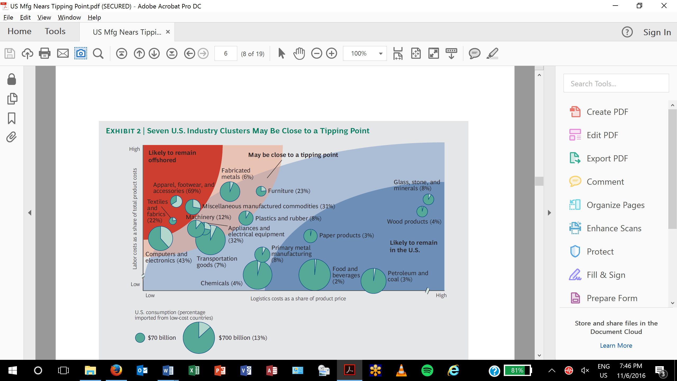

*Source: Sirkin, H. et al. U.S. Manufacturing Nears the Tipping Point, The Boston Consulting Group, March 2012.*

Figure ‑. Example Trends in PG&E Electric Energy Usage (Indexed to 1990 Usage = 1)

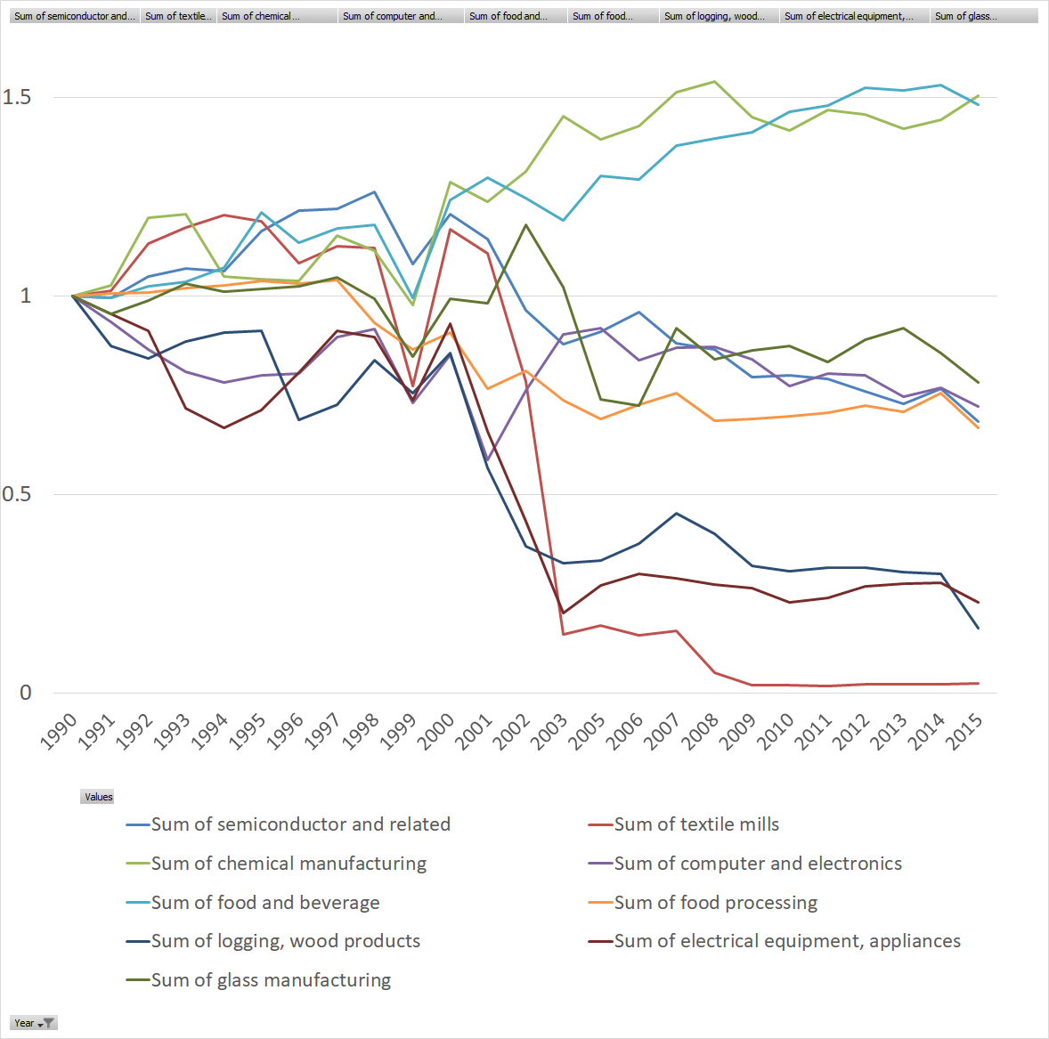

*Source: Energy use trend analysis provided by CEC.*

The values of all applicable ET multipliers were summed for each market segment to define an ET UES multiplier, provided in Table F-5, to forecast segment level potential net savings using the following equation:

Equation . Emerging Technology Segment Net Savings Potential

*ET segment level EE net savings potential = ET UES Multiplier x Annual Segment Consumption[194]*

Table ‑. Emerging Technologies UES Multipliers by Segment and Fuel

| Segment | UES Multiplier (kWh) | UES Multiplier (therm) |
| --- | --- | --- |
| Ind - Petroleum | 0.175% | 1.218% |
| Ind – Food | 1.658% | 9.178% |
| Ind - Electronics | 0.815% | 1.366% |
| Ind - Stone-Glass-Clay | 0.968% | 0.994% |
| Ind - Chemicals | 0.926% | 9.185% |
| Ind - Plastics | 0.935% | 3.580% |
| Ind - Fabricated Metals | 0.967% | 9.472% |
| Ind - Primary Metals | 0.261% | 8.612% |
| Ind - Industrial Machinery | 1.933% | 3.744% |
| Ind - Transportation Equipment | 0.784% | 1.295% |
| Ind - Paper | 0.710% | 1.868% |
| Ind - Printing & Publishing | 0.990% | 1.022% |
| Ind - Textiles | 0.474% | 0.951% |
| Ind - Lumber & Furniture | 0.852% | 1.828% |
| Ind - All Other Industrial | 4.523% | 4.579% |
| Ag - Irrigated Agriculture | 4.809% | 0.000% |
| Ag - Post-Harvest Processing | 4.095% | 9.240% |
| Ag - Dairies | 1.648% | 9.240% |
| Ag - Refrigerated Warehouses | 4.095% | 0.000% |
| Ag - Wineries and Vineyards | 1.675% | 9.240% |
| Ag - Concentrated Animal Feeding Operation | 0.957% | 0.440% |
| Ag - Greenhouses | 4.095% | 0.733% |

*Source: Navigant analysis*

The ET UES multipliers were held constant throughout the 2018 study forecast horizon. The team developed a reference and aggressive case forecast based on a compound annual growth rate (CAGR) by which the portfolio of ETs is expected to be adopted by the market (i.e., penetration). The reference case assumes a CAGR of 2.95%, achieving 21% market penetration within the forecast horizon ending in 2030. The aggressive case assumes a CAGR of 3.36% to achieve market penetration of 32% by 2030.

**Other Input Assumptions**

The model uses a universal EUL of 15 years to accommodate the broad range of emerging technology adoption curves.

A ratio of kW to kWh of 0.000195 was applied.

Finally, costs for electricity and natural gas savings are estimated at $0.42/kWh and $2.83/therm, and are applied consistently for all utilities and across all Industrial and Agricultural sectors. Costs are based on an analysis of industrial and agricultural programs operating throughout 2016, and reflect costs that are higher than average for the portfolio based on the expectation that ETs will be more expensive than more established technologies, and so will require higher incentives and EM&V costs to verify performance.

##### Low Income Programs

###### PG&E

Table ‑. PG&E Households Treated

|  |  |  |  |
| --- | --- | --- | --- |
|  | Single Family | Multifamily | Mobile Home |
| **First Time Treatment** | | | |
| **2017** | 46,636 | 12,604 | 3,781 |
| **2018** | 34,977 | 9,453 | 2,836 |
| **2019** | 33,053 | 8,933 | 2,680 |
| **2020** | 17,471 | 4,722 | 1,417 |
| **Retreatment** | | | |
| **2017** | 19,987 | 5,402 | 1,621 |
| **2018** | 34,977 | 9,453 | 2,836 |
| **2019** | 40,398 | 10,918 | 3,276 |
| **2020 -2030\*** | 59,653 | 16,122 | 4,837 |

*Annual treatment

Table ‑. PG&E UES

|  |  |  |  |  |  |  |  |  |  |
| --- | --- | --- | --- | --- | --- | --- | --- | --- | --- |
|  | Single Family | | | Multifamily | | | Mobile Home | | |
|  | **kW** | **kWh** | **Therm** | **kW** | **kWh** | **Therm** | **kW** | **kWh** | **Therm** |
| **First Time Treatment** | | | | | | | | | |
| **2017** | 0.0726 | 370 | 28.6 | 0.0247 | 230 | 13.6 | 0.0452 | 295 | 22.2 |
| **2018** | 0.0726 | 370 | 28.6 | 0.0247 | 230 | 13.6 | 0.0452 | 295 | 22.2 |
| **2019** | 0.0726 | 370 | 28.6 | 0.0247 | 230 | 13.6 | 0.0452 | 295 | 22.2 |
| **2020** | 0.0726 | 370 | 28.6 | 0.0247 | 230 | 13.6 | 0.0452 | 295 | 22.2 |
| **Retreatment** | | | | | | | | | |
| **2017** | 0.0581 | 296 | 22.9 | 0.0198 | 184 | 10.9 | 0.0362 | 236 | 17.8 |
| **2018** | 0.0581 | 296 | 22.9 | 0.0198 | 184 | 10.9 | 0.0362 | 236 | 17.8 |
| **2019** | 0.0581 | 296 | 22.9 | 0.0198 | 184 | 10.9 | 0.0362 | 236 | 17.8 |
| **2020 - 2030** | 0.0581 | 296 | 22.9 | 0.0198 | 184 | 10.9 | 0.0362 | 236 | 17.8 |

###### SCE

Table ‑. SCE Households Treated

|  |  |  |  |
| --- | --- | --- | --- |
|  | Single Family | Multifamily | Mobile Home |
| **First Time Treatment** | | | |
| **2017** | 25,069 | 7,504 | 3,949 |
| **2018** | 26,322 | 7,879 | 4,146 |
| **2019** | 27,638 | 8,273 | 4,353 |
| **2020** | 29,020 | 8,686 | 4,571 |
| **Retreatment** | | | |
| **2017** | 12,347 | 3,696 | 1,945 |
| **2018** | 12,965 | 3,881 | 2,042 |
| **2019** | 13,613 | 4,075 | 2,144 |
| **2020 -2030\*** | 14,294 | 4,278 | 2,251 |

*Annual treatment

Table ‑. SCE UES

|  |  |  |  |  |  |  |  |  |  |
| --- | --- | --- | --- | --- | --- | --- | --- | --- | --- |
|  | Single Family | | | Multifamily | | | Mobile Home | | |
|  | **kW** | **kWh** | **Therm** | **kW** | **kWh** | **Therm** | **kW** | **kWh** | **Therm** |
| **First Time Treatment** | | | | | | | | | |
| **2017** | 0.1034 | 527 | - | 0.0375 | 348 | - | 0.0417 | 272 | - |
| **2018** | 0.0983 | 501 | - | 0.0356 | 331 | - | 0.0407 | 266 | - |
| **2019** | 0.0906 | 462 | - | 0.0322 | 299 | - | 0.0371 | 242 | - |
| **2020** | 0.0867 | 442 | - | 0.0305 | 283 | - | 0.0354 | 231 | - |
| **Retreatment** | | | | | | | | | |
| **2017** | 0.0286 | 146 | - | 0.0103 | 96 | - | 0.0001 | 75 | - |
| **2018** | 0.0273 | 139 | - | 0.0099 | 92 | - | 0.0001 | 74 | - |
| **2019** | 0.0251 | 128 | - | 0.0089 | 83 | - | 0.0001 | 67 | - |
| **2020 - 2030** | 0.0239 | 122 | - | 0.0084 | 78 | - | 0.0002 | 64 | - |

###### SCG

Table ‑. SCG Households Treated

|  |  |  |  |
| --- | --- | --- | --- |
|  | Single Family | Multifamily | Mobile Home |
| **First Time Treatment** | | | |
| **2017** | 46,528 | 21,751 | 4,739 |
| **2018** | 48,798 | 22,812 | 4,970 |
| **2019** | 51,182 | 23,927 | 5,213 |
| **2020** | 46,528 | 21,751 | 4,739 |
| **Retreatment** | | | |
| **2017** | 29,813 | 13,937 | 3,037 |
| **2018** | 31,267 | 14,617 | 3,185 |
| **2019** | 32,793 | 15,330 | 3,340 |
| **2020** | 34,395 | 16,079 | 3,503 |
| **2021-2030** | 81,142 | 37,932 | 8,265 |

*Annual treatment

Table ‑. SCG UES

|  |  |  |  |  |  |  |  |  |  |
| --- | --- | --- | --- | --- | --- | --- | --- | --- | --- |
|  | Single Family | | | Multifamily | | | Mobile Home | | |
|  | **kW** | **kWh** | **Therm** | **kW** | **kWh** | **Therm** | **kW** | **kWh** | **Therm** |
| **First Time Treatment** | | | | | | | | | |
| **2017** | - | - | 32.6 | - | - | 14.8 | - | - | 38.8 |
| **2018** | - | - | 32.6 | - | - | 14.8 | - | - | 38.8 |
| **2019** | - | - | 32.6 | - | - | 14.8 | - | - | 38.8 |
| **2020** | - | - | 32.6 | - | - | 14.8 | - | - | 38.8 |
| **Retreatment** | | | | | | | | | |
| **2017** | - | - | 30.6 | - | - | 13.6 | - | - | 38.8 |
| **2018** | - | - | 30.6 | - | - | 13.6 | - | - | 38.8 |
| **2019** | - | - | 30.6 | - | - | 13.6 | - | - | 38.8 |
| **2020 - 2030** | - | - | 30.6 | - | - | 13.6 | - | - | 38.8 |

###### SDG&E

Table ‑. SDG&E Households Treated

|  |  |  |  |
| --- | --- | --- | --- |
|  | Single Family | Multifamily | Mobile Home |
| **First Time Treatment** | | | |
| **2017** | 5,782 | 4,625 | 1,156 |
| **2018** | 5,782 | 4,625 | 1,156 |
| **2019** | 5,781 | 4,625 | 1,156 |
| **2020** | - | - | - |
| **Retreatment** | | | |
| **2017** | 4,377 | 3,501 | 875 |
| **2018** | 4,885 | 3,908 | 977 |
| **2019** | 5,418 | 4,334 | 1,084 |
| **2020 -2030\*** | 11,759 | 9,407 | 2,352 |

*Annual treatment

Table ‑. SDG&E UES

|  |  |  |  |  |  |  |  |  |  |
| --- | --- | --- | --- | --- | --- | --- | --- | --- | --- |
|  | Single Family | | | Multifamily | | | Mobile Home | | |
|  | **kW** | **kWh** | **Therm** | **kW** | **kWh** | **Therm** | **kW** | **kWh** | **Therm** |
| **First Time Treatment** | | | | | | | | | |
| **2017** | 0.1120 | 571 | 24.0 | 0.0460 | 427 | 9.0 | 0.0642 | 419 | 10.0 |
| **2018** | 0.0997 | 508 | 23.0 | 0.0436 | 405 | 9.0 | 0.0629 | 411 | 10.0 |
| **2019** | 0.0991 | 505 | 22.0 | 0.0437 | 406 | 8.0 | 0.0623 | 407 | 9.0 |
| **2020** | - | - | - | - | - | - | - | - | - |
| **Retreatment** | | | | | | | | | |
| **2017** | 0.0426 | 217 | 18.0 | 0.0283 | 263 | 8.0 | 0.0003 | 135 | 9.0 |
| **2018** | 0.0379 | 193 | 15.0 | 0.0253 | 235 | 7.0 | 0.0004 | 120 | 7.0 |
| **2019** | 0.0353 | 180 | 13.0 | 0.0237 | 220 | 6.0 | 0.0004 | 112 | 6.0 |
| **2020 - 2030** | 0.0630 | 321 | 18.0 | 0.0319 | 296 | 7.0 | 0.0028 | 241 | 8.0 |

###### Effective Useful Life

|  |  |  |  |
| --- | --- | --- | --- |
| Utility | Housing Type | First Time Treatment | Retreatment |
| PG&E | Multifamily | 8.0 | 8.0 |
| Mobile Home | 11.0 | 11.0 |
| Single Family | 11.0 | 11.0 |
| SCE | Multifamily | 10.8 | 10.8 |
| Mobile Home | 11.8 | 11.4 |
| Single Family | 11.9 | 11.7 |
| SCG | Multifamily | 10.4 | 10.4 |
| Mobile Home | 10.4 | 10.2 |
| Single Family | 10.7 | 10.1 |
| SDG&E | Multifamily | 14.0 | 14.0 |
| Mobile Home | 14.0 | 13.0 |
| Single Family | 14.0 | 14.0 |

##### Detailed Scenario Results

###### PG&E

Table ‑. PG&E Electric Savings

|  |  |  |  |  |  |  |  |  |  |  |  |  |  |
| --- | --- | --- | --- | --- | --- | --- | --- | --- | --- | --- | --- | --- | --- |
| **Electric Energy (GWh/year)** | | | | | | | | | | | | | |
| **Year** | **2018** | **2019** | **2020** | **2021** | **2022** | **2023** | **2024** | **2025** | **2026** | **2027** | **2028** | **2029** | **2030** |
| **TRC | Reference** | | | | | | | | | | | | | |
| **Equipment Rebates** | 283 | 309 | 286 | 315 | 319 | 321 | 333 | 336 | 333 | 332 | 333 | 335 | 336 |
| **BROs** | 123 | 158 | 175 | 192 | 203 | 213 | 223 | 240 | 253 | 266 | 279 | 293 | 308 |
| **Low Income** | 29 | 30 | 30 | 22 | 22 | 22 | 22 | 22 | 22 | 22 | 22 | 22 | 22 |
| **Incentive Programs (Subtotal)** | 435 | 497 | 490 | 529 | 543 | 556 | 578 | 598 | 607 | 620 | 635 | 650 | 666 |
| **C&S\*** | 535 | 555 | 559 | 576 | 560 | 621 | 595 | 573 | 538 | 518 | 471 | 426 | 381 |
| **Total** | **970** | **1,052** | **1,049** | **1,104** | **1,104** | **1,177** | **1,173** | **1,171** | **1,145** | **1,138** | **1,106** | **1,076** | **1,048** |
| **mTRC (GHG adder 1) | Reference** | | | | | | | | | | | | | |
| **Equipment Rebates** | 293 | 317 | 293 | 341 | 340 | 341 | 338 | 339 | 338 | 332 | 334 | 335 | 337 |
| **BROs** | 123 | 158 | 175 | 192 | 203 | 213 | 223 | 240 | 253 | 266 | 279 | 293 | 308 |
| **Low Income** | 29 | 30 | 30 | 22 | 22 | 22 | 22 | 22 | 22 | 22 | 22 | 22 | 22 |
| **Incentive Programs (Subtotal)** | 445 | 505 | 498 | 555 | 565 | 575 | 582 | 601 | 612 | 620 | 635 | 650 | 667 |
| **C&S\*** | 535 | 555 | 559 | 576 | 560 | 621 | 595 | 573 | 538 | 518 | 471 | 426 | 381 |
| **Total** | **980** | **1,060** | **1,057** | **1,130** | **1,125** | **1,196** | **1,177** | **1,174** | **1,150** | **1,138** | **1,106** | **1,077** | **1,048** |
| **mTRC (GHG adder 2) | Reference** | | | | | | | | | | | | | |
| **Equipment Rebates** | 296 | 320 | 299 | 350 | 347 | 350 | 347 | 350 | 346 | 342 | 345 | 344 | 345 |
| **BROs** | 123 | 158 | 175 | 192 | 203 | 213 | 223 | 240 | 253 | 266 | 279 | 293 | 308 |
| **Low Income** | 29 | 30 | 30 | 22 | 22 | 22 | 22 | 22 | 22 | 22 | 22 | 22 | 22 |
| **Incentive Programs (Subtotal)** | 448 | 508 | 504 | 563 | 572 | 585 | 592 | 612 | 620 | 629 | 647 | 659 | 675 |
| **C&S\*** | 535 | 555 | 559 | 576 | 560 | 621 | 595 | 573 | 538 | 518 | 471 | 426 | 381 |
| **Total** | **983** | **1,063** | **1,063** | **1,139** | **1,132** | **1,205** | **1,187** | **1,185** | **1,158** | **1,147** | **1,117** | **1,086** | **1,056** |
| **PAC | Reference** | | | | | | | | | | | | | |
| **Equipment Rebates** | 377 | 400 | 374 | 407 | 405 | 400 | 394 | 395 | 389 | 389 | 388 | 387 | 386 |
| **BROs** | 123 | 158 | 175 | 192 | 203 | 213 | 223 | 240 | 253 | 266 | 279 | 293 | 308 |
| **Low Income** | 29 | 30 | 30 | 22 | 22 | 22 | 22 | 22 | 22 | 22 | 22 | 22 | 22 |
| **Incentive Programs (Subtotal)** | 528 | 588 | 579 | 621 | 630 | 635 | 639 | 657 | 663 | 677 | 690 | 702 | 716 |
| **C&S\*** | 535 | 555 | 559 | 576 | 560 | 621 | 595 | 573 | 538 | 518 | 471 | 426 | 381 |
| **Total** | **1,063** | **1,143** | **1,138** | **1,196** | **1,190** | **1,255** | **1,233** | **1,230** | **1,201** | **1,195** | **1,161** | **1,128** | **1,098** |
| **PAC | Aggressive** | | | | | | | | | | | | | |
| **Equipment Rebates** | 398 | 422 | 396 | 433 | 429 | 423 | 416 | 412 | 413 | 413 | 414 | 415 | 420 |
| **BROs** | 159 | 199 | 236 | 253 | 271 | 290 | 312 | 371 | 401 | 434 | 472 | 516 | 567 |
| **Low Income** | 29 | 30 | 30 | 22 | 22 | 22 | 22 | 22 | 22 | 22 | 22 | 22 | 22 |
| **Incentive Programs (Subtotal)** | 586 | 651 | 662 | 707 | 721 | 734 | 749 | 805 | 836 | 869 | 908 | 953 | 1,008 |
| **C&S\*** | 535 | 555 | 559 | 576 | 560 | 621 | 595 | 573 | 538 | 518 | 471 | 426 | 381 |
| **Total** | **1,121** | **1,206** | **1,220** | **1,283** | **1,281** | **1,355** | **1,344** | **1,379** | **1,373** | **1,387** | **1,379** | **1,379** | **1,390** |

* Includes interactive effects

Table ‑. PG&E Demand Savings

|  |  |  |  |  |  |  |  |  |  |  |  |  |  |
| --- | --- | --- | --- | --- | --- | --- | --- | --- | --- | --- | --- | --- | --- |
| **Electric Demand (MW)** | | | | | | | | | | | | | |
| **Year** | **2018** | **2019** | **2020** | **2021** | **2022** | **2023** | **2024** | **2025** | **2026** | **2027** | **2028** | **2029** | **2030** |
| **TRC | Reference** | | | | | | | | | | | | | |
| **Equipment Rebates** | 51 | 58 | 52 | 59 | 61 | 63 | 65 | 66 | 66 | 66 | 67 | 67 | 68 |
| **BROs** | 23 | 29 | 32 | 35 | 37 | 39 | 41 | 44 | 46 | 49 | 51 | 53 | 56 |
| **Low Income** | 5 | 5 | 5 | 4 | 4 | 4 | 4 | 4 | 4 | 4 | 4 | 4 | 4 |
| **Incentive Programs (Subtotal)** | 79 | 93 | 90 | 98 | 103 | 106 | 110 | 114 | 116 | 119 | 122 | 125 | 128 |
| **C&S\*** | 120 | 122 | 137 | 163 | 158 | 194 | 186 | 180 | 173 | 169 | 160 | 152 | 145 |
| **Total** | **199** | **214** | **227** | **261** | **261** | **300** | **296** | **295** | **289** | **287** | **281** | **277** | **272** |
| **mTRC (GHG adder 1) | Reference** | | | | | | | | | | | | | |
| **Equipment Rebates** | 55 | 61 | 55 | 66 | 66 | 66 | 66 | 67 | 67 | 66 | 67 | 68 | 68 |
| **BROs** | 23 | 29 | 32 | 35 | 37 | 39 | 41 | 44 | 46 | 49 | 51 | 53 | 56 |
| **Low Income** | 5 | 5 | 5 | 4 | 4 | 4 | 4 | 4 | 4 | 4 | 4 | 4 | 4 |
| **Incentive Programs (Subtotal)** | 83 | 96 | 93 | 105 | 107 | 109 | 111 | 115 | 117 | 119 | 122 | 125 | 128 |
| **C&S\*** | 120 | 122 | 137 | 163 | 158 | 194 | 186 | 180 | 173 | 169 | 160 | 152 | 145 |
| **Total** | **203** | **218** | **230** | **268** | **266** | **303** | **297** | **295** | **290** | **288** | **282** | **277** | **273** |
| **mTRC (GHG adder 2) | Reference** | | | | | | | | | | | | | |
| **Equipment Rebates** | 57 | 63 | 58 | 69 | 68 | 69 | 70 | 72 | 71 | 71 | 73 | 73 | 74 |
| **BROs** | 23 | 29 | 32 | 35 | 37 | 39 | 41 | 44 | 46 | 49 | 51 | 53 | 56 |
| **Low Income** | 5 | 5 | 5 | 4 | 4 | 4 | 4 | 4 | 4 | 4 | 4 | 4 | 4 |
| **Incentive Programs (Subtotal)** | 85 | 98 | 95 | 108 | 109 | 112 | 115 | 120 | 121 | 123 | 128 | 131 | 134 |
| **C&S\*** | 120 | 122 | 137 | 163 | 158 | 194 | 186 | 180 | 173 | 169 | 160 | 152 | 145 |
| **Total** | **205** | **220** | **233** | **271** | **268** | **306** | **301** | **300** | **294** | **292** | **288** | **282** | **278** |
| **PAC | Reference** | | | | | | | | | | | | | |
| **Equipment Rebates** | 91 | 100 | 94 | 102 | 103 | 100 | 98 | 98 | 95 | 94 | 94 | 94 | 94 |
| **BROs** | 23 | 29 | 32 | 35 | 37 | 39 | 41 | 44 | 46 | 49 | 51 | 53 | 56 |
| **Low Income** | 5 | 5 | 5 | 4 | 4 | 4 | 4 | 4 | 4 | 4 | 4 | 4 | 4 |
| **Incentive Programs (Subtotal)** | 119 | 134 | 131 | 141 | 144 | 143 | 143 | 146 | 145 | 147 | 149 | 151 | 154 |
| **C&S\*** | 120 | 122 | 137 | 163 | 158 | 194 | 186 | 180 | 173 | 169 | 160 | 152 | 145 |
| **Total** | **239** | **256** | **269** | **304** | **302** | **337** | **329** | **326** | **318** | **315** | **308** | **303** | **298** |
| **PAC | Aggressive** | | | | | | | | | | | | | |
| **Equipment Rebates** | 96 | 105 | 99 | 109 | 109 | 106 | 103 | 102 | 101 | 99 | 100 | 100 | 101 |
| **BROs** | 28 | 36 | 41 | 43 | 47 | 50 | 54 | 63 | 68 | 74 | 80 | 87 | 96 |
| **Low Income** | 5 | 5 | 5 | 4 | 4 | 4 | 4 | 4 | 4 | 4 | 4 | 4 | 4 |
| **Incentive Programs (Subtotal)** | 129 | 146 | 145 | 156 | 160 | 160 | 161 | 169 | 172 | 177 | 184 | 192 | 201 |
| **C&S\*** | 120 | 122 | 137 | 163 | 158 | 194 | 186 | 180 | 173 | 169 | 160 | 152 | 145 |
| **Total** | **250** | **267** | **283** | **319** | **318** | **354** | **347** | **349** | **345** | **346** | **344** | **343** | **346** |

* Includes interactive effects

Table ‑. PG&E Gas Savings

|  |  |  |  |  |  |  |  |  |  |  |  |  |  |
| --- | --- | --- | --- | --- | --- | --- | --- | --- | --- | --- | --- | --- | --- |
| **Gas Energy (MMTherm/year)** | | | | | | | | | | | | | |
| **Year** | **2018** | **2019** | **2020** | **2021** | **2022** | **2023** | **2024** | **2025** | **2026** | **2027** | **2028** | **2029** | **2030** |
| **TRC | Reference** | | | | | | | | | | | | | |
| **Equipment Rebates** | 7 | 8 | 6 | 8 | 9 | 10 | 10 | 11 | 13 | 13 | 13 | 13 | 14 |
| **BROs** | 4 | 5 | 6 | 7 | 7 | 7 | 8 | 8 | 8 | 9 | 9 | 10 | 10 |
| **Low Income** | 2 | 2 | 2 | 2 | 2 | 2 | 2 | 2 | 2 | 2 | 2 | 2 | 2 |
| **Incentive Programs (Subtotal)** | 13 | 16 | 15 | 16 | 18 | 19 | 19 | 20 | 23 | 23 | 24 | 24 | 25 |
| **C&S\*** | 14 | 14 | 17 | 20 | 20 | 20 | 20 | 20 | 15 | 13 | 13 | 13 | 13 |
| **Total** | **28** | **30** | **32** | **35** | **37** | **38** | **39** | **40** | **37** | **37** | **37** | **37** | **38** |
| **mTRC (GHG adder 1) | Reference** | | | | | | | | | | | | | |
| **Equipment Rebates** | 10 | 12 | 10 | 12 | 14 | 15 | 15 | 15 | 14 | 14 | 14 | 14 | 14 |
| **BROs** | 4 | 5 | 6 | 7 | 7 | 7 | 8 | 8 | 8 | 9 | 9 | 10 | 10 |
| **Low Income** | 2 | 2 | 2 | 2 | 2 | 2 | 2 | 2 | 2 | 2 | 2 | 2 | 2 |
| **Incentive Programs (Subtotal)** | 16 | 19 | 18 | 20 | 23 | 24 | 24 | 24 | 24 | 24 | 25 | 25 | 26 |
| **C&S\*** | 14 | 14 | 17 | 20 | 20 | 20 | 20 | 20 | 15 | 13 | 13 | 13 | 13 |
| **Total** | **31** | **34** | **36** | **40** | **43** | **43** | **44** | **44** | **39** | **38** | **38** | **38** | **38** |
| **mTRC (GHG adder 2) | Reference** | | | | | | | | | | | | | |
| **Equipment Rebates** | 12 | 16 | 15 | 17 | 17 | 21 | 20 | 20 | 19 | 18 | 18 | 17 | 17 |
| **BROs** | 4 | 5 | 6 | 7 | 7 | 7 | 8 | 8 | 8 | 9 | 9 | 10 | 10 |
| **Low Income** | 2 | 2 | 2 | 2 | 2 | 2 | 2 | 2 | 2 | 2 | 2 | 2 | 2 |
| **Incentive Programs (Subtotal)** | 19 | 23 | 23 | 25 | 26 | 30 | 30 | 29 | 29 | 29 | 29 | 29 | 29 |
| **C&S\*** | 14 | 14 | 17 | 20 | 20 | 20 | 20 | 20 | 15 | 13 | 13 | 13 | 13 |
| **Total** | **33** | **38** | **41** | **45** | **45** | **50** | **49** | **49** | **44** | **42** | **42** | **41** | **42** |
| **PAC | Reference** | | | | | | | | | | | | | |
| **Equipment Rebates** | 11 | 13 | 12 | 14 | 13 | 16 | 15 | 16 | 15 | 15 | 15 | 16 | 16 |
| **BROs** | 4 | 5 | 6 | 7 | 7 | 7 | 8 | 8 | 8 | 9 | 9 | 10 | 10 |
| **Low Income** | 2 | 2 | 2 | 2 | 2 | 2 | 2 | 2 | 2 | 2 | 2 | 2 | 2 |
| **Incentive Programs (Subtotal)** | 18 | 21 | 21 | 22 | 22 | 24 | 24 | 25 | 25 | 26 | 26 | 27 | 28 |
| **C&S\*** | 14 | 14 | 17 | 20 | 20 | 20 | 20 | 20 | 15 | 13 | 13 | 13 | 13 |
| **Total** | **32** | **35** | **38** | **41** | **42** | **44** | **44** | **45** | **40** | **39** | **39** | **39** | **41** |
| **PAC | Aggressive** | | | | | | | | | | | | | |
| **Equipment Rebates** | 12 | 14 | 13 | 14 | 14 | 17 | 16 | 17 | 16 | 17 | 17 | 18 | 20 |
| **BROs** | 5 | 6 | 7 | 8 | 9 | 9 | 10 | 11 | 12 | 13 | 15 | 16 | 18 |
| **Low Income** | 2 | 2 | 2 | 2 | 2 | 2 | 2 | 2 | 2 | 2 | 2 | 2 | 2 |
| **Incentive Programs (Subtotal)** | 19 | 23 | 22 | 24 | 24 | 27 | 28 | 30 | 30 | 32 | 33 | 36 | 39 |
| **C&S\*** | 14 | 14 | 17 | 20 | 20 | 20 | 20 | 20 | 15 | 13 | 13 | 13 | 13 |
| **Total** | **34** | **37** | **40** | **44** | **44** | **47** | **48** | **49** | **45** | **45** | **46** | **48** | **52** |

* Includes interactive effects

###### SCE

Table ‑. SCE Electric Savings

|  |  |  |  |  |  |  |  |  |  |  |  |  |  |
| --- | --- | --- | --- | --- | --- | --- | --- | --- | --- | --- | --- | --- | --- |
| **Electric Energy (GWh/year)** | | | | | | | | | | | | | |
| **Year** | **2018** | **2019** | **2020** | **2021** | **2022** | **2023** | **2024** | **2025** | **2026** | **2027** | **2028** | **2029** | **2030** |
| **TRC | Reference** | | | | | | | | | | | | | |
| **Equipment Rebates** | 298 | 318 | 313 | 346 | 353 | 363 | 380 | 391 | 406 | 412 | 417 | 418 | 416 |
| **BROs** | 74 | 90 | 101 | 113 | 124 | 134 | 146 | 161 | 174 | 188 | 202 | 217 | 228 |
| **Low Income** | 21 | 20 | 20 | 4 | 4 | 4 | 4 | 4 | 4 | 4 | 4 | 4 | 4 |
| **Incentive Programs (Subtotal)** | 393 | 428 | 435 | 463 | 481 | 501 | 529 | 555 | 584 | 604 | 623 | 639 | 648 |
| **C&S\*** | 552 | 572 | 577 | 594 | 578 | 640 | 613 | 591 | 554 | 534 | 486 | 440 | 393 |
| **Total** | **944** | **1,000** | **1,011** | **1,056** | **1,059** | **1,142** | **1,143** | **1,147** | **1,139** | **1,138** | **1,108** | **1,079** | **1,042** |
| **mTRC (GHG adder 1) | Reference** | | | | | | | | | | | | | |
| **Equipment Rebates** | 310 | 328 | 320 | 349 | 358 | 373 | 401 | 406 | 410 | 415 | 418 | 424 | 421 |
| **BROs** | 74 | 90 | 101 | 113 | 124 | 134 | 146 | 161 | 174 | 188 | 202 | 217 | 228 |
| **Low Income** | 21 | 20 | 20 | 4 | 4 | 4 | 4 | 4 | 4 | 4 | 4 | 4 | 4 |
| **Incentive Programs (Subtotal)** | 405 | 438 | 442 | 466 | 485 | 511 | 550 | 571 | 588 | 607 | 625 | 646 | 653 |
| **C&S\*** | 552 | 572 | 577 | 594 | 578 | 640 | 613 | 591 | 554 | 534 | 486 | 440 | 393 |
| **Total** | **956** | **1,011** | **1,018** | **1,060** | **1,063** | **1,152** | **1,164** | **1,162** | **1,142** | **1,141** | **1,110** | **1,085** | **1,046** |
| **mTRC (GHG adder 2) | Reference** | | | | | | | | | | | | | |
| **Equipment Rebates** | 315 | 333 | 328 | 372 | 383 | 408 | 425 | 430 | 431 | 435 | 442 | 441 | 437 |
| **BROs** | 74 | 90 | 101 | 113 | 124 | 134 | 146 | 161 | 174 | 188 | 202 | 217 | 228 |
| **Low Income** | 21 | 20 | 20 | 4 | 4 | 4 | 4 | 4 | 4 | 4 | 4 | 4 | 4 |
| **Incentive Programs (Subtotal)** | 410 | 443 | 450 | 489 | 511 | 546 | 575 | 594 | 609 | 627 | 649 | 662 | 669 |
| **C&S\*** | 552 | 572 | 577 | 594 | 578 | 640 | 613 | 591 | 554 | 534 | 486 | 440 | 393 |
| **Total** | **962** | **1,015** | **1,026** | **1,083** | **1,089** | **1,186** | **1,188** | **1,186** | **1,163** | **1,161** | **1,134** | **1,102** | **1,062** |
| **PAC | Reference** | | | | | | | | | | | | | |
| **Equipment Rebates** | 391 | 408 | 400 | 443 | 456 | 471 | 477 | 480 | 485 | 486 | 486 | 485 | 480 |
| **BROs** | 74 | 90 | 101 | 113 | 124 | 134 | 146 | 161 | 174 | 188 | 202 | 217 | 228 |
| **Low Income** | 21 | 20 | 20 | 4 | 4 | 4 | 4 | 4 | 4 | 4 | 4 | 4 | 4 |
| **Incentive Programs (Subtotal)** | 486 | 519 | 522 | 560 | 583 | 609 | 627 | 645 | 663 | 678 | 692 | 706 | 711 |
| **C&S\*** | 552 | 572 | 577 | 594 | 578 | 640 | 613 | 591 | 554 | 534 | 486 | 440 | 393 |
| **Total** | **1,038** | **1,091** | **1,099** | **1,153** | **1,161** | **1,249** | **1,240** | **1,236** | **1,217** | **1,212** | **1,178** | **1,146** | **1,105** |
| **PAC | Aggressive** | | | | | | | | | | | | | |
| **Equipment Rebates** | 414 | 434 | 428 | 473 | 486 | 501 | 507 | 508 | 511 | 512 | 511 | 508 | 504 |
| **BROs** | 84 | 130 | 150 | 171 | 194 | 212 | 251 | 275 | 297 | 323 | 353 | 388 | 430 |
| **Low Income** | 21 | 20 | 20 | 4 | 4 | 4 | 4 | 4 | 4 | 4 | 4 | 4 | 4 |
| **Incentive Programs (Subtotal)** | 519 | 584 | 598 | 648 | 684 | 717 | 762 | 787 | 812 | 839 | 868 | 900 | 938 |
| **C&S\*** | 552 | 572 | 577 | 594 | 578 | 640 | 613 | 591 | 554 | 534 | 486 | 440 | 393 |
| **Total** | **1,070** | **1,157** | **1,174** | **1,242** | **1,261** | **1,358** | **1,375** | **1,378** | **1,366** | **1,373** | **1,354** | **1,340** | **1,332** |

* Includes interactive effects

Table ‑. SCE Demand Savings

|  |  |  |  |  |  |  |  |  |  |  |  |  |  |
| --- | --- | --- | --- | --- | --- | --- | --- | --- | --- | --- | --- | --- | --- |
| **Electric Demand (MW)** | | | | | | | | | | | | | |
| **Year** | **2018** | **2019** | **2020** | **2021** | **2022** | **2023** | **2024** | **2025** | **2026** | **2027** | **2028** | **2029** | **2030** |
| **TRC | Reference** | | | | | | | | | | | | | |
| **Equipment Rebates** | 59 | 65 | 64 | 72 | 75 | 78 | 84 | 88 | 93 | 95 | 97 | 98 | 98 |
| **BROs** | 13 | 16 | 18 | 20 | 22 | 24 | 26 | 28 | 31 | 33 | 36 | 38 | 40 |
| **Low Income** | 4 | 4 | 4 | 1 | 1 | 1 | 1 | 1 | 1 | 1 | 1 | 1 | 1 |
| **Incentive Programs (Subtotal)** | 75 | 85 | 86 | 93 | 98 | 103 | 110 | 117 | 124 | 129 | 133 | 137 | 139 |
| **C&S\*** | 124 | 125 | 142 | 168 | 163 | 200 | 192 | 186 | 178 | 174 | 165 | 157 | 149 |
| **Total** | **199** | **210** | **228** | **261** | **261** | **303** | **302** | **303** | **303** | **303** | **298** | **293** | **288** |
| **mTRC (GHG adder 1) | Reference** | | | | | | | | | | | | | |
| **Equipment Rebates** | 64 | 69 | 67 | 74 | 78 | 83 | 90 | 93 | 94 | 96 | 97 | 99 | 99 |
| **BROs** | 13 | 16 | 18 | 20 | 22 | 24 | 26 | 28 | 31 | 33 | 36 | 38 | 40 |
| **Low Income** | 4 | 4 | 4 | 1 | 1 | 1 | 1 | 1 | 1 | 1 | 1 | 1 | 1 |
| **Incentive Programs (Subtotal)** | 81 | 89 | 88 | 95 | 100 | 107 | 117 | 122 | 125 | 130 | 134 | 138 | 139 |
| **C&S\*** | 124 | 125 | 142 | 168 | 163 | 200 | 192 | 186 | 178 | 174 | 165 | 157 | 149 |
| **Total** | **204** | **214** | **230** | **263** | **264** | **307** | **309** | **308** | **304** | **304** | **298** | **294** | **289** |
| **mTRC (GHG adder 2) | Reference** | | | | | | | | | | | | | |
| **Equipment Rebates** | 65 | 71 | 70 | 81 | 85 | 91 | 107 | 109 | 110 | 112 | 117 | 117 | 117 |
| **BROs** | 13 | 16 | 18 | 20 | 22 | 24 | 26 | 28 | 31 | 33 | 36 | 38 | 40 |
| **Low Income** | 4 | 4 | 4 | 1 | 1 | 1 | 1 | 1 | 1 | 1 | 1 | 1 | 1 |
| **Incentive Programs (Subtotal)** | 82 | 90 | 92 | 102 | 108 | 115 | 133 | 139 | 142 | 146 | 154 | 156 | 157 |
| **C&S\*** | 124 | 125 | 142 | 168 | 163 | 200 | 192 | 186 | 178 | 174 | 165 | 157 | 149 |
| **Total** | **206** | **216** | **234** | **269** | **271** | **316** | **325** | **324** | **320** | **320** | **318** | **313** | **306** |
| **PAC | Reference** | | | | | | | | | | | | | |
| **Equipment Rebates** | 102 | 111 | 109 | 126 | 128 | 141 | 142 | 143 | 142 | 143 | 144 | 146 | 145 |
| **BROs** | 13 | 16 | 18 | 20 | 22 | 24 | 26 | 28 | 31 | 33 | 36 | 38 | 40 |
| **Low Income** | 4 | 4 | 4 | 1 | 1 | 1 | 1 | 1 | 1 | 1 | 1 | 1 | 1 |
| **Incentive Programs (Subtotal)** | 119 | 131 | 131 | 147 | 151 | 166 | 168 | 172 | 174 | 177 | 181 | 185 | 186 |
| **C&S\*** | 124 | 125 | 142 | 168 | 163 | 200 | 192 | 186 | 178 | 174 | 165 | 157 | 149 |
| **Total** | **243** | **256** | **273** | **314** | **314** | **366** | **360** | **358** | **352** | **351** | **345** | **341** | **335** |
| **PAC | Aggressive** | | | | | | | | | | | | | |
| **Equipment Rebates** | 109 | 119 | 119 | 137 | 138 | 152 | 152 | 152 | 151 | 153 | 153 | 154 | 153 |
| **BROs** | 15 | 22 | 25 | 29 | 33 | 36 | 41 | 45 | 49 | 53 | 57 | 63 | 69 |
| **Low Income** | 4 | 4 | 4 | 1 | 1 | 1 | 1 | 1 | 1 | 1 | 1 | 1 | 1 |
| **Incentive Programs (Subtotal)** | 127 | 145 | 148 | 167 | 172 | 189 | 194 | 198 | 201 | 206 | 211 | 218 | 223 |
| **C&S\*** | 124 | 125 | 142 | 168 | 163 | 200 | 192 | 186 | 178 | 174 | 165 | 157 | 149 |
| **Total** | **251** | **271** | **289** | **334** | **336** | **389** | **386** | **384** | **379** | **380** | **376** | **374** | **372** |

* Includes interactive effects

###### SCG

Table ‑. SCG Gas Savings

|  |  |  |  |  |  |  |  |  |  |  |  |  |  |
| --- | --- | --- | --- | --- | --- | --- | --- | --- | --- | --- | --- | --- | --- |
| **Gas Energy (MMTherm/year)** | | | | | | | | | | | | | |
| **Year** | **2018** | **2019** | **2020** | **2021** | **2022** | **2023** | **2024** | **2025** | **2026** | **2027** | **2028** | **2029** | **2030** |
| **TRC | Reference** | | | | | | | | | | | | | |
| **Equipment Rebates** | 12 | 12 | 10 | 13 | 13 | 13 | 12 | 12 | 12 | 12 | 12 | 12 | 12 |
| **BROs** | 7 | 7 | 8 | 8 | 8 | 9 | 9 | 9 | 10 | 10 | 10 | 11 | 11 |
| **Low Income** | 3 | 3 | 4 | 3 | 3 | 3 | 3 | 3 | 3 | 3 | 3 | 3 | 3 |
| **Incentive Programs (Subtotal)** | 23 | 23 | 22 | 24 | 24 | 25 | 24 | 25 | 25 | 25 | 25 | 26 | 26 |
| **C&S\*** | 26 | 26 | 30 | 34 | 33 | 33 | 33 | 32 | 25 | 22 | 22 | 21 | 21 |
| **Total** | **49** | **48** | **52** | **58** | **58** | **58** | **57** | **57** | **50** | **47** | **47** | **47** | **47** |
| **mTRC (GHG adder 1) | Reference** | | | | | | | | | | | | | |
| **Equipment Rebates** | 14 | 14 | 13 | 15 | 15 | 18 | 17 | 16 | 15 | 14 | 14 | 13 | 14 |
| **BROs** | 7 | 7 | 8 | 8 | 8 | 9 | 9 | 9 | 10 | 10 | 10 | 11 | 11 |
| **Low Income** | 3 | 3 | 4 | 3 | 3 | 3 | 3 | 3 | 3 | 3 | 3 | 3 | 3 |
| **Incentive Programs (Subtotal)** | 25 | 25 | 24 | 26 | 26 | 30 | 29 | 29 | 28 | 27 | 27 | 27 | 28 |
| **C&S\*** | 26 | 26 | 30 | 34 | 33 | 33 | 33 | 32 | 25 | 22 | 22 | 21 | 21 |
| **Total** | **51** | **51** | **54** | **59** | **59** | **63** | **62** | **61** | **53** | **50** | **49** | **48** | **49** |
| **mTRC (GHG adder 2) | Reference** | | | | | | | | | | | | | |
| **Equipment Rebates** | 16 | 17 | 20 | 21 | 21 | 22 | 21 | 20 | 19 | 18 | 17 | 17 | 17 |
| **BROs** | 7 | 7 | 8 | 8 | 8 | 9 | 9 | 9 | 10 | 10 | 10 | 11 | 11 |
| **Low Income** | 3 | 3 | 4 | 3 | 3 | 3 | 3 | 3 | 3 | 3 | 3 | 3 | 3 |
| **Incentive Programs (Subtotal)** | 26 | 28 | 31 | 32 | 32 | 33 | 33 | 33 | 32 | 31 | 31 | 31 | 31 |
| **C&S\*** | 26 | 26 | 30 | 34 | 33 | 33 | 33 | 32 | 25 | 22 | 22 | 21 | 21 |
| **Total** | **52** | **54** | **61** | **66** | **66** | **67** | **66** | **65** | **56** | **54** | **52** | **52** | **52** |
| **PAC | Reference** | | | | | | | | | | | | | |
| **Equipment Rebates** | 17 | 16 | 17 | 17 | 21 | 21 | 21 | 20 | 18 | 17 | 17 | 16 | 17 |
| **BROs** | 7 | 7 | 8 | 8 | 8 | 9 | 9 | 9 | 10 | 10 | 10 | 11 | 11 |
| **Low Income** | 3 | 3 | 4 | 3 | 3 | 3 | 3 | 3 | 3 | 3 | 3 | 3 | 3 |
| **Incentive Programs (Subtotal)** | 27 | 27 | 28 | 29 | 32 | 33 | 33 | 32 | 31 | 30 | 30 | 30 | 31 |
| **C&S\*** | 26 | 26 | 30 | 34 | 33 | 33 | 33 | 32 | 25 | 22 | 22 | 21 | 21 |
| **Total** | **53** | **53** | **58** | **62** | **66** | **66** | **65** | **64** | **56** | **53** | **52** | **51** | **52** |
| **PAC | Aggressive** | | | | | | | | | | | | | |
| **Equipment Rebates** | 17 | 17 | 18 | 19 | 22 | 23 | 21 | 20 | 19 | 18 | 18 | 18 | 20 |
| **BROs** | 7 | 8 | 9 | 9 | 10 | 11 | 12 | 13 | 14 | 15 | 16 | 17 | 18 |
| **Low Income** | 3 | 3 | 4 | 3 | 3 | 3 | 3 | 3 | 3 | 3 | 3 | 3 | 3 |
| **Incentive Programs (Subtotal)** | 28 | 29 | 30 | 31 | 35 | 36 | 36 | 36 | 36 | 36 | 37 | 38 | 41 |
| **C&S\*** | 26 | 26 | 30 | 34 | 33 | 33 | 33 | 32 | 25 | 22 | 22 | 21 | 21 |
| **Total** | **54** | **54** | **60** | **65** | **69** | **69** | **69** | **69** | **61** | **59** | **58** | **59** | **62** |

* Excludes interactive effects

###### SDG&E

Table ‑. SDG&E Electric Savings

|  |  |  |  |  |  |  |  |  |  |  |  |  |  |
| --- | --- | --- | --- | --- | --- | --- | --- | --- | --- | --- | --- | --- | --- |
| **Electric Energy (GWh/year)** | | | | | | | | | | | | | |
| **Year** | **2018** | **2019** | **2020** | **2021** | **2022** | **2023** | **2024** | **2025** | **2026** | **2027** | **2028** | **2029** | **2030** |
| **TRC | Reference** | | | | | | | | | | | | | |
| **Equipment Rebates** | 42 | 45 | 45 | 51 | 55 | 60 | 65 | 71 | 75 | 76 | 78 | 78 | 77 |
| **BROs** | 16 | 22 | 26 | 33 | 37 | 41 | 45 | 50 | 55 | 60 | 66 | 71 | 77 |
| **Low Income** | 7 | 7 | 7 | 7 | 7 | 7 | 7 | 7 | 7 | 7 | 7 | 7 | 7 |
| **Incentive Programs (Subtotal)** | 65 | 73 | 78 | 91 | 99 | 108 | 118 | 129 | 137 | 143 | 151 | 156 | 162 |
| **C&S\*** | 125 | 130 | 131 | 135 | 131 | 145 | 139 | 134 | 126 | 121 | 110 | 100 | 89 |
| **Total** | **190** | **203** | **209** | **226** | **230** | **253** | **257** | **263** | **263** | **264** | **261** | **256** | **251** |
| **mTRC (GHG adder 1) | Reference** | | | | | | | | | | | | | |
| **Equipment Rebates** | 51 | 55 | 56 | 67 | 71 | 75 | 80 | 86 | 89 | 92 | 94 | 94 | 93 |
| **BROs** | 16 | 22 | 26 | 33 | 37 | 41 | 45 | 50 | 55 | 60 | 66 | 71 | 77 |
| **Low Income** | 7 | 7 | 7 | 7 | 7 | 7 | 7 | 7 | 7 | 7 | 7 | 7 | 7 |
| **Incentive Programs (Subtotal)** | 75 | 84 | 88 | 107 | 115 | 123 | 133 | 144 | 152 | 159 | 166 | 172 | 177 |
| **C&S\*** | 125 | 130 | 131 | 135 | 131 | 145 | 139 | 134 | 126 | 121 | 110 | 100 | 89 |
| **Total** | **200** | **214** | **219** | **242** | **246** | **269** | **272** | **278** | **277** | **280** | **277** | **272** | **266** |
| **mTRC (GHG adder 2) | Reference** | | | | | | | | | | | | | |
| **Equipment Rebates** | 53 | 58 | 58 | 70 | 74 | 81 | 84 | 91 | 94 | 96 | 98 | 98 | 96 |
| **BROs** | 16 | 22 | 26 | 33 | 37 | 41 | 45 | 50 | 55 | 60 | 66 | 71 | 77 |
| **Low Income** | 7 | 7 | 7 | 7 | 7 | 7 | 7 | 7 | 7 | 7 | 7 | 7 | 7 |
| **Incentive Programs (Subtotal)** | 77 | 86 | 91 | 110 | 118 | 129 | 137 | 149 | 156 | 164 | 170 | 176 | 180 |
| **C&S\*** | 125 | 130 | 131 | 135 | 131 | 145 | 139 | 134 | 126 | 121 | 110 | 100 | 89 |
| **Total** | **202** | **216** | **222** | **245** | **249** | **274** | **276** | **283** | **282** | **285** | **281** | **276** | **270** |
| **PAC | Reference** | | | | | | | | | | | | | |
| **Equipment Rebates** | 80 | 83 | 81 | 86 | 87 | 89 | 93 | 96 | 97 | 99 | 101 | 101 | 100 |
| **BROs** | 16 | 22 | 26 | 33 | 37 | 41 | 45 | 50 | 55 | 60 | 66 | 71 | 77 |
| **Low Income** | 7 | 7 | 7 | 7 | 7 | 7 | 7 | 7 | 7 | 7 | 7 | 7 | 7 |
| **Incentive Programs (Subtotal)** | 103 | 112 | 114 | 126 | 131 | 137 | 145 | 153 | 160 | 166 | 174 | 179 | 184 |
| **C&S\*** | 125 | 130 | 131 | 135 | 131 | 145 | 139 | 134 | 126 | 121 | 110 | 100 | 89 |
| **Total** | **229** | **242** | **245** | **261** | **262** | **282** | **284** | **287** | **286** | **288** | **284** | **279** | **273** |
| **PAC | Aggressive** | | | | | | | | | | | | | |
| **Equipment Rebates** | 84 | 88 | 86 | 92 | 93 | 96 | 99 | 102 | 103 | 104 | 105 | 105 | 103 |
| **BROs** | 21 | 40 | 47 | 55 | 65 | 74 | 91 | 102 | 114 | 127 | 141 | 155 | 167 |
| **Low Income** | 7 | 7 | 7 | 7 | 7 | 7 | 7 | 7 | 7 | 7 | 7 | 7 | 7 |
| **Incentive Programs (Subtotal)** | 112 | 135 | 141 | 155 | 165 | 176 | 197 | 211 | 224 | 238 | 254 | 267 | 277 |
| **C&S\*** | 125 | 130 | 131 | 135 | 131 | 145 | 139 | 134 | 126 | 121 | 110 | 100 | 89 |
| **Total** | **237** | **264** | **272** | **290** | **296** | **322** | **336** | **345** | **350** | **359** | **364** | **366** | **366** |

* Includes interactive effects

Table ‑. SDG&E Demand Savings

|  |  |  |  |  |  |  |  |  |  |  |  |  |  |
| --- | --- | --- | --- | --- | --- | --- | --- | --- | --- | --- | --- | --- | --- |
| **Electric Demand (MW)** | | | | | | | | | | | | | |
| **Year** | **2018** | **2019** | **2020** | **2021** | **2022** | **2023** | **2024** | **2025** | **2026** | **2027** | **2028** | **2029** | **2030** |
| **TRC | Reference** | | | | | | | | | | | | | |
| **Equipment Rebates** | 9 | 10 | 10 | 11 | 12 | 13 | 14 | 15 | 16 | 16 | 17 | 17 | 17 |
| **BROs** | 3 | 4 | 5 | 6 | 6 | 7 | 8 | 9 | 10 | 11 | 11 | 12 | 13 |
| **Low Income** | 1 | 1 | 1 | 1 | 1 | 1 | 1 | 1 | 1 | 1 | 1 | 1 | 1 |
| **Incentive Programs (Subtotal)** | 13 | 15 | 15 | 18 | 19 | 21 | 23 | 25 | 27 | 28 | 29 | 30 | 31 |
| **C&S\*** | 28 | 28 | 32 | 38 | 37 | 45 | 44 | 42 | 41 | 40 | 37 | 36 | 34 |
| **Total** | **41** | **44** | **48** | **56** | **56** | **66** | **67** | **67** | **67** | **68** | **67** | **66** | **65** |
| **mTRC (GHG adder 1) | Reference** | | | | | | | | | | | | | |
| **Equipment Rebates** | 11 | 12 | 12 | 15 | 15 | 16 | 17 | 19 | 20 | 20 | 21 | 21 | 21 |
| **BROs** | 3 | 4 | 5 | 6 | 6 | 7 | 8 | 9 | 10 | 11 | 11 | 12 | 13 |
| **Low Income** | 1 | 1 | 1 | 1 | 1 | 1 | 1 | 1 | 1 | 1 | 1 | 1 | 1 |
| **Incentive Programs (Subtotal)** | 15 | 17 | 18 | 21 | 23 | 25 | 26 | 29 | 30 | 32 | 33 | 34 | 35 |
| **C&S\*** | 28 | 28 | 32 | 38 | 37 | 45 | 44 | 42 | 41 | 40 | 37 | 36 | 34 |
| **Total** | **44** | **46** | **50** | **59** | **60** | **70** | **70** | **71** | **71** | **71** | **71** | **70** | **69** |
| **mTRC (GHG adder 2) | Reference** | | | | | | | | | | | | | |
| **Equipment Rebates** | 12 | 13 | 13 | 15 | 17 | 20 | 19 | 22 | 22 | 23 | 23 | 23 | 22 |
| **BROs** | 3 | 4 | 5 | 6 | 6 | 7 | 8 | 9 | 10 | 11 | 11 | 12 | 13 |
| **Low Income** | 1 | 1 | 1 | 1 | 1 | 1 | 1 | 1 | 1 | 1 | 1 | 1 | 1 |
| **Incentive Programs (Subtotal)** | 16 | 18 | 18 | 22 | 24 | 28 | 28 | 32 | 33 | 34 | 35 | 36 | 37 |
| **C&S\*** | 28 | 28 | 32 | 38 | 37 | 45 | 44 | 42 | 41 | 40 | 37 | 36 | 34 |
| **Total** | **44** | **46** | **51** | **60** | **61** | **73** | **72** | **74** | **74** | **74** | **73** | **72** | **71** |
| **PAC | Reference** | | | | | | | | | | | | | |
| **Equipment Rebates** | 27 | 29 | 29 | 30 | 30 | 30 | 30 | 29 | 29 | 28 | 29 | 29 | 28 |
| **BROs** | 3 | 4 | 5 | 6 | 6 | 7 | 8 | 9 | 10 | 11 | 11 | 12 | 13 |
| **Low Income** | 1 | 1 | 1 | 1 | 1 | 1 | 1 | 1 | 1 | 1 | 1 | 1 | 1 |
| **Incentive Programs (Subtotal)** | 31 | 34 | 34 | 37 | 37 | 38 | 38 | 39 | 39 | 40 | 41 | 42 | 43 |
| **C&S\*** | 28 | 28 | 32 | 38 | 37 | 45 | 44 | 42 | 41 | 40 | 37 | 36 | 34 |
| **Total** | **59** | **62** | **67** | **75** | **74** | **83** | **82** | **81** | **80** | **80** | **79** | **78** | **77** |
| **PAC | Aggressive** | | | | | | | | | | | | | |
| **Equipment Rebates** | 28 | 31 | 31 | 32 | 32 | 32 | 31 | 31 | 30 | 30 | 30 | 30 | 29 |
| **BROs** | 4 | 7 | 8 | 9 | 11 | 13 | 15 | 17 | 19 | 21 | 24 | 26 | 28 |
| **Low Income** | 1 | 1 | 1 | 1 | 1 | 1 | 1 | 1 | 1 | 1 | 1 | 1 | 1 |
| **Incentive Programs (Subtotal)** | 33 | 38 | 40 | 43 | 44 | 45 | 48 | 49 | 51 | 52 | 55 | 57 | 58 |
| **C&S\*** | 28 | 28 | 32 | 38 | 37 | 45 | 44 | 42 | 41 | 40 | 37 | 36 | 34 |
| **Total** | **61** | **67** | **72** | **81** | **81** | **91** | **91** | **91** | **91** | **92** | **92** | **92** | **92** |

* Includes interactive effects

Table ‑. SDG&E Gas Savings

|  |  |  |  |  |  |  |  |  |  |  |  |  |  |
| --- | --- | --- | --- | --- | --- | --- | --- | --- | --- | --- | --- | --- | --- |
| **Gas Energy (MMTherm/year)** | | | | | | | | | | | | | |
| **Year** | **2018** | **2019** | **2020** | **2021** | **2022** | **2023** | **2024** | **2025** | **2026** | **2027** | **2028** | **2029** | **2030** |
| **TRC | Reference** | | | | | | | | | | | | | |
| **Equipment Rebates** | 0.4 | 0.5 | 0.8 | 0.9 | 0.9 | 0.9 | 1.0 | 1.0 | 1.0 | 1.1 | 1.1 | 1.1 | 1.1 |
| **BROs** | 0.5 | 0.7 | 0.8 | 0.9 | 1.0 | 1.1 | 1.2 | 1.3 | 1.5 | 1.6 | 1.7 | 1.9 | 2.0 |
| **Low Income** | 0.3 | 0.3 | 0.3 | 0.3 | 0.3 | 0.3 | 0.3 | 0.3 | 0.3 | 0.3 | 0.3 | 0.3 | 0.3 |
| **Incentive Programs (Subtotal)** | 1.2 | 1.5 | 1.9 | 2.1 | 2.2 | 2.3 | 2.5 | 2.7 | 2.8 | 3.0 | 3.1 | 3.2 | 3.4 |
| **C&S\*** | 1.6 | 1.6 | 2.0 | 2.2 | 2.2 | 2.3 | 2.2 | 2.2 | 1.7 | 1.5 | 1.5 | 1.4 | 1.5 |
| **Total** | **2.8** | **3.1** | **3.9** | **4.3** | **4.4** | **4.6** | **4.7** | **4.9** | **4.5** | **4.5** | **4.6** | **4.7** | **4.9** |
| **mTRC (GHG adder 1) | Reference** | | | | | | | | | | | | | |
| **Equipment Rebates** | 0.9 | 1.1 | 1.1 | 1.2 | 1.2 | 1.2 | 1.3 | 1.4 | 1.3 | 1.4 | 1.4 | 1.3 | 1.4 |
| **BROs** | 0.5 | 0.7 | 0.8 | 0.9 | 1.0 | 1.1 | 1.2 | 1.3 | 1.5 | 1.6 | 1.7 | 1.9 | 2.0 |
| **Low Income** | 0.3 | 0.3 | 0.3 | 0.3 | 0.3 | 0.3 | 0.3 | 0.3 | 0.3 | 0.3 | 0.3 | 0.3 | 0.3 |
| **Incentive Programs (Subtotal)** | 1.8 | 2.0 | 2.2 | 2.4 | 2.5 | 2.6 | 2.9 | 3.0 | 3.1 | 3.3 | 3.4 | 3.5 | 3.7 |
| **C&S\*** | 1.6 | 1.6 | 2.0 | 2.2 | 2.2 | 2.3 | 2.2 | 2.2 | 1.7 | 1.5 | 1.5 | 1.4 | 1.5 |
| **Total** | **3.4** | **3.6** | **4.1** | **4.6** | **4.7** | **4.9** | **5.1** | **5.3** | **4.8** | **4.8** | **4.9** | **4.9** | **5.1** |
| **mTRC (GHG adder 2) | Reference** | | | | | | | | | | | | | |
| **Equipment Rebates** | 1.2 | 1.5 | 1.5 | 1.9 | 1.9 | 1.9 | 2.0 | 2.2 | 2.2 | 2.2 | 2.2 | 2.1 | 2.1 |
| **BROs** | 0.5 | 0.7 | 0.8 | 0.9 | 1.0 | 1.1 | 1.2 | 1.3 | 1.5 | 1.6 | 1.7 | 1.9 | 2.0 |
| **Low Income** | 0.3 | 0.3 | 0.3 | 0.3 | 0.3 | 0.3 | 0.3 | 0.3 | 0.3 | 0.3 | 0.3 | 0.3 | 0.3 |
| **Incentive Programs (Subtotal)** | 2.0 | 2.5 | 2.6 | 3.1 | 3.2 | 3.3 | 3.5 | 3.9 | 4.0 | 4.1 | 4.2 | 4.3 | 4.4 |
| **C&S\*** | 1.6 | 1.6 | 2.0 | 2.2 | 2.2 | 2.3 | 2.2 | 2.2 | 1.7 | 1.5 | 1.5 | 1.4 | 1.5 |
| **Total** | **3.7** | **4.1** | **4.6** | **5.3** | **5.4** | **5.6** | **5.7** | **6.1** | **5.6** | **5.6** | **5.7** | **5.7** | **5.8** |
| **PAC | Reference** | | | | | | | | | | | | | |
| **Equipment Rebates** | 1.1 | 1.4 | 1.5 | 1.6 | 1.7 | 1.7 | 1.8 | 2.0 | 1.9 | 2.0 | 2.0 | 2.0 | 1.9 |
| **BROs** | 0.5 | 0.7 | 0.8 | 0.9 | 1.0 | 1.1 | 1.2 | 1.3 | 1.5 | 1.6 | 1.7 | 1.9 | 2.0 |
| **Low Income** | 0.3 | 0.3 | 0.3 | 0.3 | 0.3 | 0.3 | 0.3 | 0.3 | 0.3 | 0.3 | 0.3 | 0.3 | 0.3 |
| **Incentive Programs (Subtotal)** | 1.9 | 2.3 | 2.6 | 2.8 | 3.0 | 3.1 | 3.4 | 3.6 | 3.7 | 3.9 | 4.0 | 4.1 | 4.2 |
| **C&S\*** | 1.6 | 1.6 | 2.0 | 2.2 | 2.2 | 2.3 | 2.2 | 2.2 | 1.7 | 1.5 | 1.5 | 1.4 | 1.5 |
| **Total** | **3.6** | **4.0** | **4.5** | **5.0** | **5.2** | **5.4** | **5.6** | **5.8** | **5.4** | **5.4** | **5.5** | **5.6** | **5.7** |
| **PAC | Aggressive** | | | | | | | | | | | | | |
| **Equipment Rebates** | 1.2 | 1.5 | 1.6 | 1.8 | 1.9 | 1.9 | 2.0 | 2.1 | 2.1 | 2.1 | 2.2 | 2.1 | 2.1 |
| **BROs** | 0.7 | 1.0 | 1.2 | 1.5 | 1.7 | 1.9 | 2.3 | 2.5 | 2.8 | 3.1 | 3.4 | 3.7 | 3.9 |
| **Low Income** | 0.3 | 0.3 | 0.3 | 0.3 | 0.3 | 0.3 | 0.3 | 0.3 | 0.3 | 0.3 | 0.3 | 0.3 | 0.3 |
| **Incentive Programs (Subtotal)** | 2.2 | 2.8 | 3.2 | 3.5 | 3.9 | 4.1 | 4.6 | 5.0 | 5.2 | 5.5 | 5.9 | 6.1 | 6.3 |
| **C&S\*** | 1.6 | 1.6 | 2.0 | 2.2 | 2.2 | 2.3 | 2.2 | 2.2 | 1.7 | 1.5 | 1.5 | 1.4 | 1.5 |
| **Total** | **3.8** | **4.4** | **5.1** | **5.8** | **6.1** | **6.4** | **6.8** | **7.2** | **6.9** | **7.0** | **7.3** | **7.5** | **7.7** |

* Includes interactive effects

##### Summary of Stakeholder Inputs

This appendix provides a summary of stakeholder comments on the June 2017 Draft Release and the Study team’s response to those comments.

|  |  |  |  |  |  |  |  |  |
| --- | --- | --- | --- | --- | --- | --- | --- | --- |
| Stakeholder | | | Comment | | | Staff Comment | | |
| **Policies, Scope** | | | | | | | | |
| SCE | | | Off year updates due to updates in DEER/EM&V, C&S, ISPs, Resolution E4818 Task 2, IDER decisions working group. | | | The updates are due every two years. Complexity of the study does not allow for annual updates. | | |
| SDG&E | | | PG should be adopted consistent with the needs of IEPR | | | It is, every two years as per RPC schedule. | | |
| SCE, SCG, PG&E | | | Include Public Sector market potential as per business plans. | | | Navigant notes that there is no current definition of the public sector so it can’t be forecasted. CEUS, IEPR and IOU Customer data do not indicate how many customers or number of sq. feet are attributable to the Public sector. This is an area for future building database productions in California to start addressing. | | |
| PG&E | | | Align peak definition with Avoided Cost, not the DEER definition – causes discrepancy between measures pursued for cost-effectiveness and for peak reduction. | | | Out of the scope of this study. Need updated DEER. Will align in next update. | | |
| CEDMC | | | Avoided cost should be updated as soon as possible | | | Avoided Costs updates are in the scope of the Integrated Distributed Resources Proceeding (IDER) | | |
| SCG | | | Check the IOU adder curve as it shows discrepancy on what’s proposed in IDER. | | | Navigant has confirmed that the GHG adder values used in the study and provided in the final report are accurate and consisted with the IDER values. | | |
| SCG, PG&E, NRDC | | | Low income savings does not include analysis of potential as per D16-11-022 (OP8)  Method not revised since 2011, cannot be added to residential as is. | | | This study can’t make these changes now. | | |
| NRDC | | | Suggestions to carry out Low Income Potential: saturation. Use resources available in D.16-11-022 to carry out new study. | | | Out of the scope of this study. | | |
| SCG | | | Include other non-resource related costs in the budget projections in the study | | | This study does not model non-resource interventions. Out of scope. | | |
| ORA, TURN | | | PAs should include net lifecycle savings in the BPs as a metric, avoids methodological complications of cumulative savings accounting. | | | Out of the scope of this study. | | |
| SCE, SCG, PG&E | | | Align with C&S evaluation methods from the 2013-2015 Impact Evaluation | | | The Navigant team has accounted for this update by aligning the C&S model with the 2013-2015 Impact Evaluation | | |
| BayREN | | | Present potential for REN/CCA territories, not only IOU-level as in the past. | | | Our scope has always been to look at IOU-level potential not REN/CCA. There are additional data requirements and modeling considerations that are outside the scope of this study. | | |
| SDG&E | | | Not clear how the study dealt with increased penetration of solar and if that would impact adoption. (Incentives cannot exceed customer’s energy purchases) | | | Out of scope of the study. May consider next round | | |
| SCE | | | Do not adopt ZNE in new construction market potential. 2019 ZNE will have to include other DER technologies in lieu of increased EE. | | | The ZNE measures in the Navigant study represent “ZNE-ready”. This term refers to savings achievable by EE, and does not include distributed generation | | |
| Technical Comments | | | | | | | | |
| SCE | | | Adopt guidance from D.16-08-019 COL31 – establish code baseline for upstream programs. PG used blended baseline, which reduces market potential. Commission adopts a code baseline for lighting potential and savings. | | | No update necessary.  The PG study uses a code baseline for lighting potential and savings and not a blended baseline. | | |
| SCE | | | Add CFL in the competition group with LEDs due to advancements in CFL making comparable with LED. Updates can be made in off-year updates as recommended. | | | No update necessary.  SCE has not provided any data or workpaper to support this request. Without this, Navigant is not able to characterize the measure. | | |
| SCE, SCG, PG&E | | | Adjust BRO market potential:   1. Commercial RCx EUL to 3 years instead of 5 years to align with program requirements. (SCE) 2. HERs market potential overestimated. (SCE,SCG, PG&E) 3. BER has no savings (PG&E). 4. Saturation increases program targets lower usage customers (market potential goes down) (SCE) 5. Start year for Building Operator Training once BPs approved. (SCG) 6. Overall BRO savings overstated (SCG) | | | 1. EUL for RCx was updated to 3 years after the Webinar on April 20,2017. No update necessary. 2. HERs:   PG&E: Data provided in the source PG&E references does not indicate that PG&E’s gas unit energy savings should be reduced. No update necessary.  SCE: SCE forecast was updated to <1% savings per participant and 17% penetration (up from 3%) to reflect data SCE provided in response to the April 20th webinar. No update necessary.  SCG: HERs start date was pushed to 2018 in response to comments to the Webinar on April 20, 2017. Starting penetration reflects the total of pilot populations, and is in line with SCG’s provided penetration rate. No update necessary.   1. BERs will be removed from the reference scenario to reflect data PG&E has provided on recent program trials. Study updated. 2. HERs market potential is based on percent savings per average customer, so targeting customers with high consumption first would result in front-loading savings, but not reduce total savings over time. Navigant also limits penetration to account for utilities not offering the program to customers with consumption in the bottom quartile. No update necessary.   5+6. SCG BOC, BEIMS, and RCx program start dates will be pushed to 2018 to reflect that SCG is not claiming savings from these efforts until this time. Study updated. | | |
| SCE | | | Reevaluate Peak-to-energy ratio for HVAC as per SCE program performance and PG PTE ratio. | | | The peak to energy (kW/kWh) ratios for the individual technologies in the measure characterization database are sourced from DEER and the IOU Workpapers. The difference in the peak to energy ratios in the IOU programs and those reported in the PG study are due to 2016 avoided cost updates. The PTE ratios in the PG study are low because high demand impact measures are not cost-effective under the new avoided costs. The PTE ratios under scenarios 2-5 are higher and more aligned with previously reported program savings. No update necessary. | | |
| SCE | | | Provide competition groups definition | | | This information is provided in the MICS database. Please see the “technology group” column. No update necessary. | | |
| SCE | | | Update definition of Potential, Economic, Achievable and Naturally Occurring – update the meaning of results, not changing the meaning. | | | SCE’s definition of potential is consistent with how Navigant defines these terms in the report. No update necessary. | | |
| SCG | | | Increase cost-effectiveness screen for measures to 1.0 from 0.85 in PG. Lower threshold impacts overall cost-effectiveness. | | | The rationale for including individual measures with TRC of 0.85 is based on cost-effectiveness calculated at portfolio level instead of measure level. A 0.85 TRC will ensure that a broader set of measures are considered for the market potential calculation, including measures included in the existing portfolios. No update necessary. | | |
| SCG | | | Update ISP baseline for AIMS sector; update use of shell improvement in Ag as per ex-ante review guideline | | | **ISP baseline:** The AIMS sector portion of the study relied primarily on the most recent EEStats ex-ante program data to inform measure selection and characterization. These data represent approved measures after any screening for ISP, and the forecast would therefore exclude any measures currently designated as ISP. The analysis assumes the most current interpretations of ISP are reflected in EEStats.  The model does not attempt to identify, or modify the forecast for any measures that might convert to ISP in the future. No update necessary.  **Ag shell improvement:** The AIMS sector inputs were updated based on the most current information available including California specific sources such as EEStats, DEER, and IOU workpapers. These measures were also presented and vetted by stakeholders during initial public workshops. The team strived to use these California specific sources and feedback in order to align with regulatory guidance. The Greenhouse Process Improvement (Shell Improvements) measure relates to the entire stock of applicable greenhouses- those above and below 1 million square feet in size (Energy Division’s moratorium relates to facilities over 1 million square feet). Additionally, the measure includes improvements beyond curtain measures such as insulation improvements for greenhouse process/HVAC equipment. No update necessary. | | |
| SCG | | | PG should not establish sub-targets for savings (BRO, Incentive, etc.) | | | Out of the scope of this study. | | |
| SCG | | | Include Gross and Net savings to help track historic savings | | | The results viewer does include a view of Gross savings at the end-use level | | |
| PG&E | | | Correct discrepancies in Res Lighting: CFL measure potential; | | | CFL Measure Potential  PG&E asked why CFL specialty bulbs show up in the potential when EISA standards should apply. Navigant consulted its codes & standards expert and notes the following timeline:   * Title 20 adopted new standards for general service lamps starting in 2018. Based on the Title 20 definition, specialty lamps are exempt from the standard. * Concurrently, there was an ongoing federal rulemaking that concluded most specialty lamps will be subject to the EISA standard. This standard will supersede state standards starting in 2020. * The federal rulemaking was only finalized in January 2017. Since our measure characterization work concluded in 2016, and our general policy regarding standards is not to include them until they are finalized, specialty lamps continued to be exempt from the standard in our draft results.   Navigant has applied the standard to CFL specialty bulbs for the final release. Study updated.  LED- align baseline with staff LED disposition direction | | |
| PG&E | | | LED – align baseline with staff LED disposition direction | | | Commission staff acknowledges that the technology baseline of 100% CFLs is inconsistent with the recent screw-in lamp disposition directing a revised gross savings baseline for LED lamp measures. The baseline directed in the disposition represents a mixture of normally occurring sales of halogen, compact fluorescent and LED lamps. The recent disposition also raised the NTG for LEDs under the assumption that normally occurring sales of LEDs should represent a reduction in gross savings, rather than net savings. The P&G baseline removes any portion of halogen sales due to Title 20 revisions that are effective 1/1/2018, but does not consider in the gross baseline any normally occurring sales of LEDs. The P&G baseline shifts the normally occurring LED sales back into net savings, rather than a gross savings adjustment as directed in the recent disposition. Therefore, the NTG of 0.91 included in the disposition would be too high when assuming a baseline of all CFLs. With the rapid changes in the market and the upcoming 2018 federal standard, it is likely that the adjustments directed in the disposition would soon become outdated and not reflective of the future baseline mix. In order to account for some of the uncertainty, Navigant consulted with Commission staff and the ex-ante consultants and agreed that the best way to reduce the impact of the uncertainty in future forecast in this study would be to apply the default DEER NTG (Non-Res = 0.6 and Res = 0.55). As ex-ante review will continue to update the baseline mix and calculate a corresponding NTG adjustment, in absence of better information, reverting to the default assumption was a reasonable approach. Study updated. | | |
| PG&E | | | No savings indicated for conventional ducted split HVAC but in PAC scenario | | | Navigant included a comprehensive list of conventional ducted split HVAC systems in the measure list. These technologies have high upfront costs and do not pass the cost-effective screen under TRC and mTRC. These pass the PAC test which does not include equipment cost as a cost stream.  Navigant also recognizes that utilities may choose to rebate measures that at minimum contribute towards a cost-effective program or portfolio, while the PG study screens measures strictly on a measure-by-measure basis. No update necessary. | | |
| PG&E | | | HVAC controls – smart thermostats should have increased potential and cost-effective | | | Residential thermostats are not cost-effective in our model with the 2016 avoided costs. No update necessary. | | |
| PG&E | | | HVAC: study missing potential for various measures | | | **Economizers**: Savings for economizers were taken in accordance with Workpaper SCE13HC046 R3 - Commercial Economizer - Packaged DX Unit and weather normalized to each IOU. Note that SCE retired this workpaper on 12/31/2016 after characterization activities for the measure were complete. Based on the WP the assumed EUL is 10 years and RUL follows as EUL/3. No update necessary.  Per our model calculations, economizers are not cost-effective in existing building retrofit applications, where the benefits are taken over the RUL of the existing equipment (~3 years per the workpaper cited). However, they are cost-effective in new buildings, where the benefits are calculated over the lifetime of the measure (10 years per the workpaper cited). This is what is contributing to the high potential in the results. No update necessary.  **HVAC Quality Maintenance**: The HVAC QM & QM+ measures are available in the model in accordance with Workpaper SCE13HC037 Revision 3 – Comprehensive Commercial HVAC Rooftop Unit Quality Maintenance weather normalized to each IOU. HVAC Quality Maintenance is not cost-effective under 2016 updated avoided costs. No update necessary.  **HVAC Controls:** The measure list included a comprehensive list of HVAC Controls, which includes PTAC upgrades and Demand Controlled Ventilation (DCV). We do show a small amount of savings from PTAC controls (it is not very cost-effective for most of the market). DCV is not cost-effective at all under 2016 updated avoided costs. Under BROS, we show significant potential with Building Energy Management System, which includes savings associated with HVAC controls. No update necessary.  **HVAC Ducts/Air Side Systems:** The study characterized commercial duct insulation measures which were cost-effective in most building types. Savings and costs were based on a review of Title 24 and existing DEER data. The unit energy savings associated with these duct insulation measures are relatively low and therefore potential levels are not significant. On the air side, the study included Constant Air Volume and Variable Air Volume systems. However, these are not cost-effective. No update necessary. | | |
|  | | |  | | |  | | |
| PG&E | | | Whole building (commercial): finds 15% assumption too high, 10% is more in line with ASHRAE. Potential also dependent on the opportunities and tools available. | | | In line with AB802 mandates and additional opportunities to capture multi-measure deeper savings opportunities, including BROs, 15% seems a reasonable expectation. No updates necessary. | | |
| PG&E | | | Ind/Ag: study overstates potential for non-LEDs, under-estimates for LEDs; more support for custom generic assumptions. | | | **Overstated non-LED lighting savings and understated LED lighting savings:** Navigant acknowledges that for Ind, non-LED lighting savings are overstated and has made updates to reflect more savings from LEDs instead of non-LEDs. Study updated.  **More details on generic custom assumptions:** The generic custom analysis is consistent with previous study findings that assumed similar consistent incremental market potential over time. The generic custom analysis is also informed by historic program activities data (e.g., EEStats) that showed similar consistent savings year-over-year. No updates necessary. | | |
| PG&E | | | Finance: consider results of OBF impact evaluation released March 2017. | | | Navigant has reviewed the OBF impact evaluation and doesn’t think there is any information that would warrant changing the data we currently use to model the impacts of financing. At a high-level, the impact evaluation findings (specifically the overall incremental NTGR is 0.09) confirm what we’ve modeled in the study – that financing yields a small but not insignificant increase in savings, above and beyond the traditional incentive programs. Finally, PG&E requested that Financing be included in the TRC Reference Case scenario and not just the Aggressive. Navigant consulted with CPUC staff and was instructed to not add Finance to the Reference scenario in this study. No update necessary | | |
| NRDC | | | Calibrate to most up-to-date budget information (2016) | | | Navigant did use the most up-to-update budget information from EE stats for calibration during the 2013-15-time frame and ensured alignment with that data. When calibration for the model was done in early 2017, there was no complete data from 2016. Navigant used expenditures to check that calibration ensured that the starting point of the forecast was in line with where the market was; that’s what calibration does. Furthermore, the 2013-2016 budgets used the old avoided cost and the forecasted scenarios use the new. Thus, even though we calibrate to old budgets to make sure the starting point of the forecast was in line with historical levels, simulated expenditures in 2018 (as pointed out by NRDC) is lower in the TRC reference scenario because of the updated avoided costs. No update necessary. | | |
| SDG&E | | | Seeks further discussion on market potential and willingness to adopt impacts market potential | | | Section 2.1.1.4 in the report includes details on how willingness is calculated and the impacts it has on market potential. No update necessary. | | |
| SDG&E | | | Need more information on ‘split-incentive’ barrier and how the model accounts for this factor | | | The Navigant model uses the concept of the iDR as part of its calculation of willingness to adopt. Implicit in the iDR are market barriers including the likes of split incentives as described in section 2.1.7. No update necessary. | | |
| SDG&E | | | How the study treats potential increased marginal costs of additional units of stranded potential. | | | For measures that contribute to stranded potential, we use full cost of the measure and savings relative to an existing baseline to assess cost-effectiveness. Both incentive and non-incentive costs are scaled according to these savings, so the spending associated with rebating a measure that contributes to stranded potential is higher than that associated with rebating a regular measure. No update necessary. | | |
| PG&E | | | Review the Avoided Costs for impacts the GHG adder may have on other value streams. | | | Navigant consulted with Commission staff and their consultant E3 to make necessary adjustments to the RPS values to avoid overestimation of benefits. | | |

1. “Below code” is synonymous with “to code” throughout this document. They can be used interchangeably.
2. SCT staff proposal (<http://docs.cpuc.ca.gov/SearchRes.aspx?DocFormat=ALL&DocID=173203676>); GHG adder (http://docs.cpuc.ca.gov/PublishedDocs/Efile/G000/M182/K363/182363230.PDF)
3. Decision 16-08-019 (<http://docs.cpuc.ca.gov/SearchRes.aspx?DocFormat=ALL&DocID=166232537>)
4. The default assumption for this study includes all non-emerging technologies with a TRC test threshold of 0.85; emerging technologies are included if they meet a TRC test threshold of 0.5 in a given year and also achieved a TRC test equivalent to the 0.85 threshold for non-emerging technologies within ten years of market introduction.
5. <http://demandanalysisworkinggroup.org/>
6. Note that this study categorizes the following EE program areas: (1) Rebates; (2) Behavior, Retro-commissioning and Operational Efficiency (BROs); (3) Low Income (LI); and (4) Codes and Standards (C&S). The first three program categories (Equipment Rebates, BROs, and LI) are bundled into a broader category referred to as *Incentive Programs*.
7. Equipment rebate program savings include savings from discrete equipment, whole building and shell measures.
8. It should be noted that this is the first time that the PG study has reported expenditures. As such, these cost outputs are for reference purposes and should not be used to determine budget requirements.
9. Navigant. *Analysis to Update Energy Efficiency Potential, Goals, and Targets for 2013 and Beyond - Track 1.* May 2012.
10. Navigant. *2013 California Energy Efficiency Potential and Goals Study*. February 2014.
11. Navigant. *Energy Efficiency Potential and Goals Study for 2015 and Beyond.* September 2015
12. “Above code savings” also refers to savings from energy efficiency equipment that exceeded the minimum efficiency appliance standards. “Above code” thus means “above building code or appliance standard”
13. “Below code” is synonymous with “to code” throughout this document. They can be used interchangeably.
14. Due to lower natural gas prices and GHG Cap-and-Trade prices. (http://www.cpuc.ca.gov/WorkArea/DownloadAsset.aspx?id=12504)
15. SCT staff proposal (<http://docs.cpuc.ca.gov/SearchRes.aspx?DocFormat=ALL&DocID=173203676>); GHG adder (http://docs.cpuc.ca.gov/PublishedDocs/Efile/G000/M182/K363/182363230.PDF)
16. Decision 16-08-019 (<http://docs.cpuc.ca.gov/SearchRes.aspx?DocFormat=ALL&DocID=166232537>)
17. The default assumption for this study includes all non-emerging technologies with a C-E test result of 0.85 or greater; emerging technologies are included if they meet a threshold of 0.5 in a given year and also achieve the threshold for non-emerging technologies (0.85) within ten years of market introduction.
18. Decision Providing Guidance for Initial Energy Efficiency Rolling Portfolio Business Plan Filings (D.16-08-019)
19. <http://demandanalysisworkinggroup.org/>
20. <http://www.cpuc.ca.gov/General.aspx?id=6442452619>
21. Adapted from John Sterman. 2000. *Business Dynamics: Systems Thinking and Modeling for a Complex World*. McGraw-Hill.
22. See 2015 PG Study for details on the iDR
23. *McFadden, Daniel, Train, K. “Mixed MNL Models for Discrete Response.”*  *2000. Journal of Applied Econometrics, Vol. 15, No. 5, pp. 447-470.*
24. *Train, Ken. "Discrete Choice Methods with Simulation." 2003. Cambridge University Press.*
25. In this equation, W is the willingness, *β* is a sensitivity factor fit to willingness survey results, n is the number of competing technologies, and LMC is the levelized measure cost.
26. A detailed discussion of the methodology and findings of this research are contained in “Demand Side Resource Potential Study,” prepared for Kansas City Power and Light, August 2013.
27. Sirkin, H. et al. *U.S. Manufacturing Nears the Tipping Point*, The Boston Consulting Group, March 2012.
28. November 10, 2016
29. Cadmus and DNV GL*. Integrated Standards Savings Model (ISSM).* 2017.
30. Jaffe, Newell, and Stavins. Economics of Energy Efficiency. Encyclopedia of Energy Vol. 2: 79-89. 2004.
31. PY2014 Finance Residential Market Baseline Study Report. Opinion Dynamics Corporation and Dunsky Energy Consulting. March 2016
32. Southwest Energy Efficiency Project. Energy Efficiency Finance Options and Roles for Utilities. October 2011.
33. PY2014 Finance Residential Market Baseline Study Report. Opinion Dynamics Corporation and Dunsky Energy Consulting. March 2016
34. Disposition approving Advice Letter 3697-G /4812-E, 3697-G-A/4812-E-A, PG&E’s On Bill Financing Alternative Pathway Program, as a High Opportunity Program. July 12, 2016.
35. PY2014 Finance Residential Market Baseline Study Report. Opinion Dynamics Corporation and Dunsky Energy Consulting. March 2016
36. Financing Energy Improvements on Utility Bills. Technical Appendix Case Studies. State and Local Energy Efficiency Action Network (SEE Action). May 2014.
37. California 2010-2012 On-Bill Financing Process Evaluation and Market Assessment (CALMAC ID CPU0056.01),
38. Commercial customers can receive up to a $100,000 loan for five years, and government can receive up to a $250,000 loan for

    ten years. The alternative path will leverage existing infrastructure as well as the existing on bill financing program’s revolving loan fund.
39. 2010-2012 CA IOU On-bill Financing Process Evaluation and Market Assessment. May 2012.
40. OMB Circular A-94. Available at: <https://www.wbdg.org/FFC/FED/OMB/OMB-Circular-A94.pdf>
41. Slides available at: <http://demandanalysisworkinggroup.org/event/energy-savings-pup-cpuc-2018-beyond-ee-potential-goals-study-model-calibration-and-forecasting-scenarios/?instance_id=445>
42. Navigant. *AB802 Technical Analysis - Potential Savings Analysis*. Prepared for the CPUC. March 2016.
43. Financing impacts are modeled as reductions in consumer iDR and change in customer payment structure, building off work done in the 2015 Potential and Goals Study.
44. Joint Opening GHG Adder Comments, page 6 ([http://docs.cpuc.ca.gov/PublishedDocs/Efile/G000/M185/K576/185576217.PDF](https://mail.cpuc.ca.gov/owa/redir.aspx?C=72sV4y8u715XkXKj1CiYzy4dculKYjpKBYOvgu5p991iJJvHOKXUCA..&URL=http%3a%2f%2fdocs.cpuc.ca.gov%2fPublishedDocs%2fEfile%2fG000%2fM185%2fK576%2f185576217.PDF))

    The curve is an extrapolation of the prices on ARB Staff Report, “Initial Statement of Reasons,” Appendix C, August 2, 2016, Table 5. Available at: https://www.arb.ca.gov/regact/2016/capandtrade16/appc.pdf.
45. Consistent with the 2015 Potential and Goals Study. Financing was modeled in the 2015 study but it did not inform the goals or AAEE forecast.
46. California Energy Consumption Database. Accessed April 2017: <http://ecdms.energy.ca.gov/>
47. CPUC Rulemaking 14-10-003. Downloadable from <http://docs.cpuc.ca.gov/PublishedDocs/Efile/G000/M182/K363/182363230.PDF>
48. Joint Opening GHG Adder Comments, page 6 ([http://docs.cpuc.ca.gov/PublishedDocs/Efile/G000/M185/K576/185576217.PDF](https://mail.cpuc.ca.gov/owa/redir.aspx?C=72sV4y8u715XkXKj1CiYzy4dculKYjpKBYOvgu5p991iJJvHOKXUCA..&URL=http%3a%2f%2fdocs.cpuc.ca.gov%2fPublishedDocs%2fEfile%2fG000%2fM185%2fK576%2f185576217.PDF))

    The curve is an extrapolation of the prices on ARB Staff Report, “Initial Statement of Reasons,” Appendix C, August 2, 2016, Table 5. Available at: https://www.arb.ca.gov/regact/2016/capandtrade16/appc.pdf.
49. The forecast assumes a 2% inflation rate when converting real 2016 dollars into nominal cost.
50. EEstats database downloadable at <http://eestats.cpuc.ca.gov/Views/EEDataPortal.aspx>
51. Navigant obtained database of IOU programs with savings and cost information from 2013 to Q1. 2016 from Itron.
52. Navigant reviewed EEStats and IOU program data to determine the share in savings from each technology group by enduse for the residential and commercial sectors, and included all technology groups that constituted 98% of the total savings by enduse for these two sectors.
53. Navigant described the approach for technology selection and presented the list of “selected” and “other reviewed” technologies during a DAWG workshop held on August 29, 2016.
54. Please refer to the MICS database for additional details.
55. The complete list of technology groups is presented in the MICS database.
56. Note that the technology list does not include “Whole Building Packages” and BROs Interventions The approach used for selection and characterization of these measures are discussed in separate sections of this report. Please refer to the MICS database for a complete list of technologies included in the study.
57. <http://eestats.cpuc.ca.gov/Views/EEDataPortal.aspx>
58. Navigant obtained the database of IOU programs with savings and cost information from Itron under CPUC’s directive.
59. Downloadable from <http://apps1.eere.energy.gov/buildings/publications/pdfs/ssl/2010-lmc-final-jan-2012.pdf>.
60. Navigant. *Energy Savings Forecast of Solid-State Lighting in General Illumination Applications*. Prepared for the U.S. DOE. 2016. Downloadable from <http://apps1.eere.energy.gov/buildings/publications/pdfs/ssl/2010-lmc-final-jan-2012.pdf>
61. Navigant referred to this source only in cases where CLASS and CSS did not have the required data.
62. <http://www.cpuc.ca.gov/General.aspx?id=6442452619>
63. Navigant defined a record as a unique EEStats program identification or ProgramID field, e.g., PGE21021.
64. The complete list of technology groups is presented in the MICS database.
65. Note that the technology list does not include “Emerging Technologies,” “Interventions (BROS),” or “Generic Custom” technologies. The approach used for selection and characterization of the non-diffusion measures are discussed in separate sections of this report. Please refer to the MICS database for a complete list of technologies included in the study.
66. https://energy.gov/eere/amo/industrial-assessment-centers-iacs
67. Other sources include the Pennsylvania TRM (http://www.puc.pa.gov/filing_resources/issues_laws_regulations/act_129_information/technical_reference_manual.aspx); the Illinois TRM (<http://www.ilsag.info/technical-reference-manual.html>); the Michigan Energy Measures Database (<http://www.michigan.gov/mpsc/0,4639,7-159-52495_55129---,00.html>); and the Wisconsin TRM (http://dsmexplorer.esource.com/documents/Wisconsin%20-%2010.22.2015%20-%202016%20TRM.pdf). See the Agriculture MICS for more detail on which measures these sources informed.
68. The IAC recommendations cover upgrades to inefficient equipment, the addition of energy reducing technologies to existing equipment, and improvements to industrial processes through controls.
69. The final percentages of savings by building type are a nationwide value. The IAC data does not contain enough assessment data points to calculate these values on a state or region level with any degree of statistical confidence. Further, Navigant’s vetting of IAC data during previous PG Study efforts determined that national-level IAC data is representative of California industrial sector activities.
70. The 50% suitability factor identifies the amount of lighting that is available for controls. Based on professional judgement, Navigant assumes that half25% of industrial and agriculture lighting cannot be controlled due to various operational considerations.
71. The costs in EEStats include labor to represent the full incremental cost of implementation. Lighting end use relied on a cost per kWh consumed rather than cost per kWh saved because the team relied on commercial data for the industrial lighting end use measures.
72. The IAC recommendations do not provide a density of efficient equipment in the marketplace because the inverse of the assumption regarding recommendations is not true (i.e., just because an industrial facility did not receive a recommendation, does not mean they already have the efficient version of the recommendation installed).
73. http://www.cpuc.ca.gov/General.aspx?id=2013
74. http://www.conservation.ca.gov/dog
75. http://www.conservation.ca.gov/dog/pubs_stats/annual_reports/Pages/annual_reports.aspx
76. http://www.cpuc.ca.gov/General.aspx?id=2013
77. Example from SCE: https://www.sce.com/NR/sc3/tm2/pdf/ce37-12.pdf
78. 2014 report: <https://energy.gov/sites/prod/files/2015/05/f22/energysavingsforecast14.pdf>; 2016 report: https://energy.gov/sites/prod/files/2016/10/f33/energysavingsforecast16_0.pdf
79. <http://eestats.cpuc.ca.gov/Default.aspx>
80. The emerging “technologies” represent a process for reducing energy consumption and not necessarily a specific technology.
81. Decision Approving 2013-2014 Energy Efficiency Programs and Budgets, p. 77; AB802
82. With the exception of gas savings at dual fuel utilities for the following building types: office, retail, school, and health
83. Cadmus and DNV GL*. Integrated Standards Savings Model (ISSM).* 2017.
84. Julie Liberzon. PG&E. January 3, 2017. Personal email communication in response to CPUC data request.
85. Navigant Consulting, Inc. *Energy Efficiency Potential and Goals Study for 2015 and Beyond*. September 2015.
86. Cadmus and DNV GL. California Statewide Codes and Standards Program Impact Evaluation Phase Two, Volume Two: 2013 Title 24. August 2017.
87. Cadmus and DNV GL. California Statewide Codes and Standards Program Impact Evaluation Phase Two, Volume Two: 2013 Title 24. August 2017.
88. Cadmus, Energy Services Division and DNV GL. Statewide Codes and Standards Program Appendices to Impact Evaluation Report for Program Years 2010-2012. August 2014.
89. Cadmus and DNV GL. Integrated Standards Savings Model (ISSM). 2017.
90. CPUC Decision 12-05-2015, May 8, 2012 and Decision Approving 2013-14 Energy Efficiency Programs and Budgets, October 9, 2012
91. REEL Lenders Chart. Available at: <http://www.thecheef.com/lender-chart>
92. Ibid.
93. For example, see: <http://www.gao.gov/assets/690/682586.pdf>
94. Hausman, Jerry. Individual Discount Rates and the Purchase and Utilization of Energy-Using Durables. The Bell Journal of Economics, Vol. 10, No. 1. Spring 1979.
95. The affordable housing market segment is the current focus of the proposed EE financing programs. Due to legal and regulatory

    issues, OBR is not a viable option except master-metered properties.
96. SEEaction OBF report, Appendix A <https://www4.eere.energy.gov/seeaction/system/files/documents/publications/chapters/onbill_financing_appendix.pdf>
97. See [http://eestats.cpuc.ca.gov](http://eestats.cpuc.ca.gov/)
98. Kate Johnson and Eric Mackres, Scaling up Multifamily Energy Efficiency Programs: A Metropolitan Area Assessment, Report Number E135, March 2013, American Council for an Energy Efficient Economy, from http://www.prezcat.org/sites/default/files/Scaling%20up%20MF%20Energy%20Efficiency%20Programs_0.pdf
99. PG&E, Application of Pacific Gas and Electric Company for Approval of 2018-2025 Rolling Portfolio Energy Efficiency Business Plan and Budget, Public Utilities Commission of the State of California, January 17, 2017

    SCE, Southern California Edison Company’s Energy Efficiency Rolling Portfolio Business Plan Application, Statewide Administration Approach, Public Utilities Commission of the State of California, January 17, 2017

    SDG&E, Application of San Diego Gas & Electric Company (U 902-M) to adopt Energy Efficiency Rolling Portfolio Business Plan Pursuant to Decision 16-08-019, Public Utilities Commission of the State of California, January 17, 2017

    SCG, Energy Efficiency Business Plan for Southern California Gas Company, Public Utilities Commission of the State of California, January 17, 2017
100. DNV-GL, Review and Validation of 2014 Pacific Gas & Electric Home Energy Reports Program Impacts (Final Report) 04/01/2016, California Public Utilities Commission, page 4, 19
101. DNV-GL,2013 PG&E Home Energy Reports Program Review and Validation of Impact Evaluation ED Res 3.1, April 06, 2015, California Public Utility Commission
102. DNV KEMA, Review of PG&E Home Energy Reports Initiative Evaluation, 5-31-2013, CPUC Energy Division
103. Freeman Sullivan and Company, Evaluation of Pacific Gas and Electric Company's Home Energy Report Initiative for the 2010–2012 Program, April 25, 2013, Pacific Gas and Electric Company, p 8, 26-31
104. DNV-GL, Review and Validation of 2014 Southern California Edison Home Energy Reports Program Impacts (Final Report) 04/01/2016, California Public Utilities Commission, page 3, 13
105. DNV-GL, 2013 SCE Home Energy Reports Program Review and Validation of Impact Evaluation ED Res 3.2, April 06, 2015, California Public Utilities Commission, p 3, 8
106. August 2015 Advanced Metering Semi-Annual report provided by SCG staff. Appendix E ‐ Nexant, Evaluation of Southern California Gas Company’s 2015‐2016 Conservation Campaign, August 2016, August 31, 2016, page E3
107. DNV-GL, Impact Evaluation of 2014 San Diego Gas & Electric Home Energy Reports Program (Final Report), 04/01/2016, California Public Utilities Commission, page 3, 24
108. DNV-GL, SDG&E Home Energy Reports Program 2013 Impact Evaluation ED Res 3.3, October 17, 2014, California Public Utility Commission
109. Informal comments on the webinar presented on April 20, 2017.
110. KEMA, SDG&E Home Energy Reports Program Savings Results, August 23, 2013, San Diego Gas and Electric
111. Southern California Gas Company, 2013 Program Implementation Plan, California Public Utility Commission, sourced from http://eestats.cpuc.ca.gov/EEGA2010Files/SCG/PIP/2013/Clean/1.3%20Energy%20Advisor%20Attachment.pdf
112. Informal comments on the webinar presented on April 20, 2017.
113. U.S. EIA Residential Energy Consumption Survey (RECS). “Table CE2.5 – Household Site Fuel Consumption in the West Region, Totals and Averages.” (2009). Available at: http://www.eia.gov/consumption/residential/data/2009/index.php?view=consumption#fuel-consumption
114. Informal comments on the webinar presented on April 20, 2017.
115. Ibid.
116. Kira Ashby, 2016 Behavior Program Summary, 2016, Consortium for Energy Efficiency, from https://library.cee1.org/content/2016-behavior-program-summary-public
117. Susan Mazur-Stommen and Kate Farley, ACEEE Field Guide to Utility-Run Behavior Programs, 2013, American Council for an Energy-Efficient Economy, from http://aceee.org/research-report/b132
118. Illume Advising, Energy Efficiency Behavioral Programs: Literature Review, Benchmarking Analysis, and Evaluation Guidelines, Conservation Applied Research & Development (CARD) FINAL REPORT, Prepared for: Minnesota Department of Commerce, Division of Energy Resources, May 4, 2015
119. Ben Foster and Susan Mazur-Stommen. 2012. “Results from Real-Time Feedback Studies.” American Council for an Energy Efficient Economy. Report Number B122
120. Reuven Sussman and Maxine Chikumbo. 2016. “Behavior Change Programs: Status and Impact.” American Council for an Energy Efficient Economy. Report Number B1601
121. Opinion Dynamics. “PY2013-2014 California Energy Efficiency and Demand Response Residential Behavior Market Characterization Study Report: Volume 1. Prepared for the California Public Utilities Commission Energy Division. July 2015.
122. PG&E provided this reference in response to the webinar on April 20: https://www.amazon.com/Rainforest-Energy-Monitor-ZigBee-Gateway/dp/B00AII248U
123. Alberta Energy Efficiency Alliance, Energy Savings through Consumer Feedback Programs, Feb 2014, City of Calgary
124. Grossberg, Frederick; Wolfson, Mariel; Mazur-Stommen, Susan; Farley, Kate; and Steven Nadel. 2015.(February) “Gamified Energy Efficiency Programs.” ACEEE Report B1501.
125. PG&E provided the following reference: Jones, Christopher M. and Kammen, Daniel M. 2014 “The CoolCalifornia Challenge: A Pilot Inter-City Household Carbon Footprint Reduction Competition.” Contract Number: 10-325, California Air Resources Board. https://www.arb.ca.gov/research/apr/past/10-325.pdf
126. Kira Ashby, 2016 Behavior Program Summary, 2016, Consortium for Energy Efficiency, from https://library.cee1.org/content/2016-behavior-program-summary-public
127. Susan Mazur-Stommen and Kate Farley, ACEEE Field Guide to Utility-Run Behavior Programs, 2013, American Council for an Energy-Efficient Economy, from http://aceee.org/research-report/b132
128. Illume Advising, Energy Efficiency Behavioral Programs: Literature Review, Benchmarking Analysis, and Evaluation Guidelines Conservation Applied Research & Development (CARD) FINAL REPORT, Prepared for: Minnesota Department of Commerce, Division of Energy Resources, May 4, 2015.
129. PG&E provided the following reference: Jones, Christopher M. and Kammen, Daniel M. 2014 “The CoolCalifornia Challenge: A Pilot Inter-City Household Carbon Footprint Reduction Competition.” Contract Number: 10-325, California Air Resources Board. https://www.arb.ca.gov/research/apr/past/10-325.pdf
130. Grossberg, Frederick; Wolfson, Mariel; Mazur-Stommen, Susan; Farley, Kate; and Steven Nadel. 2015.(February) “Gamified Energy Efficiency Programs.” ACEEE Report B1501.
131. Grossberg, Frederick; Wolfson, Mariel; Mazur-Stommen, Susan; Farley, Kate; and Steven Nadel. 2015.(February) “Gamified Energy Efficiency Programs.” ACEEE Report B1501.
132. Healthcare participation estimates are based on the ‘Hospitals and Healthcare Initiative Market Progress Evaluation Report 7, Northwest Energy Efficiency Alliance. March 26, 2015. REPORT #E15-310. Participation estimates for other market segments are based on professional judgement.
133. Informal comments in response to the webinar held April 20, 2017.
134. Joint Strategic Energy Management Plan for Listowel Wingham Hospitals Alliance, 2014
135. Hospitals and Healthcare Initiative Market Progress Evaluation Report 7, Northwest Energy Efficiency Alliance. March 26, 2015. REPORT #E15-310
136. Personal communication with Kay Hardy, CPUC. May 9, 2017.
137. Analysis to Update Potential Goals and Targets for 2013 and Beyond, literature search results provided in Appendix C. Navigant Consulting Inc., March 19, 2012
138. California Energy Commission (CEC), California Commercial End-Use Survey, CEC-400-2006-005, Prepared by Itron, Inc., March 2006, Final report available at: http://www.energy.ca.gov/ceus/index.html. Data available at:

     http://capabilities.itron.com/ceusweb/.
139. Energy Efficiency Potential and Goals Study for 2015 and Beyond Stage 1. Final Report Section 3.7.1 Non-Residential Behavior Model Updates. Navigant Consulting Inc., September 25, 2015
140. AB802 Technical Analysis, Potential Savings Analysis. Navigant Consulting, Inc., Reference No.: 174655. March 31, 2016
141. AB802 Technical Analysis, Potential Savings Analysis. Navigant Consulting, Inc. Reference No.: 174655, March 31, 2016
142. Ibid.
143. Ibid.
144. Jim Stewart, Energy Savings from Business Energy Feedback [for Xcel Energy], Cadmus, October 21, 2015, Behavior, Energy, and Climate Change Conference 2015
145. Gajus Miknaitis, John Lux and Deb Dynako, Mark Hamann and William Burns, Tapping Energy Savings from an Overlooked Source: Results from Behavioral Change Pilot Program Targeting Mid-Sized Commercial Customers, 2014 ACEEE Summer Study on Energy Efficiency in Buildings, Commonwealth Edison and Agentis Energy, from: http://aceee.org/files/proceedings/2014/data/papers/7-153.pdf
146. U.S. Energy Information Administration, Commercial Building Energy Consumption Survey, http://www.eia.gov/consumption/commercial/data/2012/index.php?view=consumption#c13-c22
147. Informal comments on the webinar presented on April 20, 2017 from PG&E cite results of a trial that ran January to October in 2014.
148. U.S. EIA. Commercial Building Energy Consumption Survey (CBECS) “Table B6. Building size, number of buildings, 2012.” (May 2016).
149. U.S. EIA. Commercial Building Energy Consumption Survey (CBECS) “Table C1. Total energy consumption by major fuel, 2012.” (May 2016).
150. SF Environment and ULI Greenprint Center for Building Performance. “San Francisco Existing Commercial Buildings Performance Report: 2010-2014.” (2015)
151. Katherine Tweed. “Benchmarking Drives 7 Percent Cut in Building Energy. (October 2012) Greentech Media
152. City of Chicago. “City of Chicago Energy Benchmarking Report 2016.”
153. Jewel, Amy; Kimmel, Jamie; Palmer, Doug; Pigg, Scott; Ponce, Jamie; Vigliotta, David; and Weigert, Karen. “Using Nudges and Energy Benchmarking to Drive Behavior Change in Commercial, Institutional, and Multifamily Residential Buildings.” 2016. Proceedings of the ACEEE Summer Study on Energy Efficiency in Buildings.
154. Navigant Consulting. “New York City Benchmarking and Transparency Policy and Impact Evaluation Report.” (May 2015). Prepared for the U.S. Department of Energy by Navigant Consulting, Inc., Steven Winter Associates, Inc., and Newport Partners, LLC.
155. CPUC, Statewide Benchmarking Process Evaluation, Volume 1, CPU0055.01, Submitted by NMR Group and Optimal Energy, April 2012.
156. Kira Ashby, 2016 Behavior Program Summary, 2016, Consortium for Energy Efficiency, from https://library.cee1.org/content/2016-behavior-program-summary-public
157. Susan Mazur-Stommen and Kate Farley, ACEEE Field Guide to Utility-Run Behavior Programs, 2013, American Council for an Energy-Efficient Economy, from http://aceee.org/research-report/b132
158. Edward Vine and Christopher Jones, A Review of Energy Reduction Competitions. What Have We Learned?, 2015 (May), California Institute for Energy and Environment. Report sponsored by the California Public Utilities Commission. Available at: http://escholarship.org/uc/item/30x859hv
159. Edward L. Vine and Christopher M. Jones. Competition, carbon, and conservation: Assessing the energy savings potential of energy efficiency competitions. 2016. Vol 19: 158-176. *Energy Research and Social Science*.
160. TecMarket Works, Impact Evaluation of the Smart Energy Now Program (NC) (Pilot) for Duke Energy, February 21, 2014.
161. Linda Dethman, Brian Arthur Smith, Jillian Rich, and James Russell. Engaging Small and Medium Businesses in Behavior Change through a Multifaceted Marketing Campaign. 2016. Proceedings of the ACEEE Summer Study on Energy Efficiency in Buildings.
162. Kat A. Donnelly. Workplace Engagement: Finding and Filling the Gaps for Fruitful Energy Savings. 2016 (October). Presentation at the 2016 Behavior, Energy and Climate Change Conference. Baltimore, MD.
163. Informal comments received in response to the webinar on April 20, 2017 from PG&E indicate a limited willingness to participate in commercial competitions.
164. TecMarket Works, Impact Evaluation of the Smart Energy Now Program (NC) (Pilot) for Duke Energy, February 21, 2014.
165. 2016 Statewide Retrocommissioning Policy & Procedures Manual, Version 1.0. Effective Date: July 19, 2016
166. 2014 Retro-Commissioning (RCx) Program Extreme Makeover, CenterPoint Energy at http://www.centerpointenergy.com/en-us/Documents/2014%20RCx%20Kickoff%20Slides.pdf
167. EPA. http://www.epa.gov/statelocalclimate/documents/pdf/table_rules_of_thumb.pdf
168. DEER ExAnte2013 - RTU-Retro, Rooftop Unit retrocommissioning COM IOU Workpaper
169. Informal comment received in response to webinar held April 20, 2017.
170. Version 1.0, February 8, 2017. Prepared by Sergio Dias Consulting LLC
171. Strategic Energy Management -- Comments and Responses on Design and EMV Guides, <http://www.energydataweb.com/cpuc/search.aspx>
172. Energy Efficiency Business Plan, 2018–2025
173. Southern California Edison Company’s Energy Efficiency Rolling Portfolio Business Plan For 2018-2025, January 17, 2017
174. Southern California Gas Company’s Energy Efficiency Rolling Portfolio Business Plan For 2018-2025, January 2017
175. Electric (GWh) and natural gas (therm) from the 2017 IEPR Forecast
176. Compliance rates are specific to 2016 for electric energy savings. Full details are available in the model.
177. California Public Utilities Commission. Itron, Inc. CALMAC Study ID: SCE0220.01
178. California Public Utilities Commission. Itron, Inc. February 3, 2010. CALMAC Study ID: CPU0017.01
179. California Public Utilities Commission. Itron, Inc. February 3, 2010, CALMAC Study ID: CPU0018.01
180. California Public Utilities Commission. Itron, Inc. July 14, 2014. 2010-12 WO033. CALMAC Study ID: CPU0072.01
181. California Public Utilities Commission. Itron, Inc. September 24, 2014. CALMAC Study ID: CPU0072.03
182. California Public Utilities Commission. Itron, Inc. July 17, 2015. CALMAC Study ID: CPU0147.01
183. California Public Utilities Commission. Itron, Inc. April 29, 2016. CALMAC Study ID:
184. CPUC, June 15, 2015
185. CPUC, August 1, 2016
186. Resolution E-4807, CPUC, December 15, 2016
187. Electric (GWh) and natural gas (therm) from the 2017 IEPR Forecast
188. http://www.etcc-ca.com/reports
189. http://www.energy.ca.gov/publications/searchReports.php?pier1=Buildings%20End-Use%20Energy%20Efficiency
190. https://energy.gov/eere/amo/research-development-projects
191. https://energy.gov/eere/buildings/emerging-technologies
192. Energy use trend analysis provided by CEC.
193. Sirkin, H. et al. *U.S. Manufacturing Nears the Tipping Point*, The Boston Consulting Group, March 2012.
194. Electric (GWh) and natural gas (therm) from the 2017 IEPR Forecast