# T2WG – 6/15 Phone Call on Task 4

## Agenda

1. Review the purpose of Task 4 (there should be no surprises here!)
2. Quickly introduce existing proposals (as presented in the draft report) Take a quick poll to assess positions
3. For proposals that had any level of support:
   1. For those who support – why is this a good proposal?
   2. For those who do not support – why not? What would make this proposal more compelling or agreeable? (We need details!)
4. Open discussion – Does anyone propose adjustments to existing proposals or new ideas/suggestions? What other information is important to have or consider?
5. **After the call** – we will update the existing proposals (as needed) and send out a T2WG-wide poll on the Task 4 Small Business proposed definitions.

## Slide Deck

Slide deck used to guide discussion is here: [Task 4 Slide Deck for June 15](http://t2wg.cadmusweb.com/Documents/Task%204%20-%20Small%20Business%20Definition/T2WG_Task4_PPT_20170615.pdf) - All slides are excerpts from the draft report with the exception of the following table we created to compare the four existing proposals.

***[Note we are updating this table based on the discussion on 6/15]***

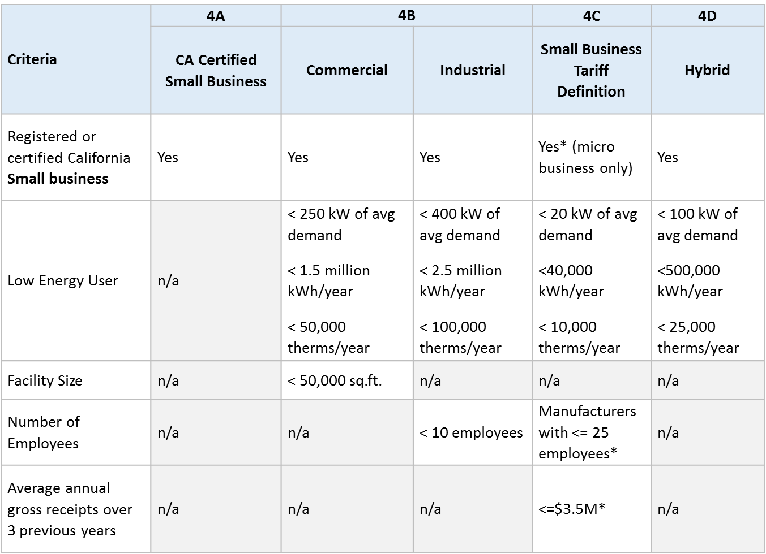

* self-certification is OK

## Polling Results

These polls were non-binding and intended only to gauge the standing of each proposal.

14 of 22 meeting attendees voted on two polls:

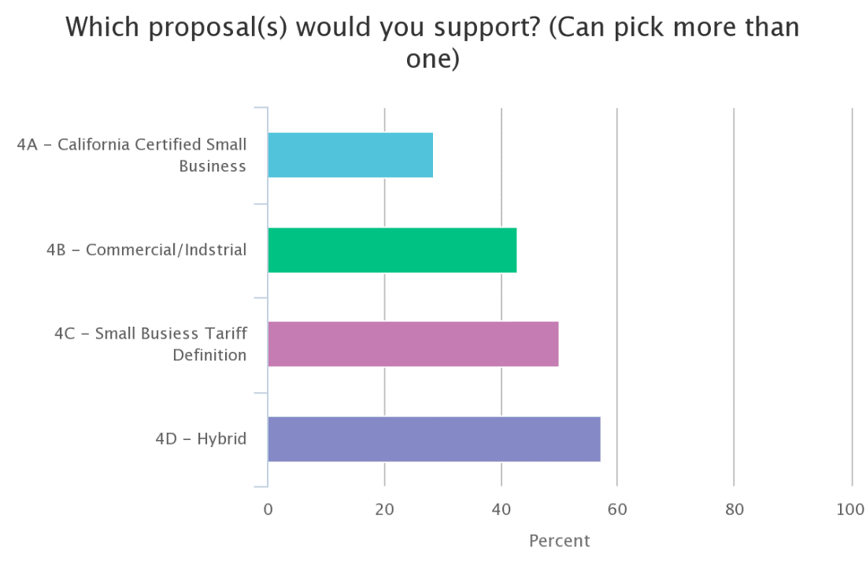

All proposals showed some level of support – with the fewest voters supporting proposal 4A and the most votes supporting Proposal 4D.

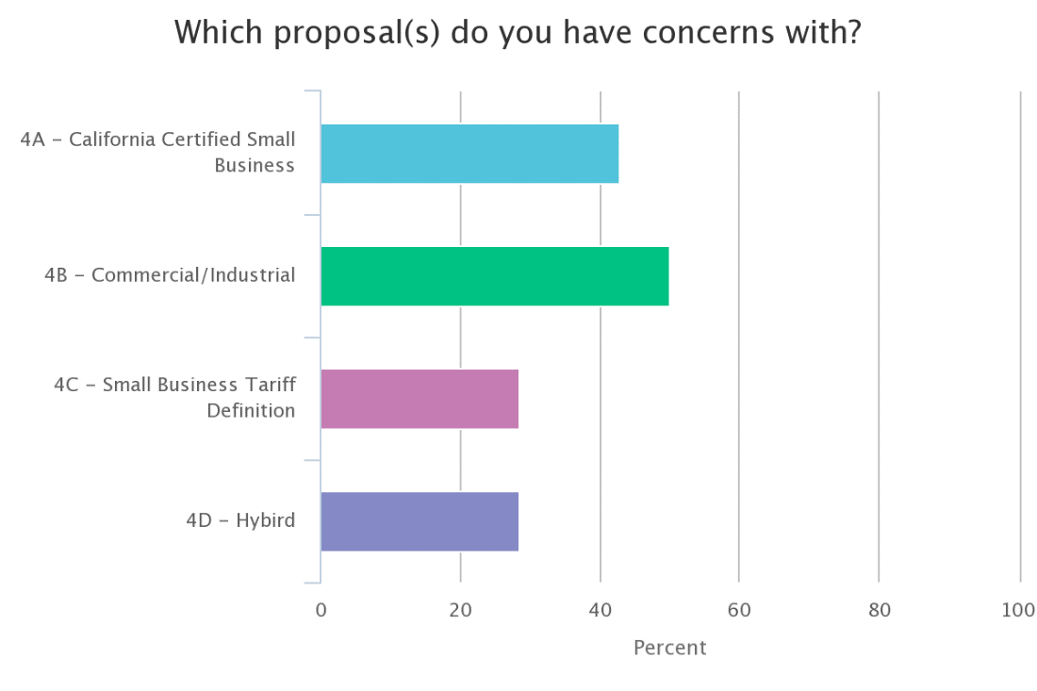

Votes expressed concern with all proposals. The most concerns were with proposals 4A and 4B, and the least concerns were with 4C and 4D.

*We were able to dig into the polling data after the call and analyzed the data by stakeholder group:*



## Discussion

Participants explained their **concerns** with proposals:

##### Proposal 4B (Commercial/industrial)

* Keith - energy limits are too high
* Leonel - energy & peak demand too high
* Jeff - employee count too low (10 was used previously)l supports 25

##### Proposal 4C (Small Business Tariff Definition)

* Mark – the definition is based on an unrelated proceeding (dealing with billing and deposits); the resolution deferred to working group to develop a definition for EE programs so we should not be limited to an existing definition from an unrelated proceeding. T2WG should originate our own content; for example, the numbers chosen for POE (in T1WG) were developed within the T2WG; we should not be required to base on past/existing proceeding; ALSO energy values are too low; the definition allows micro business only but not certified small business
* Stephen - kWh savings are too low; getting tax receipts should not be part of the process [BUT , Jeff noted, customers only have to self-certify so we don't need to collect those receipts if the customer self-certifies]
* Leonel - stuck in between 4C and 4D; the definition (used by Proposal 4C) may be too restrictive; 4C is too restrictive and doesn't capture a class of customers that should be included (e.g., based on my recollection, customers that fit the energy and demand thresholds in 4C were a class that didn’t have demand meters, not until AMI meters were installed, and their bills were based solely on energy, using SCE GS-1 rate tariff. These customers fit the demand and energy profile set in 4C. The proposed energy and demand limits in 4C exclude small business customers that fit within SCE’s GS-2 rate tariff, exceed 25 kW peak demand and typically use more energy annually than the 4C threshold. The proposed definition should allow customers that fit the GS-1 rate tariff profile and a portion of the customers that fit the GS-2 rate tariff profile.)
* Josiah - there is no evidence/logic to back up why these are appropriate levels
* Jeff – remember that the energy numbers are ORs not ANDs

##### Proposal 4D (Hybrid)

* Reggie - 100 kW may be too big

##### Proposal 4A (CA Small Business Definition)

* Josiah – there is a practical difficulty in program delivery with this proposal; we need criteria that are easy to obtain. The vast majority of small businesses haven’t certified so it's not practical to use these criteria
  + Jeff clarified that customers could self-certify – but Josiah expressed that there is still concern that customers would slip through the cracks and customers (or programs down the line) may be tripped up by some aspects of the definition that may be more subjective. Josiah expects that customers would be willing to self-certify, but concerned that the definition is subjective (potential difficulty) and that the proposal doesn’t include anything based on energy data.
* Mark – it’s difficult to target customers without having numbers to work with (e.g., energy data)
* The group on the call suggested dropping Proposal 4A; there was no opposition to dropping 4A
  + Recommendation – Drop Proposal 4A as an official proposal. We will not that the group considered it, but dropped it as a stand-alone proposal because several other proposals used it as one among several options for qualifying criteria.

##### Other Questions/Ideas

* On data - Jeff provided numbers for the average energy data and average revenues (e.g., average revenues for CA businesses $3.5M) for customers in California indicating these are public numbers. <<follow up>>
  + Action – find these data
  + Josiah - Looking at the number of businesses in a particular threshold doesn't capture other constraints (e.g., risk to business, percent of businesses revenue). We should examine things like size of impact (project savings vs consumption); 100kW (in Proposal 4D) is at the bottom end of what SB programs offer nationally; it's a small fraction of consumption and risk.
  + Mark – Staff/Consultants have expressed a concern that increasing the energy thresholds will result in flood of customers, but the percentage of customers participating is small
  + Reggie - projects less than $5k are less than 8% of the portfolio
* What data can we use to help analyze/refine these proposals
  + Action – follow up with stakeholders to strengthen proposals with data
  + Do any **volunteers** have data to share that would support an energy threshold or other relevant criteria?
* Question from the group – Are we stuck with a single statewide definition or can we "tier" by region or sector (comm vs. ind)?
  + The group seemed open to different values by market and suggested these levels should be based on data.
  + Do any **volunteers** want to work on examining data for thresholds by market?
* How do we identify the class of customers that are financially challenged?

**NEXT STEPS**

* Update the proposals and proposal comparison
* Solicit/collect data as possible to support proposals
* Distribute poll to T2WG mailing list to collect input on the updated the Small Business proposals