ISP Guide

Industry Standard Practice
Guide

Version 1.2A

Revision History
Version No. | Date | Description | Author
- | November 20, 2012 | Draft | ASW Engineering
1.0 | January 17, 2014 | Final living document – comments lead to revision | SoCal Gas
1.1 | February 14, 2014 | Final living document, for posting – comments lead to revision | SoCal Gas
1.2 | February 27, 2014 | Final living document, for posting | SoCal Gas
1.2A | April 30, 2014 | Final living document,- comments lead to revision | SoCal Gas

Revision History 2
1. Introduction 3
2. Industry Standard Practice (ISP) 3
2.1 Definition 4
2.2 Technology Measures vs. Process Measures 4
2.3 Adoption Curves 5
2.4 Take-Off 6
2.5 Factors That Determine Industry Standard Practice 7
2.6 Installation Types or Program Types 9
2.7 ISP by Code or Regulation 10
2.8 ISP by Default 10
2.8 No ISP 10
2.10 ISP Risk Assessment 10
2.11 What ISP Studies Don’t Do? 11
3. ISP Study 11
3.1 What is an Industry Standard Practice Study? 11
3.2 Who can trigger an Industry Standard Practice Study? 12
3.3 What triggers an Industry Standard Practice Study? 12
4. Submitting a Request for an ISP Study 13
4.1 Before Starting an Industry Standard Practice Study 13
4.2 Who performs an Industry Standard Practice Study? 13
4.3 ISP Study Request 13
4.4 ISP Study Scope of Work 13
4.5 One-Offs or Exceptions 14
5. ISP Study Investigation 15
5.1 The Investigation Process 15
5.2 SME Questionnaire 16
5.3 Who qualifies as SMEs? 16
5.4 Stakeholder Review and Revision 16
5.5 Who are the stakeholders? 16
5.6 Revise and Address Stakeholder Comments 17
5.7 Finalize Report and Research Notes 17
6. Submit Findings of ISP Study 17
6.1 CPUC staff Review and Approval 17
6.2 ISP Online Repository 17
6.3 Effective Date of ISP results 18
6.4 Longevity of an ISP Determination 18
7. Implications of ISP Study Findings 18
7.1 No Industry Standard Practice exists 18
7.2 An Industry Standard Practice does exist 19
APPENDIX A – CPUC Staff recommended high rigor statewide ISP Studies 20
APPENDIX B - Sample of ISP Studies 21
APPENDIX C - ISP Study Request Form 22
APPENDIX D - High Rigor ISP Study Scope of Work 23
APPENDIX E - ISP Study Investigation Checklist 24
APPENDIX F – Summary of Low and High Rigor breakdown 25
APPENDIX G - ISP Study Flow Chart 27
APPENDIX H – Proposed Implementation Plan 29
GLOSSARY 30

Introduction
The purpose of this guide is to explain the concepts and processes involved with establishing and implementing Industry Standard Practices. This includes the CPUC policies, the terminology, the process of technology adoption, factors that likely indicate technologies becoming Industry Standard Practice, and process for developing and implementing an Industry Standard Practice study.

Briefly, an Industry Standard Practice, or ISP, is a term used to describe a technology or measure that is the typical equipment or commonly-used practice.

Establishing what is Industry Standard Practice is vital to the utilities and regulatory agencies, allowing them to assess the efficacy of energy efficient technologies, measures, and the programs that institute their implementation.

The sections of this guide cover the following topics:
- What is Industry Standard Practice?
- Types of ISP studies and their triggers
- Submitting a request for an ISP study
- ISP study Investigation
- Submit findings of ISP studies to CPUC staff
- Implementation of ISP study findings

This guide is not specific to any California utility. The ISP concepts described herein apply to the portfolio of energy efficiency programs overseen by the California Public Utilities Commission (CPUC). All entities administering the CA energy efficiency programs have an underlying mandate given the fact that their supply resources are limited: to improve energy efficiency. Equally, these same concepts can apply to different types of regulatory agencies, not just limited to energy efficiency programs.

Industry Standard Practice (ISP)
The purpose of an Industry Standard Practice study is to evaluate a technology or measure as to determine standard practice or commonly used measures for a specific application.

Businesses can utilize one or more technologies to produce a product or provide a service. Although several technologies may be suitable, one technology is at times prevalently purchased. This commonly purchased technology would be considered to be standard practice for that application.
For example, in the United States it is Industry Standard Practice to install an air bag system for safety in all passenger cars and light-duty trucks. In this case, the air bag system is the technology that is ISP and the industry is automobile manufacturing since the air bag is commonly installed when the vehicles are built.

2.1 Definition
A basic definition for Industry Standard Practice:

Industry Standard Practice (ISP) represents the typical equipment or commonly used current practice absent the program.

This ISP is used as the baseline to establish the minimum efficiency requirement that must be exceeded to qualify for program incentives. An ISP baseline is used in cost-benefit analysis, comparing the incremental benefits of one technology over the ISP baseline, and to calculate the incremental cost of a technology that exceeds the ISP baseline energy performance.

2.2 Technology Measures vs. Process Measures
Industry Standard Practices are focused on energy efficiency measures and practices that can either be technology based or process based in its scope:
- A technology measure refers to the installation of a technology or equipment that can possibly improve or maintain the same level of service using less energy.
- A process measure refers to the implementation of a process or practice that can possibly improve or maintain the same level of service using less energy.
An ISP that demonstrates the difference between a technology measure and a process measure is maintaining proper tire pressure in automobiles, to maintain fuel efficiency. The practice of checking tire pressure periodically and adding air to maintain the recommended tire pressure is an example of a process measure. In comparison, the use of pure nitrogen gas to inflate tires is an example of a technology measure; in this case the technology is nitrogen gas which is purported to maintain tire pressure without re-inflation.
For the purpose of readability throughout this guide, we will use “Technology” as
a generic reference to mean both technology based and process based measures.

2.3 Adoption Curves
A technology’s adoption in an industry can be graphed over time. Two typical adoption curves are shown in Figure 1, representing how a technology can either become ISP or not.

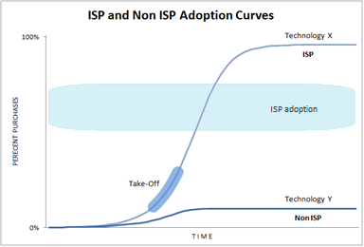
Figure 1 - Adoption Curves for ISP and Non ISP technologies
In the early stages, a technology has only limited adoption, where only a few early adopters will risk implementing the technology. If the technology does not prove to have any benefit, it will not gain momentum or grow; essentially a flat line - represented by Technology Y in figure 1. If the technology proves to have a valued incremental benefit, it will gain more adoption and start to grow exponentially. Eventually it will reach a take-off point where it becomes imminent that it will achieve near "universal" adoption; represented by Technology X in figure 1. The time when near universal adoption is reached does not indicate when Technology X has become industry standard practice.
An example of two technologies competing to be ISP was the “video tape format war” that took place during the 1980s. Video tape recorder machines came in two versions, either VHS or Beta format. Both technologies were suitable for consumers to record and playback videos at home and competed for universal adoption. Over time, VHS became the dominant format due to the longer recording times and that VHS recorder machines were cheaper. Hence VHS became ISP for home video tape recorder technology.

It should be noted that Industry Standard Practice can be localized, specific to a given region. Although VHS was ISP in both United States and Europe, in Japan Beta won the “war” and was ISP until DVD technology superseded tape technology, which occurred in both the United States and Japan simultaneously.

How quickly a technology is adopted is determined by many factors: effective useful life (EUL) of previous technologies, cost to implement a new technology, demonstrated performance, reduced risks in adoption, availability, competing technologies, regulatory requirements, , etc. The time span can range from months to years as shown in figure 2.
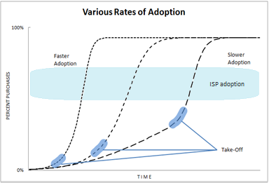
Figure 2 - Various Rates of Adoption Curves

2.4 Take-Off
The "point" when a technology becomes Industry Standard Practice occurs after the technology reaches take-off. It is not a fixed point in time or an exact percentage of the purchases, but a likely range that, through preponderance of evidence, suggests standard practice. It occurs when the technology’s adoption rate is self-sustaining and will continue to grow without external influence, i.e. incentives or rebates.

A unique situation occurs when regulations from federal, state or local agencies mandate the use of a specific technology, forcing the adoption of said technology. Figure 3 shows the rapid adoption of a technology due to the enactment of a regulation.

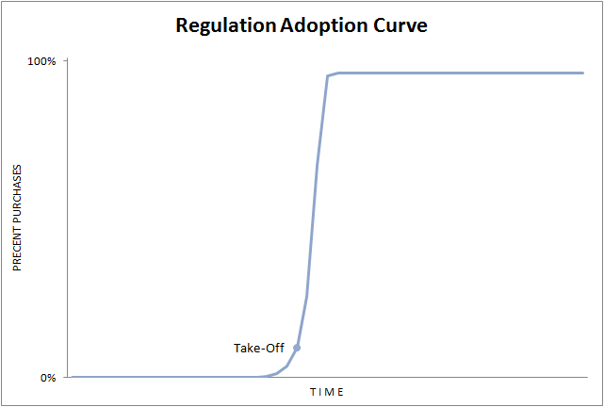
Figure 3 - Regulation Adoption Curve

The take-off point for this case is very specific, it is the date that the regulation goes into effect, and hence becomes ISP. The lead up before the take-off point is driven by early adopters who anticipate the new regulation going into effect.

Example - Early on, airbags were only required in passenger cars, not light duty trucks. But the U.S. government amended the Federal Motor Vehicle Safety Standard to require light duty trucks to have airbags. The regulation became effective on September 1, 1997, which also establishes its take-off point.

Because technologies compete against one another, when a new technology becomes Industry Standard Practice, the previous technology is displaced as ISP; figure 4 shows the transition between the previous ISP and the new ISP.

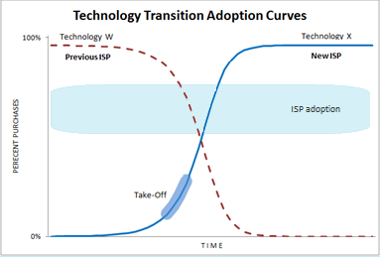
Figure 4 - Transition from One ISP Technology to Another

The take-off point for the new technology, when it becomes ISP, is also when the previous technology is no longer ISP; which occurs before the crossover point (the intersection of the two adoption curves).

2.5 Factors That Determine Industry Standard Practice
There are many factors that can determine when a technology becomes Industry Standard Practice. These factors encompass various fields, including technical, financial, historical and social. Typically it’s not a single factor but a combination of several factors that influence the making of an ISP; the exception to this is ISP by Code and Regulation - see next section.
- Regional - Factors that are local to a region will influence whether a technology is ISP in one region but not in another. These factors include what resources are available locally, customer standard practice, weather conditions, local governments and regulatory agencies, etc.
- Efficiency - This is the main goal of any energy efficiency technology or measure, to increase efficiency and hence save energy. Where the energy savings directly translates into dollars saved, offsetting the cost of the technology being purchased. Technologies that provide a greater efficiency are more motivated to be adopted.
- Nonenergy Benefits – Certain energy-efficient technologies are adopted more for their non-energy benefits such as reduction in maintenance and upkeep costs and energy efficiency benefits are only secondary.
- Availability - A technology must be readily available so implementers can install it as needed for either new installations or for replacement if an existing unit fails. Conversely an older technology that is no longer available is considered to be obsolete and cannot be ISP.
- Ease of Adoption - A technology is more likely to become ISP if it is easily implemented and does not have a steep learning curve. Implementers will be reluctant to adopt a technology that is difficult to get up and running.
- Initial Costs - High capital and purchase/installation costs can be prohibitive in the adoption of a technology. The cost of purchasing and installing a technology must be justified and financed. Typically participants’ payback threshold drives the financial viability of a technology or process.. Incentive and rebate programs can offset initial costs. Typically the cost of a technology declines as it is adopted widely and becomes ISP.
- Operating Costs - The cost of operating, maintaining and repairing are factors that implementers will consider before adopting a technology.
- Reliability - A technology that is highly reliable will consistently operate and produce, versus a technology with poor reliability that will impede production.
- Market Penetration - A technology that is commonly purchased is considered to be ISP. A distinction must be made from what is already installed in the field and what is currently being purchased. Surveying the percentage of units in the field that already employ a technology does not effectively indicate Industry Standard Practice. This installation base is more of a representation of the past or a history of what was ISP. Surveying what is currently being purchased is a more accurate representation of ISP. It is not uncommon to see that the installation base is predominately one technology but currently all new purchases are of the next generation. This typically occurs with technologies that have a long Effective Useful Life (EUL), over 10-20 years, and a newer technology has become an Industry Standard Practice. Due to the older technology’s long life, the installed units have not yet been replaced since they still have useful life. Estimating the percentage of new purchases or retrofits that employ a technology is an accurate indicator of current ISP.
Example - Distribution Transformers are used to provide electrical power to end users from the power distribution lines. These transformers are commonly seen on top of utility poles, the gray cylindrical metal box. Except for the occasional lightning strike, these transformers have long lives, more than 20 years. Periodically the U.S. Department of Energy mandates the manufacture of transformers with higher efficiencies than the previous generation. These higher efficiency transformers can take over a decade to show up in numbers on the utility poles because the current installation base won't be replaced until they have used up their Effective Useful Life (EUL) or burn out.

- Standards - Industries will often adopt standards that are established by a research and development entity for the industry. Although these standards are not legally binding, they can effectively mandate a technology to be used in an industry. Standards like ASHRAE or recommendations from the Green Grid can strongly influence what is Industry Standard Practice. Other sources of standards the California's Public Interest Energy Research (PIER), American Gas Association, etc.
- Program Administrator/Implementor Design - Incentive or Rebate programs are designed to influence standard practices, accelerating the adoption of technologies. Routine ISP studies inform program management of how a particular standard practice impacts eligibility. Good program design takes all the previous factors into account to achieve faster adoption into ISPs.

2.6 Installation Types or Program Types
An ISP study will evaluate a technology or measure for each of the installation types, and will have different implications depending on the installation type. Thus a technology can have different ISP determinations (it is or it is not ISP) for each of the other installation types.

Below is an excerpt the “Project Basis, EUL-RUL, & Preponderance of Evidence” document providing first and second period energy savings baseline.

Table 1. EUL and RUL periods for all Installation Types
Program Install Type | Measure Life Basis | (RUL)/First Period Energy Savings Baseline | (EUL – RUL)/Second Period Energy Savings Baseline
NEW | EUL | Code or ISP Baseline | N/A
ROB | EUL | Code or ISP Baseline⁴ | N/A
NR | EUL | Code or ISP Baseline⁴ | N/A
RET | RUL/EUL-RUL | Customer Existing Baseline | Code or ISP Baseline
REA | RUL or EUL | Customer Existing Baseline | N/A

“If the pre-existing equipment is not capable of reliably meeting the new requirement (such as production change) for its remaining life, then a new equipment baseline must be established utilizing either minimum code requirement or industry standard practice equipment, whichever is applicable.” D. 11.07.030, Attachment B at Page B14.

2.7 ISP by Code or Regulation
Codes and regulations enacted by federal and local governments, and regulatory agencies can mandate a particular technology to be utilized and therefore force it to be ISP. This is also referred to as Code Baseline.
Commercial Lighting Example - California Building Standards Code, Title 24 (2013), mandates that buildings with greater than 10,000 sq ft must have demand responsive automatic lighting controls that uniformly reduce lighting power consumption by a minimum of 15%.
During an ISP study investigation, the technology or measure must still be fully evaluated because even though codes and regulations mandate its use, the industry may be installing a technology that is above and beyond the code baseline as standard practice. This can occur when code standards have been long standing that are outdated, and new technology innovations have been adopted by the industry on its own volition.

2.8 ISP by Default
There are some applications where only one technology is available; no alternatives are commercially available. This can occur when the Industry Standard Practice of one technology is well established over time and all other alternative technologies have died out and became obsolete. Since only one technology is available, it is ISP by default. This also implies that there is only one level of efficiency available for the technology. No incentives will apply.
Example - Landline telephone companies maintain DC power supplies that drive their telephone circuitry. In the past, the telephone companies used Ferro-Magnetic technology to generate DC power from the electric utility's AC power lines. However, 10 years ago Switched-Mode technology was developed that is significantly more efficient and completely replaced Ferro-Magnetic technology. Currently, DC power supply manufactures no longer make Ferro-Magnetic systems and only produce high efficiency Switched-Mode technology. Since Switched-Mode technology is the only commercially available solution, it is ISP by Default.

2.8 No ISP
It is also possible for an Industry standard practice not to exist. This occurs when there is no common practice; where end users are installing more than one technology with none of them typically preferred.

2.10 ISP Risk Assessment
The purpose of an “industry standard practice” (ISP) study is not to assess the potential energy savings that a proposed custom measure can achieve when compared to the existing old equipment. Rather, the purpose is to recommend the appropriate baseline for calculating the potential energy savings. The methodology may not always be intended to provide statistically significant measurements of market penetration rates; a preponderance of evidence of ISP would suffice most of the times. The intent is to collect enough data to make an informed decision and to mitigate Program Administrator and Implementer’s risk that the claimed energy savings for the proposed project will be discounted or disallowed by the CPUC impact evaluation studies.

2.11 What ISP Studies Don’t Do?
Industry Standard Practice Studies do not evaluate how much energy will be saved by its implementation. Nor do they survey installed market penetration, since this is not a good indicator of ISP.

ISP Study

3.1 What is an Industry Standard Practice Study?
An ISP Study is an investigation as to what is presently the Industry Standard Practice for a technology/measure in a given application/market segment. At the conclusion of the ISP study, a report detailing the methodology of the study and the final determination of Industry Standard Practice is published. It is suggested that the ISP study indicate if the evolution of the market researched will require revisiting sooner than 5 years.

Two types of studies:
- Low rigor ISP study – Initiated by Program Administrator and Implementer’s for their use. A typical low rigor study should typically take 4-6 weeks. IOUs may use Direct Implementation (DI) or Evaluation Measurement and Verification (EM&V) funds as appropriate.

- High rigor ISP study – Initiated by CPUC staff and is a comprehensive ISP study for statewide use. A typical high rigor study should take 3-4 months. ISP cost to be managed by CPUC staff-Statewide team using EM&V and/or CPUC staff funding, as determined during SOW development.

All existing ISP studies Program Administrator and Implementer’s intend to use to justify ISP baseline that were not reviewed by Commission Staff, should be made available to Commission Staff for review and approval.

When ISP studies to support baselines are not conducted, strong evidence or prior and currently valid ISP study must exist to waive the need for an ISP study when baseline considerations require it.

Strong evidence, subjective but must rely on multiple sources/evidence that could draw from the some of the following:
- Years since the proposed technology has been introduced; secondary sources on market share
- Years the proposed technology has been in the program
- Literature to demonstrate that the proposed solution is not mature
- Demonstrated evidence of the IMC not meeting typical payback requirement of about three years
- Evidence of lack of widespread availability
- No regulatory or industry standard driving technology or process solution selection
- Equipment performance concerns as demonstrated by customer conducting due diligence to reduce risk

3.2 Who can trigger an Industry Standard Practice Study?
Either the Program Administrator, Implementer, or the CPUC staff can request a low or high rigor study for a measure or technology to be studied to determine if it is Industry Standard Practice.

Before Program Administrator and Implementer initiates ISP study, as a first attempt, they should reach out and interview applicant/customer to gain knowledge and access customer’s awareness of industry standards. Typical practice will be to discuss standard options with the customer performing the type of retrofit and/or consulting with industry practitioners.

3.3 What triggers an Industry Standard Practice Study?
The triggers for an ISP study are the same regardless of who requests it:
      - CPUC staff request - The CPUC staff, at its own discretion, can request the utility to perform an ISP study, or perform the ISP study itself. One situation where the CPUC staff can request an ISP Study is when they are concerned about the proposed baseline for a custom project or a deemed measure.
      - Portfolio High Impact Measures (HIM) – CPUC staff and/or IOU EM&V teams to monitor results to determine when a program cycle measure aggregates 5,000,000 kWh or 1,000,000 therms or the PIP filings may show expected accomplishments that approach these thresholds. CPUC staff-Statewide team to coordinate a high rigor ISP study for statewide use.
      - Program Administrator and Implementer Custom Projects - For a single custom project that approaches 200,000 therms or 500,000 kWh savings potential, the Program Administrator and Implementer may initiate a low rigor ISP study.
      - New or emerging technologies - A new technology, that is replacing an existing ISP technology, could be evaluated to determine if it is the new Industry Standard Practice.
      - Multiple technology solutions to the same application - An ISP study can be triggered to determine which of the competing technologies is Industry Standard Practice

Submitting a Request for an ISP Study

4.1 Before Starting an Industry Standard Practice Study
When a Utility will be starting an Industry Standard Practice Study, it will submit a collaboration form to the CPUC staff. This allows communication on expectations and prevents duplication of work.

4.2 Who performs an Industry Standard Practice Study?
Low rigor ISP study –Typically a low rigor ISP study is conducted by an internal evaluation team or engineering team or third party consultant. It is expected that an ISP study should be initiated at the project concept stage long before an incentive application is submitted and carried by engineering feasibility study.

High rigor ISP study - Initiated by CPUC staff and is a comprehensive ISP study for statewide use. Typically a high rigor ISP study is investigated by a third party research firm independent of utility companies and their customers. An independent investigation is preferred since the conclusions of an ISP study should be impartial.

4.3 ISP Study Request
For low rigor studies an ISP Study Request Form will be used to notify CPUC staff and other Program Administrators of upcoming study entailing a detailed scope of work. See Appendix C for request form.

For high rigor studies CPUC staff and Program Administrator and Implementer’s will collaborate to define the scope of work.

4.4 ISP Study Scope of Work
The ISP study SOW will clarify the EEMs and markets to study, the budget, and timeline for interim and final study results and their dissemination.

The following support documentation is required in the Scope of Work (SOW):
- Project Proposal - If a specific project is involved, then the SOW should include the project description; information on the technology being purchased and where it is being applied. The SOW may also provide information to define the scope of the application, such as size and capacity of the equipment required and the applicable market segment.
- Proposed Measure – The SOW will describe either the technology or practice to be investigated and markets where we suspect it may be ISP.

Other Support Documentation that is not required (but recommended):
- Any relevant known baselines or Industry Standard Practices studies
- Applicable regulatory jurisdictions and industry associations
- If the CPUC Staff has issued a disposition and its findings, if any.
- Measure Codes - Incentive Programs have a set of solution codes to describe the possible measures that can be implemented for projects, which could qualify for incentives or rebates.
- Documents detailing the specific equipment to be purchased: i.e. manufacturer spec sheets of the equipment.
- Other relevant research or studies – previous research and studies can assist in new research for the technology and its past performance issues.

4.5 One-Offs or Exceptions
Projects must be identified if they are “One-Offs”. ISP cannot apply since the technologies are being implemented under unique circumstances and will not apply across the industry.

Exceptions include a highly site-specific customer-engineered system typically in industrial or manufacturing oriented segments, not commercial buildings. In such cases, gross and net will have to be combined and project cost effectiveness screened upfront before approving a project. The ISP in this case would be company-specific standard practice that would have been adopted absent the program.

Program Administrator and Implementer to proactively perform internal check and due diligence to document whether project is a one-off or exception that did not require an ISP study. Commission Staff should be notified of these exceptions so that an ex-ante NTG assessment can be initiated.

“In the cases when there is no regulation, code, or standard that applies, which would normally set the baseline equipment requirements, the baseline must be established using a “standard practice” choice. For purposes of establishing a baseline for energy savings, we interpret the standard practice case as a choice that represents the typical equipment or commonly-used practice, not necessarily predominantly used practice. We understand that the range of common practices may vary depending on many industry- and/or region-specific factors and that, as with other parameters, experts may provide a range of opinions on the interpretation of evidence for standard practice choice. Here again, we expect Commission Staff to use its ex ante review process to establish guidelines on how to determine a standard practice baseline.” D.12-05-015 at 351.

ISP Study Investigation

5.1 The Investigation Process
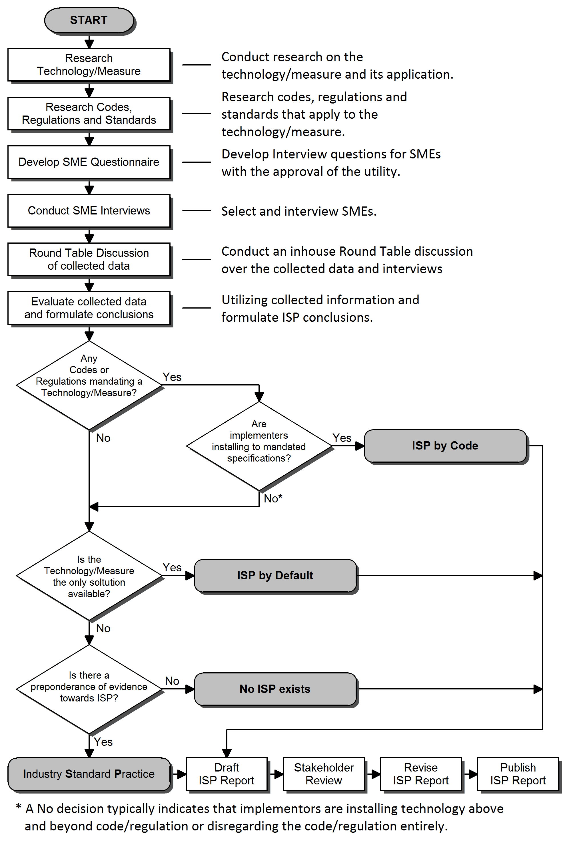
The following flowchart outlines the steps that an ISP Study investigation goes through.

A checklist used for ISP investigations is included in Appendix E - ISP Study Investigation Checklist. It provides a detailed list of tasks that must be performed in order to properly evaluate a technology/measure for its ISP determination.

5.2 SME Questionnaire
The Subject Matter Expert (SME) questionnaire is designed to elicit ISP without directly asking or leading the interviewee. The questionnaire will be developed by the party leading the ISP effort and shared with other parties to obtain input.

5.3 Who qualifies as SMEs?
- Professionals who have extensive experience with either the technology or market segment under investigation; such as industry specific consultants
- Researchers who have knowledge of the technology in question; such as scientist or technologists
- Operators in the industry that utilize the technology in question; facility operators or equipment operators
- Educational Trainers typically teach what is current and relevant in an industry. Also they get extensive feedback from their attendees who are usually operators in the field
- Implementers typically know what is being installed in the field; such as contractors but must be evaluated for biased responses when responding to questions on technologies that generate revenues for them
- Manufacturers can supply background behind their technology and possibly other competing technologies, but must be evaluated for biased responses when responding to questions on technologies that generate revenues for them

Also the utility's engineers or account representatives can supply contacts for SMEs.

As long as those with conflict of interest can provide unbiased responses and have the knowledge of the market penetration, an SME may be interviewed. The preponderance of evidence process would assign more weight to reliable responses.

5.4 Stakeholder Review and Revision
Stakeholders will receive a draft copy of the report before publication, to provide comments and feedback about the findings of the ISP study. If comments are deemed valid additional research is conducted and will be included in report.

5.5 Who are the stakeholders?
- Constituents that are impacted by the findings of ISP study (operators, manufactures, implementers, etc.)
- Account representatives involved with the customers using the technology/measure in question
- CPUC staff
- For high rigor studies, the same stakeholder group that comments on EM&V plans and reports are the stakeholders.

5.6 Revise and Address Stakeholder Comments

5.7 Finalize Report and Research Notes
Redact and finalize the report for publication
Publish Report
Document Research Sources

Submit Findings of ISP Study

6.1 CPUC staff Review and Approval
Low rigor approval – At completion, Program Administrator and Implementer will post study findings on the CMPA website for CPUC staff review and approval. CPUC-approved low-rigor ISP studies will be posted solely for information purposes.
- Upon receiving CPUC staff approval, Program Administrator will redact any customer specific or confidential information then provide a clean copy to CPUC staff to post the low rigor ISP study findings in an CPUC online repository.
- Alternate approach – If an ISP study is used to support a baseline requirement triggered by a project selected by CPUC staff for review, the ISP is approved by CPUC staff in the final EAR disposition.

High rigor approval – At completion, CPUC staff-Statewide team will post study findings in CPUC staff’s CMPA website and/or the PDA web site for review and approval.
- CPUC staff-Statewide team will route ISP study findings to Program Administrator and Implementers ‘ for review and comment, which shall be provided in 10 days after posting. Once comments are addressed CPUC staff will approve and post the final report onto an CPUC online repository.

6.2 ISP Online Repository
All approved low-rigor and high-rigor ISP studies should be uploaded to a central online repository with access available to all Program Administrators, Implementers and stakeholders.

CPUC staff approved low rigor and high-rigor studies shall be posted on the CPUC web site (http://www.cpuc.ca.gov/PUC/energy/Energy+Efficiency/Ex+Ante+Review+Custom+Process+Guidance+Documents.htm). This will aid stakeholders to download and use CPUC staff-reviewed studies to support their base case.

6.3 Effective Date of ISP results

Low rigor -
- Three months after results are approved, if study was initiated as a general study with no project-specific application driving the study.
- Immediately, if study was initiated by a project concept i.e. specific application, the results should apply to the project and similar pending applications.
- Immediately, if study was used to support an EAR baseline and the ISP is approved in the final EAR disposition.
High rigor -
- If identified from the PIPs, the results can apply in three months after the study is approved.
- If identified from a quarterly review of Program Administrator and Implementer’ claims, the results can apply no later than three months after the study results are approved by commission staff.

6.4 Longevity of an ISP Determination
“Standard practice determination must be supported by recent studies or market research that reflects current market activity. Typically market studies should be less than five years old; however this guideline is dependent on the rate of change in the market of interest relative to the equipment in question. “
Attachment B. D. 11.07.030. Page B14

7.1 No Industry Standard Practice exists
If an ISP study determines that an Industry Standard Practice does not exist, then the industry as a whole does not have a common practice for the given application. Therefore a baseline that applies to the industry as a whole cannot be assumed. However, a baseline can exist but only on a case by case basis; typically the market-share-weighted baseline that is better than the in-situ baseline would apply. Refer to “Project Basis, EUL-RUL, & Preponderance of Evidence” document for detailed subject information.

Subject to meeting the functional and technical service requirements using in-situ baseline assumes that the in-situ equipment is available and capable of providing the level of desired service. If in-situ equipment is no longer available, it cannot be used as the baseline. A non-regressive alternative that meets the CPUC’s baseline requirements but is less energy efficient than the proposed solution should be used as the baseline.

7.2 An Industry Standard Practice does exist
If an ISP study determines that an Industry Standard Practice exists, then the ISP study establishes a baseline that applies to the intended market segment.

- Develop Incentive and Rebate Programs to promote the adoption of better than ISP technology.
- Eliminate existing Incentive and Rebate programs to promote adoption of the ISP technology
- Evaluate the performance of existing Incentive and Rebate Programs; are the programs influencing the selection process towards establishing Industry Standard Practice?
- Establish a baseline for custom projects and a dual baseline for Early Retirement projects

APPENDIX A – CPUC Staff recommended high rigor statewide ISP Studies

Per CPUC staff, High Priority Baseline studies are:
1. Data Center Baseline Update
2. Hospital NC Baseline
3. Industrial Boiler Efficiency
4. Network power management software
5. Cloud computing and server virtualization
6. Variable speed drive for the Dairy and WWT industries
7. VOC control methods (RTOs, etc.)
8. Baseline new construction building practices
9. Steam trap and air leak maintenance practices
10. RCx maintenance practices
11. Oil Segment Baseline Update (Oil Field, Refineries and Pipeline)

APPENDIX B - Sample of ISP Studies

Example of quick turnaround/low rigor ISP study:

Example of elaborate/high rigor ISP study:

APPENDIX C - ISP Study Request Form
ISP Request Form Template: Sample:
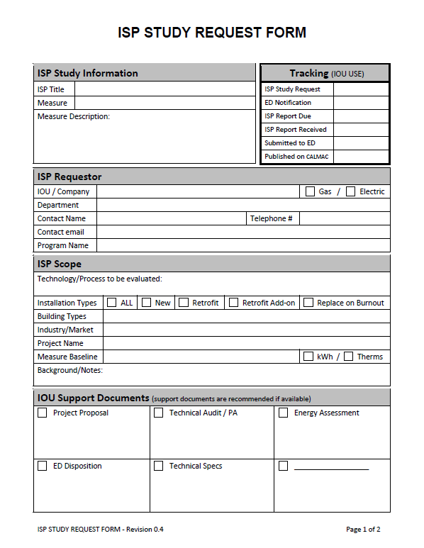

APPENDIX D - High Rigor ISP Study Scope of Work

For high rigor studies CPUC staff and IOUs will collaborate to define the scope of work. High rigor ISP studies are investigated by an third party research firm independent of utility companies and their customers. An independent investigation is preferred since the conclusions of an ISP study should be impartial. At completion, the study will require CPUC staff validation/approval.

1.0 Industry Standard Practice Scope of Work
Provide technical support for California Public Utility Commission’s Staff (CPUC Staff) and Investor Owned Utility’s (IOU); Southern California Edison (SCE), Southern California Gas Company (SoCal Gas), Pacific Gas and Electric (PG&E), and San Diego Gas and Electric (SDG&E). Provide technical support relative to Energy Efficiency and Demand Response programs. Consultant shall provide technical services on an as-needed basis in accordance with terms and conditions and related documents under the final executed Agreement. The Scope of Work shall include some or all of the following categories and tasks listed below. This list is intended for use as a set of guidelines, rather than as a limiting list of specific types of Work and responsibilities. Other technical analyses and consulting support services may be required as contained in specific work requests.
  - Perform product evaluation and research when multiple technology solutions apply to the same application
  - Communicate technology development, such as new energy efficiency products or services that are emerging in the marketplace
  - Review local, state and national building energy code and regulatory policy. Also note schedule of future pending changes and its impact
  - Research changes to building energy code policy
  - Perform parametric modeling and building energy simulation studies
  - Perform literature search and analysis
  - Perform project management of case study or technology demonstration evaluation
  - Perform monitoring and field data collection
  - Evaluate Market Effects and Market Barriers that are preventing certain energy efficiency practices from becoming self-sustaining
  - Perform market research of currently purchased technologies; standard vs. above and beyond
  - Perform research and analysis of product literature, manufacturers’ specification sheets, and technical publications
  - Research, review, assess and report on new/emerging technologies applicable to new and/or existing programs
  - Research, evaluate, analyze and report on new/emerging technology’s methodologies and parameters consistent with DEER and/or IOU deemed measures

APPENDIX E - ISP Study Investigation Checklist

For a low rigor study not all these tasks will be required.
For a high rigor study nearly all these tasks will be required.

The following checklist represents all the tasks that may need to be done to complete an ISP study:
- Research Measure or Technology:
Research history - How long has it been available?
Purchase requirements, cost, time to install, non-energy benefits, payback, EUL, etc
Identify alternative measures or technologies
Identify any barriers preventing adoption
- Research Code, Regulations and Standards
Federal, State and local government
Environmental agencies (EPA, AQMD, etc)
Industry standards
- SME Questionnaire
Program Administrator and Implementer provides any issues to research firm to aid in question development
- Research firm develops interview questions for SMEs
Program Administrator and Implementer review and approval of questions
- Interview SMEs
Locate and list potential SMEs
Call and interview SME's
Maintain call log
- Round Table Discussion (CPUC, Program Administrator and Implementer, 3Ps, EM&V, evaluators)
Review all collected research data
Discuss motives for installing the measures or technologies
- Analyze all available data
Deduce ISP study conclusions
Evaluate for all scope types
Evaluate for all purchase types
Decide what is ISP, given all the available data
Impact from and to any incentive/rebate programs
- Draft Report and Research Notes
Write draft report (redacted, no names of companies or interviewees)
Write draft research notes (document research sources and SMEs)
- Stakeholder Review
Submit draft report to stakeholders for comments
- Revise Report
Conduct additional research, if necessary
Conduct additional interviews, if necessary
Revise report to address stakeholder comments
Revise research notes
- Publication
Submit final report for publication

APPENDIX F – Summary of Low and High Rigor breakdown

§ | Subject | Low Rigor | High Rigor
Section 3.1 | Initiator | Program Administrator and Implementers | CPUC Staff
 | Impacts | Largely Individual Program Administrator and Implementer who initiated | Statewide Program Administrator and Implementer
 | Duration of study | Typically 4-6 weeks | Typically 3-4 months
 | Funding | IOUs may use Direct Implementation (DI) funds for Agriculture, Commercial, and Industrial, as appropriate. | Cost to be managed by CPUC staff-Statewide team using IOU EM&V and/or CPUC staff funding, as determined during SOW development.
Section 3.3 | Triggers | - CPUC staff request  - Portfolio HIM (measure aggregates 5,000,000 kWh or 1,000,000 therms)  - Program Administrator and Implementer custom projects (500,000 kWh or 200,000 therms)  - New or emerging technology  - Multiple technology solution for the same application.
Section 4.2 | Conducted by | An internal evaluation team or engineering team or third party consultant | A third party research firm independent of utility companies and their customers
Section 4.3 | Method of ISP study request | ISP STUDY REQUEST FORM | Standard procedure for review and conduct of EM&V studies
 | Whom to notify | CPUC staff and other Program Administrator and Implementers | CPUC staff and other Program Administrator and Implementers
Section 6.1 | Review | Program Administrator and Implementers will post study findings in CPUC staff’s CMPA website for review  Alternate approach – If an ISP study is used to support an EAR baseline | CPUC staff-Statewide team will post study findings in CPUC staff’s CMPA website and/or the PDA web site Program Administrator and Implementer to review and comment
Section 6.1 | Approval | CPUC staff will  review and approval  Alternate approach – The ISP is approved by CPUC staff in the final EAR disposition. | CPUC staff will address comments, review and approval
 | Post study on online repository | Program Administrator and Implementer to provide approved study redacted of confidential information to CPUC staff to post on online repository | CPUC staff to post approved study on online repository
Section 6.3 | Effective Date | Three months after approval of results, if study was initiated as a general study with no project-specific application.  Immediately, if study was initiated by a specific application, the results should apply to the project.  Alternate approach – Immediately, if study was used to support an EAR baseline and the ISP is approved in the final EAR disposition. | No later than three months after the study results are approved, if identified from the PIPs or a rolling review.
Section 6.4 | Shelf-life of study | Per the CPUC guidance, shelf-life of study is typically five years or less.  It is suggested the ISP study indicate if the findings of the study will change sooner than 5 years.

APPENDIX G - ISP Study Flow Chart

APPENDIX H – Proposed Implementation Plan

Who monitors the SW-ISP process? CPUC staff-DSM-QC Team and IOU-EM&V Team

Lead | IOU Program Administrator and Implementer |  | CPUC-Statewide Team
Requestor | Engineering and/or EM&V |  | CPUC and SW-IOU-EM&V
Level of Study | Low-Rigor |  | High-Rigor
Guidance Document | ISP Guide |  | EM&V Roadmap
Duration of study | 4-6 weeks |  | 3-4 months
Cost Allocation | DI Funding or EM&V |  | IOU share of EM&V/CPUC staff Funding; TBD at the SOW development stage
Review Period | Ex-Ante |  | Prospective
Approach | Proactive |  | Reactive
When is an ISP considered approved & completed? | CPUC staff approved or  EAR baseline disposition |  | CPUC staff approval
Effective Date of ISP results | Three months after approval (non project – specific) or  Immediately (specific application or final EAR disposition) |  | Three months if identified from the PIPs or from a rolling review.
ISP triggers (HIM) | ≥ 200,000 therms (per measure)  ≥ 500,000 kW hours (per measure) |  | ≥ 1,000,000 therms (aggregated)  ≥ 5,000,000 kW hours (aggregated)
ISP triggers (other) | CPUC Staff disposition  New or Emerging Technology  Multiple Tech. Solutions to same application |  | CPUC Staff Dispositions  Evaluation Studies
Repository | http://www.cpuc.ca.gov/PUC/energy/Energy+Efficiency/Ex+Ante+Review+Custom+Process+Guidance+Documents.htm  and/or the CMPA website |  | http://www.cpuc.ca.gov/PUC/energy/Energy+Efficiency/Ex+Ante+Review+Custom+Process+Guidance+Documents.htm and/or the CMPA website
Sample Studies

GLOSSARY
Above and beyond - comparative for exceeding or more than what is required; this typically refers to energy savings or efficiencies that exceeds a baseline energy performance.
Adoption Curve - a graph of the percent of installations using a technology or measure against the time from its initial release
Code Baseline - codes or regulations mandate the baseline
Contractors - Install or implement the technology
CPUC - California Public Utilities Commission is a regulatory agency that regulates investor owned utilities in the state of California, including electric power, telecommunications, natural gas and water companies.
Dual Baseline –(definition excerpt from Project Basis, EUL-RUL, & Preponderance of Evidence_9_9_13.docx)
(Effective Useful Life – Remaining Useful) Life For dual baseline measures the Effective Useful Life minus Remaining Useful Life period is also referred to as the second baseline period.
Early Retirement -

Engineering Firms - typically a third party company that designs and specifies the use of a technology; are these implementers???
End Users - Operate and maintain the equipment/technology
Effective Useful Life (EUL) – (definition excerpt from Project Basis, EUL-RUL, & Preponderance of Evidence_9_9_13.docx)
is an estimate of the median number of years that the measures installed under the program are still in place and operable. EUL values are for new equipment and are provided as years. This allows the EUL to be directly employed with CPUC authorized annual avoided costs and measure-specific energy savings to determine the lifecycle dollar benefits associated with a particular measure. Newly proposed measures may claim up to a maximum EUL of 20 years.
DEER provides estimated EUL values for many different measures to utilize in cost effectiveness calculations. These are typically based on EM&V studies called retention studies that use measure equipment failure data to develop measure survival curves and hence, statistically determine the median life of a measure. EUL values should be taken from DEER when available. When EUL data is not available in DEER, additional studies, manufacturer data, or past maintenance records may be utilized to justify a proposed EUL for a measure and will be subject to review.
New construction measures that combine multiple measures into a single line item (such as the whole building approach) are to claim the average EUL of the combined measures. Measures that consist of both mechanical and electrical components with varying EUL values shall claim the lowest EUL value for the overall measure. Finally, the EUL claimed for a measure installing used equipment should equal the new equipment EUL minus the number of years that the used equipment was operated previously.
Implementers - Spec in, install and commission a technology
Industrial Retro-commissioning (SCG IRCx) - seeks to improve the overall plant energy efficiency by making operational improvements that optimize the performance of existing energy-using systems. Systems should be optimized to meet the facility’s current operational requirements, which may have changed since the initial system design.
Industry Standard Practice (ISP) - is a practice that refers to a technology or measure that is the typical equipment purchased for a specific application.
Installation Base or Install Base -
IOU - Investor Own Utility
Manufactures - Build and sometimes install the technology
Market Penetration -
Measure -
Obsolete - a technology or practice that is no longer in general use; this can be due to that the technology is no longer available; the technology is no longer suitable for current design requirements; …
One-Offs -
Process Measures -
Round Table Discussion -
Remaining Useful Life (RUL) – (definition excerpt from Project Basis, EUL-RUL, & Preponderance of Evidence_9_9_13.docx)
is an estimate of the median number of years that equipment being replaced under the program would have remained in place and operable had the program intervention not caused the replacement. No EM&V studies have been conducted to determine this estimate. For calculated measures RUL is typically calculated by obtaining existing equipment installation dates to determine the age of the equipment, then subtracting this age from the estimated EUL from DEER. When existing equipment installation dates are not available RUL of the existing equipment may be approximated (as established by DEER) as 1/3 of the newly proposed measure EUL. For dual baseline measures, the remaining useful life period is also referred to as the first baseline period.
Stakeholders - all interested parties, technology manufacture, Program Administrator and Implementer account representatives; "those groups without whose support the organization would cease to exist,
Subject Matter Expert (SME) -
Take-Off -
Technology - (double reference)
Technology Measures -
Third Party -

Per the CPUC, D.12-05-015. Page 351: For purposes of establishing a baseline for energy savings, we interpret the standard practice case as a choice that represents the typical equipment or commonly-used practice, not necessarily predominantly used practice.” It also said, “Industry standard practice baselines are established to reflect typical actions absent the program.”
The adoption graphs presented in this guide are only illustrative and are not depicting actual hard data. The vertical axis, "Percent Installation", represents the percentage of installations (all installation types) that are using the technology in question; 100% is just an idealistic range and is rarely achieved in real world practice. The horizontal axis, "Time", represents the progression over time and is not to any scale.
Refer to “Project Basis, EUL-RUL, & Preponderance of Evidence” document for detailed subject information.
The baseline shown here must be the more efficient of existing equipment or code or ISP.
See section 4.5 for One-off or Exceptions.
When ISP studies to support baseline are not conducted, project files should maintain justification for not conducting an ISP study. Strong evidence or prior and currently valid ISP study must exist to waive the need for an ISP study when baseline considerations require it. The thresholds mentioned are starting point to initiate this process.
Similar project applications that are received in the interim after a low-rigor study was initiated should remain on hold pending the release of ISP results.
This list of studies was based on the evaluated results over time and is backward looking. This list will be refreshed by CPUC and IOUs on a quarterly basis to make sure it reflects ISP needs and optimizes limited available resources to carry out. The studies and level of effort should reflect available budget.
Similar project applications that are received in the interim after a low-rigor study was initiated should remain on hold pending the release of ISP results.

