T2WG Task 5 – ISP Guidance
List of issues, Action items, and Recommendations for Meeting #6 (7/10)

This document is a working document with draft content provided by working group participants or collected through various working group discussions. The draft material in this document has not been vetted by participants and does not reflect the final input of the working group – until the final report is produced, the material should be used only as a basis for working group discussions.
This document summarizes the context, relevant documents, identified issues, and proposals to date for Task 5 – ISP Guidance.
Please review the list of issues and proposals and be prepared to:
- Indicate whether you agree with an issue (if not, why not?)
- Indicate whether you agree with the proposal (if not, why not?)
- Share other issues/proposals to would like to add to this list
- Discuss issues/proposals that require input
If you have thoughts or material to share ahead of the next T2WG meeting (including previously-compiled findings, comments, or recommendations) email: t2wg@cadmusgroup.com. You may send notes directly in this document or as separate documents.

Contents
T2WG Task 5 Context 2
Issue 1: Definitions 3
Issue 2: Multiple Types/Applications of ISP Studies 5
Issue 3: Custom/Site-Specific Baseline 6
Issue 4: Application of ISP Findings 7
Issue 5: ISP Study Process 8
Issue 6: Leaders vs. Laggards 11

Reference Documents
All materials are available in the “Task 5” folder on http://t2wg.cadmusweb.com/
- ISP Guide (the “Document”), version 1.2A, final living document, April 2014: ISP Guide Book
  - This is the existing ISP Guidance Document that is under review for T2WG Task 5
- PG&E Redline version of ISP Guide: PGE Comments on ISP Guide
  - This marked up version of the guidance document includes detailed comments and redlines describing issues and suggested revisions to the existing guidance document
- PG&E problem statement and recommendations: PG&E problem statement
  - PG&E’s summary of ISP issues and recommendations
- PG&E kick-off meeting presentation: Kick-off meeting presentation
- PG&E Project Development Protocol: PG&E PD Protocol
  - Proposals for Issues 1, 2, 3 and 4 reference the PG&E PD protocol
- PG&E ISP study request form: ISP Study Request From
  - Proposals for Issue 5 reference the PG&E request form

T2WG Task 5 Context

R.13-11-005, Page 38:
Another issue to be addressed in a collaborative setting is the development and application of Industry Standard Practice (ISP) determinations, as suggested by SCE in its comments on EM&V.
We decline to stop reliance on ISP determinations entirely at this time, as suggested by CEEIC in their comments. Informal ISP studies were initiated by the utilities as a method of risk assessment for individual projects. Those studies can still be helpful in determining whether an implementer has achieved incremental energy savings by convincing the customer to go beyond the usual type of equipment purchased in that customer’s sub-segment, and for identifying larger ISP market studies that should be carried out by the program administrators.
- We agree with SCE that the current ISP Guidance Document should be revised.
- This should be a topic to be addressed in the collaborative working group convened by Commission staff and/or utilizing an existing collaborative forum.
- We also agree with the CEEIC’s contention in its EM&V comments that broader ISP studies should be used as an approach to market assessment.
- How these studies should be designed and carried out should be clarified in the revision to the existing ISP Guidance Document (i.e., “Industry Standard Practice Guide, Version 1.2A,” Final Living Document, April 2014

Issue 1: Definitions
The Document needs clear and consistent definitions of the following terms/concepts:
- Industry Standard Practice (ISP)
- ISP study
- ISP baseline
The document needs to be cleaned up to be clear and consistent. The term ISP is often perceived as market penetration in the document. Market saturation graphs in the existing document imply ISP determination is based upon penetration rate; however, the ISP Guide does not indicate any penetration or market saturation metric or threshold that would define a measure as ISP.

Action Item:
Review Section 1 and 2 of ISP GuideBook-v1.2A and consider whether the current definitions need revision. Are the existing definitions accurate, clear, and consistent?
If the existing definitions require or would benefit from revision, indicate what needs to be changed and suggest a new definition.

Following (in italics) are excerpts from the current Document with PG&E comments on issues with existing definitions.

Section 1. Introduction
Briefly, an Industry Standard Practice, or ISP, is a term used to describe a technology or measure that is the typical equipment or commonly-used practice.

Section 2.1 Definition
A basic definition for Industry Standard Practice:
Industry Standard Practice (ISP) represents the typical equipment or commonly used current practice absent the program.
This ISP is used as the baseline to establish the minimum efficiency requirement that must be exceeded to qualify for program incentives. An ISP baseline is used in cost-benefit analysis, comparing the incremental benefits of one technology over the ISP baseline, and to calculate the incremental cost of a technology that exceeds the ISP baseline energy performance.

Section 2.1 Footnote
Per the CPUC, D.12-05-015. Page 351: For purposes of establishing a baseline for energy savings, we interpret the standard practice case as a choice that represents the typical equipment or commonly-used practice, not necessarily predominantly used practice.” It also said, “Industry standard practice baselines are established to reflect typical actions absent the program.”
Section 2.3:
Adoption curves – justifying ISP
Section 2.5
Market Penetration - A technology that is commonly purchased is considered to be ISP. A distinction must be made from what is already installed in the field and what is currently being purchased. Surveying the percentage of units in the field that already employ a technology does not effectively indicate Industry Standard Practice. This installation base is more of a representation of the past or a history of what was ISP. Surveying what is currently being purchased is a more accurate representation of ISP. … Estimating the percentage of new purchases or retrofits that employ a technology is an accurate indicator of current ISP.
Standards - Industries will often adopt standards that are established by a research and development entity for the industry. Although these standards are not legally binding, they can effectively mandate a technology to be used in an industry. Standards like ASHRAE or recommendations from the Green Grid can strongly influence what is Industry Standard Practice. Other sources of standards the California's Public Interest Energy Research (PIER), American Gas Association, etc.
Program Administrator/Implementor Design - Incentive or Rebate programs are designed to influence standard practices, accelerating the adoption of technologies. Routine ISP studies inform program management of how a particular standard practice impacts eligibility. Good program design takes all the previous factors into account to achieve faster adoption into ISPs.”
Glossary Section:
Industry Standard Practice (ISP) - is a practice that refers to a technology or measure that is the typical equipment purchased for a specific application.

Proposal
Table summarizes issues and presents proposed new definitions for key terms.

Term | Issues | Proposed New Definition
Industry Standard Practice (ISP) | confusing, conflicting, no quantitative metric to measure | TBD
ISP study (to include types/applications) | Confusion among different types of ISP investigations; Confusion between ISP study and Project Development steps | An investigation or study through surveys to understand whether a specific measure is a common practice that meet the needs of the like process/ application.  Need to differentiate among three types/applications, and how to perform [Issue #2]
ISP baseline | needs clear and accurate definitions; confusion leads to undesirable consequences. | Task 1 language (Standard Practice Baseline_V9)

Issue 2: Multiple Types/Applications of ISP Studies
The ISP Guidance Document does not distinguish between different applications of ISP studies.

Action Item
Review Section 3.1 of the ISP Guidance Document (ISP GuideBook-v1.2A) to decide whether existing division (low rigor ISP study vs. high rigor ISP study) make sense. Provide recommendation on what different types of ISP studies exist.

Proposal
Define three types of ISP studies:
- Measure sunset
- Market-based
- Customer or site-specific
The table below suggests a sample population, sample size, and rigor level for each ISP study type.
ISP Study Type | Research Sample Population | Sample size | Rigor
Measure sunset | Customer (participant & non-participant) Vendors/suppliers/manufactures Designers | Small | Low
Market-based | Customers (participant & non-participant) Vendors/suppliers/manufactures Designers | Moderate to large | High
Custom or site-specific | Phase 1: Review with the customer to understand and analyze key project development elements (eligibility, type, influence, baseline/options*)  *Follow SP baseline definition from Task 1 (Standard Practice Baseline_V9)  Phase 2: (where there is no existing market-based ISP study applicable, but it’s still needed to justify the baseline assumption when there are no fewer than 2 options): Interview vendors, suppliers, manufacturers and/or designers. | Phase 1: One  Phase 2: Small | Phase 1: High (in-depth)  Phase 2: Low

Issue 3: Custom/Site-Specific Baseline
The Document does not provide guidance on how to determine the appropriate counterfactual baseline for custom- or site-specific projects.

Action item
Discuss proper project development (PD) process including the following:
- what level of rigor? What are questions to ask the customers?
- When it’s necessary to contact vendors/designer/manufacturers?
- What questions for the vendors/designer/manufacturers?
- Who collects the data and who does the documentation?
- Who does analysis, who does review of the data gathered
- What ‘s range of literature and regulation to be collected and reviewed?
- ****how does this process fit into PD process (drivers & responsible parties)?
- when?
Proposal
This should be part of custom project development (PD) process that includes data collection for justifying eligibility, measure type, influence, and appropriate SP baseline. In fact, the SP baseline has been fully addressed in Task 1 SP baseline definition and should be followed as part of the PD process.
A clear guideline about custom and site-specific ISP needs to be included in this update in contrast with the need for market-based ISP study, in sync with the custom review process, to avoid review process delays or wasted efforts.
We recommend the T2WG to work out a synchronized process between Project development, the applicable ISP study, and custom review process to minimize project delays due to absence of a market-based ISP study when it’s applicable and necessary. For additional info, refer to PG&E’s PD Protocol (PG&E Project Development Protocol).

Issue 4: Application of ISP Findings
The Document does not provide information on when to integrate the ISP study and outcomes into the custom project review process. ISP guidance must specify scenarios for project hold-up and contingency plans.

Action Item
Provide your recommendation on appropriate effective date or transition period for custom or site-specific ISP studies. Also, Review PG&E’s project development protocol (Project Development Protocol) and Task 1 baseline definition (Standard Practice Baseline_V9) to address project hold-up and resolutions for different scenarios.

Proposal
There is no project hold up for custom or site-specific PD (or ISP approach) by following the PD protocol. CPUC has the ultimate authority to hold up projects only if:
- the measure would trigger market-based ISP study per trigger threshold; and
- market-based ISP study is non-existent or outdated; and
- the market-based ISP, if feasibly performed with statistical significance, would be applicable to the specific measure at question.

Issue 5: ISP Study Process
The Document does not provide clear guidance on process, reviews, and stakeholder roles throughout the process of an ISP study; not does it provide guidance to justify what type of ISP study is warranted and applicable.

Action item:
Review Section 5 and 6 of ISP Guidance Document (ISP GuideBook-v1.2A) and discuss the following:
- Request form: for scope of work and justification for the types of study to apply
- Survey instrument and review
- Sample selection and recruitment
- Survey administration
- Data compilation and analysis
- Literature reviews
- Draft report
- Stakeholder/ED review
- Final publication (venue) current: http://www.cpuc.ca.gov/General.aspx?id=4133
- Turn-around time for each step
For Market-based ISP which is expected to take months to complete, discuss its rigor levels, applicability, and project hold-up related to reviews. Also, discuss the metrics/ quantitative threshold from survey data for use of deciding ISP vs. non-ISP:
- What questions PAs need to design and collect?
  - Do broad market studies suffice?
  - What secondary research suffices?
  - What primary research suffices?
  - Develop specific core questions to ask if interviews/surveys involved?
- Who collects the data and does the analysis?
- Who is involved in the development of the research plan?
- How is the data analyzed and interpreted?
- Review of the market-based ISP report?
- What is the dispute resolution process?
- What is the timelines for each step?
- Publication

The flowchart shows the current process for ISP studies [pg. 15 of ISP GuideBook-v1.2A]:

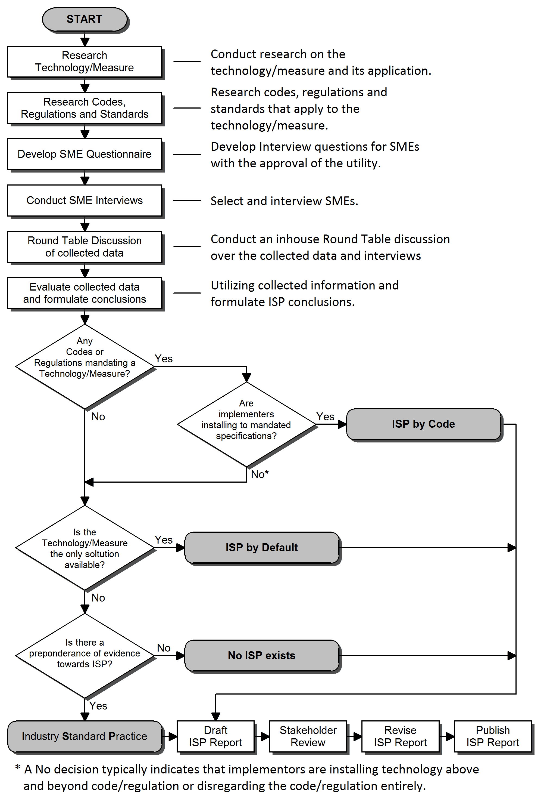

Proposal

PG&E has adopted an ISP study request form (ISP Study Request From) that is used to justify the need for an ISP study, the types of ISP study (market-based, sunset, or custom-/site-specific), and the applicability of the study outcomes.

Issue 6: Leaders vs. Laggards
The Document does not provide guidance on how to address ISP for laggards (late adopter in the market of high-penetration) vs. ISP for leaders (early adopter in market of low-penetration)

Action Item
Provide recommendation on how to address ISP for leaders (early adopters) vs. laggards (late adopters)

Proposal
TBD – Needs a proposal
- Differentiate by market sub-segmentation? e.g., by size of business, financial status, location, …

