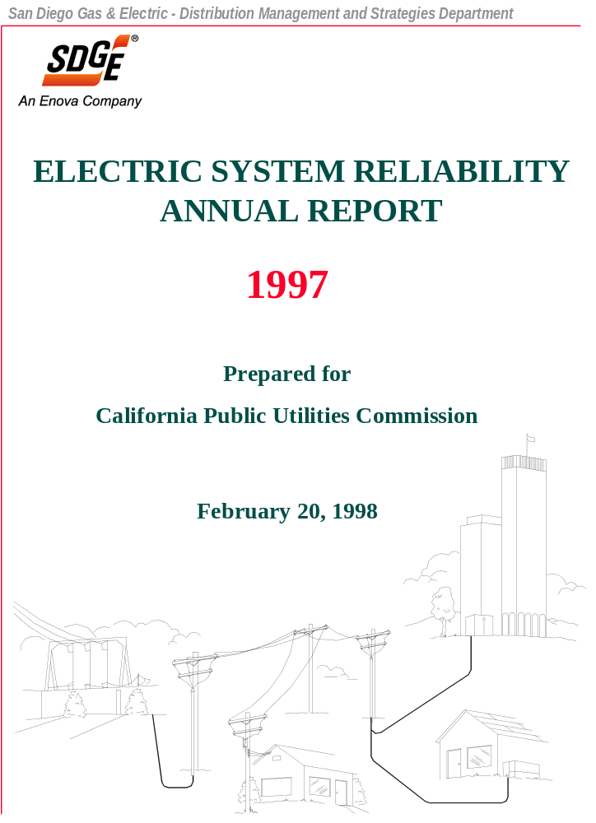

EXECUTIVE SUMMARY

This Electric System Reliability Annual Report for 1997 has been prepared in response to CPUC Decision 96-09-045. This Decision imposed additional reliability recording, calculation, and reporting requirements on SDG&E.

The data in this report is presented in tabular form. System statistics are computed as follows: (1) including transmission, substation, and distribution outages, and (2) excluding planned outages. SAIDI (System Average Interruption Duration Index) and SAIFI (System Average Interruption Frequency Index) values include sustained outages, which are defined as outages lasting 5 minutes or more. MAIFI (Momentary Average Interruption Frequency Index) values include momentary outages, which are defined as outages lasting less than 5 minutes. The units for the reliability measures are:

- SAIDI - minutes of sustained outages per customer per year

- SAIFI - number of sustained outages or more per customer per year

- MAIFI - number of momentary outages per customer per year.

For the purposes of this report, all calculations include forced outages and exclude planned outages. The excludable major event criteria (taken from CPUC Decision 96-09-045) used is as follows:

- The event is caused by earthquake, fire, or storms of sufficient intensity to give rise to a state of emergency being declared by the government, or

- Any other disaster not in (1) that affects more than 15% of the system facilities or 10% of the utility’s customers, whichever is less for each event.

A summary of 1997 values follows:

The largest outage event in 1997, which occurred on September 24-25, was due to a storm and affected 67,036 customers.

In 1997, about 729 customers within SDG&E’s territory experienced more than one 5 minute (or longer) outage per month on a rolling annual average basis, after exclusion of major events.

The reliability values in this report differ in some respects from the values reported under SDG&E’s Performance Based Ratemaking (PBR) program. The values in this report conform to the requirements of CPUC Decision 96-09-045.

TABLE OF CONTENTS

HISTORICAL SYSTEM RELIABILITY DATA
TEN LARGEST OUTAGE EVENTS IN 1997
TEN LARGEST OUTAGE EVENTS IN 1996
TEN LARGEST OUTAGE EVENTS IN 1995
TEN LARGEST OUTAGE EVENTS IN 1994
TEN LARGEST OUTAGE EVENTS IN 1993
TEN LARGEST OUTAGE EVENTS IN 1992
TEN LARGEST OUTAGE EVENTS IN 1991
TEN LARGEST OUTAGE EVENTS IN 1990
TEN LARGEST OUTAGE EVENTS IN 1989
TEN LARGEST OUTAGE EVENTS IN 1988
EXCLUDABLE MAJOR EVENT DETAILS (EXTRACTED FROM THE
10 LARGEST OUTAGE EVENTS) FOR 1997
EXCLUDABLE MAJOR EVENT DETAILS (EXTRACTED FROM THE
10 LARGEST OUTAGE EVENTS) FOR 1996
EXCLUDABLE MAJOR EVENT DETAILS (EXTRACTED FROM THE
10 LARGEST OUTAGE EVENTS) FOR 1995
EXCLUDABLE MAJOR EVENT DETAILS (EXTRACTED FROM THE
10 LARGEST OUTAGE EVENTS) FOR 1994
EXCLUDABLE MAJOR EVENT DETAILS (EXTRACTED FROM THE
10 LARGEST OUTAGE EVENTS) FOR 1993
EXCLUDABLE MAJOR EVENT DETAILS (EXTRACTED FROM THE
10 LARGEST OUTAGE EVENTS) FOR 1992
EXCLUDABLE MAJOR EVENT DETAILS (EXTRACTED FROM THE
10 LARGEST OUTAGE EVENTS) FOR 1991
TABLE OF CONTENTS (continued)

EXCLUDABLE MAJOR EVENT DETAILS (EXTRACTED FROM THE
10 LARGEST OUTAGE EVENTS) FOR 1990
EXCLUDABLE MAJOR EVENT DETAILS (EXTRACTED FROM THE
10 LARGEST OUTAGE EVENTS) FOR 1989
EXCLUDABLE MAJOR EVENT DETAILS (EXTRACTED FROM THE
10 LARGEST OUTAGE EVENTS) FOR 1988
CUSTOMERS EXPERIENCING MORE THAN 12 SUSTAINED OUTAGES
IN A ROLLING 12 MONTH PERIOD (EXCLUDING MAJOR EVENTS) FOR 1997
CUSTOMERS EXPERIENCING MORE THAN 12 OUTAGES IN A
12 MONTH PERIOD (EXCLUDING MAJOR EVENTS) FOR 1988-1996

HISTORICAL SYSTEM RELIABILITY DATA

TEN LARGEST OUTAGE EVENTS IN 1997*

*Based on SAIDI impact.

TEN LARGEST OUTAGE EVENTS IN 1996*

*Based on SAIDI impact.

TEN LARGEST OUTAGE EVENTS IN 1995*

*Based on SAIDI impact.

TEN LARGEST OUTAGE EVENTS IN 1994*

*Based on SAIDI impact.

TEN LARGEST OUTAGE EVENTS IN 1993*

*Based on SAIDI impact.

TEN LARGEST OUTAGE EVENTS IN 1992*

*Based on SAIDI impact.

TEN LARGEST OUTAGE EVENTS IN 1991*

*Based on SAIDI impact.

TEN LARGEST OUTAGE EVENTS IN 1990*

*Based on SAIDI impact.

TEN LARGEST OUTAGE EVENTS IN 1989*

*Based on SAIDI impact.

TEN LARGEST OUTAGE EVENTS IN 1988*

*Based on SAIDI impact.

EXCLUDABLE MAJOR EVENT DETAILS (EXTRACTED FROM THE 10 LARGEST OUTAGE EVENTS) FOR 1997

EXCLUDABLE MAJOR EVENT DETAILS (EXTRACTED FROM THE 10 LARGEST OUTAGE EVENTS) FOR 1996

EXCLUDABLE MAJOR EVENT DETAILS (EXTRACTED FROM THE 10 LARGEST OUTAGE EVENTS) FOR 1995

EXCLUDABLE MAJOR EVENT DETAILS (EXTRACTED FROM THE 10 LARGEST OUTAGE EVENTS) FOR 1994

EXCLUDABLE MAJOR EVENT DETAILS (EXTRACTED FROM THE 10 LARGEST OUTAGE EVENTS) FOR 1993

EXCLUDABLE MAJOR EVENT DETAILS (EXTRACTED FROM THE 10 LARGEST OUTAGE EVENTS) FOR 1992

EXCLUDABLE MAJOR EVENT DETAILS (EXTRACTED FROM THE 10 LARGEST OUTAGE EVENTS) FOR 1991

EXCLUDABLE MAJOR EVENT DETAILS (EXTRACTED FROM THE 10 LARGEST OUTAGE EVENTS) FOR 1990

EXCLUDABLE MAJOR EVENT DETAILS (EXTRACTED FROM THE 10 LARGEST OUTAGE EVENTS) FOR 1989

EXCLUDABLE MAJOR EVENT DETAILS (EXTRACTED FROM THE 10 LARGEST OUTAGE EVENTS) FOR 1988

EXCLUDABLE MAJOR EVENT DETAILS (EXTRACTED FROM THE 10 LARGEST OUTAGE EVENTS) FOR 1988 (continued)

CUSTOMERS EXPERIENCING MORE THAN 12 SUSTAINED OUTAGES IN A ROLLING 12 MONTH PERIOD (EXCLUDING MAJOR EVENTS) FOR 1997

Data is based upon station outages as reported through SDG&E’s Outage Management System.

CUSTOMERS EXPERIENCING MORE THAN 12 OUTAGES IN A 12 MONTH PERIOD
(EXCLUDING MAJOR EVENTS) FOR 1988-1996

Year | District | Circuit Number | Number of Customers Experiencing >12 Sustained Outages
1988 |  |  | None
1989 |  |  | None
1990 |  |  | None
1991 |  |  | None
1992 |  |  | None
1993 |  |  | None
1994 |  |  | None
1995 |  |  | None
1996 |  |  | None

Data for years 1988 through 1994 is based upon complete circuit outages due to historical data limitations.

- Data for 1995-1996 is based upon station outages as reported through SDG&E’s Outage Management System.

