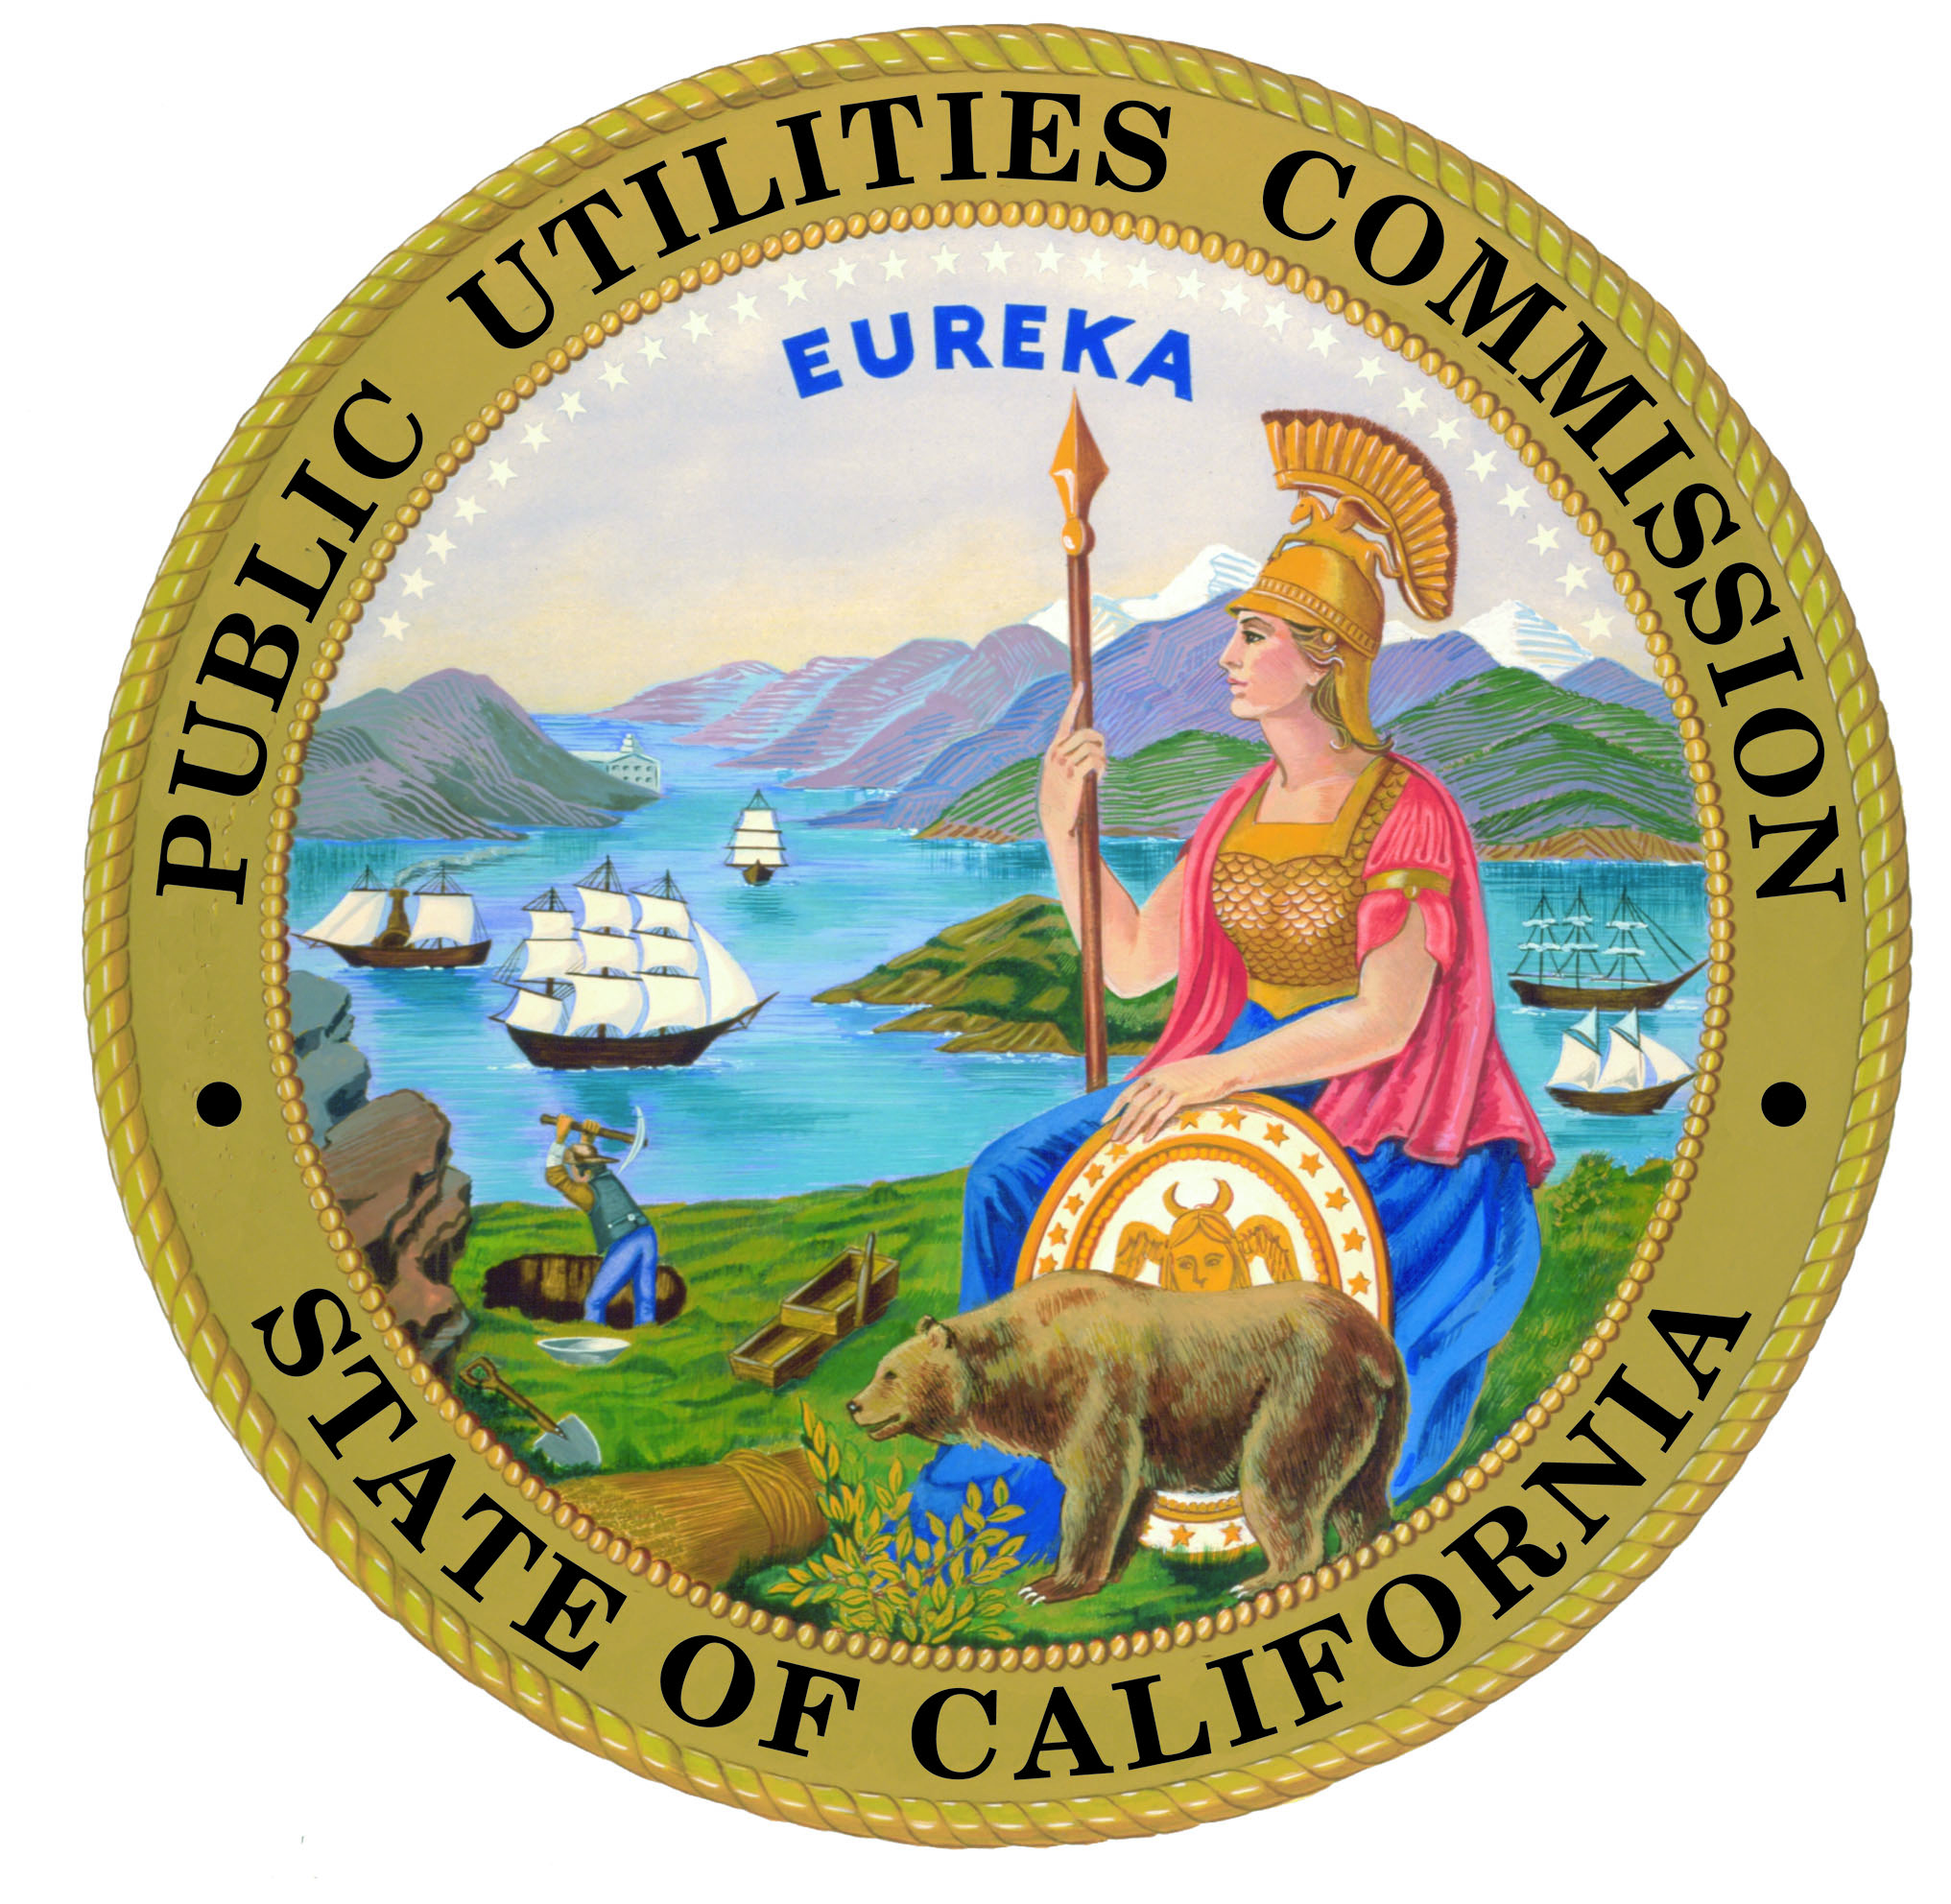

PUC’s Energy Leadership

The California Public Utilities Commission (PUC) plays a key role in making California a national and international leader on a number of energy related initiatives and policies designed to benefit consumers, the environment, and the economy.

Energy Action Plan (EAP) – Roadmap for California
Created by the PUC and its sister agencies, the EAP establishes goals and proposes actions to ensure that adequate, reliable, and reasonably priced electrical power and natural gas supplies are achieved and provided through policies, strategies, and actions that are cost-effective and environmentally sound for California’s consumers.
- The EAP adopts a “loading order” of preferred energy resources to meet the state’s needs. Energy efficiency and demand response are the first ways to meet the energy needs of California’s growing population; Renewable energy is the best way on the supply side. Finally, the state would look to conventional generation and transmission infrastructure investment.

Protecting the Environment – Lowering Greenhouse Gas Emissions
Cleaner electricity production is an essential factor in solving climate change issues. The PUC is a member of the Climate Action Registry and the state’s Climate Action Team.
- Adopted a policy requiring the state’s investor-owned utilities to account for the financial risk associated with greenhouse gas emissions in evaluating new long-term resource investments. This $8 value per ton of CO2 is used by the utilities as a “Greenhouse Gas Adder” in long-term planning or procurement (five years or longer). The adder is for evaluation of contracts and is not for payment by any entity.
- On January 25, 2007, the PUC adopted an interim Greenhouse Gas Emissions Performance Standard (EPS) in an effort to help mitigate climate change. The EPS is a facility-based emissions standard requiring that all new long-term commitments for baseload generation to serve California consumers be with power plants that have emissions no greater than a combined cycle gas turbine plant. That level is established at 1,100 pounds of CO2 per megawatt-hour.
- Evaluating a cap on greenhouse gas emissions of the utilities’ generation portfolios, both owned and contracted.

Groundbreaking Energy Efficiency Goals
Building on California's proud history in energy efficiency, the PUC created the most ambitious energy efficiency and conservation campaign in the history of the utility industry in the U.S.

- Approved $2 billion in energy efficiency funding for 2006-2008 for the state's utilities, reaffirming that cost-effective energy efficiency is the state's first line of defense against power shortages, as outlined in the Energy Action Plan.
- Obviates the need to build three additional conventional fired power plants, yielding net savings of $2.7 billion dollars, a 2 to 1 return on investment.
- Cuts energy costs for homes and businesses by more than $5 billion.
- Reduces global warming by an estimated 3.4 million tons of carbon dioxide by 2008, which is equivalent to taking about 650,000 cars off the road.

Aggressive Renewable Power Targets
The PUC is committed to the environment and the use of renewable power. California has the most ambitious renewable goals in the country.
- In the Energy Action Plan, the Commission set a goal of requiring the utilities to obtain 20 percent of their power from renewables sources by 2010 (Senate Bill 107 codified this goal in state law).
- Utilities are making progress toward attaining this target and the PUC is now identifying the steps necessary to meet even higher goals beyond 2010, such as the governor’s goal of 33 percent of electricity sales by 2020.

Advanced Metering and Demand Response
Demand Response enhances electric system reliability, reduces power purchases and individual consumer costs, and protects the environment.
- Approved PG&E’s Advanced Metering Infrastructure (AMI) plan. PG&E will be deploying advanced meters throughout its service territory over the next five years. SDG&E’s AMI proposal is currently under consideration, and if approved, SDG&E will begin deployment starting in 2008. Edison is evaluating options and is expected to file a business plan by mid-2007.
- PUC’s efforts on demand response will moderate peak demand growth and allow the state to reduce infrastructure investments that would otherwise have to be made. For example, the PUC recently directed Edison to expand their AC Cycling program by 225 MW at a cost of $18 million dollars. This avoids the need to build new peaker plants.

Promoting Solar Power - the California Solar Initiative (CSI)
California has set a goal to install 3,000 megawatts of new, customer-side solar photovoltaic (PV) projects by 2017 under the new California Solar Initiative - moving the state toward a cleaner energy future and helping lower the cost of solar systems for consumers. The PUC, as the lead agency for incentives for all solar installations except those in new homes, is launching this flagship incentive program for the nation.
- Designed performance-based incentives that motivate demand for incentives and accurately reward the best solar installations, while also encouraging energy efficiency upgrades.
- Wrote a descriptive handbook that guides purchasers and installers through program eligibility requirements and the process to apply for incentives.
- Developed a consumer-friendly calculator and online application tool to illustrate the rebate levels and the projected return on investment for the purchase—and make it easier to apply for the incentives.
- Created a new solar website with the California Energy Commission: www.GoSolarCalifornia.ca.gov – a one-stop information center for solar education, rebates and other incentives, and applications.

Ensuring the Lights Stay on - Procurement and Resource Adequacy
The PUC reviews and approves plans for the utilities to purchase energy and ensures that the utilities maintain a set amount of energy above what they estimate they will need to serve their customers (called a reserve margin).
- PUC requires the utilities to implement a long-term energy planning process.
- Considering a capacity market and multi-year requirements to further support contracting.
Ensuring Adequate Energy Transmission
The PUC evaluates whether utilities can build new transmission lines in the state or upgrade existing lines. In making this determination, the PUC considers whether the line will contribute to providing reliable electricity to consumers. Since 2001 the Commission has approved over 10,000 MW of transmission expansion projects and is working closely with the Independent System Operator to coordinate decision making on the need for additional upgrades and new projects.
- Upgrades made to Path 15 on schedule and under budget.
- Approved upgrade to PG&E's Jefferson-Martin 230 kV line.
- Approved upgrade to SDG&E's Mission-Miguel line.
- Approved upgrade to Edison's Viejo System project.
- Approved construction of Edison's Devers-Palo Verde No. 2 (DPV2) transmission line project.
- Approved construction of the Antelope-Vincent, Antelope-Pardee, and Antelope-Tehachapi transmission line projects. When completed, the Tehachapi Renewable Transmission Project will provide 4,500 MW of capacity from the wind-rich Tehachapi resource area into the LA Basin.
- Reviewing SDG&E's application for its Sunrise Powerlink transmission line, a proposed 500 kV line and several 230 kV lines that would have the capacity to import up to 1,000 MW of electricity.

Natural Gas and Liquefied Natural Gas (LNG)
To ensure reliable, long-term natural gas supplies to California at reasonable rates, the state must reduce or moderate demand for natural gas. Because natural gas is becoming more expensive, and because much of electricity demand growth is expected to be met by increases in natural gas-fired generation, reducing consumption of electricity and diversifying electricity generation resources are significant elements of plans to reduce natural gas demand and lower consumers’ bills. California must also promote infrastructure enhancements, such as additional pipeline and storage capacity, and diversify supply sources to include liquefied natural gas (LNG). LNG will help to increase supply and thereby moderate price for California.
- PUC has required the California natural gas utilities to file open access tariffs, which provide firm access to natural gas supplies from LNG terminals or from pipelines.
- PUC approved stricter natural gas quality standards. By establishing natural gas quality rules now, the PUC gave LNG providers the certainty they need in order to begin procuring new supplies.
The first LNG receipt point has been established in southern California at Otay Mesa, with deliveries expected in 2008.

California Clean Energy Fund (CalCEF) Promotes Clean Technologies
CalCEF was created as a result of the PG&E bankruptcy settlement. It will make investments in new clean energy technologies.
- CalCEF has made investments in early-stage companies and has taken a leadership role in fostering energy efficiency.
- In April 2006 the nation’s first academic center dedicated to energy efficiency was established at UC Davis—funded by a $1 million challenge grant from the CalCEF.

