COMMENTS OF THE UTILITY REFORM NETWORK ON DRAFT “PROTOCOLS FOR ESTIMATING THE LOAD IMPACTS
FROM DR PROGRAM” (THE REPORT)

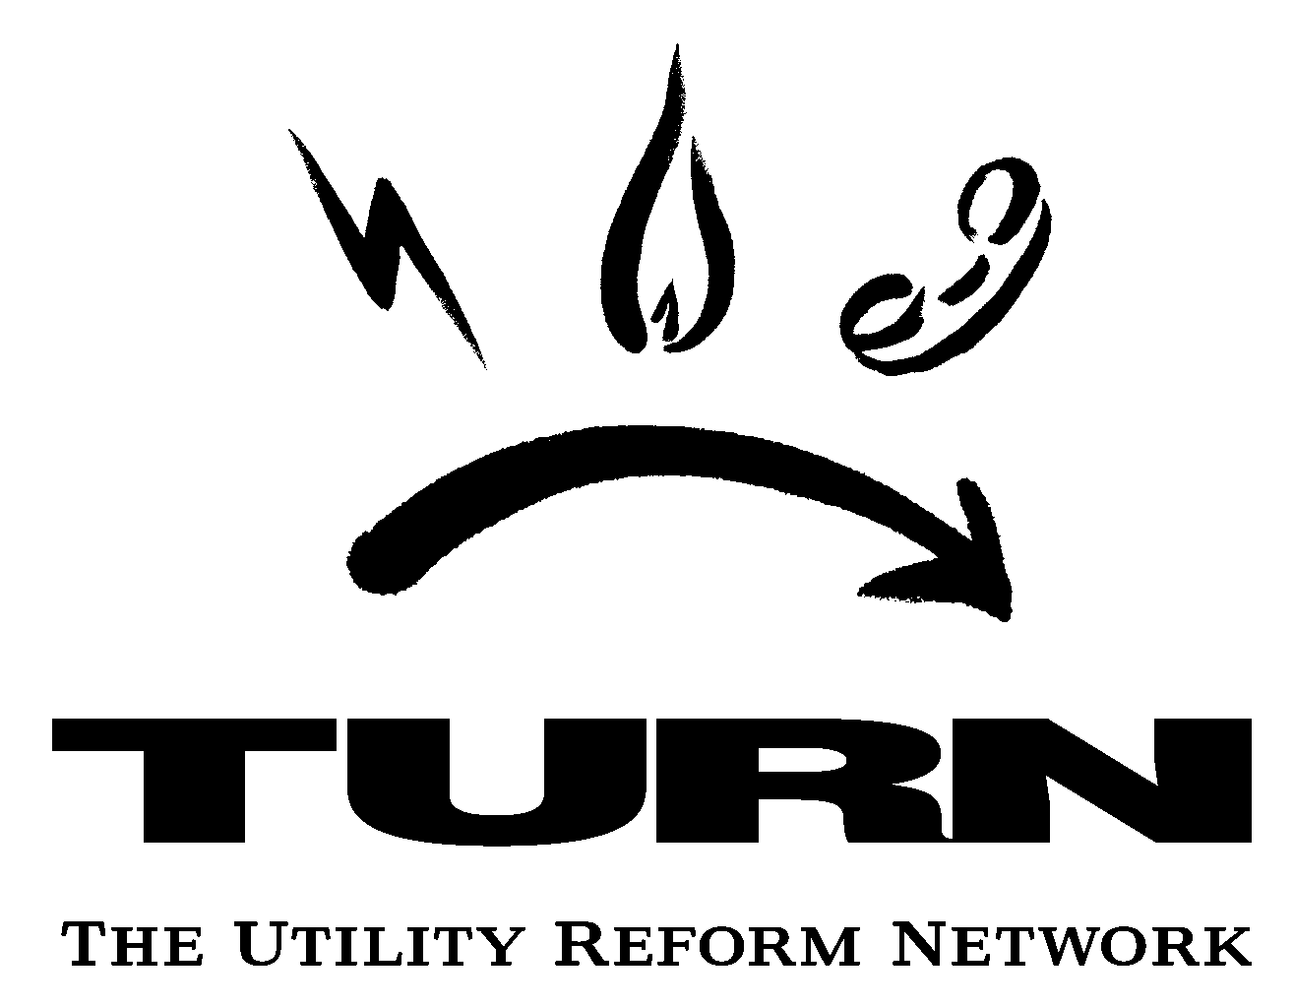 | Marcel Hawiger, Staff Attorney  Jeffrey Nahigian, JBS Energy, Inc.  THE UTILITY REFORM NETWORK  711 Van Ness Avenue, Suite 350  San Francisco, CA 94102  Phone: (415) 929-8876 ex. 311  Fax: (415) 929-1132  Email: marcel@turn.org
May 2, 2006

The Commission directed agency staff in D.05-11-009 to “prepare a set of draft protocols for estimating load impacts for both price responsive and reliability demand response programs,” and then to “prepare a proposed rulemaking or recommend an alternative procedural approach for Commission consideration no later than six months after the draft protocols are circulated.” (D.05-11-009, p. 12-13.) TURN commends staff and their consultants for preparing a report that thoroughly and concisely addresses the issues related to measuring the load impacts from demand response programs.
General Comments
1. The Report defines “price-responsive” versus “reliability-triggered” programs and then discusses the distinction between “dispatchable” and “non-dispatchable” programs. TURN offers the following observations concerning program definitions:
- Despite the language in D.05-11-009, the Commission categorized programs as “day-ahead” versus “day-of” in D.05-01-056, replacing the previous “price-responsive” versus “reliability” distinctions; and the Commission stated that only “day-of” programs qualify to meet adopted DR goals. The Report could address the relationship between measurement protocols for purposes of meeting Commission-established DR goals versus other planning purposes.
- The Report defines all programs that have an event trigger as dispatchable, thus excluding only programs such as scheduled load reductions and TOU or RTP tariffs. Presumably, this definition is based on language in D.04-10-035 and D.05-10-042. The Commission has stated that “dispatchable” DR programs that meet certain requirements (available at least 48 hours, operate at least two hours per day) are eligible to count toward resource adequacy requirements. However, it is not clear that a final definition of “dispatchability” has been adopted for the purpose of identifying eligible DR programs, and the Commission noted that no specific protocols governing program dispatch have been established by the ISO or by LSEs. (D.05-10-042, p. 53.)
TURN recommends that staff identify the purpose of this distinction as it relates to both CPUC-regulated resource planning as well as ISO decisions regarding load and resource forecasting. TURN recommends a discussion of how DR dispatchability (based solely on a trigger event) relates to supply side reliability in the context of using DR as a replacement for supply side resources in resource adequacy analyses. For example, a supply contract that has a “trigger” for calling upon a particular power plant would be unlikely to qualify as a “dispatchable” contract if the generator had complete discretion (with no contractual penalties) as to whether to supply or not based strictly on economic calculations.
- The Report makes clear that it is addressing measurement protocols primarily for the purpose of resource planning and cost effectiveness analyses, rather than for financial settlement. TURN does not, however, necessarily agree that financial settlements should be based on simpler methods even if those prove to be erroneous. While TURN understands that customers and aggregators would prefer monthly payments, there is no inherent regulatory justification for overpaying for DR merely to settle sooner. Consideration should be given to using a consistent methodology or to adjusting simpler baseline methods based on retrospective comparison to regression analyses.
- While TURN offers our initial comments on the various identified issues, we also note that evaluations of demand response program performance in 2005 is ongoing, and that preliminary results were presented only last month. TURN’s analyses and recommendations concerning several important issues (especially regarding proper baseline measurement) will be affected by consideration of the final evaluation reports that provide actual data concerning performance of these programs and measurement methods.
Comments on Specific Impact Issues

Issue # | Brief Description | TURN Comment
1 | Retrospective v. Forecasted Load Impacts | Retrospective methods should be used since are likely to be more accurate. If you use forecasted load impacts, must understand whether there is an inherent and systematic bias stemming from this method.
2 | Impact Estimation for Education and Marketing Programs | No, do not estimate impacts from these programs. High likelihood of inaccuracy does not warrant cost of measurement or data collection.
3 | Event-based Programs | All four impact are important. Outside event period important and discussed in the section on spillover effects.
4 | Other Influential Factors to be Estimated | - Should measure factors identified in first bullet (multiple days, heat storms and variability of baseline).  - Time dimension more important for dispatchable programs like AC cycling and interruptible programs. Also more important for programs used to bid into ancillary markets. Should communicate with aggregators/entities that bid into these markets.  - Synergies—may be worthwhile to assess, but synergies between energy efficiency and DR programs should be adjusted out of DR program impacts. For instance, installing efficient air conditioners will dilute savings from DR. The diluted savings should be netted out of the demand response program (CPP, smart thermostat, or AC cycling) and not netted out of energy efficiency.
5 | MW Impact Estimates for non-Event-based DR | - Certainly need to look at these issues, but this is not a high priority item (given limited ratepayer money to look at these issues need to prioritize them). Essentially the issue is not going to be do we need this for resource adequacy or system operations, but what effect these programs will have on overall system load shapes, and most importantly are they worsening or improving load shapes.
6 | Other Influential Factors for non-Event-based DR | n/c
7 | Estimation for Settlements versus B/C Analyses and Resource Planning | While we understand the need for transparency for load settlements and the tradeoff in accuracy (vs. regression analysis), we should measure whether inherent bias exists between two methods. TURN’s understanding is that 10 day baseline is better than 3 day baseline but less than regression in accuracy. If bias found using a baseline technique necessary for settlements, then consider using regressions technique to define and measure the bias and consider developing some type of adjustment factor in the tariffs accordingly.
8 | Program-wide v. Customer-specific impacts | n/c
9 | Control groups | Probably OK to use only participant load drops and little need for nonparticipants.
10 | Adjustments to Event-day baseline | - Using event day baseline is not a good idea and appears to increase potential for customer gaming.
11 | Baseline and Extreme Load Variability | - May need special measurement for customers with extremely variable loads (e.g. submetering of end uses). Need information on customer scheduling to forecast reduction for interruptible-type programs. For example, in the 1980s Edison called an interruption on 4th of July but got no load reduction because no one was working. May need to determine a customer coincidence load factor. However, this could be of lower priority than other issues. (should be studied but move down the list).
12 | Estimation for Large Contributors | - Special measurement for very large contributors has merit, though may be a low priority item.
13 | End-Use Metering | - If regression is not providing adequate accuracy may need specific submetering for particular customer end-uses, but this is a low priority.
14 | Negative Customer Impacts | - Yes, should definitely net out negative impacts from programs.
15 | Free Riders | - Yes, should net out free riders. This is even more important than energy efficiency because of operational and resource planning concerns. May be more difficult to figure than free riders for energy efficiency but is more important.
16 | Spillover | - Not a high priority. Little system benefit and customer benefits from bill reduction. Bounceback of load may actually be more important by shifting system peak.
17 | Post-Event Day Load Data | - Not high priority and examine in the future.
18 | Statistical Accuracy of Impacts using Representative Day Baseline | - Fact that statistical accuracy of representative day baseline cannot be determined is a rationale for discounting impacts of DR programs.
19 | Statistical accuracy of Baselines | - Same as #18
20 | Representative Day approach for mass-market | - n/c
21 | Other issues with representative day baseline | - n/c
22 | Time period for regression | - n/c
23 | Event-specific versus average event impacts | - Prefer event specific to averaging impact measurement. Many programs need this because they are weather and season specific (AC cycling, smart thermostat, etc.).
24 | Prior estimates in regression | - n/c
25 | Extending customer-specific impact estimates | - n/c
26 | EE evaluation protocols | - n/c
27 | Ratio and difference estimation procedures | - n/c
28 | Impacts other than customer load | - Must not apply additional value to DR program that do not to apply to a combustion turbine. For instance, reducing market prices (avoiding blackouts, etc.) can also be accomplished through dispatch of a CT. Must be able to compare supply and demand resource on equal basis.

Comments on Specific Cost Issues

Issue # | Brief Description | TURN Comment
1 | Non-participant Costs | TURN believes these costs are similar to the situation of a customer who could not transact business with a business that was should down because of the calling of the nonfirm program. Such non-participant costs are highly speculative and do not warrant ratepayer expenditure for study. Not a priority.
2 | Incremental DR Participant Costs | TURN assumes these participant costs comprise the costs traditionally included in all the b/c tests (participant, utility and TRC).
3 | Valuing Foregone Electric service | While this may be a real opportunity cost, it is not a priority and not worth ratepayer funds for study. Recent data certainly shows that many customers value the opportunity cost enough that they provide DR only by running backup generators (DBP) or planning on recouping costs of interruptions in years without interruptions. Nevertheless, of insufficient priority to spend limited ratepayer dollars.
4 | Separating out Joint Costs | Separating joint costs is extremely speculative and is likely to results in double counting of benefits and overvaluing the DR program. Not a high priority. Operational benefits of advanced metering already included in cost-effectiveness analysis of AMI projects in utility AMI applications. Joint IDSM budgets for EE and DR already likely to result in double counting benefits.

Sincerely yours,

Marcel Hawiger
TURN

