STATE OF CALIFORNIA ARNOLD SCHWARZENEGGER, Governor
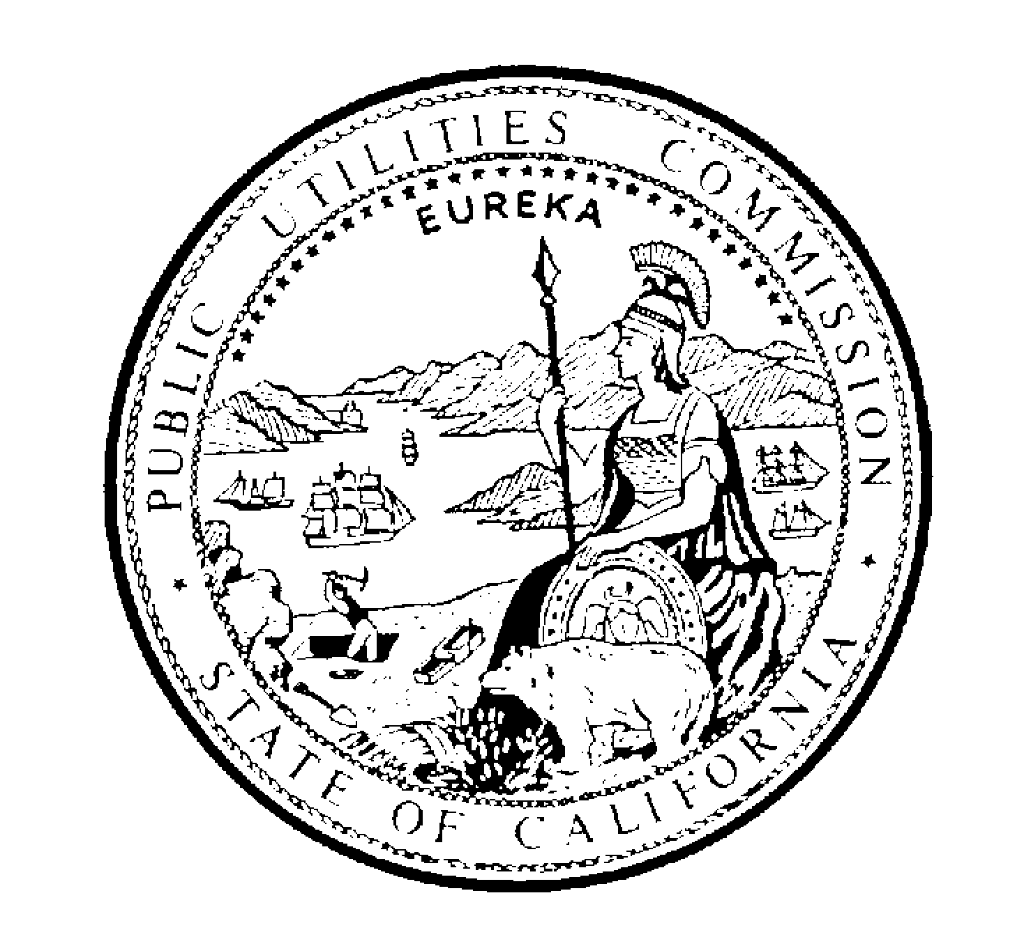PUBLIC UTILITIES COMMISSION
505 VAN NESS AVENUE
SAN FRANCISCO, CA 94102-3298

July 30, 2026

To: All Telecommunications Carriers

Subject: 811 Implementation Informational Workshop

On Wednesday, December 14, 2005, the California Public Utilities Commission’s Telecommunications Division (TD) will hold an informational workshop regarding the statewide implementation of “811” as a National Abbreviated Dialing Code. Pursuant to FCC Order FCC 05-59, CC Docket No. 92-105, and in compliance with the Pipeline Safety Act, all telecommunications carriers have two years from the publication of that Order (March 14, 2005) to implement 811 as the abbreviated dialing code for state One Call notification systems for providing advanced notice of excavation activities to underground facility operators.

The purpose of the workshop is to identify and discuss the technical and regulatory issues regarding implementation of “811.” Carriers should be prepared to address implementation and operational strategies, timelines, and costs associated with the new dialing code.

The Workshop will be held December 14, 2005, from 10:00 AM to 4:00PM in
Training Room A
505 Van Ness Avenue
San Francisco, CA 94102-3298

TD requests that carriers limit themselves to 3 attendees, as space is limited. Carriers may also participate via teleconferencing: (866) 621-8358, Passcode: 9632806. Please respond to Joseph Perman (jsp@cpuc.ca.gov, 213-576-7106) by December 9, 2005 to confirm your attendance and provide suggested changes to the draft agenda below:

DRAFT AGENDA:

1. Introductions and Finalize the Agenda
2. FCC 05-59, CC Docket 92-105
3. Presentation from Dig Alert
How the dial-up system works today
How Dig Alert envisions the system working with 811
4. What is Happening in other States?
Workshop participants’ comments
5. Discussions of Technical, Operational and Regulatory Issues
Presentations by carriers: Wireline, Wireless, CLECs
Identify Issues

If you need special accommodations for this workshop, please request them from the Public Advisor's Office by December 9, 2005 by any of the following means:
E-Mail: public.advisor@cpuc.ca.gov
Voice: (415) 703-2174
FAX: (415) 703-1758 Attention Public Advisor
TTY: (866) 836-7825 (toll free) or (415) 703-5282

