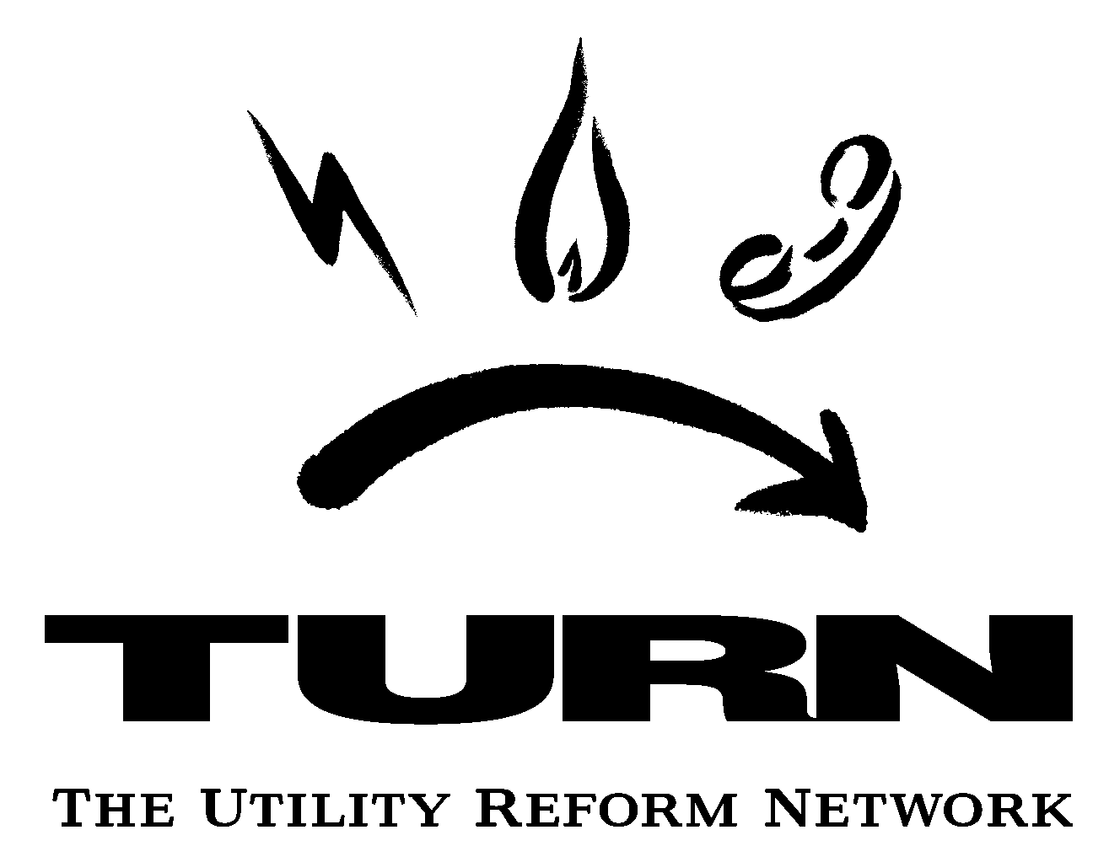
711 Van Ness Ave.
Suite 350
San Francisco
CA 94102
Tel 415/929-8876
Fax 415/929-1132
turn@turn.org
www.turn.org

November 23, 2005

Edward Howard, Division of Strategic Planning
California Public Utilities Commission
505 Van Ness Avenue
San Francisco, CA 94102

Re: TURN’s Comments on Draft Water Action Plan

Dear Mr. Howard:

The Utility Reform Network (TURN) submits these comments on the draft Water Action Plan issued November 9, 2005.

TURN has rarely ventured into Commission proceedings involving the regulation of investor-owned water utilities during our three-plus decades representing the interests of the state’s utility consumers. However, in recent years we have observed what appears to be an increase in the number of water utilities that become subject to the Commission’s jurisdiction, often due to acquisition efforts of public-owned companies by larger, privately-owned companies. Furthermore, TURN is very familiar with many of the issues flagged in the Water Action Plan (WAP), at least as those issues have arisen with regard to the regulation of energy and telecommunication services in California. TURN hopes that our experience with similar issues in the other regulated industries will provide the Commission with useful information.

- Increasing Block Rates Should Be Implemented Expeditiously For CPUC-Regulated Water Utilities.

The draft WAP (pp. 6-7) correctly recognizes that increasing block rates would promote greater conservation by water consumers. TURN agrees strongly with this general principle (although it may be necessary to phase in such a rate design to avoid adverse customer impacts in a short period of time).

From the point of view of both marginal and embedded cost causation, tiered residential rates are supported. Tiered rates reflect that the marginal cost of acquiring new water supplies on a statewide basis, and delivering those supplies to customers is more expensive than the use of water from existing sources. It therefore promotes efficiency in use of a scarce resource.
Re: TURN Comments on Draft WAP
November 23, 2005
Page 2

Tiered rates could also be structured to reflect the fact that water is more expensive in summer months on both a marginal and embedded cost basis than in winter months because demand-related costs (to treat and deliver water) are incurred in order to meet excess summer water demand, largely for landscaping. The tiered rate also implicitly reflects that the typical customer’s higher amounts of usage are more coincident with the system’s peak loads than the customer’s base usage.

From the point of view of commercial customers, tiered rates (with the tiers tied to the size of the meter) would also support conservation. This design means that a business would not be penalized simply for being large, but would pay more for high usage relative to its meter size. Tiered commercial rates, particularly when tiers are set based on the meter size, are cost-based for the same reason as tiered residential rates.

But as the draft WAP recognizes, the sad truth is that only approximately half of water utilities have inverted block rates, including virtually none of those under the jurisdiction of the Commission (Draft WAP p. 6). Even sadder is the fact that the Commission’s past policies bear at least some responsibility for this. Most CPUC-regulated water utilities have relatively high customer charges (in excess of $10/customer-month for the smallest meter for large utilities like San Gabriel Water and San Jose Water, and rising to $20 or more for some utilities) and flat per-unit charges. The Commission’s own standard practice may get in the way of the changes suggested in the Water Action Plan and is directly in conflict with the new and appropriate emphasis on conservation. Standard Practice U-7-W calls for collecting 50% of fixed costs in per-meter fixed charges from water utilities. This was modified in D. 92-03-093 to collect even more costs in fixed charges from smaller water utilities (up to 65% for Class C utilities and 100% for Class D utilities). Remaining costs are generally collected through a single commodity charge. Only in exceptional circumstances does the CPUC allow inverted block rates:

During times of drought or other shortage in water supply the Commission may adopt “increasing block” rates. This rate design sets a “reasonable” amount of water use and charges customers who use more than this amount a higher commodity charge (see D.00-03-053 for example). These types of rate designs are much more volatile that the Commission’s standard rate design and may also involve a revenue adjustment mechanism which tracks revenues and allows the utility to make up or give back revenues that were less or more than the adopted revenue requirement.
TURN therefore urges the Commission to revise Standard Practice U-7-W to provide for a freeze or reduction in water system customer charges (particularly for the smallest customers) and a movement to tiered rates to promote conservation. In order to mitigate rate impacts, the shift
Re: TURN Comments on Draft WAP
November 23, 2005
Page 3

could be done incrementally (i.e., assign all rate increases to a second tier until it reaches a certain point above first tier rates).

On a related point, TURN would not oppose measures to provide for revenue stability in the face of declining use due to conservation (and variable use depending on weather conditions) similar to decoupling in gas and electric utilities, if inverted block rates became the norm for water companies.

- Rather Than Rely On Special Surcharges Or CWIP To Encourage Infrastructure Investment, The Commission Should Require Developers To Bear Such Development Related Costs Whenever Possible.

Water utilities, particularly municipal utilities, require developers to pay for new hookups and to contribute a share of upstream system improvements as a condition of being provided new water supply. The Commission should review its policy regarding payment for new hookups to assure that developers are paying for new infrastructure that they cause before moving toward other mechanisms to collect money from existing ratepayers such as Construction Work in Progress in the rate base or the distribution infrastructure surcharges. For small water companies (where money is often commingled), the Commission may wish to require that developer contributions are placed in special accounts until used.

With the possible exception of the smallest water utilities which may find it difficult to raise capital (Class C and D utilities), TURN believes that the draft WAP report has not made a compelling case for extraordinary rate relief such as Construction Work in Progress in the rate base or for special distribution infrastructure surcharges.

- The Energy Usage Implications Of Water Policy Decisions Mean That The Commission Should Take Advantage Of Opportunities To Influence A Broader Array Of Water Companies Through The Regulated Energy Utilities.

TURN agrees with the Commission that there are significant interactions between water and energy policy, and that the agency should seek out and take advantage of opportunities to reduce energy consumption by water utilities. (Draft WAP, pp. 8-9). TURN reminds the agency that we addressed one such opportunity in A. 05-05-006 et al. (regarding the 2006-2008 demand response programs of the electric utilities), in testimony aimed at specifically encouraging the utilities to promote demand response among water utilities, both public and private. Enabling water agencies to pursue load reductions through demand response programs administered by the investor-owned utilities, and assessing how many private water companies are served by investor-owned utilities and the peak or load reduction opportunities such private companies
Re: TURN Comments on Draft WAP
November 23, 2005
Page 4

offer might allow the Commission to leverage energy reductions even with entities not directly subject to the agency’s jurisdiction.

- Before Committing to Incentive Regulation, The Commission Should Carefully Assess Whether Such An Approach Encouraged Sufficient Infrastructure Investment When In Place For The Investor-Owned Energy Utilities.

Under the heading of streamlining regulation, the draft WAP suggests that incentive regulation could be feasible and effective for the Commission-regulated water utilities. The Commission should carefully review the results obtained from the incentive regulation that has been in place at various times in the past decade for the major investor-owned energy utilities. After approximately seven years under a PBR regime, Southern California Edison Company came forward with a GRC that sought a return to cost-of-service ratemaking and, according to many observers, included higher rates in part to “catch-up” for investments deferred during the period when PBR was in place. Similarly, both Sempra utilities recently went through a “cost-of-service” review that led many to have the same concerns about investments that should have been made during prior years, but were not due at least in part to the incentives under the applicable PBR mechanisms. If the Commission’s first priority is to encourage investment in water utility infrastructure, it needs to carefully examine the interplay between that priority and a move to PBR or any other form of “incentive regulation” that moves away from cost-of-service regulation.

- In Order To Assess Whether Blanket Approaches Make Sense, The Commission Needs To First Gather More Specific Information About The Agency-Regulated Water Companies and the Customers They Serve.

The draft WAP makes a number of observations regarding California consumers and water utility service that may well be accurate on a state-wide basis, but not necessarily for the subset of the state presently served by CPUC-regulated water utilities. Before the Commission firmly commits to any model for efforts such as low-income assistance programs or “high cost” funds, it needs to develop a better understanding of the conditions that exist for that subset.

An example of that more specific review appears in the draft WAP’s table setting forth “selected poverty data for Class A water utilities” at page 14. The ability to develop appropriate low-income assistance programs or other programs will depend on the characteristics of the specific populations served by the water utilities regulated by the CPUC, rather than the state-wide statistics.

On the other hand, an example of an area requiring the more detailed break-out of information is the discussion of water-related energy use at pages 8-9 of the draft WAP. While TURN does not
Re: TURN Comments on Draft WAP
November 23, 2005
Page 5

doubt that the water-related energy use associated with water customers served by CPUC-regulated water utilities, any attempt to target a reduction of that energy usage requires more specific information.

TURN is not suggesting that the draft WAP threatens to commit the PUC to a course without adequate compilation and review of the information necessary to ensure that the adopted course best serves the interests of consumers served by CPUC-regulated water utilities. Rather, we merely wish to remind the agency of the data-intensive work ahead, with the hope that perhaps the data gathering can be jump-started or, if it has already begun, the data can be made more widely available.

- Edit to “Water Action Plan Objectives” Section

The first sentence of the sixth sub-section under “Water Action Plan Objectives” (at page 3) should be edited as follows:

The CPUC will ensure that the established rates will provide an opportunity for recovery of reasonable and prudently incurred costs and a fair and equitable return to ratepayers shareholders.
The first proposed edit is to make the statement consistent with the longstanding regulatory standard – the Commission’s job is to set rates at a level that gives the regulated utility an opportunity (but not a guarantee) of cost recovery and attainment of a particular return on investment. For example, utility mismanagement might result in even reasonable costs not being recovered in rates. The second edit seeks to state what TURN presumes was the intended meaning of the sentence.

TURN appreciates this opportunity to comment on the draft WAP.

Respectfully submitted,

Robert Finkelstein
Executive Director

cc: All members of CPUC
Kevin Coughlan, Water Division

EXCERPT FROM TURN TESTIMONY IN A.05-05-006
(DEMAND RESPONSE APPLICATIONS)

One potential customer group that appears to have both an interest and large potential to provide demand reductions is the Association of California Water Agencies (ACWA). As part of the California Energy Commission’s (CEC) preparation of the 2005 Integrated Energy Policy Report (2005 Energy Report), ACWA presented material demonstrating the large potential for peak load reductions from the State’s public water agencies. Excerpts from that presentation are included as Attachment D. [not attached to these comments]
According to ACWA, water agencies’ are the single largest electricity end user in California (current maximum demand of 3,200 MW) and are forecast to increase peak demand by approximately 3,575 MW in the next 10 years. Public water agencies have already reduced 400 MW of peak load due to electric time-of-use rates. They report that they can reduce another 250 MW of peak demand without physically altering their existing systems and an additional 1000 MW of peak demand reduction with more storage capability.
ACWA members have expressed frustration trying to participate in utility demand response programs. First, this seems to be a customer segment that might actually benefit from Technical Assistance and Technical Incentives (TA/TI). However, water agencies have experienced serious frustration in attempting to take advantage of utility TA/TI programs. Part of water agencies’ frustration is caused because utilities do not classify certain changes to water agency operations that would be necessary to reduce on-peak electric demand as measures that would qualify for TA/TI. For instance, water agency measures such as increased storage capability, nitrification sensors, or water control valves do not qualify for TA/TI because they do not directly result in lower energy usage.
The Commission should assess whether strict adherence to awarding TA/TI funds only to direct energy-related measures results in a missed opportunity for tapping a large potential of MWs that could provide demand reduction. If TA/TI funds are used for altering non energy-related practices that result in reducing peak energy usage and those reduced MWs are then committed to a verifiable demand response program, then using TA/TI might provide benefits to ratepayers.
It is TURN’s understanding that many of the measures ACWA members could take to reduce peak demand are measures that would result in permanent load reductions rather than load shifting. Thus, while a permanent load reduction is not strictly a demand response program (as defined by the Commission), peak demand reductions still provide value to the system. Because of this, water agencies might benefit more from programs such as PG&E’s proposed Business Energy Coalition or the utilities’ proposed Integrated DSM programs. TURN urges the Commission to direct the utilities to pursue these types of programs that are specifically designed to tap the large peak load reduction potential associated with public water agencies.

The Commission Should Use its Current Authority Over Private Water Companies to Direct Those Companies to Implement Demand Reduction Measures
TURN urges the Commission to use its regulatory authority to regulate private-owned water companies to investigate and assess the potential for peak load reductions from this customer segment. As a first step, the Commission should assess how many private water companies are served by investor-owned utilities and how much peak load is associated with those water companies. It should then develop a plan for addressing how those private water companies can reduce peak loads and the effects of those peak load reductions would have on the water company customers and the electric investor owned utilities.
Under this approach, the Commission can directly order private water companies to develop and implement measures that would reduce their peak load on the IOUs electric systems. This may allow the Commission to take advantage of its regulatory authority and provide material peak load relief more efficiently than indirectly relying solely on electric ratepayers to fund demand response and demand reduction measures.

CPUC, “Rate Design for Water and Sewer System Utilities,” Standard Practice U-7-W (August 2000). http://www.cpuc.ca.gov/word_pdf/RULES_PRAC_PROC//5381.doc, p. 3.
Id., p. 5.
Standard Practice U-7-W, p. 6.
Jeffrey A. Nahigian, Prepared Testimony on Utility Demand Response Programs on behalf of TURN, A. 05-05-006 et. al, (September, 2005), pp. 9-12. An excerpt from that testimony is attached to these comments.
TURN has not typically endorsed the utility 2004 and 2005 TA/TI programs primarily because no customers have shown interest in this option and because TA/TI, by themselves, provide no MW reductions.
On one hand, TURN appreciates the utilities interest in ensuring incentive dollars result in reduced peak MWs. On the other hand, an overly strict adherence to rewarding only energy related operational changes could miss an opportunity to reduce peak demand from one of the state’s largest electric end-users.
PG&E’s states that it intends to find another customer group that has a strong potential to partner with PG&E for long-term savings (PG&E-1, p. 3-6, FN 3). It appears that public water agencies might be that potential customer group.

