Fact Sheet
THE BROADBAND ADOPTION GRANT PROGRAM

As many as 13% of Californians experience barriers that prevent them from utilizing and accessing the internet, according to the 2017 survey by the University of California Berkeley Institute of Governmental Studies survey for the California Emerging Technology Fund.

In 2017, California set an ambitious goal of being a national and global leader in the adoption of broadband technology, and designated $20 million for grants to increase publicly available or after-school broadband access and digital inclusion. These funds will be distributed by the California Public Utilities Commission in the new Broadband Adoption Grant Program:

Types of Grants  Digital Inclusion Projects providing digital literacy training and public education to communities with limited broadband adoption.  Broadband Access Projects providing publicly available or after-school broadband access that may include free broadband access in community training rooms or other public spaces, such as local government centers, senior citizen centers, schools, public libraries, nonprofit organizations, and community-based organizations. These projects may also include community outreach, such as analysis, comparison of Internet plans within the community, and call centers that will increase broadband access and adoption.  Eligible Entities  Eligible Applicants include local governments, senior centers, schools, public libraries, non-profit organizations, and community-based organizations.  Award Amounts  The $20 million fund for Broadband Adoption programs will be awarded in biannual application cycles.  Priorities  Communities with demonstrated low broadband access and/or low broadband subscription rates will be given preference, as well as low-income communities, senior communities, and communities facing socioeconomic |  | barriers to broadband adoption.  Timeline  The deadline for the first round of applications is August 31st, 2018. Program rules were adopted in a Commission Decision on June 21, 2018.  Background  The adoption funding was made available in 2017 by the Internet for All Now Act, which promotes broadband adoption and infrastructure deployment by providing an additional $330 million to unserved areas with a goal of providing broadband access to no less than 98 percent of California households in each region.  Learn More  For more information about the California Advanced Services Fund and the Broadband Adoption program, please visit: www.cpuc.ca.gov/casf/  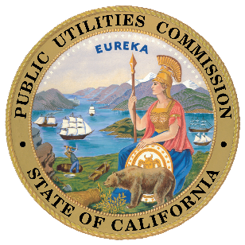  Questions? Interested in submitting an application?  Email us at: casf_adoption@cpuc.ca.gov

