OPENING TESTIMONY OF KARIN HIETA

Q1. Please state your name and business address.
A1. My name is Karin Hieta and my business address is 505 Van Ness Avenue, San Francisco, California 94102.

Q2. By whom are you employed and what is your position?
A2. I am employed by the California Public Utilities Commission (CPUC). I am a Public Utilities Regulatory Analyst I (PURA I) in the Telecommunications Branch of the Office of Ratepayer Advocates (ORA).

Q3. Please describe your educational and professional qualifications.
A3. I received a Bachelor of Science degree, with a double major in Geography and General Social Sciences, from Portland State University in 1999. I received a Master of Arts degree in Spiritual Psychology from University of Santa Monica in 2001. I joined the CPUC in February 2001 after interning there for three months the previous fall.

Q4. Please describe the scope of your duties since joining the Commission staff.
A4. As an intern working for ORA, I constructed a database of service quality standards for telecommunication and energy utilities in various states throughout the U.S. During this time I also used Microsoft Access and ESRI’s ArcView Geographical Information System (GIS) as database and geographical analysis tools to examine service quality data provided to ORA by telecommunication utilities. As a PURA I, I worked on C.00-11-018, analyzing SBC Pacific Bell’s out-of-service repair history. In that analysis I used Microsoft Access to analyze SBC Pacific Bell’s out-of-service raw repair data and I examined meteorological and geographic impacts on SBC Pacific Bell’s repair service in various states in relation to California.

Q5. What is the purpose of your testimony?
A5.The purpose of my testimony is to assess how the service quality of repair services provided by SBC Pacific Bell (SBC Pacific) and Verizon California, Inc. (Verizon) have fared under the New Regulatory Framework (NRF).

Q6. Please describe the results of your analysis.
A6. I examined the service quality of SBC Pacific and Verizon based upon data reported to the Federal Communications Commission’s (FCC) Automated Reporting Management Information System (ARMIS), raw data provided by the telephone companies, and a comparison of Verizon’s raw data with Service Performance Guarantee data. According to these analyses, both SBC Pacific and Verizon exhibit a decline in service quality. Additionally, questions are raised about the validity of both company’s raw data.

My examination of SBC Pacific’s repair service based upon the numbers reported by SBC Pacific to ARMIS shows increases in initial and repeat out-of-service repair intervals for business customers, increases in initial and repeat all other trouble report intervals for residential customers, increases in the number of initial and repeat all other trouble reports for residential customers, and increases in the number of initial and repeat all other trouble reports per million lines for residential customers during the NRF review period. Residential customers experienced a high number of repeat out-of-service trouble reports as a percentage of initial out-of-service trouble reports. An analysis of SBC Pacific’s raw data shows that many of the repeat out-of-service repairs occurred within 24 hours of the initial repair, and repairs that should have been identified as repeat troubles were located with the initial repairs data.

Verizon’s repair service, according to ARMIS reports, shows that initial and repeat out-of-service and all other repairs have increased in the last year for business and residential customers. A comparison of Verizon’s raw data with Service Performance Guarantee (SPG) data shows that many records are missing from Verizon’s data, raising questions about the integrity of this data.

SBC Pacific’s Business Repair Service According to ARMIS

Q7. What is ARMIS?
A7. The Automated Reporting Management Information System (ARMIS) is the FCC’s publicly accessible database that was initiated in 1987. It is a collection of financial and non-financial data for the nation’s largest telecommunications carriers. ARMIS contains service quality data, located in Report 43-05, for the years 1993 to 2001. The companies file these reports with the FCC, according to standards set by the FCC.

Q8. What is the quality of SBC Pacific’s business repair service according to ARMIS service quality data?
A8. ORA reviewed the reported number of total access lines, number of initial trouble reports, number of initial out-of-service trouble reports, initial out-of-service trouble report intervals, number of initial all other trouble reports, initial all other trouble report intervals, number of repeat trouble reports, number of repeat out-of-service trouble reports, repeat out-of-service trouble report intervals, number of repeat all other trouble reports, and repeat all other trouble report intervals. Problems were found in the categories of initial and repeat out-of-service repair intervals for business customers.
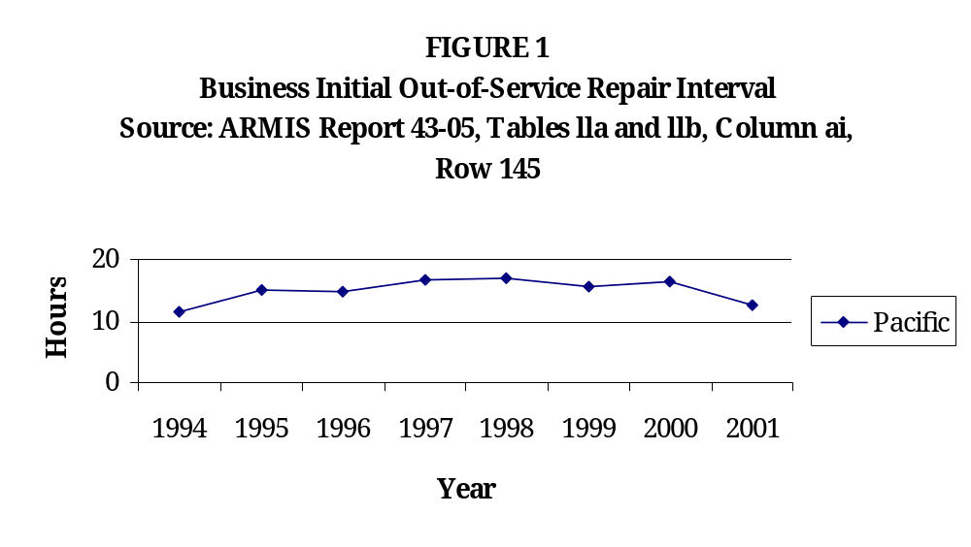

Figure 1 shows that SBC Pacific’s business initial out-of-service repair interval rose from an average of 11.56 hours in 1994 to 16.5 hours in 2000, and then dropped to 12.5 hours in 2001. Despite the drop in 2001, ORA is concerned about the overall increase in the out-of-service interval for the 1994 to 2001 time period.

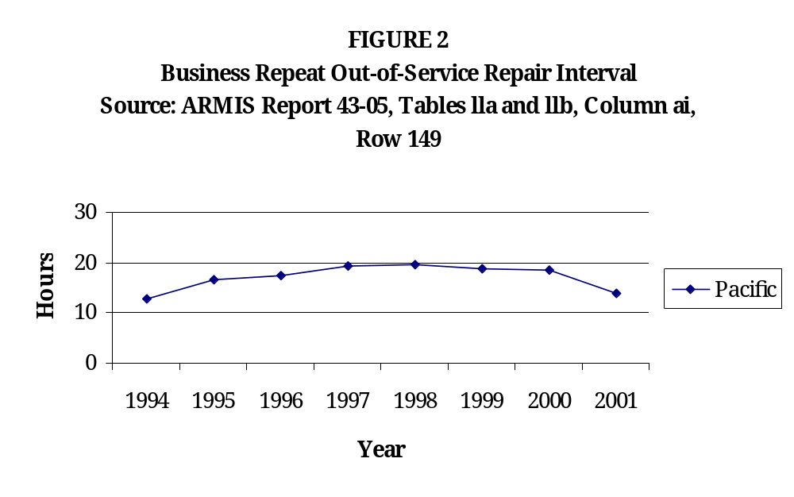
Figure 2 shows that SBC Pacific’s business repeat out-of-service interval rose from an average of 12.9 hours in 1994 to 18.5 hours in 2000, then dropped to 13.9 hours in 2001. Despite the drop in 2001, the overall increase in the interval for the 1994 to 2001 time period is of concern to ORA.

Although SBC Pacific’s business initial and repeat out-of-service repair intervals have improved in 2001, ORA is likewise concerned about the overall increases in the intervals during the NRF review period. The years in which the intervals were higher indicate longer waits for business customers and a decrease in service quality.

Top of Form
Bottom of Form

SBC Pacific’s Residential Repair Service According to ARMIS

Q9. What is the quality of SBC Pacific’s residential repair service according to ARMIS service quality data?
A9. ORA reviewed the reported number of total access lines, number of initial trouble reports, number of initial out-of-service trouble reports, initial out-of-service trouble report intervals, number of initial all other trouble reports, initial all other trouble report intervals, number of repeat trouble reports, number of repeat out-of-service trouble reports, repeat out-of-service trouble report intervals, number of repeat all other trouble reports, and repeat all other trouble report intervals. Out-of-service intervals have increased for residential customers. These increased intervals will not be addressed in this testimony, as they were addressed in C.00-11-018. In fact, in that proceeding the Commission found that “The Commission cannot find that SBC Pacific’s service quality is excellent when the initial out-of-service repair intervals for residential customers has increased 45% since 1996.” The reported numbers concerning all other trouble reports for residential customers have grown worse during the NRF review period. The repair intervals and the numbers of repairs for residential initial and repeat all other trouble reports have risen between the years 1994 and 2000. In addition to this, the ratios of residential initial and repeat all other trouble reports per million access lines have increased between the years 1994 and 2000.

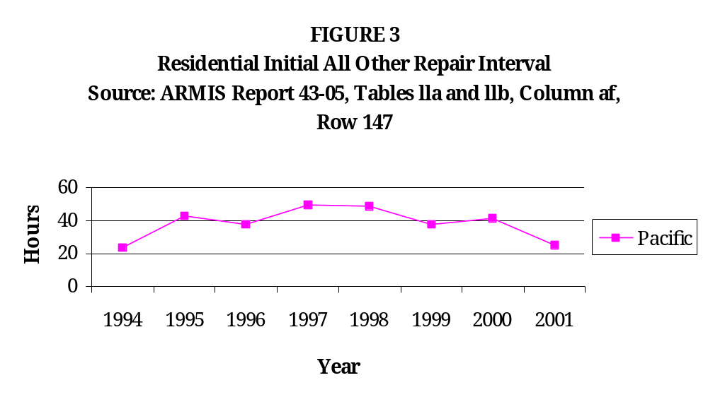
Figure 3 shows that SBC Pacific’s residential initial all other repair interval rose from an average of 23.57 hours in 1994 to 41.6 hours in 2000, dropping to 25.5 hours in 2001. Despite the drop in 2001, ORA is concerned about the overall rise in average hours and the unacceptably high intervals of 50 hours in 1997 and 49.2 hours in 1998.
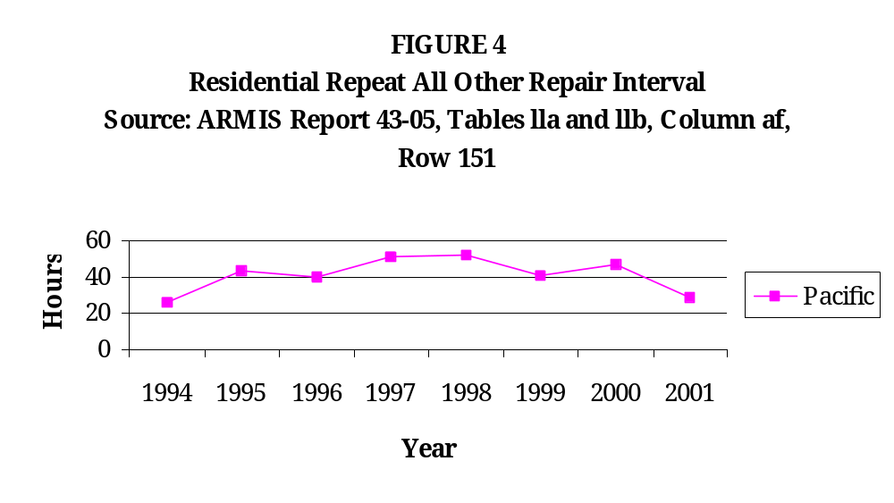
Figure 4 shows that SBC Pacific’s residential repeat all other repair interval rose from an average of 25.78 hours in 1994 to 46.9 hours in 2000, dropping to 28.6 hours in 2001. Despite the drop in 2001, ORA is concerned about the overall rise in average hours and the high intervals of 51.1 hours in 1997 and 52.5 hours in 1998.

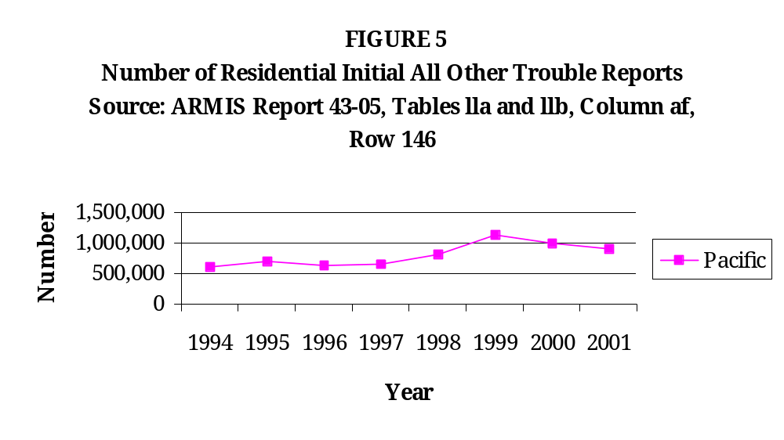

In Figure 5, SBC Pacific’s number of residential initial all other trouble reports rose from 622,310 in 1994 to 916,431 in 2001. The number of trouble reports in 2001 dropped from 1,127,512 reports in 1999, but the overall trend is an increase in the number of trouble reports.

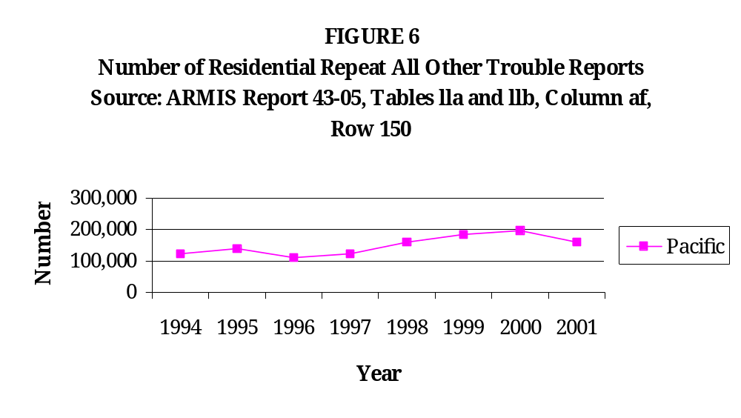
In Figure 6, SBC Pacific’s number of residential repeat all other trouble reports rose from 125,231 in 1994 to 162,035 in 2001. The current number of trouble reports decreases from the previous year, but still exhibits an overall increase.

The increases in the number of initial all other trouble reports and repeat all other trouble reports for residential customers implies that more customers are experiencing more problems and inconveniences with lapses in the quality and reliability of their phone service.

While the previous two figures show a rise in the number of trouble reports, there was also a rise in the number of SBC Pacific’s access lines. Illustrative examples of the decline in service quality are the increases in the number of initial and repeat all other trouble reports per million lines.

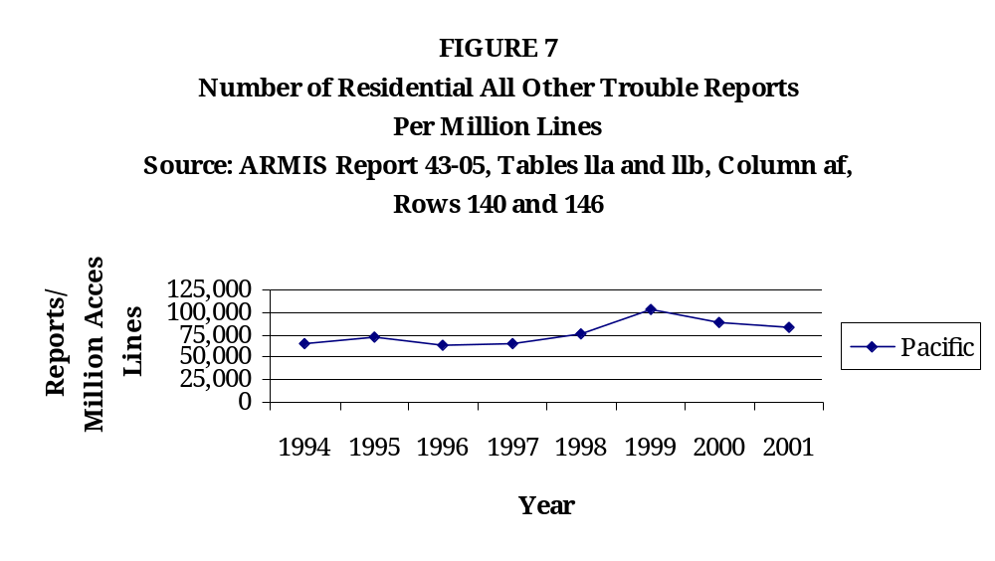
In Figure 7, SBC Pacific’s number of residential initial all other trouble reports per million lines increased from 65,286 reports per million lines in 1994 to 83,153 reports per million lines in 2001, and increased dramatically by 37.4% between 1998 and 1999.

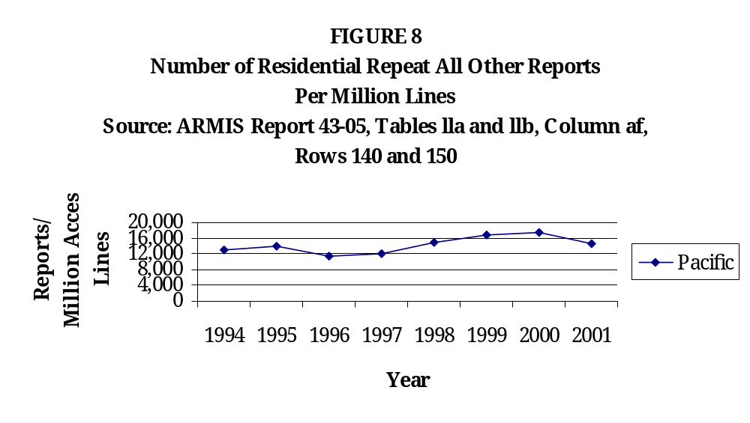
In Figure 8, SBC Pacific’s number of residential repeat all other reports per million lines rose steadily from 11,317 reports per million lines in 1996 to 17,562 reports per million lines in 2000, dropping to 14,702 reports per million lines in 2001. Figure 8 reveals an overall increase in the number of repeat trouble reports per million lines. These increases in residential initial and repeat all other reports per million lines indicate that service quality problems have been growing.

It appears that SBC Pacific’s reported numbers for residential initial and repeat all other repair intervals, number of initial and repeat all other reports, and number of initial and repeat all other reports per million lines show a strong improvement in 2001. While ORA is pleased with the recent improvement, we cannot ignore the overall decline in the reported data during the NRF review period. The years in which the intervals and numbers of reports were higher indicate longer waits for residential customers and a decrease in service quality.

Q10. What is the quality of SBC Pacific’s residential repair service according to ARMIS Preset Service Quality Reports?
A10. ORA reviewed the Preset Service Quality Reports in the ARMIS database. In reviewing these preset reports, ORA is concerned by the increase in the repeat out-of-service reports as a percentage of initial out-of service trouble reports.

TABLE 1

Repeat Out-of-Service Trouble Reports as a Percentage of Initial Out-of-Service Trouble Reports
CALIFORNIA , Residence
COMPANY | STUDY AREA | 1994 | 1995 | 1996 | 1997 | 1998 | 1999 | 2000 | 2001
SBC
SBC Pacific Telesis | California | 20.2 | 16.7 | 14.7 | 15.9 | 18.7 | 16.4 | 17.3 | 15.5
VERIZON
Verizon California | GTE/California | 8.9 | 10.1 | 11.3 | 11.2 | 11.4 | 9.3 | 10.0 | 10.4
Verizon California | Contel/California | 5.8 | 8.7 | 10.4 | 11.0 | 11.9 | 9.3 | 10.2 | 9.4
Verizon Northwest | West Coast California | 10.5 | 10.2 | 9.6 | 6.7 | 5.9 | 8.2 | 9.7 | 7.0
CITIZENS
 | CT-Shasta/California | N/A | N/A | N/A | N/A | N/A | 15.3 | 13.6 | 12.5
 | CT-Golden State Colusa-California | N/A | N/A | N/A | N/A | 97.7 | 8.7 | 9.7 | 12.7
 | CT-Tuolumne/California | N/A | N/A | N/A | N/A | N/A | 8.0 | 11.1 | 14.9
CALIFORNIA AGGREGATE |  | 18.6 | 15.9 | 14.2 | 15.3 | 17.7 | 15.4 | 16.2 | 14.8

Data Source: ARMIS Report 43-05, Table II, Column (af), Rows 144, 148
Top of Form

Bottom of Form

Table 1 shows repeat out-of-service trouble reports as a percentage of initial out-of-service trouble reports for residential customers. The percentage for SBC Pacific fluctuates over the years shown. Yet, of all the local exchange carriers displayed in Table 1, SBC Pacific exhibits the highest percentage each year. This number is significant specifically because it is a percentage, which means that it is a relative number. Looking at Table 1 in this manner, the relationship of SBC Pacific’s repeat out-of-service trouble reports relative to its initial out-of-service trouble reports is worse than that same relationship for other California carriers.

SBC Pacific’s Repair Service According to Raw Data

Q11. What is the quality of SBC Pacific’s service quality based upon raw data provided to ORA?
A11. SBC Pacific provided ORA with the raw repair data that is used to calculate ARMIS numbers for the years 2000 and 2001. In the residential repeat out-of-service repair data there are a number of repair tickets that were closed, followed by new repair tickets being opened within 24 hours. An example of this was drawn from the residential repeat out-of-service repair data for the year 2000, and is shown in Table 2.

TABLE 2
SBC Pacific Bell Residential Repeat Out-of-Service Repair Data
Excerpt from 2000 data

Phone Number | Date/Time Reported | Date/Time Cleared | Time Elapsed Since Last Repair
209-529-xxxx | 11/5/2000 5:24 PM | 11/8/2000 6:05 PM
209-529-xxxx | 11/8/2000 6:59 PM | 11/9/2000 7:17 AM | 54 minutes
209-529-xxxx | 11/9/2000 7:31 AM | 11/9/2000 12:00 PM | 14 minutes
209-572-xxxx | 9/1/2000 5:50 PM | 9/6/2000 10:00 AM
209-572-xxxx | 9/6/2000 7:22 PM | 9/7/2000 8:50 AM | 9 hours 22 minutes
209-572-xxxx | 9/7/2000 11:53 AM | 9/7/2000 3:36 PM | 3 hours 3 minutes
209-874-xxxx | 11/24/2000 6:12 PM | 12/1/2000 11:40 AM
209-874-xxxx | 12/1/2000 12:57 PM | 12/8/2000 3:47 PM | 1 hour 17 minutes
213-746-xxxx | 9/29/2000 7:23 PM | 10/2/2000 3:24 PM
213-746-xxxx | 10/2/2000 6:59 PM | 10/4/2000 6:00 PM | 3 hours 35 minutes
213-746-xxxx | 10/4/2000 8:28 PM | 10/5/2000 3:35 PM | 2 hours 28 minutes

In Table 2 the “Date/Time Reported” column is the date and time the problem was called in by the customer, and the “Date/Time Cleared” column is the date and time the problem was asserted to have been fixed and the repair ticket was closed. Table 2 shows examples of telephone numbers for which repair tickets were closed, followed by the issuance of a new repair ticket within 24 hours, indicating that the problem was not fixed. These records are especially disturbing because they are repeat out-of-service repairs, meaning that the customer is totally without use of his or her telephone service, and the customer’s service was repaired within 30 days prior to the repair(s) occurring in this database. Approximately 5.28% of the residential repeat out-of-service repairs in 2000 and 4.63% of the residential repeat out-of-service repairs in 2001 occurred within 24 hours of a previous repeat out-of-service repair. These records indicate that either some problems are not being fixed or repair tickets are being prematurely closed. Either way, it does not indicate good service quality for SBC Pacific’s customers.

ORA also reviewed residential initial out-of-service repair data. There were a number of new repair tickets in this data that were opened within 30 days of the previous problem for the same phone number. According to ARMIS reporting requirements, these repairs should be counted as repeat out-of-service problems. An example of this was drawn from the residential initial out-of-service repair data for the year 2001, and is shown in Table 3.

TABLE 3

SBC Pacific Bell Residential Initial Out-of-Service Repair Data
Excerpt from 2001 data

Phone Number | Date/Time Reported | Date/Time Cleared | Time Elapsed Since Last Repair
209-984-xxxx | 1/30/2001 3:49 PM | 1/31/2001 10:50 AM
209-984-xxxx | 2/5/2001 2:04 PM | 2/6/2001 10:13 AM | 5 days 3 hours 14 minutes
209-984-xxxx | 2/7/2001 3:30 PM | 2/8/2001 11:30 AM | 1 day 5 hours 17 minutes
310-204-xxxx | 1/16/2001 2:09 PM | 1/16/2001 9:48 PM
310-204-xxxx | 2/4/2001 3:13 PM | 2/5/2001 2:50 PM | 18 days 17 hours 25 minutes
310-204-xxxx | 2/10/2001 7:33 PM | 2/14/2001 7:51 PM | 5 days 4 hours 43 minutes
310-271-xxxx | 2/20/2001 2:55 PM | 2/21/2001 5:30 PM
310-271-xxxx | 2/22/2001 10:14 AM | 2/23/2001 2:45 PM | 16 hours 44 minutes
323-231-xxxx | 1/6/2001 11:59 AM | 1/10/2001 1:22 PM
323-231-xxxx | 1/10/2001 4:19 PM | 1/11/2001 12:29 PM | 2 hours 57 minutes
323-231-xxxx | 1/11/2001 2:12 PM | 1/12/2001 10:15 AM | 1 hour 43 minutes

In Table 3 the “Date/Time Reported” column is the date and time the problem was called in by the customer, and the “Date/Time Cleared” column is the date and time the problem was supposedly fixed and the repair ticket was closed. Table 3 shows examples of telephone numbers for which repair tickets were closed, followed by the need for a new repair ticket within 30 days. Approximately 1.06% of the records in January and February 2001 that were located in the residential initial out-of-service repairs data should have been located in repeat out-of-service repairs. The existence of these records in the initial out-of-service data indicates that repairs are not being recorded correctly. Not only do these records indicate poor service quality, as indicated in the residential repeat out-of-service repair data shown in Table 2, they raise questions about the validity of SBC Pacific’s record-keeping and treatment of the raw data that it uses as the basis for its ARMIS reports.

Verizon’s Business Repair Service According to ARMIS

Q12. What is the quality of Verizon’s business repair service according to ARMIS service quality data?
A12. ORA reviewed the reported number of total access lines, number of initial trouble reports, number of initial out-of-service trouble reports, initial out-of-service trouble report intervals, number of initial all other trouble reports, initial all other trouble report intervals, number of repeat trouble reports, number of repeat out-of-service trouble reports, repeat out-of-service trouble report intervals, number of repeat all other trouble reports, and repeat all other trouble report intervals. Problems were found in the categories of initial and repeat out-of-service repair intervals and initial and repeat all other repair intervals for business customers.
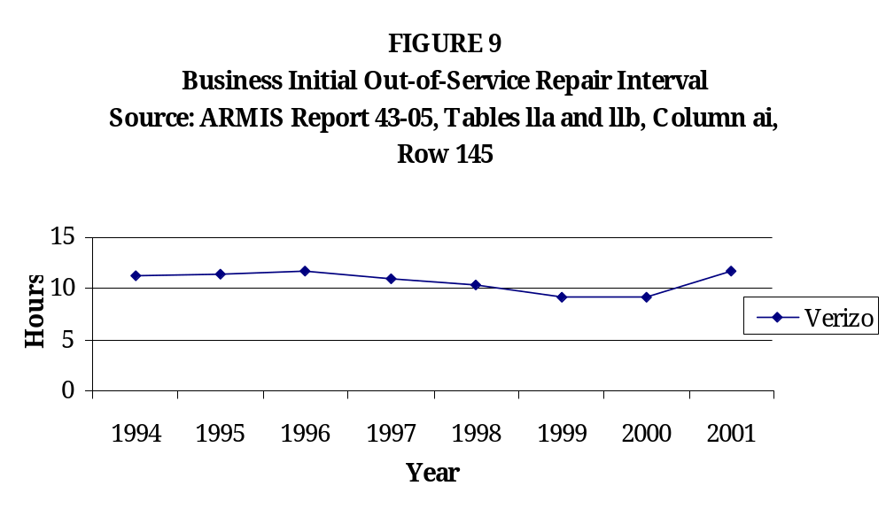

Figure 9 shows that Verizon’s business initial out-of-service repair interval rose from 9.2 hours to 11.7 hours in the previous two years. The last time Verizon’s repair interval was as high as its current level was 1996.

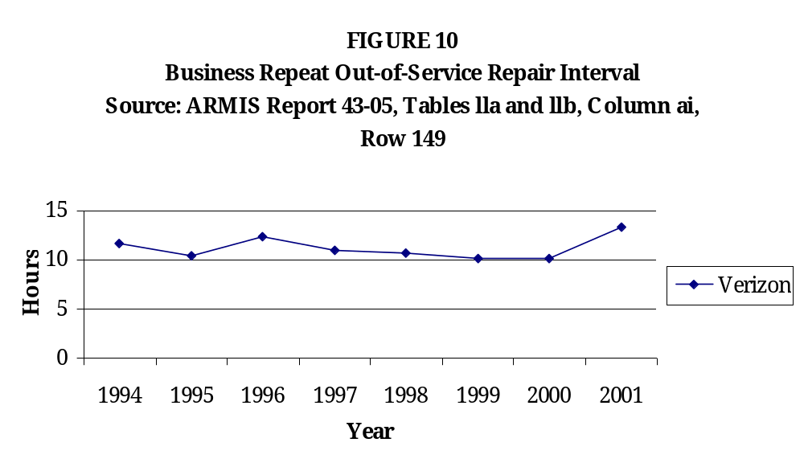
Figure 10 shows that Verizon's business repeat out-of-service repair interval rose from an average of 10.1 hours in 2000 to 13.3 hours in 2001. The current average interval is higher than it has been in any of the previous years recorded in the ARMIS data.

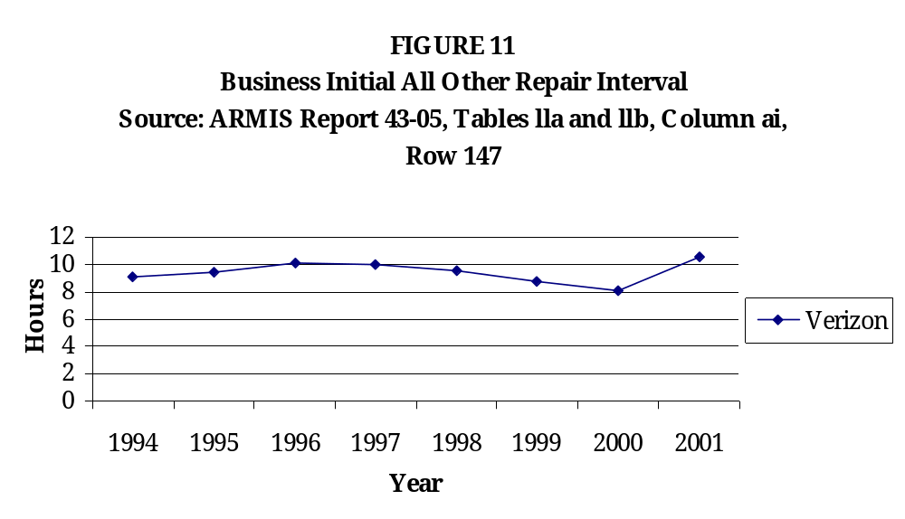
Figure 11 shows that Verizon’s business initial all other repair interval rose from an average of 8.1 hours in 2000 to 10.5 hours in 2001. The rise in 2001 follows a steady decline in the average interval since 1996.

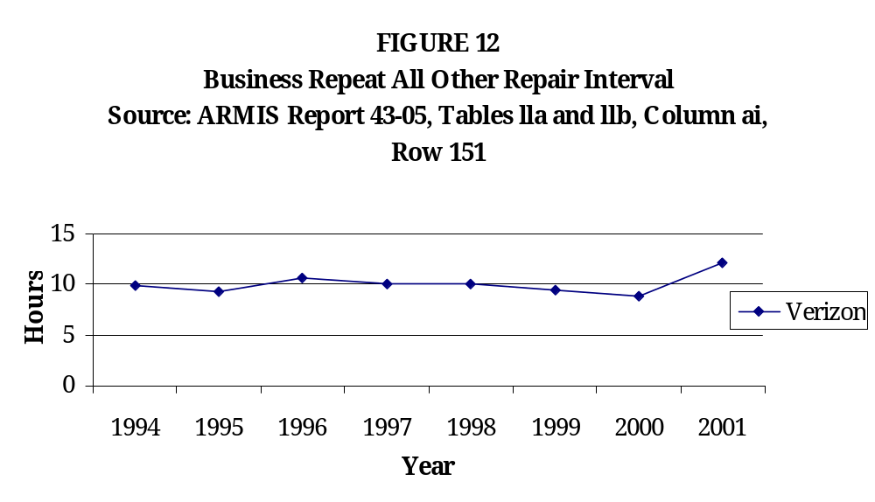
Figure 12 shows that Verizon’s business repeat all other repair interval rose from an average of 8.8 hours in 2000 to 12.1 hours in 2001.

The increases in initial and repeat out-of-service and repeat all other repair intervals for business customers are disturbing. Prior to 2001 these intervals were fairly consistent, but the rise in the past year signifies longer waits for customers than ever before and deterioration in service quality.

Verizon’s Residential Repair Service According to ARMIS

Q13. What is the quality of Verizon’s residential repair service according to ARMIS service quality data?
A13. ORA reviewed the reported number of total access lines, number of initial trouble reports, number of initial out-of-service trouble reports, initial out-of-service trouble report intervals, number of initial all other trouble reports, initial all other trouble report intervals, number of repeat trouble reports, number of repeat out-of-service trouble reports, repeat out-of-service trouble report intervals, number of repeat all other trouble reports, and repeat all other trouble report intervals. Problems were found in the categories of initial and repeat out-of-service repair intervals and initial and repeat all other repair intervals for residential customers.

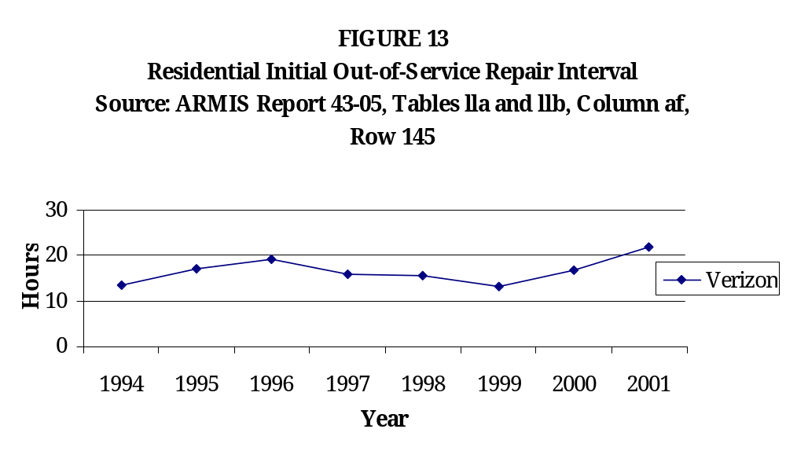
Figure 13 shows that Verizon’s residential initial out-of-service repair interval rose from an average of 13.1 hours in 1999 to 22 hours in 2001, after steadily decreasing from 1996 to 1999.

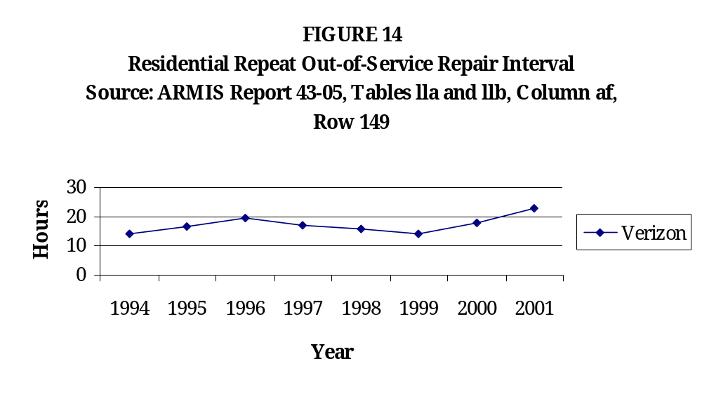
Figure 14 shows that Verizon’s residential repeat out-of-service repair interval increased from an average of 14 hours in 1999 to 22.9 hours in 2001, after steadily decreasing from 1996 to 1999.

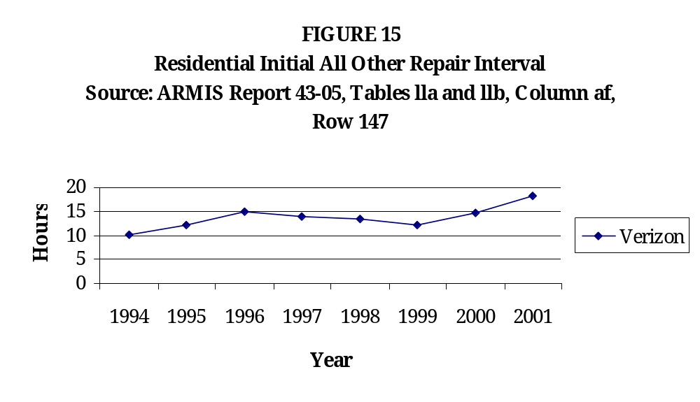
Figure 15 shows that Verizon's residential initial all other repair interval increased from an average of 12.1 hours in 1999 to 18.2 hours in 2001, after steadily decreasing from 1996 to 1999.

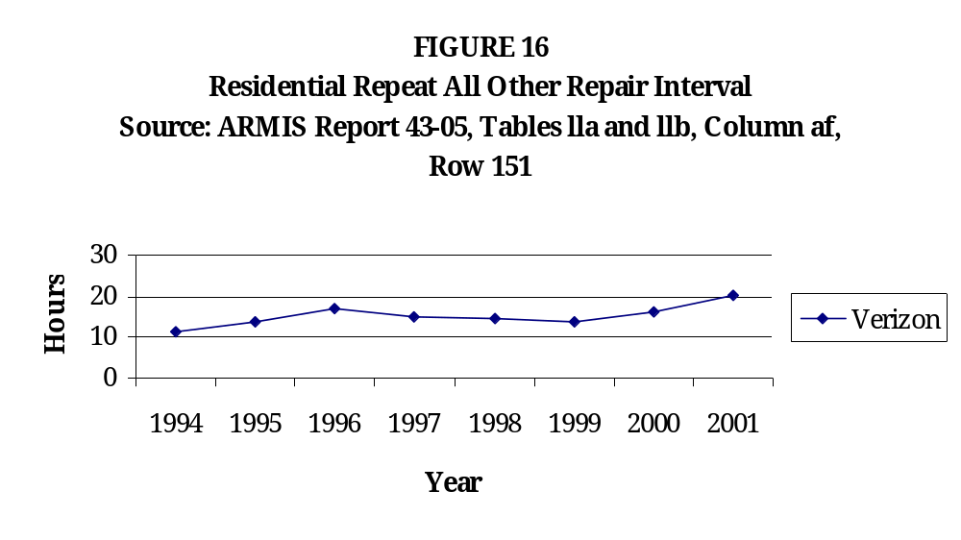
Figure 16 shows that Verizon’s residential repeat all other repair interval rose from an average of 13.6 hours in 1999 to 20.4 hours in 2001, after steadily decreasing from 1996 to 1999.

The increases in the residential initial and repeat out-of-service and all other repair intervals are disturbing. Previous to 2000 these intervals were fairly consistent, but the rise in the past two years signifies longer waits for customers than ever before and deterioration in service quality.
Bottom of Form

Verizon’s Repair Service According to Raw Data

Q14. What is the quality of Verizon’s service quality as seen in raw data provided to ORA?
A14. Verizon provided ORA with the raw repair data that is used to calculate ARMIS numbers for the years 1999, 2000, and 2001. In the residential repeat out-of-service repair data there are a number of repair tickets that were closed, followed by new repair tickets being opened within 24 hours. An example of this was drawn from the residential repeat out-of-service repair data for the year 2000, and is shown in Table 4.

TABLE 4
Verizon Residential Repeat Out-of-Service Repair Data
Excerpt from 2000 data

Phone Number | Date/Time Reported | Date/Time Cleared | Time Elapsed Since Last Repair
209-239-xxxx | 10/31/2000 3:22:00 PM | 11/3/2000 3:30:00 PM
209-239-xxxx | 11/3/2000 4:12:00 PM | 11/4/2000 2:50:00 PM | 42 minutes
562-404-xxxx | 8/10/2000 8:55:00 PM | 8/11/2000 3:50:00 PM
562-404-xxxx | 8/11/2000 5:59:00 PM | 8/12/2000 3:24:00 PM | 2 hours 9 minutes
562-404-xxxx | 8/12/2000 6:48:00 PM | 8/13/2000 3:00:00 PM | 3 hours 24 minutes
562-430-xxxx | 10/5/2000 9:06:00 PM | 10/6/2000 2:30:00 PM
562-430-xxxx | 10/7/2000 8:17:00 AM | 10/7/2000 1:45:00 PM | 17 hours 47 minutes
562-430-xxxx | 10/8/2000 8:46:00 AM | 10/9/2000 1:30:00 PM | 19 hours 1 minute
760-948-xxxx | 10/4/2000 11:47:00 AM | 10/4/2000 2:30:00 PM
760-948-xxxx | 10/5/2000 12:44:00 PM | 10/5/2000 5:00:00 PM | 22 hours 14 minutes
760-948-xxxx | 10/6/2000 3:26:00 PM | 10/7/2000 2:00:00 AM | 22 hours 26 minutes

In Table 4 the “Date/Time Reported” column is the date and time the problem was called in by the customer, and the “Date/Time Cleared” column is the date and time the problem was supposedly fixed and the repair ticket was closed. Table 4 shows examples of repair tickets being closed, followed by the need for a new repair ticket within 24 hours, indicating that the problem was not fixed. These records are especially disturbing because they are repeat out-of-service repairs, meaning that the customer is totally without use of his or her telephone service, and the customer’s service was repaired within 30 days prior to the repair(s) occurring in this database. Approximately 3.69% of the residential repeat out-of-service repairs in 2000 occurred within 24 hours of a previous repeat out-of-service repair. These records do not indicate good service quality for the customers.

ORA also compared the same raw repair data to Service Performance Guarantee (SPG) data. SPG was established in 1993 under Advice Letter No. 5521 as a way for Verizon to compensate customers for missed appointments for repair or installation service. Only one credit may be issued for each missed appointment, and it is applicable when service is not restored on the due date, rather than by a specific time of day. The credit is applicable to tariffed services, and does not apply to non-regulated services. Comparing the SPG data with the raw data to find matching records raises concerns about the veracity of the data.

Since raw data reported by Verizon was supposed to contain all the business and residential repair records according ARMIS reporting requirements, all of the credit records should find a match. This is not the case. In the 2000 SPG residential repairs data there were 12,383 credit records. Of these, 3,238 were unmatched with the raw data, or 26.15%. In the 2000 SPG business repairs data 347, or 34.29%, of the 1,012 credit records had no matching record in the raw data. In the 2001 SPG residential repairs data there were 9,084 credit records. Of these, 2,260 were unmatched, resulting in 24.88% of the records remaining unmatched. In the 2001 SPG business repairs data 235, or 34.76%, of the 676 credit records had no matching record in the raw data.

In addition to the number of credit reports with no matching records, there were a number of credit reports with a matching phone number in the raw data, but no matching date. In some instances the credit was issued before the date of the only repair found in the raw data. This indicates that there are missing records in the raw data, and that data may have been misreported to ARMIS.

ORA found an additional problem in the comparison of the SPG data with the raw data, as shown in Table 5.

Table 5

Verizon Residential Repairs and SPG Credits Paid by Verizon
Excerpt from Residential 2000 comparison

Repair Phone | Reported Date | Cleared Date | Repair Interval | Credit Date | Credit Phone | Credit Amount
310-207-xxxx | 4/11/2000 | 4/11/2000 | 0 | 5/3/2000 | 310-207-xxxx | -25
310-207-xxxx | 9/6/2000 | 9/6/2000 | 0
310-207-xxxx | 10/17/2000 | 10/17/2000 | 0 | 10/20/2000 | 310-207-xxxx | -25
310-208-xxxx | 8/4/2000 | 8/7/2000 | 3
310-208-xxxx | 8/8/2000 | 8/10/2000 | 2
310-208-xxxx | 8/11/2000 | 8/12/2000 | 1 | 8/16/2000 | 310-208-xxxx | -25
310-208-xxxx | 6/22/2000 | 6/24/2000 | 2
310-208-xxxx | 6/26/2000 | 6/28/2000 | 2
310-208-xxxx | 7/4/2000 | 7/6/2000 | 2 | 7/4/2000 | 310-208-xxxx | -25
310-214-xxxx | 11/25/2000 | 11/25/2000 | 0 | 11/25/2000 | 310-214-xxxx | -25
310-230-xxxx | 9/19/2000 | 9/19/2000 | 0 | 9/19/2000 | 310-230-xxxx | -25
310-235-xxxx | 2/10/2000 | 2/11/2000 | 1
310-235-xxxx | 2/12/2000 | 2/13/2000 | 1
310-235-xxxx | 2/13/2000 | 2/15/2000 | 2 | 2/28/2000 | 310-235-xxxx | -25

A number of the records appear to have been issued for repair intervals of zero days. Credits should only be issued for repairs with intervals of at least one day, since credits are only issued when service is not restored by the end of the appointed day. This is a disturbing finding. Not only would issuing a credit for an appointment that was met in a timely manner not comply with Verizon’s own tariff rule, but combined with the number of missing records it signifies that there are major errors in Verizon’s data. The extent of these errors cannot be determined until there is a complete audit of Verizon’s raw data. This unknown amount of error in Verizon’s data calls into question all computations drawn from that data, such as the ARMIS and reports submitted to the Merger Compliance Oversight Team (MCOT).

Further, ORA notes that there are a number of records indicating that repairs are not being completed or that repair tickets are being closed prematurely. For example, for the telephone number 310-208-xxxx the original ticket was opened on 8/4/2000 and closed on 8/7/2000. Another ticket was opened the next day on 8/8/2000 and closed on 8/10/2000. A third ticket was opened the following day on 8/11/2000 and closed on 8/12/2000. A credit was issued for a missed appointment on the final credit. This record indicates that a problem was recurring, having not been fixed initially. There is also the possibility that the repair ticket was closed prematurely. Records such as this do not indicate good service quality or accurate reporting.

Geographic Perspective of Verizon’s Repair Service

Q15. What is the quality of Verizon’s service quality when viewed geographically?
A15. Verizon provided ORA with the raw repair data that is used to calculate the numbers reported to ARMIS. ORA used this data to create maps that depict residential total out-of-service repair intervals averaged by wirecenter. When looking at the maps portraying the years 2000 and 2001 it is clear that service quality grew worse in 2001, as indicated by the increase in the black areas on the map for 2001 as compared to the map for 2000 (See Maps 1 and 2).

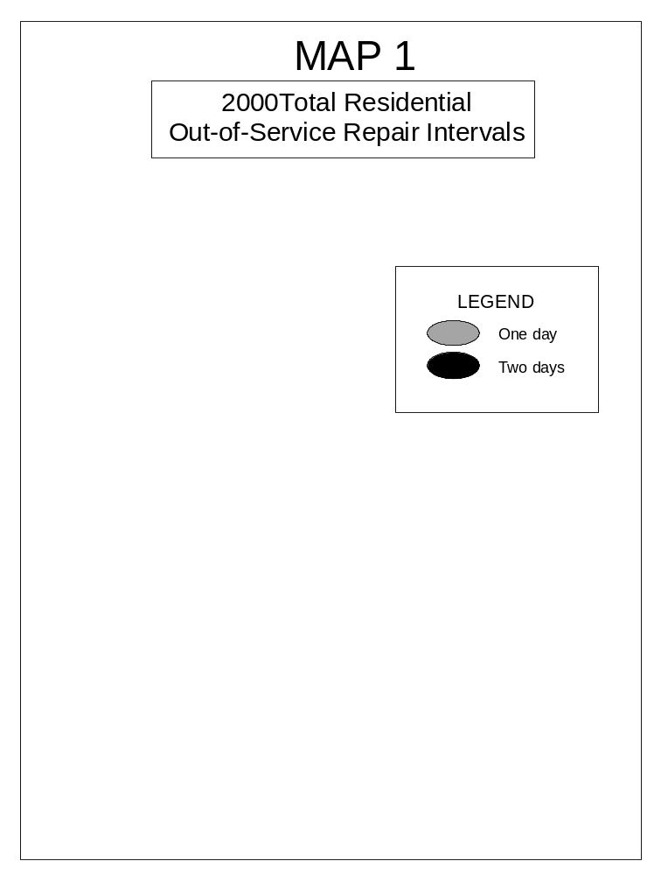
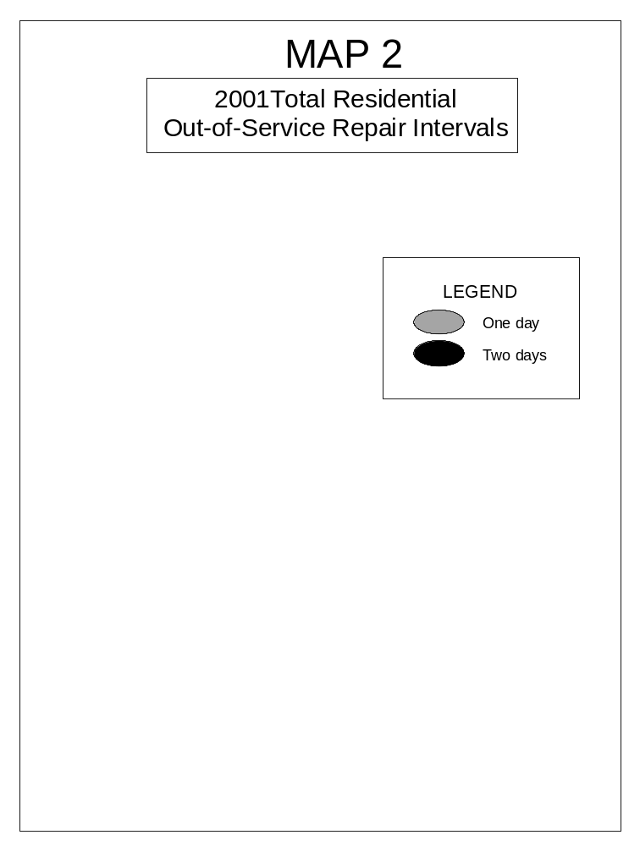
Additional Information

Q16. Is there another service quality measure for repair service that is a useful evaluation tool?
A16. Viewing the percent of out-of-service troubles that were repaired within 24 hours is a valuable tool when measuring service quality, exemplifying how many customers are receiving prompt restoration of their phone service. This is not currently a service quality measurement that is reported to ARMIS, but is reported to the Merger Compliance Oversight Team (MCOT). ORA compared SBC Pacific Bell and Verizon’s raw data to the numbers reported to the MCOT (See Tables 9 and 10).

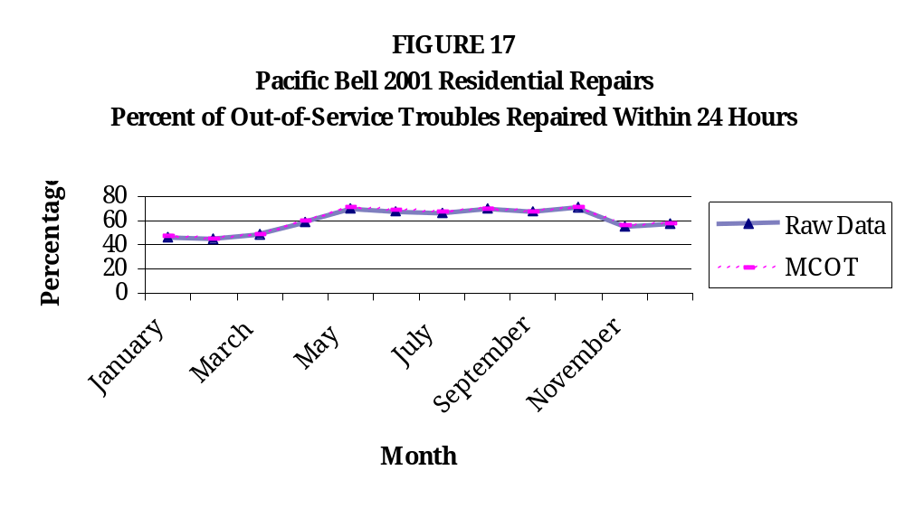
The percent of SBC Pacific’s residential out-of-service troubles that were repaired within 24 hours ranged between 45.02% and 71.03% in 2001. The raw data and MCOT data are both shown and are practically identical.

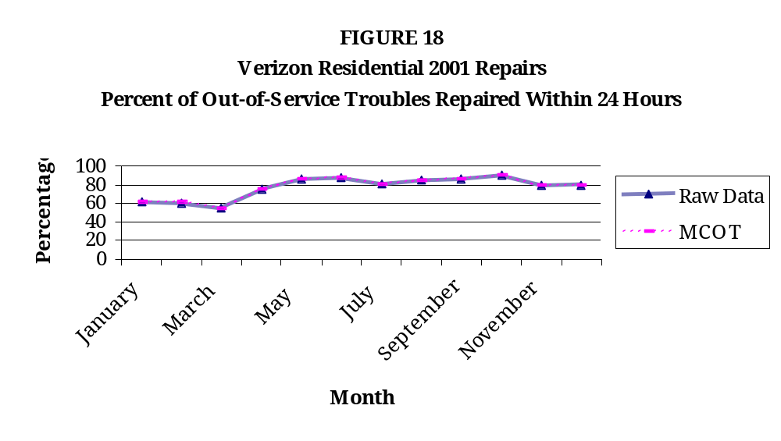
The percent of Verizon’s residential out-of-service troubles that were repaired within 24 hours ranged between 54.99% and 90.05% in 2001. The raw data and MCOT data are practically identical.

Conclusions

Q17. What are your conclusions?
A17.

SBC PACIFIC BELL

Looking at the data reported to ARMIS, it is clear that many of SBC Pacific’s business customers have experienced increases in the amount of time they must endure without phone service, as indicated by the overall increases in initial and repeat out-of-service repair intervals during the NRF review period. The longer waits indicate a decline in service quality for SBC Pacific’s business customers.

For SBC Pacific’s residential customers the data reported to ARMIS demonstrate overall increases in the initial and repeat all other repair intervals, increases in the number of initial and repeat all other trouble reports, and increases in the number of initial and repeat all other trouble reports per line during the NRF review period. Residential customers also face a comparatively high number of repeat out-of-service trouble reports as a percentage of initial out-of-service trouble reports, indicating that repair problems are not being solved in a timely manner. This problem appears even worse when viewing the raw data behind the numbers reported to ARMIS. Many of the repeat out-of-service repair problems occur within 24 hours of closure of the prior repair ticket, indicating that a single problem is not being repaired or that repair tickets are being closed prematurely. Additionally, many repairs that should be reported as repeat out-of-service repairs occur in the initial out-of-service repairs data. This calls into question the validity of the service quality numbers that SBC Pacific Bell reports to the FCC and the integrity of SBC Pacific’s raw data. These problems demonstrate a decline in service quality for SBC Pacific’s residential customers.

ORA determines that the service quality of SBC Pacific’s repair service has declined during the last NRF review period. Business customers have suffered increased time intervals lacking phone service. A growing number of residential customers have experienced problems with their telephone service, and these customers have endured longer waiting times to have their telephone service repaired. Residential customers are also obliged to cope with repair problems that must be repeatedly repaired. All of these factors show that service quality has declined in the NRF review period.

VERIZON

Verizon’s business customers have experienced increases in initial and repeat out-of-service repair intervals and increases in initial and repeat all other repair intervals in the past year, as displayed in the numbers reported to ARMIS. The longer amount of time business customers must wait to have their phone service repaired indicates a decline in Verizon’s service quality in the past year.

Numbers supplied for the ARMIS database show that residential customers of Verizon have encountered increases in initial and repeat out-of-service repair intervals and increases in initial and repeat all other repair intervals in the past year. This evidence is further confirmed when looking at total out-of-service repair intervals averaged by wirecenter. Viewing the data from a geographical perspective it is obvious that residential customers throughout California experienced longer service restoration waiting periods in 2001 than in 2000. The longer repair intervals during the NRF review period indicate a decline in service quality for residential customers. Further, it becomes evident when viewing raw data about residential service provided by Verizon that many repair tickets are closed only to be re-opened a day or two later, indicating that either the same repair problem continues unresolved or repair tickets are being closed prematurely. This suggests poor service quality for residential customers. When comparing this raw data to SPG residential credit data it appears that because such a large number of the credit records do not find a matching record in the raw data, a number of records are missing. This, coupled with a number of credits issued for repair intervals of zero days, calls into question the veracity of Verizon’s raw data.

ORA determines that the service quality of Verizon’s repair service has declined during the NRF review period. While the service quality was consistent during much of the NRF review period it has declined in the past year, as revealed in the increased durations business and residential customers must tolerate to have their telephone service repaired. Maps depicting Verizon’s residential repair intervals illustrate many regions of California in which waiting periods for repairs have increased. The increased intervals within the last year are concerning and hopefully not indicative of a further-reaching decline in service quality. Additionally, ORA finds the questionable veracity of Verizon’s raw data very significant and troubling. Without reliable data it is difficult, if not impossible, to receive a clear portrayal of the quality of service provided to customers.

OVERALL CONCLUSIONS

It has been shown in this testimony that both SBC Pacific’s and Verizon’s service quality have declined in some areas during the NRF review period. Because of this decline, an increasing number of customers have experienced problems with their telephone service, and have had to endure longer waiting periods to have these problems remedied. ORA determines that it is impossible to know how far these service quality problems reach, because the validity of both SBC Pacific’s and Verizon’s raw data is questionable. ORA has relied on numerous data from ARMIS reports, which we expect to be accurately reported by telecommunication carriers. An audit is necessary to know how reliable SBC Pacific’s and Verizon’s raw and reported data are. If these numbers are unreliable, a major tool for monitoring service quality data is lacking.

Initial out-of-service trouble reports are defined as troubles concerning service quality in which the customer is totally without phone service. These troubles are reported by customers or end-users to LEC’s and do not apply to problems that have been reported within the last 30 days. The interval is defined as "the total time from receipt of the customer trouble to clearing the trouble. Clear represents the final disposition of the report, either repairing the problem or closing the report to another category, such as a no trouble found category." The average interval is reported for each year.
Repeat out-of-service trouble reports are defined as troubles concerning service quality in which the customer is totally without phone service. These troubles are reported by customers or end-users to LEC’s and apply to problems that have been reported within the last 30 days. The interval is defined as "the total time from receipt of the customer trouble to clearing the trouble. Clear represents the final disposition of the report, either repairing the problem or closing the report to another category, such as a no trouble found category." The average interval is reported for each year.
D.01-12-021, mimeo, p.48.
Initial all other trouble reports are defined as all other troubles besides out-of-service troubles. These troubles are reported by customers or end-users to LEC’s and do not apply to problems that have been reported within the last 30 days. The interval is defined as "the total time from receipt of the customer trouble to clearing the trouble. Clear represents the final disposition of the report, either repairing the problem or closing the report to another category, such as a no trouble found category." The average interval is reported for each year.
Repeat all other trouble reports are defined as all other troubles besides out-of-service troubles. These troubles are reported by customers or end-users to LEC’s and apply to problems that have been reported within the last 30 days. The interval is defined as "the total time from receipt of the customer trouble to clearing the trouble. Clear represents the final disposition of the report, either repairing the problem or closing the report to another category, such as a no trouble found category." The average interval is reported for each year.
See SBC Pacific’s response to Data Request SQ-PB-007a.
The complete telephone numbers are proprietary information.
This data was provided in response to a verbal request on February 7, 2002. See letter included with the data response.
Ibid.
Ibid.

