EXECUTIVE SUMMARY
Pursuant to the May 6, 1997 decision by the California Public Utilities Commission on threshold Direct Access issues (D. 97-05-040), Pacific Gas and Electric Company (PG&E), Southern California Edison Company (Edison), and San Diego Gas and Electric Company (SDG&E) (the Utility Distribution Companies or UDCs) held a workshop concerning the development of statistical load profile methodologies, a process for updating and revising statistical load profiles, and ways in which the effects of inaccurate load profiling can be mitigated. The workshop also addressed whether statistical load profiles should be developed for certain kinds of customers whose maximum demand is greater than or equal to 20 kW but less than 50 kW. The three UDCs prepared and distributed a joint direct access load profiling proposal in advance of the workshop. Thirteen other parties also submitted proposals.
Conclusions of the UDCs
- In order to achieve a January 1, 1998 implementation date for direct access, UDCs should develop and implement load profiles using load shapes from existing rate categories, systems, procedures, load research meters and samples to the extent feasible.
- Initial implementation of load profiling should not prejudice parties’ opportunity to propose alternatives. The evidentiary hearings suggested in D. 97-05-040, if required, should be deferred until 1998.
- Substantive load profiling issues to be deferred include: segmentation proposals beyond the UDCs’ existing rate categories, more advanced reconciliation techniques, and establishment, if any, of new entities to develop and/or authorize load profiles.
Conclusions of Workshop Participants
- Many, but not all of the workshop participants supported the UDC proposal to implement load profiling on January 1, 1998 using load shapes from existing rate categories, systems, procedures, load research meters and samples.
- Many, but not all of the workshop participants supported the UDC proposal to consider further improvements in the design of load profiles in a subsequent proceeding concluding with implementation of any modifications to load profiles no later than January 1, 1999, subject to re-prioritization of the timing of the proceeding by the Commission.
- There was strong opposition to the UDCs’ proposal to defer consideration of whether certain kinds of customers whose maximum demand is greater than or equal to 20 kW but less than 50 kW should be eligible for load profiles. A meeting will be held within 30 days of the date of this report to further consider exceptions to the eligibility criteria for the use of load profiles.
- Some workshop participants identified a number of other issues that they believe should not be deferred to a 1998 proceeding:
- resolution of whether ESP-based load profiles will be permitted
- expanded use of dynamic updating of load profiles
- further segmentation of customer classes
- applicability of load profiles to all streetlight customers, including customer-owned streetlight facilities
Some parties suggested that their concerns should be addressed through hearings, while others maintained that Commission decision would suffice.
- Some retailers expressed a concern that they must receive specific information on the load profiles that the UDCs propose be used on 1/1/98 as soon as possible. The UDCs have agreed to make this information available to the extent possible by August 1, 1997.
Further CPUC Actions
- The UDCs are proceeding to develop procedures to implement direct access load profiling in accordance with the procedures described at the workshop, and supported (as an interim measure) by many workshop participants. If, after reviewing comments on the workshop report, the CPUC concludes some other course of action is appropriate, it should take action immediately to provide UDCs with as much lead time as possible. Without sufficient lead time, it may not be possible to implement other strategies by 1/1/98.
- Given the varied positions of workshop participants, some action regarding eligibility for customers between 20 kW and 50 kW peak demand may be required by the CPUC later this year. A follow-up meeting on eligibility will be held within 30 days of the filing of this report. The UDCs will notify the CPUC of the results of this meeting and suggest what further actions may be required.
TABLE OF CONTENTS
1. INTRODUCTION
2. PRINCIPLES FOR THE USE OF LOAD PROFILES
2.1 Implementation and Timing
2.2 Load Profile Development Responsibility
2.3 Other Principles
3. APPLICATIONS FOR LOAD PROFILES
3.1 ISO/PX Settlement Applications
3.2 Power Exchange Credit/Charge Calculation (UDC Billing)
3.3 Load Scheduling/Bidding, SC/ESP Settlement, ESP Pricing and Market Research Applications
4. METHODOLOGY
4.1 Definition
4.2 Design of load profiles
4.3 Reconciliation with available metered data
4.4 Mechanism for dispute resolution
5. ELIGIBILITY
5.1 Customers with maximum demands of less than 20 kW
5.2 Customers with maximum demands between 20 kW and 50 kW
6. SEGMENTATION
6.1 Definition of segmentation
6.2 Interim segmentation schemes for 1/1/98
6.3 Sample metering
6.4 Entity or entities responsible for developing and evaluating segmentation plans
6.5 Establishment of segmentation criteria
6.6 Establishment of methodologies for revising segmentation schemes
7. FUTURE REVIEW
7.1 Necessary data collection for use in future review
7.2 Evaluation of interim design and changes needed to create a more effective design
8. IMPLICATIONS FOR IMPLEMENTATION COSTS
8.1 Sources of cost
8.2 Reimbursement of costs
9. UNRESOLVED ISSUES
10. CONCLUSION
APPENDIX

REPORT ON JUNE 5, 1997 DIRECT ACCESS WORKSHOP ON LOAD PROFILING

1. INTRODUCTION

On May 6, 1997, a Commission decision (D. 97-05-040) directed Pacific Gas and Electric Company (PG&E), Southern California Edison Company (Edison), and San Diego Gas and Electric Company (SDG&E) (the Utility Distribution Companies (UDCs)) to meet with interested parties concerning load profiling and to file a report by June 16, 1997. The workshop was to:
“develop statistical load profile methodologies. The workshop should also address whether statistical load profiles should be developed for certain kinds of customers whose maximum demand is greater than or equal to 20 kW but less than 50 kW, a process for updating and revising statistical load profiles, and ways in which the effects of inaccurate load profiling can be mitigated.” (p. 41)
The UDCs held the required workshop on June 5, 1997, after due notice to all parties on the formal Restructure service list. A pre-workshop meeting was held on May 23, 1997, to identify issues to be covered in the workshop and to identify parties interested in presenting proposals at the workshop.
The workshop was well attended, with over 100 participants representing the UDCs, California state regulatory agencies, large and small customer representatives, potential energy service providers and aggregators, energy industry consultants, and metering systems providers. The sign-in sheet, signed by most of the attendees, is provided in Attachment A. The meeting was facilitated by Dawn Tiura of The Denali Group, Inc., a consultant hired for this purpose, and proceeded according to the final agenda (see Attachment B).
Dan Kirshner, of the Environmental Defense Fund and a member of the Board of Governors of the Independent System Operator (ISO), was invited to provide some perspective on the design and application of statistical load profiles as they impact the ISO and Power Exchange (PX). His overheads are attached as Attachment C.
Representatives from the UDCs presented a consolidated proposal for developing and using load profiles beginning January 1, 1998, and recommended a subsequent proceeding to consider further modifications to the design of load profiles. Thirteen other parties also presented proposals, all of which have been posted to the Direct Access Implementation website, http://162.15.5.2/wk-group/dai/. A list of presenting parties and summaries of their proposals are included as Attachment D. Time was provided after each presentation for questions from participants.
The afternoon was devoted to a discussion of unresolved issues. Fifteen issues were identified and considered. The following sections of this report detail the elements of load profiling that were discussed at the workshop. Each section presents the UDC implementation proposal followed by differing viewpoints provided by other parties at the workshop.
- Principles: what principles guide the development and application of load profiles?
- Application: who will use load profiles and how will they be used?
- Methodology: how will load profiles be designed and updated, and by whom?
- Eligibility: which customers should be eligible to use load profiles?
- Segmentation: how should customer classes be segmented for the purpose of developing additional load profiles beyond existing rate categories?
- Future review: what process should be used to implement further modifications to load profiles?
- Implementation costs: what are the cost implications for various design and segmentation strategies?
- Contentious issues: what issues remain unresolved?

2. PRINCIPLES FOR THE USE OF LOAD PROFILES

2.1 Implementation and Timing
The UDCs’ joint direct access load profiling proposal promotes direct access for all customers by 1/1/98 by using existing systems, procedures, load research meters and samples to the extent possible. This approach builds on proven techniques borrowed from current ratemaking practices and extended to the development of load profiles. Its implementation is straightforward, cost-effective, and achievable.
The UDCs believe that Commission acceptance of their approach to load profile development would eliminate the need for hearings on the subject in 1997, thereby improving the chances for direct access readiness by 1/1/98. The UDCs recognize that their proposal represents a simplified approach that may not reflect an optimal methodological end-state, and do not intend to prejudice parties’ opportunities to seek changes in the UDCs’ initial implementation efforts at a later date. The UDCs therefore recommend that a proceeding be opened in 1998 to further examine load profile development methodologies.
Most workshop participants agree with the UDCs’ near-term implementation proposal, and with deferring further proceedings on unresolved issues until early 1998. Unresolved load profiling issues that would be deferred include: segmentation proposals beyond the UDCs’ current proposals, more advanced reconciliation techniques, and establishment, if any, of new entities to develop and/or authorize load profiles.
Some workshop participants disagree with aspects of the UDCs’ proposal, and believe the Commission should direct the UDCs to modify their proposed implementation of load profiling by 1/1/98, or as soon as practical thereafter. These specific issues, which are addressed in various places in this report, are as follows:
- resolution of whether ESP-based load profiles will be permitted
- expanded use of dynamic updating of load profiles
- further segmentation of customer classes
- applicability of load profiles to all streetlight customers, including customer-owned streetlight facilities

2.2 Load Profile Development Responsibility
The UDCs believe that a single entity in each service territory should administer direct access load profiles, subject to CPUC regulatory oversight. At least initially, that entity should be the UDC.
Closely related, is the UDCs’ recommendation that a single load profile be used for all customers in a rate category regardless of whether the customer takes service from the UDC or a retailer. The UDCs propose to create load profiles for the existing rate categories and provide this information to all retailers. If a customer chooses another retailer, then the same load profile would still apply to this customer.
Some parties believe that any retailer should be able to design its own load profiles, specifically created to reflect the characteristics of the retailer’s customers. These parties believe there would be a conflict of interest issue if retailers are forced to use another entity’s load profiles. In addition, these parties suggest that competition among retailers in load profile design would lead to innovation and efficiency. Implicit in this idea is that customers in the same market segment could choose between retailers offering different load profiles.
The UDCs believe that there are three problems associated with allowing retailer-developed load profiles. The first is the "churning" effect created when customers switch between the UDC and retailers, or between retailers. If retailers are to develop aggregated load profiles specific to their own customer mix, customer migration between retailers will result in a systematic loss of accuracy in the load profiles, even with a significant increase in the frequency with which load research samples are redrawn. The second problem is that there are no existing procedures to verify the accuracy of a non-standard load profile. Without such procedures, load profile gaming and fraud become real possibilities. Furthermore, fraudulent development of load profiles may lead to cost shifting between market participants. Finally, the process involved in developing standards for retailer-developed load profiles, such as requirements for sampling accuracy, independence of the sample selection process, and frequency of redrawing samples, needs to be prescribed by an independent regulatory entity.
CEC staff does not believe that churning will be a problem, given the UDC segmentation proposal, because a retailer would have to capture significant market share before the class average load profile would need to be updated. Further, it believes that the verification concern, while valid, can be overcome. CEC staff supports the need for developing load profile standards.
These are two fundamentally different approaches to load profiling. Resolution of the issue of who does load profiling has profound impacts on jurisdiction, the need for oversight/verification procedures, the cost of load profiling, and the need to develop explicit procedures and standards that would apply to entities performing third party load profiling. Although most workshop participants support the UDC proposal in this area, CEC staff and some other parties believe that an agreement in principle must reached so that ESP-based load profiles can be implemented in 1998.

2.3 Other Principles
The UDCs believe that they should be financially indifferent to the application of load profiles. This point received very little coverage in the other parties’ proposals and was not addressed in the workshop, but is implicit in the unbundling methodology proposed by the UDCs in their cost separation/unbundling applications.
ORA’s proposed principles focus on allowing competitive services to reach all customers and encouraging accurate cost allocation between suppliers. ORA believes that a customer’s load profile should represent characteristics of the customer itself, which are independent of which energy retailer serves the customer. Design and evaluation of load profiles should focus not only on setting up initial practices for January 1998, but also on establishing processes to maintain and improve those practices over time.
CEC staff proposed additional principles as follows. The same load profiles should be used for determining direct access charges and power exchange credits. A single methodology should be used in developing and applying profiles for use in all applications. Application of load profiles should result in a statistically accurate representation of actual load based on established criteria. Load profiling should be designed so that retailers and the UDCs can use information from load research samples to improve the accuracy of the day-ahead forecast. Finally, retailers should be able to petition the reviewing agency for establishment of a segmented load profile.

3. APPLICATIONS FOR LOAD PROFILES

Load profiles will be used in a variety of applications where hourly information is required for customers (or market participants serving those customers) for whom hourly metered information is not readily available. These applications include ISO settlements with Scheduling Coordinators (including the Power Exchange), Power Exchange settlements with UDCs and other PX participants, and UDC identification of Power Exchange energy costs on both full service and direct access customer bills.
Virtually all parties agree that a single consistent load profile should apply to a given customer across each of these three applications, in order to mitigate opportunities for strategic self-reporting of loads and to ensure access to necessary market data. Most parties at the workshop believe that initially, a single entity should be designated to authorize load shapes in each UDC service territory for use in these three applications, pending any subsequent load profile proceeding in 1998. The UDCs and many parties believe that for 1/1/98, UDC load shapes derived from existing procedures and samples should be authorized for use in load profiling for the ISO settlement, PX settlement, and UDC billing applications.
Other potential applications of load profiles may include ISO scheduling (forecasting) of hourly loads, PX bidding by the UDCs and others, non-PX Scheduling Coordinator settlement with participant ESPs, ESP pricing to direct access customers, and ESP market research. The UDCs and many parties at the workshop propose that approved load profiles be available for parties’ use in these applications, but that no requirement be made for the use of an approved load profile (or that a load profile be used at all) for these other applications.

3.1 ISO/PX Settlement Applications
ISO settlement is the process of determining on an hour-by-hour basis the load responsibility of individual Scheduling Coordinators (including the Power Exchange). Scheduling Coordinators must submit balanced forecasts of demand and generation (final schedules), which are then compared against after-the-fact “actual” demands -- in fact, estimates of hour-by-hour Scheduling Coordinator demand, based on available metered data. Differences between forecasts and the actual demands of individual Scheduling Coordinators are imbalances, which the ISO must settle with each Scheduling Coordinator. Differences between the total known inputs to the ISO system (metered generation plus net imports at grid interconnection points) and total known end-use metered consumption represent Unaccounted For Energy (UFE), which, by definition, cannot be directly assigned to any individual market participant.
Because hourly metered usage is not available for load profile customers, errors resulting from the use of statistical load profiles will contribute to hourly UFE. The ISO is currently considering proposals for separately identifying the load profile portion of UFE and assigning it to Scheduling Coordinators in proportion to their load profile customer loads. However, the UDCs understand that the ISO has concluded that such methods cannot be implemented on January 1, 1998. Other sources of UFE, which include energy theft, metering errors, and transmission and distribution loss estimation errors, would still be allocated to Scheduling Coordinators in proportion to their total hourly loads, both metered and load profiled.
This relationship between load profile error and ISO settlement of UFE is a significant one, because any improvements in load profile estimation accuracy will lead to a corresponding reduction in the UFE which must be allocated administratively by the ISO. (See Section 4 and Section 6, for discussion of proposals for improving load profile estimation accuracy.)

3.2 Power Exchange Credit/Charge Calculation (UDC Billing)
During the transition period, UDCs are required to procure energy through the Power Exchange to meet all full service customer needs, and to separately reflect the costs of this energy on customer bills. In the Cost Separation/Unbundling proceeding currently before the Commission (A. 96-12-009, et. al.), the UDCs have proposed that load profiling be used to calculate PX charges for full service customers without hourly metering, and, residually, to assign CTC charges for these customers (based on total, frozen rates minus transmission, distribution, public purpose, and PX energy charges). Furthermore, the same PX charge would be subtracted from the bundled rate for a direct access customer to credit the customer for the UDCs’ avoided costs of purchasing PX energy on that customer’s behalf. After the end of the transition period, UDCs would use load profiling to calculate the PX energy charges for any remaining full service customers without hourly metering. Other parties have submitted proposals in the Unbundling proceeding that suggest different methods for calculating the PX portion of a customer’s bill.
Applied Econometrics Inc., a consulting firm, proposes that a separate load profile be developed and applied to calculate CTC charges on UDC bills.

3.3 Load Scheduling/Bidding, SC/ESP Settlement, ESP Pricing and Market Research Applications
Load profiling may have a variety of other uses for unregulated market participants in forecasting, cost allocation, and market research. Because these participants are unregulated, and these applications do not directly affect the customers of other market participants, the UDCs and the majority of parties make no proposal as to whether and how parties should use load profiles in these applications. Nothing would prevent an unregulated market participant from utilizing an approved load shape in developing a load profile for any of these applications, should it choose to do so. The CEC staff and ORA believe that information from dynamic updating of authorized load profiles should be made available to the marketplace to improve the accuracy of load bidding and forecasting activities.

4. METHODOLOGY

4.1 Definition
Parties generally agree with the UDC definition that load profiling is the process of taking the cumulative kWh usage of a customer over a billing cycle and assigning it to individual hours in the cycle, based on the aggregate characteristics of the customer segment in which the customer resides.
Several parties would include in the UDC definition the further clarification that statistically valid methods be used in the assignment process. EDF believes the assignment should be based on “an estimate of the time pattern of the customer’s proportionate energy usage,” rather than the aggregate characteristics of the customer segment.

4.2 Design of load profiles
The UDCs’ propose to create daily load shapes, and make these shapes available to all applicable parties. The daily load shapes will consist of hourly kW loads for each applicable load profiling category, or equivalent normalized values. The UDCs will employ a load profiling method to develop daily load shapes from load research data that is currently available or can be readily developed. The methods used will vary across the UDCs and by rate category within the UDCs. These methods are:
- Dynamic load profiles are created by reading the load research meters on a daily basis and producing daily load shapes which reflect the customer segment usage for the day. Edison will use dynamic load profiles for its Domestic and GS-1 classes.
- Static load profiles are created by averaging historical data from load research samples by class, and creating load shapes that approximate customer segment usage for the given day. Static load shapes are pre-determined and fixed in advance. They can be differentiated by season, month, and day type (weekend/holiday and weekday). PG&E’s load profiles utilize three years worth of data to create average load profiles that smooth out unusual operating characteristics for any particular year; these data are aligned so that holidays and weekdays are correctly mapped for all years, and reflected in the aggregate load profiles. Edison and SDG&E will use similar methods to develop static load profiles. PG&E and SDG&E will use static load profiles for the majority of their rate categories.
- Deemed load profiles are created by using engineering estimates to create daily load shapes. This method is used for some rate schedules with predictable loads, specifically streetlights (all UDCs) and traffic control devices (PG&E and Edison) where metering may not be available.
Some retailers have expressed their concerns about obtaining load profile information quickly, to assist in developing their marketing strategies and implementation plans. The UDCs will provide load profile information for all applicable load profile categories, and will provide the data to all appropriate market participants. The UDCs have agreed to provide load profile data for current rate categories on August 1, 1997. These data will include load shapes for all rate classes for which PG&E and SDG&E will use load profiling. Edison will provide load shapes for PA-1, TC-1 and LS-1 rate classes, since dynamic load shapes will be used for its Domestic and GS-1 customers. At the workshop, Edison indicated it may use a static load profile for Domestic master-metered customers (DMS schedules), since these customers are not part of the Domestic dynamic sample.
For each load profiled customer group, UDCs intend to provide daily load shapes for each day of the year in 1998. The three UDCs have provided typical load profile data for their recommended direct access load profiling categories in Appendix E of this report. The UDCs anticipate that information access procedures will be developed in a manner similar to other settlements data, such as consumption meter usage.
The UDCs propose to periodically redraw their load research samples and redeploy their sample meters in response to customer turnover and customer migration to hourly meters. This will be performed in a manner comparable to current practices. This proposal received little discussion at the workshop.
The UDCs currently use stratification within each rate category to increase the sample’s accuracy. Stratification is a process in which characteristics of a population, like average usage or territory, are used to enhance the information contained within the sample for the entire class. The UDCs propose that stratification for the interim period be based on current practices, and that stratification continue to be used for improving the total rate class accuracy but not for further segmentation within each class.
One concern with the use of static load profiles is that static profiles do not follow actual weather patterns. As a consequence, static profiles are subject to greater daily errors than other possible load profiling methods. Some parties argue that approved econometric techniques could be used to estimate load profiles and to verify the fit of load profiles. The UDCs agree that econometric techniques reflecting weather and other relevant variables would be an improvement, but suggest that dynamic load profiling is preferable in the long term. In addition, the regulatory burden and administrative costs of such techniques will make the process of gaining approval of econometrically derived load profiles slow and inflexible, and may not permit implementation on January 1, 1998. ORA presented an alternate proposal (see Attachment F) that would use econometric techniques to improve the accuracy of load profiles.
UDCs were requested by some parties to expand their use of dynamic profiles. The UDCs are not opposed to moving towards dynamic load profiles, although for PG&E and SDG&E, this is not feasible by 1/1/98. However, there are additional costs associated with dynamic load profiles. Some parties voiced their opposition to allowing PG&E and SDG&E to expend Section 376 costs for this purpose to develop the capabilities to perform dynamic load profiling in a manner comparable to Edison. In other forums, CEC staff has supported the authorization of additional expenditures by the UDCs to permit more accurate load profiling, such as dynamic updating, for forecasting and settlement applications.

4.3 Reconciliation with available metered data
For determining PX credits, UDCs propose that an average PX price will be computed by multiplying hourly PX prices times hourly load profiled usage computed using the applicable authorized daily load shapes. Edison proposes to compute a rolling average PX price reflecting hourly PX prices and load profiled usage for the approximately 30 days prior to the date at which a customers meter is read. PG&E and SDG&E propose to compute a monthly average PX price, reflecting hourly PX prices and load profiled usage for the calendar month prior to the date at which a customer’s meter is read. Participants felt that these bill calculation procedures were not within the scope of the load profiling workshop. This issue is also being adjudicated the Commission in the Unbundling proceeding.

4.4 Mechanism for dispute resolution
The UDCs have proposed that the CPUC be the regulatory entity responsible for oversight of load profiles used within their respective service areas. Most workshop participants appear to accept the CPUC’s jurisdiction regarding load profiling methodology and design. According to the current ISO tariff, the ISO will require that settlements for customers with consumption meters be based on load profiles approved by the applicable local regulatory body. Dan Kirshner stated that the ISO can modify the tariff’s language on load profiling responsibility, and suggested that there might be a greater degree of ISO interest in reviewing load profiling methodologies than expressed in the current proposed ISO tariff. Other parties have proposed other entities as appropriate for overseeing the load profiling process, making this an unresolved issue.

5. ELIGIBILITY

D. 97-05-040 permits customers with maximum demands of less than 20 kW to participate in direct access through load profiling. The decision also indicates that the Commission will “consider whether load profiles for certain customers whose maximum demand is equal to or greater than 20 kW, but less than 50 kW should be permitted. The possibility of those kinds of exceptions should be addressed in the load profiling workshop” (footnote 13, p. 35).

5.1 Customers with maximum demands of less than 20 kW
The UDCs propose that the 20 kW threshold be determined using existing rate schedule breakpoints. Where existing rate breakpoints are not aligned with the 20 kW threshold, the UDCs propose to screen 1996 billing data for demand-metered accounts less than 20 kW. The UDCs answered several clarifying questions regarding their eligibility criteria for accounts less than 20 kW.
For PG&E, customers eligible to use load profiles and their respective load profiling methods appear below. For demand-metered accounts, PG&E proposes to screen annually for accounts with maximum demands of less than 20 kW in 9 of the last 12 billing cycles.
PG&E Class | Eligibility | Estimation Method
Residential | E-1, E-7, E-8  (All residential schedules) | Static
Small Commercial | A-1, A-6  (All small commercial schedules) | Static
Medium Commercial | A-10, E-19V  screened for demands < 20 kW | Static
Agriculture | <35 hp connected load  or “A” schedules | Static
Traffic Control Devices | TC-1 | Deemed
PG&E-Owned Streetlights | LS-1 | Deemed
For Edison, eligible rate schedules and load profiling methods are as follows. Edison does not need to screen demand-metered accounts as its rate schedules break at 20 kW.
Edison Class | Eligibility | Estimation Method
Domestic | D (includes all schedules except DMS)  DMS | Dynamic  Static
Small Commercial  and Industrial | GS-1 | Dynamic
Small Agriculture  and Pumping | PA-1 | Static
Traffic Control Devices | TC-1 | Deemed
Edison-Owned Streetlights | LS-1 | Deemed
For SDG&E, the following customers would be eligible to elect direct access using load profiles. SDG&E proposes to screen annually for accounts with Maximum Annual Demands of less than 20 kW or, if no demand meter is present, with usage of less than 12,000 kWh in each of the previous 12 billing cycles.
SDG&E Class | Eligibility | Estimation Method
Domestic | All residential rate schedules | Static
Small Commercial: | Schedules A, A-TC | Static
Large Com/Ind. | Schedules A-TOU, AL-TOU, AO-TOU, and AY-TOU | Static
Agricultural | Schedules PA, PA-TOU | Static
Lighting | Schedules LS-1, LS-2, LS-3, OL-1 | Deemed
The California City-County Street Light Association (CAL-SLA) suggested that all streetlight accounts should be eligible for load profiles. Edison and PG&E responded that for streetlights that are not UDC-owned, the municipal owner is not currently required to meet any maintenance standards for the photocell that controls operation of each streetlight. Faulty photocells could lead to inefficient operation of the streetlight and further cost shifting. SDG&E proposes to make all streetlight schedules eligible for load profiles.

5.2 Customers with maximum demands between 20 kW and 50 kW
D. 97-05-040 asks workshop participants to explore exemptions for customers with maximum demands greater than or equal to 20 kW but less than 50 kW. The UDCs propose that only customers with measurable maximum demands below 20 kW be eligible for load profiling. D. 97-05-040 sets the cut-off for load profiles at 20 kW to correlate generally with AB 1890’s definition of a small commercial customer, to more closely reflect the current tariff schedules of customer classes, and to reduce the potential for cost shifting. In addition, the cost of hourly metering is small in relation to medium commercial customer bills; these customers should install hourly meters to become eligible for direct access.
Parties expressed several concerns with the UDC proposal. In particular, the availability and affordability of meters were raised as potential direct access constraints. One party commented that meter availability and affordability were discussed in the Commission’s deliberations on the Unbundling of Revenue Cycle Services, and that various parties, including the Commission, expressed the belief that competition in metering will help alleviate affordability and availability issues (D. 97-05-039, page 28).
Other parties suggest consumption level or load factor cut-offs as eligibility criteria for load profiles. Still other parties propose profiles for 20-50 kW customers that are part of a homogenous group, or outright expansion of eligibility to 50 kW. While these particular proposals received little debate, workshop participants believe that resolution of eligibility issues should not be deferred until 1998. There was unanimous agreement to hold a meeting to further discuss these issues.

6. SEGMENTATION

6.1 Definition of segmentation
In the context of load profiling, segmentation is the degree to which customers are divided into categories of similar customer types. Simple segmentation schemes, such as one load profile applied to all customers in a rate category, would facilitate implementation of direct access, but may result in less accuracy in the assignment of PX costs. On the other hand, a high degree of segmentation would greatly complicate and could delay the implementation of direct access but may result in greater accuracy in the assignment of PX costs.
Methods for dividing customers into homogeneous groups are varied. Segmentation alternatives include: by currently-adopted customer categories, by rate schedule, by usage, by climate zone, by appliance mix, by all-electric versus gas & electric, by dwelling type, by Standard Industrial Classifications (SIC), by ESP, or by multi-site customer.

6.2 Interim segmentation schemes for 1/1/98
The UDCs propose that, initially, load profile categories correspond to existing rate categories, with no finer degree of segmentation. Load profile categories are readily and consistently identifiable, and would correspond to the customer classes listed in Section 5.1 of this report. The UDCs are not opposed to consideration of additional segmentation. However, to enable implementation of direct access with load profiling on January 1, 1998, the UDCs propose that discussion of additional segmentation be deferred. The need for additional segmentation should be addressed after January 1, 1998, in the proceeding described in Section 7 of this report.
Although most workshop participants agree with the UDCs’ interim proposal for simplified segmentation, CEC staff, ORA, CAL-SLA, and SPURR-REMAC expressed their belief that additional segmentation should occur on January 1, 1998. Some workshop participants expressed support for one or more of the following additional segmentation schemes on January 1, 1998:
- for schools
- for customers of an ESP
- for customer-specific load shapes in the 20-50 kW range
- for residential customers by climate zone
- for residential customers: all-electric versus gas & electric
Without additional segmentation beyond the UDCs’ proposal, some workshop participants are concerned that load profiling errors could be significant and these errors could result in an inequitable allocation of costs. CEC staff quantifies that, for some residential customers, error could amount to tenths of a penny per kWh, but that the size of this error largely depended on the price volatility of the PX. While acknowledging that these differences would be minor for individual customers, CEC staff believes that such cost differences may have substantial impacts on the cash flows of retailers. ORA estimates that if imbalance costs exceed marginal costs that were produced from optimization models, this would amount to $11 million to $68 million per year for Edison’s residential class during summer weekdays, and $1.5 million to $9 million for its small commercial class. However, most ESPs represented at the workshop support the UDCs interim proposal for segmentation.

6.3 Sample metering
The UDCs propose that the issue of how sample metering should be modified to accommodate additional load profiling segments be deferred without prejudice to the proceeding described in Section 7.
Most workshop participants agree with the UDCs’ proposal to defer this issue. Hence, workshop discussion of sample metering requirements was limited and should be continued in the subsequent CPUC proceeding described in Section 7.

6.4 Entity or entities responsible for developing and evaluating segmentation plans
The UDCs propose that the issue of which entities should be responsible for developing and evaluating segmentation plans should be deferred without prejudice to the proceeding described in Section 7.
This issue is linked to the question of which entities may develop and/or authorize load profiles, as discussed in Section 4 of this report. These issues should not be resolved independently. Most workshop participants agree with this characterization of the issue. Discussion of this issue during the workshop was limited, and should be continued in the subsequent proceeding described in Section 7.

6.5 Establishment of segmentation criteria
As described in Section 6.2 and listed in Section 5.1, the UDCs propose that load profile segmentation for 1/1/98 should correspond to existing rate categories. The UDCs propose that the issue of how segmentation criteria should be established beyond 1/1/98 should be deferred without prejudice to the proceeding described in Section 7.
Most workshop participants agree with the UDCs’ proposal. Hence, discussion of this issue during the workshop was limited, and should be continued in the subsequent proceeding described in Section 7.

6.6 Establishment of methodologies for revising segmentation schemes
In 1998 and beyond, the UDCs propose that further segmentation can be considered, subject to the following criteria:
- Customer eligibility must be readily verified to minimize enforcement burdens.
- The possibility for collusive behavior among segment members should be remote.
- The segmentation must trade off costs/administrative burden with improved accuracy.
- The load shape resulting from a particular segmentation of a customer class must represent, to a reasonable degree of statistical accuracy, the actual shape for the segment in aggregate.
- The load profiles resulting from the particular segmentation scheme should be subject to consistent application in determining PX credits and charges, CTCs and ISO/PX settlements.
Most parties agree with the UDCs’ proposal to defer the issue of establishment of methodologies for revising segmentation schemes without prejudice to the proceeding described in Section 7.
CEC staff is concerned that an additional principle must be agreed upon prior to implementation on January 1, 1998. Specifically, CEC staff believes that ESPs must be able to pursue their own segmentation schemes in 1998. CEC staff believes that the CPUC’s intent of enabling competition would be undermined if ESPs are denied this option. While most ESPs at the workshop acknowledge that they do not plan to propose specific segmentation schemes on January 1, 1998, most ESPs would like to eventually have such an opportunity.
Other parties propose additional segmentation methodologies or criteria. These include: identification of homogeneous customer groups with consistent load shapes, identification of costs-of-service differences on a per customer basis, and use of statistically valid approaches, such as econometric modeling.
While the UDCs do not object to discussion of methodologies for revising segmentation schemes (and the implications on ESPs, UDCs and customers), they note that implementation requirements prohibit extensive consideration prior to January 1, 1998.

7. FUTURE REVIEW

Issues related to load profiling are complex and contentious, therefore, the UDCs propose delayed consideration of unresolved issues to allow parties to devote time and resources to in-depth discussion and analysis. The requirement for significant system changes prevents UDCs from accommodating many load profiling proposals that may ultimately be considered appropriate by the CPUC. Since significant system changes require substantial (e.g. months or more) of lead time for implementation, the UDCs propose that an interim load profiling methodology be adopted for January 1, 1998.
The UDCs propose that issues to be deferred should include: segmentation proposals beyond the UDCs’ current proposals, more advanced reconciliation techniques, and more advanced procedures for settlement of energy imbalances. Deferred consideration of these issues will also allow the interim load profiling methodology to be evaluated.
Proposals requiring significant methodology and system changes should not be foreclosed, but issues should be deferred without prejudice or establishing any presumption regarding whether changes should or should not be made in the future.
Most workshop participants are in accord with the UDCs’ proposal for addressing unresolved load profiling issues in a future CPUC proceeding. Most participants agree that the proceeding should begin as soon as possible after January 1, 1998, and implementation of the approved methodology should be scheduled for no later than January 1, 1999. Some parties felt that the hearing schedule should be prioritized against other restructuring activities for 1998.
The UDCs propose the following schedule for future workshops and potential CPUC hearings:
1st quarter 1998 Status report on use of load profiles
Workshops and Workshop reports (if necessary)
2nd quarter 1998 Hearings (if necessary)
3rd quarter 1998 CPUC decision
January 1, 1999 Implementation

7.1 Necessary data collection for use in future review
In its written proposal, the CEC staff have proposed that a more permanent design should be implemented in 1999 so that the CPUC reevaluation of load profiles in 2000 will have a year’s worth of data based on the more permanent methodology. The CEC staff have suggested that data collection should include PX price variation, direct access penetration into residential and commercial sectors, and energy imbalance costs due to load profile errors. However, there was minimal discussion of this issue in the workshop.

7.2 Evaluation of interim design and changes needed to create a more effective design
ORA’s written proposal suggests that the issue of improved metering at central metering points should be examined in the CPUC review. There was no discussion of this issue in the workshop.

8. IMPLICATIONS FOR IMPLEMENTATION COSTS

8.1 Sources of cost
Workshop participants identified several potential sources of costs associated with load profiling. The UDC proposal provides for load profiles based on existing rate categories, systems, procedures, load research meters, and samples. UDCs have already begun the process of developing systems and load shapes to create load profiles. Some costs will be incurred to maintain these profiles, apply them in customer bills and ISO settlements, and disseminate them to the marketplace. To the extent additional segmentation or dynamic updating of load profiles is required, the UDCs will incur additional costs.
While the UDCs have not yet developed estimates of the specific costs of developing samples or load profiles for additional segments or upgrading systems to revise profiles more frequently, the current UDC proposal requires minimal incremental costs to make customer class-based profiles available January 1, 1998.

8.2 Reimbursement of costs
UDCs will seek Section 376 cost recovery for systems and process changes necessary to implement direct access load profiling methodologies.
UDCs will require additional funding if additional customer segmentation or dynamic updating (PG&E and SDG&E) is required. Several representatives of ESPs and customers noted at the workshop their reluctance to bear these costs. Greater accuracy in load profiles, while a desirable goal, incurs costs that ratepayers may not be willing to pay. The UDCs, supported by some workshop participants, ask the Commission to consider the tradeoffs between certain UDC implementation costs and uncertain benefits of increased accuracy before determining whether or not they should undertake these activities.

9. UNRESOLVED ISSUES

During the afternoon portion of the session, participants listed 15 unresolved issues resulting from the morning’s presentations and subsequent discussion. These issues appear below as they were grouped by participants. Further discussion of these issues led to the conclusions listed in the Executive Summary and other sections of this report.
Timing
- What should be decided today and elsewhere?
- What methodologies should be allowed in load profile design?
- How should the resolution of outstanding issues be timed and/or staged?
Responsibility
- Who develops load profiles? (UDC vs. ESP vs. other)
- Who pays for the development of load profiles?
Segmentation
- What level of segmentation should be required?
- What criteria should used for developing additional load profiles?
Eligibility
- Which customers (if any) with maximum demands between 20-50 kW should be eligible for load profiles? If so, when?
- How would extending eligibility for customers above 20 kW affect cost-shifting and the CTC firewall?
Application and Jurisdiction
- Should profiles be applied to load scheduling and bidding?
- Who authorizes new load profiles or arbitrates disputes?
Clarifying Questions
- How will load profiles be disseminated to the marketplace?
- Which load profile is subtracted from the customer bill for the PX credit?
- What are dynamically updated profiles? Static profiles?
- What is the definition of the 20 kW limitation?

10. CONCLUSION

All three UDCs and most workshop participants agree that, in order to implement load profiling on January 1, 1998, UDCs should use load shapes from existing rate categories, systems, procedures, load research meters and samples to develop load profiles. Many workshop participants supported the UDC proposal to consider further improvements to the design of load profiles in a subsequent proceeding concluding with implementation of any modifications to load profiles no later than January 1, 1999, subject to re-prioritization of the timing of the proceeding by the Commission.
Most workshop participants do not support deferring the issue of whether certain kinds of customers whose maximum demand is greater than or equal to 20 kW but less than 50 kW should be eligible for load profiles. A meeting will be held within 30 days of the filing of this report to further consider exceptions to the eligibility criteria for the use of load profiles. Some workshop participants believe there are other issues that should not be deferred to a 1998 proceeding: an agreement in principle that ESP-based load profiles will be implemented in 1998, implementation of dynamic updating of load profiles, and further segmentation of customer classes. Some parties suggested that their concerns should be addressed through hearings, others that a Commission decision would suffice.
All three UDCs are committed to implementing the Commission’s directives, and request that these issues be addressed as quickly as possible.

Respectfully submitted on behalf of Pacific Gas & Electric Company, Southern California Edison Company, and San Diego Gas & Electric Company,

By:___________________________________
Peter Ouborg, PACIFIC GAS AND ELECTRIC COMPANY

APPENDIX

ATTACHMENT A.
(copies of sign-up sheets)
(available in hard-copy only)

ATTACHMENT B

AGENDA FOR LOAD PROFILING WORKSHOP
June 5, 1997
California Public Utilities Commission
505 Van Ness Ave., San Francisco, CA
Auditorium
Facilitator: Dawn Tiura

9:00-9:15 Introductions, review of agenda/format of meeting

9:15-9:30 Review of WEPEX perspective on load profiles

9:30-11:30 Review proposal summaries, clarifying Q&A

11:30-12:30 Identify unresolved issues, scope afternoon discussion

12:30-1:30 Lunch break

1:30-4:30 Discuss unresolved issues

4:30-5:30 Wrap up, next steps

ATTACHMENT C
(Dan Kirshner overheads)
(available in hard copy only)

ATTACHMENT D
Summary of Load Proposals

PARTY | ELIGIBILITY | APPLICATION | PRINCIPLES | METHODOLOGY | SEGMENTATION
PG&E/SCE/SDG&E  Toby Tyler  Carl Silsbee  Robert Hansen | Use existing rate schedule breakpoints. Where applicable, UDCs will screen for accounts less than 20 kW. | All settlements with ISO/PX. PX credits/prices. PX/CTC separation. LPs not required for scheduling or bidding. | Use existing systems, samples, etc. Non-precedential initial implementation. UDC financial indifference. Customers use same profile regardless of supplier. Hearings on unresolved issues in 1998. | UDCs administer load profiles. Dynamic, static and deemed methods based on what is feasible. Periodic re-sampling in response to customer migration in manner comparable to current practices. | Based on existing rate categories. Additional segmentation will be considered in 1998. Segmentation criteria: verifiable, no gaming opportunity, cost-effective, improved accuracy.
AECA  Steve Moss |  |  | Customer should be able to offer their own profiles; error costs should be borne by all.
Applied Econometrics  Michael Parti |  | CTCs should be separately calculated from PX settlements |  | Retailers should develop their own profiles using a variety of approved statistical and sampling methodologies. Load profile oversight by independent entity. | Retailers should submit segmentation plans to an approval authority. Start with existing utility samples but create approval authority by November to handle new requests.
CAL-SLA  Reed Schmidt | All street light accounts should be eligible for LPs using existing UDC methods (deemed)
CEC  Ken Goeke | Max demand equals highest "integrated hourly customer load". Use same thresholds as for rate reduction. Recommend if 75% of customers in a "commercial group" are eligible, rest (between 20 and 50 kW) should be, too. Review impacts of LP use in 2000. | Energy imbalance settlements (ISO, ISO/SC, and SC/ESP), customer billing (UDC PX charge/credit) , load forecasting (ISO,PX). | Consistency between UDC and ESP billing applications. A single methodology for all applications. Validation of assignments from billing records Design LPs to aid scheduling; if LP a perm. option, install telemetry. Retailers may petition for segments. | 1/1/98 use existing utility samples, reviewed by ORA/CEC. Establish a verification procedure for retailers to petition for and install dynamic samples. | Segment to identify cost-of-service differences or reduce imbalance costs. For 1/1/98 two climate zones. Retailers should petition for bus. segments with unusual operating schedules.
DGS  Jeanne Sole | Low load factor customers between 20 and 50 kW should be eligible -- generic exemption for annual use less than or equal to 30,000 kWh.
EDF  Dan Kirshner |  |  | Keep it simple for 1/1/98, review later. UDC should create LPs for use by retailers and SCs, ISO settlement, however, retailer may develop later. LP not exclusively CPUC jurisdictional -- ISO and PX requirements.
Eastern Pacific  Tony Wayne | All accounts < 50 kW should be exempt until interval metering is available.

PARTY | ELIGIBILITY | APPLICATION | PRINCIPLES | METHODOLOGY | SEGMENTATION
ORA  Jim Price | If profiles for homogenous groups (e.g. schools) then include like cust's up to 50 kW. | UDC PX charge/credit and ISO/PX settlement applications should use consistent LPs. UFE allocation and LP error sep. proposal for settlement. LPs useful in scheduling/bidding, but shouldn't require any given methodology. | LPs based on characteristics of customer that are independent of retailer. | Initially LPs UDC enforced, ultimately another entity. Dynamically sample. ESP-specific LPs an alternative approach. Stratification within segments to improve accuracy. | Two basic criteria for new LPs -- different from existing, and statistically accurate. For 1/1/98 use 500 kWh cutoff between large and small res, identify el. heat customers, climate zone for SCE. Use advice letter or RAP process for revisions.
Portland General  Richard Carroll | Install interval metering on all 50 kW and up by 1/1/98, on all 20 kW and up by 2000 -- LPs in interim. Revise LPs annually to reflect migration to RTMs. | All profiling determinants for settlement need to be available for ESP forecasting. | Simple, transparent methodology as interim solution, transition to RTM. Annual updates and calibration to "remaining non-interval meters within that segment". | Existing utility segments, UDCs do all profiling for settlement. | Use existing UDC strat's, don't change over time.
RLW  Michael Becker |  | ESP settlement and forecasting should use same (ESP-specific) LP. Also ESP application for marketing energy services (can use separate confidential LP). | Should accurately represent each ESPs individual customer population -- continued use of "generic" profiles stifles hourly price signals. | ESPs should develop and continually maintain samples of their customer pop's, updating LPs annually. CPUC would "scrutinize for correctness". | For 1/1/98 start with utility segments based on "billing determinants". Segmenting by ESP allows target marketing then ESP's aggregate LP becomes the segment.
Southland (7-11)  Mark Morgan | Consideration should be given to customers with demands of 20-50 kW. |  |  | 7-11 has done extensive work to understand their LP and wants to use that data
SPURR-REMAC  Tom Solberg | All PG&E A-1's should be eligible, plus customers with low load factors up to 50 kW. | Load profiles should be developed for customer groups with consistent load shapes that are easily verifiable. | Use generic load profiles unless can identify verifiable characteristics of a group (e.g. schools) with consistent usage patterns. | Start with utility data, including any class load research. File non-standard profiles with UDCs.
UTS/ITRON  Ed White |  |  | Develop load shapes via “cluster sampling.” For static profiles, use regression analysis to adjust for weather. For dynamic profiles, use daily load research data to balance to daily meter readings.

ATTACHMENT E

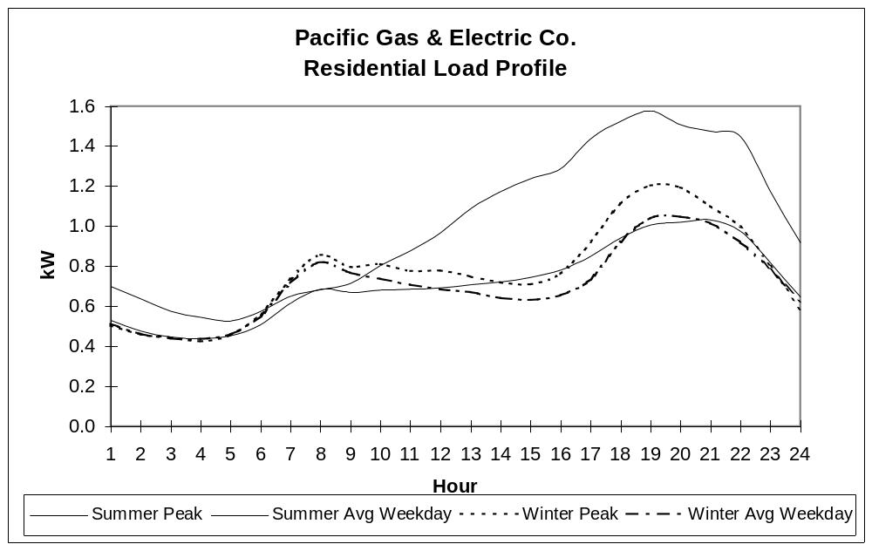

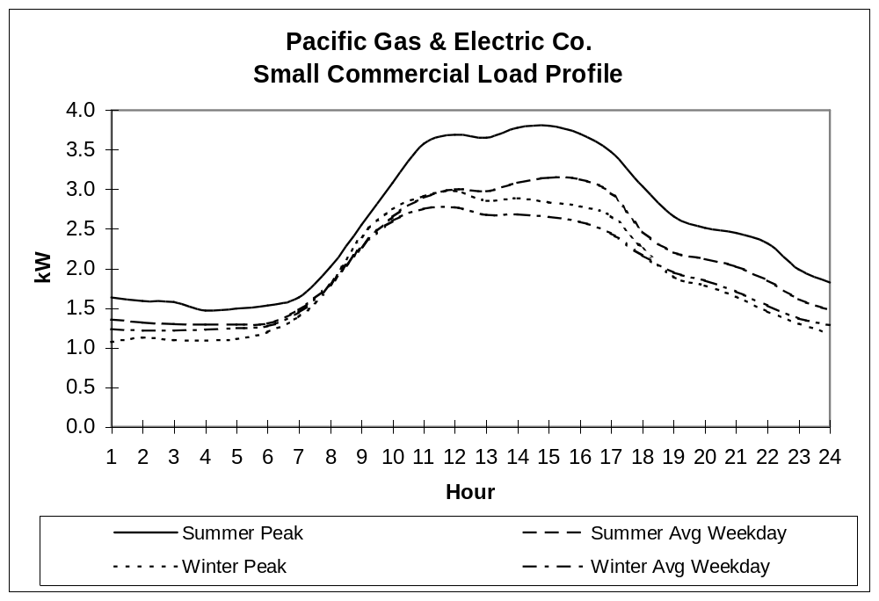

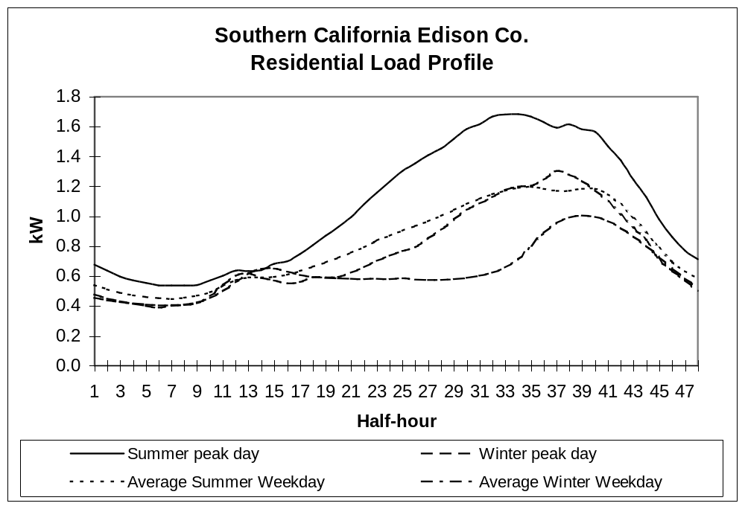

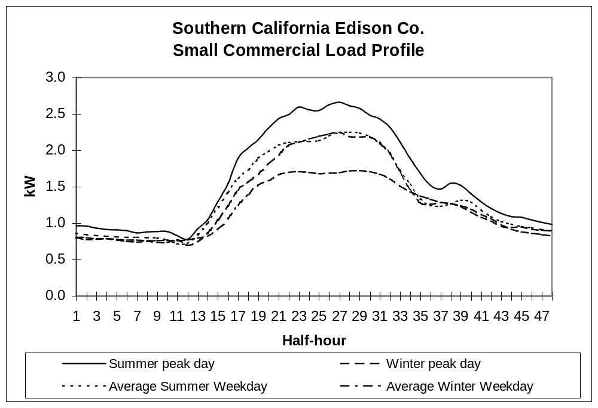
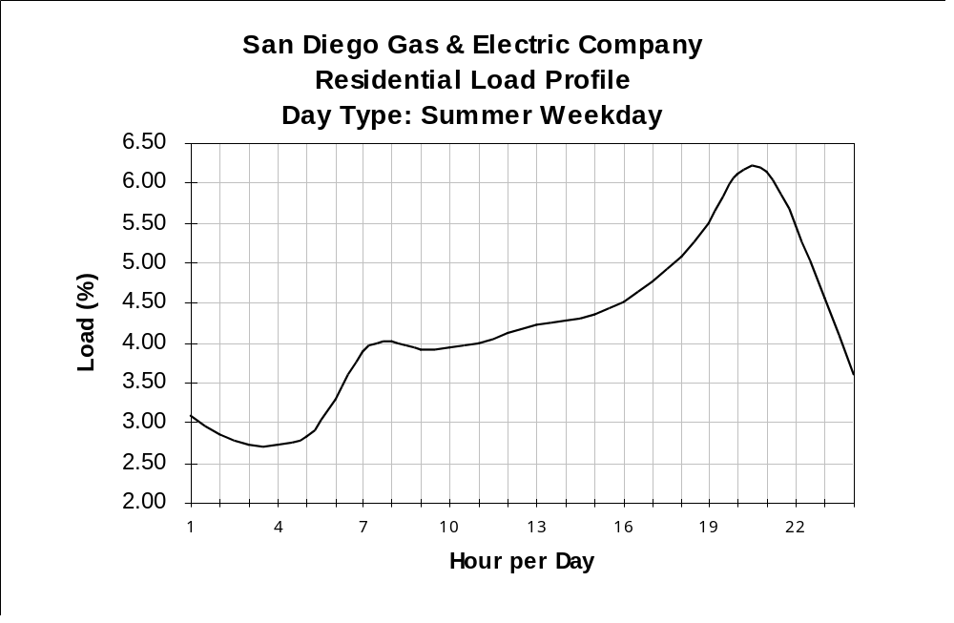

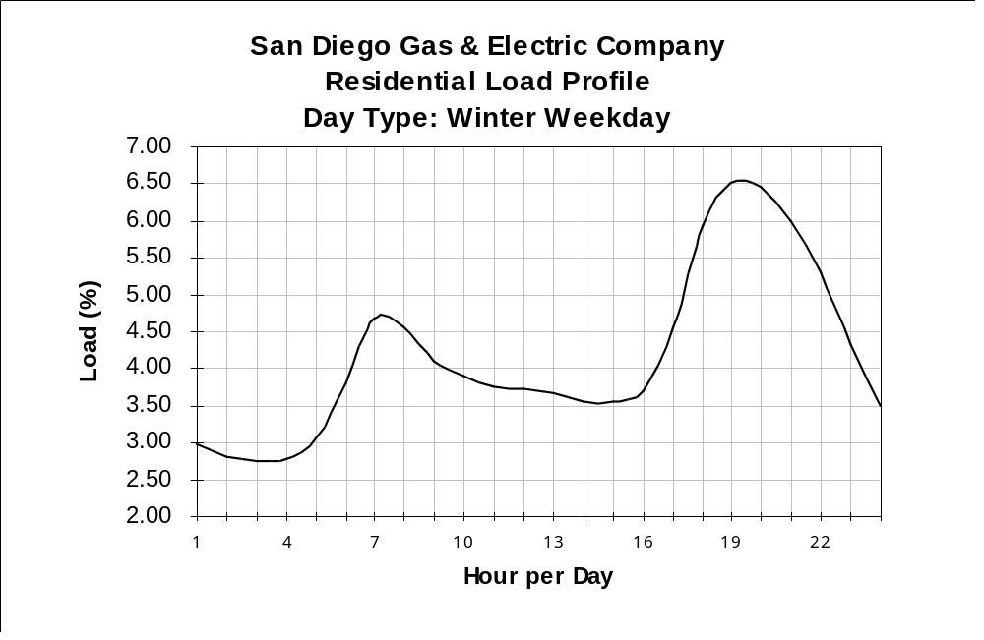
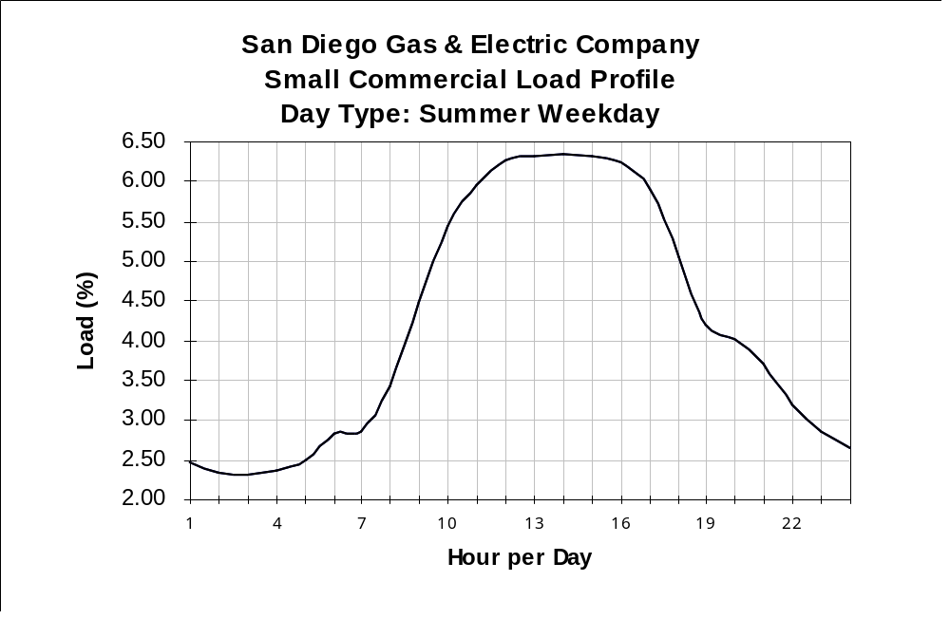

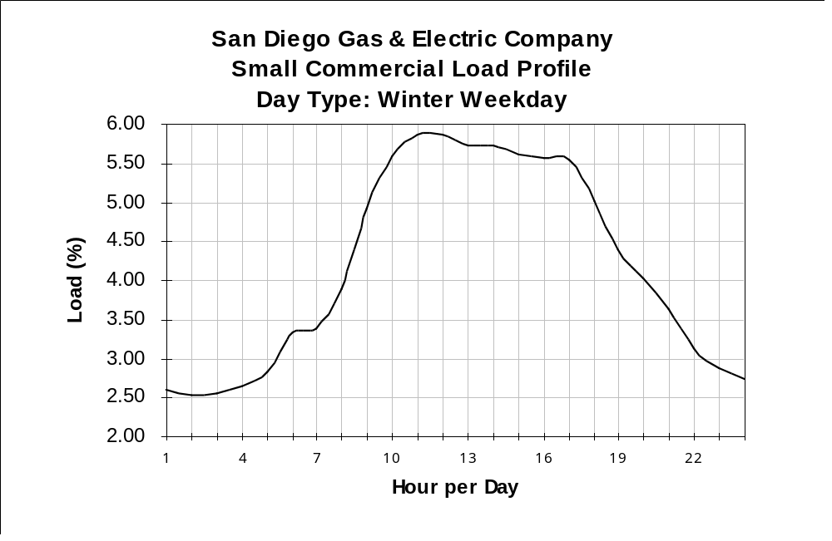

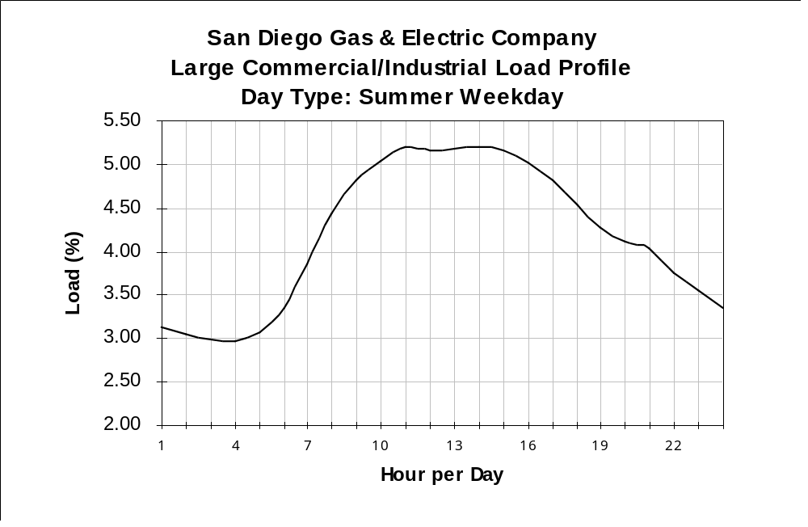

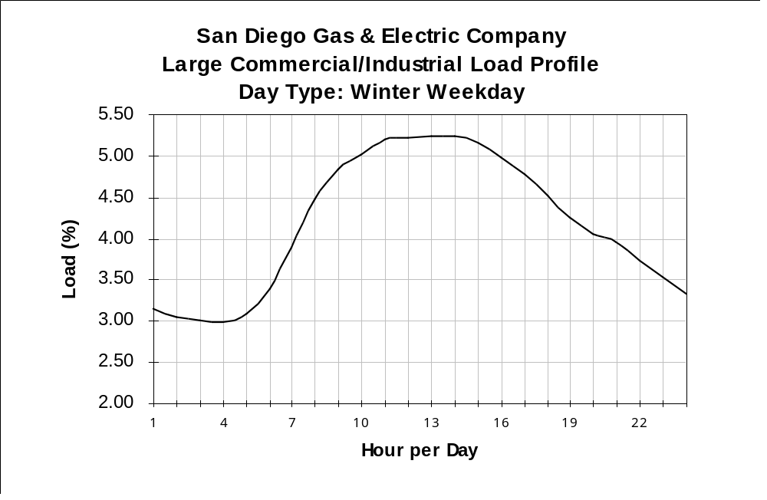

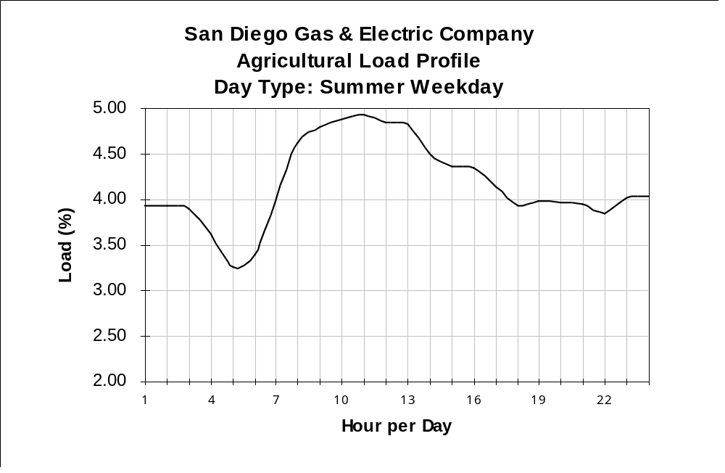

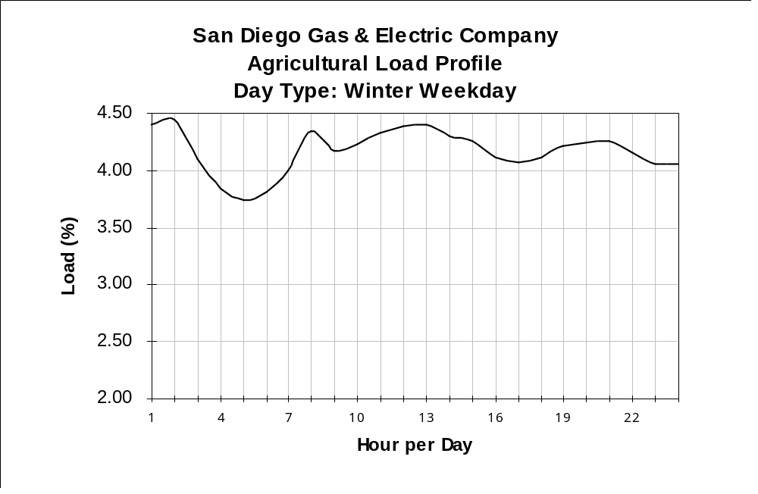

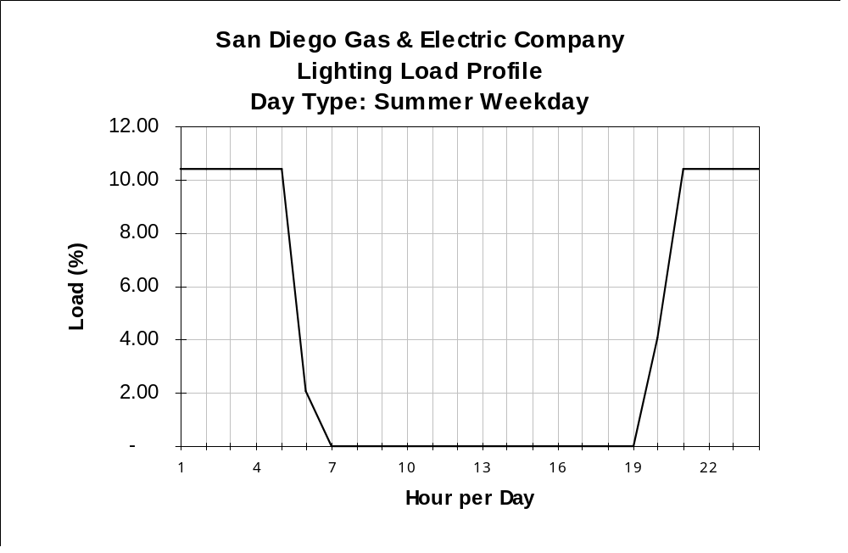

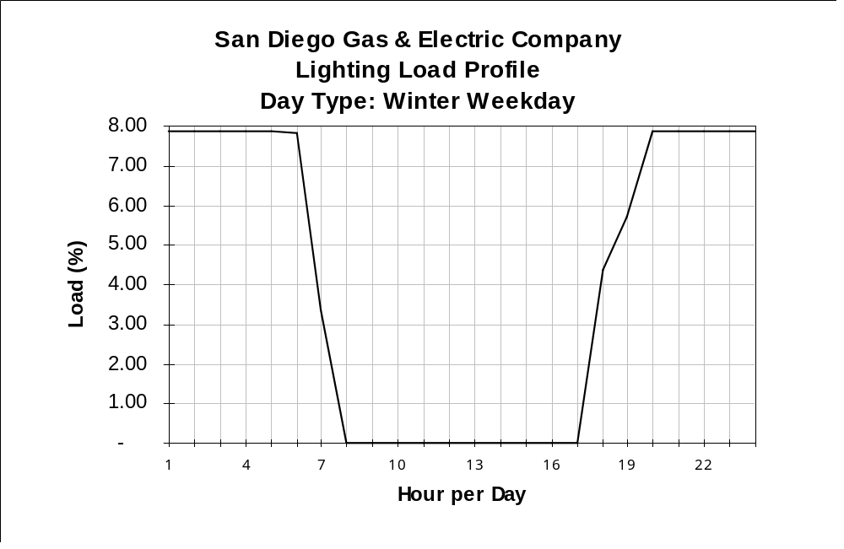

ATTACHMENT F

LOAD PROFILING WORKSHOP

OFFICE OF RATEPAYER ADVOCATES
JUNE 2, 1997

ALTERNATE PROPOSAL

ORA has emphasized the importance of distinguishing among load characteristics within customer classes as they are affected by pertinent factors like customer size, service on TOU rates, use of space heating, and daily temperature. Some proposals have discussed the use of regression techniques to make such distinctions, and to make efficient use of the existing load research sample size. The utilities have expressed reservations about modifying the structure of their load research programs by 1998.

A regression technique may satisfy all of these interests, by avoiding modifications of the existing load research programs and instead applying a formula (based on the existing programs) to customer billing data during the settlements process, to reflect the characteristics such as customer size. Similar months could be grouped into seasons, and equations developed for each hour of the day, for each season, as predictors of customers’ loads. Benefits of this approach could be assisting new ESPs with their load forecasting for bidding and scheduling, and simplifying the audit requirements that extensive segmentation of load profiles could produce. Regression is a familiar technique to many participants in CPUC proceedings.

To illustrate this approach, ORA pooled the data used to produce Figures 6 to 9 of ORA’s main proposal into a single sample, treating the average summer weekday as a “day” with an assumed temperature of 85 degrees, and assuming a temperature of 105 degrees for August 30, 1995. The dependent variable is hourly load in kW, while annual kWh is in kWh and “TOU” is 1 for TOU customers and “0” for non-TOU. This example is intended only to illustrate the possible use of a regression technique, and this specific model formulation is not a recommendation by ORA at this time. Additional discussion in technical workshops is recommended to develop appropriate models, if a regression technique is used.

Modeling of Residential Summer Loads

 | Regression Output: |  | 7-8 AM | 5-6 PM
 | R Squared |  | 0.5638 | 0.5665
 | Degrees of Freedom |  | 1383 | 1383
 | Constant |  | 0.103 | -0.681
 | Regression Coefficient(s) | Annual kWh | 0.00011 (T=38.7) | 0.0002 (T=42.2)
 |  | Temperature | -0.0014 (T=0.8) | 0.007 (T=2.9)
 |  | TOU | 0.276 (T=4.2) | -0.803 (T=8.9)

(CEC overheads, AEI overheads)
(available in hard-copy only)

Opinions on the timing and nature of this further consideration of load profiling vary. Some would initiate further workshops in 1997, while others, including the UDCs, would wait until the latter part of 1998 to initiate formal proceedings, once there has been some experience with the initial implementation of load profiling. Initiating a proceeding in early 1998 appears to be a middle position acceptable to many workshop participants, including the UDCs. The actual scheduling of any testimony and hearings would, of course, be dependent on the priorities that exist at that time.
An exception to the general support for deferral is the issue of load profiling eligibility for customers with peak demands between 20 kW and 50 kW. A follow-up meeting will be held within 30 days of the filing of this report to further address this issue.
However, ORA’s written proposal expressed a concern that financial indifference could be a disincentive for UDCs to minimize load profiling errors.
For Edison’s use of dynamic load profiles, process modifications are needed to acquire, validate, and process data on a “real-time” production system basis.
Under a dynamic load profiling approach, daily load shapes are not known in advance.
For Edison’s use of dynamic load profiles, process modifications are needed to acquire, update, and process data on a “real-time” production system basis.

