BEFORE THE PUBLIC UTILITIES COMMISSION
OF THE STATE OF CALIFORNIA

____________________________________
Order Instituting Rulemaking on the )
Commission’s Proposed Policies )
Governing Restructuring California’s ) R. 94-04-031
Electric Services Industry and )
Reforming Regulation )
____________________________________)
Order Instituting Investigation on )
the Commission’s Proposed Policies )
Governing Restructuring California’s ) I. 94-04-032
Electric Services Industry and )
Reforming Regulation )
)
____________________________________)

RETAIL DATA QUALITY AND INTEGRITY:
SUPPLEMENT TO THE JULY 25, 1997 WORKSHOP REPORT ON RETAIL SETTLEMENTS AND INFORMATION FLOWS

Submitted by Pacific Gas and Electric Company (U 39E),
San Diego Gas and Electric Company (U 902E),
Southern California Edison Company (U 338E), and
California Energy Commission Staff

ROGER J. PETERS
PETER OUBORG
Law Department
PACIFIC GAS AND ELECTRIC COMPANY
P. O. Box 7442
San Francisco, CA 94120
Telephone: (415) 973-2286
Fax: (415) 973-5520
Attorneys for
PACIFIC GAS AND ELECTRIC COMPANY
August 18, 1997
TABLE OF CONTENTS

I. INTRODUCTION
I.A. Purpose of the Report
I.B. Specific Recommendations
II. ASSESSMENT OF DATA COLLECTION AND EXCHANGE REQUIREMENTS
II.A. Review of Data Collection and Exchange Requirements
II.B. A Major Flaw in the Settlements Process
II.C. A Specific Example of Potential Market Abuse
III. POSSIBLE SOLUTIONS AND IMMEDIATE RECOMMENDATIONS
III.A. Oversight and Enforcement Framework
III.B. Maintenance of Records
III.C. Immediate Recommendations
IV. IDENTIFICATION OF OTHER FLAWS
V. CONCLUSION
APPENDIX A: Proposed Market Oversight and Enforcement Frameworks A-
APPENDIX B: Auditing Framework B-
APPENDIX C: MDMA Certification Requirements C-

RETAIL DATA QUALITY AND INTEGRITY:
SUPPLEMENT TO THE JULY 25, 1997 WORKSHOP REPORT ON RETAIL SETTLEMENTS AND INFORMATION FLOWS

INTRODUCTION

The restructured electricity industry in California depends upon a complex set of data and information exchanges among separate commercial entities for scheduling power, identifying energy imbalances as the basis for financial settlements, billing customers, and remitting funds collected by one entity on behalf of others. The integrity and security of these customer usage data and financial exchanges will greatly influence the faith that market participants have in multi-party transactions and shared efforts to provide revenue cycle services.

Thus far, there have been only limited provisions in the market development process for creating business control and oversight mechanisms to ensure the required integrity and accuracy of this data. As a result, there is a potential for settlement inaccuracies and market abuses that could negatively impact the financial health of market participants and undermine overall confidence in the marketplace.

The lack of adequate controls to ensure that energy transactions are properly accounted for is considered by participants to be the most serious threat to market integrity on January 1, 1998.

Purpose of the Report

On July 25, Pacific Gas and Electric Company (PG&E), San Diego Gas and Electric Company (SDG&E), Southern California Edison Company (SCE) (collectively, the UDCs), and the California Energy Commission staff filed a report on Retail Settlements and Information Flows (RSIF), following a Commission-ordered workshop on July 7. That report contained a broad overview of the information flows between entities that will be required for the new electric market structure to function beginning 1/1/98 and incorporated the views expressed by several other parties during the workshop process.

Among the high-priority issues identified in the RSIF report requiring immediate implementation efforts was the establishment of standards, procedures, and responsible entities for the auditing and performance monitoring functions. The sub-team that has taken up this issue has addressed it in terms of the importance of ensuring data quality and integrity.

This supplemental report:

- highlights the major threats to data integrity and quality in the RSIF processes;

- presents some possible solutions to this problem;

- recommends a forum for further analysis and development of mechanisms that would establish control procedures where they are appropriate; and

- proposes record-keeping requirements to facilitate such procedures.

This preliminary proposal is based on several specific areas identified as potential problems at the August 6 stakeholder meeting, in three of the workshop reports (RSIF, Direct Access Implementation Plan (DAIP), and Meter and Data Communications Standards (MDCS)), and on subsequent discussions within the RSIF sub-team that assembled this report.

Parties that participated actively in Retail Data Quality and Integrity sub-team discussions or contributed comments on prior drafts of this report include the three UDCs, the CEC, Green Mountain Energy Resources, MZA Grid Services, Mock Energy, CellNet, and PacificCorp. These parties support the recommendations contained herein.

Specific Recommendations

The parties ask the Commission to take the following actions, concurrent with its actions on the other workshop recommendations:

- Sanction a collaborative effort among all market participants to conduct a more comprehensive transactional analysis of the new industry structure and to identify areas where additional business controls and/or oversight mechanisms are desirable or necessary.

- Require that all parties to commercial electric transactions maintain auditable records of all data pertinent to those transactions for a period of at least three years. This data should include, but not be limited to, meter data, billing and settlements records.

- Initiate discussions with the FERC and/or other appropriate oversight entities to gain adoption of the control, record-keeping, and other recommendations of the collaborative effort mentioned above pertaining to the functions/entities under shared jurisdiction or the jurisdiction of those other entities.

ASSESSMENT OF DATA COLLECTION AND EXCHANGE REQUIREMENTS

Broadly speaking, four elements are needed to ensure data quality and integrity:

- The procedures and rules for performing various data collection and processing activities must be designed to ensure that data needed to support the market structure is collected and transmitted to all appropriate entities.

- Standard agreements among parties are necessary to ensure that data transfers and information exchanges are clearly specified, and that data is accurate and of high quality.

- An effective monitoring and oversight regime must be in place to discourage errors and abuses and to detect them whenever they occur.

- The mechanisms to resolve disputes must ensure that customer data continues to be collected and processed, and that information is exchanged, even when unresolved disputes are being investigated.

The parties have performed a preliminary assessment of the current requirements for customer data collection and exchange. This section will describe the overall results of this process and discuss, as an example, a specific problem that has been identified.

Review of Data Collection and Exchange Requirements

The RSIF report identifies the general flow of data from the customer meter through various applications using this data, eventually resulting in a bill to the customer and a series of financial exchanges among entities. As a result of their preliminary review, parties believe that the necessary data will be collected from the customer; however, there are weaknesses in the mechanisms whereby aggregates of customer data are processed and exchanged.

These weaknesses take two specific forms:

- lack of control procedures to ensure that settlement data is complete and accurate as it passes between various market participants, and

- the absence of any regulatory authority with effective oversight of retail customer data as it is used by the ISO, PX, and SCs.

Processing of validated individual customer consumption data into settlement-ready aggregates was not identified as an essential step in the retail information flow until the late spring of this year. The ISO interim staff and its various vendors realized at this time that the ISO could not, and should not, perform this massive data processing step, but that SCs should be responsible for ensuring that the necessary data processing is done before data are reported to the ISO.

This is a key activity, because these aggregate usage data becomes the basis for comparison with PX and/or ISO schedules, identification of energy imbalances, and resulting financial settlements. Application of local regulatory authority-sanctioned load profiles and distribution loss factors occur in this step.

As a result of the review undertaken as part of the RSIF report development process, follow-up activities are underway to ensure that distribution loss factors and load profiles are available to those entities that must access them when developing settlement-ready data.

The CPUC and other local regulatory authorities believe they have jurisdiction over revenue-quality meters and meter data collection processes. CPUC D.97-05-039 and the MDCS reports speak clearly to proposals developed for review and consideration by the CPUC for investor-owned utilities and ESPs that might provide revenue cycle services to UDC customers.

Unfortunately, whatever jurisdiction FERC might have over the ISO and the PX cannot be readily translated into effective jurisdiction over retail customer data used by scheduling coordinators and energy service providers. Even if FERC's jurisdiction could be asserted over these entities, FERC has no effective process to deal with retail customer data issues. The CPUC, other local regulatory authorities that may permit direct access, but FERC must develop a workable assignment of authority and oversight responsibilities to ensure that retail customer data issues can be properly supervised.

A Major Flaw in the Settlements Process

The lack of adequate controls to ensure that energy transactions are properly accounted for is considered by participants to be the most serious threat to market integrity on January 1, 1998.

The data for a given direct access energy transaction often undergoes numerous processes before it can be translated accurately into a customer bill. In some cases, the market participants themselves will be able to detect inaccuracies in the data. In others, however, detection will be problematic, and there are currently no control procedures in place to ensure that energy transactions are adequately accounted for, from the point of delivery of energy to the reading of the meter through to the settlements process and allocation of unaccounted-for energy (UFE). Furthermore, no entity has been assigned the responsibility to investigate any suspected abuses or errors involving end-use meters and the associated end-use meter data, or to institute procedures to discourage or detect such abuses or errors.

Figure II-1 below diagrams the reporting of end-use meter data all the way from the retail customer meter through a Meter Data Management Agent (MDMA) to the Energy Service Provider (ESP) to both the UDC and Scheduling Coordinator (SC), and through the ESP’s Scheduling Coordinator to the ISO for final energy settlements. A dashed vertical line indicates the jurisdictional boundary between state (CPUC or other local regulatory authority) and federal authority.

Neither jurisdiction has asserted oversight over the private commercial contracts between an ESP and its Scheduling Coordinator. As a result, neither the ISO nor the UDCs have access to all the information necessary to audit the information exchanged between ESPs and SCs, or the responsibility to do so, to ensure that all the load of each end-use meter served by ESPs is included somewhere in the aggregate metered load submitted by SCs for ISO settlement. This gap in market oversight creates the potential for inaccuracies or abuse to remain undetected.

Currently, customer load that is not included in the aggregate metered load of any SC will fall into the Unaccounted-For Energy (UFE) imbalance, which is allocated to all Scheduling Coordinators (and/or their client ESPs) in proportion to their share of reported load in each hour. The customer will continue to receive uninterrupted physical flows of energy. However, either the customer, its ESP, or its SC could escape paying directly for the commodity generation consumed by the customer.

Figure II-1

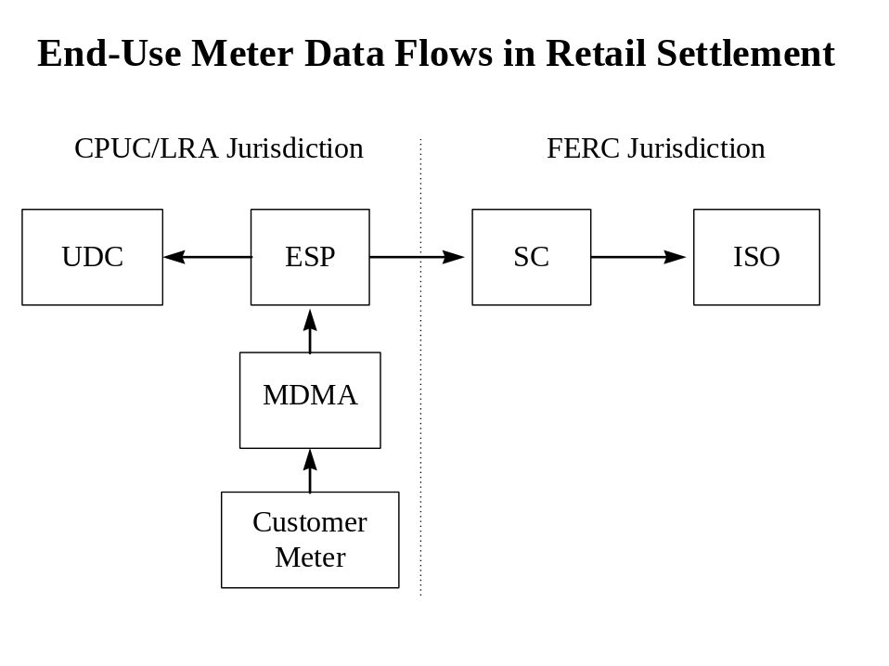

A Specific Example of Potential Market Abuse

At the July 7, 1997 RSIF workshop, examples were presented of how Energy Service Providers (ESPs) could evade paying electric commodity costs. As one specific instance, consider the case of an ESP that fails to establish a contractual relationship with any SC to procure all or some portion of a given customer’s generation needs on any given day. The ESP continues to read and report accurate meter data to the UDC for this customer, settles with the UDC for delivery charges and bills the customer either directly or through UDC consolidated billing, but can avoid payment for generation to serve that customer. In essence, the ESP has received energy to serve the customer for free.

Without further controls and oversight, this practice could continue undetected indefinitely. Pervasive abuse of this nature would damage both equity and efficiency in the new market – i.e. both the misallocation of costs among parties and, also, higher overall costs of doing business for all parties would accrue due to inaccurate settlements and higher UFE charges (and potentially higher required ISO reserve margins). Serious and widespread errors or abuse could also lead to an overall loss of market confidence, contributing to lower customer Direct Access participation rates and a disincentive to market entry by potential participants.

All legitimate market participants have a strong, shared self-interest in protecting themselves, their customers, and the market from unintentional errors or abuse.

POSSIBLE SOLUTIONS AND IMMEDIATE RECOMMENDATIONS

Oversight and Enforcement Framework

The RSIF sub-team considered possible controls that could be put in place immediately to detect cases where under-reporting of end-use metered loads occurs. Two key control checks or “triggers” were identified that could motivate further investigation by an oversight agent.

The first involves the tracking of UFE for any aberrant or “unacceptably high” Unaccounted For Energy flows. As the market evolves, parties expect to develop greater experience with UFE levels, and any departure from expected and reasonable levels would be a red flag, indicating that any of a number of potential errors or market abuses might be taking place.

A second control check would involve a comparison of UDC and ISO data on the number of end-use meters and the total load of all metered reads reported. If the number of end-use meters or the total end-use metered loads reported by ESPs to the UDCs for a given settlement period differed appreciably from the total end-use meters or end-use metered loads reported to the ISO by Scheduling Coordinators, further investigations should be initiated.

While there was general consensus on the nature of the required controls, parties were unable to agree on an entity or entities that should be entrusted with performing the oversight functions and on an institutional framework for enforcement. Two alternatives are shown in Appendix A, one regulatory in nature, the other contractual.

Under the regulatory model, an existing regulatory agency (CPUC, CEC, or FERC), a regulated entity (such as the UDCs or ISO), or some newly formed entity would build systems and conduct routine control checks of settlements data. The same or another regulated entity could then be empowered to investigate cases of potential errors or abuse, impose regulatory sanctions on violators, and participate in any necessary dispute resolution with affected parties. Parties note that no regulatory agency currently appears to have the authority or resources to perform this task, and that the ISO has indicated that it will not involve itself in any tracking of individual customer or ESP data. The UDCs have indicated that they do not wish to assume any “policing” and enforcement role over the commodity generation market, and believe that such a proposal on their part would be resisted by a number of other parties. Appendix B contains Edison’s proposal for an audit framework that would address market-wide control and oversight issues.

Under the contractual model, the market participants themselves would voluntarily form a joint oversight team, including both regulated and unregulated entities, which would establish mutually agreeable control procedures. This same or another jointly sponsored entity could then further investigate suspected abuses under powers provided by audit clauses in commercial agreements among the parties.

Enforcement could be achieved through contractual provisions, for example, via termination clauses or other contractual remedies, perhaps subject to dispute resolution. These oversight and enforcement provisions could only be included by mutual consent of the parties to each contract in the web of commercial relationships in the new energy marketplace (e.g. the UDC/ESP agreements, ESP/SC contracts, SC/ISO agreements, etc.), and with blessing from both state and federal regulators.

A final alternative is to allow market participants to self-police each other on an individual basis; however, this approach is substantially limited by the restricted availability of necessary information (e.g. settlements data, private contracts, etc.).

Maintenance of Records

Regardless of the form of business controls or procedures adopted by the Commission (or other entities), the need to maintain historical records of energy transactions is critical to any oversight function. Rules should be established concerning record retention requirements governing all participants, so that information will be available when detailed monitoring requirements are implemented. The Commission should acknowledge that retention requirements should be established for, but not limited to meter data, billing records, and settlements records.

Immediate Recommendations

The parties believe that a control and oversight regime must be in place on January 1, 1998 to detect and deter the kinds of market errors or abuses detailed above. The parties believe that a regulatory solution is both less desirable and less feasible within the narrow time constraints that remain. However, in order to ensure that sufficient controls are in place, the parties request that the CPUC:

- Immediately initiate and sanction a broad stakeholder group charged with developing collaborative contract-based oversight protocols;

- Communicate with the FERC under the doctrine of cooperative federalism, in order to coordinate ISO and PX participation in collaborative discussions;

- Support reasonable cost recovery of UDC costs incurred to implement any agreed-upon collaborative oversight regime; and

- Order UDCs, ESPs, and other market participants to maintain data records related to meter reading, meter data exchange, billing, settlements, and other records related to physical direct access transactions.

The nucleus of the stakeholder group referenced above has already formed as a sub-team if the RSIF process, and has made possible this report. The group intends to continue its collaborative efforts and expects to return to the Commission in October with more specific recommendations for control and oversight mechanisms. The parties will request a response from the Commission before January 1, 1998.

IDENTIFICATION OF OTHER FLAWS

Other Direct Access Workshop reports identify specific areas where control weaknesses exist. These areas are consolidated below in Table IV-1. For some of these control issues, there may be sufficient information available to market participants that it may not be necessary to establish any oversight procedures.

For example, ESPs offering “green” power are likely to keep apprised of similar offers made by their competitors. Should one of them misrepresent its product to customers, other ESPs could pursue a remedy through the Federal Trade Commission.

For other control issues, procedures will be needed to ensure smooth and equitable operation of the new market structure. For example, Meter Data Management Agents could be certified through an audit to confirm that their business practices meet minimum standards for ensuring data quality and integrity. (See Appendix C for CellNet’s proposal on this topic.)

Some control issues have a public safety component. The requirement for certification of third-party meter installers (as discussed in the MDCS workshop report) is an example where vendor and/or consumer safety could be compromised without some mechanism for enforcing these standards.

As parties have made clear, the UDCs should not have the obligation to enforce these kinds of requirements. This report suggests that the joint participants’ effort recommended above should be the vehicle for deciding how these issues are to be resolved.

Table IV-1 Summary of Business Controls and Oversight Issues Identified in Direct Access Workshop Reports

Direct Access Implementation Plan

- ESP has complied with any registration requirements
- ESP has complied with any requirements to independently verify direct access sign-ups
- Energy is being purchased to cover all of an ESP’s load by a certified scheduling coordinator*
- ESP has complied with any renewables certification
- ESP has complied with any requirement to obtain written agreement from all its customers to pay CTC
- Inclusion of required regulatory notices in customer bills

Meter and Data Communications Standards Report: Meter Data Management Functions

- Meter reading accuracy*
- Application of validation/editing/estimation procedures*
- Application of load profiles*
- Application of distribution loss factors, where applicable*
- Geographic segregation of meter data, per ISO requirements (e.g., by congestion zone)
- Meter data storage requirements

Meter and Data Communication Standards Report: Metering Agent functions

- Meter hardware conformance to CPUC standards
- Personnel/company certification (installation, reading, maintenance)
- Conformance of meter installation/maintenance procedures with safety requirements
- Meter installation/calibration procedures
- Meter maintenance procedures
- Meter hardware accuracy*

Retail Settlements and Information Flows Report

- Scheduling coordinators are scheduling/purchasing energy to cover all their loads*
- Application of validation/editing/estimation procedures*
- Application of load profiles*
- Application of distribution loss factors, where applicable*
- Geographic segregation of meter data, per ISO requirements (e.g., by congestion zone)

* these control issues are components of the major flaw described in Section II.

CONCLUSION

This preliminary review of data quality and integrity offers a more complete framing of the issues. Direct Access and the unbundling of revenue cycle services has resulted in a marketplace in which multiple market participants are mutually dependent upon data for operational and billing purposes. The needs within this market for mechanisms to provide assurance of data quality and integrity that may be unprecedented within commercial business. Development of market rules and organizational management controls to implement those rules are important preconditions to data quality and integrity. Ensuring that all market participants actually follow these rules, however, requires an oversight authority that can perform audits, impose sanctions, and provide motivation to market participants to comply with the rules.

The parties believe that substantial additional assessment is needed before a complete understanding of all of the potential weaknesses of the retail information flows of the restructured industry are known. This report has expanded upon the brief introduction of the additional assessments first described in the RSIF report.

Since the entire industry is dependent upon the quality and integrity of these data flows, it seems appropriate that a stakeholder group perform these additional activities. Therefore, we request that the CPUC formally sanction the RSIF participants and the sponsors of this report as an ongoing entity to provide recommendations for adoption by the industry and the CPUC, where appropriate.

The CPUC itself has two major activities to undertake. First, the CPUC should adopt the recommendations in the RSIF and MDCS reports and August 1 direct access tariff filings that establish "rules of the game" through metering standards and service agreements that permit unbundling of revenue cycle services. Second, the CPUC needs to initiate a dialogue with the ISO and PX, along with FERC, about the retail customer data quality and integrity concerns expressed here, and move toward clarification of jurisdictional issues for the regulatory authority with oversight responsibilities for this segment of the restructured industry.

Respectfully submitted on behalf of:
Pacific Gas and Electric Company,
San Diego Gas and Electric Company,
Southern California Edison Company, and
California Energy Commission Staff

ROGER J. PETERS
PETER OUBORG

By____________________
PETER OUBORG
Law Department
PACIFIC GAS AND ELECTRIC COMPANY
P. O. Box 7442
San Francisco, CA 94120
Telephone: (415) 973-2286
Fax: (415) 973-5520
Attorneys for
August 18, 1997 PACIFIC GAS AND ELECTRIC COMPANY

APPENDIX A: Proposed Market Oversight and Enforcement Frameworks

Activity | Model | Entity (Options)
1. Routine control checks  - track UFE levels  - compare ISO/UDC meter counts  - compare ISO/UDC end-use metered loads  - flag potential abuses | Regulatory  Contractual | - CPUC, CEC, or FERC  - ISO  - UDCs  - new entity  - joint participants’ body  - self-policing by marketplace
- 2. Further Investigation triggered by routine controls  - audit SC/ESP contracts  - identify gaps in contractual coverage  - submit violators for enforcement | Regulatory  Contractual | - CPUC, CEC, or FERC  - ISO  - UDCs  - new entity  - joint participants’ body
- 3. Enforcement  - report to regulators/ market  - prosecute violators  - participate in/adjudicate dispute resolution | Regulatory  Contractual | - CPUC/FERC through new ESP/SC certification requirements  - ISO through SC agreements  - UDC through ESP agreements  - joint participants through contract provisions  - legal/regulatory remedy

APPENDIX B: Auditing Framework
(Developed by Edison)

INTRODUCTION

The body of this document describes certain control weaknesses in the retail settlement process, particularly the potential for under-reporting of energy consumption. Proposed solutions to these and other problems will require auditing as a key component of the overall control structure. This opinion is consistent with many of the views expressed in the original RSIF Report. The information described in this appendix provides recommendations to strengthen the audit framework in the new market. These recommendations fall into two general categories: audits within the PX and ISO, and audits between participants. It is a proposal sponsored by Southern California Edison and is not necessarily endorsed by the other RSIF sub-team members.

AUDITS WITHIN THE PX AND ISO

The March 31, 1997, FERC filing PX Tariff, page 93 to 96, describes the auditing framework at the PX. The March 31, 1997 FERC filing ISO Tariff, page 244 to 247, describes a very similar auditing framework at the ISO. Basically, the audits described could be characterized as reviews by outside public accountants or consultants, performed either annually as a routine financial or operational audit, or on a one-time basis to address a specific concern. This structure has two primary weaknesses:

- It lacks the in-depth analysis provided by an on-going audit process performed by people, with a detailed understanding of the operations, who are solely dedicated to the success of those organizations.

- It minimizes the involvement of the market participants.

Need for Internal Audit Departments

To assist the PX and ISO Audit Committees in fulfilling their responsibilities, strong, effective internal audit programs need to be established within both organizations.

- The internal audit departments should have broad authority to conduct financial, operational, and system audits of all aspects of PX and ISO functions. The departments should have the authority to review activities of individual participants that interface with the PX and ISO.

- At a minimum, the scope of the internal auditing departments’ coverage should include the following:

  - Accuracy of data reported to, or generated by, the PX and ISO.

  - Compliance with policies, procedures, rules, laws, regulations, etc.

  - Accuracy of transactions, including payments, billings, receipts, and accounting entries.

  - Investigation of instances of suspected market manipulation or fraud, including audits of the records of various market participants, if necessary.

  - Research to evaluate the merits of participant disputes.

  - Monitoring of usage reporting, unaccounted for energy, and other statistics to determine the need to further investigate possible irregularities.

  - Coordination with the independent CPAs to facilitate the financial audits and minimize duplication of effort.

- The departments should conform to the Standards for the Professional Practice of Internal Auditing established by the Institute of Internal Auditors.

- Responsibilities of the departments should be identified in formal charters.

- The departments should be headed by experienced, professional general auditors.

- The general auditors should report to the audit committees of the PX and ISO.

- The internal audit departments should be staffed with audit professionals, preferably with Certified Internal Auditors (CIAs), Certified Public Accountants (CPAs), and/or Certified Information Systems Auditors (CISAs).

- Internal audit staffs should include individuals with backgrounds in auditing computer systems who are knowledgeable of computer controls, systems development, computer extract procedures, and computer fraud risks.

Need for Participant Involvement

There are two areas in which participant involvement is needed to strengthen the audit frameworks within the PX and ISO:

- At least annually, a Joint Participant Audit Team should conduct audits of the PX and ISO’s fees, charges, and allocated costs. The audit team members should be volunteered by individual participants, and the associated costs of performing the audit should be borne by those participants.

- Participants should have the right to present disputes in writing to the PX or ISO. Upon initial screening, the disputing participant should have the further right to perform an audit of PX or ISO records pertaining to the dispute. The cost of performing a dispute resolution audit should be borne by the disputing participant.

AUDITS BETWEEN MARKET PARTICIPANTS

To provide an efficient market, it will be important to allow audits between participants, including UDCs, ESPs, scheduling coordinators, and other market participants. All market participants should be allowed to include reasonable audit rights in the contracts signed with other market participants. This is made necessary due to:

- The large number of expected participants in the new market.

- The lack of more stringent restrictions on participants entering the market.

- The fact that many of the smaller participants could fall outside the scope of normal audits of PX or ISO activity.

- The inability to verify data upon receipt due to the high volumes transmitted between participants.

- The significant exposures for market manipulation, unethical behavior, and fraud in the new market.

- The dependence on the accuracy and integrity of information provided by others.

- The inability to detect exposures by any method other than an effective audit program.

Basic Principles Governing Audits Between Participants

Audit rights should be guided by the following principles:

- Audits should be allowed to verify the accuracy of information provided by other participants, but not to gather additional information of a competitive nature.

- Participants should be allowed to negotiate audit clauses in all contracts that allow for regular audits to verify the accuracy of data affecting those participants’ business.

- Each participant should have the right to choose the method of conducting audits that is the most efficient and cost-effective. The audits could be performed by either independent public accountants, consultants, or the participant’s internal auditors.

- Audits should be allowed upon reasonable notice, with the actual timing being negotiated between participants.

- Audit scope should be broad enough to allow participants to protect themselves, but limited to verification of the accuracy of data provided by the other participants.

- Audits’ scope should extend to all subcontracted activities (e.g. scheduling coordinators, metering agents, etc.), with the subcontractors’ cooperation guaranteed through the contract relationship.

- Audits should be limited to the examination of specific records or documents. These records should be identified in the form of data requests.

- To facilitate the audit process, rules governing all participants should be established concerning record retention requirements. Retention requirements should be established for but not limited to the following types of documents:
  - Records of PX bids for the sale of electricity.
  - Records of reported generation of electricity.
  - Records of reported forecasts of usage requirements.
  - Customer authorization for the release of data.
  - Customer service provider election documents.
  - Customer contracts.
  - Records of meter placement, service, changes, etc.
  - Records of meter readings.
  - Records of consumption reported to the scheduling coordinator and/or PX.
  - Customer billing records.
  - Customer payment records.
  - Records supporting settlement payment between UDCs and ESPs.
  - Records supporting billings for internal services between UDCs and ESPs.

- The costs of audits should be borne by the participant initiating the audit.

- Wherever practical, similar audits by multiple parties, sharing the same business relationship, should be consolidated and performed by joint audit teams (e.g. multiple ESPs using one metering agent).

Resolution of Disputes

A process should be established to resolve disputes identified through audits.

- The results of all audits should be promptly reported to the audited participant.

- The two participants should first attempt to resolve any inaccuracies in the audit results, determine any monetary settlement required between the two parties, and establish any required corrective action plans to prevent similar occurrences.

- Binding arbitration should be required to resolve disputes that result from participant audits.

- Market participants that engage in unethical behavior, fraudulent behavior, or violation of established market rules or policies should be subject to disciplinary action, including possible decertification and/or monetary damages.

- Situations of potential unethical behavior, fraudulent behavior, or violation of market rules, identified through participant audits, should require reporting to the PX, ISO, CPUC, or FERC for evaluation of possible disciplinary actions.

APPENDIX C: MDMA Certification Requirements
(CellNet Data Systems)

An example of a potential solution to assuring proper conduct by MDMAs (one aspect of the data quality and integrity problem) is CellNet’s proposed mechanism modeled on auditing procedures of the Securities and Exchange Commission. According to this proposal, Meter Data Management Agents (MDMAs) would be required to pay for an independent auditor to certify that they have met the standards necessary to offer services and exchange data on behalf of Direct Access customers, ESPs, or SCs. Each MDMA would be required to arrange for annual audits as a condition of continued certification. The standards against which each MDMA would be audited should be developed as part of the ongoing collaborative effort recommended in the body of this Report.

Attached are the slides presented by CellNet at the August 6th meeting of the sub-team on Retail Data Quality and Integrity, which further lay out this proposed framework for MDMA audits.

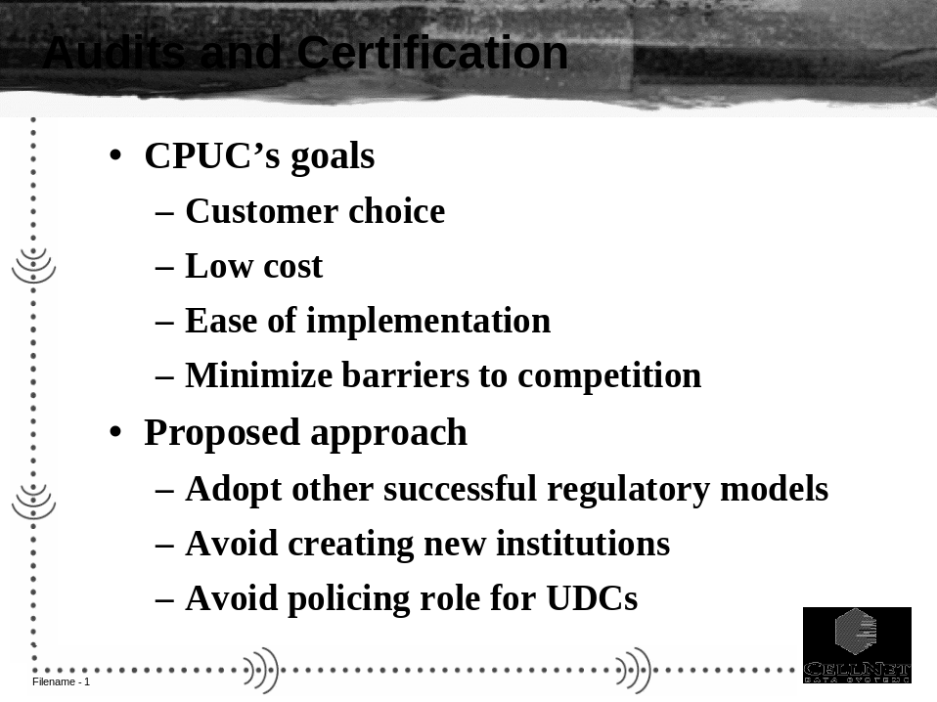

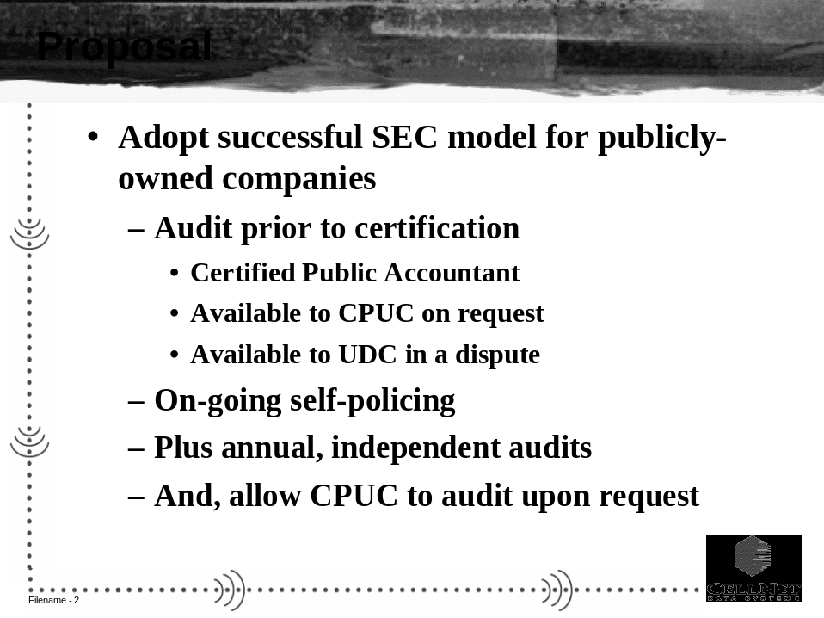

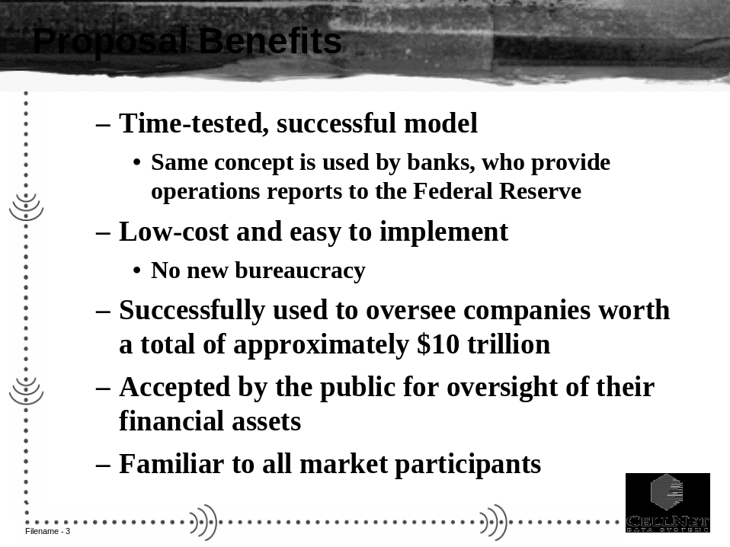

PROOF OF SERVICE

I am employed in the City and County of San Francisco, California. I am over the age of 18 years and not a party to the within action. My business address is 77 Beale Street, San Francisco, California 94105. On August 15, 1997, I served the within:

RETAIL DATA QUALITY AND INTEGRITY:
SUPPLEMENT TO THE JULY 25, 1997 WORKSHOP REPORT ON RETAIL SETTLEMENTS AND INFORMATION FLOWS

on the parties in this action, by transmitting a true copy thereof via electronic mail, addressed to each member of the list of Retail Settlement and Information Flows Workshop participants. I have also transmitted a true copy of this document by electronic mail for placement on the California Public Utility Commission Internet Website.

I declare under penalty of perjury under the laws of the United States that the foregoing is true and correct. Executed at San Francisco, California, on August 18, 1997.

__________________________________
Esther Chin

Proof of Service List

LAST NAME | FIRST NAME | ORGANIZATION | E-MAIL
Ackerman | Gary | Mock Energy Services | FOOTHI19@IDT.NET
Allott | Gordon | GW Electric | GALLOTT@SOLUCIAN.COM
Baldwin | Barbara | SDG&E | BBALDWIN@SDGE.COM
Banagan | Ellen | Tabers Caramants | ELLEN@TCA-US.COM
Blunden | Julie | Green Mountain Energy Resources | BLUNDEN@GMPVT.COM
Bowers | Bill | Sierra Pacific Phone Co. | BILL_BOWERS@SPPCO.E-MAIL.COM
Bray | Peter | PG&E Energy Services | PTB2@PGE.COM
Brown | Jeff | R. W. Beck | JBROWN@RWBECK.COM
Brown | Layne | Illinova Power Marketing | LAYNE_bROWN@ILLINOVA.COM
Brubaker | Maurice | Brubaker & Associates | BILL.BUCKLEY@ITRON.COM
Buckley | William | I Iron | BILL.BUCKLEY@ITRON.COM
Bylina | Richard | CellNet | RICHARD.BYLINA@CELLNET.COM
Carroll | Richards | Enron First Point Utility | RICHARD_CARROLL@PGN.COM
Casey | Sean | CPUC/ORA | SEANCASEY@CPUC.CA.GOV
Chang | Cathy | So California Gas Co. | TPCKC@PAC ENT.COM
Clark | Smith |  | CLARK.SMITH@PACIFICORP.COM
Czarnecki | Ken | SCE | CZARNEKJ@SCE.COM
DeFrawi | Sam | US Navy | SDEFRAWI@EFACHES.NAVFAC. NAV.MIL
Diaz-Flores | Hebert | CEC | HDIAZFLO@ENERGY.STATE.CA.US
Douglass | Dan | Reznik & Reznik | DOUGLASS@EARTHLINK.NET
Eustis | Conrad | First Point | CONRAD_EUSTIS@PGN.COM
Feezor | Betty | Southern Company | BETTY.C.FEEZOR@SCSNET.COM
Fox | Bill | SCE
Gallagher | Patrick | Seattle City Light | PATRICK.GALLAGHER@CI.SEATTLE.WA.US
Geier | Dave | SDG&E | DGEIER@SDGE.com
Gibson | Betsy | Eastern Pacific Energy | BETZSEALLE@AOL.COM
Hallin | Bruce | New West Energy | BLHALLIN@NEWWESTENERGY.COM
Hekkel | Sandi | MID | SANDIH@MID.ORG
Henderson | Ross | Edison Source | RHENDERSON@EDISON-SOURCE.COM
Hetrick | Nancy | Enron | NHETRICK@EES.ENRON.COM
Hoch | Frank | So Cal Gas | FHOCH@PACENT.COM
Holmes | David | Avista Advantage | DHOLMES@WWPCO.COM
Howe | Albert | LC&E | ALBERT.HOWE@LgEENERGY.COM
Inouye | Craig | SCE | INOUYECS@SCE.COM
Jacke | Mike | CEC | MJASKE@ENERGY.STATE.CA.US
Jacobson | Malcolm | Enron | MJACOBS@ECT.ENRON.COM
Johnson | Roger | ISO | HJOHN@us.NET
Jones | Robert | APS | RJONES06@APSC.COM
Julian | Bill | Government Affairs Consulting | CONSULT700@AOL.COM
Kader | Ab | EPRI | AKADER@EPRI.cOM
Kain | Scott | UCAN | SKAIN@GV.NET
Kakires | Megan-Scott | Edison | SCOTTM@SCE.COM
Kebler | Curtis | Edison | KEBLERCL@SCE.COM
Kehrein | Carolyn | Energy Management Services | CMKEHREIN@UCDAVIS.EDU
Keyes | Marc | I Tron | MARC.KEYES@ITRON.COM
King | Chris S. | Cell Net | CHRISK@CELLNET.COM
Kito | Suzie | MRW | MSK@MRWASSOC.COM
Koons | Luke | New West Energy | LEKoONS@NEWWESTENERGY.COM
Kristov | Lorenz | California Energy Commission | LKRISTOV@ENERGY.STATE.CA.US
Kubasek | Paul | SCE
Lackey | Ken | Edison Source | KLACKEY@EDISON-SOURCE.COM
Lambertson | Sheryl | MP Energy | SLAMB@MTPOWER.COM
Larsen | Wade | Schumberger | Wlarsen@oconee.em.slb.com
Lecar | Matt | PG&E | MELJ@PGE.COM
Lemon | Bill | Connext | LEMONB@CONNEXT.COM
Levy | Roger | PX Interim Staff | ROGERL47@AOL.COM
Lewis | JIm | Veris Industries | JIM.LEWIS@VERIS.COM
Lezie | Jim | Eastern Pacific Energy | JIMLEZIE@EARTHLINK.NET
Liebert | Ron | California Farm Bureau Federation | RLIEBERT@CFBF.COM
Lizak | Gregory | I Tron | GREG.LIZAK@ITRON.COM
London | Jody | Working Assets | JLONDON@WALD.COM
Marsh | Harry | PacifiCorp | hARRY.MARSH@PACIFICORP.COM
Martin | Patricia | LA Dept Water & Power | PMARTIN@LADWP.COM
Matchim | Shawn | RMI | SHAWN_MATCHIM@RMIINC.COM
Maxwell | Paul | EES Consulting Inc. | MAXWELL@EES_CONSULTING.COM
Mazy | Anthony | CPUC/ORA | AMAZY@CPUC.CA.GOV
Morgan | Hogo | Houston Light & Power | H.MORGAN@HL&P.COM
Muller | Phillip | SCD Energy Solutions | PJMULLER@PACBELL.NET
Navarrete | Jim | Edison | NAVARRJA@SCE.COM
Nevolo | August | EPRI | ANEVOLO@CCNET.COM
Nicol | Robert | New West Energy | RSNICHOL@NEWWESTENERGY.COM
Nicotre | Tom | CellNet | TOM.NICOTRE@CELLNET.COM
Norris | David | Sierra Pacific Phone Co.
Norton | Tom | PacifiCorp | TOM.NORTON@PACIFICORP.COM
Olivia | Lawrence M. | Arthur Andersen | LAWRENCE.M.OLIVA@ARTHURANDERSEN.COM
Ouborg | Peter | PG&E | PXO2@PGE.COM
Palmer | Maureen | ENRON | MPALME1@ECT.ENRON.COM
Patterson | Jamie | CEC | JPATTERS@ENERGY.STATE.CA.US
Pau | Judy | El Paso Energy | JUDYPAU@AOL.COM
Peretti | JIM | Global Energy Metering Service | EAP.GEMS@IX.NETCOM.COM
Peterson | Dennis | LA Dept Water & Power | DPETER@LADWP.COM
Pickle | Steve | LBNU | SJPICKLE@LBL.GOV
Ponder | Steve | ESI Energy
Posness | Jeff | PacifiCorp | JEFF.POSNESS@PACIFICORP.COM
Pouliot | Daniel | Nertec Design Inc. | MARKETING@NERTEC.COM
Price | Jim | CPUC/ORA | Jep@cpuc.CA.GOV
Pyburn | Jack | Southern Energy | JACK.PYBURN@SOUTHERNENERGY.COM
Reed | Britt | Illinova Power Marketing | BRITT_REED@ILLINOVA.COM
Reynolds | David | Illinova Power Marketing | CLARK.SMITH@PACIFICORP.COM
Rihn | Diane | LG&E Energy Corp. | DIANE.RIHN@LGEENERGY.COM
Roberts | George | Schumberger | GROBERTS@oconee.em.slb.com
Roscow | Steve | CPUC/Energy Divison | SCR@CPUC.CA.GOV
Rostker | Margaret | Wright & Talisman | mail48488@POP.NET
Sadn | Ali | ABB/CARY, NC | ALI.SADRI@USTRA.MAIL.ABB.COM
Saldinger | Bruce | CellNet | BRUCES@CELLNET.COM
Samaniego | George | SDG&E
Schaefer | John | Clean Power Works | JCSCHEAF@igc.org
Schneider | Susan | PG&E | SRS4@PGE.COM
Schneider | Susan | PG&E | SRS4@PGE.COM
Scott | Howard | SecureTech & AMRA | HASXSRP@AOL.COM
Scott | Sue | ABB | SUSAN.SCOTT@USTRA.MAIL.ABB.COM
Skillman | Fred | Global Energy Metering Service | FRS.GEMS@IX.NETCOM.COM
Smith | Kathy | ABB | KATHY.SMITH@USTRA.MAIL.ABB.COM
Smith J. | Clark | PacifiCorp | CLARK.SMITH@PACIFICORP.COM
Stephans | George | Schumberger | gSTEPHANS@oconee.em.slb.com
Sumic | Zarkd | Connext | SUMICZ@CONNEXT.COM
Sutro | Mark | Price Waterhouse | MARK_SUTRO@NOTES.PW.COM
Sweeney P | David | LA Dept Water & Power | DSWEEN@DWP.CI.LA.CA.US
Szymanski | Paul | SDG&E | PSZYMANS@SDGE.COM
Takemura | Earl | So. California Gas Co | ETAKEMURA@PACENT.COM
Tyler | Toby | PG&E | TXT9@PGE.COM
Vahlstrom | Tim | PG&E | TCV1@PGE.COM
Van Wagenen | Lyn | SDG&E | LVANWAGE@sdge.com
Vargos | Steve | MP Energy | SVARGOS@MTPOWER.COM
Veechi | Michael | Boston Edison | MICHAEL_VEECHI@BEDISON.COM
Wathchempiro | Arnie | GE | WATCHEAR@SCHRMT5.SCH.GE.COM
Weijo | Rick | Portland General | RICKWEIJO@PGN.COM
Weissenberg | Robert | Southern California Gas Co. | RWEISSENBERG@PACENT.COM
Welsh | Mike | Green Mountain Energy Resources | WELSHM@DIAMTECH.COM
Woychik | Eric | UCAN/Turn | 100670.365@COMPUSERVE.COM
Wynne | Michele | MZA Grid Services | MWYNNE@uOC.COM
Yamada | Mike | LA Dept Water & Power | MYAMAD@DWP.CI.LA.CA.US
Yap | Cathy | CLEA (Barkovich & Yap) | CEYAP@AOL.COM
York | Ted | ABB | TED.H.YORK@USTRA.MAIL.ABB.COM
Zinker | Dave | Green Mountain Energy Resources | ZINER@GMPVT.COM
Zollinger | Orvid | PacifiCorp | ORVID.ZOLLINGER@PACIFICORP.COM

See the July 25, 1997 final report of the RSIF workshop for a description of the MDMA function. This function may reside organizationally within the UDC, the ESP, or a subcontractor to the ESP, depending on the specific unbundled metering arrangement for a given customer.
Unlike derivative final settlements data, which involve estimated quantities such as transmission and distribution loss factors, load profiled hourly loads, and corrections for generation-level meter error, the total settlement-ready end-use meter loads for a given settlement period are a known, fixed quantity. The settlement-ready end-use meter data for a given customer and settlement period that are passed by an ESP to UDCs and to the SC(s) ought to be mathematically identical. Any difference between these two quantities must result from a systematic (either intentional or unintentional) under-reporting of load.
Further financial remedy, in cases of serious market abuse, could be pursued through the courts and/or by regulatory means.

