Strawman California Standards Connecting an
Electric Meter Located on a CEBus LAN to a Telephone Network

Topology

This document is intended t stimulate discussion by describing a specific implementation of a remote electrical meter reading system. The general model, taken from IEEE 1397, is shown in Figure 1. The IEEE 1397 topology, as adapted for California electric meters, is shown in Figure 2. The topology for linking electric meters located on a CEBus LAN to the telephone network is shown in Figure 3, as a subset of the general California model. Interfaces and devices addressed within this implementation are indicated by white blocks and solid lines. Null devices are cross-hatched. Devices and interfaces not addressed are shaded gray. Functionally, this implementation is a meter connected to a CEBus LAN, which is then interfaced to the telephone Wide Area Network (WAN).

Reference Model

The system described is based upon the standard reference model, also set forth in IEEE 1397. The reference model described in IEEE 1397 is shown connected to a router in Figure 4, along with some editorial lines of demarcation. The specific CEBus/telephone implementation addresses all of the layers within the router, and the physical layer interface up through the analysis layer within the meter, the layers enclosed within the heavy lines in Figure 4. The remaining layers above the application service, from storage through the primary element, are typically enclosed within the meter, so they are left to the manufacturer’s discretion.

Recommended Standards for Interface

Specific assignment of standards for the services (layers) being provided shall be as follows-

Meter

Physical and Data Link and Network layers: | EIA-IS-60 CEBus Specification
Application Layer: | ISO 9506-1, 2 Manufacturing Message Specification-  Part 1: Service Definition; Part 2: Protocol Specification
Analysis service: | ANSI C12.19 = IEEE1377 = Utility Industry End Device Data Tables = “Tucker Tables”

Meter Socket

Any standard meter socket.

Router

Physical and Data Link and Network layers: | Standard under development at IEEE SCC31

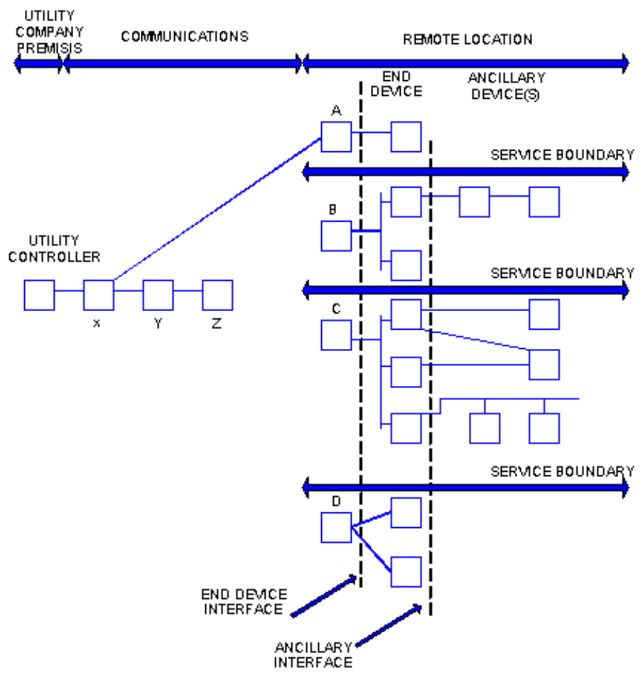

Figure 1 – IEEE 1397 Topology
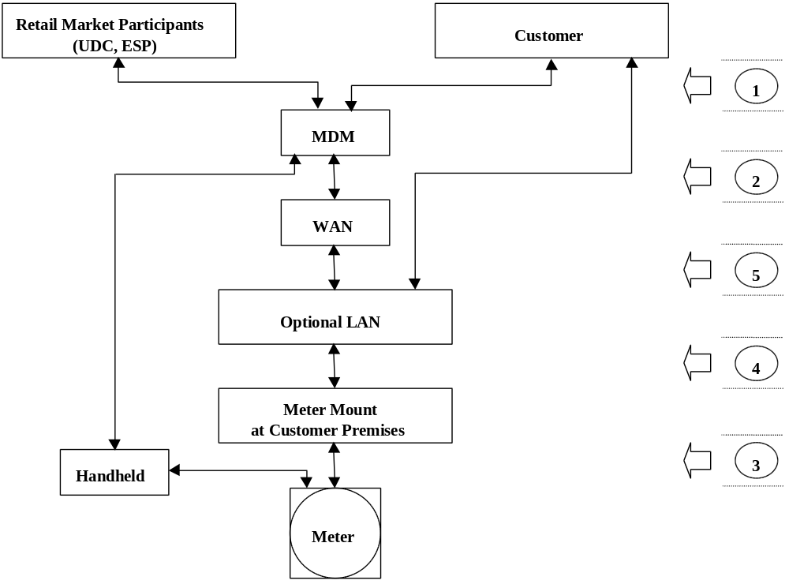

Figure 2 – IEEE Topology Adapted for California Electric Meters

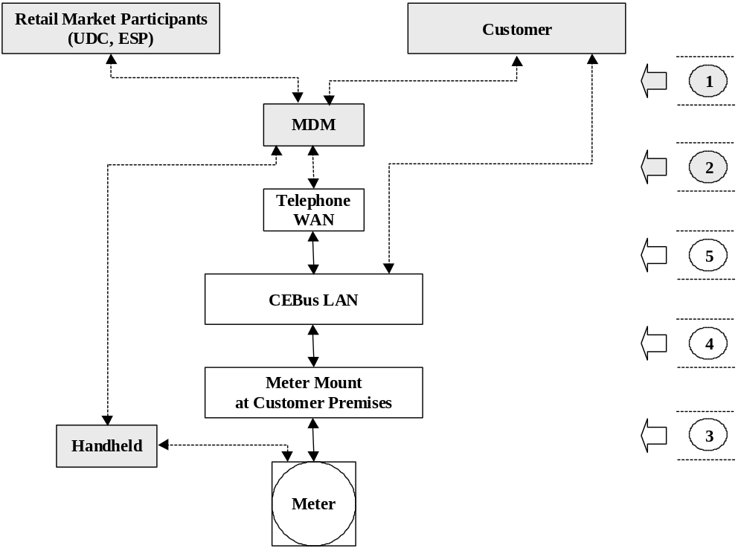

Figure 3 – IEEE1397 Implementation Connecting Electric Meters on a CEBus LAN to Telephone

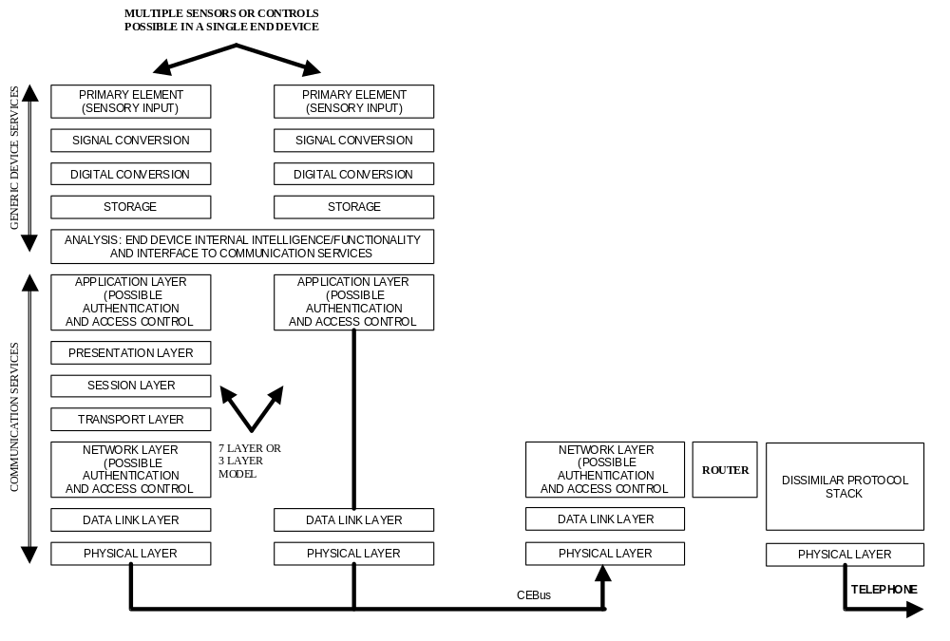

Figure 4 – IEEE 1397 End Device Reference Model and Router

